Connecting to the UniFirst GlobalProtect VPN Service
- Open the RSA SecureID token application on your computer:
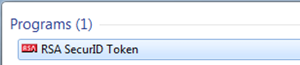
- To Connect to VPN, click on the GlobalProtect Icon in your computer’s System Tray.
- This will open the GlobalProtect client on your computer. Click on the Connect button.
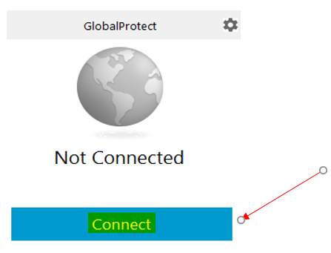
- The first time you use GlobalProtect, you will be asked to enter a portal address.
Enter unifirstvpn.unifirst.com in the portal address section.
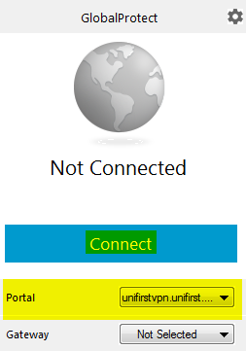

- Enter your login credentials using your network Username and Password on the First screen and click the Sign In button.
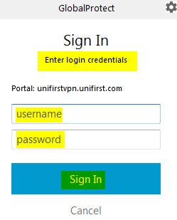
NOTE: Your network Username and Password are what you use to log into your computer
- You will then be prompted with a similar screen to enter your RSA SecurID token information. Enter the Tokencode that display on your RSA SecureID token in the password section and click Sign In.
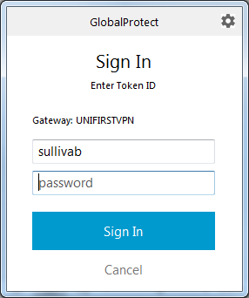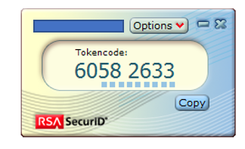
- The GlobalProtect VPN client will now connect you to the UniFirst network. The GlobalProtect client will display a “Connected” message and the icon in your system tray will now turn blue with a checkmark. You are now successfully connected.
