RASAN-426 Creating a wearer on RA for a customer that has ALL lockers occupied will create a transaction with bankCode NULL and error in logdb
Environment | Prerequisites
DBServerName= abs-srv20.internal.abslbs.com  DBSID=CUST24  DBUser=UNFDEV  Environment=PRODUCTION | - Module:  - System setting

Contents
Regression test 1
Steps to reproduce: 1

Regression test
Bu: 841 Harlingen, TX
9.07.00.UNF21 hash: b8e21b77b284 + RouteAssistant_v12.40.INTERNAL_TEST_ONLY.5e9fb4c29.apk

Steps to reproduce:
- RSC dlg: Create a new route, keep at least 1 customer which has wearers and garment delivery days.
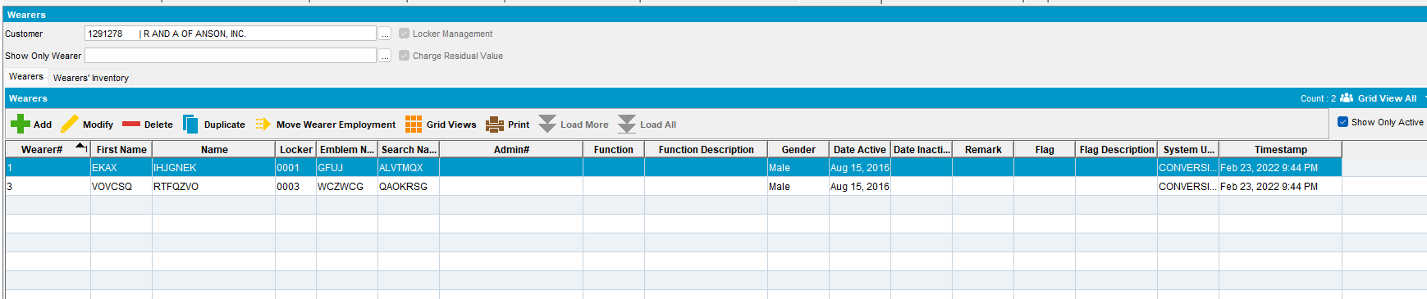
- Bank and Lockers dlg: Check how many lockers have.
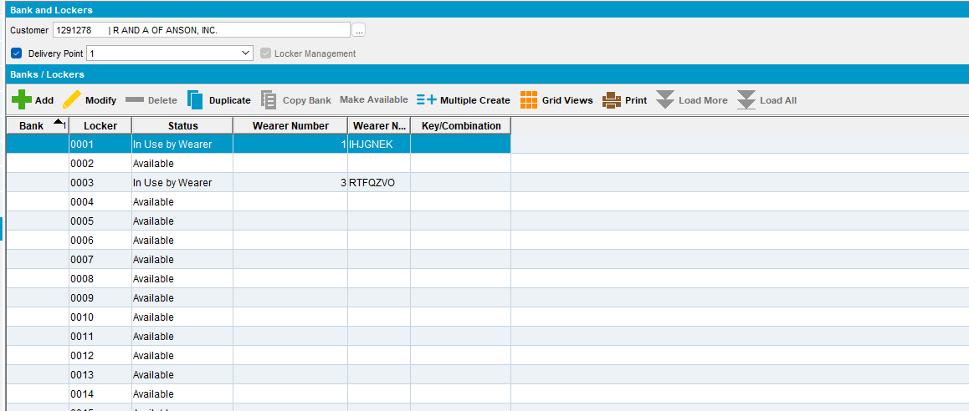
- Bank and Lockers dlg: Delete all the lockers that are not in use by wearers, to simulate a full occupation of lockers.
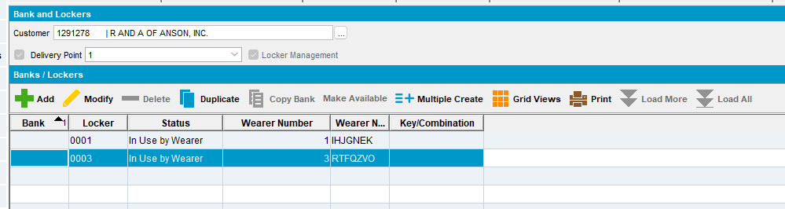
- RSC dlg: Create a new route containing this customer, move out all others, generate packing notes and invoices. Send the route to PDA.
- RA: Download the route, arrive at the customer and enter wearers and duplicate an existing wearer.
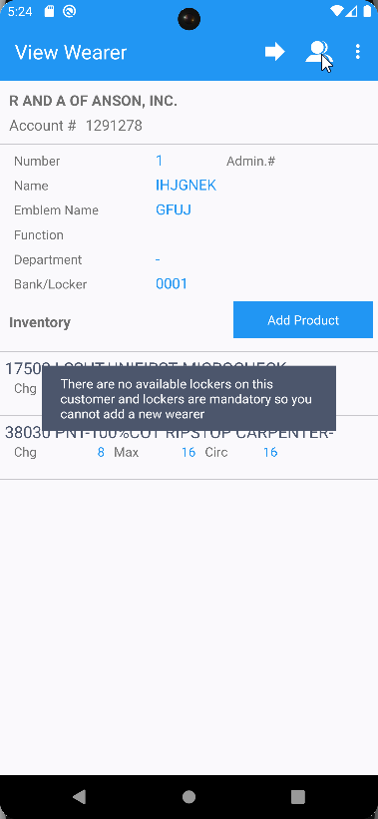
- RA: Try to create a new wearer.
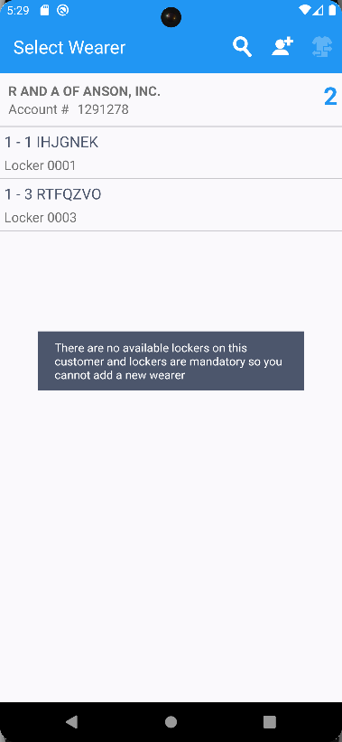

- Bank and lockers dlg: Create some new lockers
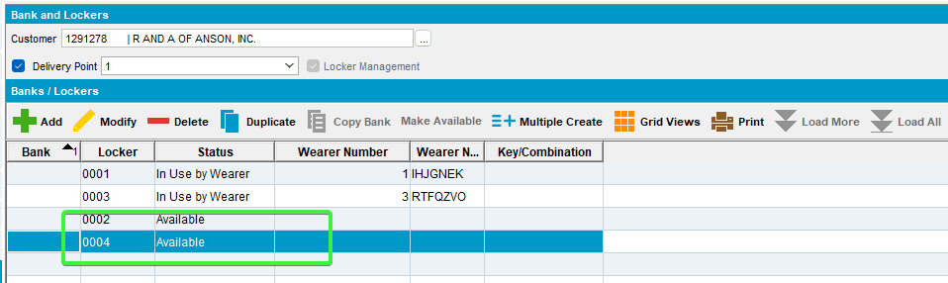
- RSC dlg: Re-transfer the route to PDA.
- RA: Redownload the route.
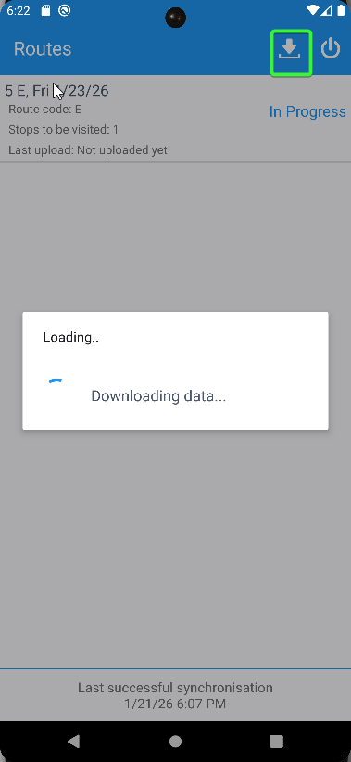
- RA: Duplicate a wearer
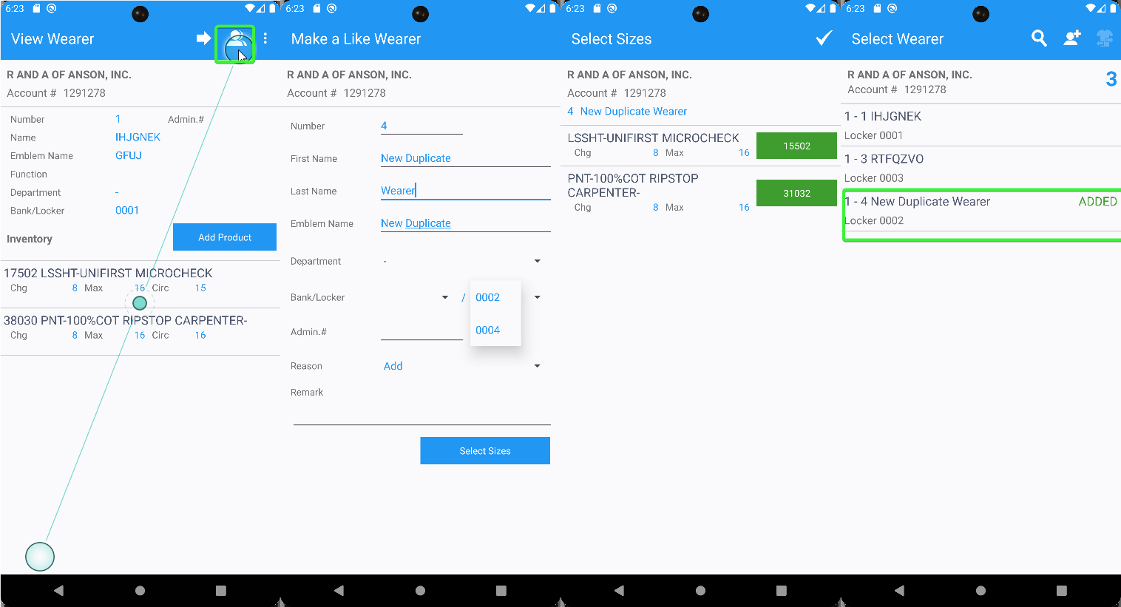
- RA: Add a new wearer.
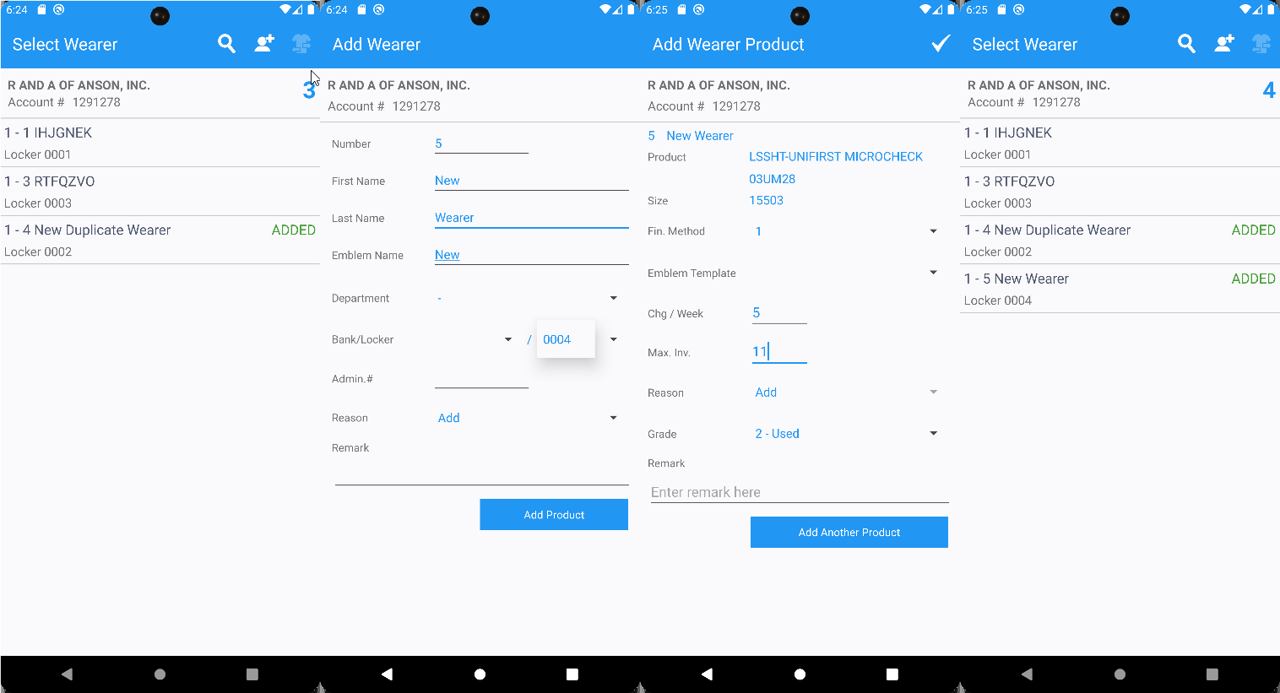
- Check the RA database.
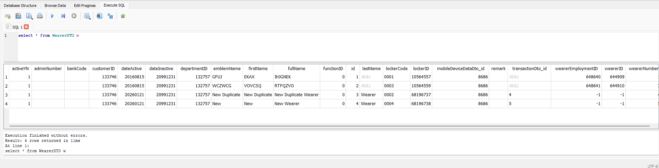
No errors

Tested OK

