RASAN-343 D_UBS_2763 Don't do an exchange on new garments in RA when there are work orders in progress
Environment | Prerequisites
Version:9.10.00  DBServerName= abs-srv20.internal.abslbs.com  DBSID=CUST24  DBUser=UNFA  Environment=PRODUCTION | - Module:  - System setting

Contents
Test before fix 1
Retest after fix 3

Test before fix
Hash: 1ac22a53b226 + RouteAssistant_v12.40.INTERNAL_TEST_ONLY.ee87457af

- Take a wearer, for example, 50 for the customer 109635, and increase max inventory
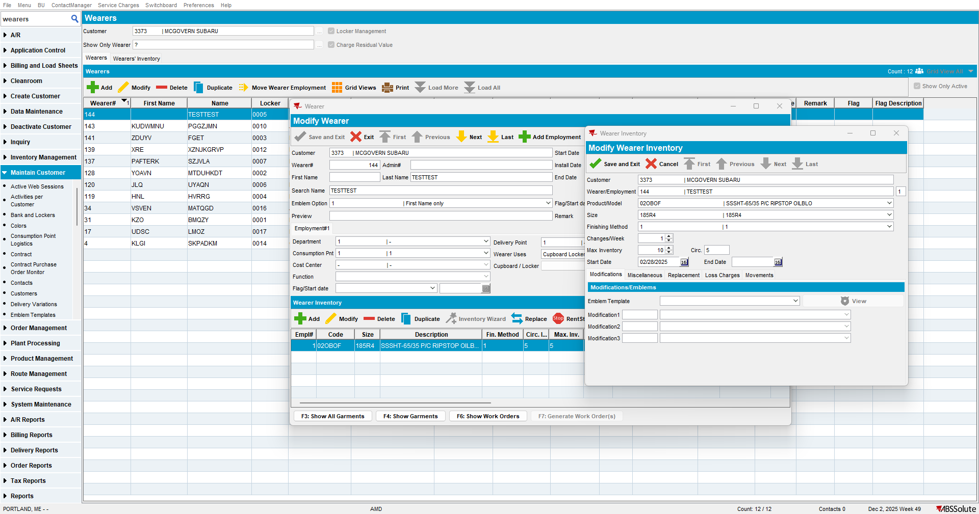

- Generate a Work order for the wearer's inventory
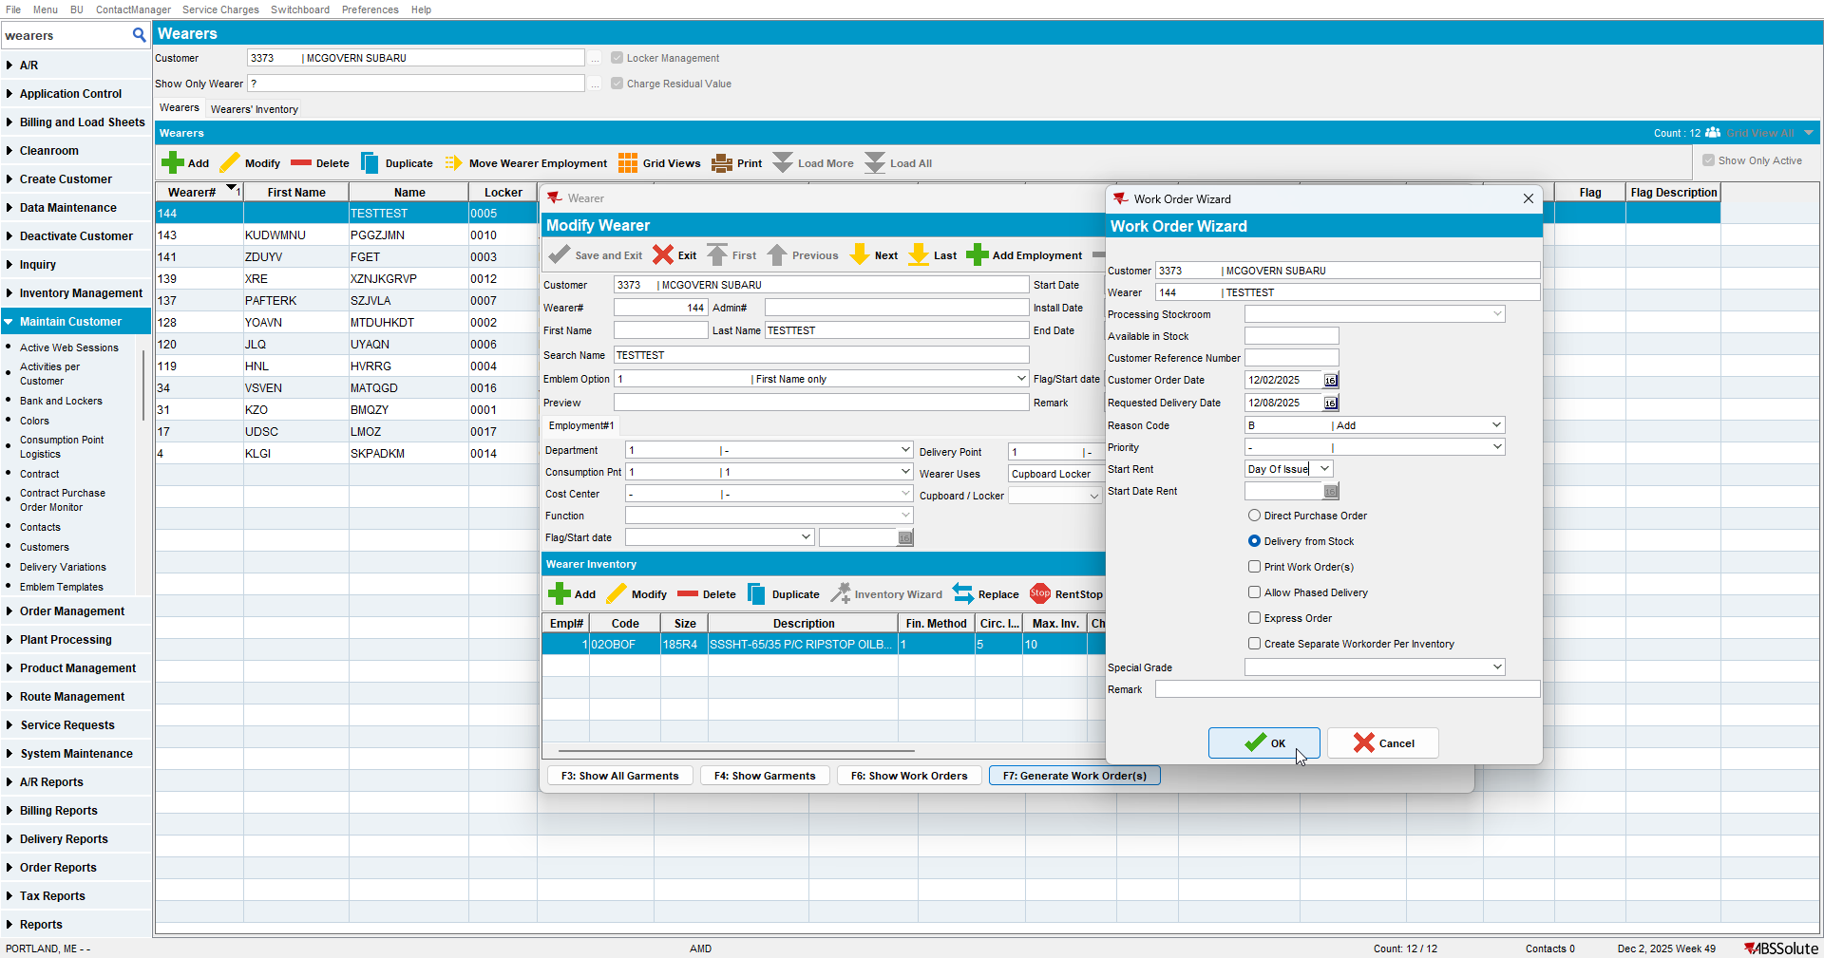

If you try to replace from the button, you will get a pop-up and you can't do it:
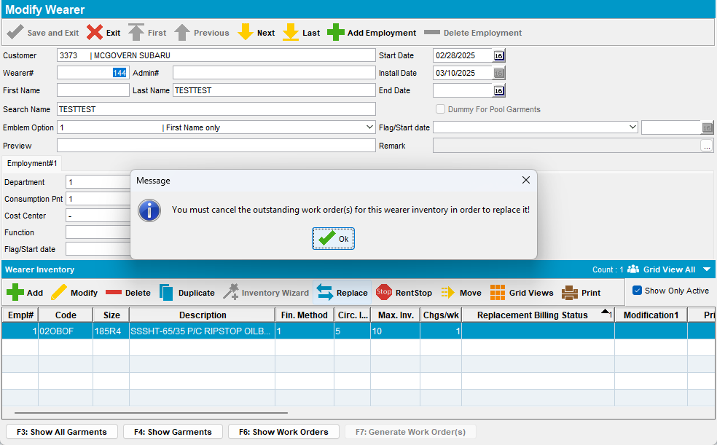

- . Generate a route for this customer and send it to RA
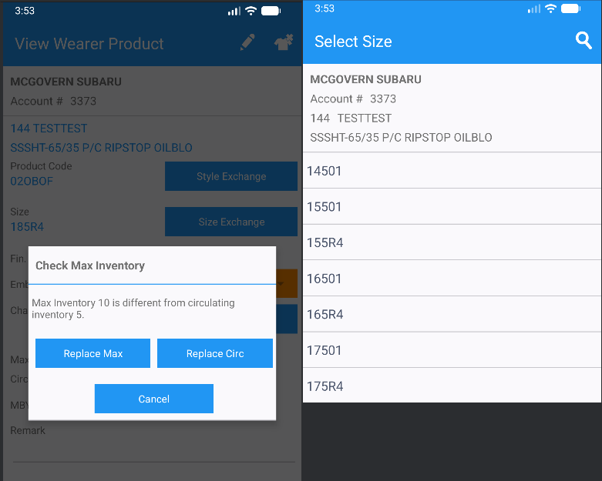

Current behaviour:
Try to do an exchange, and it is possible.

Expected behaviour:
In the client, a size/style exchange is blocked if there are work orders in progress, and it’s also disabled if there is no circulating inventory. And it’s not blocked on the RA, so this seems like an inconsistency.

Retest after fix
Hash: 6b7e093d9734 + RouteAssistant_v12.40.INTERNAL_TEST_ONLY.606258b4e

- Take a wearer, for example, 144 for the customer 3373, and increase max inventory

- Generate a Work order for the wearer's inventory

If you try to replace from the button, you will get a pop-up and you can't do it:

- Generate a route for this customer and send it to RA
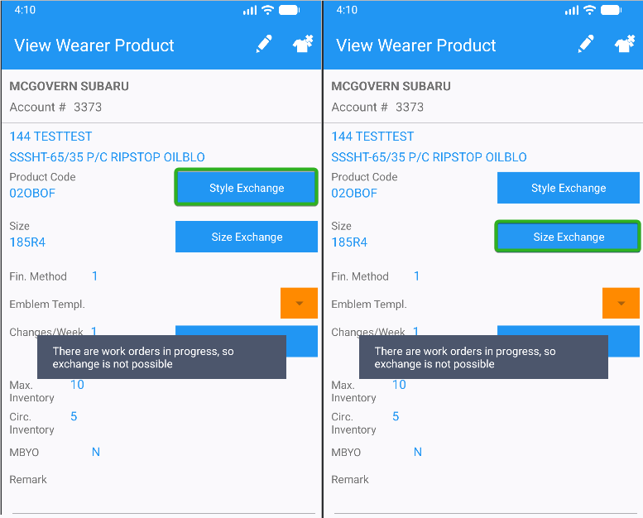

Current behaviour:
Try to do an exchange, an error appears.

Tested OK

