RASAN-473 - [QF][Smartbarcodes] Unique items at quit wearer inventory not accepted
Environment | Prerequisites
Version: RouteAssistant_v12.40  DBServerName= abs-srv20.internal.abslbs.com  DBSID=CUST24  DBUser=UNFDEV  Environment=Test | - Module:  - System setting

Contents
Reproducing before fix 1
Data preparation 1
Steps to reproduce 1
Retest after fix 7
Test Case 1 – Wi with Unique items > Scan unique an item on RA 7
Test Case 2 – WI with mixed inventory > Decrease only Non-unique items 10
Test Case 3 – WI with mixed inventory > Decrease Unique and Non-unique items 14

Reproducing before fix

Data preparation

Steps to reproduce
- In RA for route 1, customer 58522, wearer 4 we quit an wearer inventory with unique items and scan returned items
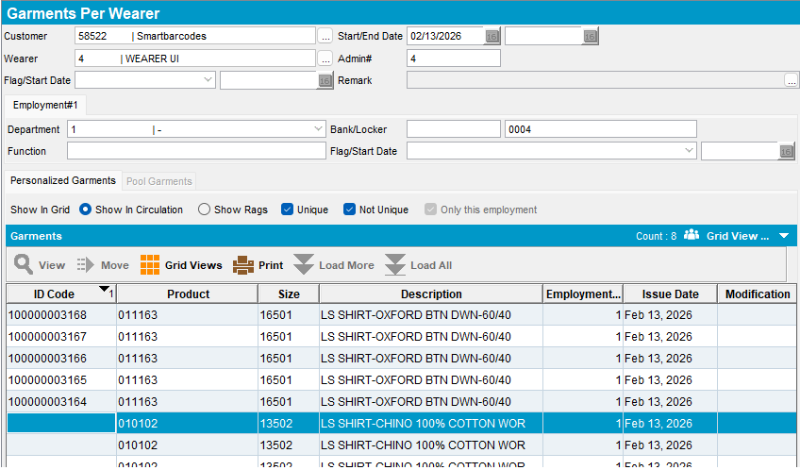
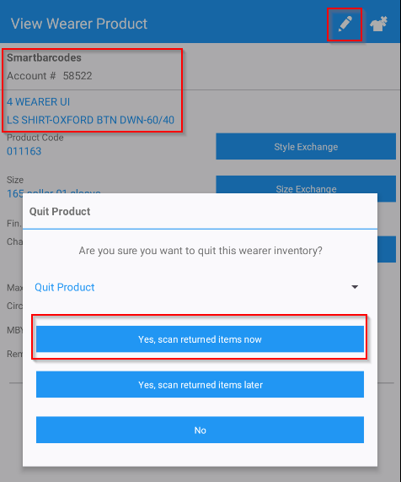
- When we scan a unique items the following error is given:
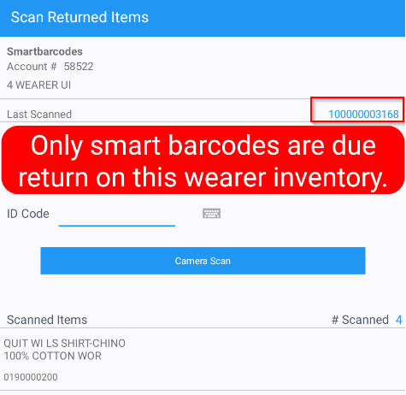
- We scan a smart barcode, and it is accepted:
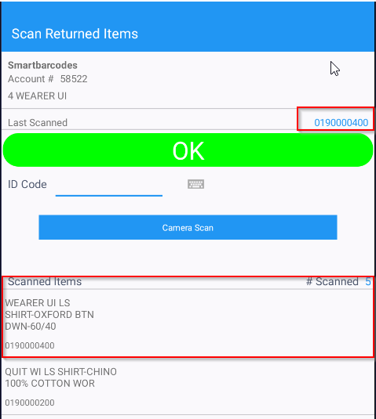
- After scanning that smart barcode we try again to scan the unique item from before and it says that is already scanned but for the rest of the unique items are accepted:
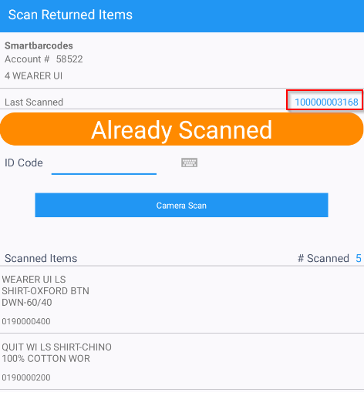
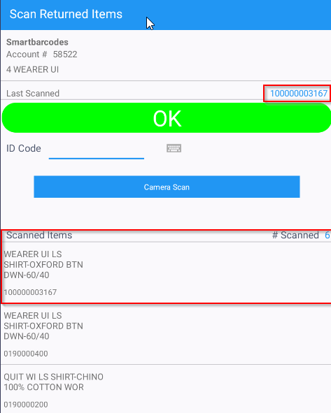

REPRODUCED OK.

Retest after fix

Test Case 1 – Wi with Unique items > Scan unique an item on RA
Hash: 9.07.00.UNF17.p20 hash: 3930ae9c21a6 + RouteAssistant_v12.40.INTERNAL_TEST_ONLY.08706083b
Expected behavior: The user can scan the unique item on RA with no errors encountered
- Wearers: have a WI of all unique items
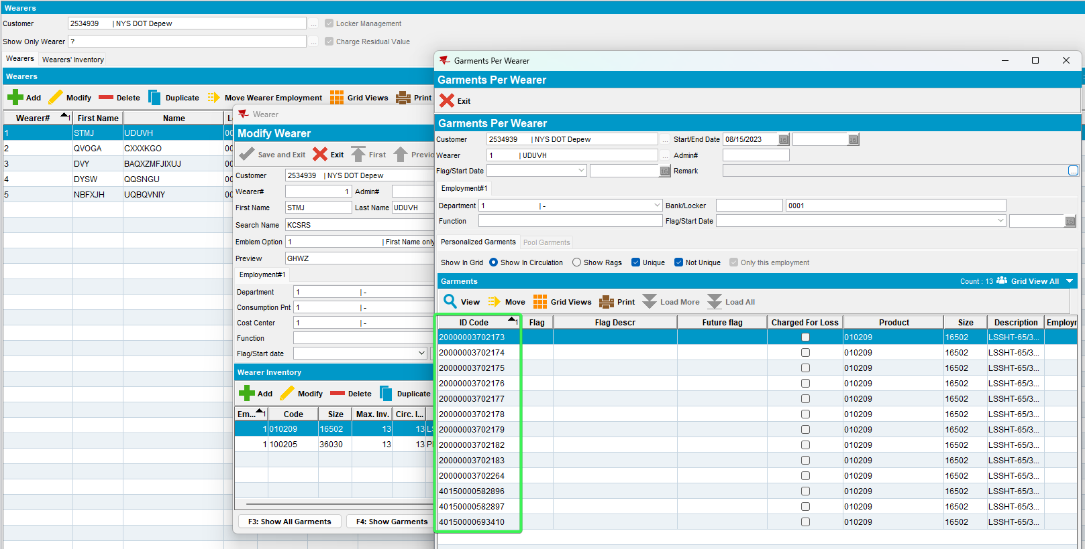
- RSC: Have the customer on a route and generate invoices
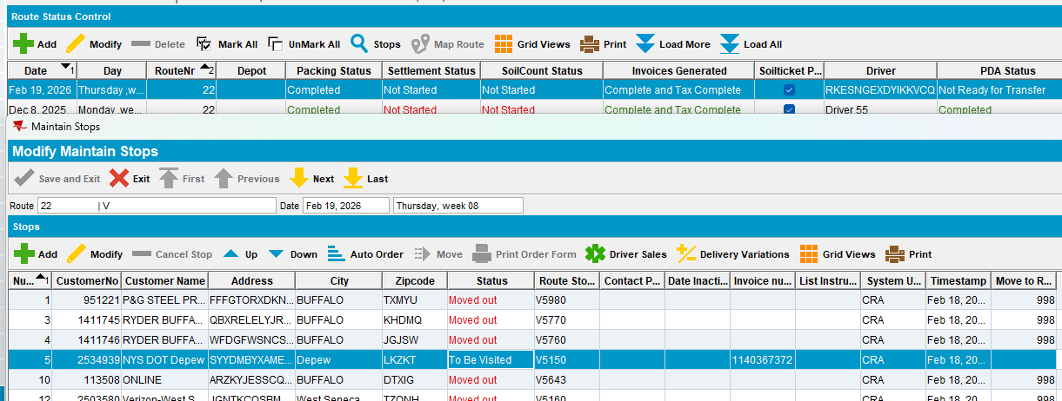
- Send the route to RA
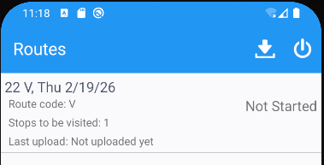
- Arrive at the customer > Wearers tab > Quit a wearer inventory with unique items
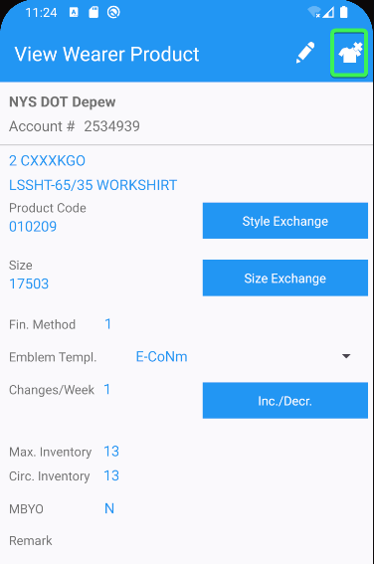
- On the pop-up message select “Yes, scan returned items now”
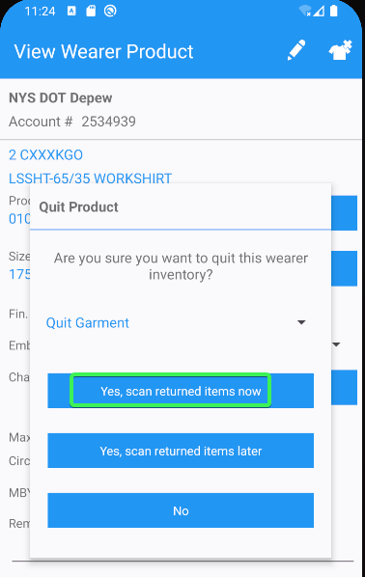
- Scan a unique ID
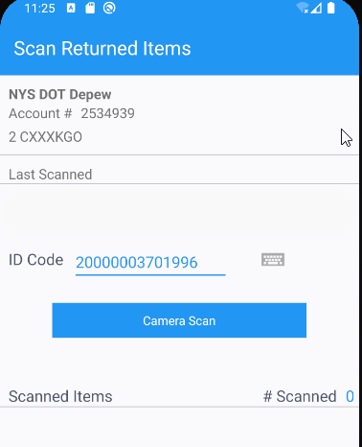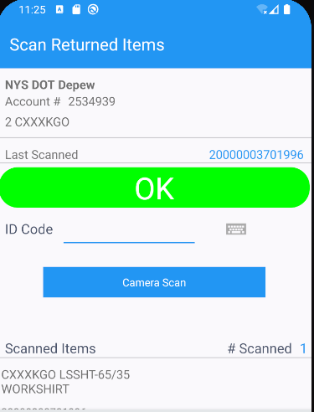
Tested OK

Test Case 2 – WI with mixed inventory > Decrease only Non-unique items
Hash: 9.07.00.UNF17.p20 hash: 3930ae9c21a6 + RouteAssistant_v12.40.INTERNAL_TEST_ONLY.08706083b
Expected behavior: The user cannot scan a Unique item on RA, an error is prompted because the decreased items are all non-unique
- Wearers DLG: Add a wearer with all non-unique Items
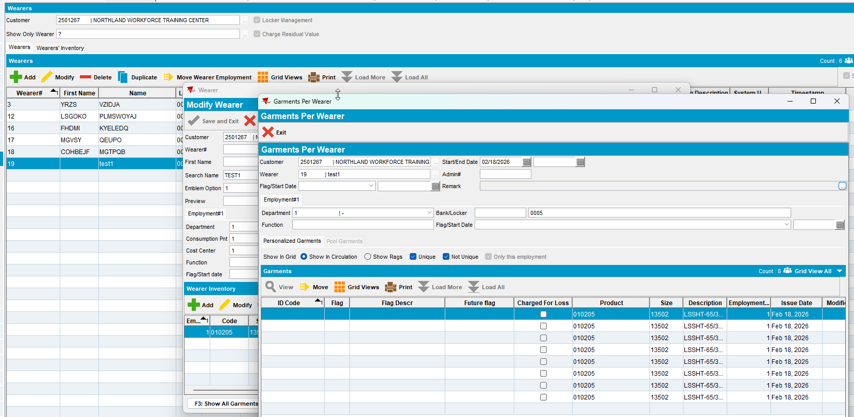
- Make 4 of the items Unique
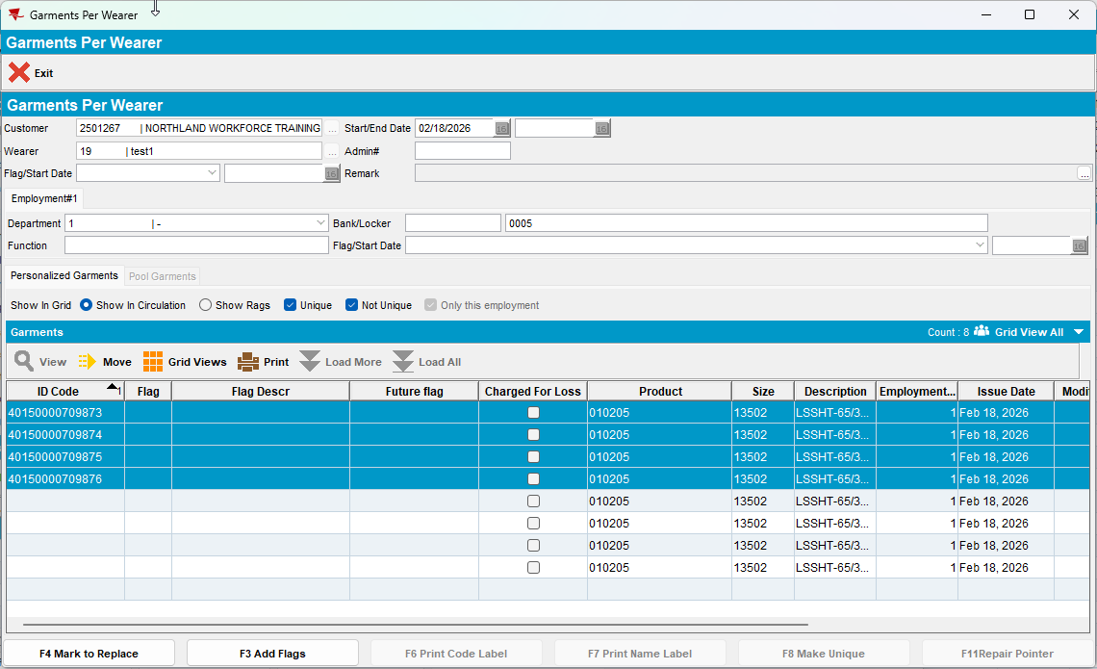
- Perform a decrease of Max inventory of 3 items, return the Oldest items so the non-unique can be flagged
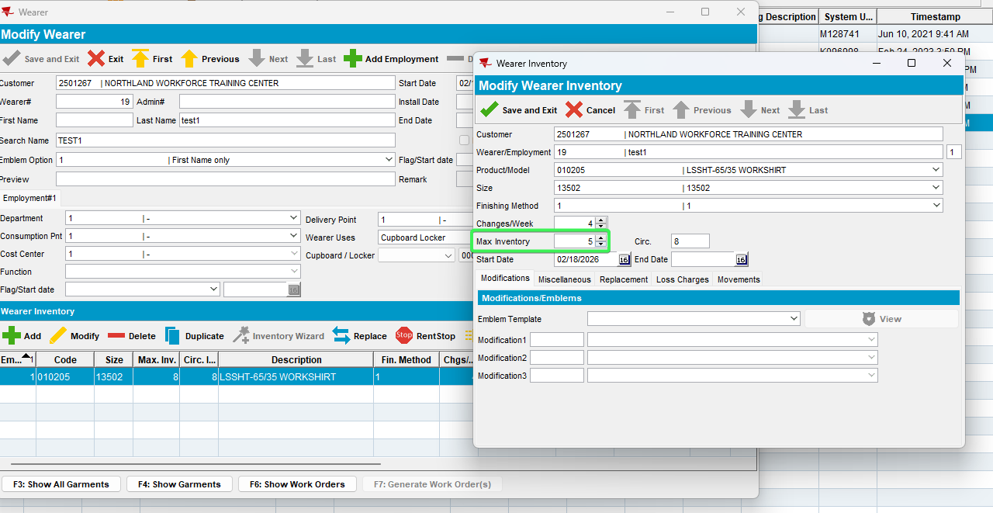
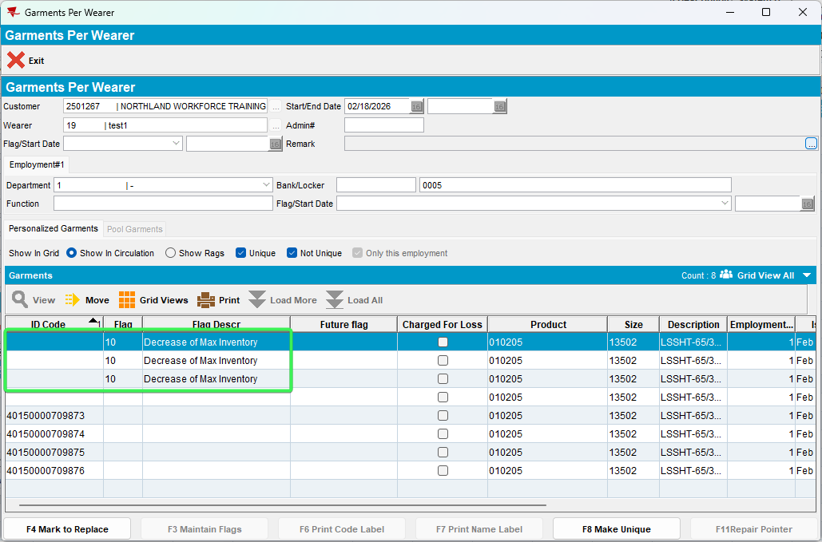
- RSC: Create a new route with the customer on it
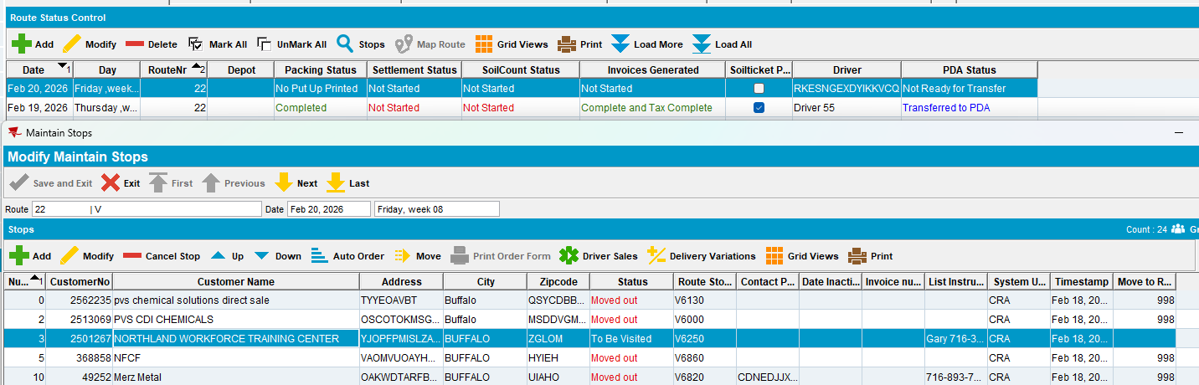
- Send the route to RA
- RA: Returned Items > Scan returns
- Scan 1 unique item and see that an error message is preventing you from scanning the item
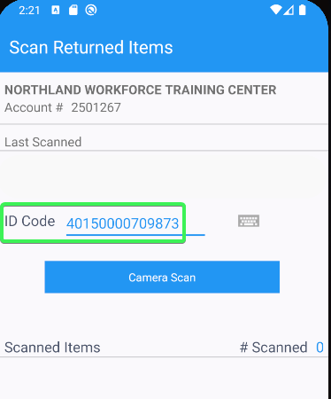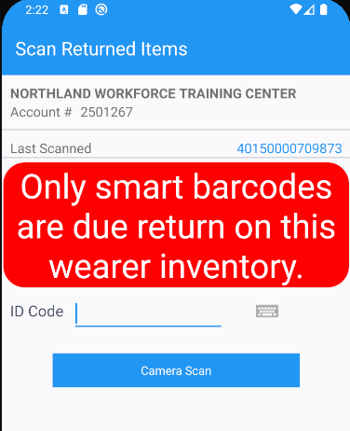
- Scan a Smart barcode
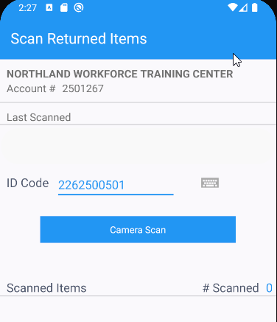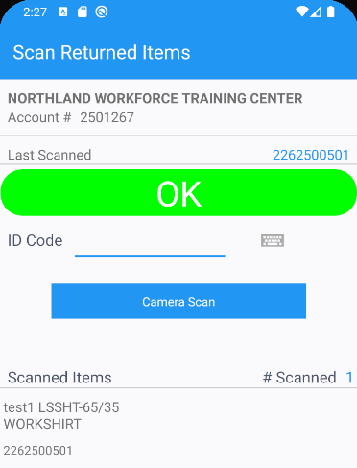
- Scan the remaining Smart bar codes
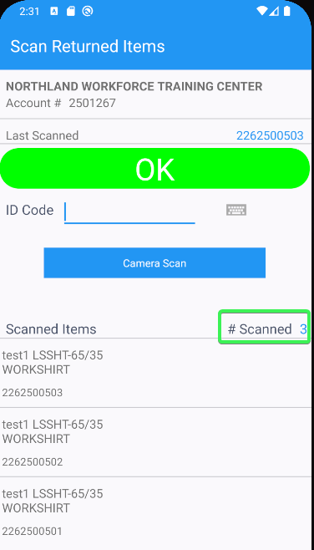
- Scan a 4th Smart barcode
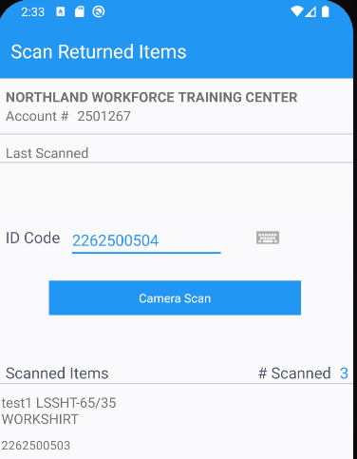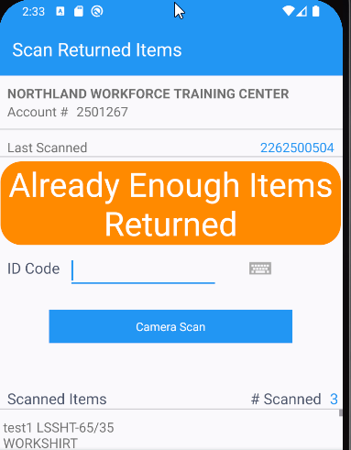
Tested OK

Test Case 3 – WI with mixed inventory > Decrease Unique and Non-unique items
Hash: 9.07.00.UNF17.p20 hash: 3930ae9c21a6 + RouteAssistant_v12.40.INTERNAL_TEST_ONLY.08706083b
Expected behavior: The user cannot scan a more unique items of the RA that were flagged for decrease on server

- Wearers DLG: Add a wearer with all non-unique Items
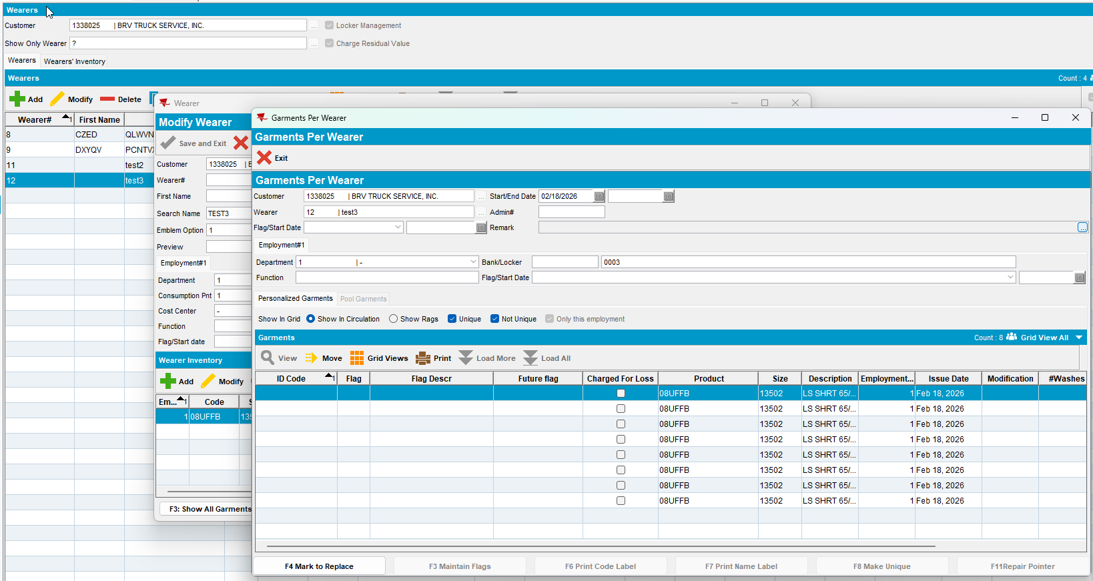
- Make 4 of the items Unique
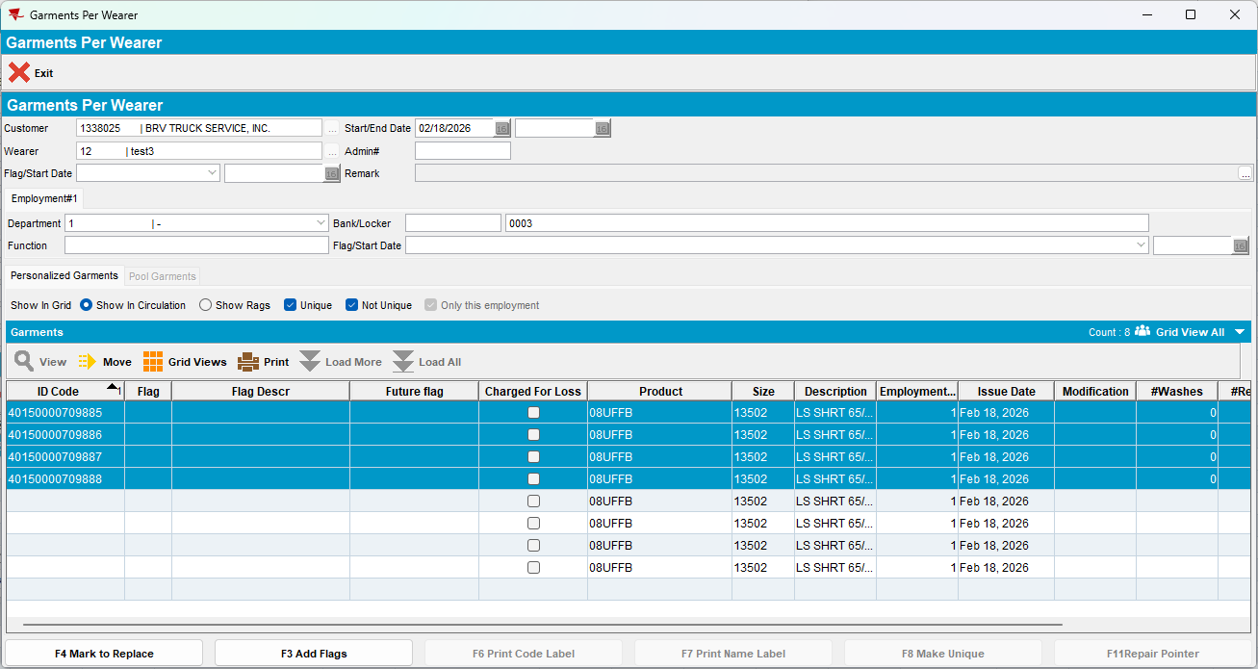
- Perform a decrease of Max inventory of 5 items which include 1 unique
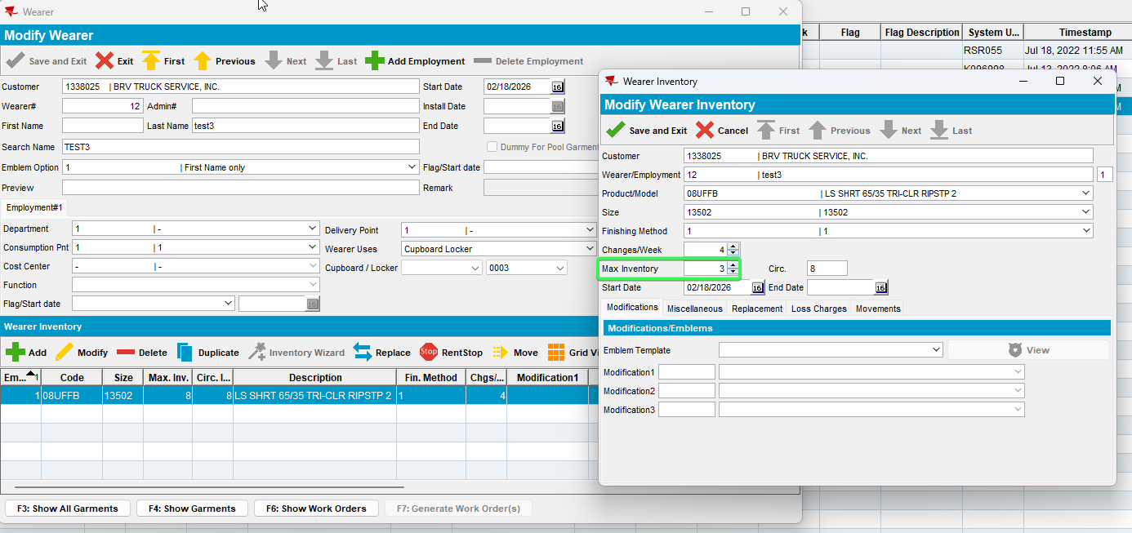
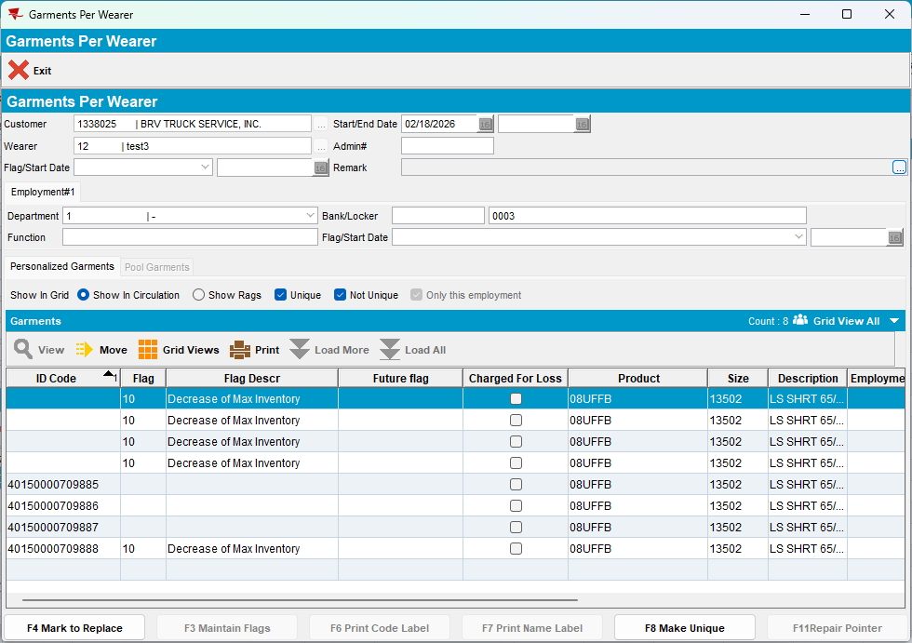
- RSC: Create a new route with the customer on it
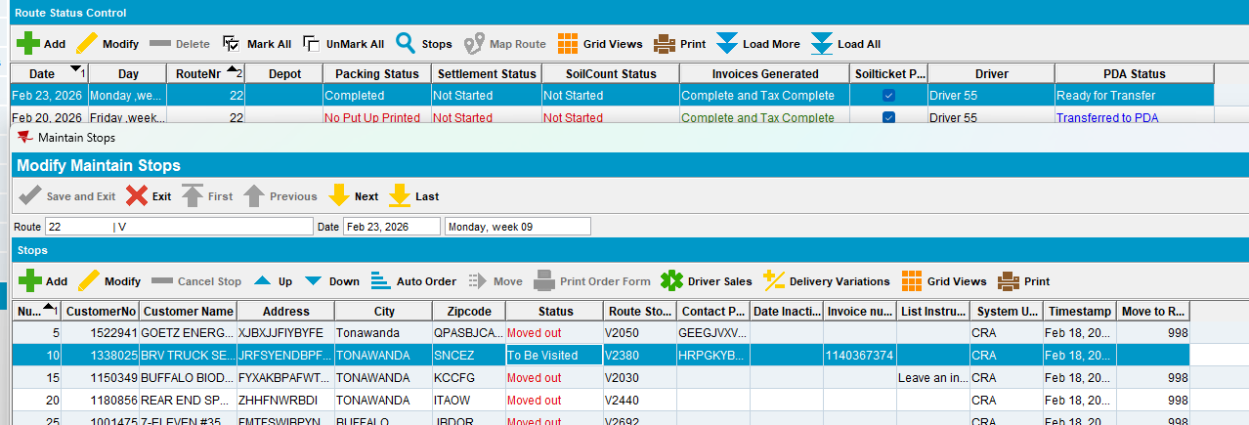
- Send the route to RA
- RA: Returned Items > Scan returns
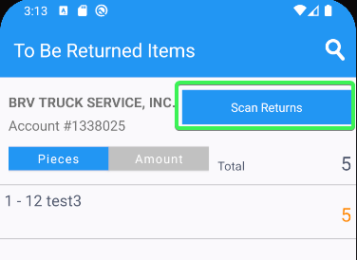
- Scan the Unique ID and see that no error is prompted
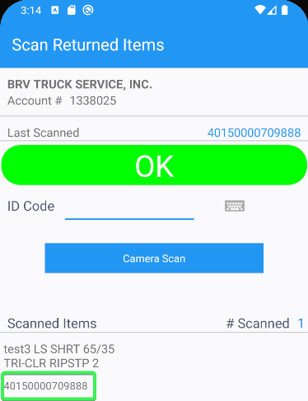
- Scan another Unique ID
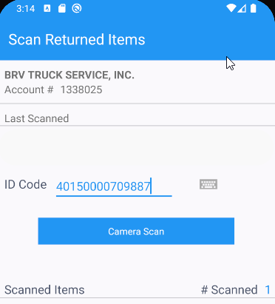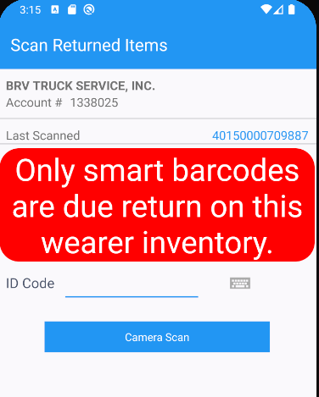
- Scan a Smart barcode
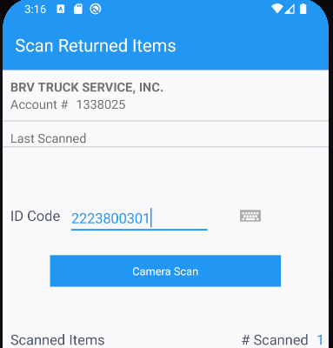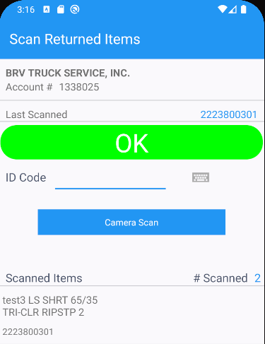
Tested OK

