RASAN-445 Prevent double upload by temporarily disabling upload and download buttons
Environment | Prerequisites
DBServerName= abs-srv20.internal.abslbs.com  DBSID=CUST24  DBUser=UNFDEV  Environment=PRODUCTION | - Module:  - System setting

Contents
Retest after fix 1
Expected behavior: 1
Steps to reproduce: 1

Retest after fix
Bu: 044 Nashua, NH
RouteAssistant_v12.40.INTERNAL_TEST_ONLY.bad9eea0c.apk + 9.07.00.UNF17.p20 hash: 864d9c5faad9

Expected behavior:
Download button
Upon download the first step is to disable the button to block the user pressing it again whilst the is in progress

Upload button
Will be enabled only there is at least one transaction with status ready for export, for the selected route, except Start Route transaction. When pressing the upload button, disable the button to block the user pressing it again whilst the is in progress
Buttons available in message fragment: OK/Cancel. If OK is pressed then it will upload all transactions connected to the current route, to Absolute. When Cancel is pressed, the upload will not take place, the button is reenabled and the application remains in Route Info screen.

Steps to reproduce:

Soap services
- RSC dlg: Create a new route, keep a few customers. Generate packing notes and invoices.
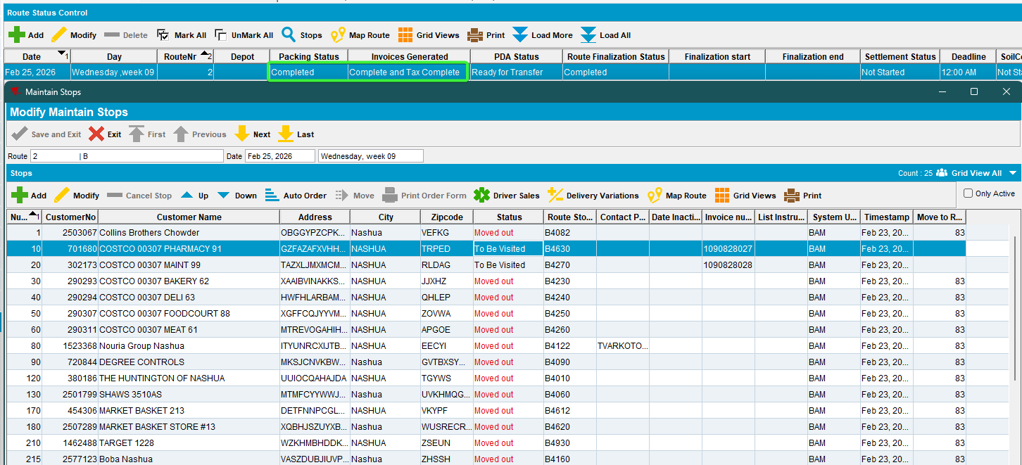
- RSC dlg: Send the route to PDA.
- RA: Download the route. Arrive at the first customer and make some transactions to enable upload
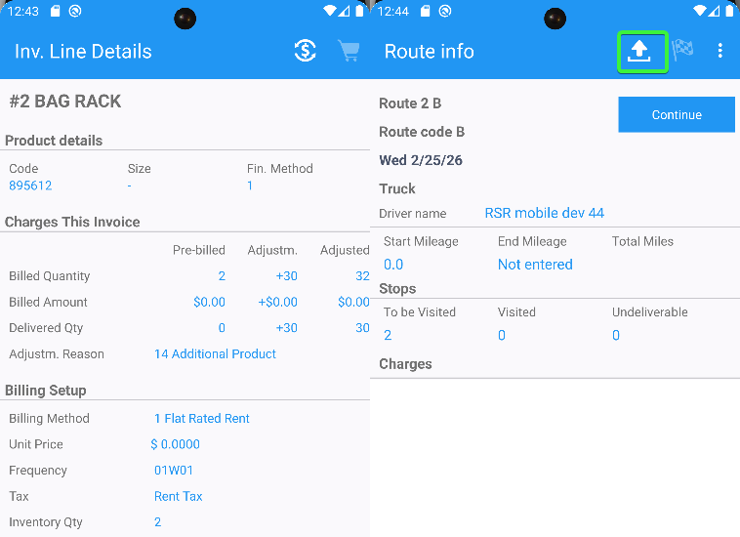
- RA: Press download button.
Upon download the first step is to disable the button to block the user pressing it again whilst the download is in progress Download button get enabled again after everything is finished.
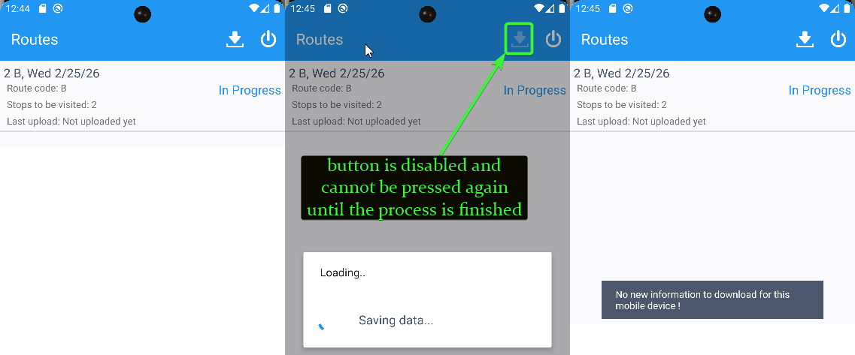
- RA: Enter again the customer and make other transactions.
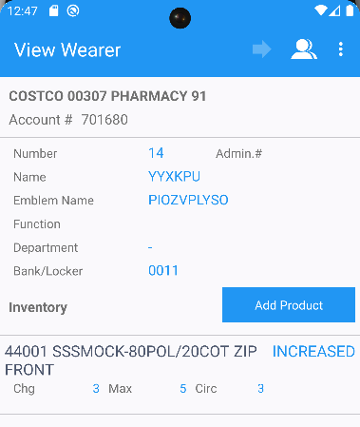
- RA: Go to the upload button.
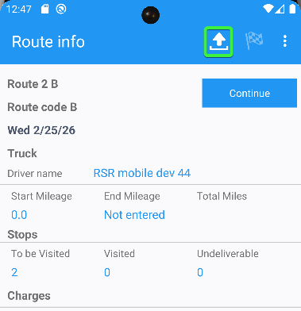
- RA: Press the upload button, a warning will appear, the upload button becomes disabled and cannot be pressed again until we choose OK or Cancel
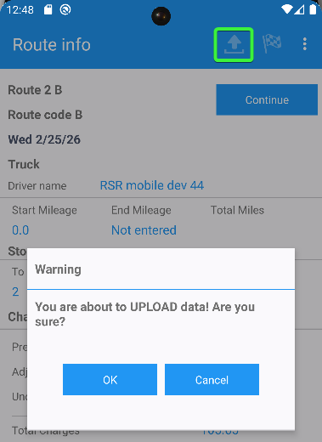
- RA: Press Cancel. The upload button is re enabled.
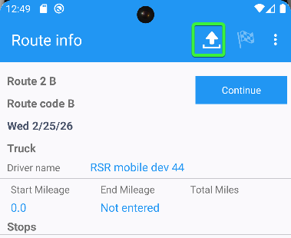
- RA: Press the upload button again and choose OK on the warning to upload the data back to the server. After the upload is finished, the button will become disabled.
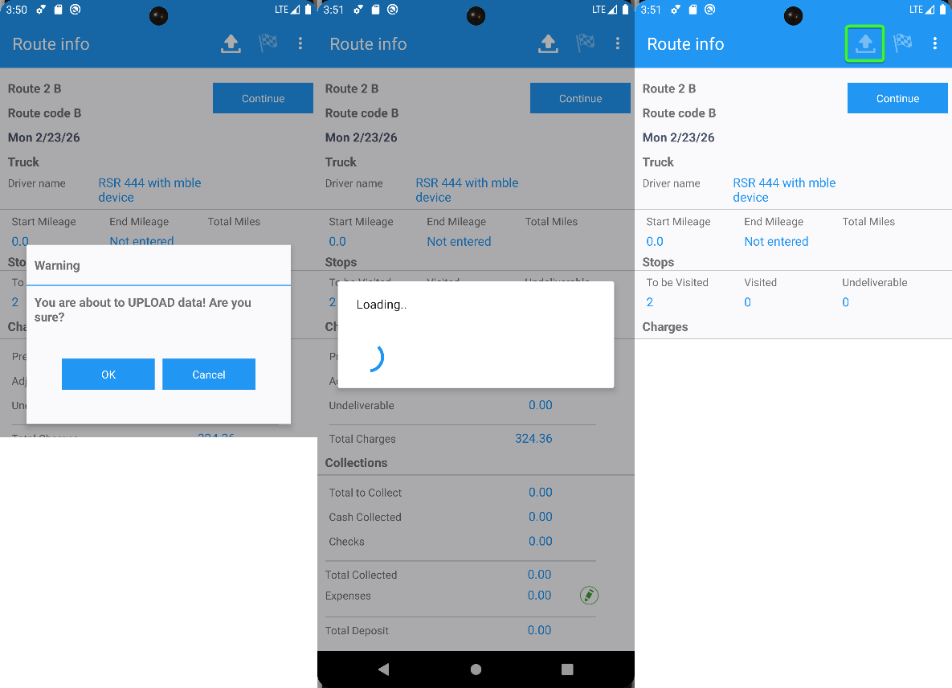

- RA: Enter the other customer, make some more transactions, settle, depart, finish and upload the route.
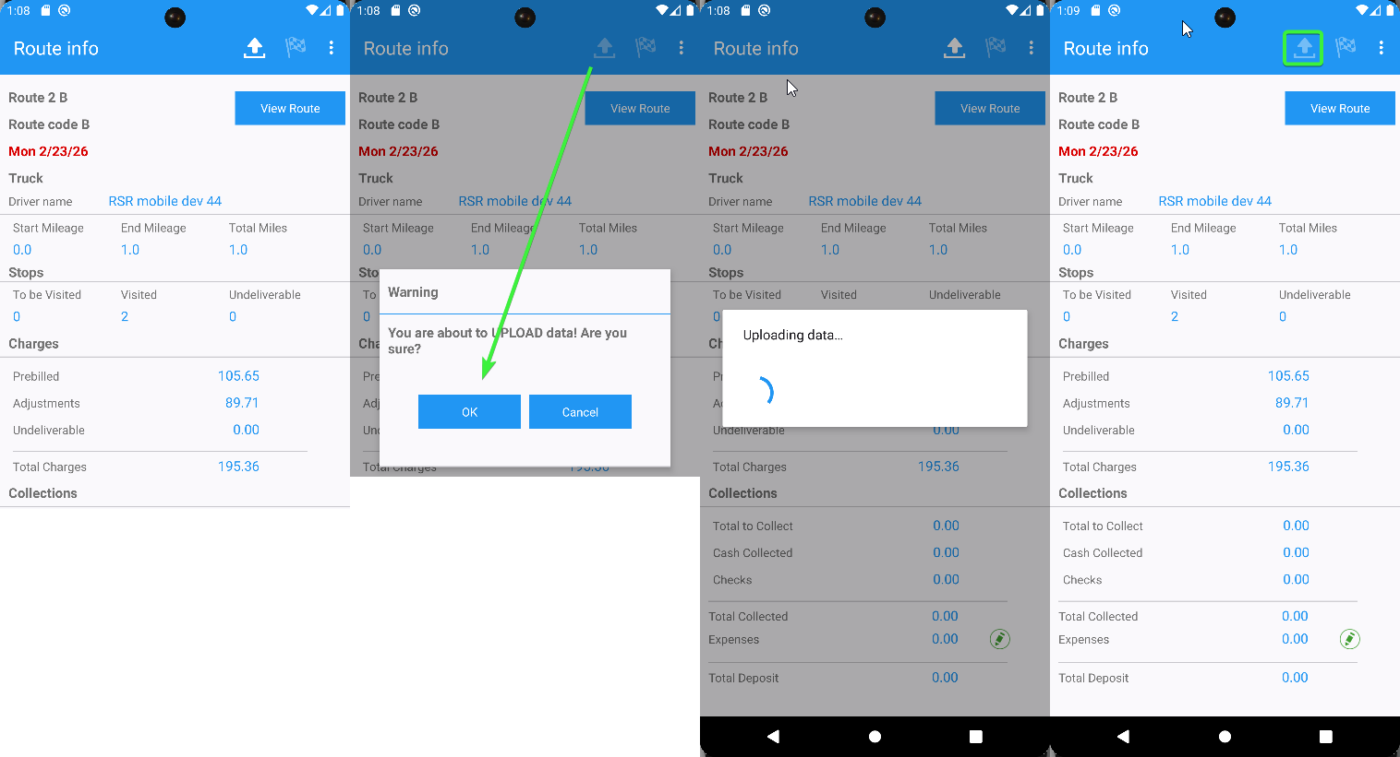

Check the log, no errors.
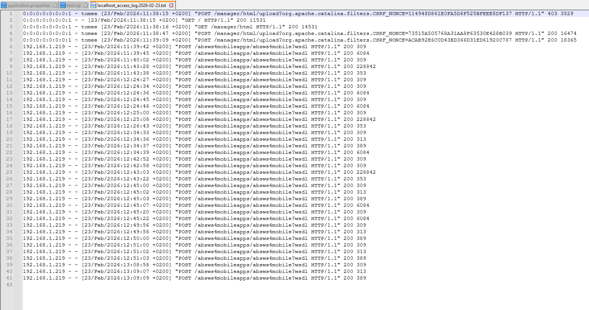
- Route Check-in dlg: Check the uploaded route.
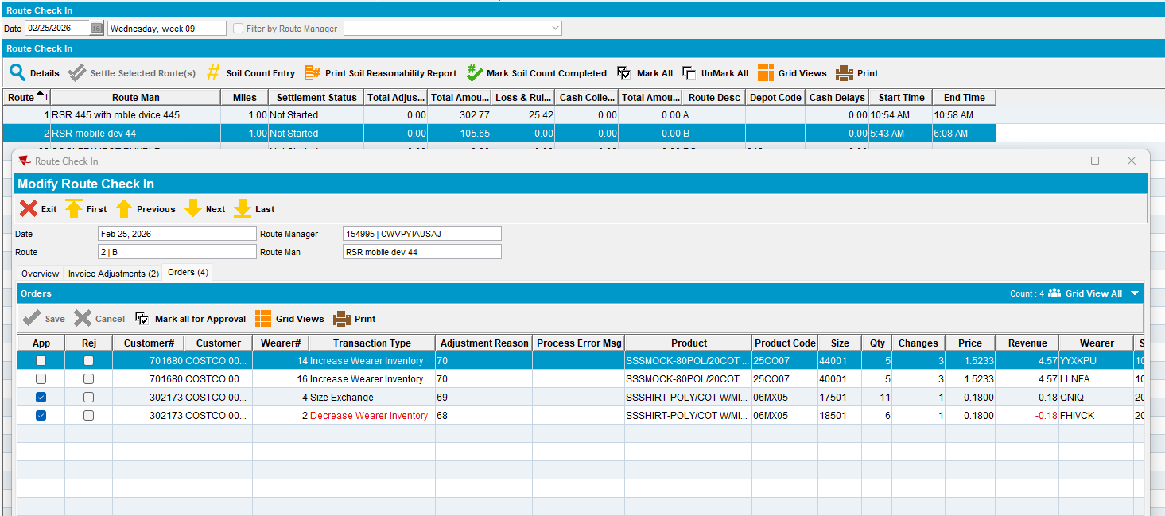
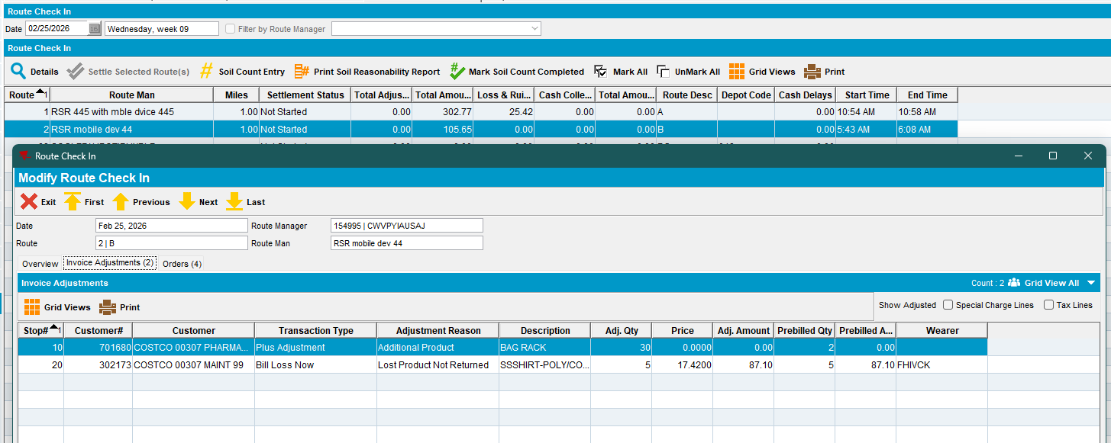
Tested OK

Rest services
Configure the RA on rest services.
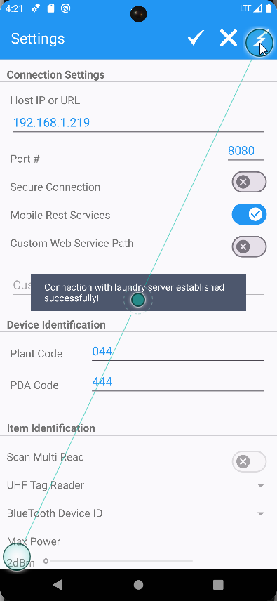

- RSC dlg: Create a new route, keep a few customers. Generate packing notes and invoices.
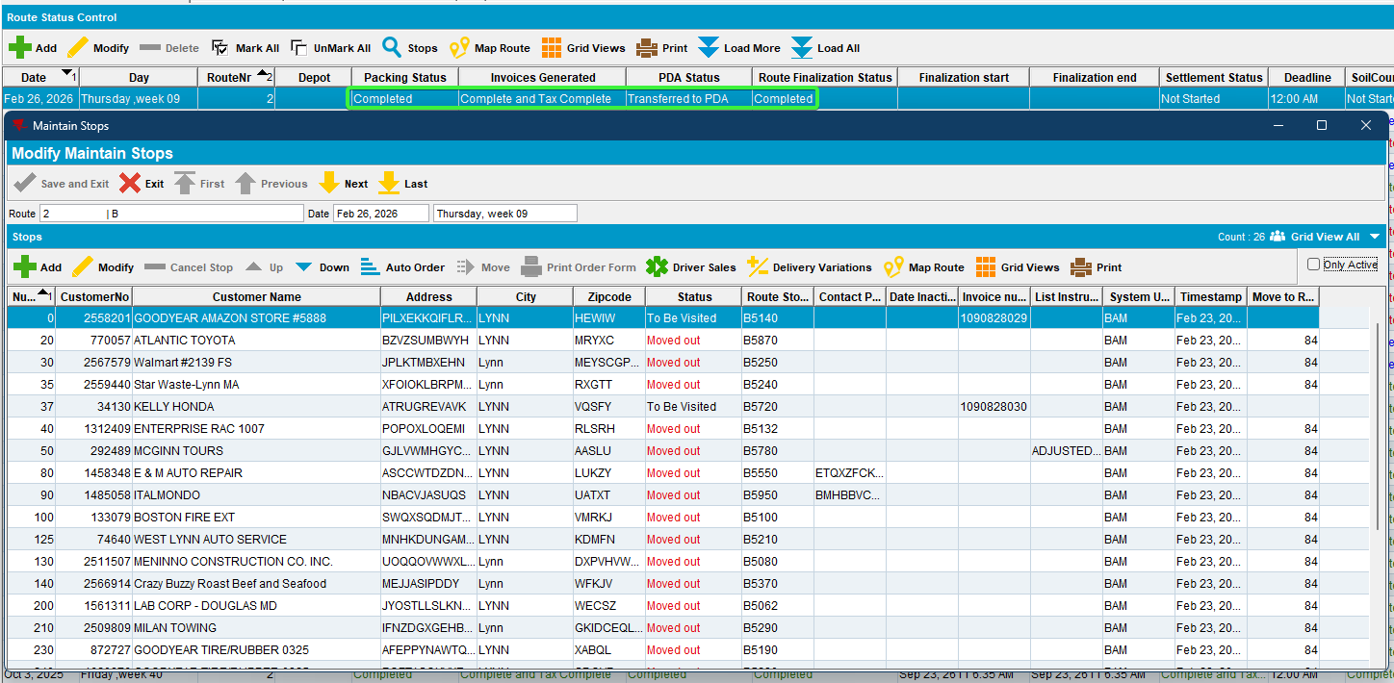
- RSC dlg: Send the route to PDA.
- RA: Download the route. Arrive at the first customer and make some transactions to enable upload
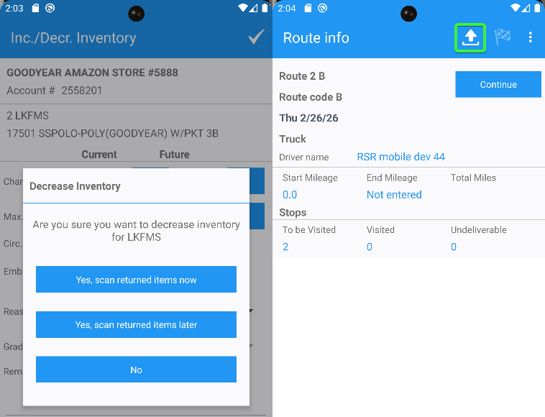
- RA: Press download button.
Upon download the first step is to disable the button to block the user pressing it again whilst the download is in progress
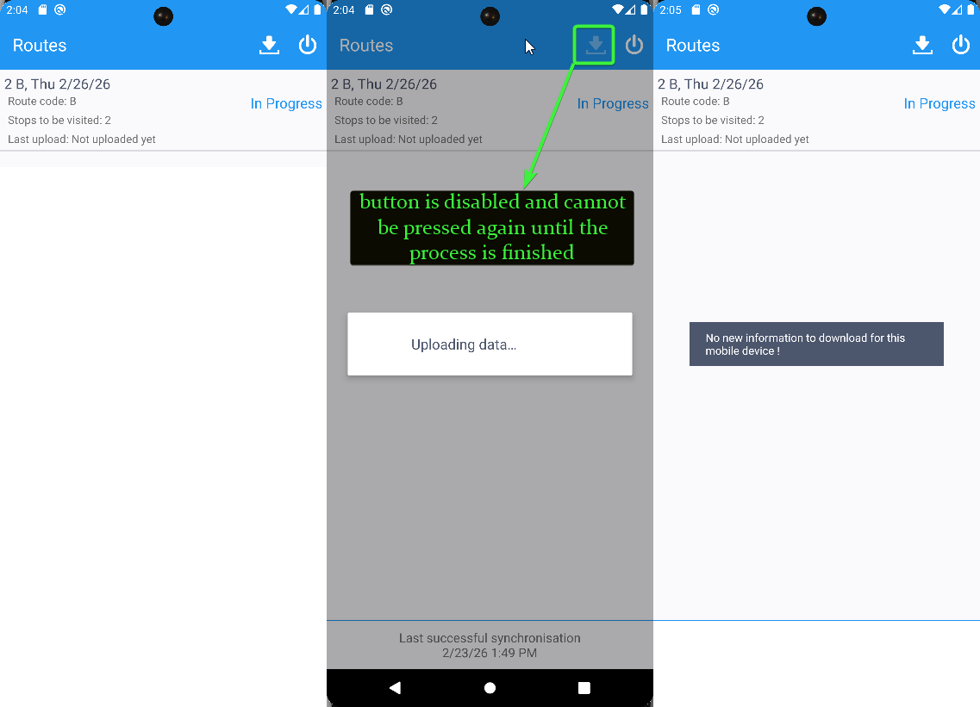
- RA: Enter again the customer and make other transactions.
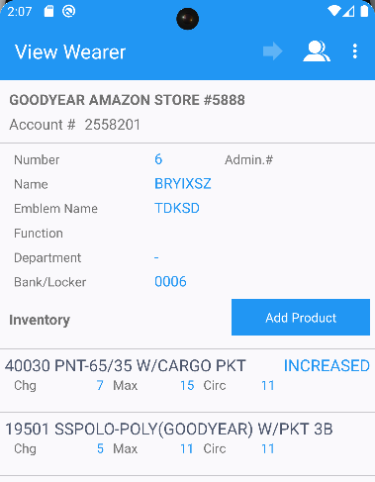
- RA: Go to the upload button.
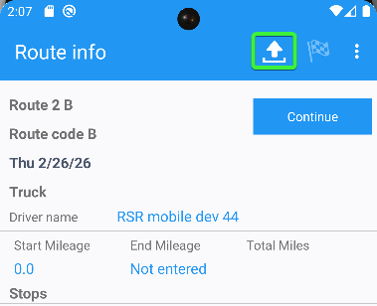
- RA: Press the upload button, a warning will appear, the upload button is disabled and cannot be pressed again until we choose OK or Cancel
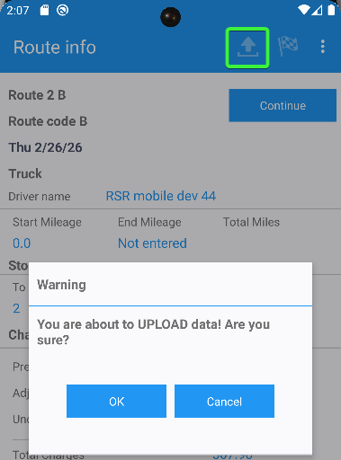
- RA: Press Cancel. The upload button is still enabled.
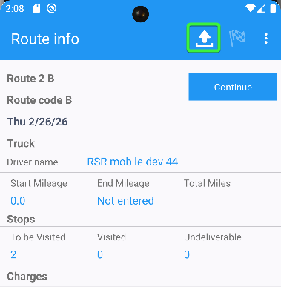
- RA: Press the upload button again and choose OK on the warning to upload the data back to the server. After the upload is finished, the button will become disabled.
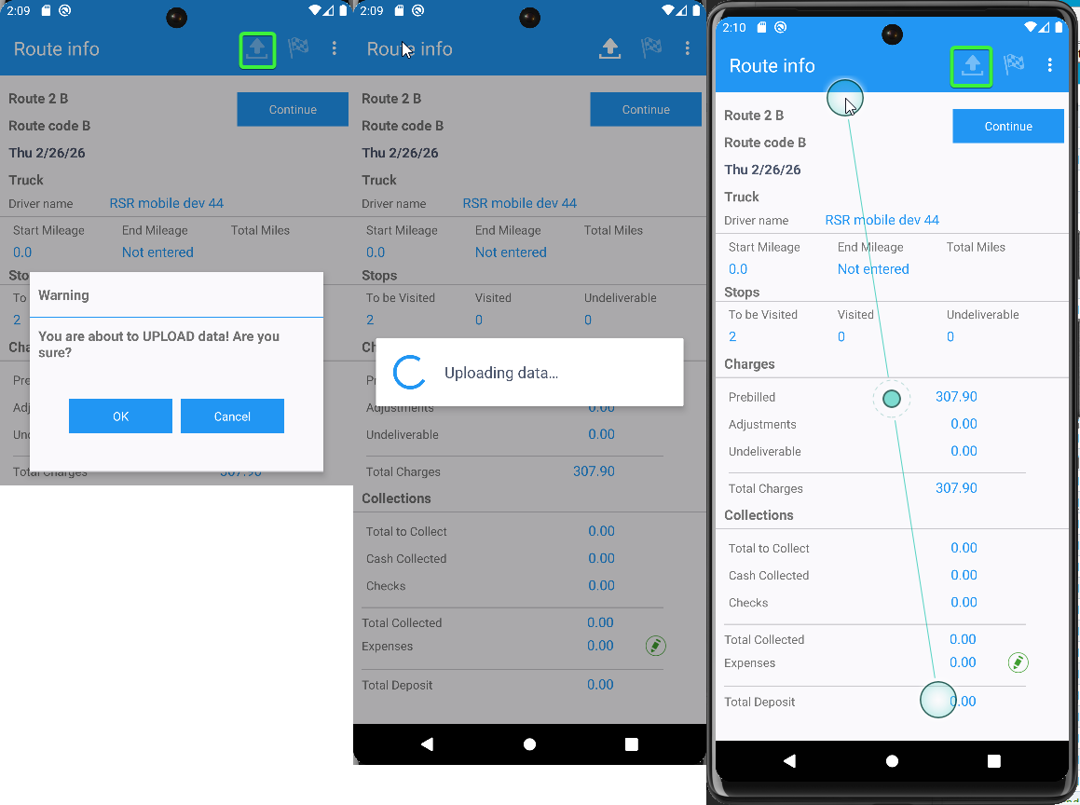

- RA: Enter the other customers, make some more transactions, settle, depart, finish and upload the route.
Decrease of inventory and scan return
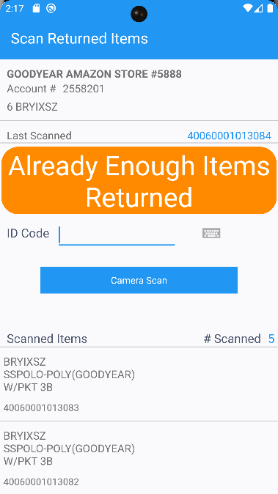
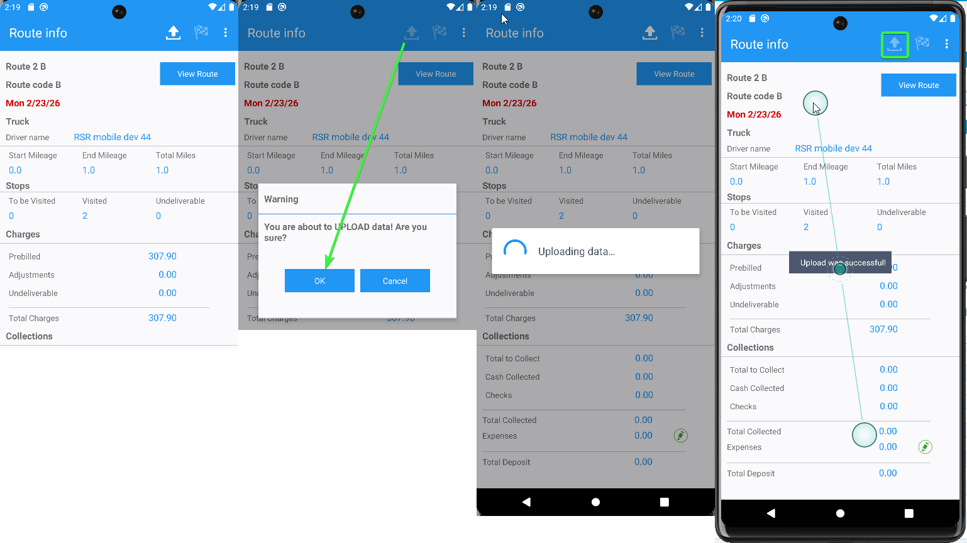

Check the log, no errors.

localhost_access_log

ServerErrorLog
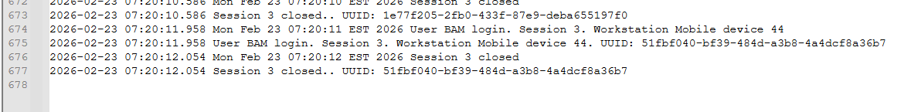

- Route Check-in dlg: Check the uploaded route.
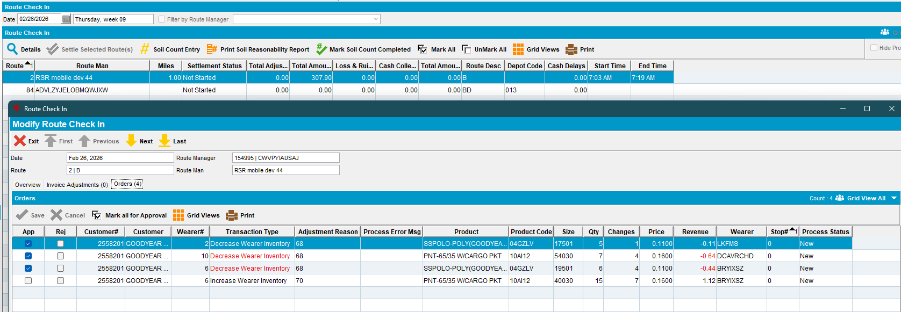

Tested OK

