RASAN-130 D_UBS_2662 There is no longer a blue box around the chain link icon on the RA
Environment | Prerequisites
Version: 9.09.01  DBServerName=abs-SRV20.internal.abslbs.com  DBSID=CUST24  DBUser=UNFA  DBPassword=UNFA  Environment=Test | - Module:  - System setting

Contents
Retest after fix 1
Test Case 1 – Inc./Decr. Inventory screen with UNFCUSTOM in license 1
Test Case 2 – Inc./Decr. Inventory screen without UNFCUSTOM in license 3

Retest after fix
Hash: bf242f11498e

Test Case 1 – Inc./Decr. Inventory screen with UNFCUSTOM in license

- RSC: Add a new route, generate the invoices and transfer them to PDA.
- RA: Open the route, go to Wearers, select a wearer inventory then go to Inc./Decr. Inventory
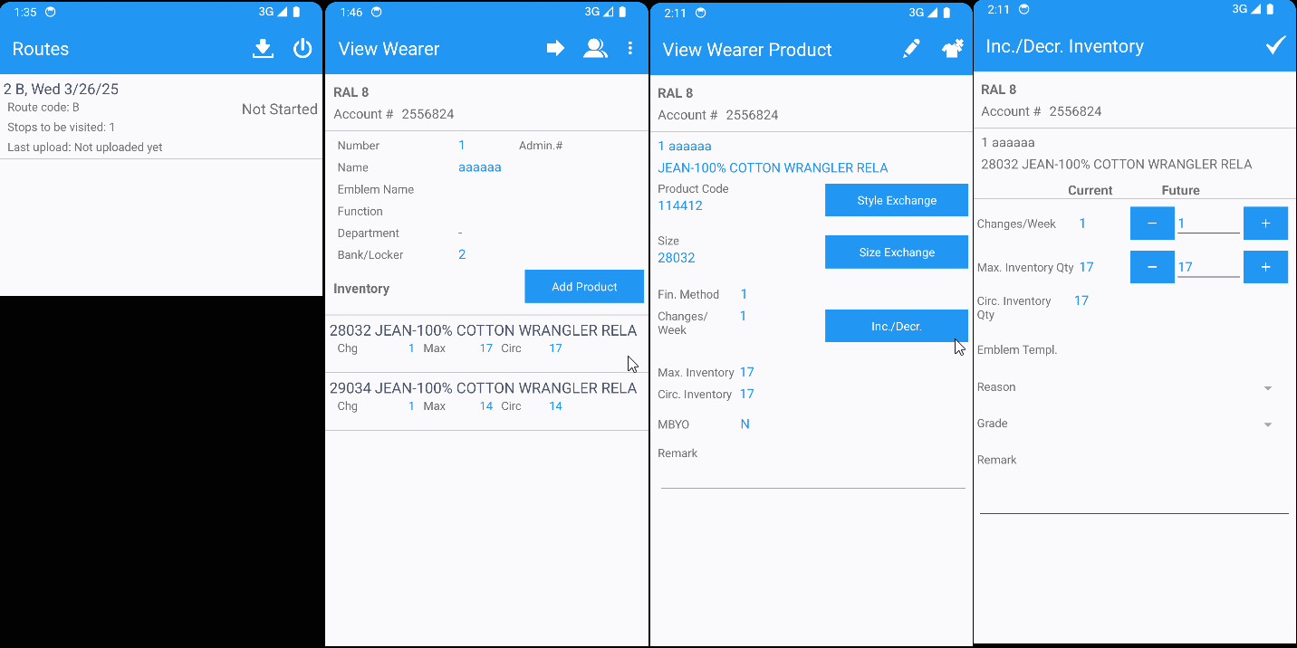
There is no button for linked functionality with UNFCUSTOM in the license.

TESTED OK.

Test Case 2 – Inc./Decr. Inventory screen without UNFCUSTOM in license

- RSC: Add a new route, generate the invoices and transfer them to PDA.
- RA: Open the route, go to Wearers, select a wearer inventory then go to Inc./Decr. Inventory
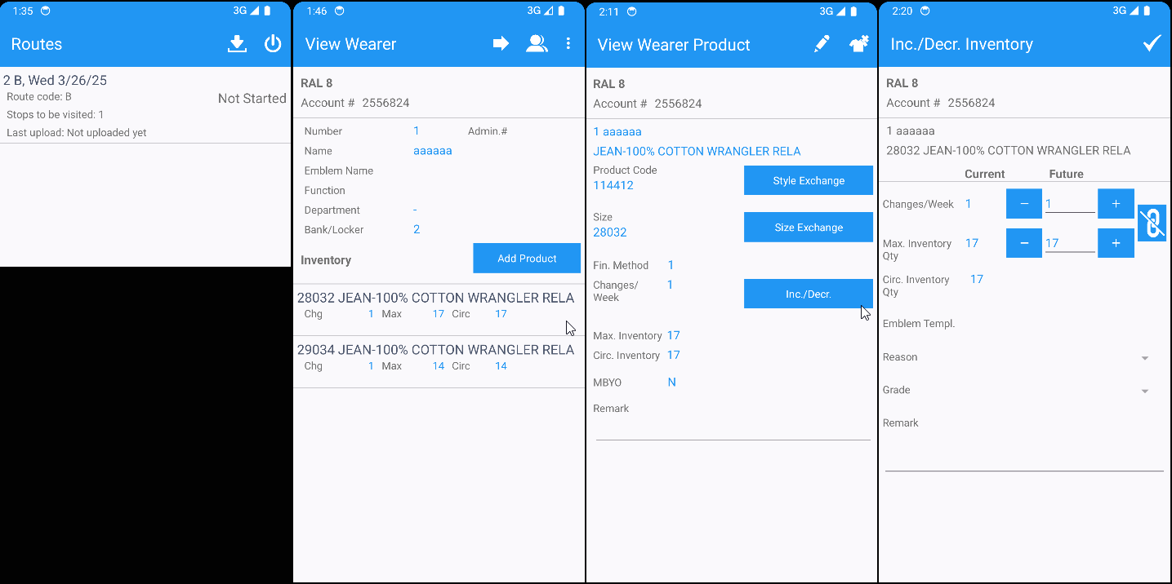
There is a button for linked functionality without UNFCUSTOM in the license.

TESTED OK.

