RASAN-236 Allow amount adjustments for lines without a quantity
Environment | Prerequisites
Version:9.07.00  DBServerName=abs-srv20.internal.abslbs.com  DBSID= CUST24  DBUser= UNFDEV  DBPassword= UNFDEV  Environment=Production | - Module:  - System setting

Contents
Reproducing before fix 1
Steps to reproduce 1
Expected behavior: 6
Retesting after fix 6
Test Case 1 – With UNFCUSTOM in the license 6
Expected behavior: 6
Steps to reproduce 6
Test Case 2 – Regression testing without UNFCUSTOM in the license 14
Steps to reproduce 14

Reproducing before fix
Hash: RouteAssistant_v12.39.INTERNAL_TEST_ONLY.0a43b291f.apk

Steps to reproduce
- Search for customer who previously had finance charges.
select ih.deltocustomernumber, ih.invoicenumber,il.code, il.* from invoiceline il
join invoicelinetype ilt on ilt.invoicelinetype_id = il.invoicelinetype_id
join invoiceheader ih on ih.invoiceheader_id = il.invoiceheader_id
where ilt.factorydescription like '%Finance charge%'
and ih.invoicebusinessunit_id = (select bu.businessunit_id from businessunit bu where bu.code = '091');
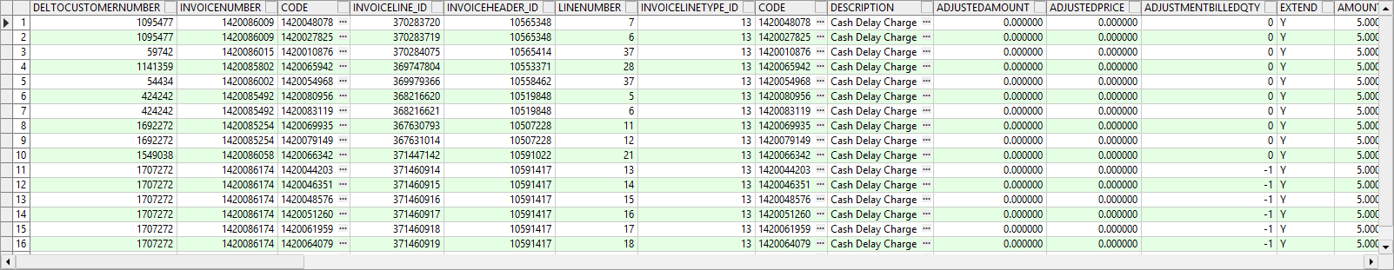
- Customers dlg: Open the first customer and check that it has special charges.
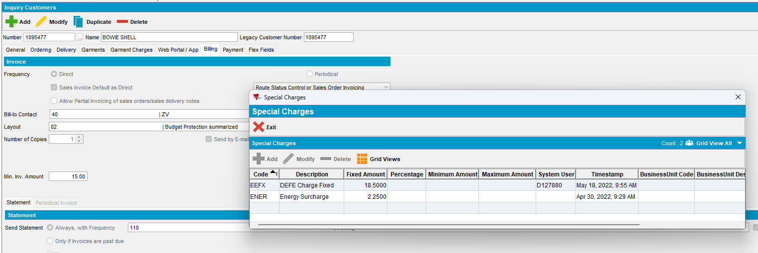
Also ad a percentage special charge.
- System Settings dlg: Change NOTINCONTRACTALLOWED to have default values and not fixed.
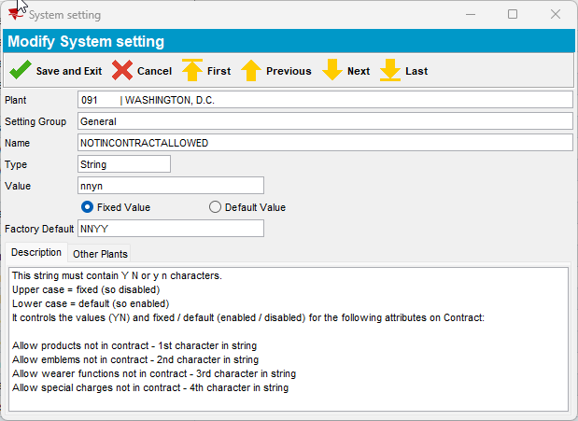
- Contract dlg: Add Allow Special Charges Not In Contract for the contract the customer is linked
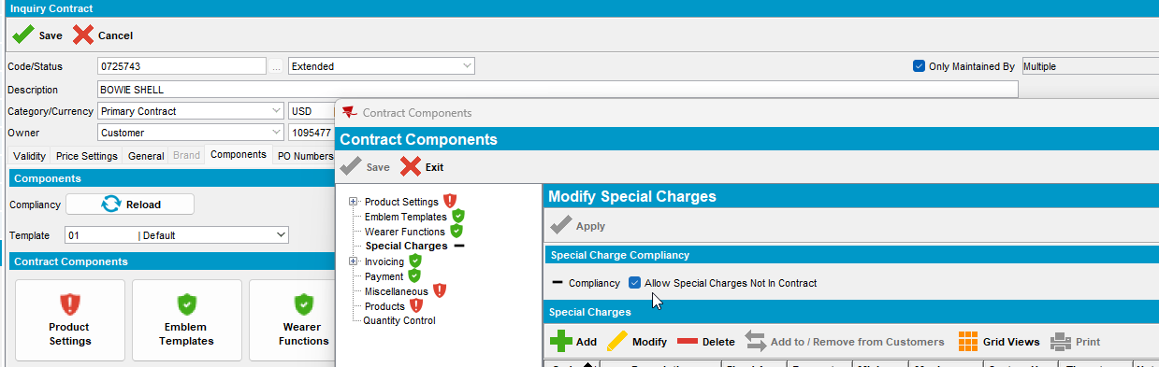

- Customers dlg: Add a percentage special charge
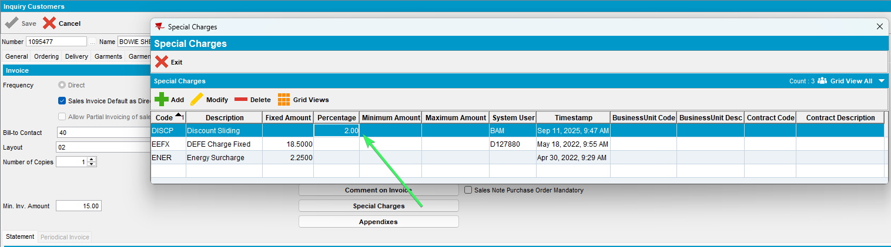

- Customers dlg: Make sure the customer has route assistant template
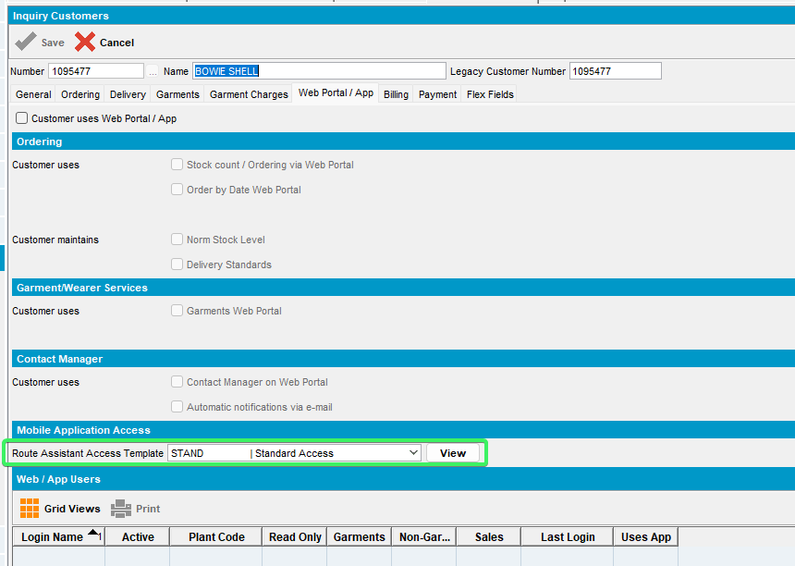
- Mobile application Access Template dlg: Open that template and make sure that invoice line adjust amount is added and disabled.
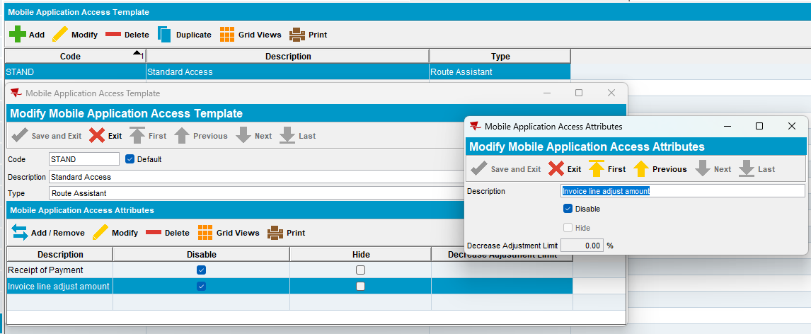
- Generate statements dlg: Start creating finance charges
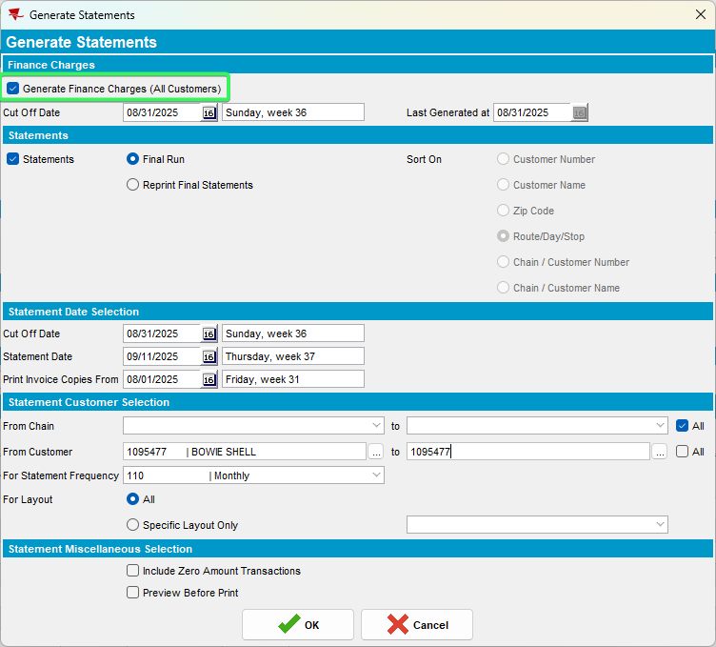
- Maintain Invoices dlg: Add a manual invoice for the customer when is visited next time, make sure you add the special charges.
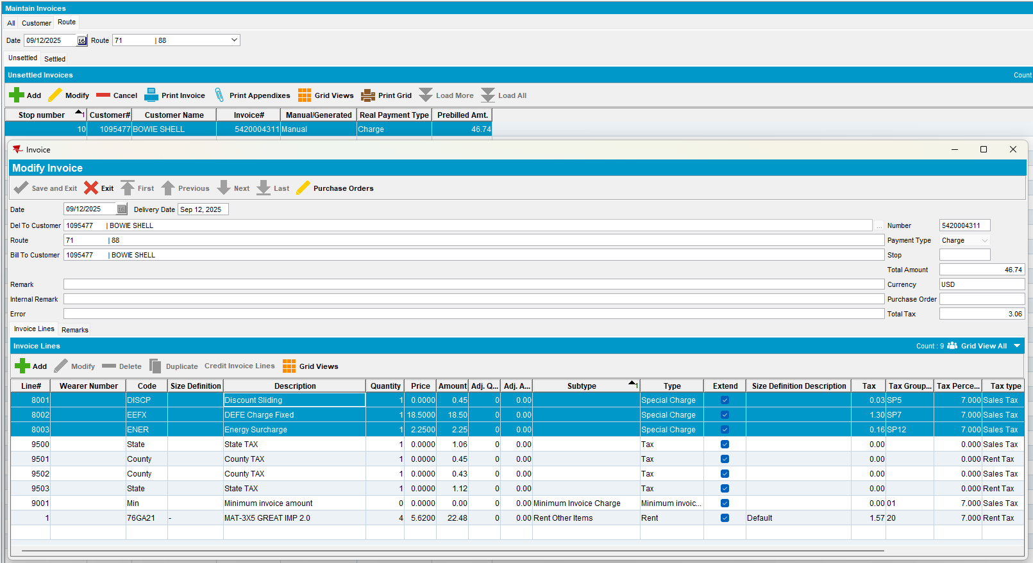
- RSC dlg: Generate put up documents and invoices for the route when the customer is visited.
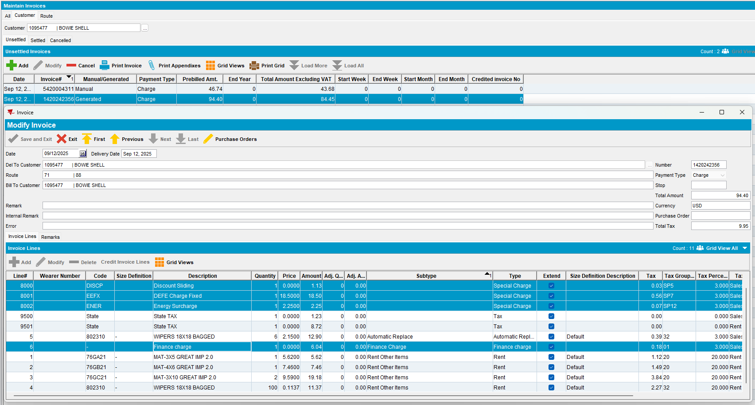
- RA: Send the route to PDA.
- RA: Download, arrive at the customer and adjust a special charge:
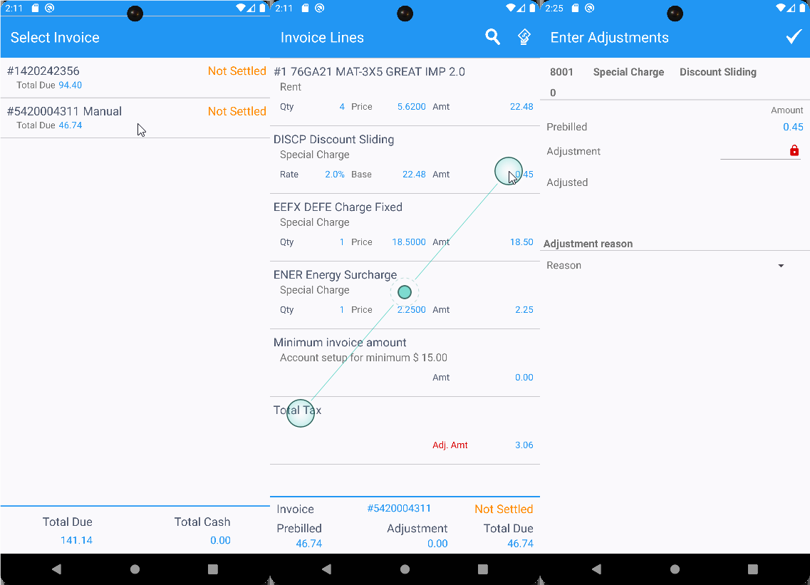
A finance charge
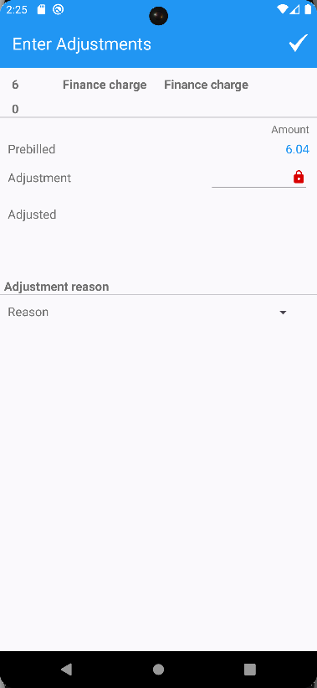

Expected behavior:
It is possible to adjust the total amount for a special charge & finance charge line even if this is being blocked by a mobile access template.
Reproduced OK

Retesting after fix
Hash: 9.09.03.RC1 hash: 6b7f753629ae + RouteAssistant_v13.28.INTERNAL_TEST_ONLY.880547e13

Expected behavior:
It is possible to adjust the total amount for a special charge & finance charge line even if this is being blocked by a mobile access template.

Steps to reproduce
- Search for customer who previously had finance charges.
select ih.deltocustomernumber, ih.invoicenumber,il.code, il.* from invoiceline il
join invoicelinetype ilt on ilt.invoicelinetype_id = il.invoicelinetype_id
join invoiceheader ih on ih.invoiceheader_id = il.invoiceheader_id
where ilt.factorydescription like '%Finance charge%'
and ih.invoicebusinessunit_id = (select bu.businessunit_id from businessunit bu where bu.code = '091');
- Customers dlg: Open the first customer and check that it has special charges.
Also ad a percentage special charge.
- System Settings dlg: Change NOTINCONTRACTALLOWED to have default values and not fixed.
- Contract dlg: Add Allow Special Charges Not In Contract for the contract the customer is linked

- Customers dlg: Add a percentage special charge

- Customers dlg: Make sure the customer has route assistant template
- Mobile application Access Template dlg: Open that template and make sure that invoice line adjust amount is added and disabled.
- Generate statements dlg: Start creating finance charges
- Maintain Invoices dlg: Add a manual invoice for the customer when is visited next time, make sure you add the special charges.
- RSC dlg: Generate put up documents and invoices for the route when the customer is visited.
- RA: Send the route to PDA.
- RA: Download, arrive at the customer and adjust a percentage special charge from manual invoice
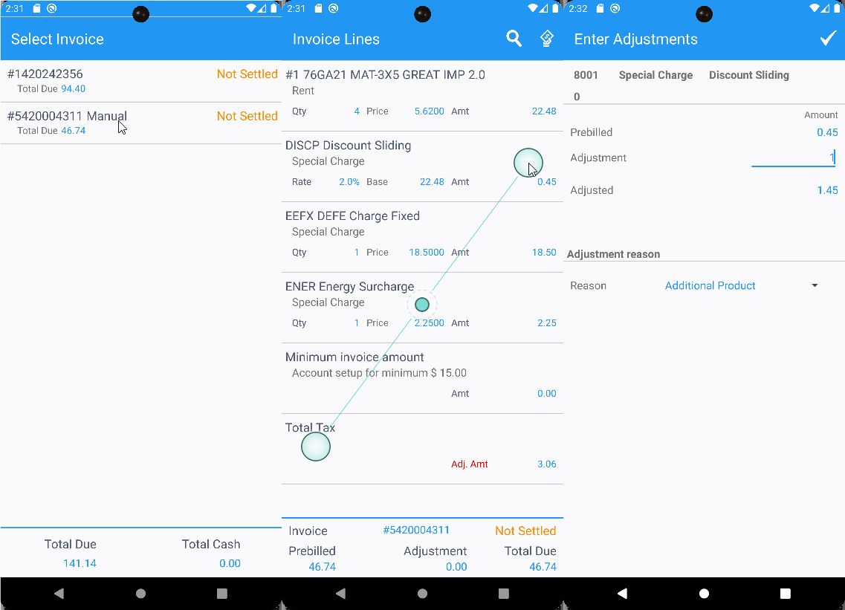
A fixed special charge
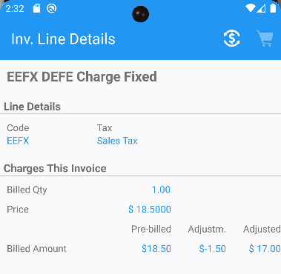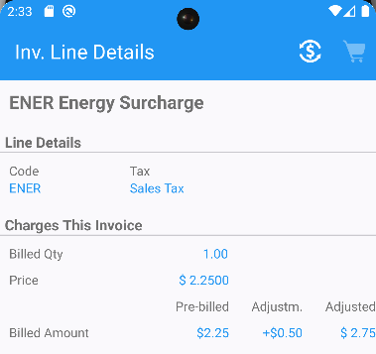
Minimum invoice amount is disabled
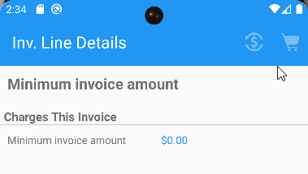

adjust from a generated invoice a:
- Percentage special charge
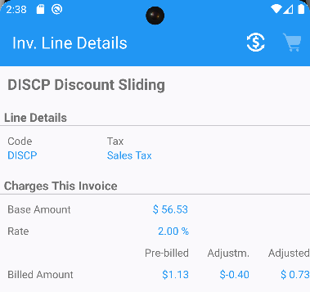
- Fixed special charge
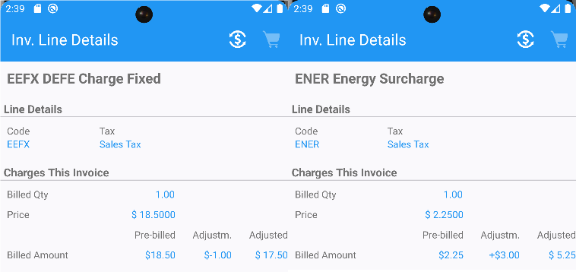
- Finance charge
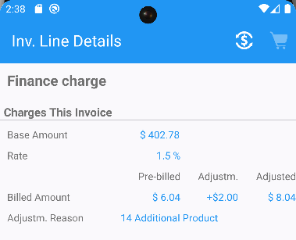
- RA: Settle the invoices and depart from customer. Finish and upload the route.
- WebX: Load the route, complete Start my Day.
- WebX: Approve all the invoice adjustments made on RA.
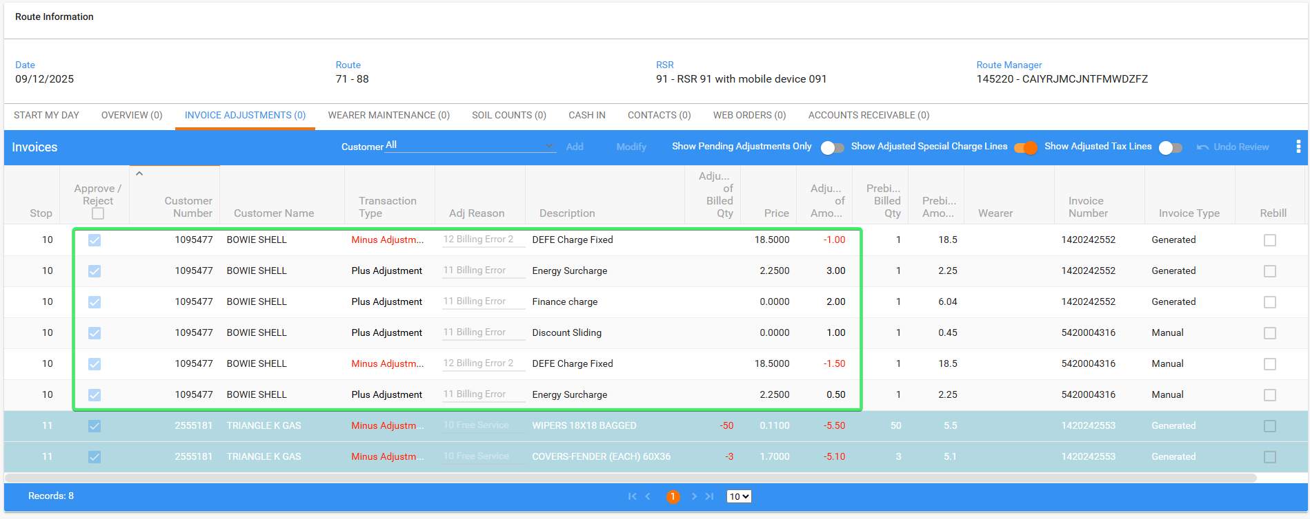
- WebX: Review everything and settle the route.
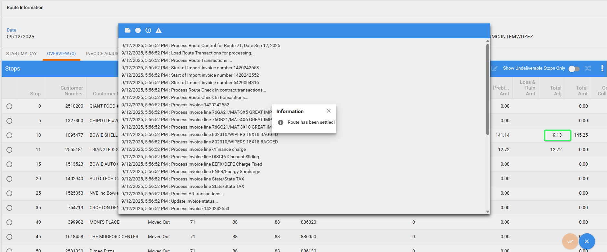
- Maintain Invoices dlg: Check the adjustments made on RA.
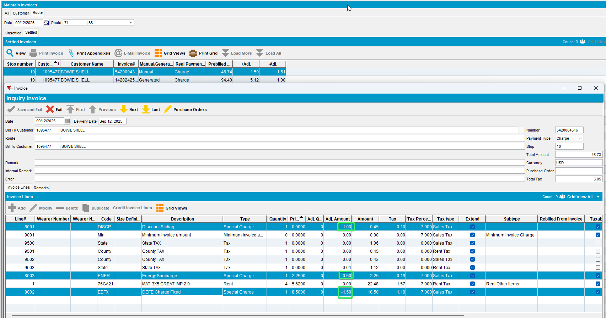
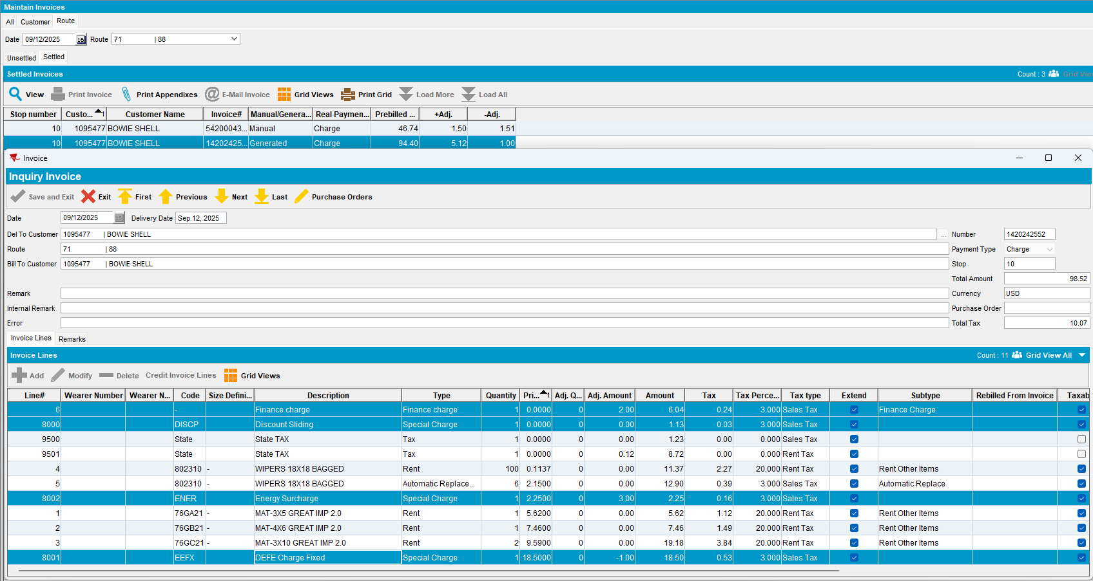

Tested OK

