RASAN-178 Remove entry of dollars for adjustments - RA modifications
Environment | Prerequisites
Version: 9.07.00.UNF17.p06 & RA v12.37  DBServerName=db01-buc.internal.abslbs.com  DBSID=CUST25  DBUser=UNFLIVE  DBPassword=UNFLIVE  Environment=Test | - Module:  - System setting

Contents
Reproducing before fix 1
Data preparation 1
Steps to reproduce 2
Current Behavior 4
Expected behavior 4
Retest after fix 4
Test Case 1 – Retest with v12.37 4

Reproducing before fix

Data preparation
- Mobile Application Template DLG: add Invoice line adjust amount element
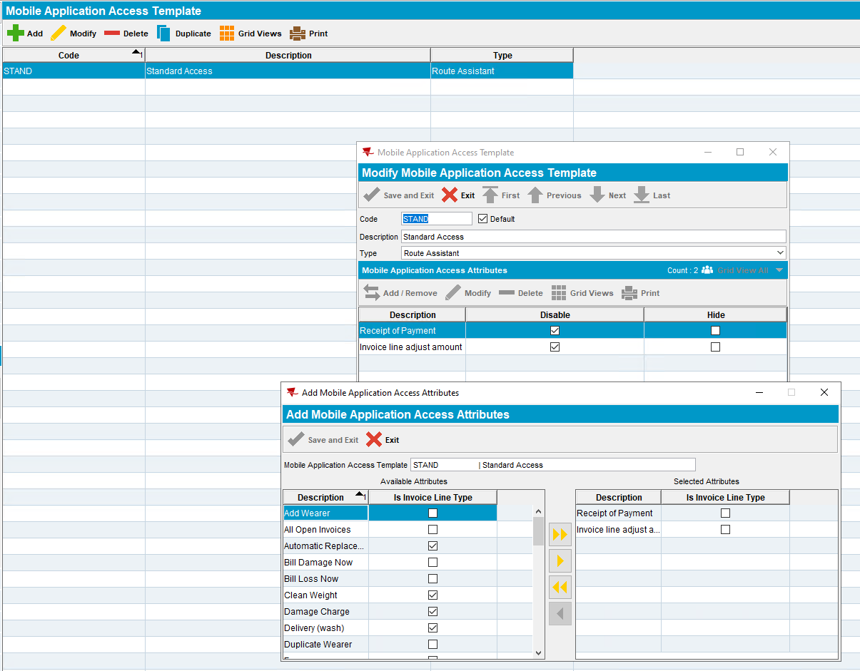

Steps to reproduce
- Make sure your customer has the Mobile Application Access Attribute
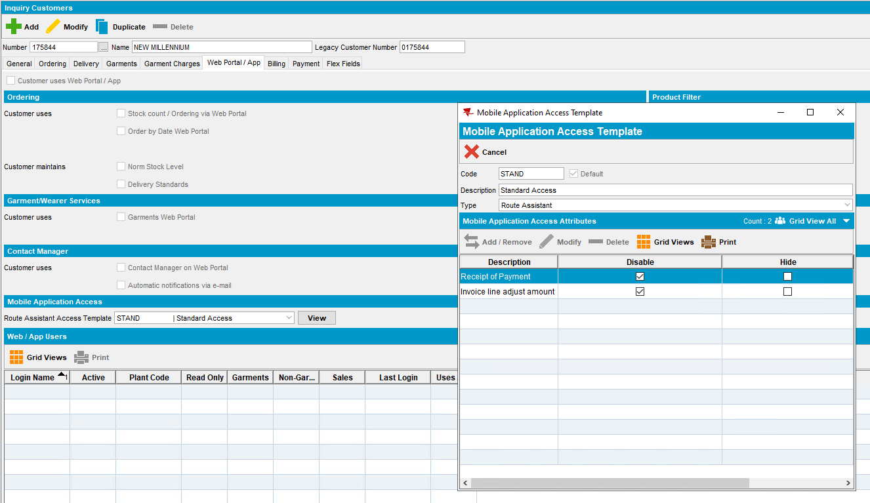
- Download a route on RA v12.36 with invoices.
- RA: Try to adjust the amount of one of the invoice lines
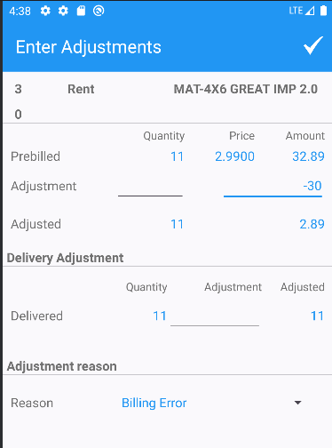
- RA: save your changes
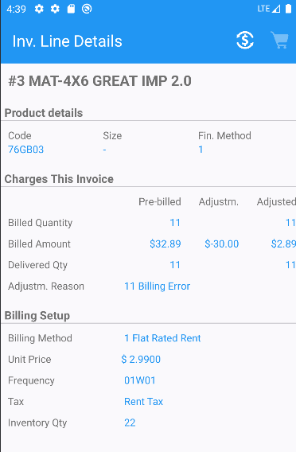
REPRODUCED OK.

Current Behavior
Although the user should not be able to adjust the amount on RA the user is allowed to.

Expected behavior
The user should not be able to adjust the amount on invoice lines on RA.

Retest after fix

Test Case 1 – Retest with v12.37
Expected behavior: The user should not be able to adjust the amount on invoice lines on RA.
- Install RouteAssistant_v12.37.INTERNAL_TEST_ONLY.3c4308d98.apk
- Re-download the same route from the reproduction test steps
- Go to the same customer and try to adjust the amount only
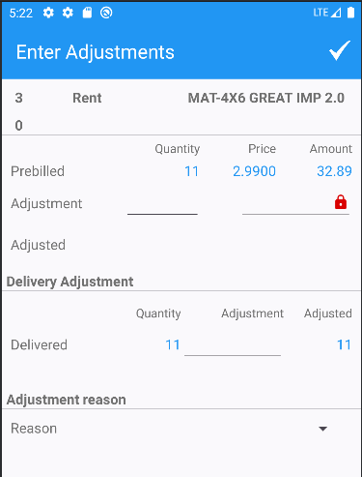
The amount field is disabled and there is a lock icon there.
- Try an adjustment on the quantity
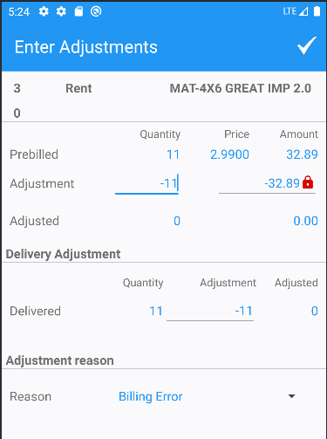
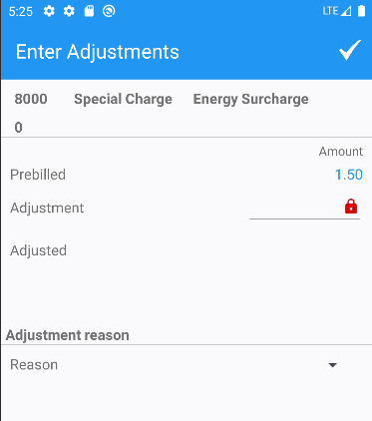
RETEST OK

