RASAN-111 - D_UBS_1991 Character limitation of adjustment line on RA
Environment | Prerequisites
Version: 9.07.00.UNF17 + RouteAssistant_v12.37  DBServerName= abs-srv20.internal.abslbs.com  DBSID=CUST24  DBUser=UNFDEV  DBPassword= UNFDEV  Environment=Test | - Module:  - System setting

Contents
Retest after fix 1
Test Case 1 – Check that it is possible to write in the adjustment field the prebilledQty + characters 1

Retest after fix

Test Case 1 – Check that it is possible to write in the adjustment field the prebilledQty + characters
Expected behavior: It is possible to write in adjustmentQty field only prebilledQty.length + 1 characters.
example:
if prebilledQty = 5 then adjustmentQty can be -5 or -9 or 99, all these have 2 characters

Hash: e7d86a841
- Find a customer which has Product Bagged Wipers
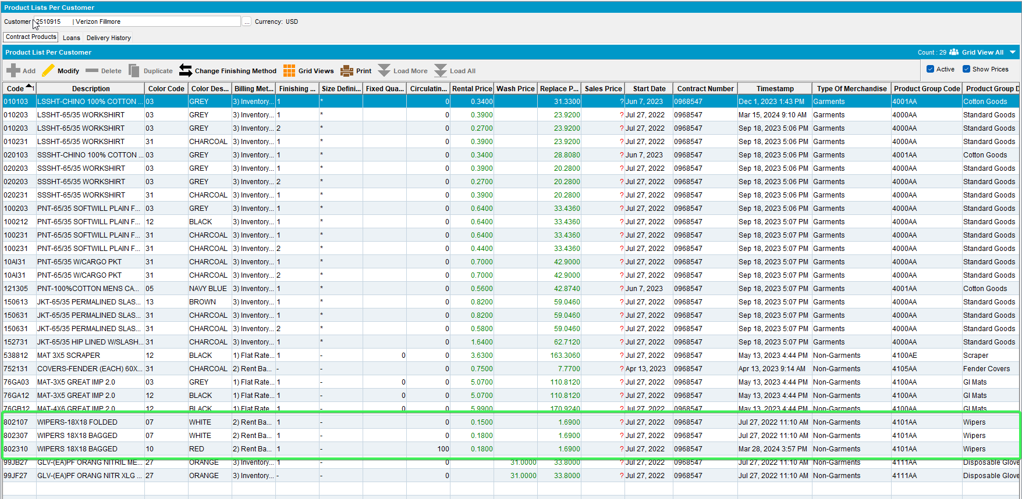
- RSC: Create a new route with that customer on it
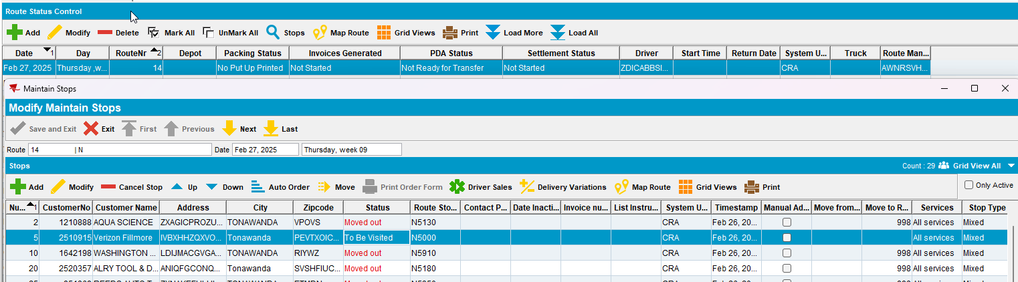
- Maintain Invoices: Route > Select the date and route
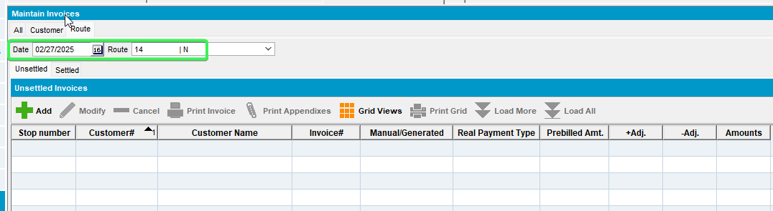
- Add a new manual invoice to your customer
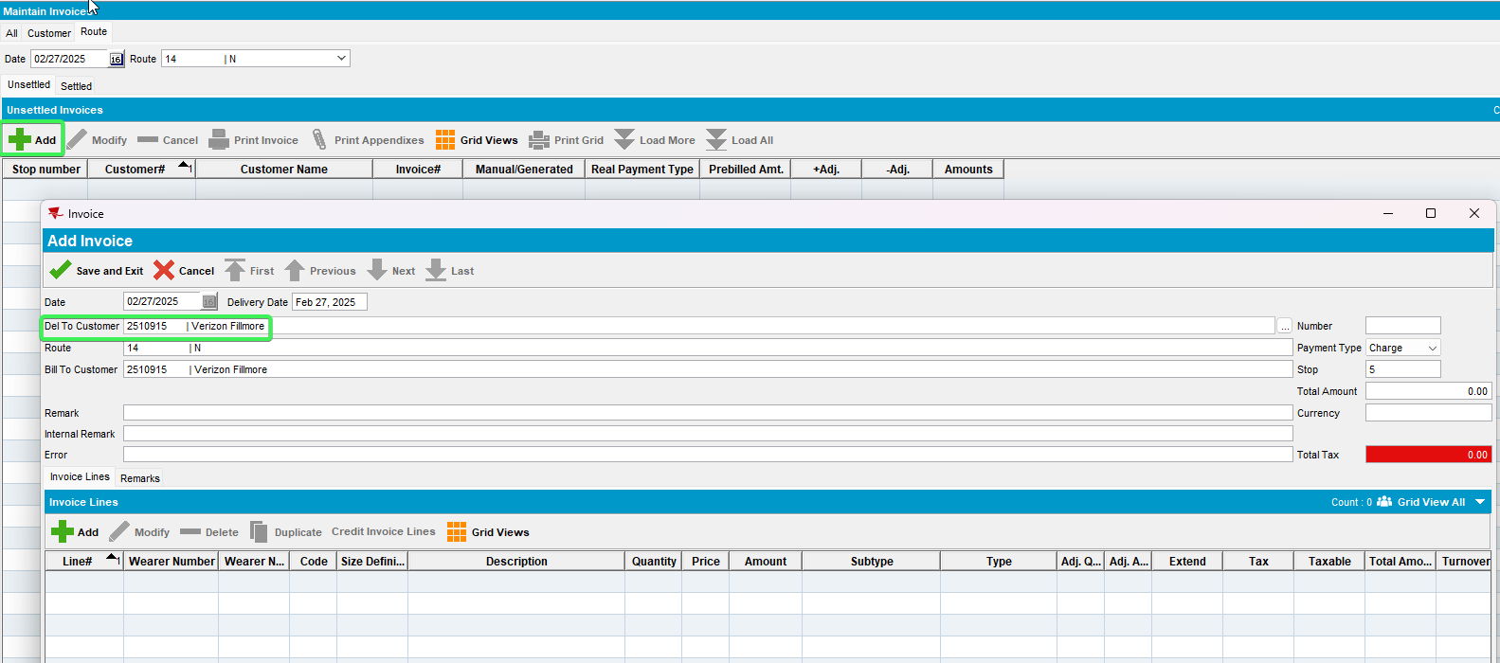
- Add product Bagged Wipers, Line type Rent and a quantity of 5 + characters
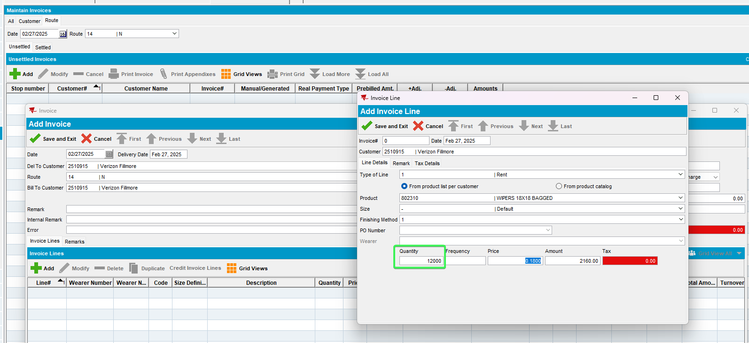
- RSC: Generate invoices and script taxes for your route
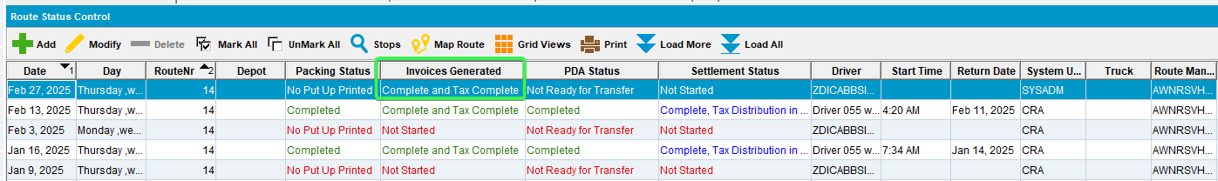
- Set the route as Ready to Transfer to PDA
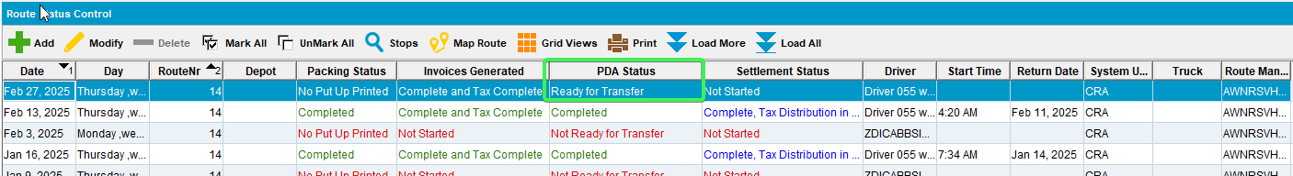
- Download the route to PDA
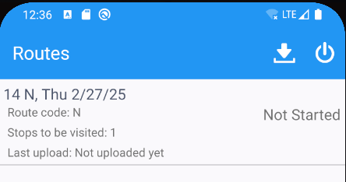
- Arrive at your customer > Adjust tab
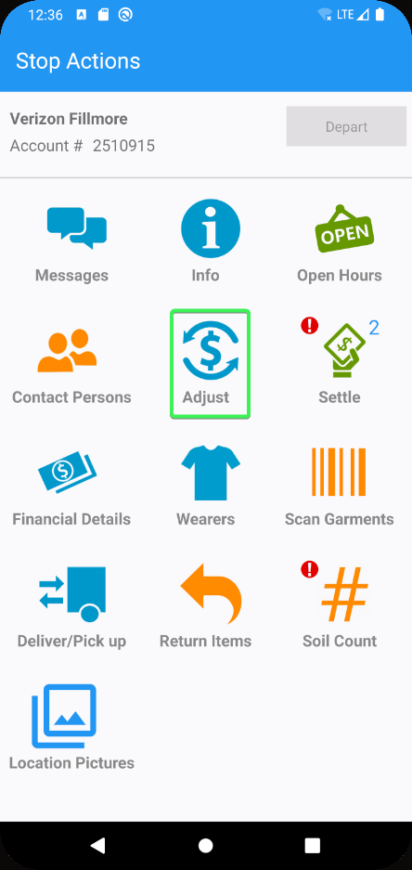
- Select the Manual invoice > View lines
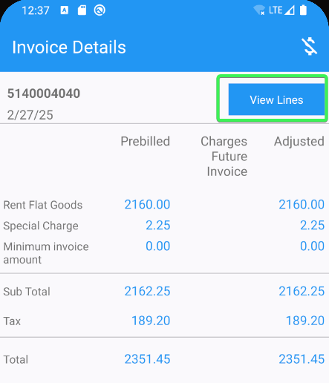
- Adjust the Bagged Wipers line you created with a Quantity of 5+ characters
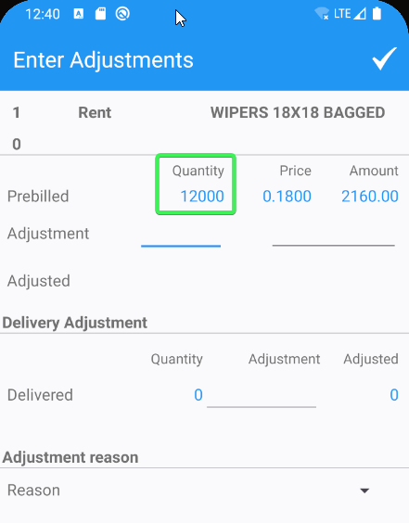
- Check that you can adjust the Quantity field with a value that consists of 6 characters including “-“
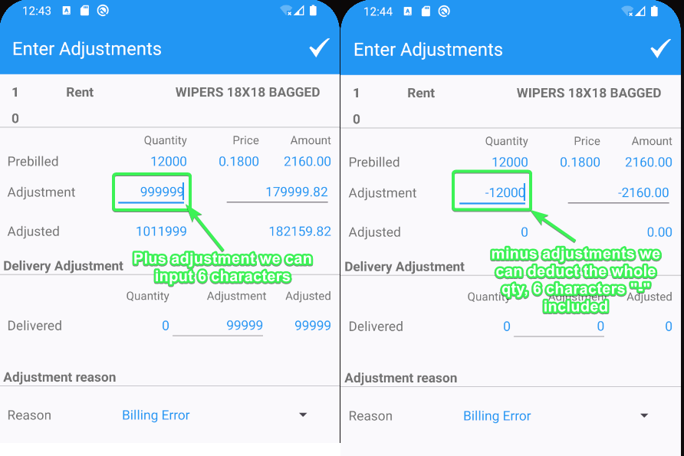
Tested OK

