RASAN-108 - D_UBS_2039 Unable to scan garments for quit wearer
Environment | Prerequisites
Version: 9.07.00.UNF17 + RouteAssistant_v12.37  DBServerName= abs-srv20.internal.abslbs.com  DBSID=CUST24  DBUser=UNFDEV  DBPassword= UNFDEV  Environment=Test | - Module:  - System setting

Contents
Retest after fix 1
Test Case 1 – Scanning garments for 2 different customers (Quit wearer action) 1

Retest after fix

Test Case 1 – Scanning garments for 2 different customers (Quit wearer action)
Hash: e7d86a841
- Customer dlg – Make sure you will visit on the same route two different customers having the following particularities:
- one will be charged for Loss Charges
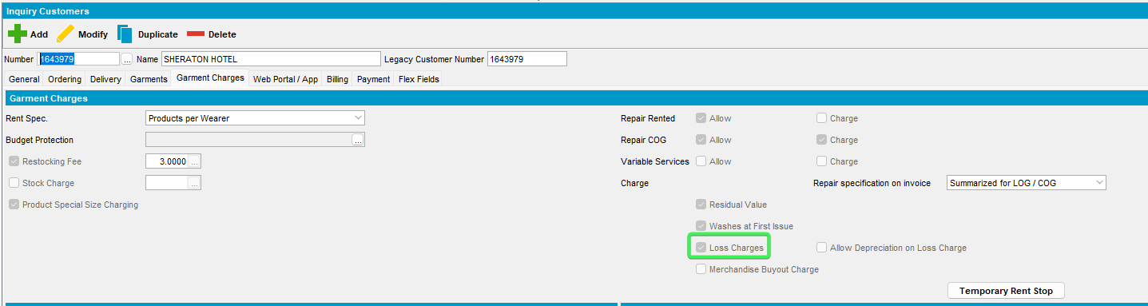
- the other will not be charged for Loss Charges
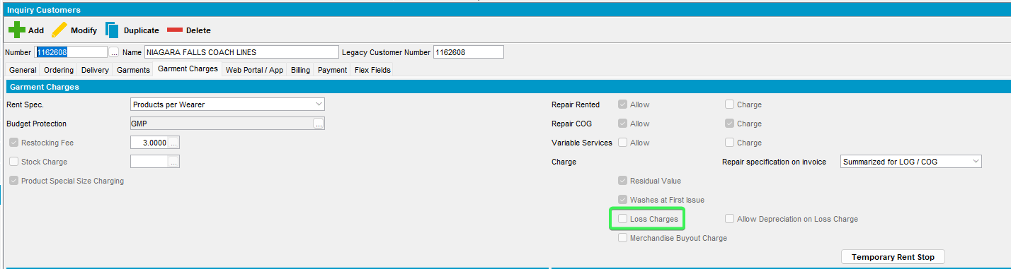
- Route Status Control dlg: Create a new route and generate the direct invoices.
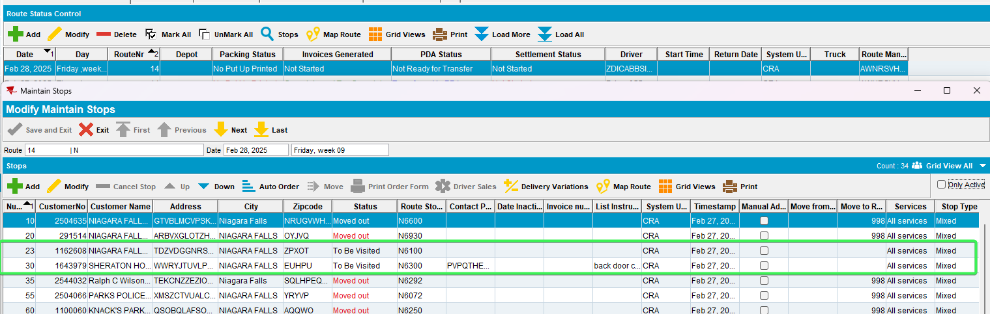
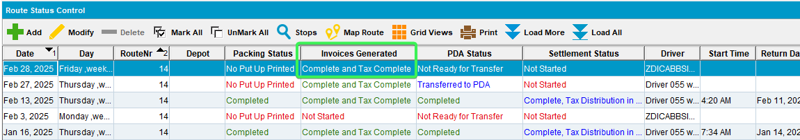
- Send the route to PDA.
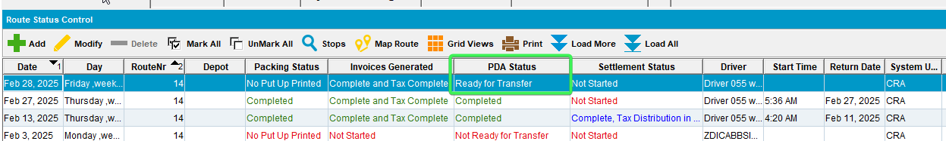
- Load the new route to PDA.
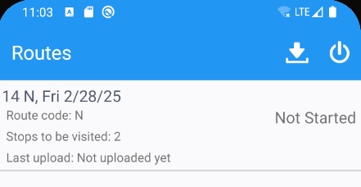
- Go and visit the first stop (the one who is not charged for loss)
- Go to Wearers screen – Quit a wearer
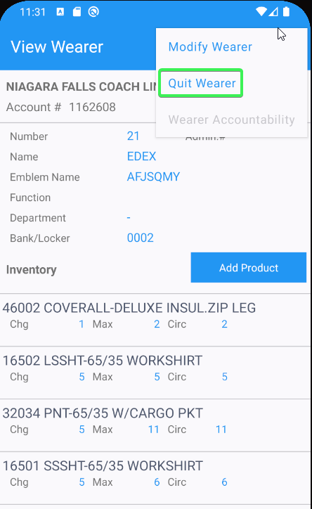
- Go to Return Items screen – Check if the “Scan Returns” is enabled.
Expected result – Scan Returns should be enabled.
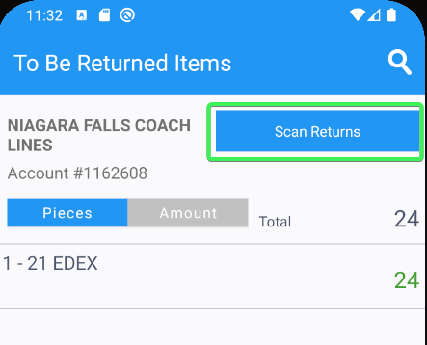
- On the same screen – check if you can navigate between the tabs Pieces and Amount.
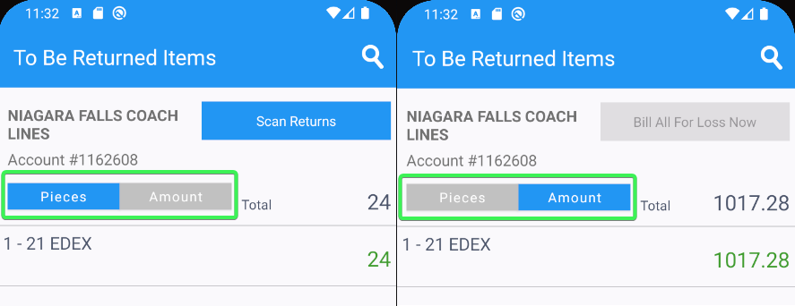
- When the user switched to Amount, check if the “Bill All For Loss Now” button is disabled
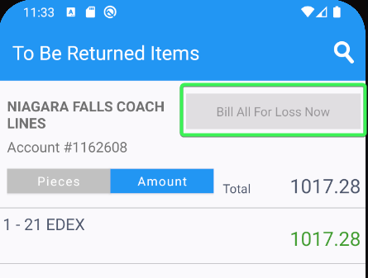
- Switch back to Pieces tab and scan a garment – via Scan Returns screen
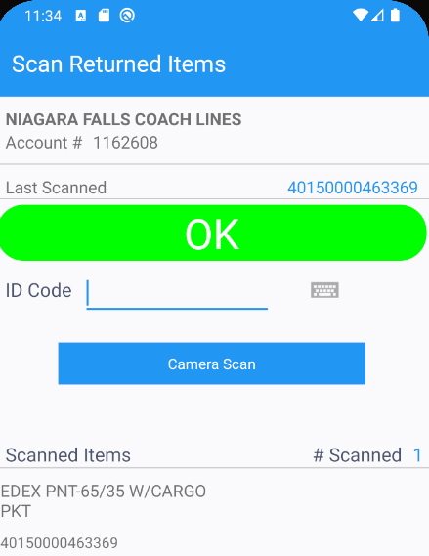
- Exit the screen and go back to the main screen.
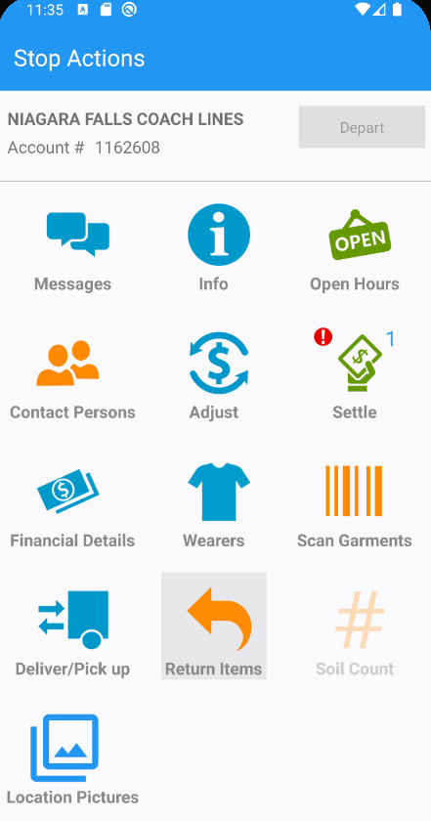
- Enter the Return Items screen again – switch from Pieces to Amount tab – Check again if Bill All For Loss Now is disabled.
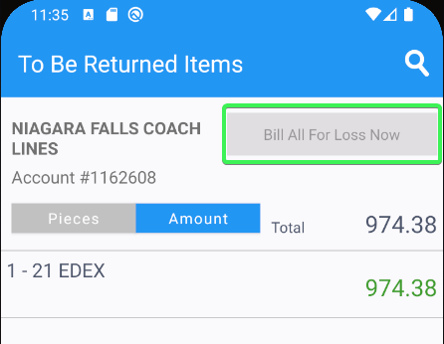
- Switch back to Pieces tab and try to undo the previous scan action.
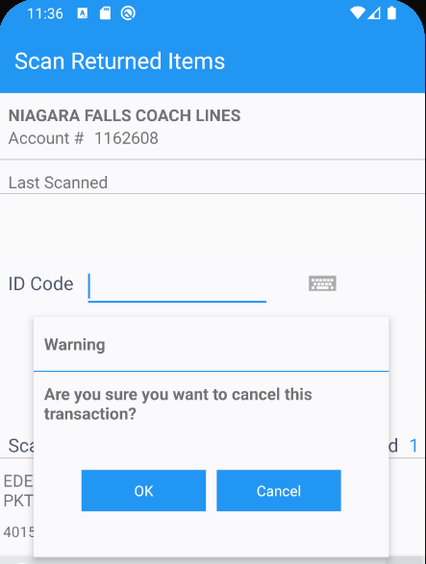
- Settle the stop and depart.
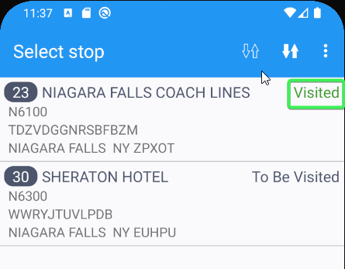
- Arrive at the next customer (the one who is set to be charged for Loss). Afterwards go to Wearers screen and quit the wearer
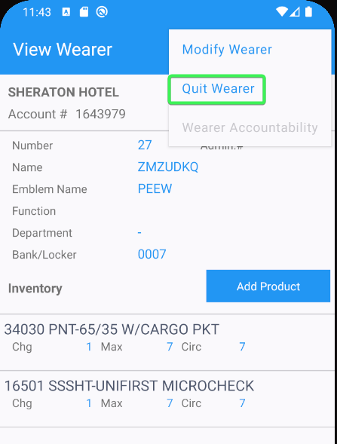
- Go to Return Items screen – Check if the Scan Returns button is enabled. Scan an item.
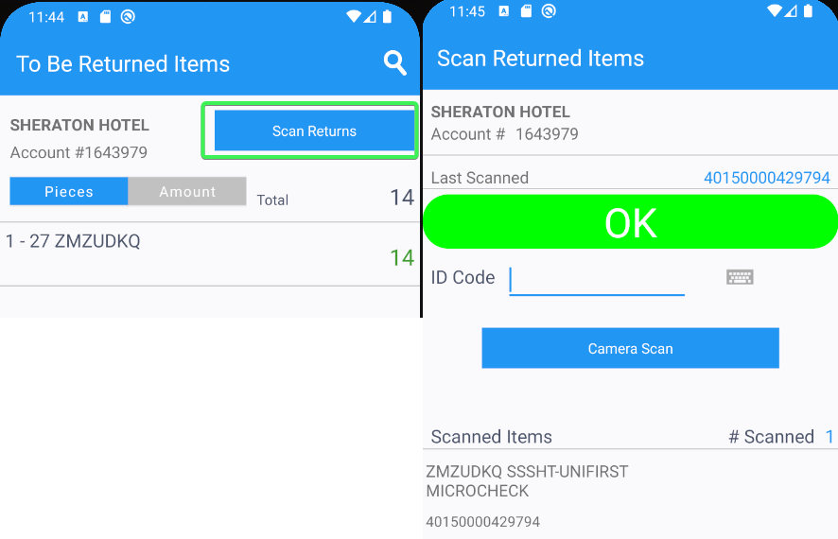
- Switch from Pieces to Amount tab and check if Bill All For Loss Now button is enabled (should be enabled). Press it.
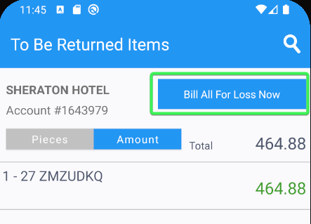
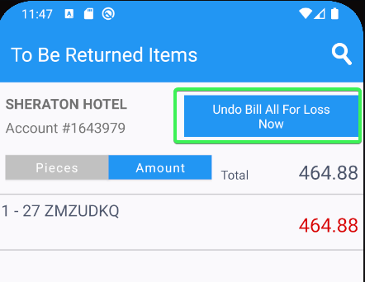
- Exit the Return Items screen and go back to the main screen.
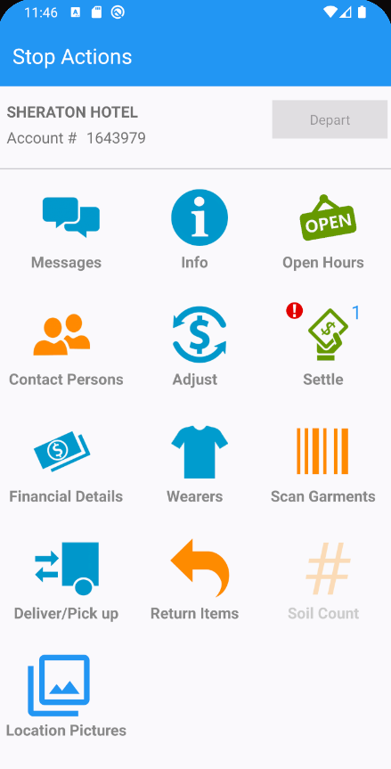
- Go to Return Items screen and try to undo the Bill All For Loss Now action
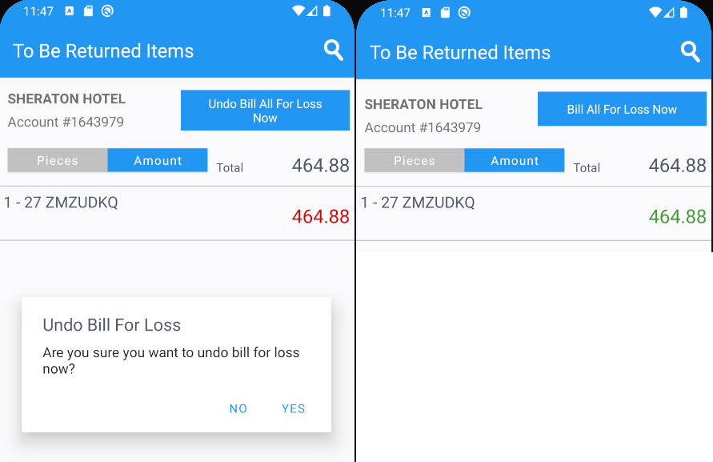
- Now press the Bill All for Loss Now button
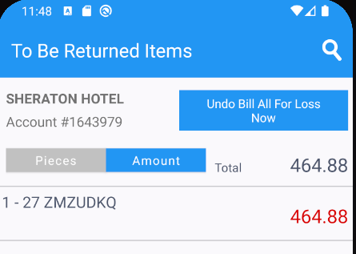
- Settle the stop, depart, finish and upload the route.
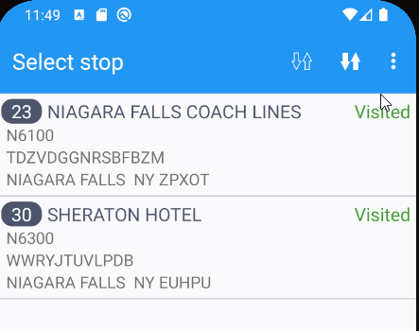
- Check the logs.
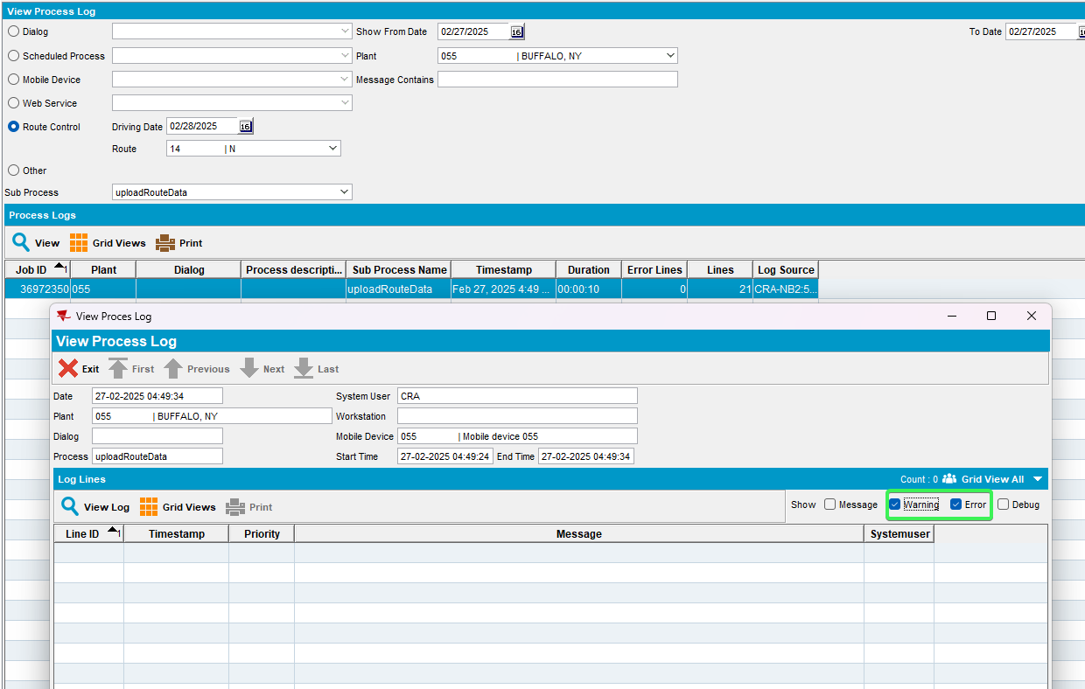
Tested OK

