RASA-4478 Two buttons in scan item -> replacement remark are not available
Environment | Prerequisites
Version:9.07.00  DBServerName=abs-SRV20.internal.abslbs.com  DBSID=CUST24  DBUser=UNFDEV  DBPassword=UNFDEV  Environment=Test | - Module:  - System setting

Contents
Test after fix 1
Test Case 1 – Scan for replace – Tested OK 1

Test after fix

Test Case 1 – Scan for replace – Tested OK
Expected behavior: “OK” and “Cancel” buttons are now visible when scan an ID from “Scan Garment” -> “Replace” – Replacement Remark window.
Hash: 51d4689
- Have a customer that has emblem templates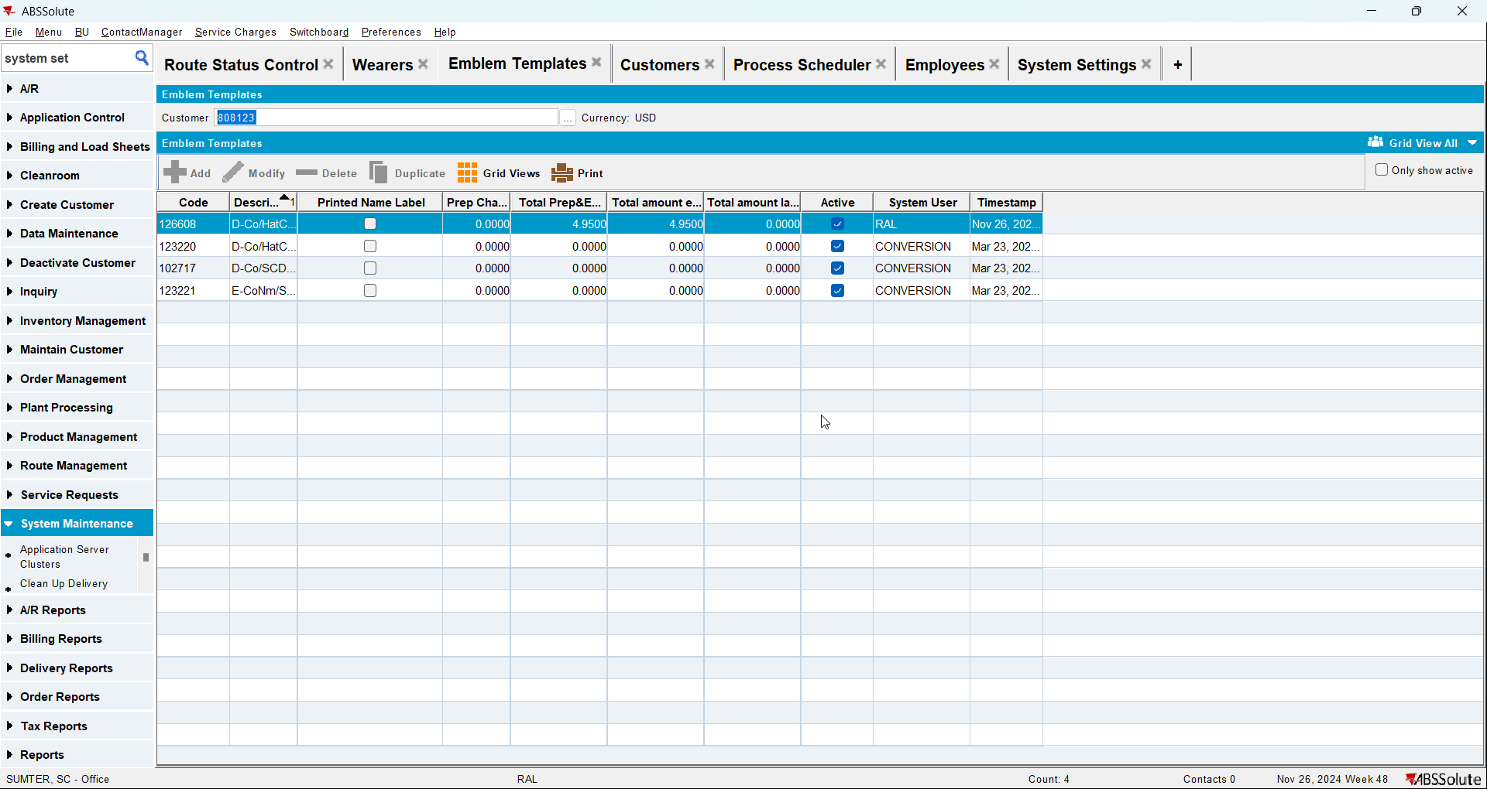
- Add the route for your customer
- Generate packing notes, invoices and mark the route ready for transfer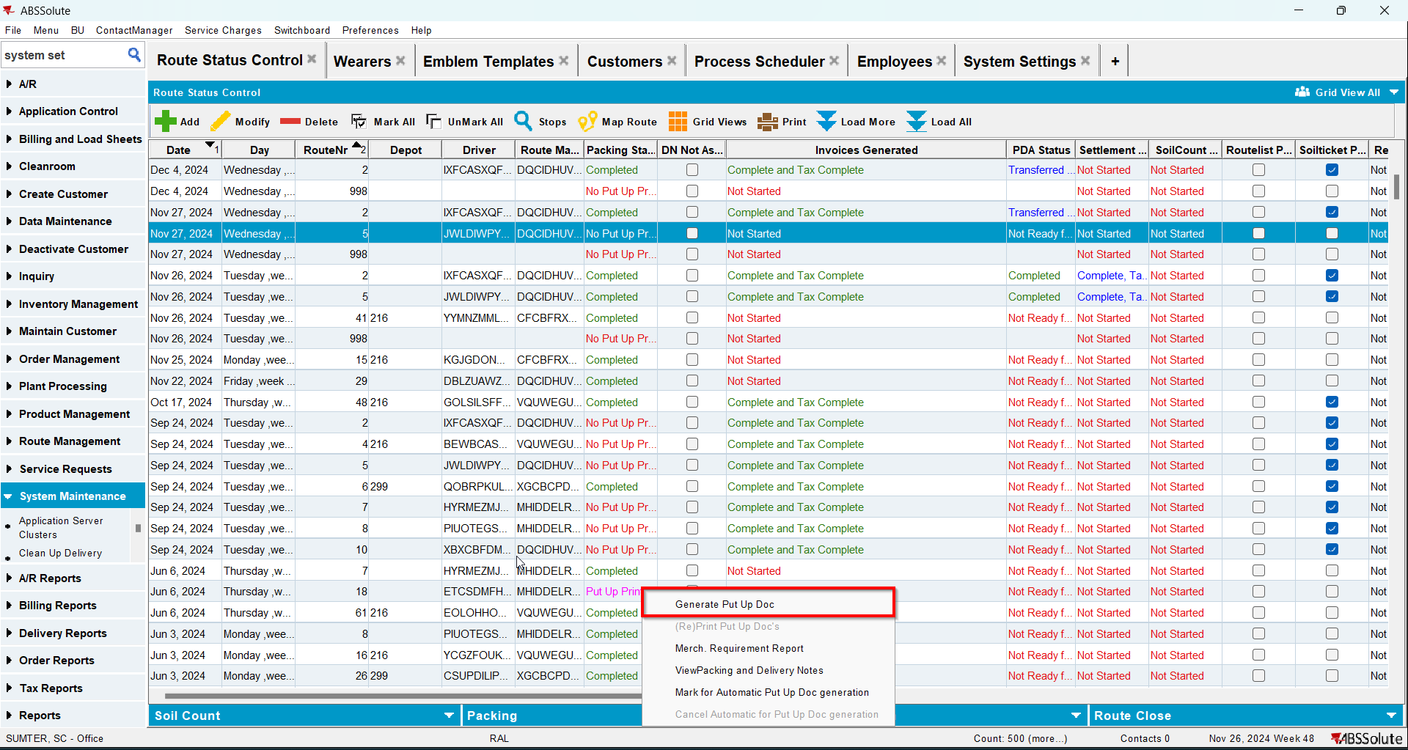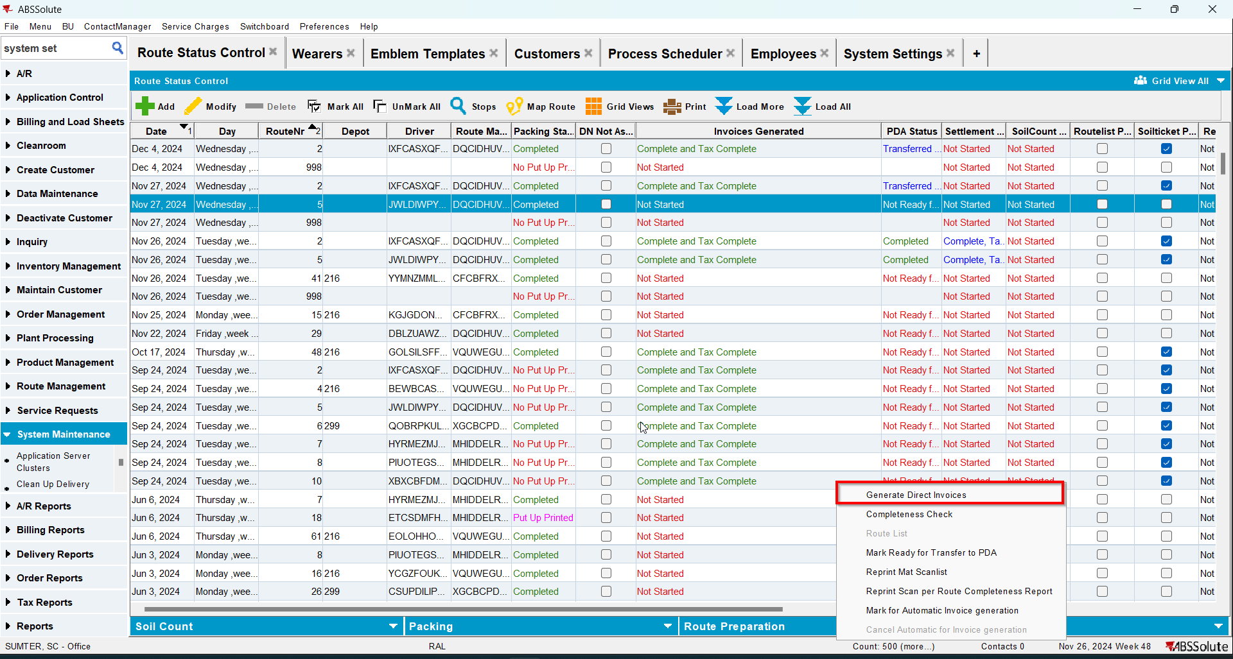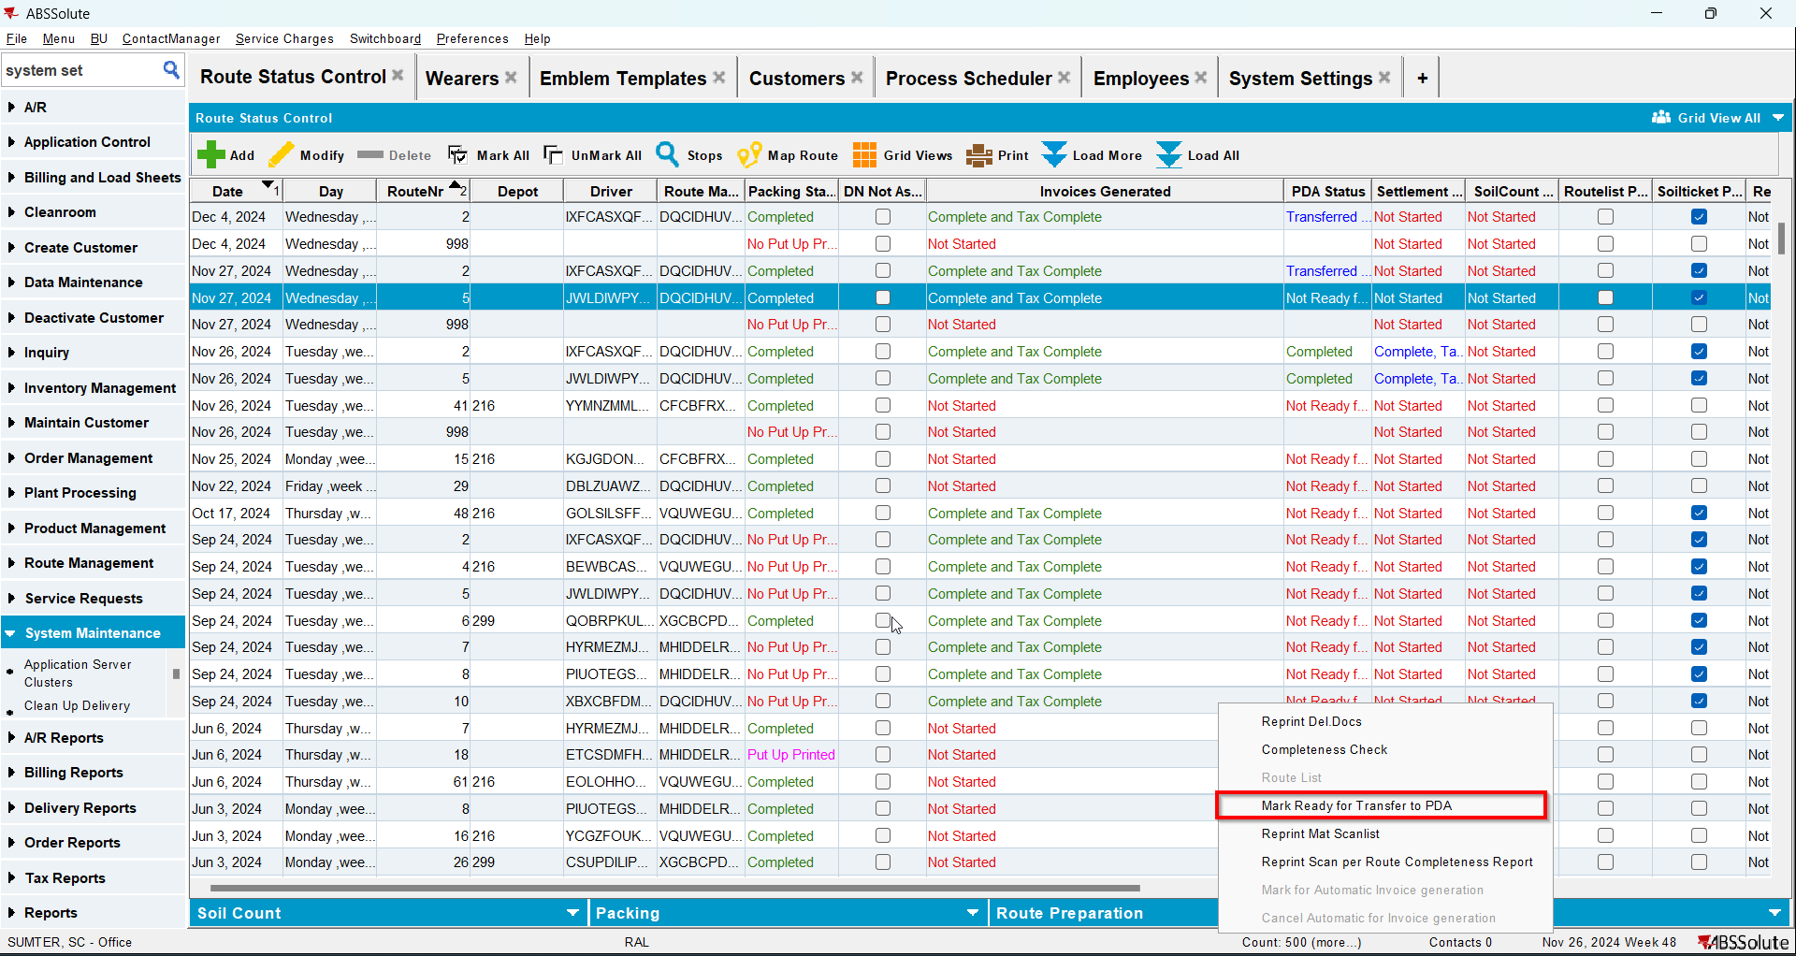
- On RA go to Scan garment and scan for replace a garment