ABS-00000 Issue summary here
Environment | Prerequisites
Version:9.03.00  DBServerName=abs-srv8.abs.ro  DBSID=ABSS  DBUser=QFTDEMOEU  DBPassword=QFTDEMOEU  Environment=QFT | - Module:  - System setting

Contents
Retest after fix 1
Test Case 1 – 701 Minus Adjustment to a Finance Charge– Tested OK 1
Test Case 2 – Short Description – Tested NOT OK 3

Retest after fix

Test Case 1 – 701 Minus Adjustment to a Finance Charge vs 9.07.00.UNF10.p03
Expected behavior: Finance Charge can be adjusted on RA and the adjustment is applied correctly on the invoice on upload
Hash: 9.07.00.UNF10.p03 + RouteAssistant_v12.34.INTERNAL_TEST_ONLY.0f371a71.apk
- Invoice Settings per Plant: Make sure you have Finance Charge percentage set at the plant level
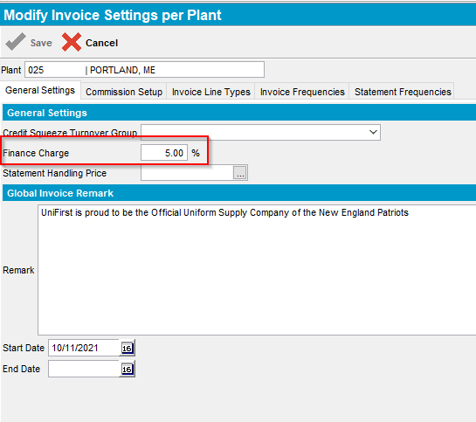
- Generate Finance Charges
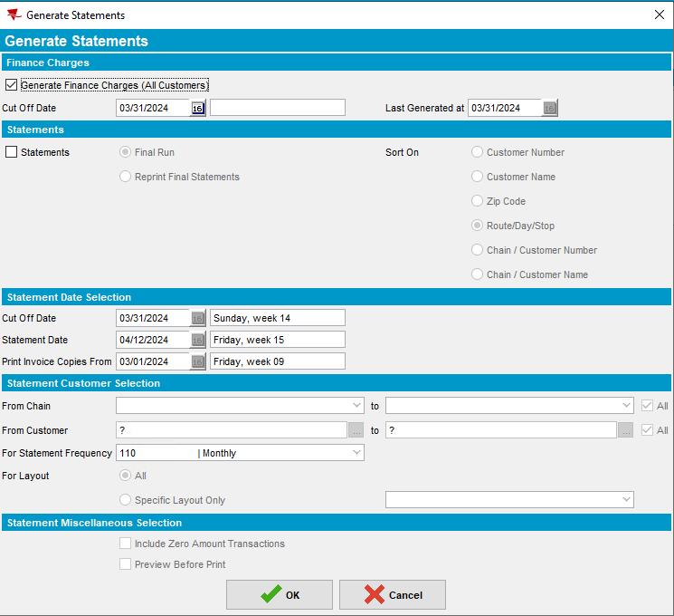
- Use the following query to find customers that have pending Finance Charges on your BU:
select c.customernumber, f.amountdue, f.* from financecharge f
join customer c on c.customer_id = f.customer_link_id
join businessunit bu on bu.businessunit_id = c.defaultbusinessunit_id
where bu.code = '025';
- Select one of the customers with DATEPROCESSED = ‘12/31/2099’
- Go to Customers DLG and load the customer to find route/stop
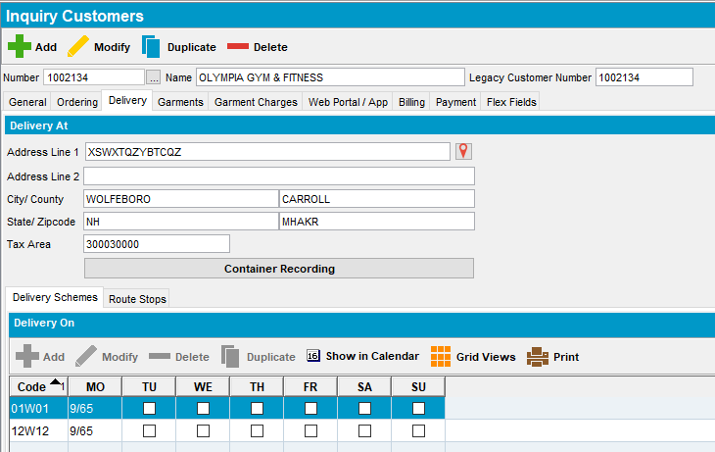
- RSC DLG: Add a new RC for the customer and generate invoices
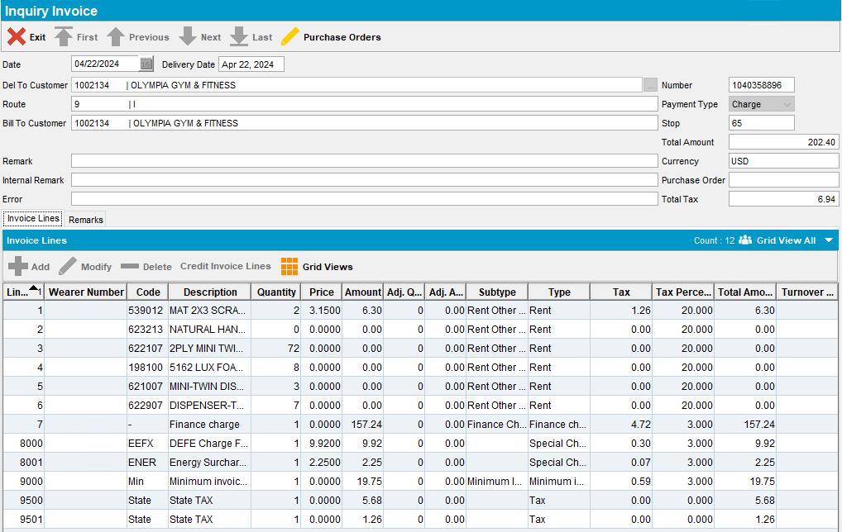
- Send route to RA
- RA: Go to Adjust screen
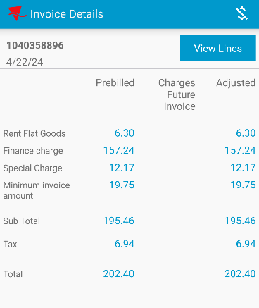
- Go to Invoice Lines and adjust the Finance Charge line
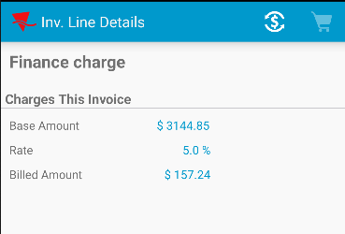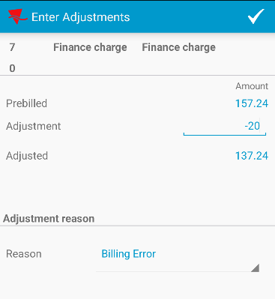
- Press the check mark button to save your changes
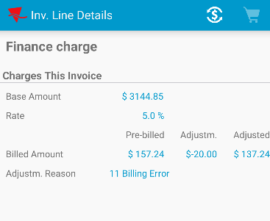
- Back out and click on the invoice line again
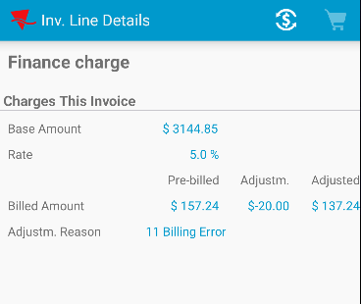
- Make other adjustments and backout
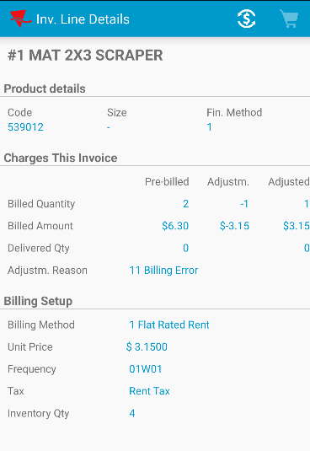
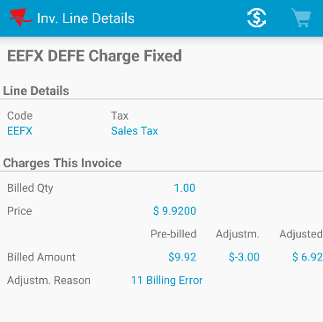
- Finish and upload the route data
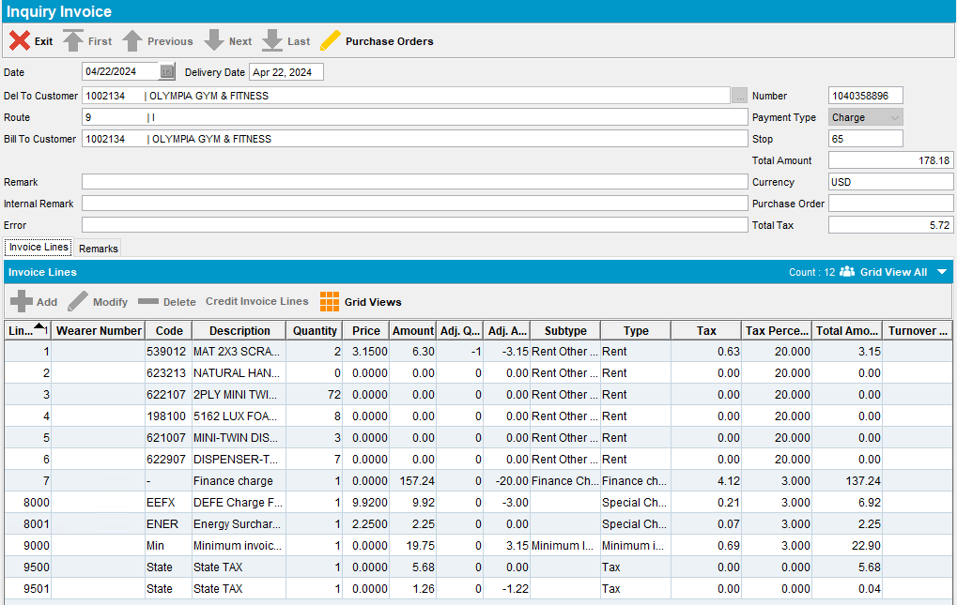
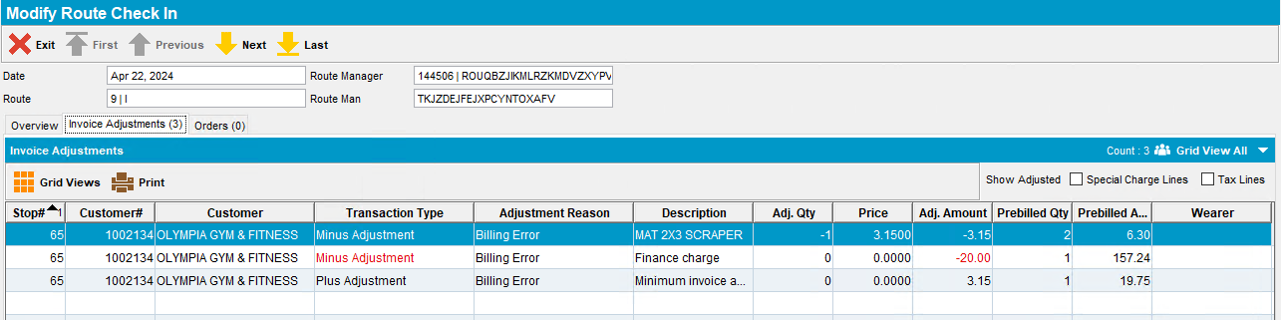
- WebX: Check that the Finance Charge Invoice Adjustment is displayed
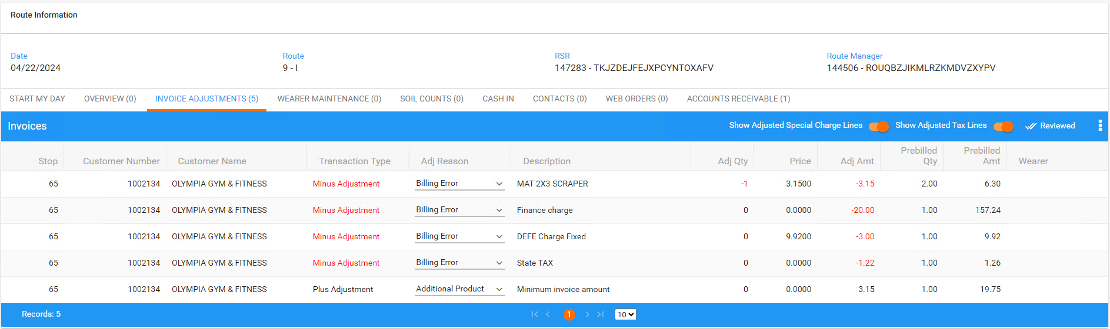
- Settle the route and make sure there are no errors
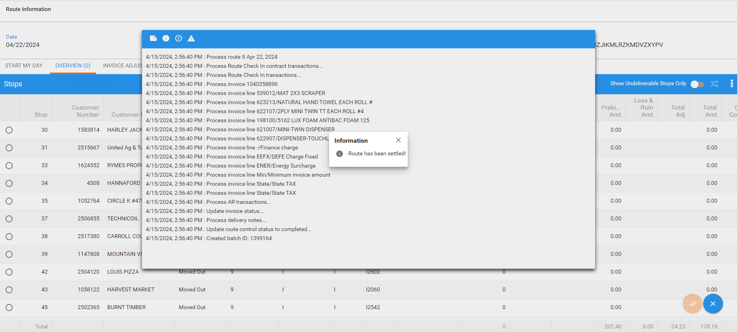
- Check that the invoice looks ok after tax distribution
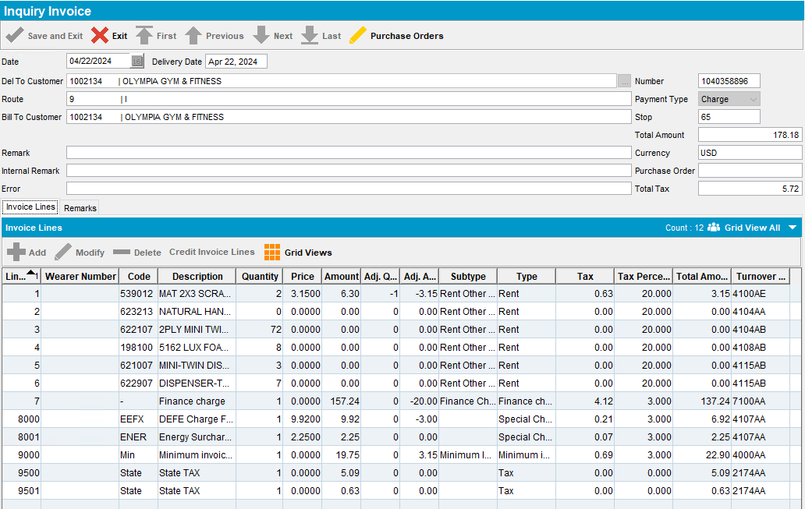
Tested OK

Test Case 2 – 702 Plus Adjustment to a Finance Charge vs 9.07.00.UNF10.p03
Expected behavior: Finance Charge can be adjusted on RA and the adjustment is applied correctly on the invoice on upload
Hash: 9.07.00.UNF10.p03 + RouteAssistant_v12.34.INTERNAL_TEST_ONLY.0f371a71.apk
- Invoice Settings per Plant: Make sure you have Finance Charge percentage set at the plant level
- Generate Finance Charges
- Use the following query to find customers that have pending Finance Charges on your BU:
select c.customernumber, f.amountdue, f.* from financecharge f
join customer c on c.customer_id = f.customer_link_id
join businessunit bu on bu.businessunit_id = c.defaultbusinessunit_id
where bu.code = '025';
- Select one of the customers with DATEPROCESSED = ‘12/31/2099’
- Go to Customers DLG and load the customer to find route/stop
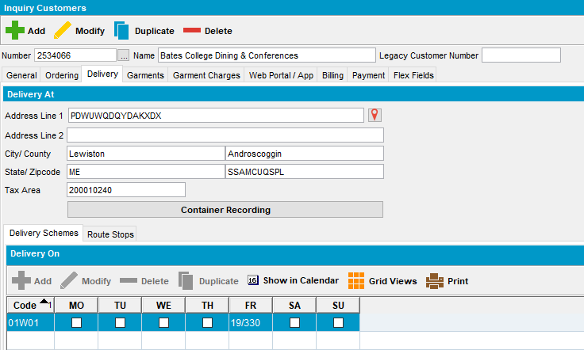
- RSC DLG: Add a new RC for the customer and generate invoices
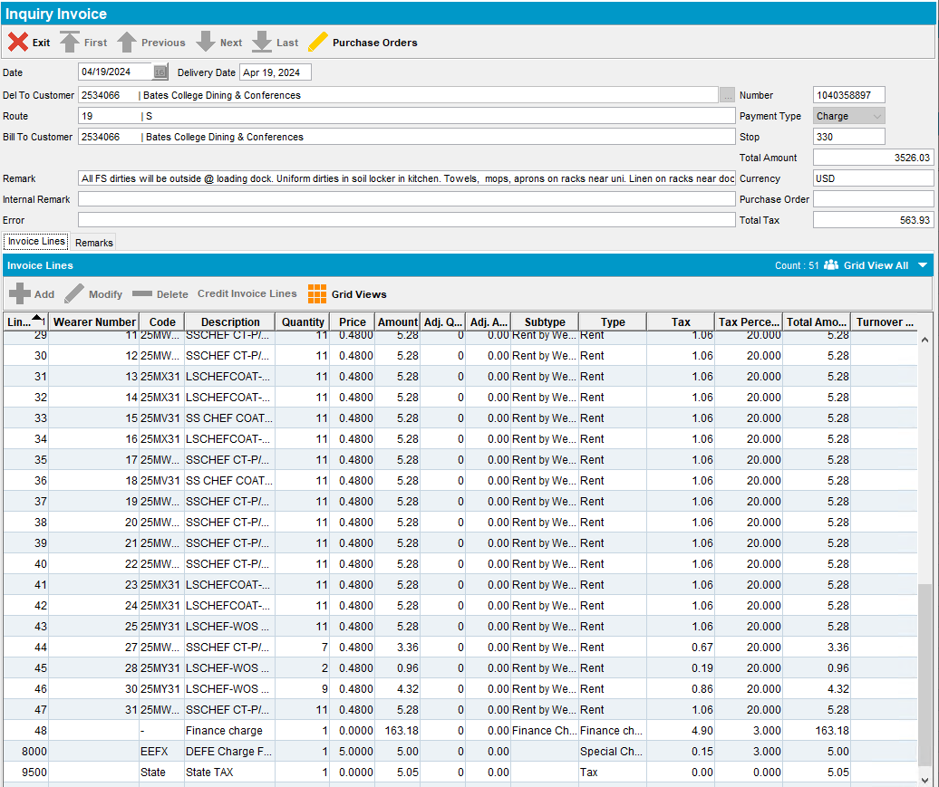
- Send route to RA
- RA: Go to Adjust screen
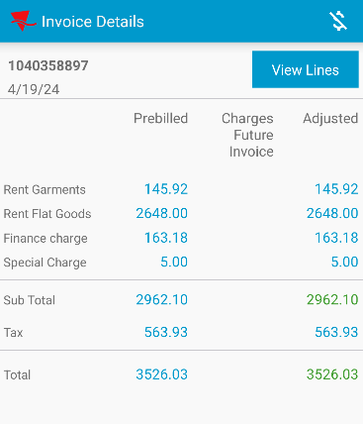
- Go to Invoice Lines and adjust the Finance Charge line
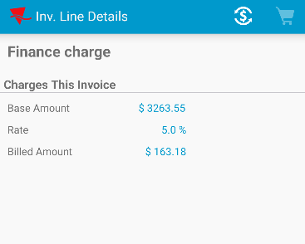
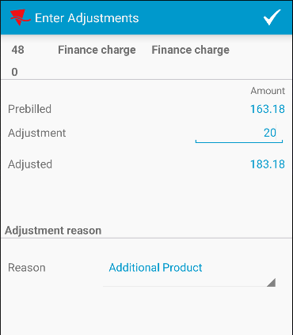
- Press the check mark button to save your changes
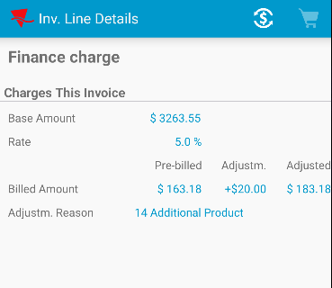
- Back out and click on the invoice line again
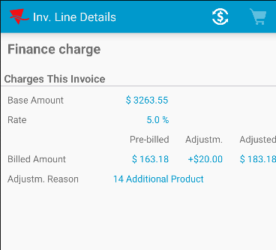
- Make other adjustments and backout
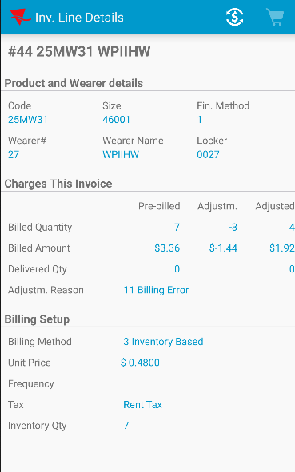
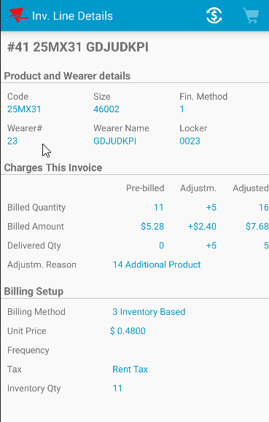
- Finish and upload the route data
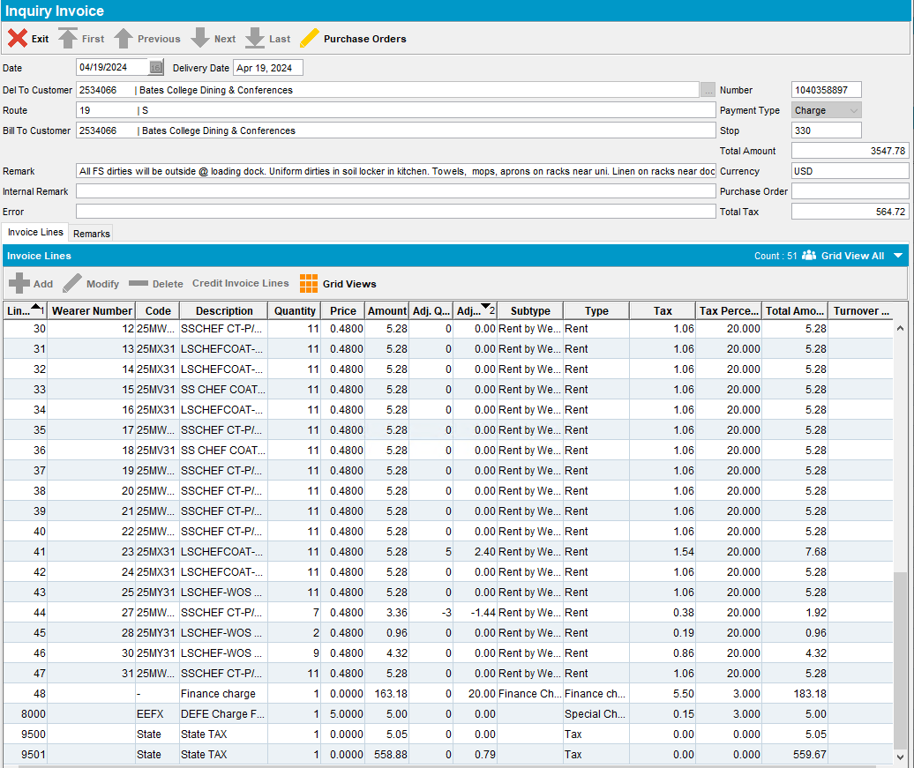
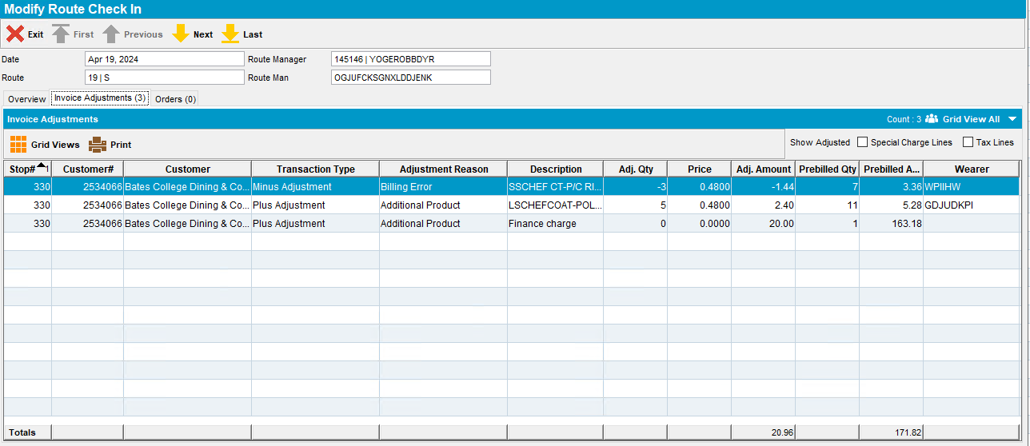
- WebX: Check that the Finance Charge Invoice Adjustment is displayed
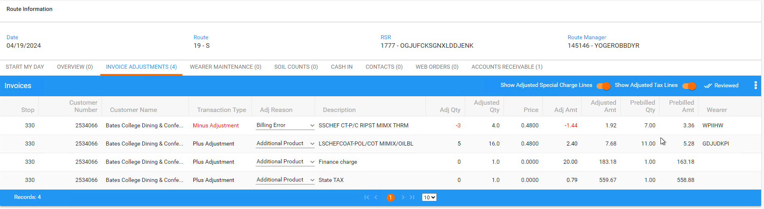
- Settle the route and make sure there are no errors
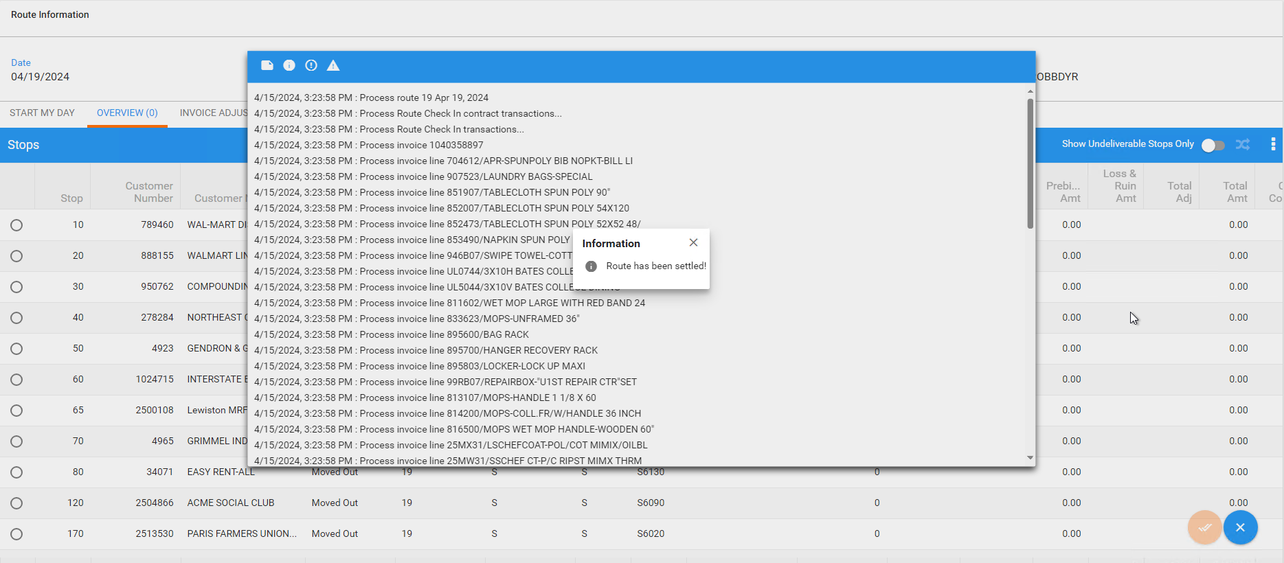
- Check that the invoice looks ok after tax distribution
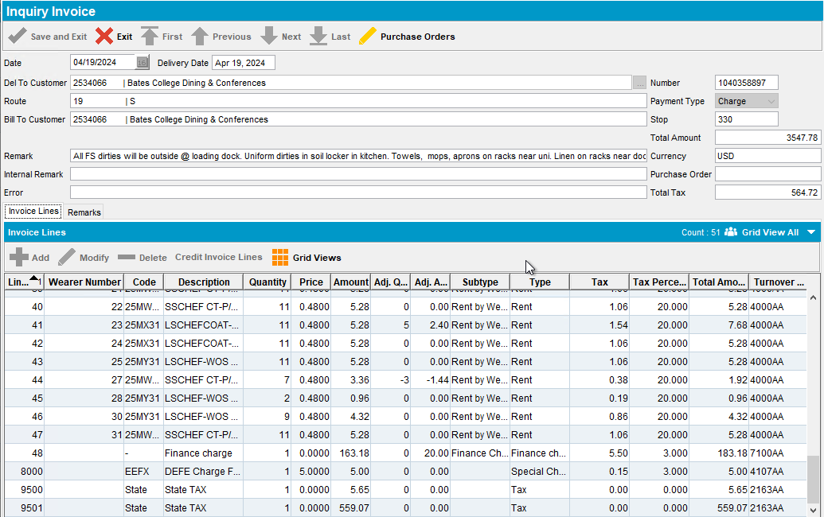
Tested OK

Test Case 3 – 701 Minus Adjustment to a Finance Charge on WEBX vs 9.07.00.UNF11
Expected behavior: Finance Charge can be adjusted on WEBX and the adjustment is not applied on settlement.
Hash: 9.07.00.UNF11 + RouteAssistant_v12.34.INTERNAL_TEST_ONLY.0f371a71.apk
- Check the relevant System Settings
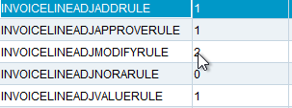
- Invoice Settings per Plant: Make sure you have Finance Charge percentage set at the plant level
- Generate Finance Charges
- Use the following query to find customers that have pending Finance Charges on your BU:
select c.customernumber, f.amountdue, f.* from financecharge f
join customer c on c.customer_id = f.customer_link_id
join businessunit bu on bu.businessunit_id = c.defaultbusinessunit_id
where bu.code = '025';
- Select one of the customers with DATEPROCESSED = ‘12/31/2099’
- Go to Customers DLG and load the customer to find route/stop
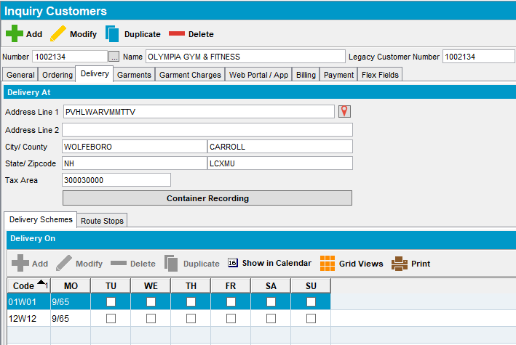
- RSC DLG: Add the next week’s route control for the customer and generate invoices
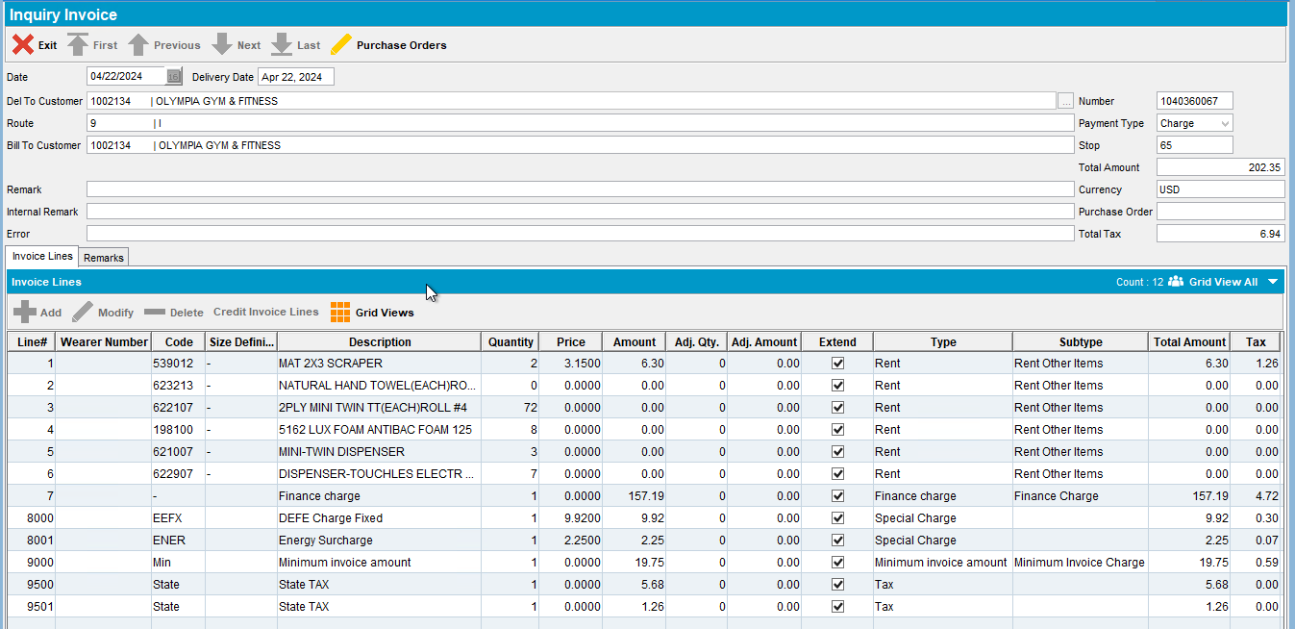
- Send the route to RA
- Settle and depart
- Finish and upload
- Check that the invoice was not adjusted
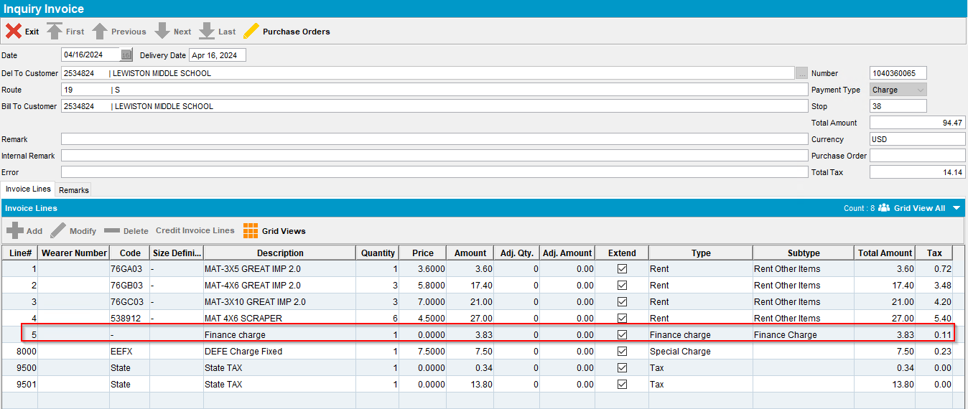
- WebX: Find the route you just uploaded
- WebX: add a negative adjustment to the finance charge
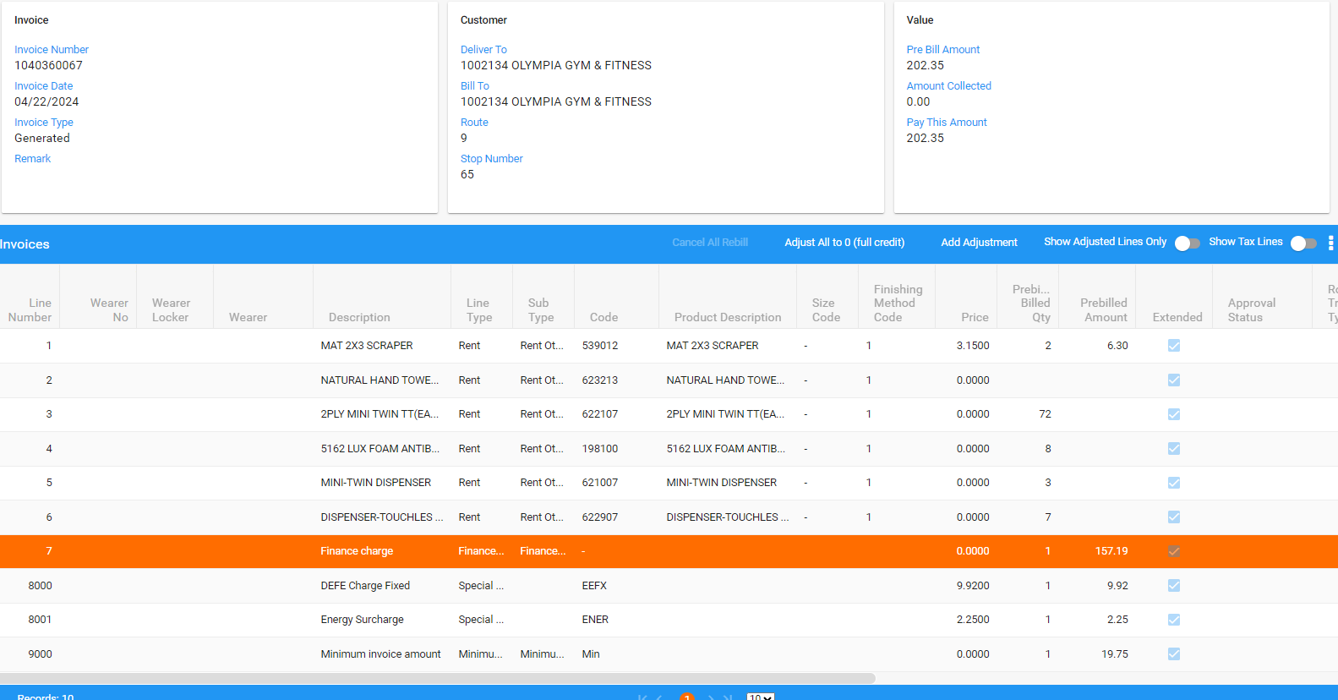
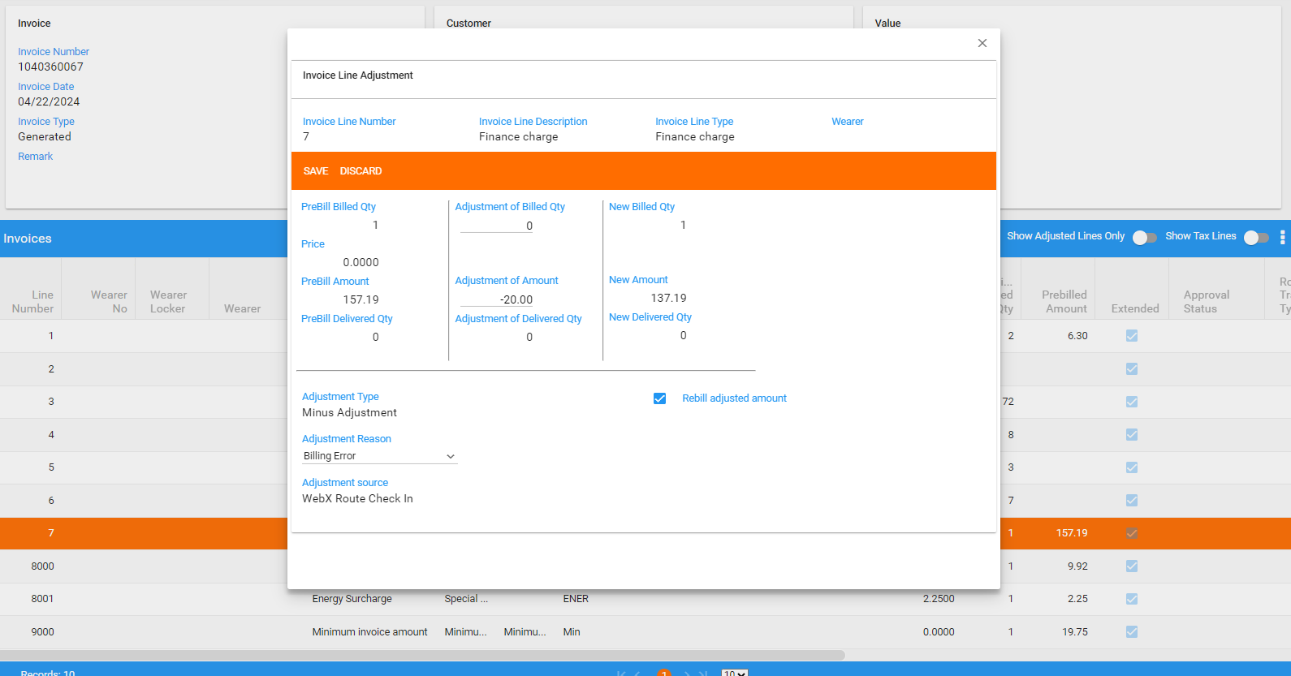
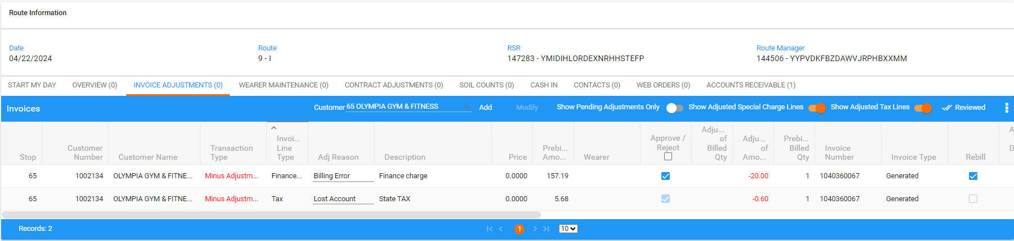
- Settle the route
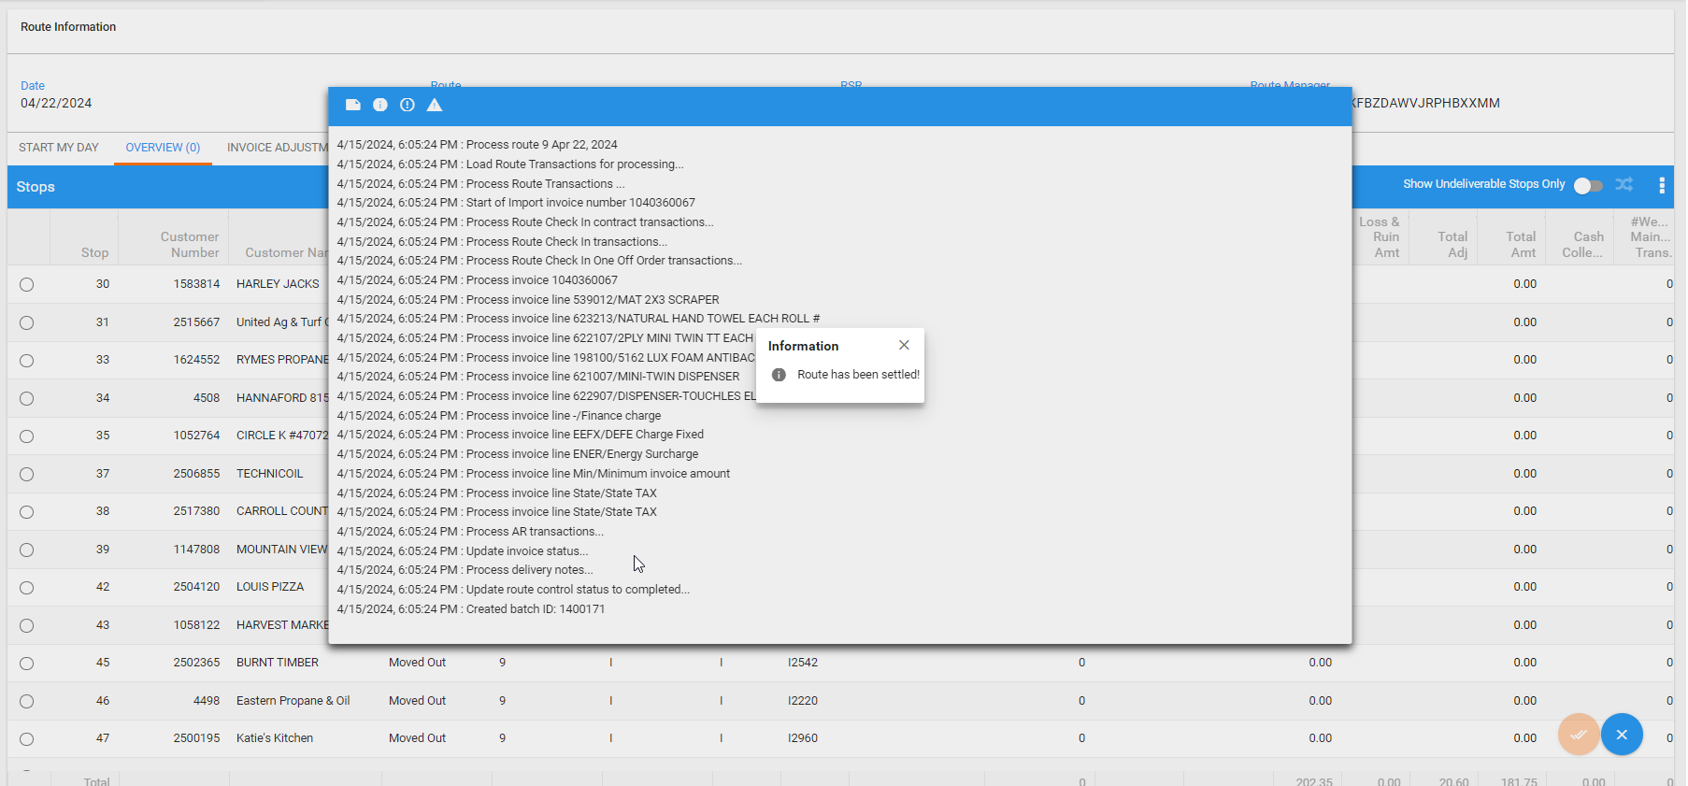
- Check the invoice
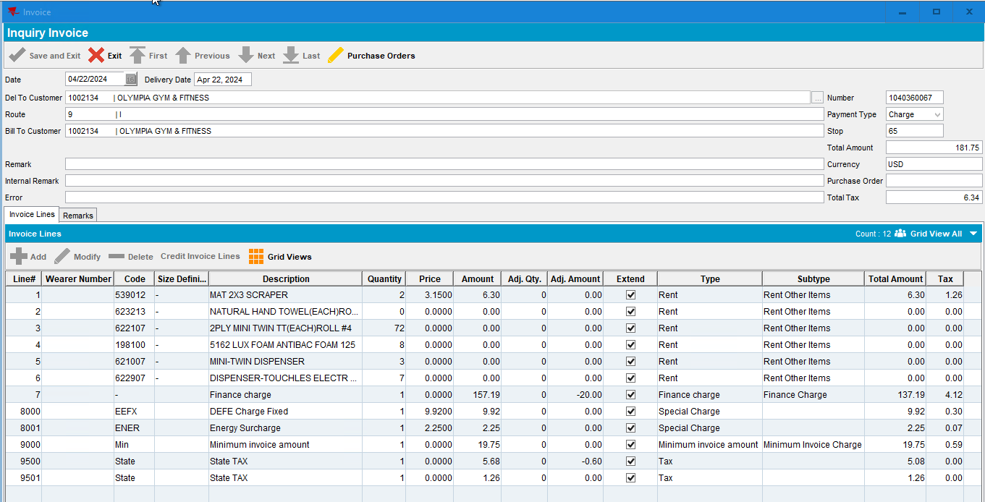
RETEST OK

