RASA-4245 Error during download of route data/RASA-4248

Downgrading to version 12.33

Environment | Prerequisites
Version: 9.07.00.UNF10 hash: 19585c978885  RASA v12.33 hash 9296f329  DBServerName= abs-srv16.internal.abslbs.com  DBSID=CUST21  DBUser=UNFDEV  DBPassword=UNFDEV  Environment=Test | - Module:  - System setting:  - Other applications versions (if is applicable)  - Device used for mobile applications (if is applicable: Memo, physical device, Nox)

Contents

Test Case 1 – When I use abs4wsmobileapps 1
Test Case 2 – When I use absmobilerestservices 5

Retest after fix

Test Case 1 – When I use abs4wsmobileapps
- Route Status Control dlg: Create a new route and keep 1 customer
- Route Status Control dlg: Generate invoice and send the route to PDA
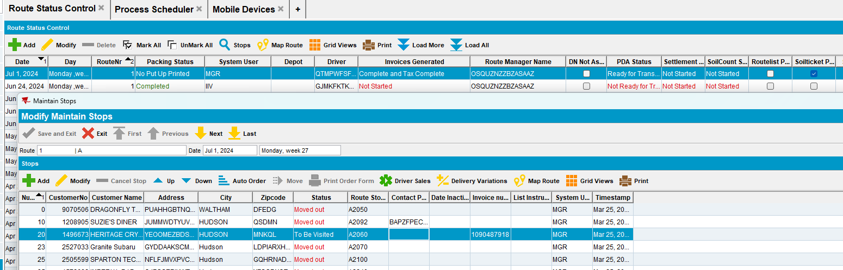
- RA: Download the route on the PDA
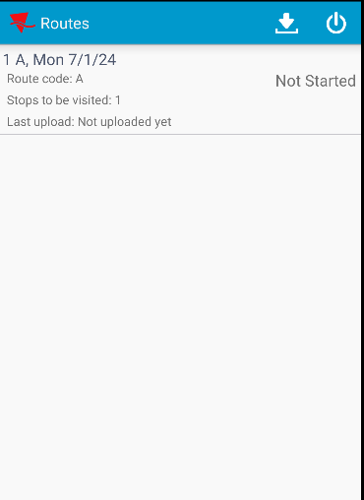
- Route Status Control dlg: Go back in the client.
a) mark route ready for retransfer
b) remove mark ready for retransfer
c) cancel invoice
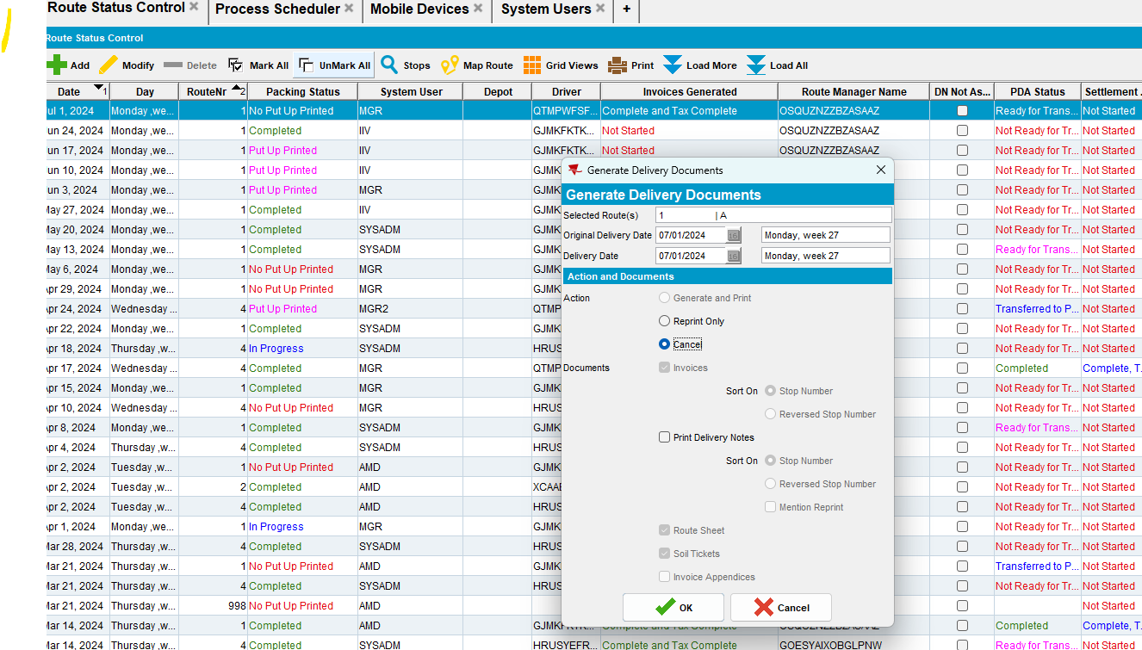
- Export PDA database
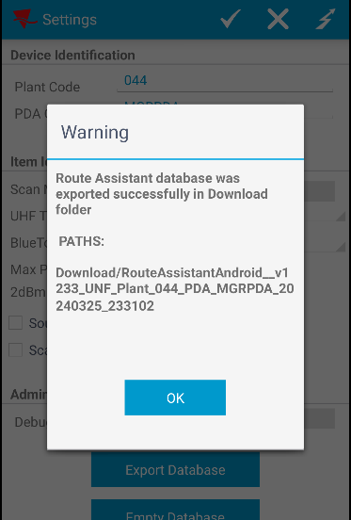
- Route Status Control dlg: Generate invoice again and send the route to PDA
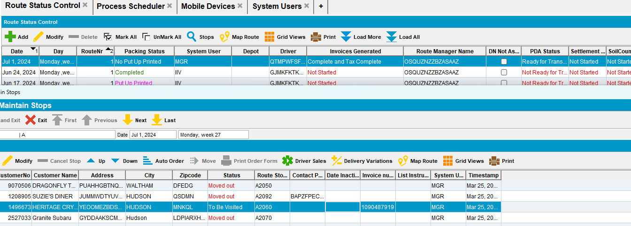
- RA: Download route again on RA. You don't have to empty the DB or remove the old stop
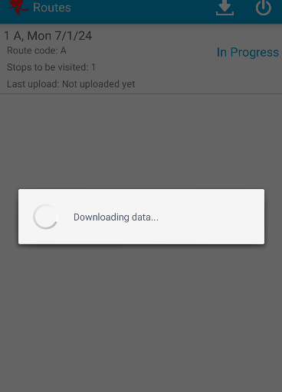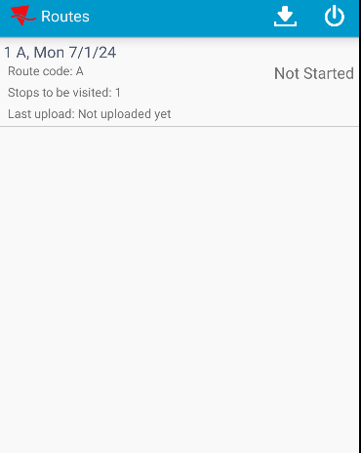
I noticed that the old transactions was removed and the new data was saved.
- Export PDA database. Compare with the first database.
- First db
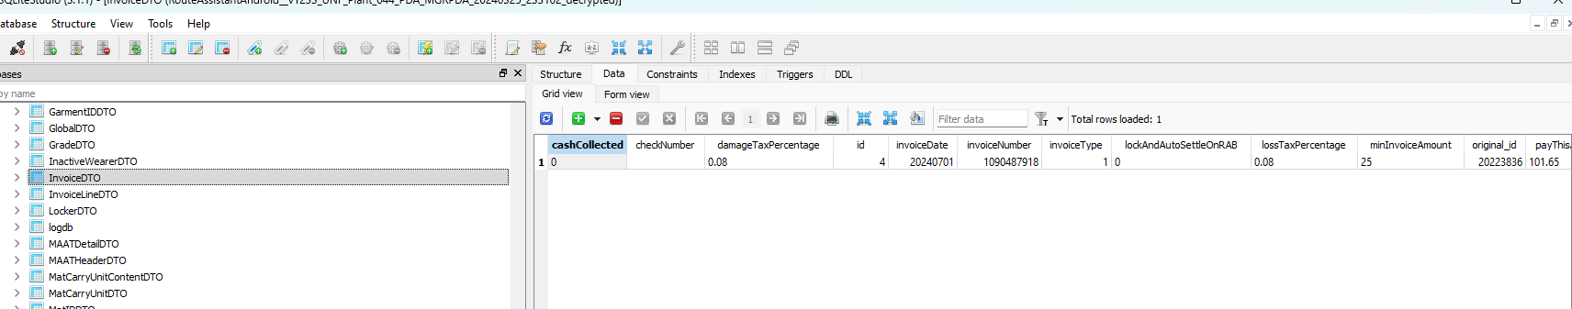
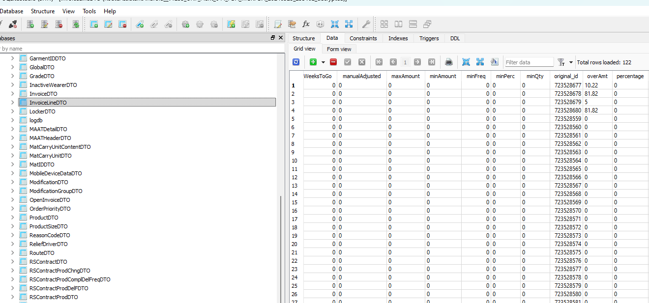

-second db
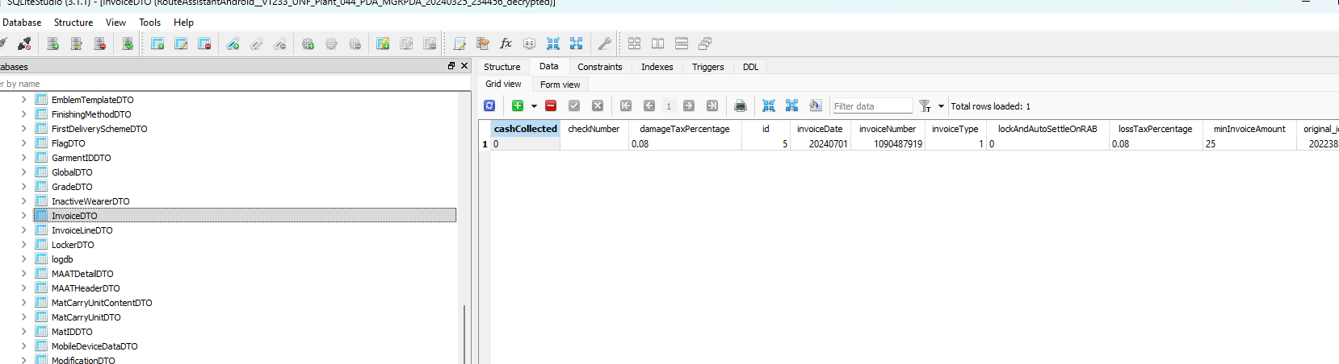
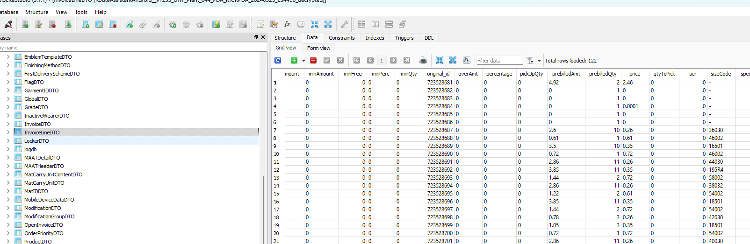

I noticed that invoiceNumber's from InvoiceDTO must is different between databases / invoices.
Also the original_id from InvoiceLineDTO is different between databases / invoices.
Pretest ok.
- RA: Do some transactions and then upload the route

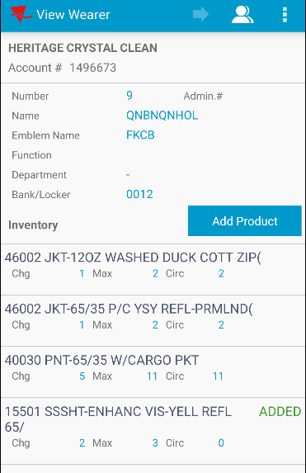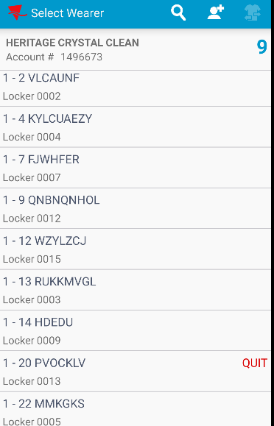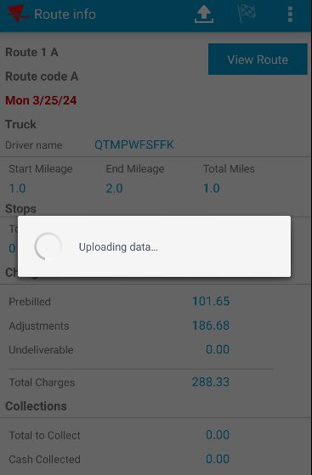

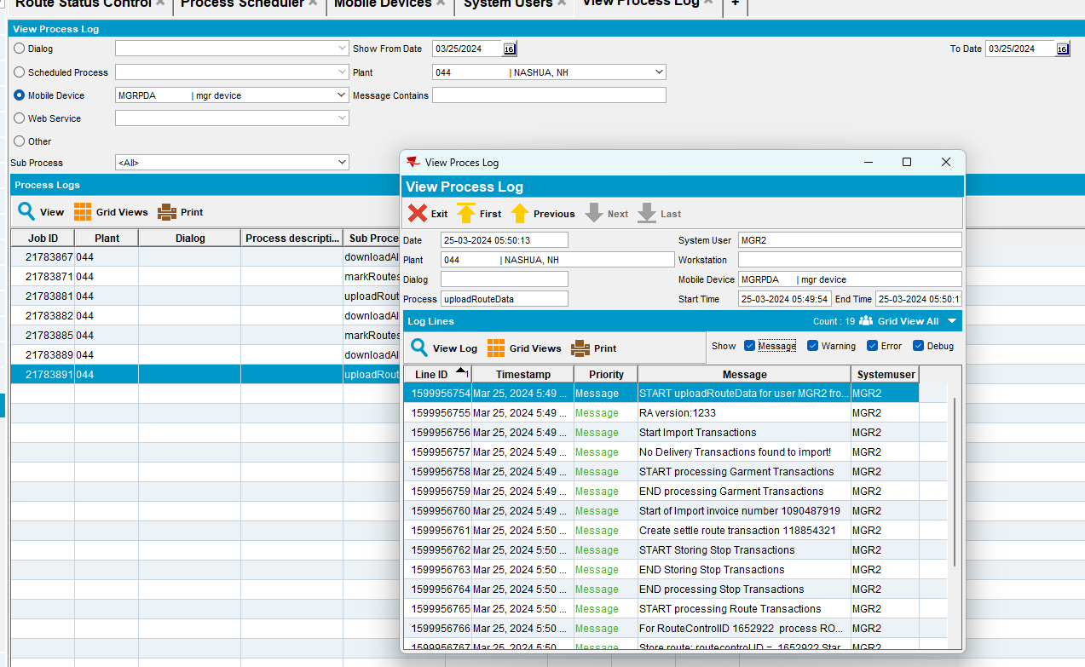
I noticed that no error occurred.

Test Case 2 – When I use absmobilerestservices
- Route Status Control dlg: Create a new route and keep 1 customer
- Route Status Control dlg: Generate invoice and send the route to PDA
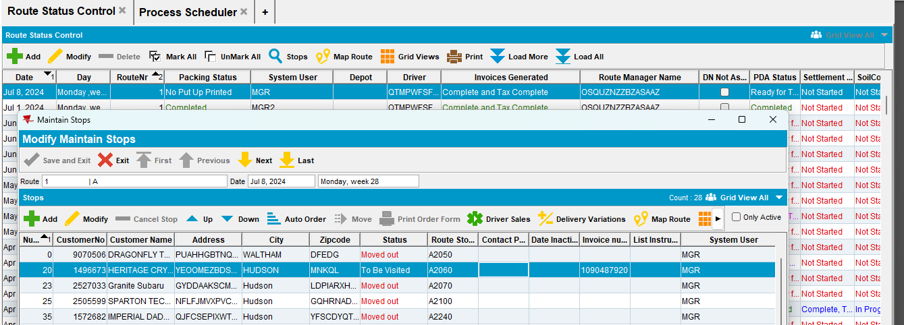
- Download the route on PDA
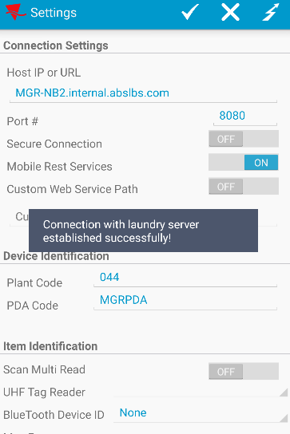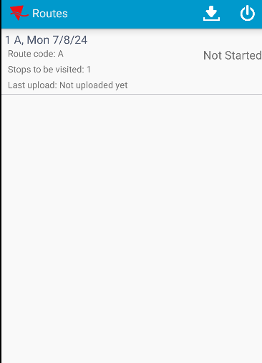

Then I made some transactions:
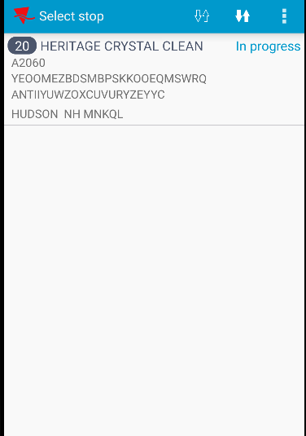

- Route Status Control dlg: Go back in the client.
a) mark route ready for retransfer
b) remove mark ready for retransfer
c) cancel invoice
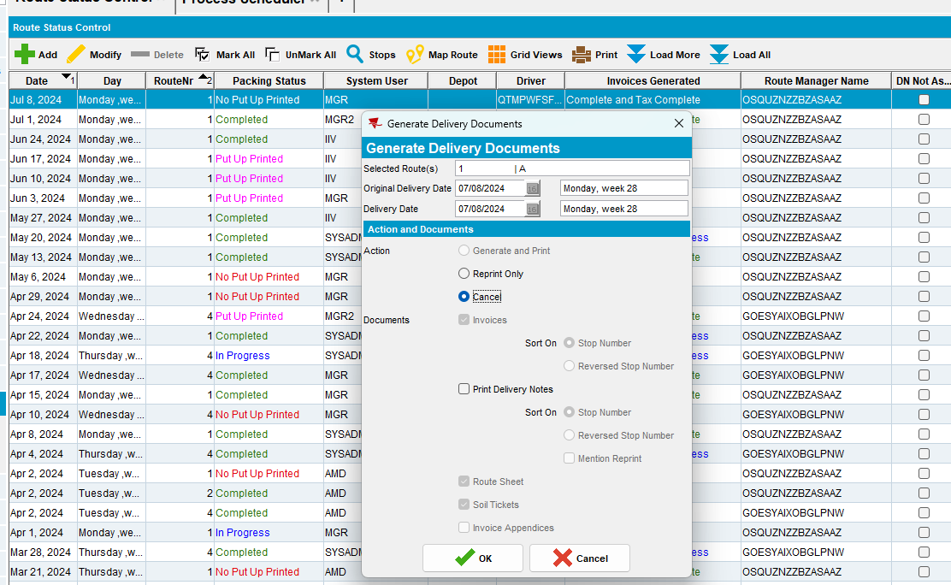

- Export the db
- Route Status Control dlg: Generate invoice again and send the route to PDA

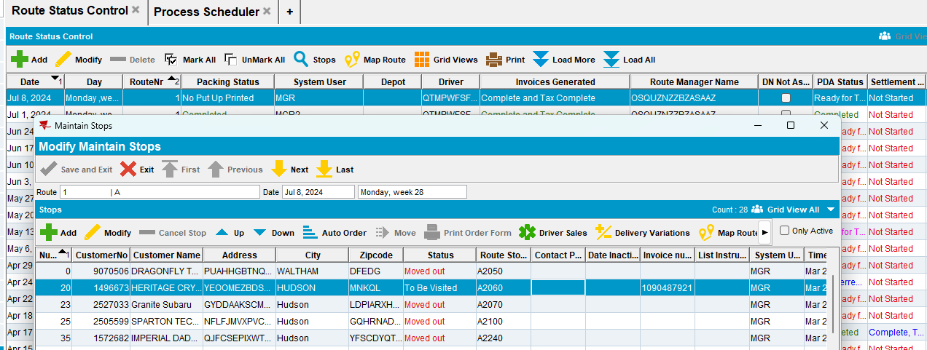

- RA: Download route again on RA. You don't have to empty the DB or remove the old stop
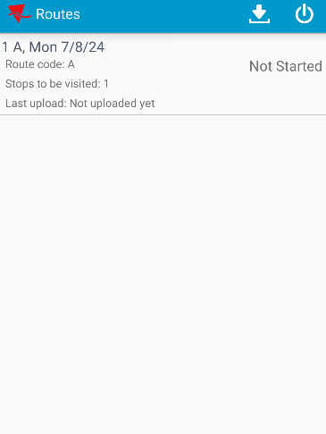
I noticed that the old transactions were removed and the new data was saved.

- Export PDA database. Compare with the first database.

- First db
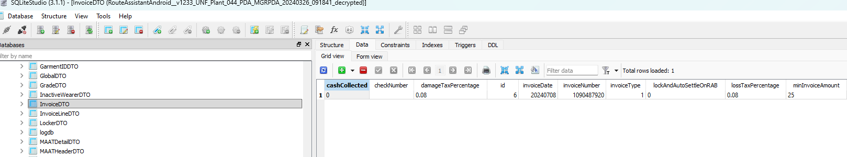
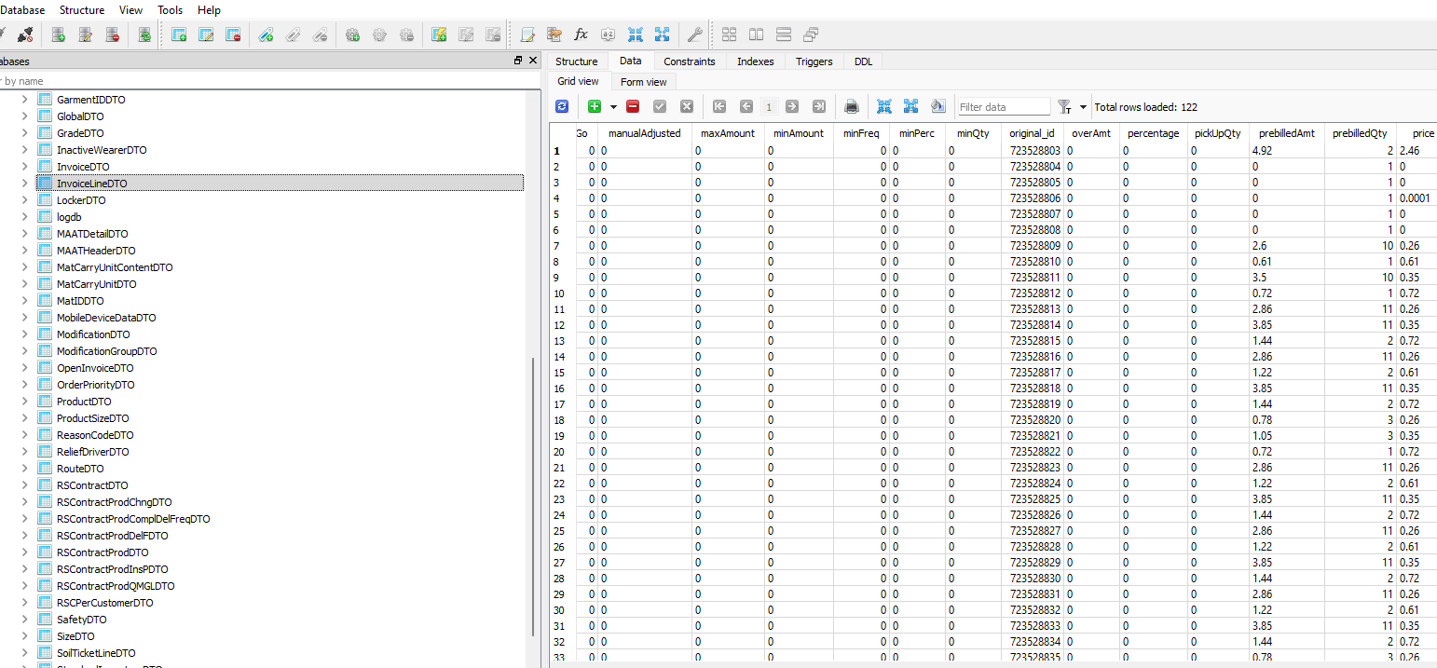
- Second db
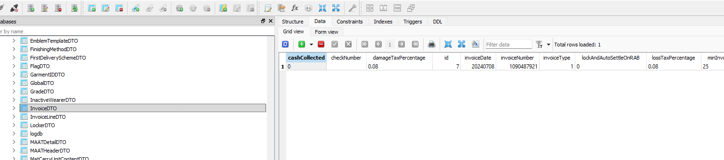
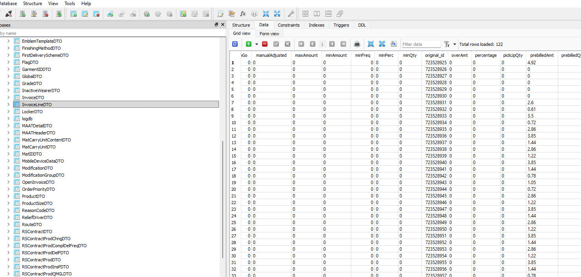
I noticed that invoiceNumber's from InvoiceDTO must is different between databases / invoices.
Also the original_id from InvoiceLineDTO is different between databases / invoices.
Pretest ok.
- RA: Do some transactions and then upload the route
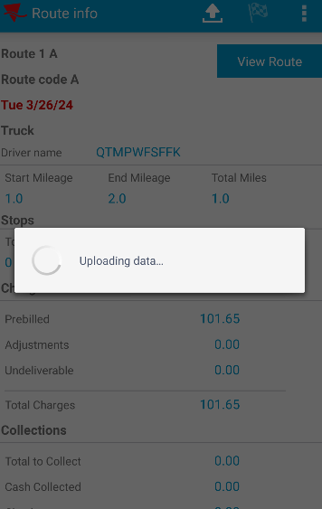
I noticed that no errors occurred.
Pretest ok.

