RASA-4203 Blocking scanning garments after bill loss now
Environment | Prerequisites
Version: 9.07.00.UNF11  DBServerName= abs-srv16.internal.abslbs.com  DBSID=CUST21  DBUser=UNFDEV  DBPassword=UNFDEV  Environment=PRODUCTION | - Module:  - System setting:  - Others…

Contents
Test Case 1 - Loss charge extend = Y on the invoice, scan return on RA 1
Expected behavior: 1
Test Steps: 1
Test Case 2 - Loss charge extend = N on the invoice, scan return for the loss charge and after bill for loss now 4
Expected behavior: 4
Test Steps: 4
Test Case 3 - No loss charges on the invoice, quit a wearer and bill for loss now 7
Expected behavior: 7
Test Steps: 7
Test Case 4 - Loss charge extend = N on the invoice, bill for loss now and try to modify with minus and plus adjustments 9
Test Steps: 9

System Settings:
USEROUTECHECKINSCREEN = Y
INVOICELINEADJADDRULE=1
INVOICELINEADJAPPROVERULE=1
INVOICELINEADJMODIFYRULE=2
INVOICELINEADJVALUERULE=1
BU: 095
Route: 1
Date: 12.02.2024

Test Case 1 - Loss charge extend = Y on the invoice, scan return on RA

Hash: 9.07.00.UNF11 hash: 8038fd897678 + RouteAssistant_v12.33.INTERNAL_TEST_ONLY.c75857ea.apk

Expected behavior:
Scan for return garments on RA will create a 704 transaction, and for this loss charge invoice line we can adjust it further with a 701 (minus) and 702 (plus) adjustments on top

Test Steps:
- RSC dlg: Create a route containing customers which have wearers and garment delivery.
- Wearers dlg: Choose a customer 1320616 and end a wearer 2 weeks + in the past from your route, to have 2 loss charges extend = Y when generating the invoice
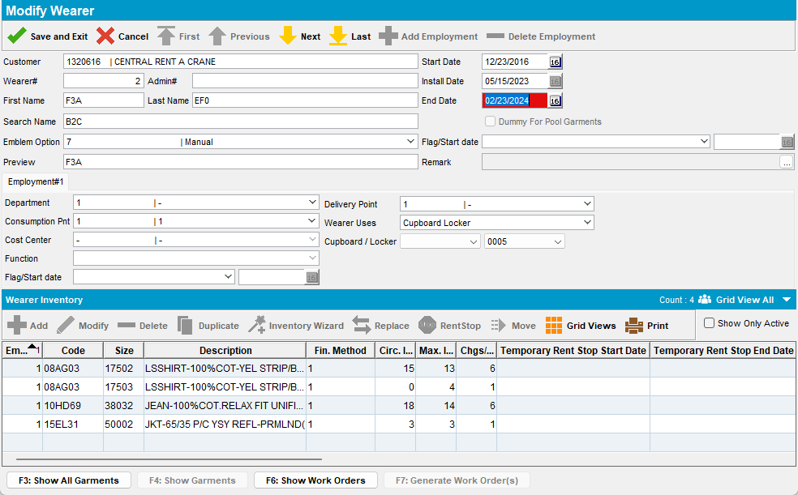

- Route Status control dlg: Generate invoices, script the taxes and run Import Vertex Tax BCI process.
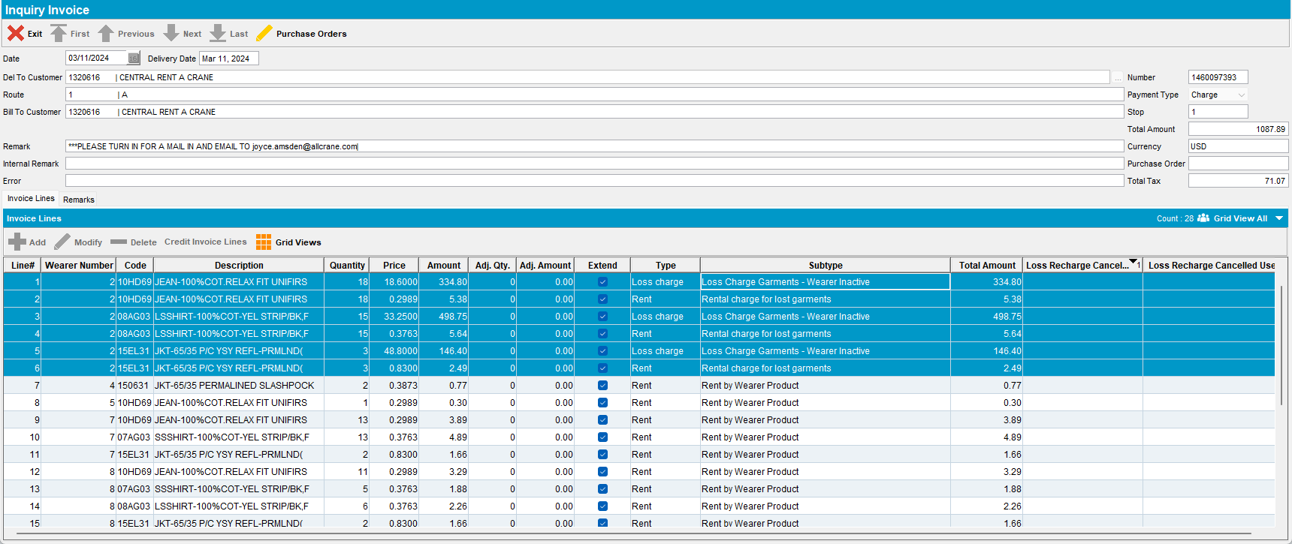
- RSC: Send the route to PDA.
- RA: Download the route and arrive at customer 1320616, which has the lost charges.
- RA: Enter Return items / Scan return, and scan 4 garments from each loss charge to generate a 704 transaction
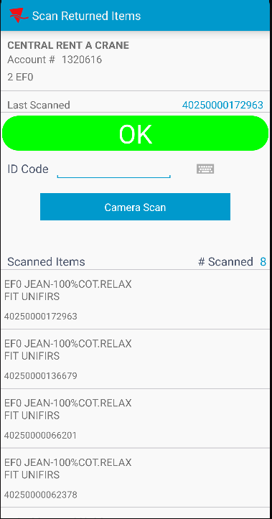
- RA: Make a minus adjustment on the first scan replace 704 transaction
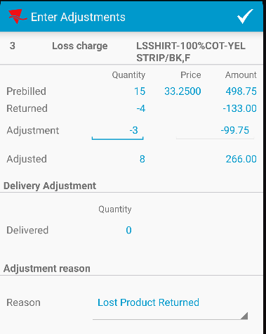
- RA: Make a plus adjustment on the second scan replace 704 transaction
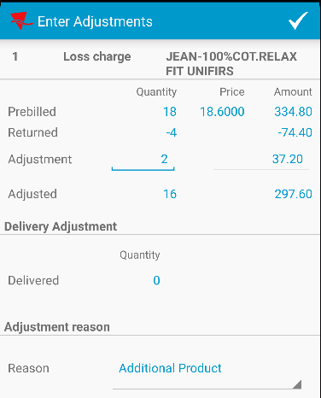

Check the RA database.
SELECT T.type, T.invoiceline_id, T.long1, T.double1, T.Double6, T.Double3, T.* from TRANSACTIONDTO T
WHERE T.type between 701 AND 707;

- RA: Make another plus and minus adjustments on regular rent lines
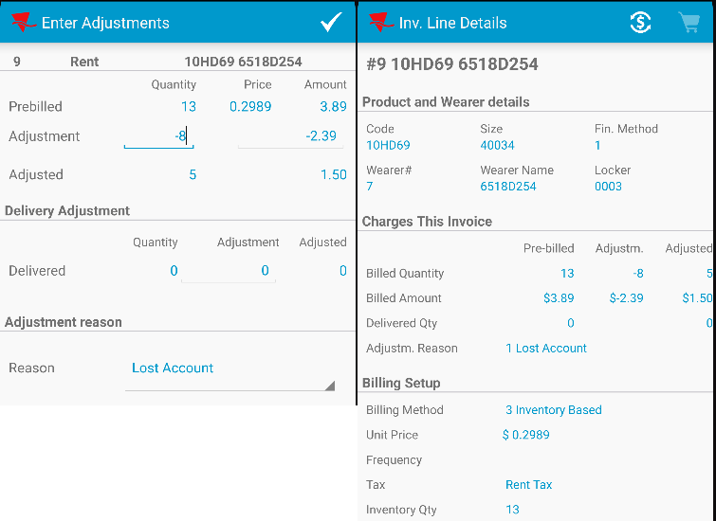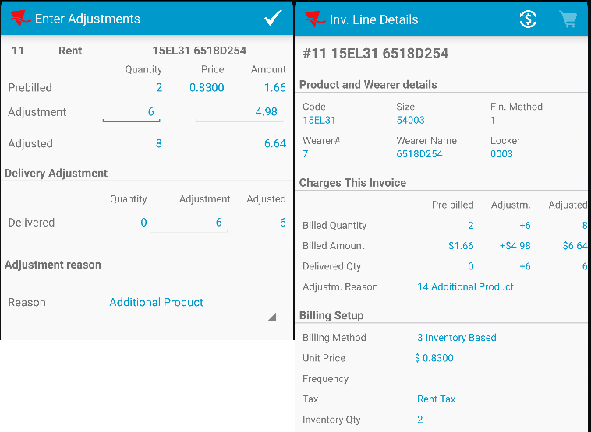

Recheck the RA database for the transactions.
SELECT T.type, T.invoiceline_id, T.long1, T.double1, T.Double6, T.Double3, T.invoice_id, T.invoiceline_id, T.route_id, T.stop_id, T.* from TRANSACTIONDTO T
WHERE T.type between 701 AND 707;
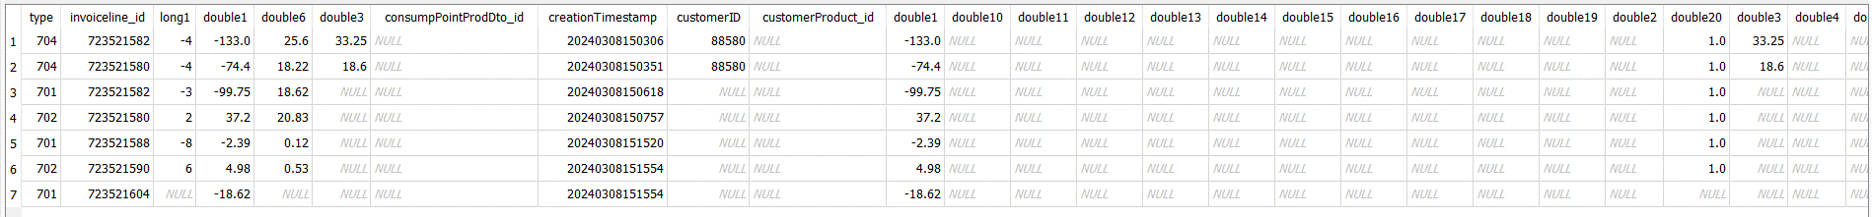

- RA: Settle and depart route and upload it.
- View Process Log dlg: No errors.
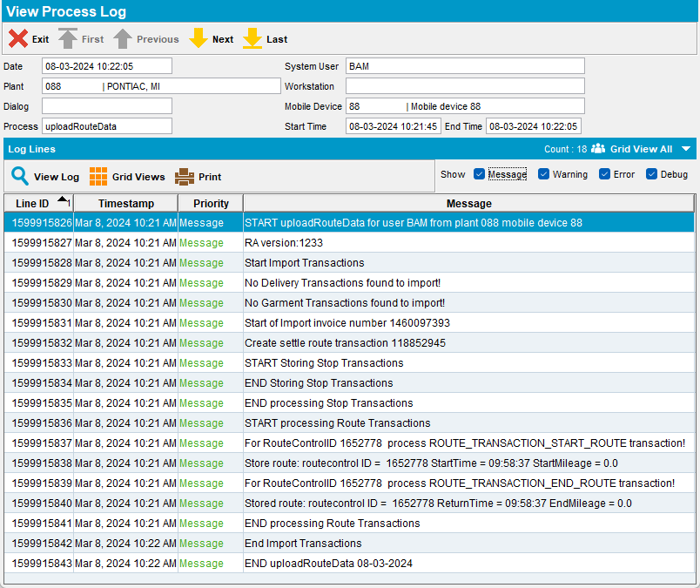
Tested OK
The loss charge invoice line can be adjusted further with a 701 and 702

Test Case 2 - Loss charge extend = N on the invoice, scan return for the loss charge and after bill for loss now

Hash: 9.07.00.UNF11 hash: 8038fd897678 + RouteAssistant_v12.33.INTERNAL_TEST_ONLY.c75857ea.apk

Expected behavior:
On RA after Bill all for loss which results a 703 transaction, for this loss charge invoice line we can’t add on top further 701 (minus) / 702 (plus) adjustments.

Test Steps:
- RSC dlg: Create a route containing customers which have wearers and garment delivery.
- Wearers dlg: Choose a customer and end a wearer 1 week in the past from your route, to have loss charges extend =N when generating the invoice
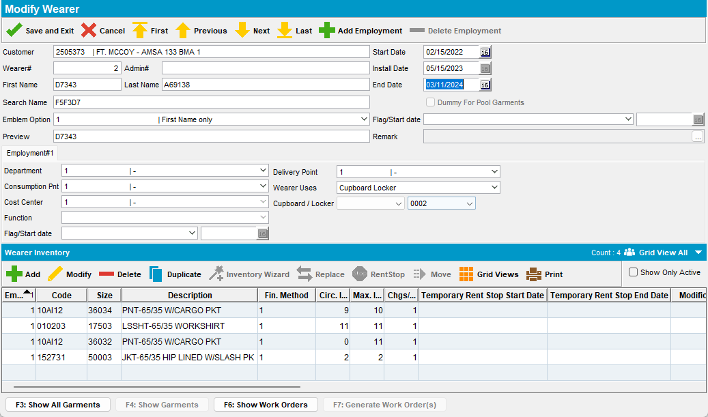

- Route Status control dlg: Generate invoices, script the taxes and run Import Vertex Tax BCI process.
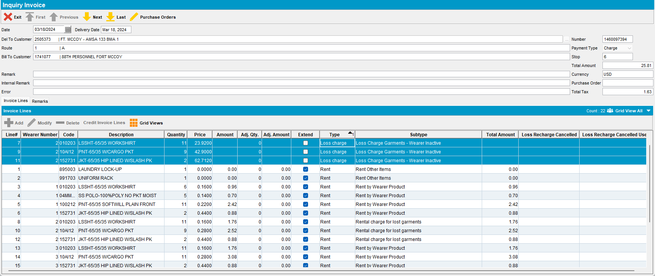
- RSC: Send the route to PDA.
- RA: Download the route and arrive at customer 2505373, which has the lost charges.
- RA: Scan for return garments, will not create 704 transactions
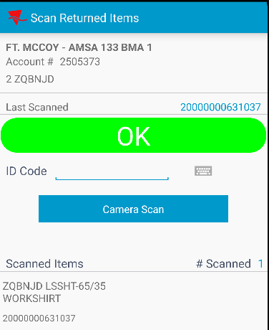
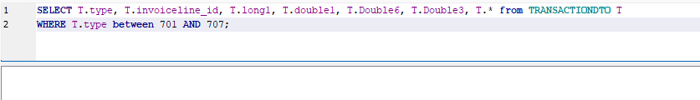
- RA: Enter Return items and bill all for loss now
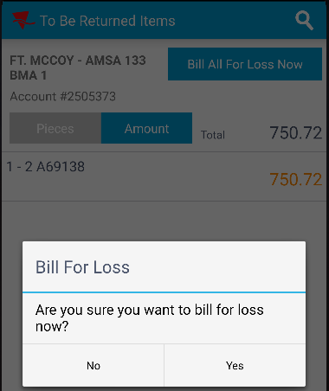
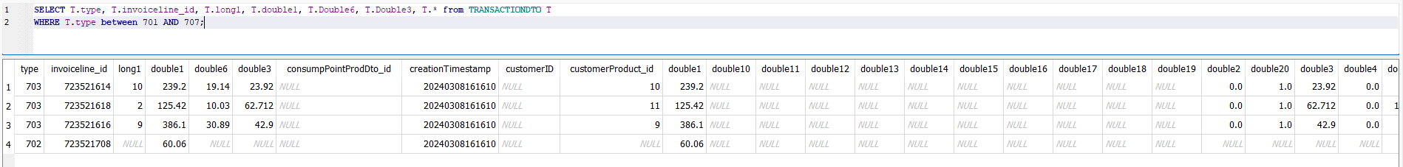
- RA: Enter adjust, find the newly created loss line and try to modify it. The adjust is disabled.
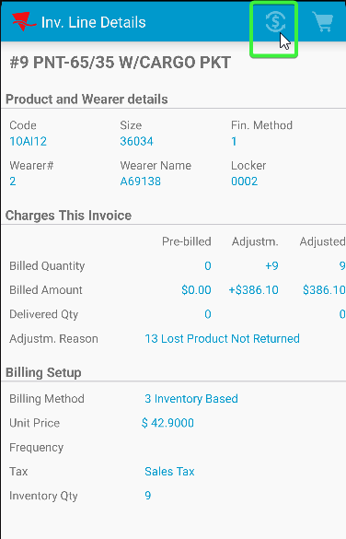

- RA: Scan for return garments from the billed for loss charge line.
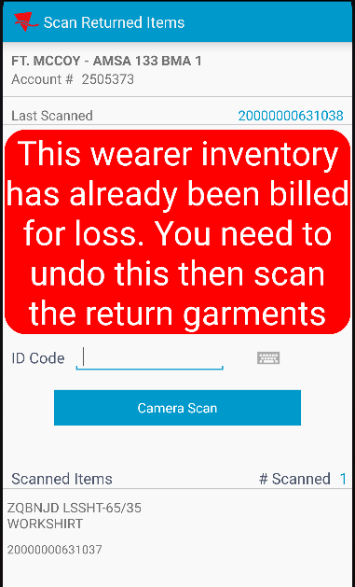

- RA: Settle and depart.
Tested OK
Bill for loss now => scanning garments for return should not be allowed anymore

Test Case 3 - No loss charges on the invoice, quit a wearer and bill for loss now

Hash: 9.07.00.UNF11 hash: 8038fd897678 + RouteAssistant_v12.33.INTERNAL_TEST_ONLY.c75857ea.apk

Expected behavior:
After a bill for loss now on RA, scanning garments for return should not be allowed anymore to add 704 transactions on top of 703

Test Steps:
- RSC dlg: Create a route containing customers which have wearers and garment delivery.
- Wearers dlg: Don’t make any wearers adjustments
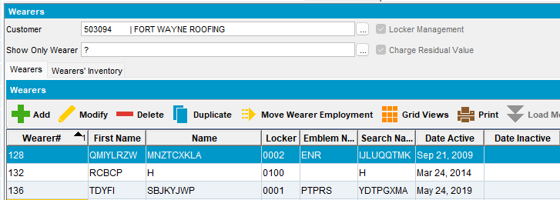
- Route Status control dlg: Generate invoices, script the taxes and run Import Vertex Tax BCI process.
- RSC: Send the route to PDA.
- RA: Download the route and arrive at customer 503094, which doesn’t have loss charges.
- RA: Quit a wearer inventory
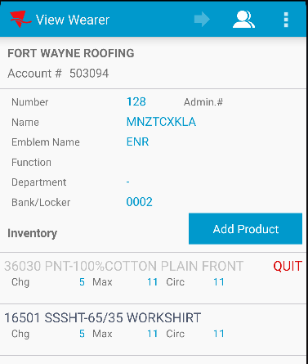
- RA: Scan garments for return on RA (is allowed) but will not create a 704 tranzaction
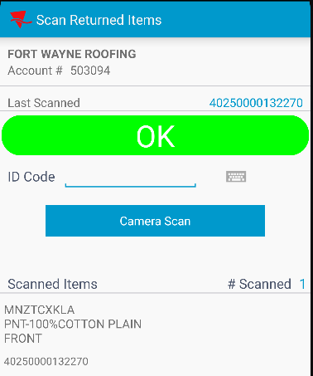
SELECT T.type, T.invoiceline_id, T.long1, T.double1, T.Double6, T.Double3, T.* from TRANSACTIONDTO T
WHERE T.type between 701 AND 707;
- RA: Bill for loss now => scanning garments for return should not be allowed anymore
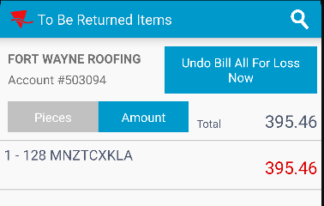

- RA: Enter Return items / Scan return, and scan garments for return to generate a 704 transaction
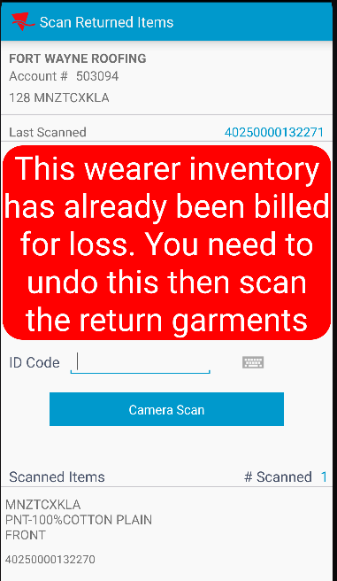

Tested OK
Bill for loss now => scanning garments for return should not be allowed anymore

Test Case 4 - Loss charge extend = N on the invoice, bill for loss now and try to modify with minus and plus adjustments

Hash: 9.07.00.UNF11 hash: 8038fd897678 + RouteAssistant_v12.33.INTERNAL_TEST_ONLY.c75857ea.apk

Expected behavior:
After a bill loss now, for this loss charge invoice line we can’t add any further 701 / 702 adjustments

Test Steps:
- RSC dlg: Create a route containing customers which have wearers and garment delivery.
- Wearers dlg: Choose a customer and end a wearer 1 week in the past from your route, to have loss charges extend =N when generating the invoice
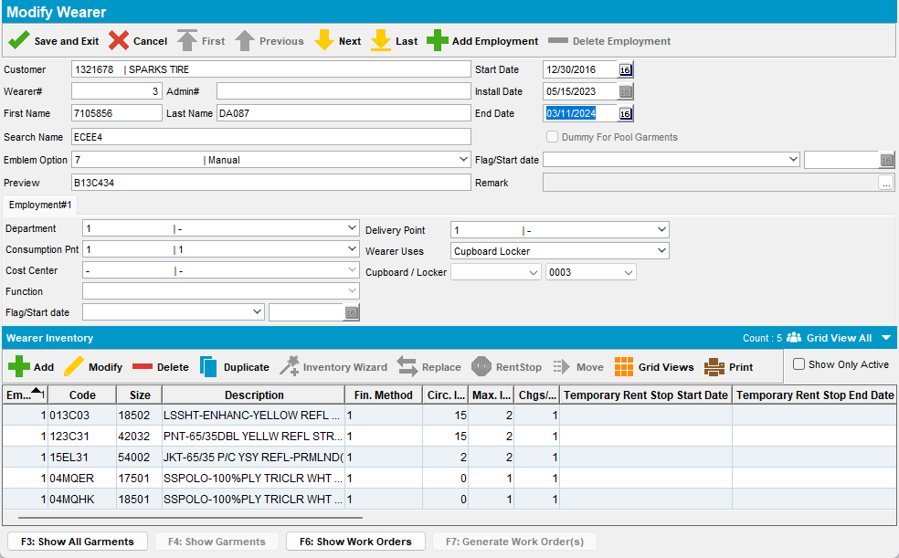

- Route Status control dlg: Generate invoices, script the taxes and run Import Vertex Tax BCI process.
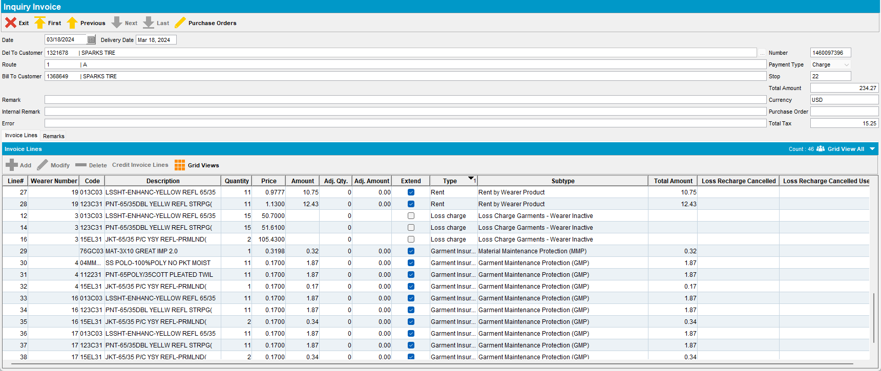
- RSC: Send the route to PDA.
- RA: Download the route and arrive at customer 1470964, which has the lost charges.
- RA: Enter Return items / Scan return, and scan 4 garments for return a garment
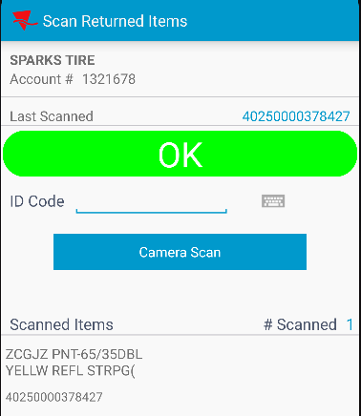
Check the RA database.
SELECT T.type, T.invoiceline_id, T.long1, T.double1, T.Double6, T.Double3, T.* from TRANSACTIONDTO T
WHERE T.type between 701 AND 707;
- RA: Bill for loss now => scanning garments for return should not be allowed anymore
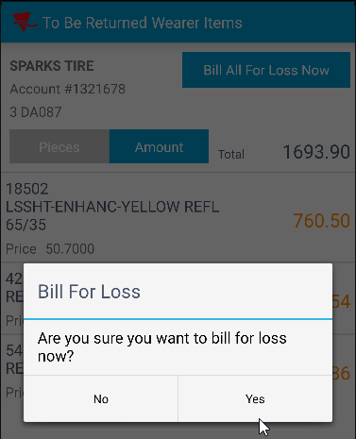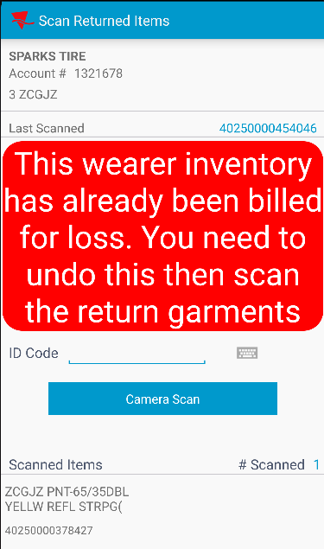

Recheck in RA
SELECT T.type, T.invoiceline_id, T.long1, T.double1, T.Double6, T.Double3, T.* from TRANSACTIONDTO T
WHERE T.type between 701 AND 707;
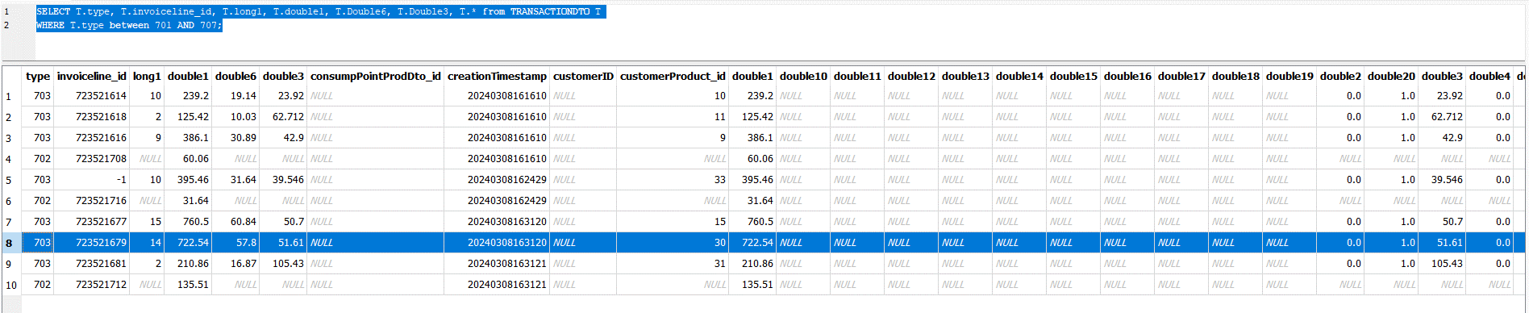
Tested OK
Only the 703 transactions and the first scanned returned garment was created

