RASA-4137 Additional fields for invoice adjustment route transactions
Environment | Prerequisites
Version: 9.07.00.RC1  DBServerName= abs-srv16.internal.abslbs.com  DBSID=CUST21  DBUser=UNFDEV  DBPassword=UNFDEV  Environment=PRODUCTION | - Module:  - System setting: AUTOASSIGNOPENPAYMFORCOD  - Others…

Contents
Test Case 1 – Invoice adjustments transactions are not processed in upload except from full invoice credit 707 1
Test Case 1.1 – Invoice adjustments 701, 702, 703 (loss charge extend = No), 704 (loss Charge Extend = Yes), 707 1
Expected behavior: 1
Test Steps: 2
Test Case 1.2 – Invoice adjustments 701, 702, 703 (will be created on RA with quit wi) 9
Expected behavior: 9
Test Steps: 9
Test Case 2 – Scanning some garments for loss return and credit the rest 11
Expected behavior: 11
Test Steps: 11
Test Case 3 - Changing a special charge from percentage to fixed 13
Expected behavior: 13
Test Steps: 13

Test Case 1 – Invoice adjustments transactions are not processed in upload except from full invoice credit 707

Test Case 1.1 – Invoice adjustments 701, 702, 703 (loss charge extend = No), 704 (loss Charge Extend = Yes), 707
Hash: 9.07.00.UNF11 hash: 5b7cd9c1c815 + 12.33.INTERNAL_TEST_ONLY.605962f4

Expected behavior:
Invoice adjustments transactions are processed in settlement not in upload except from full invoice credit 707 that still creates the 701 invoice adjustments in upload.
So the RouteTransaction record is created at upload but the processing is now in settlement

The following columns will be updated after RA upload
RouteTransactionType_ID will be 701, 702, 703, 704 or 707
ApprovalStatus for 701, 704 and 707 will be 1 approved along with adjustment for taxes
ApprovedBySystemUser_ID with the system user ID used
ApprovalTimeStamp
Wearer_ID Wearer_ID
WearerInventory_ID WearerInventory_ID for transactions that don’t have invoiceline_ID (703 bill for loss now, 704 scan return for loss)
StringValue1 TransactionDTO.StringValue1 (Product Code)
StringValue2 TransactionDTO.StringValue2 (Description)
StringValue3 TransactionDTO.StringValue3 (Wearer.Name)
DoubleValue1 negative value of Invoiceline.amount
DoubleValue6 If module VERTEXTAX is in the license then 0 (new total tax for the invoice line)
NumberValue9 707 (so we can identify this came from a 707 transaction) or linked transactions the id should be the same, example 704 with 701
StringValue10 If the transaction type = 701, Then if the invoice line type of the invoice line being adjusted is set as RebillAdjustment = ‘Y’ then set this to ‘Y’ else ‘N’

Test Steps:
System Settings:
USEROUTECHECKINSCREEN = Y
INVOICELINEADJADDRULE=1
INVOICELINEADJAPPROVERULE=1
INVOICELINEADJMODIFYRULE=2
INVOICELINEADJVALUERULE=1

- Route Status Control dlg: Create a new route and keep 3 customers which have garment delivery days.
- Wearers dlg: For one customer quit a wearer inventory in the past (1 weeks) so that when generating invoices we have loss charges extend = N
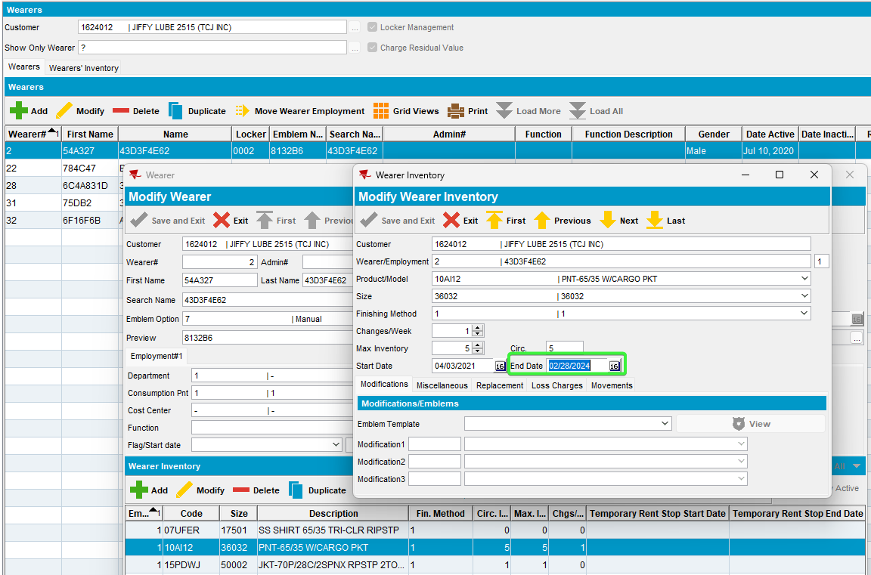
703 (customer 1624012, wearer 2, 10AI12)

- Wearers dlg: For one customer quit a wearer inventory in the past (1 weeks) so that when generating invoices we have loss charges extend = Y
704 (customer 1235813, wearer 8, 121305 PNT)
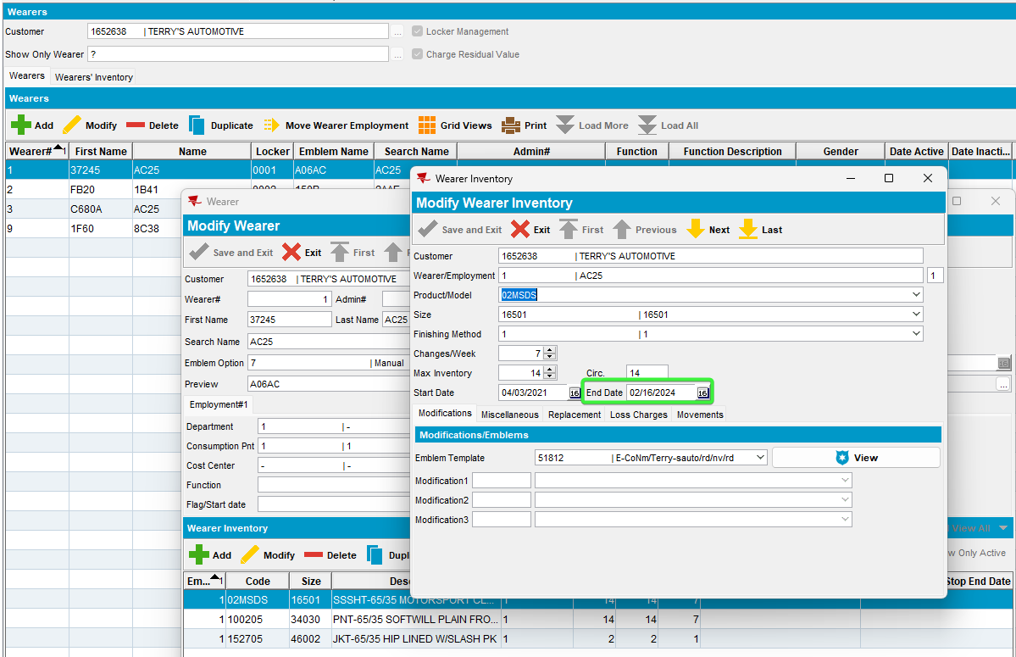
707 (customer 1652638) – for this customer we will create a full credit.
- Route Status Control dlg: Generate invoices and send the route to PDA.

703 (customer 1624012, wearer 2, 10AI12)
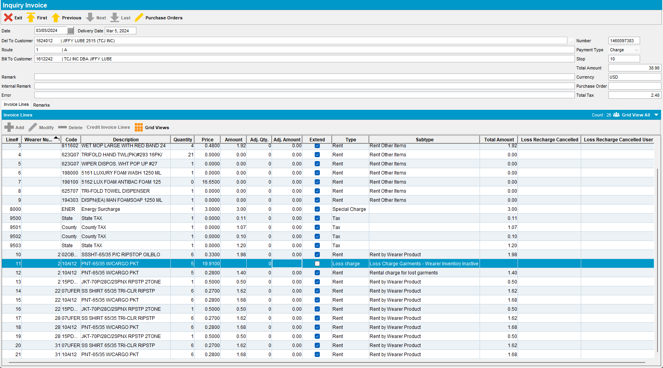
704 (customer 1235813, wearer 8, 121305 PNT)
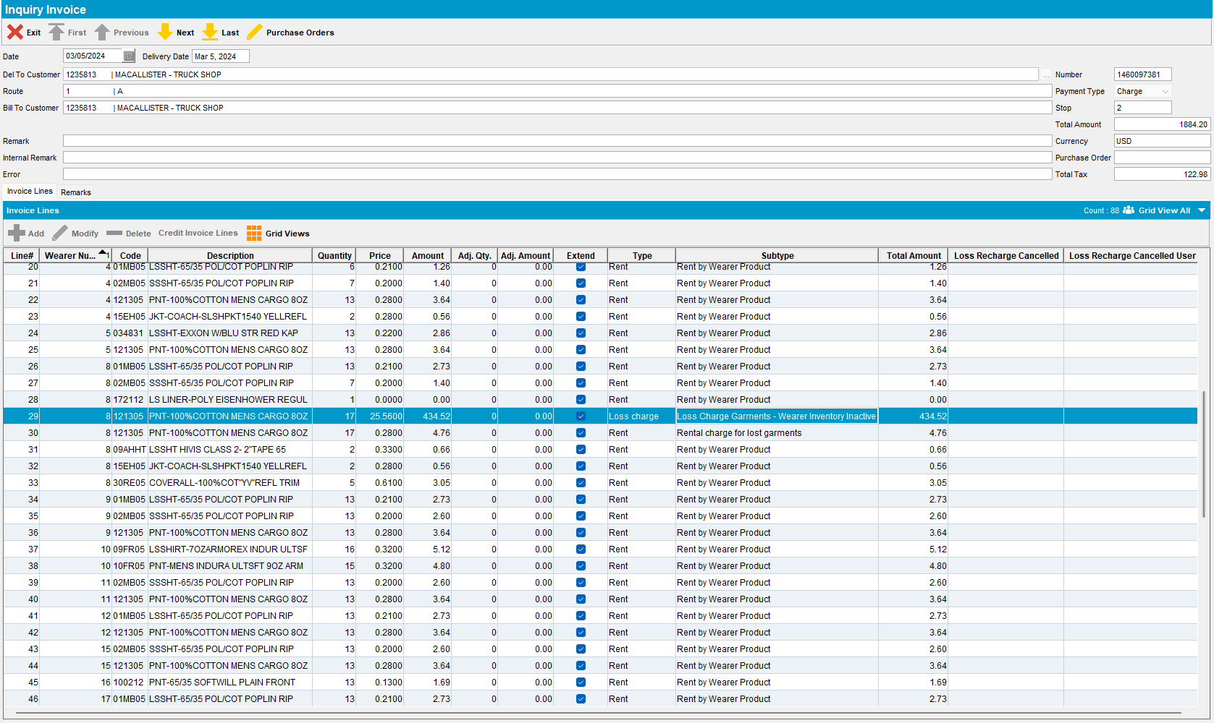
- RA: Download the route and arrive at the customer 1652638 – for this customer we will create a full credit 707. Settle and depart
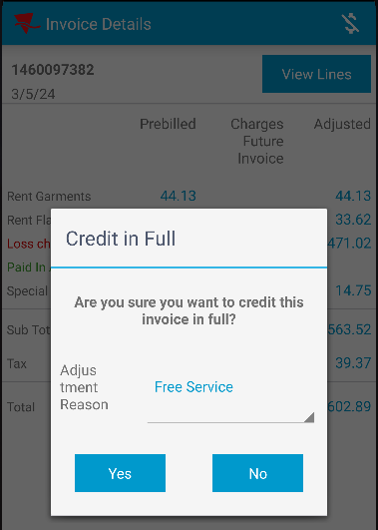
- Check the RA database
SELECT T.type, T.invoiceline_id, T.long1, T.double1, T.Double6, T.Double3, T.invoice_id, T.invoiceline_id, T.route_id, T.stop_id, T.* from TRANSACTIONDTO T
WHERE T.type between 701 AND 707;
- RA: For the next customer 1235813, wearer 8, garment PNT, start scanning for return to create 704 adjustments
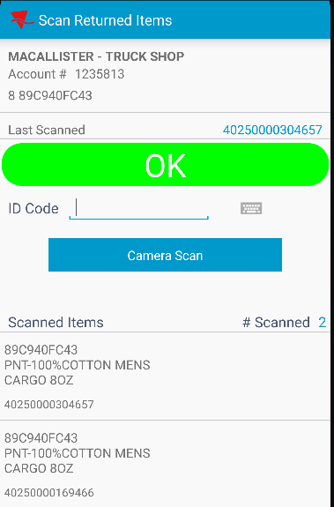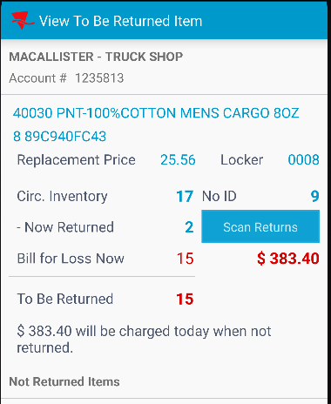
- Check the RA database.
SELECT T.type, T.invoiceline_id, T.long1, T.double1, T.Double6, T.Double3, T.invoice_id, T.invoiceline_id, T.route_id, T.stop_id, T.* from TRANSACTIONDTO T
WHERE T.type between 701 AND 707;
- RA: Adjust further the loss charge line manually
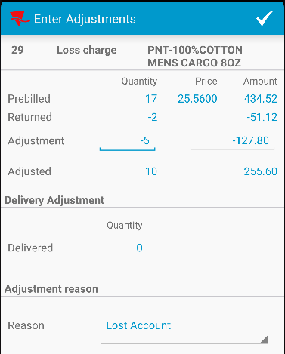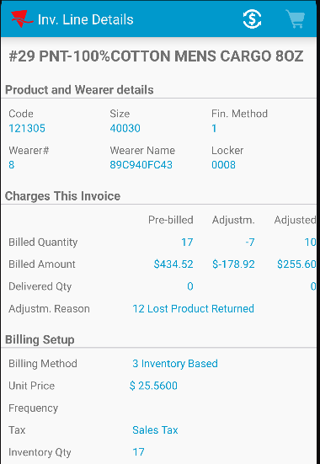
- Check the RA database.
SELECT T.type, T.invoiceline_id, T.long1, T.double1, T.Double6, T.Double3, T.invoice_id, T.invoiceline_id, T.route_id, T.stop_id, T.* from TRANSACTIONDTO T
WHERE T.type between 701 AND 707;
- RA: For another loss charge adjust it on plus.
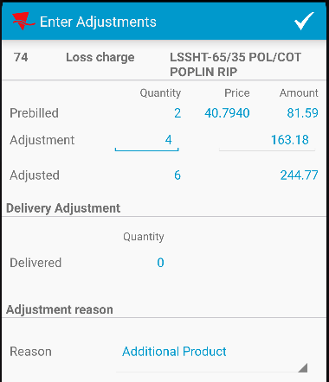
- Check PLSQL
SELECT T.type, T.invoiceline_id, T.long1, T.double1, T.Double6, T.Double3, T.invoice_id, T.invoiceline_id, T.route_id, T.stop_id, T.* from TRANSACTIONDTO T
WHERE T.type between 701 AND 707;
- RA: Add more 701 minus adjustments and 702 plus adjustments for the other rent lines.
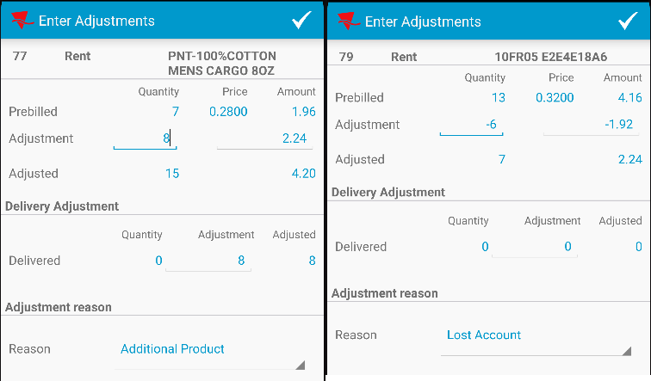
- RA: Check in the RA database.
SELECT T.type, T.invoiceline_id, T.long1, T.double1, T.Double6, T.Double3, T.invoice_id, T.invoiceline_id, T.route_id, T.stop_id, T.* from TRANSACTIONDTO T
WHERE T.type between 701 AND 707;
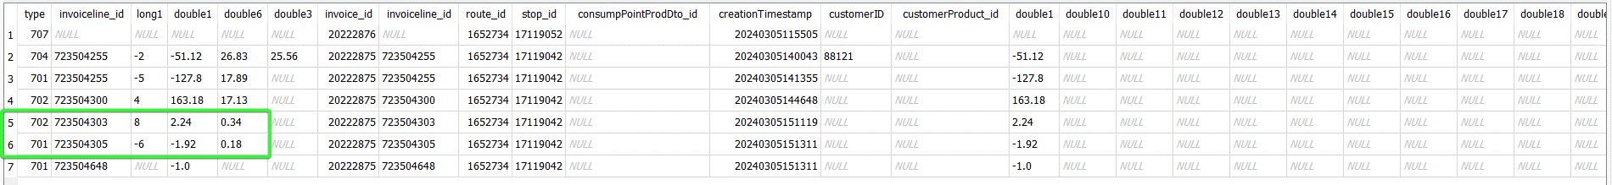
- Settle and depart from the customer
- RA: Arrive at the last customer 703 (customer 1624012, wearer 2, 10AI12) and scan for return 2 garments
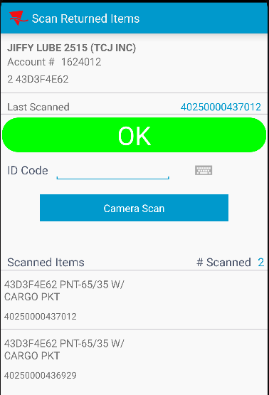
- RA: Bill all for loss now the rest of the garments.
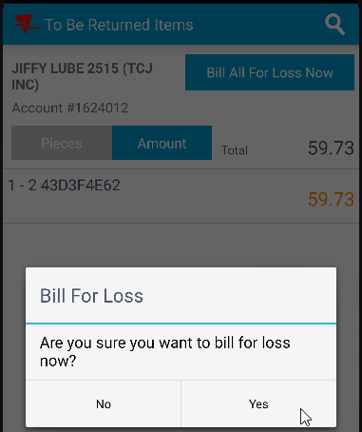
- Check the RA database.

SELECT T.type, T.invoiceline_id, T.long1, T.double1, T.Double6, T.Double3, T.invoice_id, T.invoiceline_id, T.route_id, T.stop_id, T.* from TRANSACTIONDTO T
WHERE T.type between 701 AND 707;
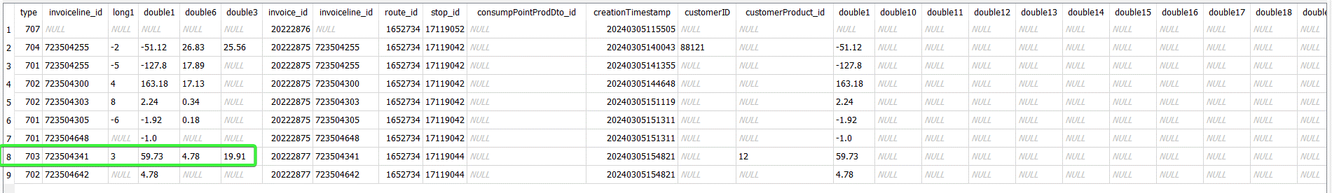
- RA: Add a plus adjustment on a regular line
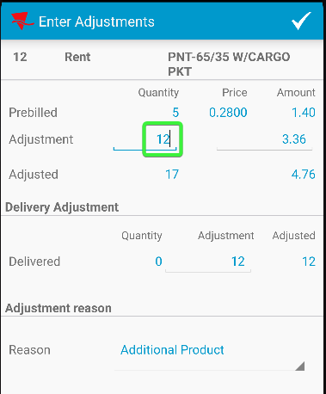
- RA: Add a minus adjustment on a regular line.
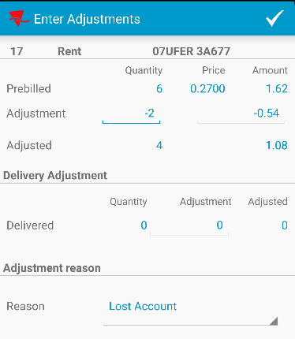

SELECT T.type, T.invoiceline_id, T.long1, T.double1, T.Double6, T.Double3, T.invoice_id, T.invoiceline_id, T.route_id, T.stop_id, T.* from TRANSACTIONDTO T
WHERE T.type between 701 AND 707;
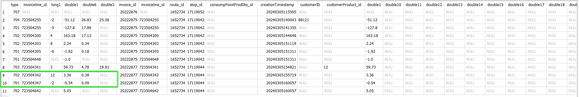
- RA: Settle, upload and depart.
- Check the adjustments in database.
select RT.ROUTETRANSACTIONTYPE_ID,RT.APPROVEDBYSYSTEMUSER_ID, RT.APPROVALTIMESTAMP, RT.PROCESSEDSTATUS, RT.APPROVALSTATUS, RT.WEARER_ID, RT.WEARERINVENTORY_ID, RT.STRINGVALUE1, RT.STRINGVALUE2, RT.STRINGVALUE3,
RT.DOUBLEVALUE1, RT.DOUBLEVALUE6, RT.DOUBLEVALUE9, RT.DOUBLEVALUE10,
RT.*
from ROUTETRANSACTION RT
left outer join INVOICELINE IL
on IL.INVOICELINE_ID = RT.INVOICELINE_ID
join INVOICEHEADER IH
on IH.INVOICEHEADER_ID = RT.INVOICEHEADER_ID
join STOP S
on S.STOP_ID = RT.STOP_ID
where RT.ROUTECONTROL_ID =
(select RC.ROUTECONTROL_ID
from ROUTECONTROL RC
join ROUTE R
on R.ROUTE_ID = RC.ROUTE_ID
join PLANT P
on P.PLANT_ID = R.PLANT_ID
where P.CODE = '088'
and R.ROUTENUMBER = 1
and RC.ORIGINALDRIVINGDATE = TO_DATE('20240305', 'YYYYMMDD'))
and RT.ROUTETRANSACTIONTYPE_ID in
(701, 702, 703, 704, 704, 705, 706, 707)
ORDER BY S.Stopnumber, IH.INVOICENUMBER, RT.DEVICETRANSACTION_ID asc;

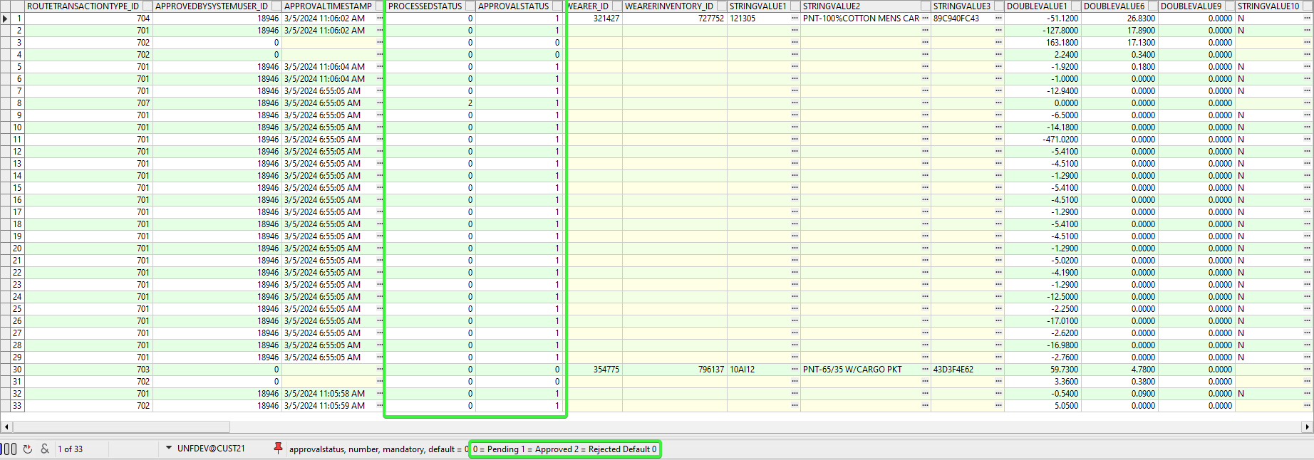
Invoice adjustments transactions are processed in settlement not in upload except from full invoice credit 707 that still creates the 701 invoice adjustments in upload.
So the RouteTransaction record is created at upload but the processing is now in settlement

The following columns will be updated after RA upload
RouteTransactionType_ID will be 701, 702, 703, 704 or 707
ApprovalStatus for 701, 704 and 707 will be 1 approved along with adjustment for taxes
ApprovedBySystemUser_ID with the system user ID used
ApprovalTimeStamp
Wearer_ID Wearer_ID
WearerInventory_ID WearerInventory_ID for transactions that don’t have invoiceline_ID (703 bill for loss now, 704 scan return for loss)
StringValue1 TransactionDTO.StringValue1 (Product Code)
StringValue2 TransactionDTO.StringValue2 (Description)
StringValue3 TransactionDTO.StringValue3 (Wearer.Name)
DoubleValue1 negative value of Invoiceline.amount
DoubleValue6 If module VERTEXTAX is in the license then 0 (new total tax for the invoice line)
NumberValue9 707 (so we can identify this came from a 707 transaction) or linked transactions the id should be the same, example 704 with 701
StringValue10 If the transaction type = 701, Then if the invoice line type of the invoice line being adjusted is set as RebillAdjustment = ‘Y’ then set this to ‘Y’ else ‘N’

- WebX: Check the route, the adjustments are present.
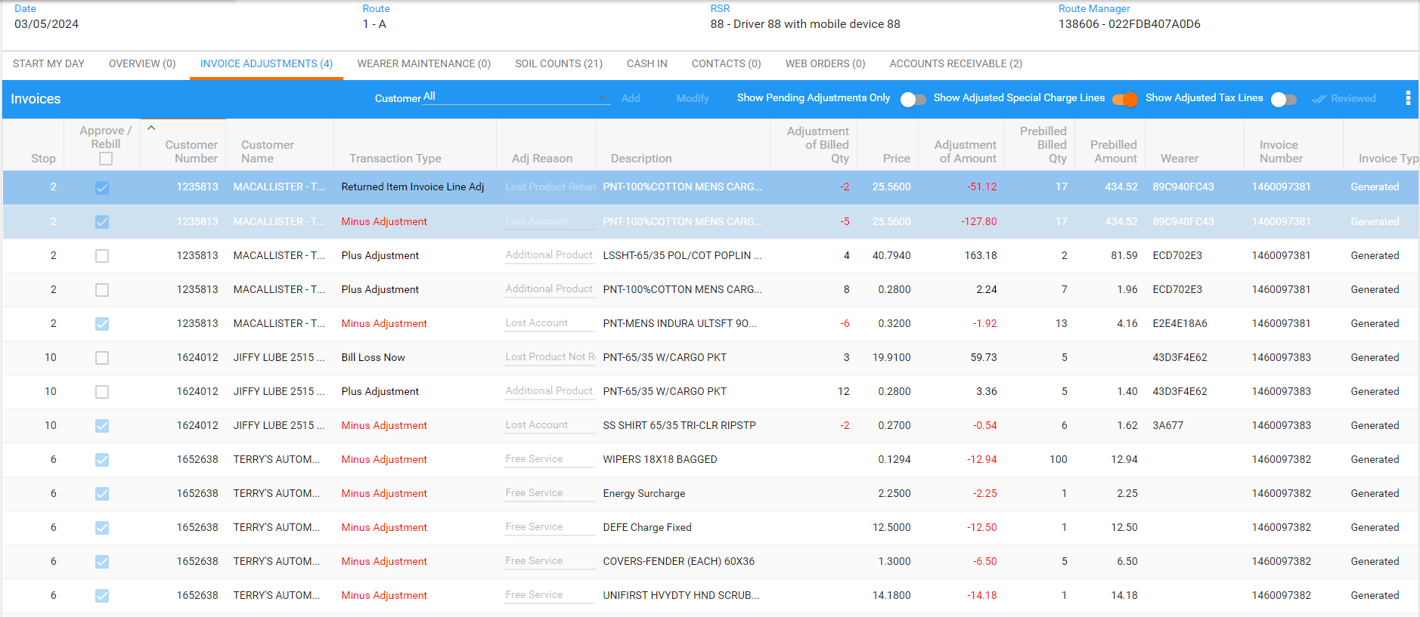
Tested OK

Test Case 1.2 – Invoice adjustments 701, 702, 703 (will be created on RA with quit wi)
Hash: 9.07.00.UNF11 hash: 5b7cd9c1c815 + 12.33.INTERNAL_TEST_ONLY.605962f4

Expected behavior:
Invoice adjustments transactions are processed in settlement not in upload except from full invoice credit 707 that still creates the 701 invoice adjustments in upload.
So the RouteTransaction record is created at upload but the processing is now in settlement

The following columns will be updated after RA upload
RouteTransactionType_ID will be 701, 702, 703, 704 or 707
ApprovalStatus for 701, 704 and 707 will be 1 approved along with adjustment for taxes
ApprovedBySystemUser_ID with the system user ID used
ApprovalTimeStamp
Wearer_ID Wearer_ID
WearerInventory_ID WearerInventory_ID for transactions that don’t have invoiceline_ID (703 bill for loss now, 704 scan return for loss)
StringValue1 TransactionDTO.StringValue1 (Product Code)
StringValue2 TransactionDTO.StringValue2 (Description)
StringValue3 TransactionDTO.StringValue3 (Wearer.Name)
DoubleValue1 negative value of Invoiceline.amount
DoubleValue6 If module VERTEXTAX is in the license then 0 (new total tax for the invoice line)
NumberValue9 707 (so we can identify this came from a 707 transaction) or linked transactions the id should be the same, example 704 with 701
StringValue10 If the transaction type = 701, Then if the invoice line type of the invoice line being adjusted is set as RebillAdjustment = ‘Y’ then set this to ‘Y’ else ‘N’

Test Steps:
System Settings:
USEROUTECHECKINSCREEN = Y
INVOICELINEADJADDRULE=1
INVOICELINEADJAPPROVERULE=1
INVOICELINEADJMODIFYRULE=2
INVOICELINEADJVALUERULE=1

- Route Status Control dlg: Create a new route and keep 1 customer which have garment delivery days.
- RSC: Generate invoices and send the route to PDA.
- RA: Download the route and arrive at the customer. Enter wearers and quit a wearer inventory. Bill all for loss now.
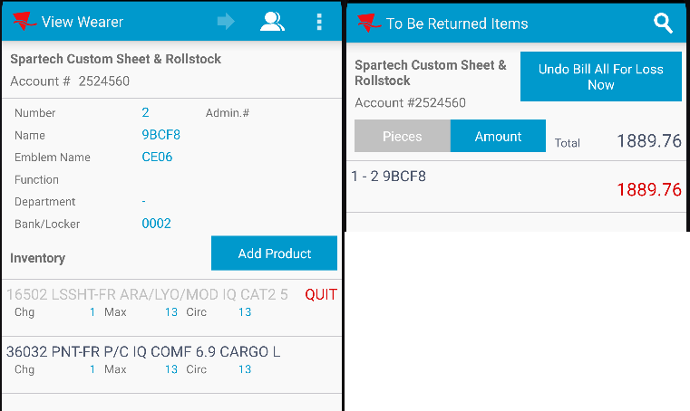
- Check the RA database for the transactions
SELECT T.type, T.invoiceline_id, T.long1, T.double1, T.Double6, T.Double3, T.invoice_id, T.invoiceline_id, T.route_id, T.stop_id, T.* from TRANSACTIONDTO T
WHERE T.type between 701 AND 707;
- RA: Settle the route and upload it.
- Check the transaction in database.
select RT.ROUTETRANSACTIONTYPE_ID,RT.APPROVEDBYSYSTEMUSER_ID, RT.APPROVALTIMESTAMP, RT.PROCESSEDSTATUS, RT.APPROVALSTATUS, RT.WEARER_ID, RT.WEARERINVENTORY_ID, RT.STRINGVALUE1, RT.STRINGVALUE2, RT.STRINGVALUE3,
RT.DOUBLEVALUE1, RT.DOUBLEVALUE6, RT.DOUBLEVALUE9, RT.Stringvalue10,
RT.*
from ROUTETRANSACTION RT
left outer join INVOICELINE IL
on IL.INVOICELINE_ID = RT.INVOICELINE_ID
join INVOICEHEADER IH
on IH.INVOICEHEADER_ID = RT.INVOICEHEADER_ID
join STOP S
on S.STOP_ID = RT.STOP_ID
where RT.ROUTECONTROL_ID =
(select RC.ROUTECONTROL_ID
from ROUTECONTROL RC
join ROUTE R
on R.ROUTE_ID = RC.ROUTE_ID
join PLANT P
on P.PLANT_ID = R.PLANT_ID
where P.CODE = '088'
and R.ROUTENUMBER = 2
and RC.ORIGINALDRIVINGDATE = TO_DATE('20240305', 'YYYYMMDD'))
and RT.ROUTETRANSACTIONTYPE_ID in
(701, 702, 703, 704, 704, 705, 706, 707)
ORDER BY S.Stopnumber, IH.INVOICENUMBER, RT.DEVICETRANSACTION_ID asc;
- WebX: Check the adjustment
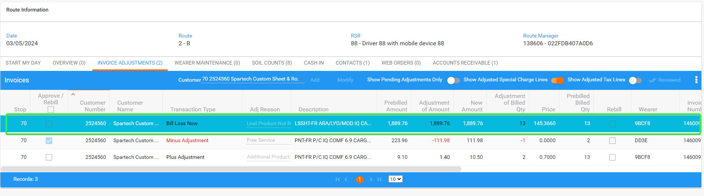
Tested OK

Test Case 2 – Scanning some garments for loss return and credit the rest
Hash: 9.07.00.UNF11 hash: 5b7cd9c1c815 + 12.33.INTERNAL_TEST_ONLY.605962f4

Expected behavior:
After scanning some garments for return, we should be able to full credit the remaining garments.

Test Steps:
System Settings:
USEROUTECHECKINSCREEN = Y
INVOICELINEADJADDRULE=1
INVOICELINEADJAPPROVERULE=1
INVOICELINEADJMODIFYRULE=2
INVOICELINEADJVALUERULE=1

- Route Status Control dlg: Create a new route and keep 1 customer which have garment delivery days. Make sure it has loss charges extend = Y. Generate invoices and send the route to PDA.
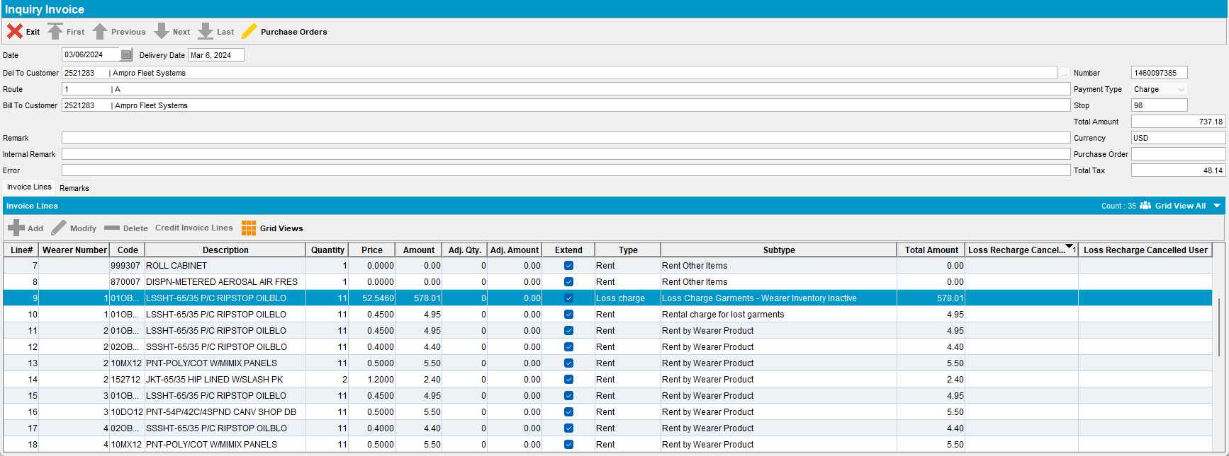
- RA: Download the route and arrive at the customer.
- RA: Enter Return items and scan for return some garments.
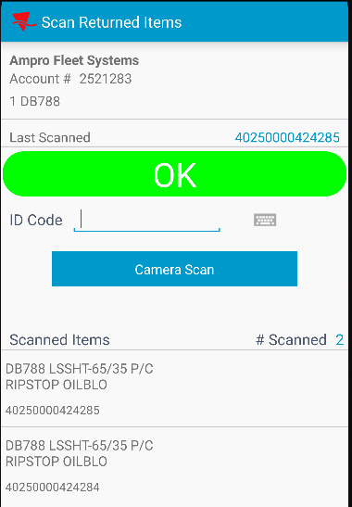
- RA: Enter adjust / View Lines and credit the rest of the garments
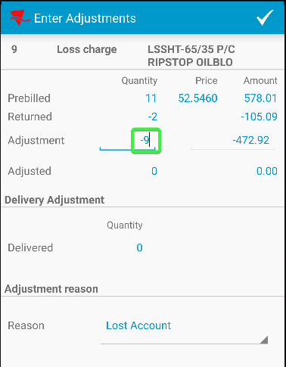 -> 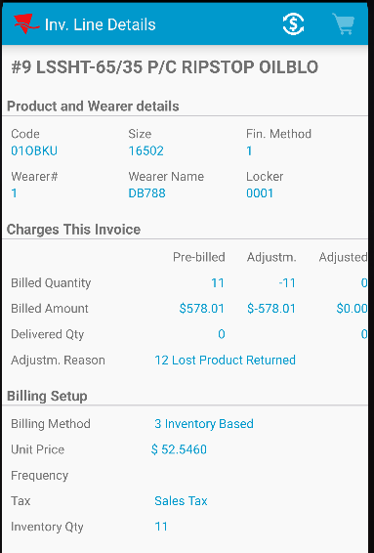
- RA: Settle the route and upload it.
- Check the adjustments it in database
select RT.ROUTETRANSACTIONTYPE_ID,RT.APPROVEDBYSYSTEMUSER_ID, RT.APPROVALTIMESTAMP, RT.PROCESSEDSTATUS, RT.APPROVALSTATUS, RT.WEARER_ID, RT.WEARERINVENTORY_ID, RT.STRINGVALUE1, RT.STRINGVALUE2, RT.STRINGVALUE3,
RT.DOUBLEVALUE1, RT.DOUBLEVALUE6, RT.DOUBLEVALUE9, RT.Stringvalue10,
RT.*
from ROUTETRANSACTION RT
left outer join INVOICELINE IL
on IL.INVOICELINE_ID = RT.INVOICELINE_ID
join INVOICEHEADER IH
on IH.INVOICEHEADER_ID = RT.INVOICEHEADER_ID
join STOP S
on S.STOP_ID = RT.STOP_ID
where RT.ROUTECONTROL_ID =
(select RC.ROUTECONTROL_ID
from ROUTECONTROL RC
join ROUTE R
on R.ROUTE_ID = RC.ROUTE_ID
join PLANT P
on P.PLANT_ID = R.PLANT_ID
where P.CODE = '088'
and R.ROUTENUMBER = 1
and RC.ORIGINALDRIVINGDATE = TO_DATE('20240306', 'YYYYMMDD'))
and RT.ROUTETRANSACTIONTYPE_ID in
(701, 702, 703, 704, 704, 705, 706, 707)
ORDER BY S.Stopnumber, IH.INVOICENUMBER, RT.DEVICETRANSACTION_ID asc;
- Check the adjustments it in WebX.
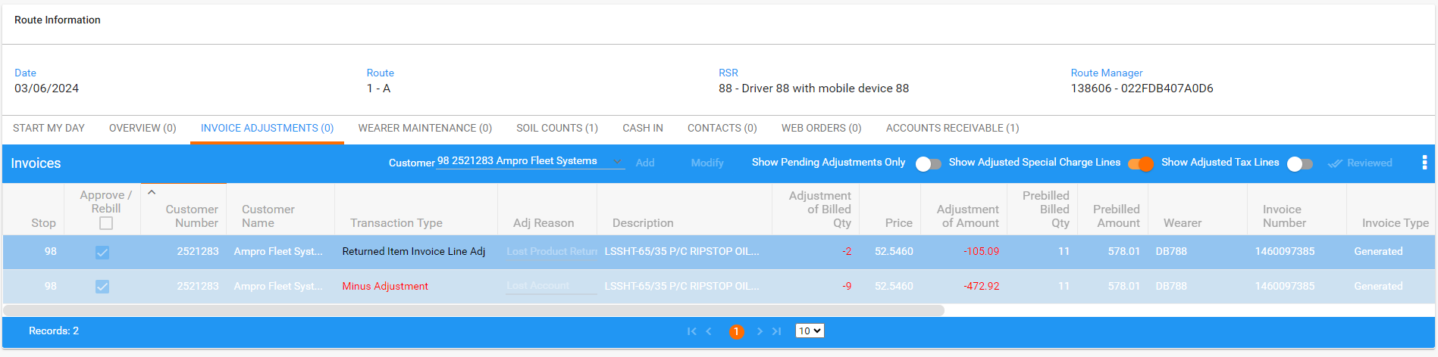

Tested OK

Test Case 3 - Changing a special charge from percentage to fixed
Hash: 9.07.00.UNF11 hash: 5b7cd9c1c815 + 12.33.INTERNAL_TEST_ONLY.605962f4

Expected behavior:
If the RA changes a percentage special charge to a fixed one, it stays fixed no matter what we do in WebX
This will be done by deleting records from SpecialChargePerInvoiceLine in upload which will stop it recalculating and
put Y on stringvalue4 from TransactionDTO when a special charge is manual adjusted

Test Steps:
System Settings:
USEROUTECHECKINSCREEN = Y
INVOICELINEADJADDRULE=1
INVOICELINEADJAPPROVERULE=1
INVOICELINEADJMODIFYRULE=2
INVOICELINEADJVALUERULE=1

- Route Status Control dlg: Create a new route and keep 2 customers which have garment delivery days.
- Special Charges dlg: Add 2 new special charges. First which applies to rent lines and second which applies to rent lines and other special charges.
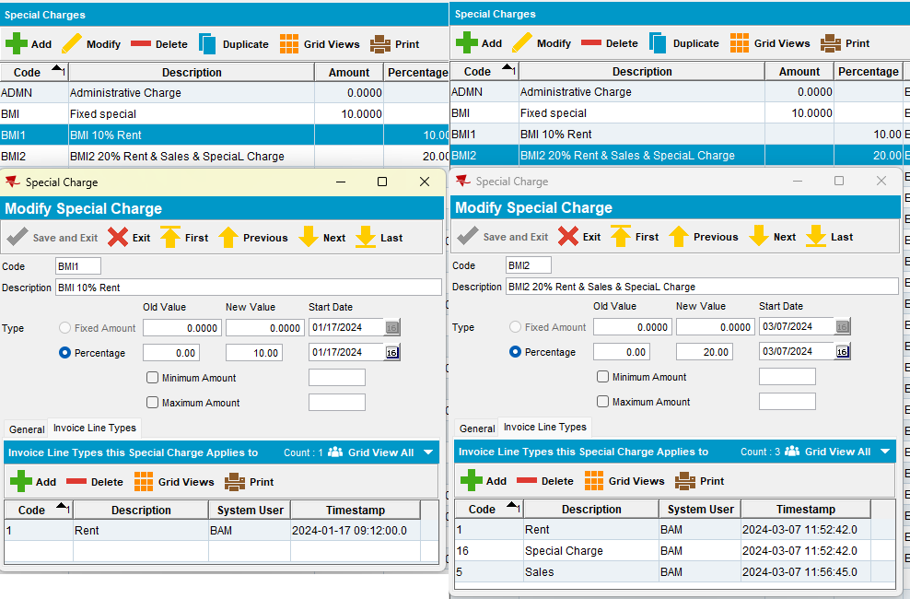

- Customers dlg: Add both the percentage special charges on the customers and one fixed amount. Also add a minimum invoice amount.
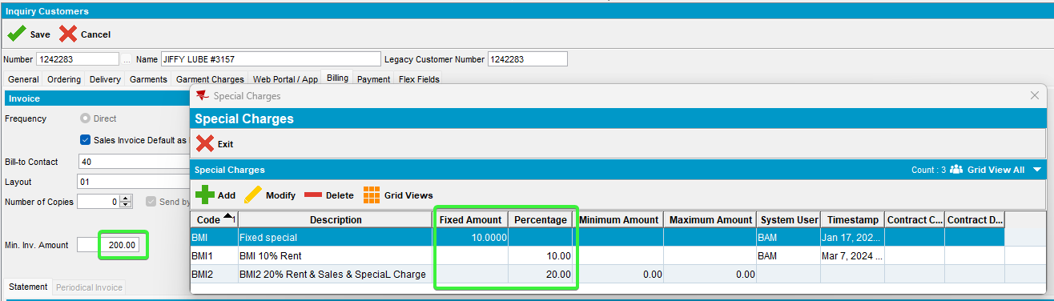
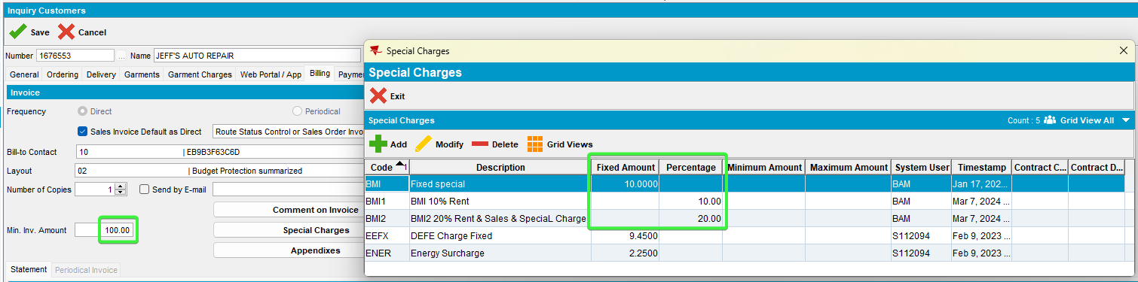
- Route Status Control dlg: Generate invoices and send the route to PDA.
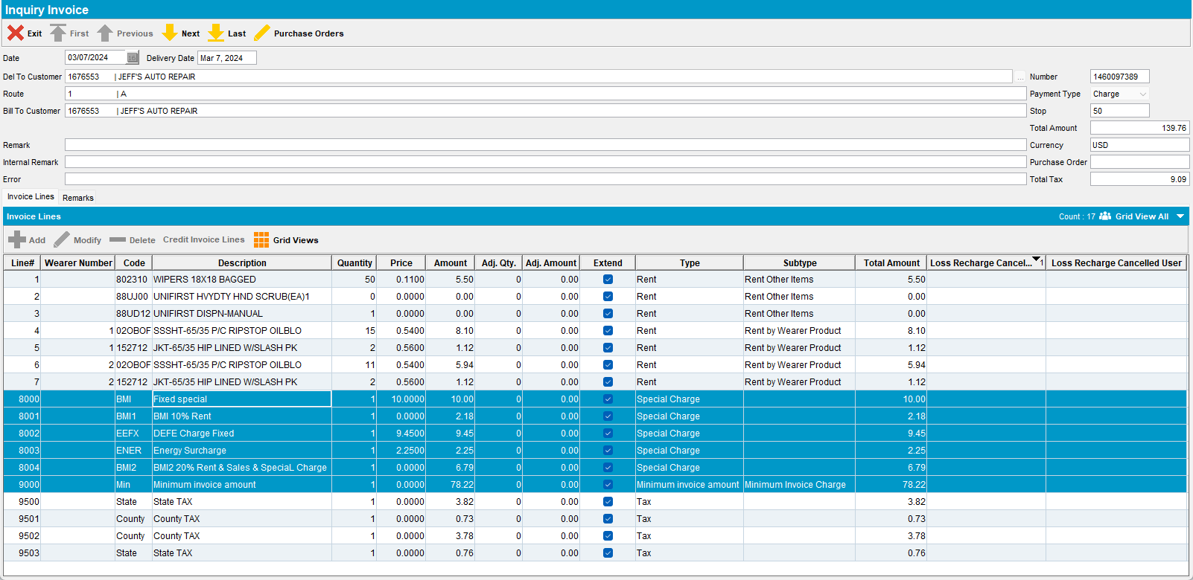
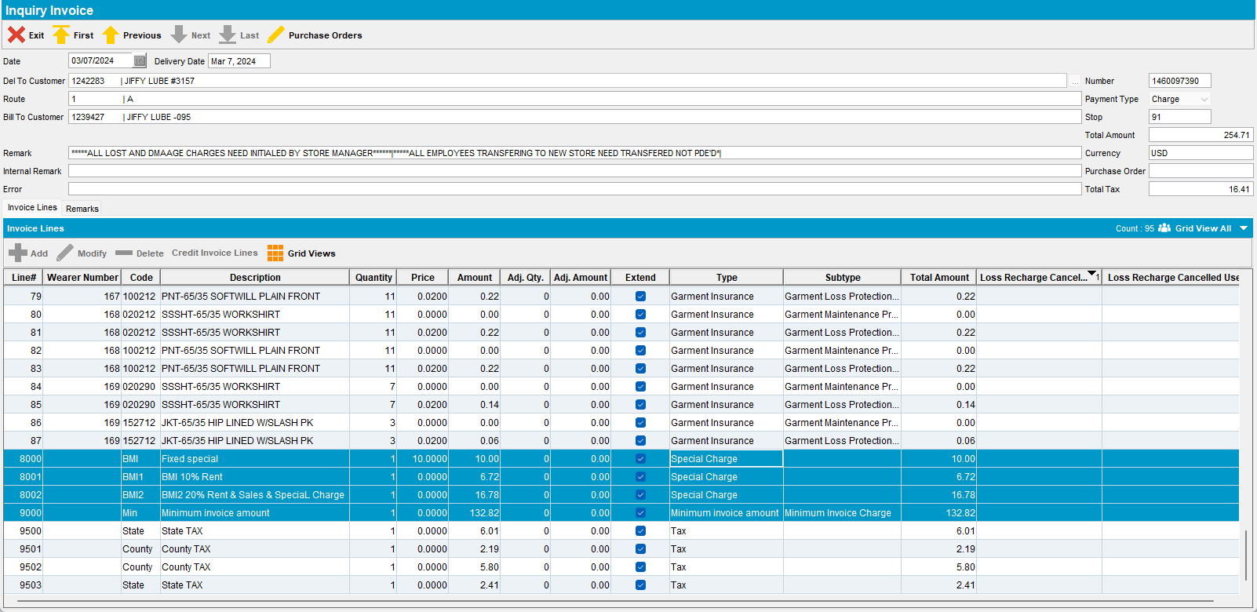
- RA: Download the route and arrive at the first customer. Enter adjust and adjust the first percentage special charge that applies only to rent lines with a plus value.
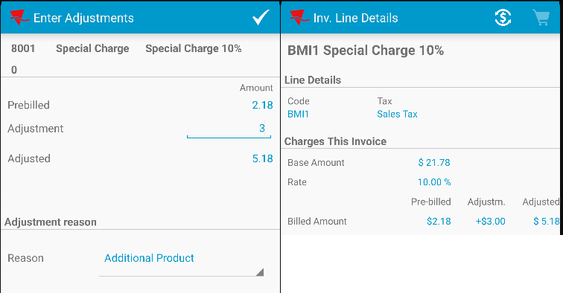

- Check the RA database.
SELECT T.type, T.invoiceline_id, T.long1, T.double1, T.Double6, T.Double3, T.invoice_id, T.invoiceline_id, T.route_id, T.stop_id, T.string4, T.* from TRANSACTIONDTO T
WHERE T.type between 701 AND 707;
- Check in database the SpecialChargePerInvLine for the customers invoice.
select SCPIL.*
from SpecialChargePerInvLine SCPIL
where SCPIL.INVOICELINE_ID in
(select IL.INVOICELINE_ID
from INVOICELINE IL
join INVOICEHEADER IH
ON IH.INVOICEHEADER_ID = IL.INVOICEHEADER_ID
where IH.INVOICENUMBER = 1460097389)
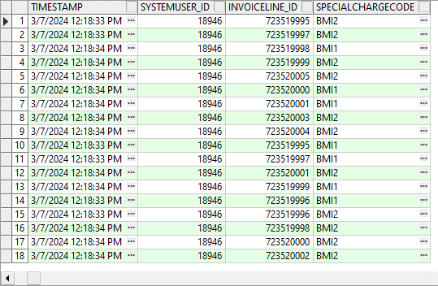

- RA: Adjust a fixed special charge
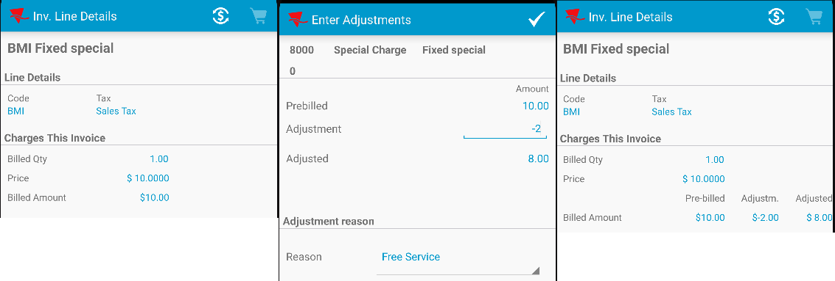
- Check the RA database.
SELECT T.type, T.invoiceline_id, T.long1, T.double1, T.Double6, T.Double3, T.invoice_id, T.invoiceline_id, T.route_id, T.stop_id, T.string4, T.* from TRANSACTIONDTO T
WHERE T.type between 701 AND 707;
- RA: Arrive at the second customer and adjust the second percentage special charge that applies to rent lines and other special charges with a minus value.
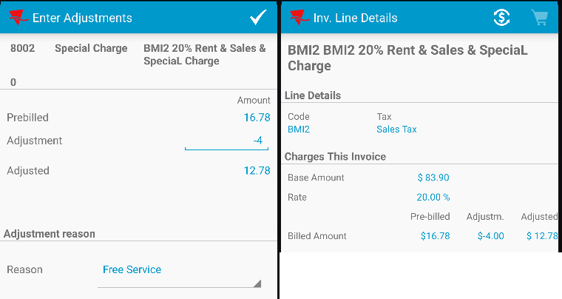
- Check the RA database
SELECT T.type, T.invoiceline_id, T.long1, T.double1, T.Double6, T.Double3, T.invoice_id, T.invoiceline_id, T.route_id, T.stop_id, T.string4, T.* from TRANSACTIONDTO T
WHERE T.type between 701 AND 707;
- Check in database the SpecialChargePerInvLine for the second customer invoice.
select SCPIL.*
from SpecialChargePerInvLine SCPIL
where SCPIL.INVOICELINE_ID in
(select IL.INVOICELINE_ID
from INVOICELINE IL
join INVOICEHEADER IH
ON IH.INVOICEHEADER_ID = IL.INVOICEHEADER_ID
where IH.INVOICENUMBER = 1460097390)
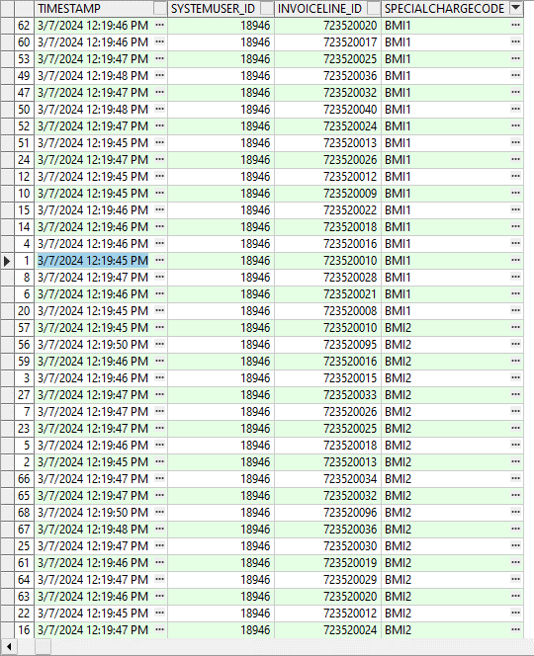

- RA: Adjust a fixed special charge
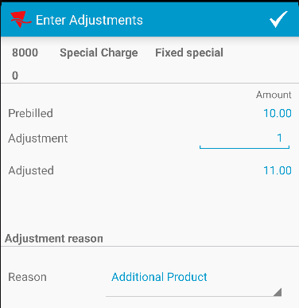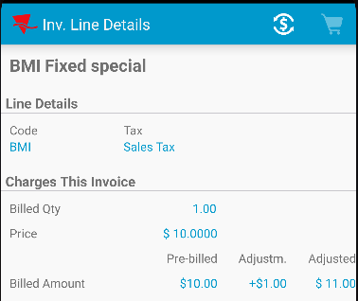
- Check the RA database
SELECT T.type, T.invoiceline_id, T.long1, T.double1, T.Double6, T.Double3, T.invoice_id, T.invoiceline_id, T.route_id, T.stop_id, T.string4, T.* from TRANSACTIONDTO T
WHERE T.type between 701 AND 707;
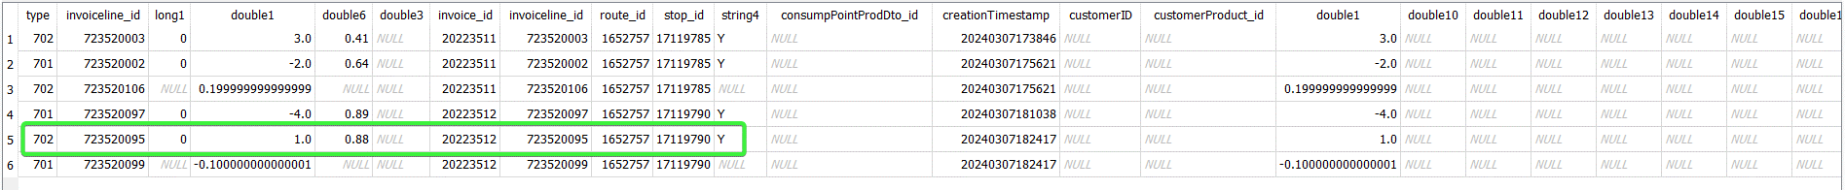

- RA: Adjust a regular rent line
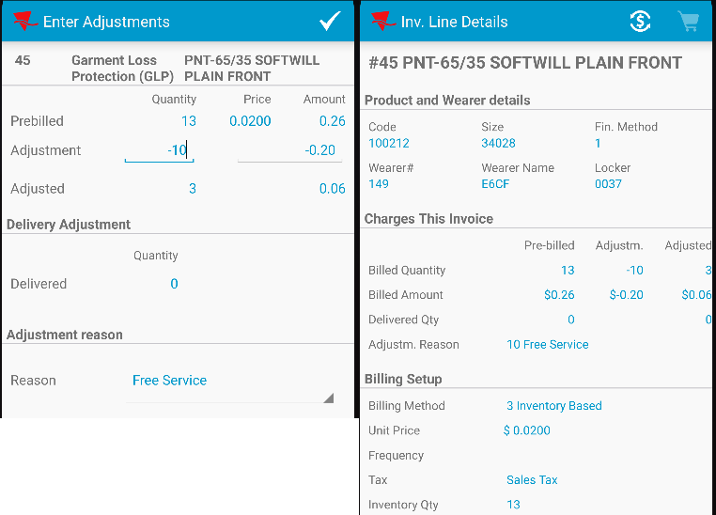
- Check the RA database
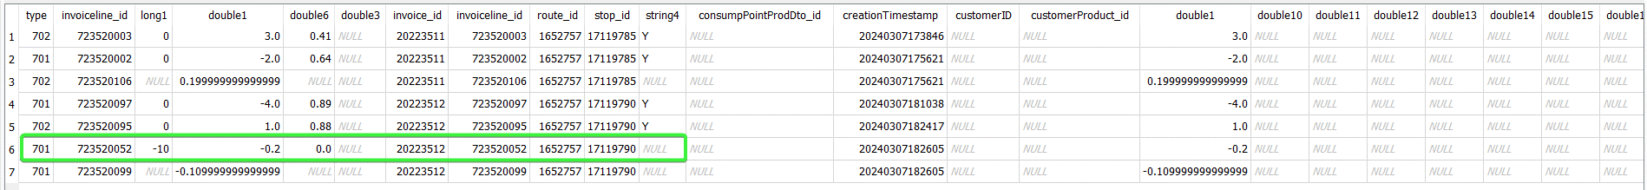
- RA: Settle the route and upload it
- Check the client database
select RT.ROUTETRANSACTIONTYPE_ID,RT.APPROVEDBYSYSTEMUSER_ID, RT.APPROVALTIMESTAMP, RT.PROCESSEDSTATUS, RT.APPROVALSTATUS, RT.WEARER_ID, RT.WEARERINVENTORY_ID, RT.STRINGVALUE1, RT.STRINGVALUE2, RT.STRINGVALUE3,
RT.DOUBLEVALUE1, RT.DOUBLEVALUE6, RT.DOUBLEVALUE9, RT.Stringvalue10,
RT.*
from ROUTETRANSACTION RT
left outer join INVOICELINE IL
on IL.INVOICELINE_ID = RT.INVOICELINE_ID
join INVOICEHEADER IH
on IH.INVOICEHEADER_ID = RT.INVOICEHEADER_ID
join STOP S
on S.STOP_ID = RT.STOP_ID
where RT.ROUTECONTROL_ID =
(select RC.ROUTECONTROL_ID
from ROUTECONTROL RC
join ROUTE R
on R.ROUTE_ID = RC.ROUTE_ID
join PLANT P
on P.PLANT_ID = R.PLANT_ID
where P.CODE = '088'
and R.ROUTENUMBER = 1
and RC.ORIGINALDRIVINGDATE = TO_DATE('20240307', 'YYYYMMDD'))
and RT.ROUTETRANSACTIONTYPE_ID in
(701, 702, 703, 704, 704, 705, 706, 707)
ORDER BY S.Stopnumber, IH.INVOICENUMBER, RT.DEVICETRANSACTION_ID asc;

- Recheck the SpecialChargePerInvLine for the first customer invoice.
select SCPIL.*
from SpecialChargePerInvLine SCPIL
where SCPIL.INVOICELINE_ID in
(select IL.INVOICELINE_ID
from INVOICELINE IL
join INVOICEHEADER IH
ON IH.INVOICEHEADER_ID = IL.INVOICEHEADER_ID
where IH.INVOICENUMBER = 1460097389)
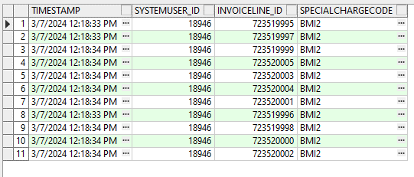
The SpecialChargePerInvLine for the first special percentage charge we’ve adjusted, was deleted, special charge BMI1. The other records for the other percentage special charge were kept.

- Recheck the SpecialChargePerInvLine for the second customer invoice.
select SCPIL.*
from SpecialChargePerInvLine SCPIL
where SCPIL.INVOICELINE_ID in
(select IL.INVOICELINE_ID
from INVOICELINE IL
join INVOICEHEADER IH
ON IH.INVOICEHEADER_ID = IL.INVOICEHEADER_ID
where IH.INVOICENUMBER = 1460097390)
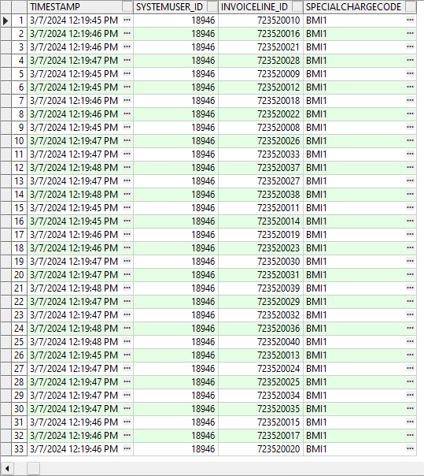

The SpecialChargePerInvLine for the second percentage special charge we’ve adjusted, was deleted, special charge BMI2. The other records for the other percentage special charge were kept.

- WebX: Complete the start my day and check the special charges.
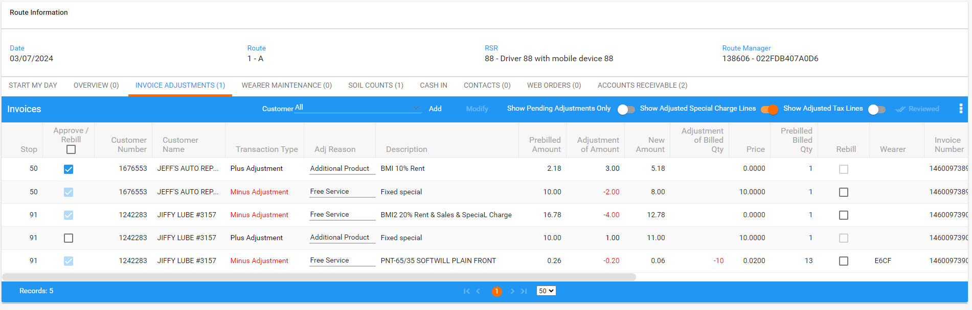

Tested OK

