RASA-3485 Duplicate Wearers appear on PDA when more routes are downloaded in the same time/RASA-4254 Downgrading to version 12.33

Environment | Prerequisites
Version: 9.07.00.UNF10 hash: 19585c978885  RASA v12.33 hash 9296f329  DBServerName= abs-srv16.internal.abslbs.com  DBSID=CUST21  DBUser=UNFDEV  DBPassword=UNFDEV  Environment=Test | - Module:  - System setting:  - Other applications versions (if is applicable)  - Device used for mobile applications (if is applicable: Memo, physical device, Nox)

Contents
Reproducing before fix 1
Retest after fix 3
Test Case – Adding a new wearer with a product on PDA when many routes are downloaded on the device 3

Reproducing before fix

Hash: RA v 12.27

BU/Plant:044

Steps to reproduce
- Add 3 new routes in RSC, generate invoices and mark ready for transfer

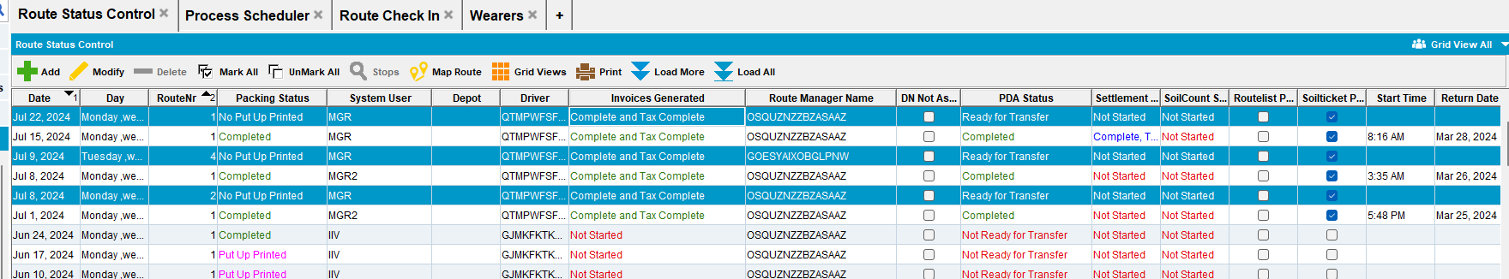

- RASA: download the routes on pda

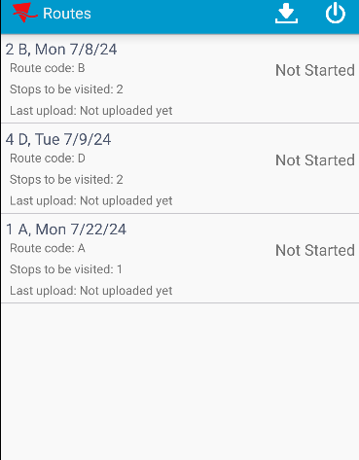
- Select one route and add a new wearer with a specific product

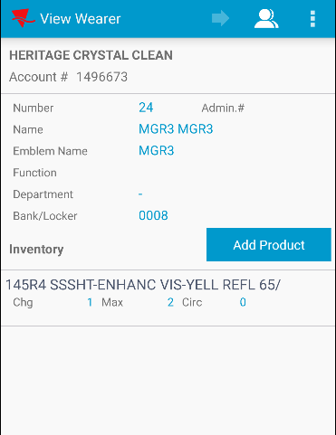
- Assign another product to this wearer
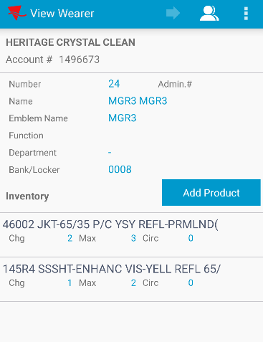
- Finalize the route and upload the route
- Check on the client the wearer added

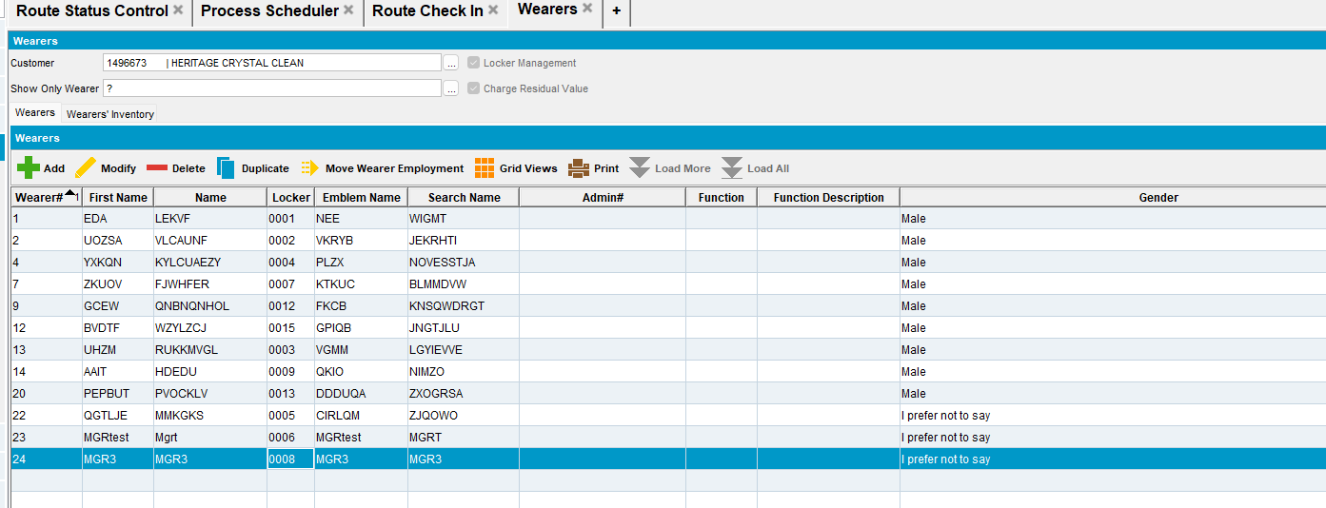
- RSC: Add the same route for the next week delivery day. Generate invoices. Mark ready for transfer the route
- Download the route on pda
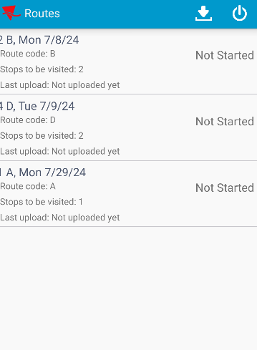
- Select route no 1. Check if the wearer isn’t duplicated

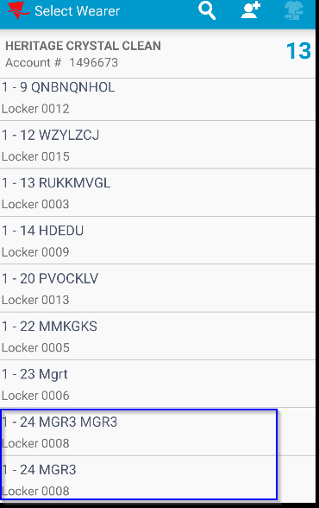
REPRODUCED OK.

Retest after fix

Test Case – Adding a new wearer with a product on PDA when many routes are downloaded on the device

- Add 3 new routes in RSC, generate invoices and mark ready for transfer
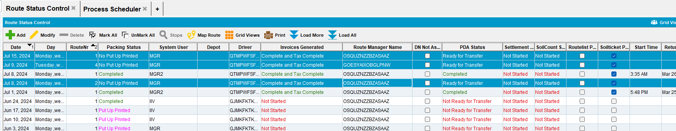
- RASA: download the routes on pda
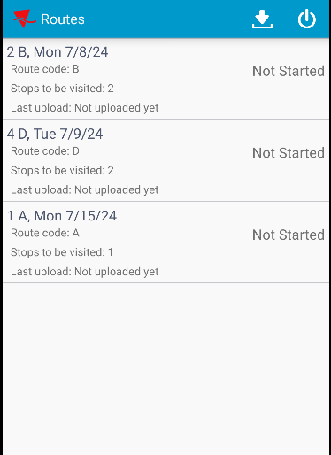
- Select one route and add a new wearer with a specific product
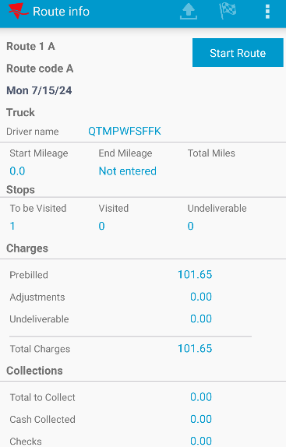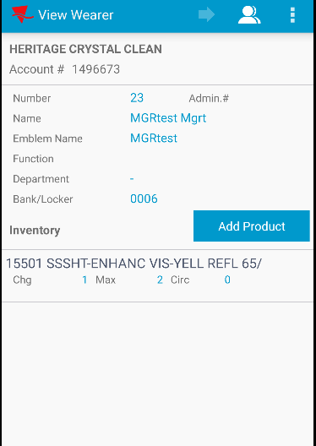
- Assign another product to this wearer
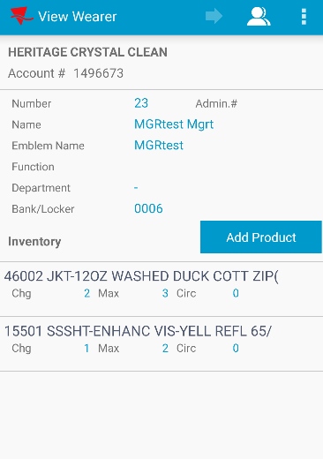
- Finalize the route and upload the route
- Check on the client the wearer added

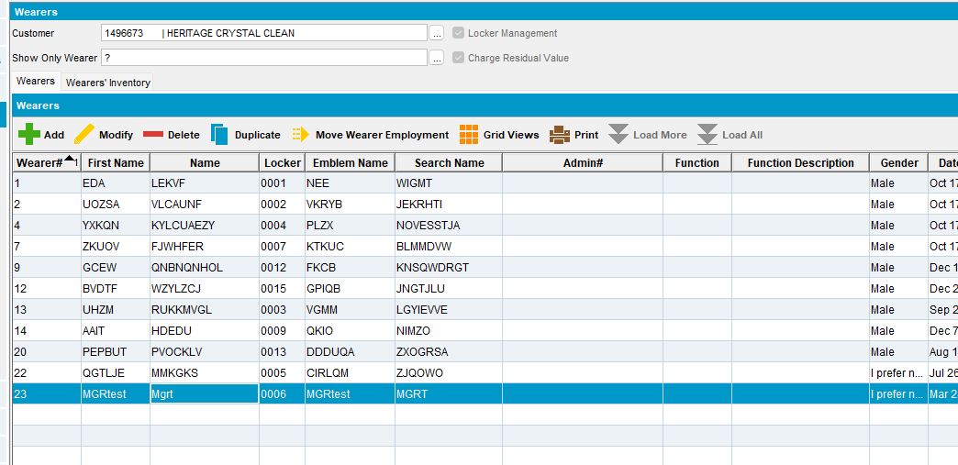
- RSC: Add the same route for the next week delivery day. Generate invoices. Mark ready for transfer the route
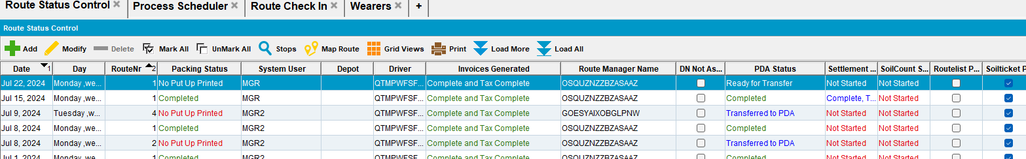
- Download the route on pda
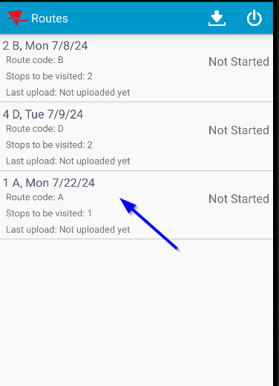
- Select route no 1. Check if the wearer isn’t duplicated
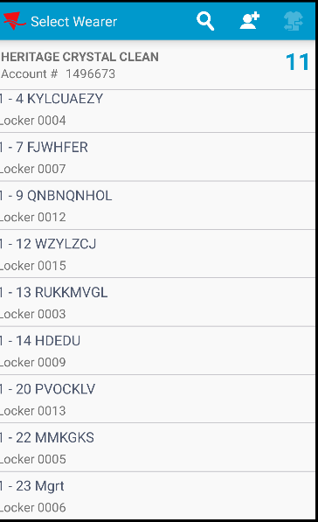
I noticed that the wearer is not duplicated.
Pretest ok.

