RASA-4164 D_UBS_2304 Emblem Template description of 30 characters is preventing user from completing CAN order on the RA
Environment | Prerequisites
Version:9.07.00.UNF10.p01_UNF  DBServerName= abs-srv16.internal.abslbs.com  DBSID=CUST21  DBUser=UNFDEV  DBPassword=UNFDEV  Environment=PRODUCTION | - Module:  - System setting:

Contents
Retest before fix 1
Steps to reproduce 1
Retest after fix 3
Steps to reproduce 3

Retest before fix
Bu: 095 Fort Wayne, IN
9.08.00.RC1 hash: 8f2ba096a893 + RA 12.32
Android Version 10
Device resolution is 1280 x 720.

Steps to reproduce
- RSC dlg: Create a new route containing a customer with wearers that have emblem templates with Emblem Template description of 30 characters, eg: 1379452
- Contract dlg: Load the contract 0747477 at which the customer is linked and modify an emblem template with the maximum character description.
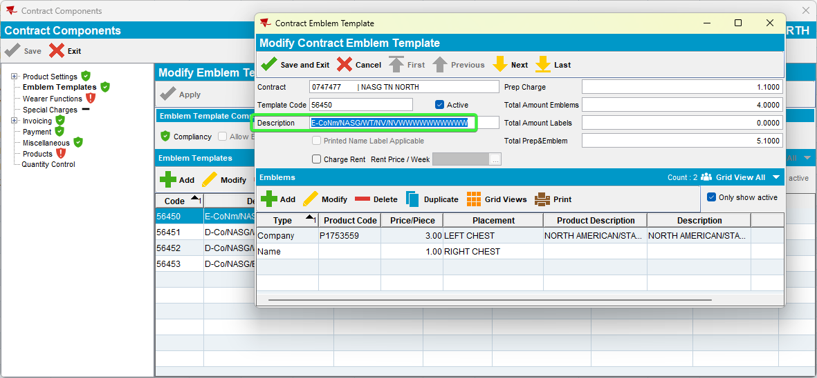
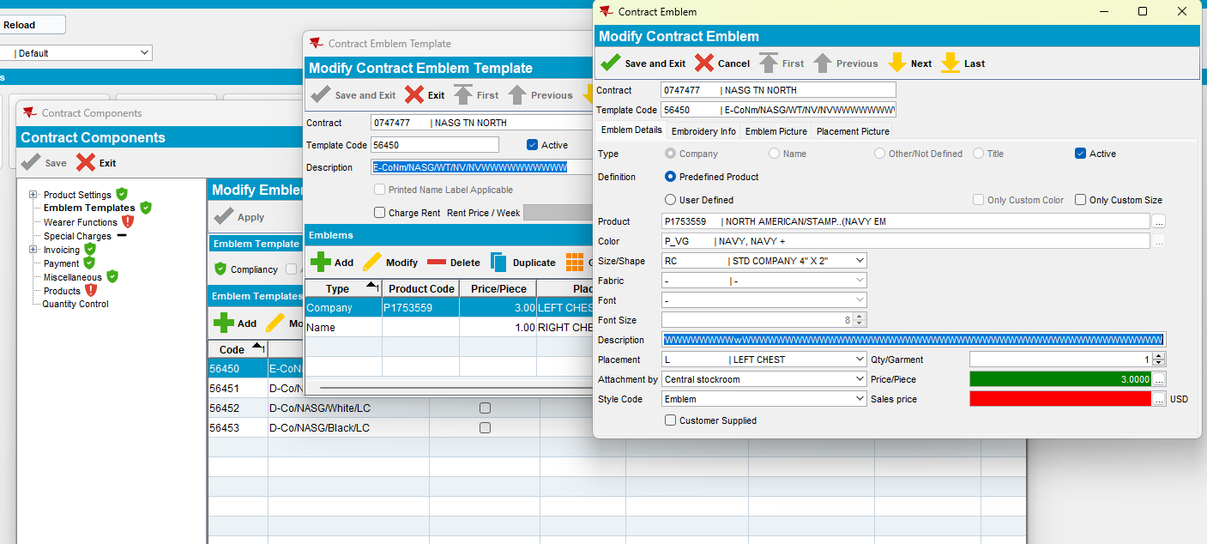
- RSC dlg: Generate invoices and send the route to PDA.
- RA: Scan replace a garment from that wearer inventory.
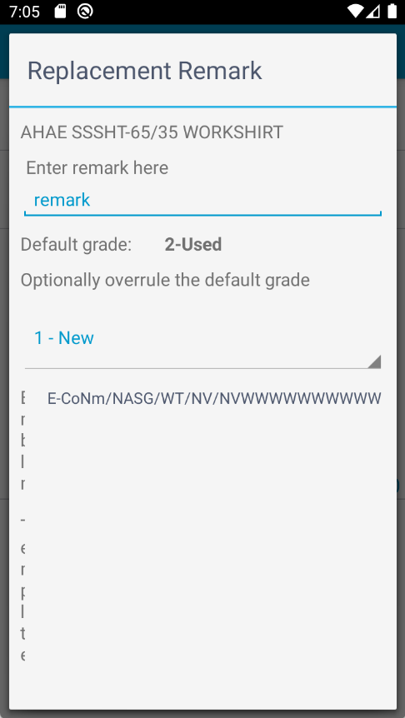

REPRODUCED OK

Retest after fix
Bu: 095 Fort Wayne, IN
9.07.00.UNF10 hash: 846c555de3da + RouteAssistant_v12.33.INTERNAL_TEST_ONLY.fee99a46.apk
Android Version 10
Device resolution is 1280 x 720.

Steps to reproduce
- RSC dlg: Create a new route containing a customer with wearers that have emblem templates with Emblem Template description of 30 characters, eg: 1379452
- Contract dlg: Load the contract 0747477 at which the customer is linked and modify an emblem template with the maximum character description.
- RSC dlg: Generate invoices and send the route to PDA.
- RA: Scan replace a garment from that wearer inventory.
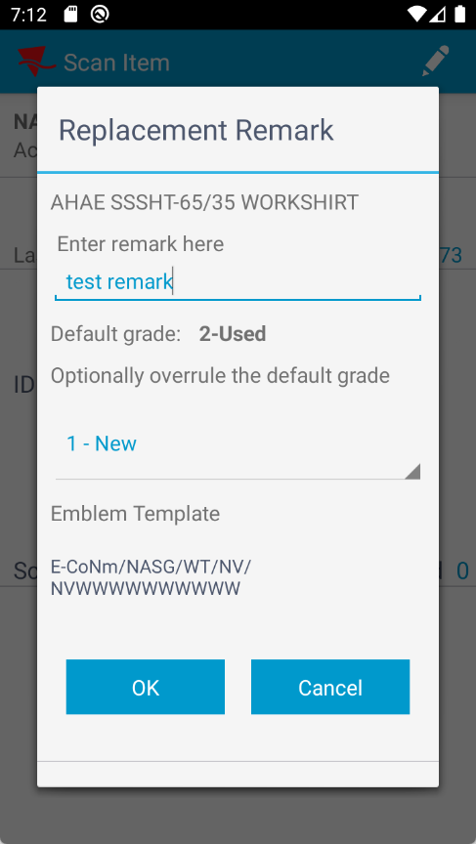
- RA: Settle, depart, finish and upload the route.
- View process log dlg: No errors
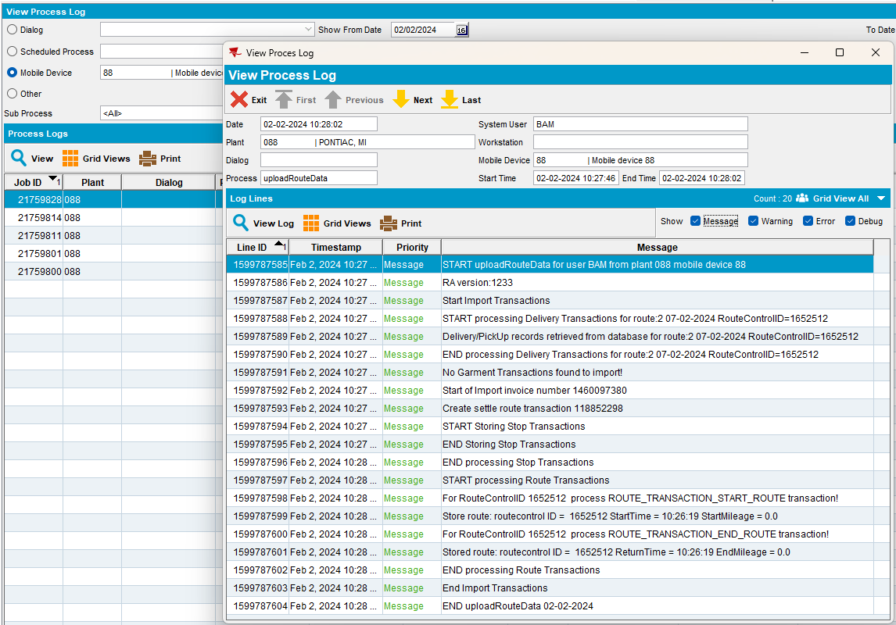
RETESTED OK

