RASA-4177 D_UBS_2317 VertexTax - Double6 value is not recalculated correctly
Environment | Prerequisites
Version: 9.07.00.UNF10  DBServerName= abs-srv16.internal.abslbs.com  DBSID= CUST21  DBUser= UNFDEV  DBPassword= UNFDEV  Environment=Production | Module: VERTEXTAX  APK: RouteAssistant_v13.15.INTERNAL_TEST_ONLY.8b55d8a09.apk

Contents
Reproducing before fix 1
Version: 9.07.00.UNF10 & APK: 12.31 1
BU/Plant: 025 1
Steps to reproduce 1
Current behavior 5
Retest after fix 5
Version: 9.07.00.UNF9 hash: 34e326937f51 5
BU/Plant: 025 5
Data preparation 5
Test Case 1 – Return garments, (701) adjust invoice line and then return more garments 5
Expected behavior: 5
Steps to reproduce 6
Test Case 2 – Return garments, (702) adjust invoice line and then return more garments 11
Expected behavior: 11
Steps to reproduce 11
Test Case 3 – (702) adjust invoice line and then return garments 17
Expected behavior: 17
Steps to reproduce 18
Test Case 4 – (701) adjust invoice line and then return garments 20
Expected behavior: 20
Steps to reproduce 20

Reproducing before fix

Version: 9.07.00.UNF10 & APK: 12.31

BU/Plant: 025
Steps to reproduce
- Find a customer with wearers (example: 1489592 on BU 025)
- Find a wearer on this customer with a wearer inventory of 8 circ/8 max
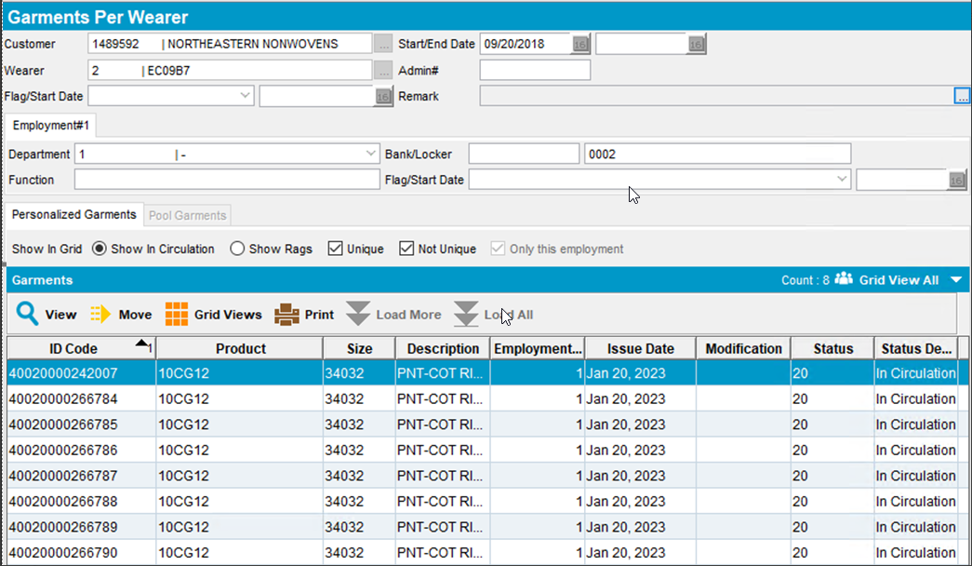
- Do a reduction of max inventory from 8 to 3
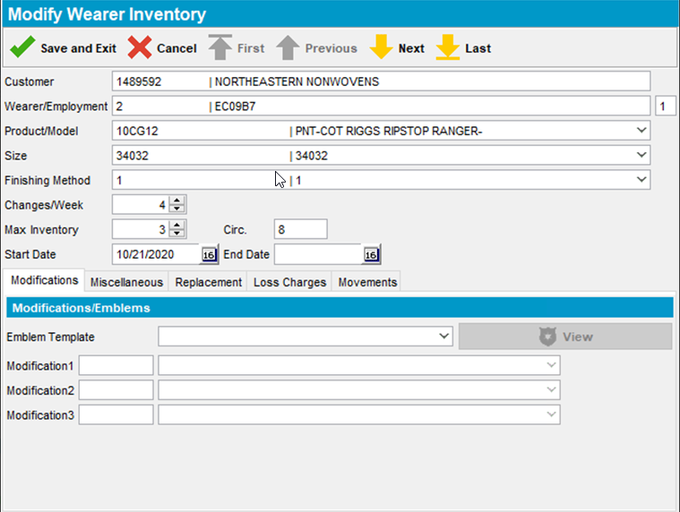
- Generate invoices 2 weeks after the current week
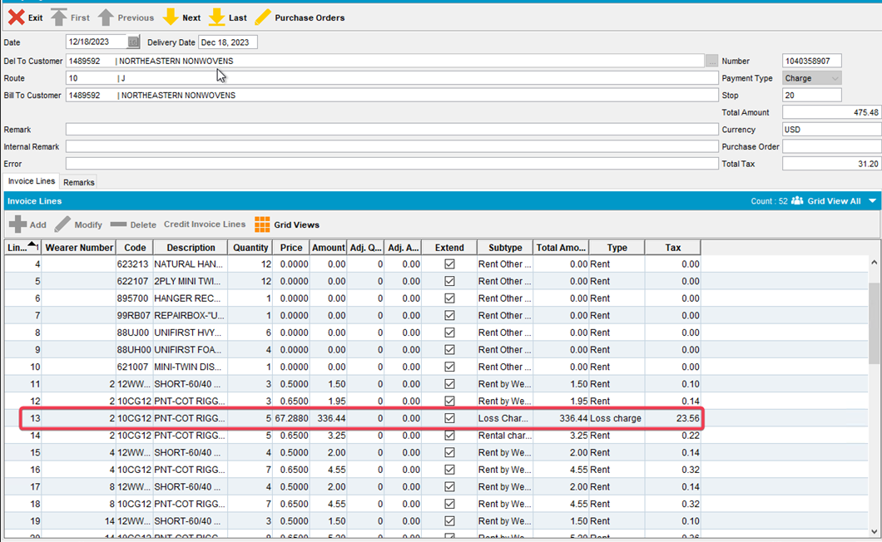
- Send the route to RA
- After arriving at the customer return 2 of the garments this adjusts the loss line by -2
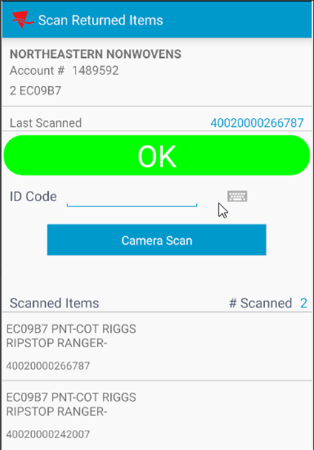
- Check the new tax on the Adjust screen
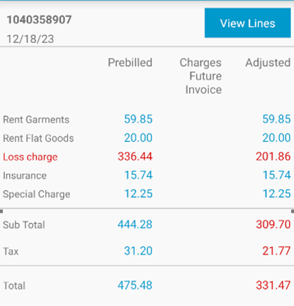
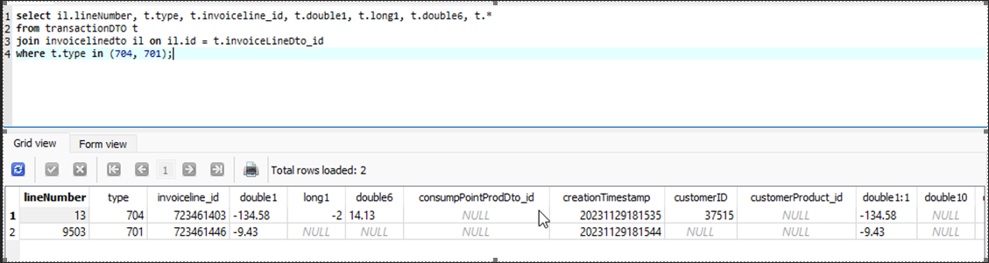
New Tax on 704 = > 336.44 – 134.58 = 201.86 * 0.07 = 14.13 (this is the double6)
So Tax line adjustment is prebill tax for this line 23.56 – 14.13 = 9.43
New total tax is 31.2 – 9.43 = 21.77
- Adjust the same loss charge line by -1 to a quantity of 2
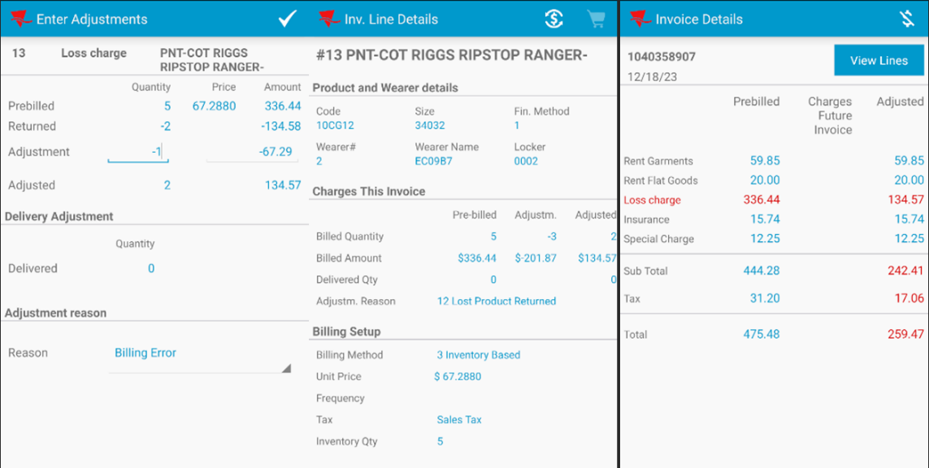
- Check the tax and route transactions
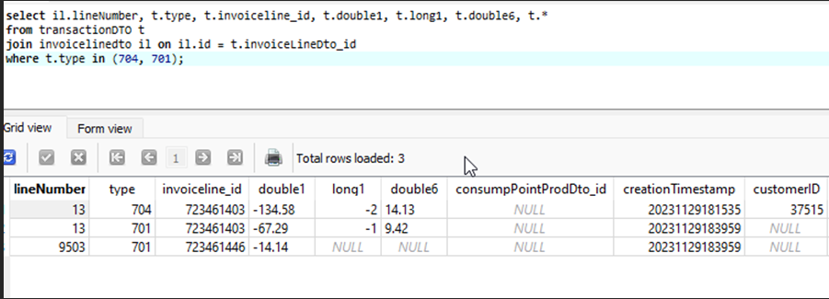
Double6 on 704 => (336.44 – 134.58) * 0.07 = 14.13 (this is the double6)
Double6 on 701 => (336.44 – 134.58 – 67.29) * 0.07 = 9.4199 (rounded up to 9.42)
So Tax line adjustment is prebill tax for this line 9.42 – 23.56= -14.14
New Total tax is 31.2 – 14.14 = 17.06
- Return 2 more garments this adjusts the invoice line by -2 to a quantity of 0
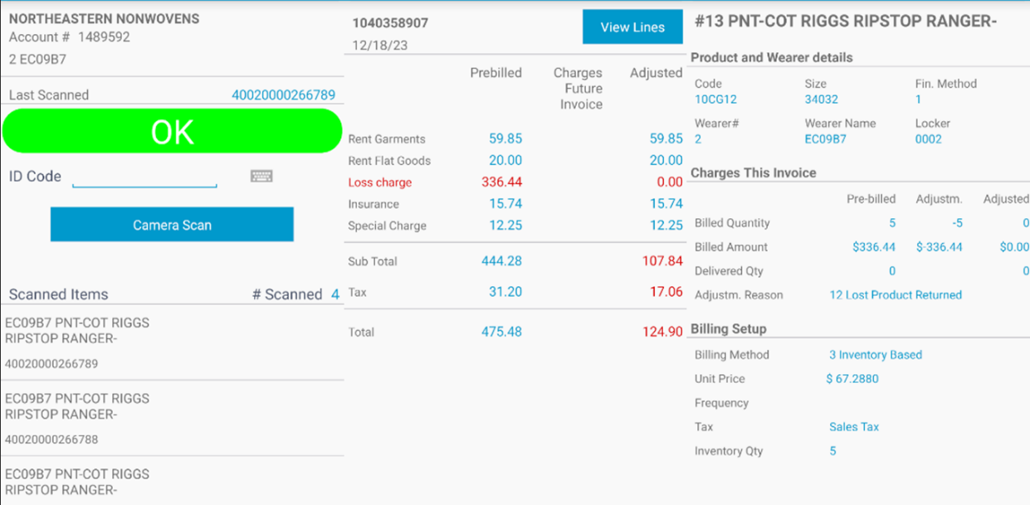
- Check the tax and route transactions again
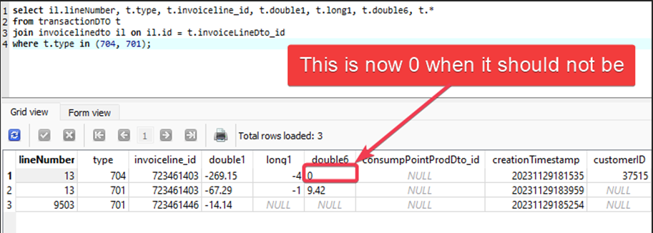
Current behavior
We are only updating the 704 transaction and the 701 transaction is not updated, but because the 701 transaction was generated after the 704 it is the 701 double6 value that is used to calculate the final tax adjustment.

Retest after fix

Version: 9.07.00.UNF9 hash: 34e326937f51 & RouteAssistant_v12.32

BU/Plant: 025

Data preparation
- Find a customer with wearers (example: 1489592 on BU 025)
- Generate several loss charges via DOI and Quit Wearer
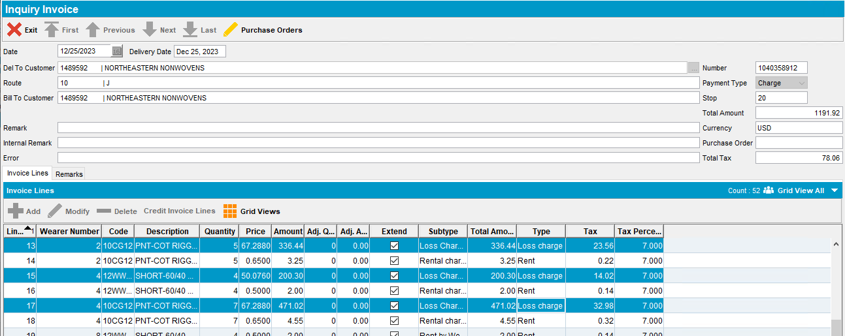
- Send the route to RA

Test Case 1 – Return garments, (701) adjust invoice line and then return more garments

Expected behavior:
When a garment is scanned after a manual invoice line adjustment (701 or 702) the following message appears on screen “This invoice line has been manually adjusted by <numbervalue1 of 701/702>, this adjustment will be deleted".
After this the 701 or 702 invoice line adjustment transactions for this invoice line are deleted and the tax is recalculated only for the 704 transaction.

Steps to reproduce
- For the first loss charge line scan 2 garments
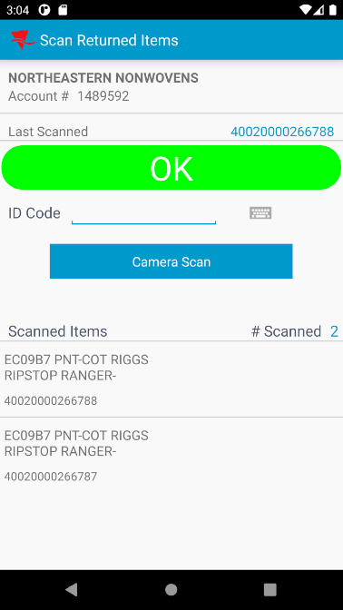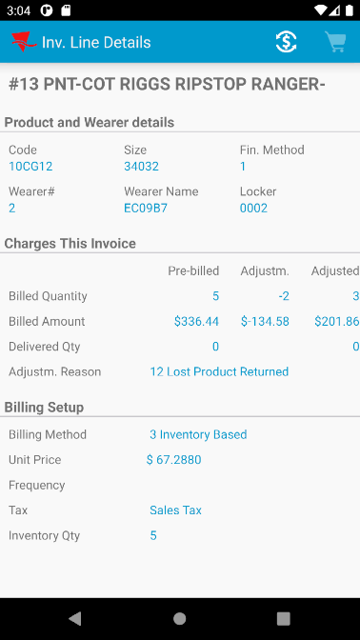
- Check the new tax on the Adjust screen
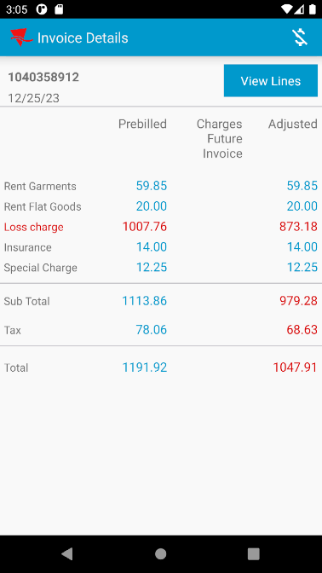
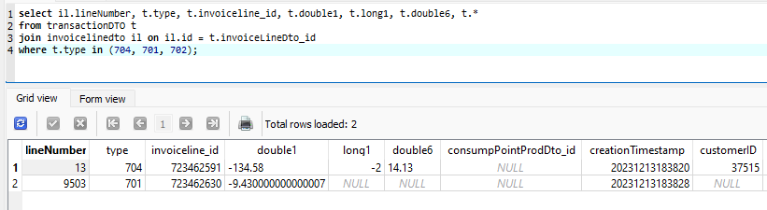
New Tax on 704 = > 336.44 – 134.58 = 201.86 * 0.07 = 14.13 (this is the double6)
So Tax line adjustment is prebill tax for this line 23.56 – 14.13 = 9.43
- Adjust the same loss charge line by -1 to a quantity of 2
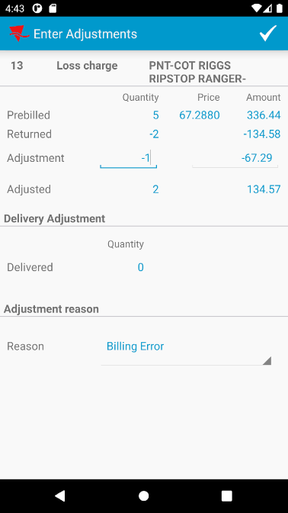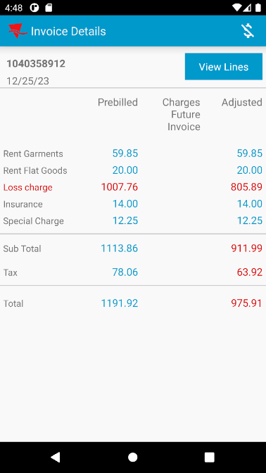
- Check the tax and route transactions
Double6 on 704 => (336.44 – 134.58) * 0.07 = 14.13 (this is the double6)
Double6 on 701 => (336.44 – 134.58 – 67.29) * 0.07 = 9.4199 (rounded up to 9.42)
So Tax line adjustment is prebill tax for this line 9.42 – 23.56= -14.14
- Return 1 more garment
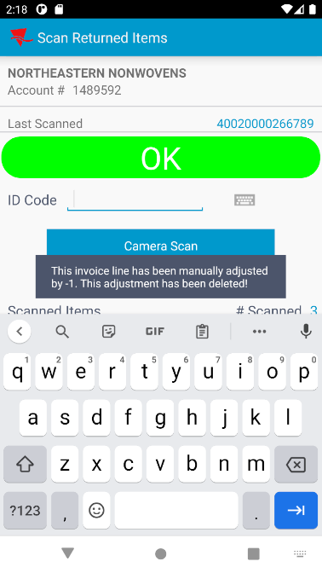
- Scan one more garment
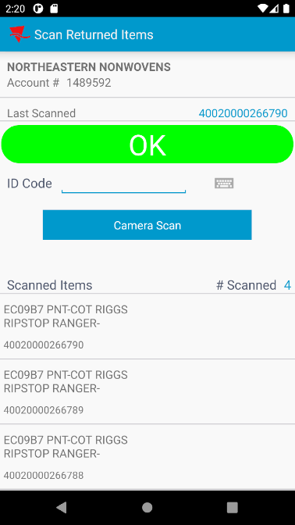
- Check the adjustments on the invoice line, there should be a -4 qty adjustment
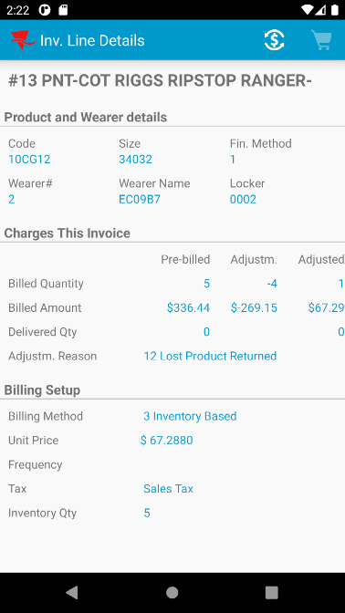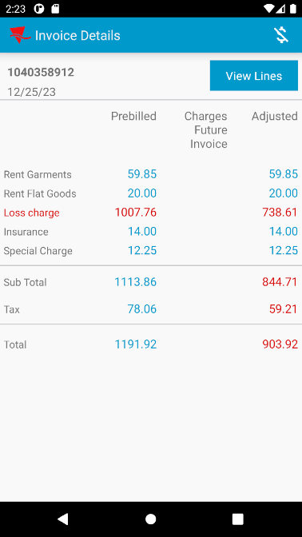
- Export the database and check the routetransactions
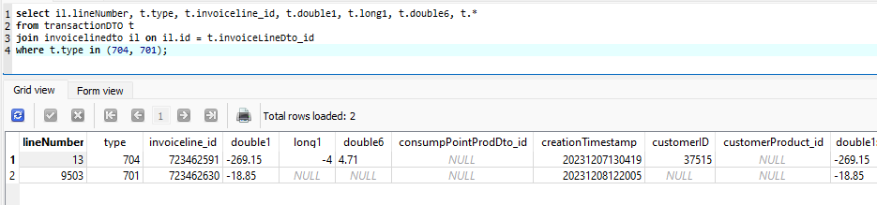
Double6 on 704 => (336.44 – 269.15) * 0.07 = 4.71 (this is the double6)
So Tax line adjustment is prebill tax for this line 4.71 – 23.56= -18.85
- Perform another manual adjustment of -1
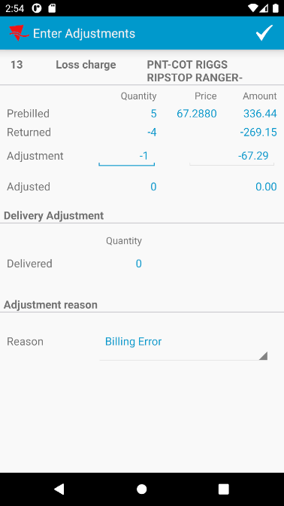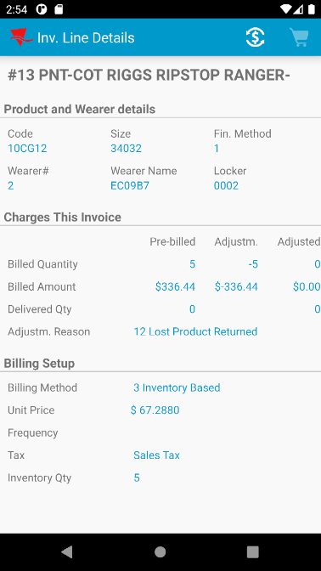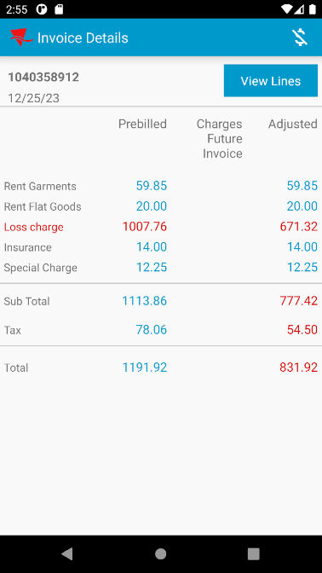
- Check the routetransactions
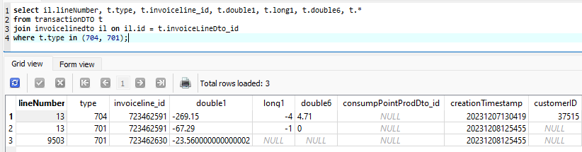
Double6 on 704 => (336.44 -269.15) * 0.07 = 4.71
Double6 on 701 => (336.44 – 269.15– 67.29) * 0.07 = 0*0.07 = 0
So Tax line adjustment is prebill tax for this line 0 – 23.56= – 23.56
Tested OK

Test Case 2 – Return garments, (702) adjust invoice line and then return more garments

Expected behavior:
When a garment is scanned after a manual invoice line adjustment (701 or 702) the following message appears on screen “This invoice line has been manually adjusted by <numbervalue1 of 701/702>, this adjustment will be deleted".
After this the 701 or 702 invoice line adjustment transactions for this invoice line are deleted and the tax is recalculated only for the 704 transaction.

Steps to reproduce
- For the first loss charge line scan 2 garments
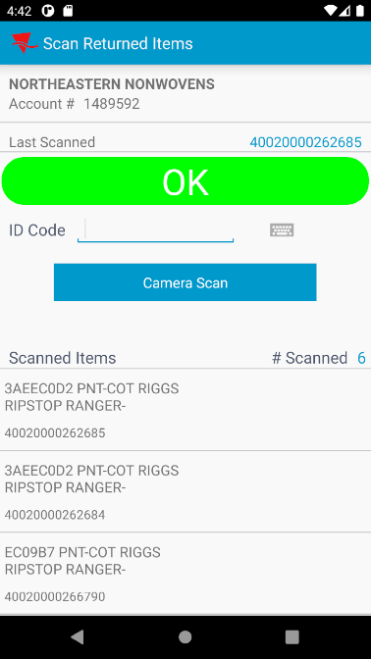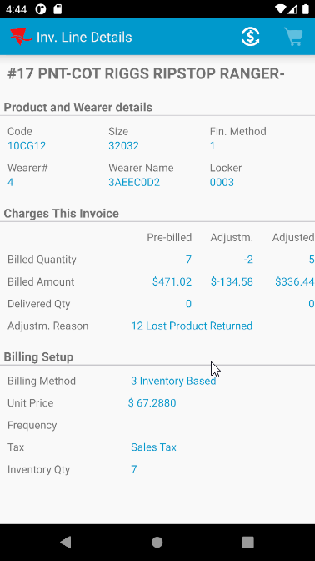
- Check the new tax on the Adjust screen
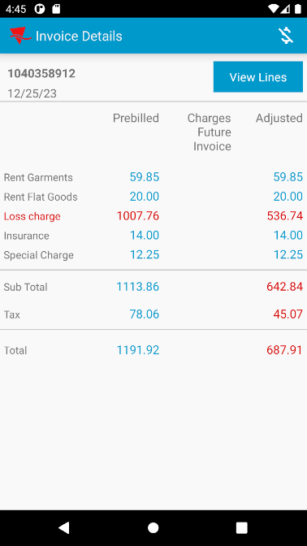
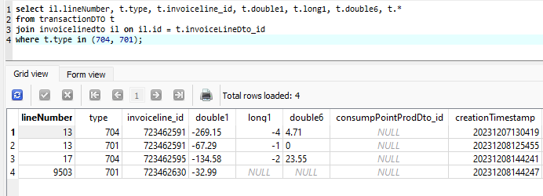
Line 17 now has a 704 where double6 = > 471.02 – 134.58 = 336.44 * 0.07 = 23.55 (this is the double6)
- Adjust the same loss charge line by +1 to a quantity of 6
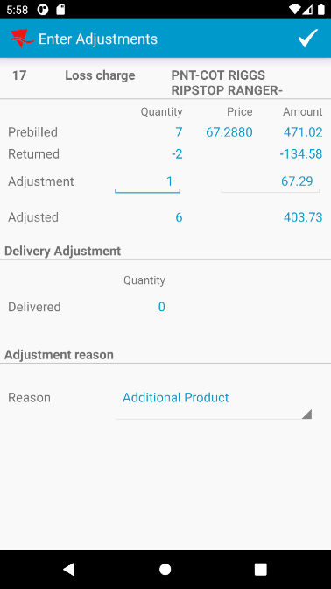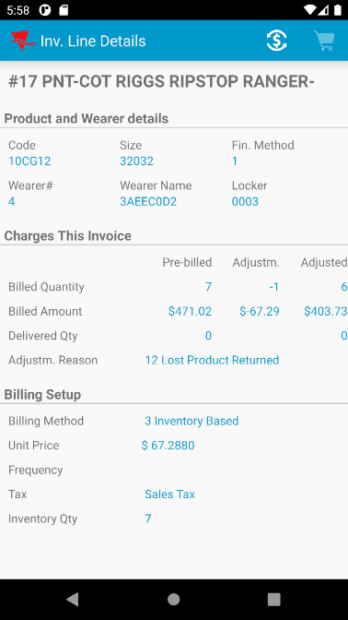
- Check the tax and route transactions
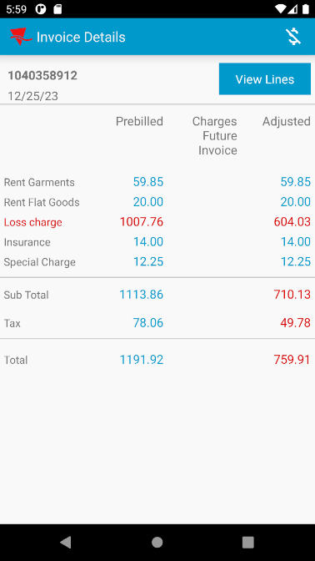
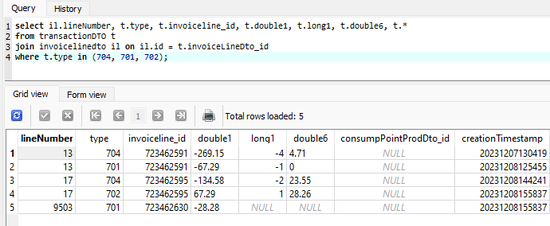
Line 17 now has:
704 where double6 = > 471.02 – 134.58 = 336.44 * 0.07 = 23.55 (this is the double6)
702 where double6 = > (471.02 – 134.58 + 67.29) * 0.07 = 28.26
- Return 1 more garment
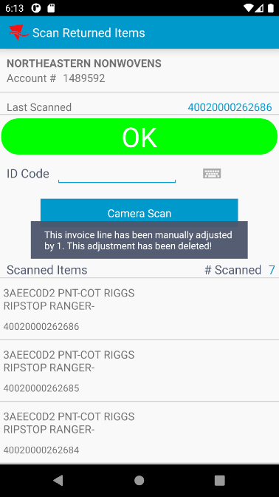
- Scan one more garment
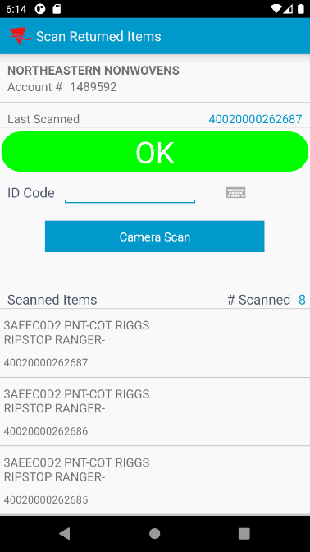
- Check the adjustments on the invoice line, there should be a -4 qty adjustment
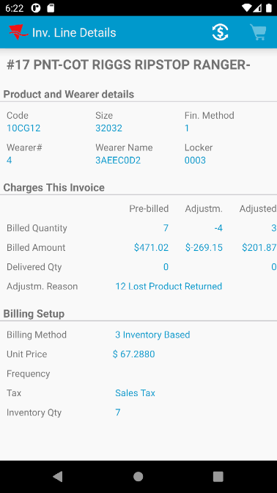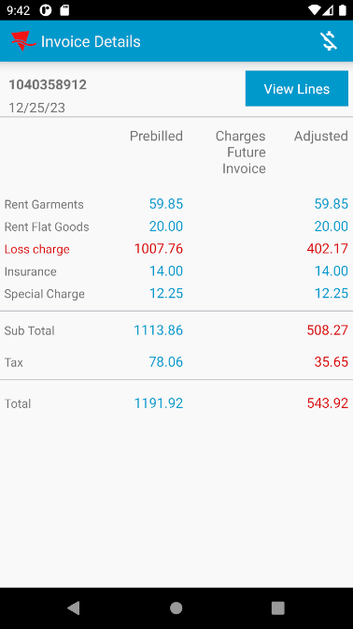
- Export the database and check the routetransactions
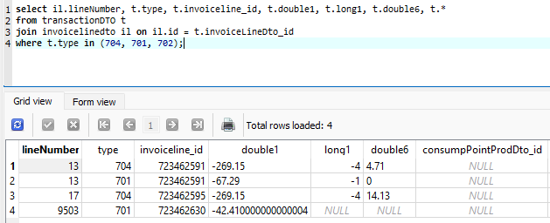
Line 17 now has:
704 where double6 = > 471.02 – 269.15 = 201.87 * 0.07 = 14.13 (this is the double6)
- Perform another manual adjustment of +1
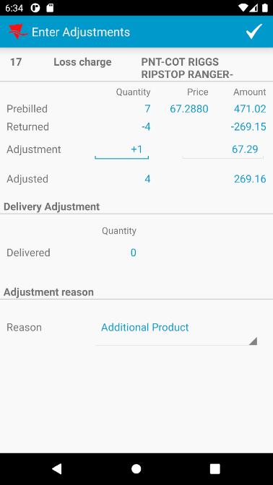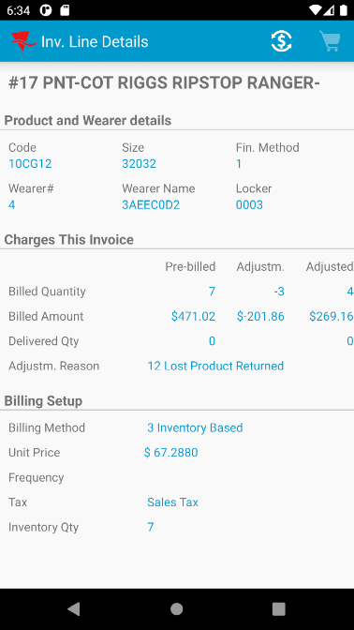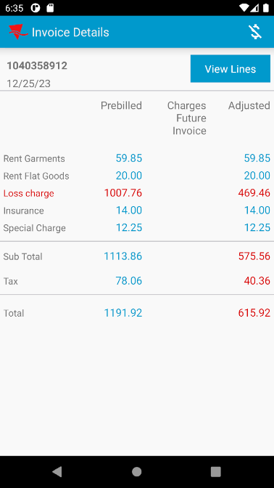
- Check the routetransactions
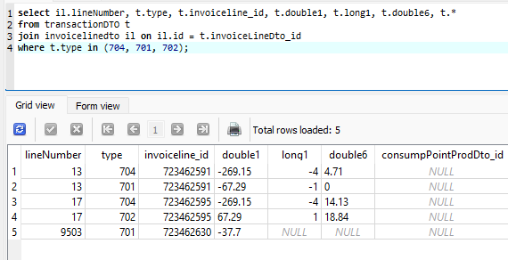
Line 17 now has:
704 where double6 = > (471.02 – 269.15) * 0.07 = 14.13
702 where double6 = > (471.02 – 269.15 + 67.29) * 0.07 = 18.84
Tested OK

Test Case 3 – (702) adjust invoice line and then return garments

Expected behavior:
When a garment is scanned after a manual invoice line adjustment (701 or 702) the following message appears on screen “This invoice line has been manually adjusted by <numbervalue1 of 701/702>, this adjustment will be deleted".
After this the 701 or 702 invoice line adjustment transactions for this invoice line are deleted and the tax is recalculated only for the 704 transaction.

Steps to reproduce
- Adjust the #15 loss charge line by +2 to a quantity of 6
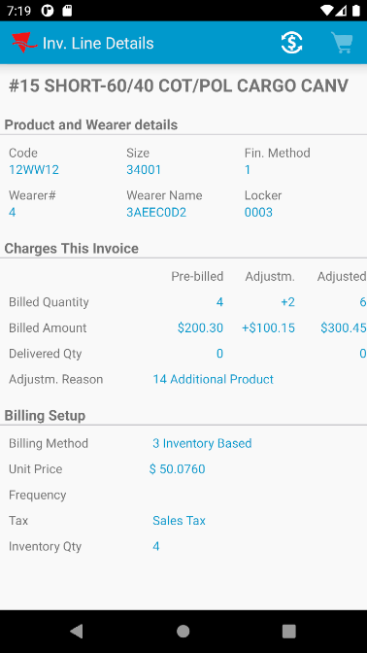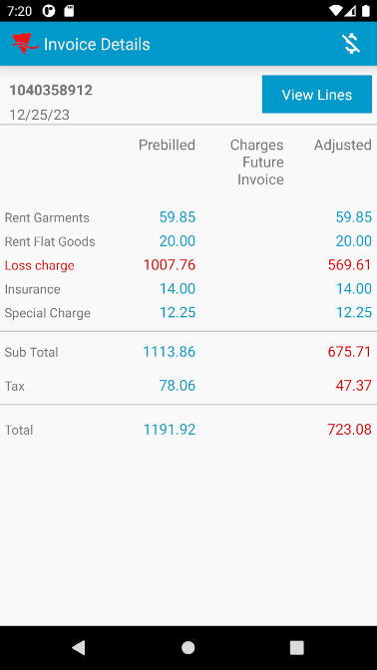
- Check that there is a 702 transaction on the RA for line 15
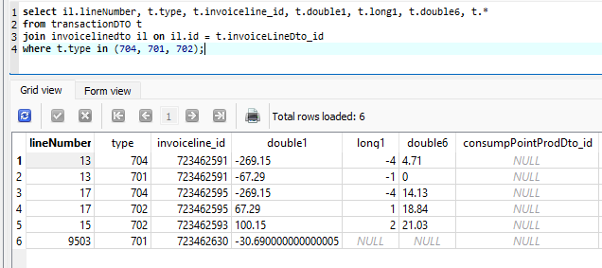
- Return a garment for line 15
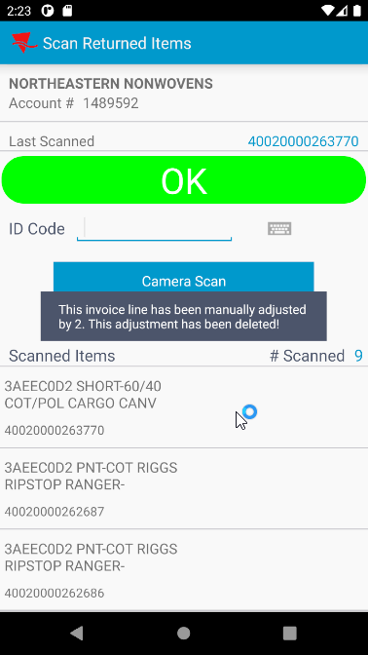
- Check the adjustment on the invoice line, the +2 adjustment should have been deleted and you should only have a -1 adjustment from the returned garment
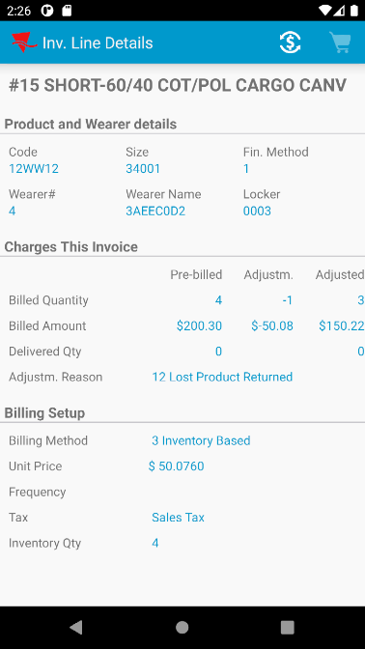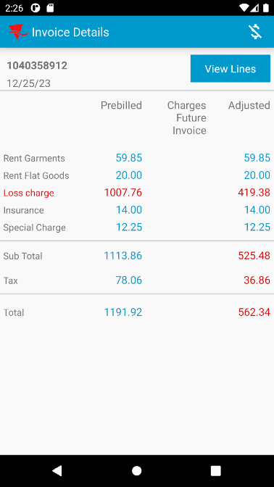
- Check the route transactions from the RA
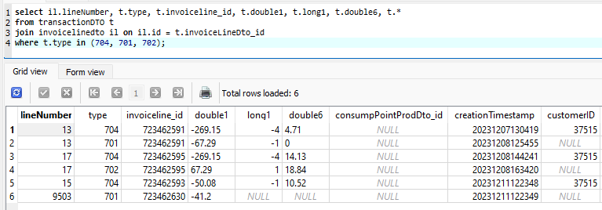
Tested OK

Test Case 4 – (701) adjust invoice line and then return garments

Expected behavior:
When a garment is scanned after a manual invoice line adjustment (701 or 702) the following message appears on screen “This invoice line has been manually adjusted by <numbervalue1 of 701/702>, this adjustment will be deleted".
After this the 701 or 702 invoice line adjustment transactions for this invoice line are deleted and the tax is recalculated only for the 704 transaction.

Steps to reproduce
- Adjust the #15 loss charge line by -2 to a quantity of 2
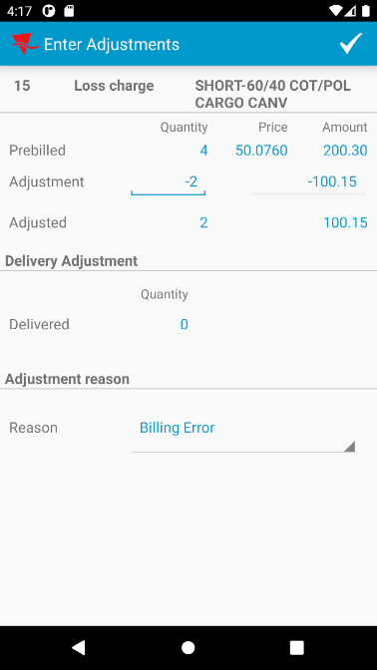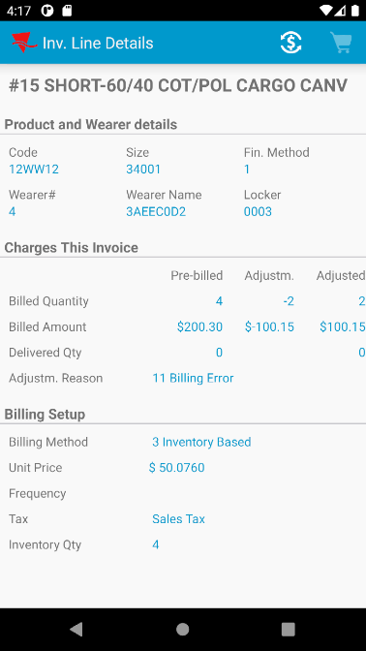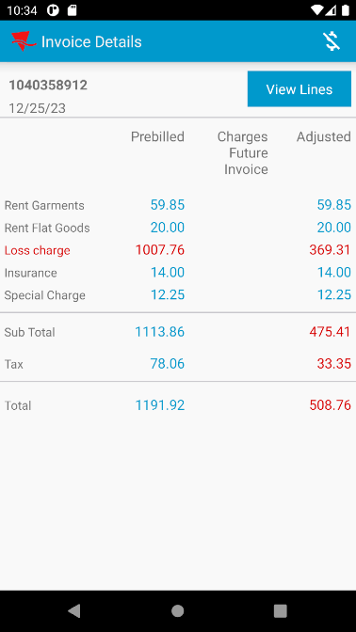
- Check that there is a 701 transaction on the RA for line 15
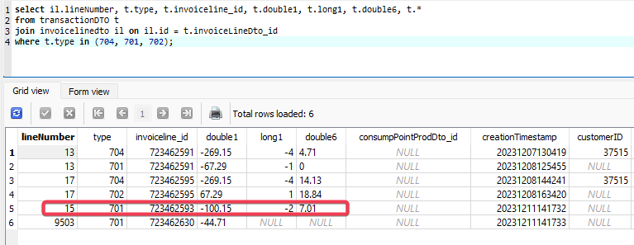
- Return a garment for line 15
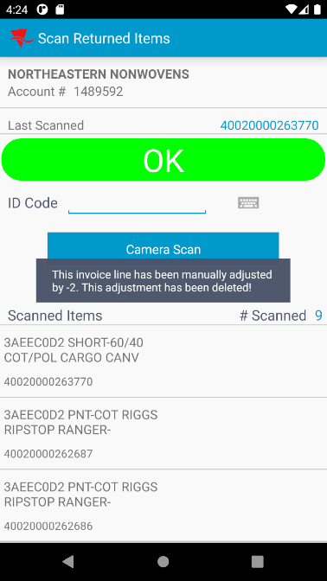
- Check the adjustment on the invoice line, the -2 adjustment should have been deleted and you should only have a -1 adjustment from the returned garment
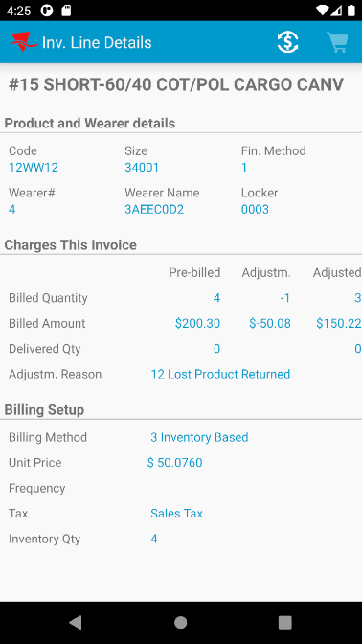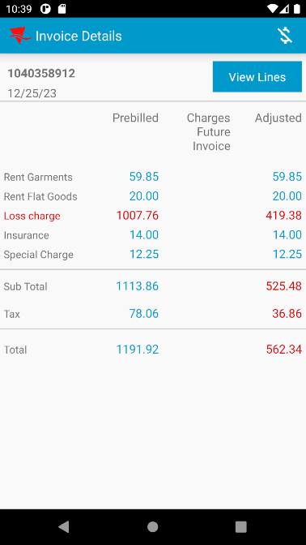
- Check the route transactions from the RA
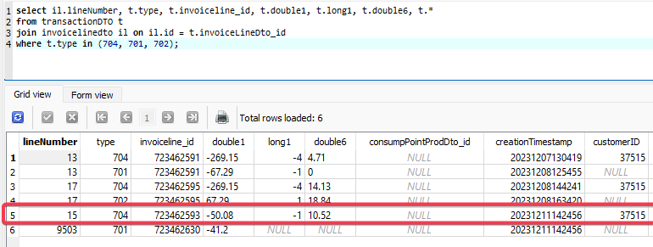
Tested OK

Test Case 5 – Finish the route and upload to ABSSolute to check the ROUTETRANSACTION table
- Check the ROUTETRANSACTIONS after upload
SELECT IL.LINENUMBER, RT.ROUTETRANSACTIONTYPE_ID, RT.DOUBLEVALUE1, RT.NUMBERVALUE1, RT.DOUBLEVALUE6, RT.*
FROM ROUTETRANSACTION RT
JOIN INVOICELINE IL
ON IL.INVOICELINE_ID = RT.INVOICELINE_ID
WHERE RT.ROUTECONTROL_ID =
(SELECT RC.ROUTECONTROL_ID
FROM ROUTECONTROL RC
JOIN ROUTE R
ON R.ROUTE_ID = RC.ROUTE_ID
JOIN PLANT P
ON P.PLANT_ID = R.PLANT_ID
WHERE RC.DRIVINGDATE = TO_DATE('12-25-2023', 'mm-dd-yyyy')
AND R.ROUTENUMBER = 10
AND P.CODE = '025')
AND RT.ROUTETRANSACTIONTYPE_ID IN (701, 702, 703, 704, 705, 706)
ORDER BY RT.PDACREATIONTIMESTAMP;
- Check the invoice for the following:
  - there is a -41.2 invoice line adjustment for one of the tax line
  - line 13 was fully credited so it has a tax of 0
  - line 17 has a tax of 18.84
  - line 15 has a tax of 10.52
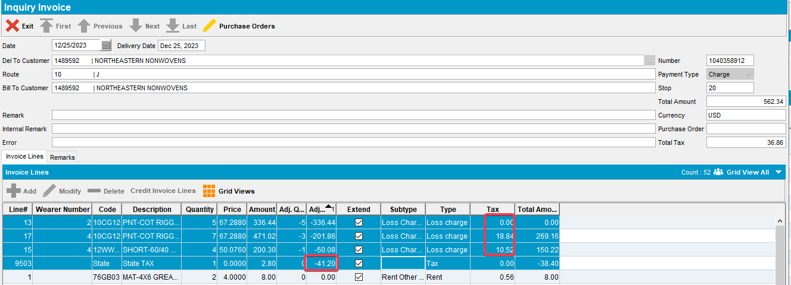
Tested OK

