RASA-4174 RA changes for D_UBS_2298 Error during upload from RA- Downgrading to version 12.32
Environment | Prerequisites
Version: 9.07.00.UNF9 hash: 26e744dbeb82  DBServerName= abs-srv16.internal.abslbs.com  DBSID= CUST21  DBUser= UNFDEV  DBPassword= UNFDEV  Environment=Production | RouteAssistant_v12.32.INTERNAL_TEST_ONLY.7ef663fe

Contents
Retest after fix 1
BU/Plant: 044 | NASHUA 1

Retest after fix

BU/Plant: 044 | NASHUA

Step 1: Open “Contacts” dialog and add a new contact with 500 characters on contact notes
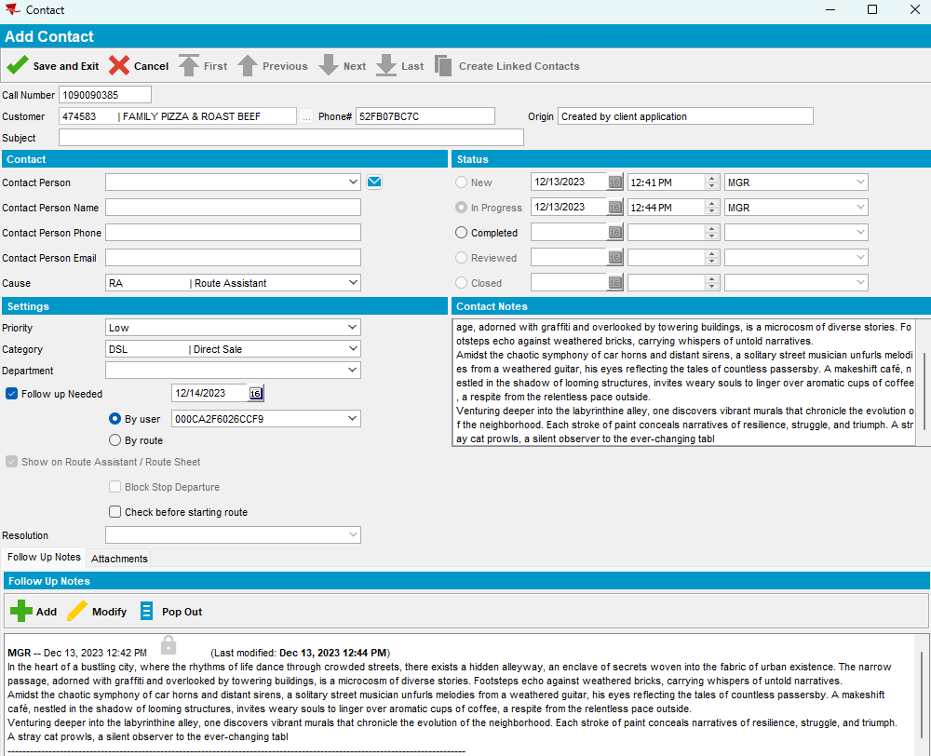

Step 2: Add a new route in RSC. Generate invoices and mark ready for transfer the route.
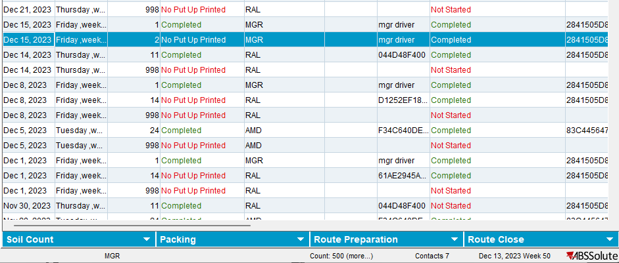

Step 3: Download the route on PDA then go to Messages and add a new message.
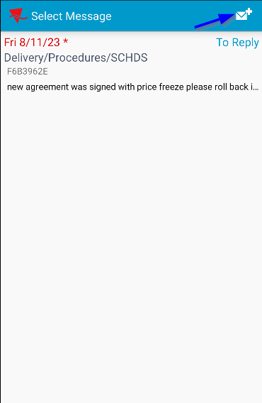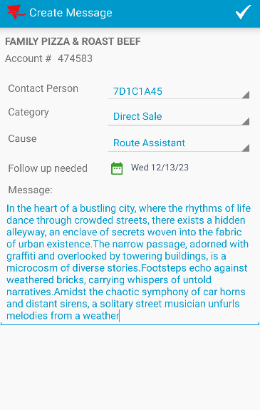
The maximum number of characters is 500.
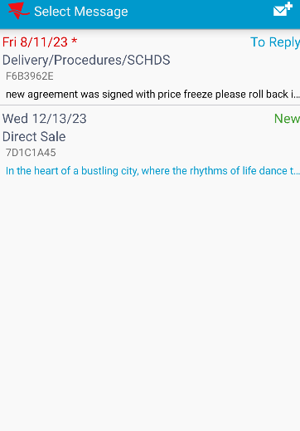
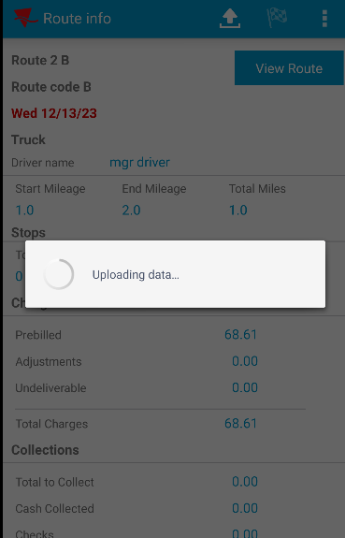
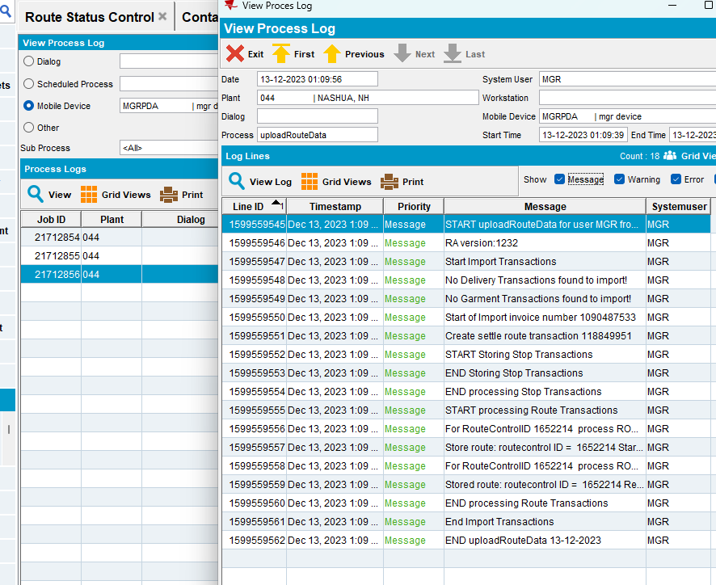
No error occurred.
TESTED OK.

