RASA-4162 D_UBS_2317 RA allows you to scan garments for return in the Scan Garments icon after the full prebilled amount was adjusted creating a negative amount
Environment | Prerequisites
Version:9.07.00  DBServerName=abs-srv16.internal.abslbs.com  DBSID=CUST21  DBUser=UNFDEV  DBPassword=UNFDEV  Environment=Production | - Module:  - System setting

Contents
RASA-4162 D_UBS_2317 RA allows you to scan garments for return in the Scan Garments icon after the full prebilled amount was adjusted creating a negative amount 1
Retest after fix 1
Test Case 1 – Decrease from 11/11 to 11/4 + Return 4 + adjust by -3 + Return 2 – UNIQUEITEMS ONLY– Tested OK 1
Test Case 2 – Decrease from 11/11 to 11/4 + Return 4 (smartbarcodes) + adjust by -3 + Return 2 (smartbarcodes) – NONUNIQUES ONLY– Tested OK 9
Test Case 3 – Decrease from 11/11 to 11/4 + Return 4 + adjust by -3 + Return 2 – MIXED INVENTORY (5 uniques/6 nonuniques) ONLY– Tested OK 15
Test Case 4 – Quit wearer with 11/11 + Return 7 + adjust by -4 + Return 2 – UNIQUEITEMS ONLY– Tested OK 23

Retest after fix

Test Case 1 – Decrease from 11/11 to 11/4 + Return 4 + adjust by -3 + Return 2 – UNIQUEITEMS ONLY– Tested OK
Expected behavior: After the invoiceline gets to 0 Qty there are no more adjustments to the invoiceline
Hash: 4108525
RA version: 83457143
- Create a wearer inventory with max inv 11 with unique items only and generate WO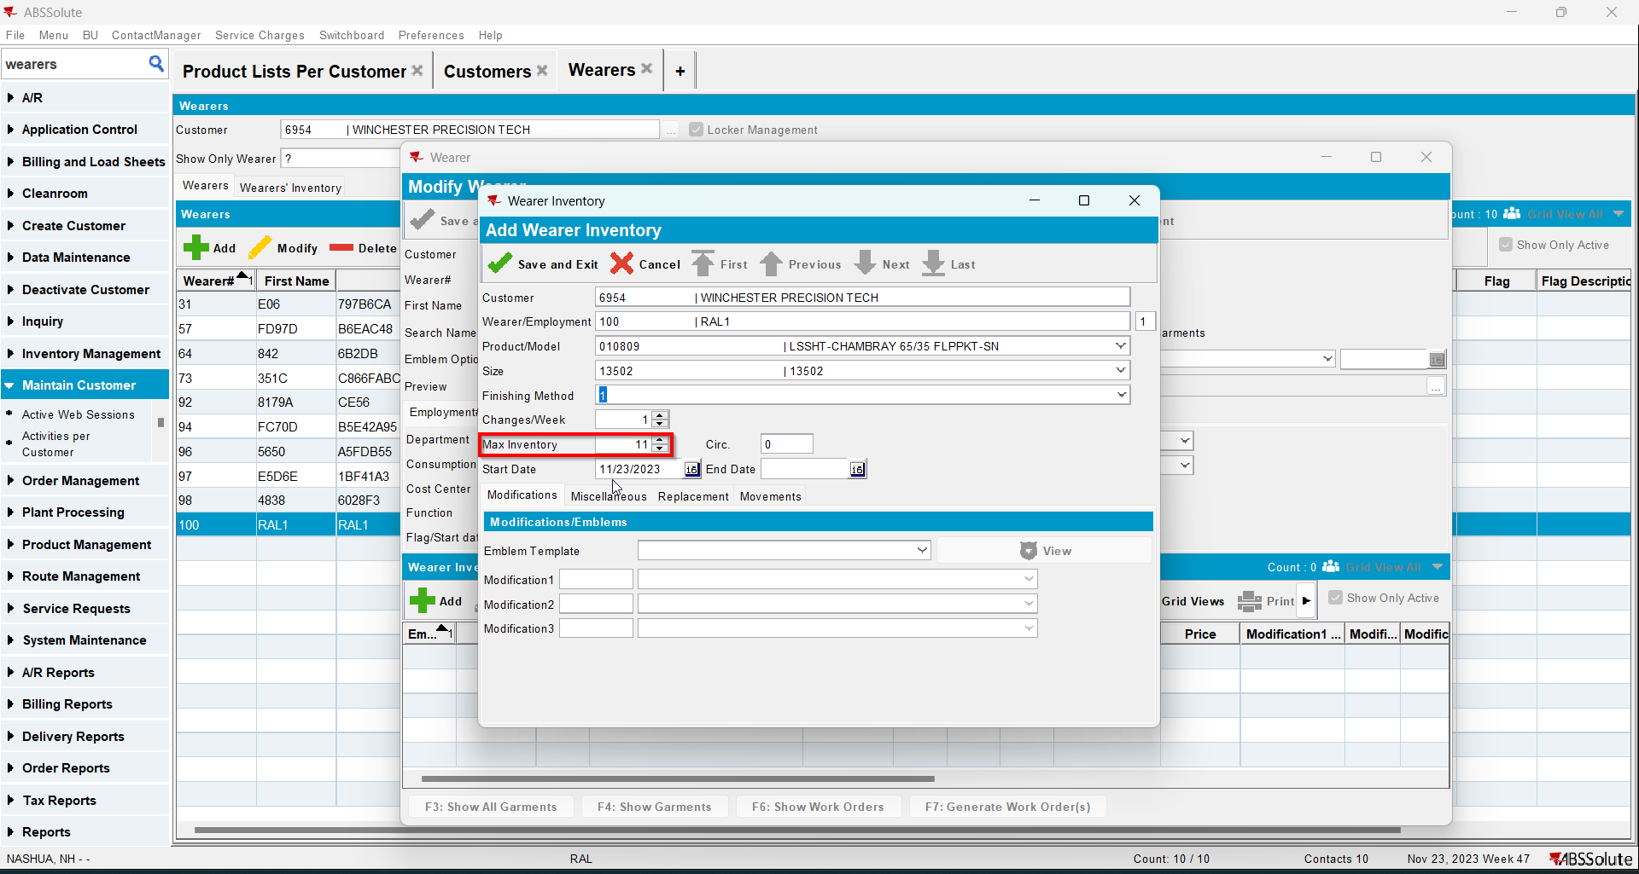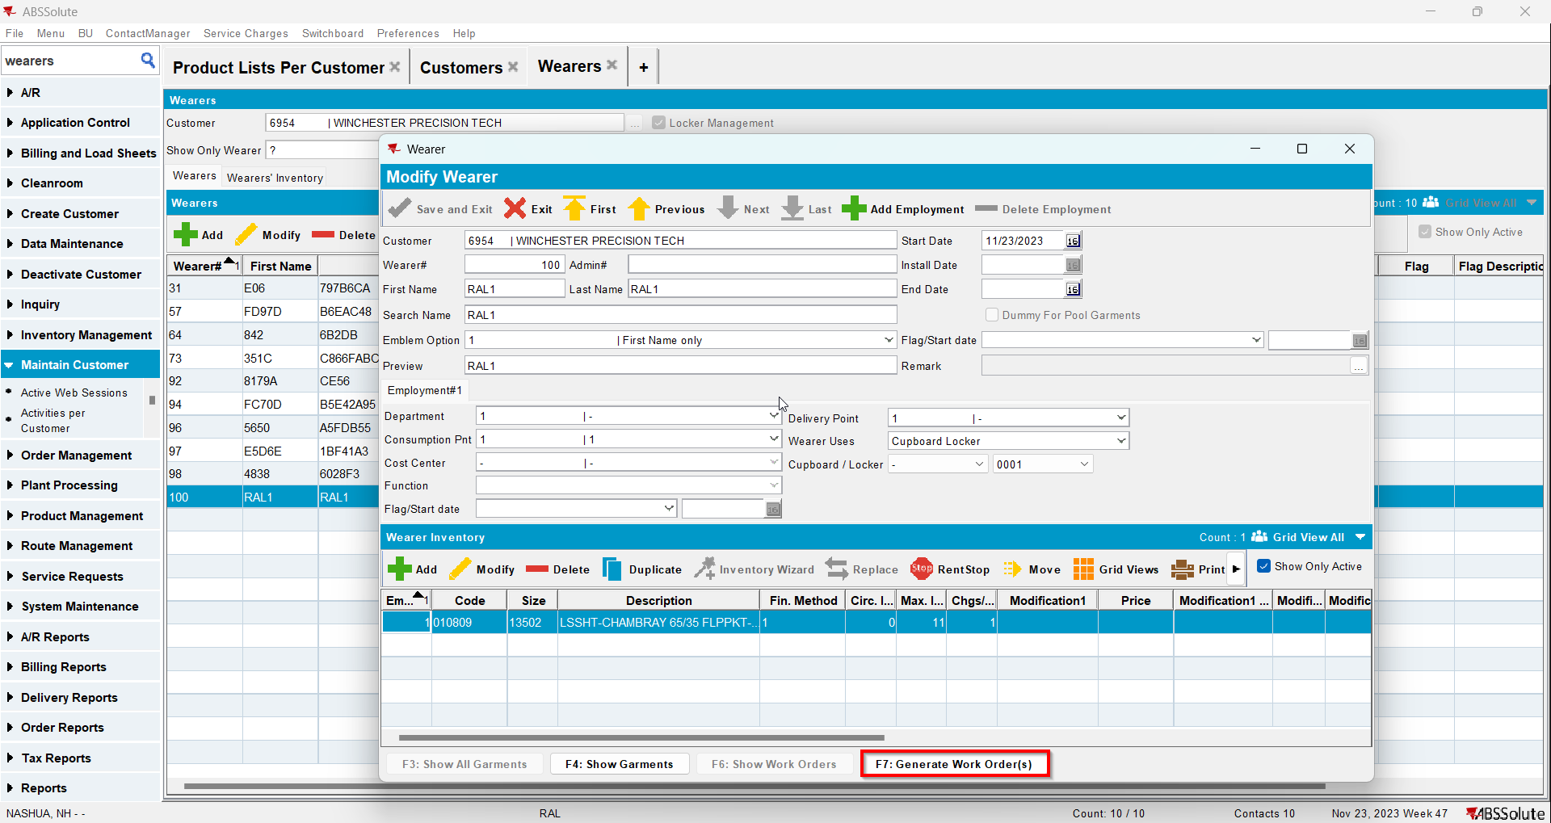
- Issue WO and generate delivery notes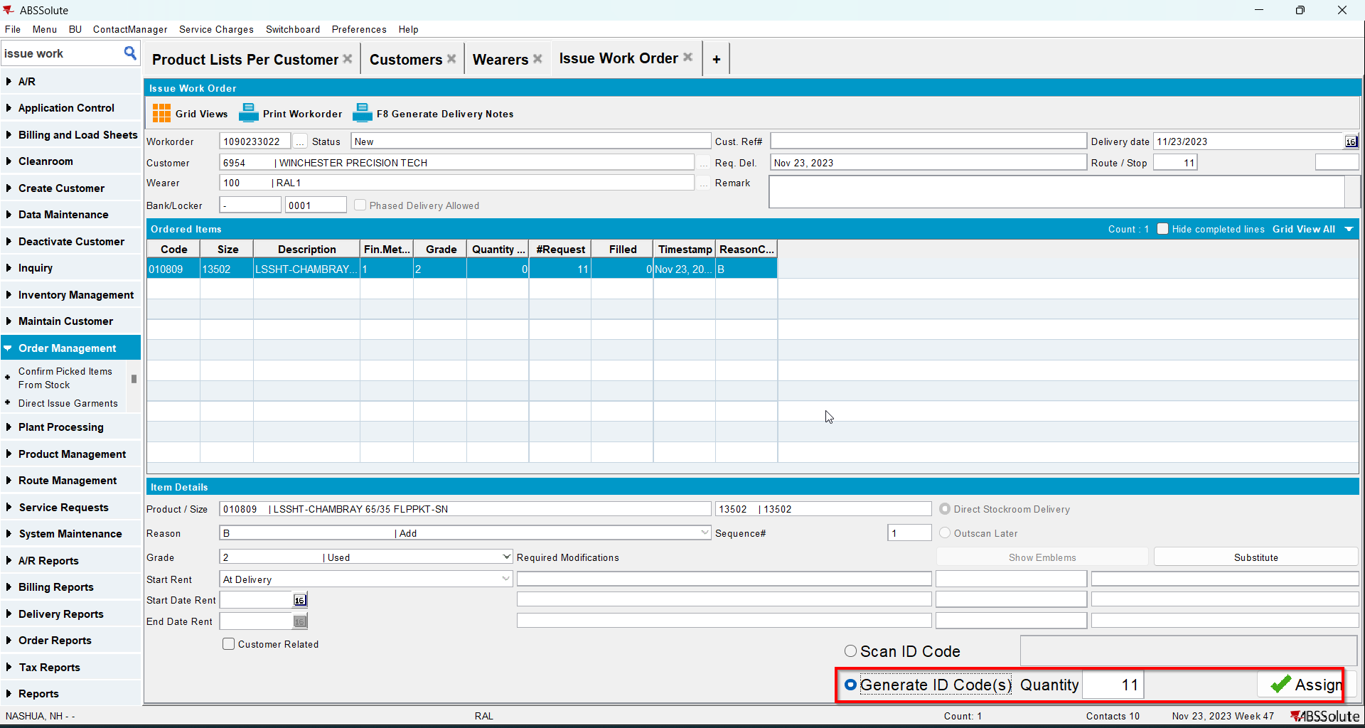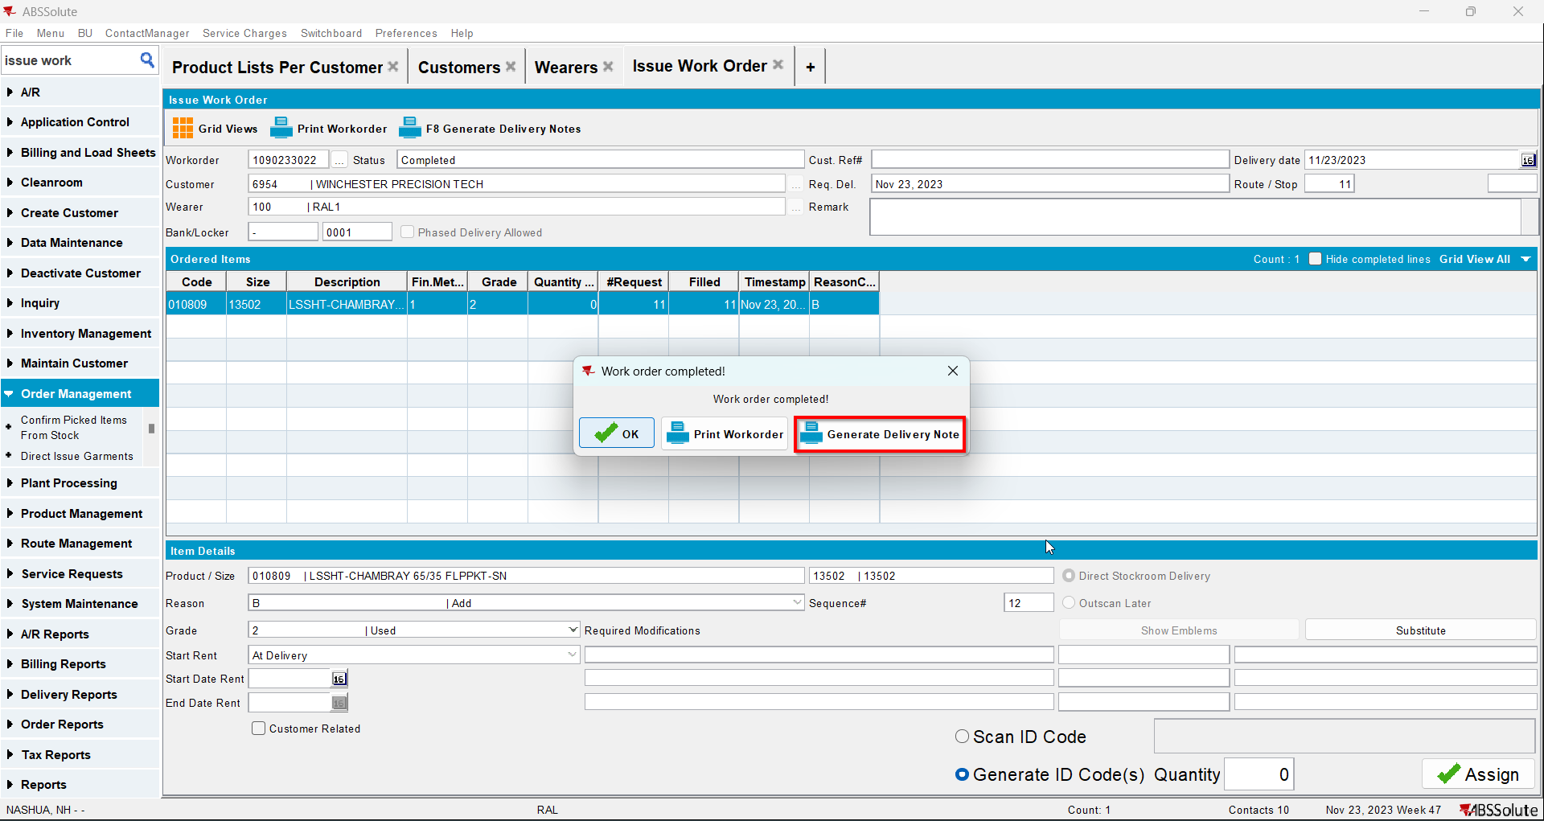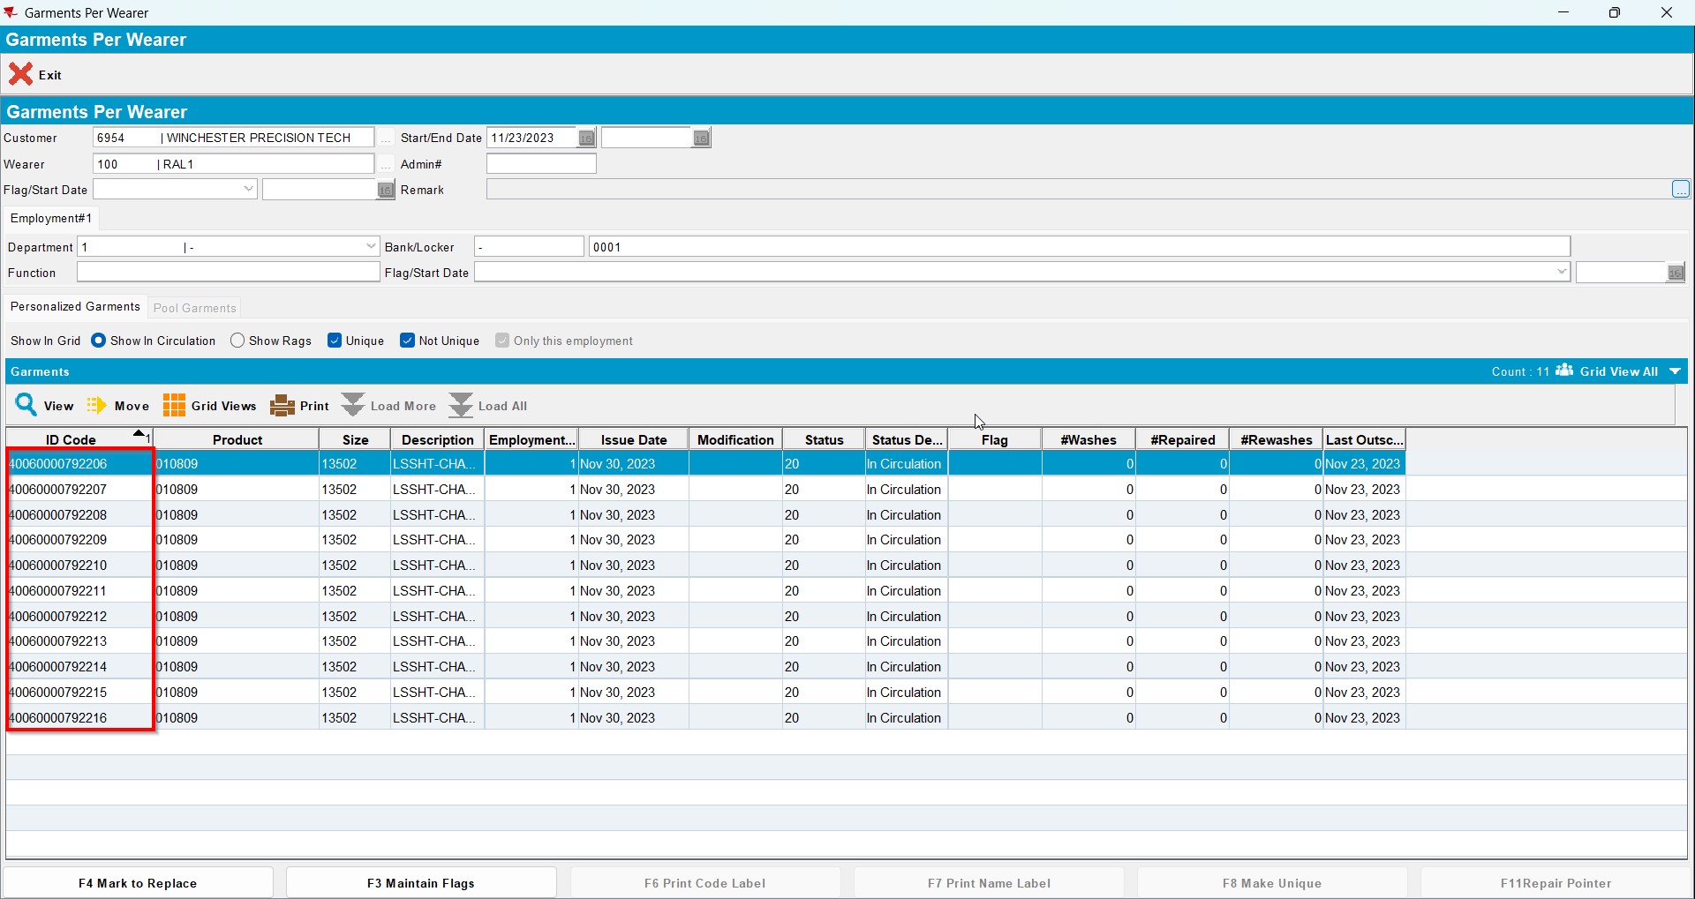
- Decrease the max inv to 4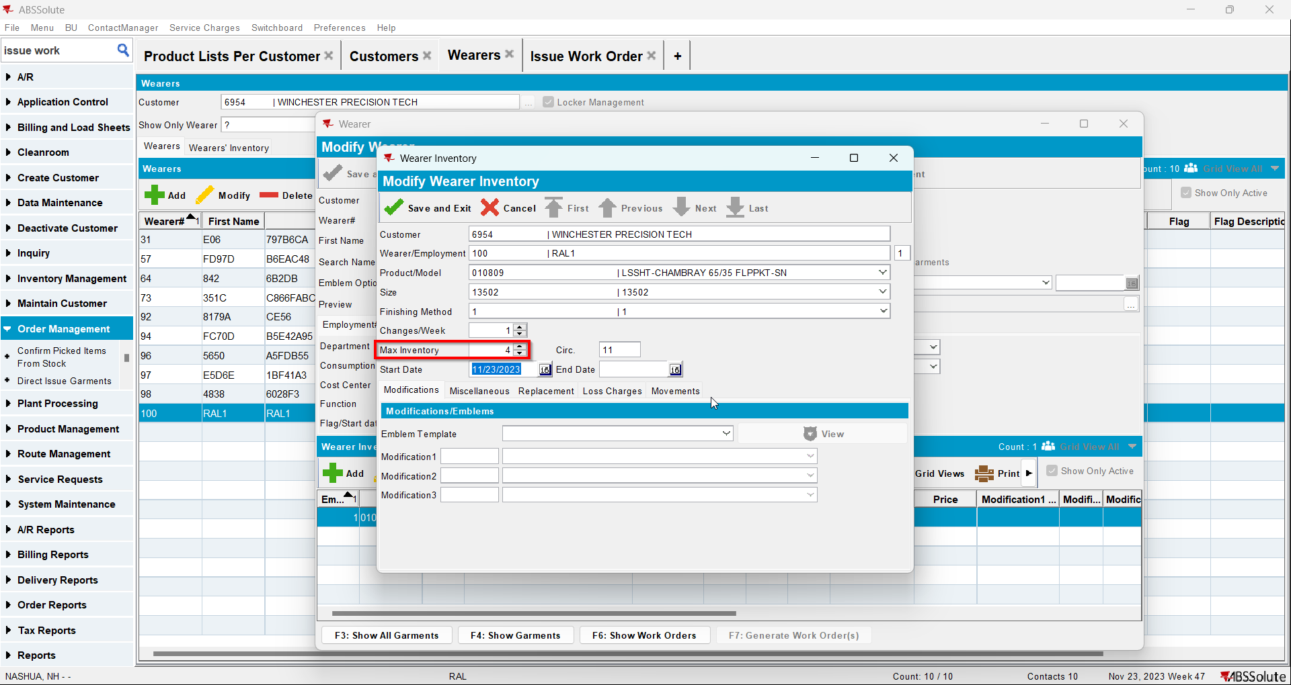
- Go to Route Status Control dlg and add a route for at least 2 weeks in the future
- Generate invoices and mark the route ready for transfer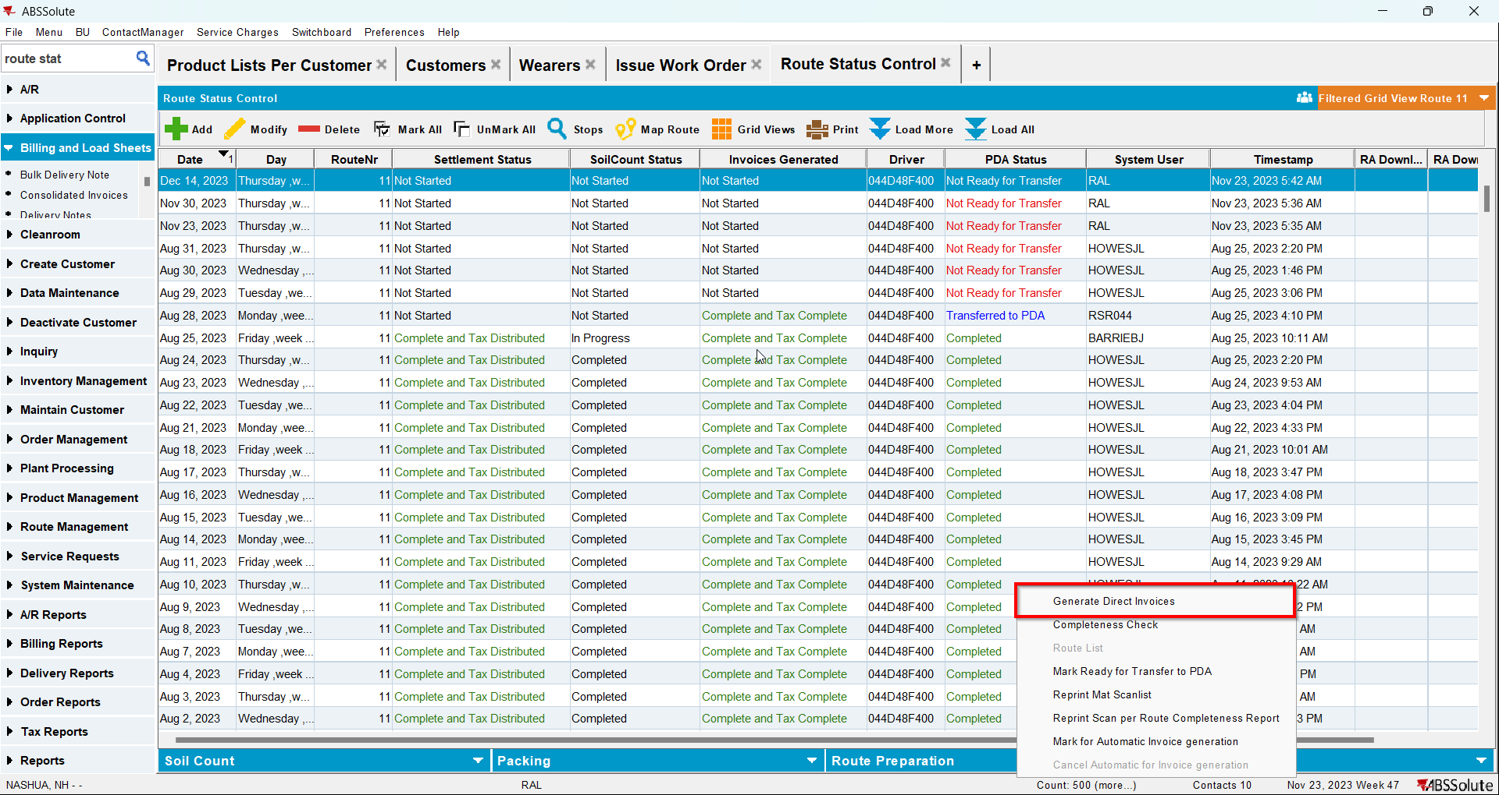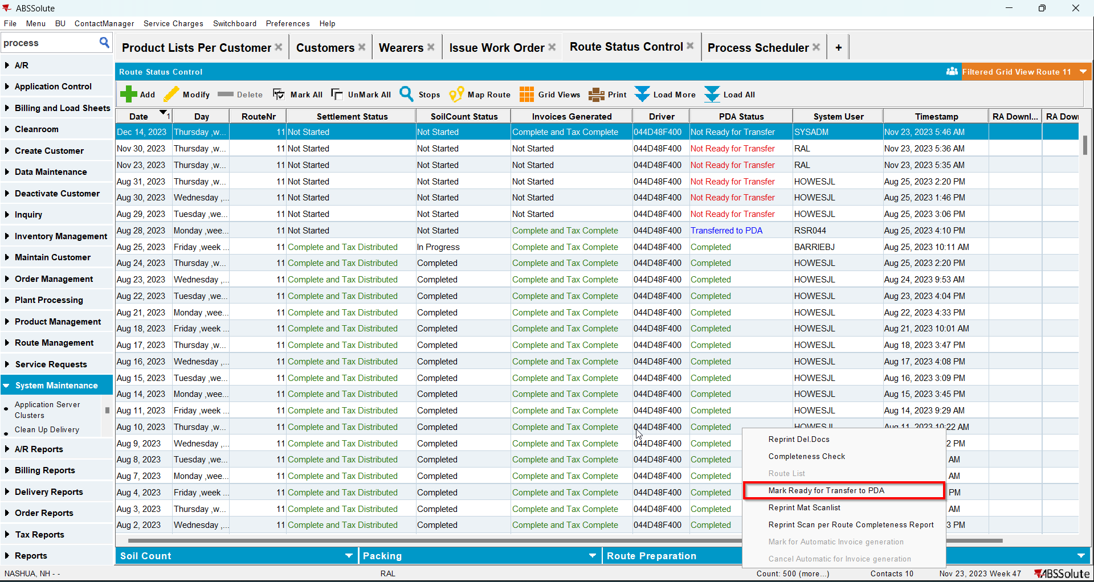
- In RA scan 4 items for return
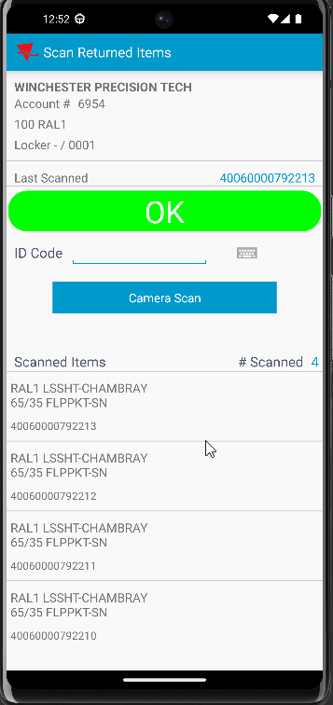
- Adjust by -3 the invoice with loss charge
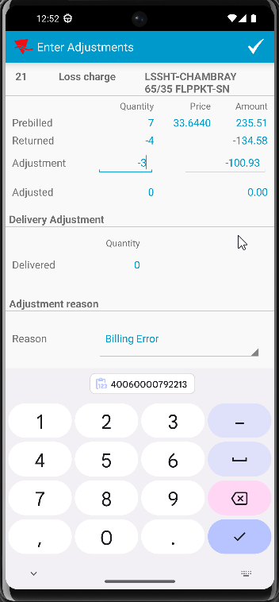
- Scan another 2 items for return
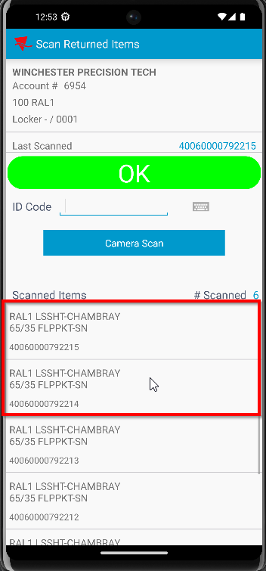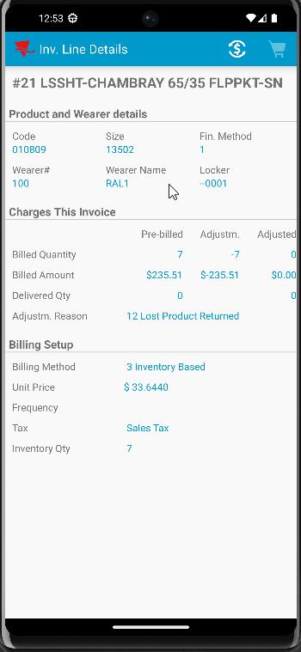

Test Case 2 – Decrease from 11/11 to 11/4 + Return 4 (smartbarcodes) + adjust by -3 + Return 2 (smartbarcodes) – NONUNIQUES ONLY– Tested OK
Expected behavior: After the invoiceline gets to 0 Qty there are no more adjustments to the invoiceline
Hash: 4108525
RA version: 83457143
- Create a wearer inventory with max inv 11 with nonunique items only and generate WO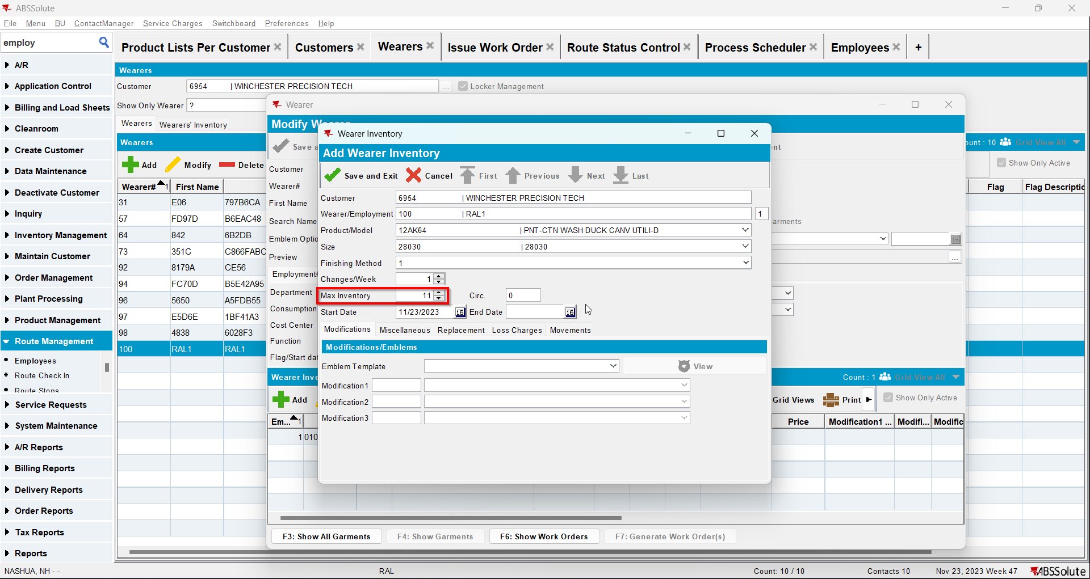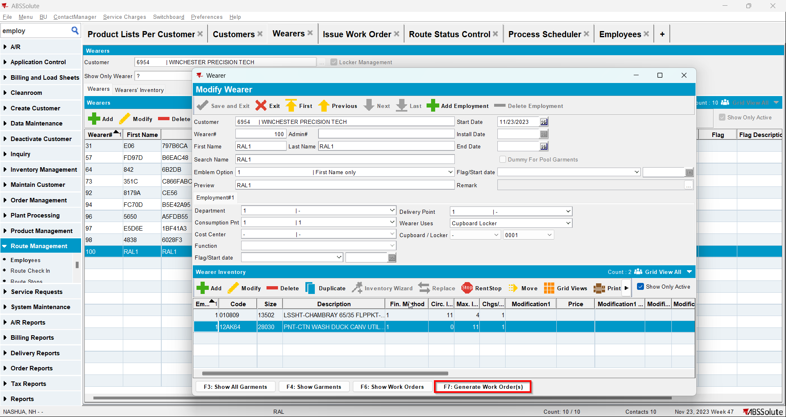
- Issue WO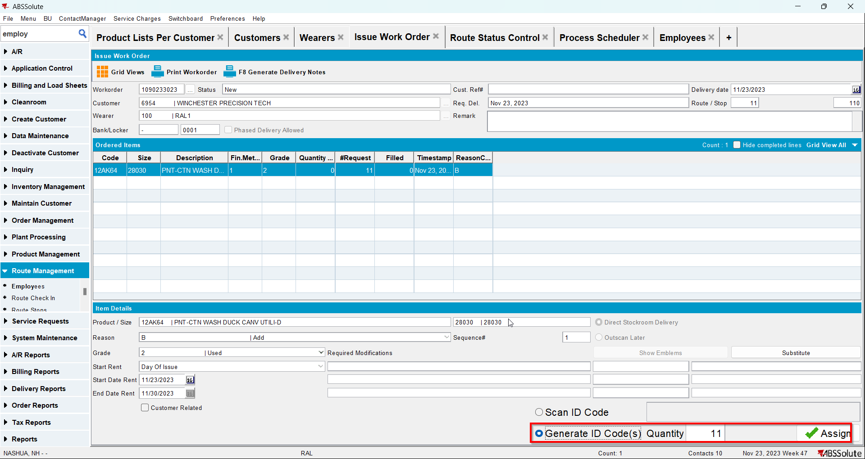
- Decrease the max inv to 4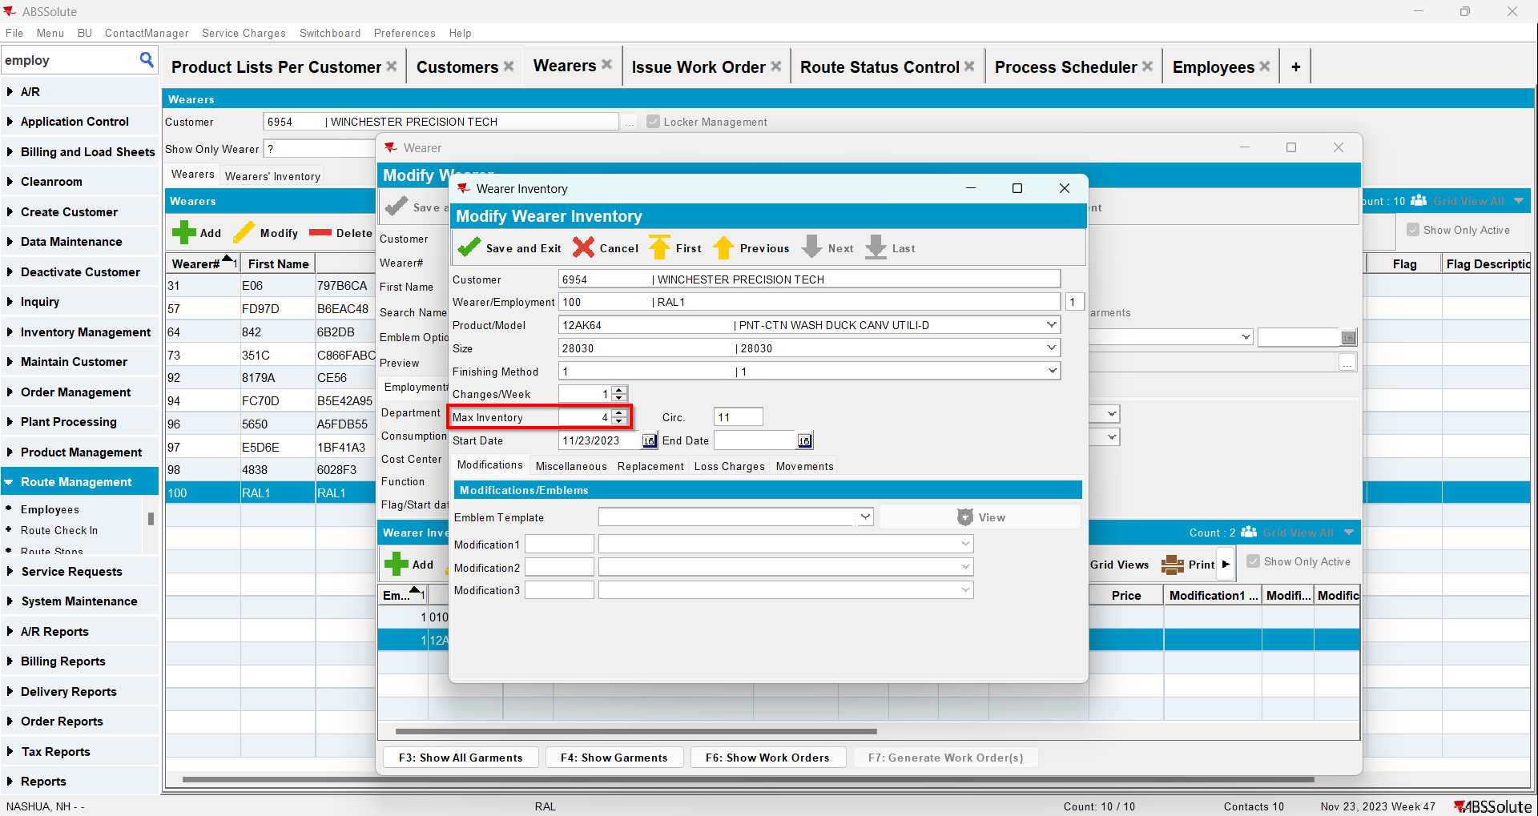
- Go to Route Status Control dlg and add a route for at least 2 weeks in the future
- Generate invoices and mark the route ready for transfer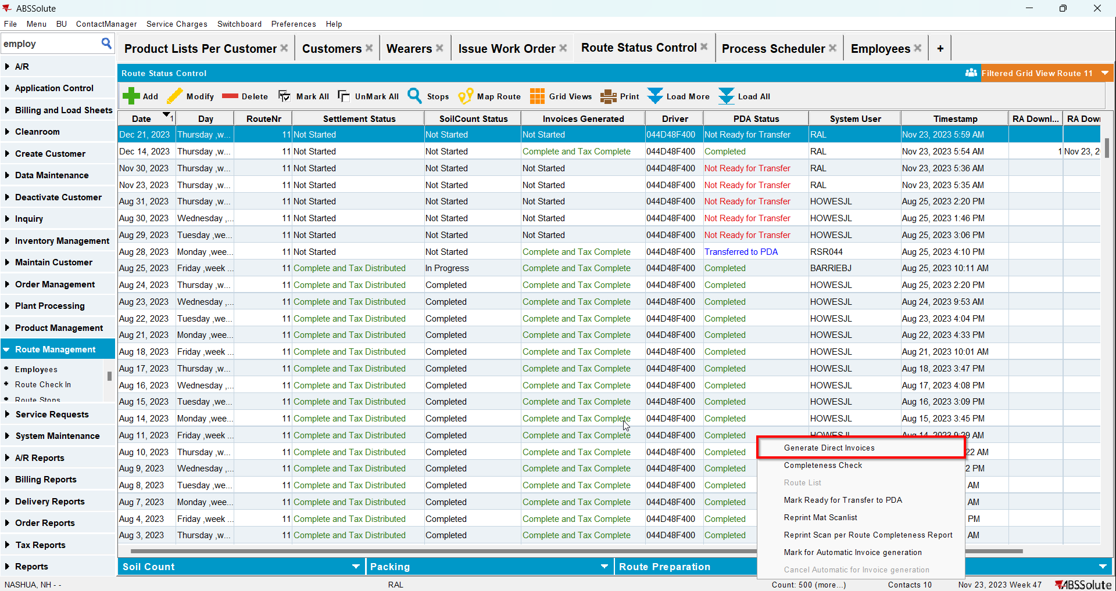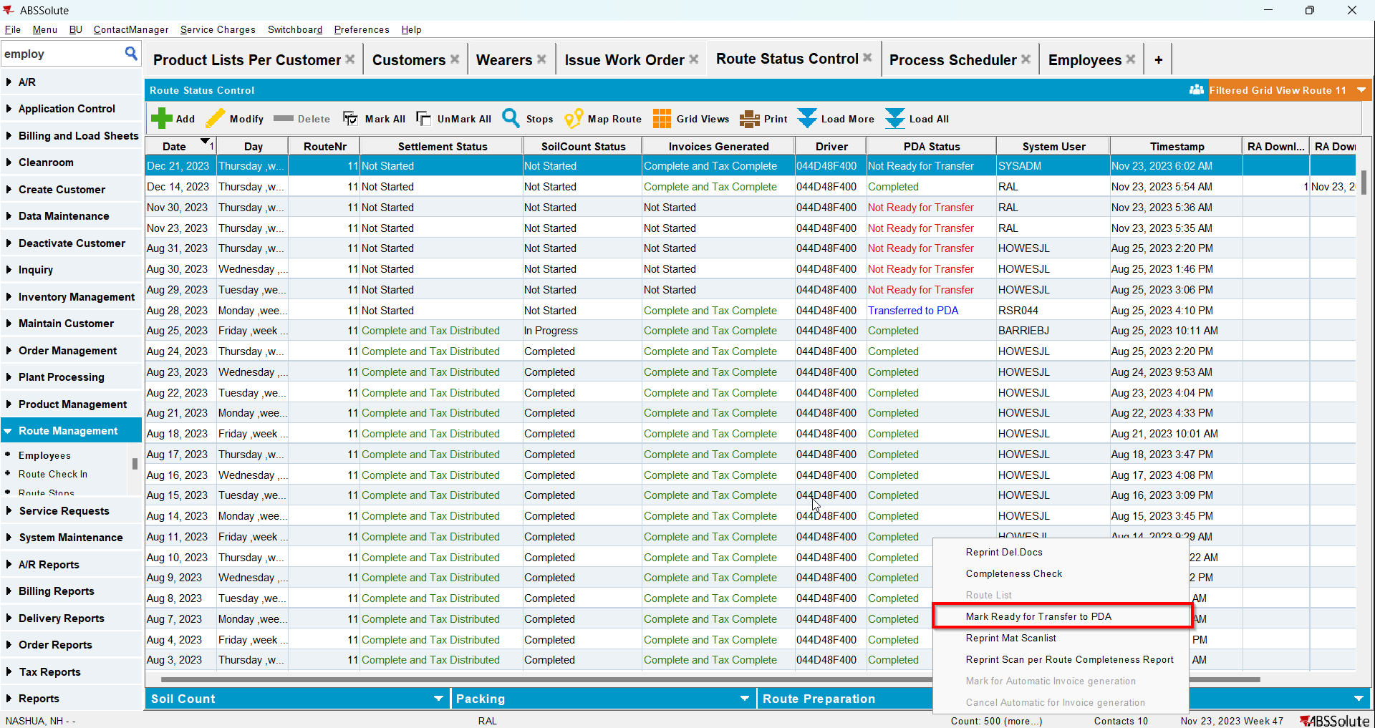
- In RA scan 4 items for return
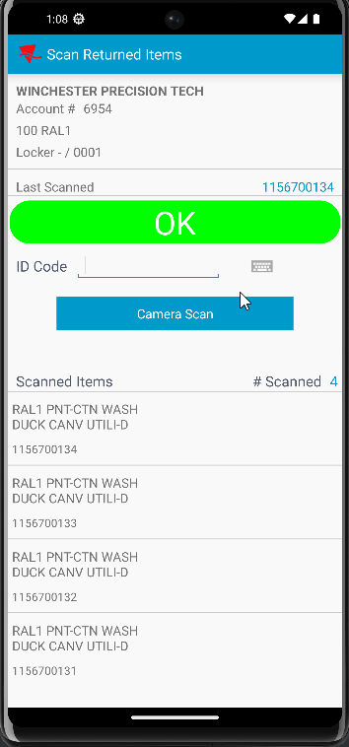
- Adjust by -3 the invoice with loss charge
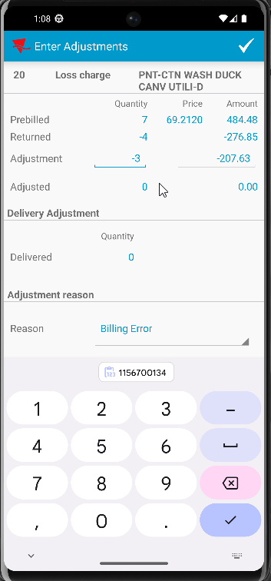
- Scan another 2 items for return
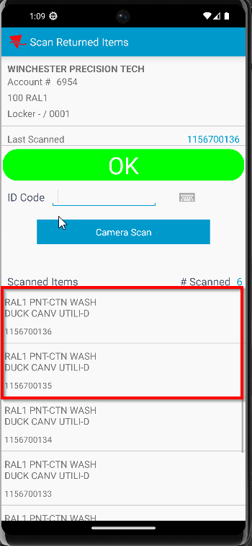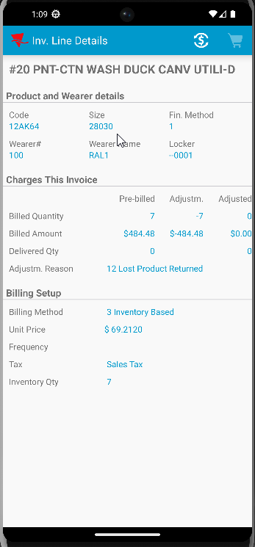

Test Case 3 – Decrease from 11/11 to 11/4 + Return 4 + adjust by -3 + Return 2 – MIXED INVENTORY (5 uniques/6 nonuniques) ONLY– Tested OK
Expected behavior: After the invoiceline gets to 0 Qty there are no more adjustments to the invoiceline
Hash: 4108525
RA version: 83457143
- Create a wearer inventory with max inv 11 with nonunique items and generate WO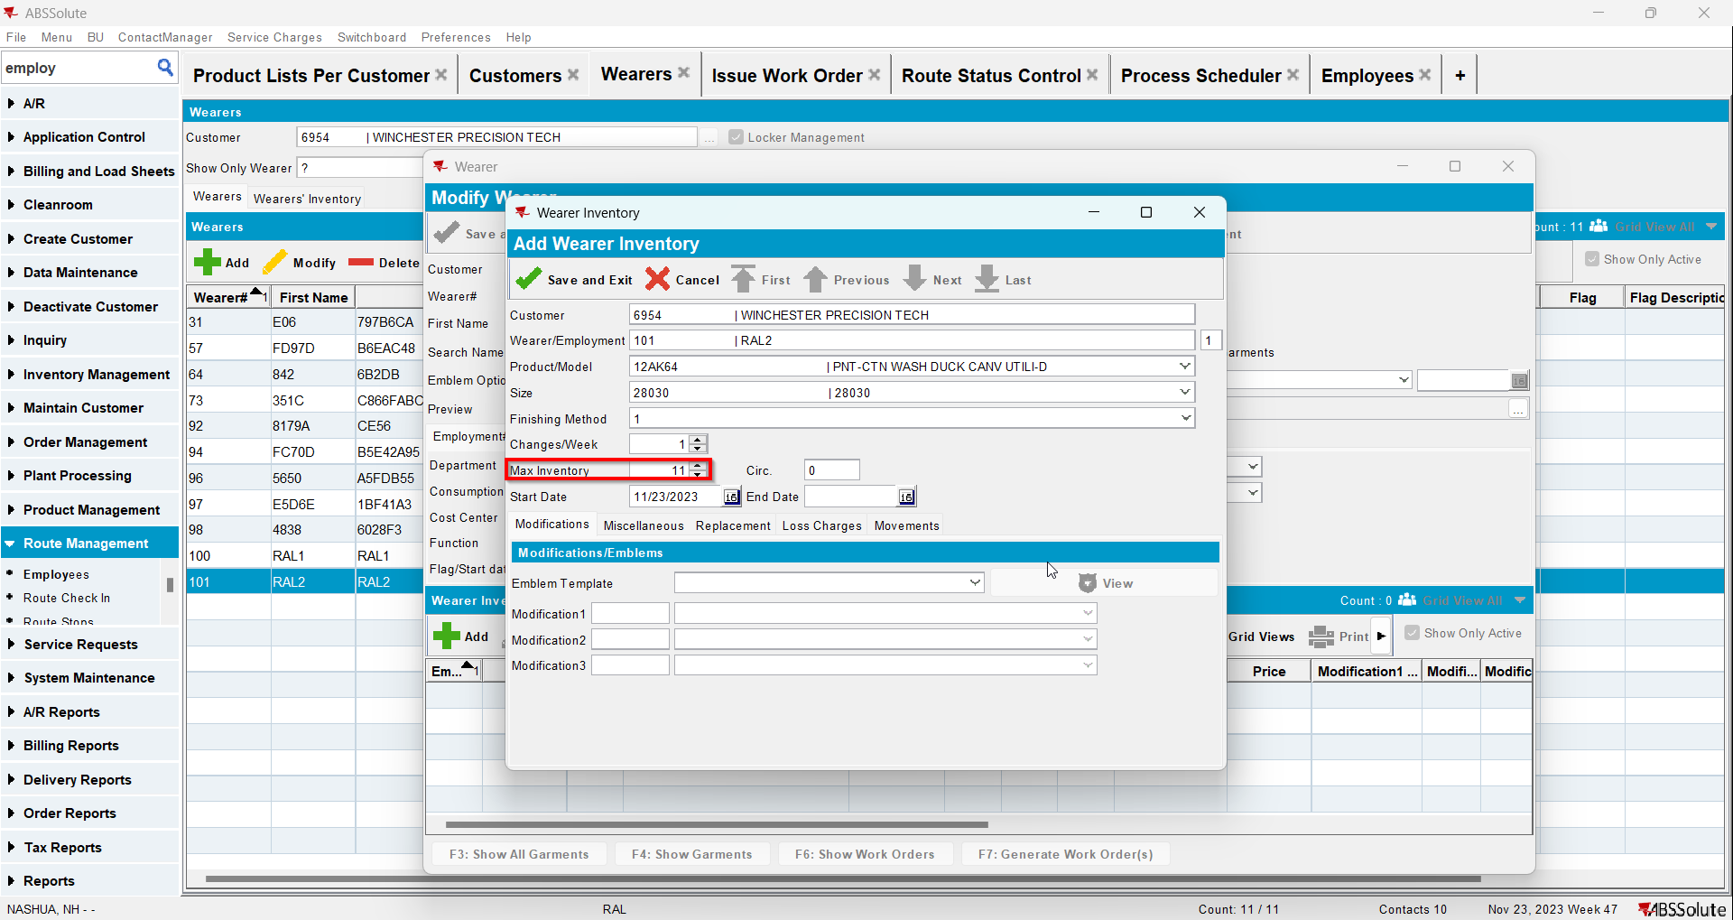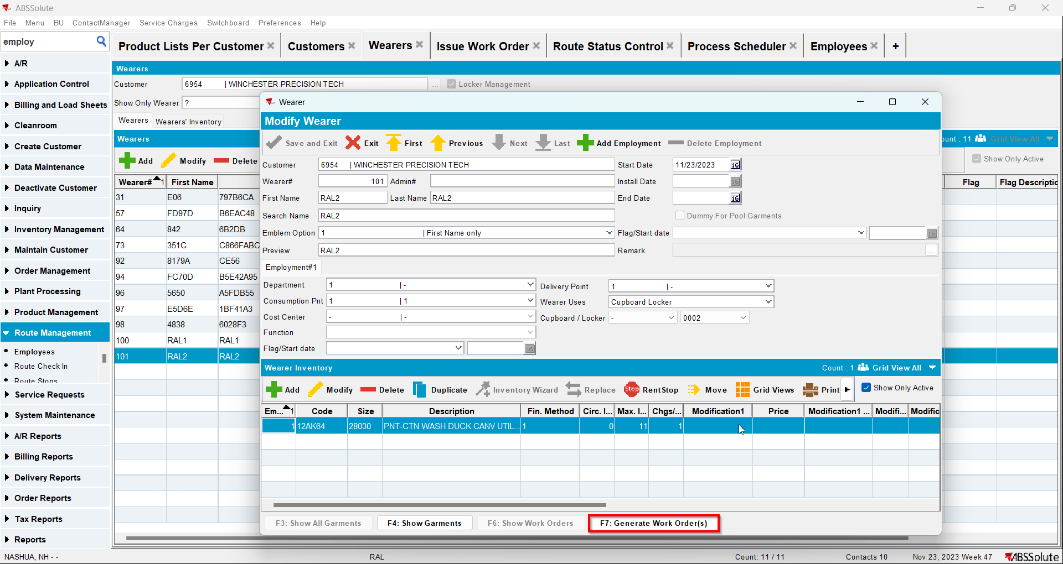
- Issue WO 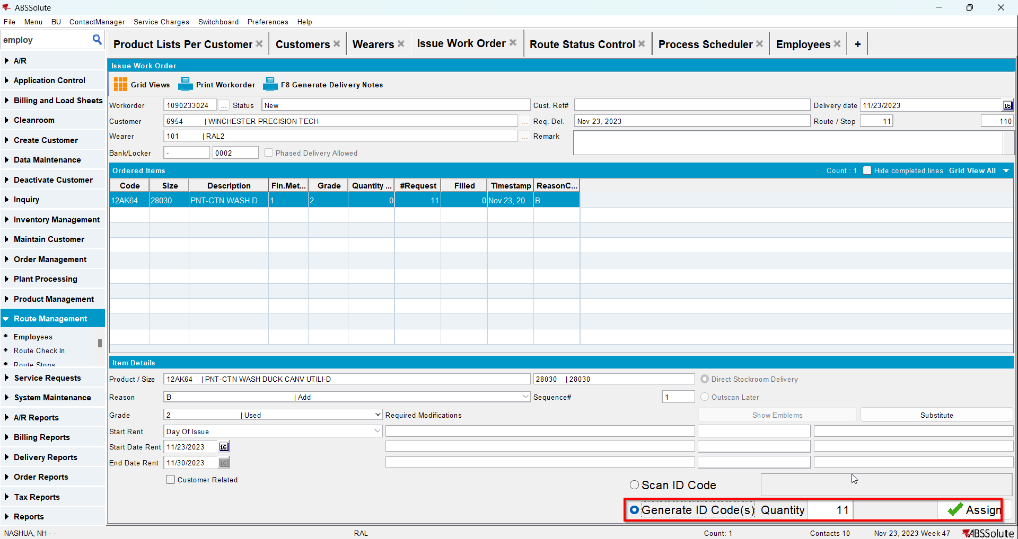
- Make 5 items unique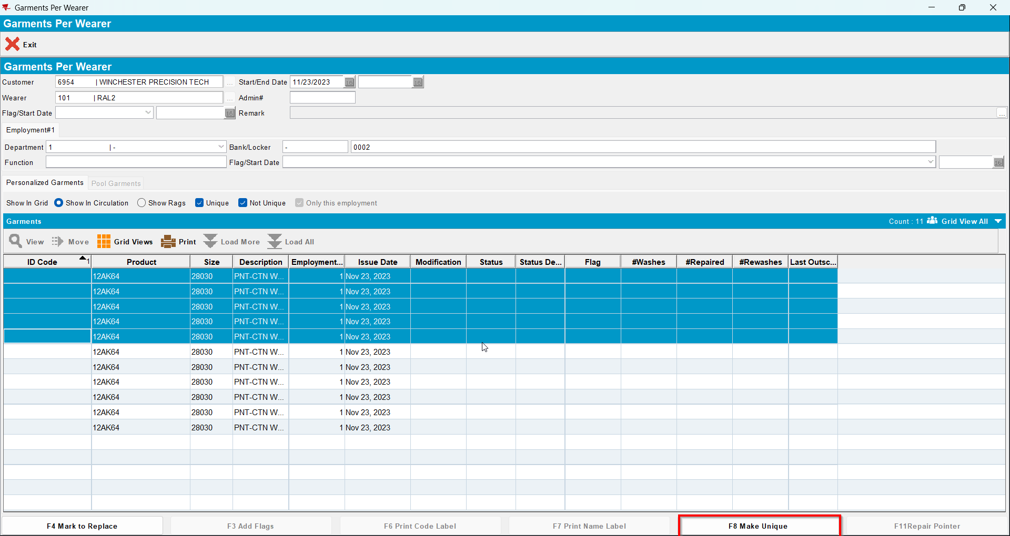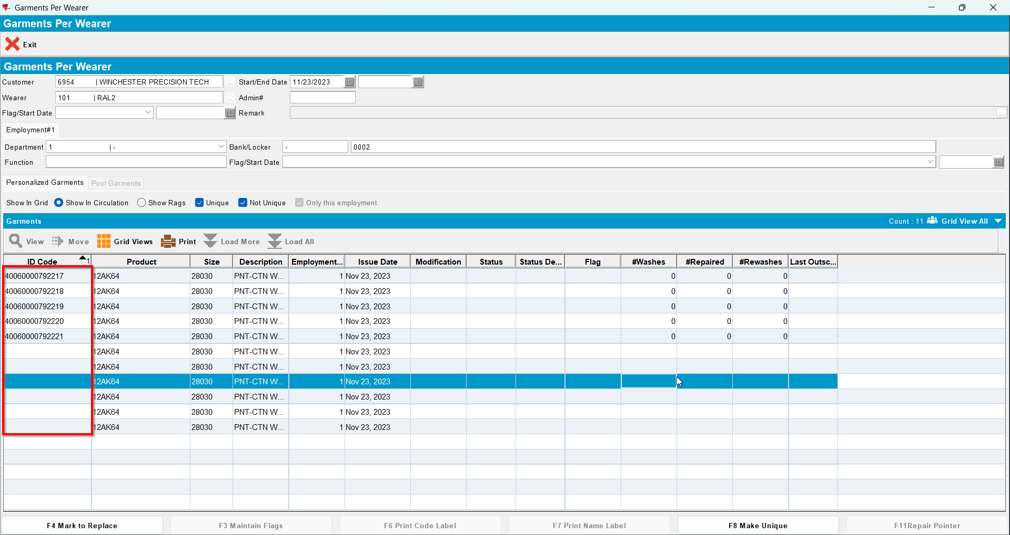
- Decrease the max inv to 4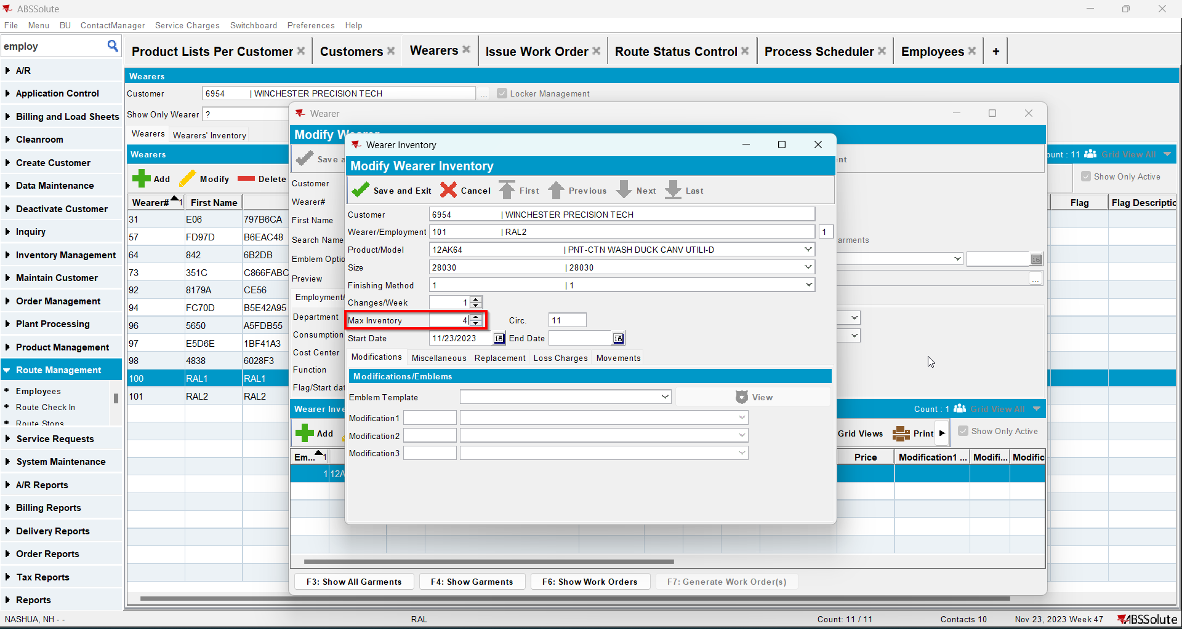
- Go to Route Status Control dlg and add a route for at least 2 weeks in the future
- Generate invoices and mark the route ready for transfer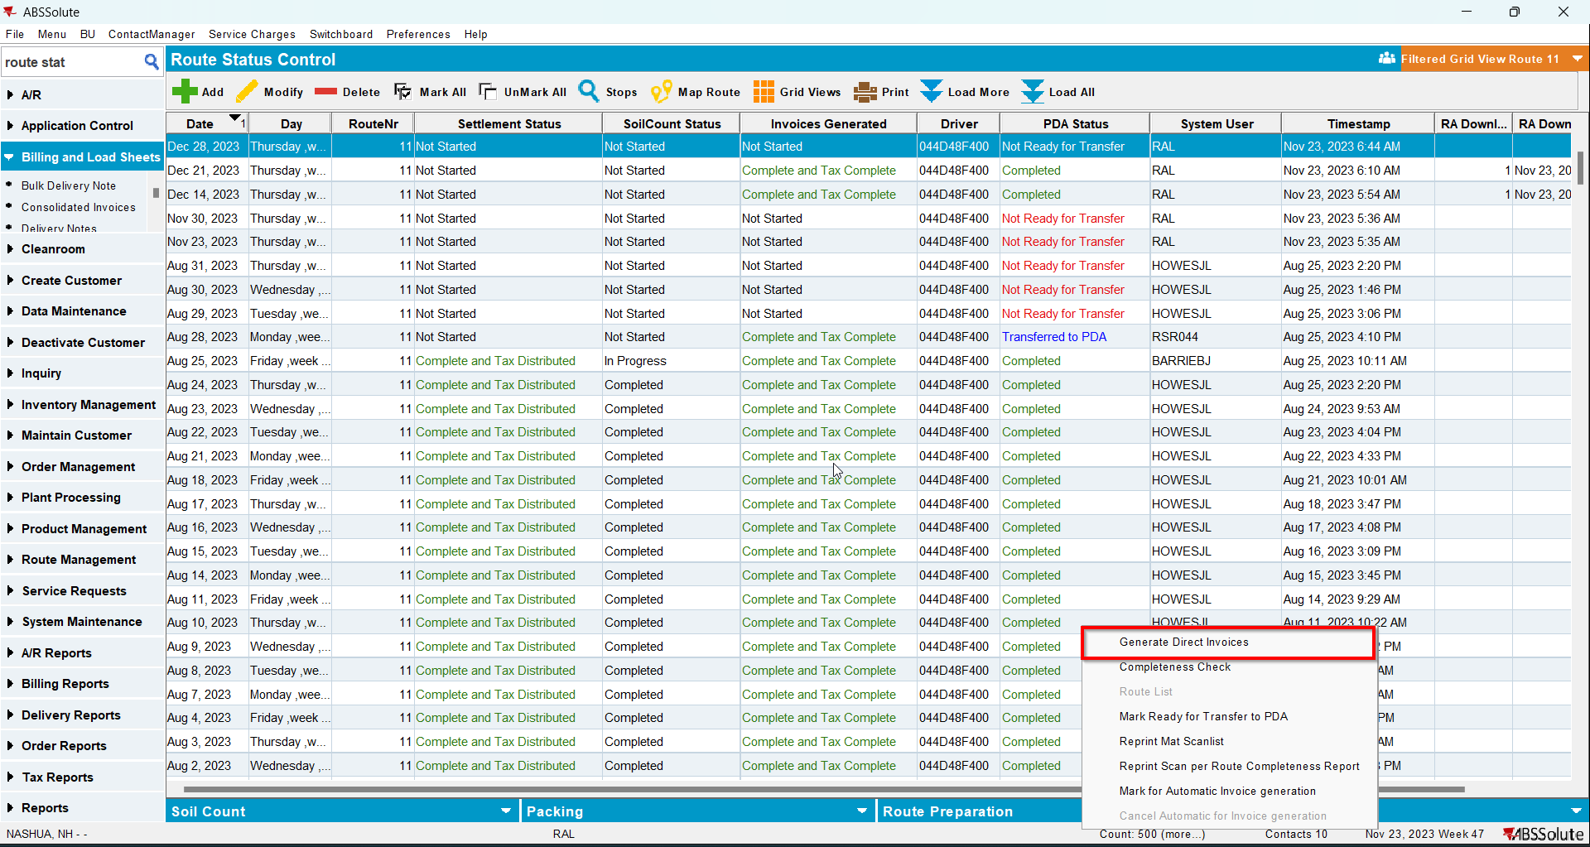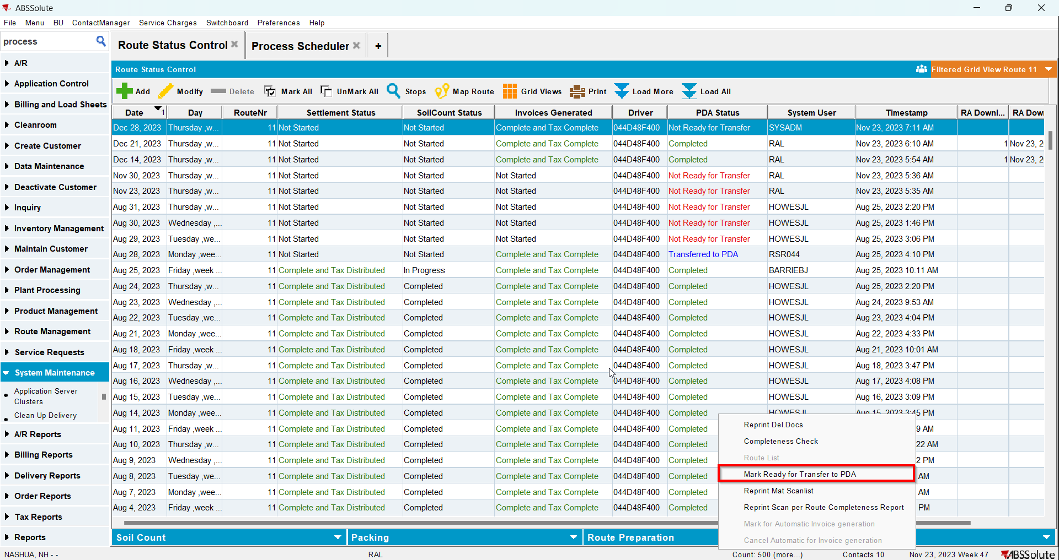
- In RA scan 4 items for return
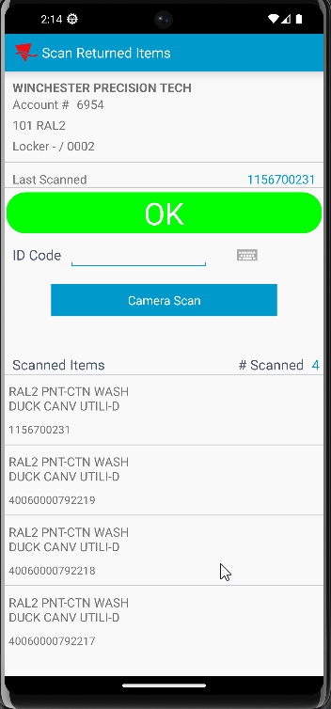
- Adjust by -3 the invoice with loss charge
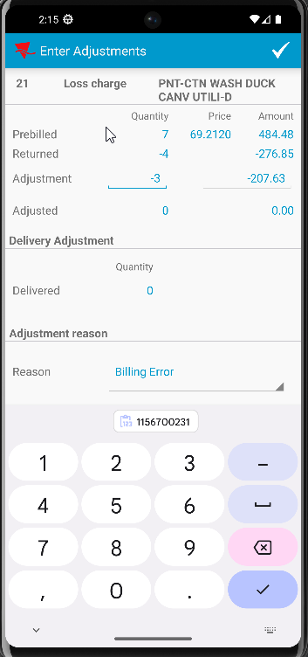
- Scan another 2 items for return
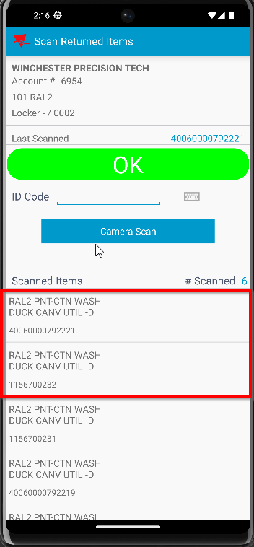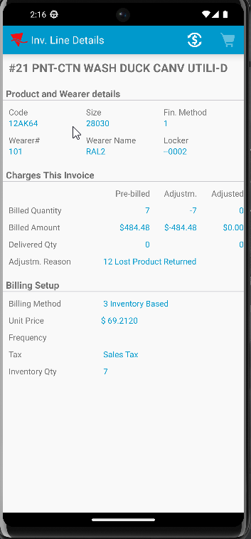

Test Case 4 – Quit wearer with 11/11 + Return 7 + adjust by -4 + Return 2 – UNIQUEITEMS ONLY– Tested OK
Expected behavior: After the invoiceline gets to 0 Qty there are no more adjustments to the invoiceline
Hash: 4108525
RA version: 83457143
- Create a wearer inventory with max inv 11 with unique items only and generate WO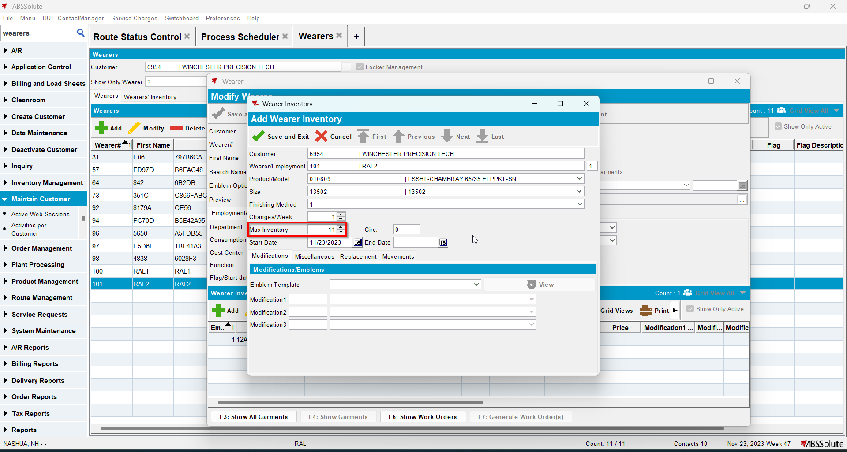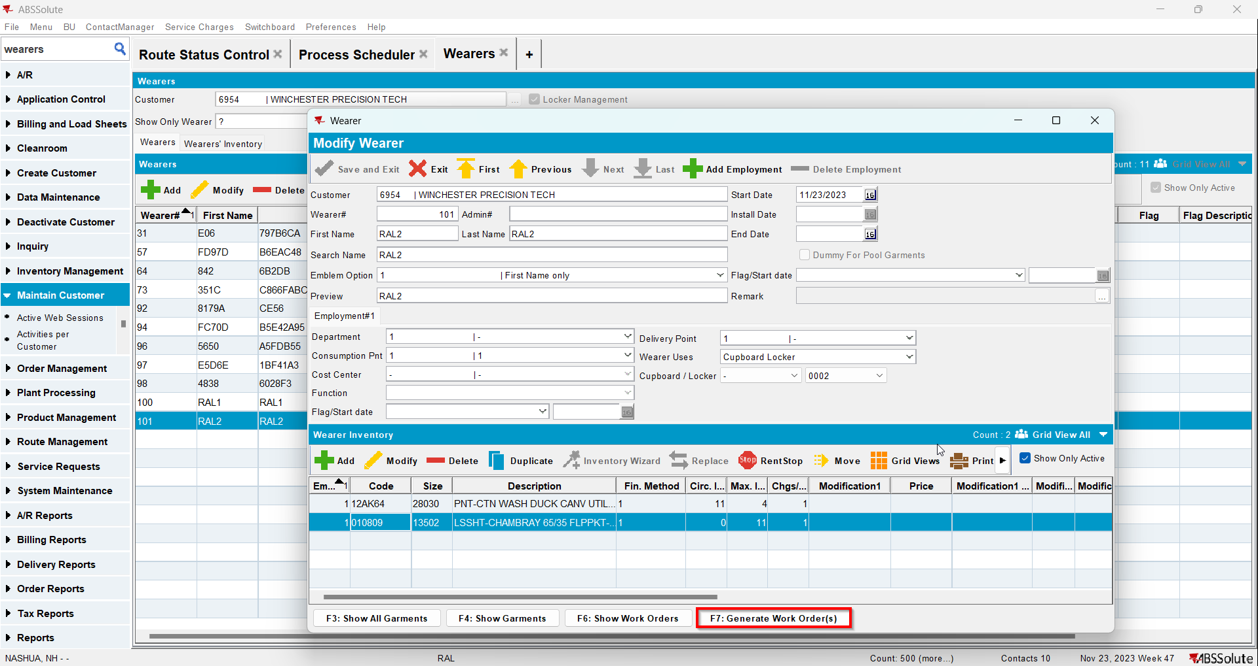
- Issue WO and generate delivery notes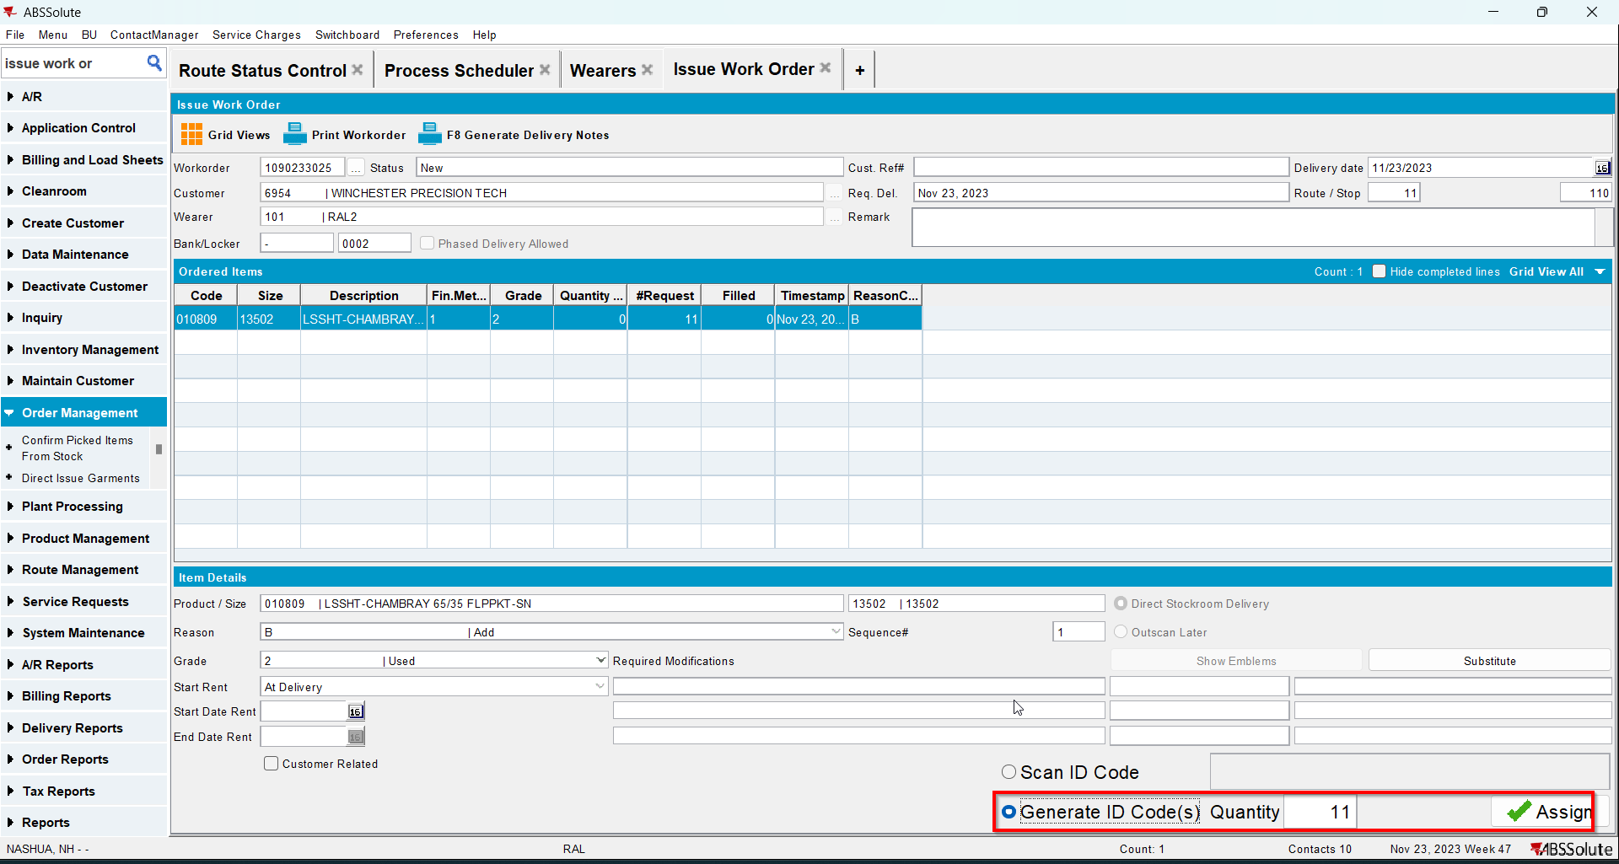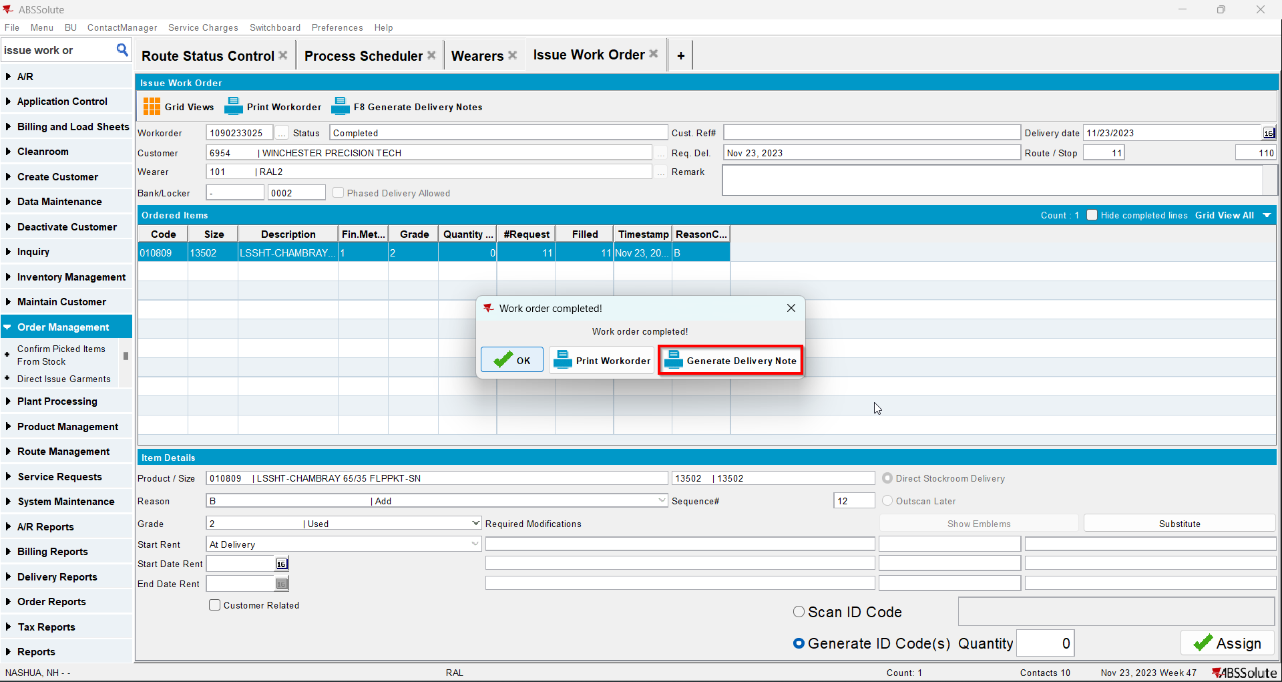
- Quit your wearer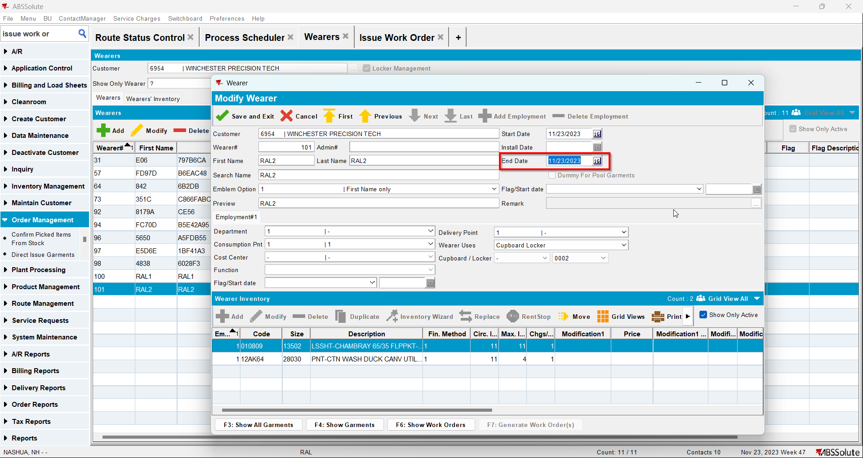
- Go to Route Status Control dlg and add a route for at least 2 weeks in the future
- Generate invoices and mark the route ready for transfer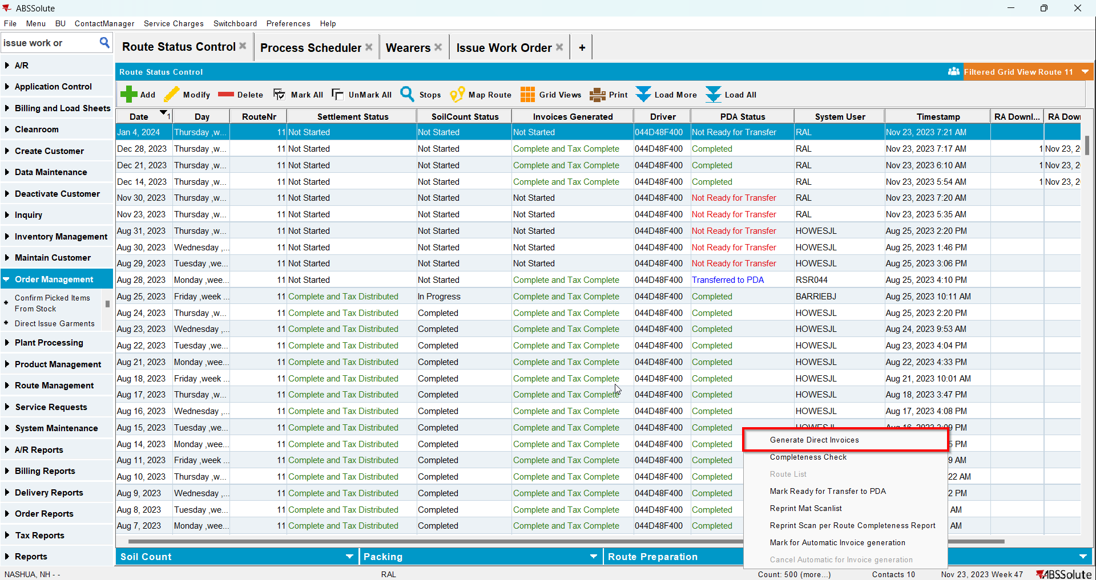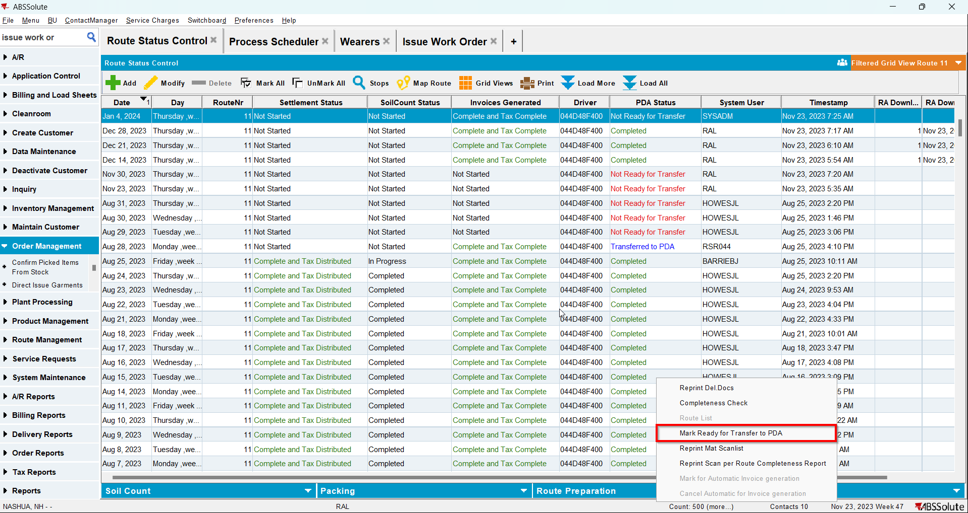
- In RA scan 7 items for return
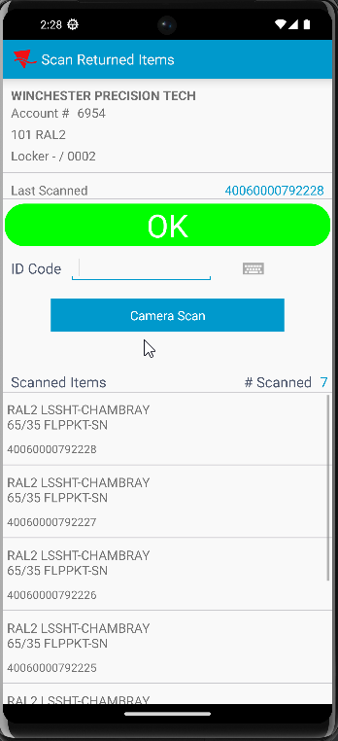
- Adjust by -4 the invoice with loss charge
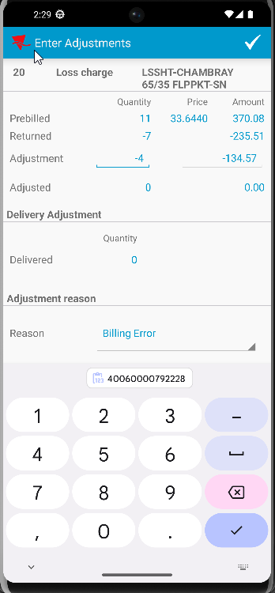
- Scan another 2 items for return
