ABS-153261 Decrease of Max and Replacement on the same WI does not show garments to be returned correctly on RA
Environment | Prerequisites
Version: 9.07.00.UNF6 hash: 68c87c446a3e  DBServerName=abs-srv16.internal.abslbs.com  DBSID=CUST21  DBUser=UNFDEV  DBPassword=UNFDEV  Environment=Production | - Module:  - System setting:  RouteAssistant_v12.28.INTERNAL_TEST_ONLY.6089006f.apk

Contents
Reproduction before fix 1
Test steps: 1
Current Behavior 6
Expected Behavior 6
Retest after fix 6
Expected Behavior: 6
Test steps: 6

Reproduction before fix
Bu: 088 PONTIAC, MI
9.07.04.RC1 hash: 250775cbdee0 + RouteAssistant_v12.27

Test steps:
- Wearers dlg: Load a customer that on a wearer has mixed wearer inventory.
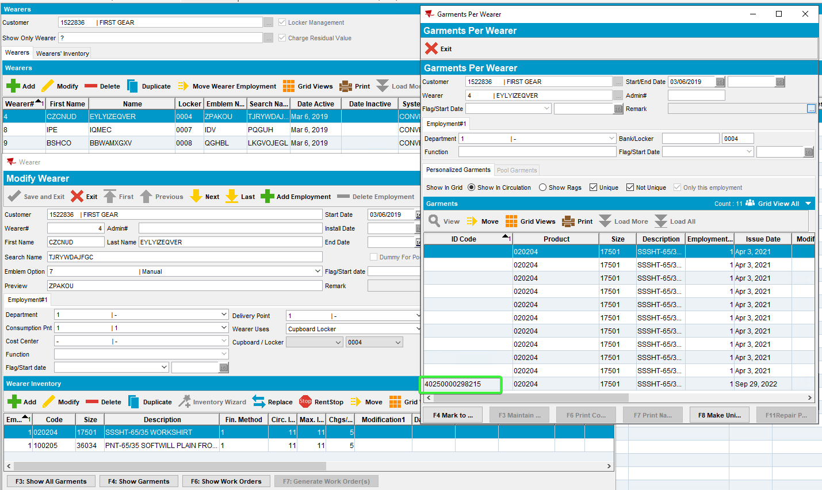
- Wearers dlg: Make a decrease DOI
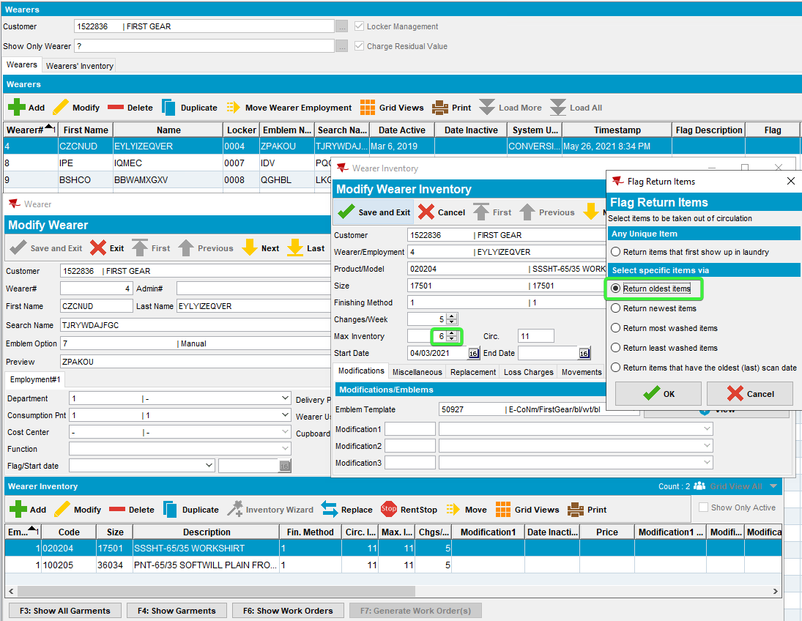

- Wearers dlg: Make a replace garment on the same wearer inventory.
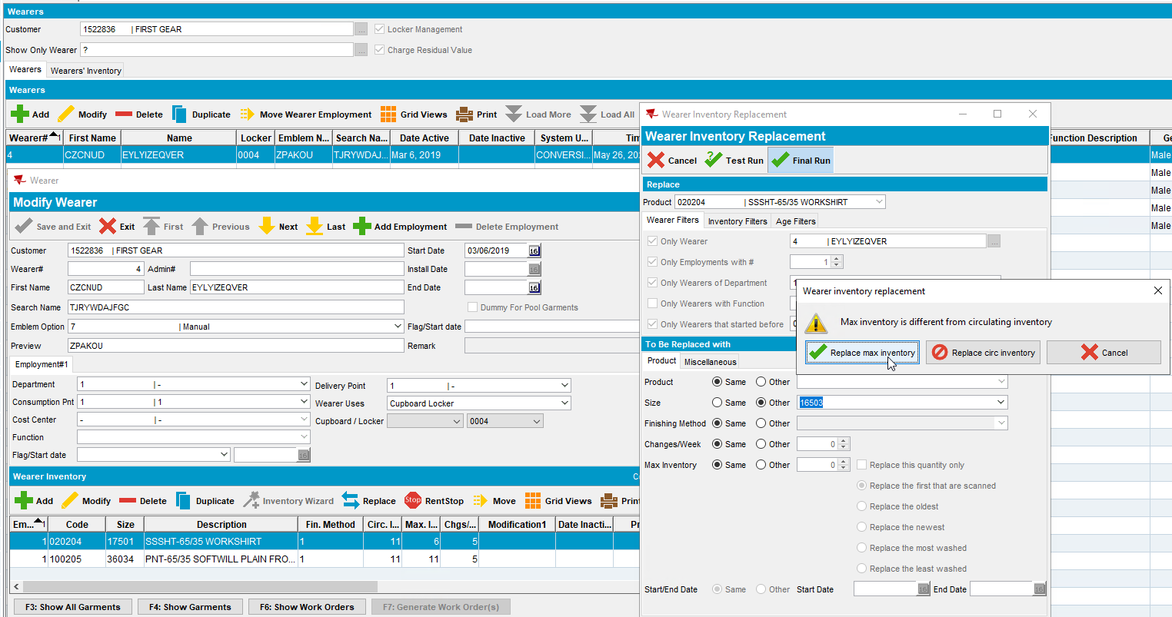
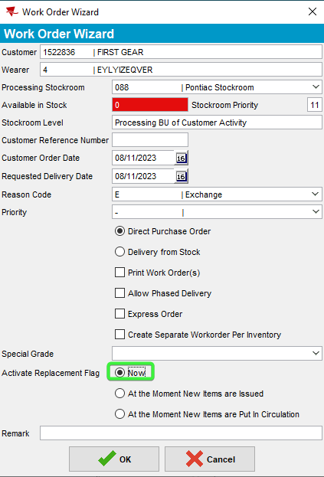

- Route Status Control dlg: Create a route that contains our customer.
- Script in the BCI data and run the process scheduler for Vertex Import Tax.
- RA: Download the route and arrive at the customer.
- RA: Enter Return items and check the to be return field
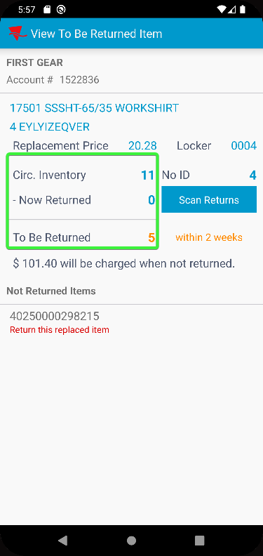

Current Behavior
The number of items to be returned is not correct (should be the sum of replaced and decreased)
Expected Behavior
The number of items to be returned should be correct as the sum of replaced and decreased items.
The list of items to be returned should contain also the items marked for take decrease, the UI ones
REPRODUCED OK

Retest after fix
Bu: 044 Nashua
9.07.00.UNF6 hash: 68c87c446a3e + RouteAssistant_v12.28.INTERNAL_TEST_ONLY.6089006f.apk
Expected Behavior:
The number of items to be returned should be correct as the sum of replaced and decreased items.
The list of items to be returned should contain also the items marked for take decrease, the UI ones

Test steps:
- Wearers dlg: Load a customer that on a wearer has mixed wearer inventory.
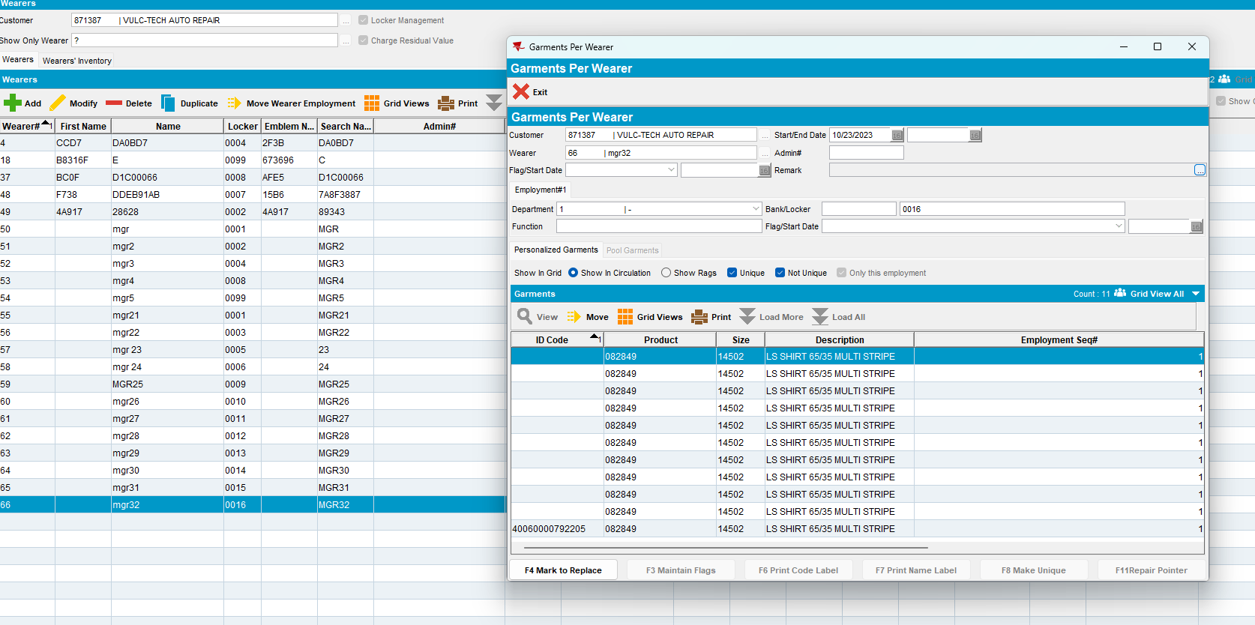
- Wearers dlg: Make a decrease DOI
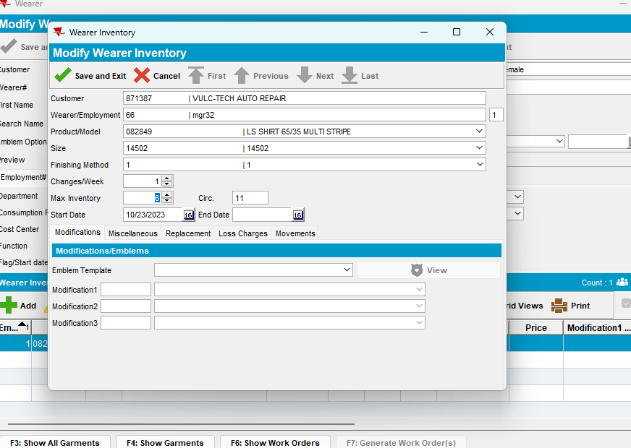
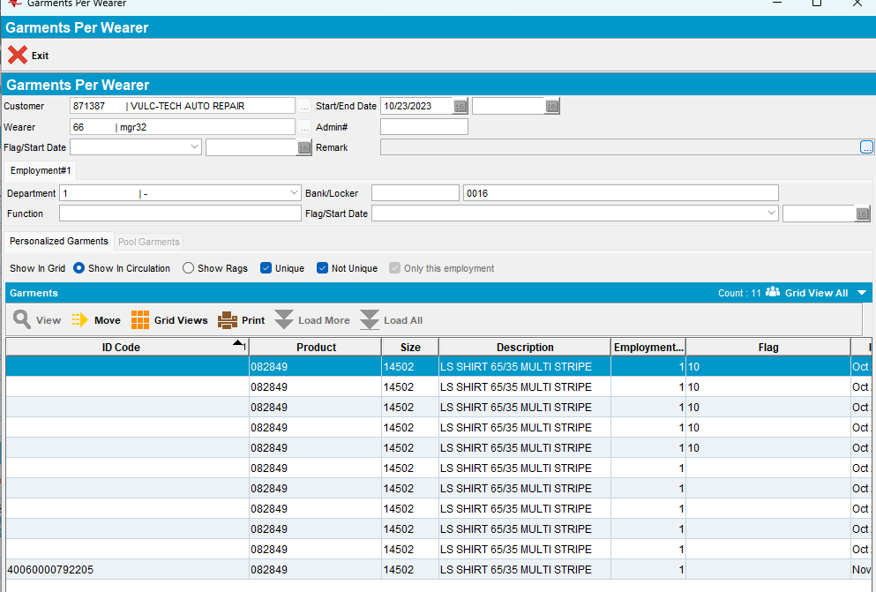

- Wearers dlg: Make a replace garment on the same wearer inventory.
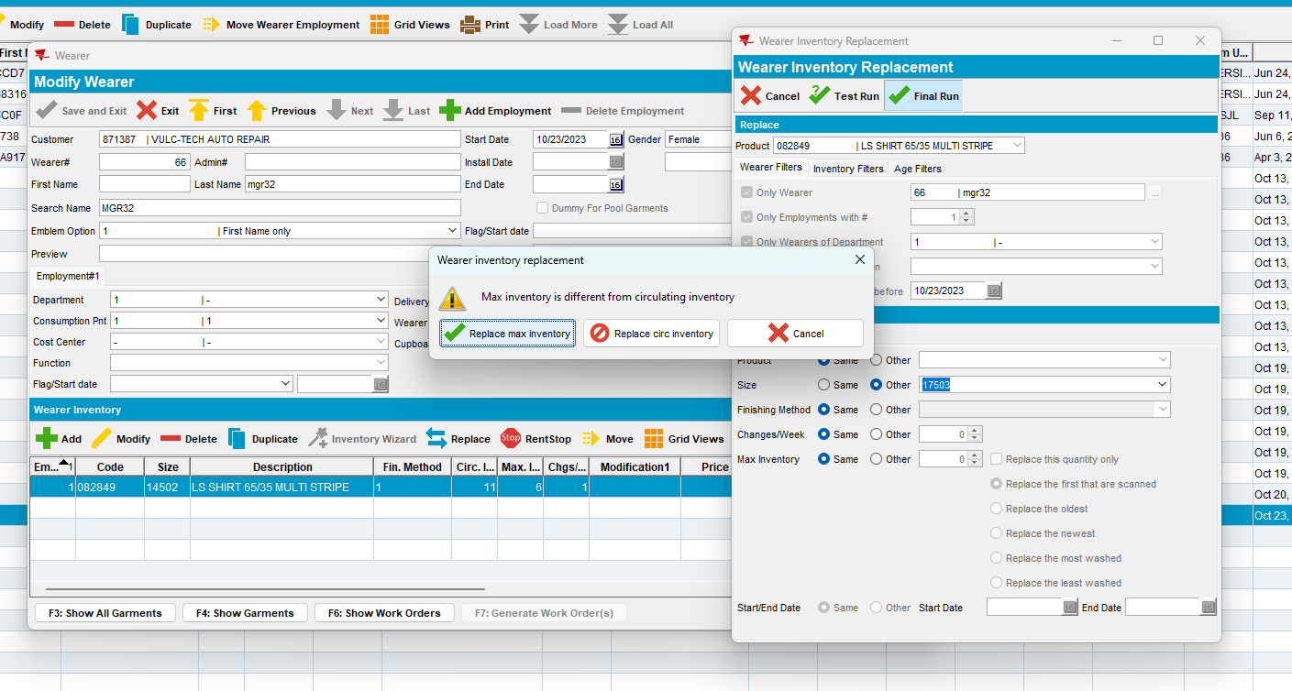
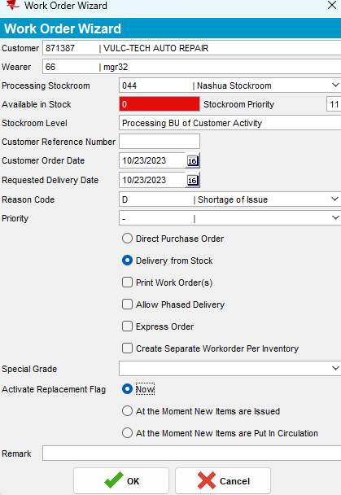
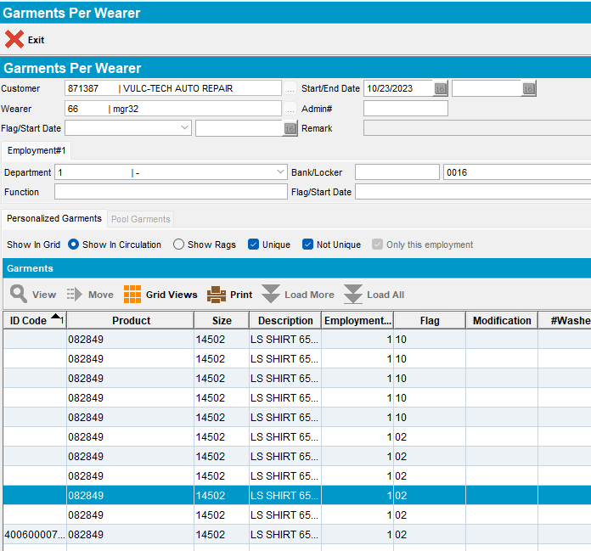

- Route Status Control dlg: Create a route that contains our customer.
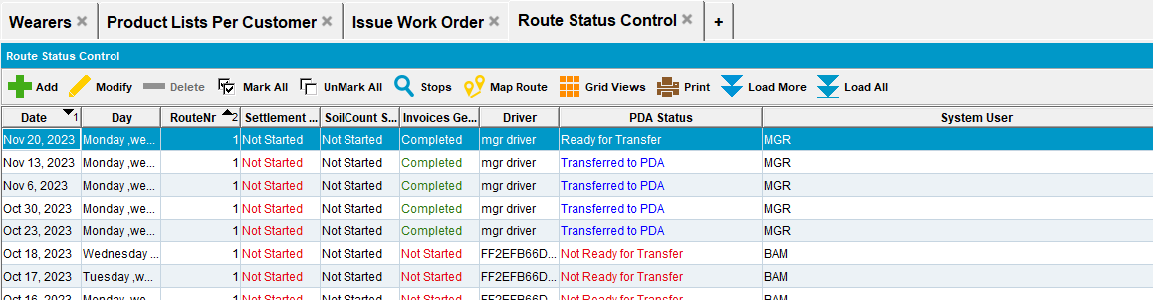
- Script in the BCI data and run the process scheduler for Vertex Import Tax.
- RA: Download the route and arrive at the customer.
- RA: Bill all for loss now and check the loss field
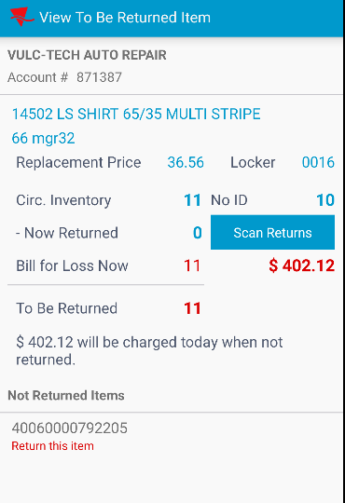

- RA: Scan one unique garment and recheck the fields
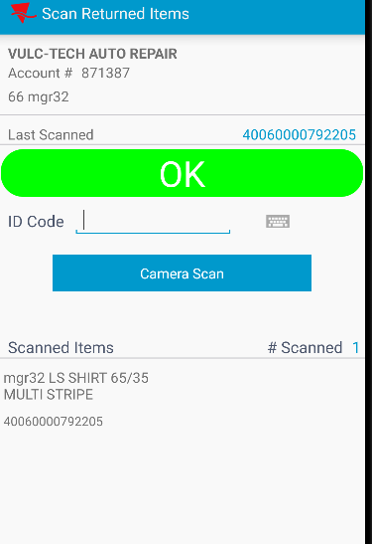
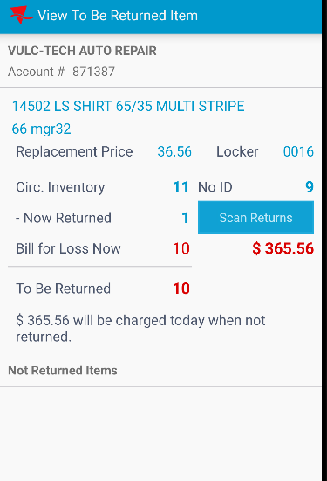

Tested OK

