RASA-3528 items to be returned list shows decrease of inventory as "Return this replaced item"

Environment | Prerequisites
Version: 9.07.00.UNF6 hash: 68c87c446a3e  DBServerName=abs-srv16.internal.abslbs.com  DBSID=CUST21  DBUser=UNFDEV  DBPassword=UNFDEV  Environment=Production | - Module:  - System setting:  - Other applications versions (if is applicable)  - Device used for mobile applications (if is applicable: Memo, physical device, Nox)  - RouteAssistant_v12.28.INTERNAL_TEST_ONLY.6089006f.apk

Contents
Retest after fix 1
Test Case – Decrease an inventory on RA with 2 pieces 1

Retest after fix

Test Case – Decrease an inventory on RA with 2 pieces
Expected behavior: It should show those 2 pieces to be returned and all the items from the same inventory without a message
Hash:
- RSC dlg: Add a new route which contains a customer with wearers and garments per wearers
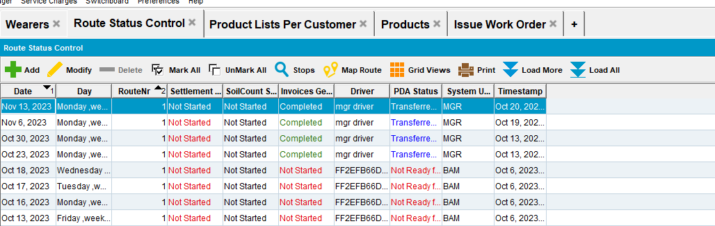
- Generate Invoices and mark route ready for transfer
- Download the route on PDA
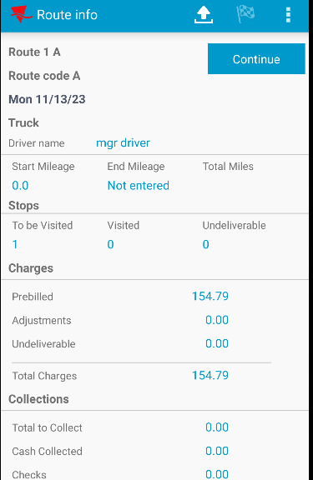
- Wearer screen: Select a wearer and an inventory for it
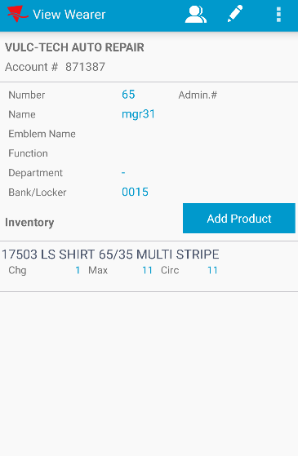
- Decrease the inventory with 2 pieces
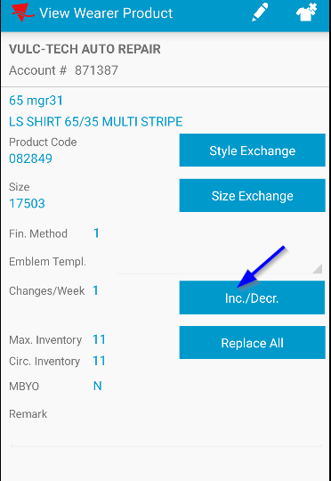
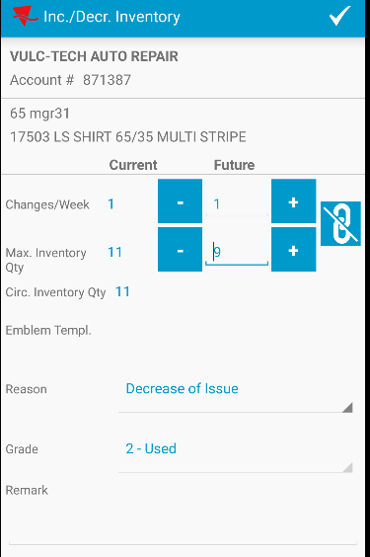

- Go to Returned items screen and select the line with the returned items. Check if data appears ok.
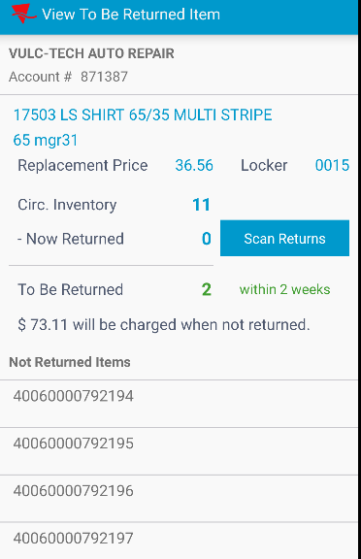
I noticed that it shows those 2 pieces to be returned and all the items without a message.

RETEST OK

