RASA-4114 D_UBS_2278 Garment showing to be returned but error when returned

Environment | Prerequisites
Version: 9.07.00.UNF6 hash: 68c87c446a3e  DBServerName=abs-srv16.internal.abslbs.com  DBSID=CUST21  DBUser=UNFDEV  DBPassword=UNFDEV  Environment=Production | - Module:  - System setting:  - Other applications versions (if is applicable)  - Device used for mobile applications (if is applicable: Memo, physical device, Nox)  RouteAssistant_v12.28.INTERNAL_TEST_ONLY.6089006f.apk

Contents
Reproducing before fix 1
Data preparation 1
Steps to reproduce 1
Current Behavior 1
Expected behavior 2
Retest after fix 2
Test Case 1 – System Setting to 1 and tested from RSC – Tested OK 2
Test Case 2 – System Setting to 2 and tested from RSC – Tested NOT OK 2

Retest after fix

Test Case 1 – Initial case: Replace an item which is non-unique on client, download the route on PDA and check what appears at not returned items
Expected behavior: No id codes should appear at not returned items on pda
Hash:
- Wearers dlg : Find a wearer with unique and non-unique items and replace a non-unique item from that wearer

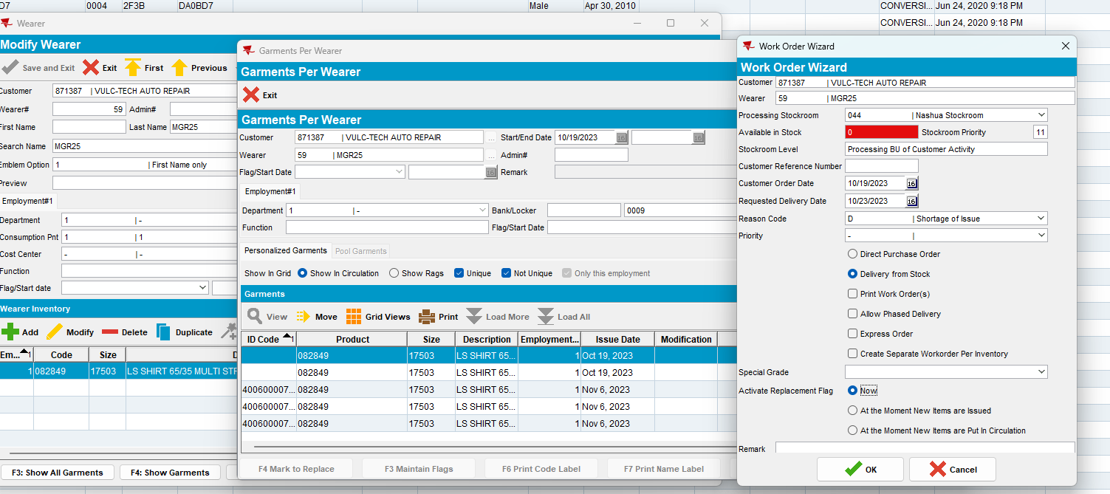
- RSC: Add a new route, generate invoices and mark ready for transfer
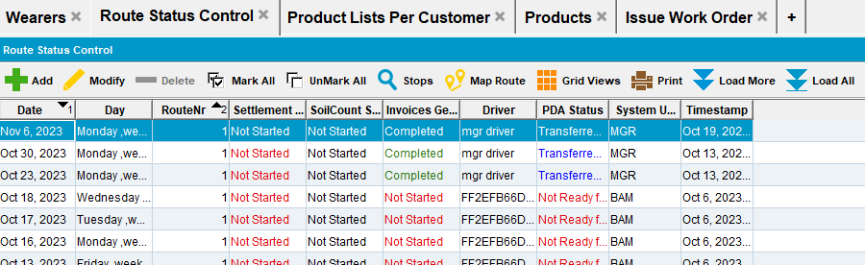
- Download the route on pda
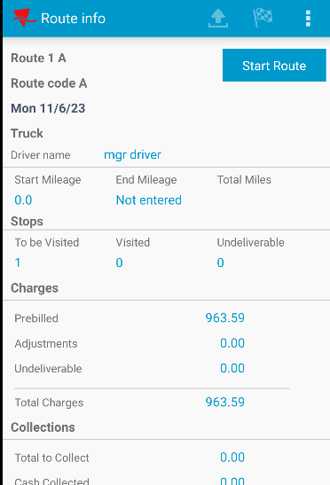
- Go to Scan Returned items screen and check the information
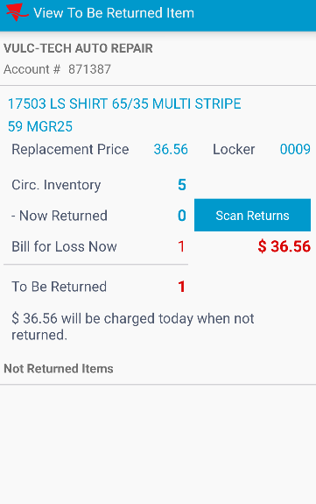
I noticed that one item is marked for to be returned but no id code appears in the last section ( not returned items).
Pretest ok.

Test Case 2 –Decrease mixed wearer inventory from RA by 4 (11 max - 9 unique, 2 non-unique)

Expected behavior: When going to Return Items screen on RA, To be Returned item list should show all uniqueitem PrimaryID codes. In the scan screen you should be able to scan any unique item code and at least 2 smartbarcodes up to 4 garments in total (uniques + non-uniques).
Hash:
- Add a new wearer with an wearer inventory ( with 11 garments – 9 unique and 2 non-unique). Create a new route and download it to pda

- Go to wearers screen and decrease a wearer max inventory from 11 to 7
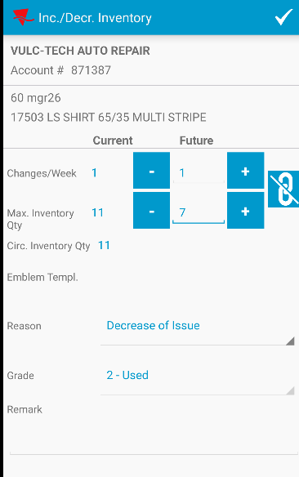
- Go to Return Items screen and check if all unique items code appear
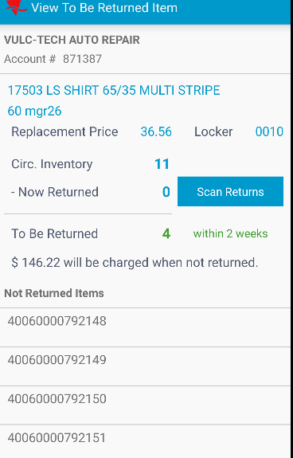

- Scan 2 unique items and 2 smartbarcodes
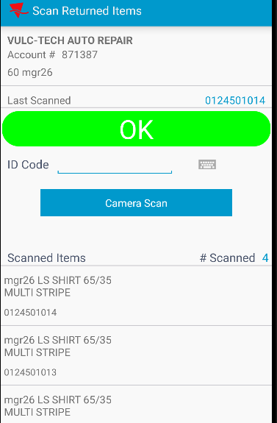
- Try to scan one more barcode
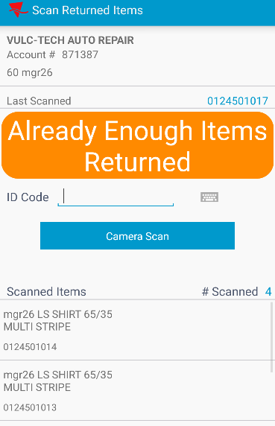
I noticed that only 4 scans were accepted( 2 unique and 2 smartbarcodes)
Pretest ok.

Test Case 3 – Style exchange for a mixed wearer inventory from RA (11 max - 9 unique, 2 non-unique)
Expected behavior: When going to Return Items screen on RA, To be Returned item list should show all uniqueitem PrimaryID codes. In the scan screen you should be able to scan any unique item code and at least 2 smartbarcodes up to 11 garments in total (uniques + non-uniques).
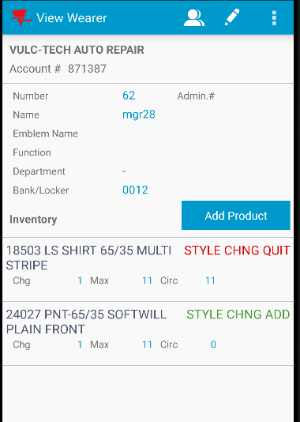
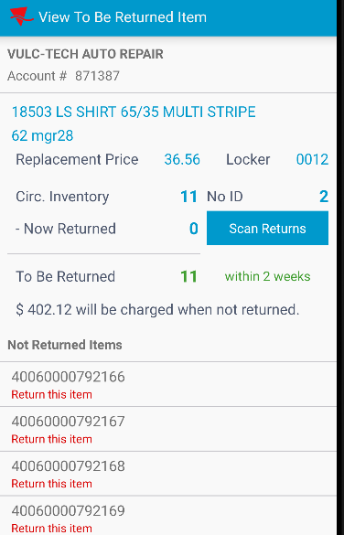

Then I scanned 9 unique items and 2 smartbarcodes:
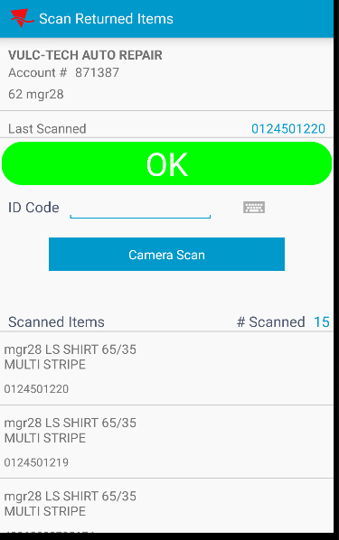

Then I tried to scan one more smartbarcode:
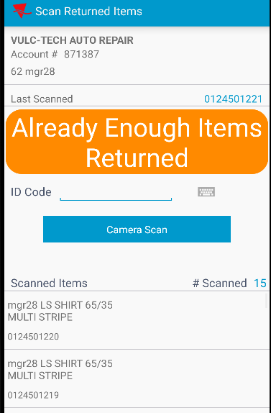
I noticed that only 11 items from the same wearer inventory were accepted ( unique + smartbarcodes). Pretest ok.

Test Case 4 – Scan a replacement (Change as Needed) for a mixed wearer inventory from RA (11 max - 10 unique, 1 non-unique)
Expected behavior: In the scan screen you should be able to scan any unique item code and at least 1 smartbarcodes up to 11 garments in total (uniques + non-uniques).

- Go to Scan garments screen and scan a unique item
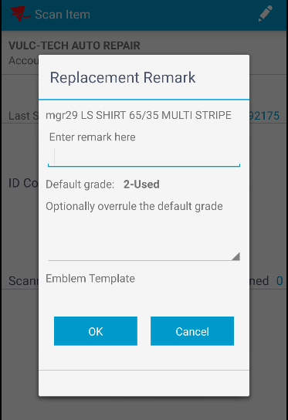
- Scan another 9 unique items and one smartbarcode

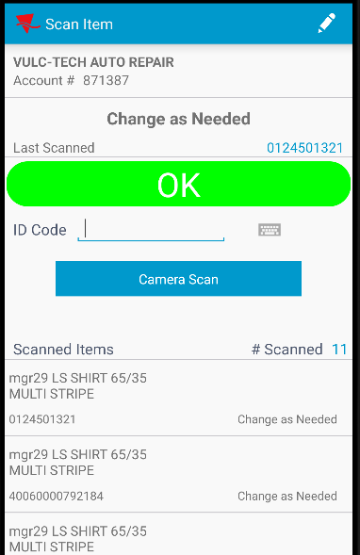

Pretest ok.

Test Case 5 – Replace product for a mixed wearer inventory from ABSSolute Client (11 max - 9 unique, 2 non-unique)
Expected behavior: When going to Return Items screen on RA, To be Returned item list should show all primaryID's that were flagged for replacement on the client (9 unique ids).
In the scan screen you should be able to scan any unique item code and at least 2 smartbarcodes up to 11 garments in total (uniques + non-uniques).
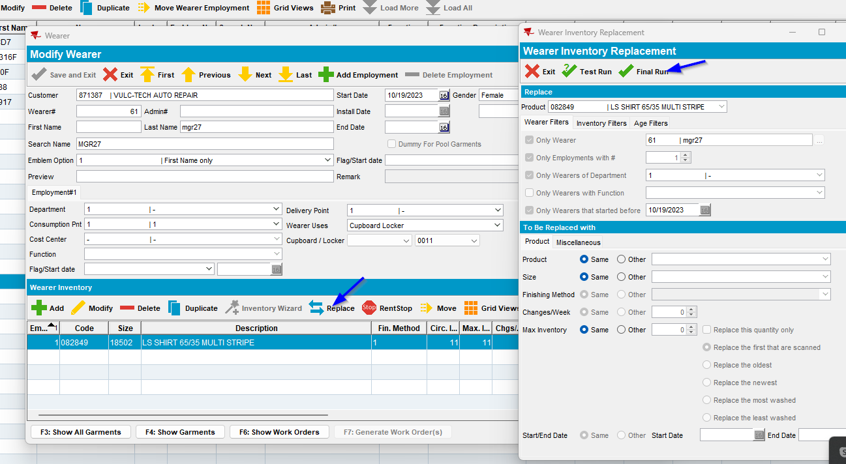
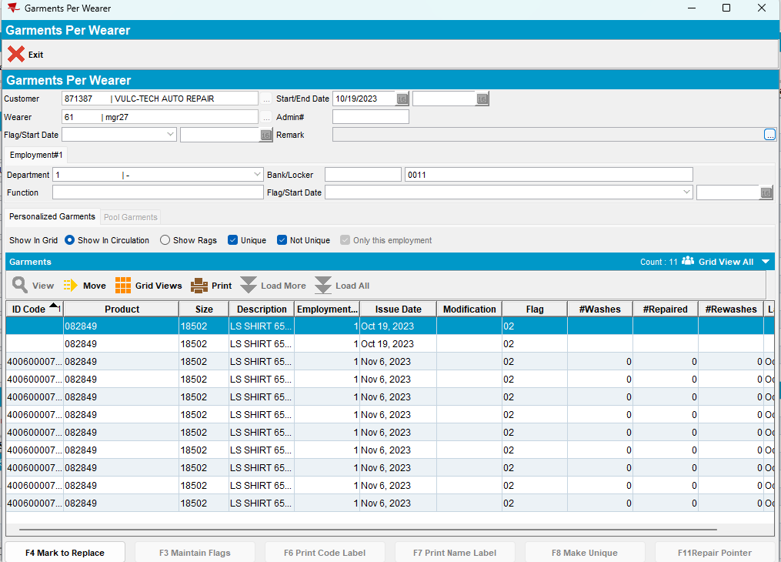

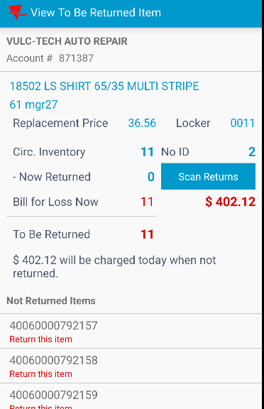

I noticed that only the id codes for unique items replaced appear.
Then I scan some items to return:
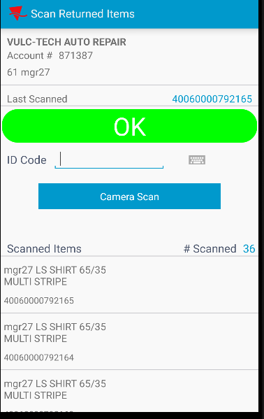

Then I scan 2 smartbarcodes:
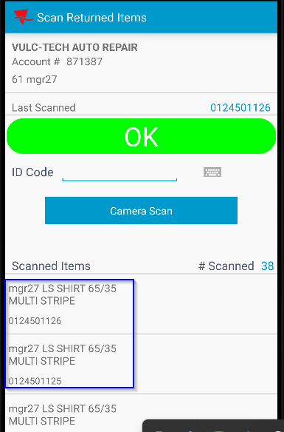

I noticed that the smartbarcodes were scanned ok.
After scanning 11 items I’ve tried to scan another smartbarcode:
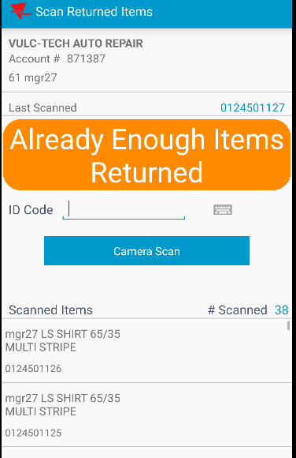
As I expected the item wasn’t accepted and a message appeared on the screen.
Pretest ok.

