RASA-4039 : D_UBS_2198 If you scan one garment for return and then credit the rest, you see error "You are not allowed to adjust more than was billed"
Environment | Prerequisites
Version: 9.07.04.RC1 hash: 92031dad3281  DBServerName= abs-srv11.internal.abslbs.com  DBSID=CUST22  DBUser=UNFA  DBPassword=UNFA  Environment=PRODUCTION | - Module:  - System setting:  RA v12.88 hash 6311c406

Contents
Retest after fix 2
5

Retest after fix
Bu: 245 GARDEN CITY, KS
9.07.04.RC1 hash: 92031dad3281 + RouteAssistant_v12.28.INTERNAL_TEST_ONLY.6311c406.apk
Expected Behavior:
NOTE: If the adjusted quantity goes to 0, assume the amount is 0 – This is needed because if the adjusted amount is now 0, the adjustment amount (so the negative figure entered) * the price that may be rounded may not be the same as the amount so the even though the sum of quantity is 0, the sum of the amount is not 0.
Test steps:
1. Find a wearer with a wearer inventory that has only unique items

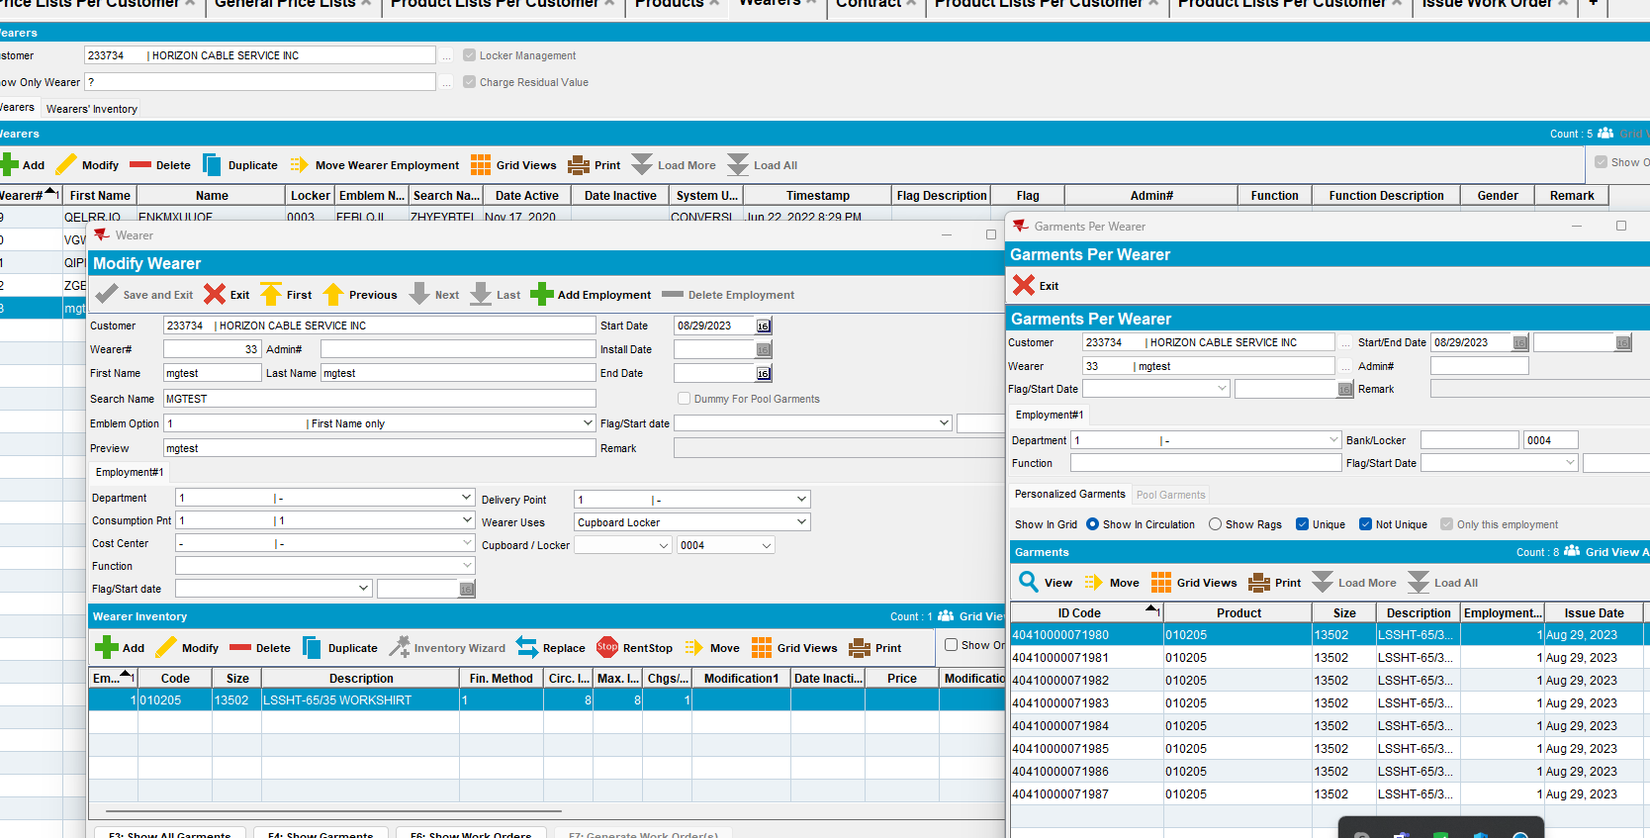

2. Set the inactive date for that wearer

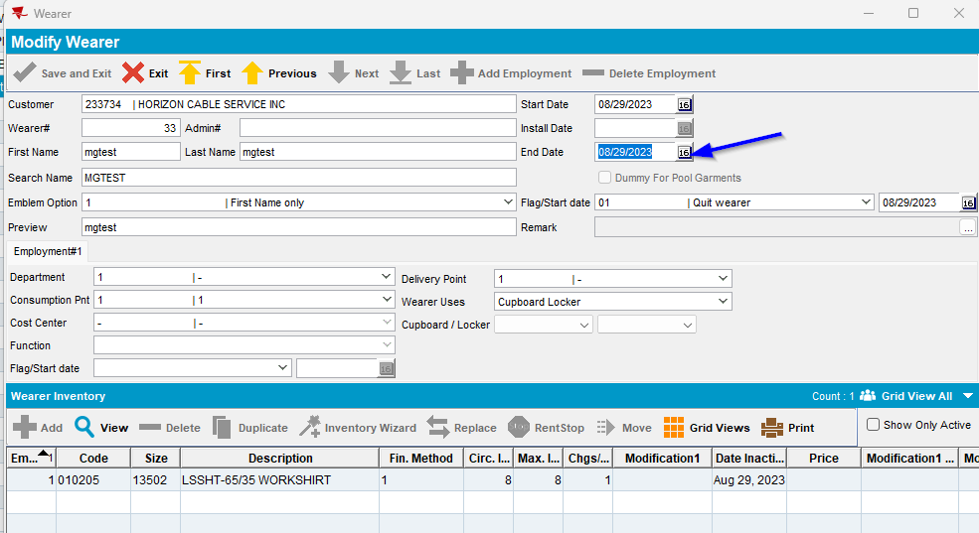

3. Route Status Control DLG: Add a routecontrol for this customer for the next available billing day.

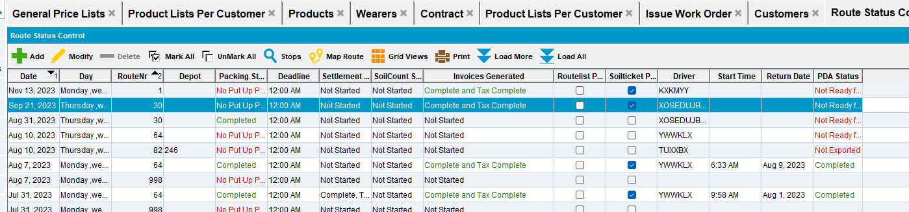

4. Route Status Control DLG: Generate invoices for that RouteControl and process the Vertex BCI taxes
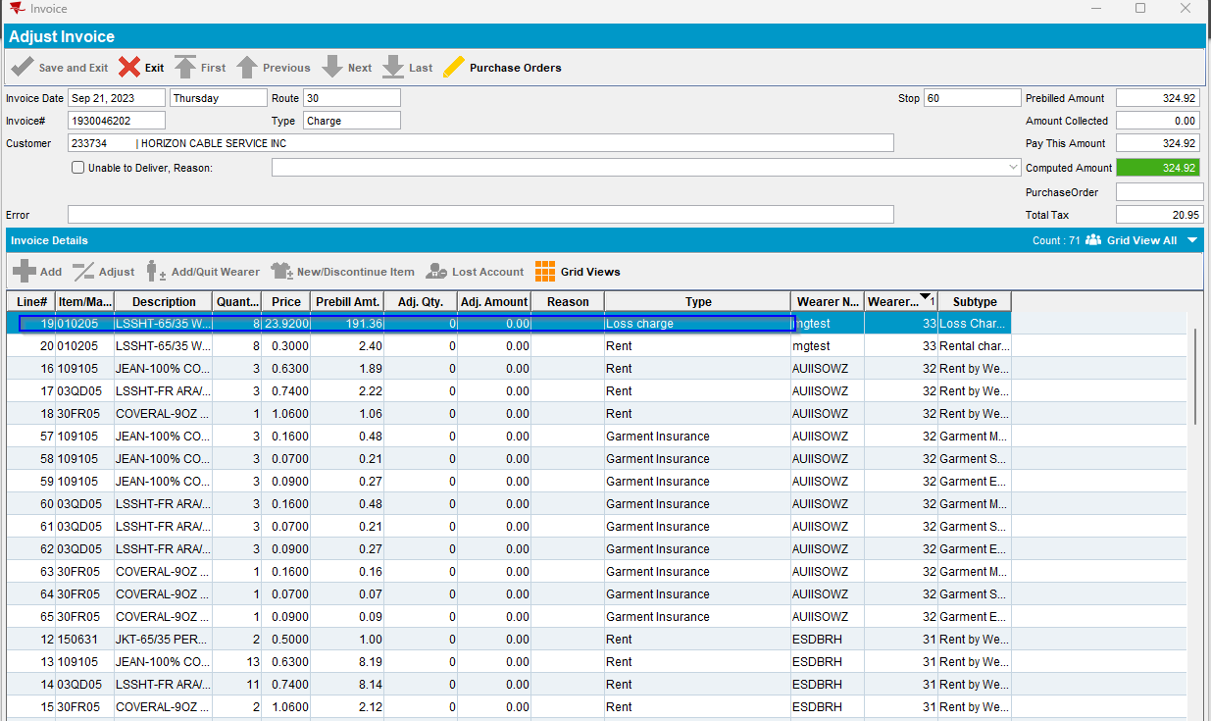
5. Send the route to RA
6. On RA -> Return Garments, scan 6 garments for product 010205 on wearer 33
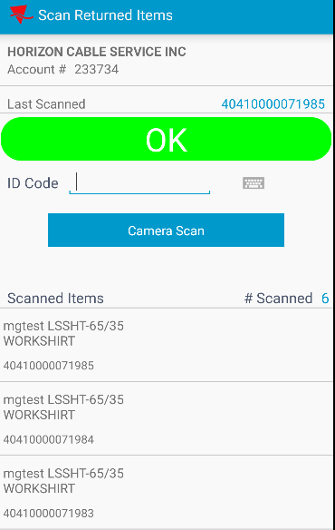
7. On RA -> Adjust: Go to line 19 and try to put in -2 in the adjusted quantity

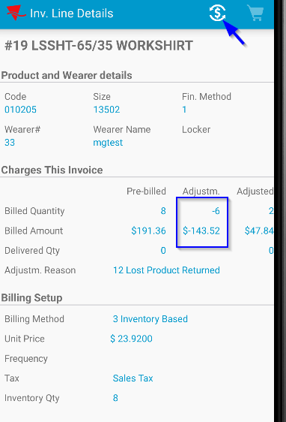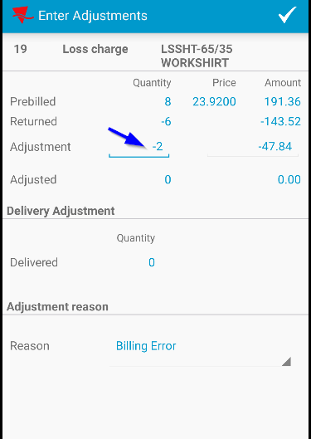
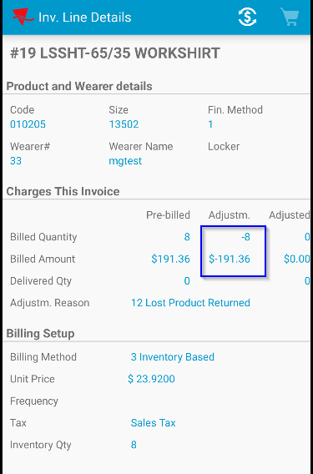
8. RA: Settle the route, depart from the customer and upload the route back to the client.

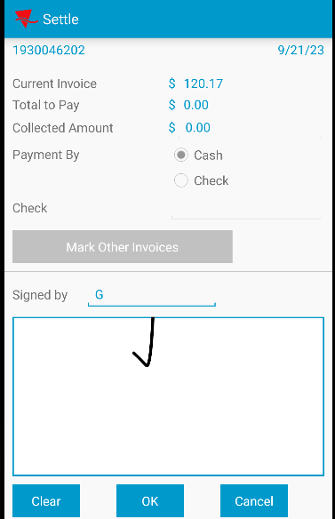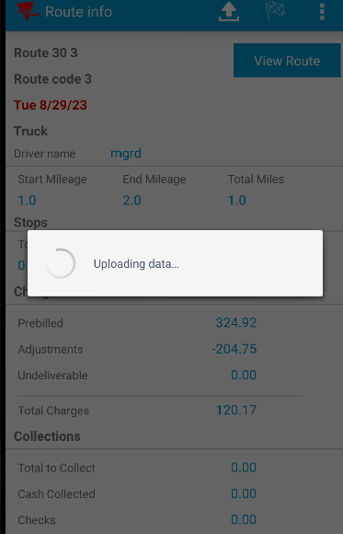

9. Route Check-In dlg: Load the route and check the Invoice adjustments tab. The adjustments made on RA are present in the client.

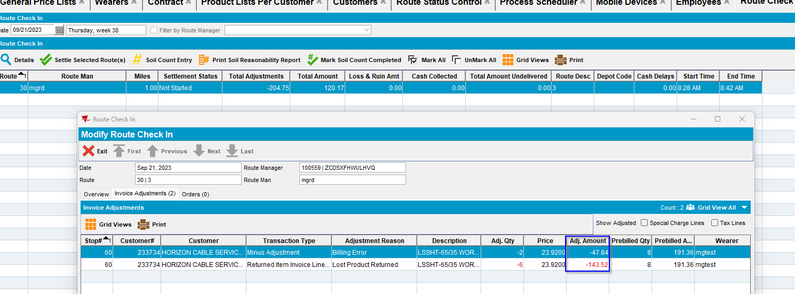

Tested OK

