ABSN-9808 Compliancy not Refreshed for setting Size Surcharge Pricing when enforce Special Size Charge
DataBase | Preconditions
Version: 9.07.00.UNF21  DBServerName= abs-srv20.internal.abslbs.com  DBSID=CUST24  DBUser=UNFDEV | - Module: CONTRACTMANAGEMENT; ONEOFFSPECIALSIZECHARGE;  - System setting:  - Other applications versions (if is applicable)  - Device used for mobile applications (if is applicable: Memo, physical device, Nox)
Contents
Summary: Retest after fix 1

Summary: Retest after fix
Preconditions: Hash: 9.07.00.UNF21 hash: 8d9e27e5f9f1
Note:
SSP = “Size Surcharge Pricing”
SSC = “Special Size Charging”
Step 1) I will be using contract 0005954:
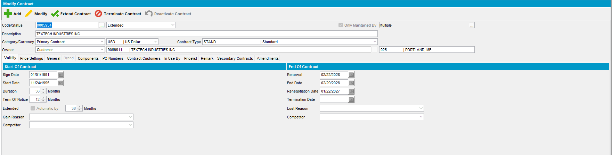
Step 2) Open contract in modify mode, go to components, reload compliancy and open products:
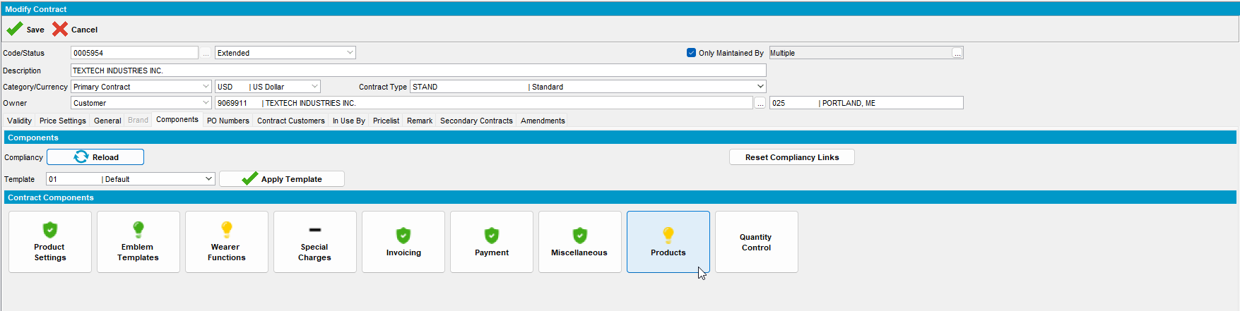
Step 3) Make sure SSP and SSC are unchecked. 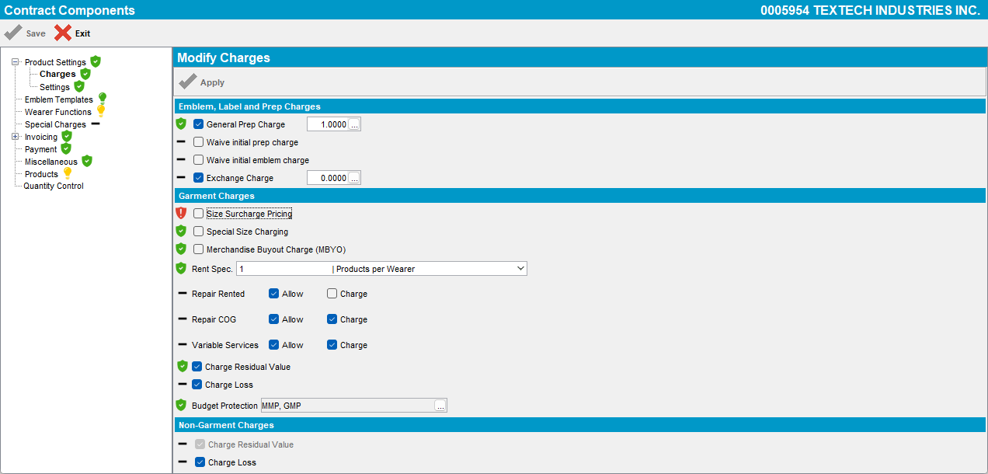
SSP is not compliant:
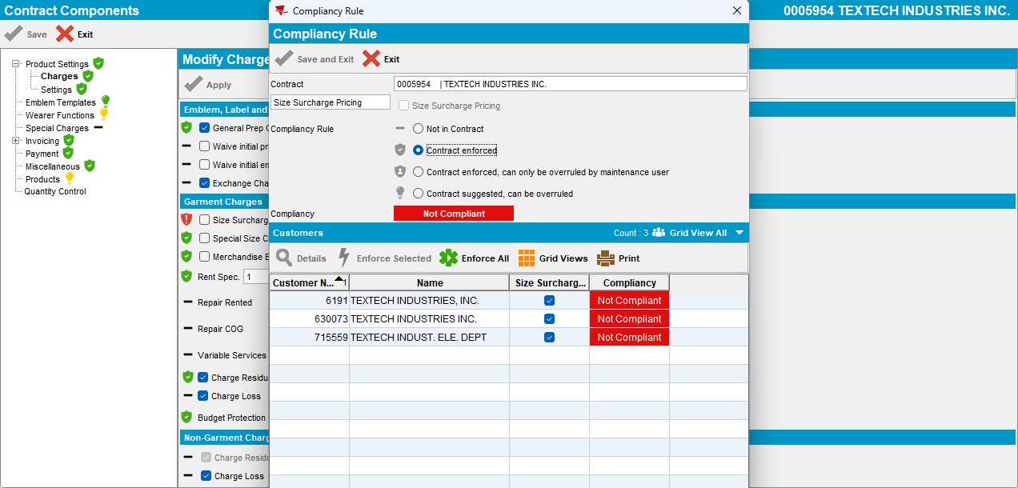

SSC is compliant:
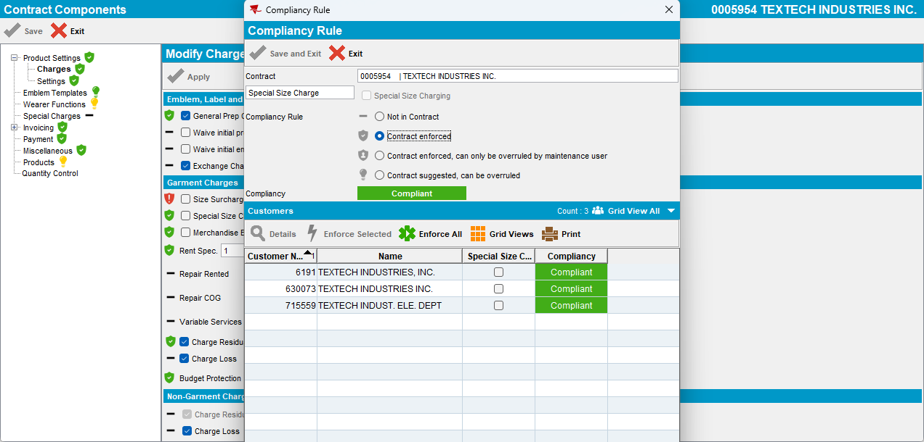
Step 5) Set SSC to Y:
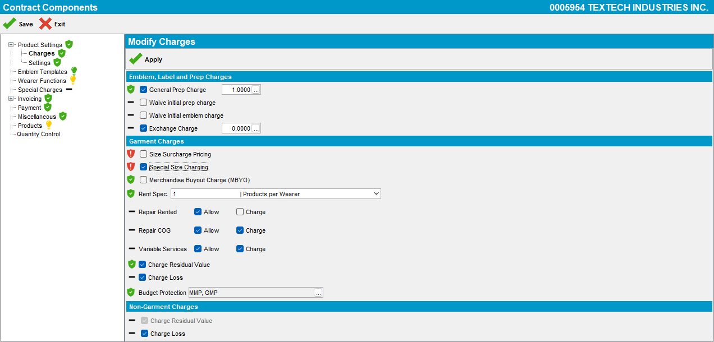

Step 6) Enforce one customer:
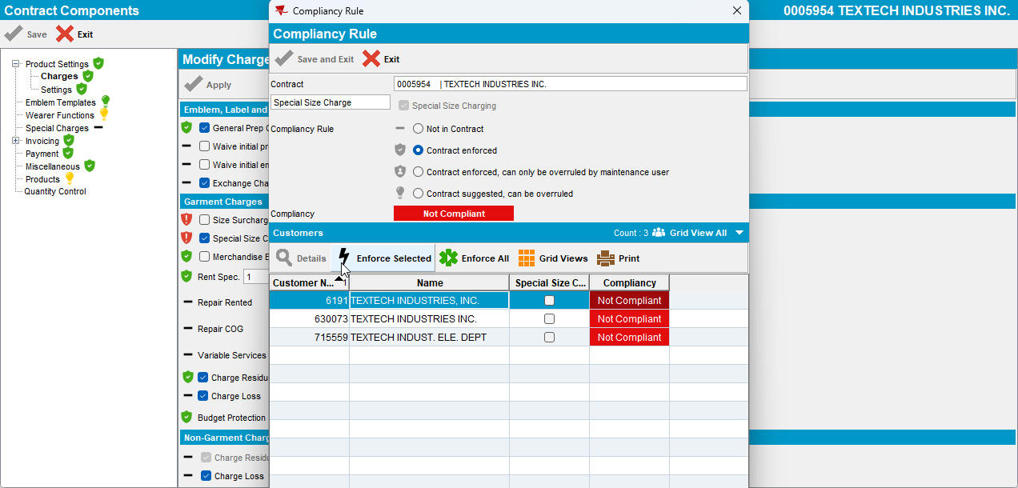
Notice only that customer is now compliant: Per total the component remain not compliant. This is correct.
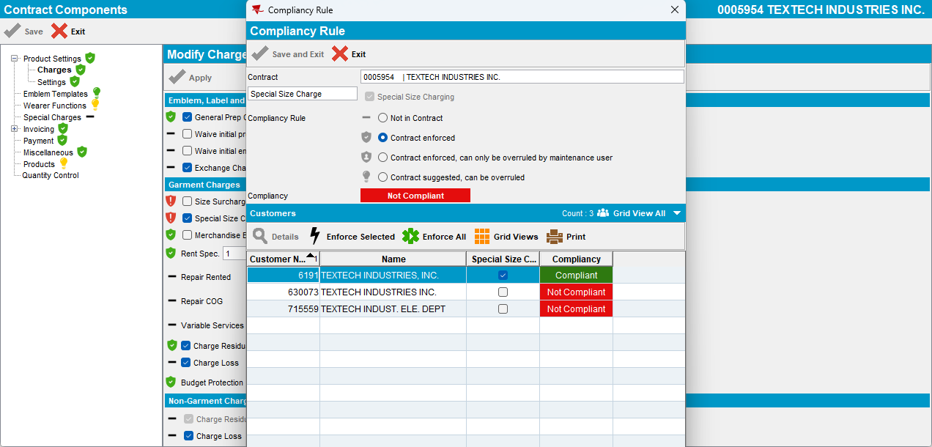

Notice the rule was updated on customer level:
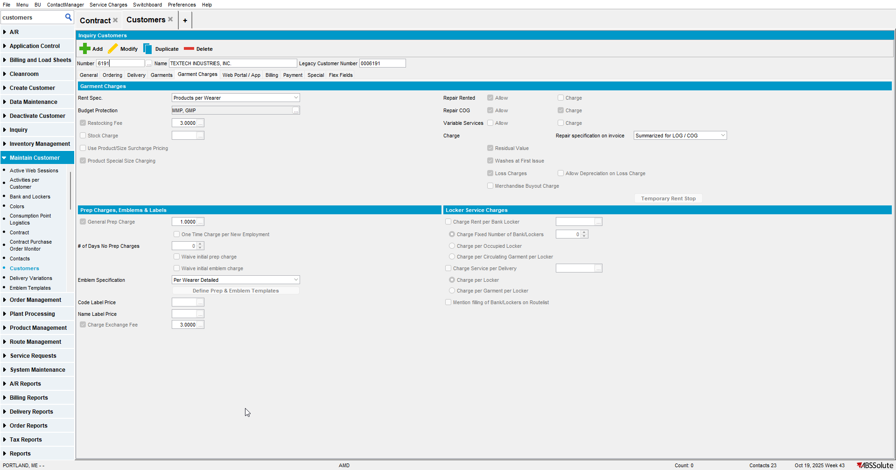
Check on SSP level: customer is compliant here as well (this is correct. Since SSC wash checked thn being uncheked on SSP level is correct. Notice this was updated correctly and per total, the component remain not compliant). This is correct:
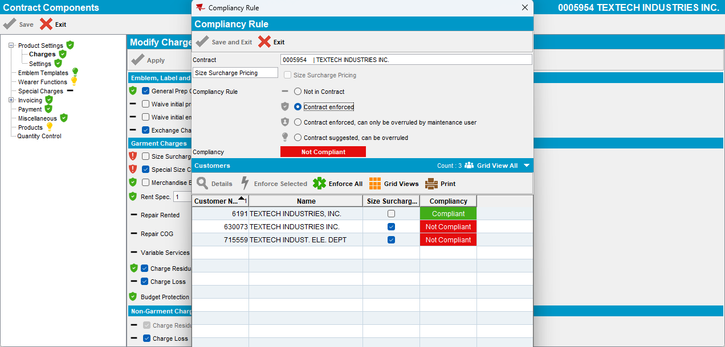

Step 7) Enforce all on SSC level:
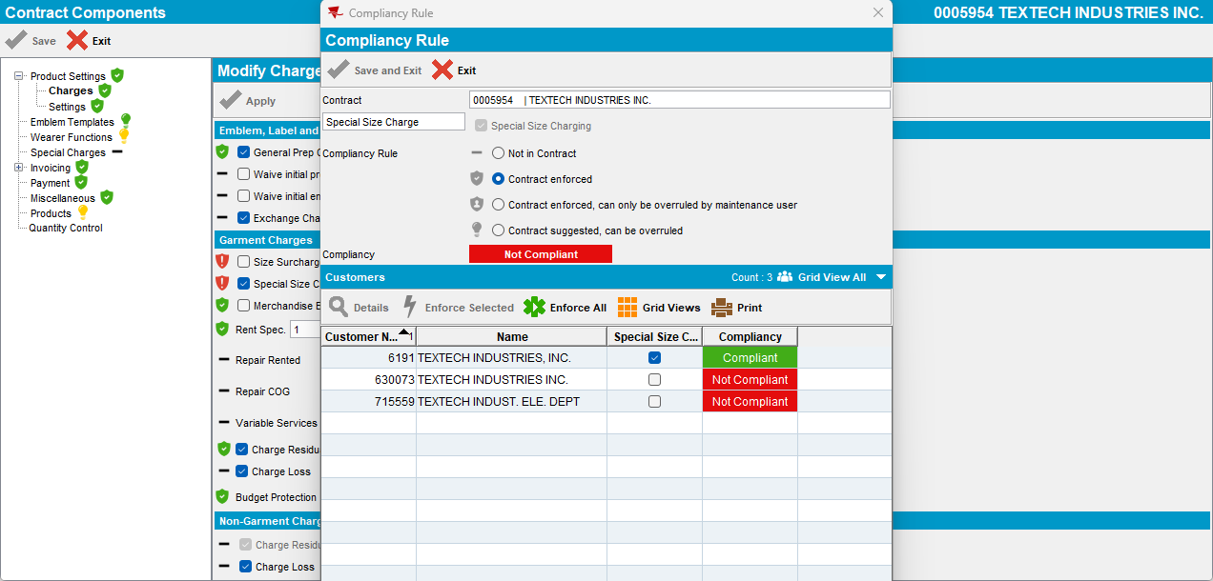
Step 8) Notice it was correctly refreshed for being compliant:
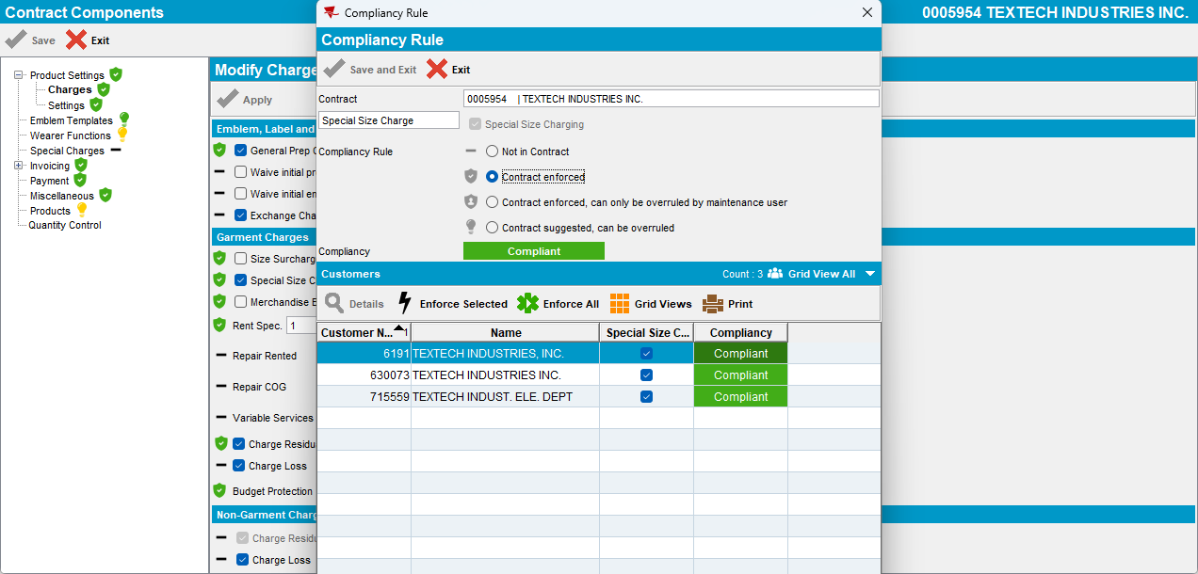

Step 9) SSP remains unchecked, that is correct, and notice that after fix, it is refreshed as compliant.
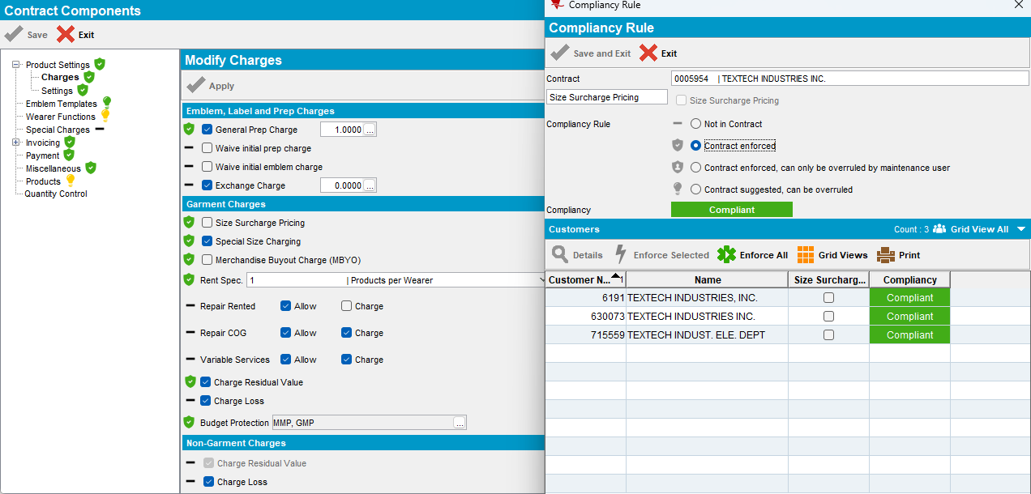
Step 10) Reload contract and reopen. Everything remains compliant:
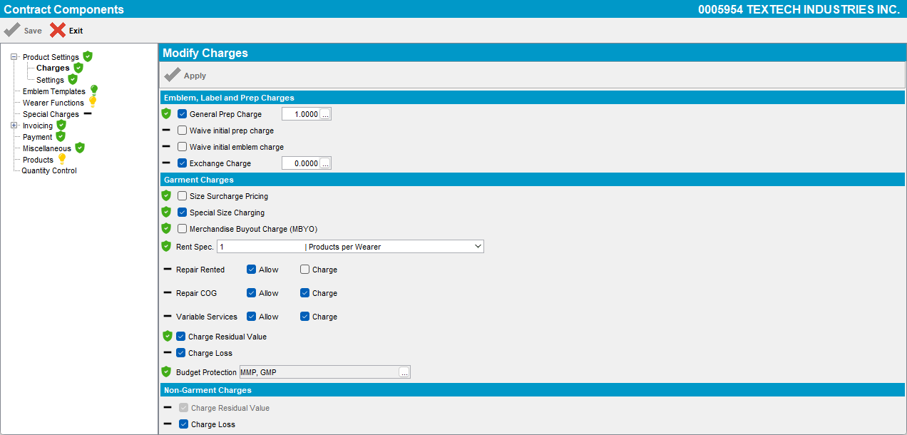
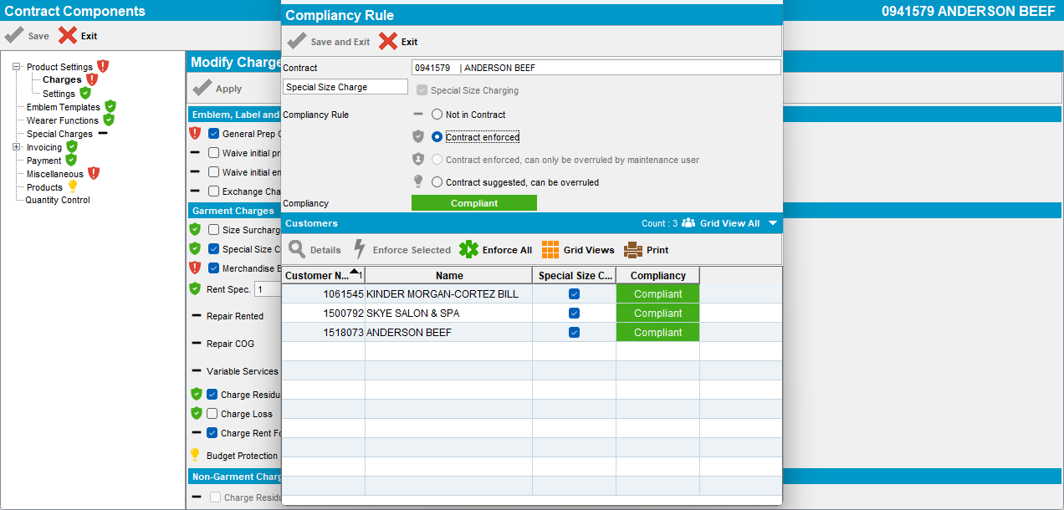
RETEST OK

