ABSN-9381 - ASD-53193 D_UBS_1943 GLP compliancy when customer does not have GLP budget protection
Environment | Prerequisites
Version: 9.07.00.UNF21  DBServerName= abs-srv20.internal.abslbs.com  DBSID=CUST24  DBUser=UNFDEV  Environment=Test | - Module:  - System setting

Contents
Reproducing before fix 1
Steps to reproduce 1
Current Behavior 4
Expected behavior 4
Retest after fix 4
Test Case 1 – Check that the Budget Protection is compliant when only the compliancy attributes of the contract are present 4
Test Case 2 – Check that the Budget Protection badge shows as compliant when interrogating a contract product 7

Reproducing before fix

Steps to reproduce
- Customer: 1784263 does not have any budget protection
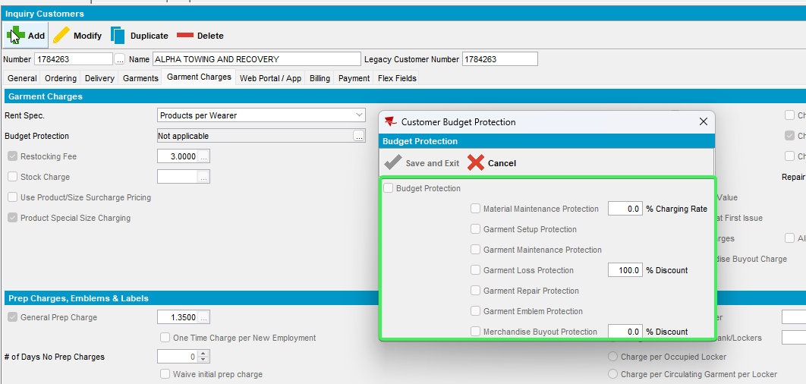
- Contract: 1029386 load customer contract
- Go to Compliancy and press load
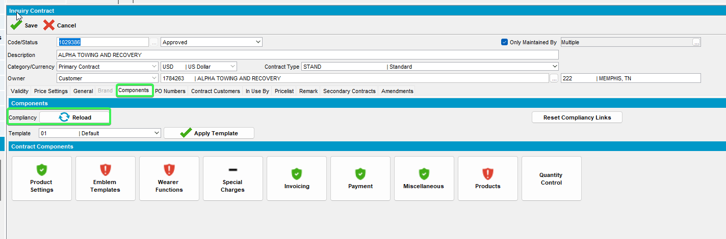
- Press Products and see that budget protection is not compliant for your customer
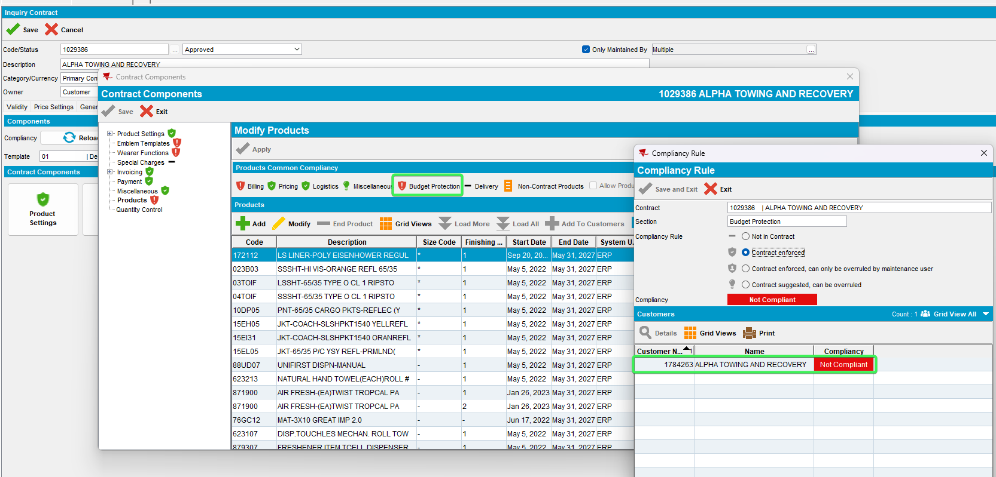
- Press details and see that there are the products say are not compliant to several budget protections even though the customer does not have any
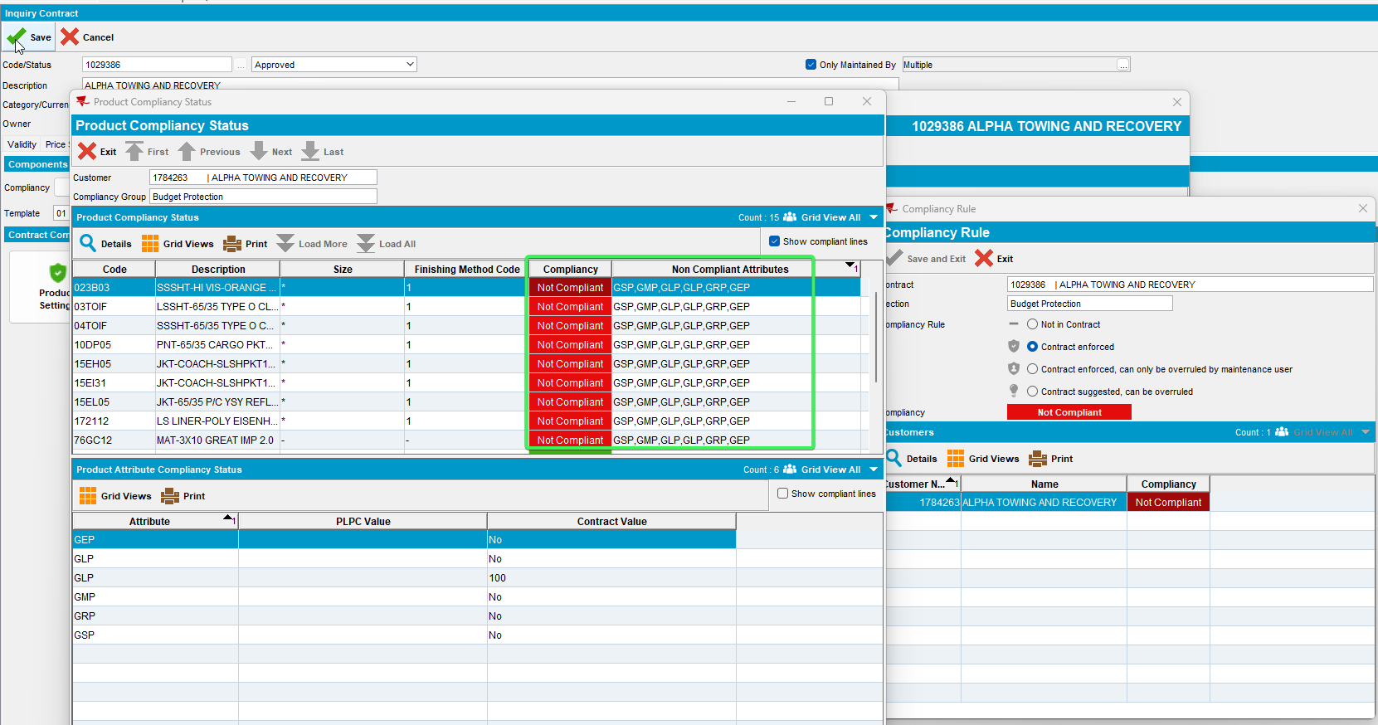
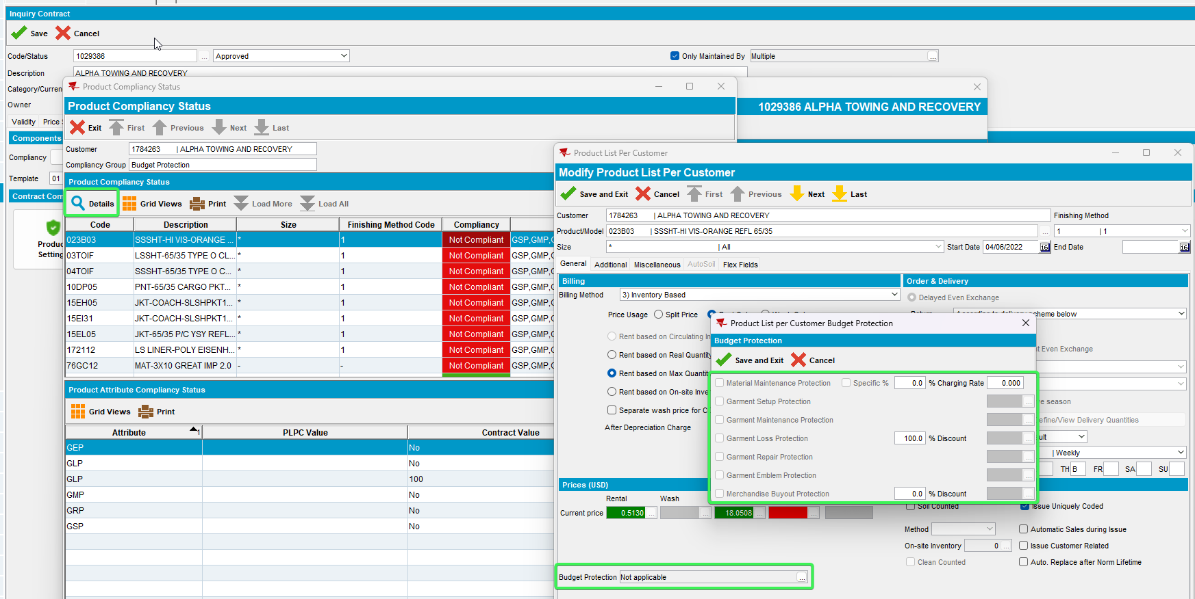
Check the Product Attribute Compliancy Status
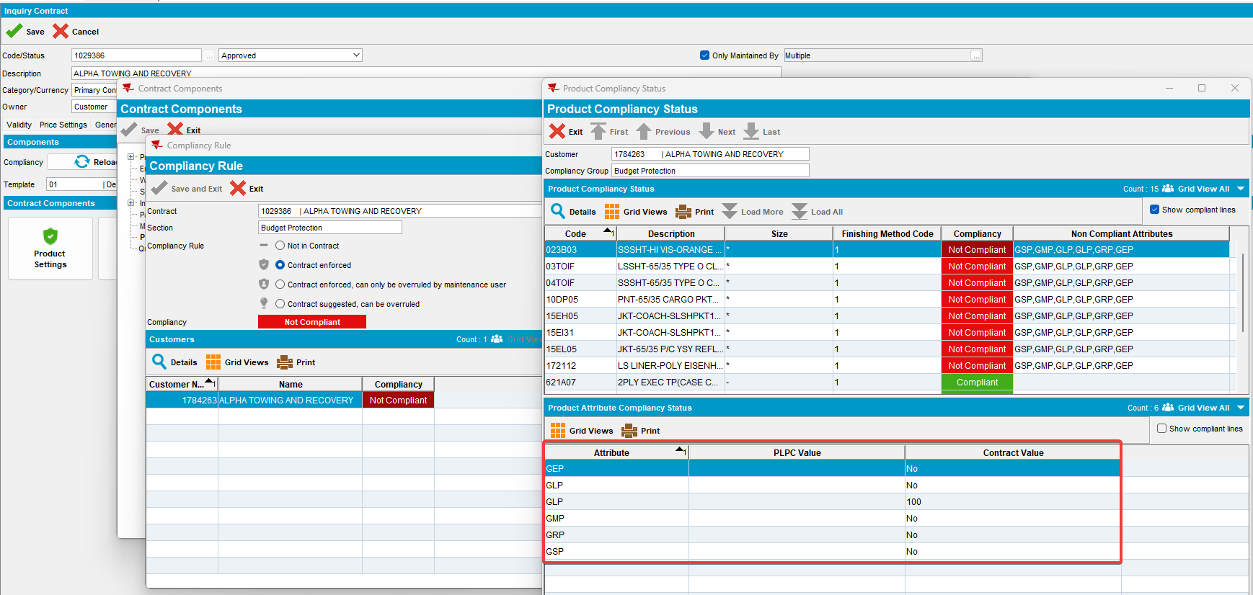
REPRODUCED OK.

Current Behavior
Budget Protection shows as not compliant for compliancy attributes the product does not have.

Expected behavior
Budget Protection should shows as compliant when all attributes in the contract are compliant. Or the customer does not have any budget protection attributes.

Retest after fix

Test Case 1 – Check that the Budget Protection is compliant when only the compliancy attributes of the contract are present
Hash: 8ed2eff14e56
- Customer: 1784263 does not have any budget protection
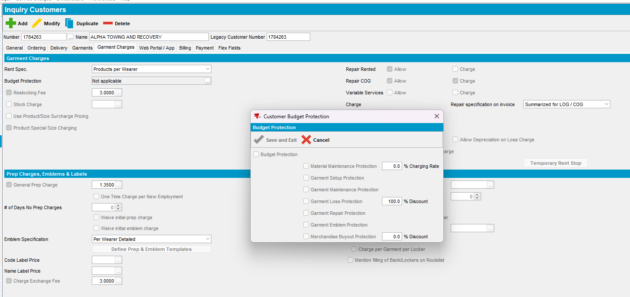
- Contract: 1029386 load customer’s contract
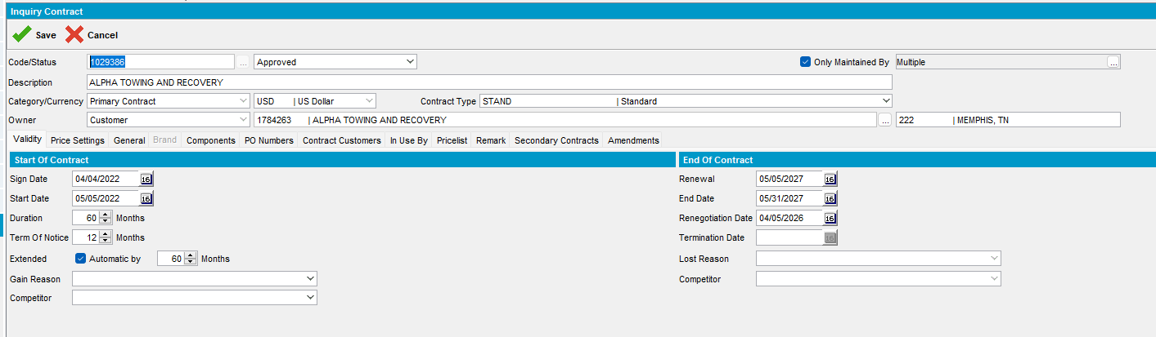
- Go to Compliancy and press load
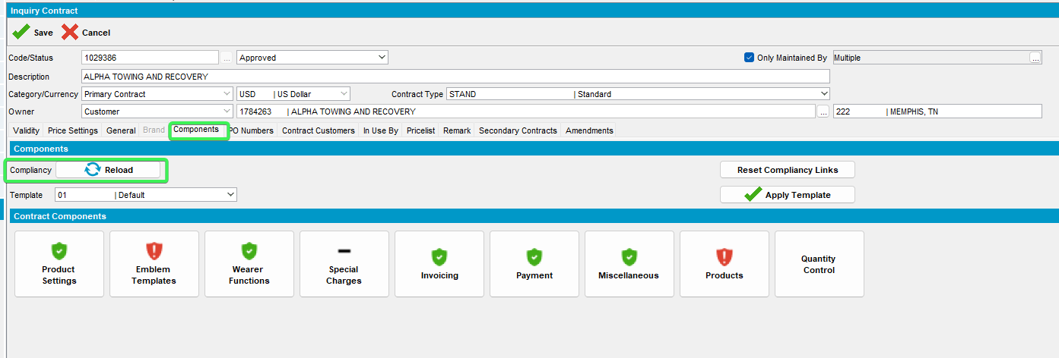
- Press Products and check the budget protection icon (it should show green as compliant)
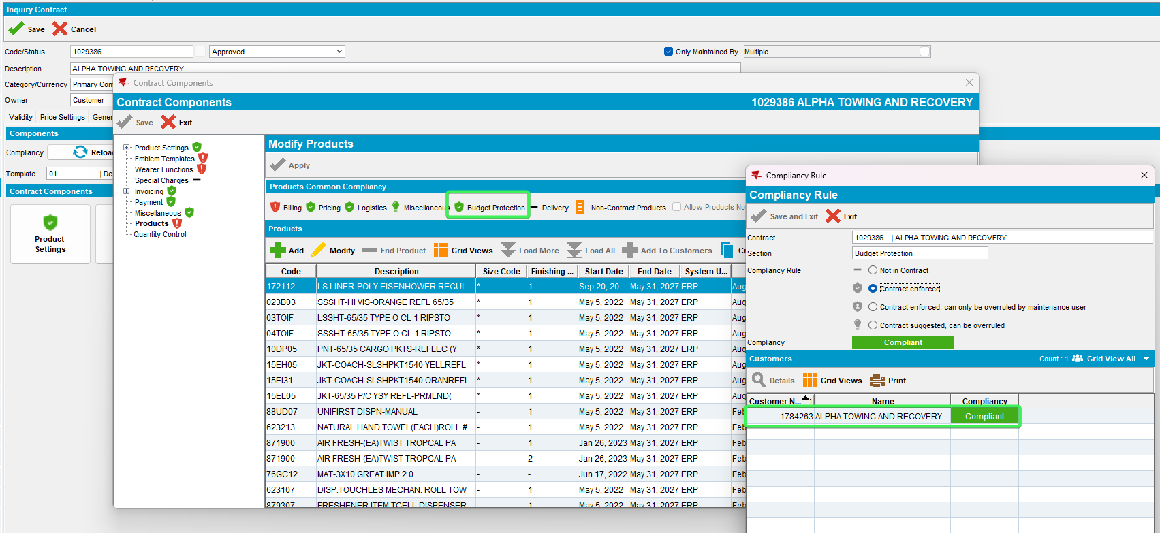
- Press details on the customer and check the “Show compliant lines” checkbox
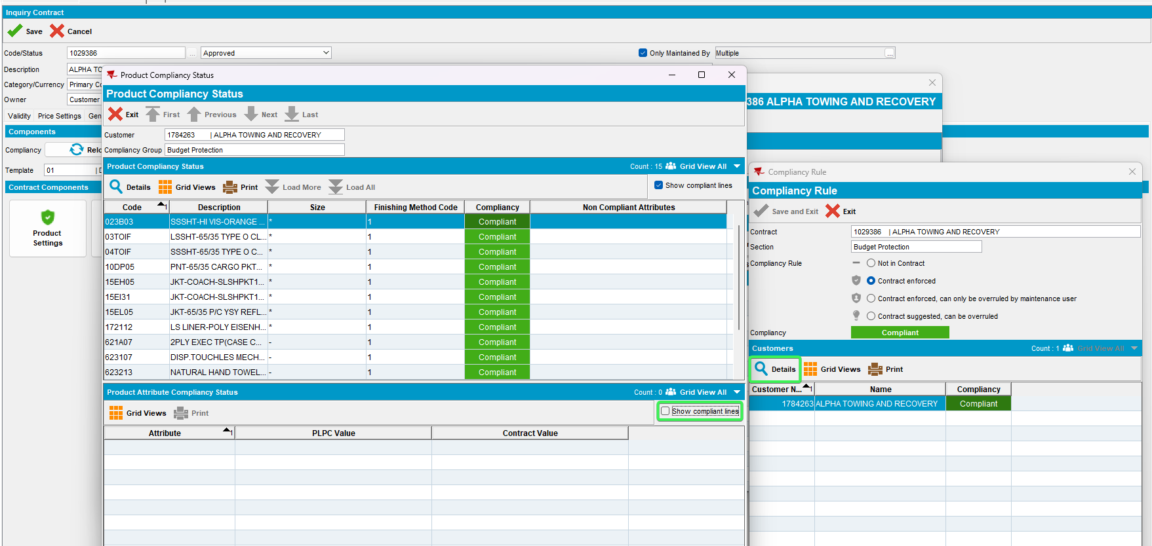
- Check to see that all budget protection lines have the same value both in PLPC and Contract
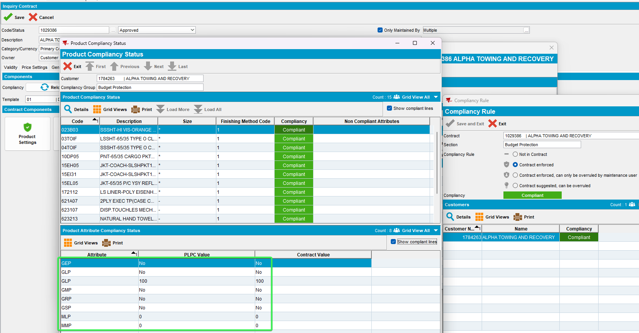
Tested OK

Test Case 2 – Check that the Budget Protection badge shows as compliant when interrogating a contract product
Hash: 8ed2eff14e56
- Contract: 1029386 load customer’s contract
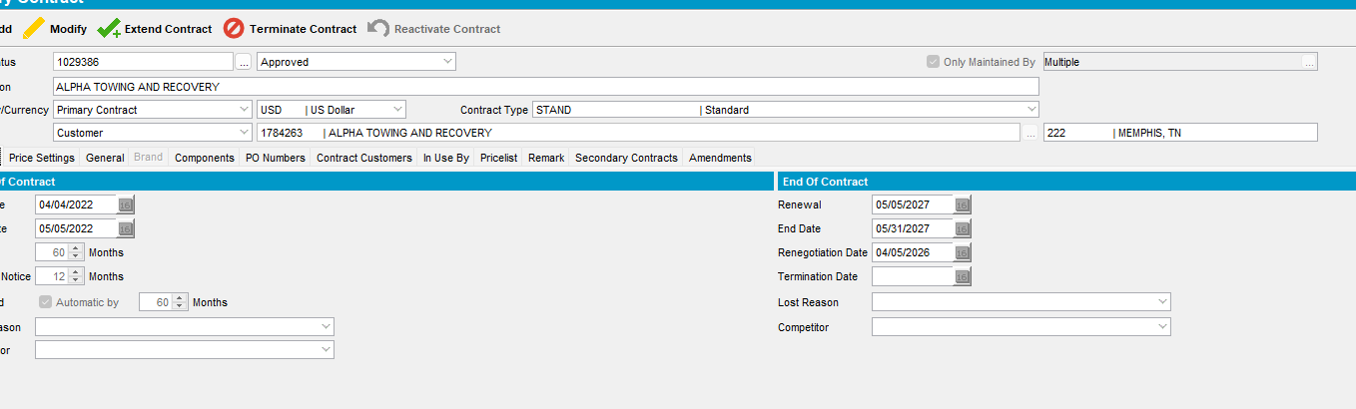
- Go to Compliancy and press load
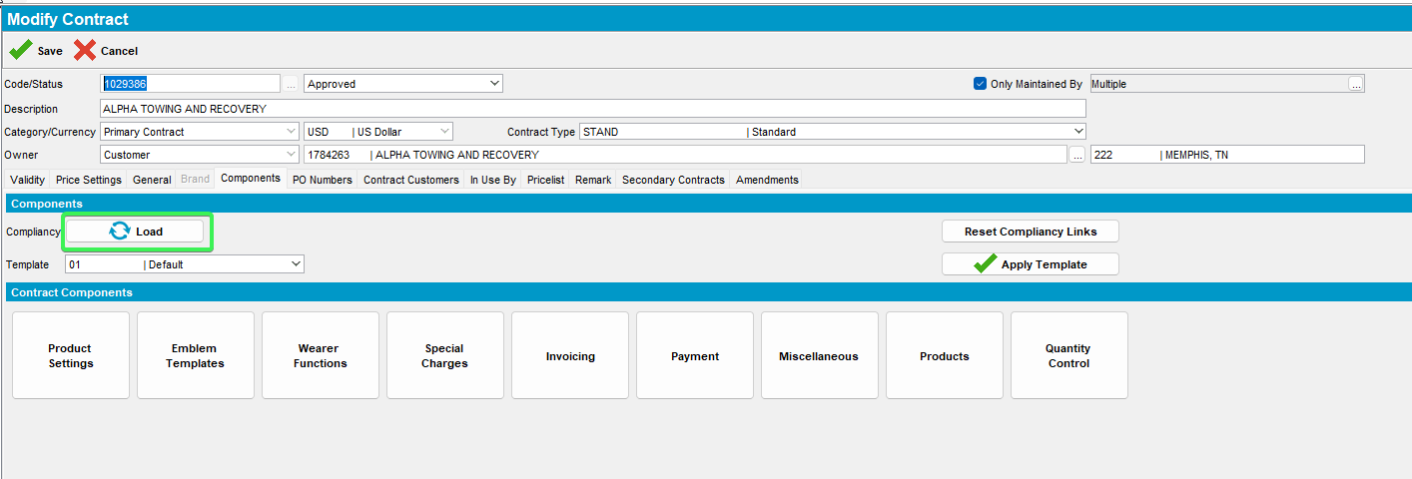
- Press Products button > select a product and press modify
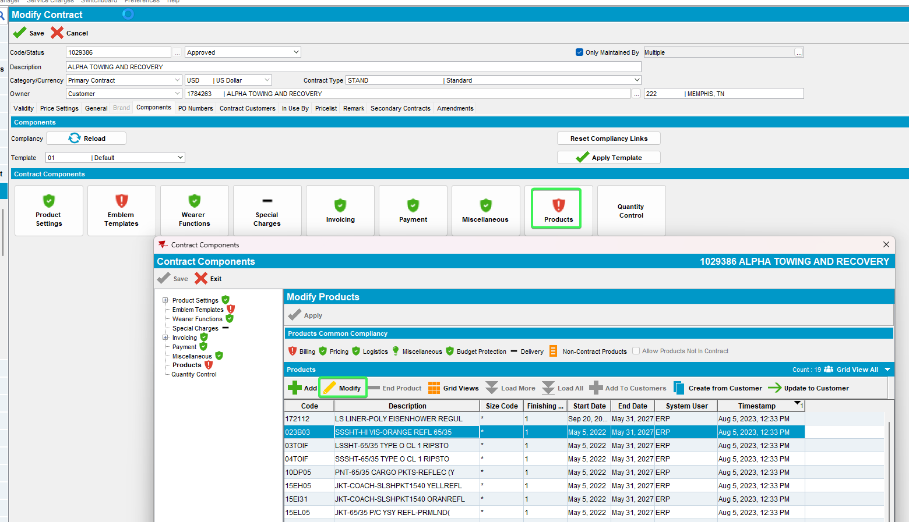
- Expand billing and press budget protection > Notice the Budget protection badge and see that is green
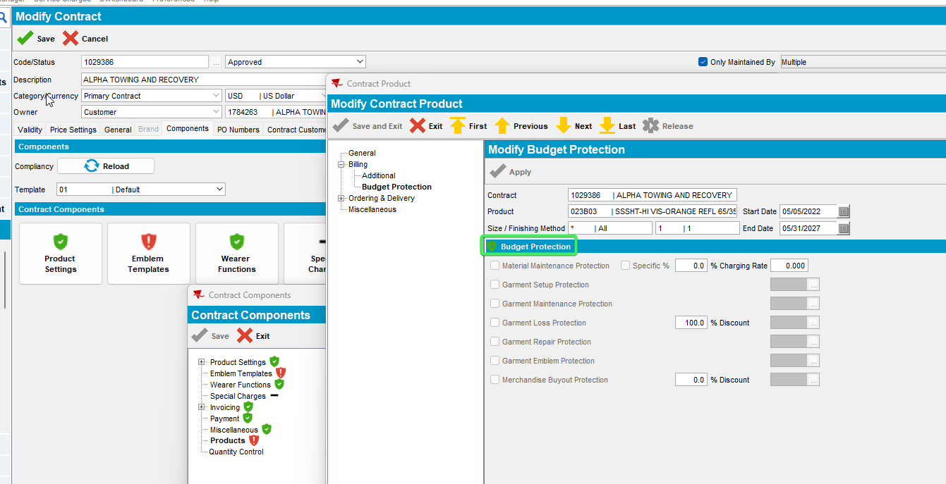
- Click on it and see that the client is also compliant
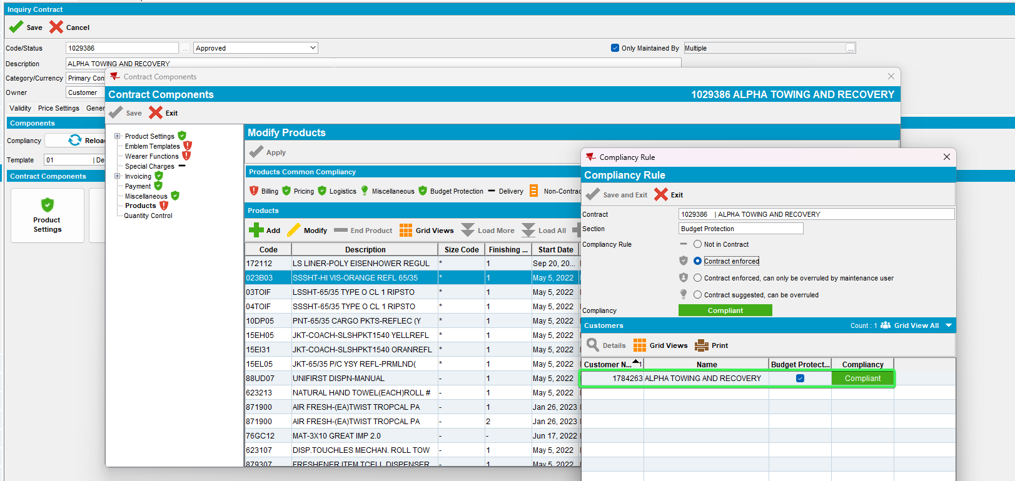
Tested OK

