ABSN-819 Web Client X - Diagnostics
Environment | Prerequisites
Version: 9.07.00
Environment=PRODUCTION
DBServerName=abs-SRV20.internal.abslbs.com
DBSID= CUST24
DBUser= UNFDEV
Contents:
Web Client X - Diagnostics
#1 – Check Diagnostics option on Web Client X (X-RouteCheckInDlg) – Passed 1

#1 – Check Diagnostics option on Web Client X (X-RouteCheckInDlg) – Passed

Diagnostics is similar to the client implementation.
It is started by this option:

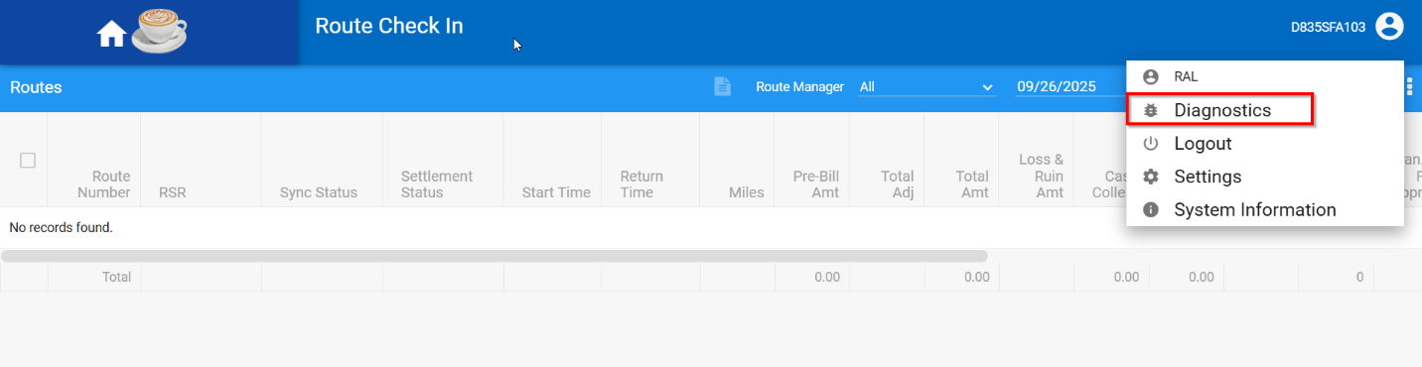
and opens a new tab with these options (this new tab is where you switch it off as well):

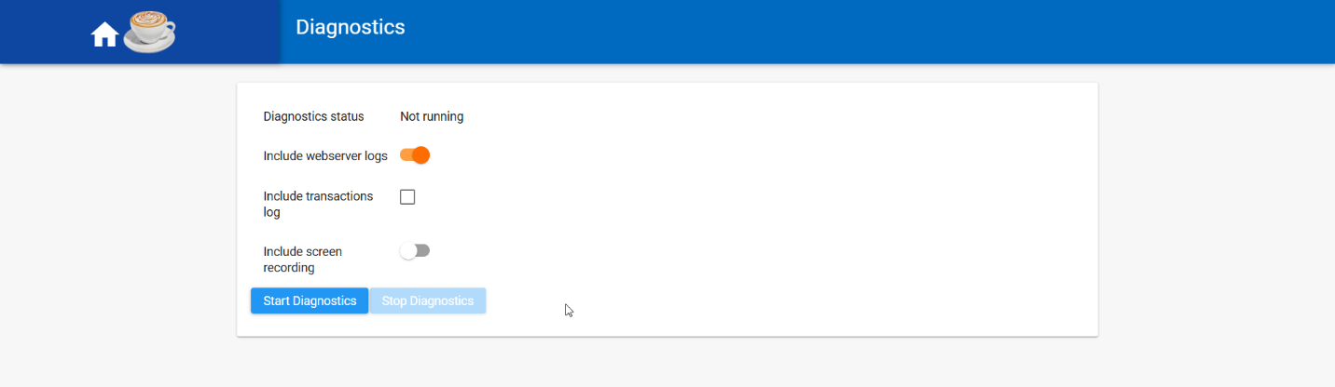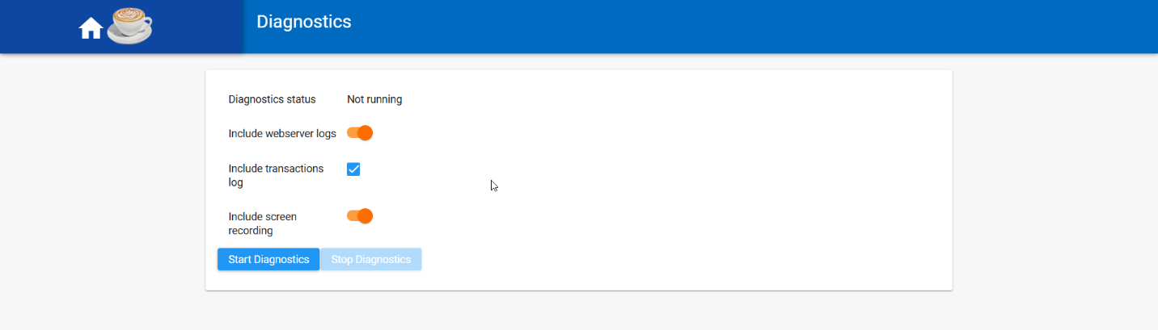

If you allow screen recording, then this popup appears, and you must select this tab:

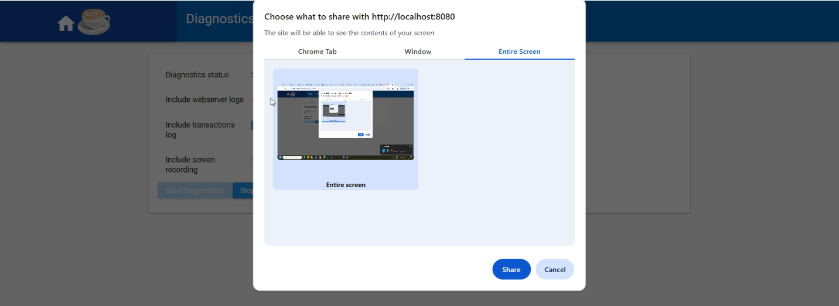

and if you are using Mozilla, it looks a little different where you must select “entire screen”:
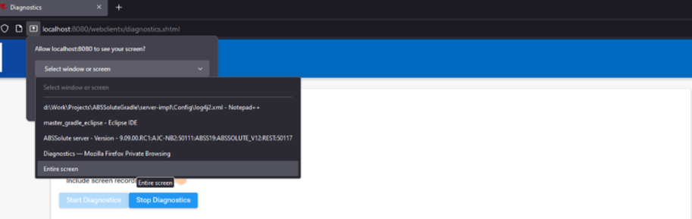

Which then tells the user that recording is started and will automatically stop after 5 minutes.

Go to the Route Details tab and do the current actions (which will be recorded).

Press Stop sharing -> diagnostics zip file is saved automatically:

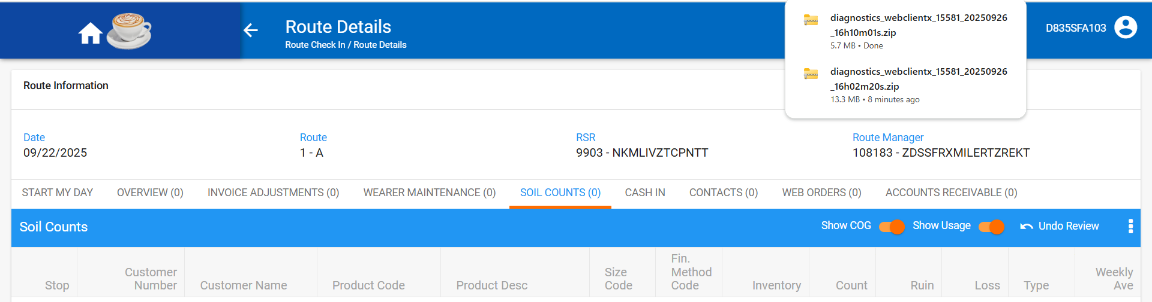

If the user does not manually stop recording, after 5 minutes is stopped automatically:

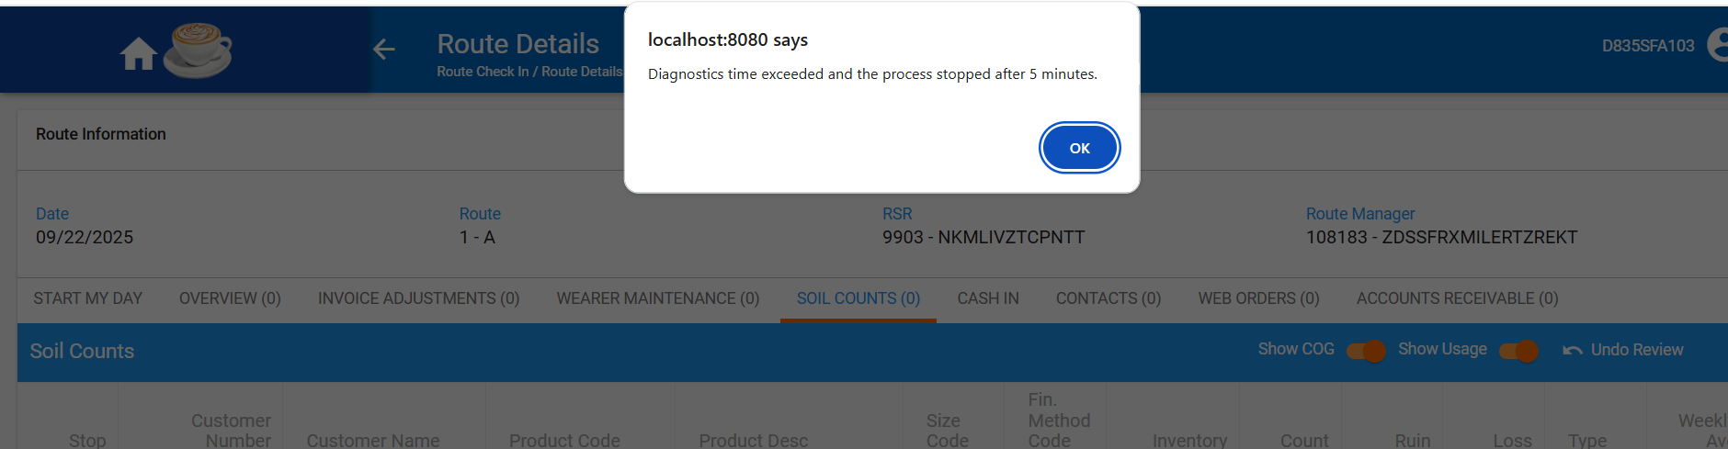

1. the user can start diagnostics by checking only one option, two or all three:

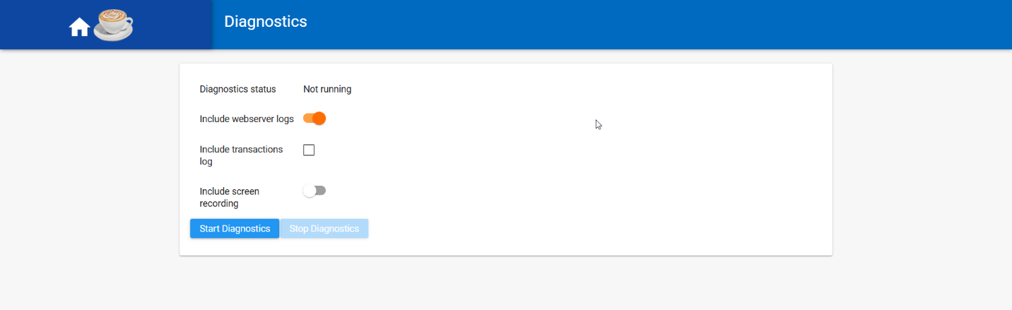

After 5 minutes the process is stopped automatically, the zip file is created/ saved and Stop Diagnostics button becomes enable:
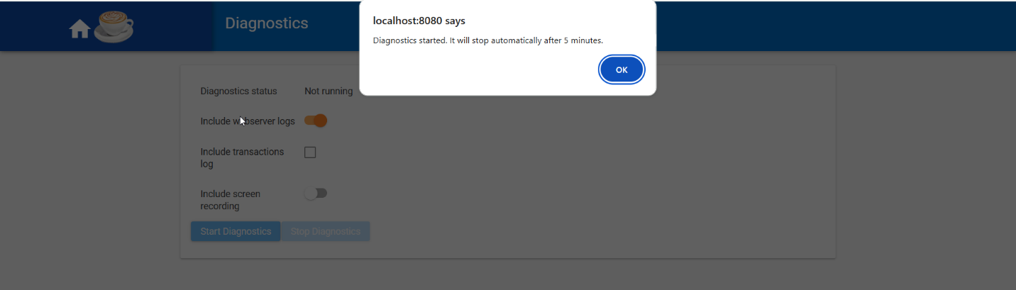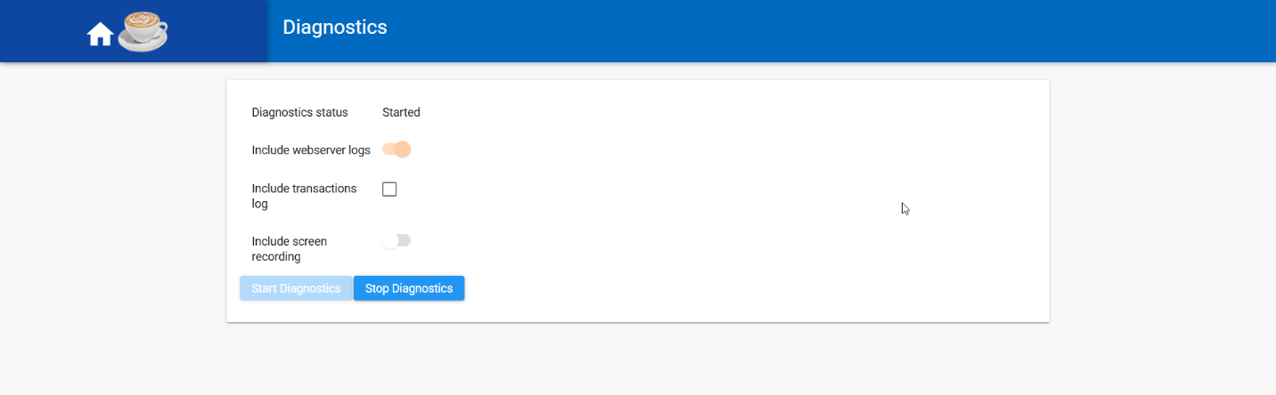

Also, the user can stop the process by pressing Stop Diagnostics button;
the zip file is created and saved automatically:
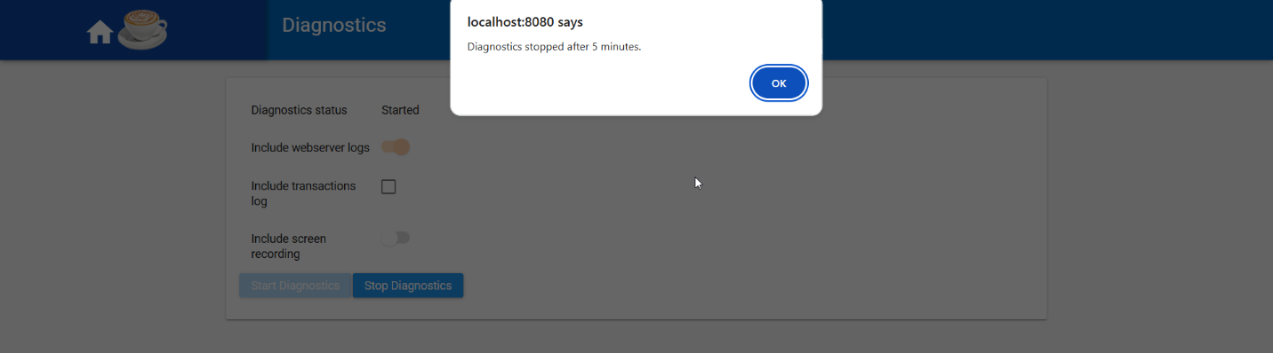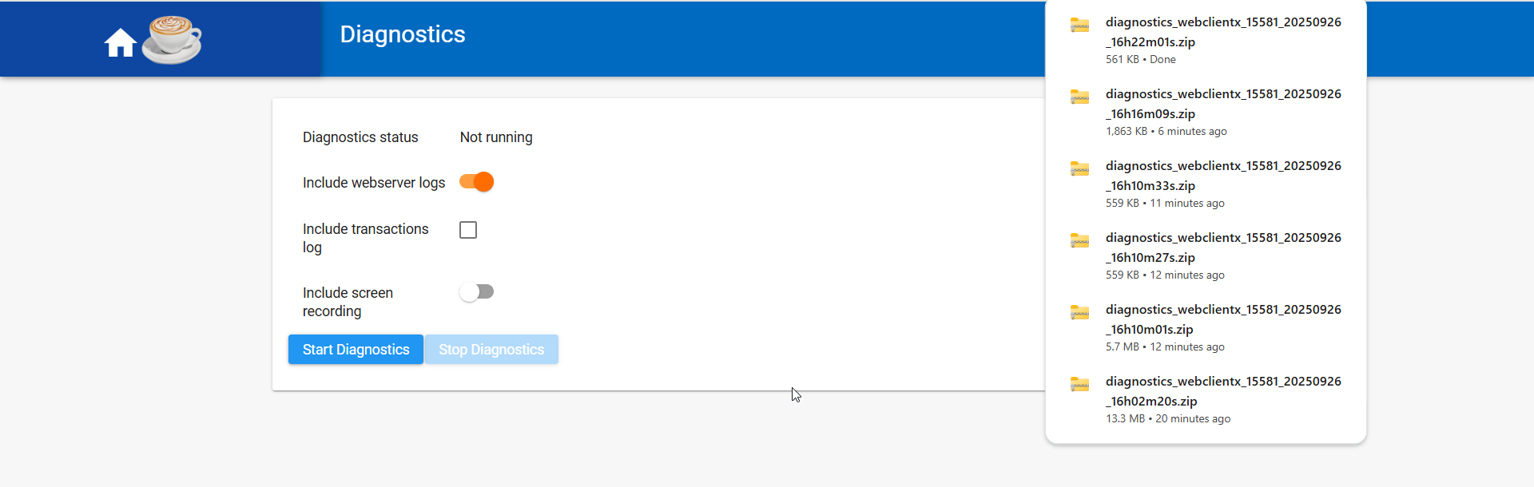

Include webserver logs option checked save a zip file with web logs and Server logs:
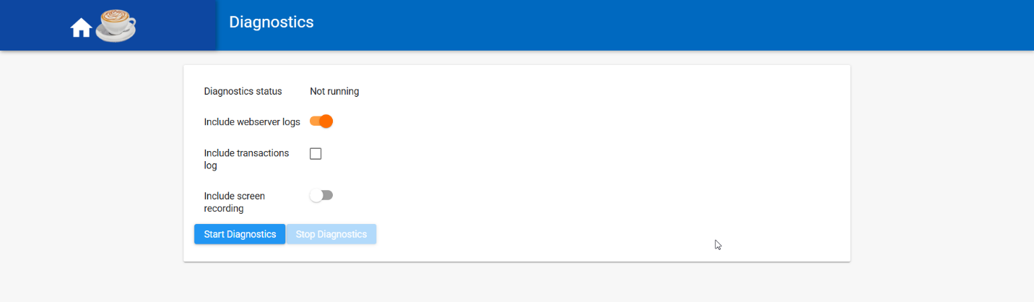

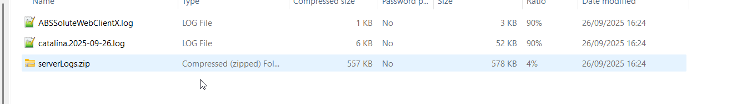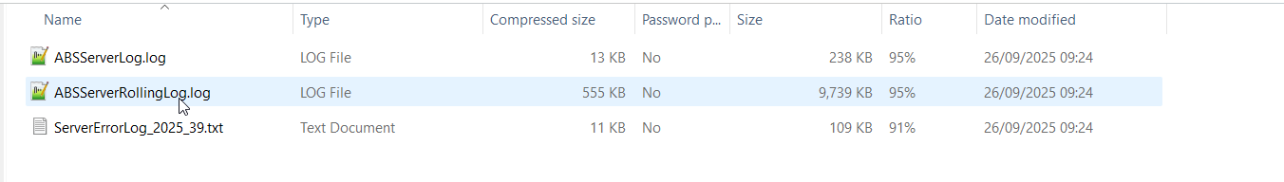

2. Start Diagnostics with Include transactions log option checked, also:

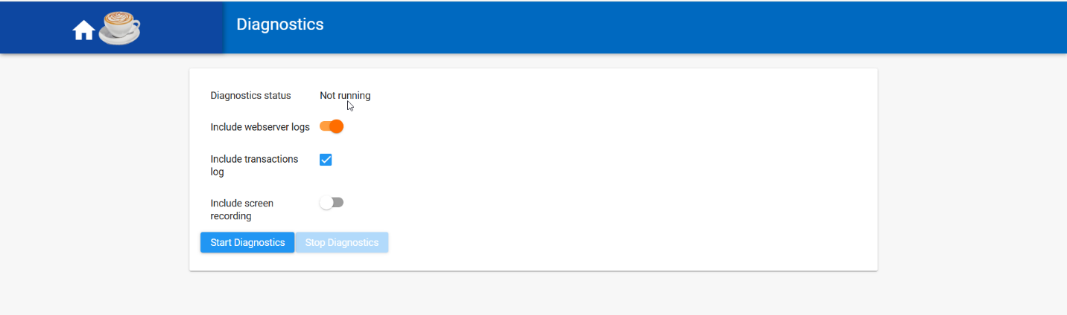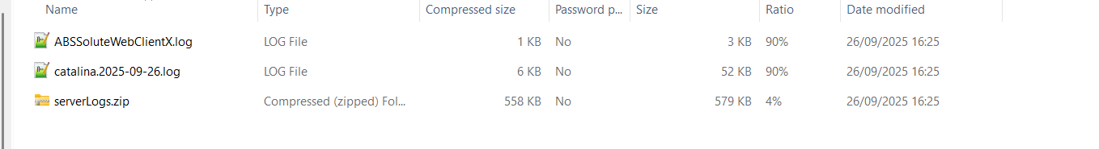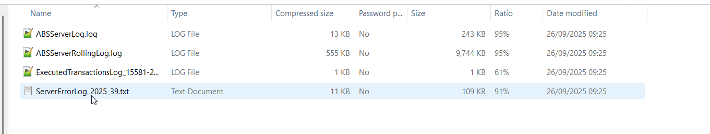

Include transactions log option checked save in addition, in zip file, ExecutedTransactionsLog file:
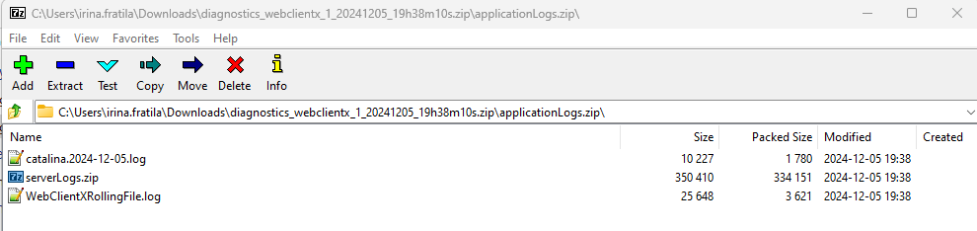
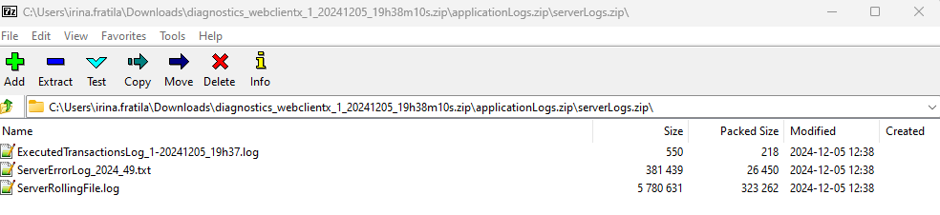

3. Start Diagnostics with all 3 options checked, Include screen recording option checked, also:

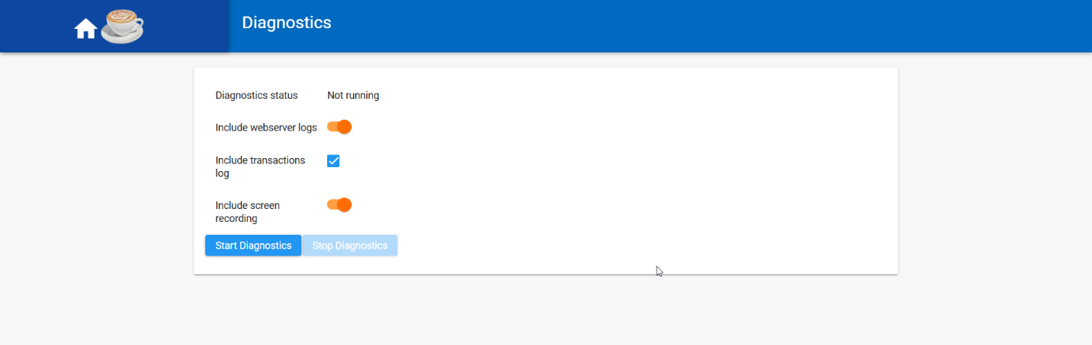

The zip file now also includes the video recording:

