ABSN-80 Add CreationTimestamp, CreationSystemUser_ID and ExternalTimestamp columns for Wearer, WearerEmployment and WearerInventory
Environment | Prerequisites
Version: 9.07.00.UNF21  DBServerName= abs-srv19.internal.abslbs.com  DBSID=CUST22  DBUser=UNFLIVE  Environment=Test | - Module:  - System setting

Contents
Retest after fix 1

Retest after fix
Hash: 43b57722685c

The records created in the database over the past few days were checked, and no null values were found.
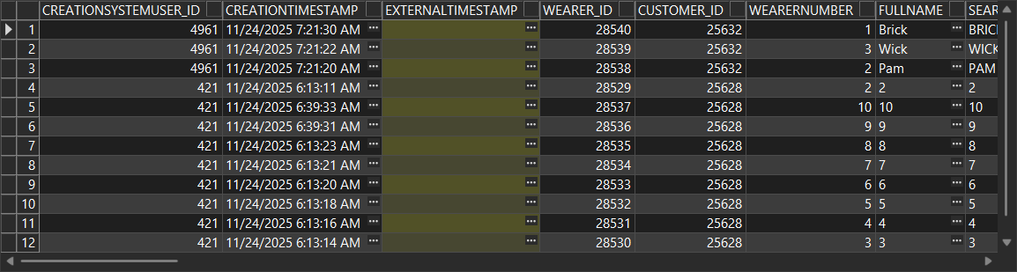
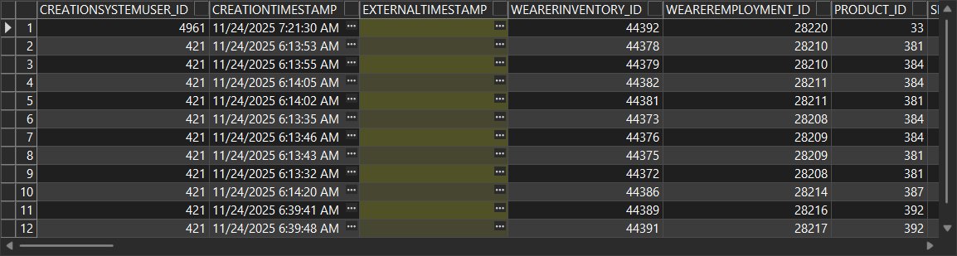
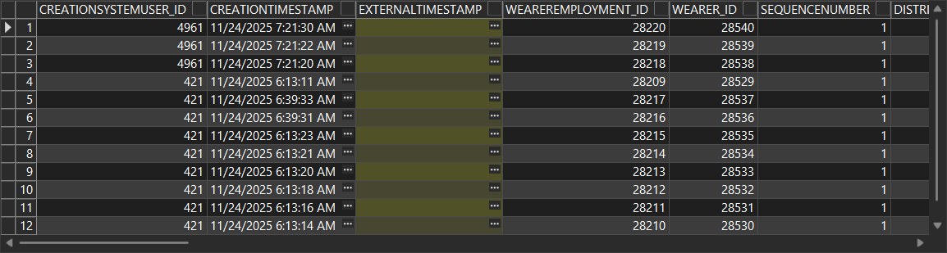

Next, the externaltimestamp column will be verified via web services.
- Change size or product for a wearer inventory
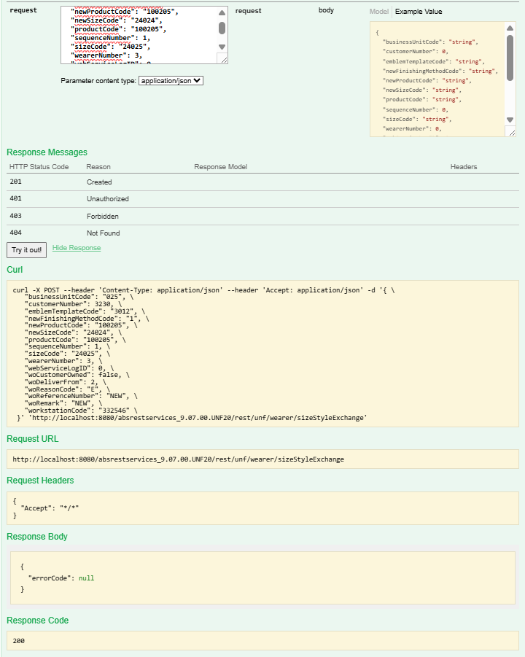
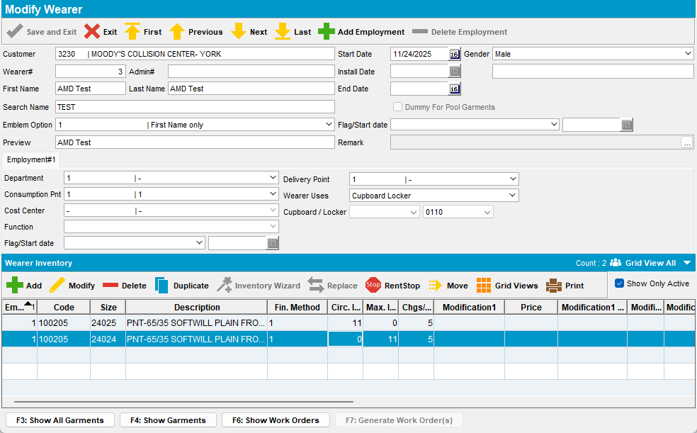
Externaltimestamp column was populated.

