ABSN-7884 D_UBS_2716 Tax Error during route settlement
Environment | Prerequisites
Version:9.07.00.UNF21  DBServerName= abs-srv20.internal.abslbs.com  DBSID=CUST24  DBUser=UNFDEV  Environment=PRODUCTION | - Module:  - System setting

Contents
Reproduce before fix 2
Steps to reproduce: 2
Retest after fix 11
Test Case 01 Route is loaded on WebX before being downloaded on PDA, before any invoices were generated, make following operations: – Tested NOT OK 11
Steps to reproduce: 12
Complete Start my Day using the webservice 12
WebX: Try to Settle before PDA upload, correct message Invoices have not been generated 13
WebX: Review all the tabs. 13
WebX: Try to settle again after all tabs have been reviewed but the route still hasn't been invoiced, correct message Invoices have not been generated 15
WebX: Try to settle by clicking on next week route, all tabs have been reviewed but the route still hasn't been invoiced, correct message Invoices have not been generated 15
WebX: Try to settle by clicking on next week route, packing status is complete but route is not invoiced, , correct message Invoices have not been generated 16
WebX: Try to settle by clicking on next week route, the route has been invoiced but the taxes were not completed, correct message This route has not been uploaded from the Route Assistant 17
WebX: Try to settle by clicking on next week route, the route has been invoiced but the taxes were not completed, correct message This route has not been uploaded from the Route Assistant 18
WebX: Cannot make undeliverable a stop from WebX while route hasn’t been through PDA 19
Cannot make invoice adjustments while route hasn’t been through PDA 19
Cannot make Wearer Maintenance while route hasn’t been through PDA 19
WebX: Try to settle, the route has been Mark Ready for Transfer but is not downloaded 20
WebX: Try to settle, the route has been downloaded on RA 20
WebX: Try to settle, the route has been uploaded from RA, correct message with pending actions on the tabs 24
Test Case 02 Route is loaded on WebX after route was downloaded on pda (not uploaded), make following operations: Needs testing 27
Steps to reproduce: 27
Complete Start my Day using the webservice 28
WebX: Try to Settle. 29
WebX: Review all the tabs. 29
Cannot make undeliverable a stop from WebX while route hasn’t been through PDA 31
Cannot make invoice adjustments while route hasn’t been through PDA 31
Cannot make Wearer Maintenance while route hasn’t been through PDA 32
Test Case 03 Route is loaded on WebX right after the invoices are done, but all the operations and settle are done from another WebX instance Needs retesting 36
Steps to reproduce: 37
Complete Start my Day using the webservice 37
WebX (Incognito new user): Settle the route. 45
WebX (Non – Incognito, original user): Settle the route. 46
WebX (Non – Incognito, original user): Try to make some modifications to the settled route. 46
Test Case 04 Check message Stop cannot be marked as undeliverable because the route has already been settled while also having another route next week for same day with same customers to have next button on WebX 48
Steps to reproduce: 48

Reproduce before fix
Bu: 044 Nashua, NH
hash: 03d36f66131a

Steps to reproduce:
- RSC dlg: Add a new route, keep at least 4 customers and move out the others. Also add a new route for the next week.
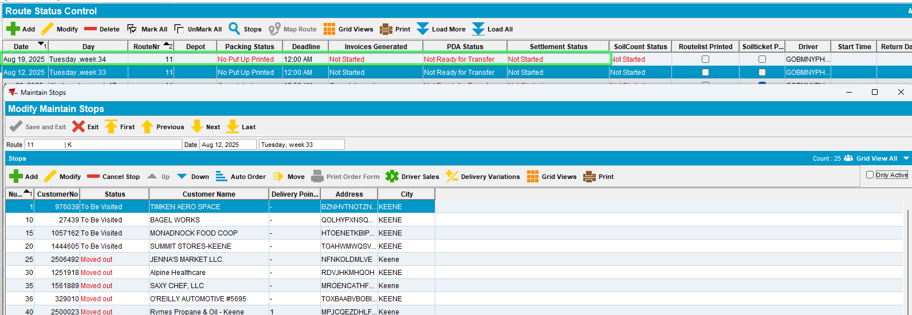
- WebX: Load the route newly created.
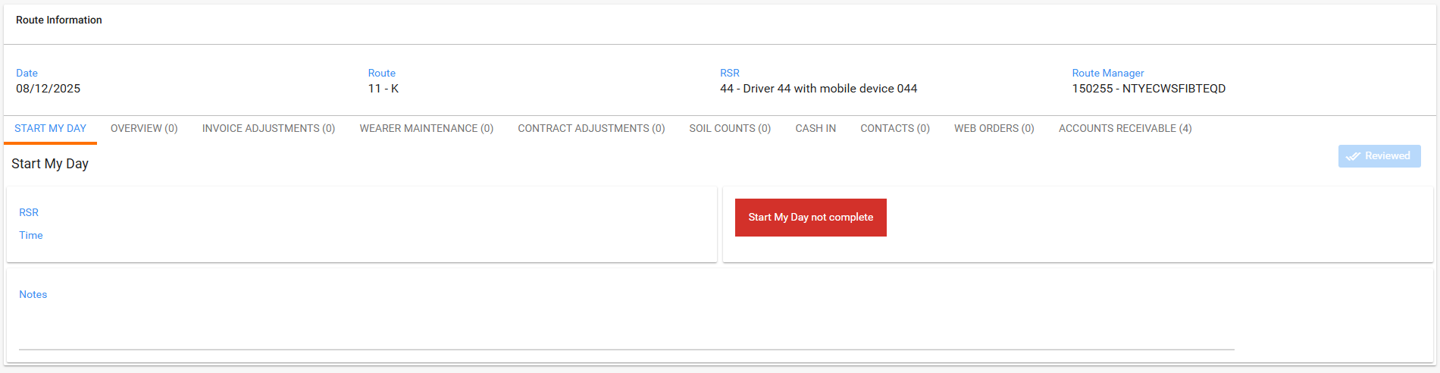
- RSC dlg: Generate put up docs, generate invoices and complete the taxes.
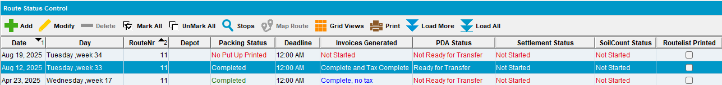
- Start my Day: complete the start my day.
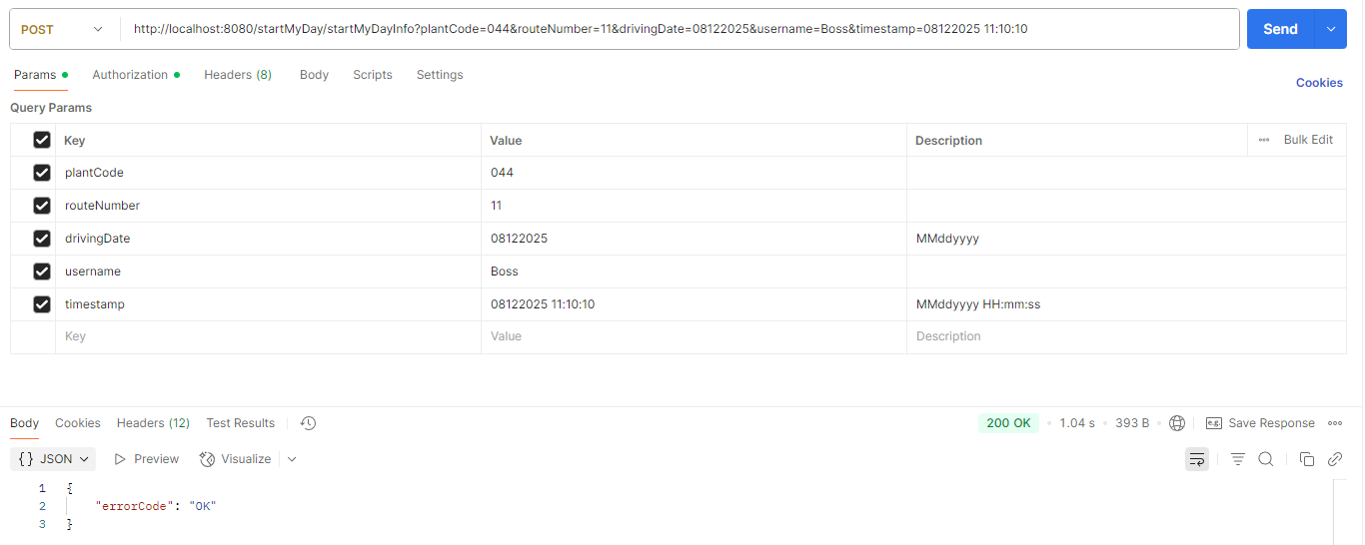
- WebX dlg: Refresh the route and keep it loaded in browser.
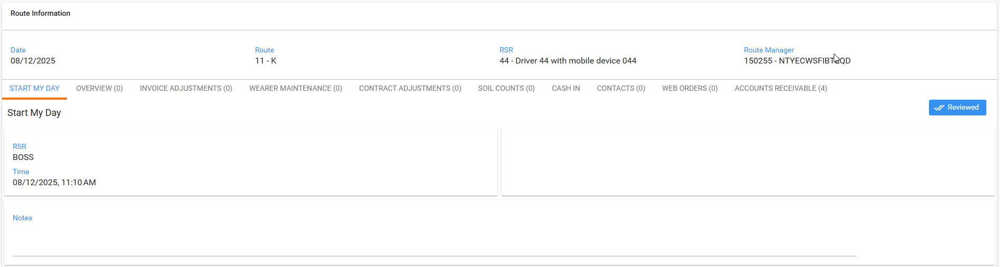
- WebX: Review everything we can.
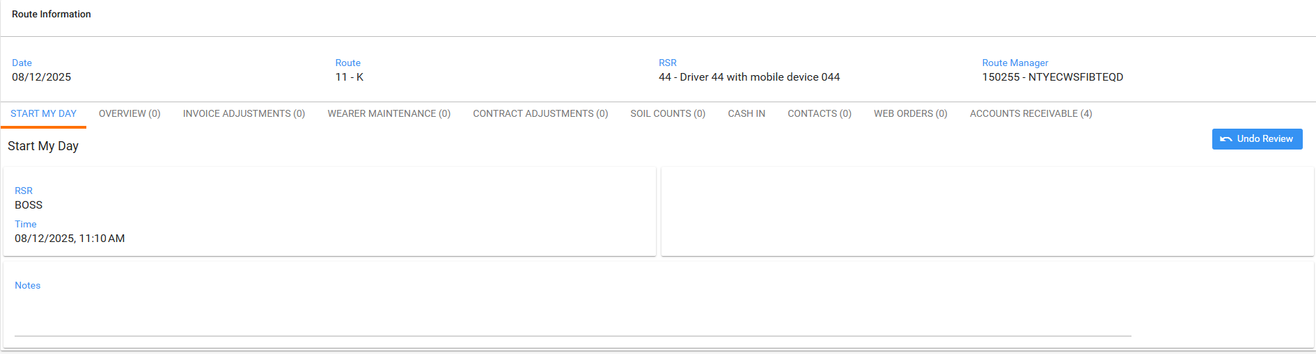
Try to settle
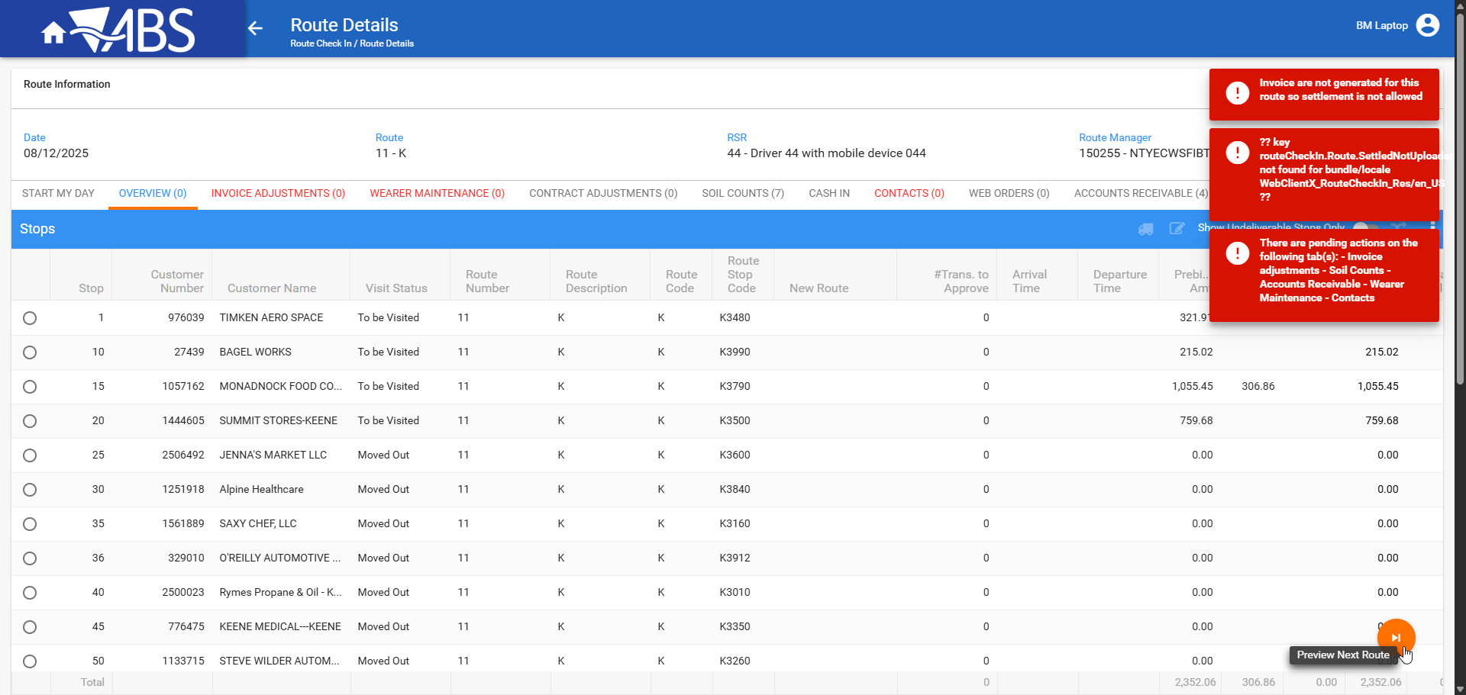

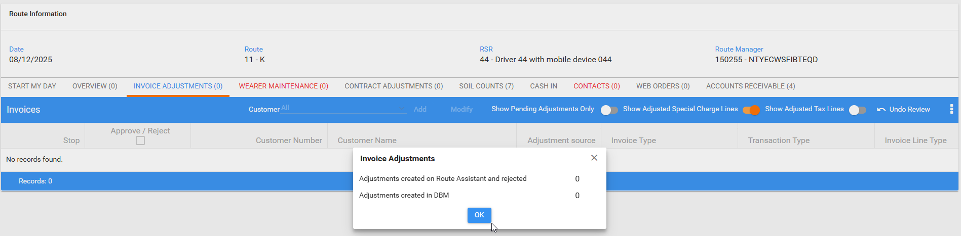

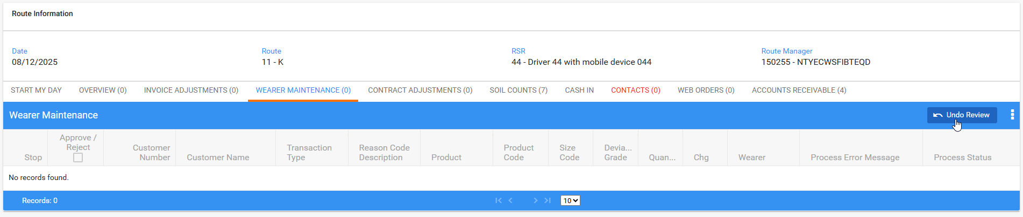

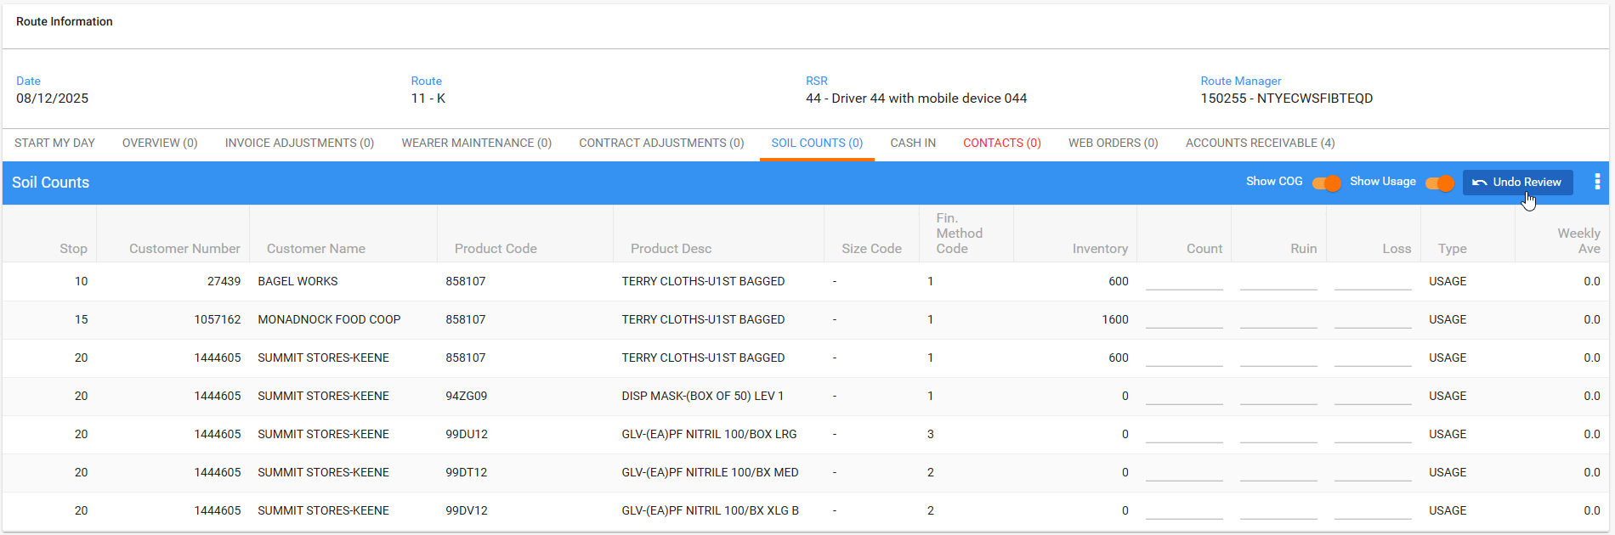

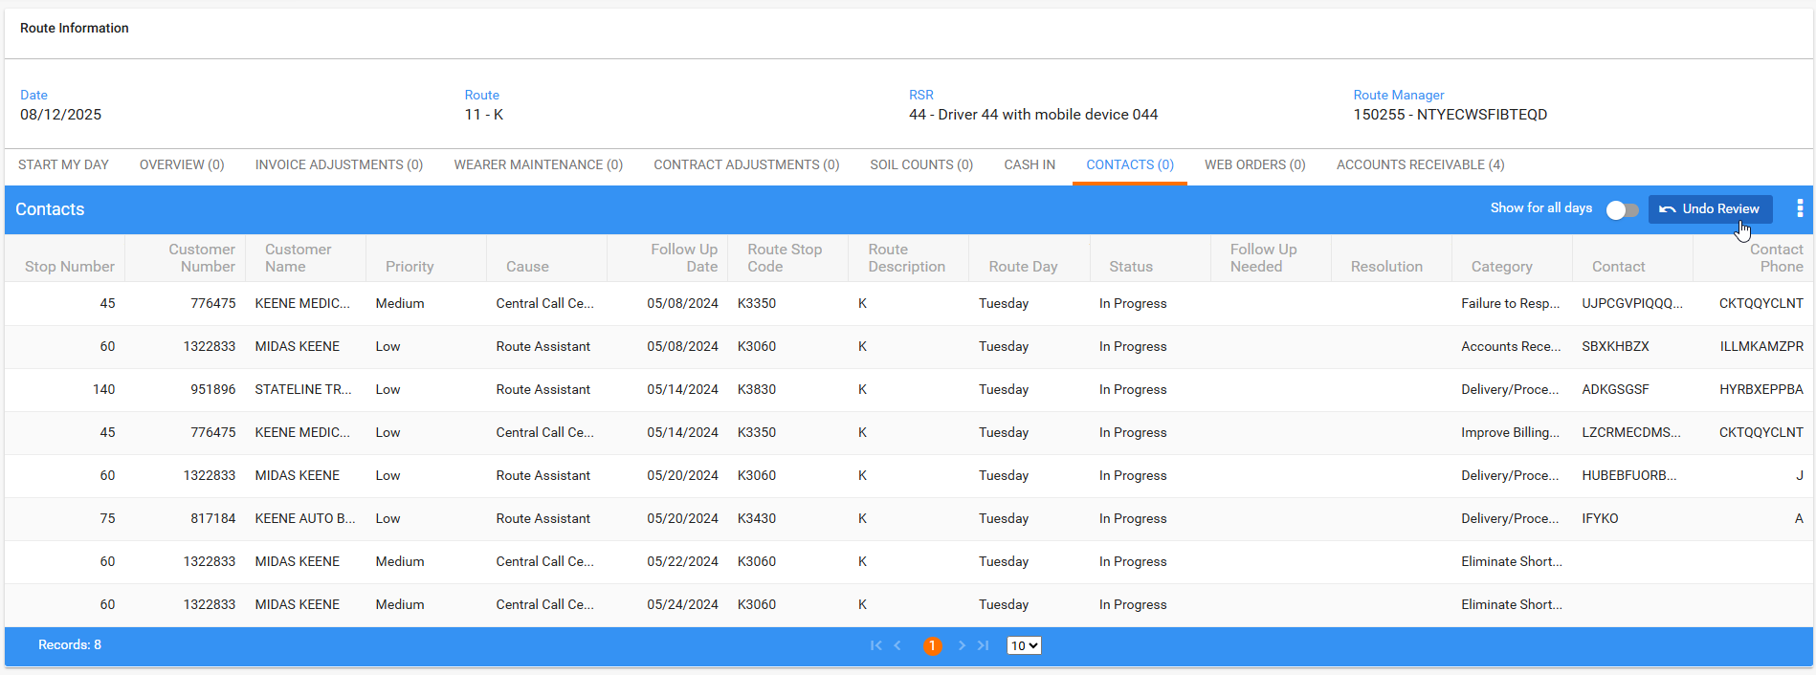

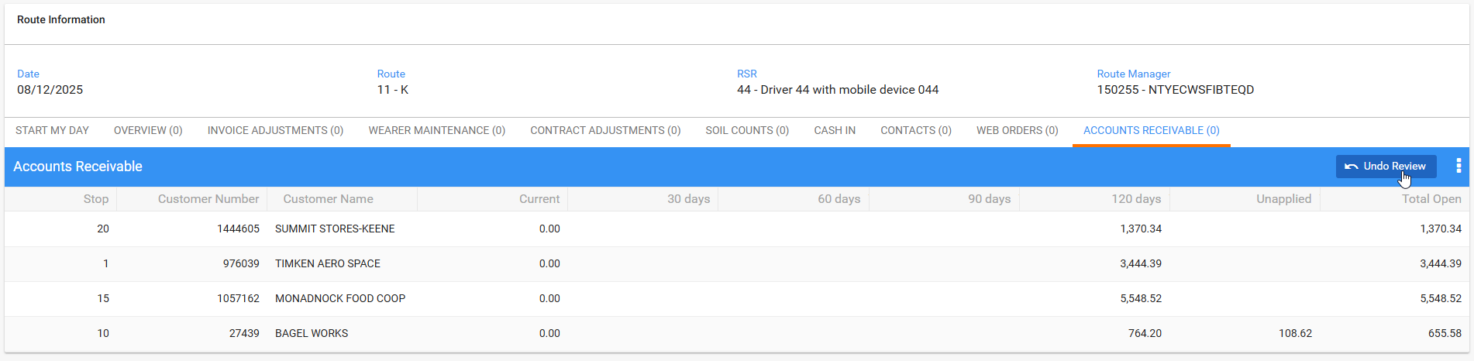
- RSC dlg: Send the route to PDA.
- RA: Download the route. Arrive at one customer and credit the invoice
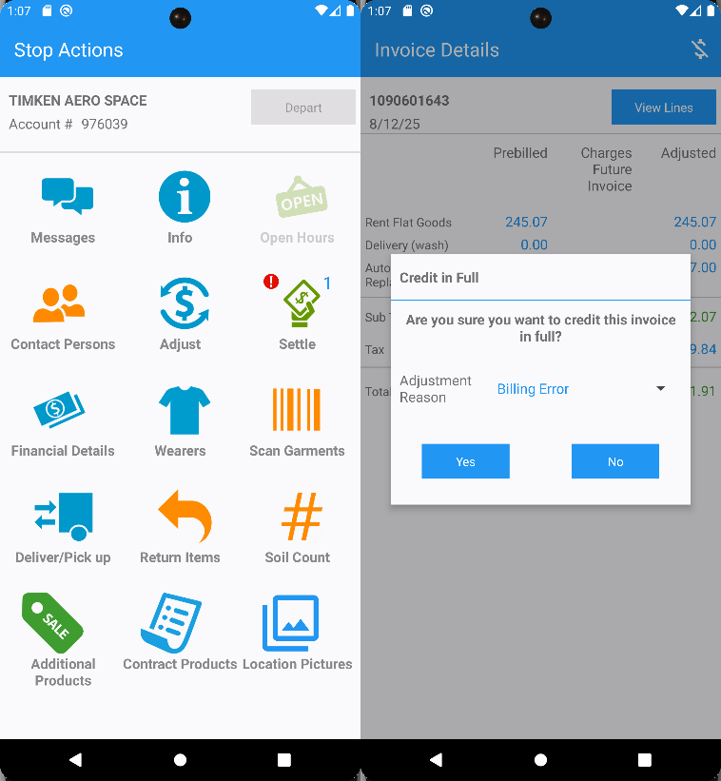
Set as undeliverable the stop
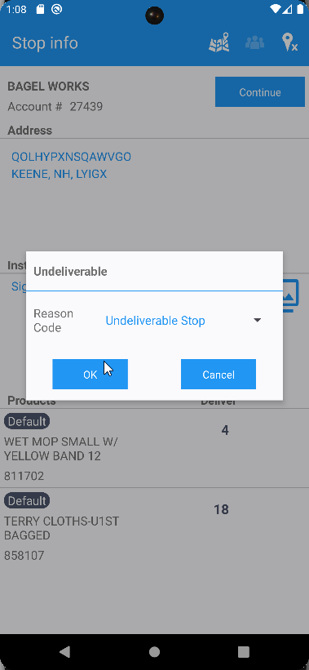
Another customer make some wearer adjustments abd bill all for loss now
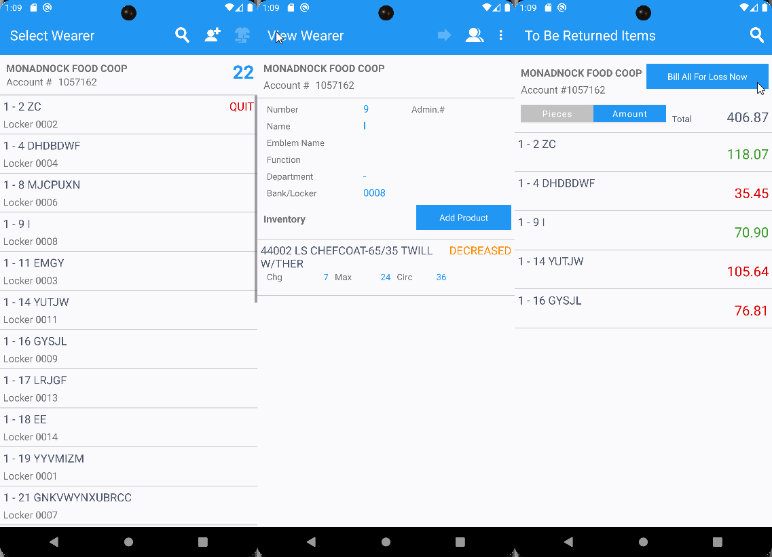
On the third customer just settle the invoice and depart.
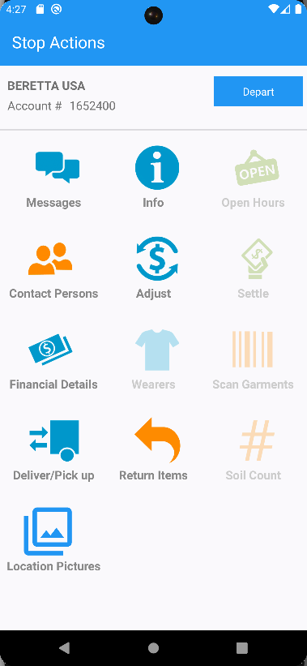

- RA: While the route is still loaded in WebX , finish and upload the route.
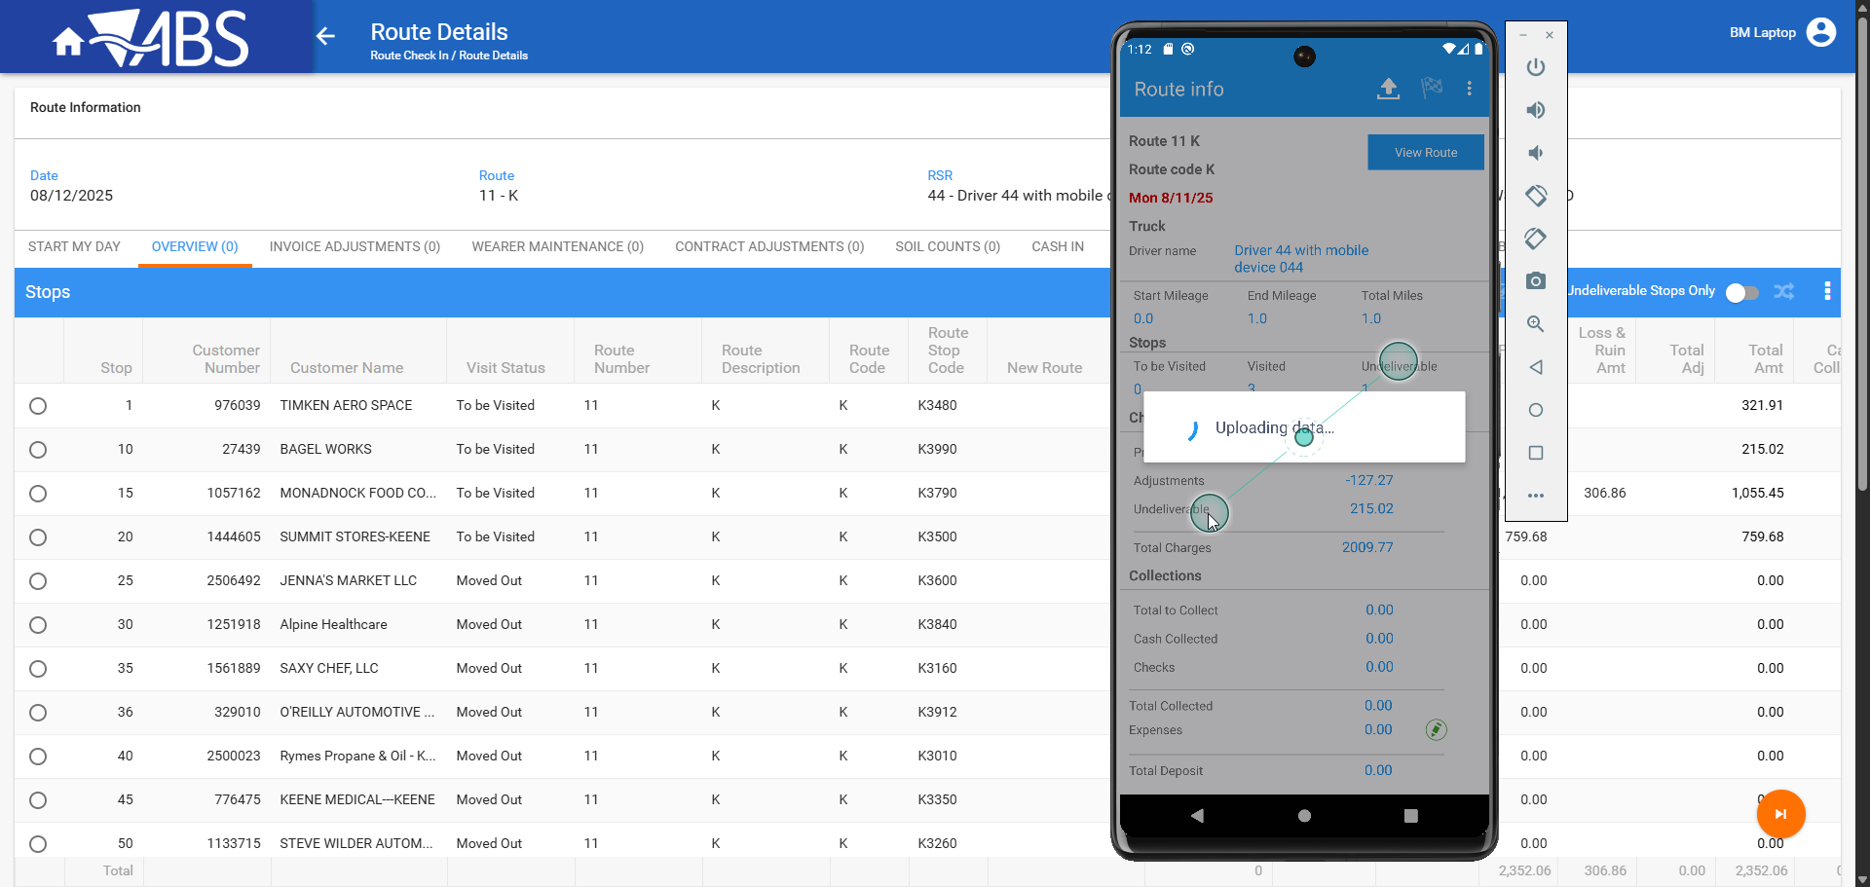
- WebX: Settle the route after the route has been uploaded
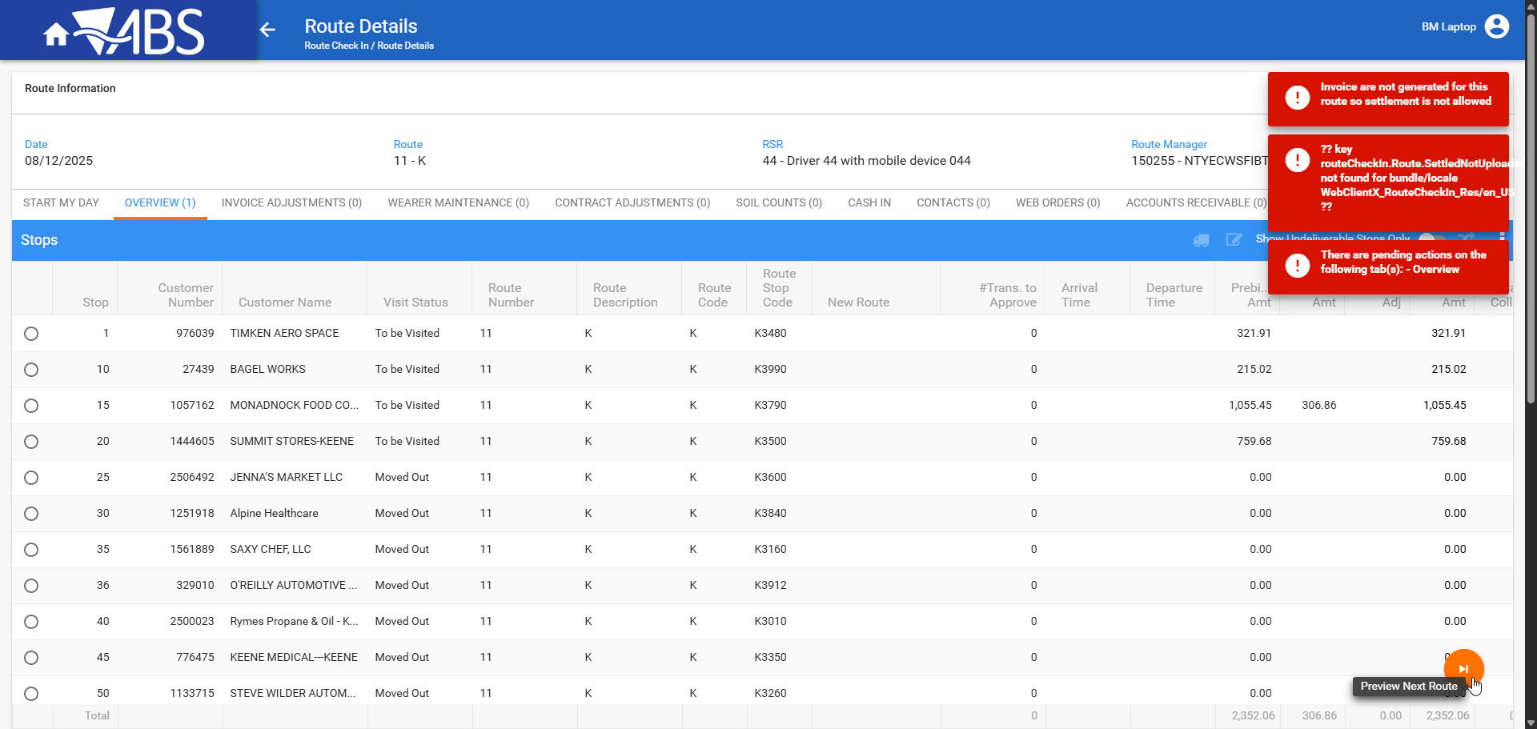
- WebX: Navigate through tab and return to Overview tab and select as undeliverable the stop from RA.
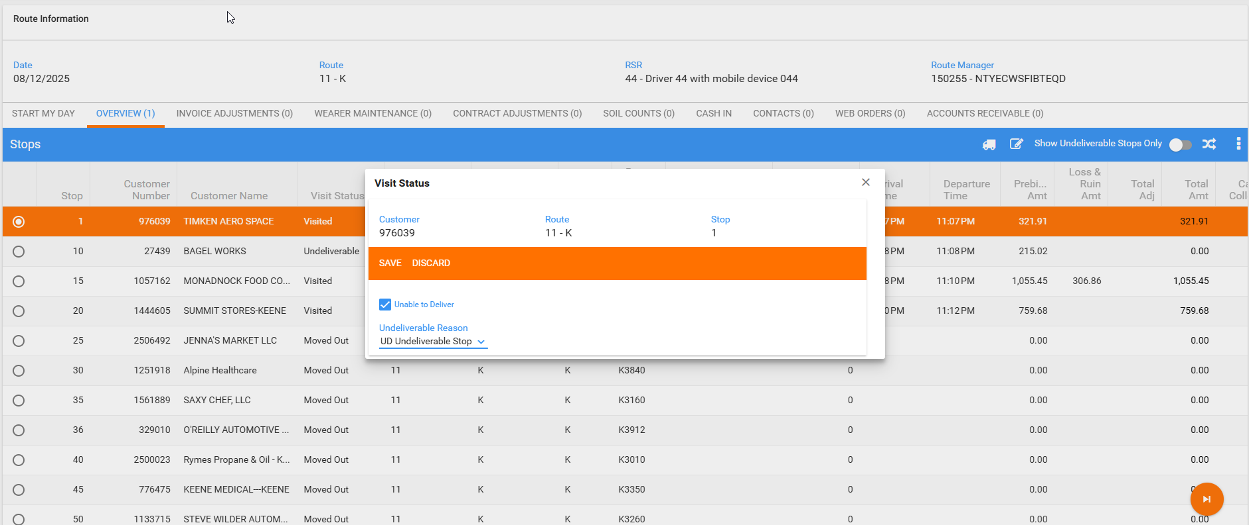
- WebX: Assign it to another route
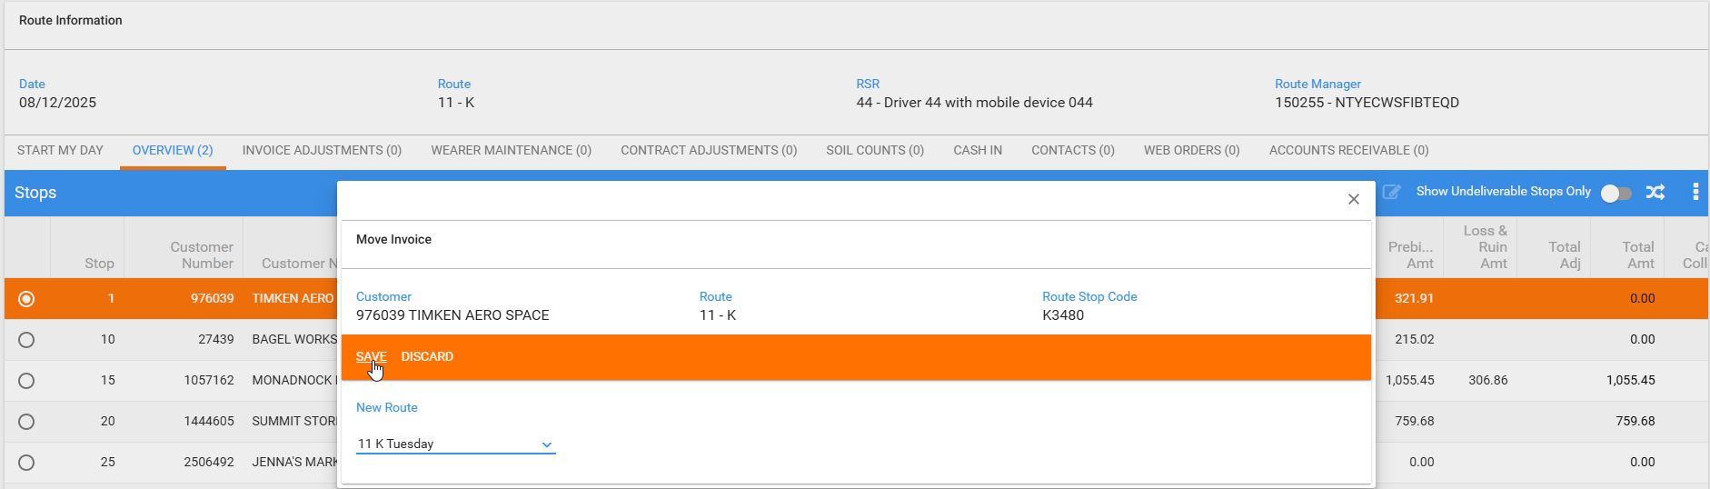
- WebX: Assign to another route the undeliverable stop.
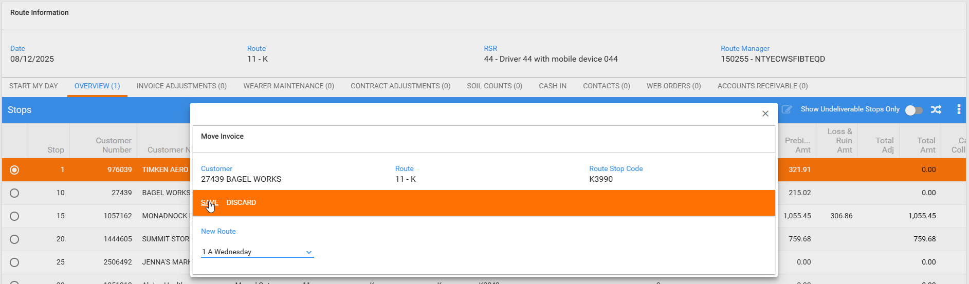
- WebX: Try to settle the route.
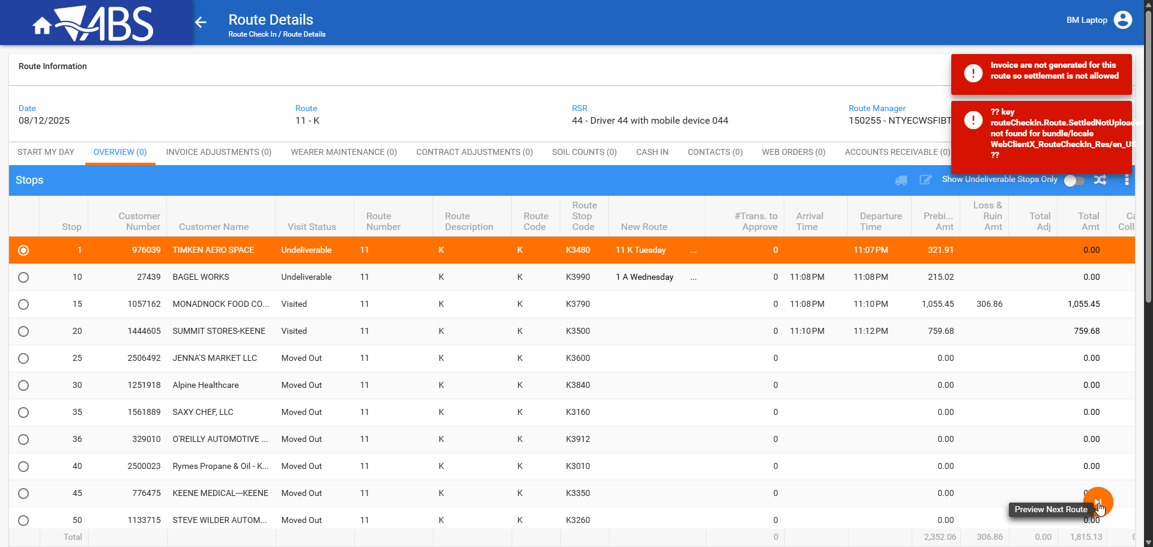
- WebX: While keep using the route loaded on the first instance, using another account, log in to webx
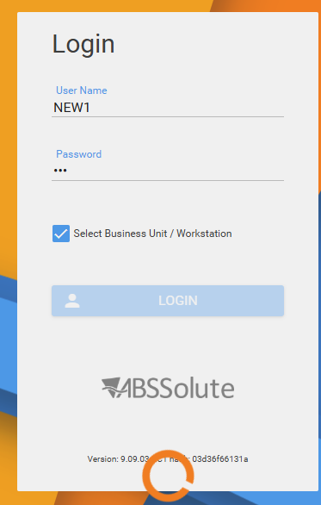
- WebX incognito: Settle the route with the new account.
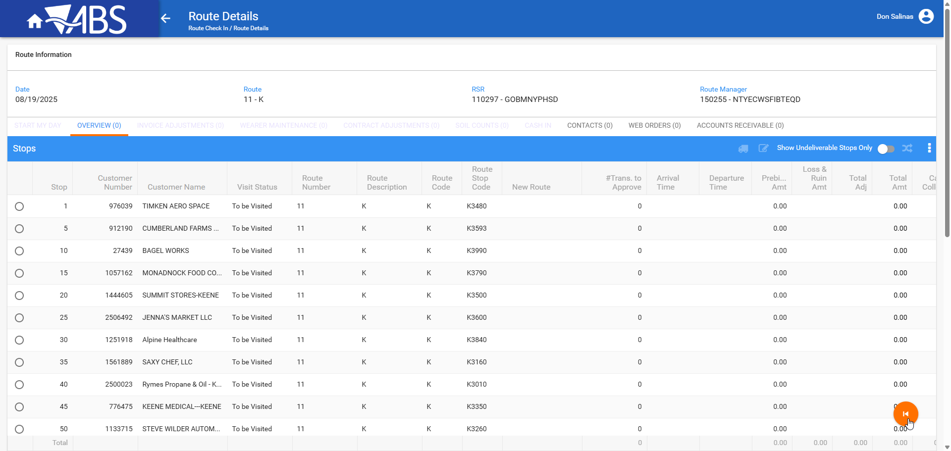
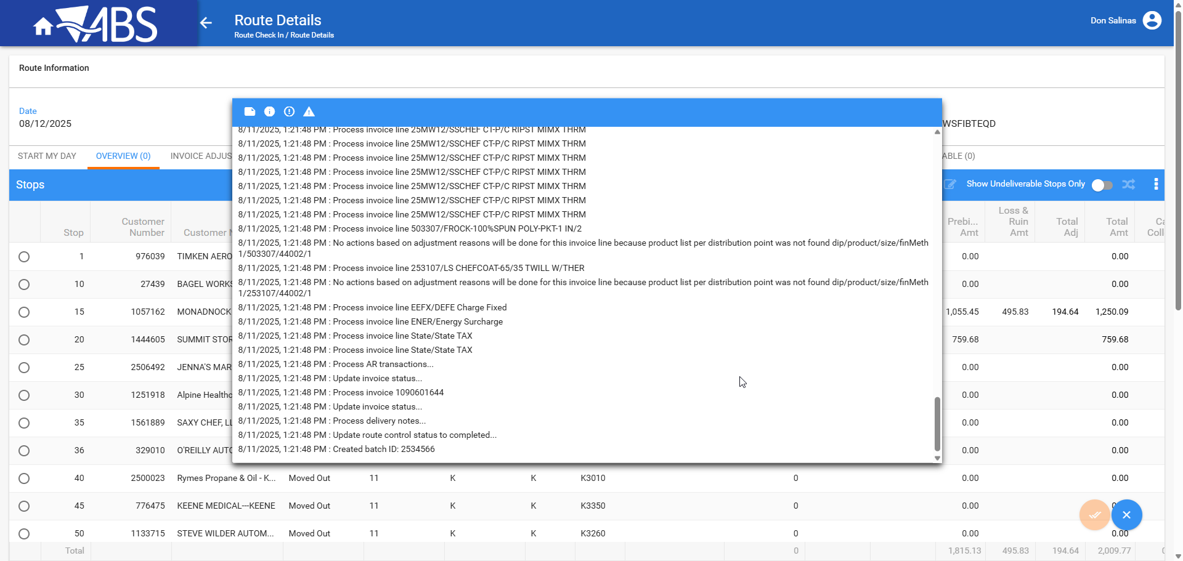
- WebX: Return to the first user and try to settle the route.
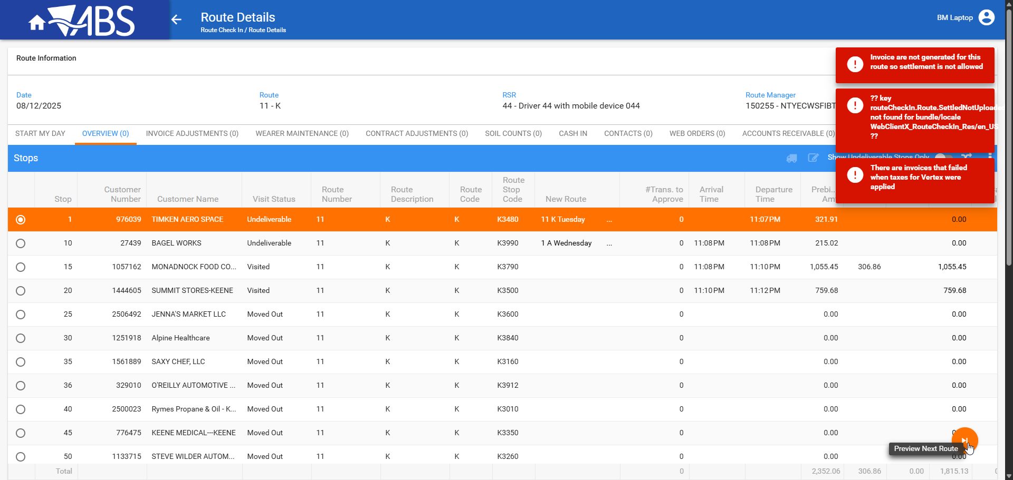

Reproduced OK

Retest after fix
Bu: 288 RICHMOND, VA
9.07.00.UNF21 hash: 31bc8452ed1a

Test Case 01 Route is loaded on WebX before being downloaded on PDA, before any invoices were generated, make following operations:

Steps to reproduce:
- RSC dlg: Create a new route, keep at least 5 customers on the route.
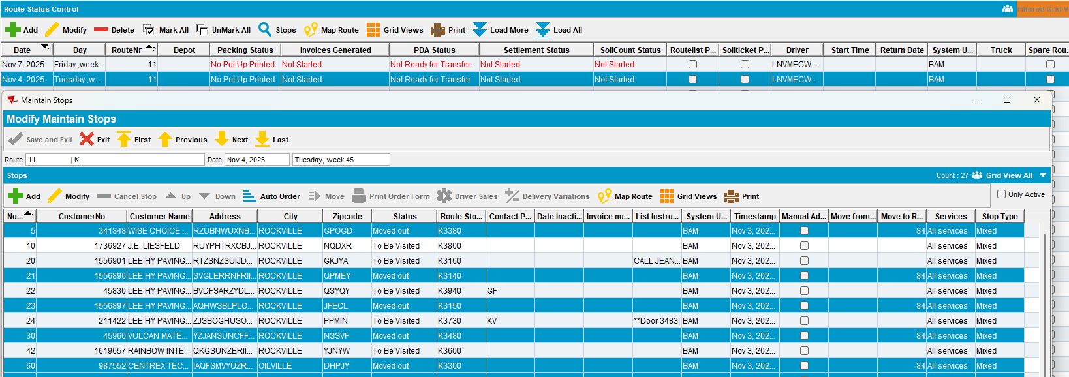
- WebX: Load the route.
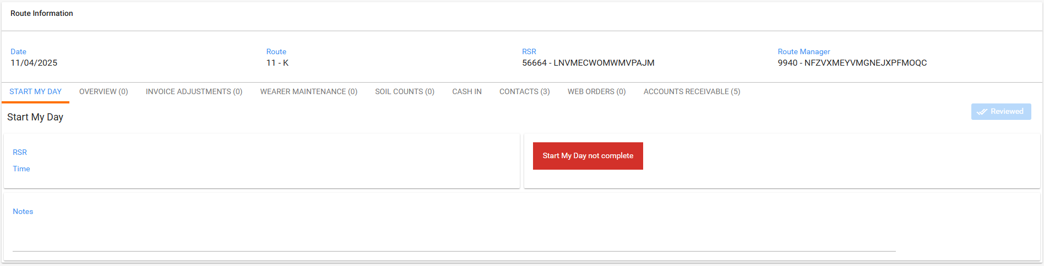

Complete Start my Day using the webservice
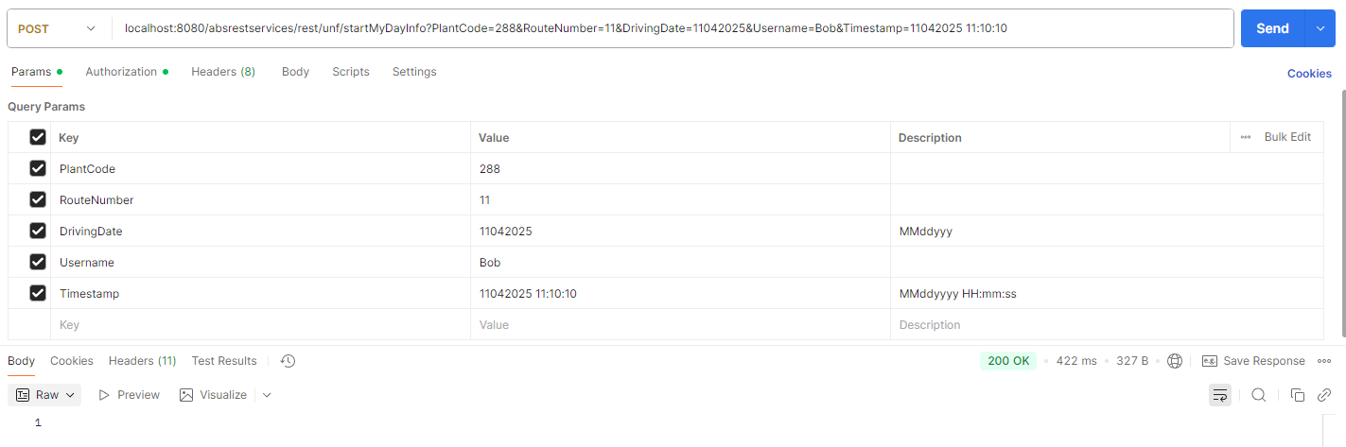
- Refresh route in WebX
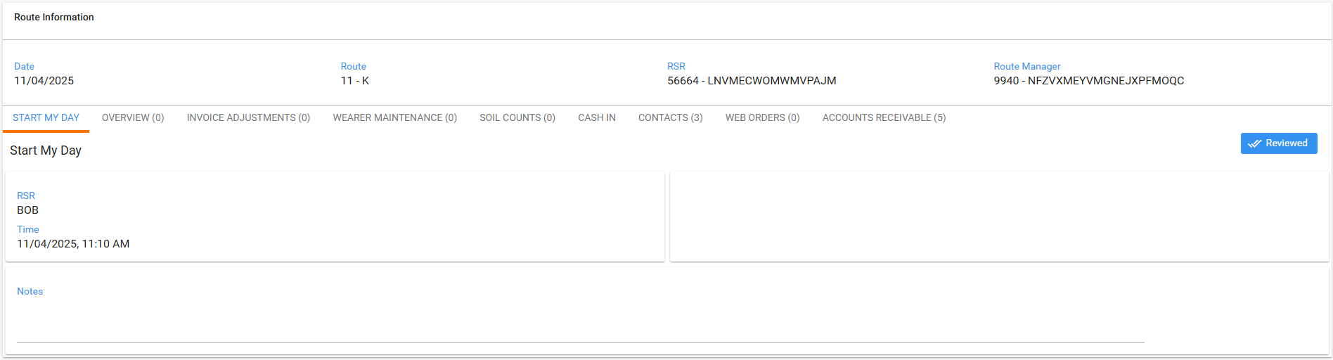

WebX: Try to Settle before PDA upload, correct message Invoices have not been generated
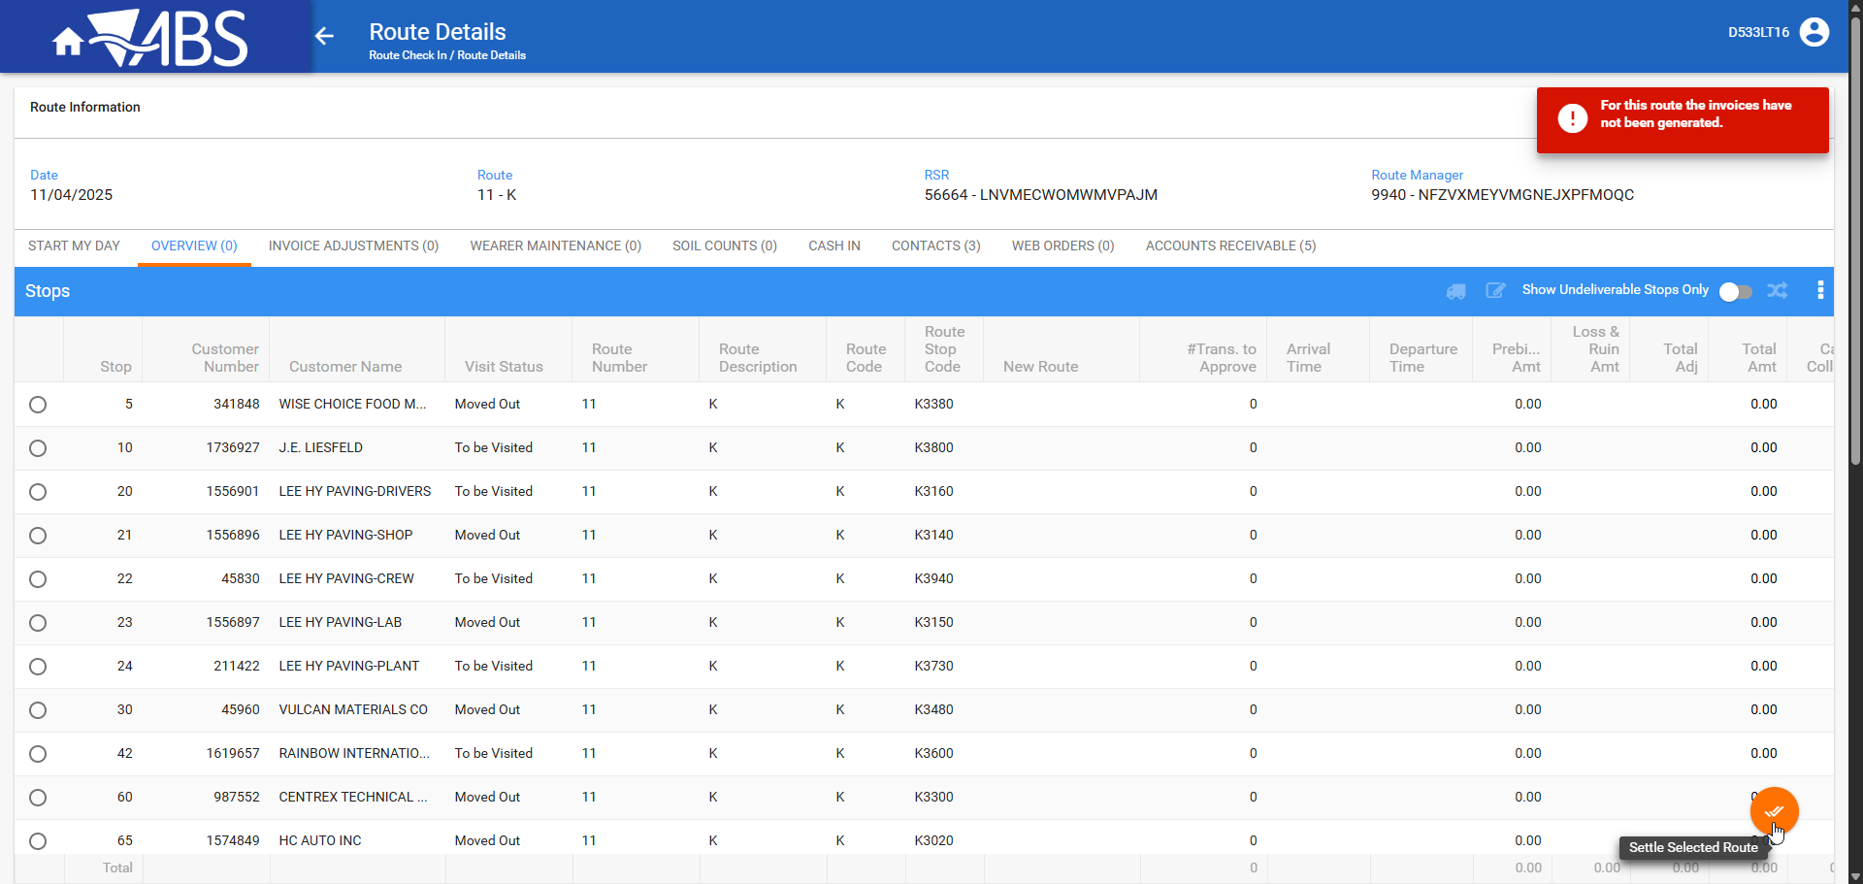

WebX: Check all the tabs.
Invoice adjustments
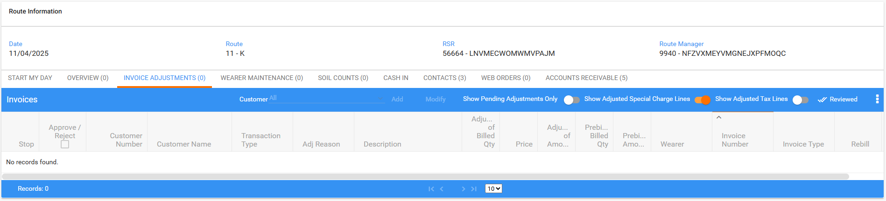
Wearer maintenance
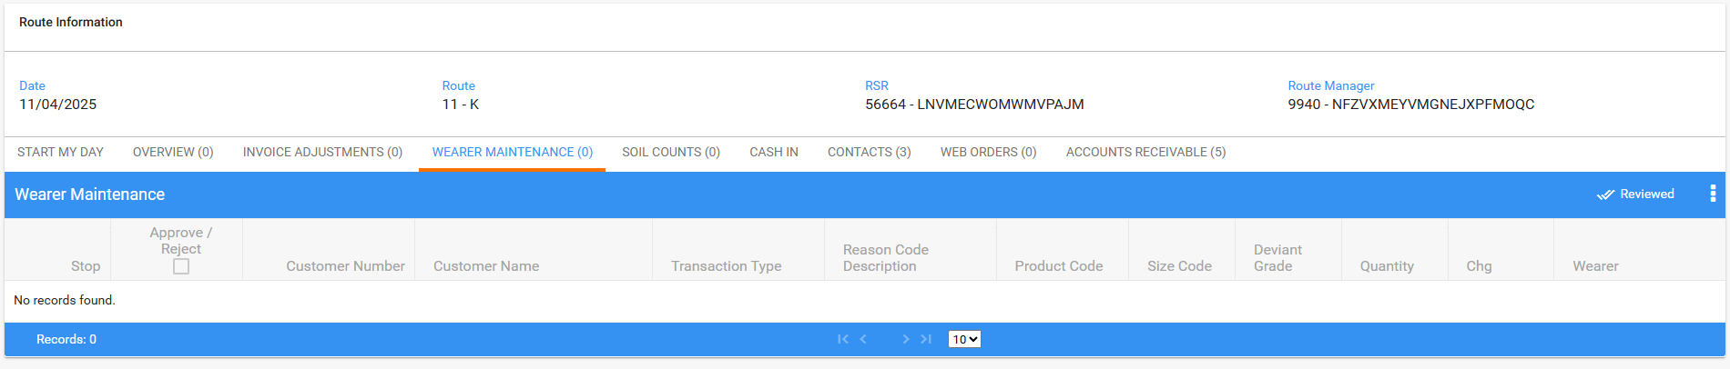Soil Counts
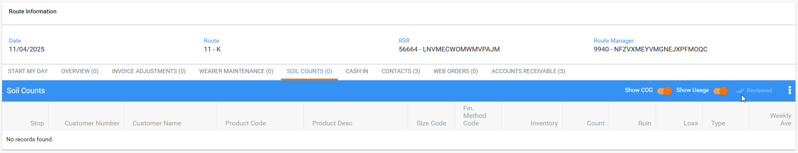

Cash In
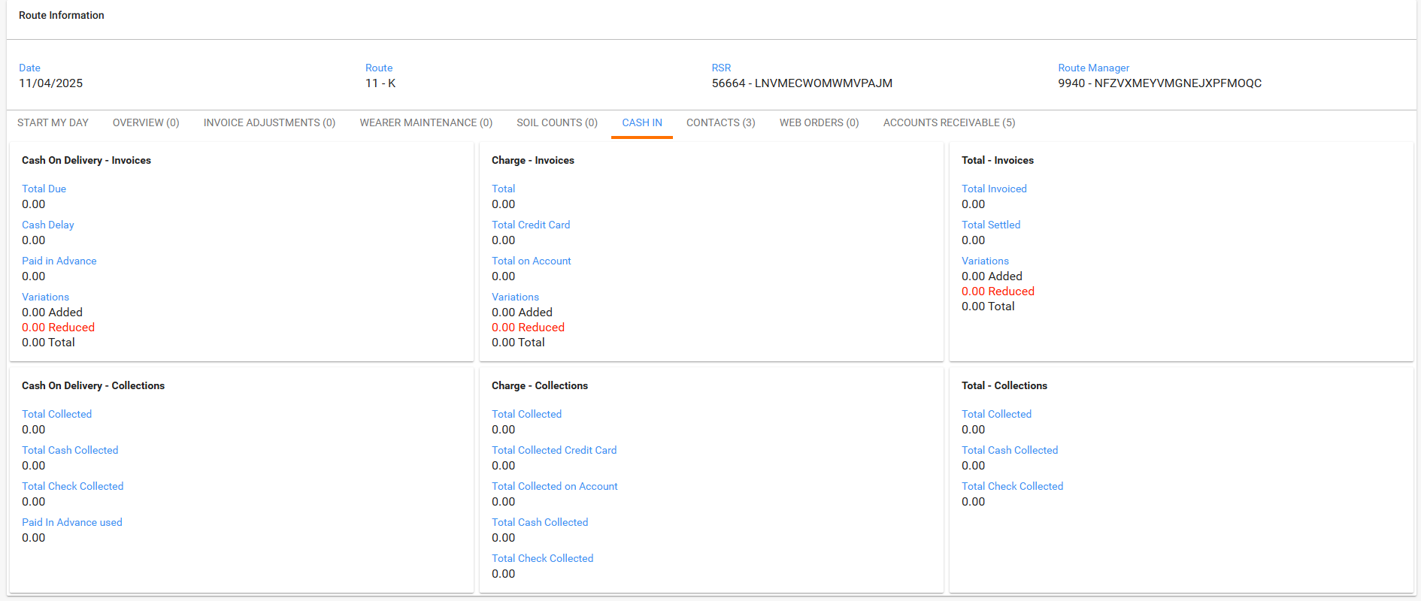

Contact details, add a new follow up note for a contact.
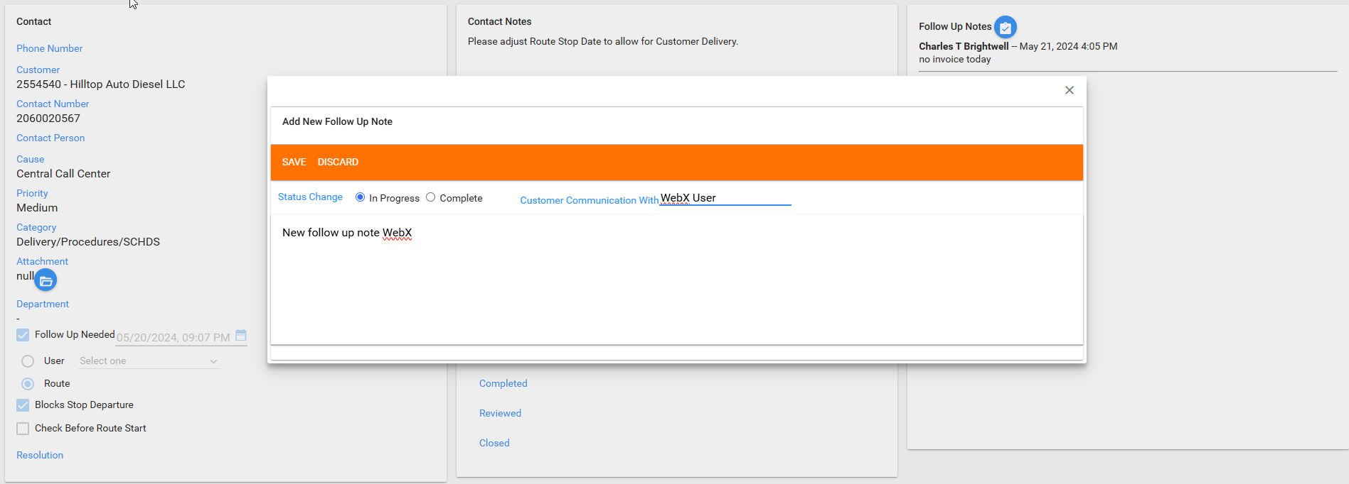
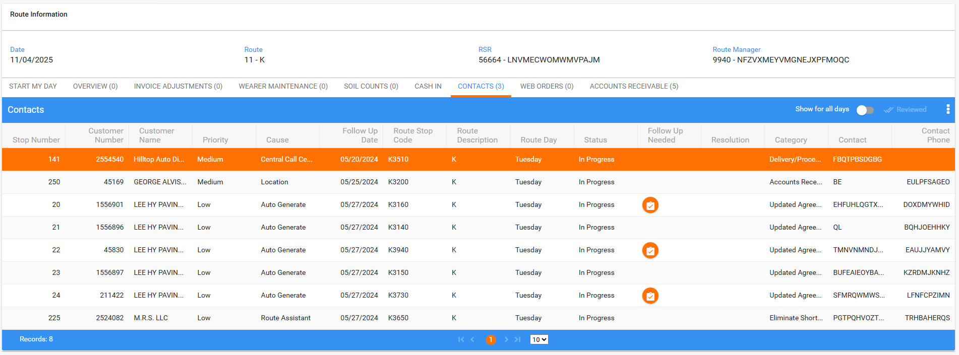
Web orders
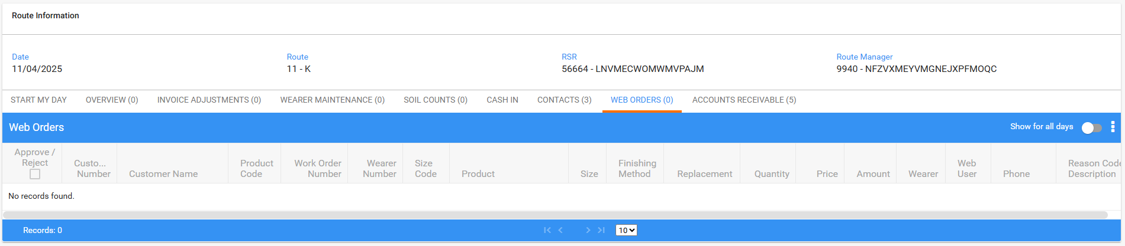
Account receivable
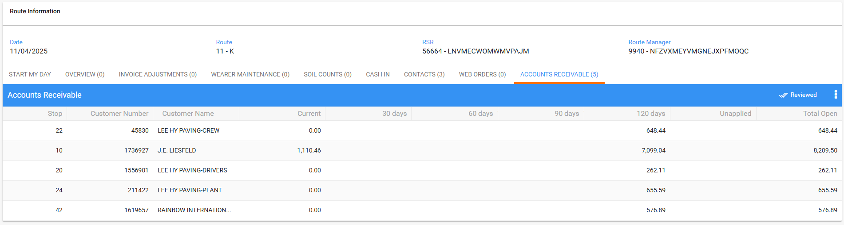
- RSC dlg: Add another route in the future, same route number.
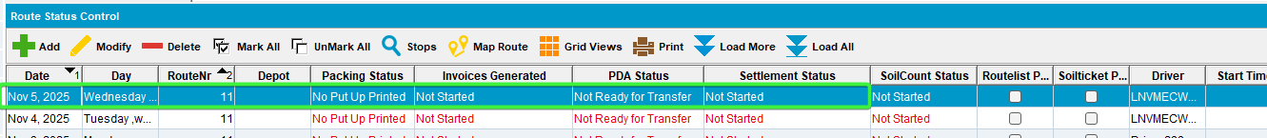
- WebX: Refresh the page with the route so that preview button appears because next week route was created in RSC. Try to settle.

WebX: Try to settle by clicking on next week route, all tabs have been reviewed but the route still hasn't been invoiced, correct message Invoices have not been generated

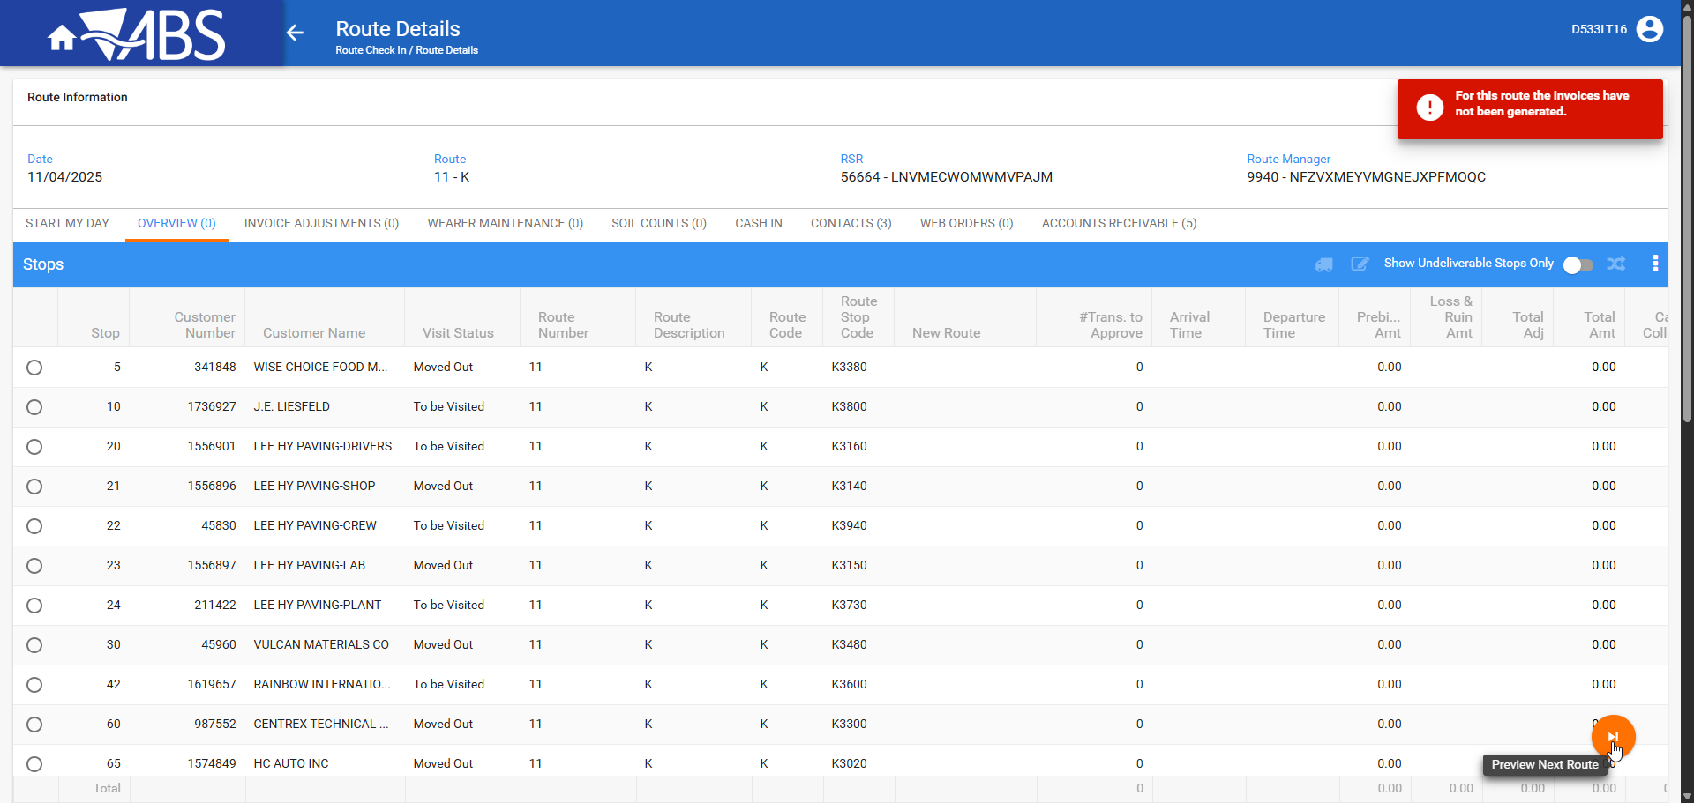

- RSC dlg: For the current route, generate put up documents to complete packing status.

WebX: Try to settle by clicking on next week route, packing status is complete but route is not invoiced, , correct message Invoices have not been generated

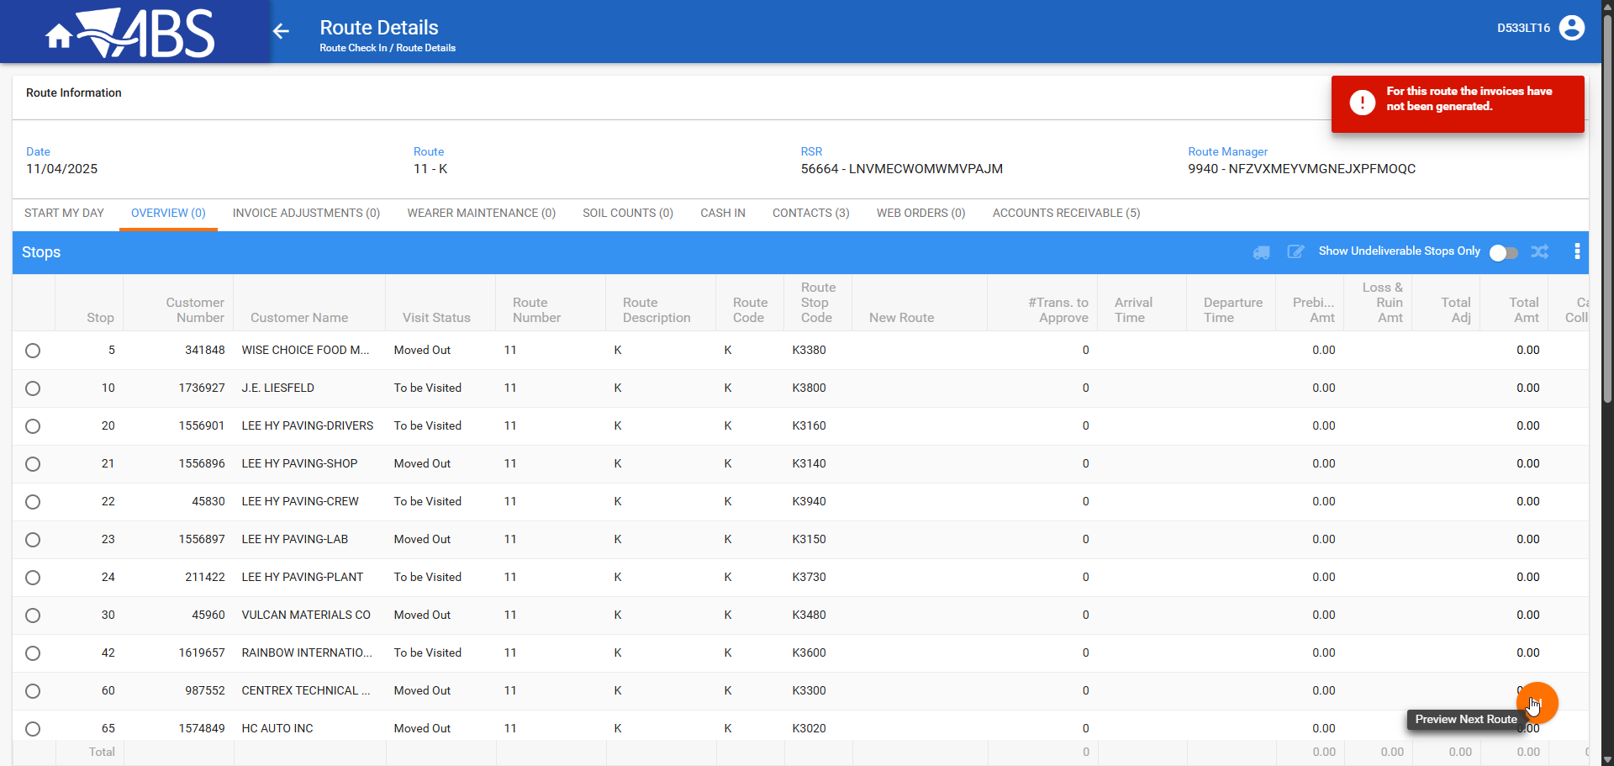
- RSC dlg:Generate invoices

WebX: Try to settle by clicking on next week route, the route has been invoiced but the taxes were not completed, correct message This route has not been uploaded from the Route Assistant

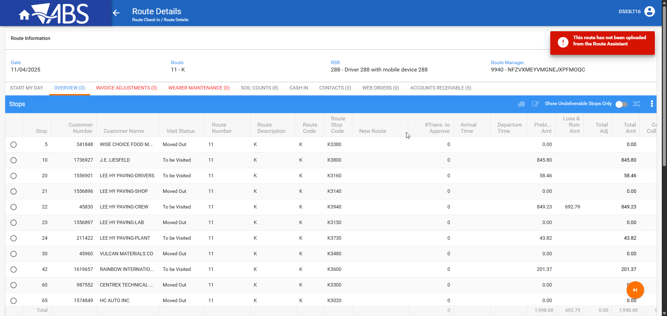
- RSC dlg: Complete the taxes.
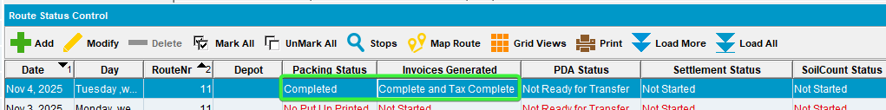

WebX: Try to settle by clicking on next week route, the route has been invoiced but the taxes were not completed, correct message This route has not been uploaded from the Route Assistant

- WebX: Complete the Soil Counts tab.
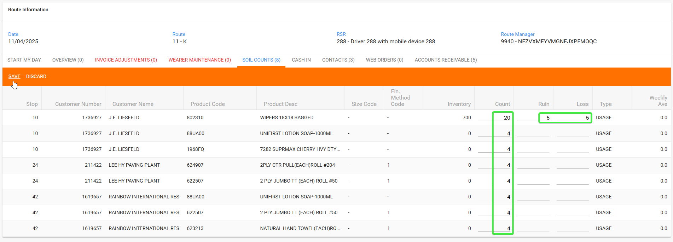
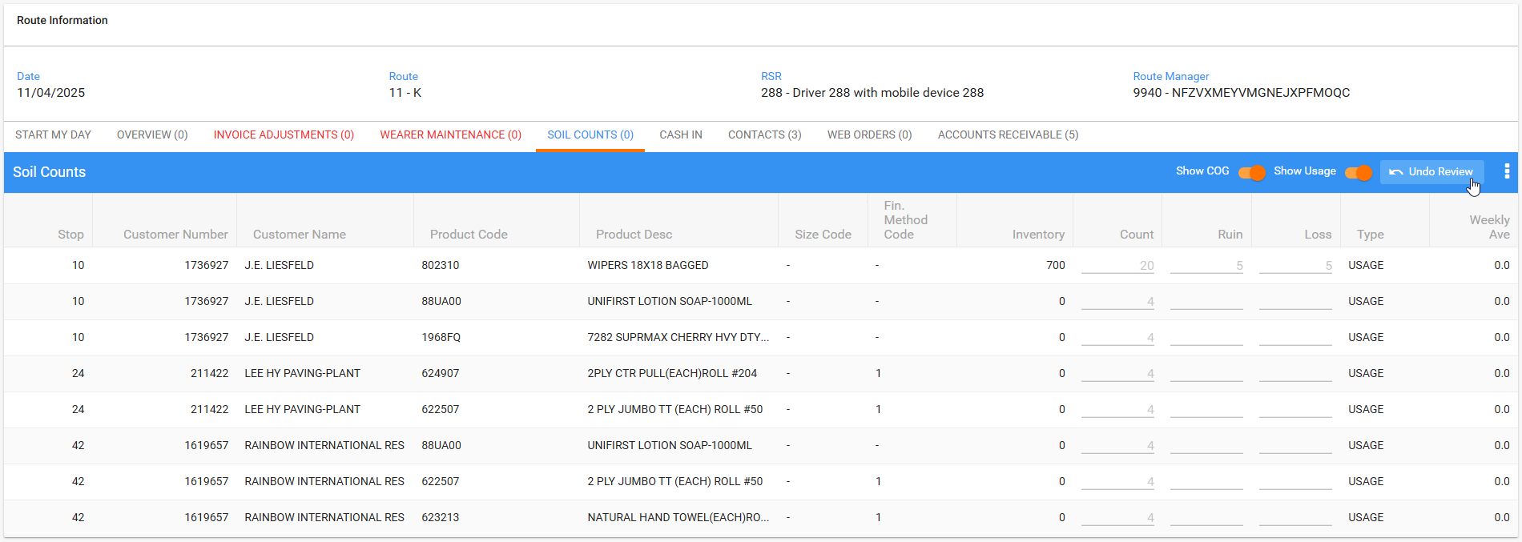

WebX: Cannot make undeliverable a stop from WebX while route hasn’t been through PDA
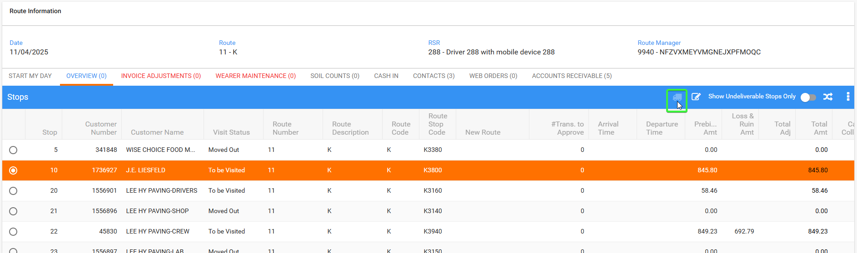

Cannot make invoice adjustments while route hasn’t been through PDA
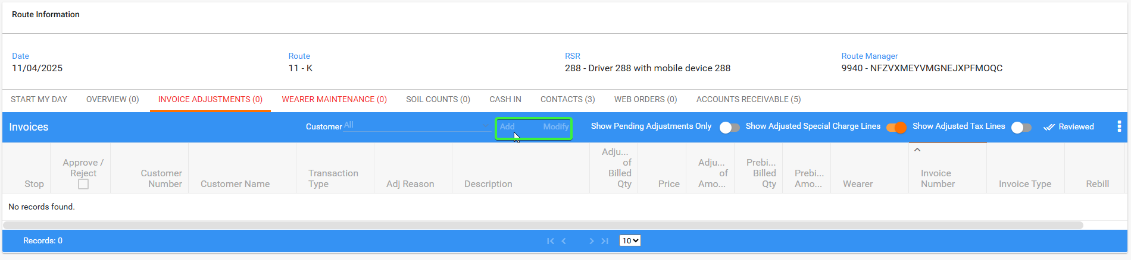

Cannot make any actions on Wearer Maintenance while route hasn’t been through PDA
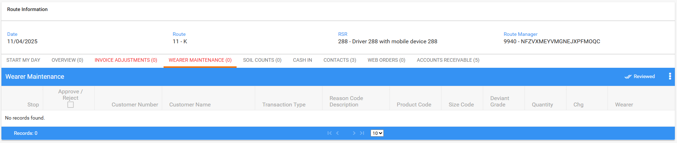

- RSC dlg: Send the route to PDA.
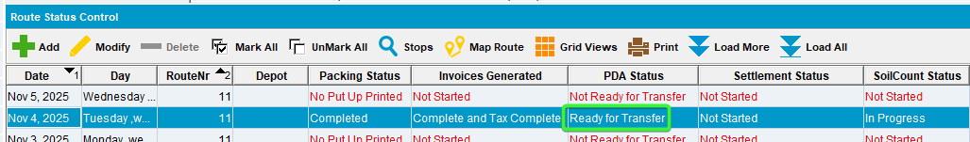

WebX: Try to settle, the route has been Mark Ready for Transfer but is not downloaded

- RA: Download the route.

WebX: Try to settle, the route has been downloaded on RA

- RA: Arrive at one customer and credit the invoice and add a new contact person
- RA: For another customer, make some wearer adjustments and bill some for loss.
- RA: On the third customer just settle the invoice and depart.
- RA: On the fourth customer just set it as undeliverable.
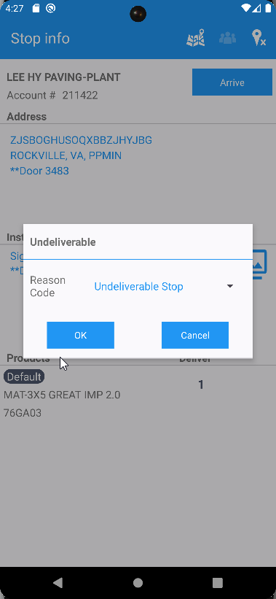
- RA: On the fifth customer, scan replace some garments with different grades and make some adjustments.
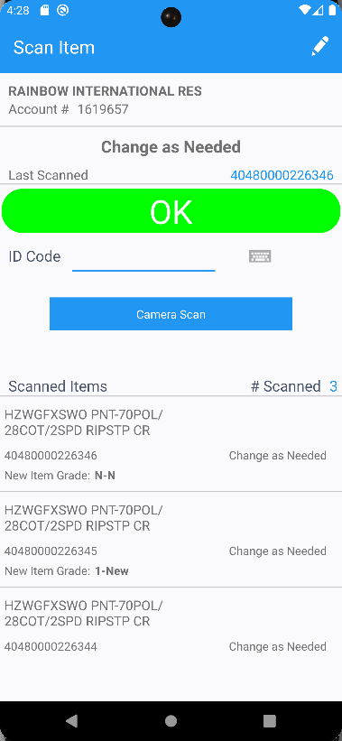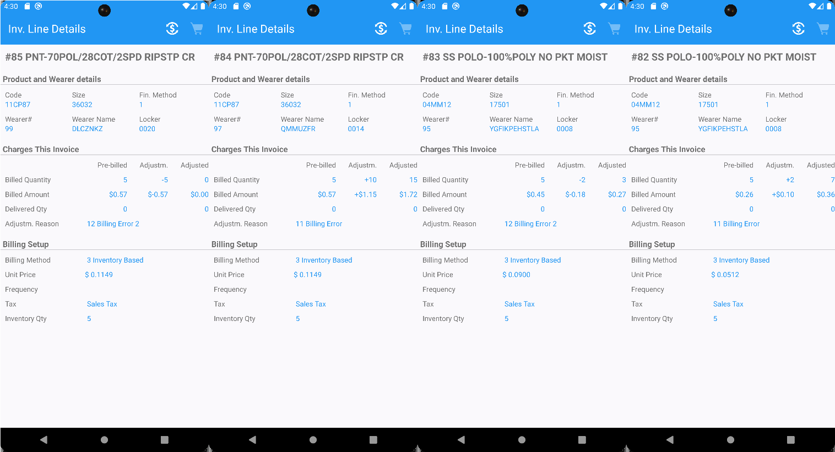
- RA: While the route is still loaded in WebX, finish and upload the route.
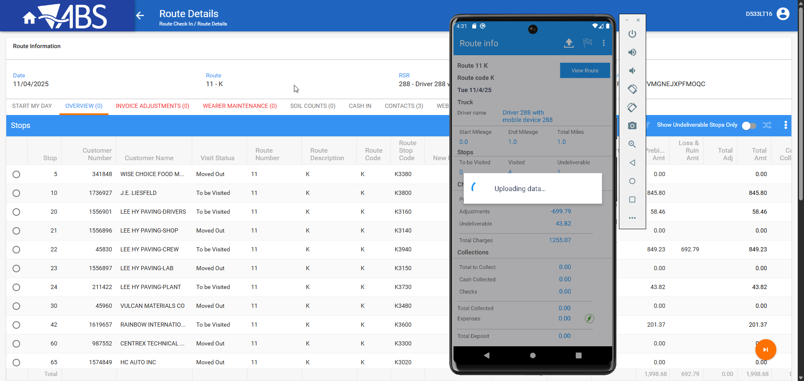

WebX: Try to settle, the route has been uploaded from RA, correct message with pending actions on the tabs
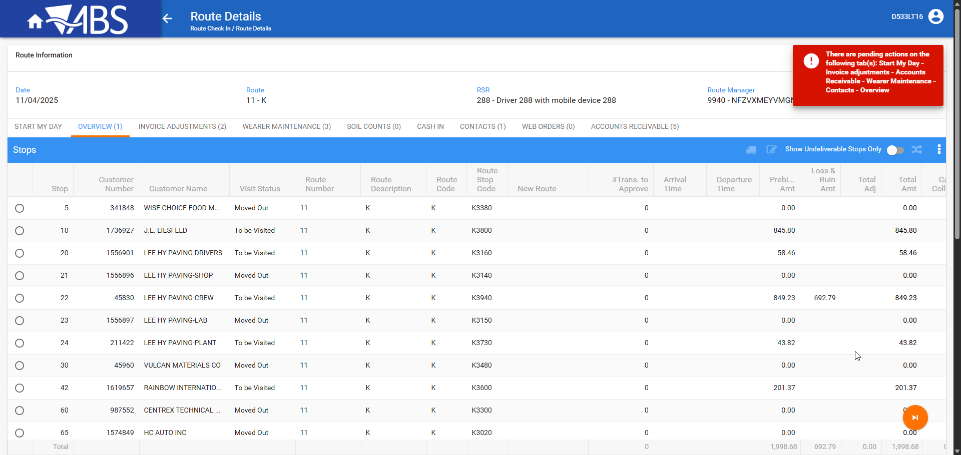
- WebX: Re-check the tabs with data coming from RA and review every one

Start my day
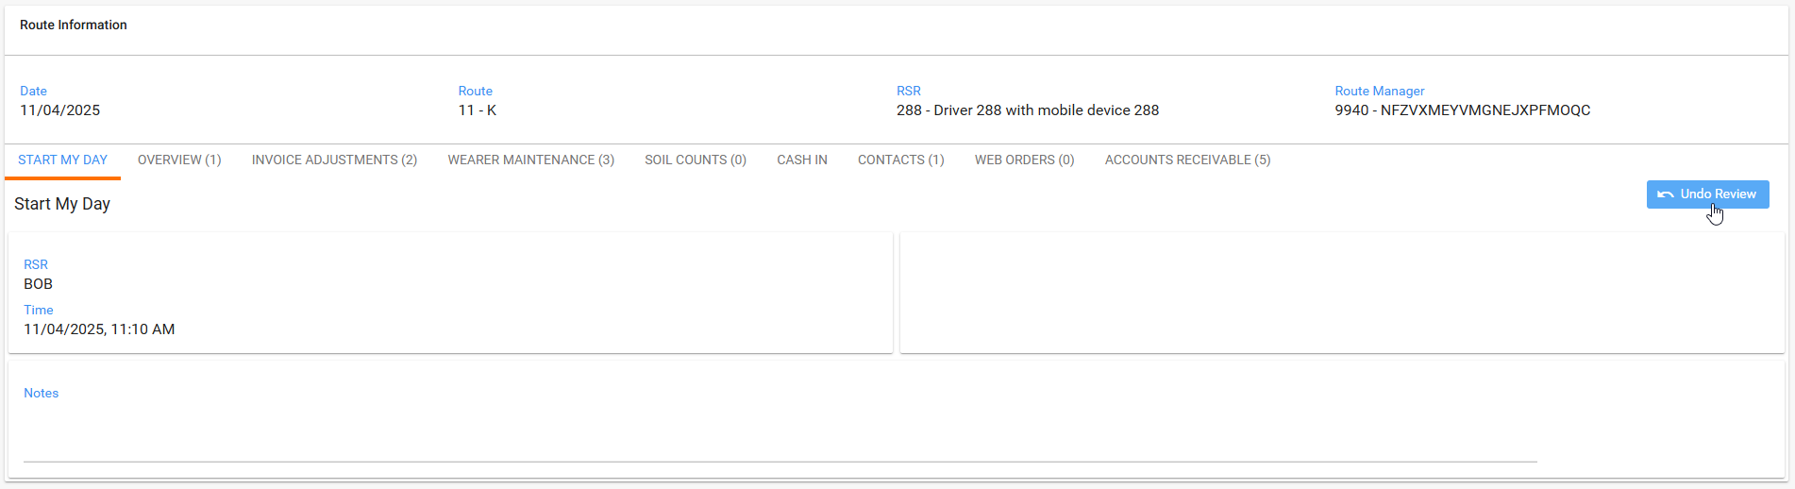

WebX: Try to settle, the route has been uploaded from RA, only Start my Day reviewed, correct message with pending actions on the tabs

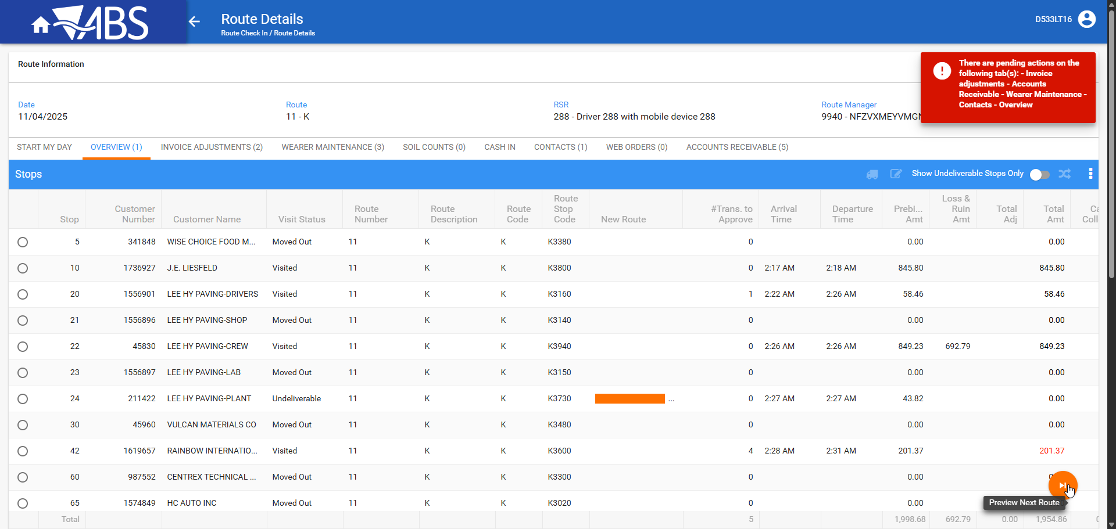

Invoice adjustments
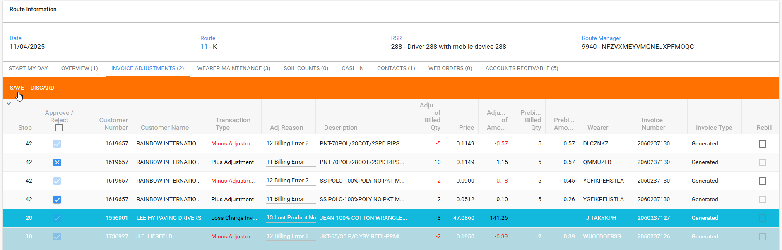

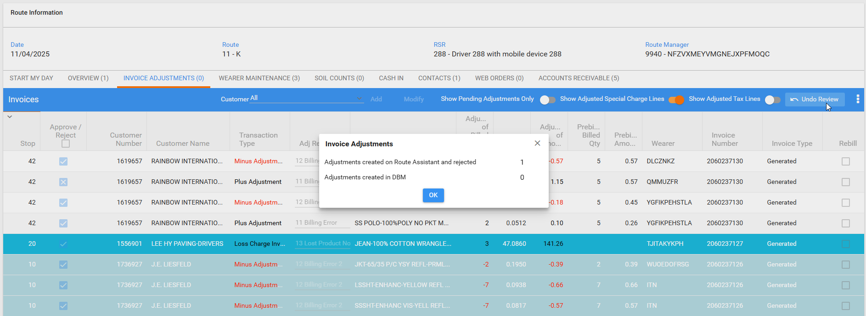

WebX: Try to settle, the route has been uploaded from RA, Invoice adjustments reviewed, correct message with pending actions on the tabs
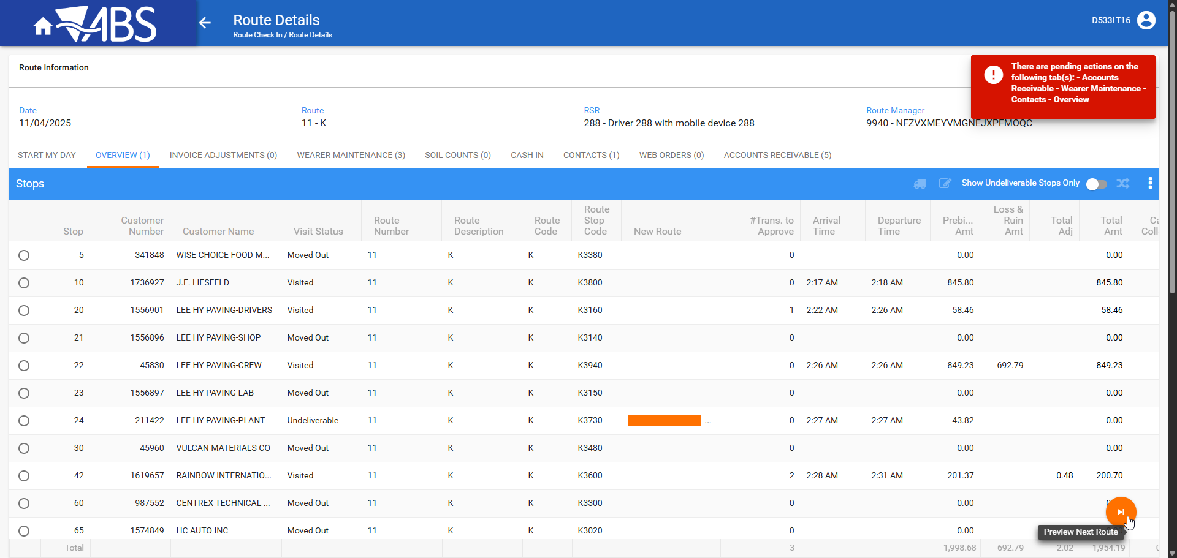

Wearer maintenance
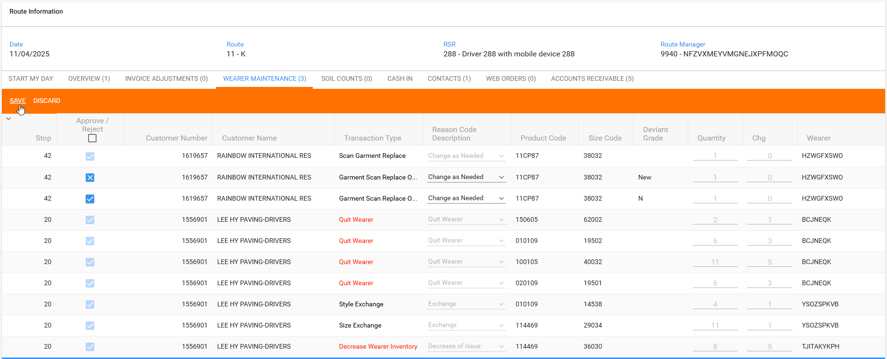
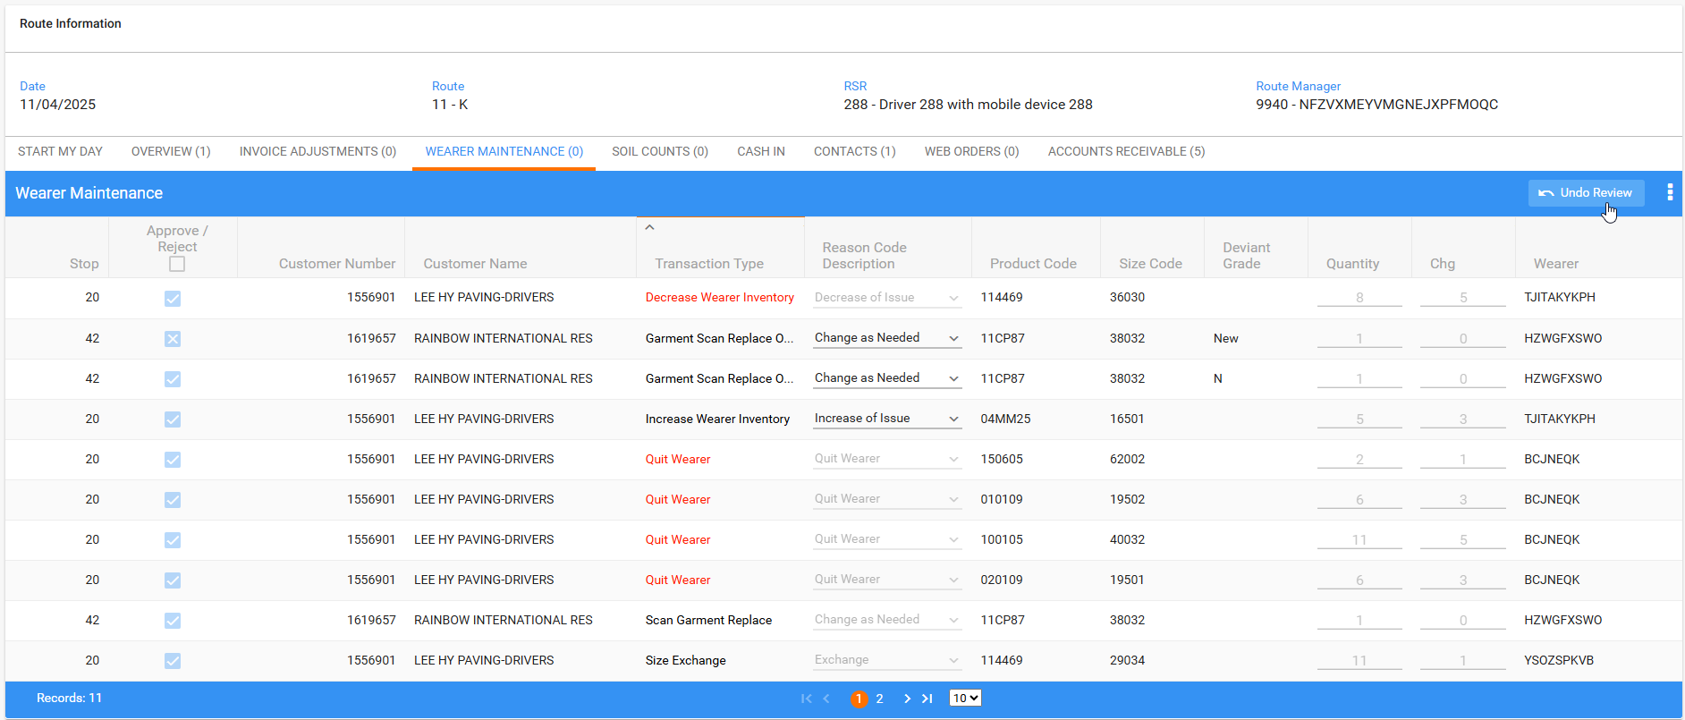

WebX: Try to settle, the route has been uploaded from RA, Wearer maintenance reviewed, correct message with pending actions on the tabs
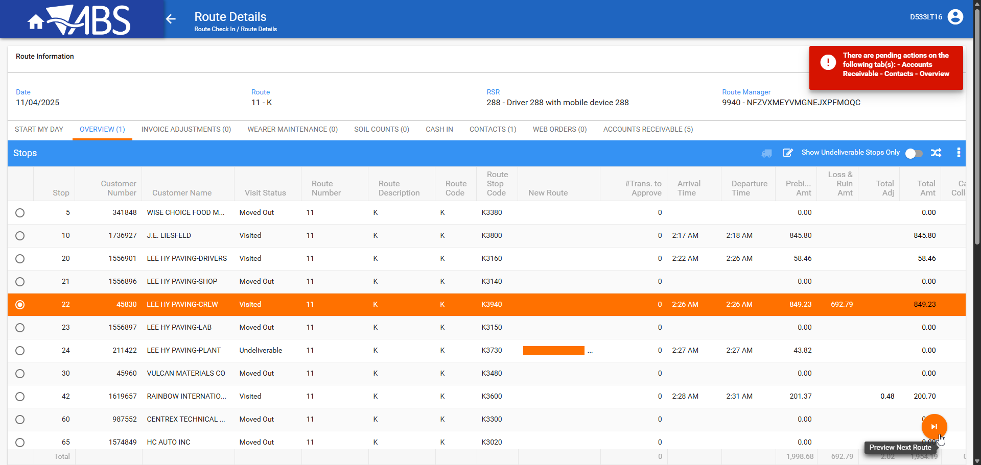

Soil Counts
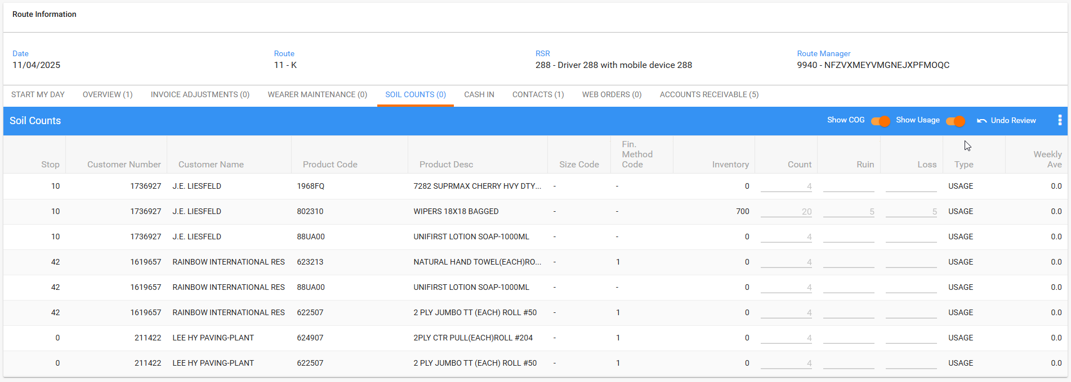

WebX: Try to settle, the route has been uploaded from RA, Soil Counts reviewed, correct message with pending actions on the tabs
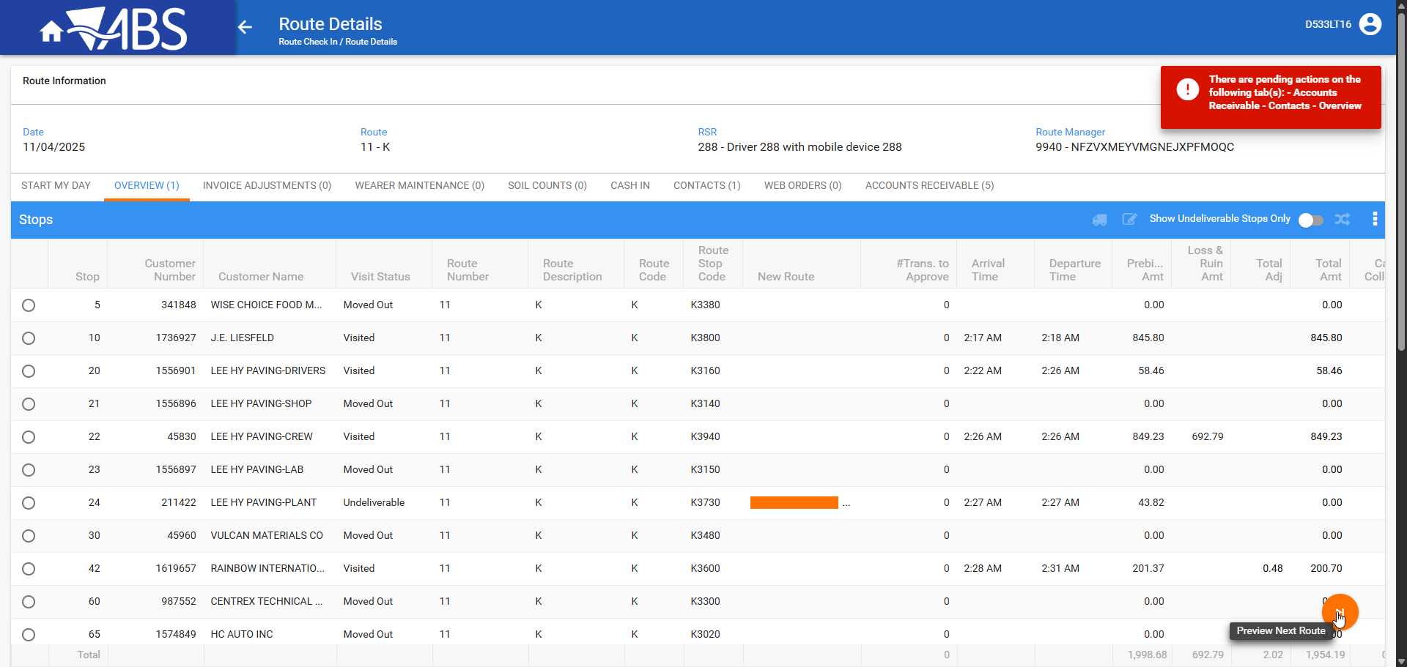

Cash IN
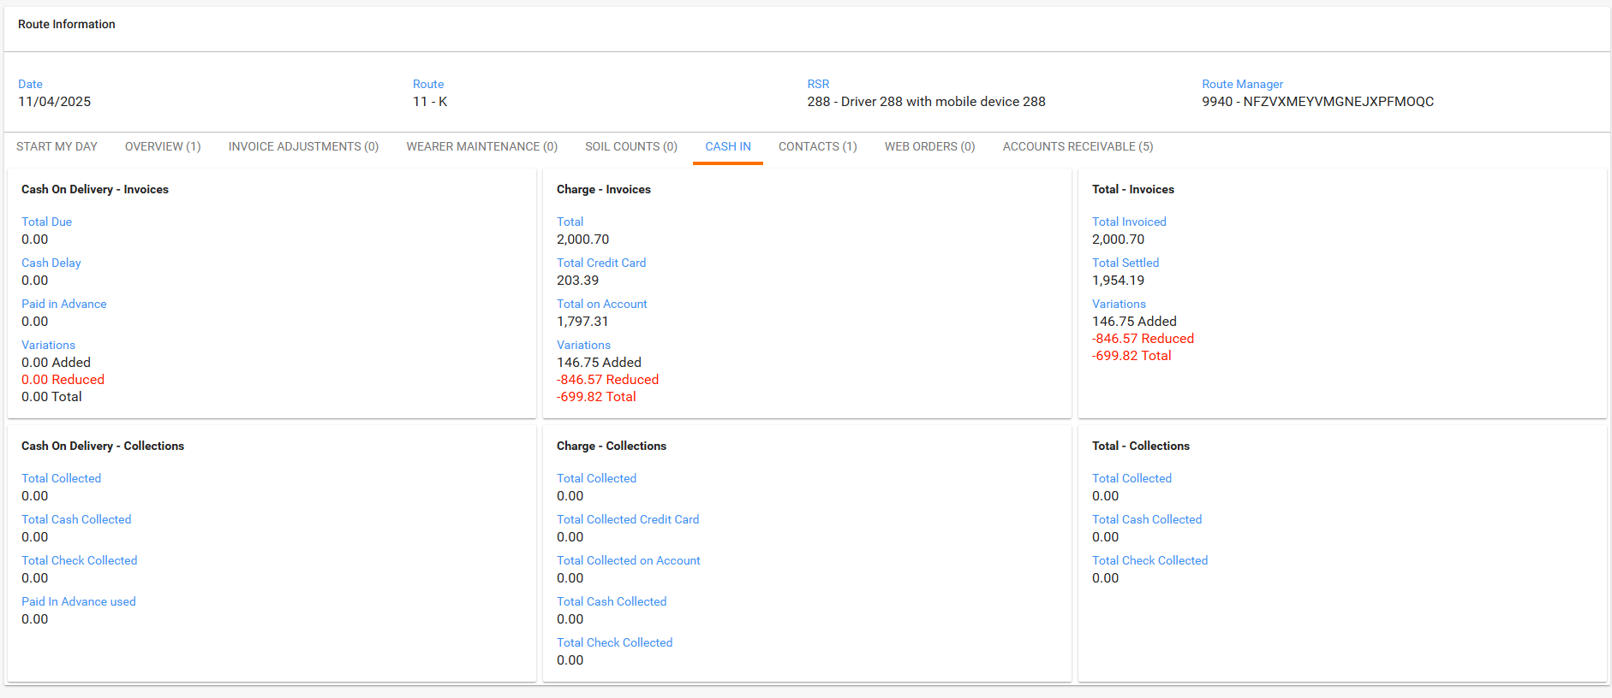

Contacts
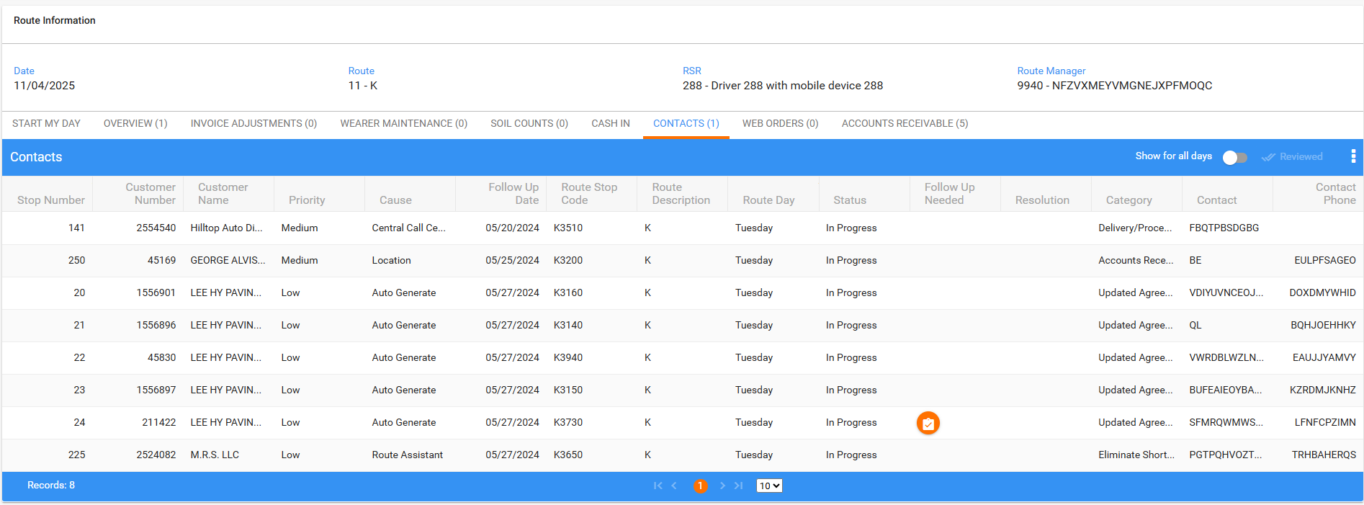
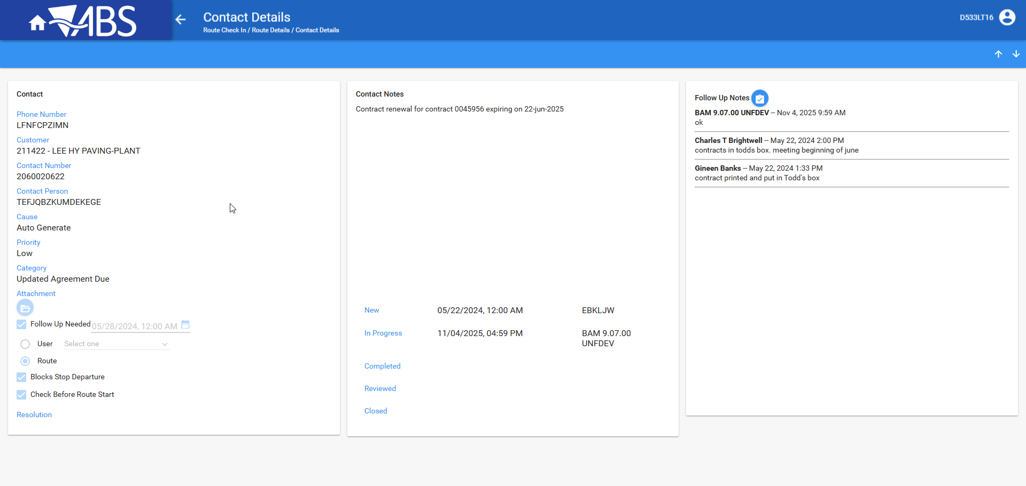
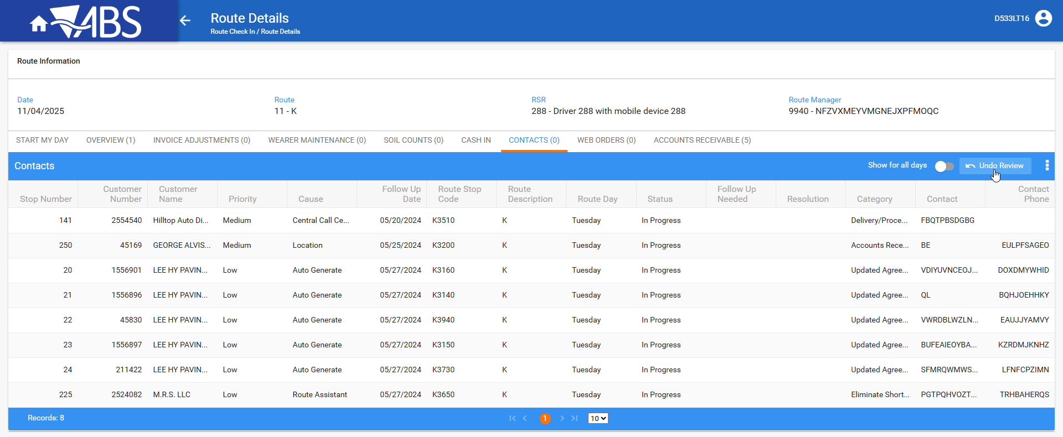

WebX: Try to settle, the route has been uploaded from RA, Contacts reviewed, correct message with pending actions on the tabs
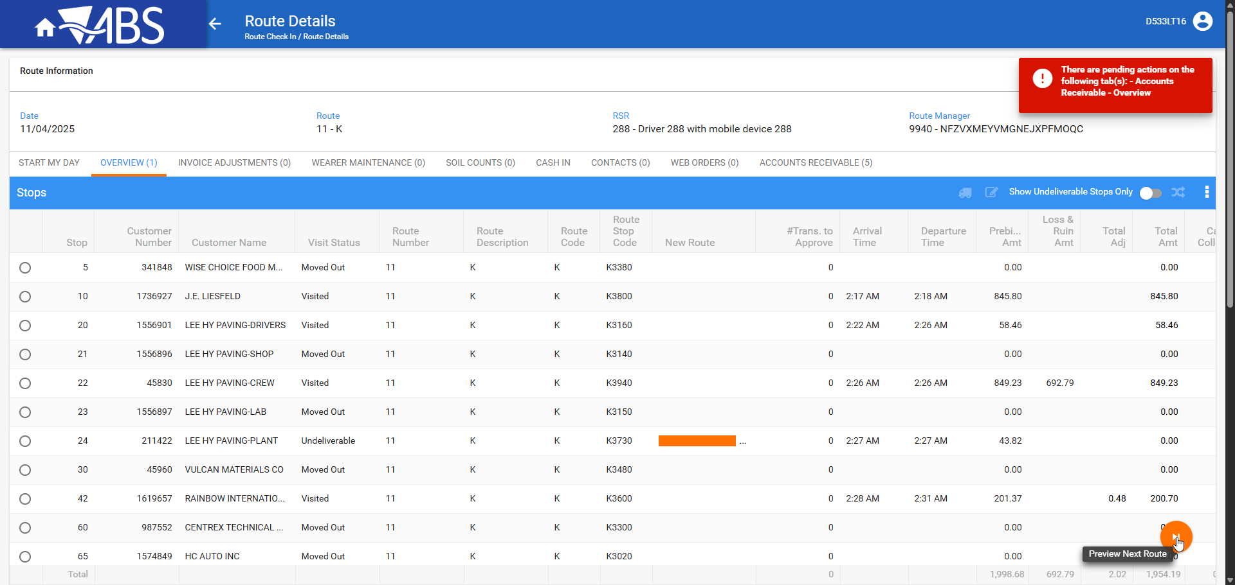

Accounts Receivable
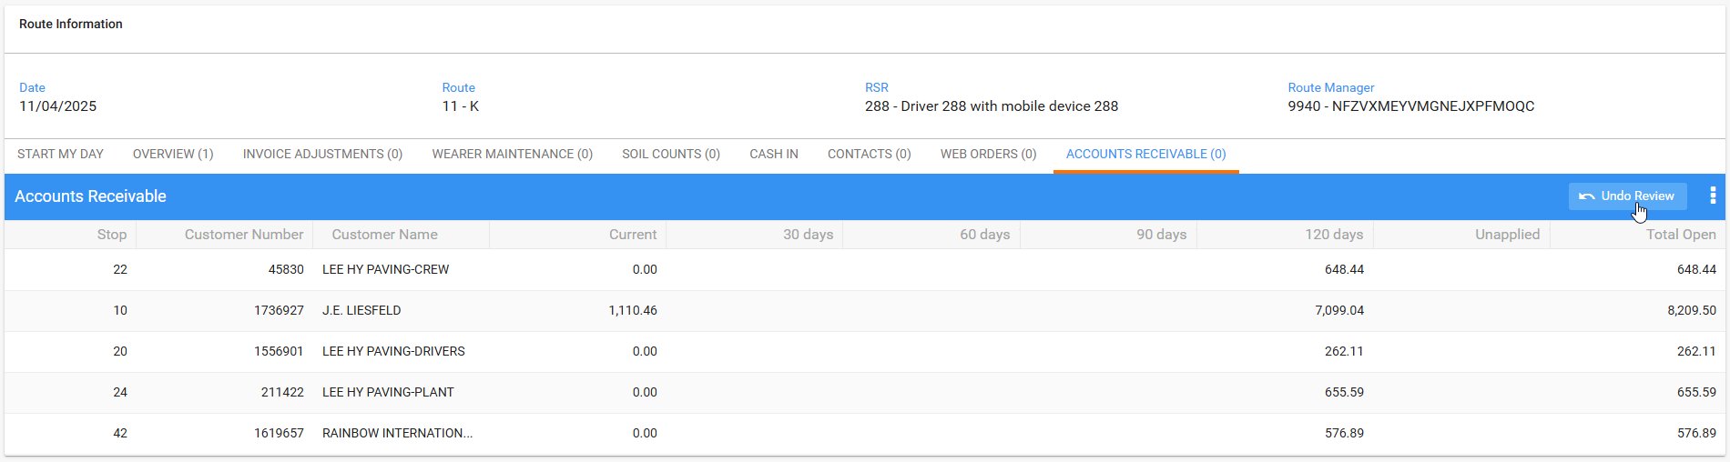

WebX: Try to settle, the route has been uploaded from RA, Accounts Receivable reviewed, correct message with pending actions on the tabs
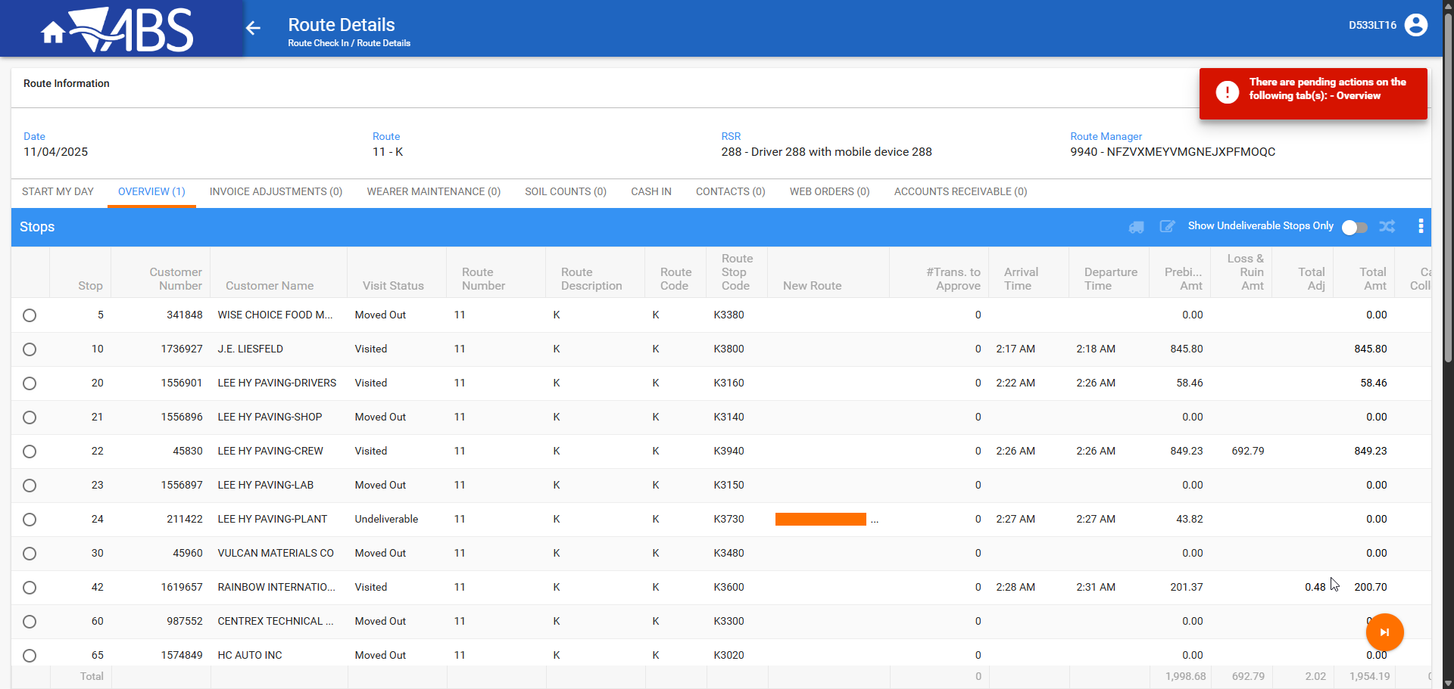

- WebX: Overview tab, for the credited customer, make the stop undeliverable.
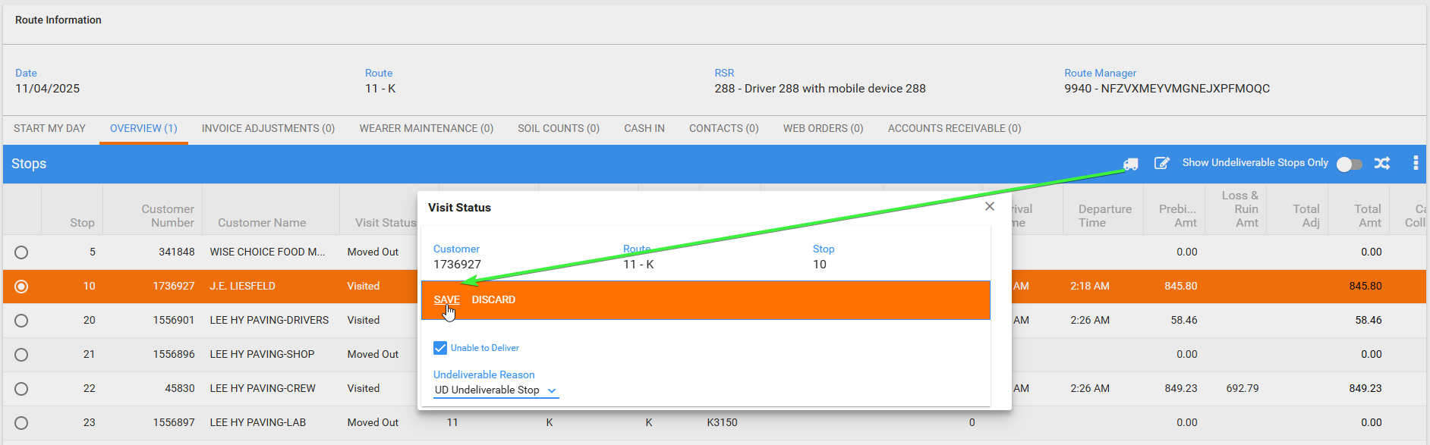
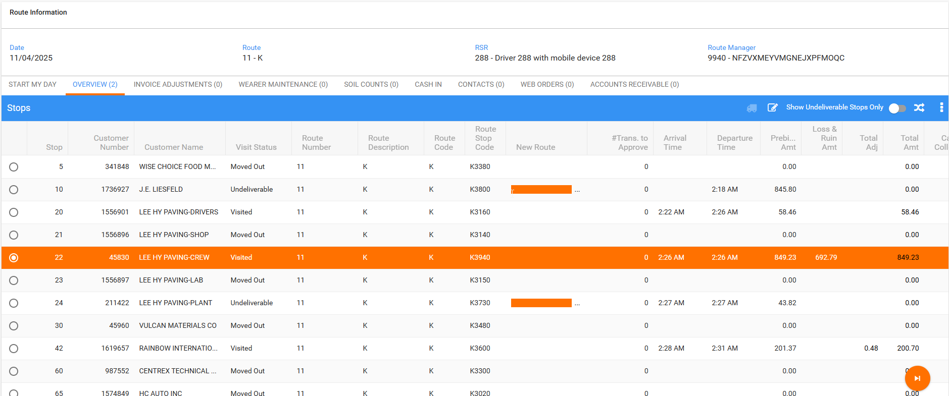

WebX: Using a different account and browser, make the final preparations and settle while it’s still loaded in the previous instance

- WebX: While keep using the route loaded on the first instance, using another account, log in to webx
- WebX incognito: Assign the credited invoices from RA and WebX to other routes.
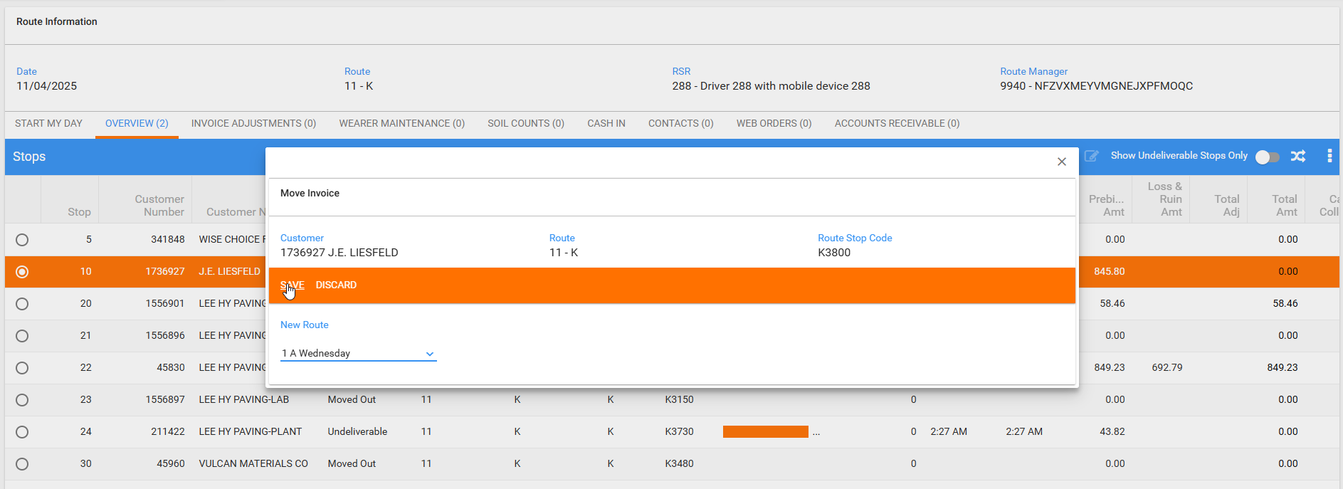
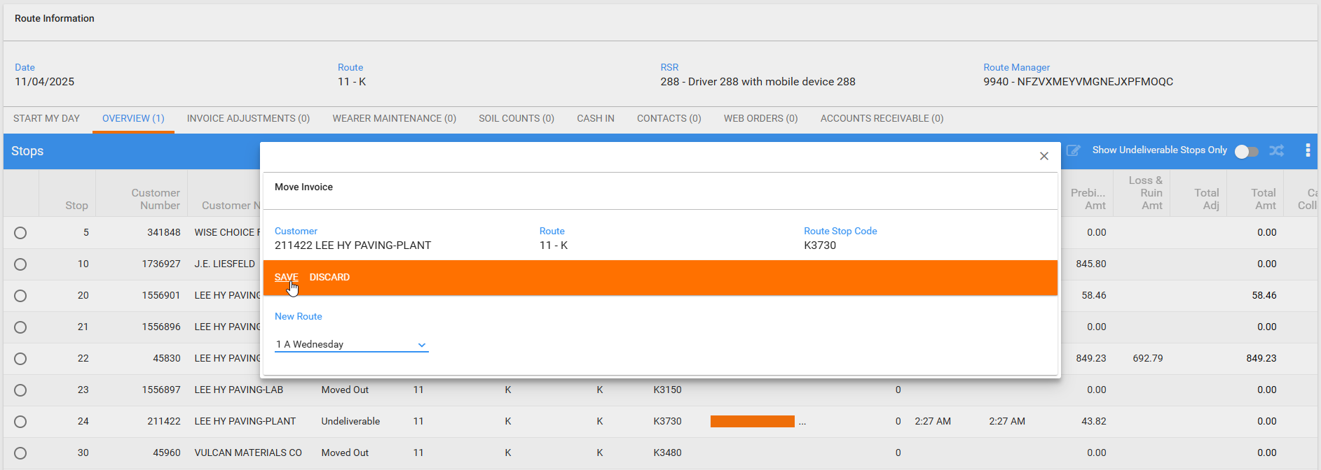

- WebX incognito: Settle the route.
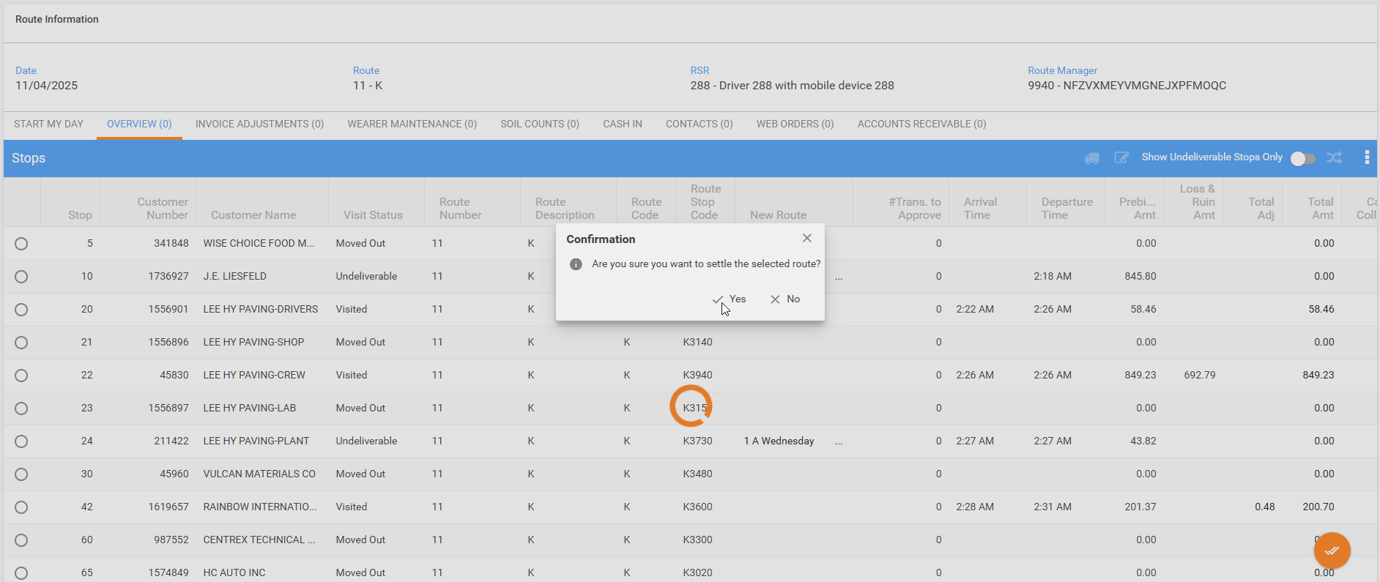

WebX: First WebX session, move the invoice to another route, correct error message Route has changed!

- WebX: Return to the first user and try to move the credited invoice to other routes, correct error message
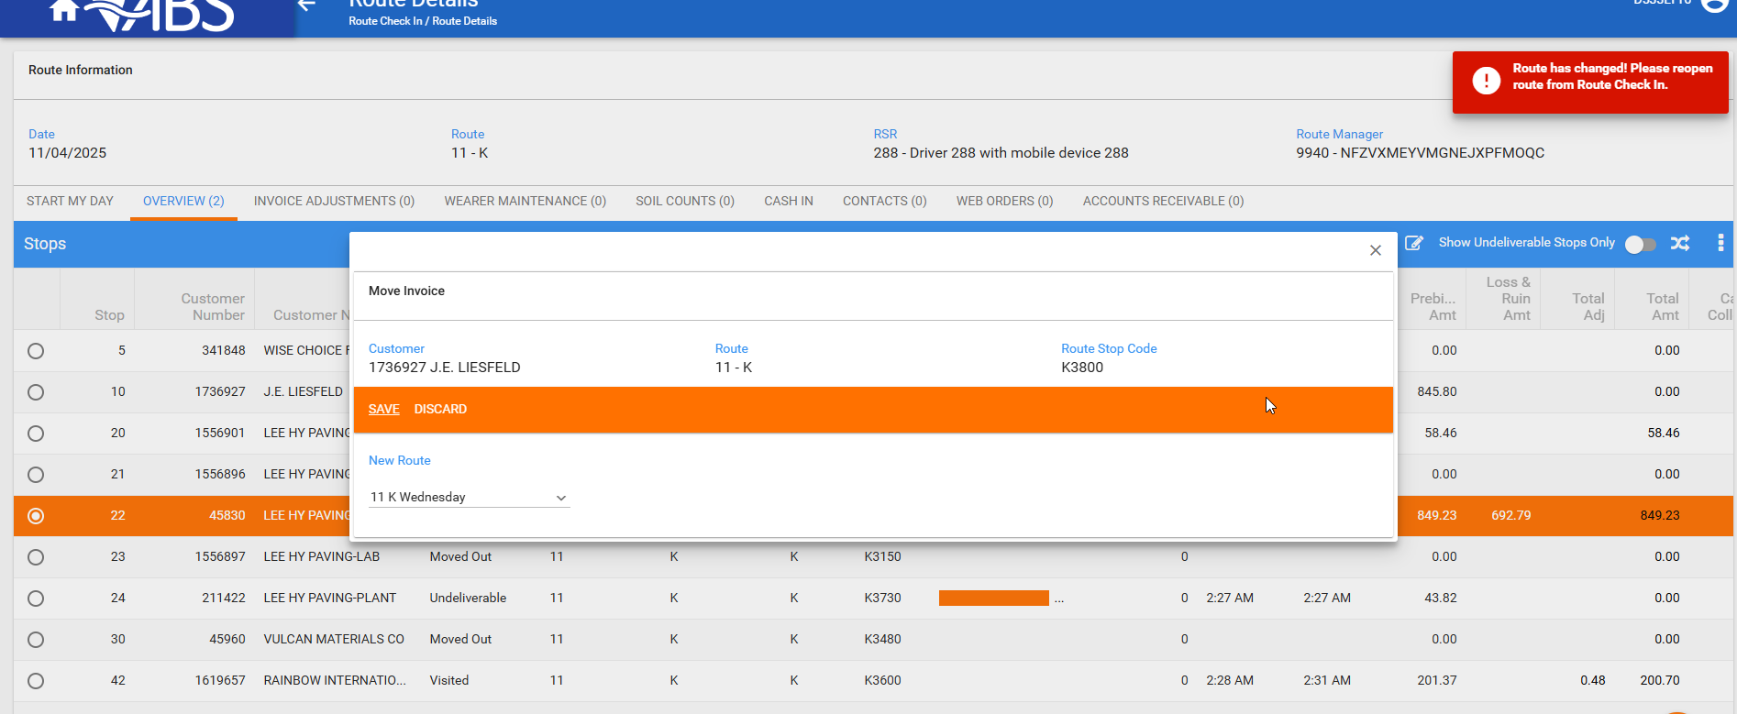

WebX: First WebX session, try to settle, correct error message Route has been settled!
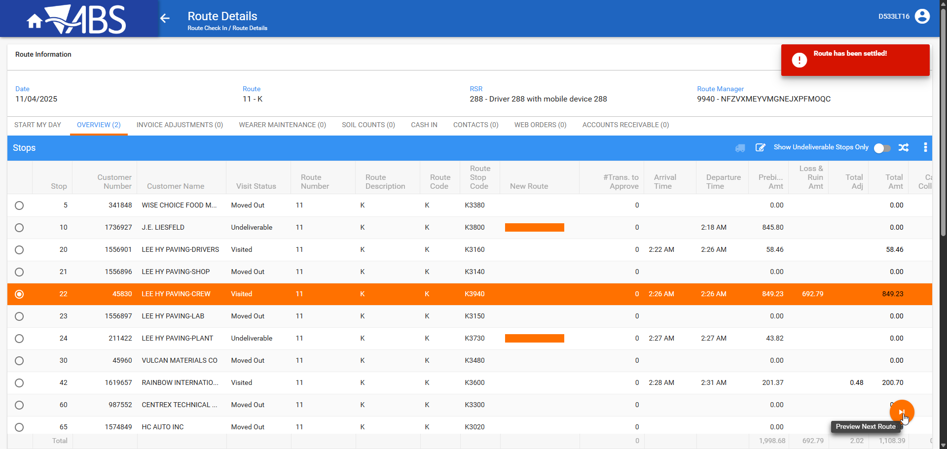

- WebX: Get out from the route and re-enter it.
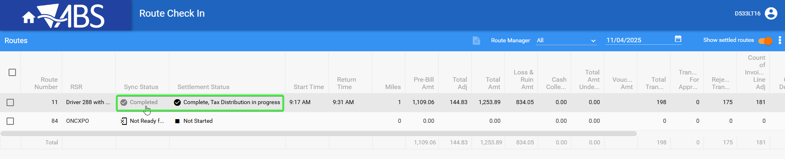

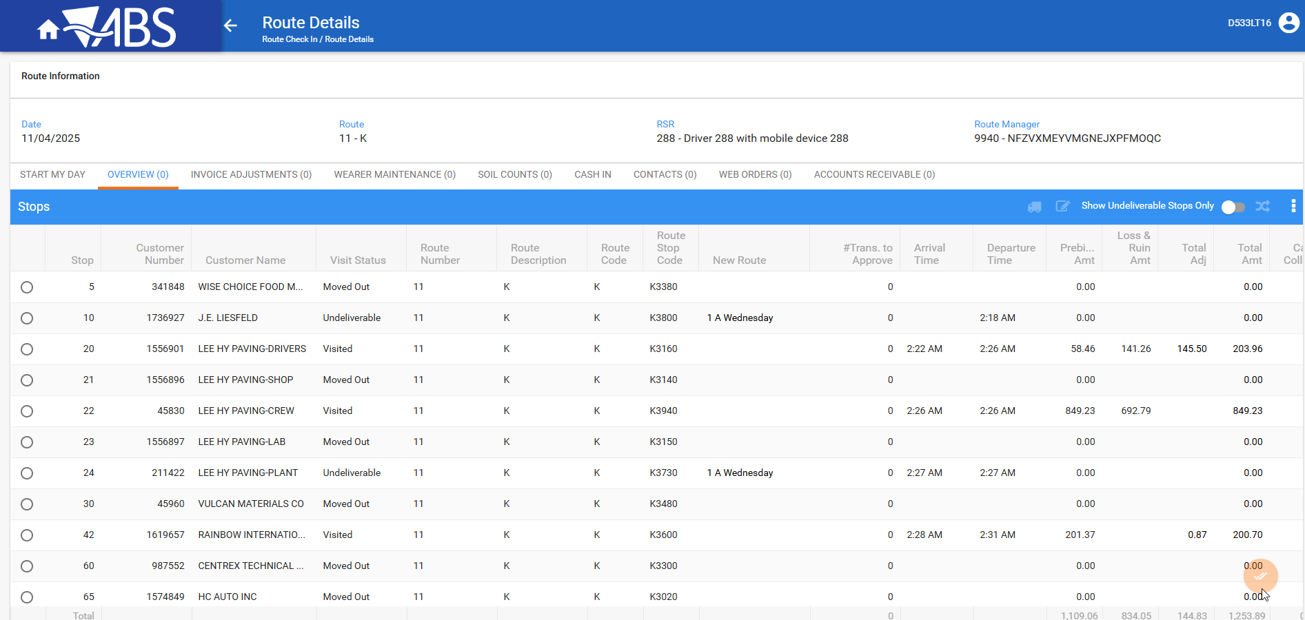
The settle button is disabled and everything is updated

- Check the logs for any errors.
WebX - localhost.log
No errors
Server ErrorLogs
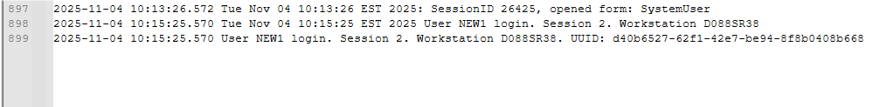
No errors

The route could not be settled until it passes through PDA and not until everything is reviewed and approved. After everything is in order the settlement is successful.
Also, the WebX have a check mechanism if the route was settled from a different WebX/user instance and informs the user with an explanatory message.

Tested OK

Test Case 02 Check message Stop cannot be marked as undeliverable because the route has already been settled while also having another route next week for same day with same customers to have next button on WebX
Bu: 288 RICHMOND, VA
9.07.00.UNF21 hash: 31bc8452ed1a

Steps to reproduce:
- RSC dlg: Create a new route, keep at least 3 customers on the route.
Generate put up documents, generate invoices and complete the tax for the first route.
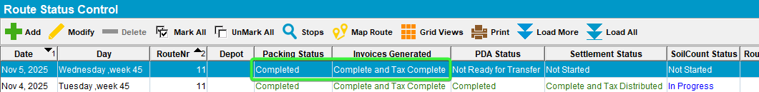
- WebX: Load the route newly created.
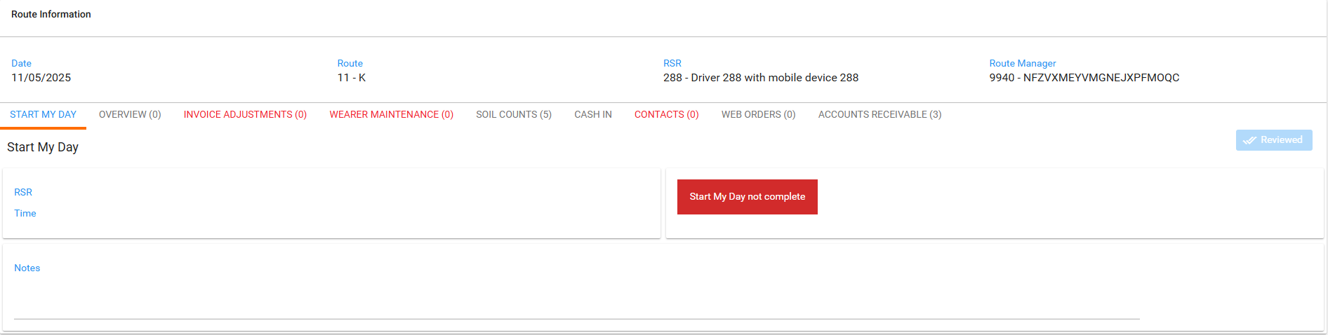
- Start my Day: complete the start my day.
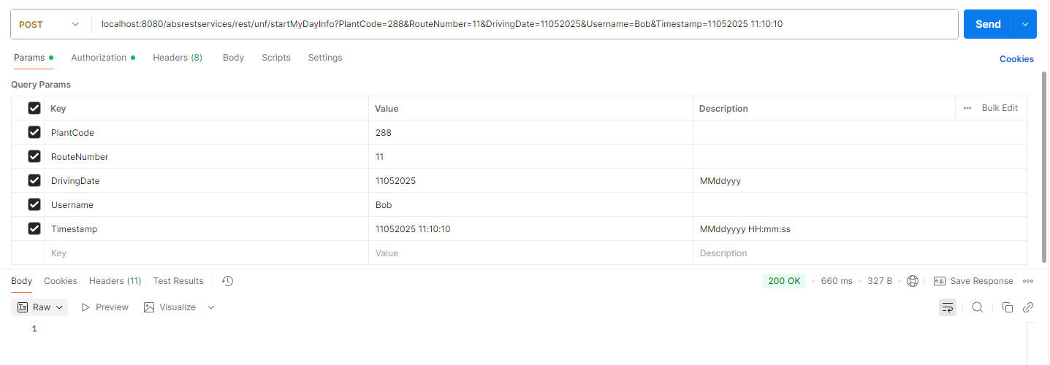
- WebX dlg: Refresh the route and keep it loaded in browser.
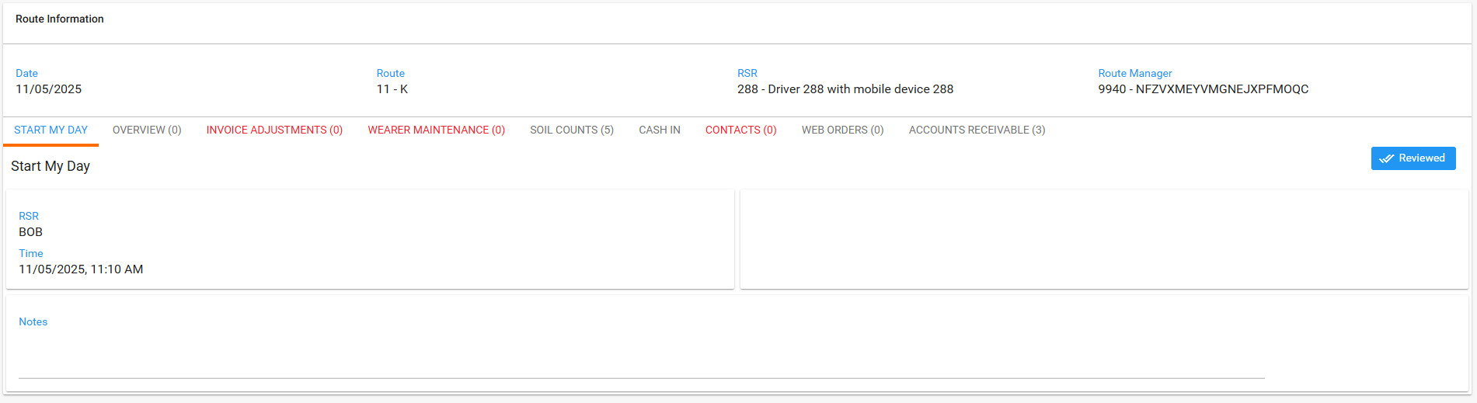
- WebX: Review everything we can.
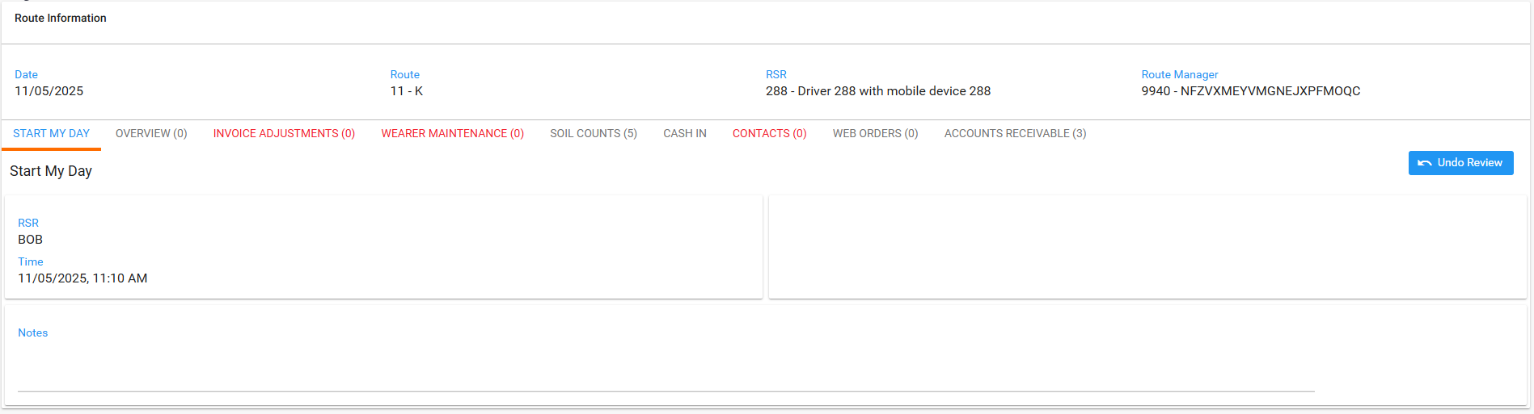
Try to settle
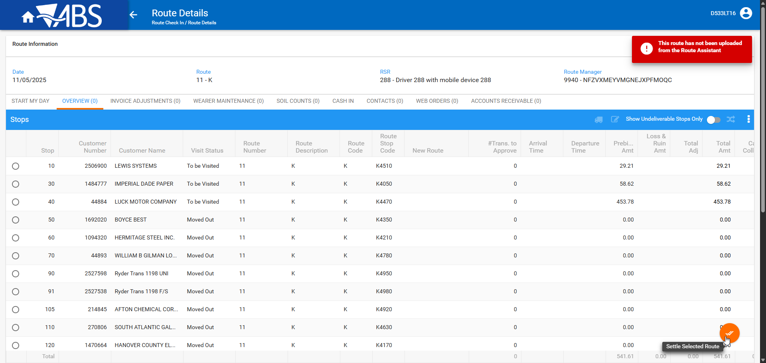

- RSC dlg: Send the route to PDA.
- RA: Download the route. Arrive at one customer and credit the invoice
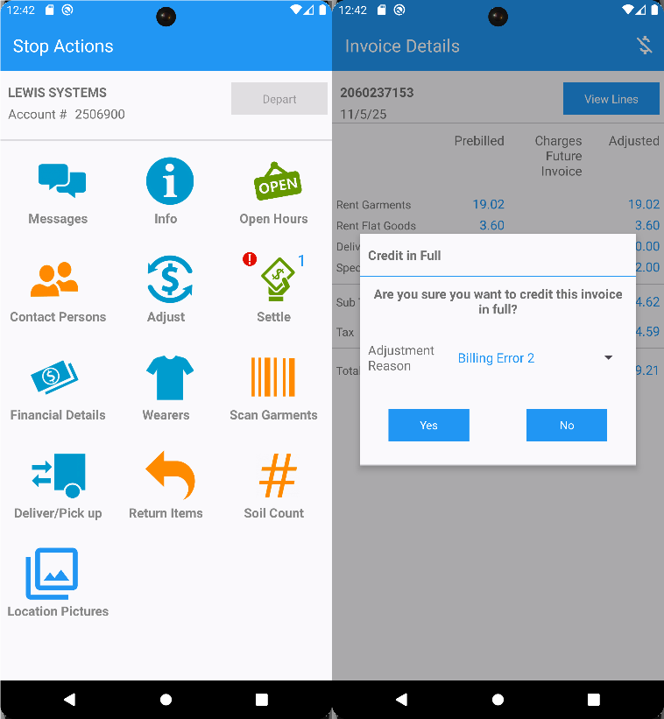
Set as undeliverable the next stop.s
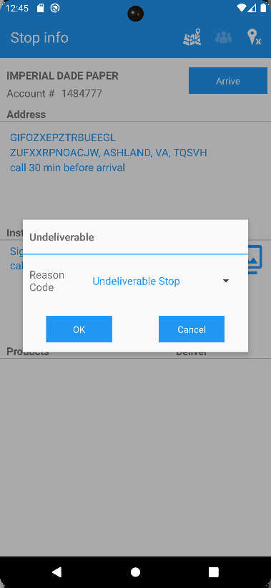
Another customer make some wearer adjustments and bill all for loss now
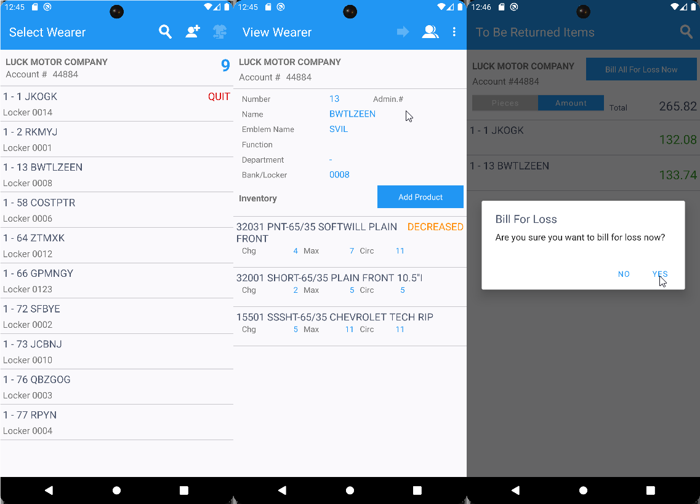

- RA: While the route is still loaded in WebX, finish and upload the route.
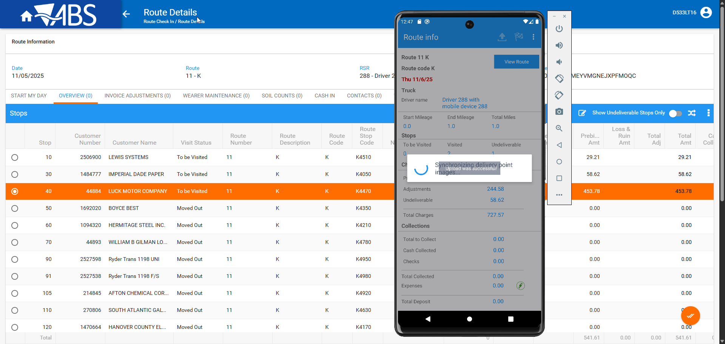
- WebX: Select the credited stop to try to make it as undeliverable. Don’t change anything yet.
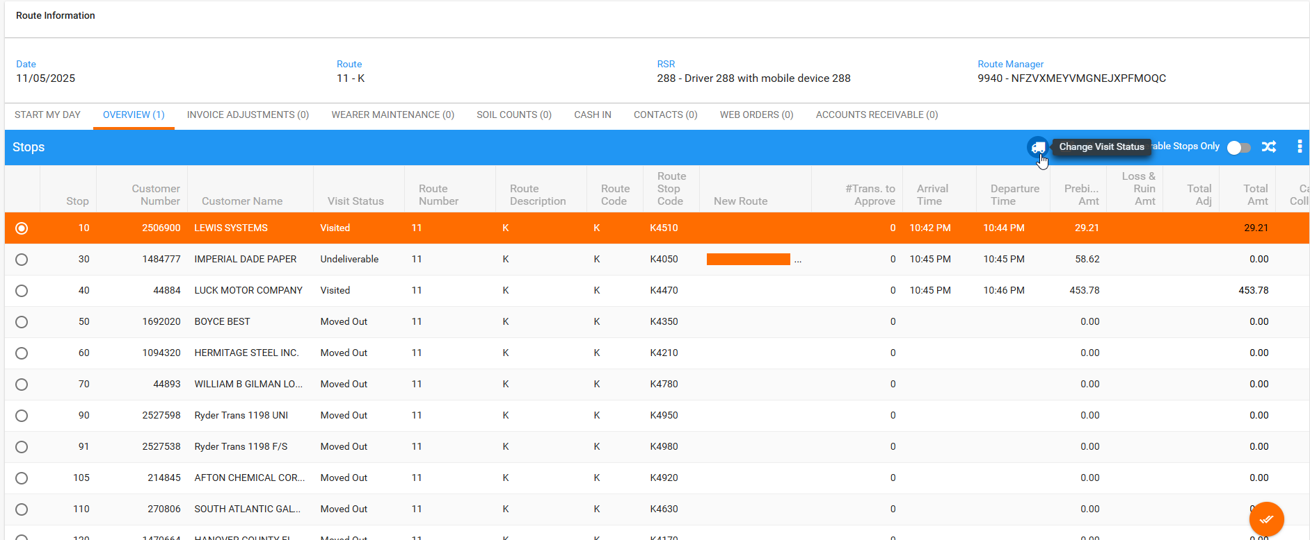

- WebX: While keep using the route loaded on the first instance, using another account, log in to WebX incognito
- WebX incognito: Make the credited invoice as undeliverable. Assign the credited invoice to another route.
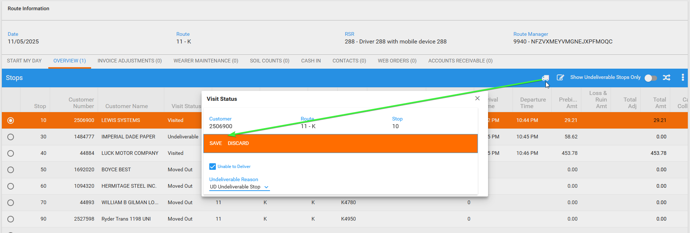
- WebX incognito: Assign to another route the undeliverable stop.
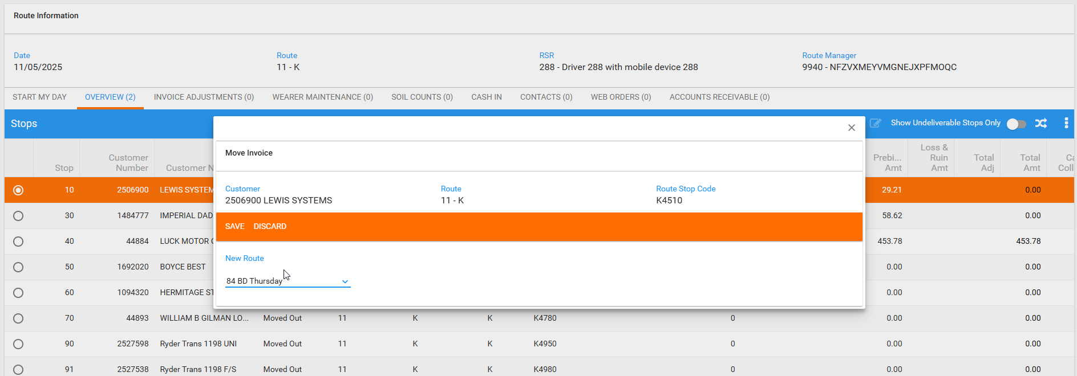
- WebX incognito: Change the route to the next undeliverable stop made on RA.
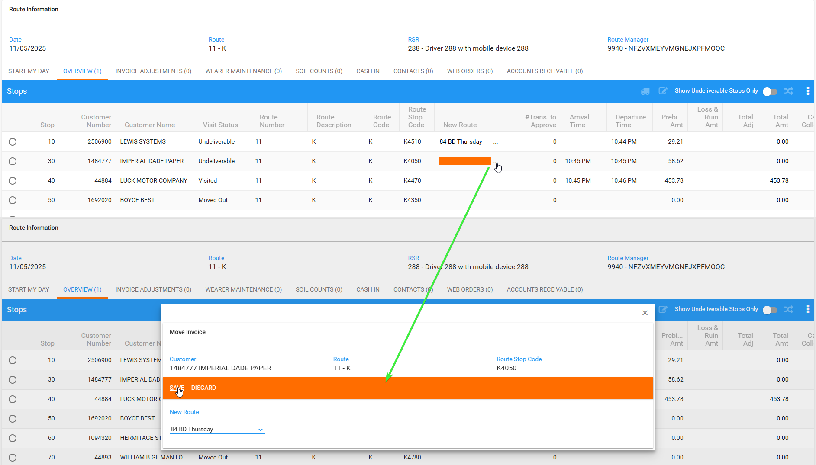
- WebX incognito: Settle the route.
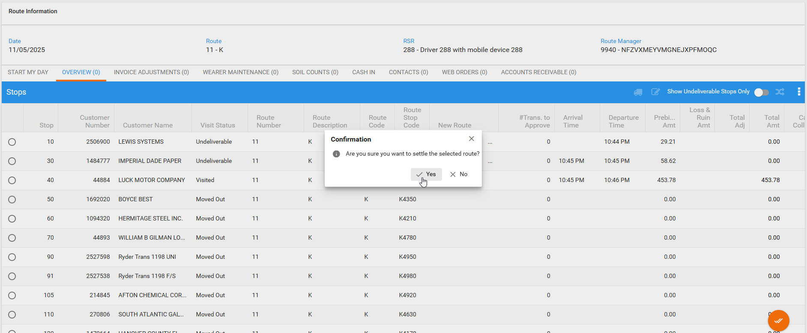
- WebX: Return to the first user and try to make undeliverable the credited invoice.
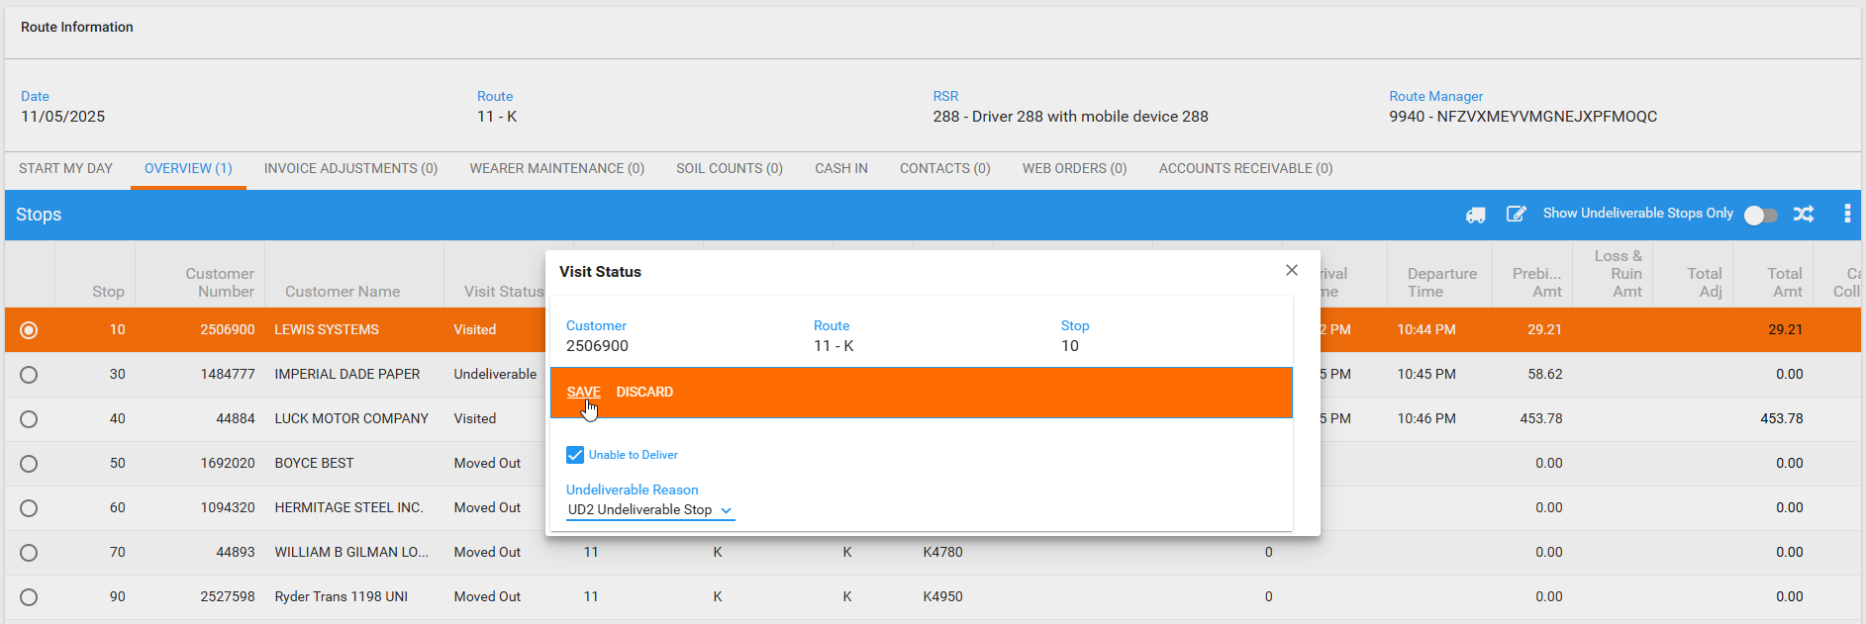
After a loading time, an automatic refresh of the page is done and the change visit status becomes disable
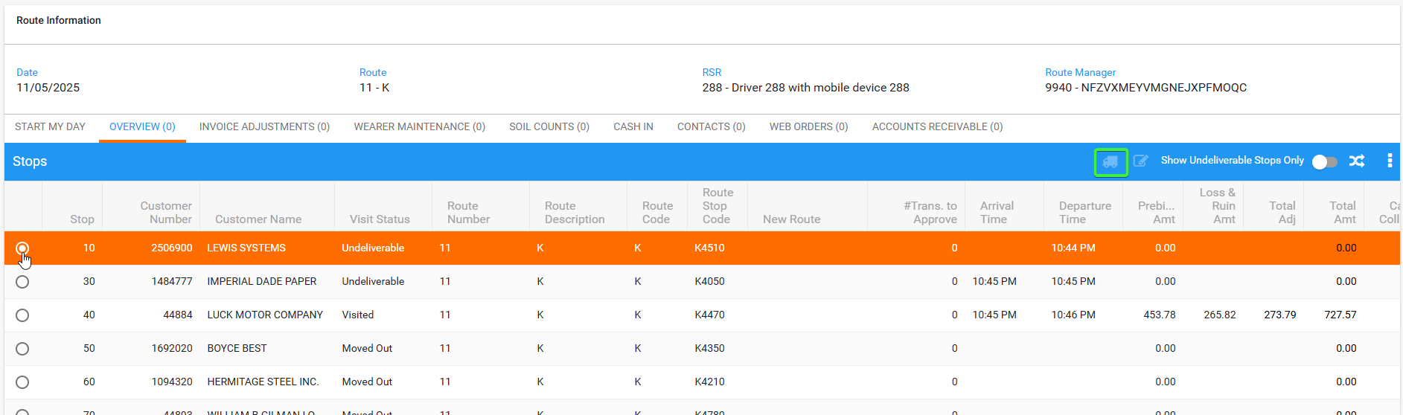
- WebX: Settle the route from the first instance.
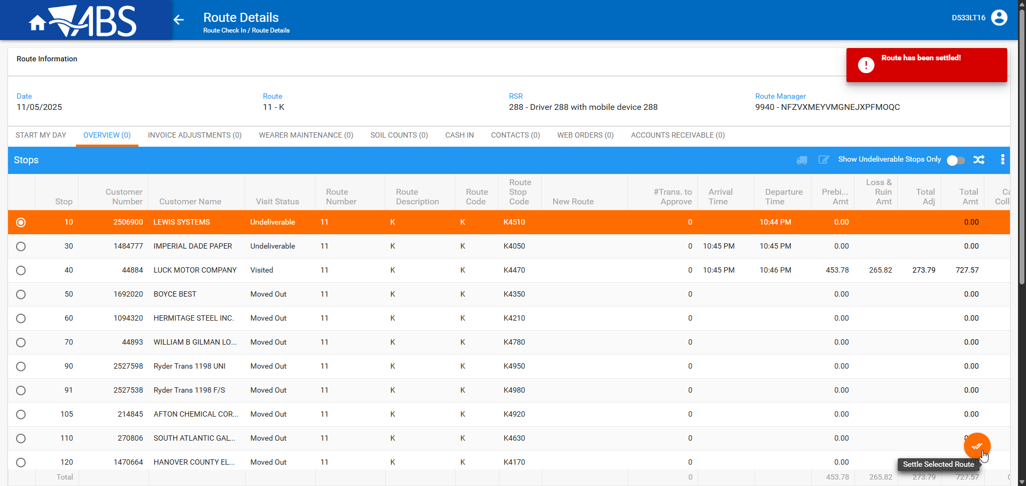
An informative message that the route has been settled is presented.
- WebX incognito: See that the route was settled successfully.
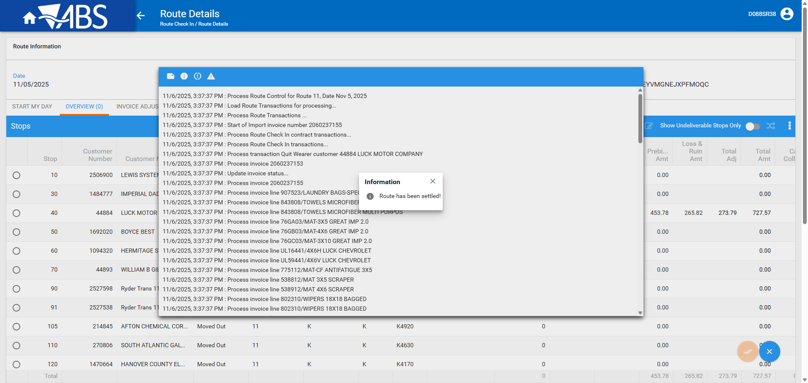
- WebX: From first instance, get out from the route and re-enter it.
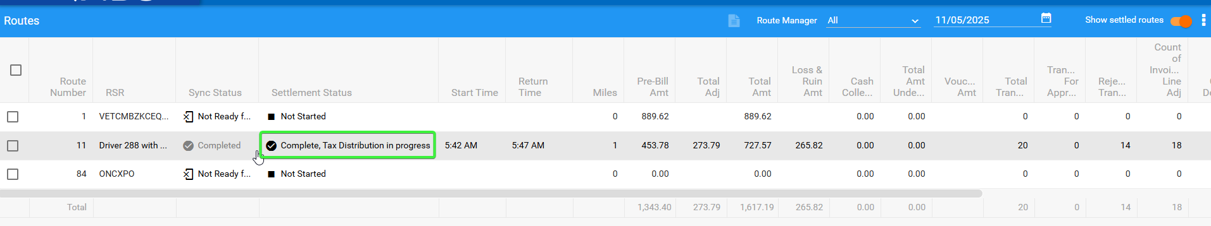
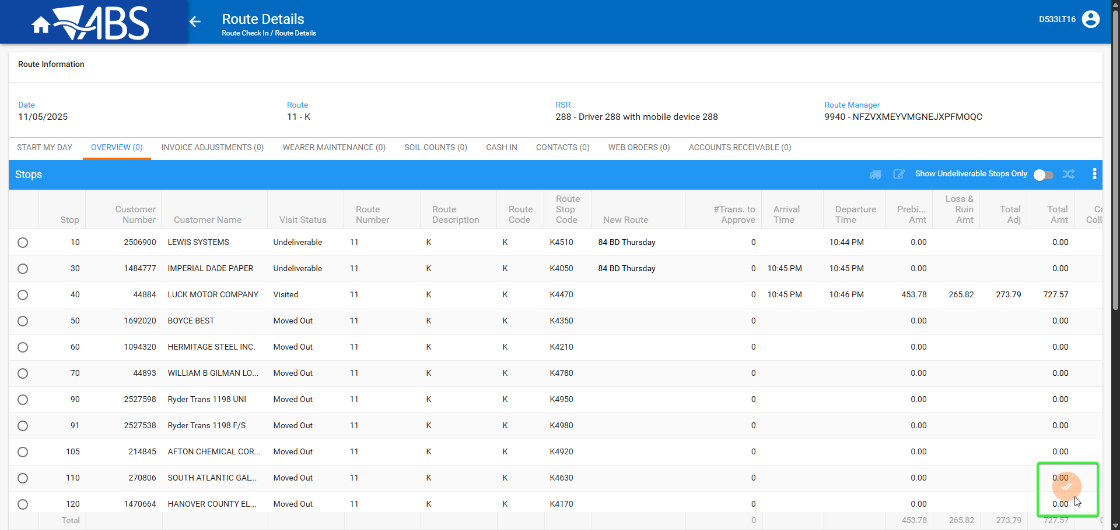
The settle button is disabled and everything is updated

