ABSN-736 ASD-65970 UNF: D_UBS_2593 COG only customer was temporarily moved to a new route and day but the garment delivery notes did not get attached to the invoice
Environment | Prerequisites
Version:9.07.00  DBServerName=abs-SRV20.internal.abslbs.com  DBSID=CUST24  DBUser=UNFDEV  Environment=Test | - Module:  - System setting

Contents
Retest after fix 1
Test Case 1 – Generate Garment delivery notes for COG products for a moved in stop– Tested OK 1
Test Case 2 – Generate packing note for a moved in stop with BM3 - wash only– Tested OK 9
Test Case 3 – Test that update script works correctly – Tested OK 18
Test Case 4 – Make sure LINKTOINVOICEDRC =1 does not affect assigning sales note packing notes to routes– Tested OK 24
Test Case 5 – BM3 - Wash only PLPC, have a routecontrol with this customer that is already invoiced and add manual DVs and then generate packingnotes from those DVs for the same routecontrol then run route finalization for the routecontrol– Tested OK 31

Retest after fix

Test Case 1 – Generate Garment delivery notes for COG products for a moved in stop– Tested OK
Expected behavior: Before changing LINKTOINVOICEDRC to 1 verify that the COG product is not invoiced. Cancel invoices and change LINKTOINVOICEDRC = 1 and verify that the COG product is now invoiced.
Hash: 9934ef3
- Use the below SQL to find data:
SELECT distinct C.CUSTOMERNUMBER, BU.CODE FROM CUSTOMER C
JOIN BUSINESSUNIT BU ON C.DEFAULTBUSINESSUNIT_ID = BU.BUSINESSUNIT_ID
JOIN PRODUCTLISTPERCUSTOMER PLPC ON PLPC.CUSTOMER_ID = C.CUSTOMER_ID
JOIN PRODUCT P ON P.PRODUCT_ID = PLPC.PRODUCT_ID
WHERE P.CODE = 'COOT00'
AND PLPC.DATEINACTIVE > SYSDATE
AND EXISTS (SELECT 1 FROM DELIVERYSCAN DS
WHERE DS.PRODUCT_LINK_ID = PLPC.PRODUCT_ID
AND DS.CUSTOMER_LINK_ID = C.CUSTOMER_ID
AND DS.PACKINGNOTE_ID IS NULL);
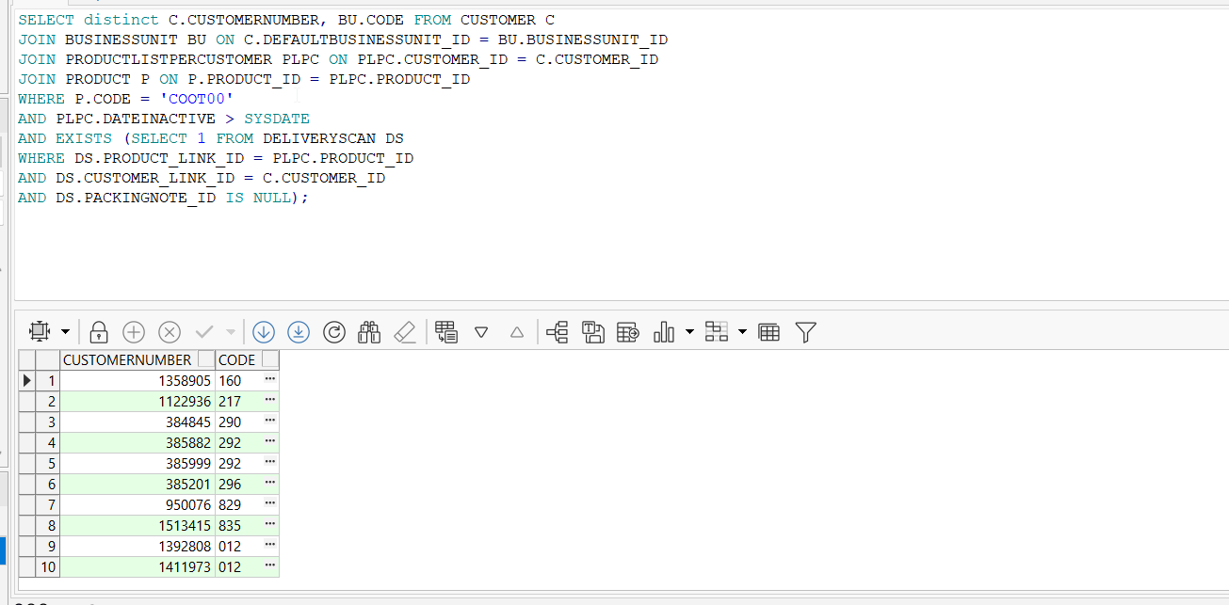
- Set SS LINKTOINVOICEDRC to 0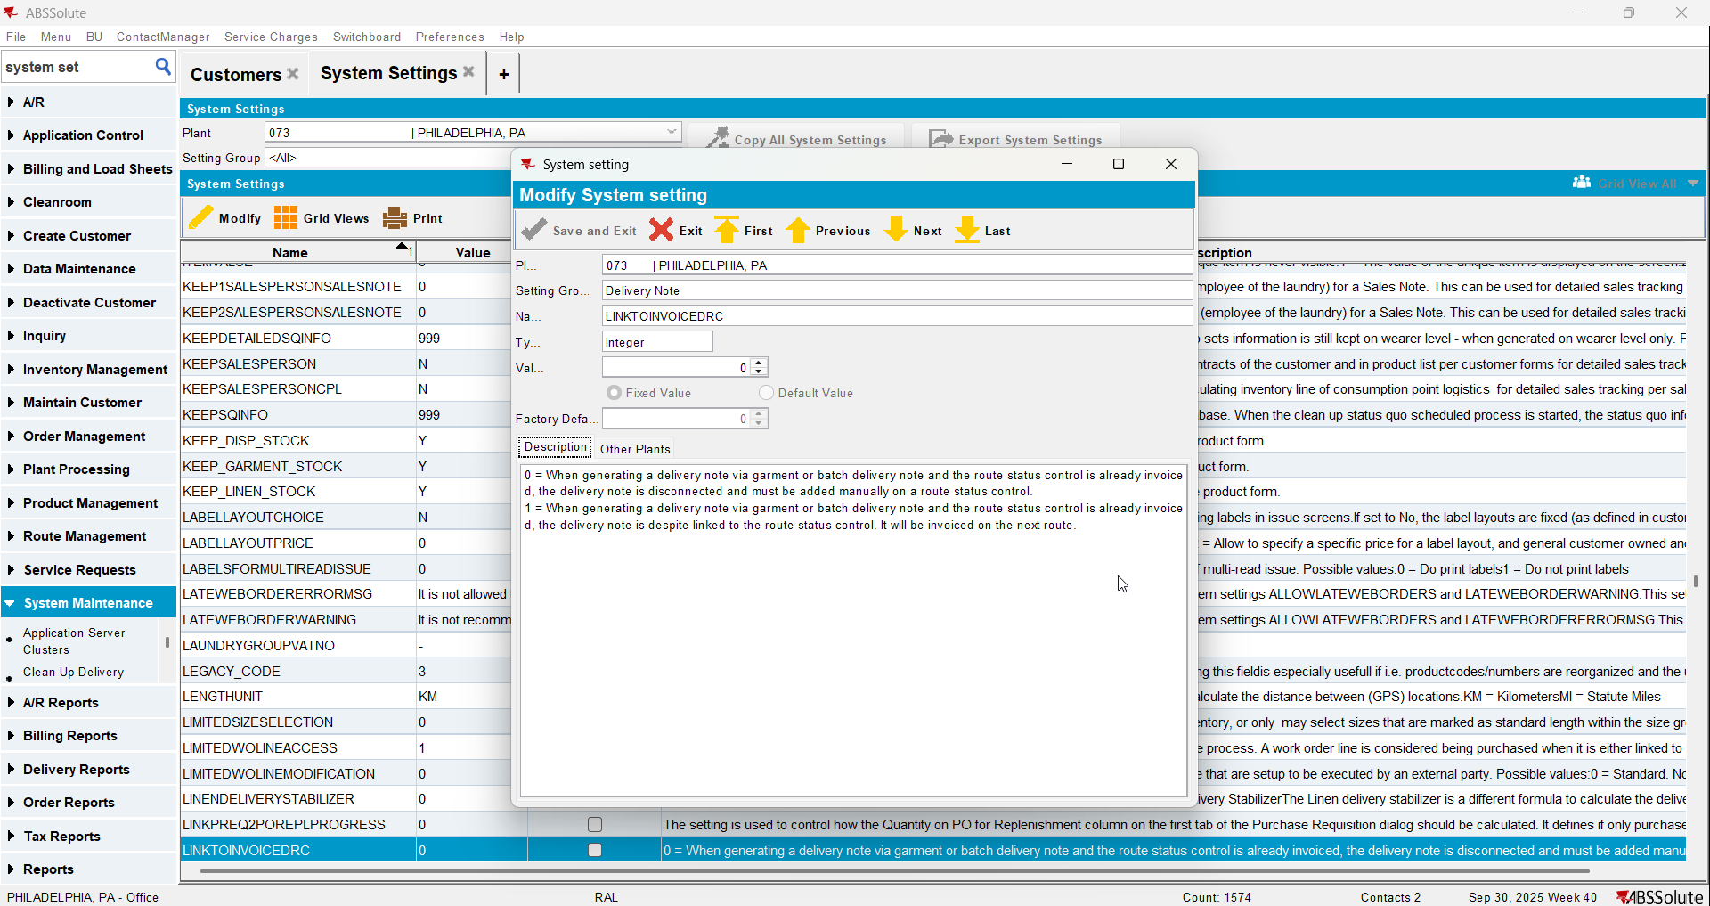
- Garment Delivery Notes DLG: Load the customer and make sure there are unprocessed delivery scans for COG products.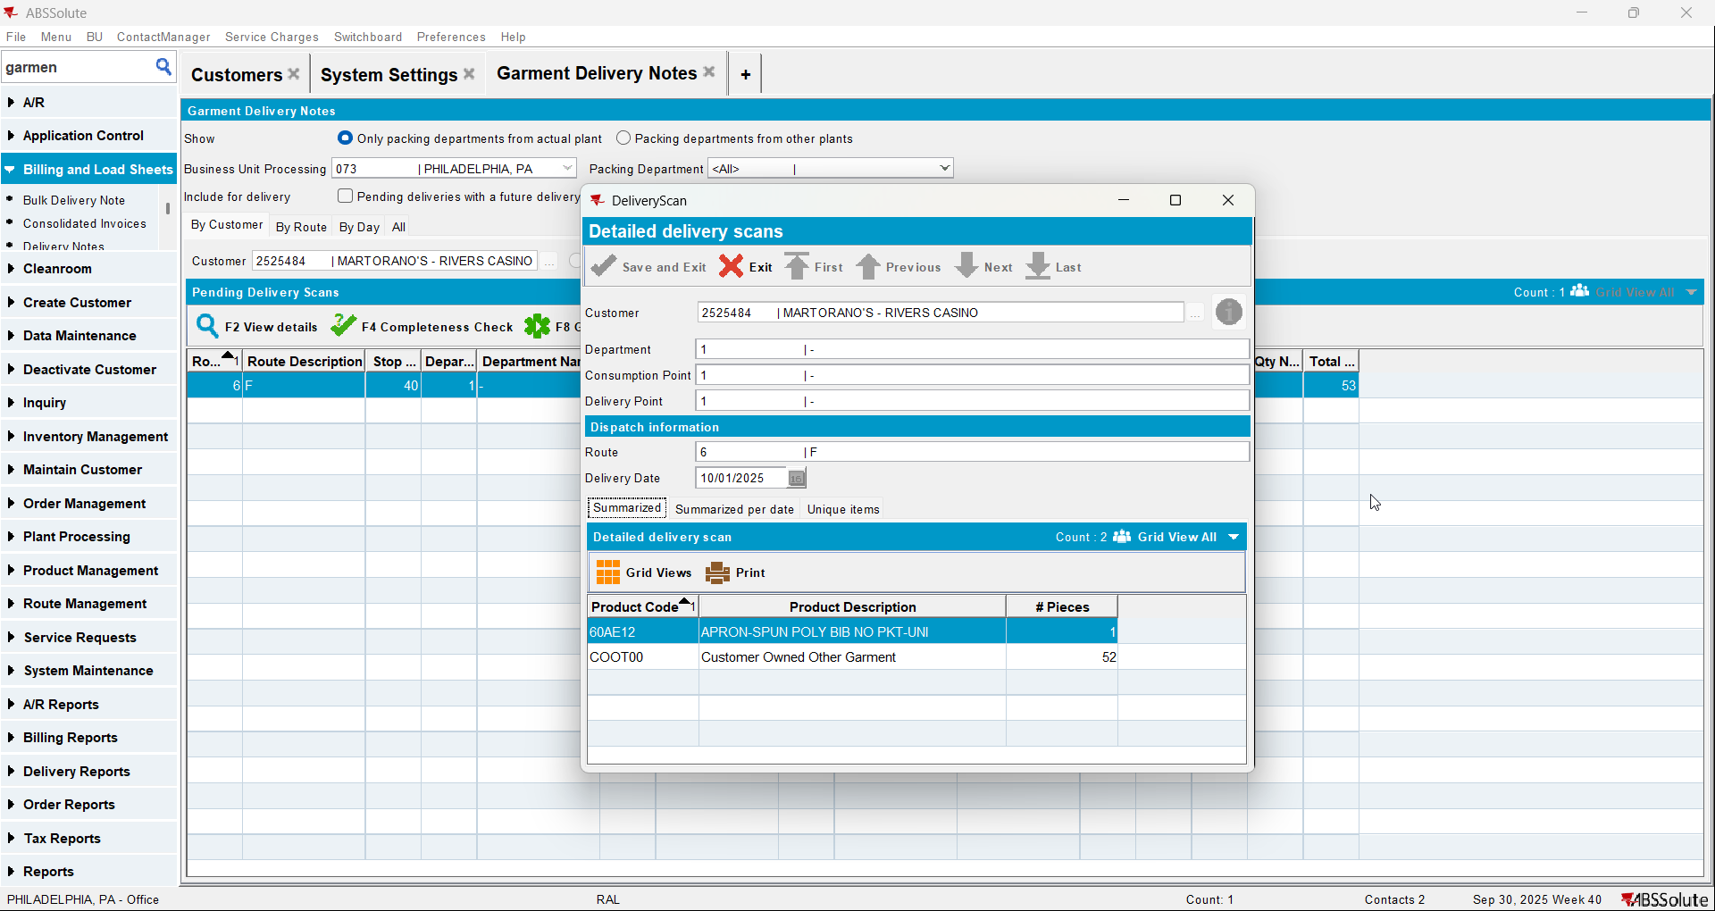
- Route Status Control DLG: Add this week's route control for this customer (route 6 on October 1)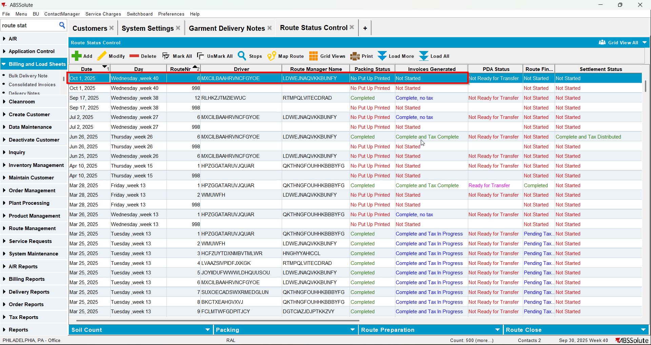
- Route Status Control DLG: Add tomorrow's route too(route 6 on October 2)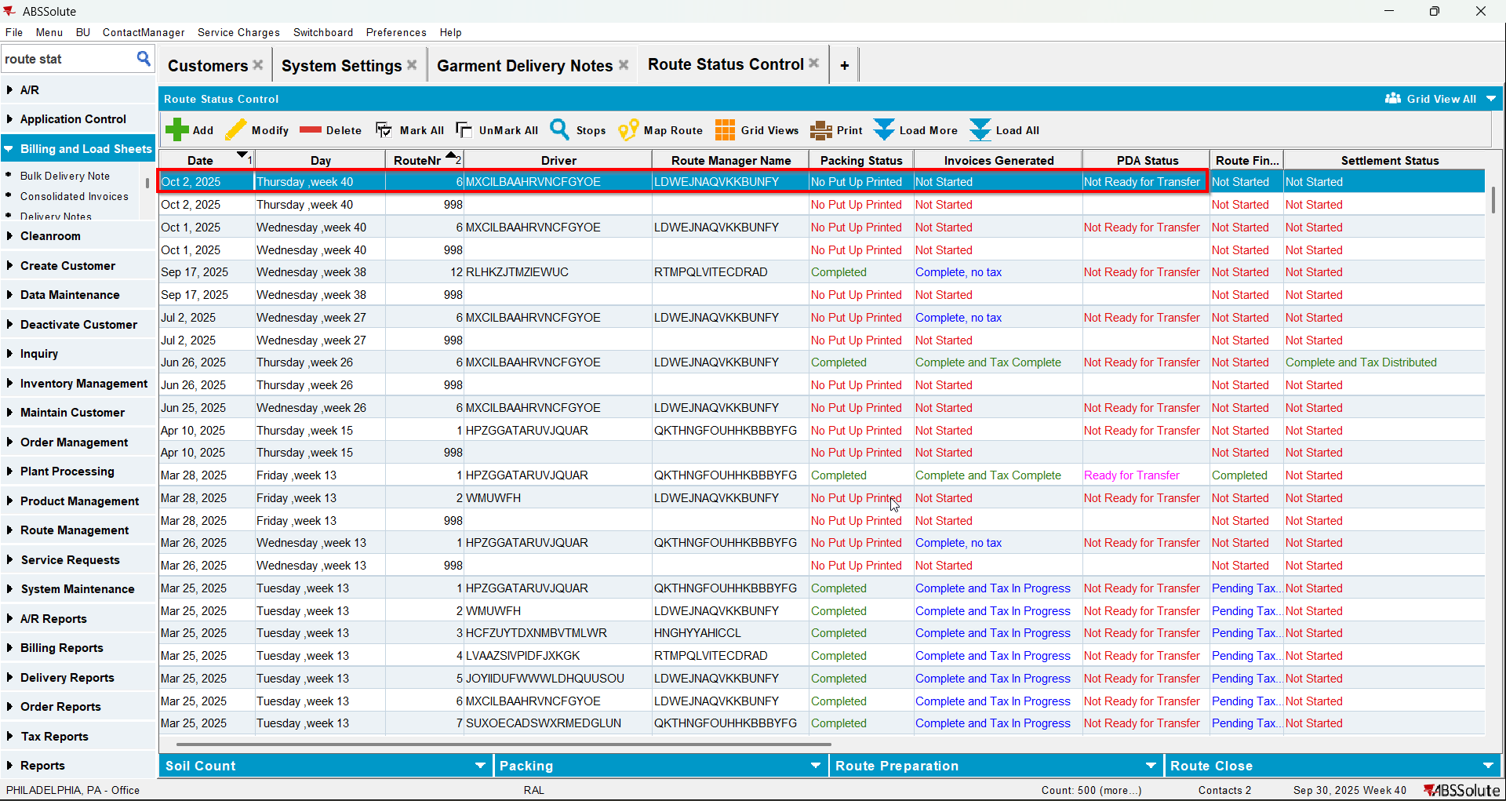
- Route Status Control DLG: Move the customer from its original route to the next day route(from route 6 on October 1 to route 6 on October 2)
- Garment Delivery Notes DLG: Generate garment delivery note for October 2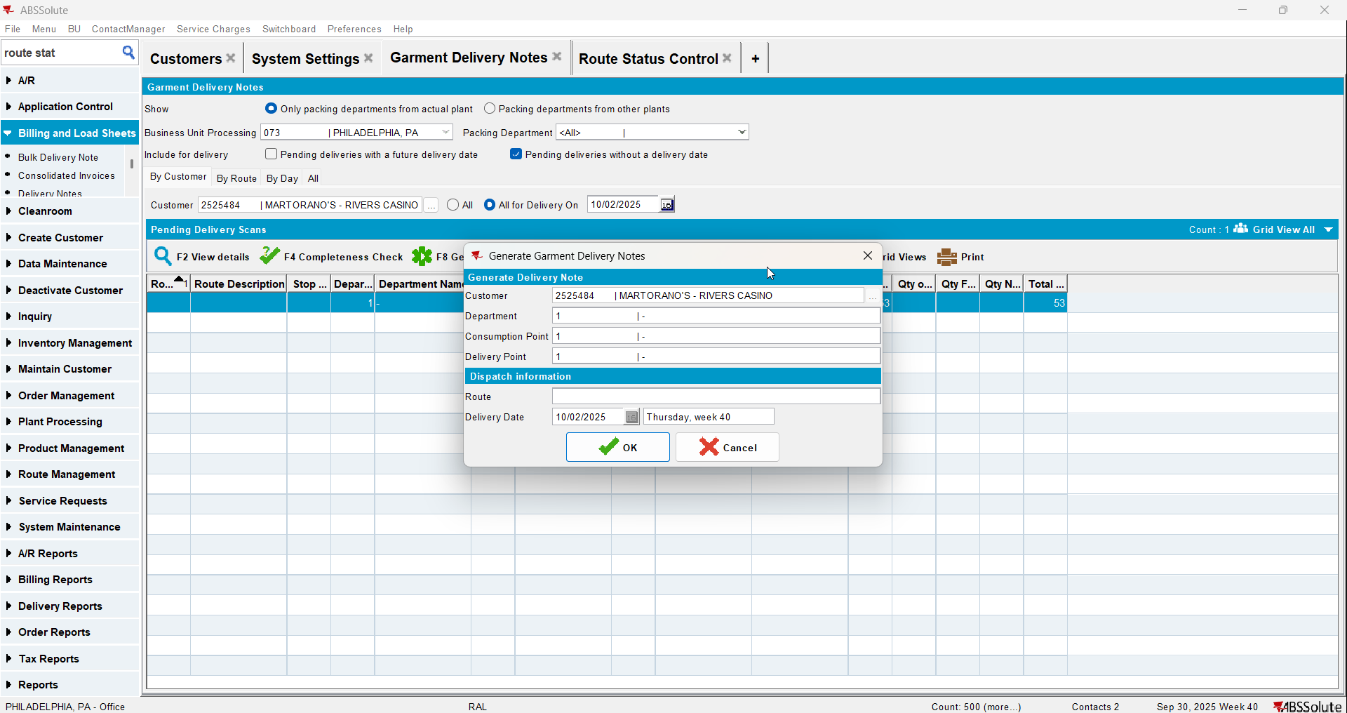
- Route Status Control DLG: Generate Packing notes and finalize them for route 6 on October 2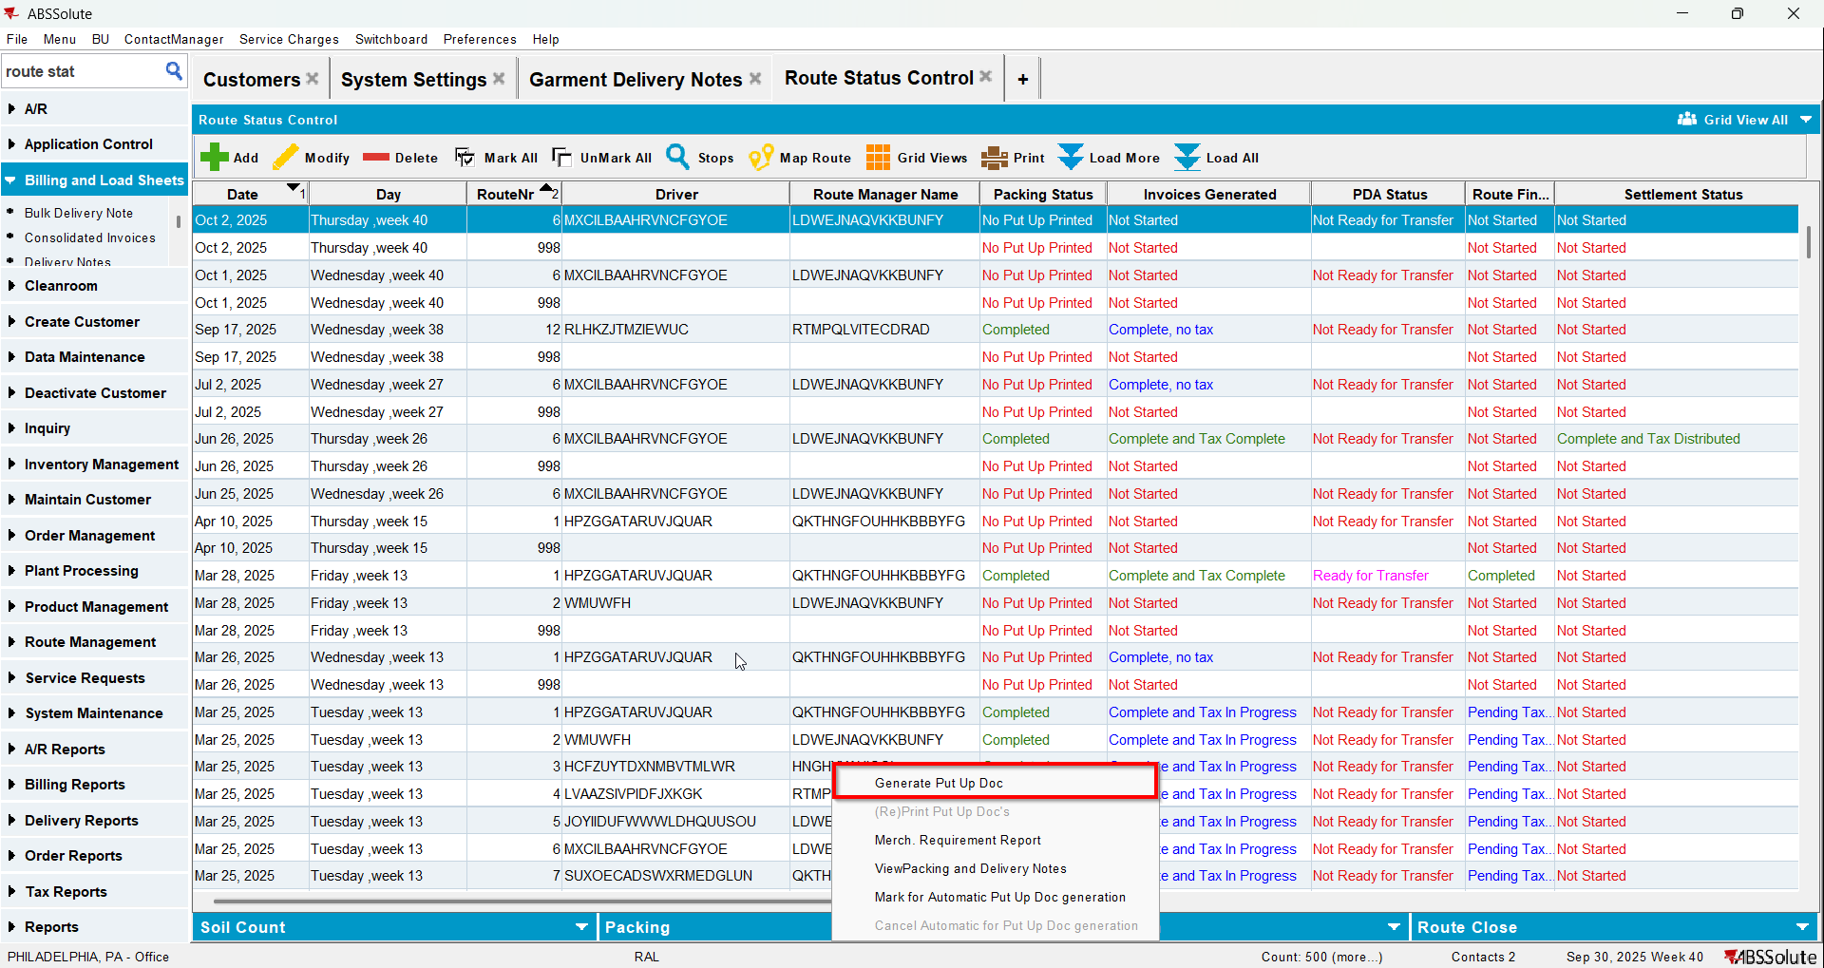
- Route Status Control DLG: Generate invoices for route 6 on October 2 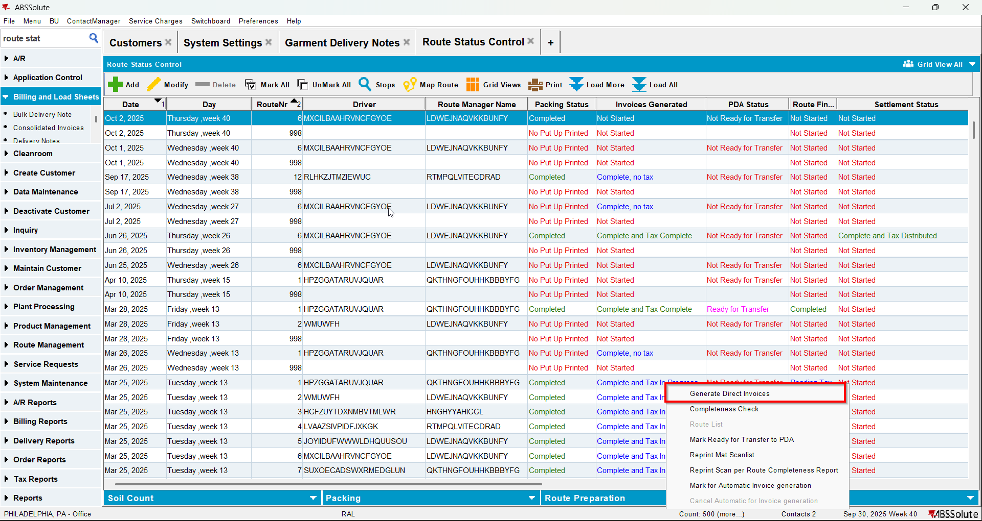
- Settle the route 6 on October 2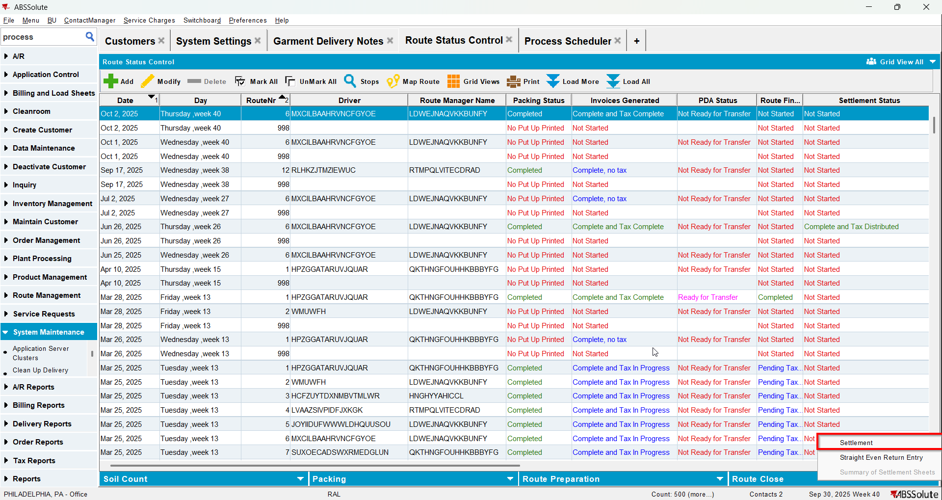
- Create the route for next week for your customer
- Generate packing notes for it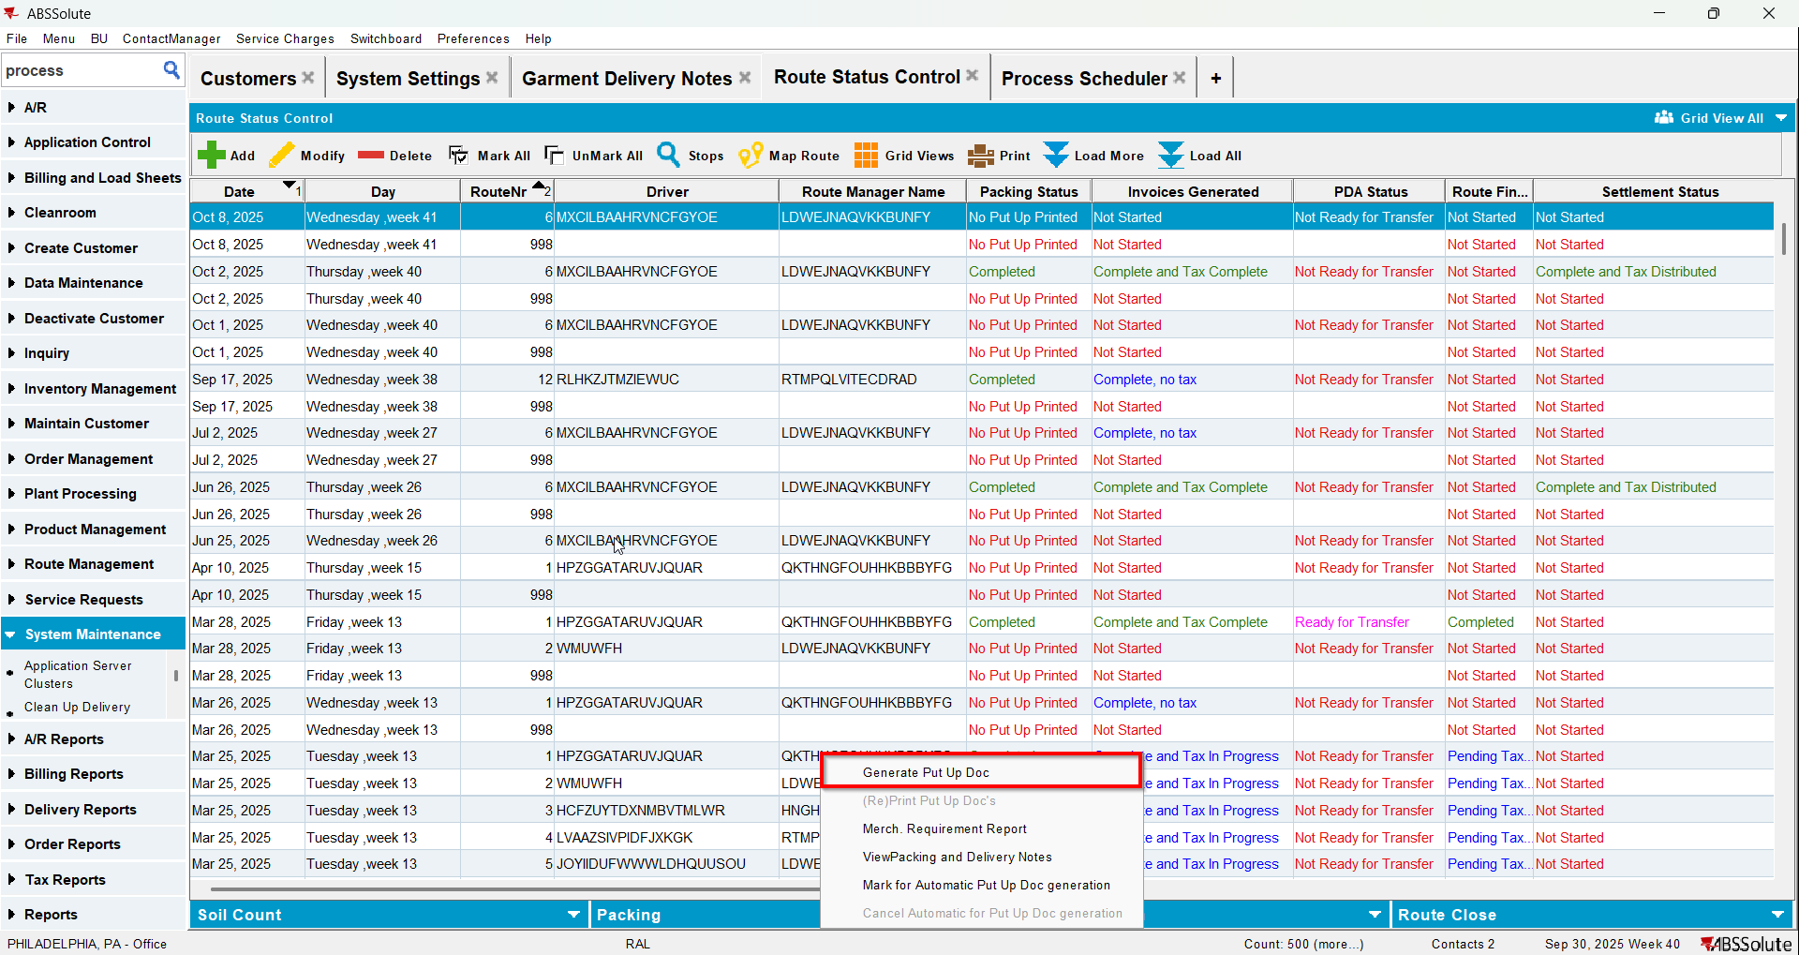
- Generate invoices for it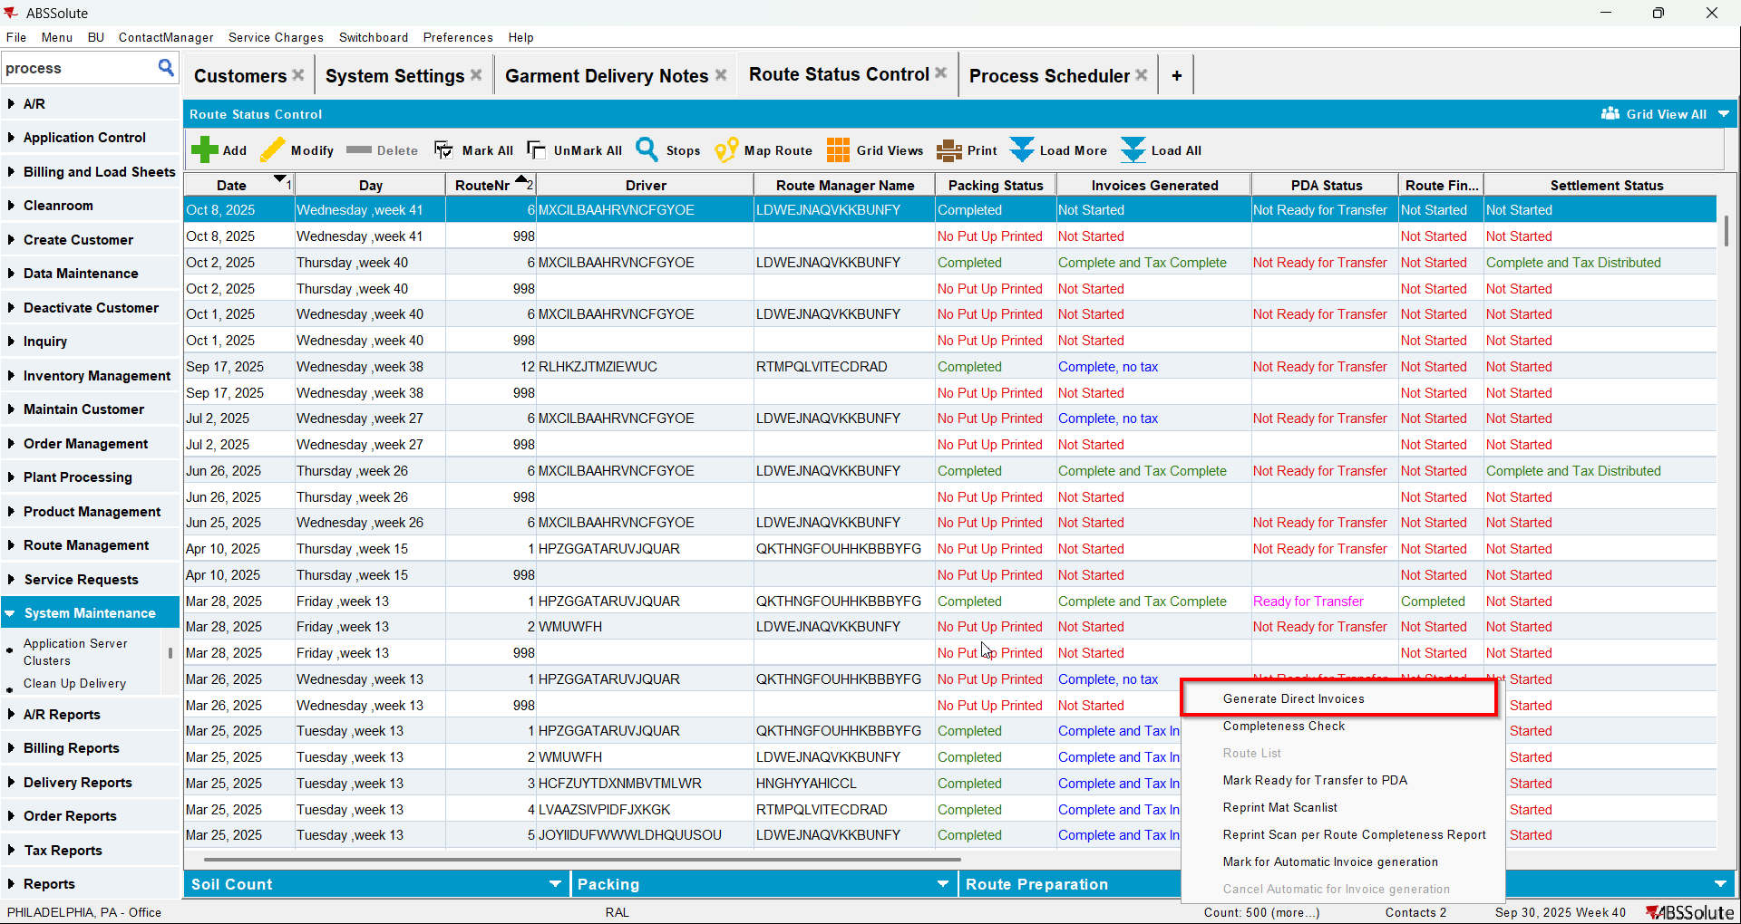
- Check that there is 0 qty for the items that were on the garment delivery note or the items do not appear on the invoice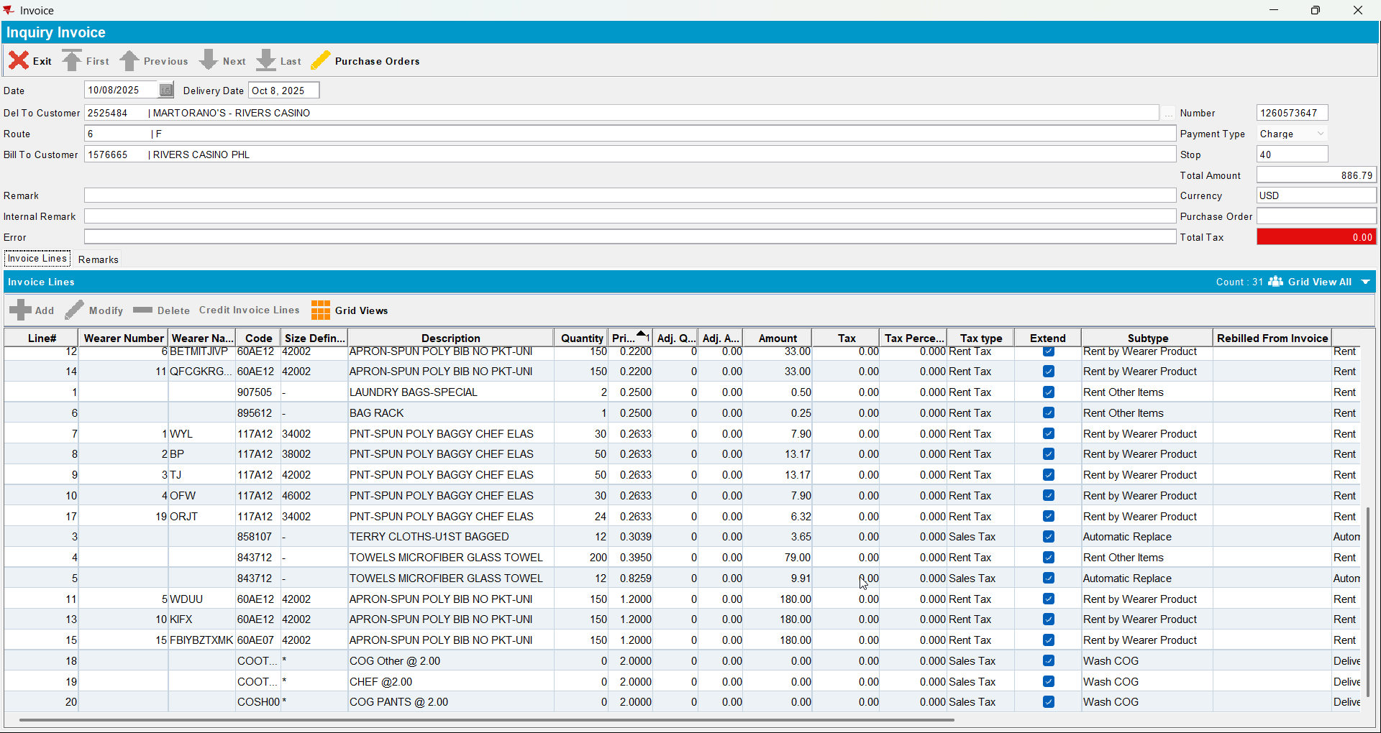
- Cancel invoices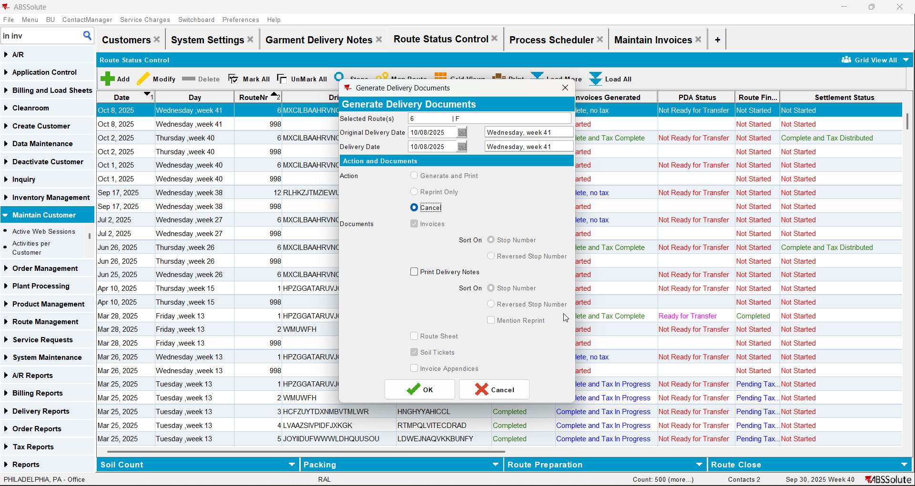
- Set SS LINKTOINVOICEDRC to 1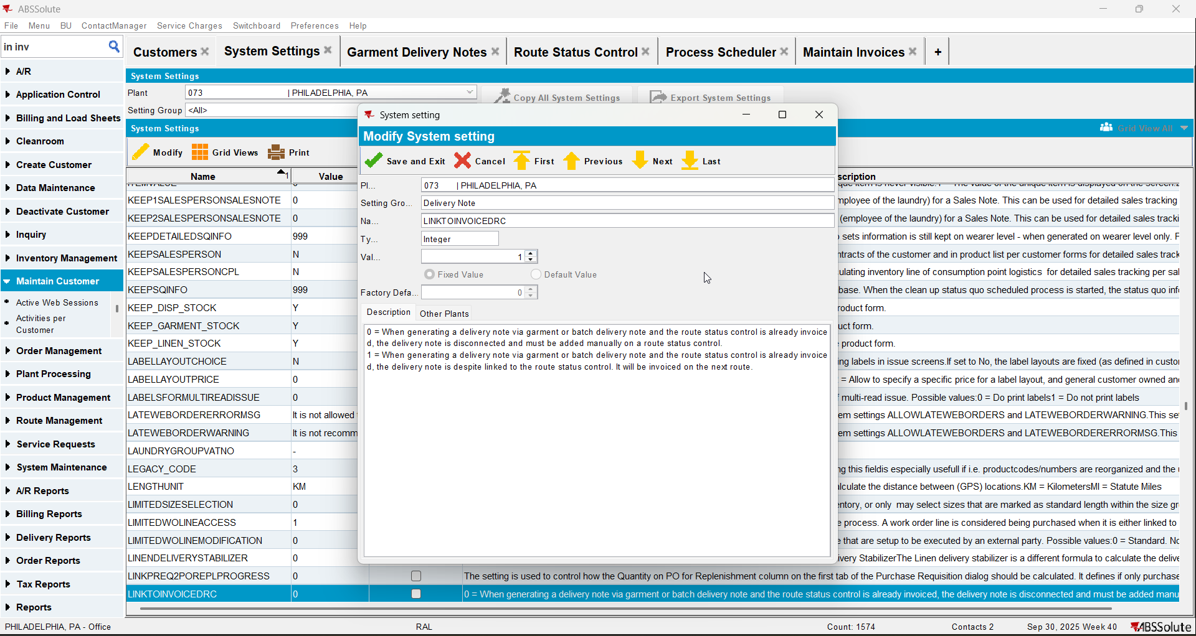
- Generate invoices again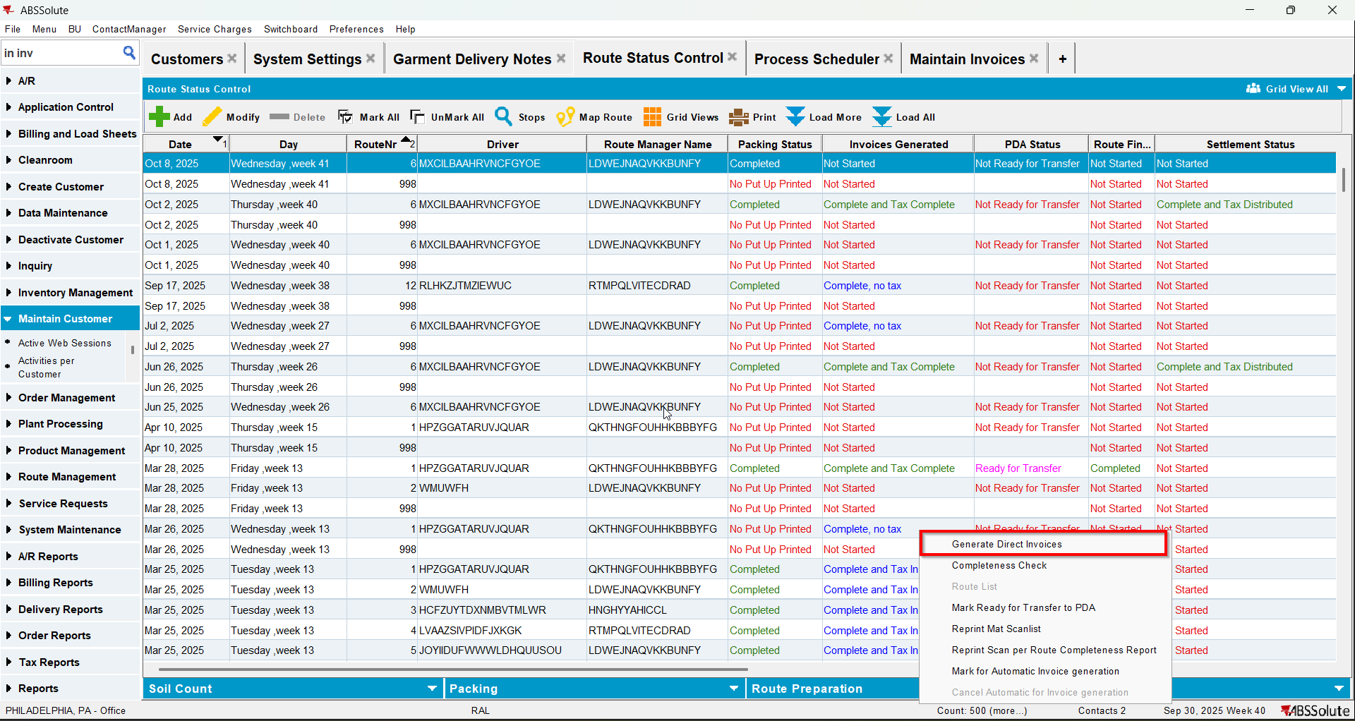
- Check now that on the invoices the products from garment delivery notes appear with their qty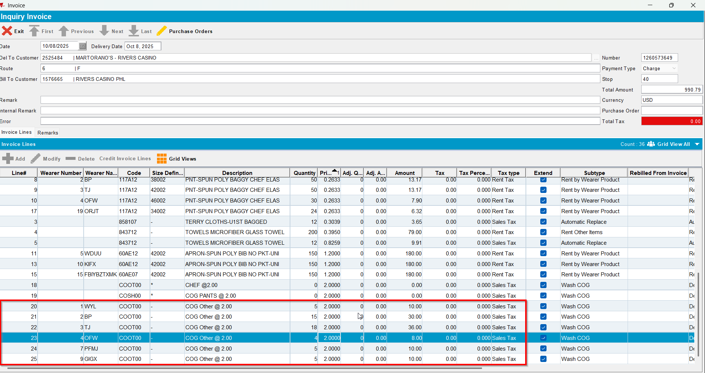

Test Case 2 – Generate packing note for a moved in stop with BM3 - wash only– Tested OK
Expected behavior: Before changing LINKTOINVOICEDRC to 1 verify that the COG product is not invoiced. Cancel invoices and change LINKTOINVOICEDRC = 1 and verify that the COG product is now invoiced.
Hash: 9934ef3

- Set SS LINKTOINVOICEDRC to 0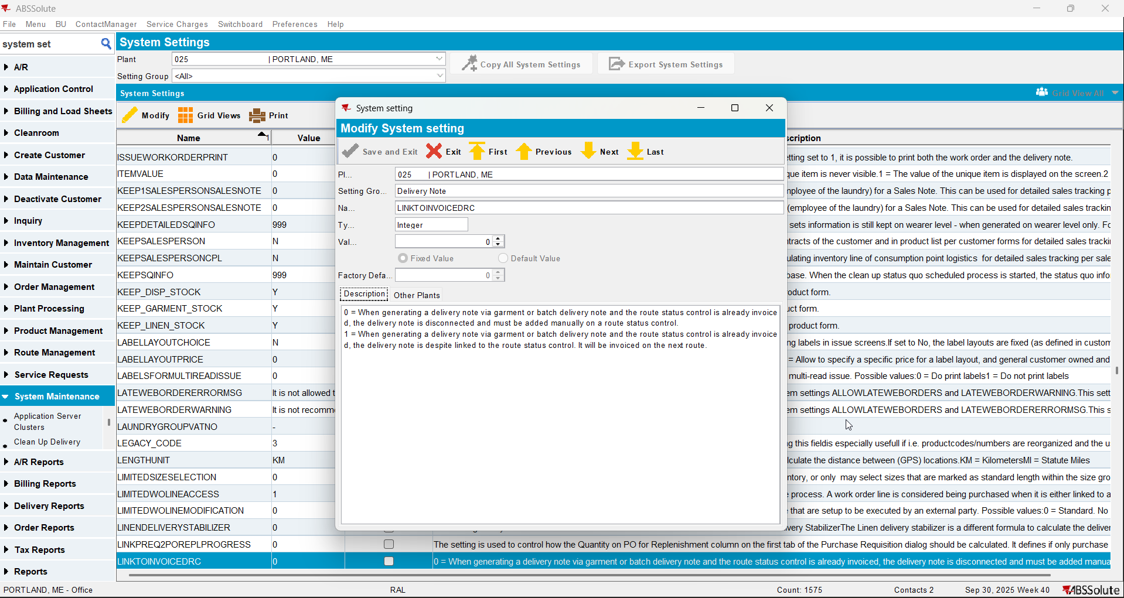
- PLPC: Have a non garment product with BM3 wash only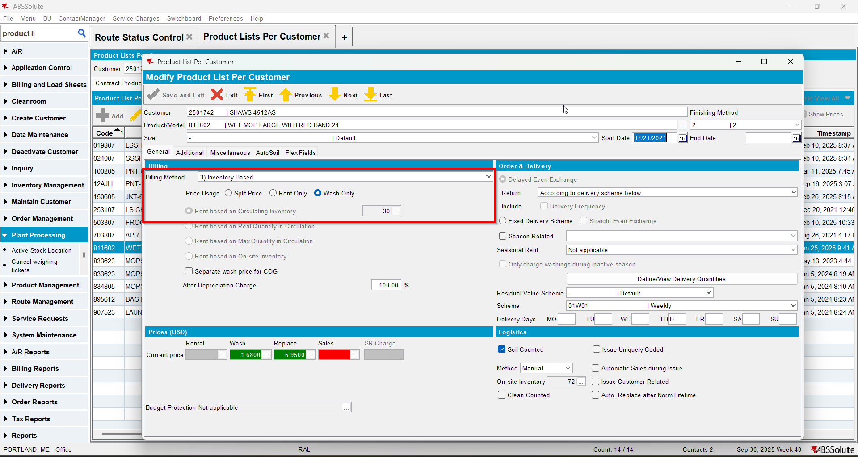
- Add a delivery variations for your customer using that product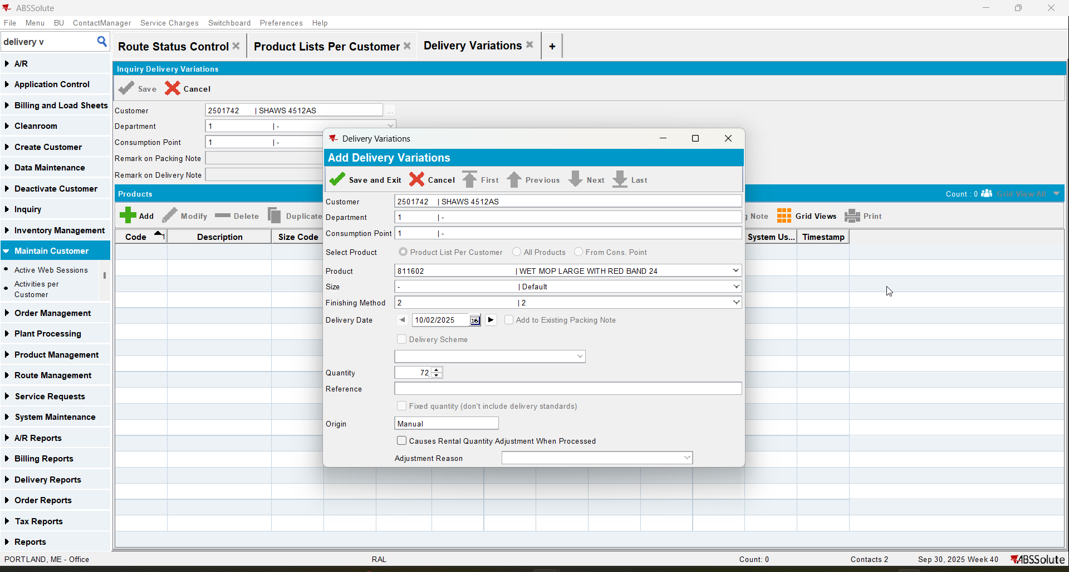
- Route Status Control DLG: Add this week's route control for this customer (route 1 on October 2)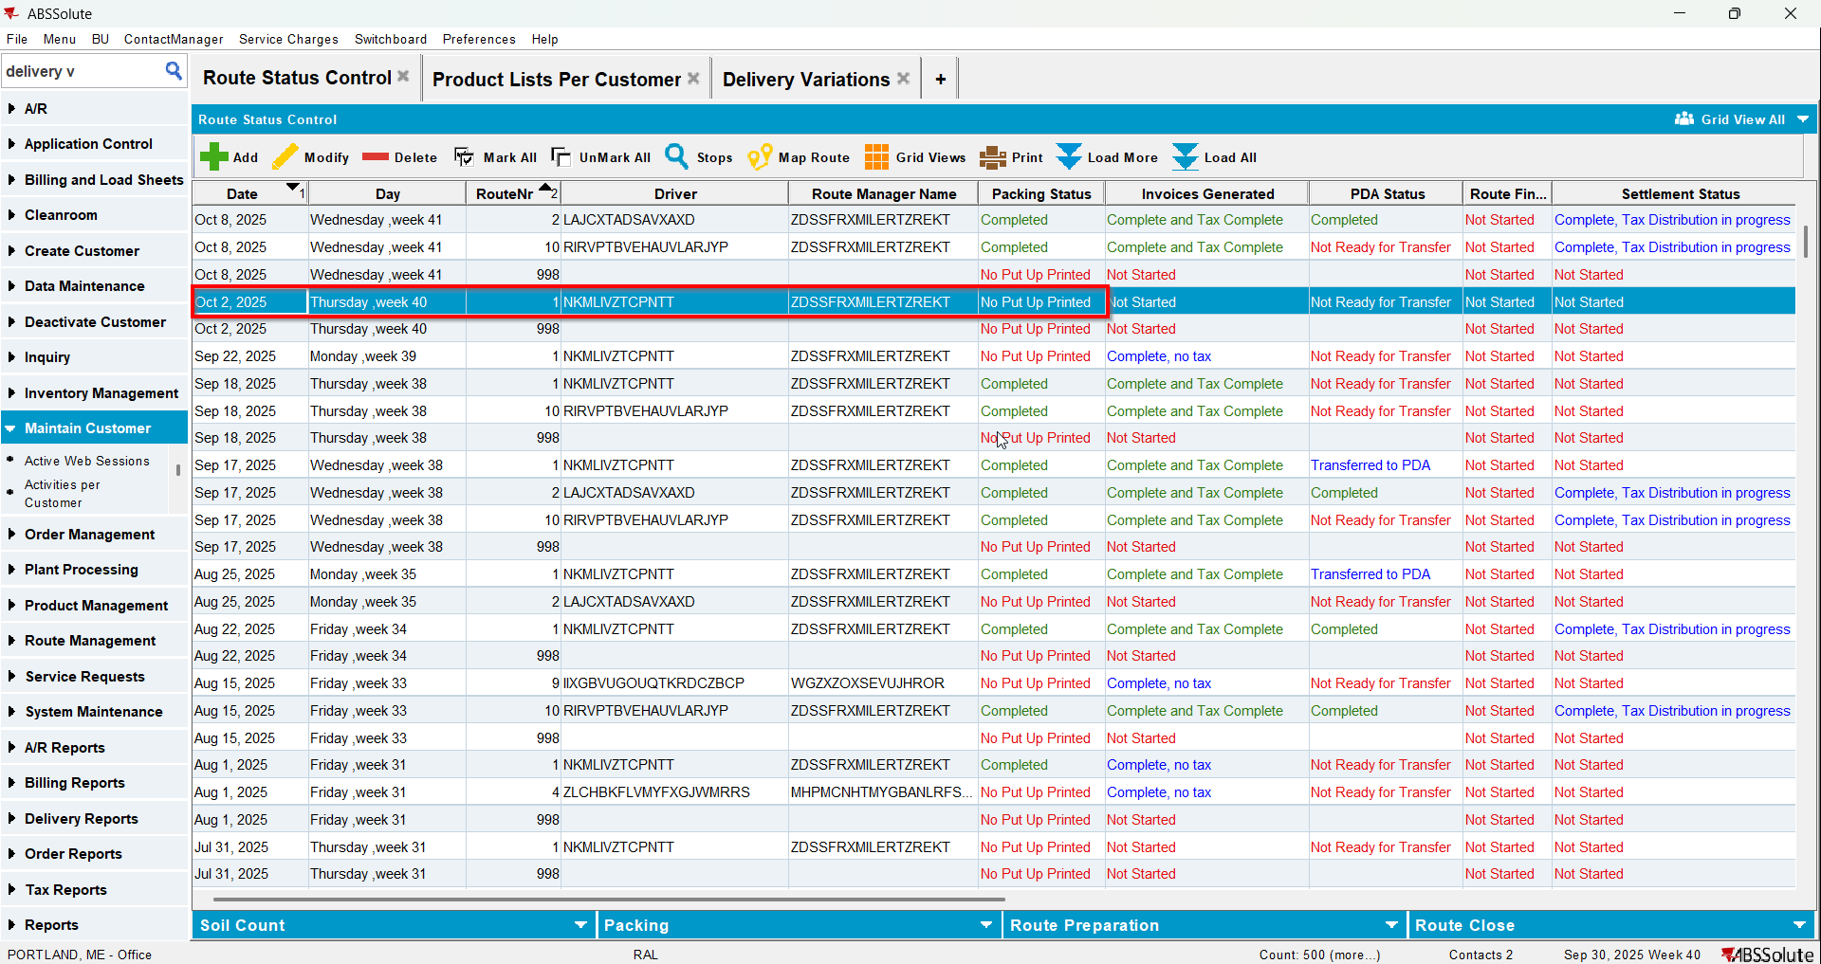
- Route Status Control DLG: Add tomorrow's route too(route 1 on October 3)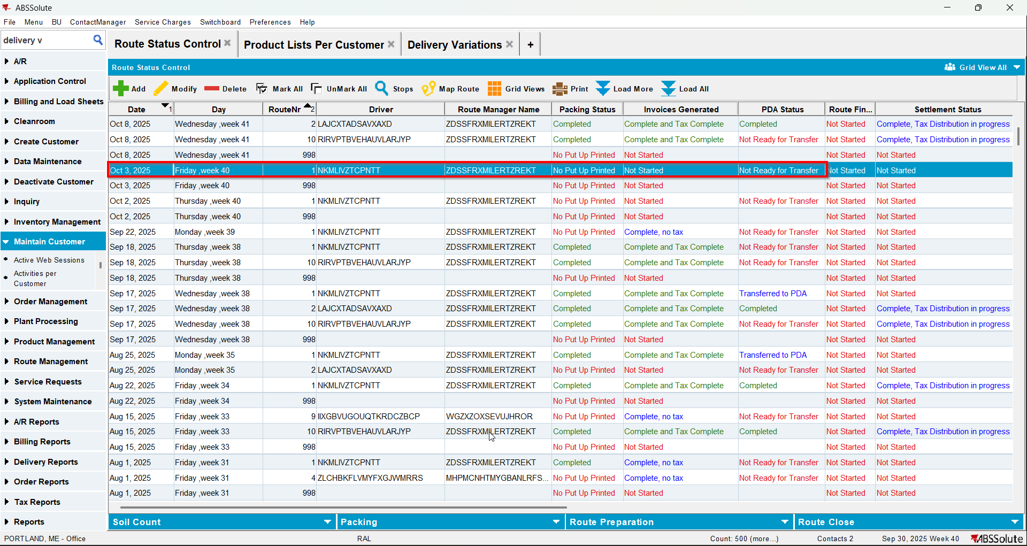
- Route Status Control DLG: Move the customer from its original route to the next day route(from route 1 on October 2 to route 1 on October 3)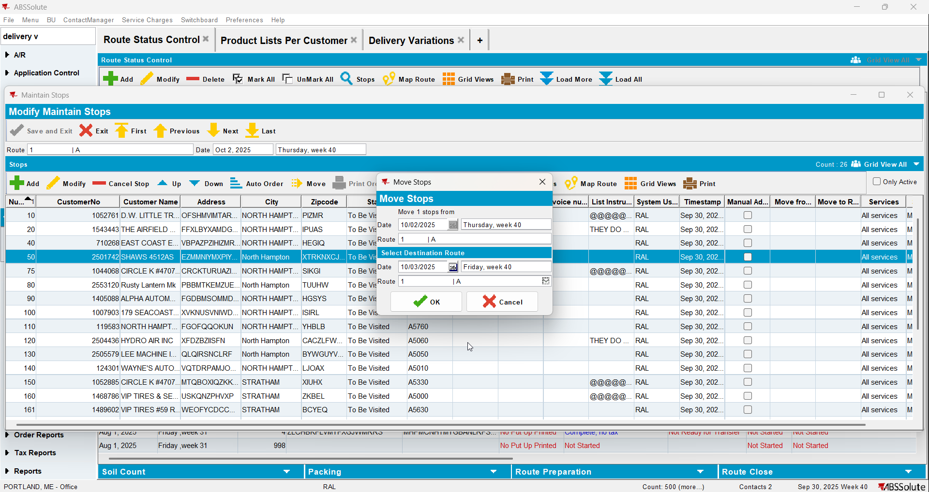
- Delivery Variations DLG: generate packing note from that delivery variations for October 3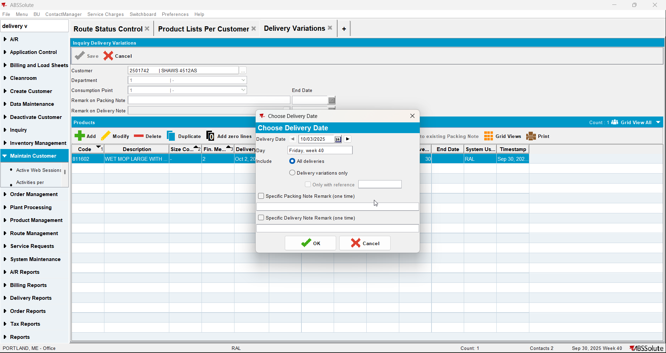
- Route Status Control DLG: Generate Packing notes and finalize them for route 1 on October 3 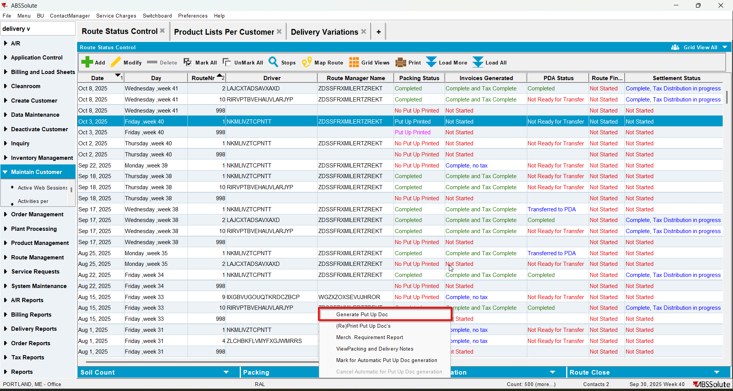
- Route Status Control DLG: Generate invoices for route 1 on October 3 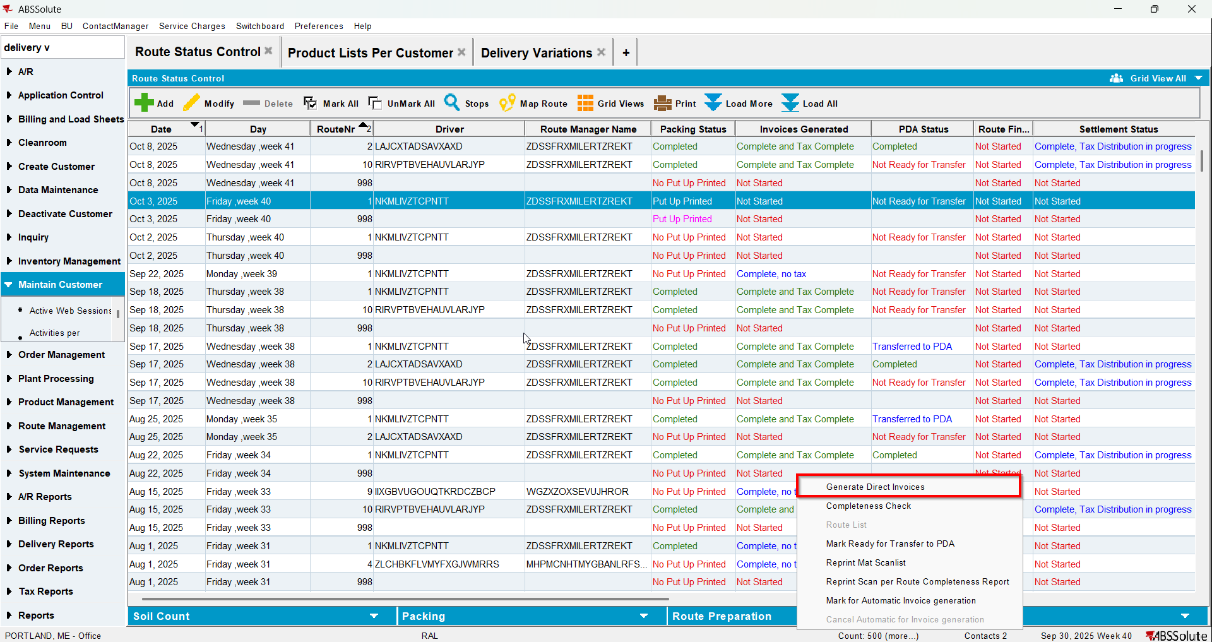
- Settle the route 1 on October 3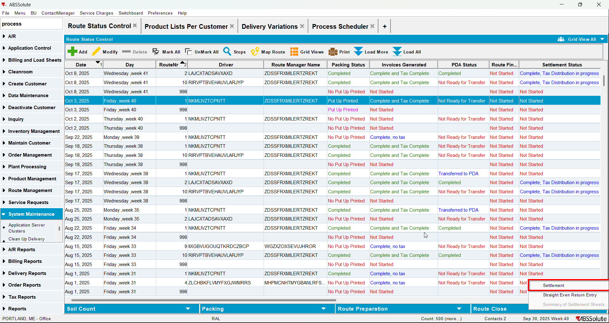
- Create the route for next week for your customer
- Generate packing notes for it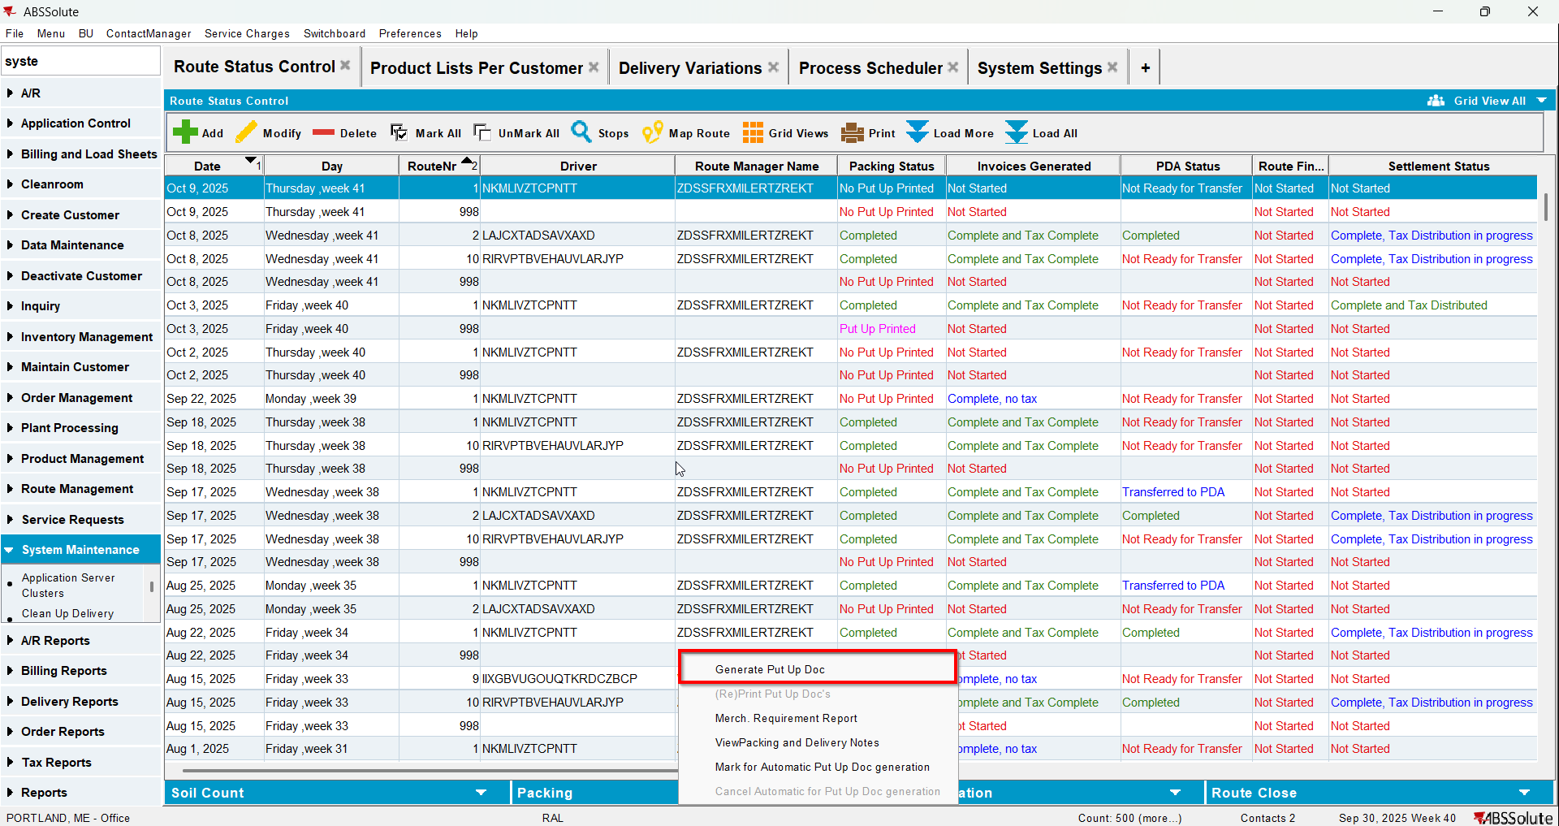
- Generate invoices for it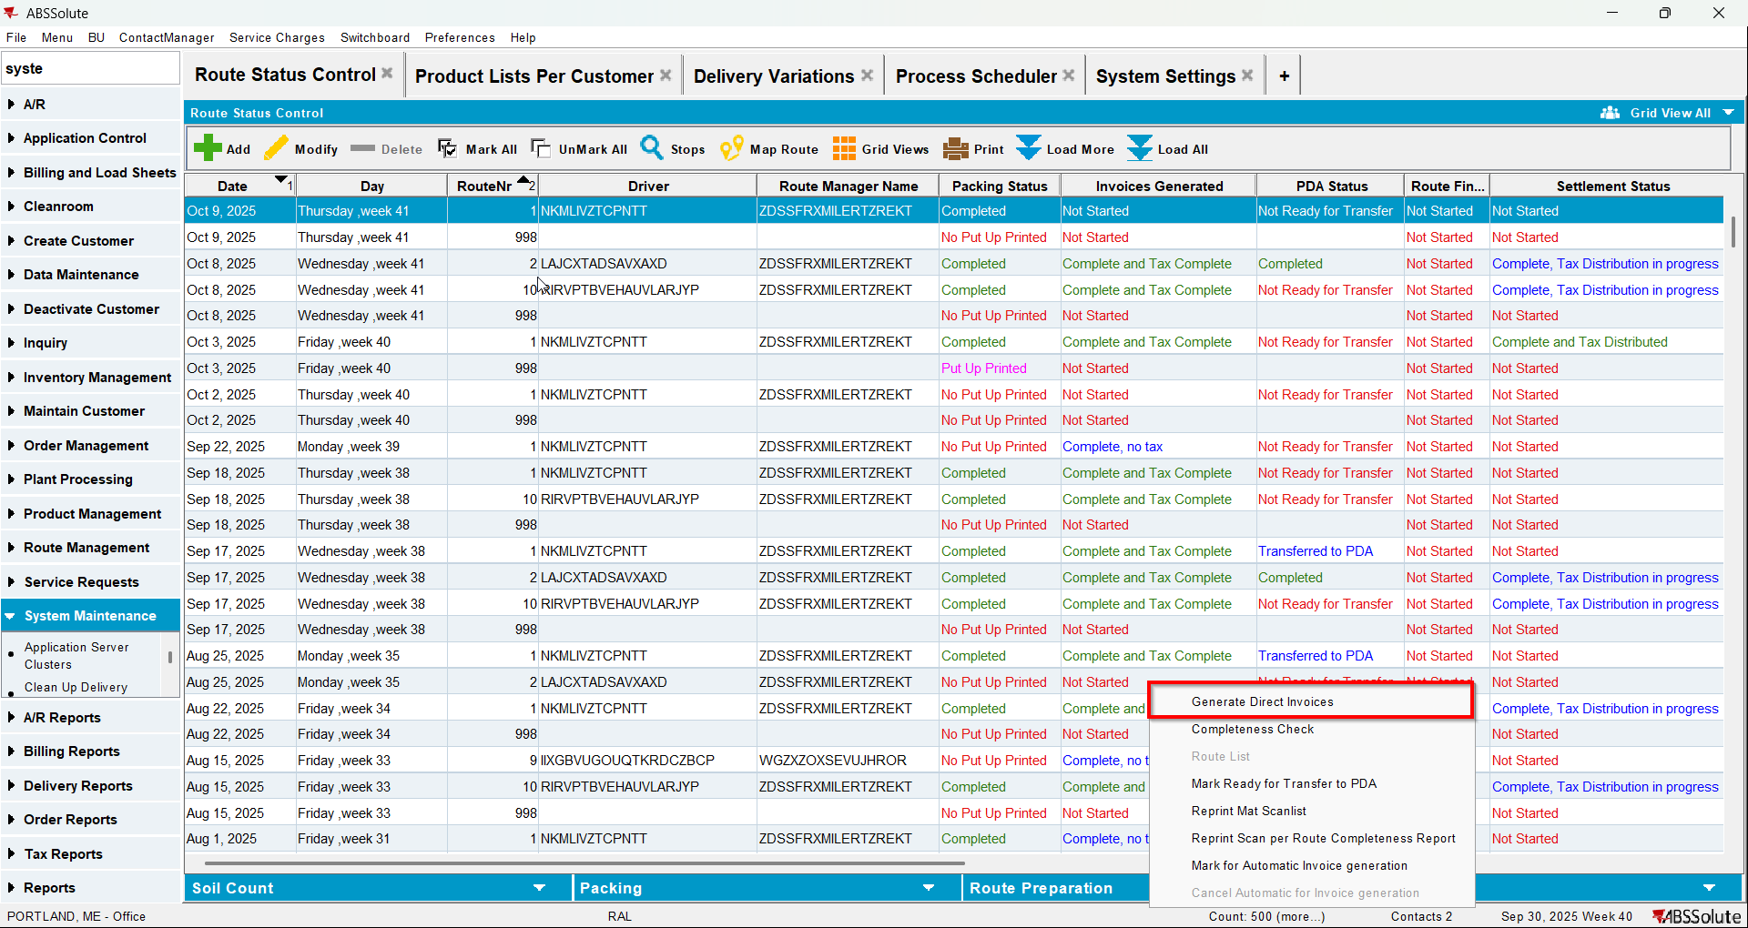
- Check that there is 0 qty for the items that were on the garment delivery note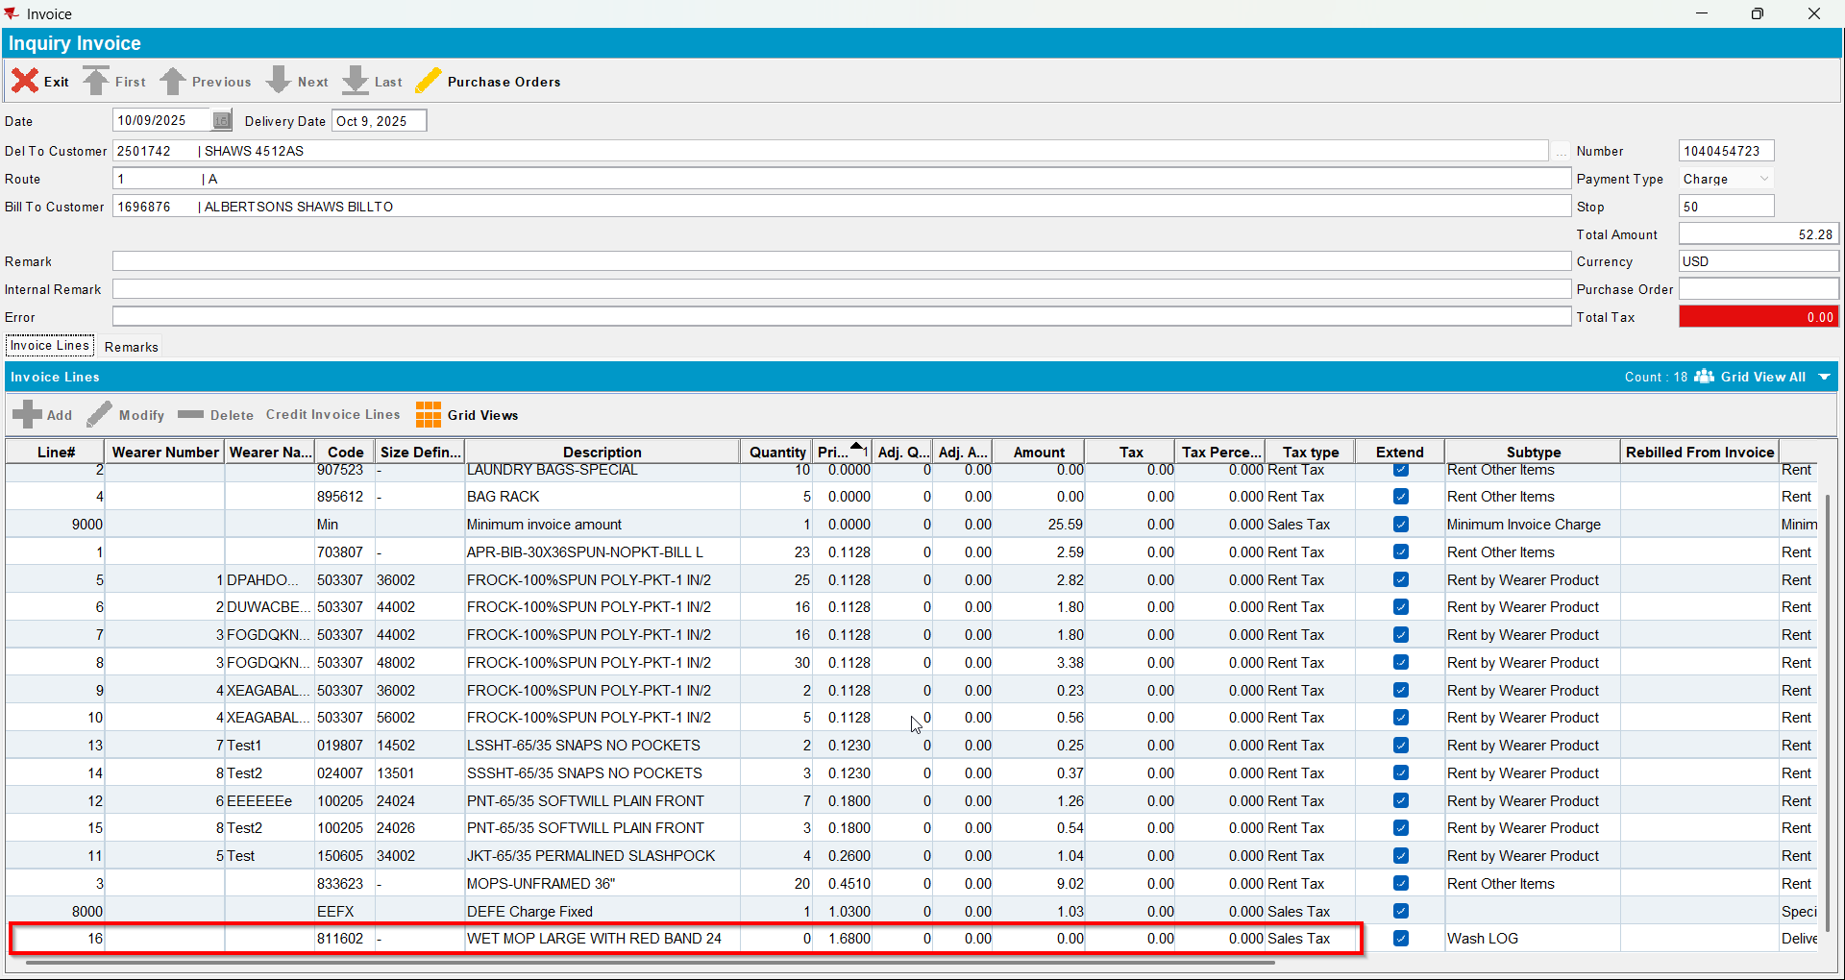
- Cancel invoices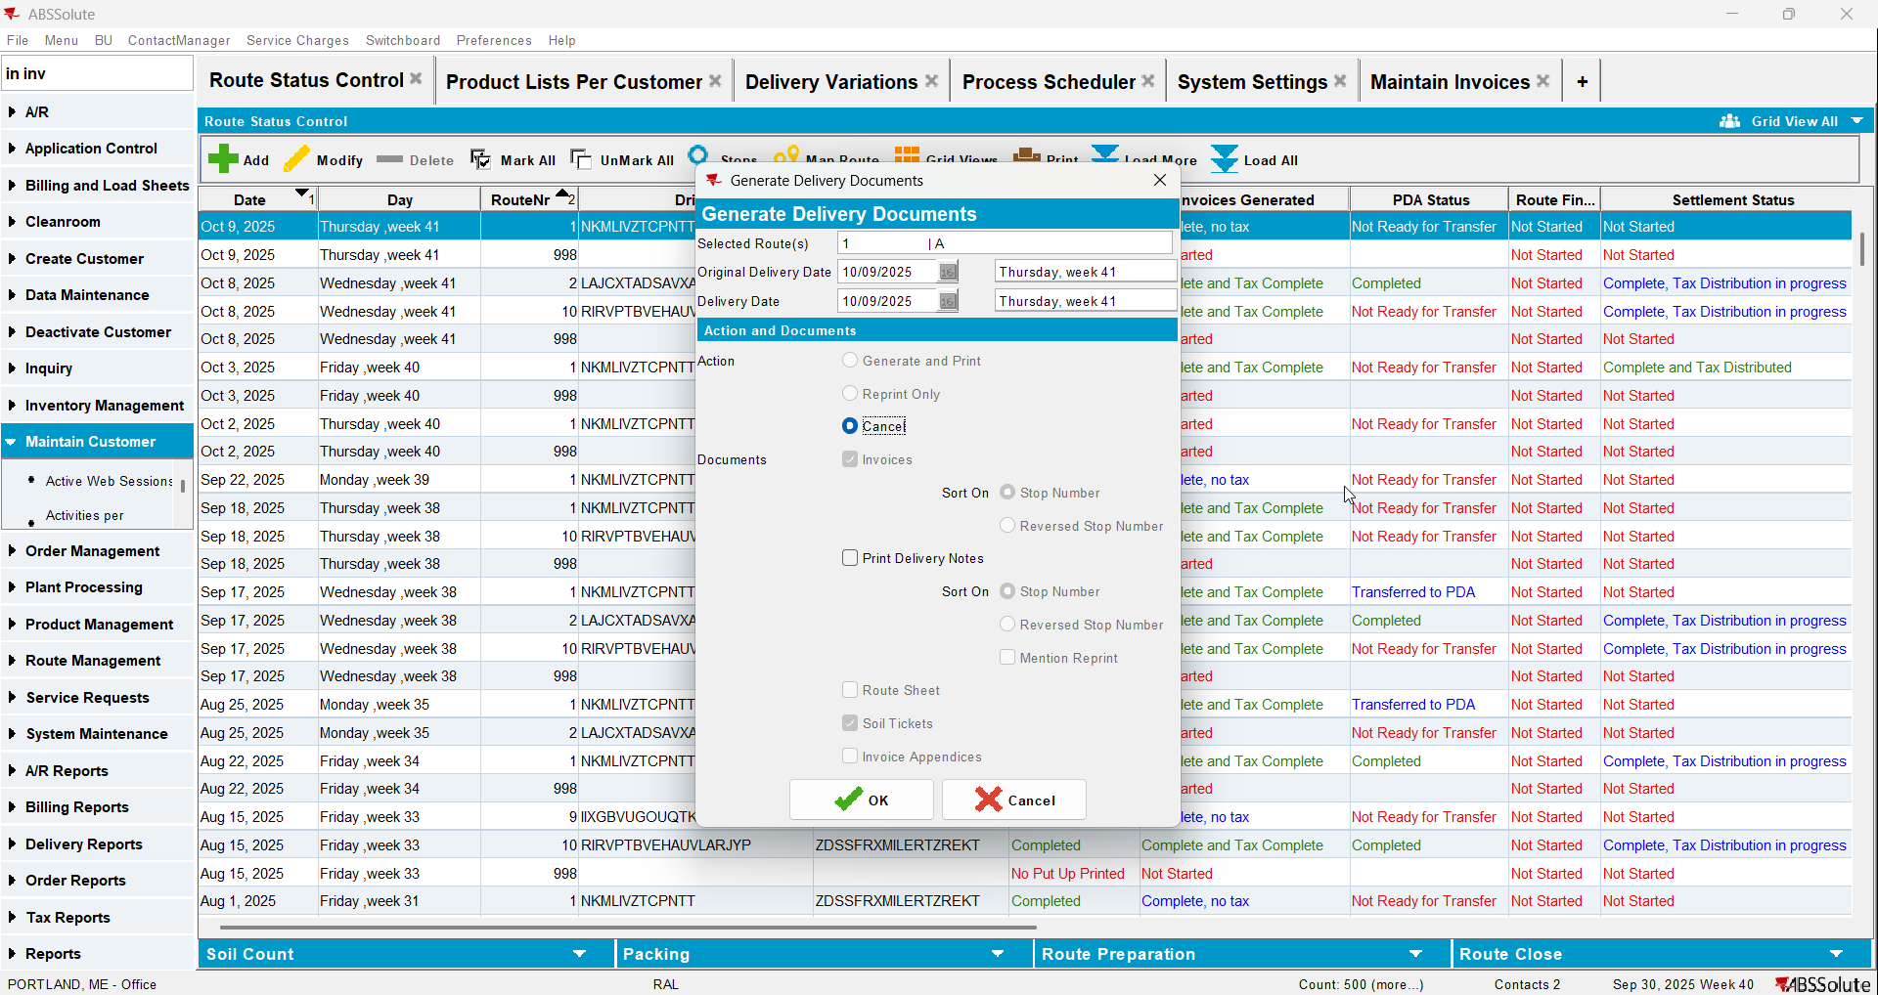
- Set SS LINKTOINVOICEDRC to 1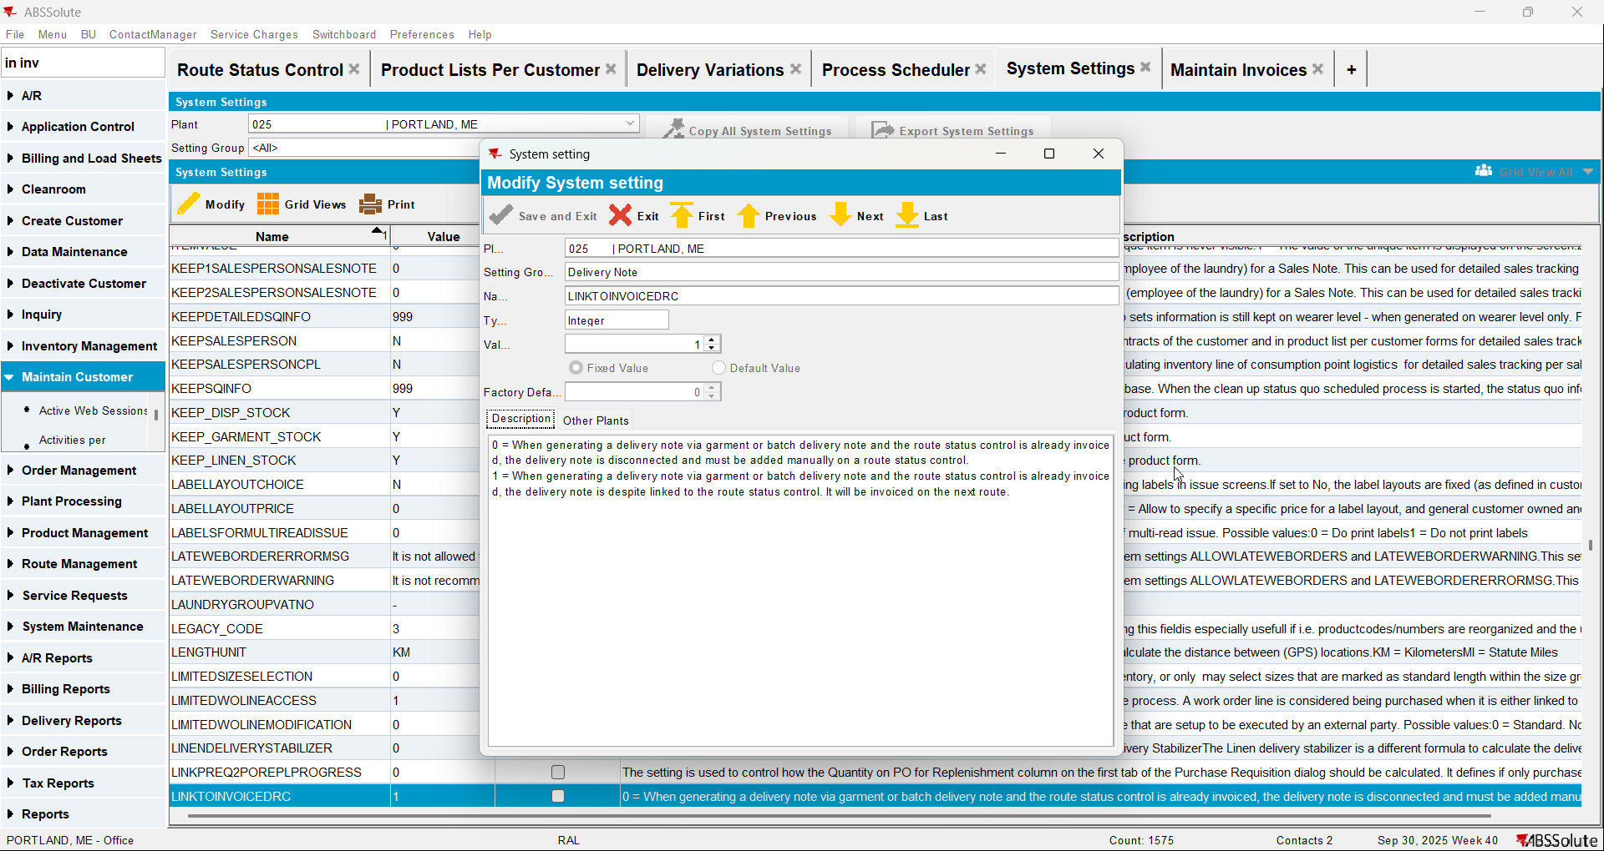
- Generate invoices again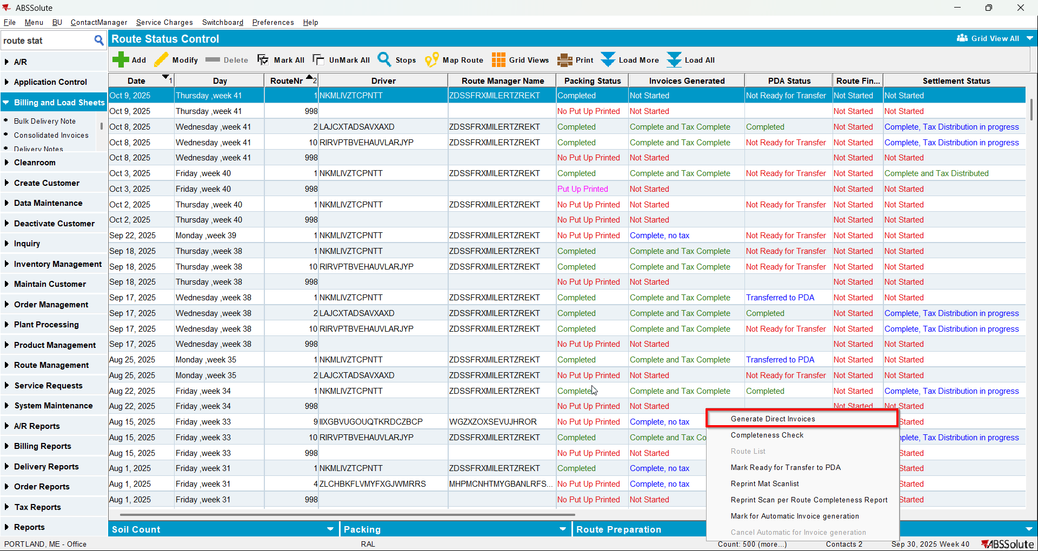
- Check now that on the invoices the products from garment delivery notes appear with their qty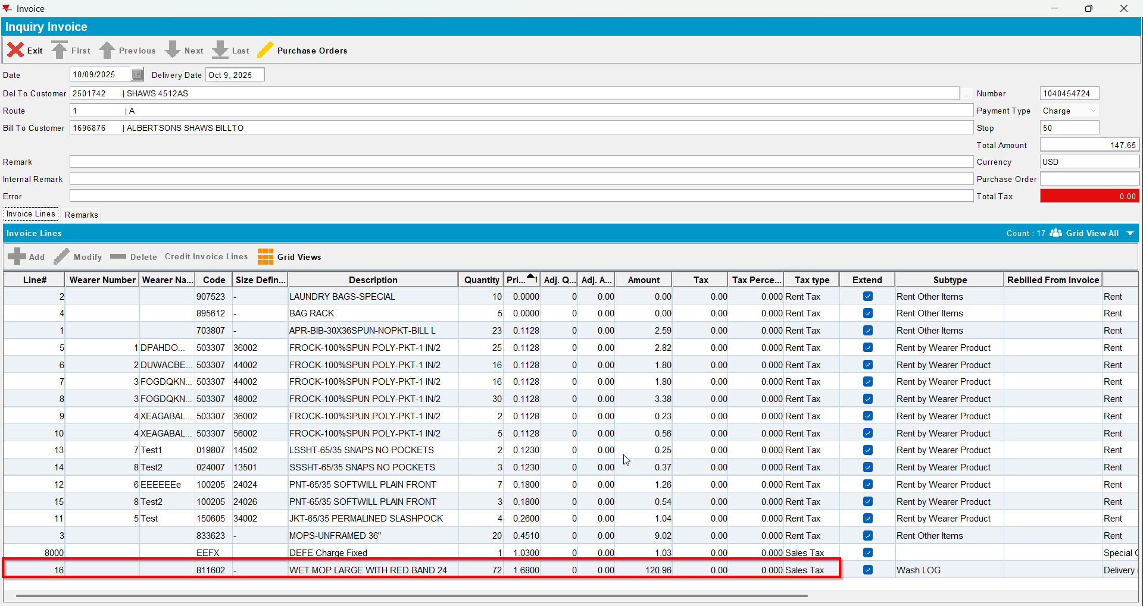

Test Case 3 – Test that update script works correctly – Tested OK
Expected behavior: Before changing LINKTOINVOICEDRC to 1 verify that the COG product is not invoiced. Cancel invoices and change LINKTOINVOICEDRC = 1 and verify that the COG product is now invoiced.
Hash: 9934ef3
- Set SS LINKTOINVOICEDRC to 1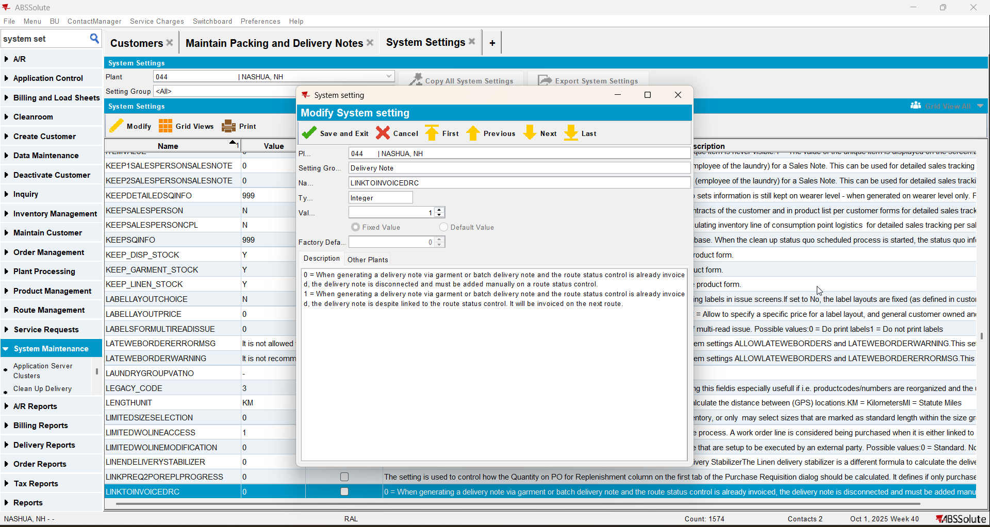
- Find a customer with packingnotes that will be affected by the LINKTOINVOICEDRC being changed:
select BU.CODE INVOICING_BU, CU.CUSTOMERNUMBER, RC.DRIVINGDATE, R.ROUTENUMBER, PN.NOTENUMBER, PN.DELIVERYDATE
from PACKINGNOTE PN
join ROUTECONTROL RC on RC.ROUTECONTROL_ID = PN.ROUTECONTROL_ID
left join ROUTE R on R.ROUTE_ID = RC.ROUTE_ID
left join DISTRIBUTIONPOINT DIP on DIP.DISTRIBUTIONPOINT_ID = PN.DISTRIBUTIONPOINT_ID
left join DEPARTMENT DEP on DEP.DEPARTMENT_ID = DIP.DEPARTMENT_ID
left join CUSTOMER CU on CU.CUSTOMER_ID = DEP.CUSTOMER_ID
left join BUSINESSUNIT BU on BU.BUSINESSUNIT_ID = CU.DEFAULTINVOICEBUSINESSUNIT_ID
where RC.INVOICESGENERATED = 3
and PN.STATUS_ID = 7
and PN.INVOICESTATUS = 0
and PN.ORIGIN not in (5, 6, 11, 12)
and exists (
SELECT 1 FROM PACKINGNOTELINE PNL
WHERE PNL.PACKINGNOTE_ID = PN.PACKINGNOTE_ID
and PNL.INVOICEHEADER_ID is null
)
and BU.CODE = <businessunit code>
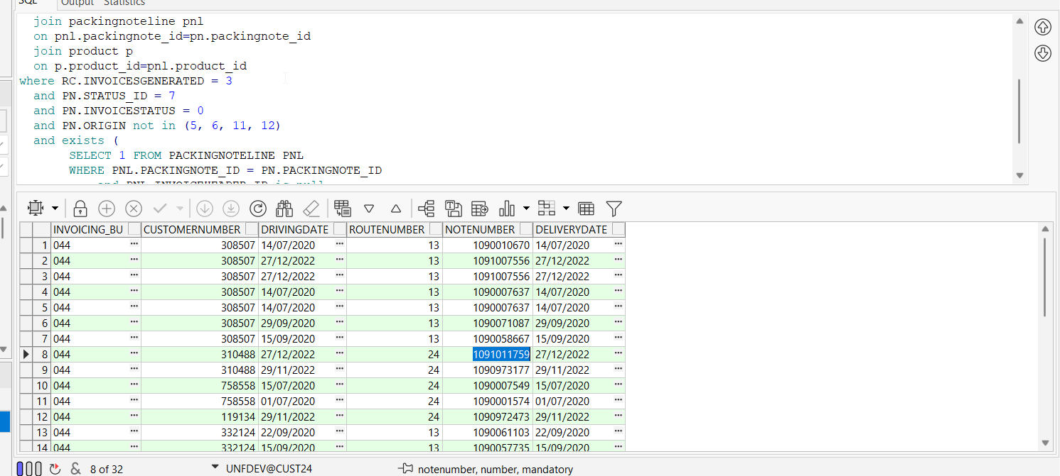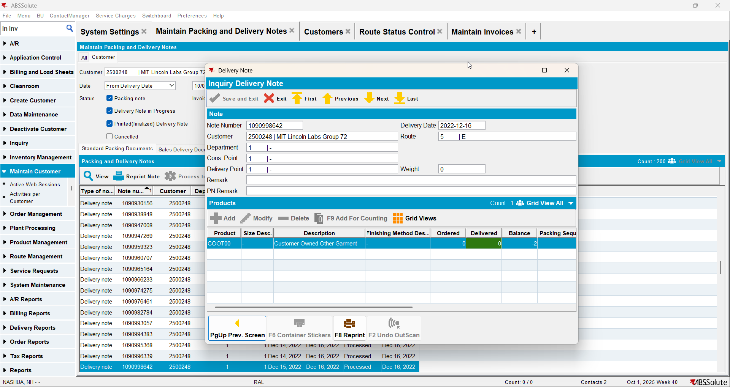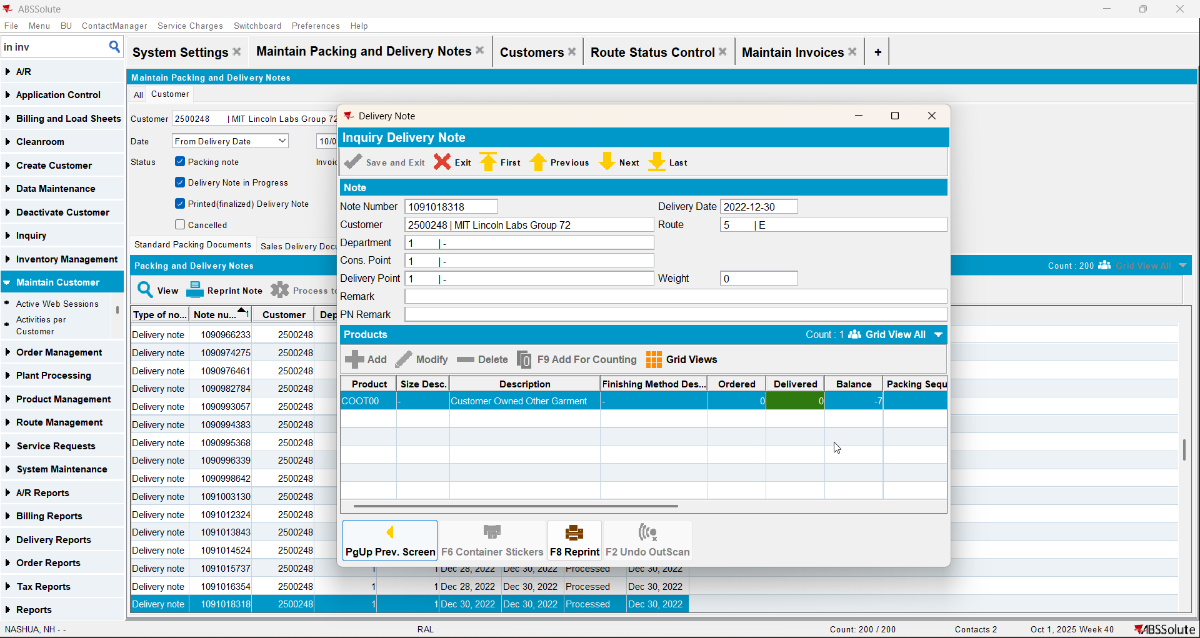
- Pick a customer from the select and add a route control in the future for this customer
- Generate invoices for that customers route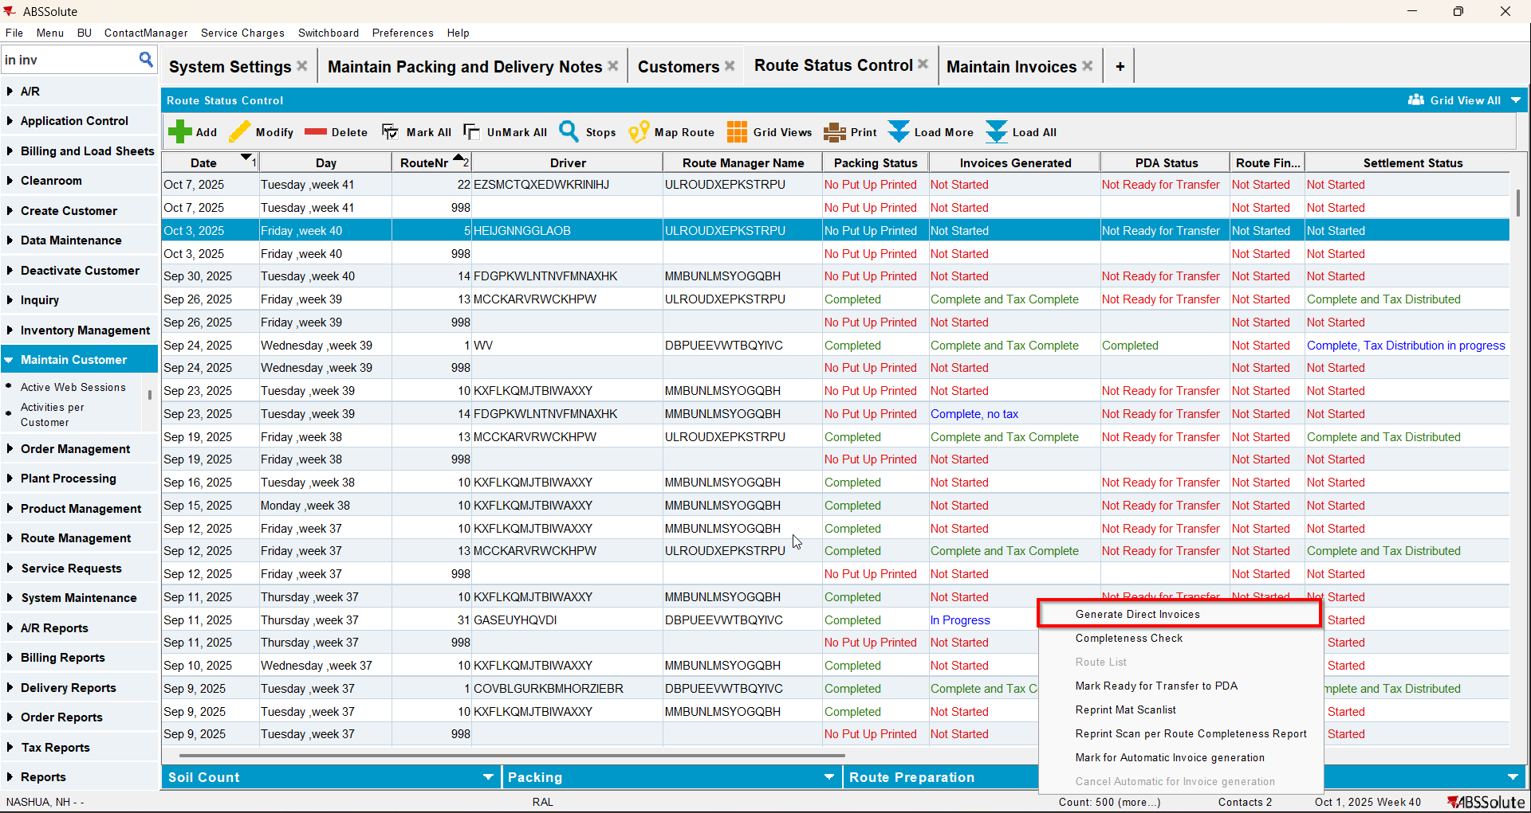
- Maintain Invoices DLG: Check that the invoice contains the quantity from the packing note found by the select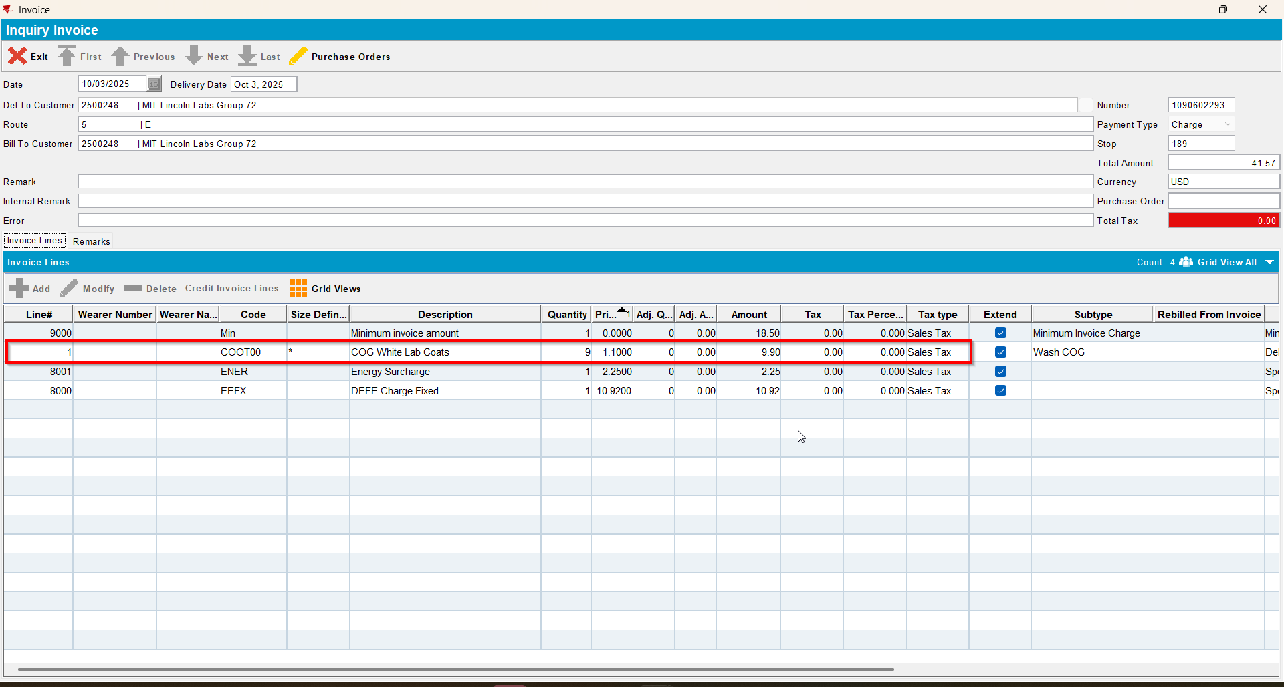
- Cancel invoices.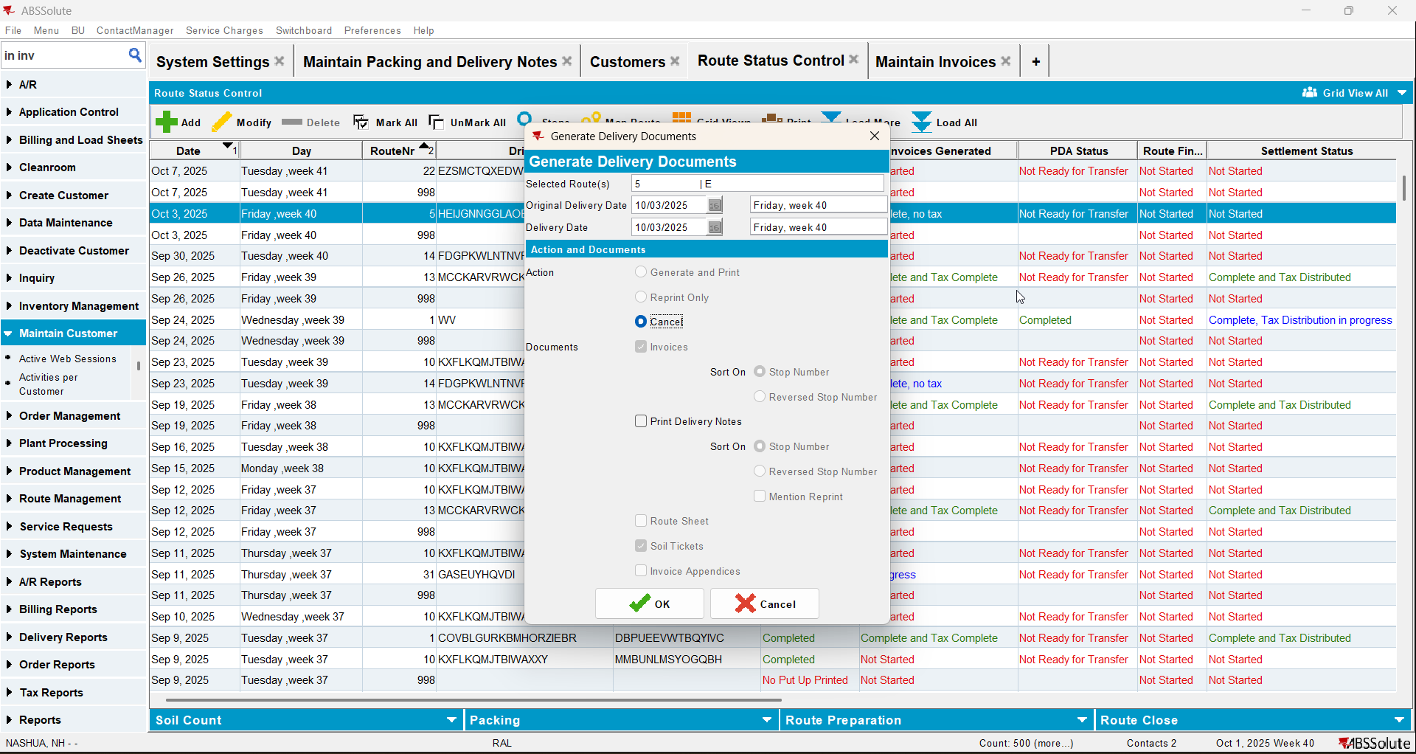
- PLSQL: run the update script for this customer (if there are more PN update just a few)
update PACKINGNOTE PN
set PN.INVOICESTATUS = 1
where PN.STATUS_ID = 7
and PN.INVOICESTATUS = 0
and PN.ORIGIN not in (5, 6, 11, 12)
and (select RC.INVOICESGENERATED from ROUTECONTROL RC where RC.ROUTECONTROL_ID = PN.ROUTECONTROL_ID) = 3
and exists (
SELECT 1 FROM PACKINGNOTELINE PNL
WHERE PNL.PACKINGNOTE_ID = PN.PACKINGNOTE_ID
and PNL.INVOICEHEADER_ID is null
)
and PN.DELIVERYDATE < date 'YYYY-MM-DD' -- replace with the actual limit date
and PN.DISTRIBUTIONPOINT_ID in (
select DP.DISTRIBUTIONPOINT_ID
from DISTRIBUTIONPOINT DP
join DEPARTMENT DEP on DEP.DEPARTMENT_ID = DP.DEPARTMENT_ID
join CUSTOMER CU on CU.CUSTOMER_ID = DEP.customer_id
where CU.CUSTOMERNUMBER = nnnnnnn -- put here the (only) customer to process
)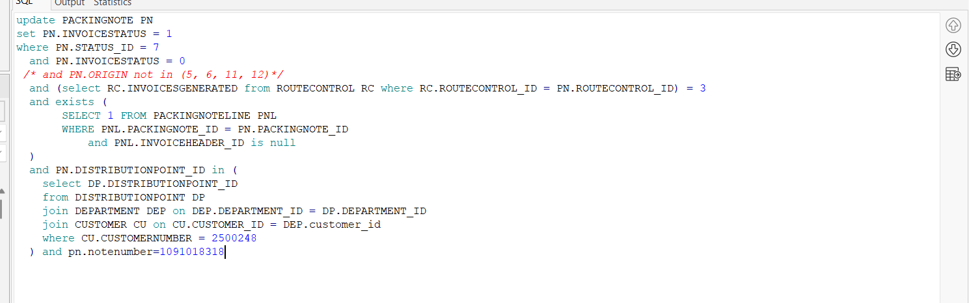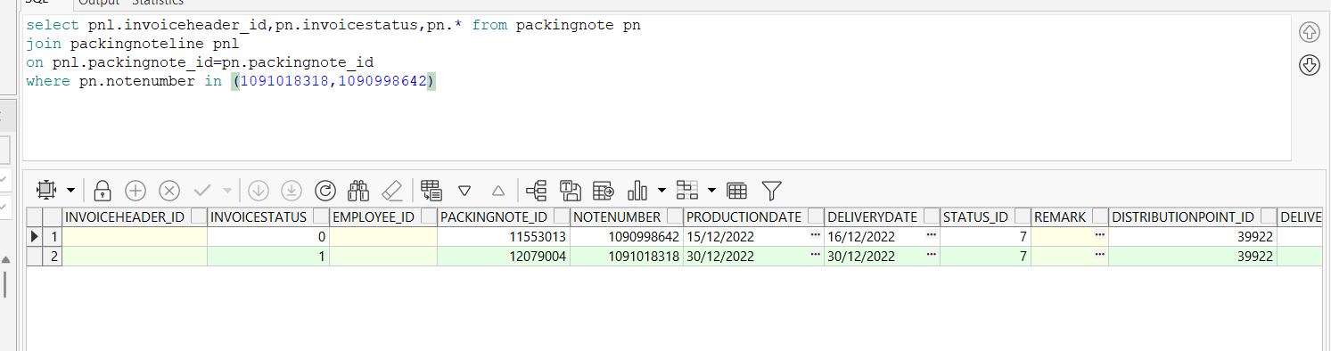
- Run invoices again and make sure that the new invoice does not contain the quantity from the packing note from step 4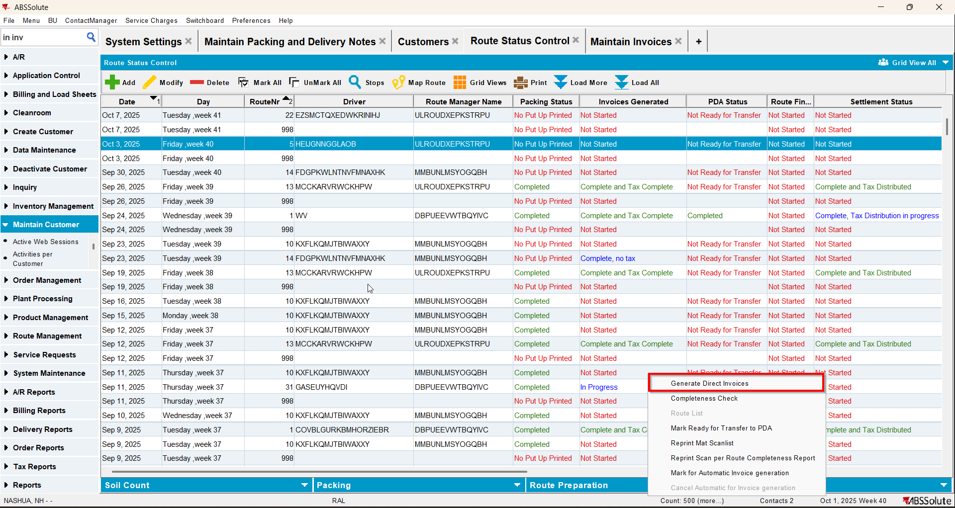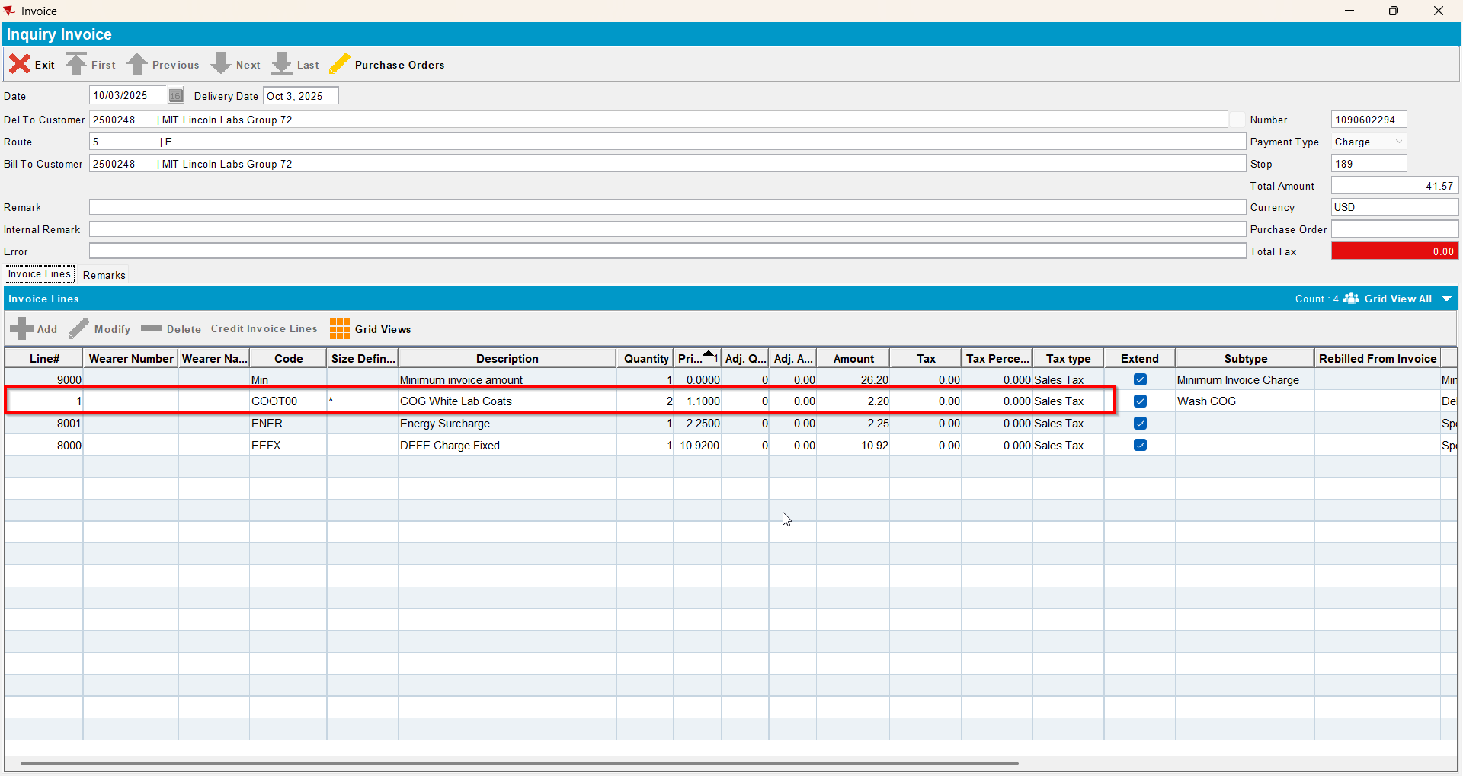

Test Case 4 – Make sure LINKTOINVOICEDRC =1 does not affect assigning sales note packing notes to routes– Tested OK
Expected behavior: When a route control is invoiced and LINKTOINVOICEDRC =1 you still can select that date as the delivery date and the sales note is attached
Hash: 9934ef3
- Set SS LINKTOINVOICEDRC to 1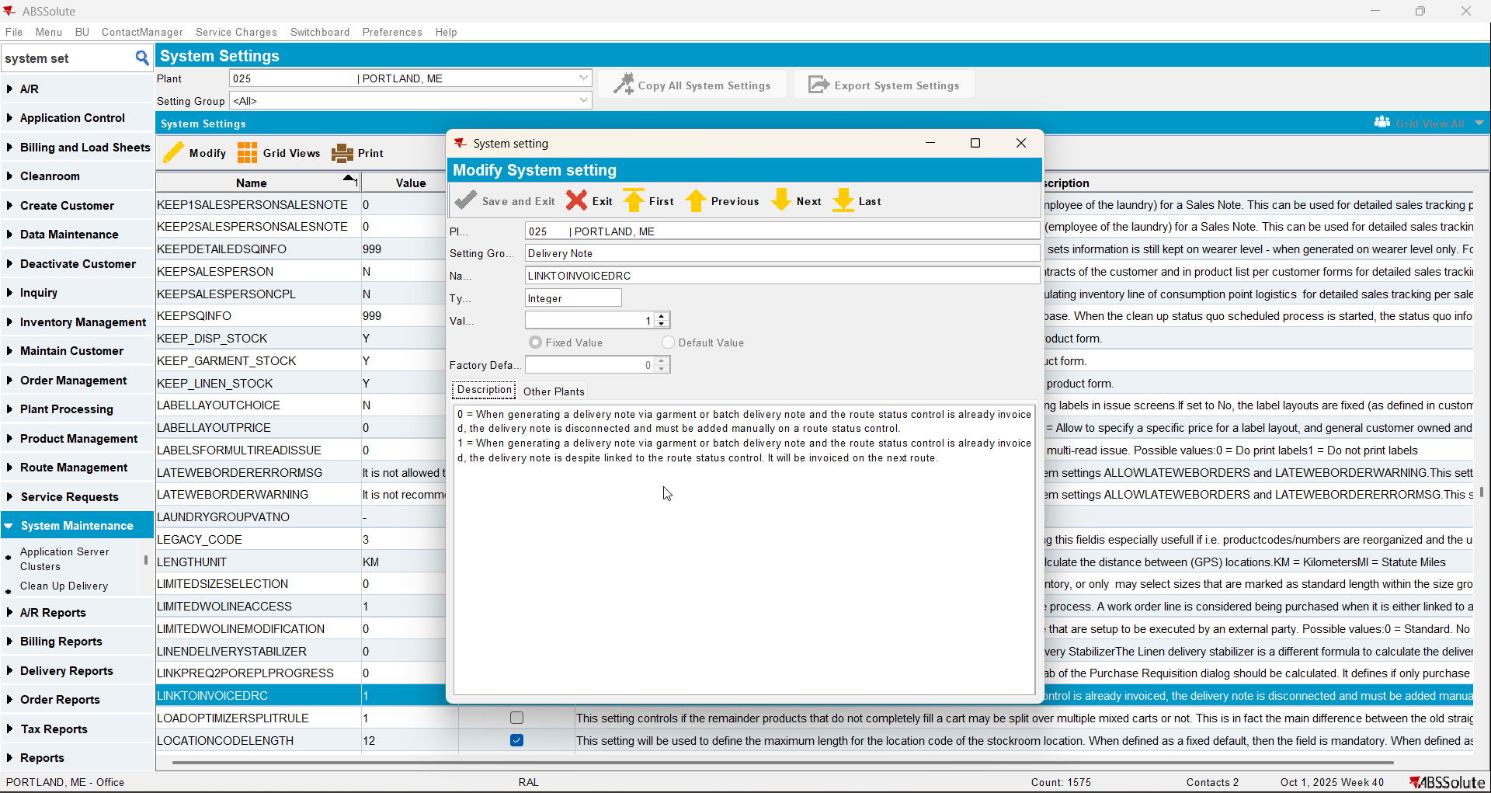
- For a customer generate its invoices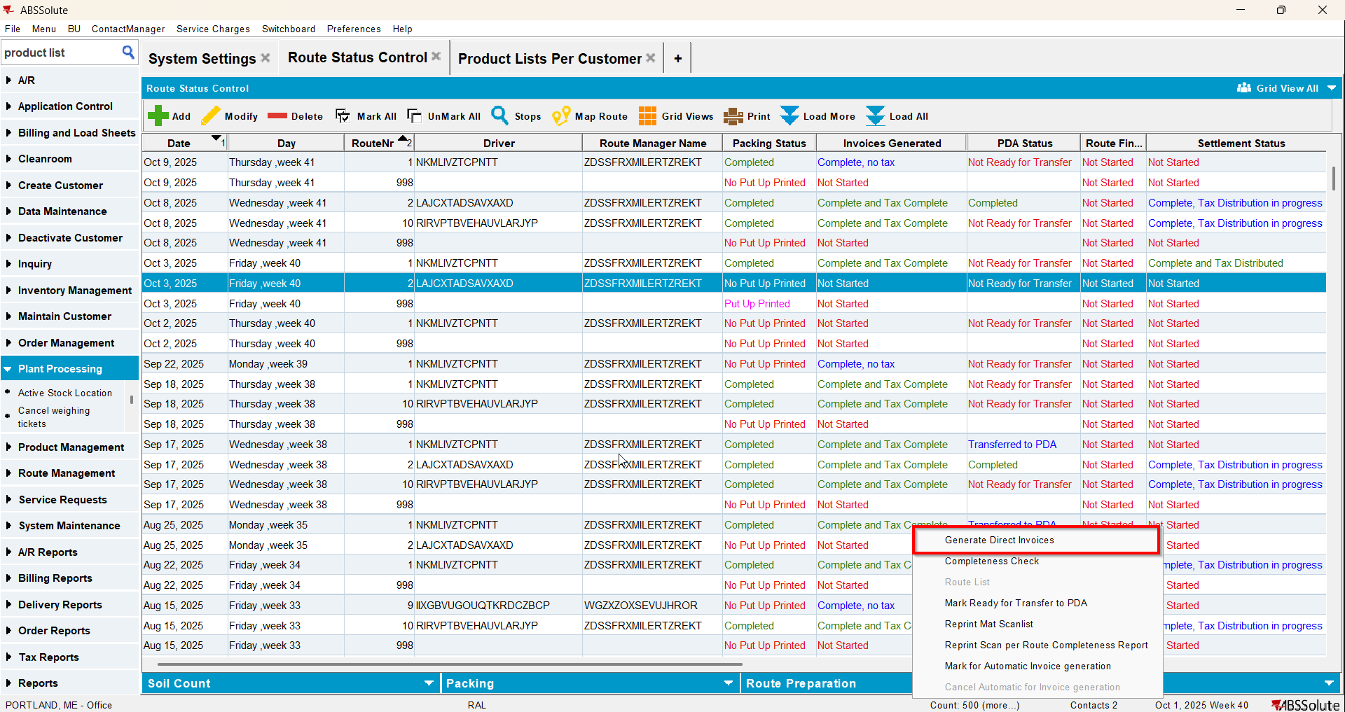
- Go to Maintain Sales Note dlg and add a product for that customer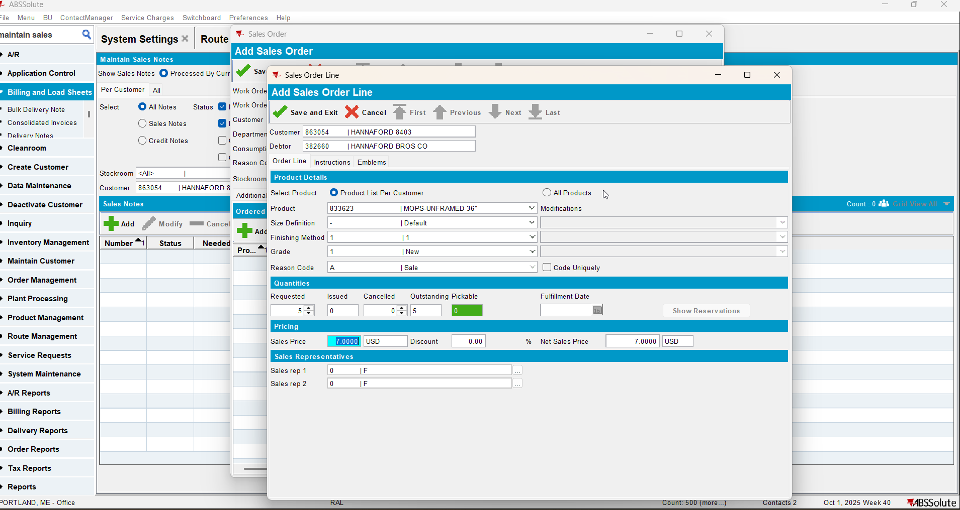
- Go to Work Orders Waiting for Approval dlg and approve the sales note
- Go to Maintain Sales Note dlg and issue the sales item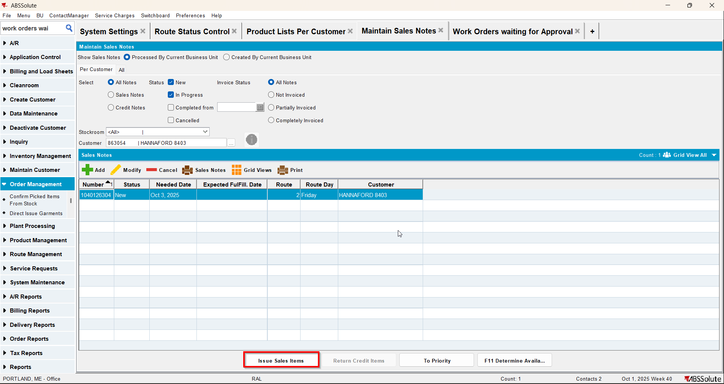
- Generate Delivery Notes on the date your route is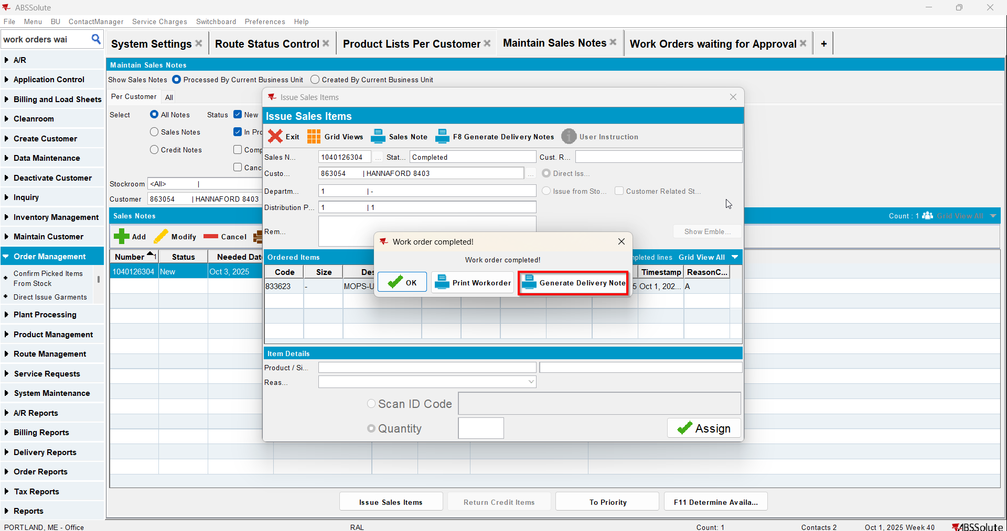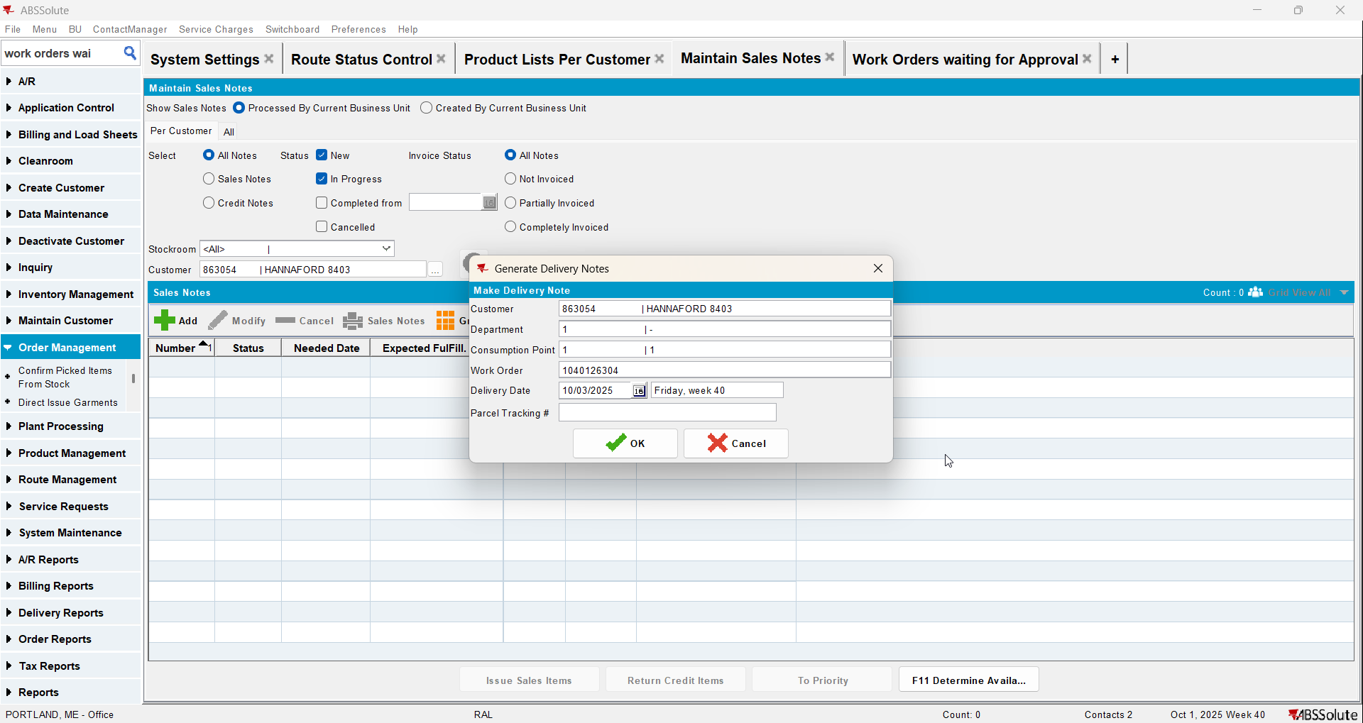
- Check that the sales note is attached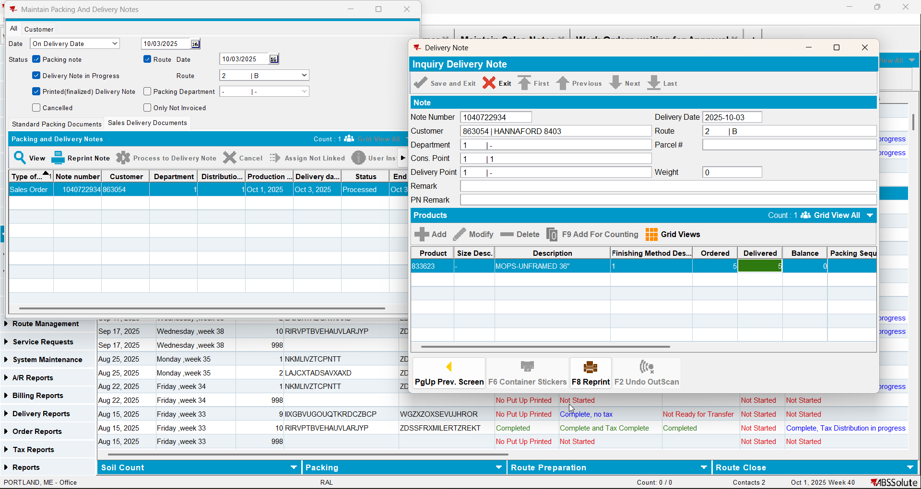
- Change SS LINKTOINVOICEDRC to 0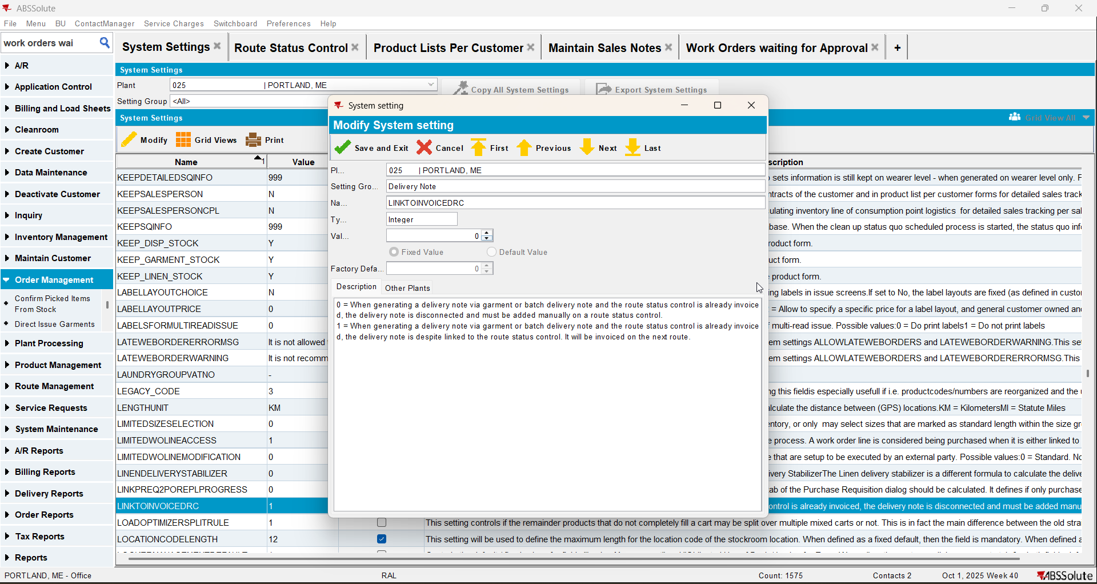
- Go to Maintain Sales Note dlg and add a product for that customer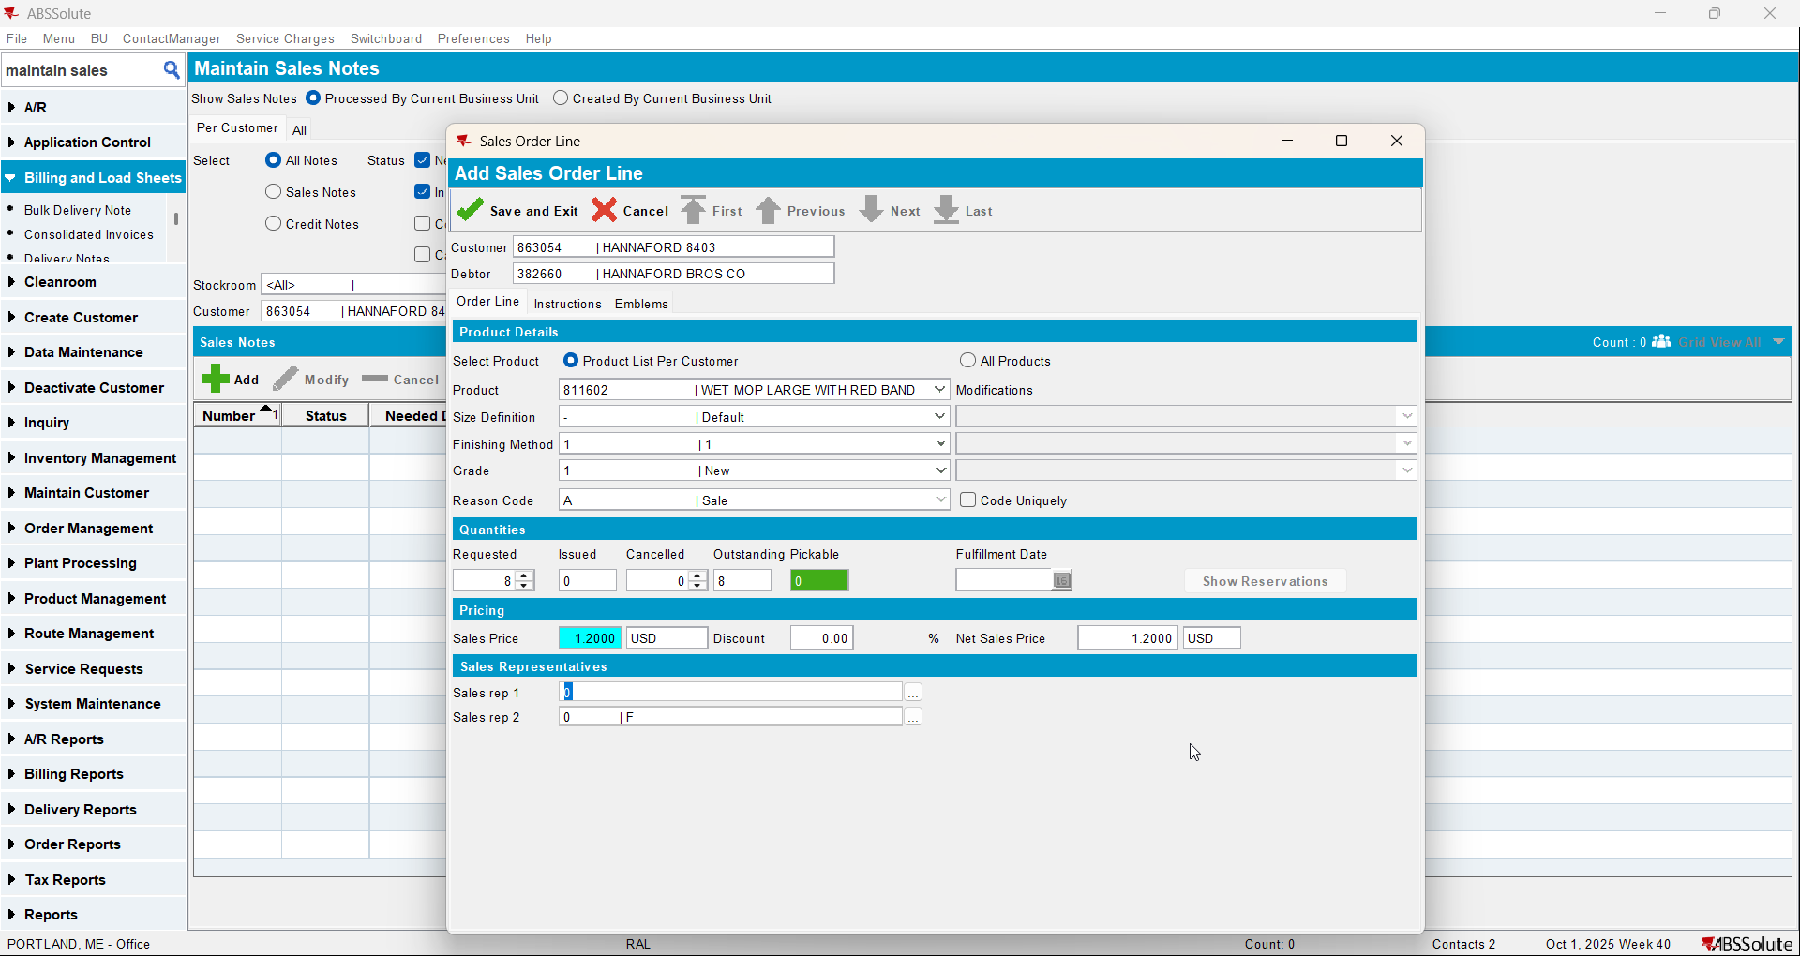
- Go to Work Orders Waiting for Approval dlg and approve the sales note
- Go to Maintain Sales Note dlg and issue the sales item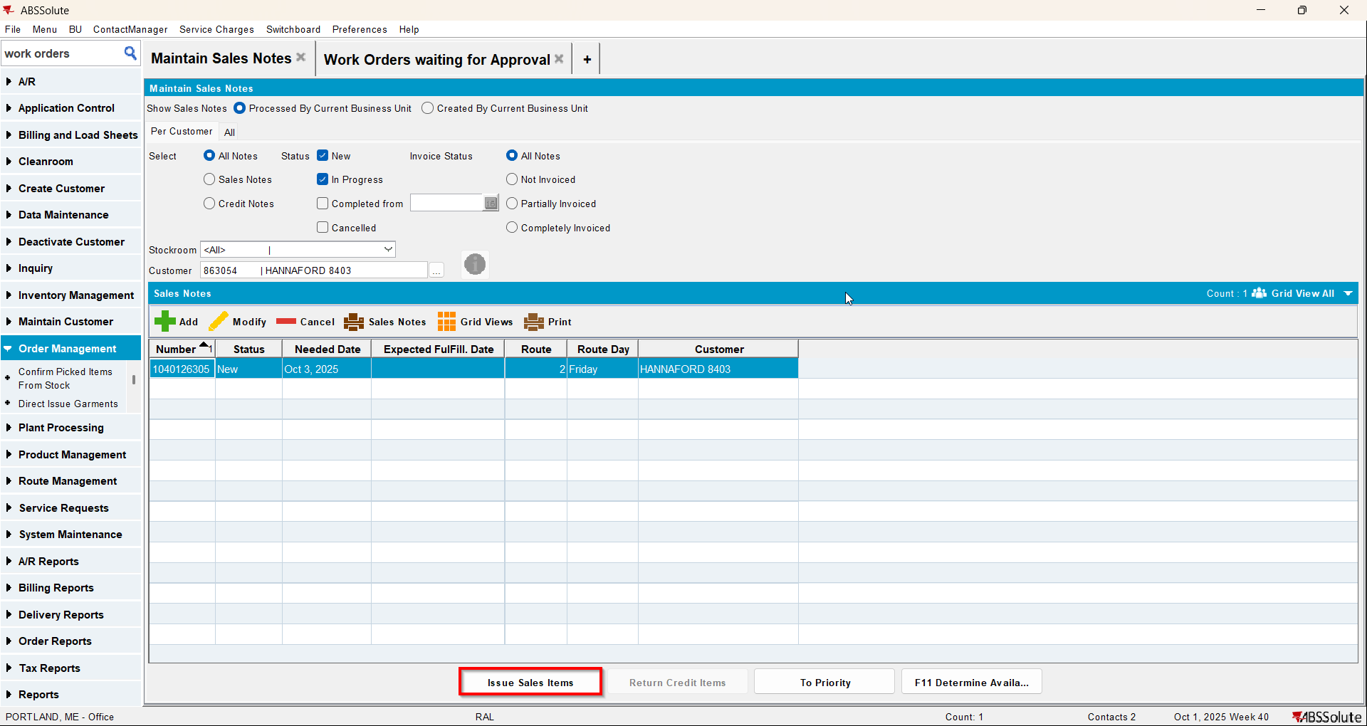
- Generate Delivery Notes on the date your route is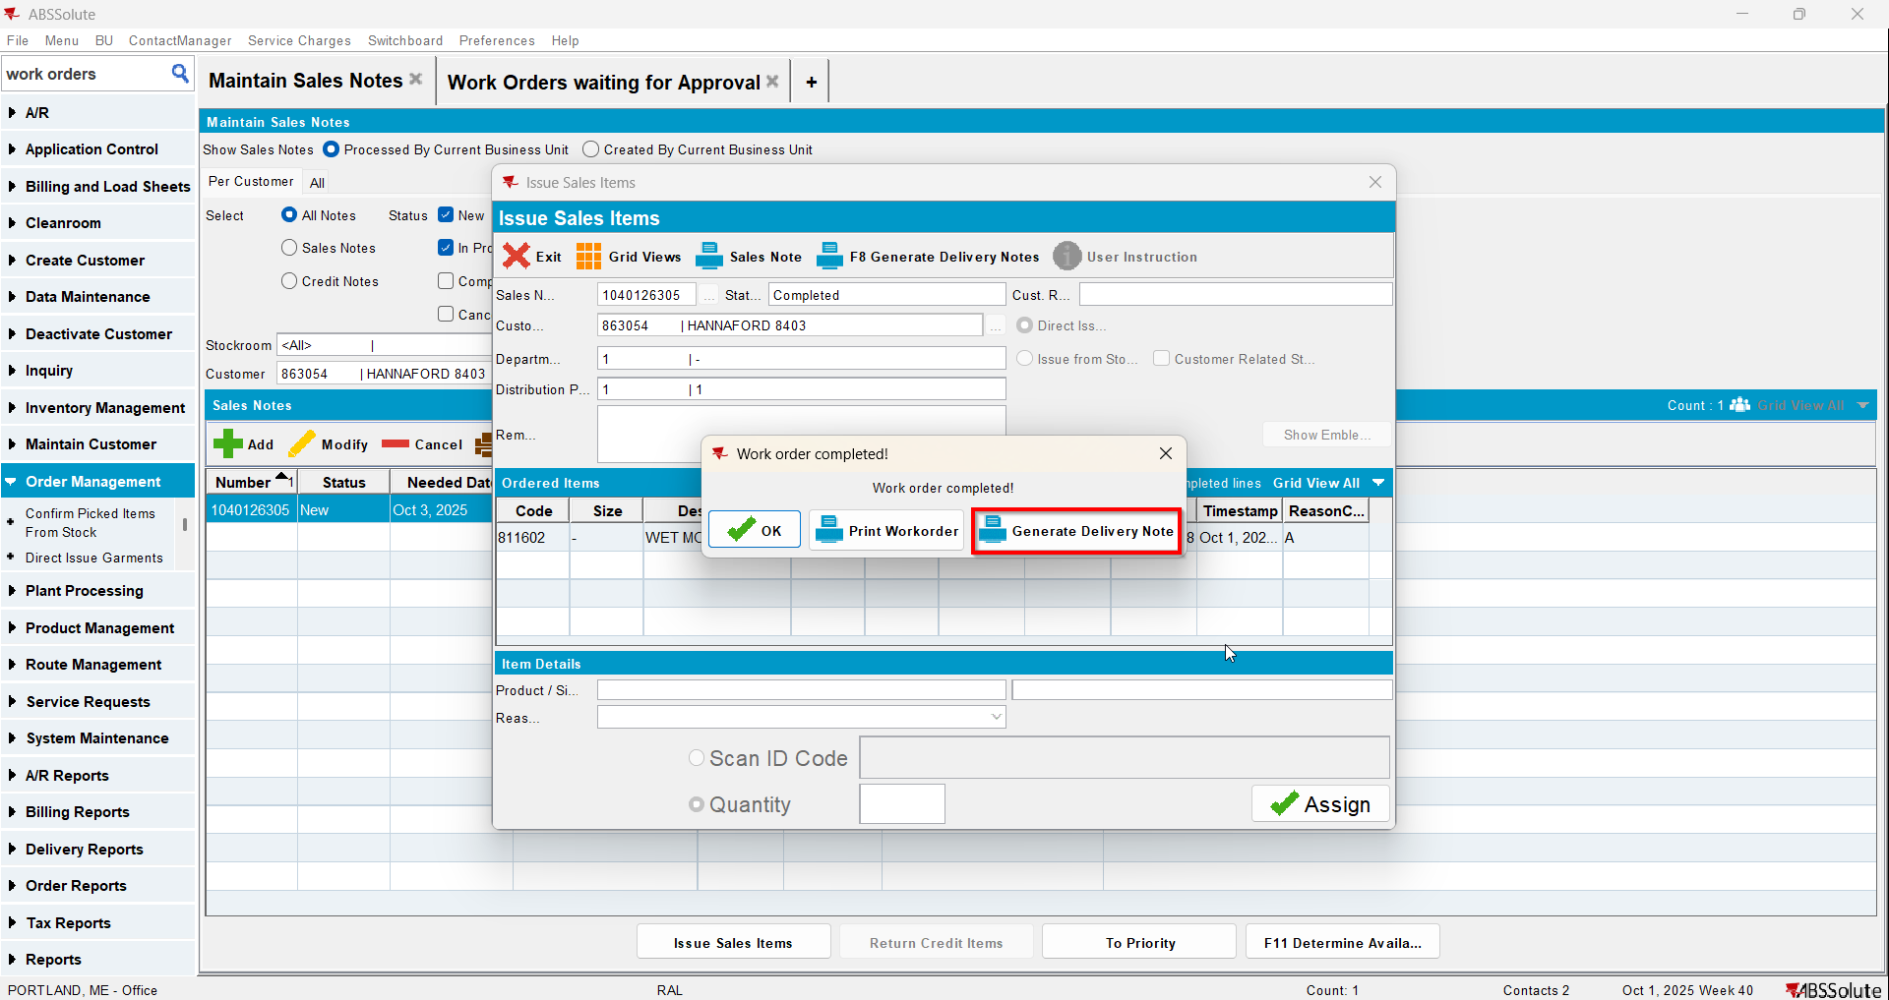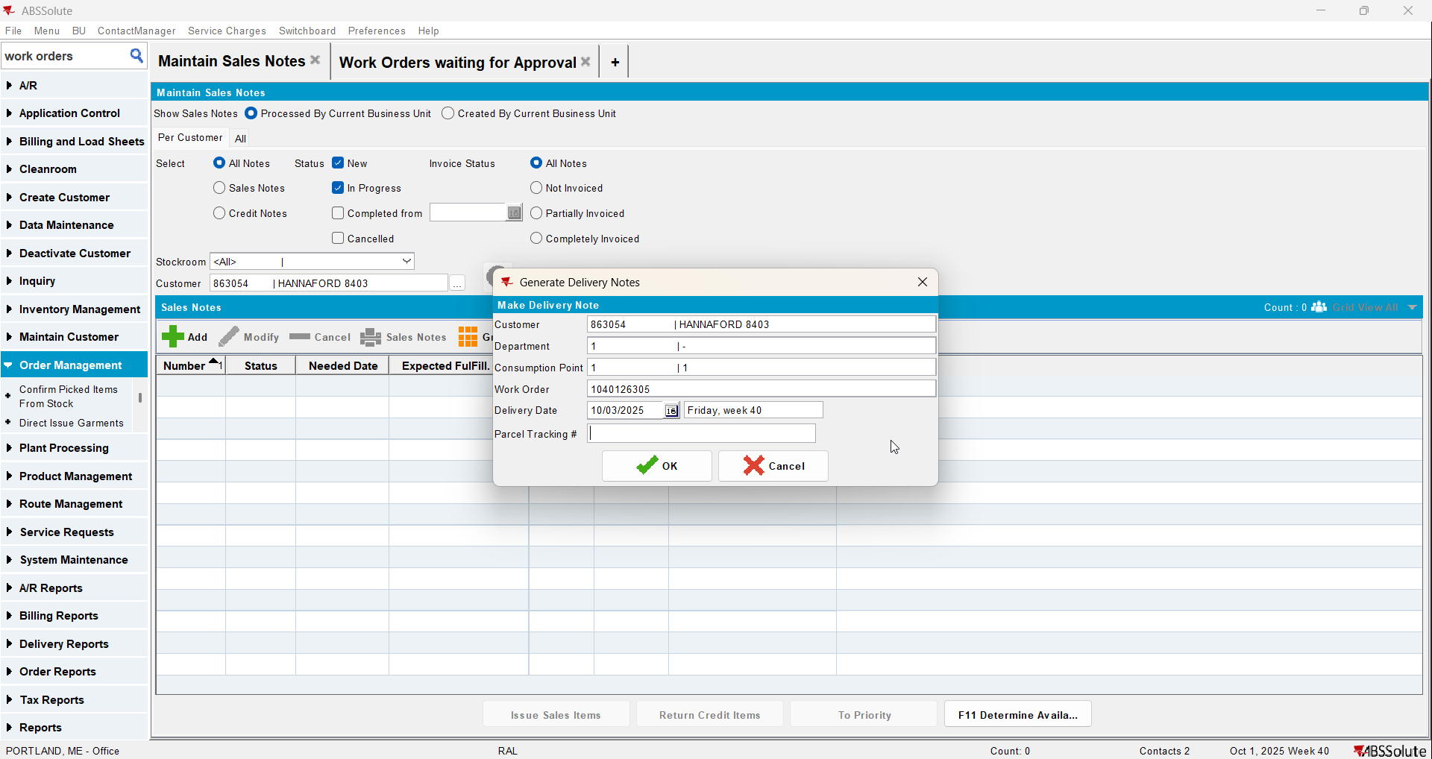
- Check that the sales note is attached
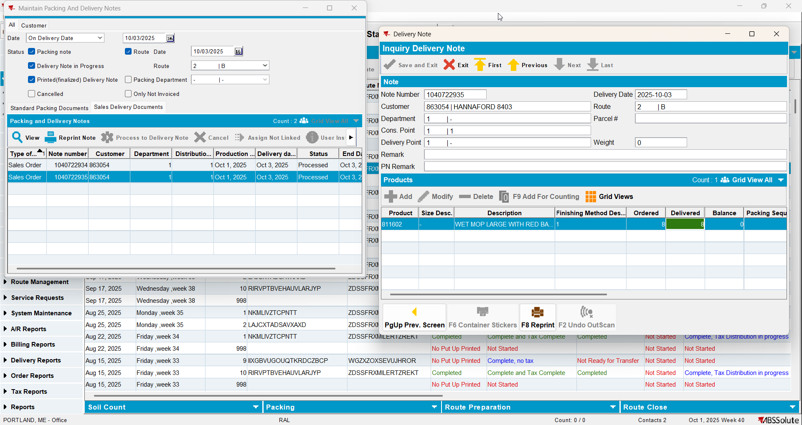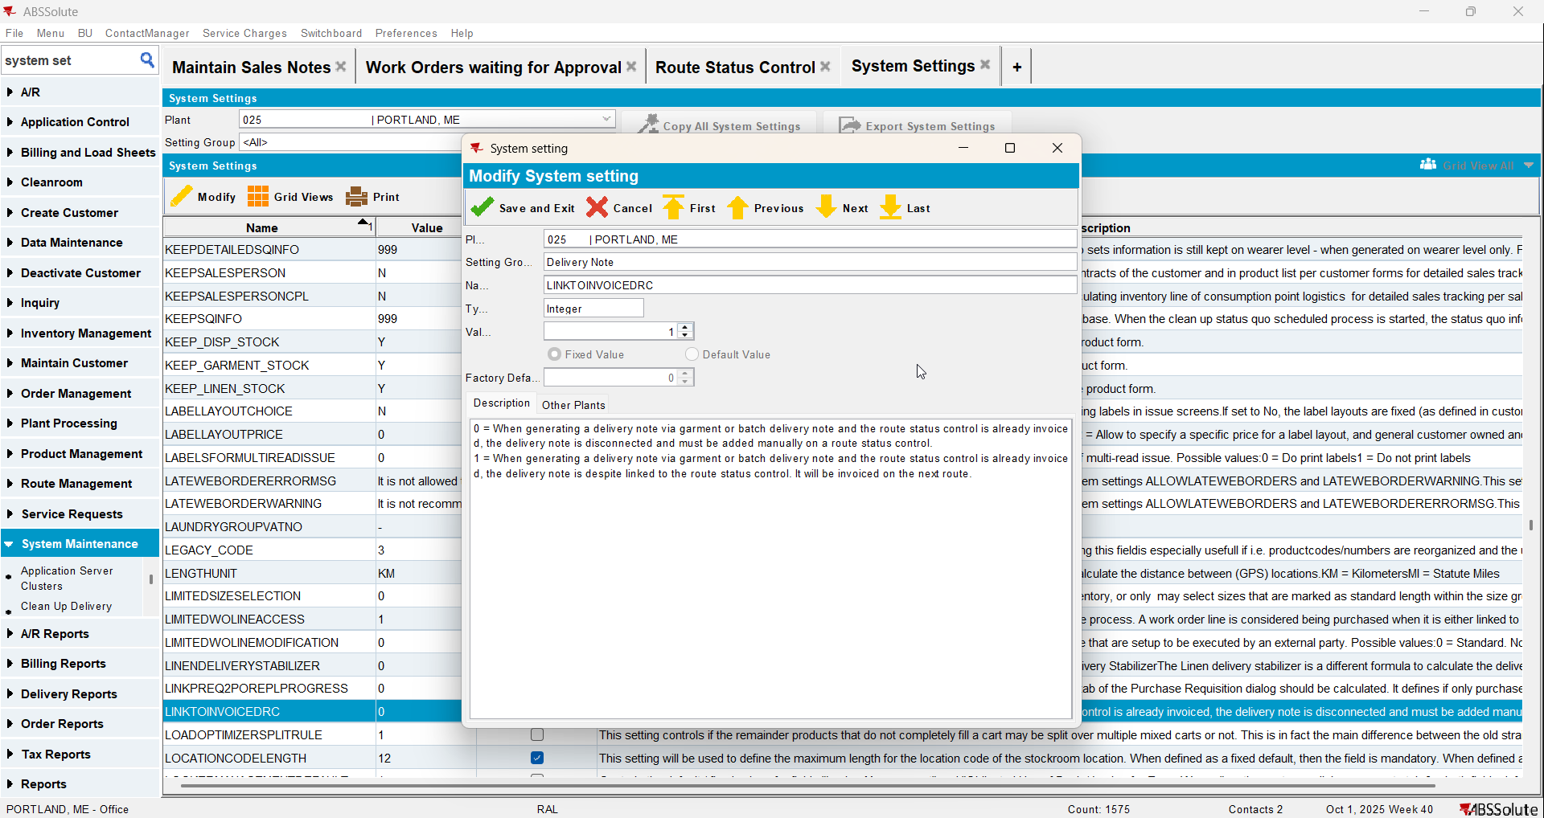

Test Case 5 – BM3 - Wash only PLPC, have a routecontrol with this customer that is already invoiced and add manual DVs and then generate packingnotes from those DVs for the same routecontrol then run route finalization for the routecontrol– Tested OK
Expected behavior: Route finalization does invoice the new packing note from the manual DVs
Hash: 9934ef3
- Set SS LINKTOINVOICEDRC to 1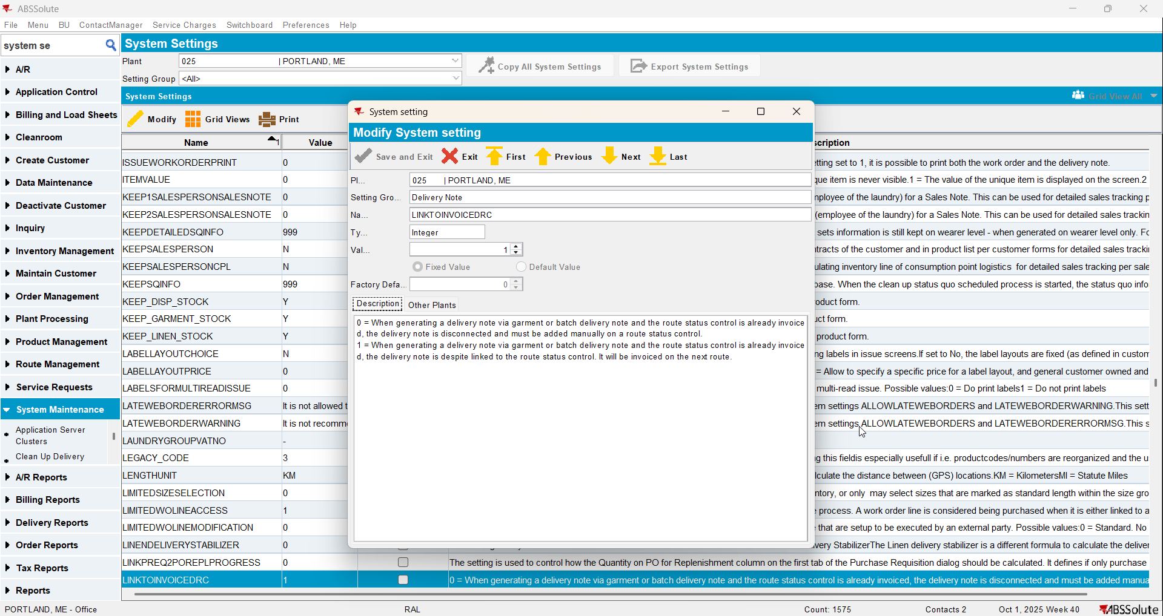
- Have a customer that has a non garment with BM3 wash only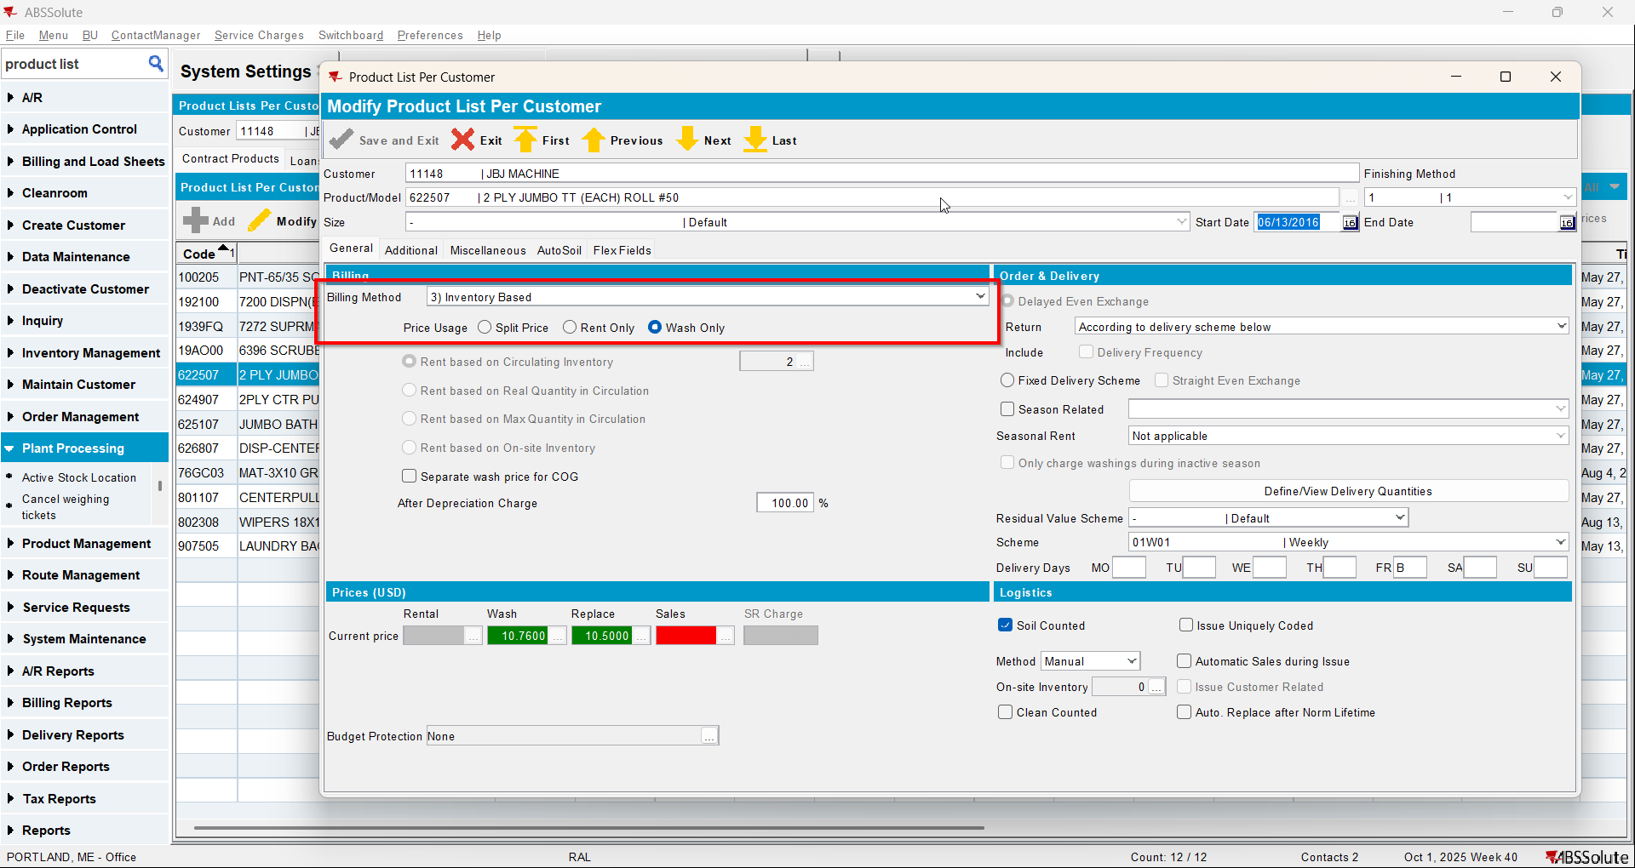
- Generate invoices for your route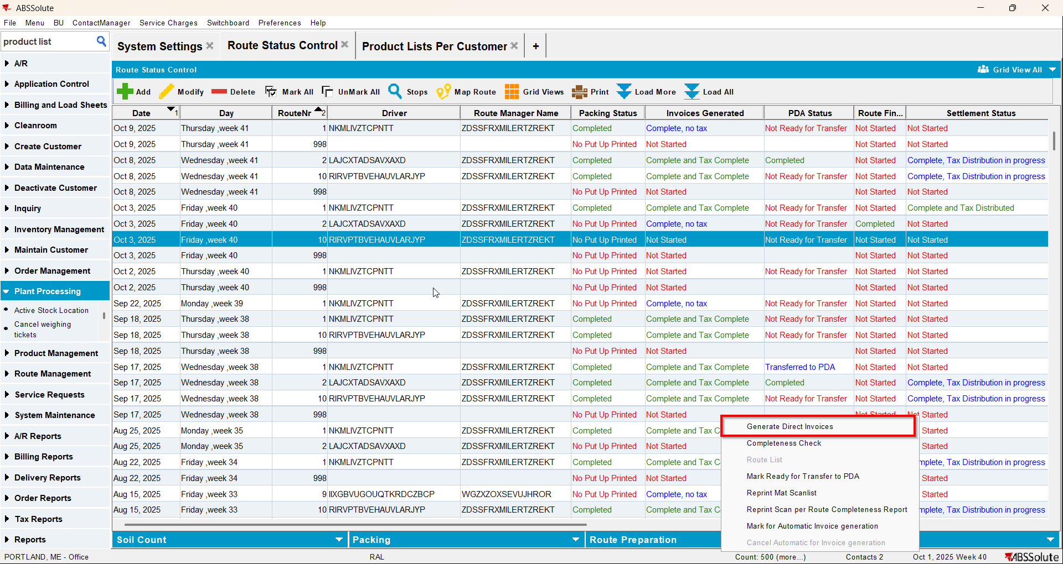
- Check that the product does not appear or does not have a qty on the invoice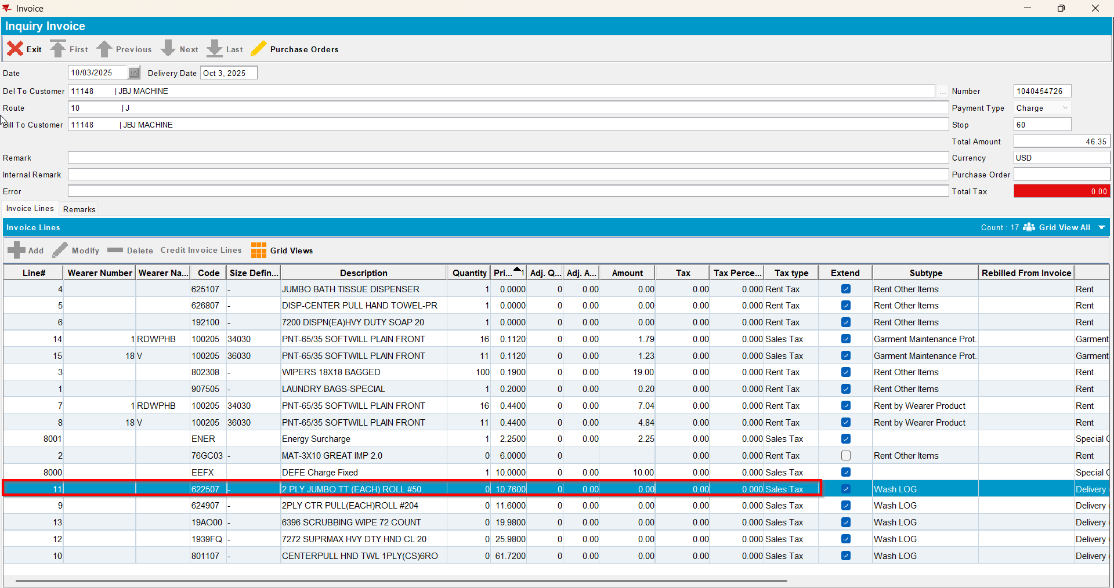
- Add a delivery variation using that product for your customer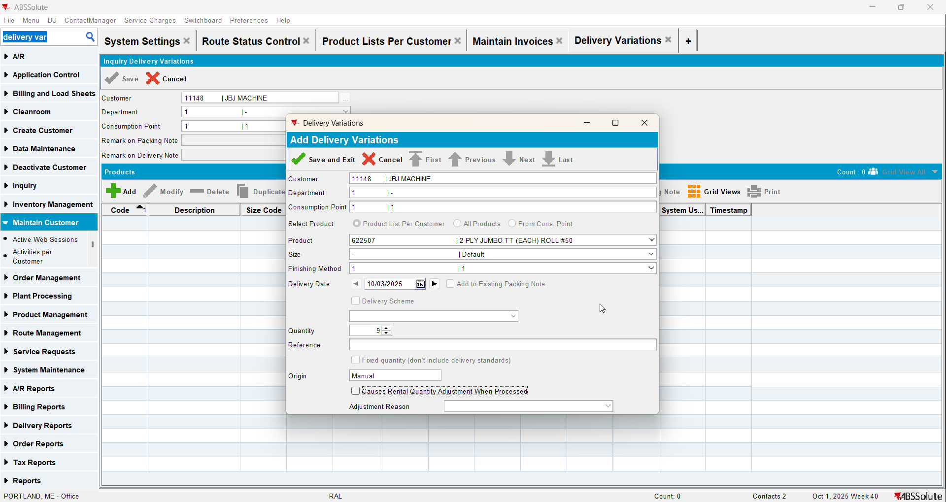
- Generate PN from the delivery variations on the date that the route is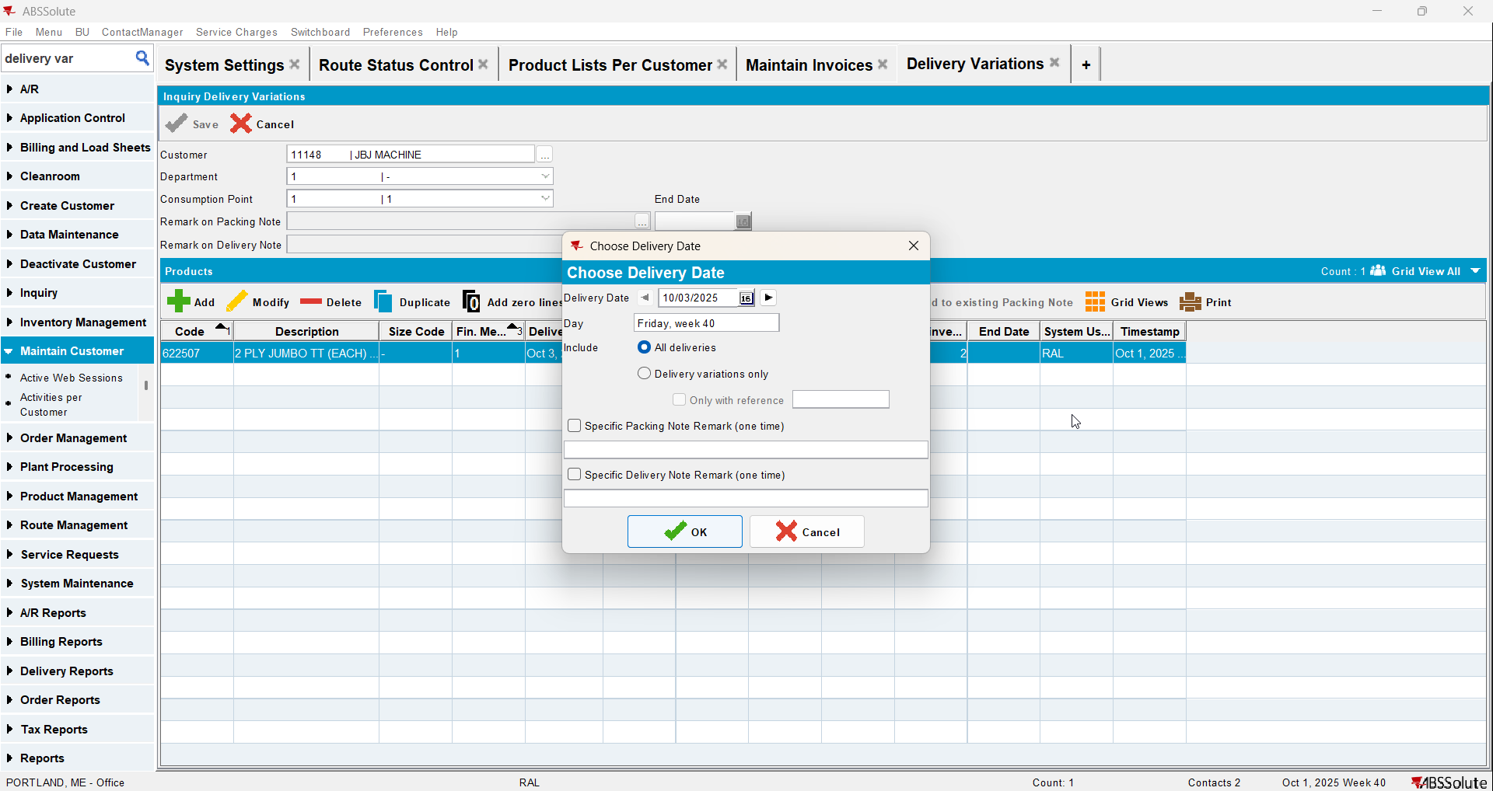
- Run process Cancel and Regenerate US direct invoices for late delivery notes
- Check that the product appears now on the invoice