ABSN-7182 Cannot move stop to route with inactive customers
Environment | Prerequisites
Version: 9.07.00.UNF21  DBServerName= abs-srv20.internal.abslbs.com  DBSID=CUST24  DBUser=UNFDEV  Environment=Test | - Module:  - System setting

Contents
Reproduction before fix 1
Retest after fix 3

Reproduction before fix
Hash: b5fe58ee143e

- Find a route stop with all customers inactive. For example, route 78 from Friday
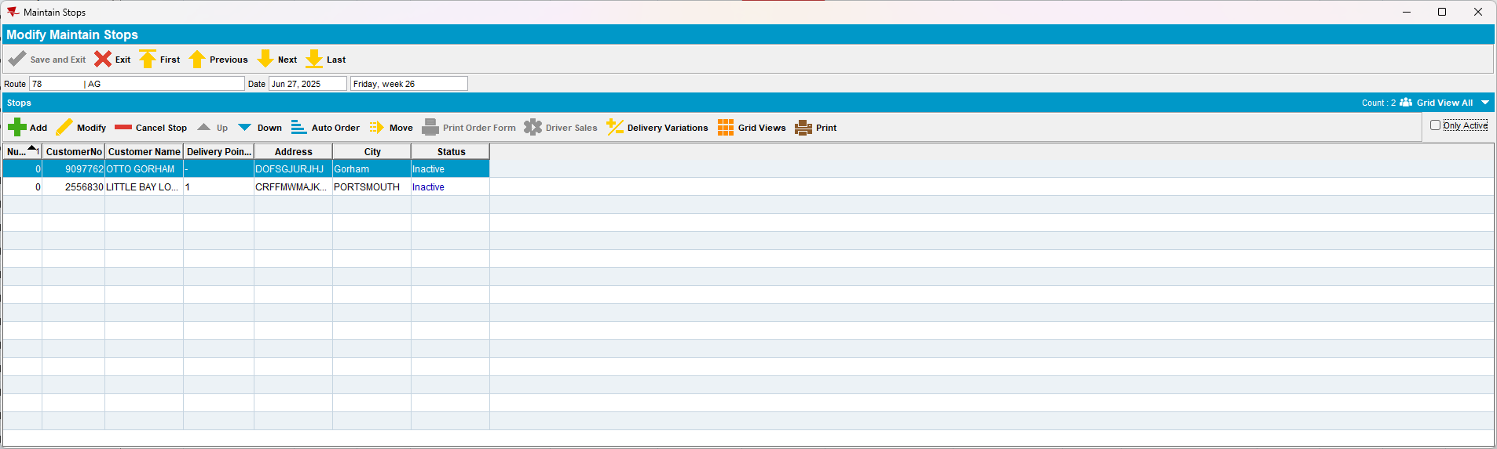

- Find a customer from that BU that doesn't have a route stop on Friday, for example, 3360
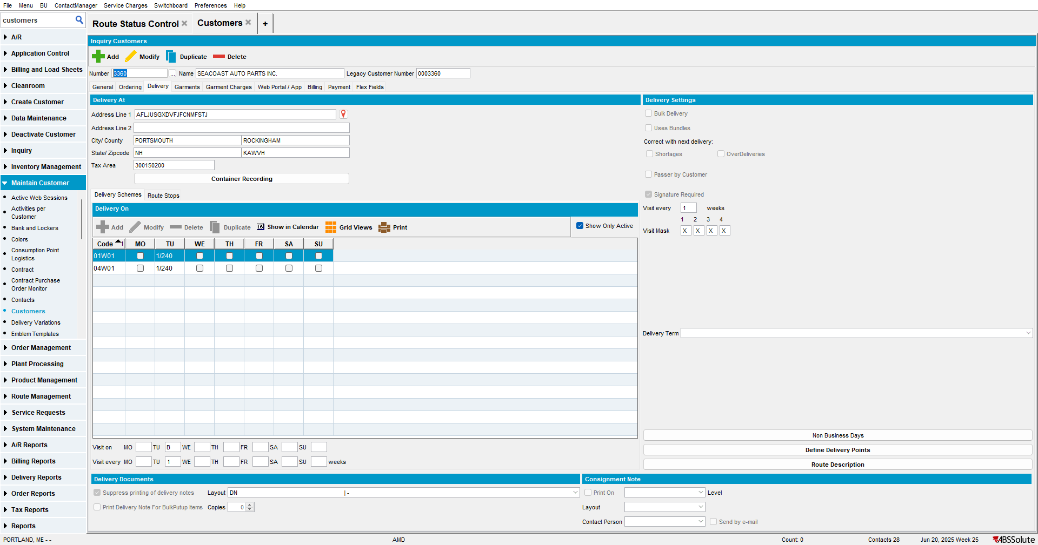

- From Customer dlg, try to move the route stop to the one found in the first step.
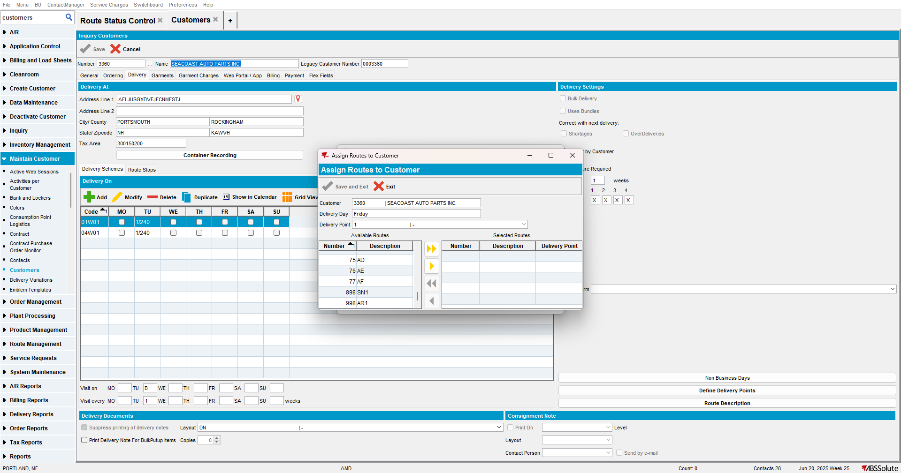

Current behavior
The route from the first step doesn't appear in the To Route List because all the customers are inactive.
Expected behavior
The route can be selected even if the customers are inactive.

Retest after fix
Hash: 923ece98d54d

Test Case #1 – Move stop to route with inactive customers with same invoice business unit.

- Find a route stop with all customers inactive. For example, route 53 from Monday
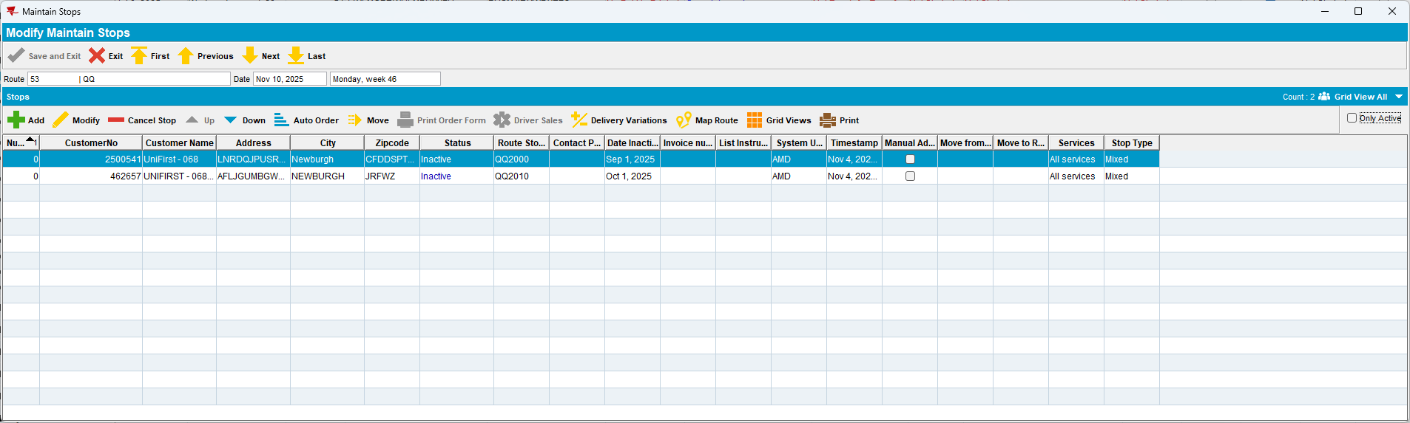

- Find a customer from that BU that doesn't have a route stop on Monday, for example, 3360
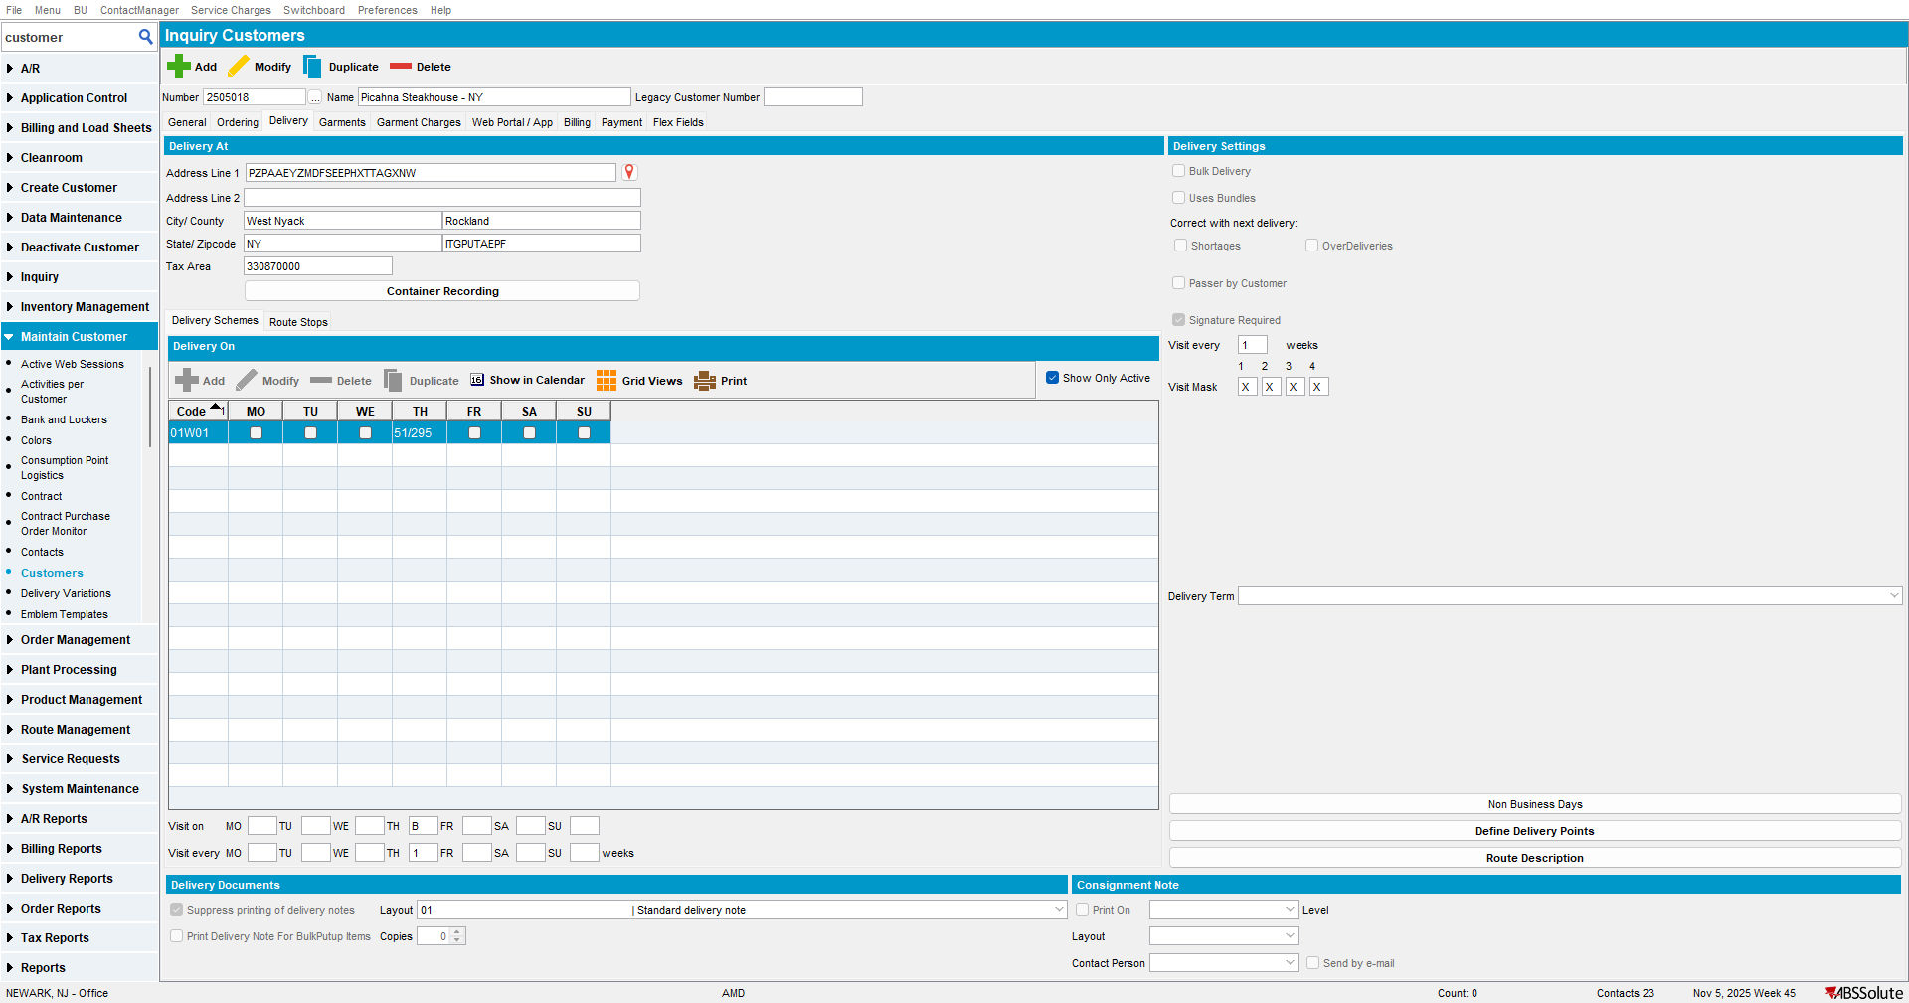

- From Customer dlg, try to move the route stop to the one found in the first step.
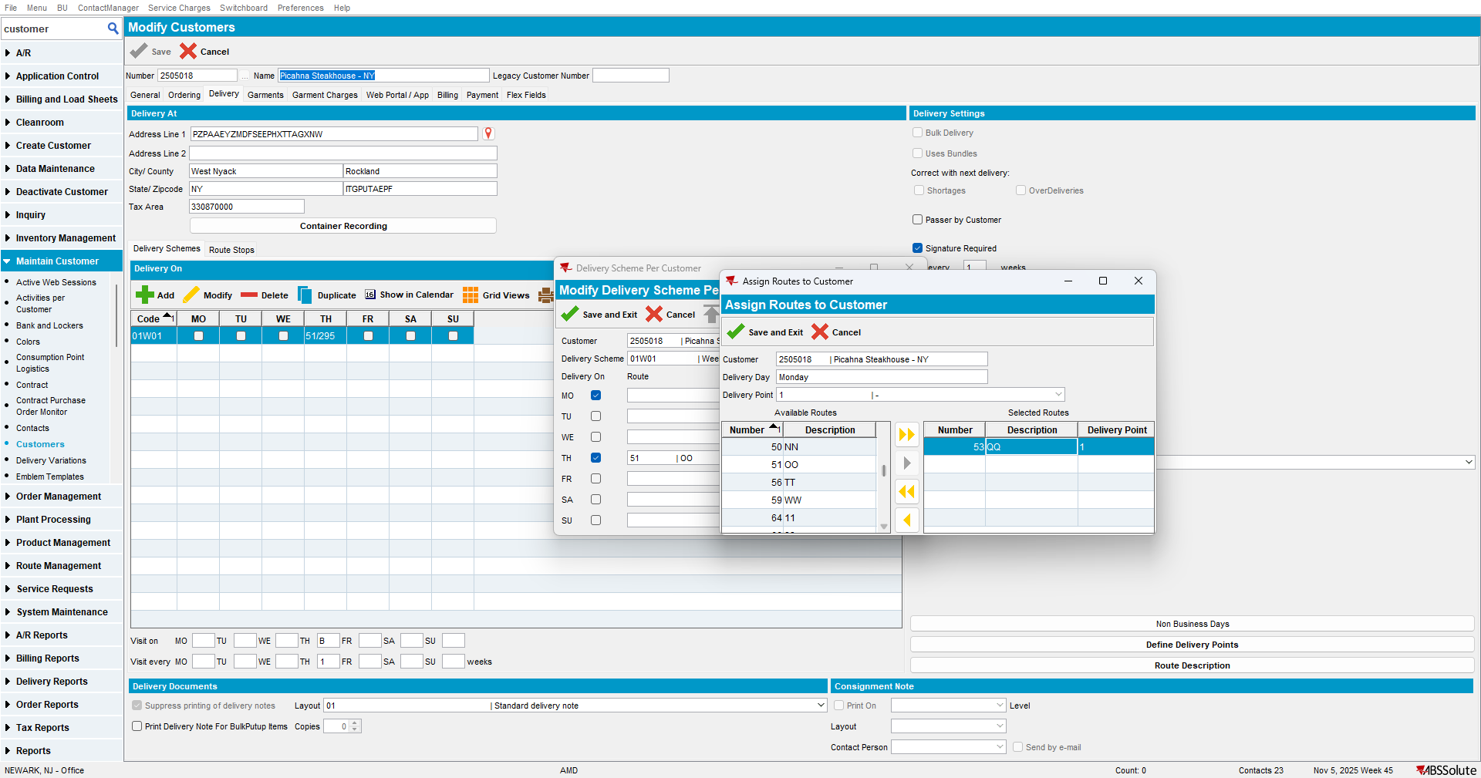

Current behavior
The route can be selected even if the customers are inactive.
Expected behavior
The route can be selected even if the customers are inactive.

Test Case #2 – Move stop to route with inactive customers with different invoice business unit.

- Find a route stop with all customers inactive. For example, route 53 from Monday

- Find a customer from that BU that doesn't have a route stop on Monday, but different invoice BU.
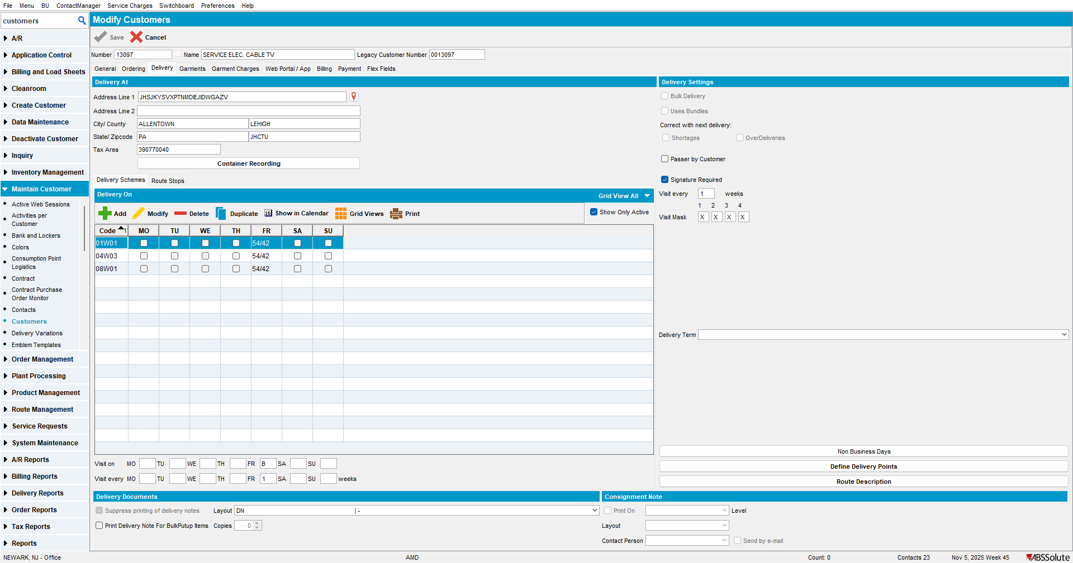

- From Customer dlg, try to move the route stop to the one found in the first step.
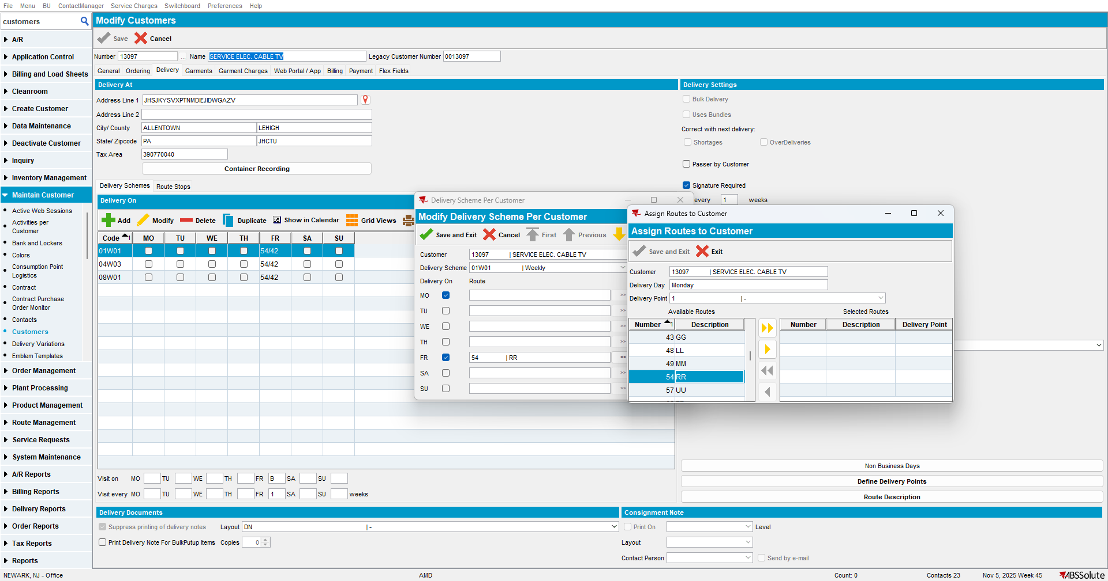

Current behavior
The route can’t be selected.
Expected behavior
The route can’t be selected.

