ABSN-6494 D_UBS_2545 Show Repl_StillToBeCharged in Wearer Inventory grids
Environment | Prerequisites
Version:9.07.00.UNF21  DBServerName= abs-srv20.internal.abslbs.com  DBSID=CUST24  DBUser=UNFDEV  Environment=PRODUCTION | - Module:  - System setting

Contents
Test before fix 1
Steps to reproduce: 1
Current behaviour: 2
Expected behaviour: 3
Retest after fix 3
Expected behavior: 3
Test steps: 3

Test before fix

Steps to reproduce:

- Create a route with a customer who has at least 2 wearers with garments with unique items
- Upload the route on RA
- On RA, do a scan garments, replace (Change as Needed)
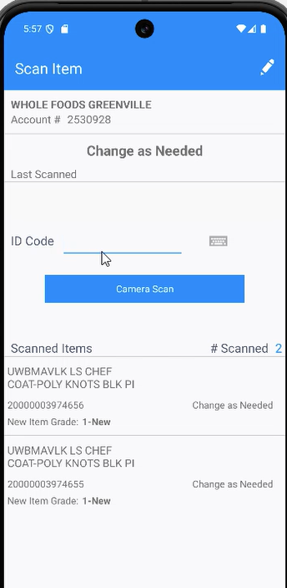
- Scan 2 unique item ID from each wearer and set the grade:
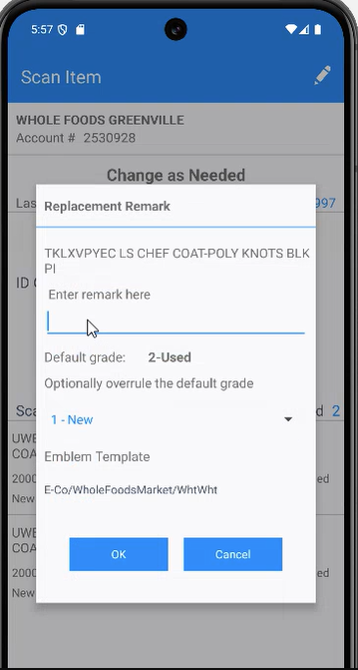
- Settle the route and uploaded
- in WebX, review the route
- in Route returns application, rag the unique items that you scan on RA except one that you should move in stock
- in WebX, settle the route

Current behaviour:
The transactions with the unique items that were ragged don't have the work order number set and, in the log there is no line to indicate the work order was created

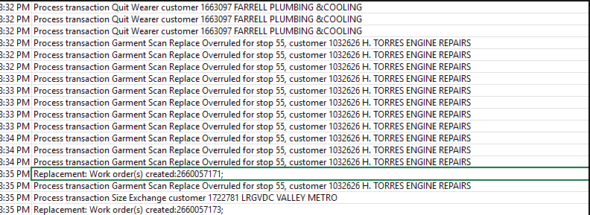

Expected behaviour:
The transactions with the unique items that were ragged should have the work order number set, and a line in the log should indicate the work order number that was created.

Retest after fix
9.07.00.UNF21 hash: 8d9e27e5f9f1
Bu: 083 CINCINNATI

Expected behavior:
Create workorder, workorderline, workorderlinemodification and workorderlineemblem records using the requested grade from PDA for the work order line
Update the route transaction with the workordernumber
NOTE: If RouteReturn dialog is in use then it is possible that the unique item being replaced has been ragged before this processing. If this happens, then the ragged item should be used as the source of data for creating the work order, the unique item updates skipped and no error logged

Test steps:
- Create a route with a customer who has at least 2 wearers with garments with unique items
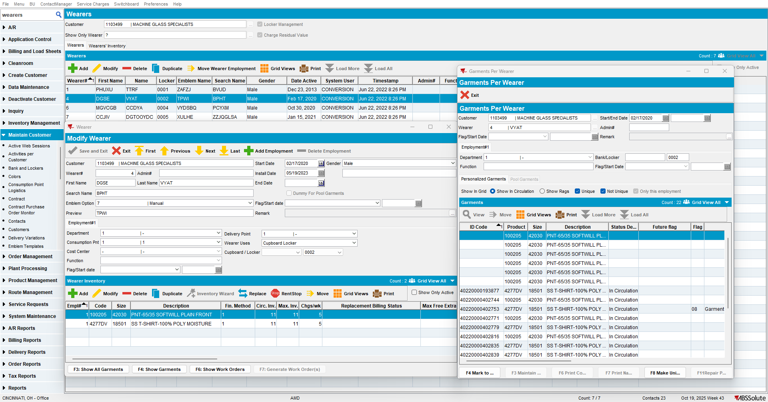
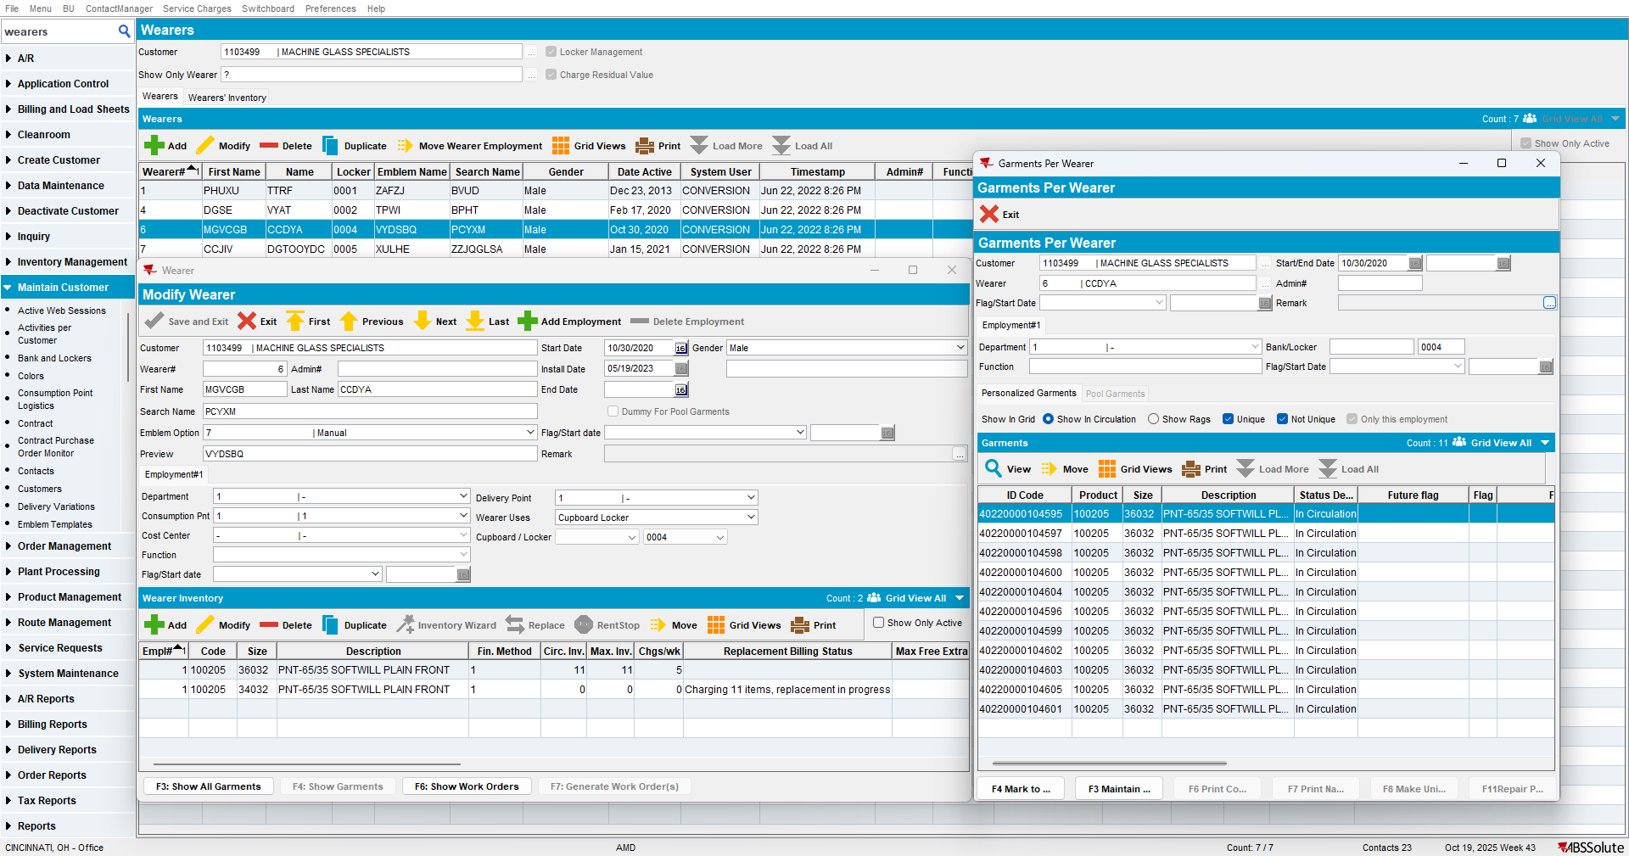
- Upload the route on RA
- On RA, do a scan garments, replace (Change as Needed)
- Scan 2 unique item ID from each wearer and set the grade:
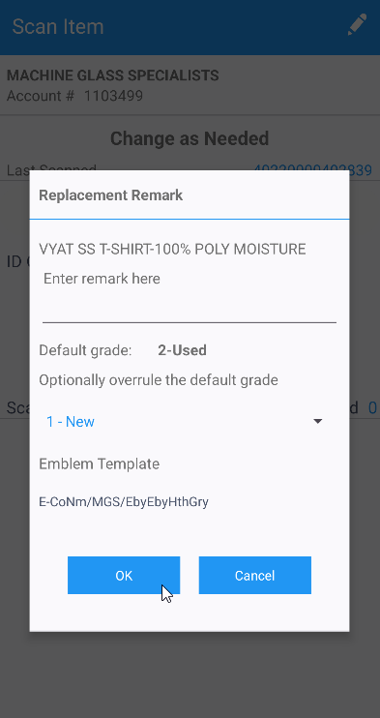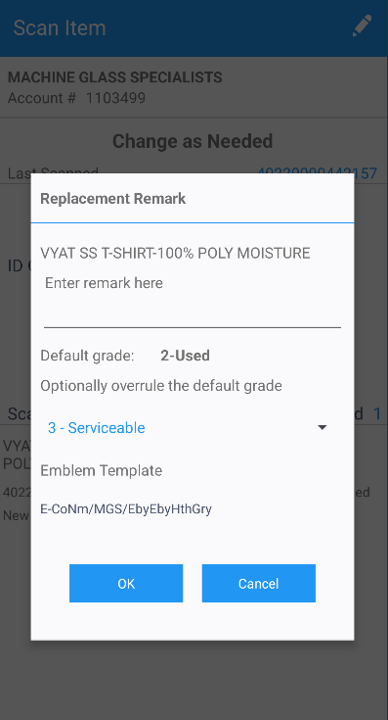
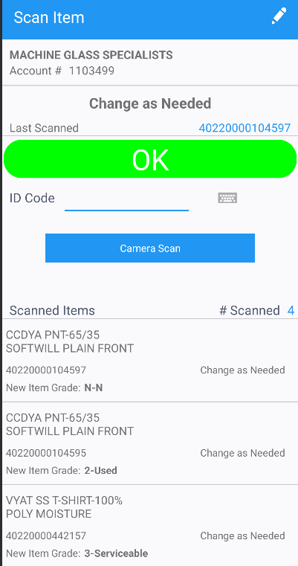
- RA: Settle the route and uploaded.
- WebX: Complete start my day and review everything for the route.
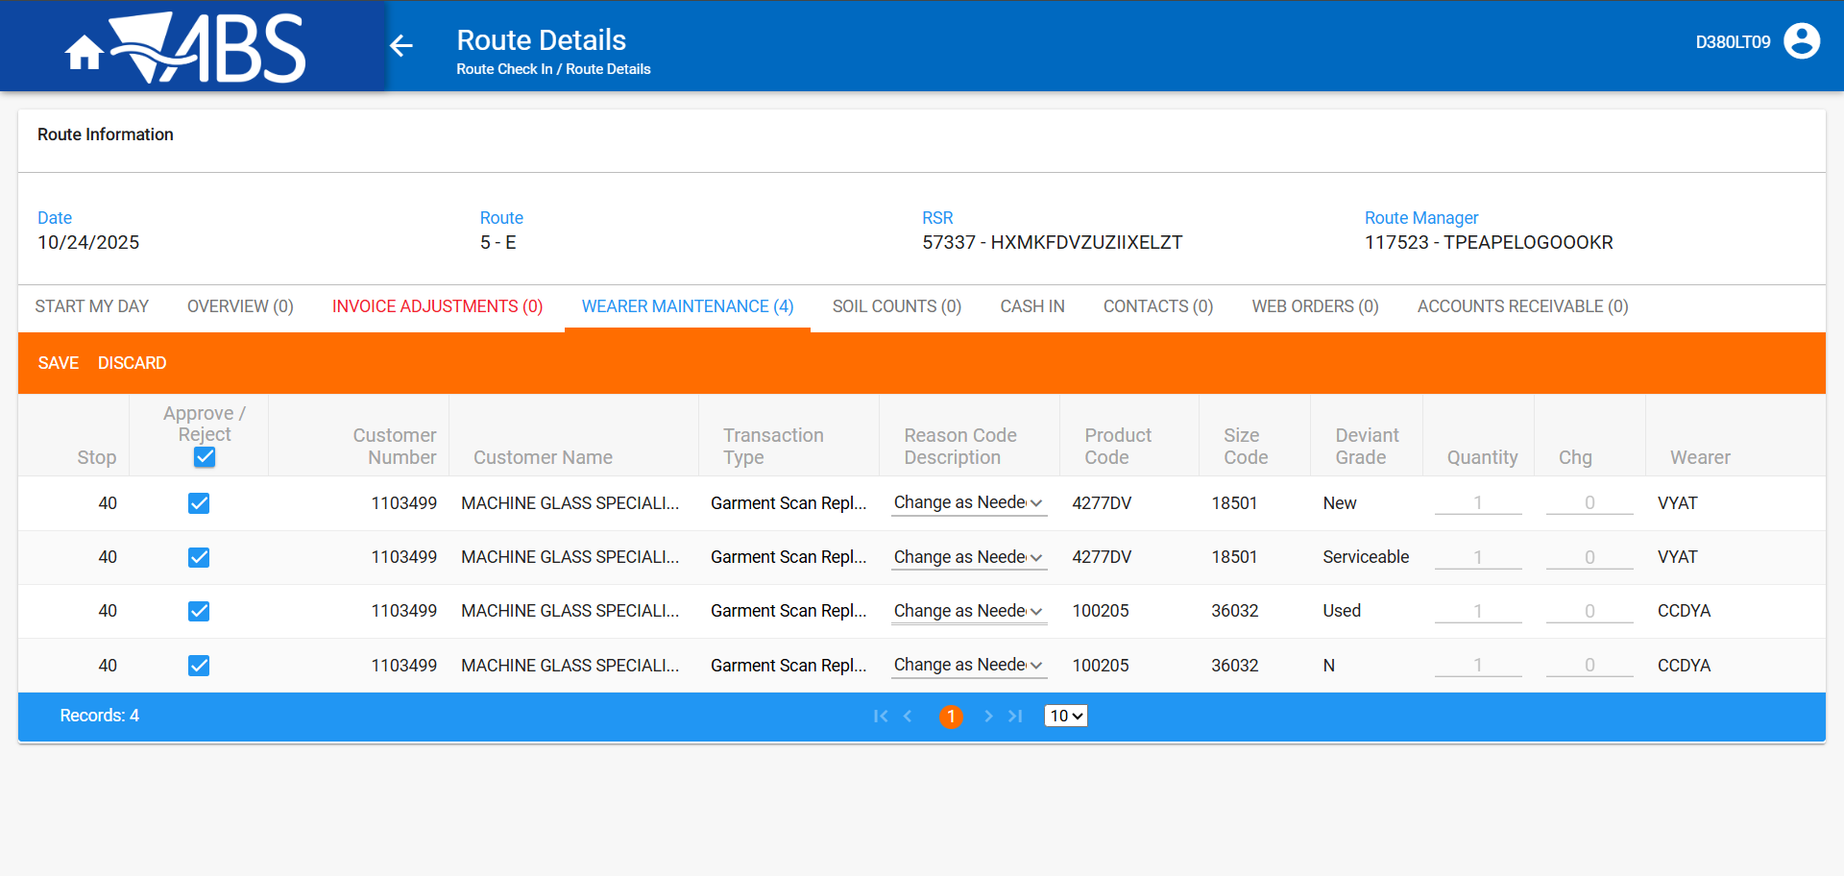
- Route returns application: Rag one unique item from each wearer and keep one from each to move to stock, from the total of 4 scanned on RA.
Ragged
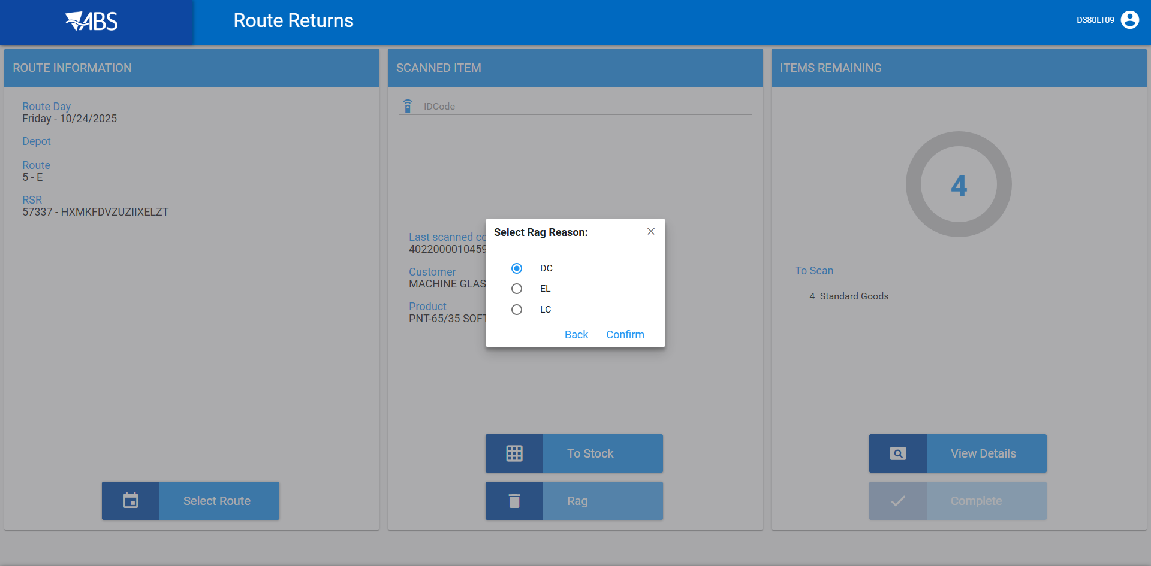

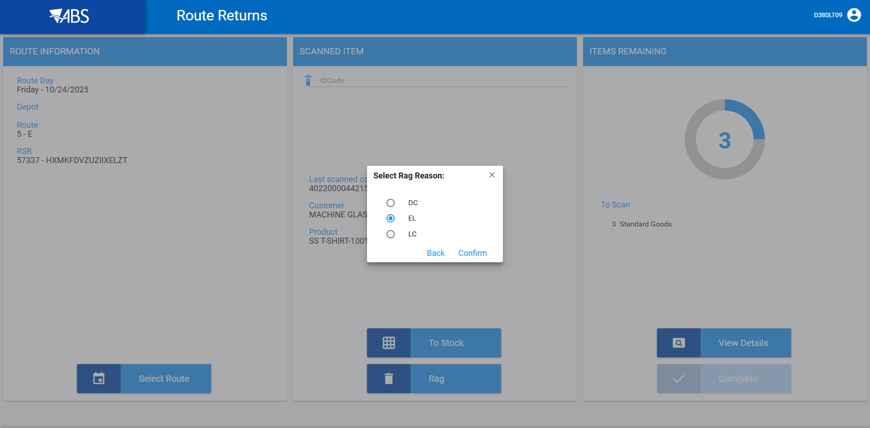

Stock
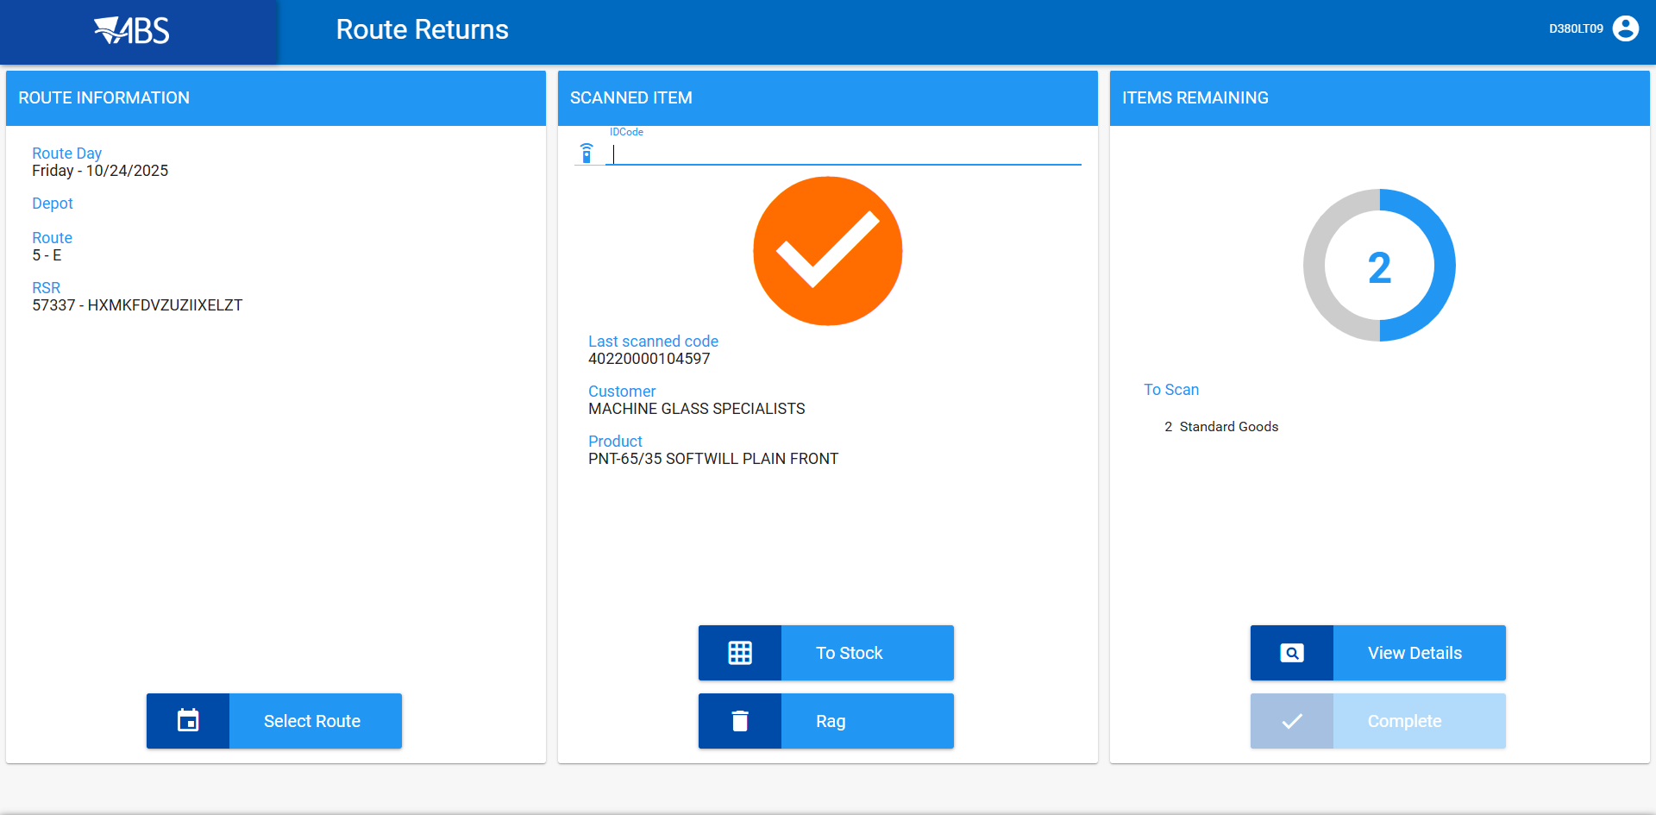
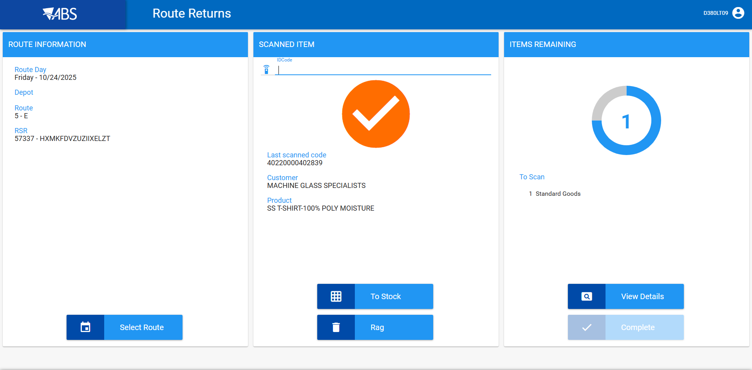

- WebX: Settle the route
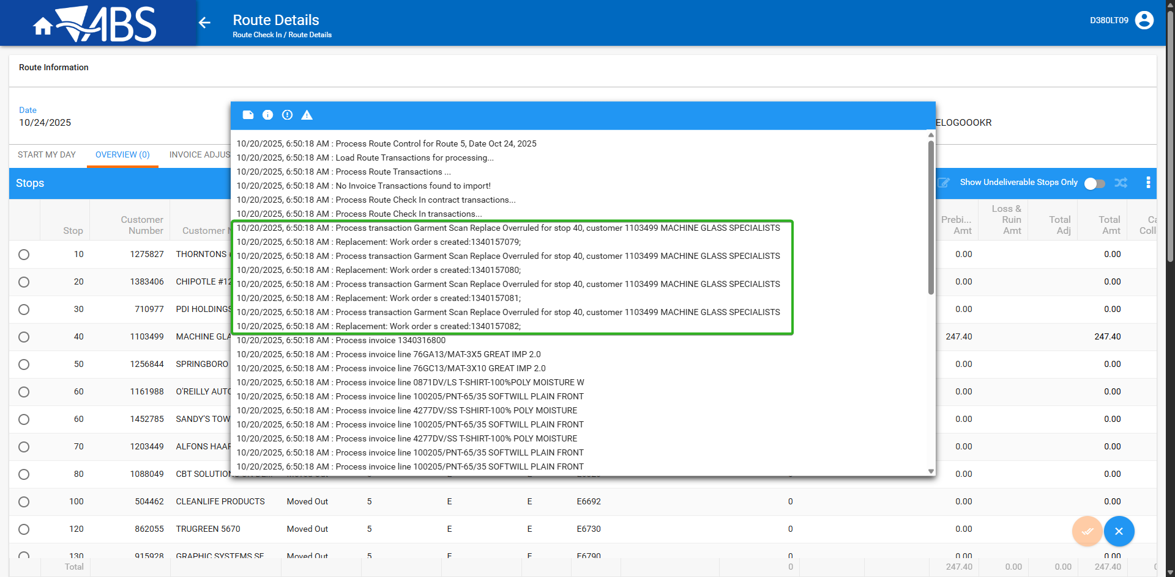

- WebX: Re-check on the wearer maintenance tab the workorders.
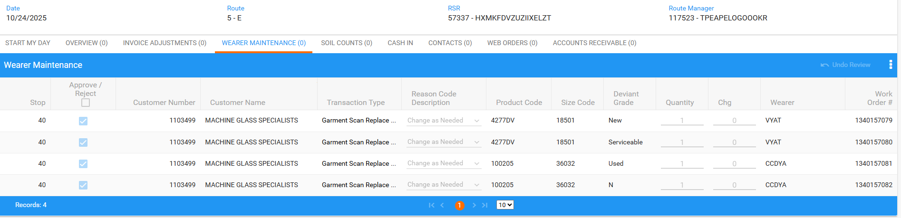

Tested OK

