ABSN-3249 Extend REST logging to include request body
Environment | Prerequisites
Version:9.07.00.UNF21  DBServerName= abs-srv16.internal.abslbs.com  DBSID=CUST24  DBUser=UNFDEV  Environment=PRODUCTION | - Module:  - System setting

Contents
Retest before fix 1
Test Steps: 1
Retest after fix 2
Expected behavior: 2
Test Steps: 2

Retest before fix
9.07.00.UNF21 hash: 8d9e27e5f9f1
Bu: 288 RICHMOND, VA

Test Steps:
- Customers dlg: Load any customer that has CustomerDeliveryDay.
- Customers dlg: Delete the B from the Delivery tab.
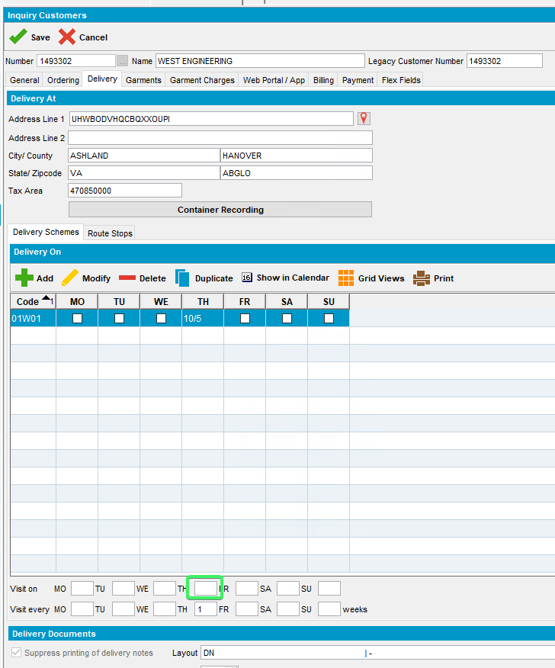
- Customers dlg: Save the customer. No message informing the user of the garment delivery day.
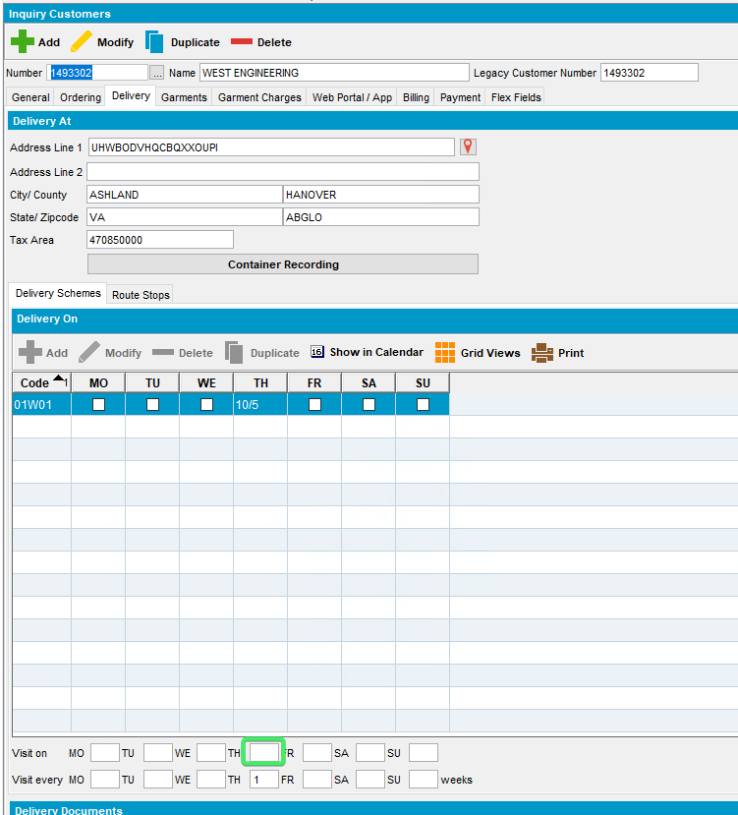
Reproduced OK

Retest after fix
9.09.02.RC1 hash: 424daf6da7eb
Bu: 288 RICHMOND, VA

Expected behavior:
If a delivery day is changed from D,B or P to Blank, then check if there is a garment delivery day for this day of the week (CustomerDeliveryDay.TypeOfMerchandise = 2 for the same Customer and Day_ID of any delivery type) and if there is, show an error message “You cannot remove delivery on <day description> as this is a garment delivery day.” And restore the value

Test Steps:
- Customers dlg: Load any customer that has CustomerDeliveryDay.
- Customers dlg: Delete the B from the Delivery tab.
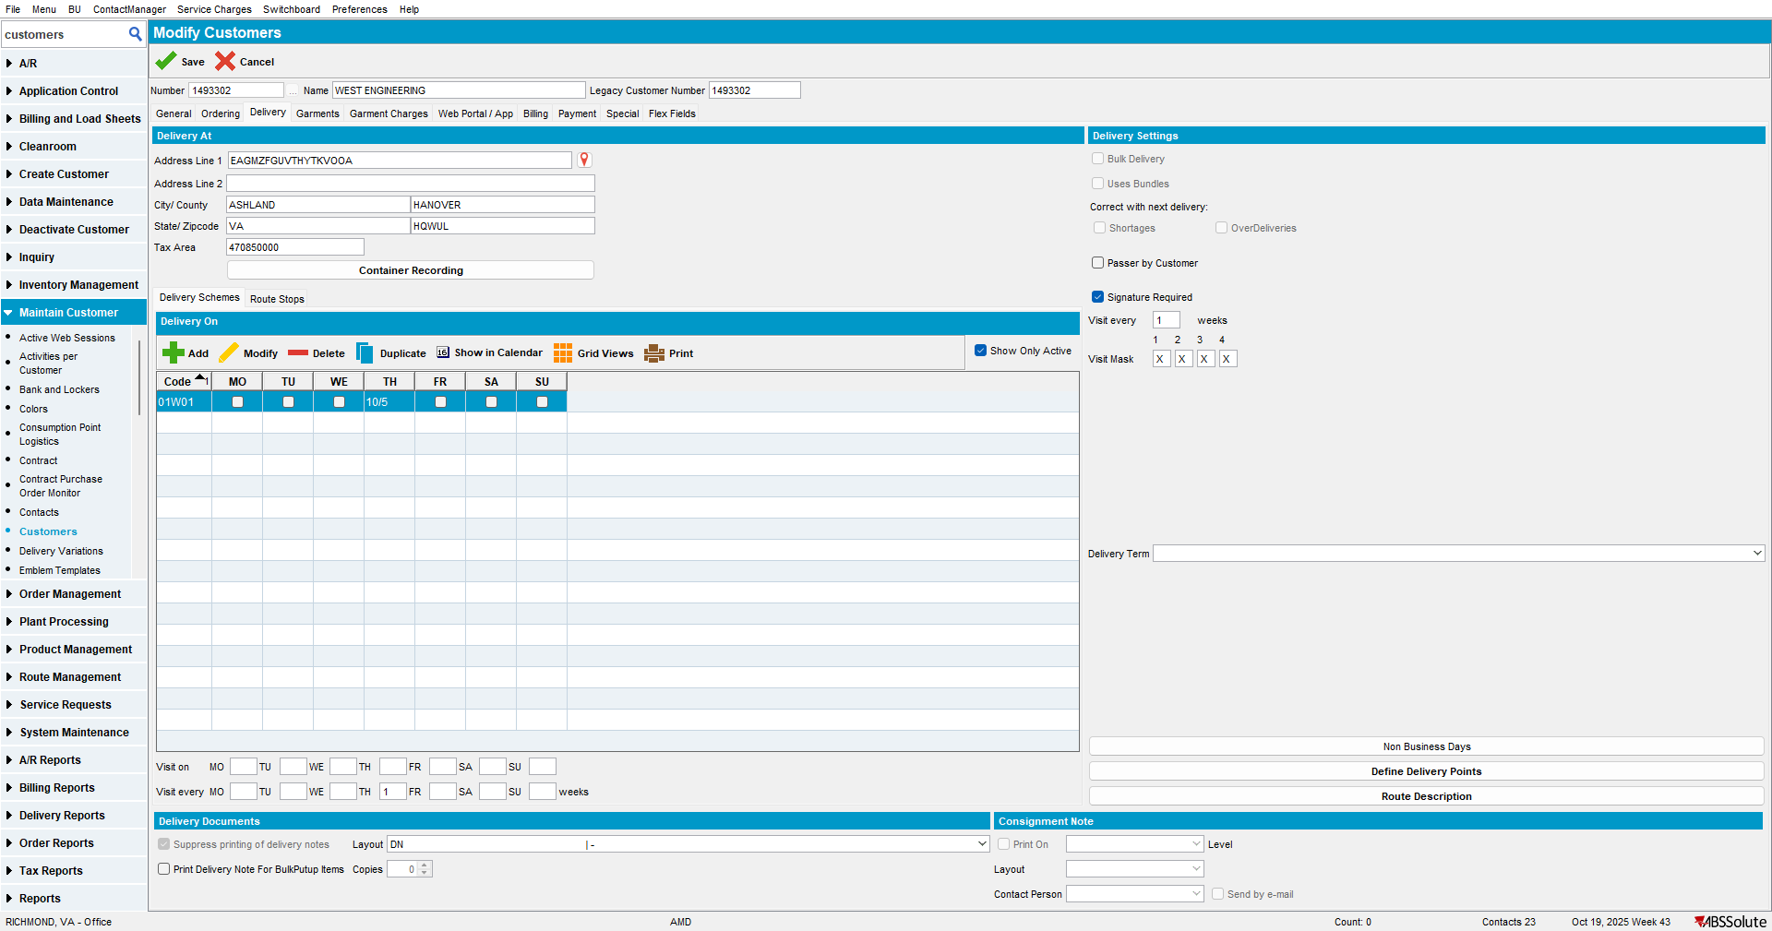
- Customers dlg: Save the customer. An error message is displayed and the value was restored.
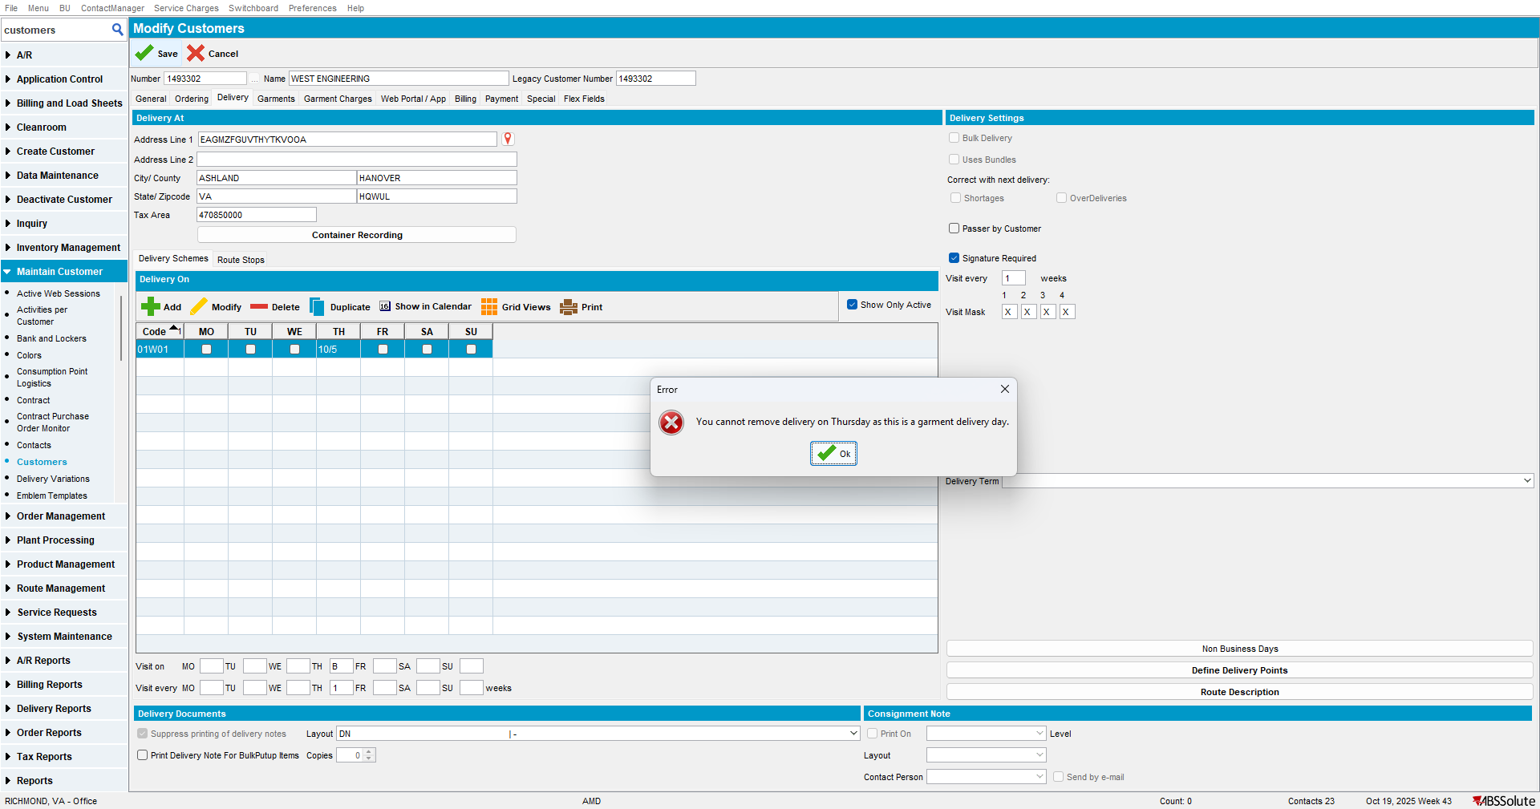
- Find a customer with D delivery days.
select * from Customerdeliveryday CDD
join customer c on c.customer_id = cdd.customer_id
join businessunit bu on bu.businessunit_id = c.defaultbusinessunit_id
where cdd.deliverytype = 'D'
and bu.code = '288'
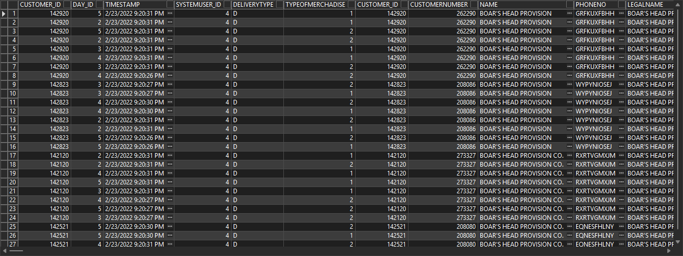
- Customers dlg: Load the customer, delete de D. Save. An error message is displayed and the value was restored.
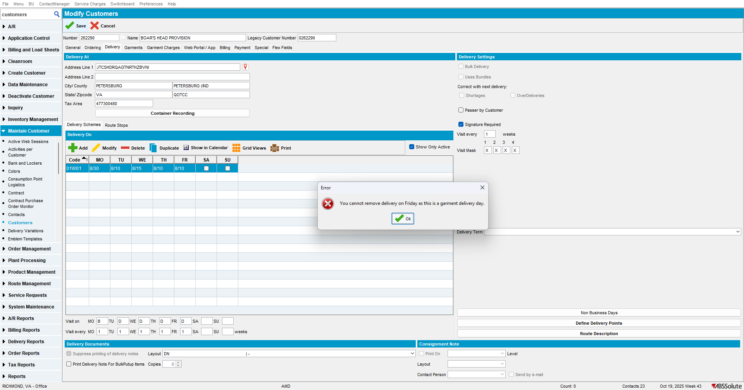
- Find a customer with P delivery days.
select * from Customerdeliveryday CDD
join customer c on c.customer_id = cdd.customer_id
join businessunit bu on bu.businessunit_id = c.defaultbusinessunit_id
where cdd.deliverytype = 'P'
- Switchboard dlg: Load the customer
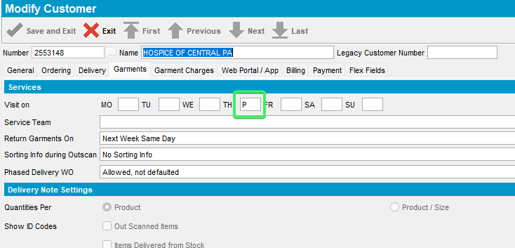
- Switchboard dlg: Delete the P value.
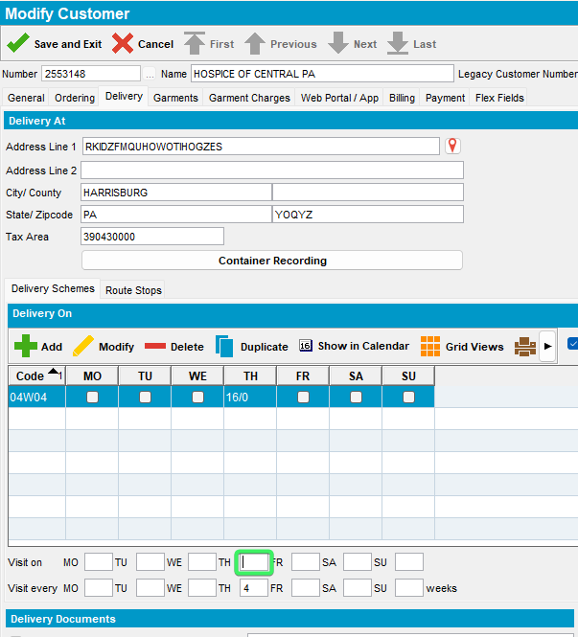
- Switchboard dlg: Save. An error message is displayed and the value was restored.
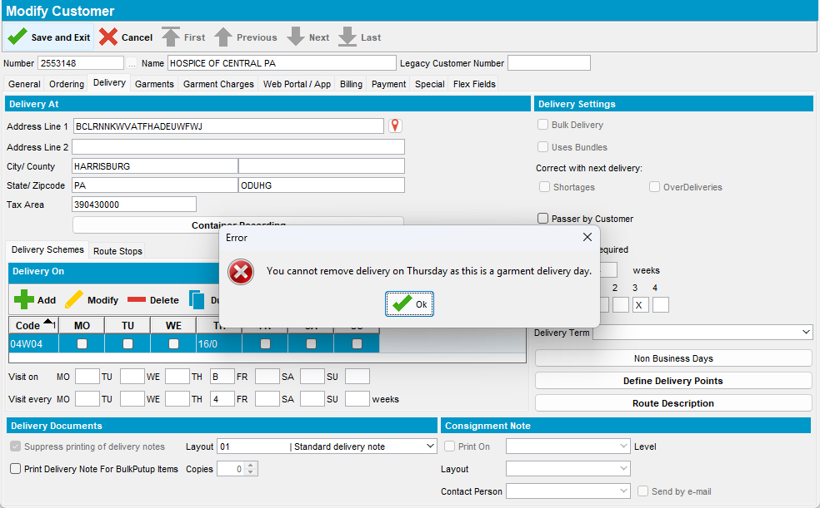

Tested OK

