ABSN-4116 D_UBS_2643 Wearer is billing a higher quantity of garments on the invoice than what is in the Max or Circulating
Environment | Prerequisites
Version:9.07.00.UNF21  DBServerName=abs-SRV20.internal.abslbs.com  DBSID=CUST24  DBUser=UNFDEV  DBPassword=UNFDEV  Environment=Test | - Module:  - System setting

Contents
Test after fix 1
Test Case 1 –Replacement WO cancelled with BM3– Tested OK 1
Test Case 2 –Replacement WO new with BM3– Tested OK 8
Test Case 3 –Replacement WO cancelled with BM1– Tested OK 13
Test Case 4 –Replacement WO new with BM1– Tested OK 20

Test after fix

Test Case 1 –Replacement WO cancelled with BM3– Tested OK
Expected behavior: If repl_stilltobecharged=Y and replacement WO is not in progress then reset repl_stilltobecharged to Null and use MaxInventory
Hash: e1ed7b9
- Have a product with BM3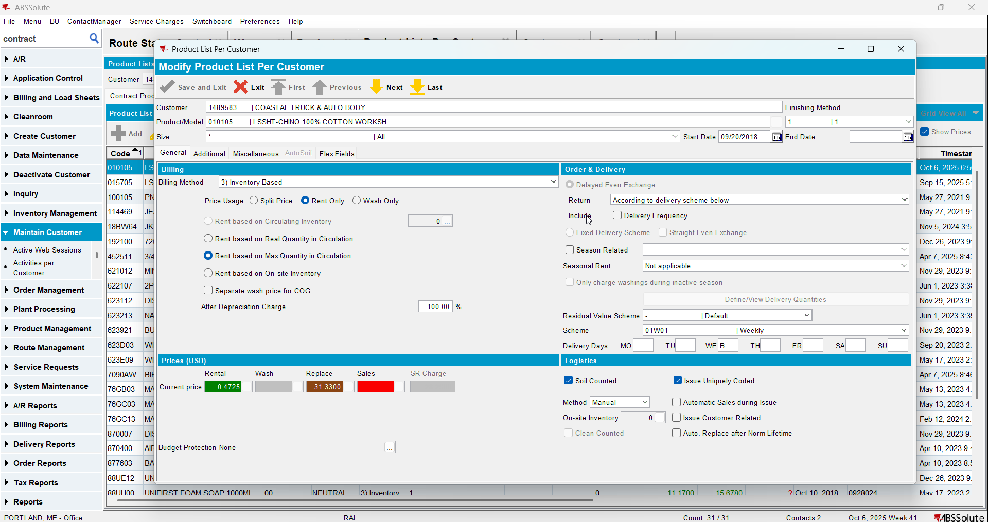
- Create a wearer with wearer inventory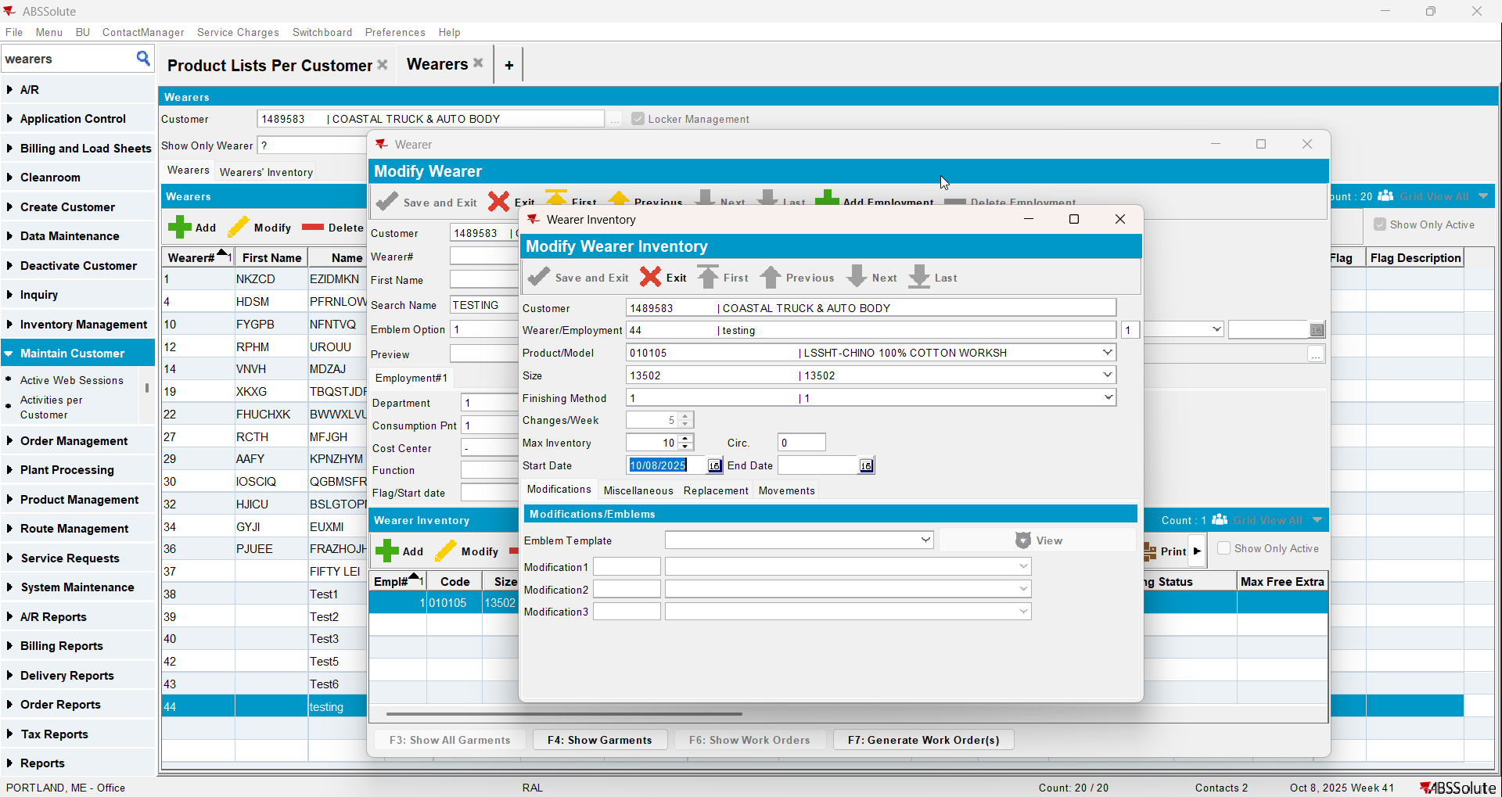
- Generate WO and issue it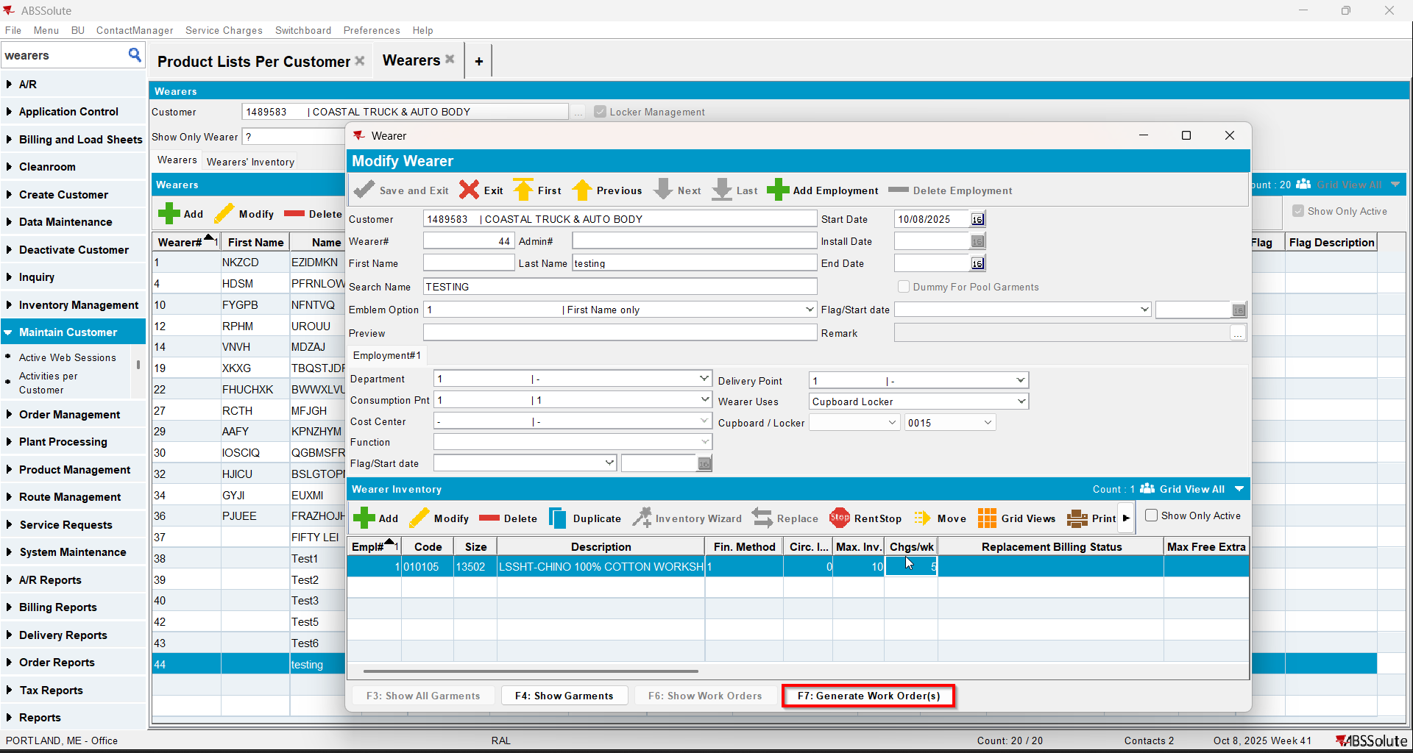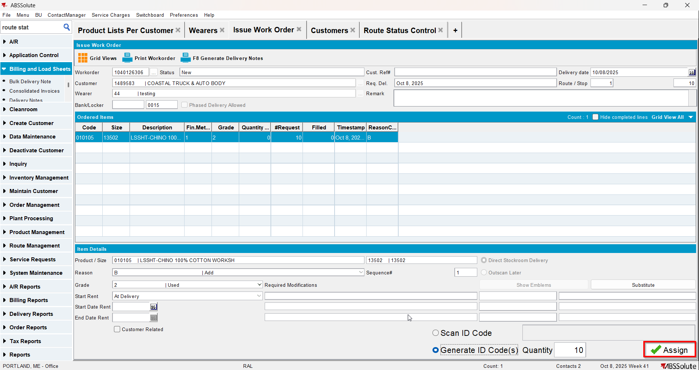
- Repl_stilltobecharged should be null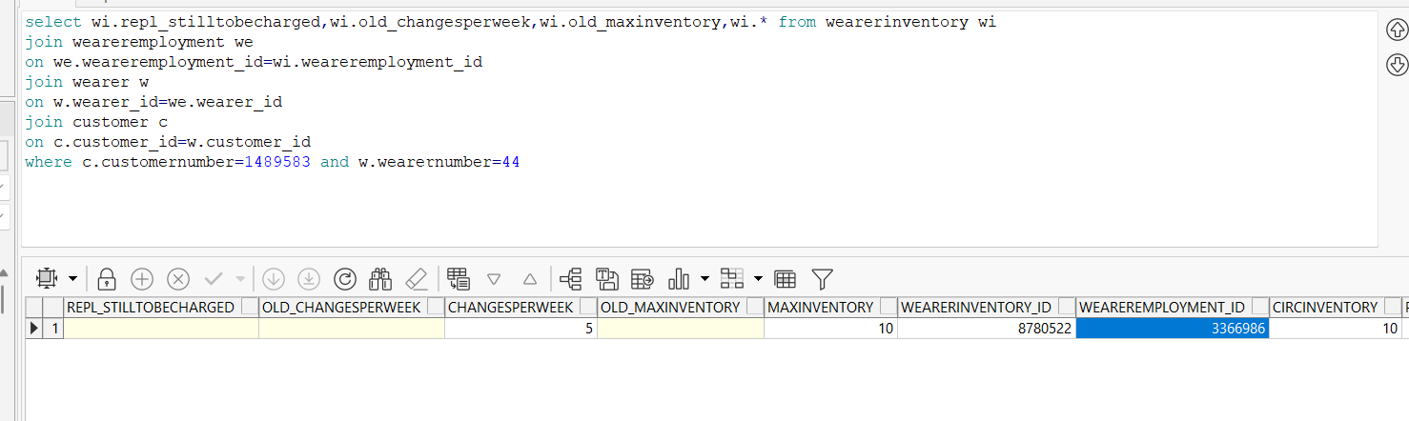
- Do a replacement but don’t issue the WO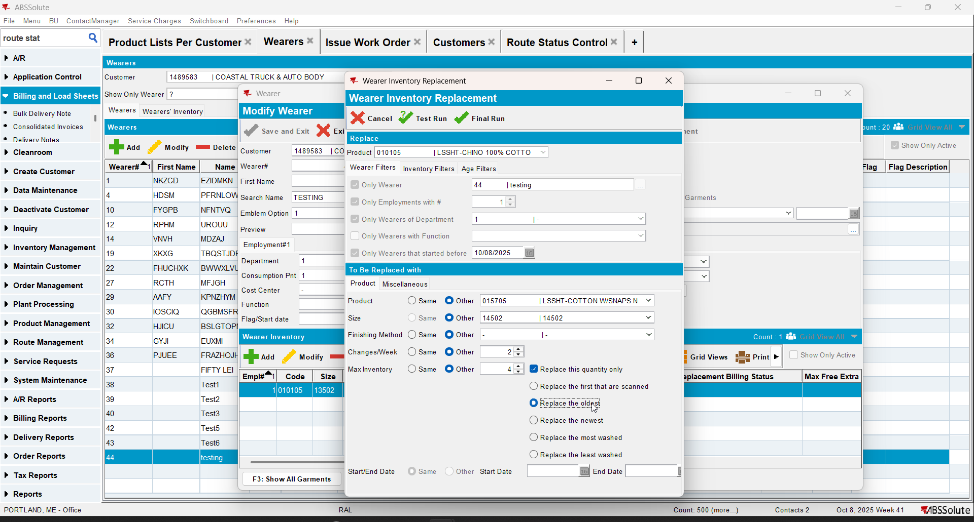
- Repl_stilltobecharged will be Y for the initial product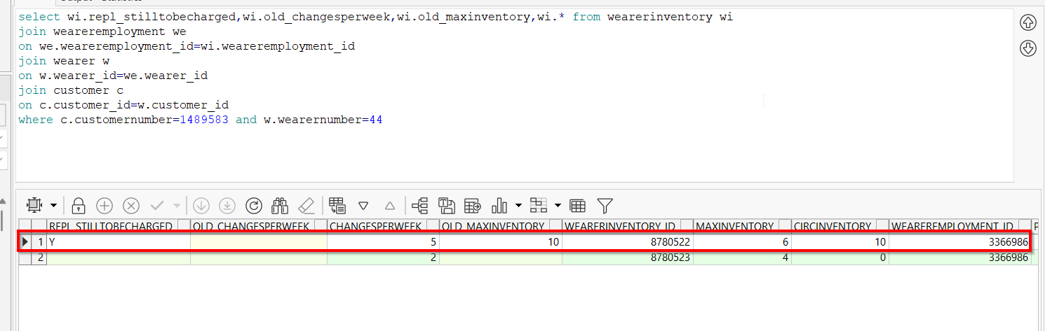
- Cancel the replacement WO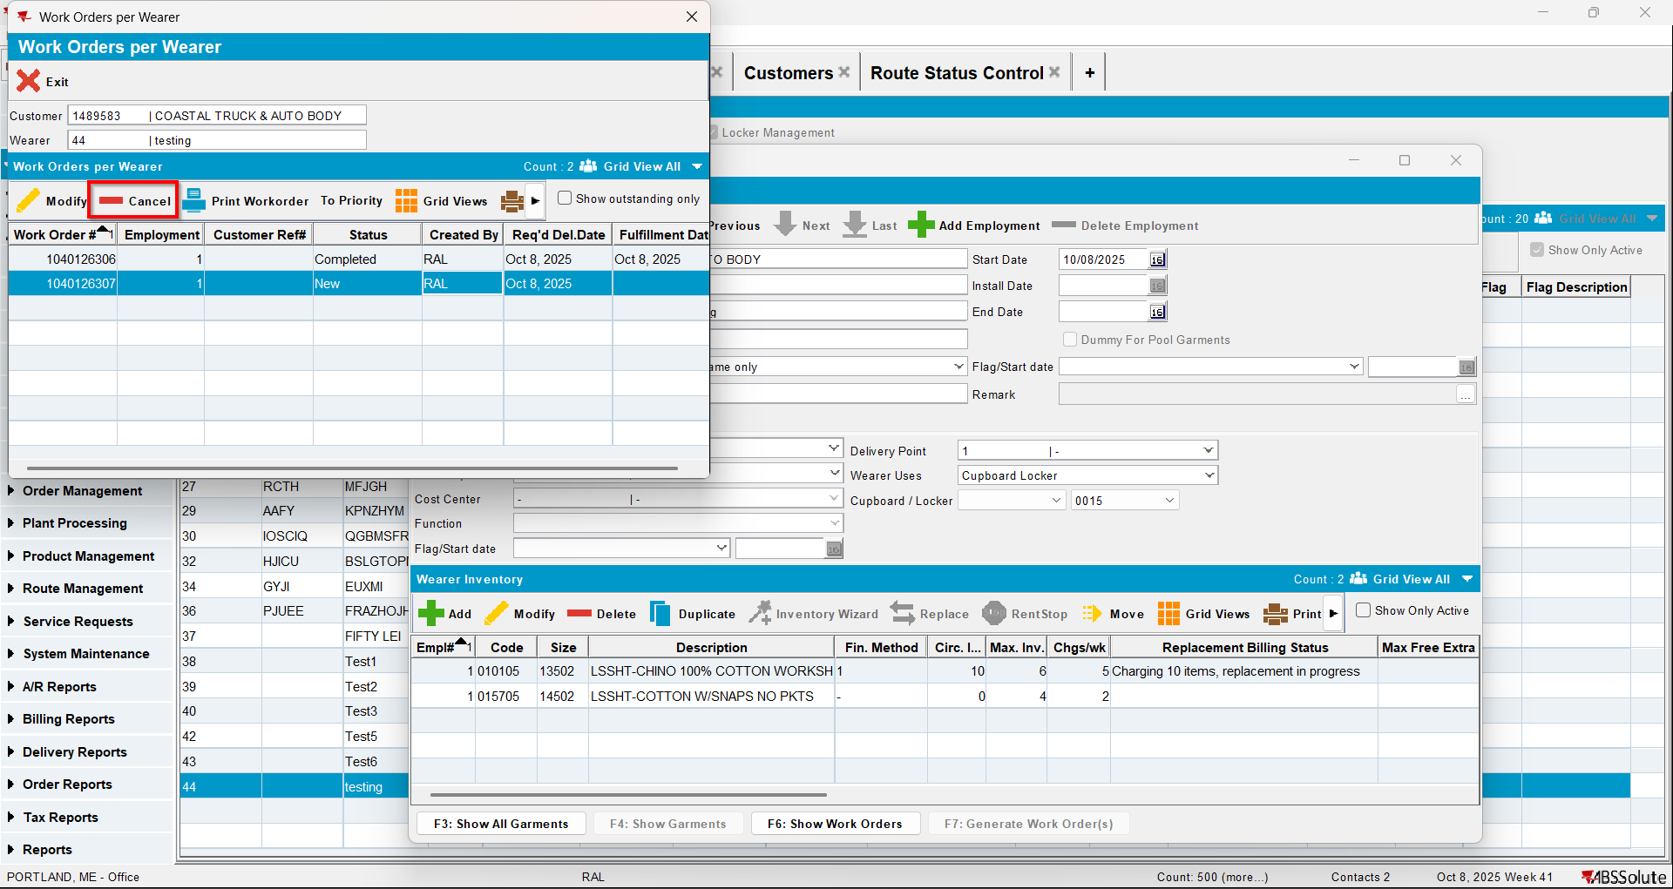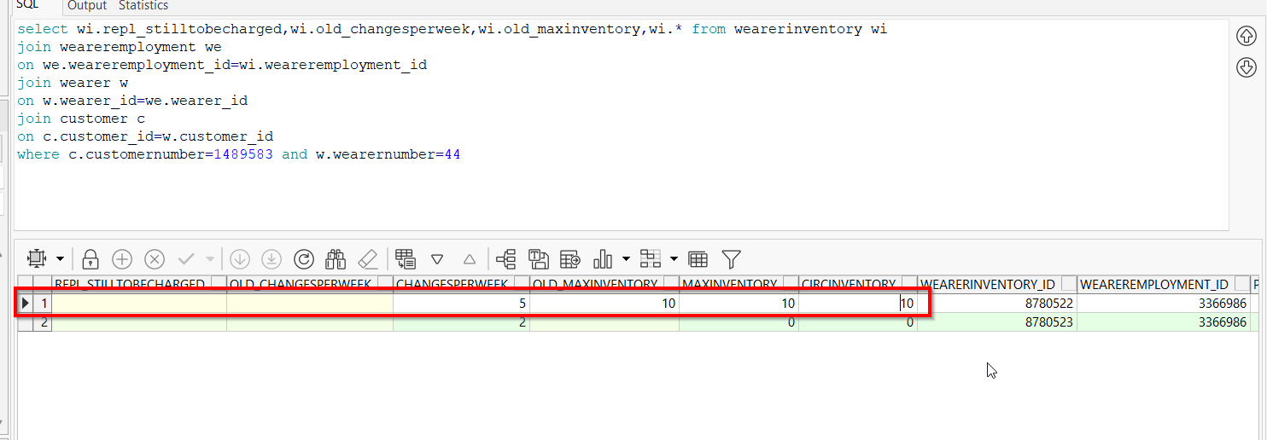
- Decrease the inventory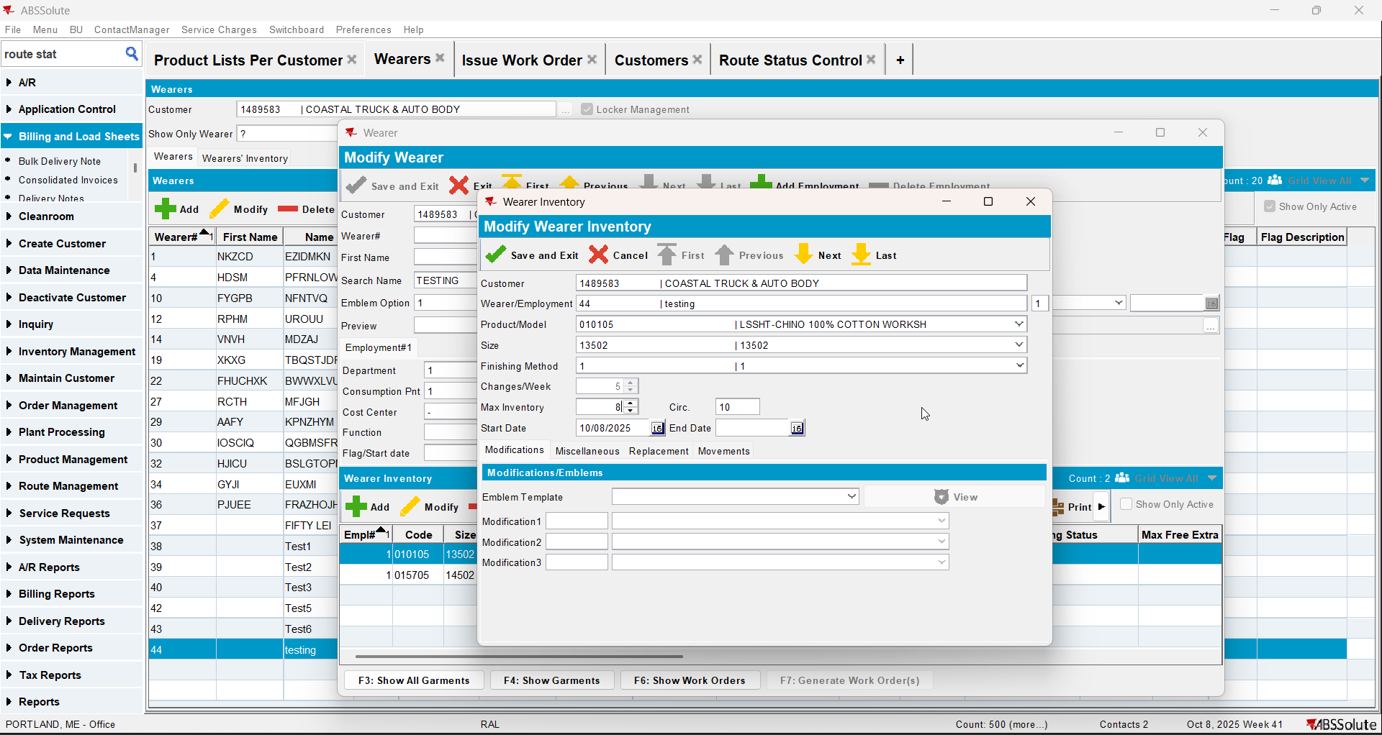
- Update repl_stilltobecharged to Y for the wearer inventory for the initial product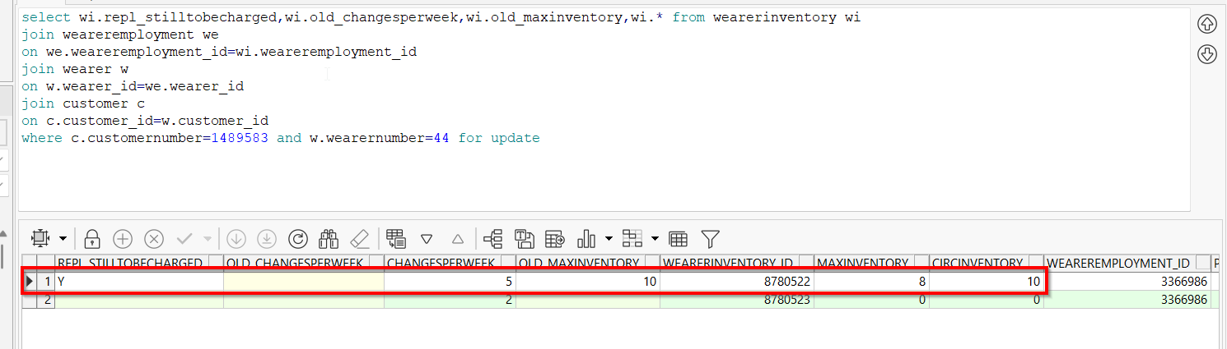
- Generate invoices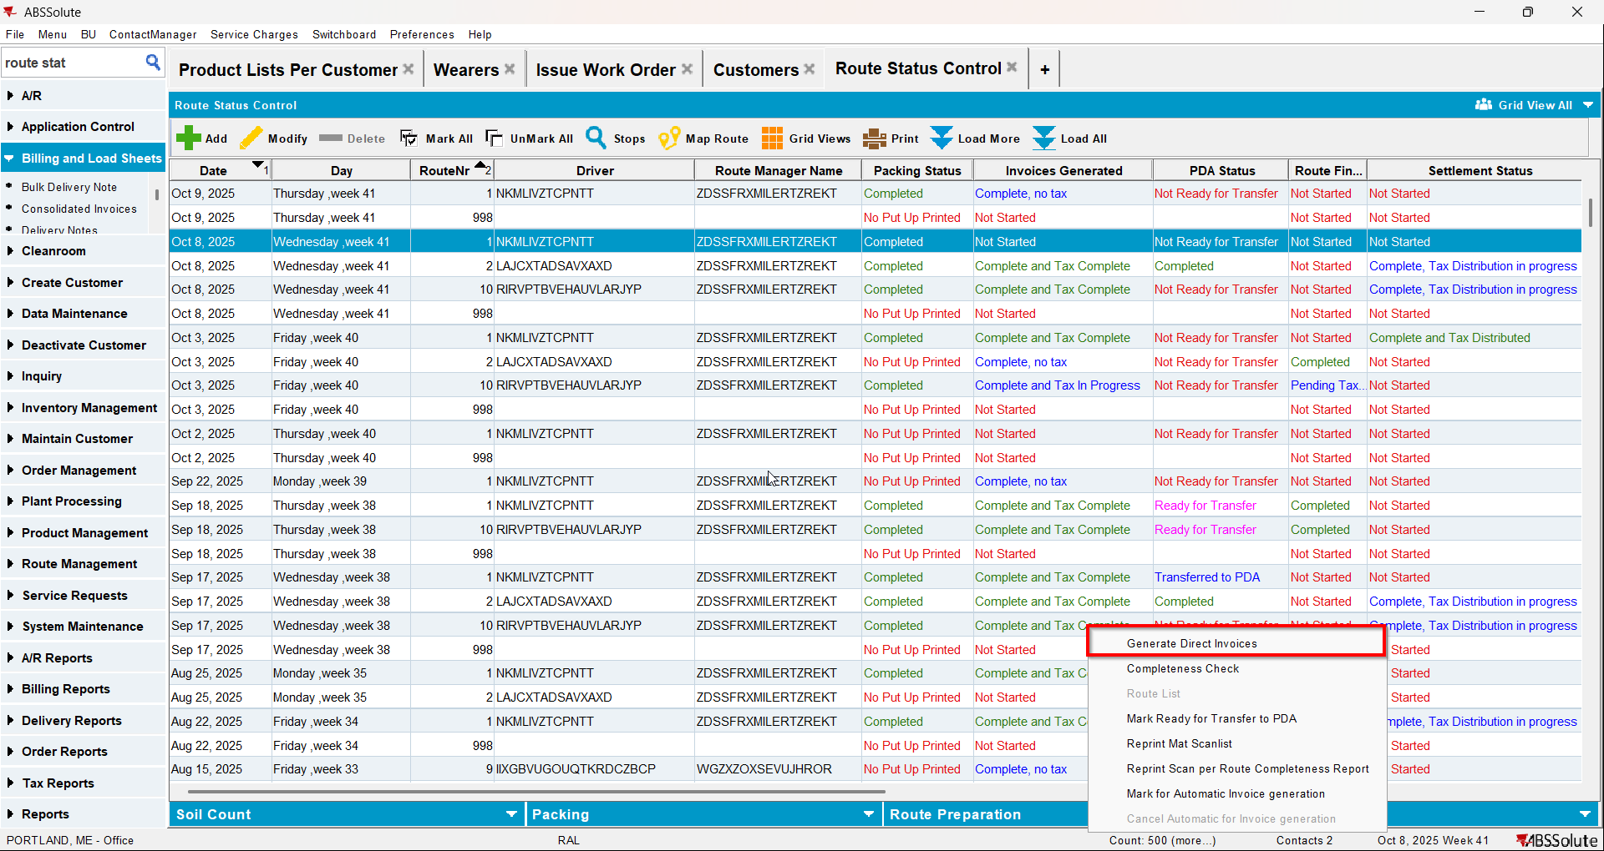
- Check that the repl_stilltobecharged changed to Null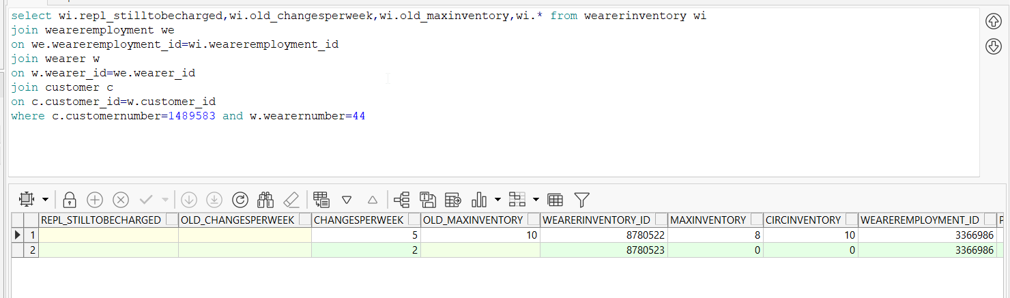
- Check that on the invoice the max inventory is billed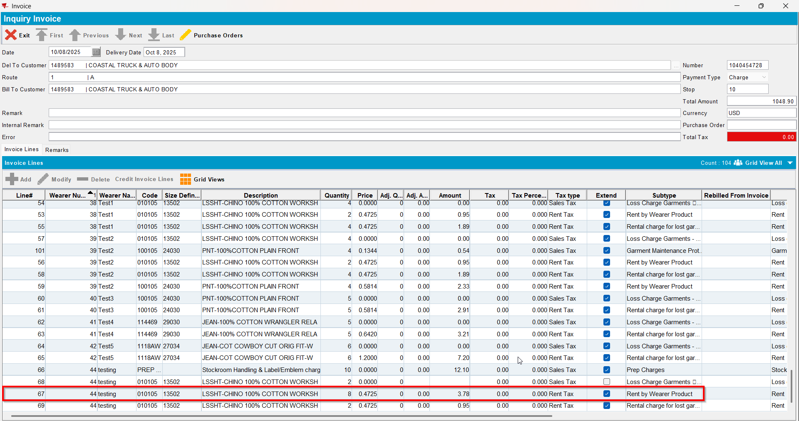

Test Case 2 –Replacement WO new with BM3– Tested OK
Expected behavior: If repl_stilltobecharged=Y and replacement WO is in progress then use Old_MaxInventory
Hash: e1ed7b9
- Have a product with BM3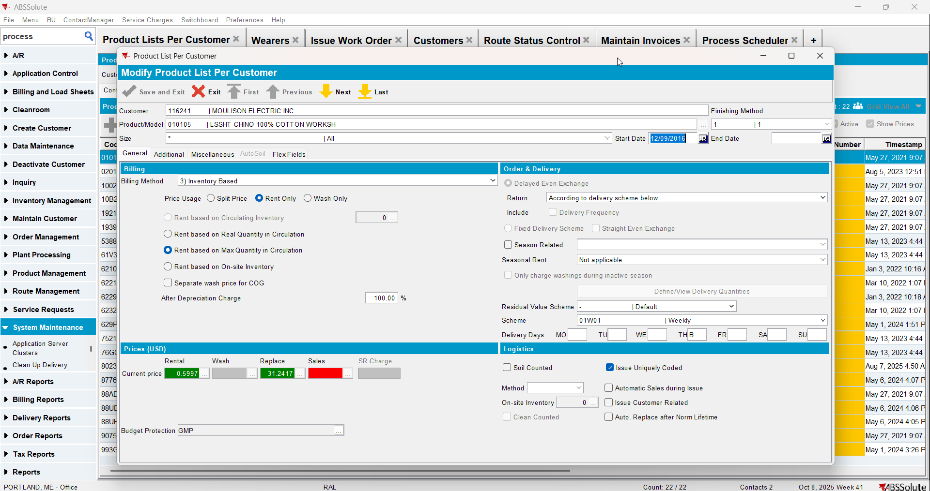
- Create a wearer with wearer inventory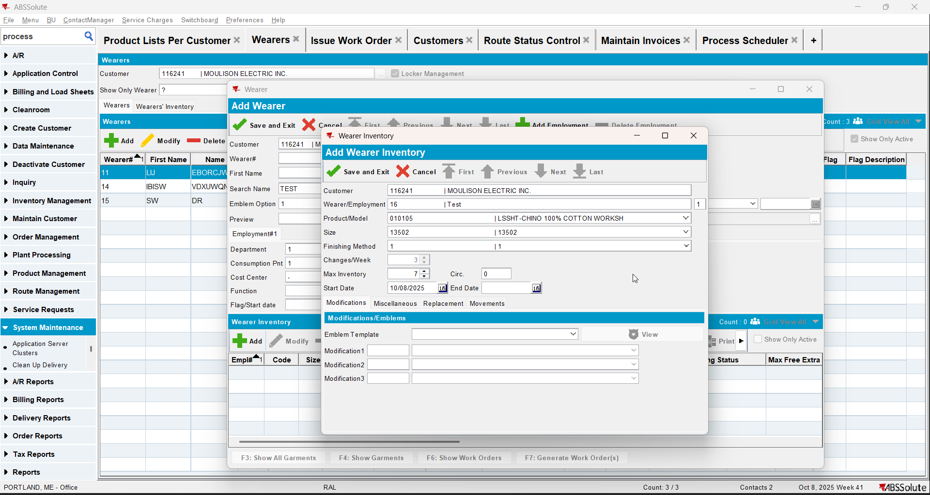
- Generate WO and issue it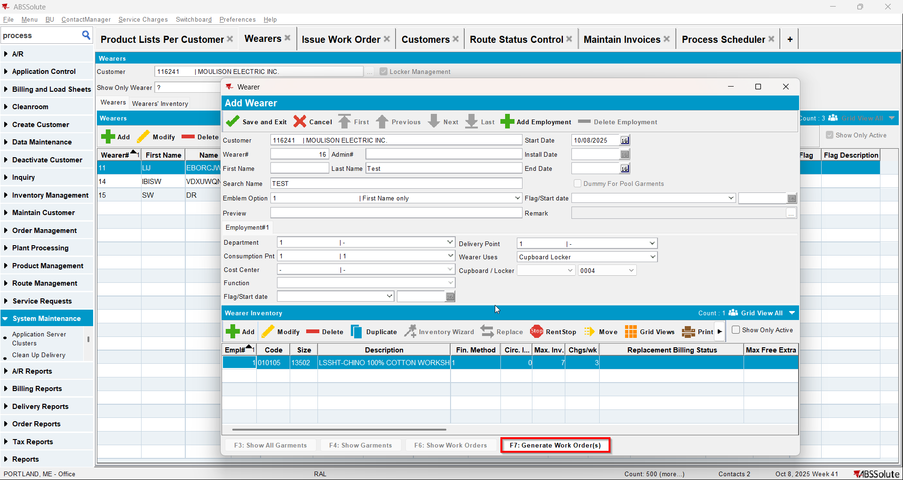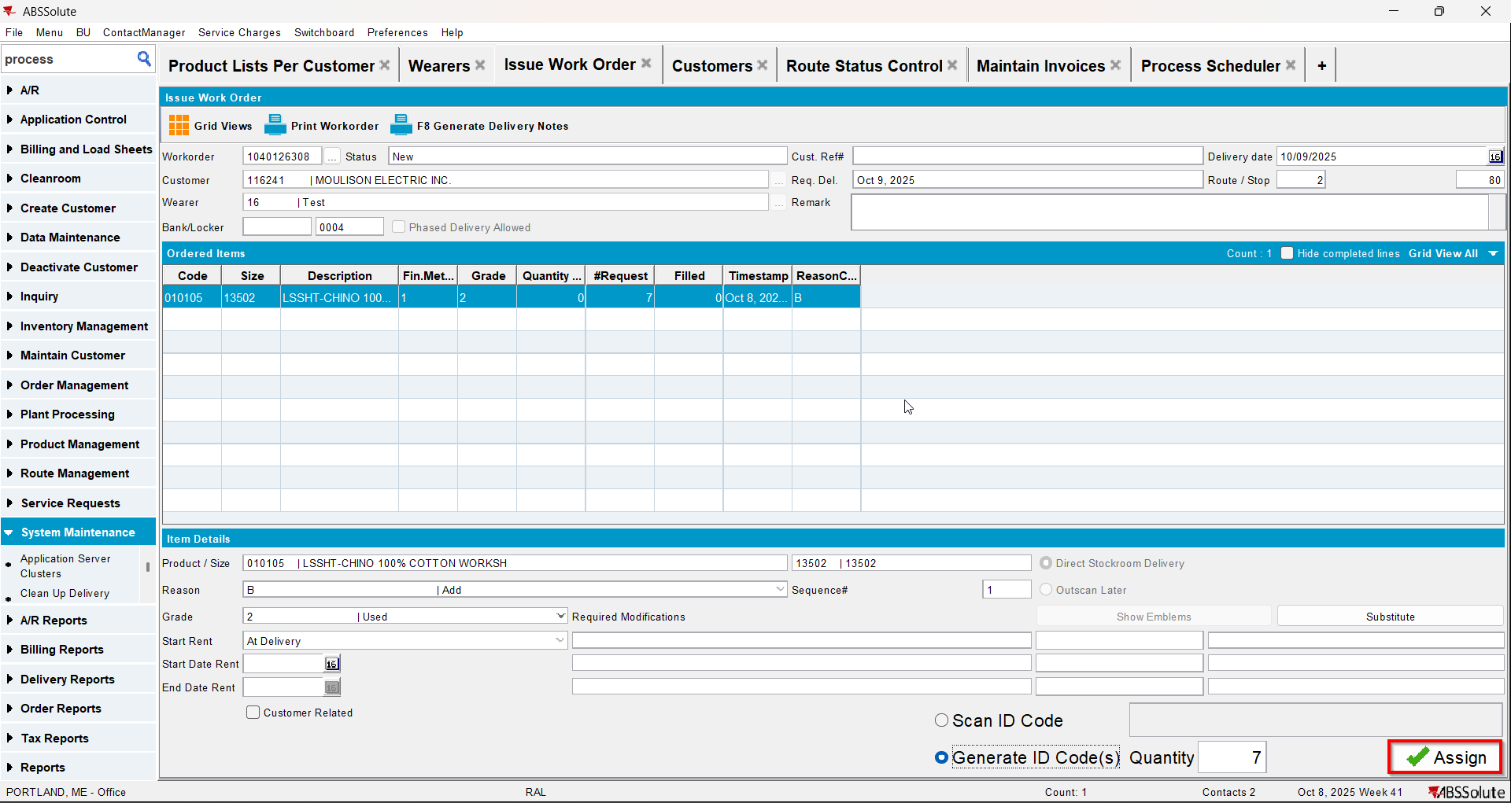
- Repl_stilltobecharged should be null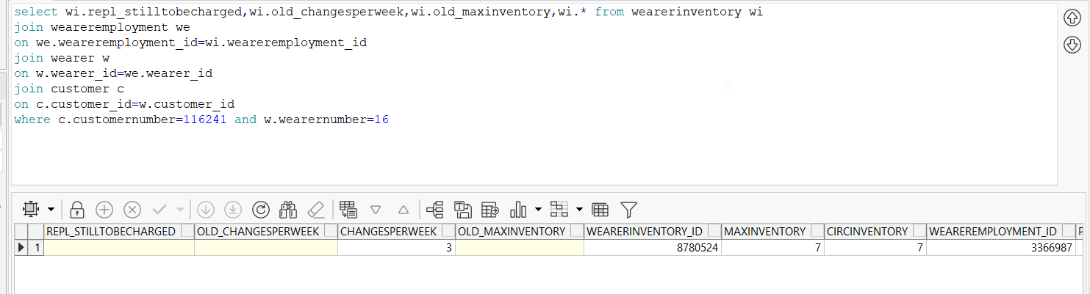
- Do a replacement but don’t issue the WO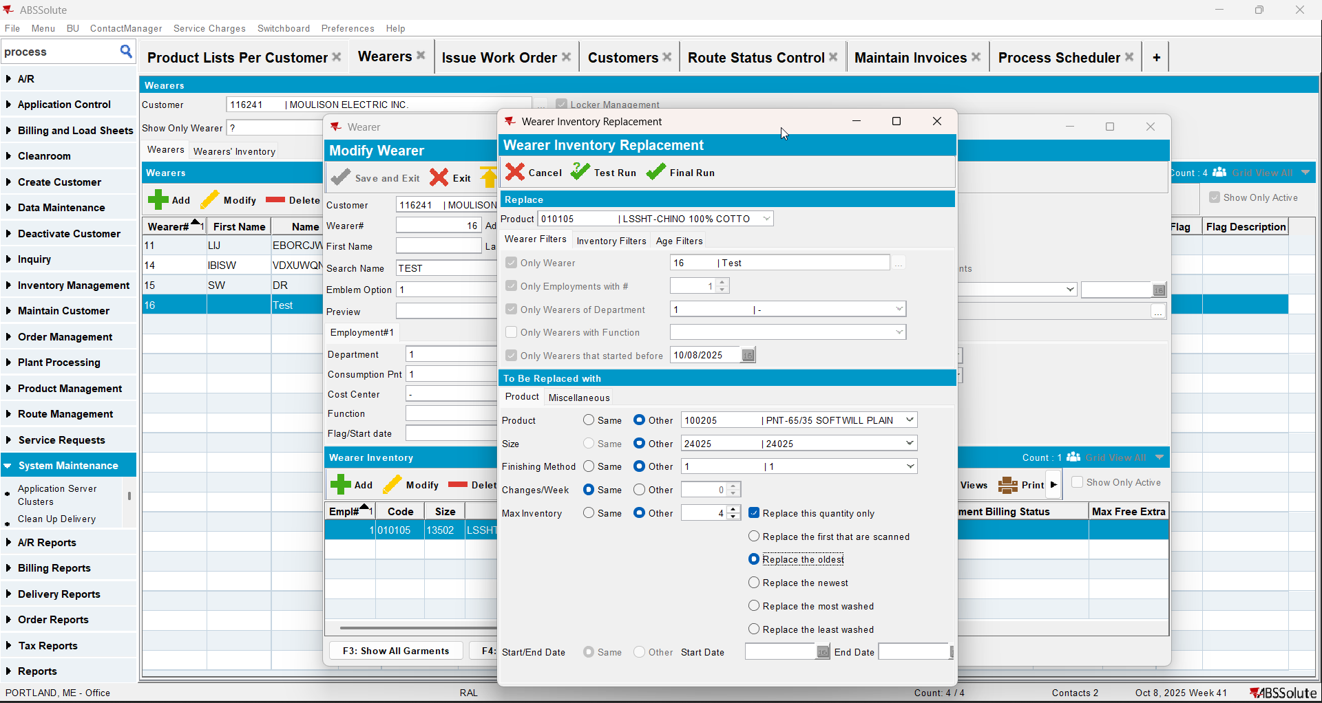
- Repl_stilltobecharged will be Y for the initial product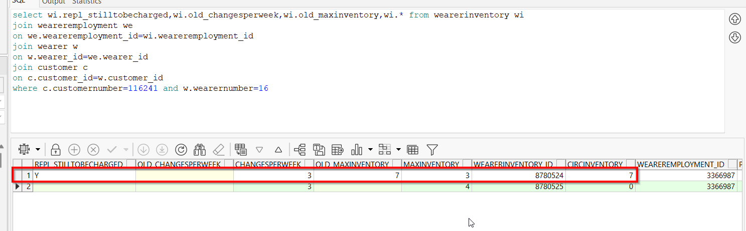
- Generate invoices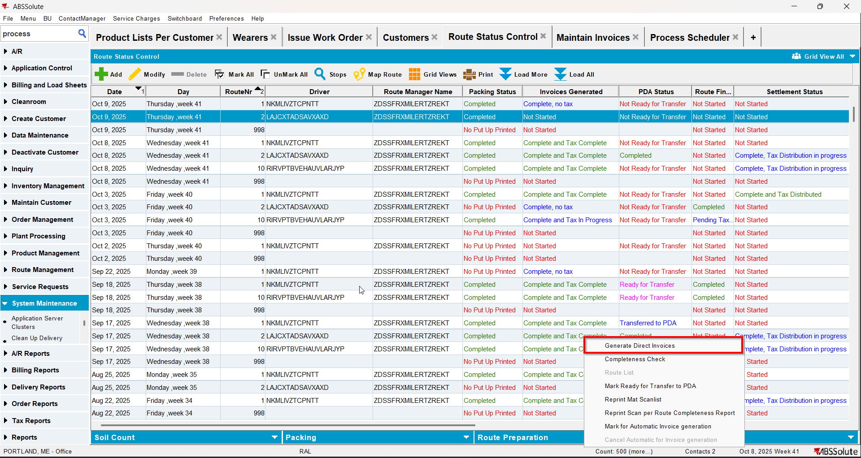
- Check that the repl_stilltobecharged is still Y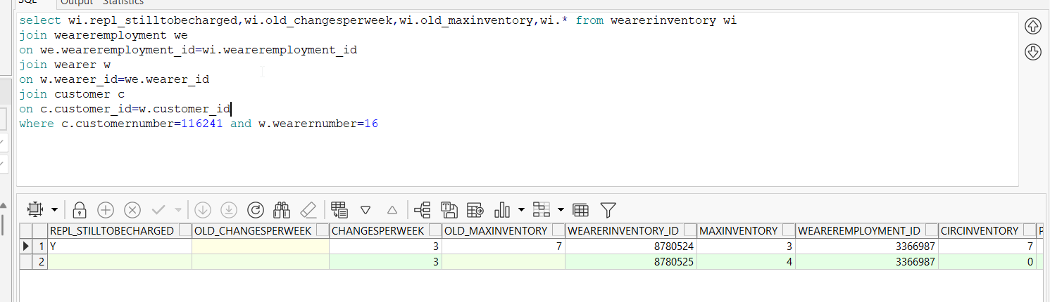
- Check that on the invoice the old max inventory is billed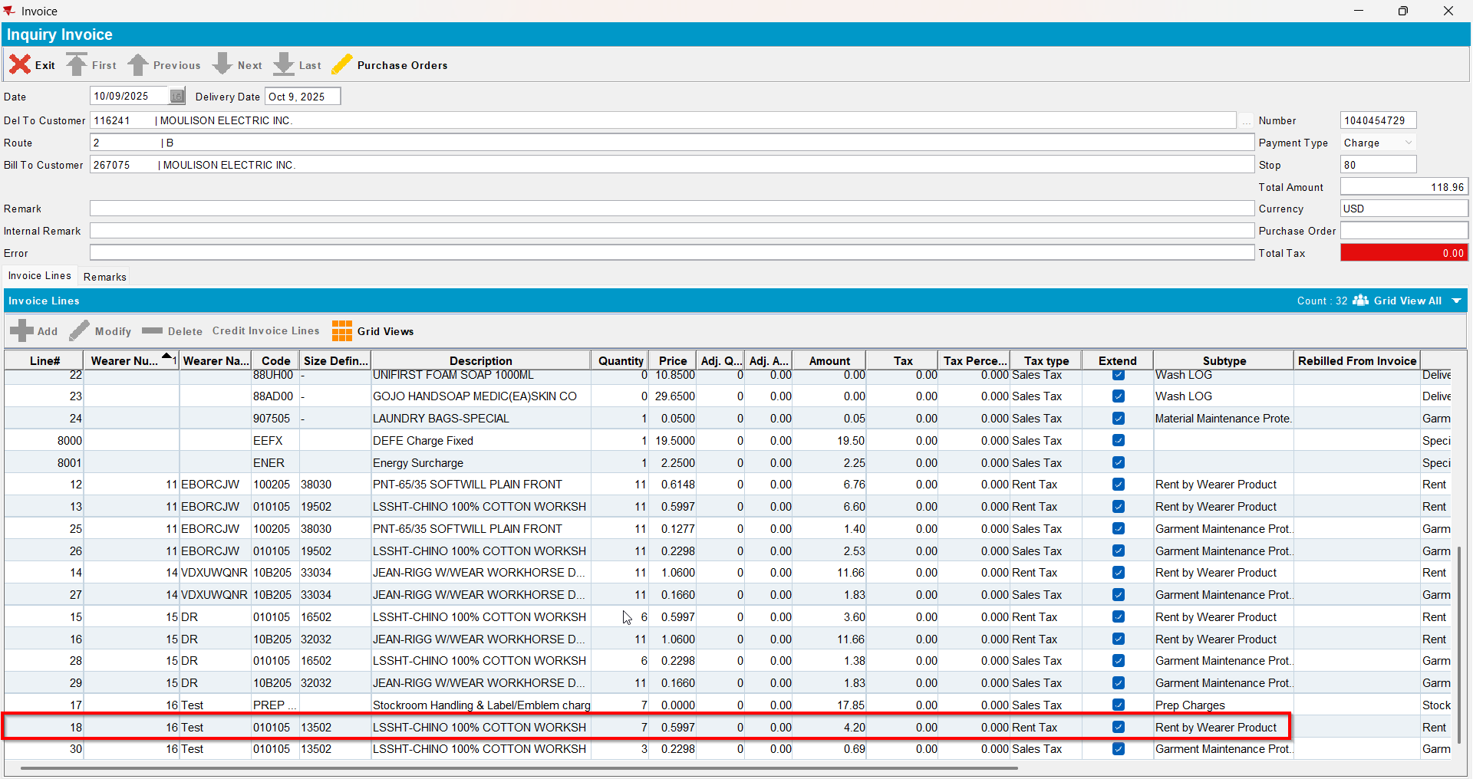

Test Case 3 –Replacement WO cancelled with BM1– Tested OK
Expected behavior: If repl_stilltobecharged=Y and replacement WO is not in progress then reset repl_stilltobecharged to Null and use ChangesPerWeek
Hash: e1ed7b9
- Have a product with BM1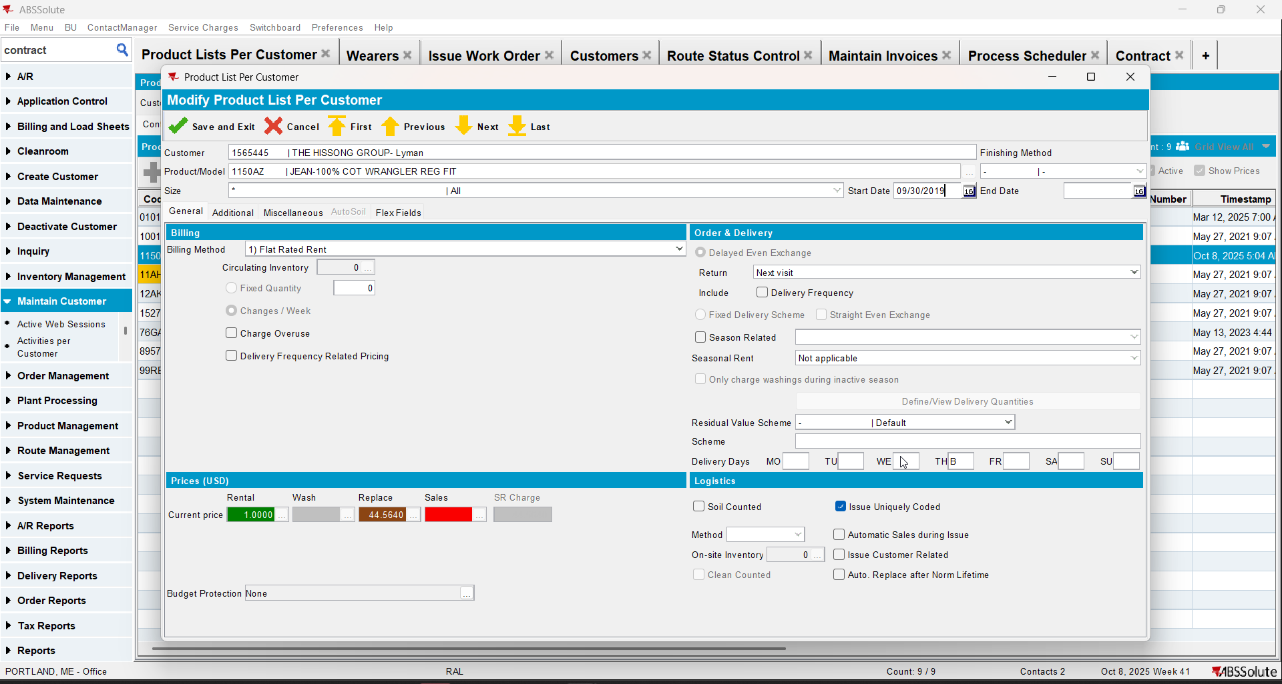
- Create a wearer with wearer inventory(changes/week should be more than 1)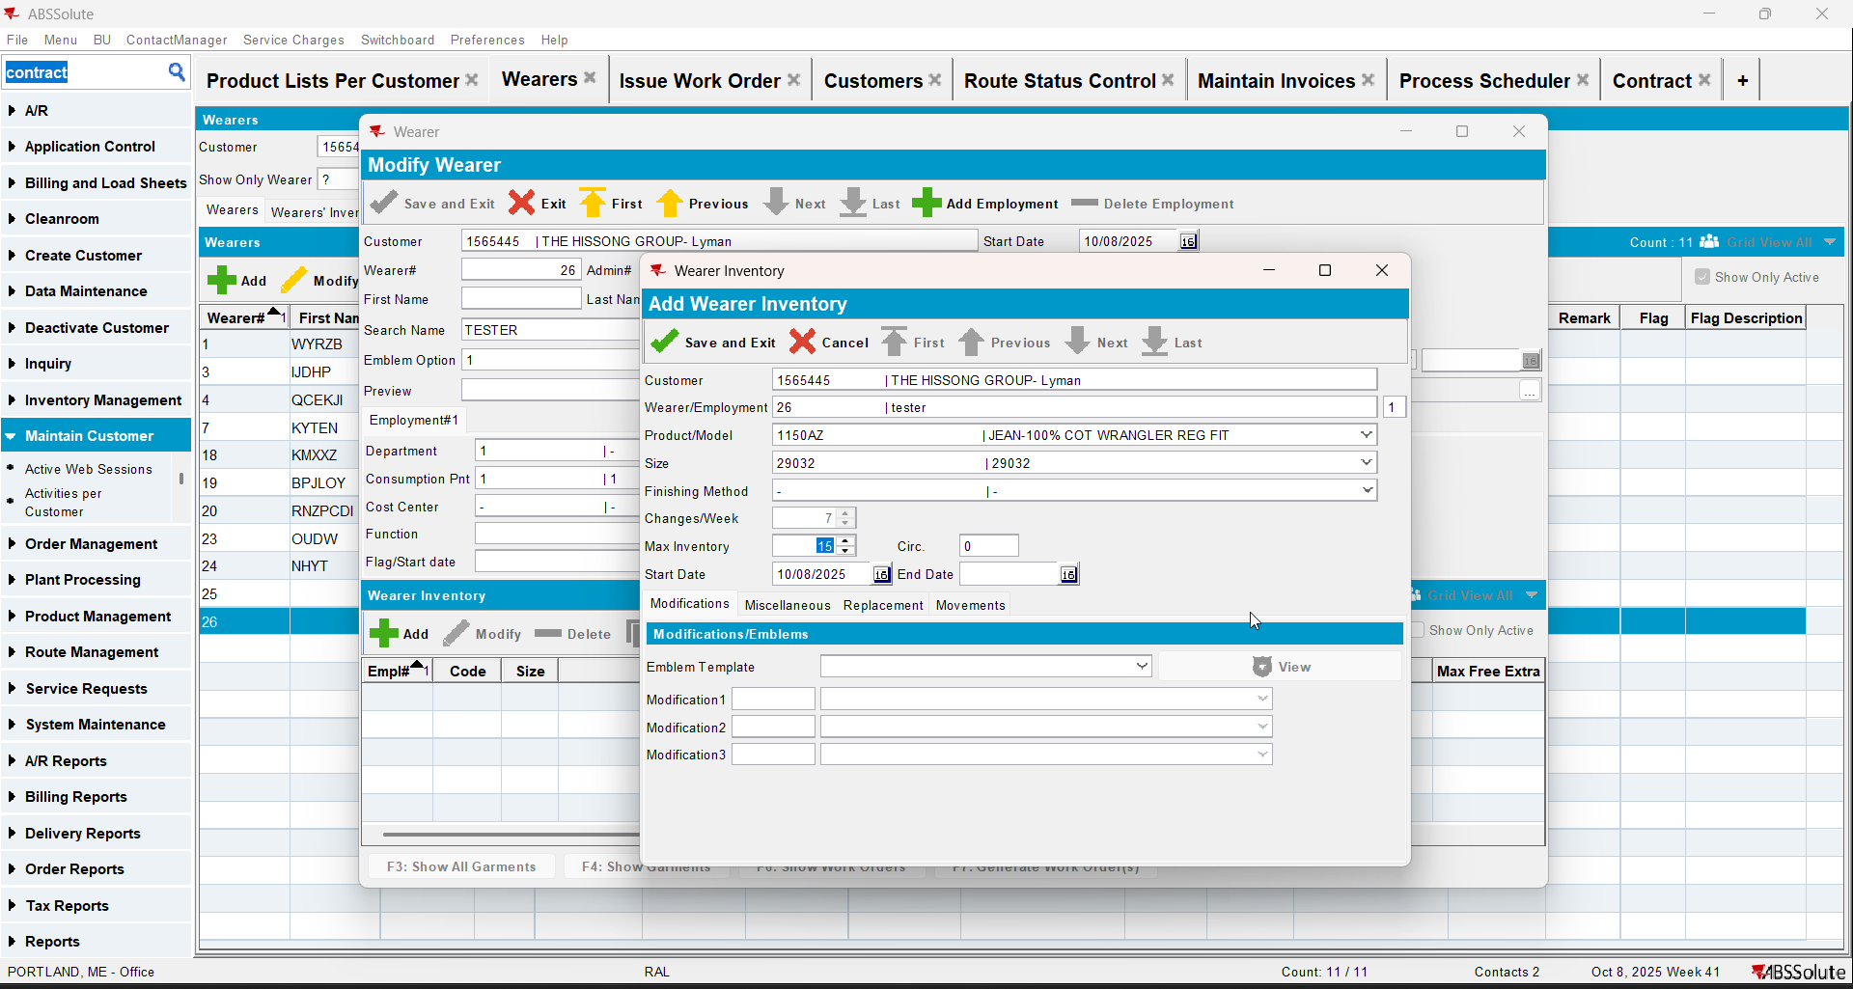
- Generate WO and issue it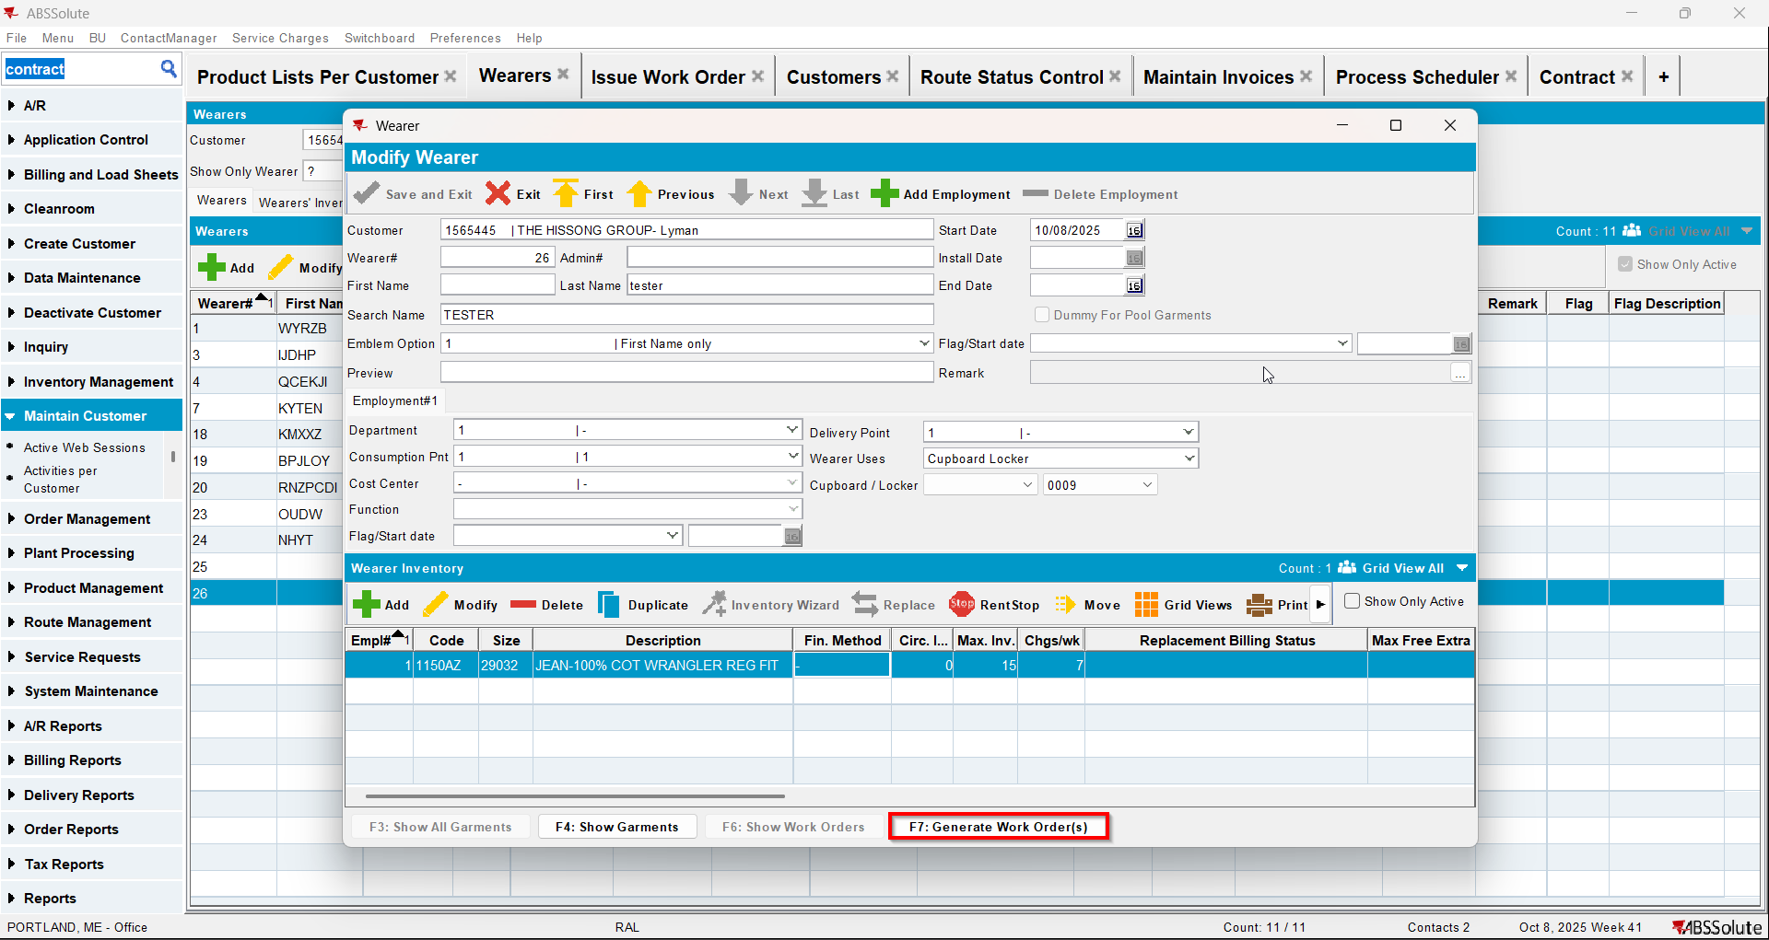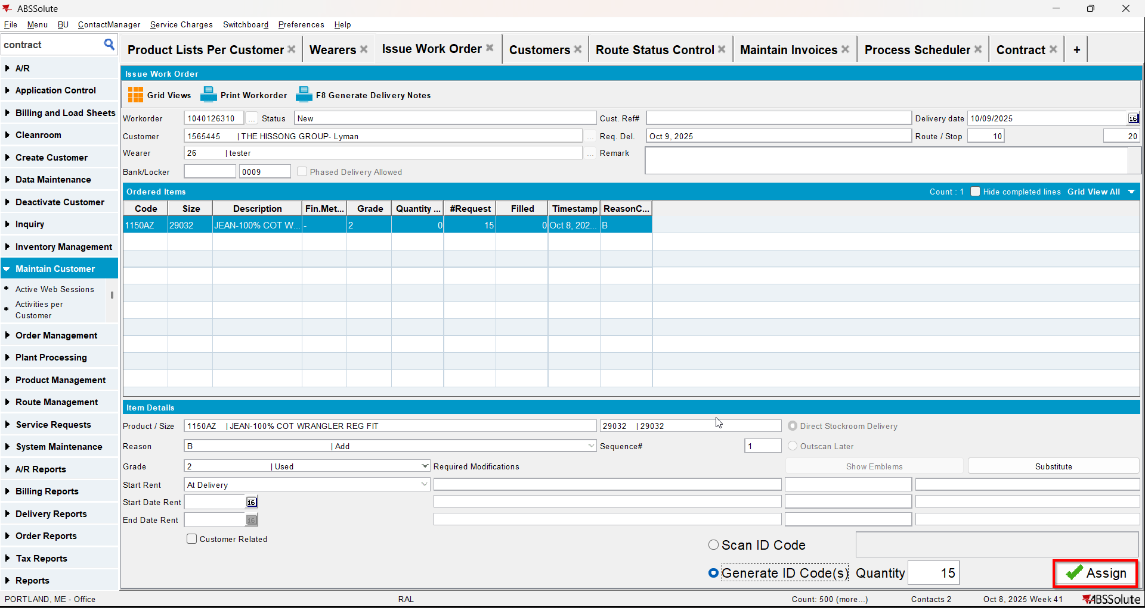
- Repl_stilltobecharged should be null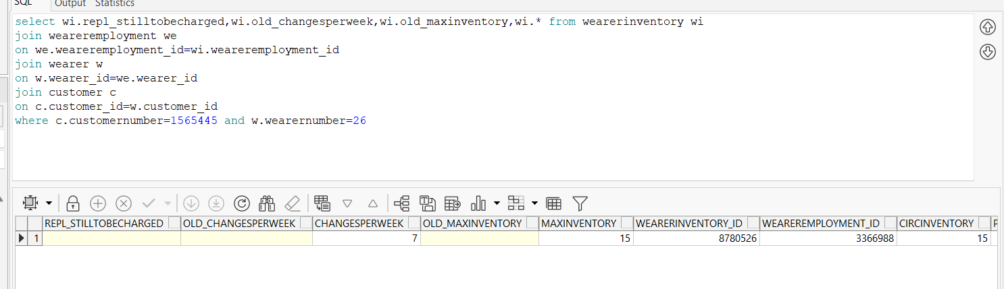
- Do a replacement but don’t issue the WO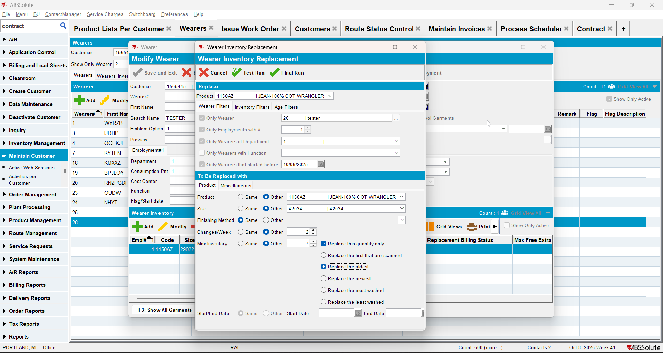
- Repl_stilltobecharged will be Y for the initial product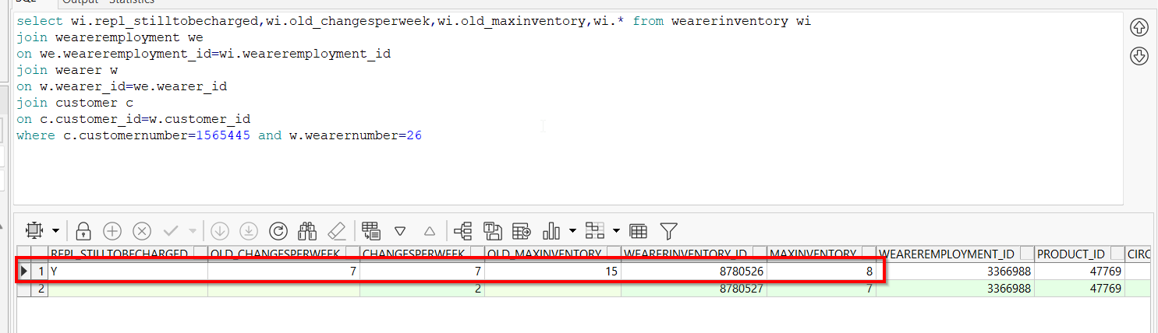
- Cancel the replacement WO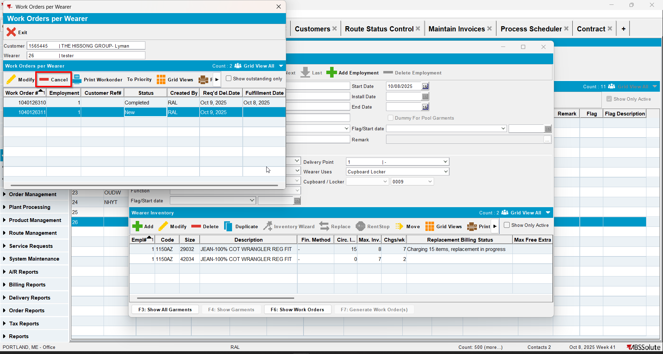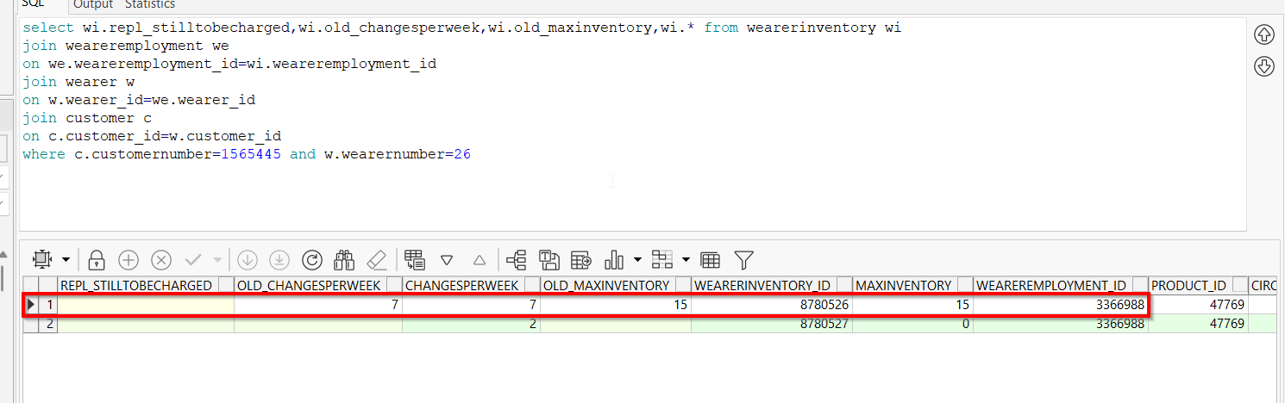
- Decrease the inventory and decrease the changes/week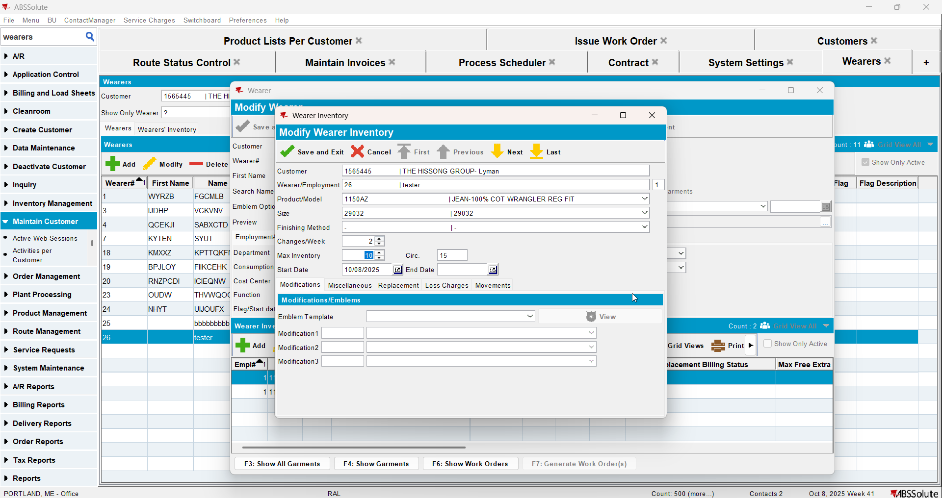
- Update repl_stilltobecharged to Y for the wearer inventory for the initial product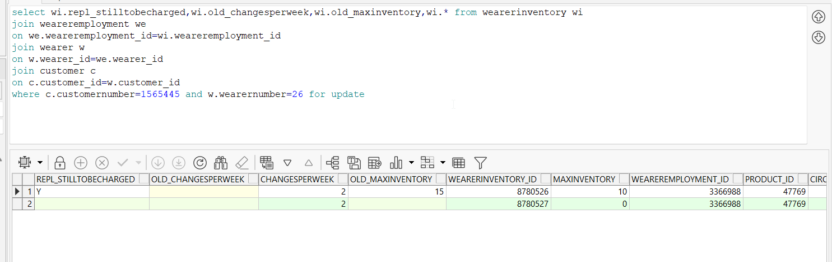
- Generate invoices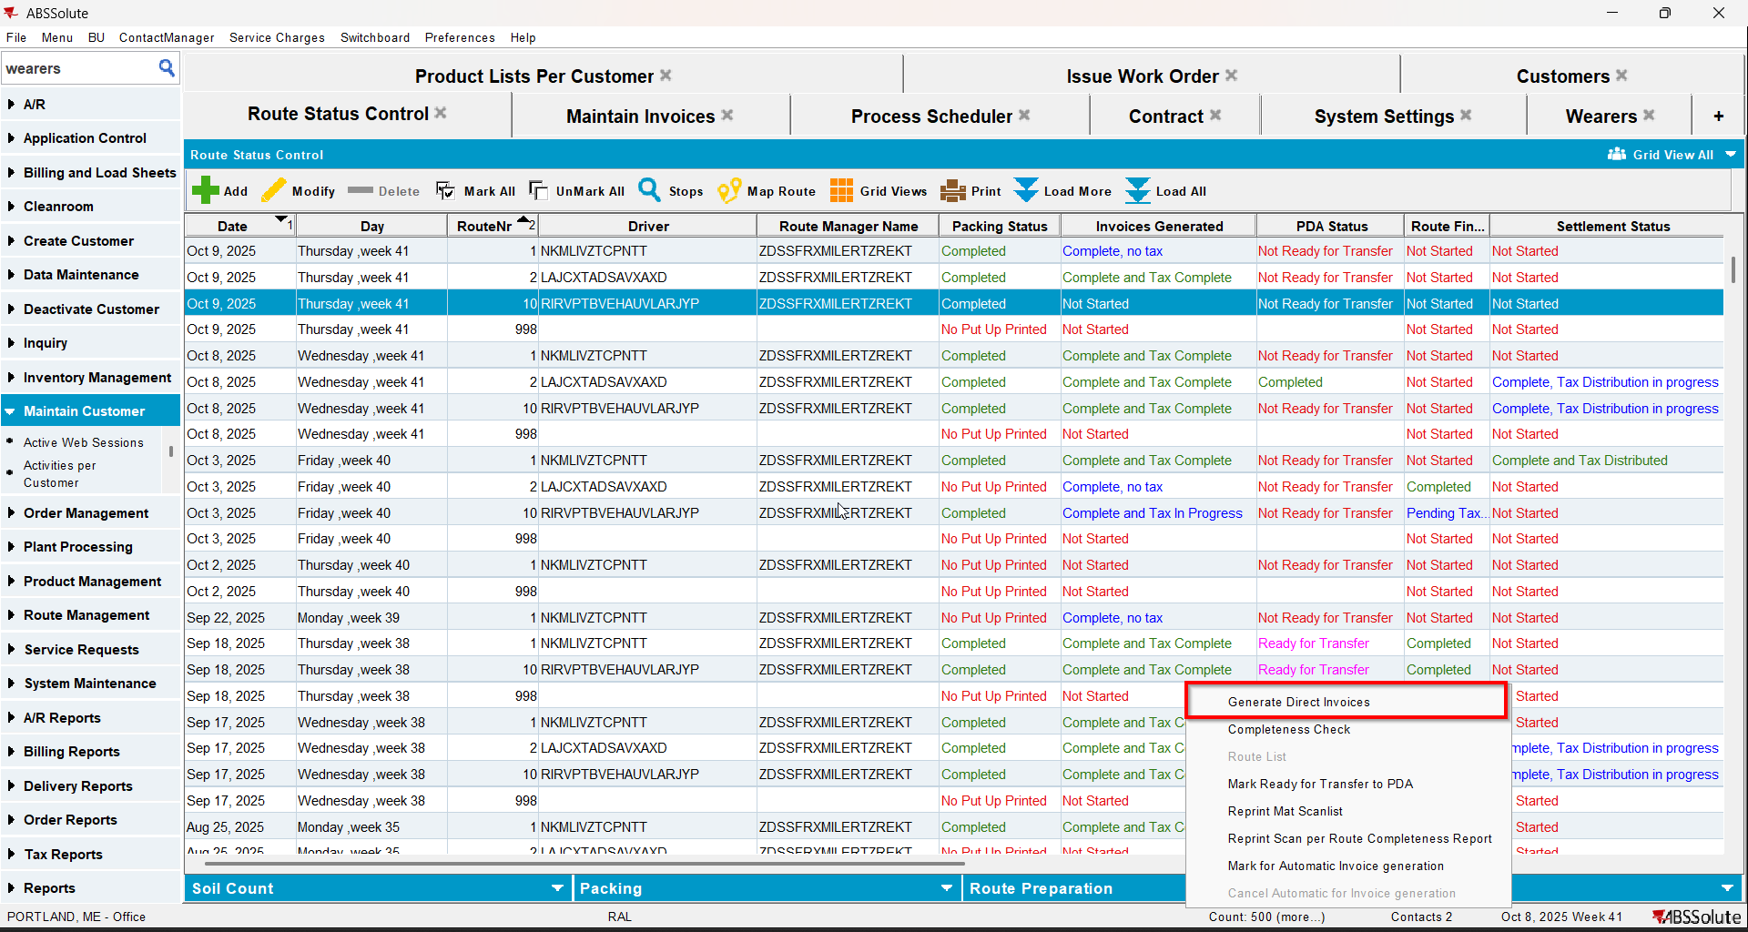
- Check that the repl_stilltobecharged changed to Null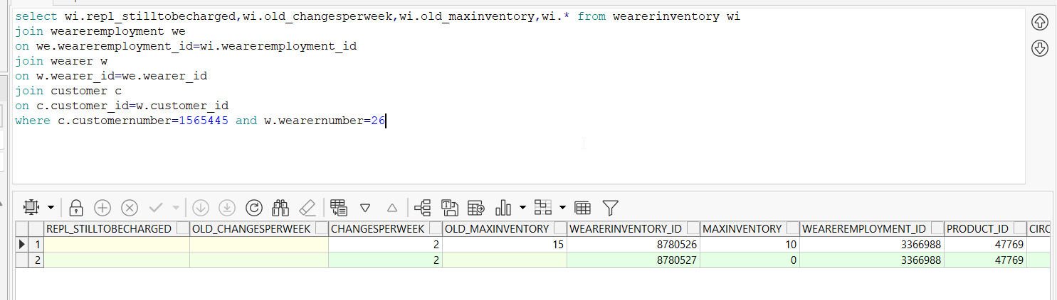
- Check that on the invoice the changes/week is billed 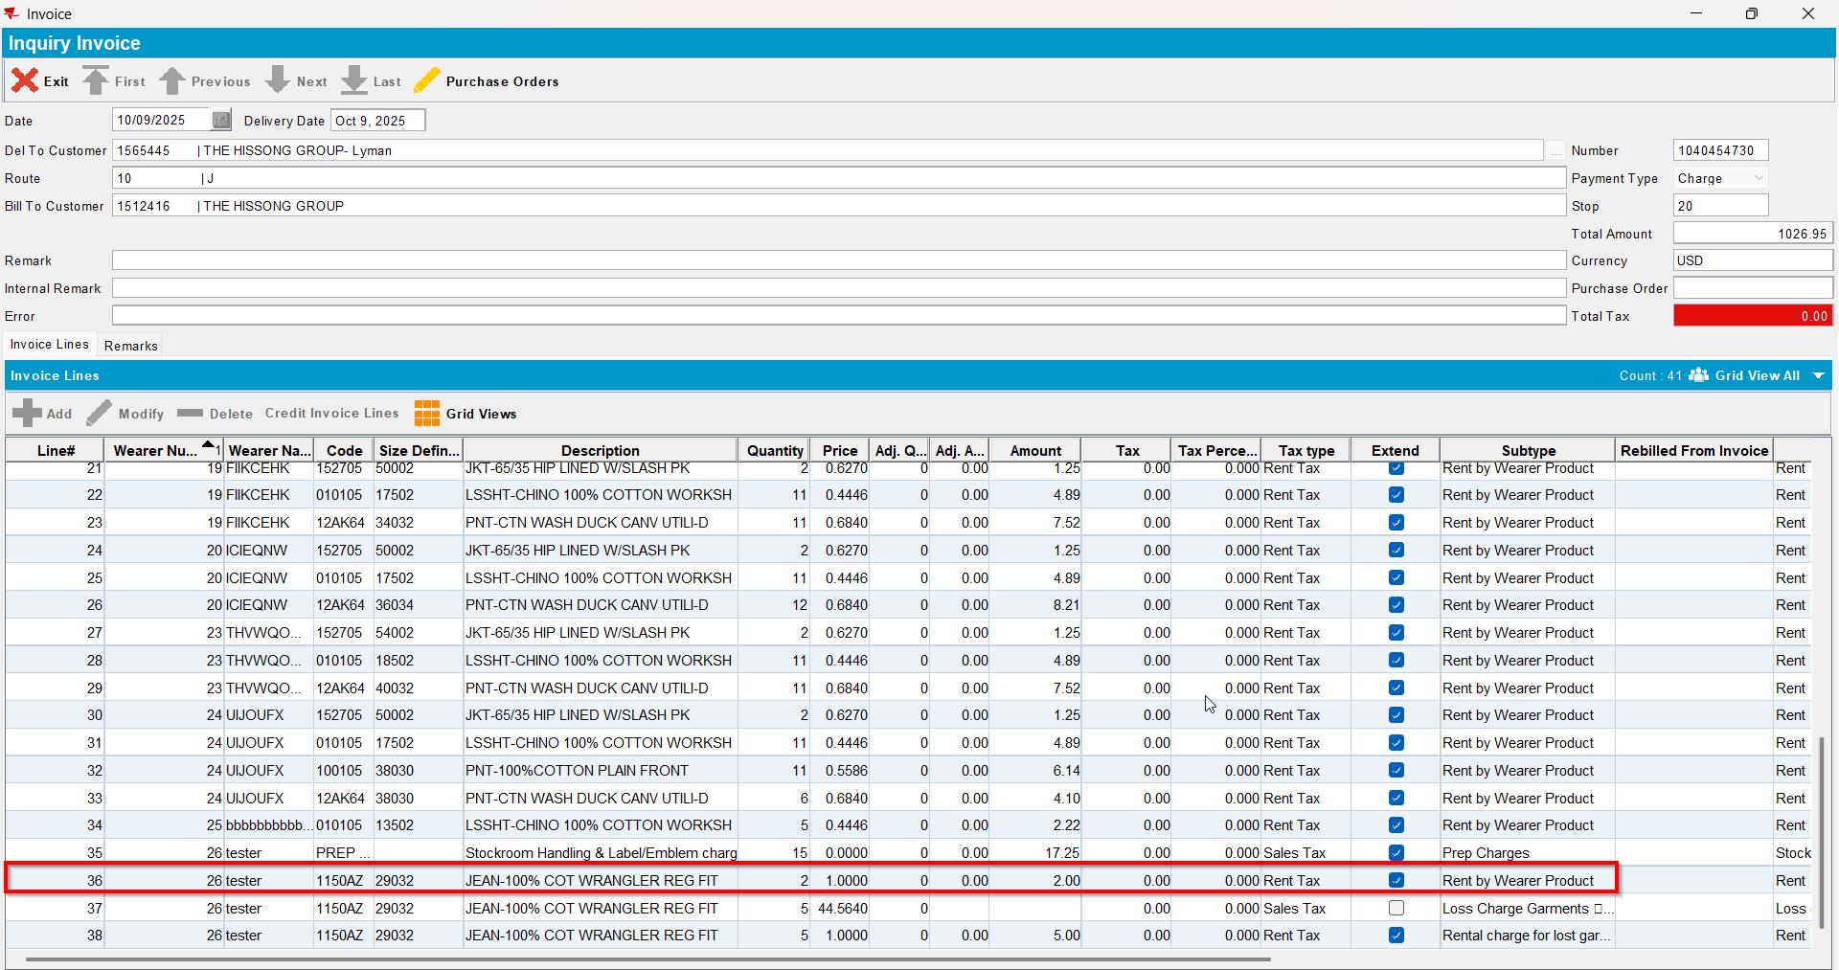

Test Case 4 –Replacement WO new with BM1– Tested OK
Expected behavior: If repl_stilltobecharged=Y and replacement WO is in progress then use Old_ChangesPerWeek
Hash: e1ed7b9
- Have a product with BM1
- Create a wearer with wearer inventory (changes/week should be more than 1)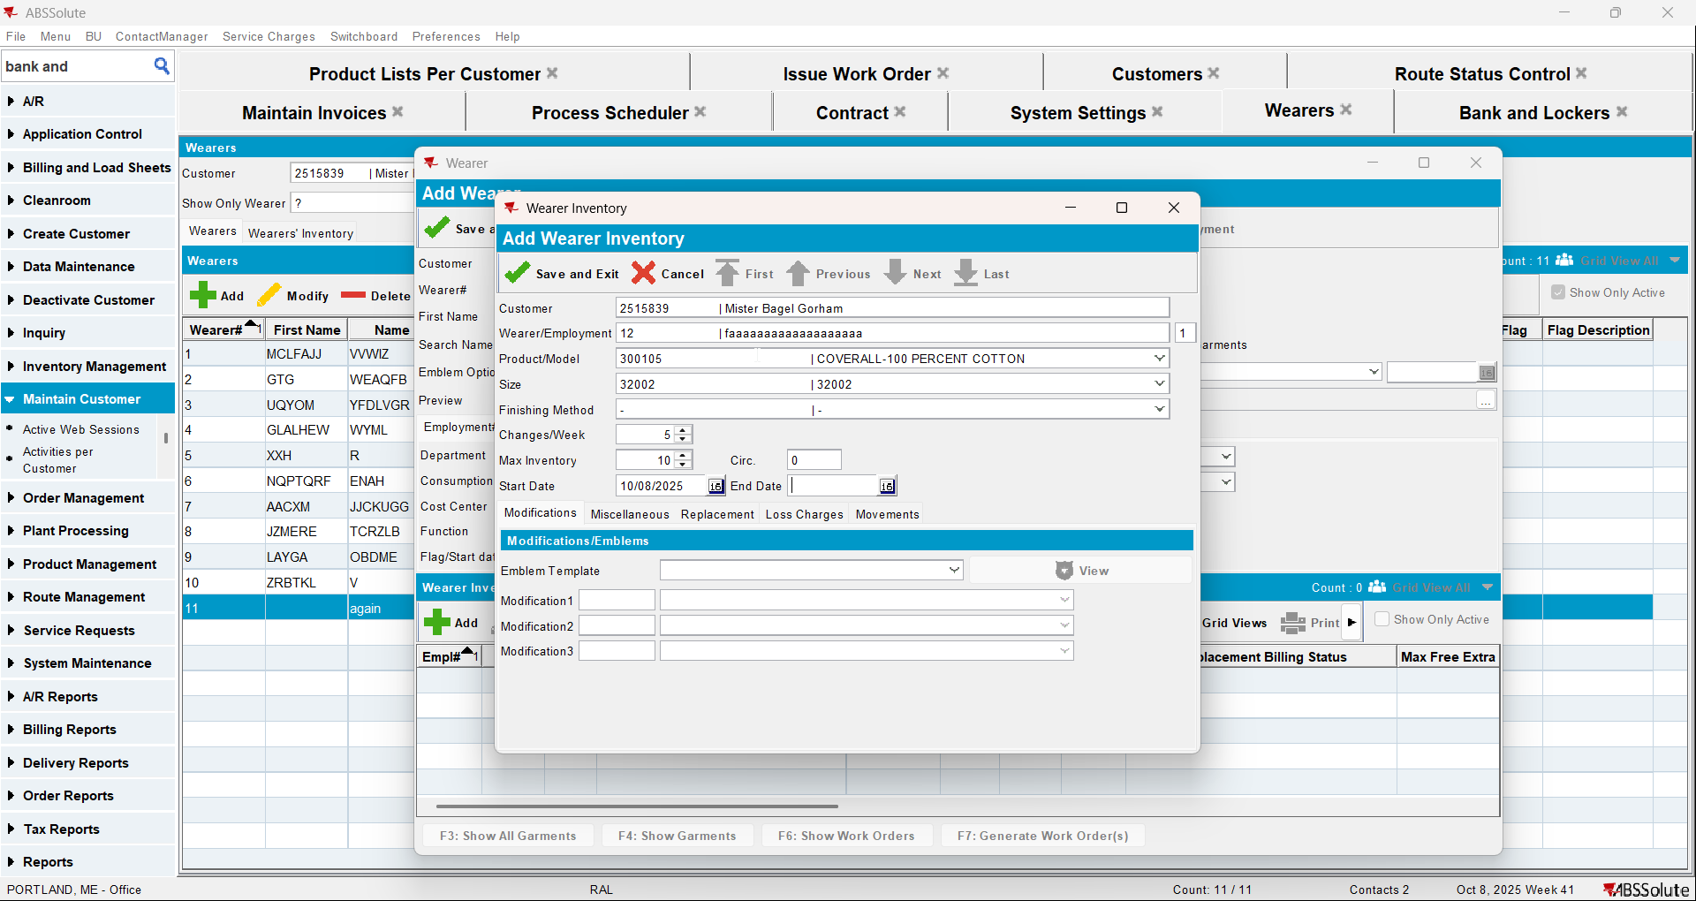
- Generate WO and issue it
- Repl_stilltobecharged should be null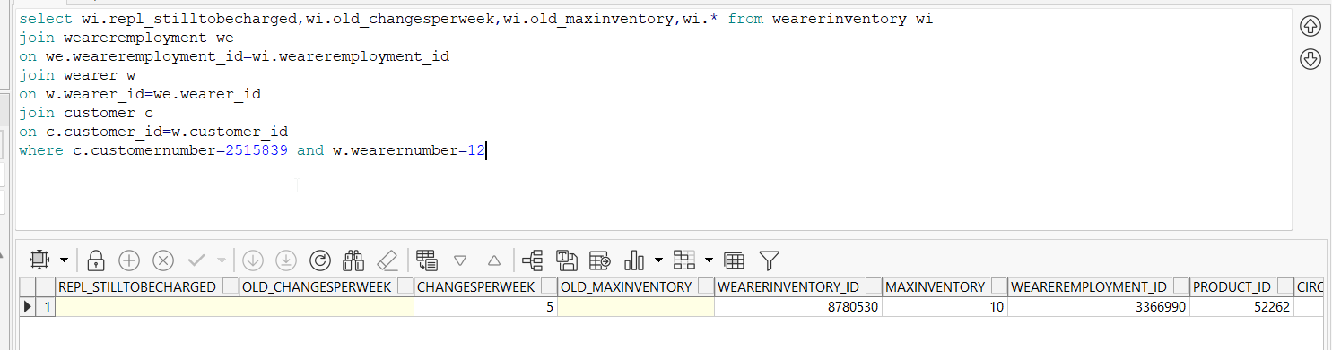
- Do a replacement but don’t issue the WO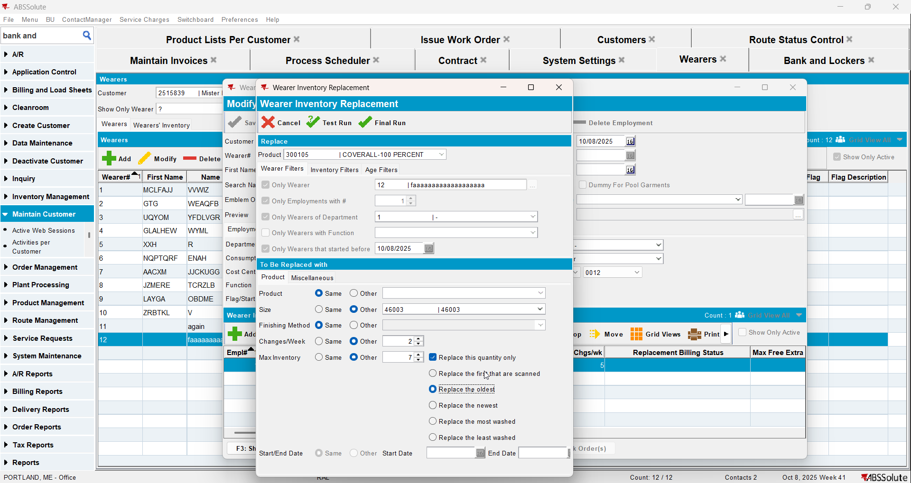
- Repl_stilltobecharged will be Y for the initial product and also update the old_chagesperweek to a different value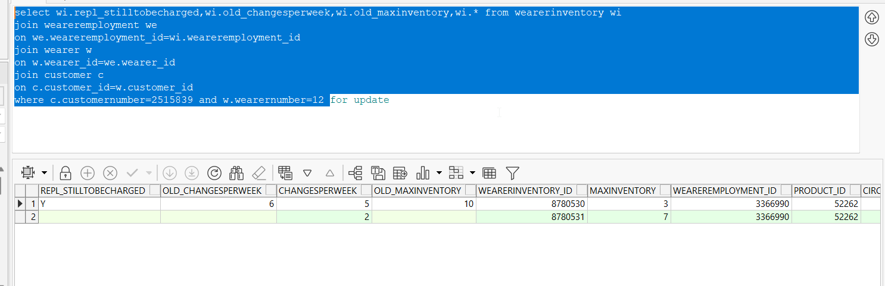
- Generate invoices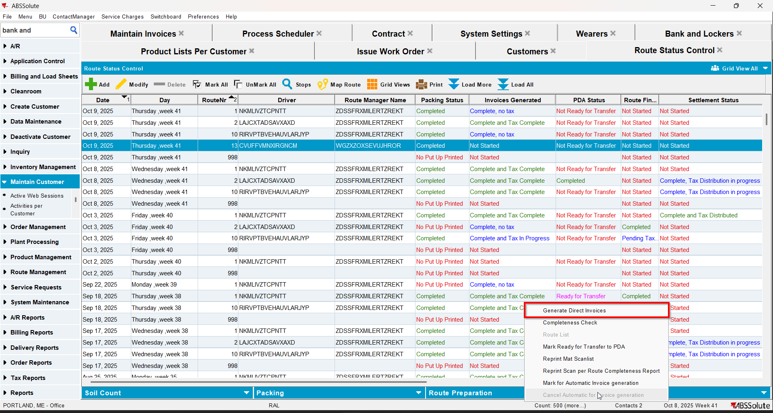
- Check that the repl_stilltobecharged is still Y 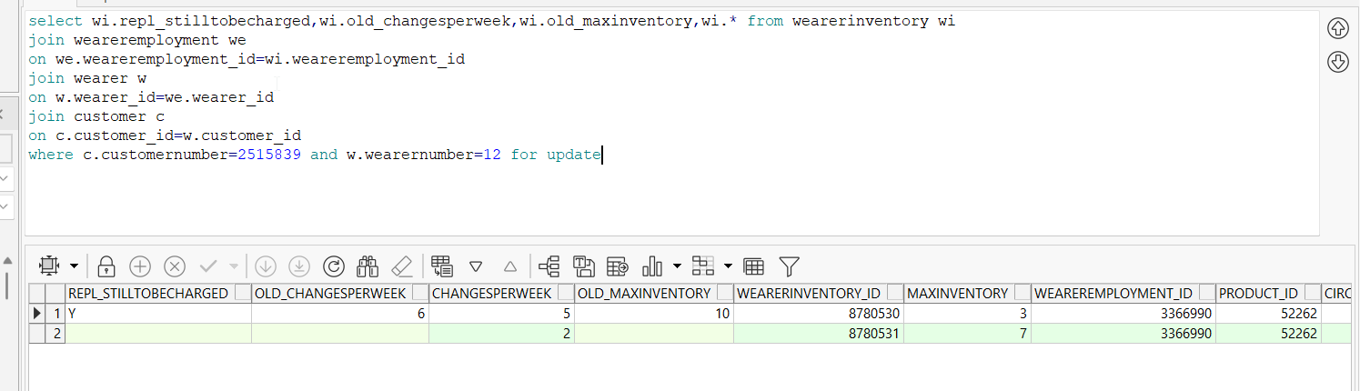
- Check that on the invoice the old changes/week is billed 