ABSN-3984 - D_UBS_2645 Changed to grade 1 on RA but still ABS is issuing grade 2 garments
Environment | Prerequisites
Version: 9.07.00.UNF21  DBServerName= abs-srv20.internal.abslbs.com  DBSID=CUST24  DBUser=UNFDEV  Environment=Test | - Module:  - System setting

Contents
Reproducing before fix 1
Steps to reproduce 1
Current Behavior 6
Expected behavior 6
Retest after fix 6
Test Case 1 – Check that the Grade assigned on RA to a IOI is the same on the work order in client 6
Test Case 2 – Check that the Grade assigned on RA to new WI is the same on the work order in client 11
Test Case 3 – Generate Work Order By adding a new Wearer inventory from Client 16
Test Case 4 – Generate Work order by replacing a Wearer Inventory 20
Test Case 5 – Generate Work order from Renewal/Replacement dialog 25

Reproducing before fix

Steps to reproduce
- Wearers: Have a Customer with Wearers and WI
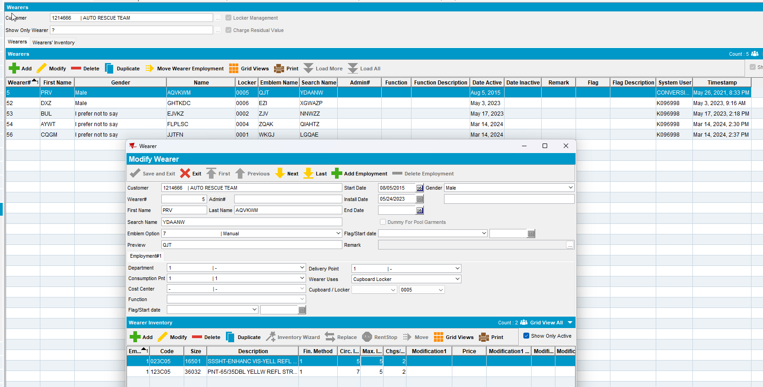
- RSC: Add a new route for this customer and generate invoices
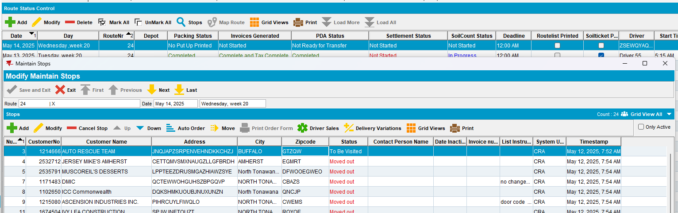
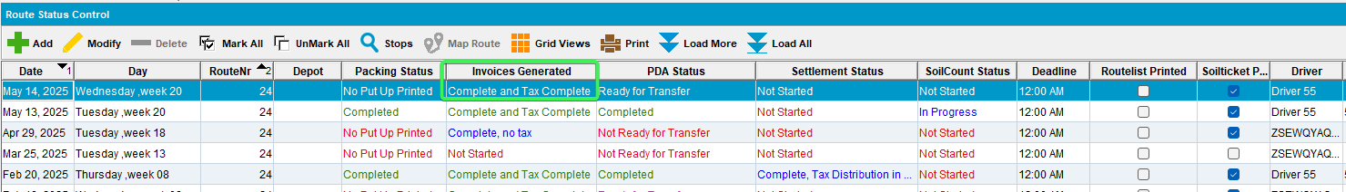
- Send the RC to PDA
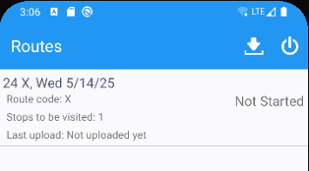
- Arrive at the customer > Wearers > Select a wearer
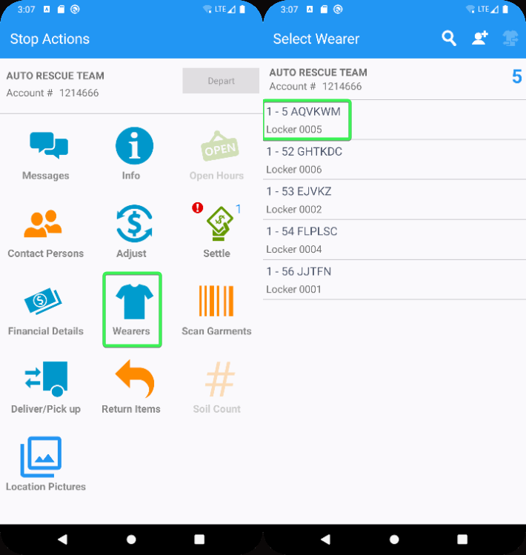
- Select a WI and perform an Increase of Max Inventory > Change the Grade to “1 – New”
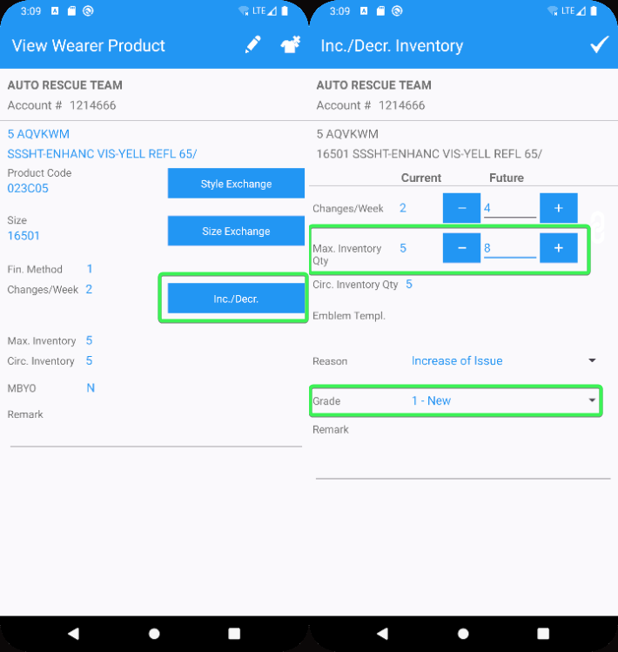
- Finish the route and upload the data
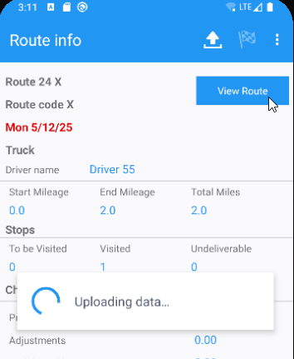
- WebX: Wearer Maintenance tab approve the Increase of Inventory
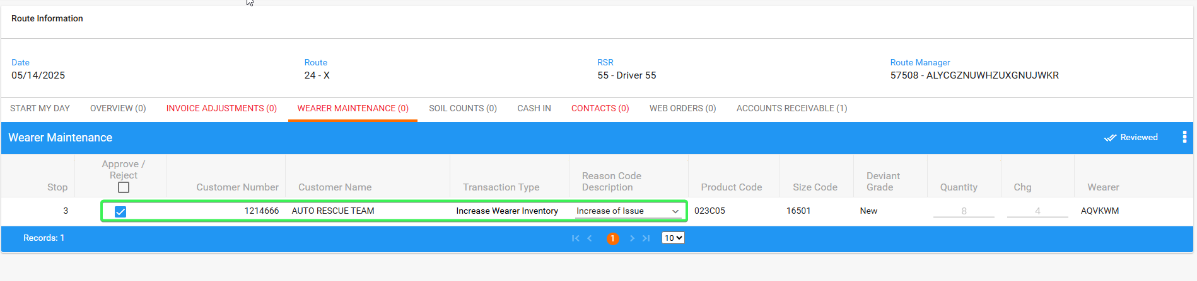
- Settle the route
- Wearers DLG: Go to the WI you incresed and press Show work Orders button
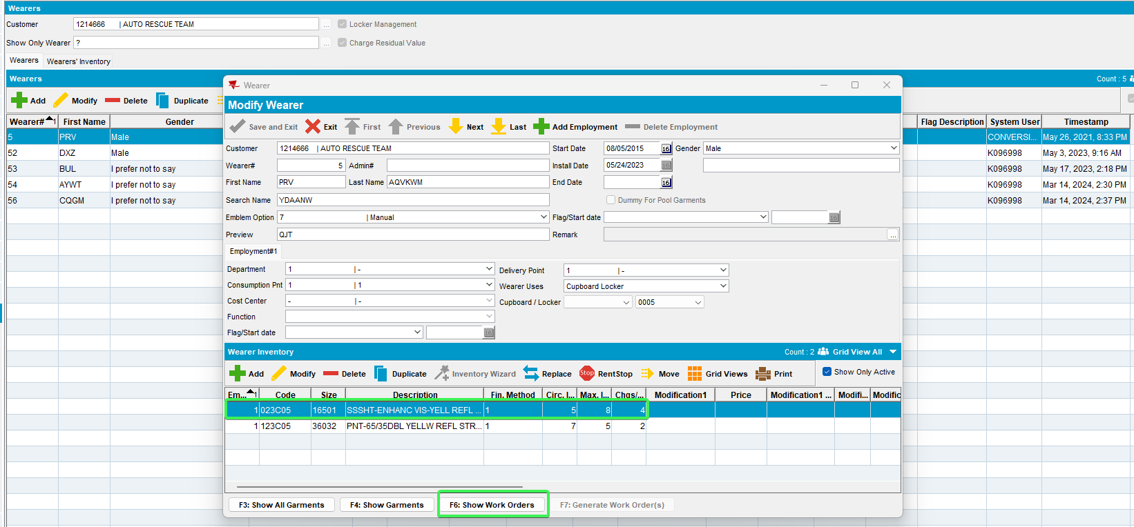
- Check your WO and see that it has the Grade which was assigned on RA “1 – New”
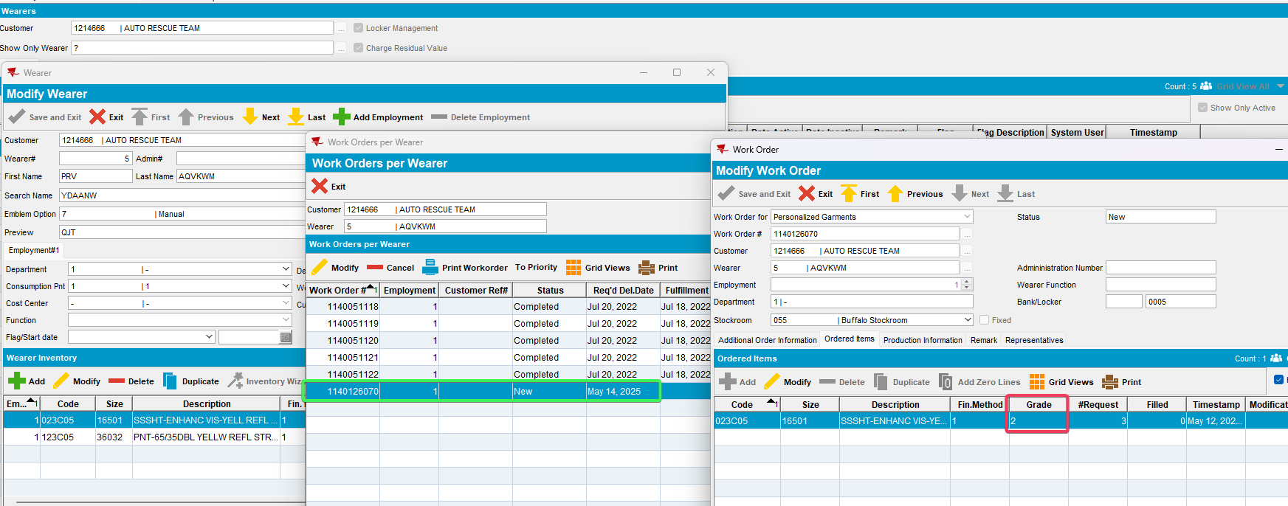
REPRODUCED OK.

Current Behavior
On the newly created work order, the grade is not the one selected on RA

Expected behavior
The newly created work order should have the Grade assigned on RA

Retest after fix

Test Case 1 – Check that the Grade assigned on RA to a IOI is the same on the work order in client
Hash: bd6a1758d30c
- Wearers: Have a Customer with Wearers and WI
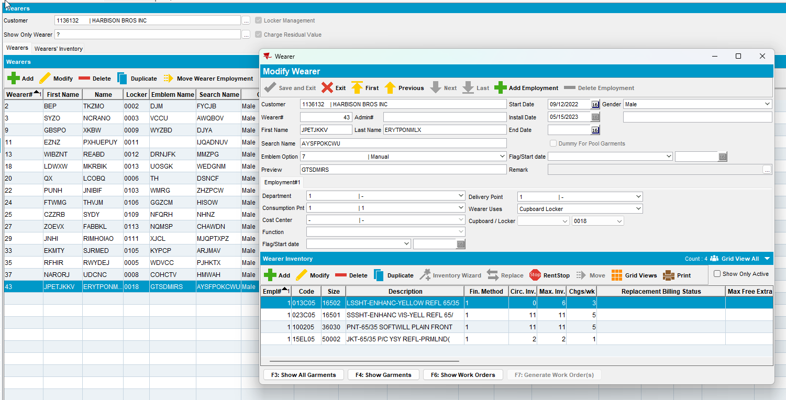
- RSC: Add a new route for this customer and generate invoices
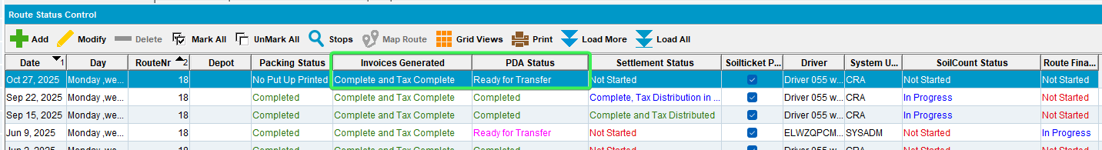
- Send the RC to PDA
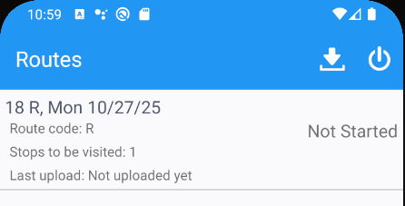
- Arrive at the customer > Wearers > Select a wearer
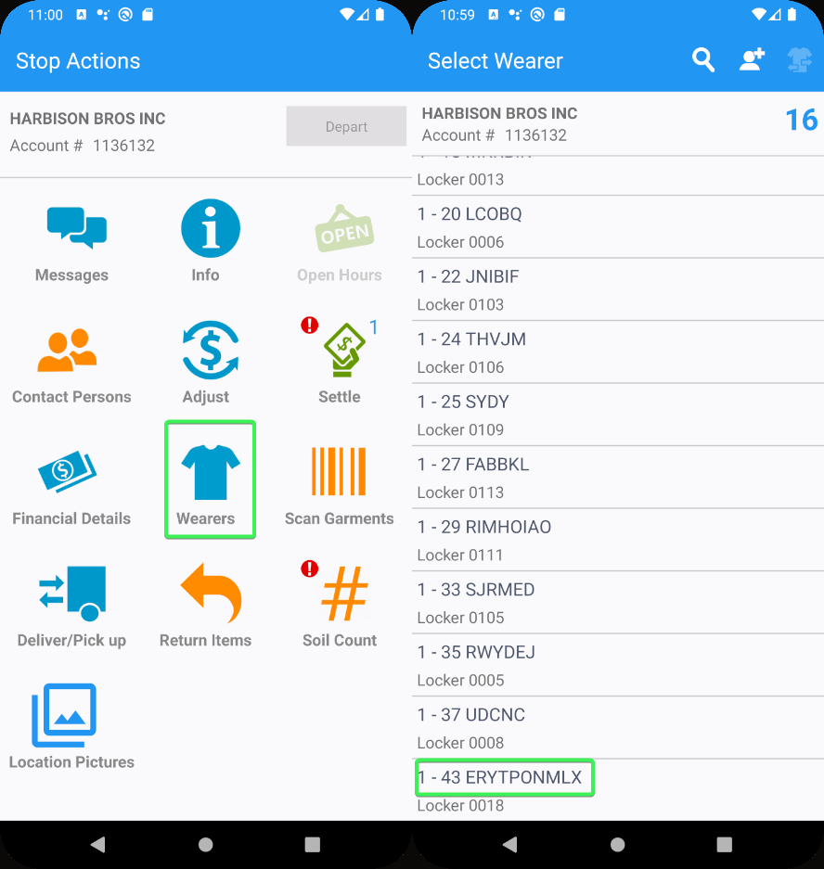
- Select a WI and perform an Increase of Max Inventory > Change the Grade to “1 – New”
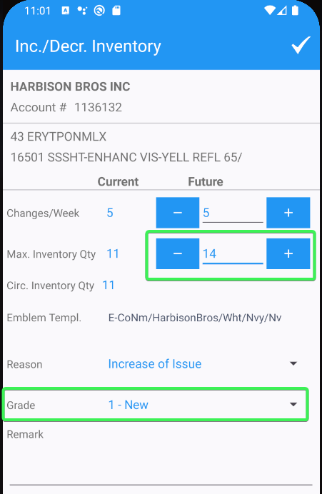
- Finish the route and upload the data
- WebX: Wearer Maintenance tab > approve the Increase of Inventory
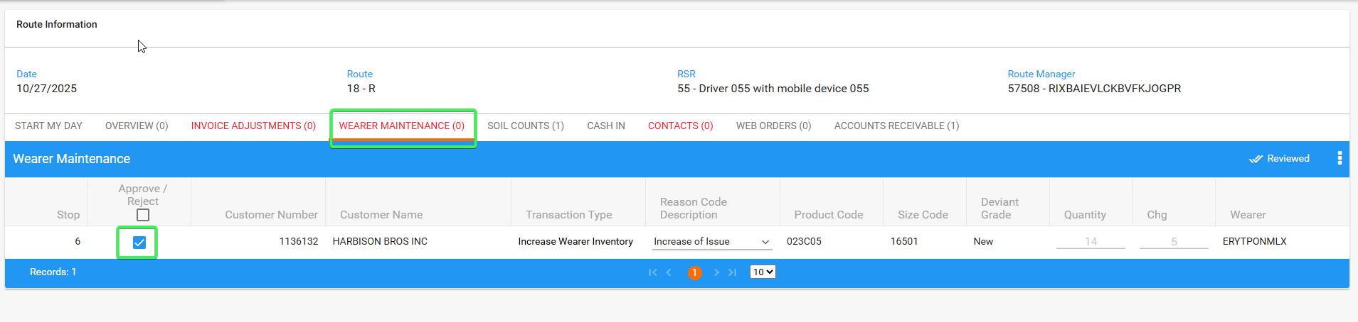
- Review all tabs
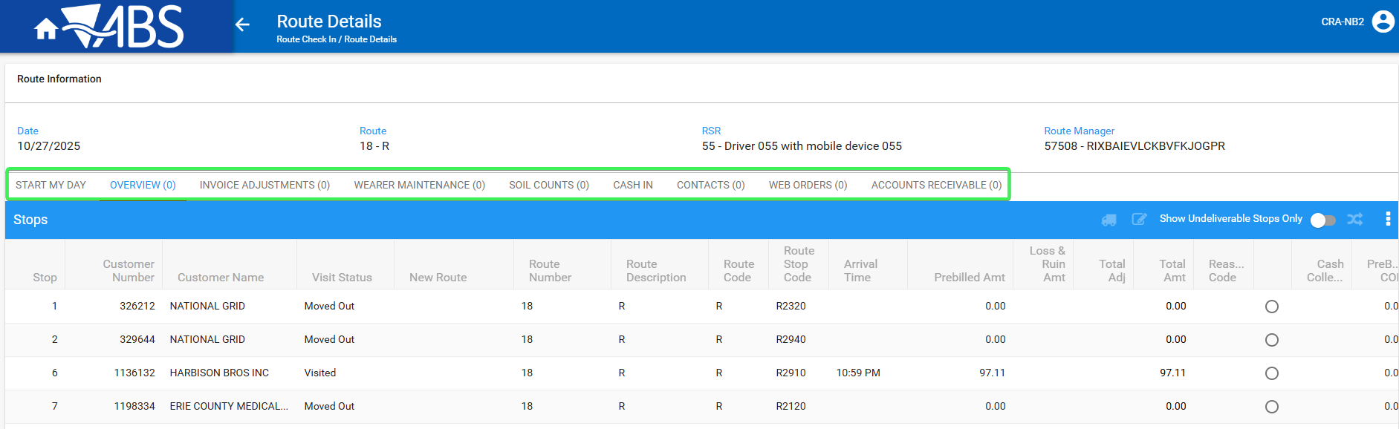
- Settle the route
- Wearers DLG: Go to the WI you incresed and press Show Work Orders button
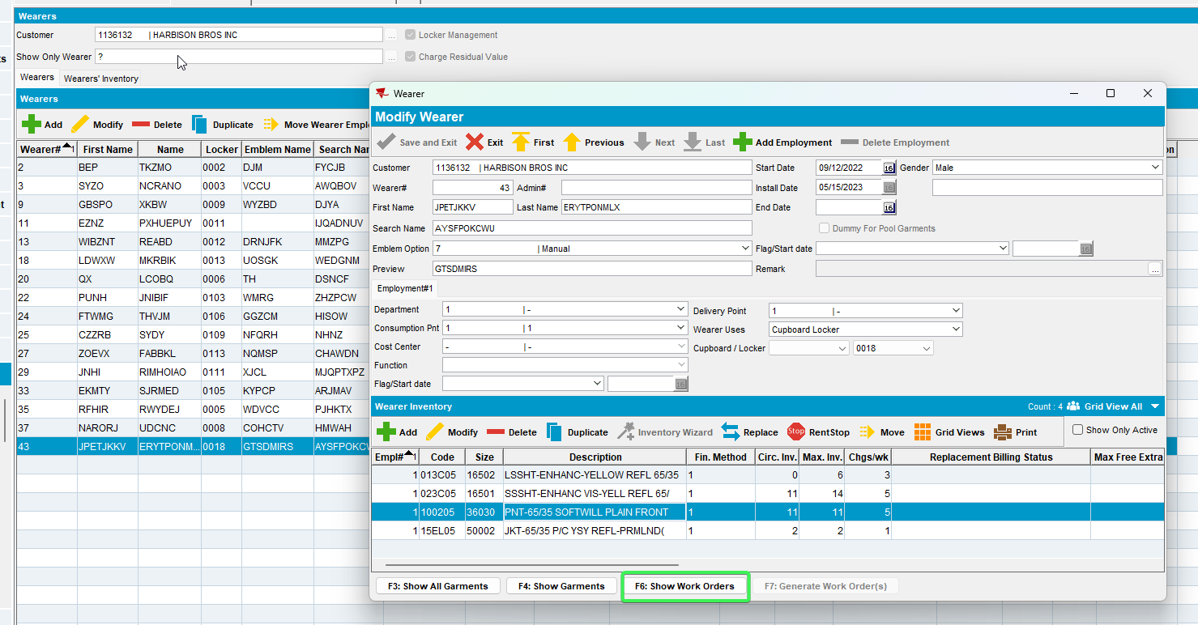
- Check your WO and see that is has the Grade which was assigned on RA “1 – New”
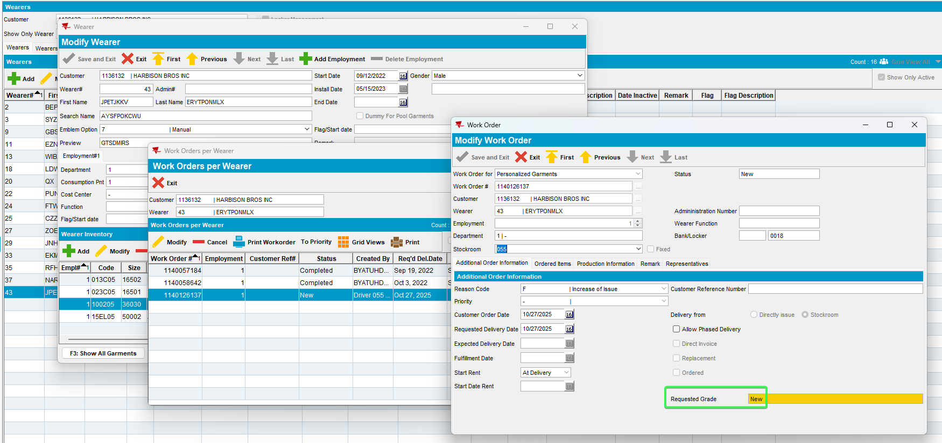
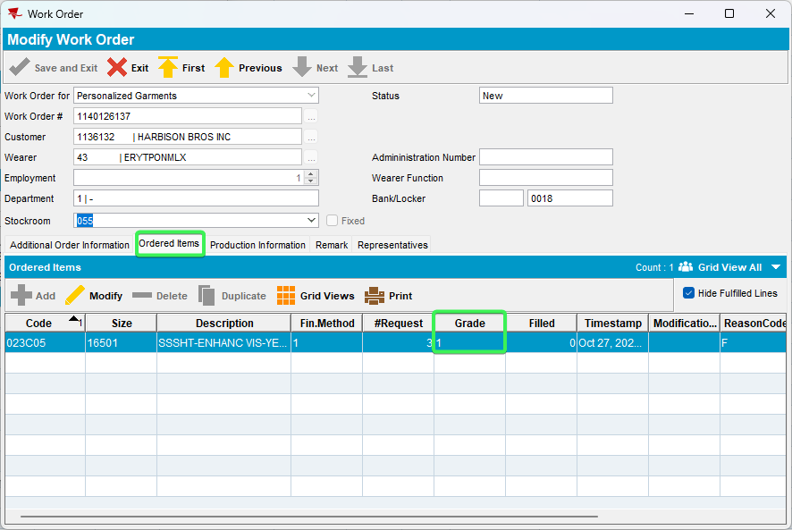
Tested OK

Test Case 2 – Check that the Grade assigned on RA to new WI is the same on the work order in client
Hash: bd6a1758d30c
- Wearers: Have a Customer with Wearers and WI
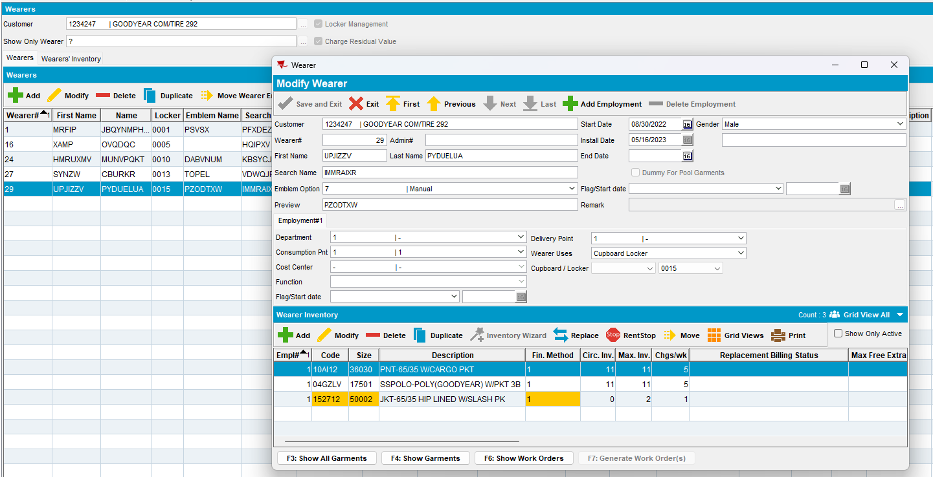
- RSC: Add a new route for this customer and generate invoices
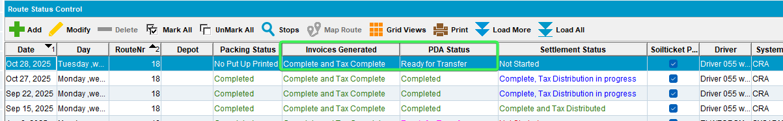
- Send the RC to PDA
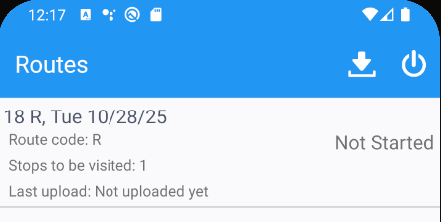
- Arrive at the customer > Wearers > Select a wearer
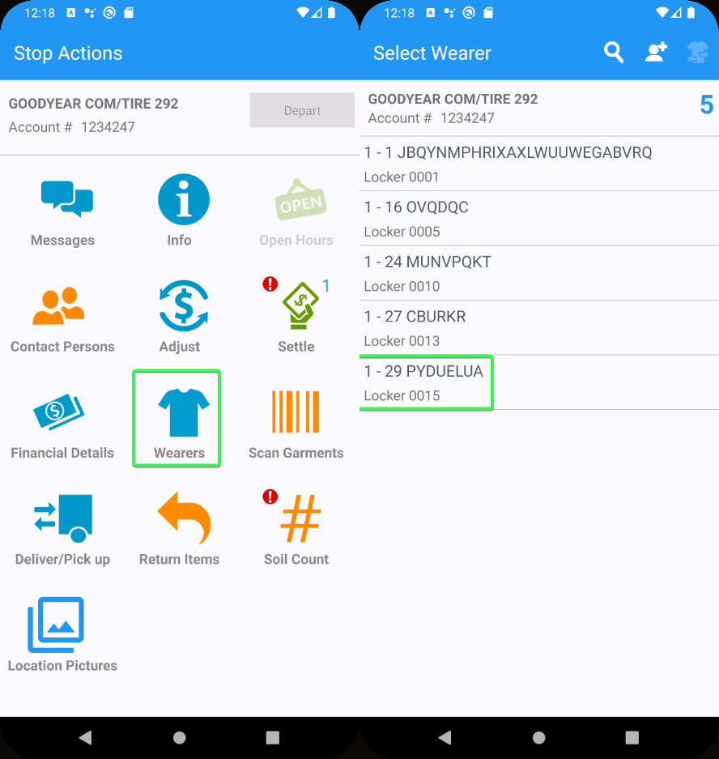

- For a Wearer add a new WI > set the Requested Grade a 1 – new
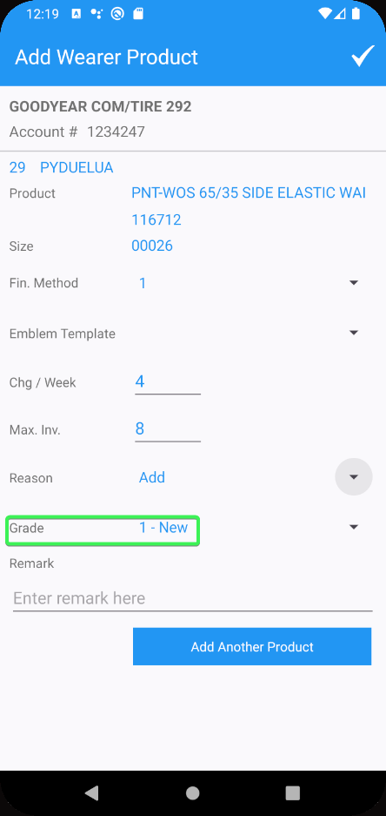
- Finish the route and upload the data
- WebX: Wearer Maintenance tab > approve the transaction
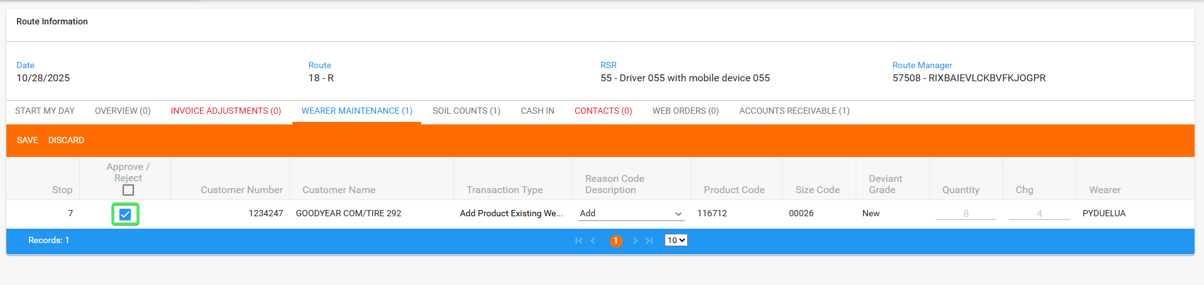
- Review all tabs
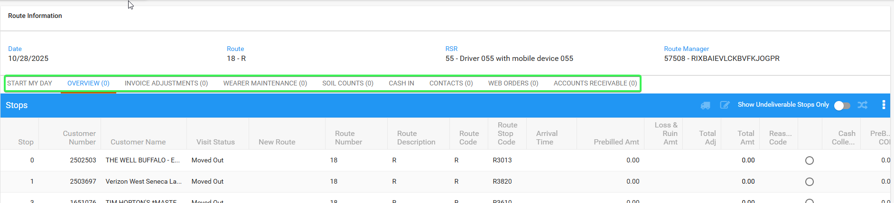
- Settle the route
- Wearers DLG: Go to the wearer you added the new WI and press Show Work Orders button
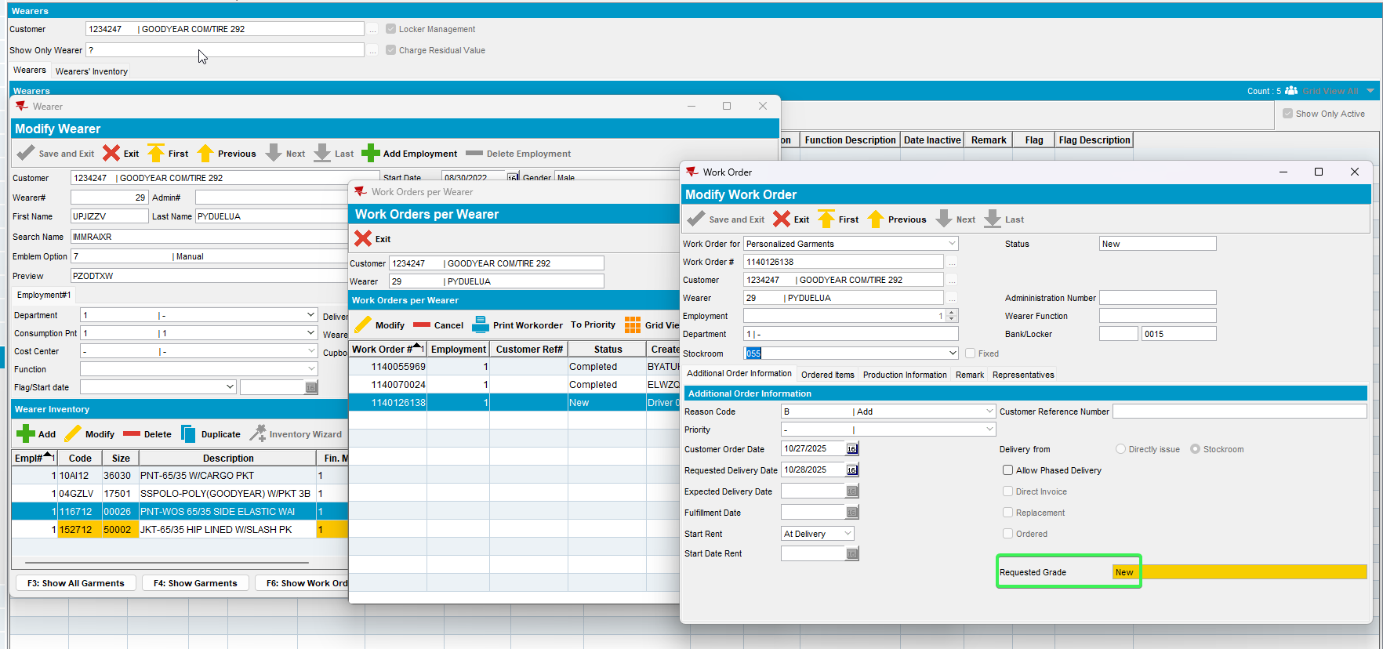
- Check your WO and see that is has the Grade which was assigned on RA “1 – New”
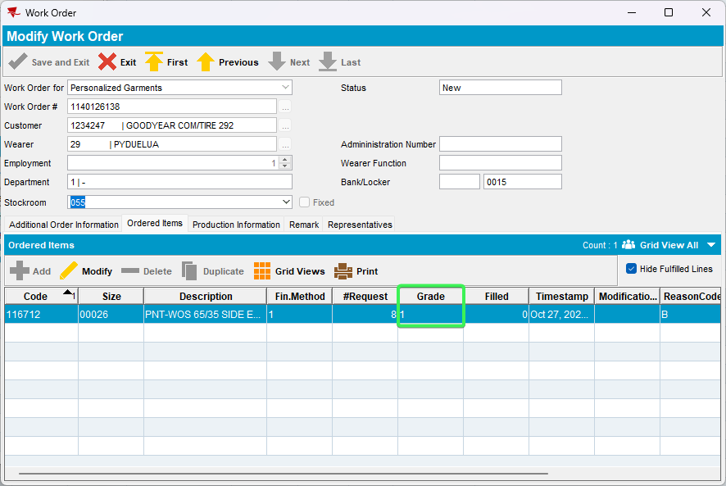
Tested OK

Test Case 3 – Generate Work Order By adding a new Wearer inventory from Client
Expected behavior: Grade used on work order is the grade selected by the user before generating the work order
Hash: bd6a1758d30c
- Wearers DLG – Select a customer
- Press modify on a wearer > Wearer Inventory Press the Add button and add a new Wearer Inventory
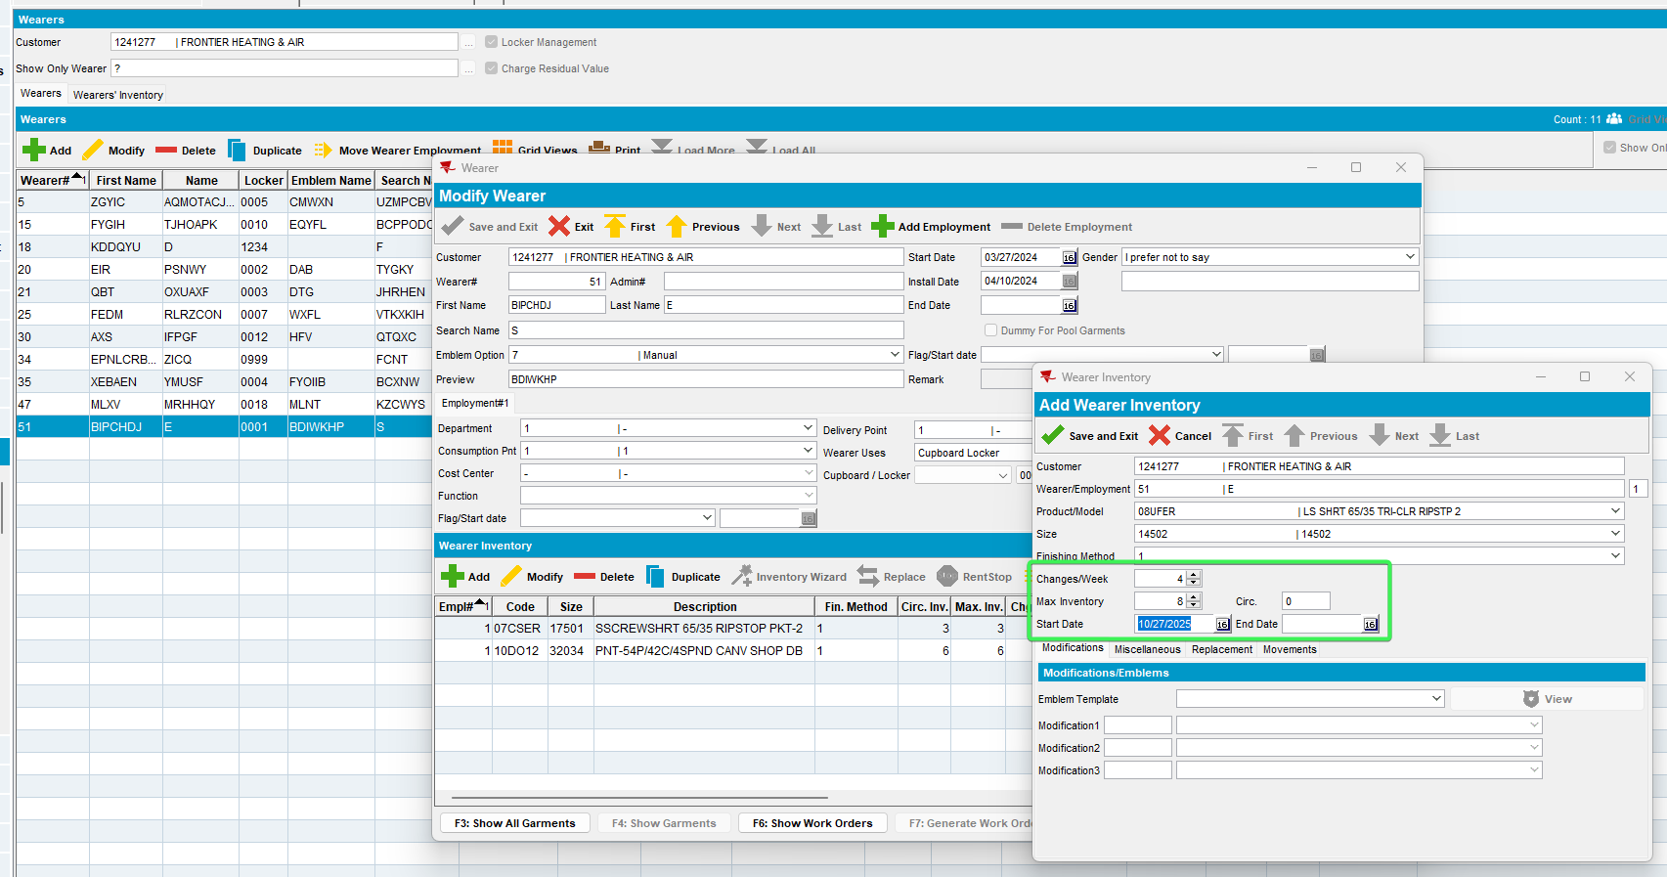
- After adding a new wearer inventory press “F7: Generate Work Order” Button
- Work Order Wizard pop-up: Fill out the necessary fields and select Special grade select: 3 – Serviceable
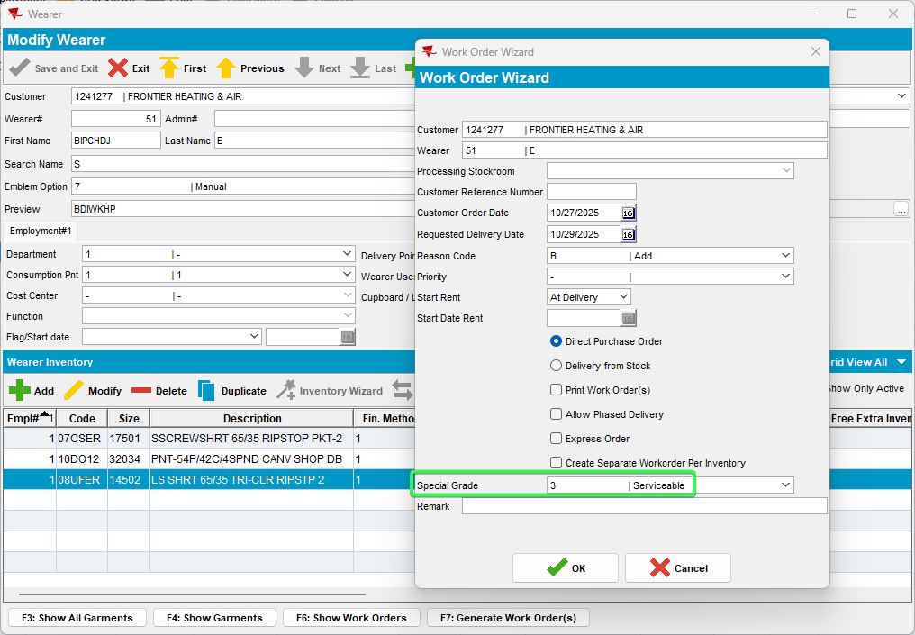
- After the Work Order has been generated – Press the F6: Show Work Orders button and select your work order
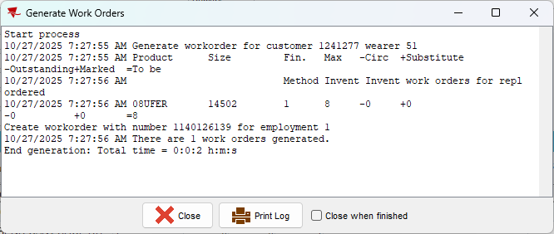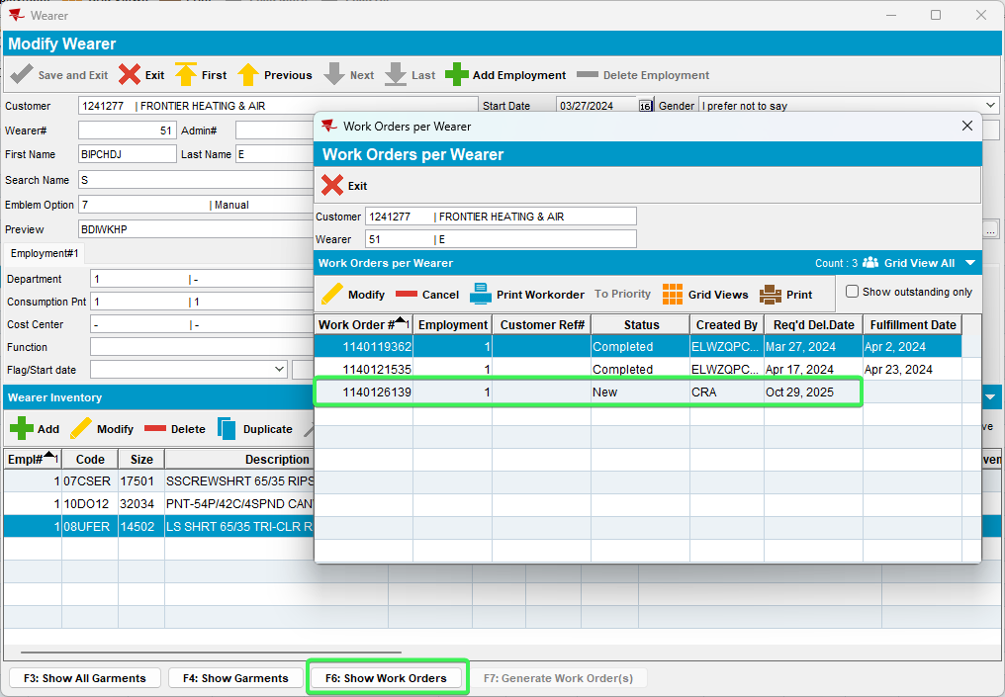
- Additional Order Information tab: Requested grade field – notice the grade
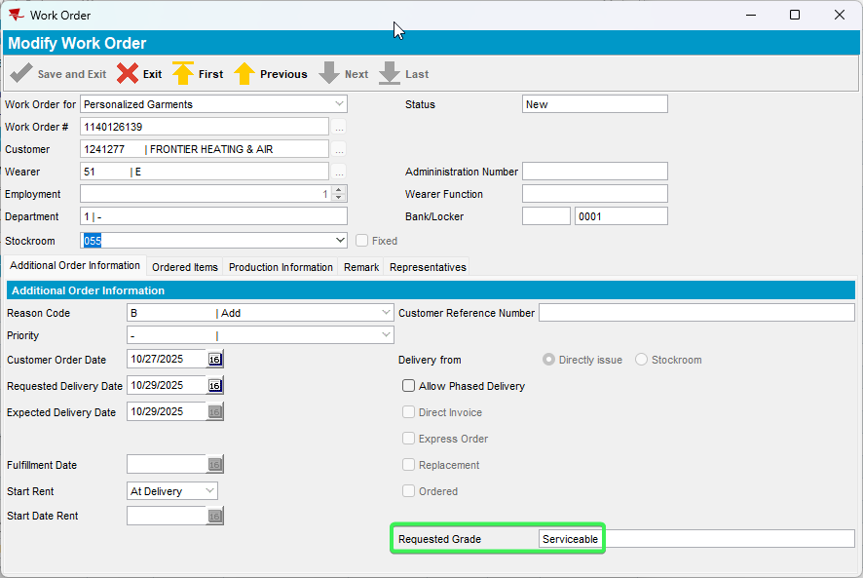
- Ordered Items tab Grade row: Notice the given grade.
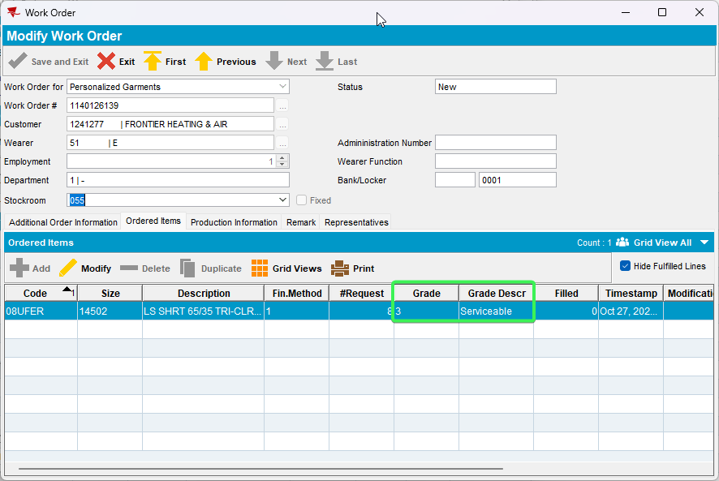
Tested OK

Test Case 4 – Generate Work order by replacing a Wearer Inventory
Expected behavior: Grade used on work order is the grade selected by the user before generating the work order
Hash: bd6a1758d30c
- Wearers DLG – Select a customer
- Press Modify on a Wearer > Select a Wearer Inventory and press “Replace” button
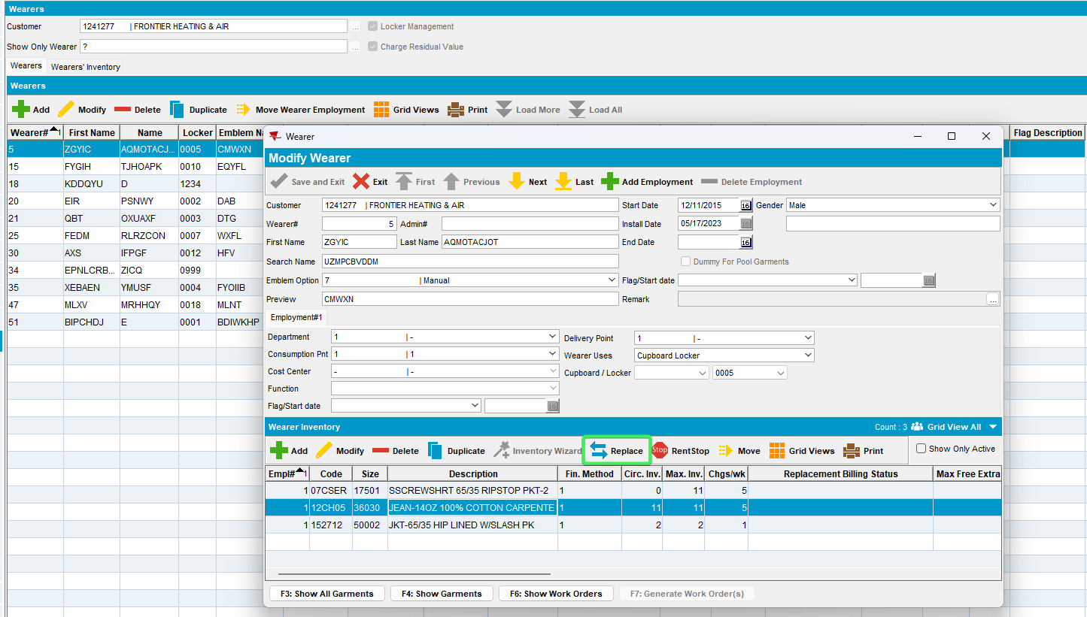
- On the Wearer Inventory Replacement window press Final Run
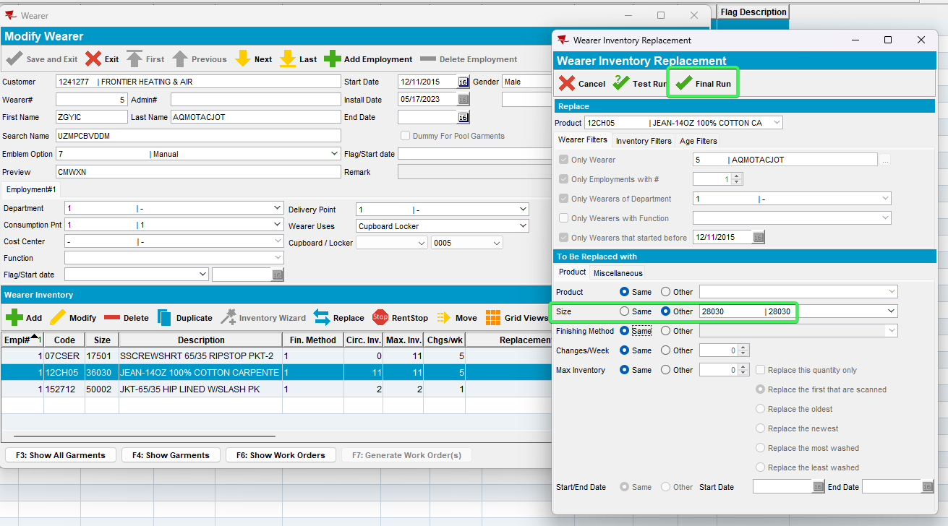
- On Work Order Wizard window fill out the required fields and select Special grade as 1 - New press OK
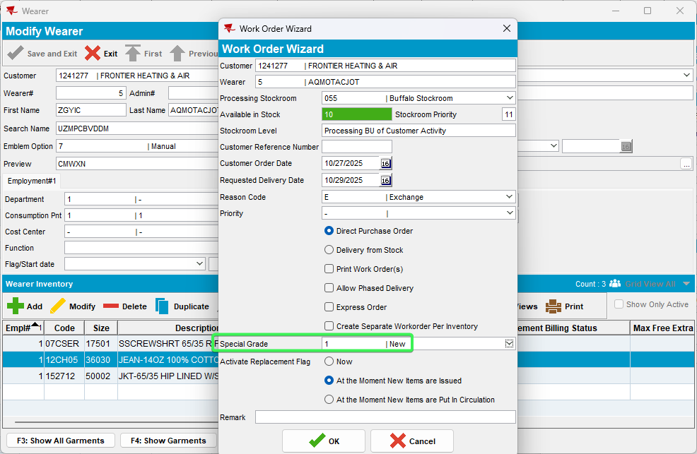
- After the Work Order is finished press “F6: Show Work Orders” button from Wearer Inventory and access the Replacement WO you just created
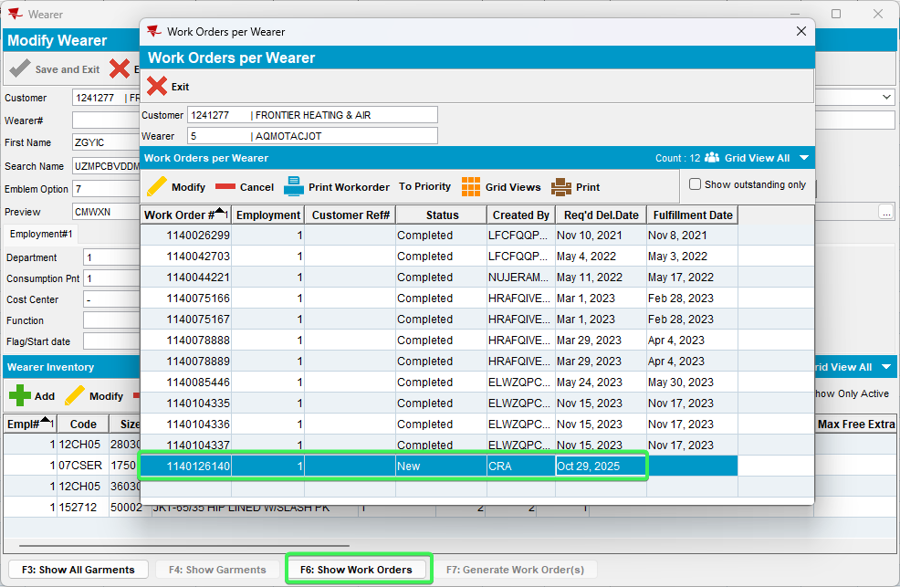
- Additional Work Order Information tab: Check the Requested Grade field
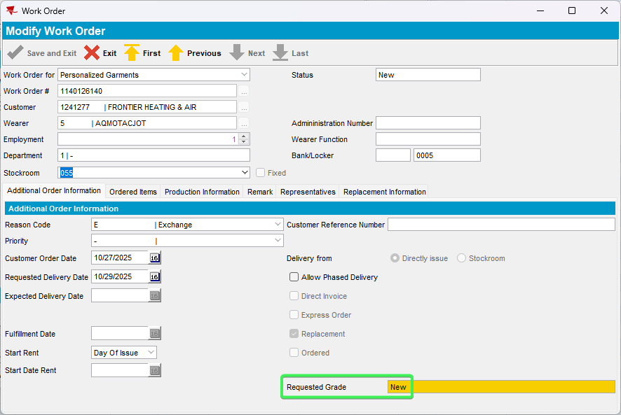
- Ordered Items tab: check the given Grade in the grid
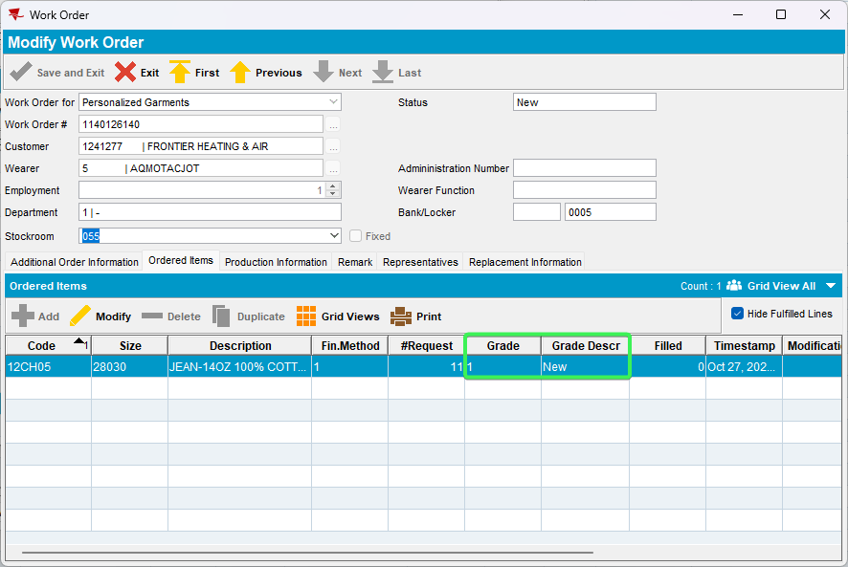
Tested OK

Test Case 5 – Generate Work order from Renewal/Replacement dialog
Expected behavior: Grade used on work order is the grade selected by the user before generating the work order
Hash: bd6a1758d30c
- Replacement / Renewal DLG: Select a customer
- Press the Add button and select a Product > Save and Exit
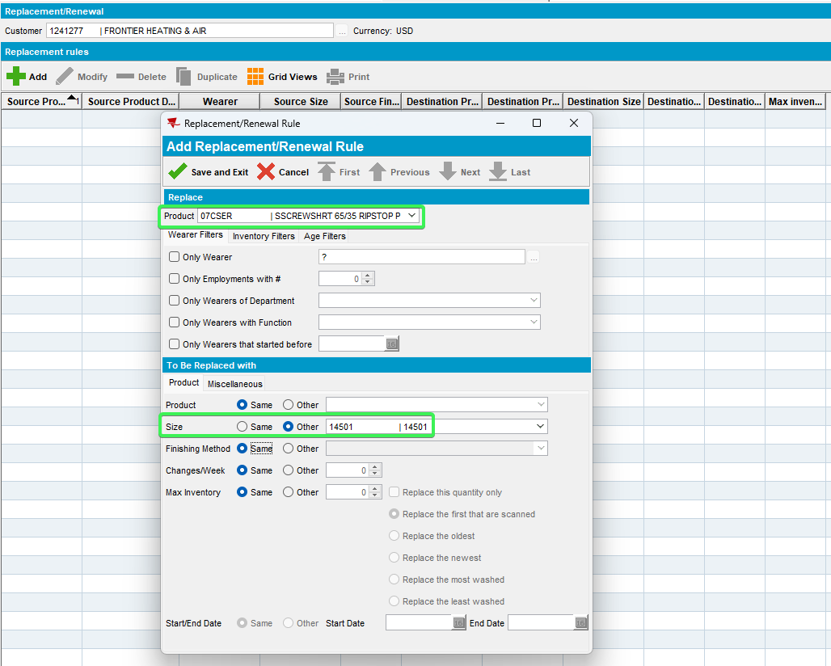
- Press Final Run at the bottom of the screen
- Work Order Wizard: Complete the mandatory fields and select Special Grade: 1 - new > Press OK
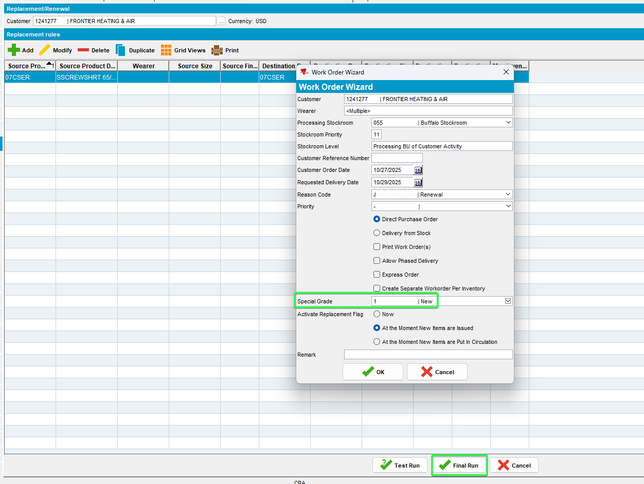
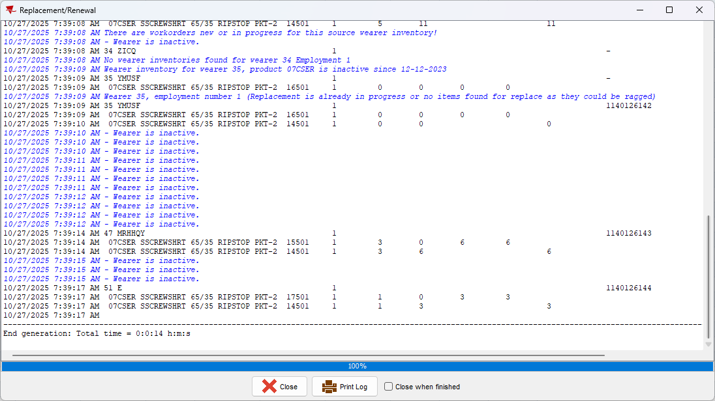
- After the work Order finishes go to Work Orders DLG and input your workorder number
- Additional Order information tab: Check the Requested grade field
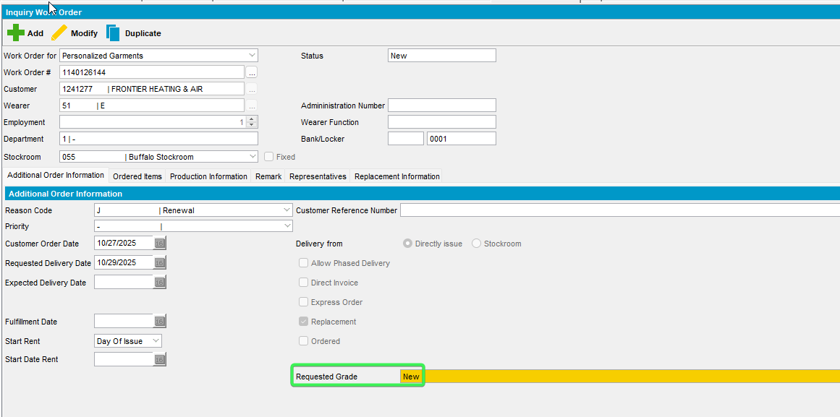
- Ordered Items tab: check the Grade field in the grid
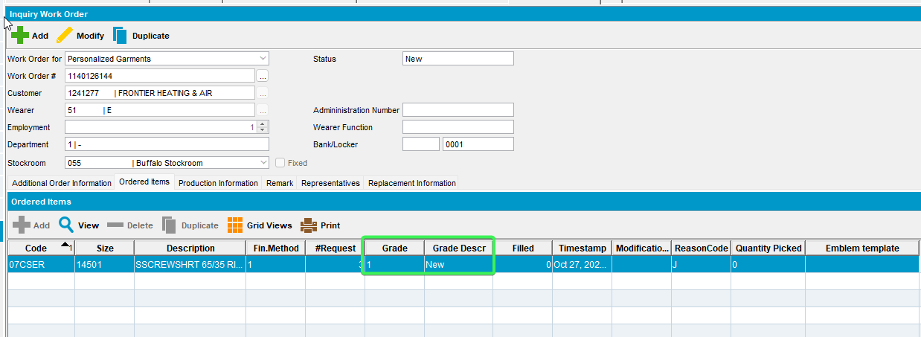
Tested OK

