ABSN-3060 Generating WO from Wearers Inventory tab when product is inactive in PLPC
Environment | Prerequisites
Version:9.07.00.UNF21  DBServerName=abs-srv19.internal.abslbs.com  DBSID=CUST22  DBUser=UNFLIVE  Environment=Test | - Module:  - System setting

Contents
Retest after fix 1
Test Case 1 – Product.Active = 'N' & PLPC.DateInactive <= sysdate– Tested OK 1
Test Case 2 – Product.Active = 'Y' & PLPC.DateInactive <= sysdate– Tested OK 4

Retest after fix

Test Case 1 – Product.Active = 'N' & PLPC.DateInactive <= sysdate– Tested OK
Expected behavior: Generate Work Orders from Wearer Inventory and Generate Work Order from Wearer Inventory TAB are disabled
Hash: 3bc60b8a4ff3
- Have a WI with 5 circ/5 max
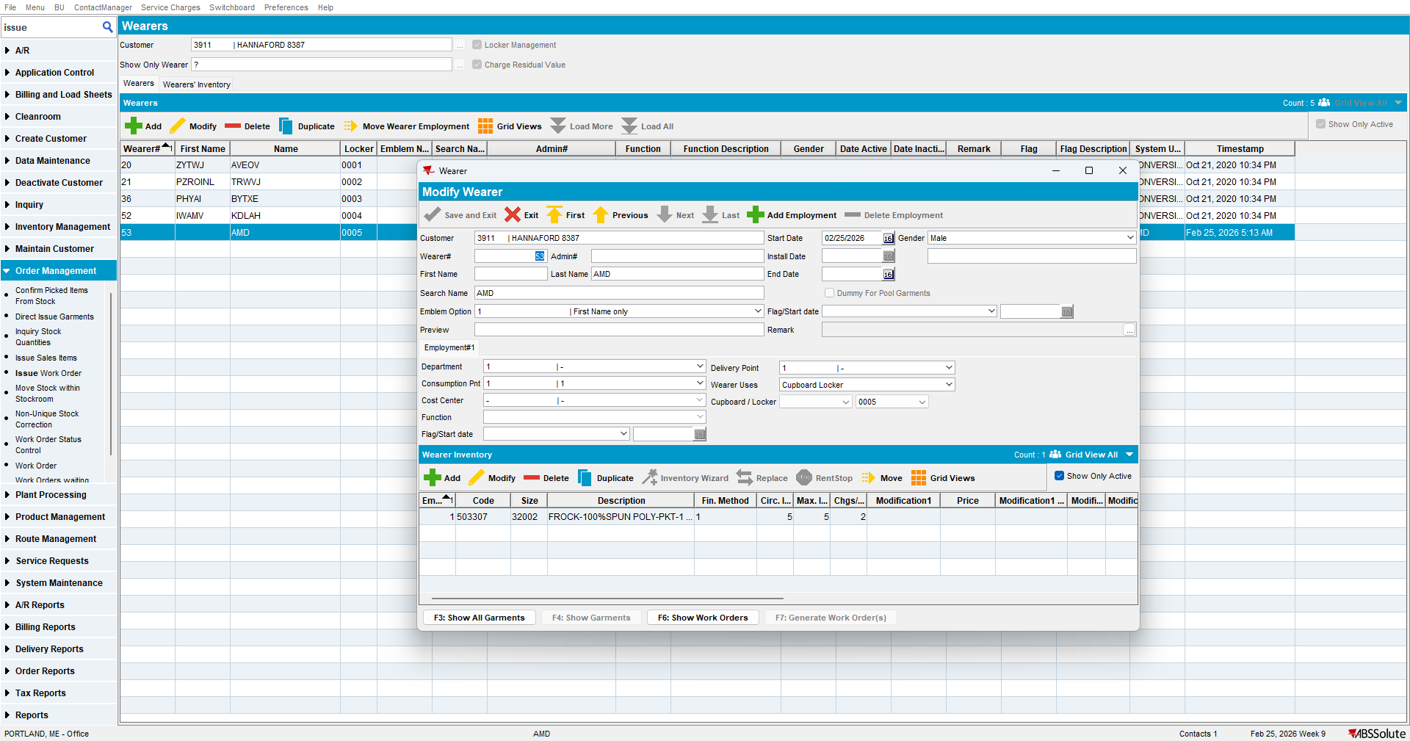
- Increase max
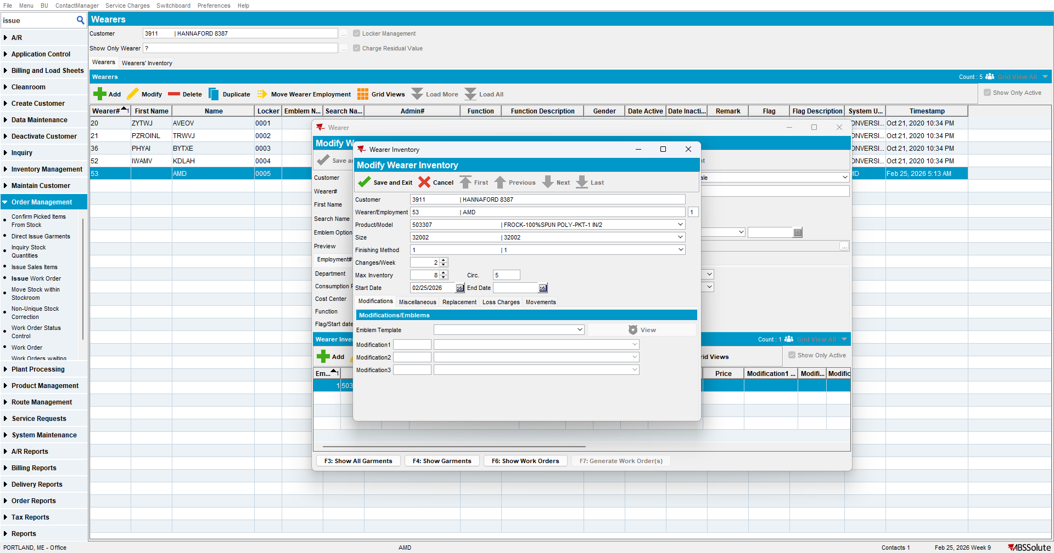

- Go to Products dlg and inactivate the product
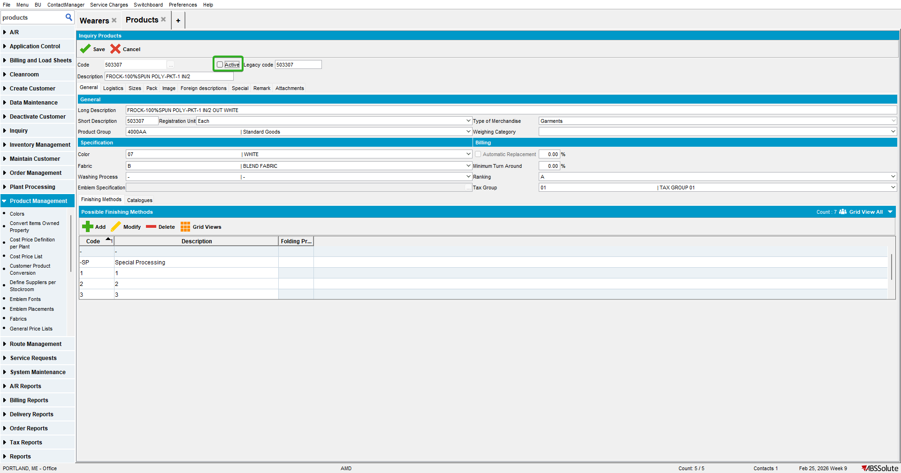

- Go to PLPC dlg and inactivate the product
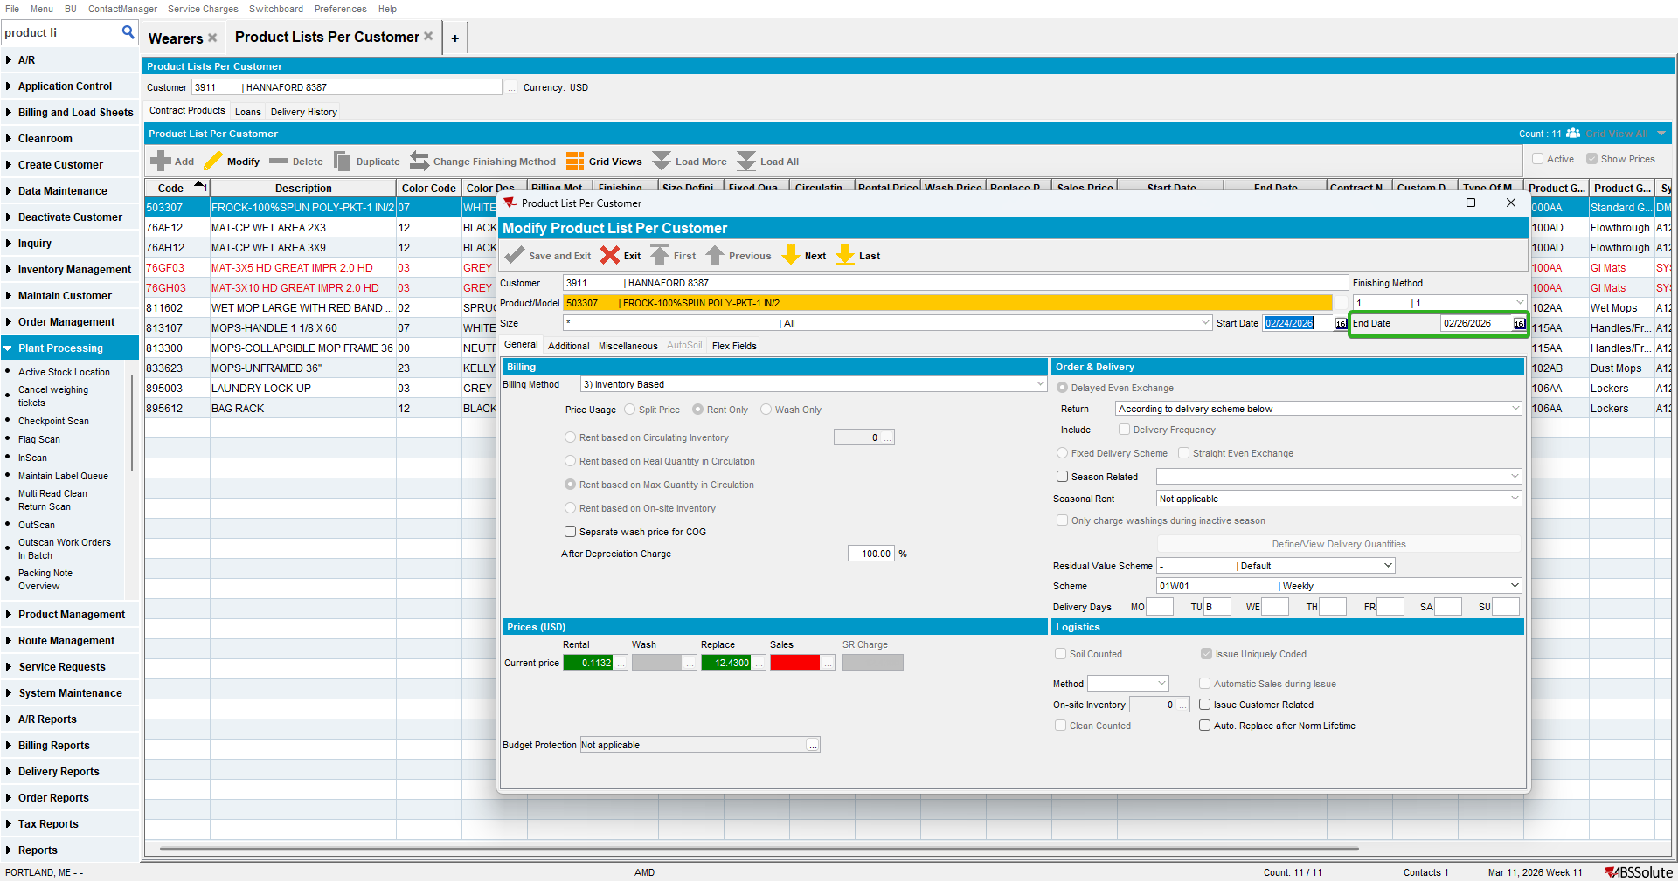

- Go to Wearers dlg to Wearers tab, select your wearer and check that the Generate Work Order button is disabled
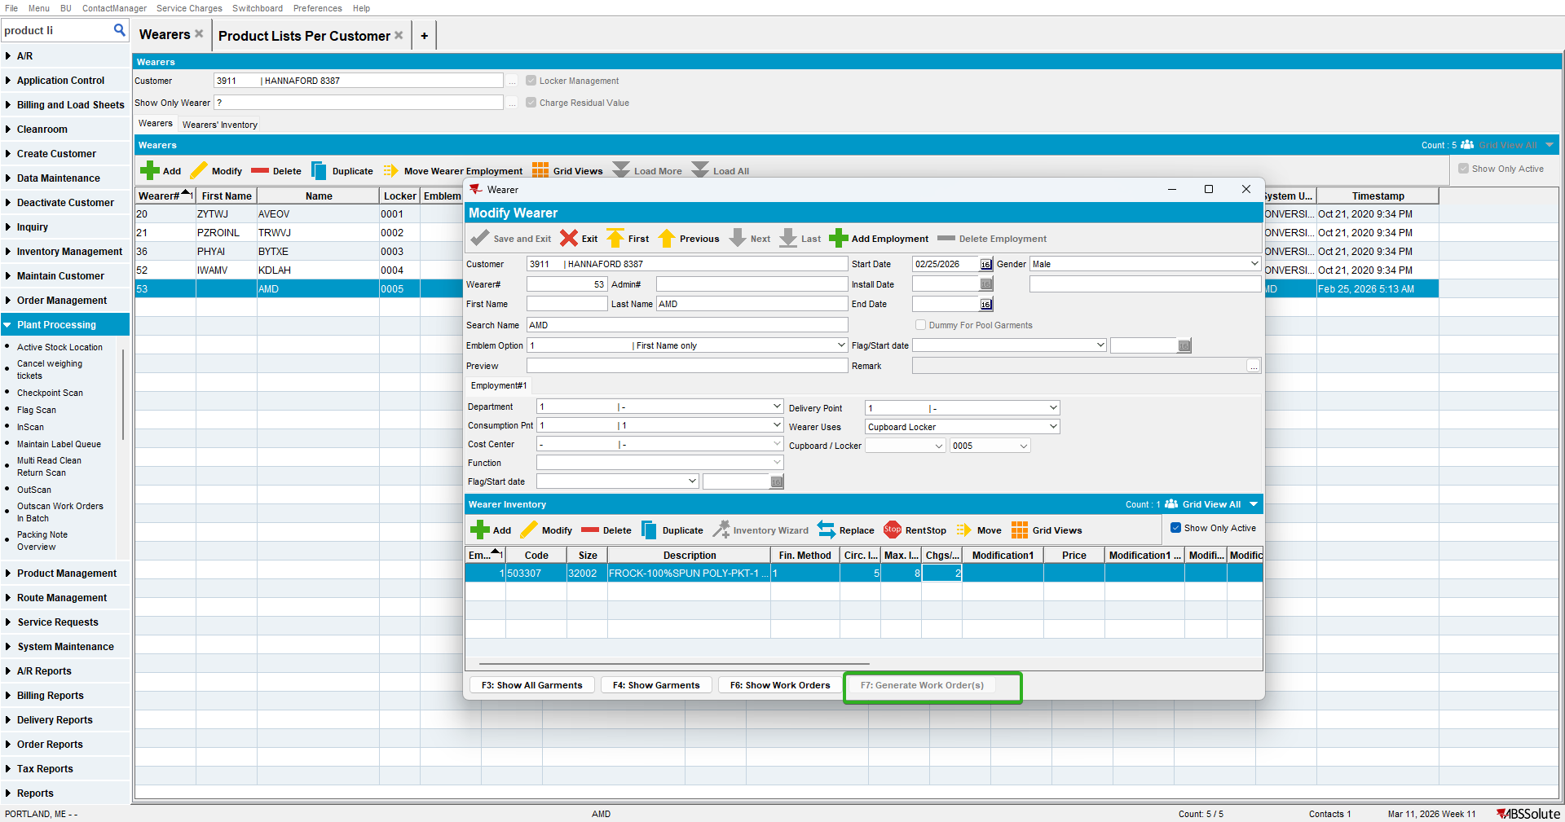

- Go to Wearers dlg to Wearer Inventory tab, select Not Completed Inventories and check that the Generate Work Order button is disabled for your WI
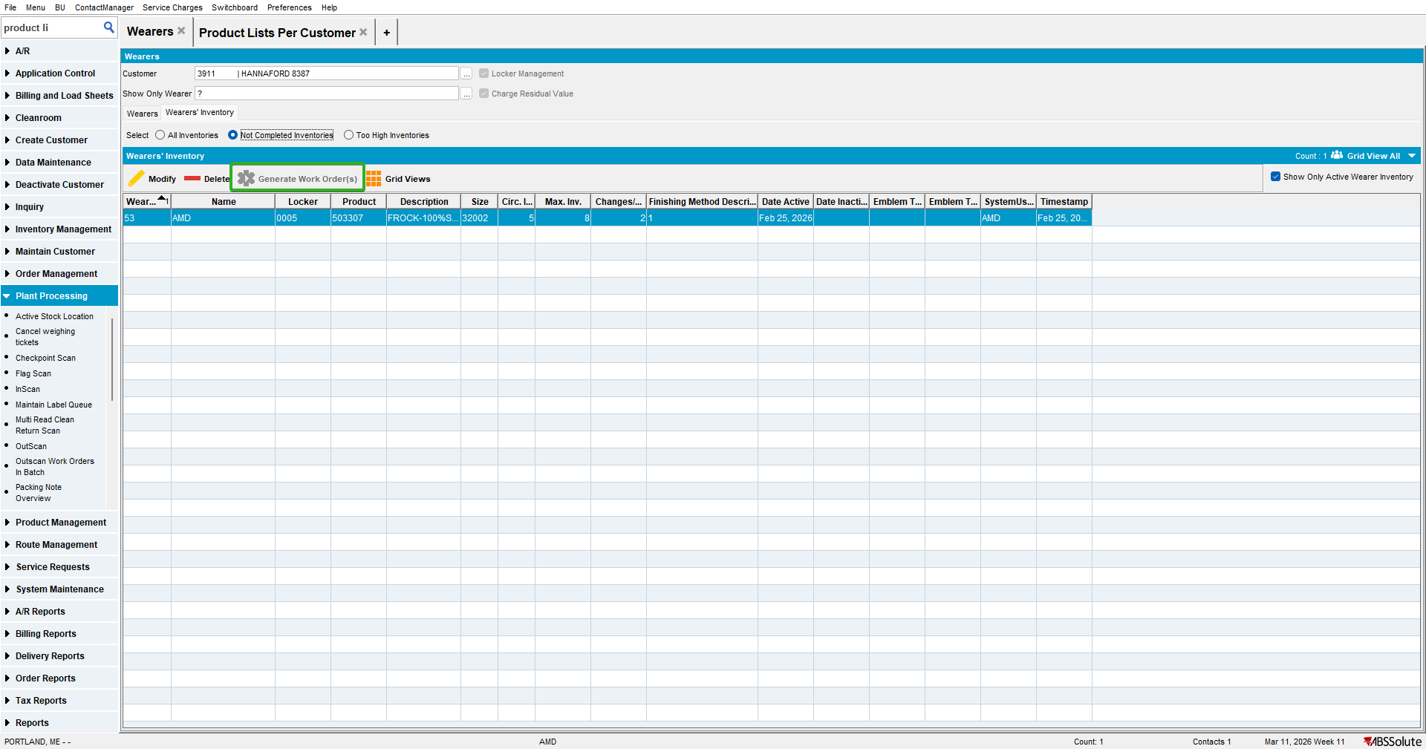

Test Case 2 – Product.Active = 'Y' & PLPC.DateInactive <= sysdate– Tested OK
Expected behavior: Generate Work Orders from Wearer Inventory and Generate Work Order from Wearer Inventory TAB are disabled
Hash: 3bc60b8a4ff3
- Have a WI with 5 circ/5 max

- Increase max
- Go to Products dlg and check the product is active
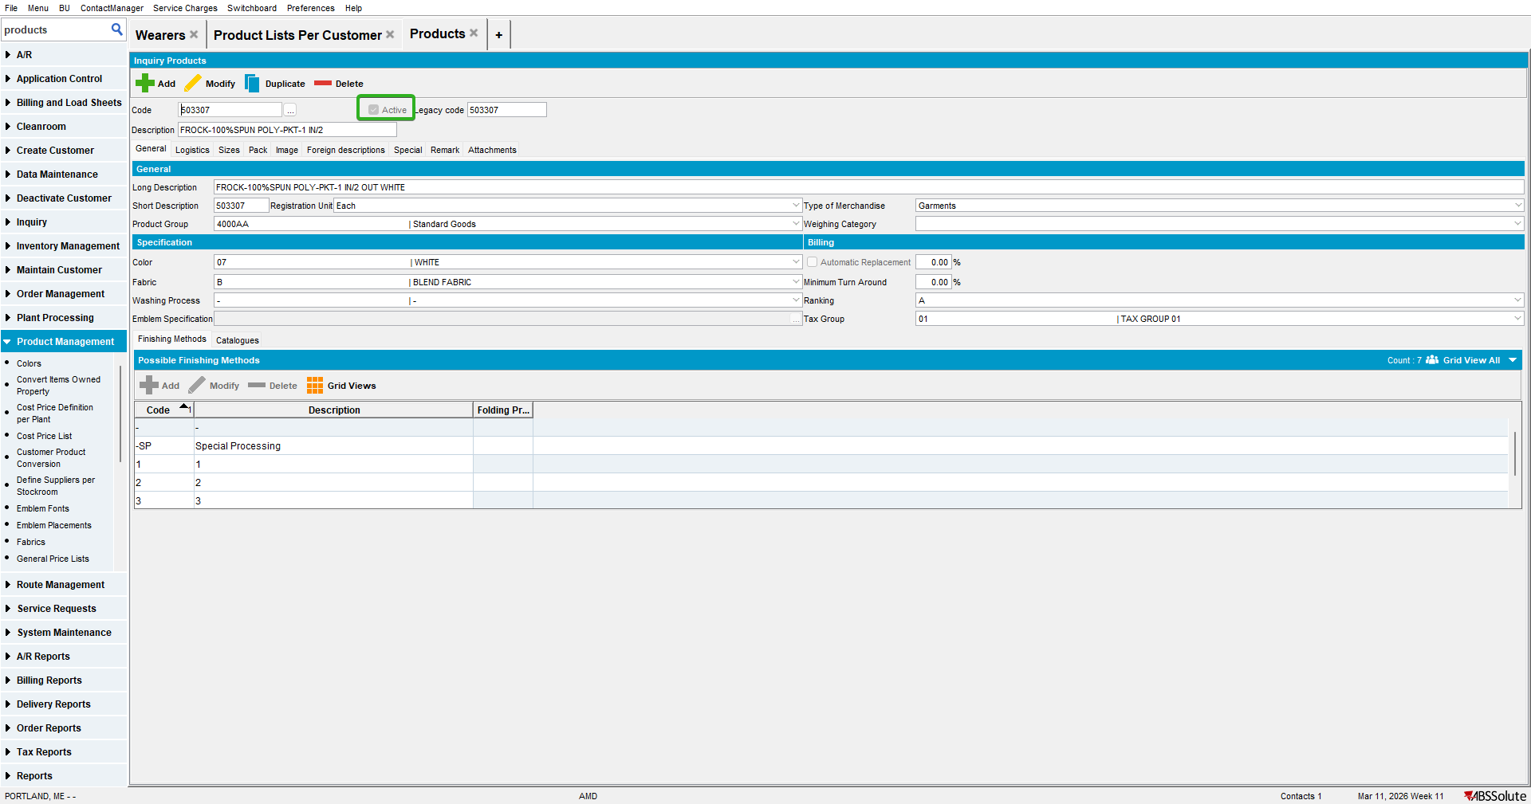

- Go to PLPC dlg and inactivate the product

- Go to Wearers dlg to Wearers tab, select your wearer and check that the Generate Work Order button is disabled

- Go to Wearers dlg to Wearer Inventory tab, select Not Completed Inventories and check that the Generate Work Order button is disabled for your WI

