ABSN-1723 Inconsistency generating work orders when a product is inactive
Environment | Prerequisites
Version:9.07.00.UNF21  DBServerName=abs-SRV19.internal.abslbs.com  DBSID=CUST22  DBUser=UNFLIVE  Environment=Test | - Module:  - System setting

Contents
Retest after fix 1
Test Case 1 – Product.Active = 'N' Increase wearer inventory before inactivating product– Tested OK 1
Test Case 2 – Product.Active = 'N' Increase wearer inventory after inactivating product – Tested OK 5
Test Case 3 – Product.Active = 'Y'– Tested OK 11

Retest after fix

Test Case 1 – Product.Active = 'N' Increase wearer inventory before inactivating product– Tested OK
Expected behavior: Generate Work Orders from Wearer Inventory and Generate Work Order from Wearer Inventory TAB are active
Hash: 3bc60b8a4ff3
- Have 2 wearers with WI 5 circ/5 max with the same product
- Increase max for both WI
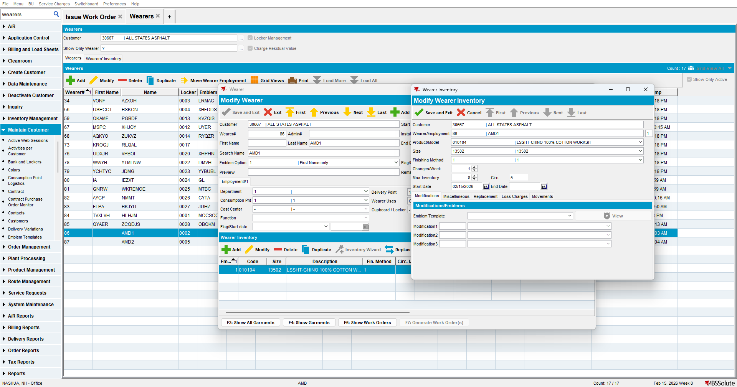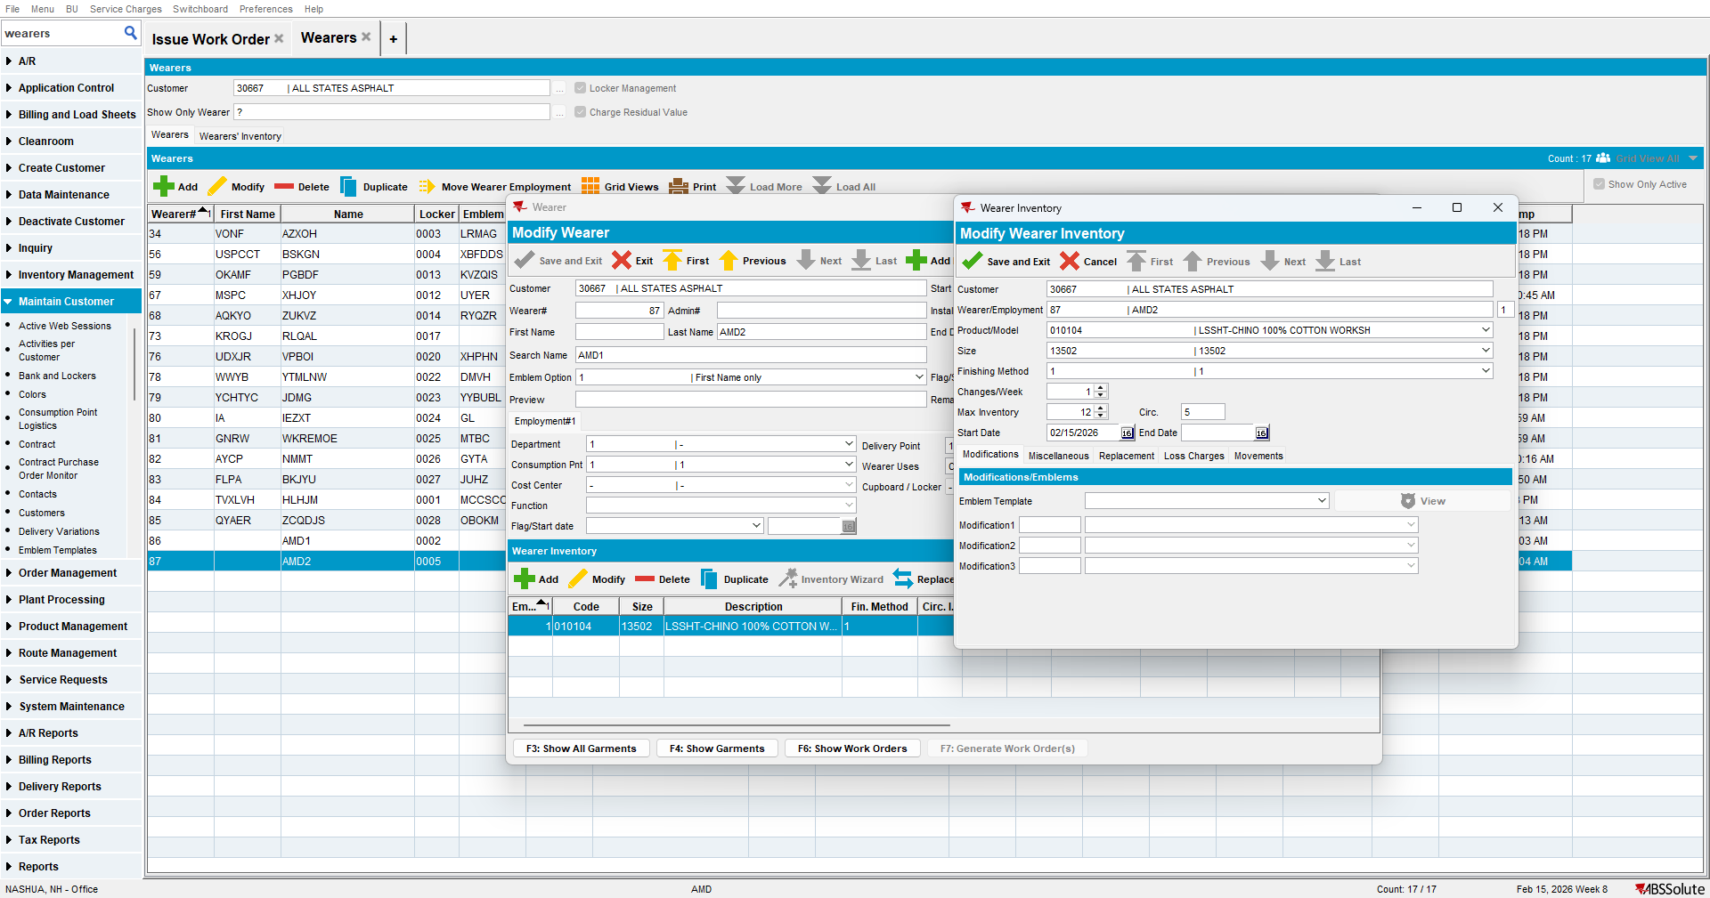

- Go to Products dlg and inactive the product of those WI
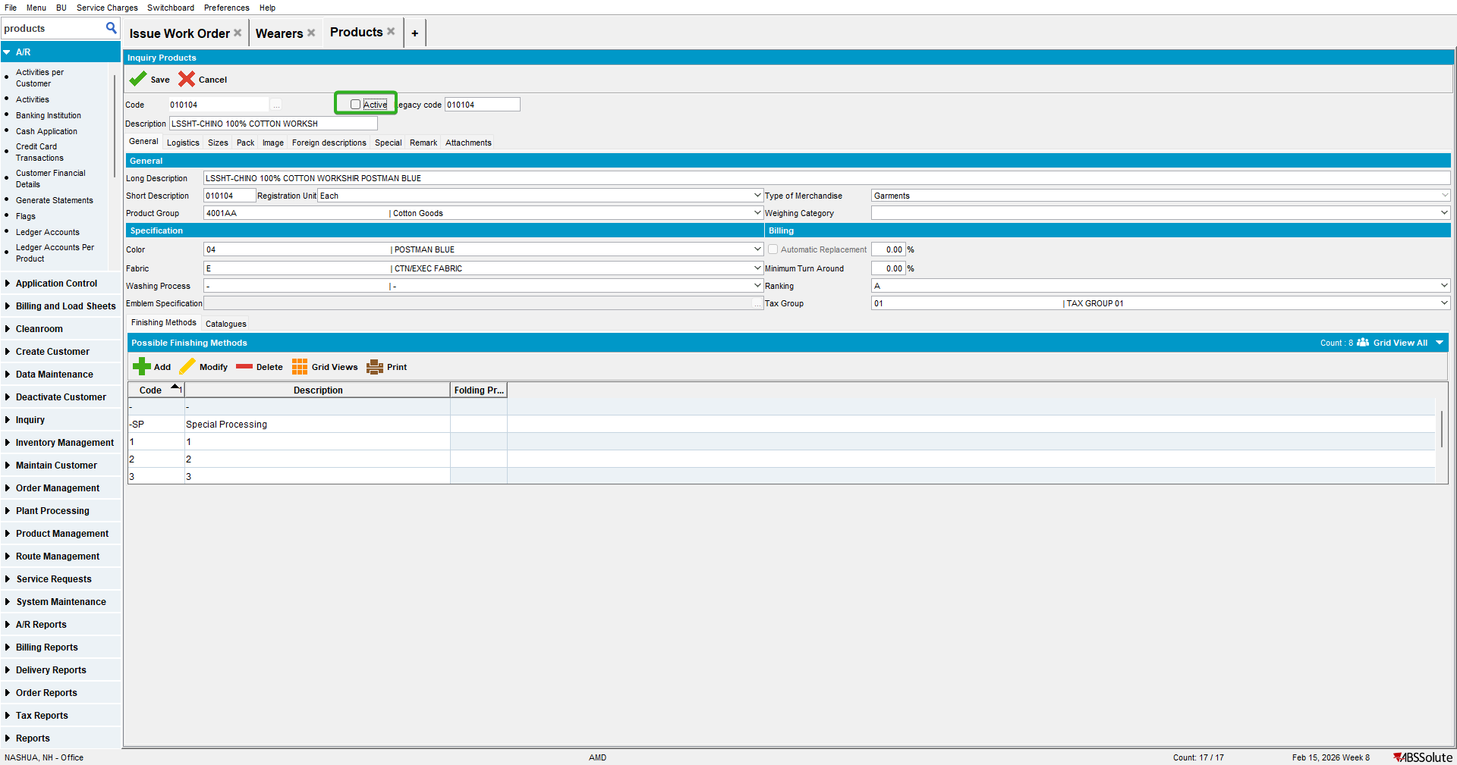

- Go to Wearers dlg to Wearers tab and generate WO for one of the WI
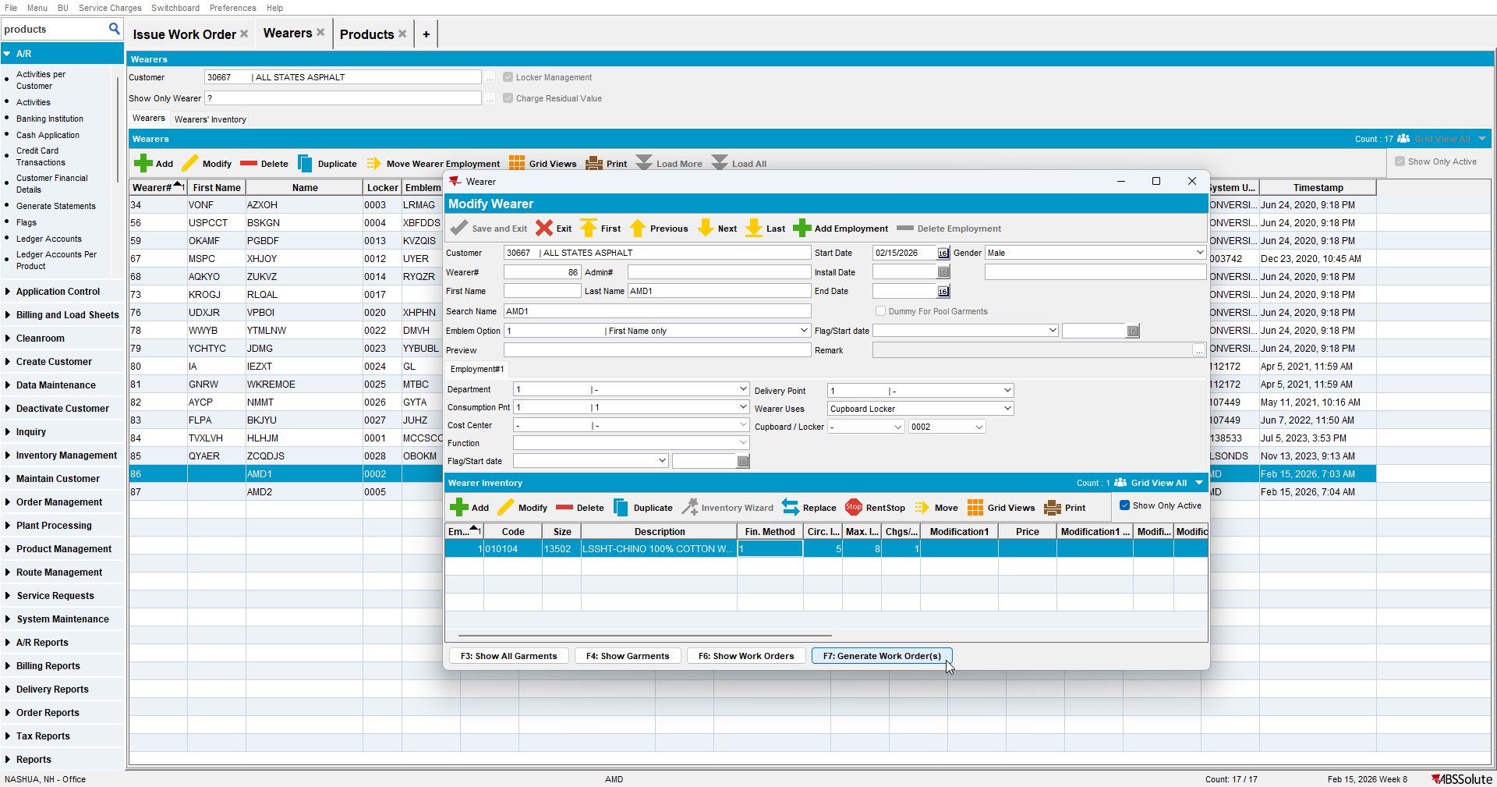
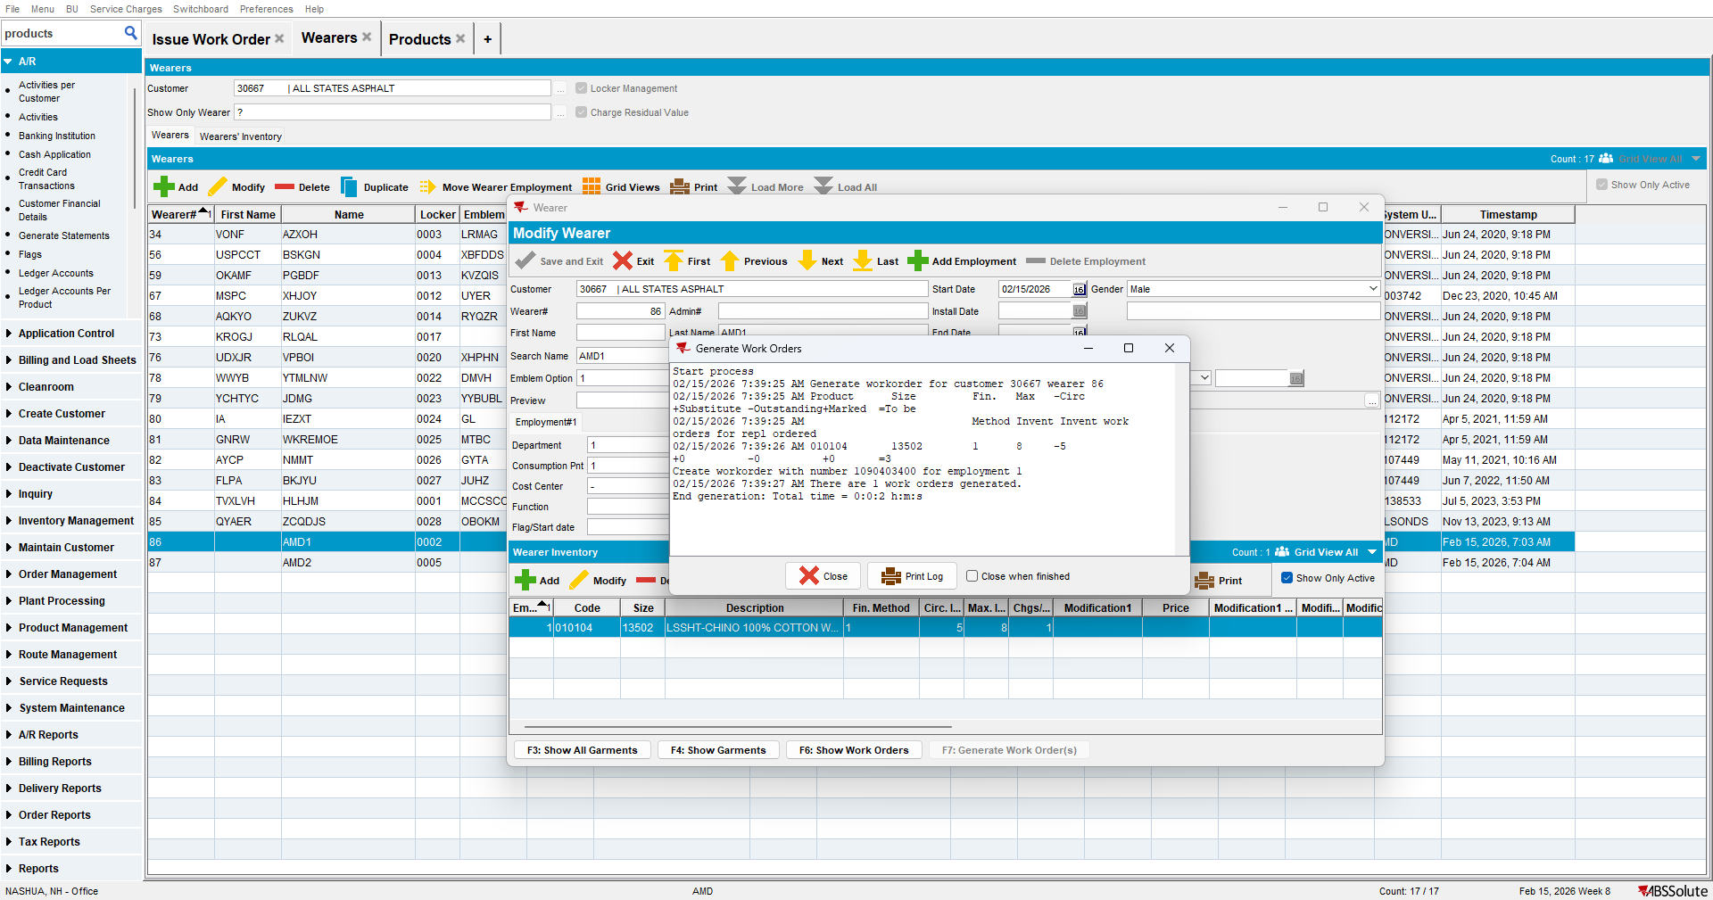

- Go to Wearers Inventory tab, check Not Completed Inventories and generate WO
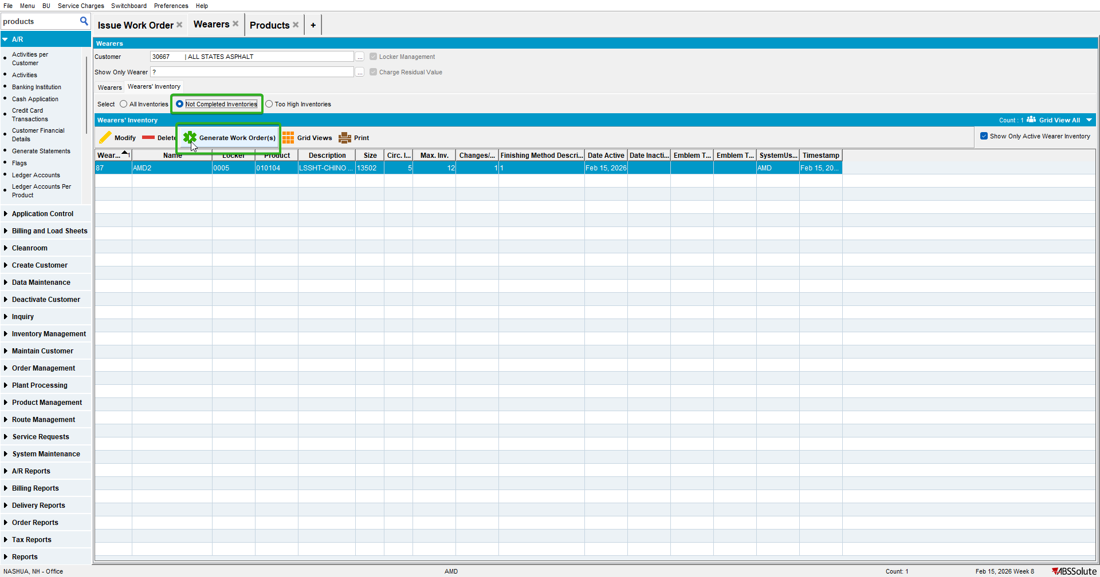
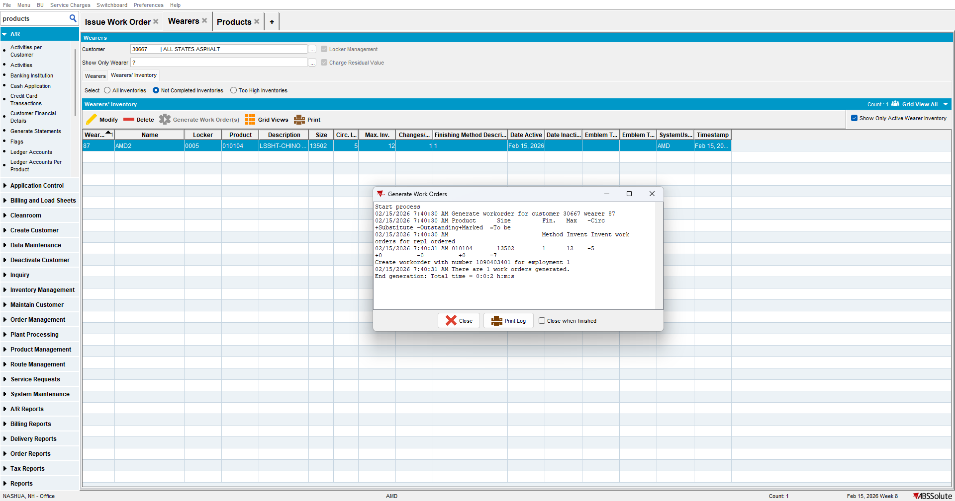

Test Case 2 – Product.Active = 'N' Increase wearer inventory after inactivating product – Tested OK
Expected behavior: Generate Work Orders from Wearer Inventory and Generate Work Order from Wearer Inventory TAB are active
Hash: 3bc60b8a4ff3
- Have 2 wearers with WI 5 circ/5 max with the same product
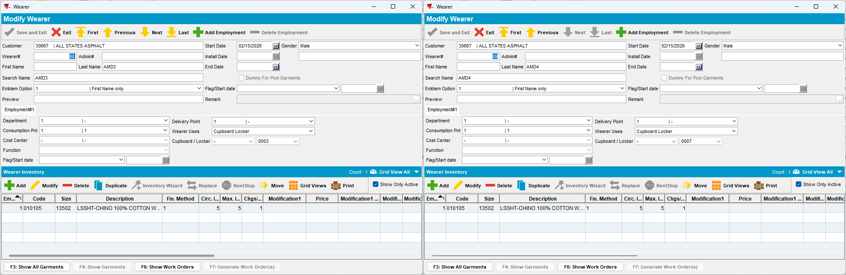

- Go to Products dlg and inactive the product of those WI
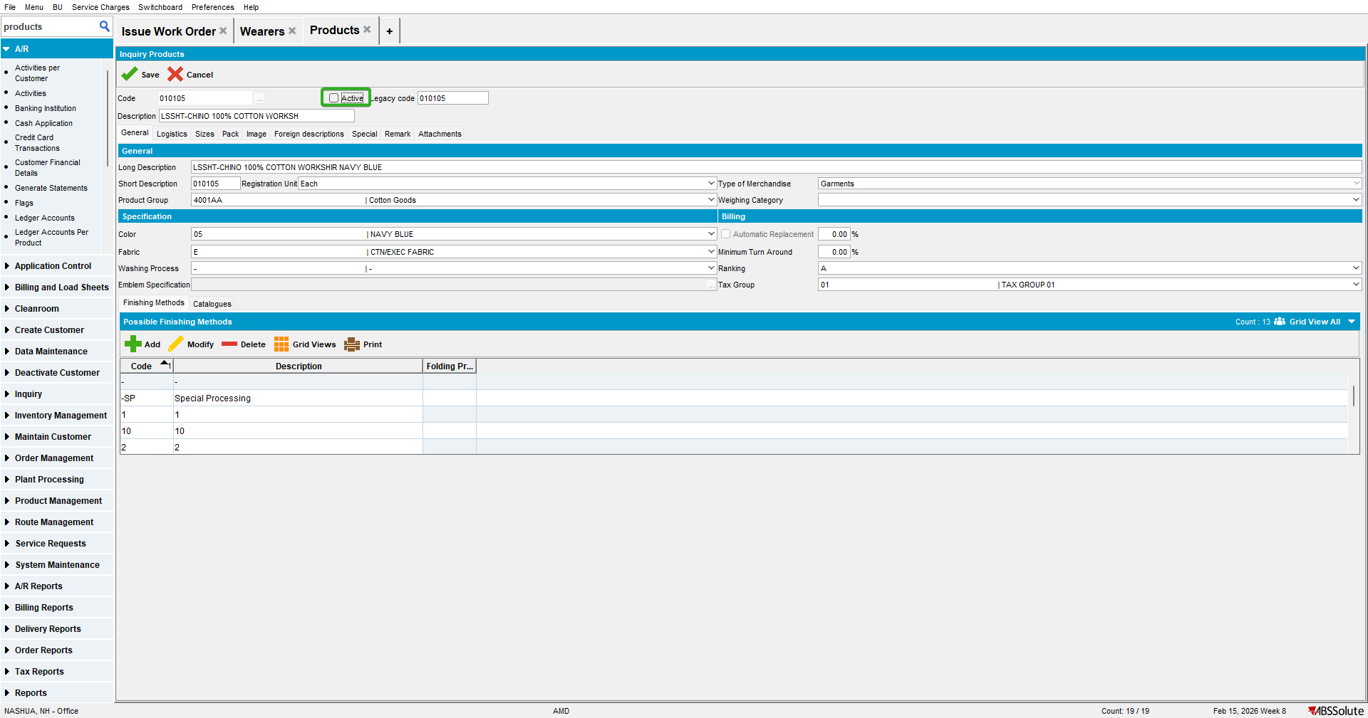

- Go to Wearers dlg to Wearers tab and increase the max for one of the WI
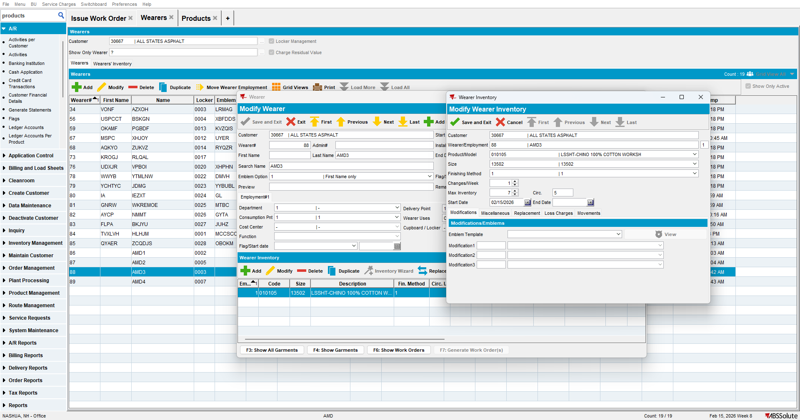

- Generate WO
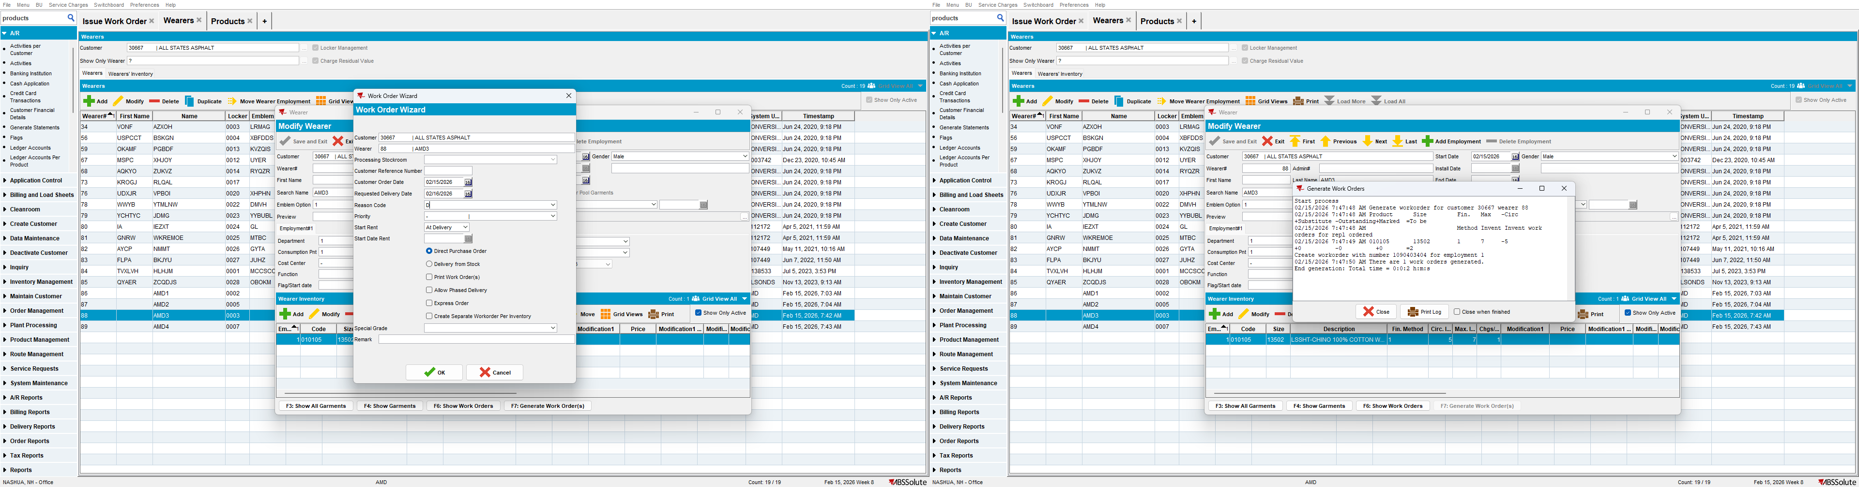

- Go to Wearers Inventory tab and increase the max for the other WI
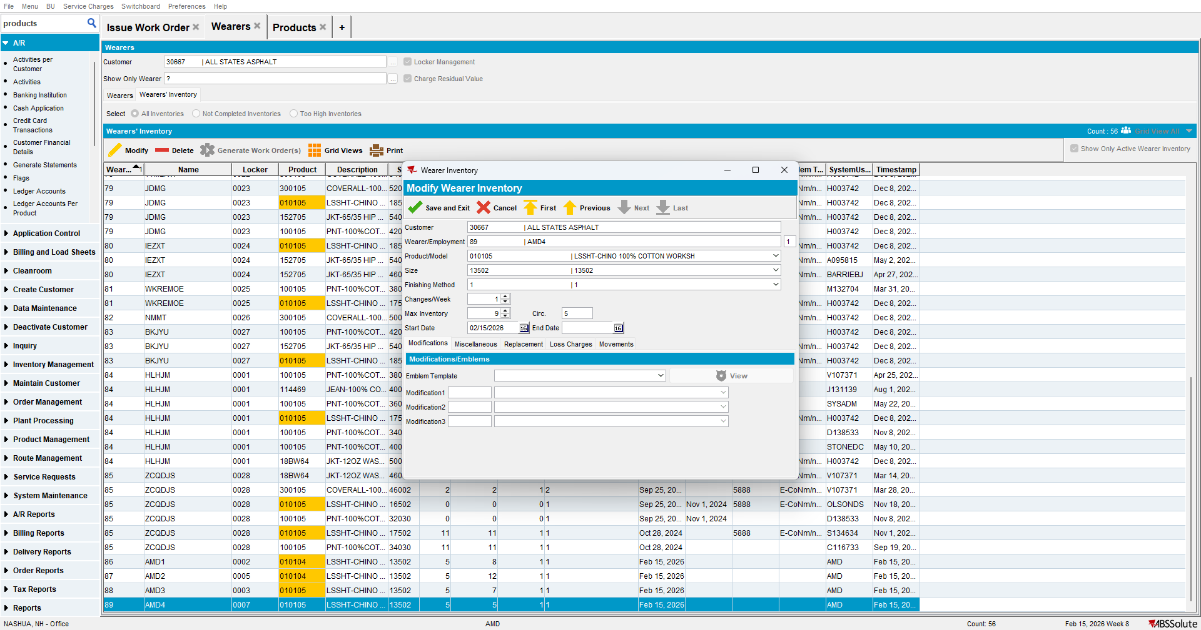

- Check Not Completed Inventories
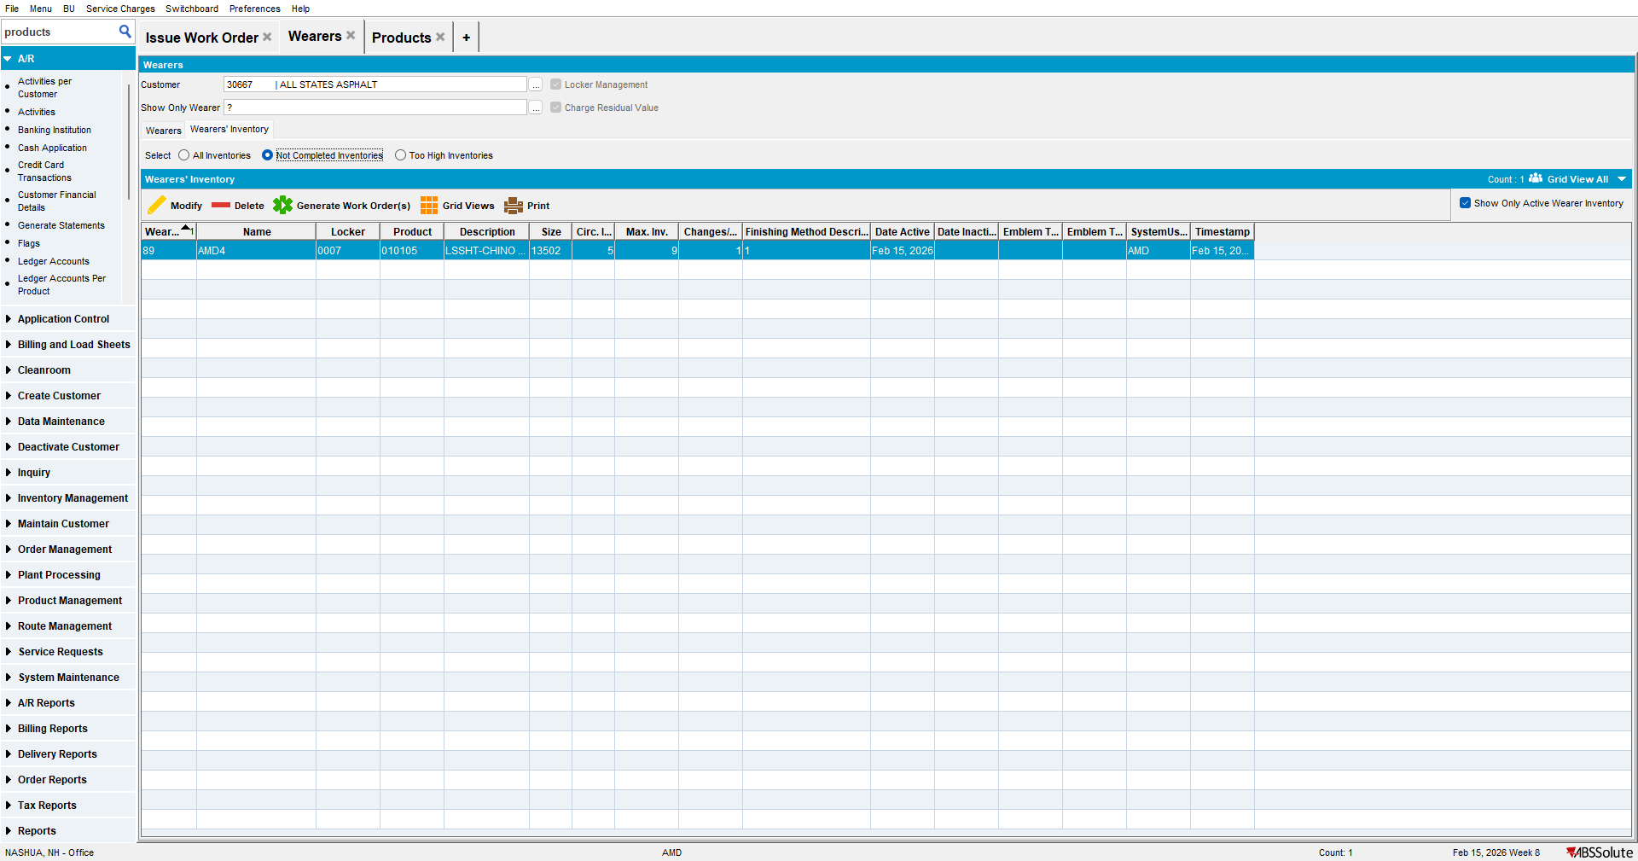

- Generate WO
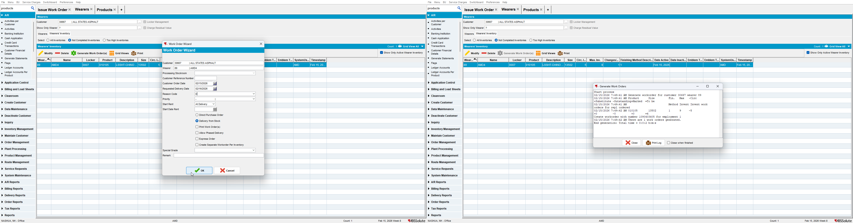

Test Case 3 – Product.Active = 'Y'– Tested OK
Expected behavior: Generate Work Orders from Wearer Inventory and Generate Work Order from Wearer Inventory TAB are active
Hash: 3bc60b8a4ff3
- Go to Products dlg and check that the product is active
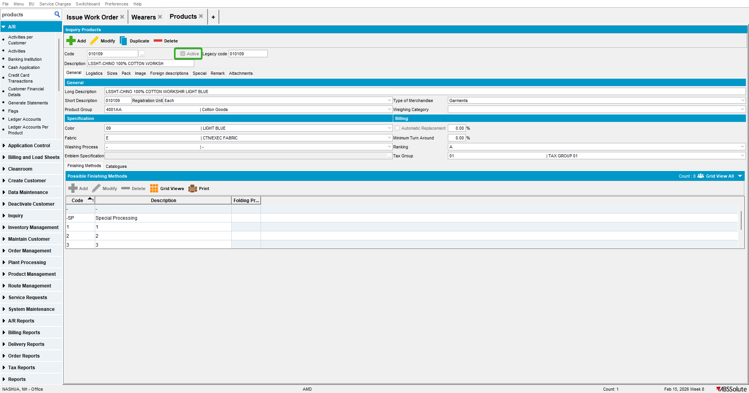

- Have 2 wearers with WI 5 circ/5 max
- Go to Wearers dlg to Wearers tab and increase the max for one of the WI
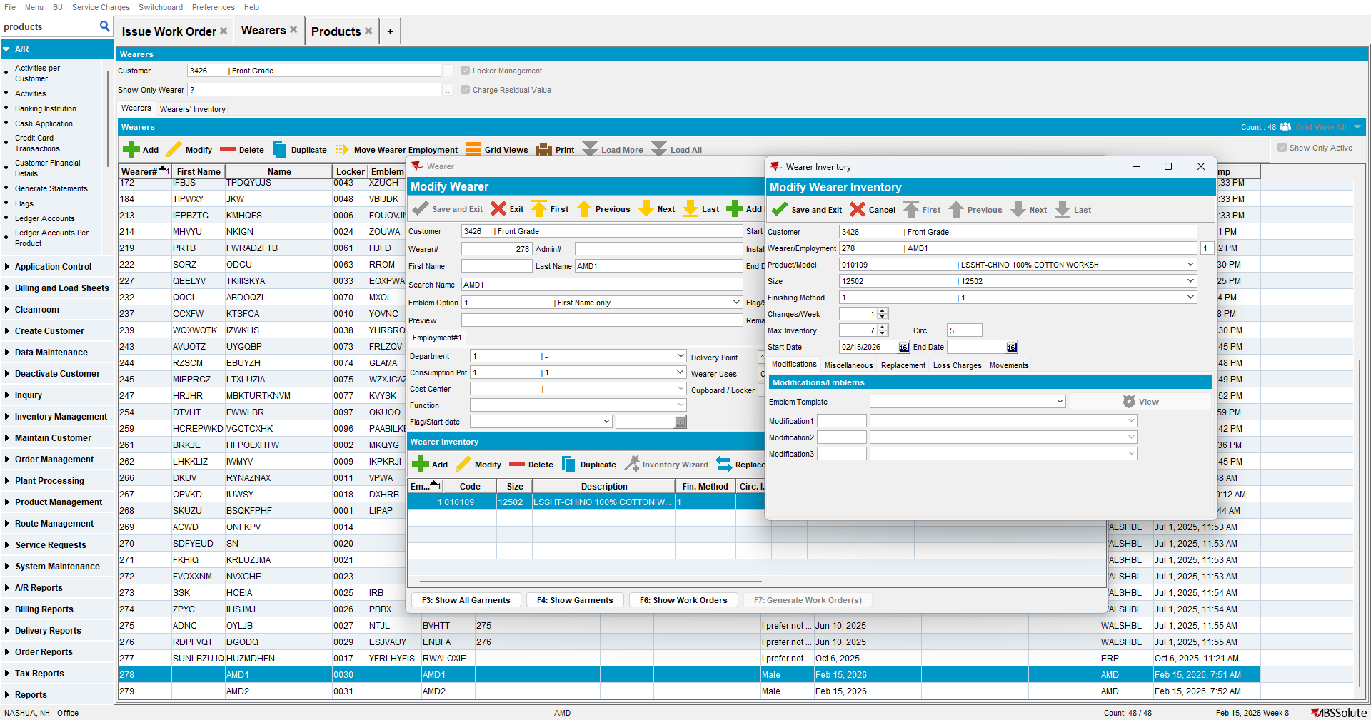
- Generate WO
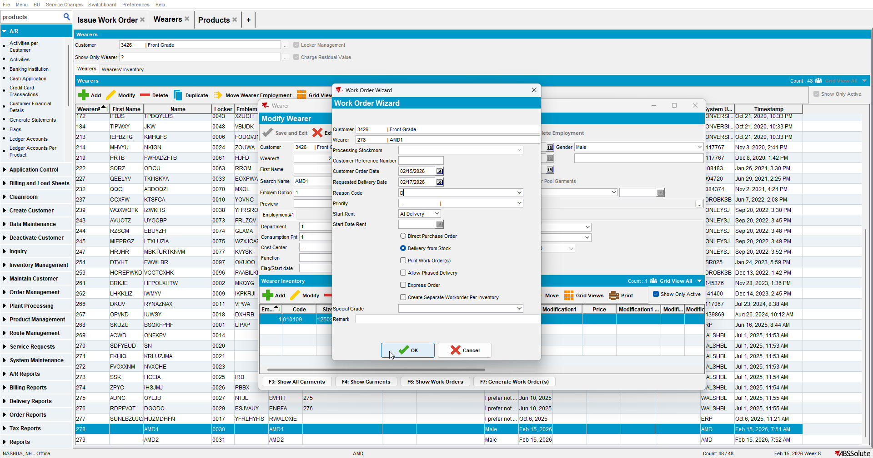
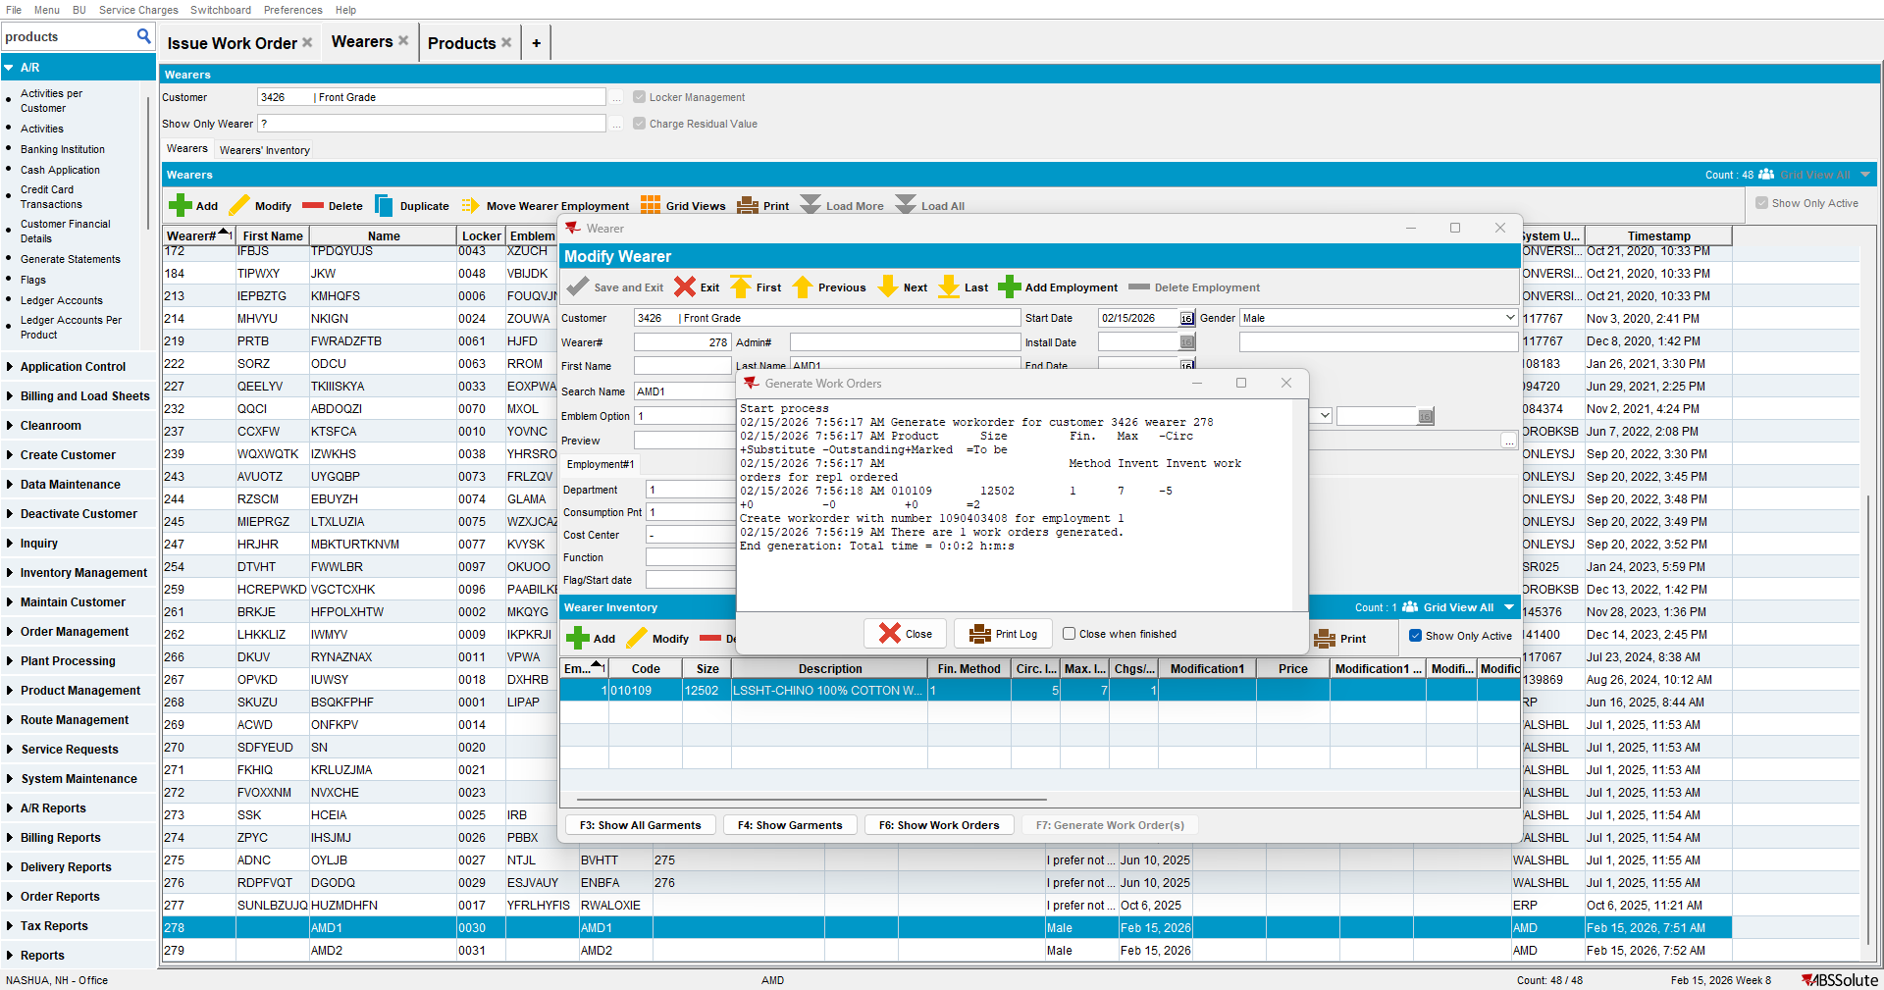

- Go to Wearers Inventory tab and increase the max for the other WI
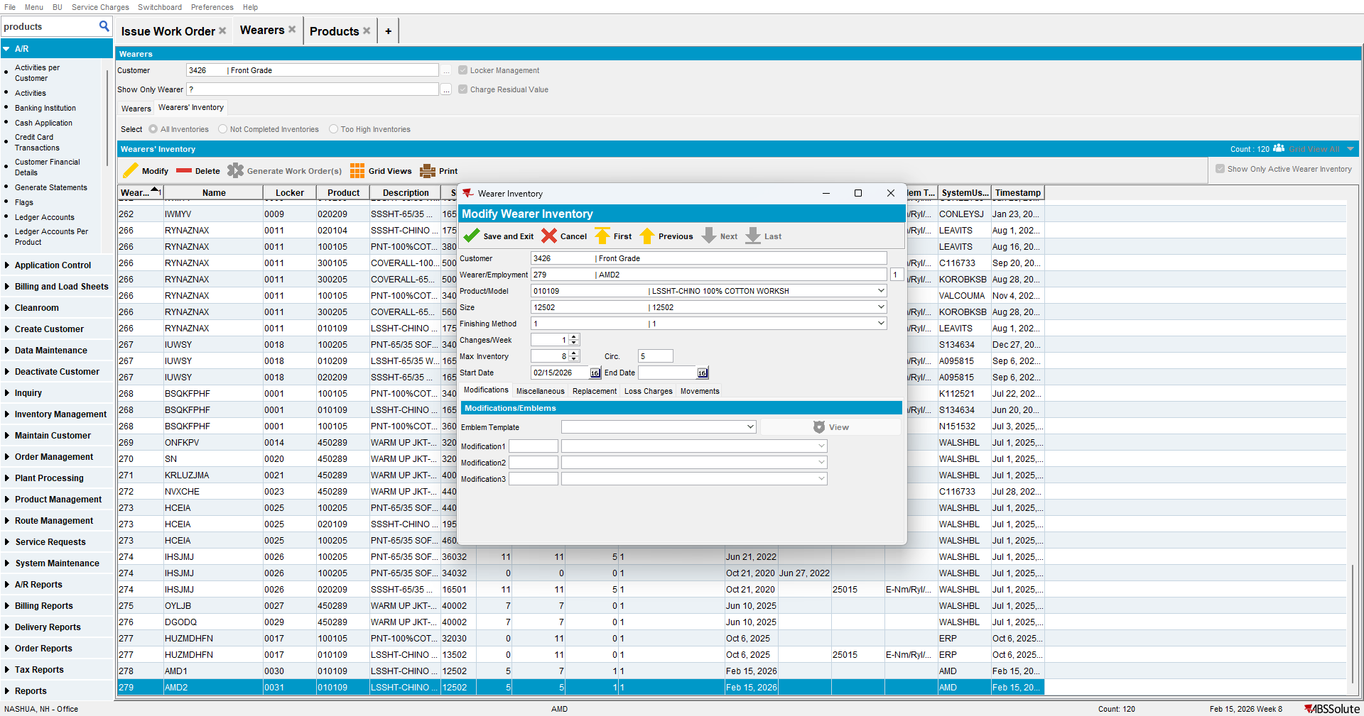

- Check Not Completed Inventories
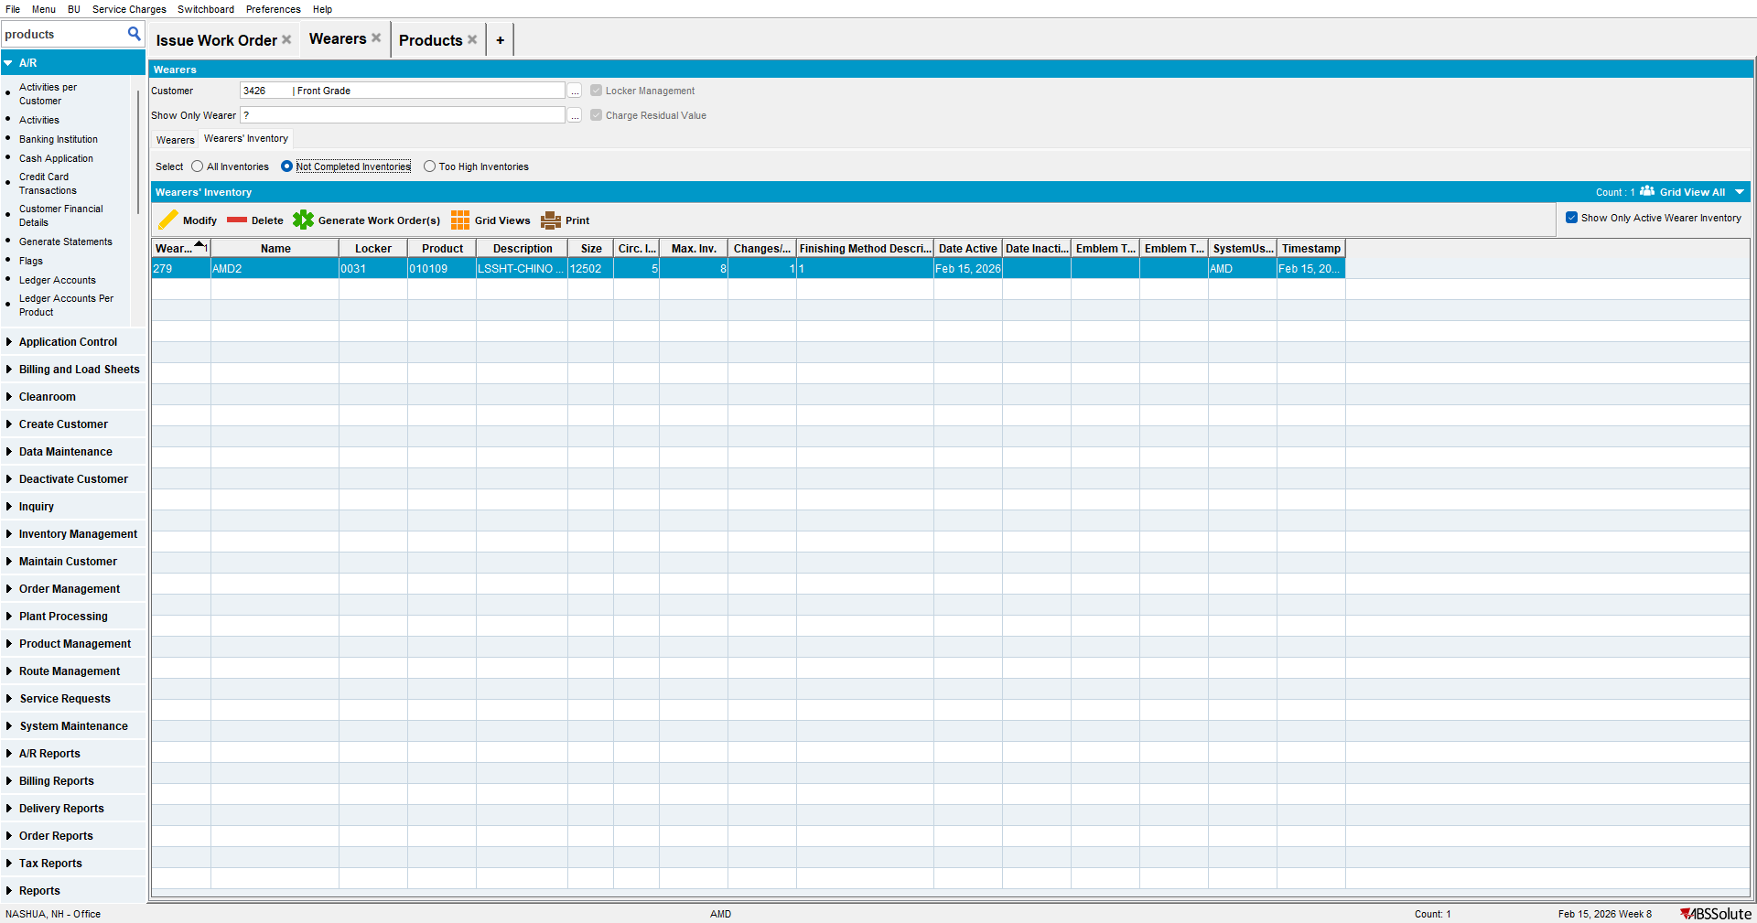

- Generate WO
