ABSN-16601 Improve the message shown during the issue work order
Environment | Prerequisites
Version:9.07.00.UNF21  DBServerName=abs-srv19.internal.abslbs.com  DBSID=CUST22  DBUser=UNFLIVE  Environment=Production | - Module:  - System setting

Contents
Reproducing before fix 1
Retest after fix 2

Reproducing before fix
Version: 9.07.00.UNF21 hash: 973f7c2fe3dd

- Create a work order then try to scan an ID code of an item which is not on stock.
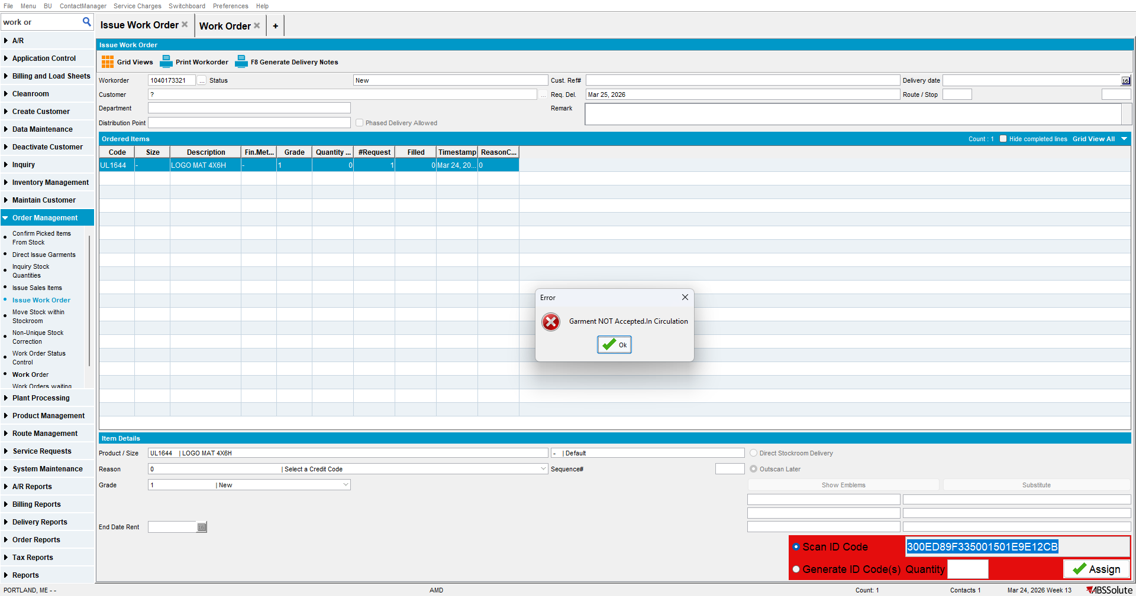

REPRODUCED.

Retest after fix
Version: 9.07.00.UNF21 hash: 3b3b3b42df12

- Create a work order then try to scan an ID code of an item which is not on stock.
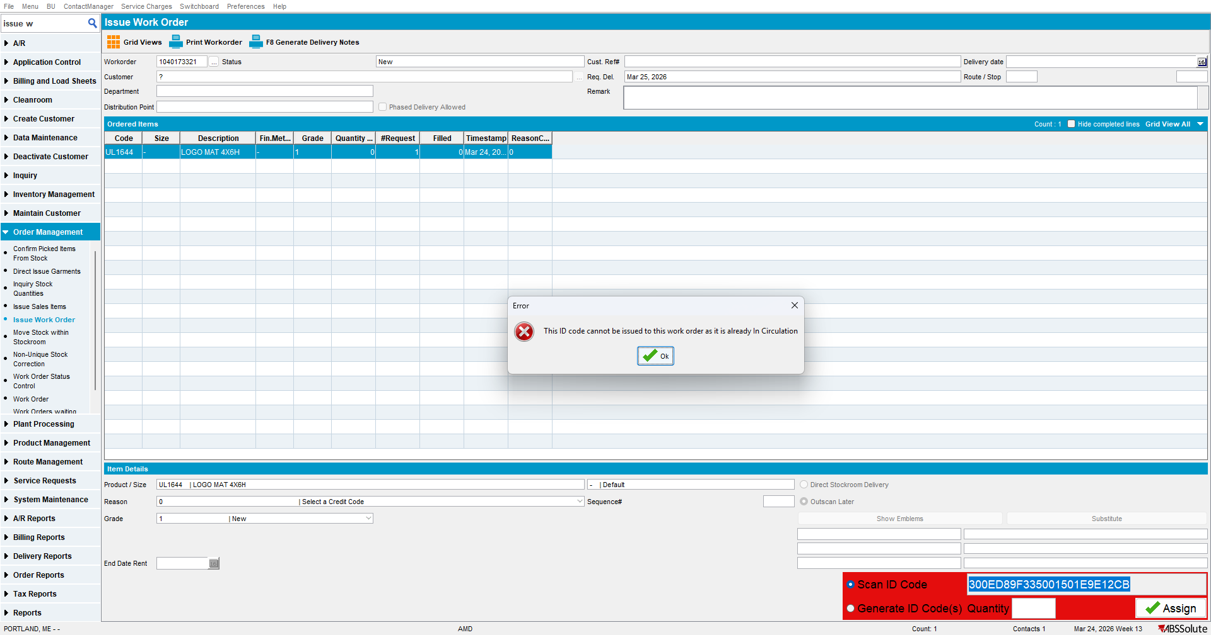

TESTED OK.

