ABSN-16067 GMP not charged for wash only products with BM3 or BM4
Environment | Prerequisites
Version:9.07.00.UNF21  DBServerName=abs-srv19.internal.abslbs.com  DBSID=CUST22  DBUser=UNFLIVE  Environment=Production | - Module:  - System setting

Contents
Retest after fix 1

Retest after fix
Version: 9.07.00.UNF21 hash: b612015a789f

- Customer setup for delivery every day and billing on Friday
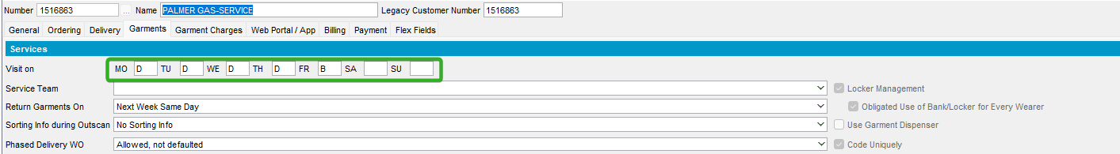

- PLPC set the same:
- PLPC setup for wash only products with BM3 and BM4 + GMP
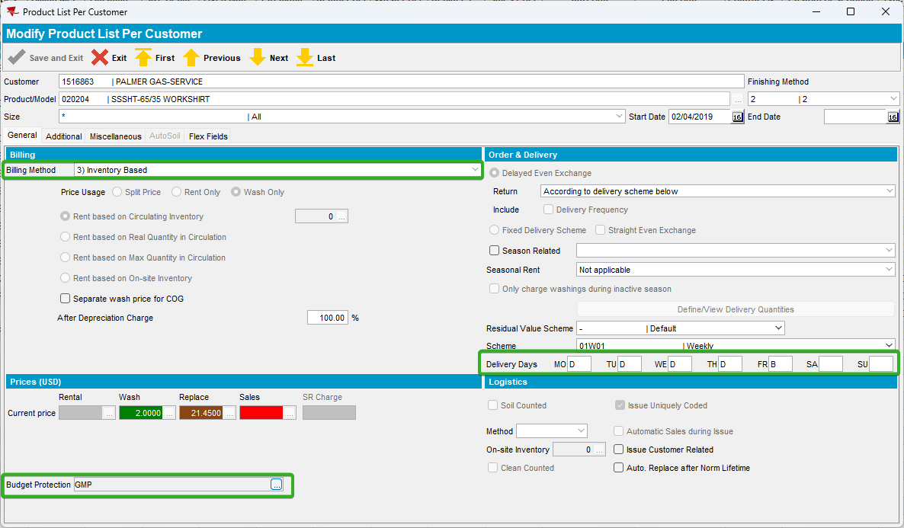
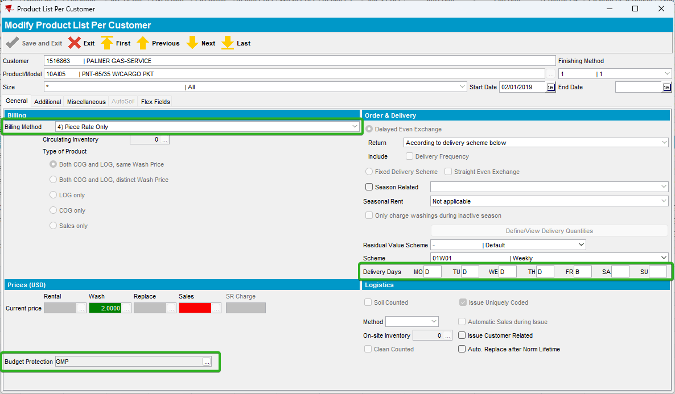

- System setting BM4BILLONBDAYONLY = 2
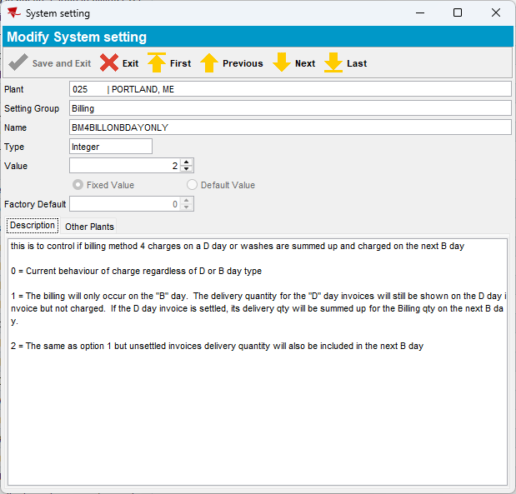

- Outscan an item for Monday for BM4 product
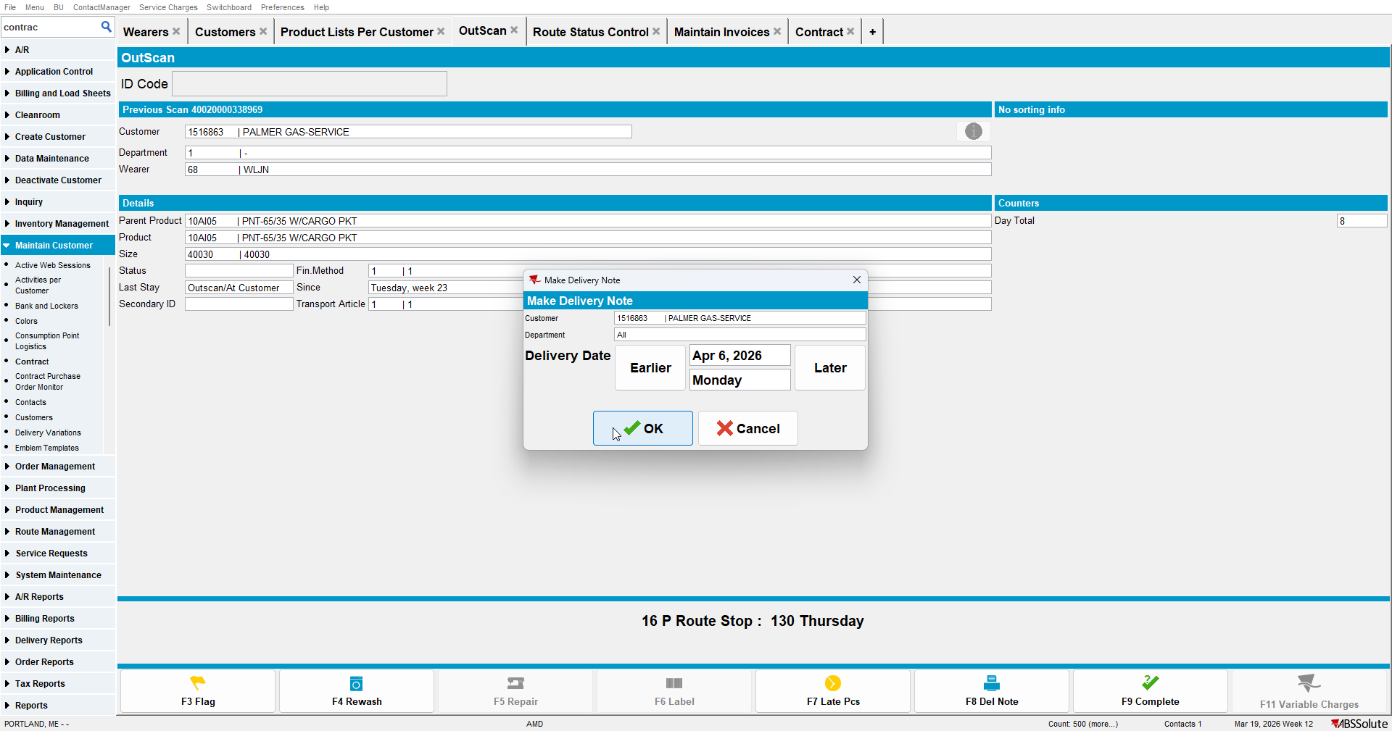

- Outscan an item for Monday for BM3 product
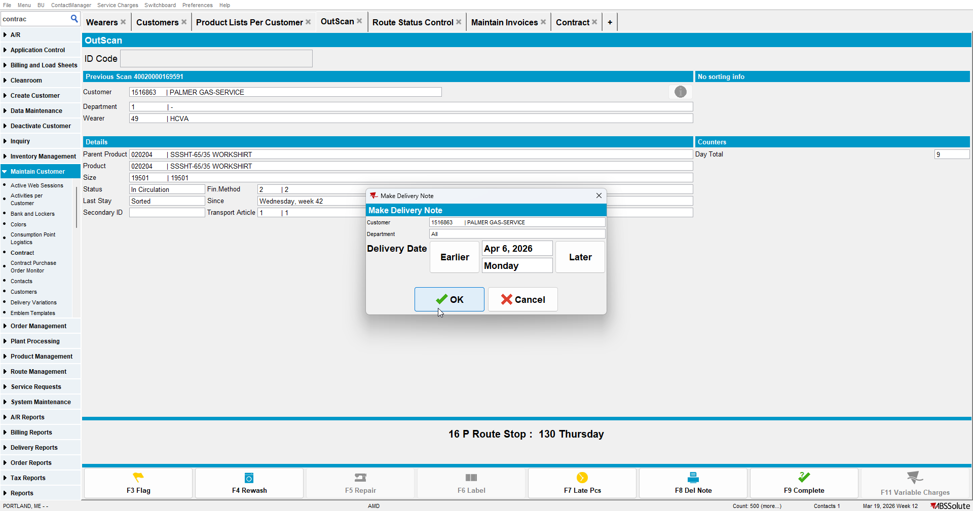

- Generate invoices for Monday
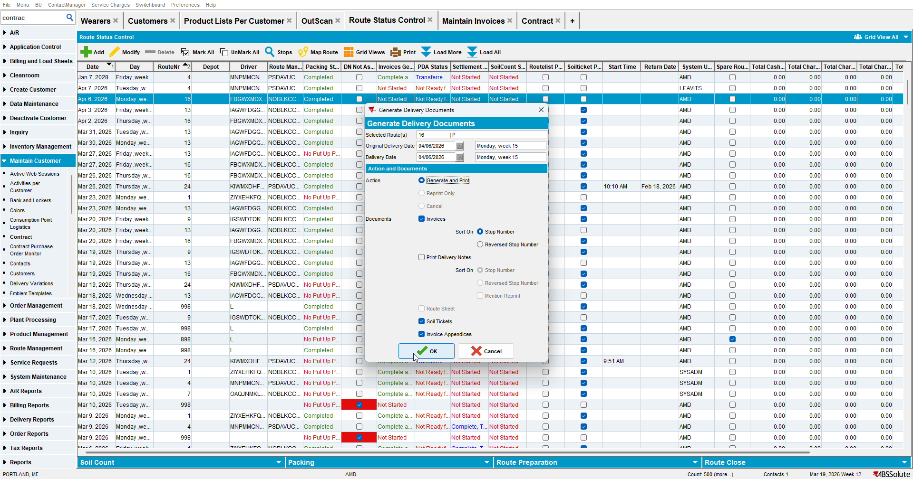

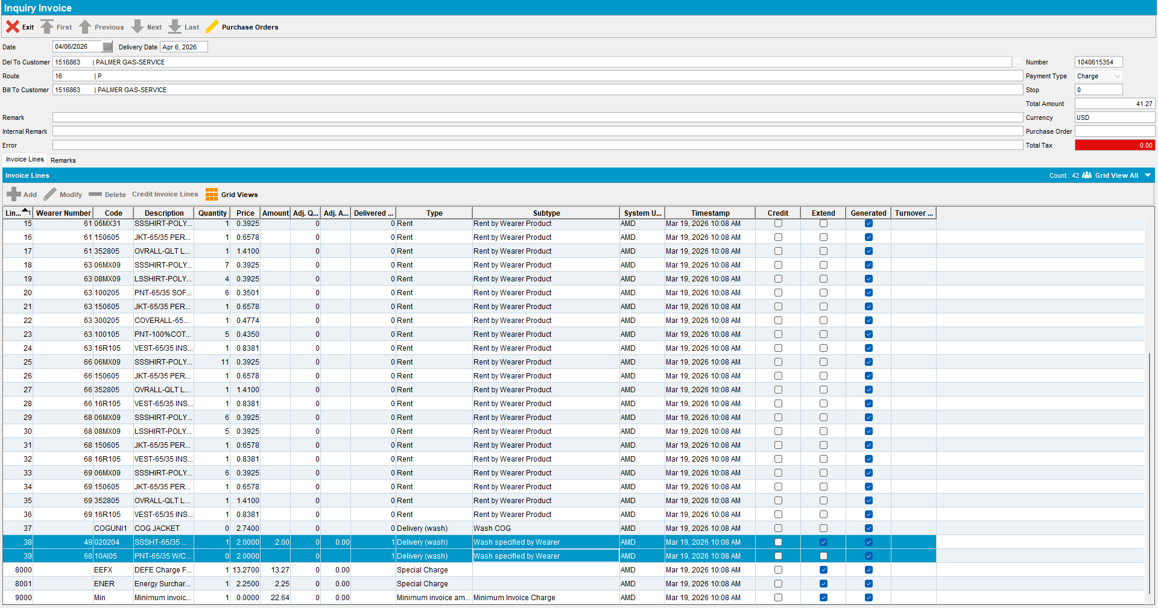
Expecting an invoice with qty = 0, amount = 0, delivered qty = 1 on wash lines and no GMP.

- Outscan an item for BM4 product for Friday.
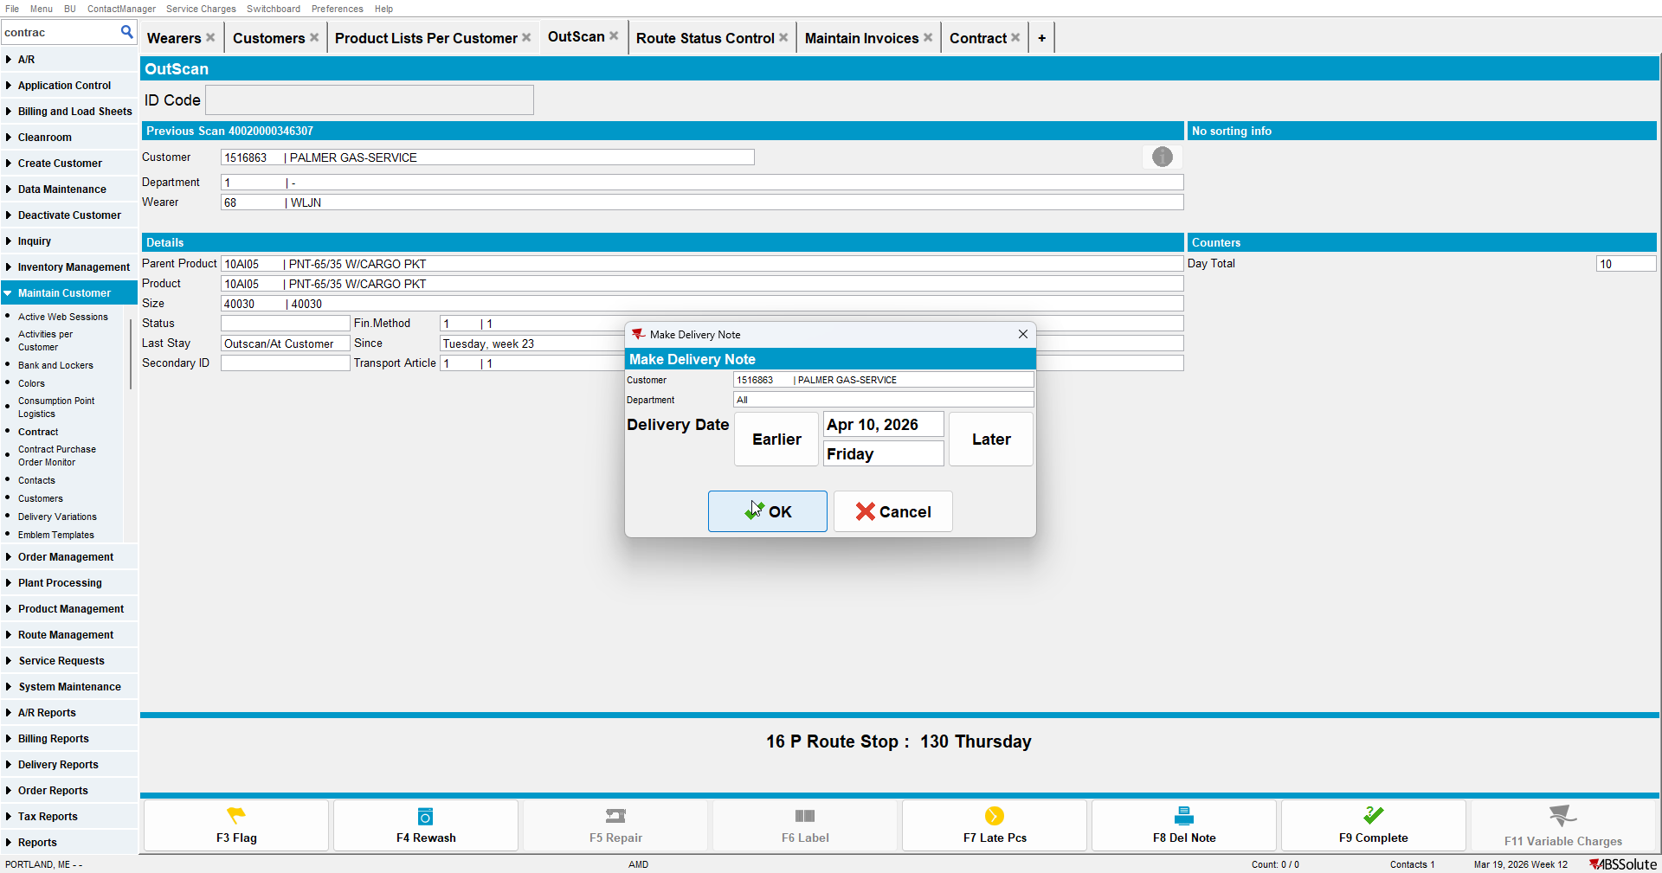

- Generate invoices for Friday.
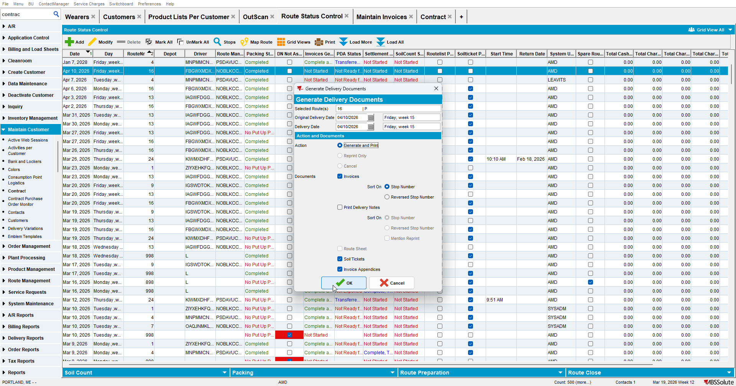
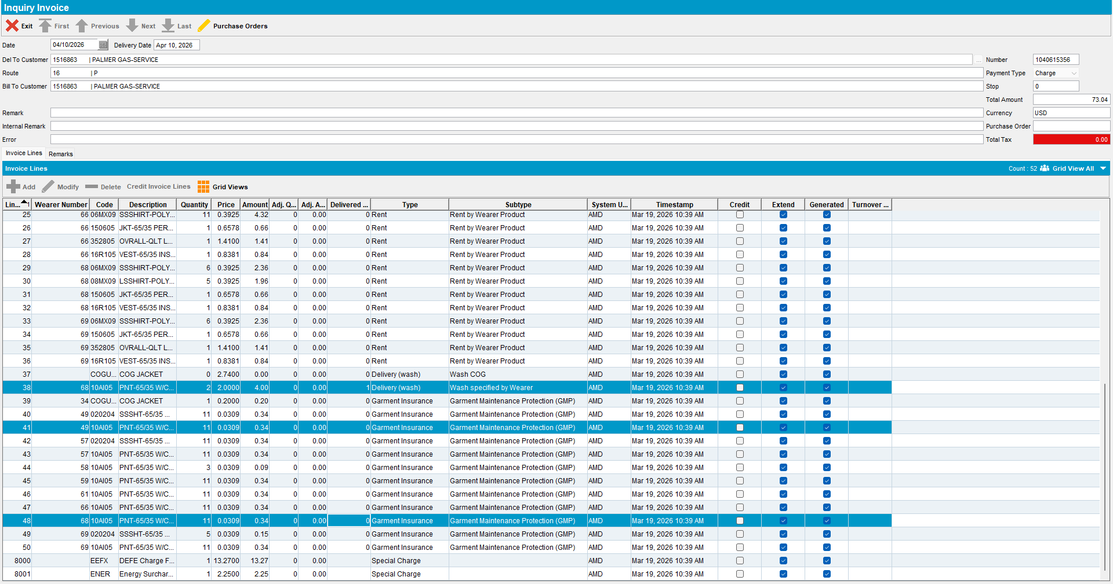
Invoice with qty = 2, amount = 2 * price, delivered qty = 1 (from Friday's outscan) for BM4 product, + GMP lines for both of them

TESTED OK.

