ABSN-16026 D_UBS_2827 Error when scanning an ID in Take items out of circulation which was created as a pool item without a customer
Environment | Prerequisites
DBServerName= abs-srv20.internal.abslbs.com  DBSID=CUST24  DBUser=UNFDEV  Environment=PRODUCTION | - Module:  - System setting

Contents
Reproduce before fix 1
Steps to reproduce: 1
Current behavior: 3
Expected behavior: 3
Retest after fix 3
Steps to reproduce: 3

Reproduce before fix

BU: 725
Product: UL1644
9.07.00.UNF17.p17 hash: beebfb3f158f

Steps to reproduce:

- Work Order DLG: Create a new workorder for “General Use Pool Items.
- Don’t input any customer.
- Ordered items tab: add the following mat UL1644
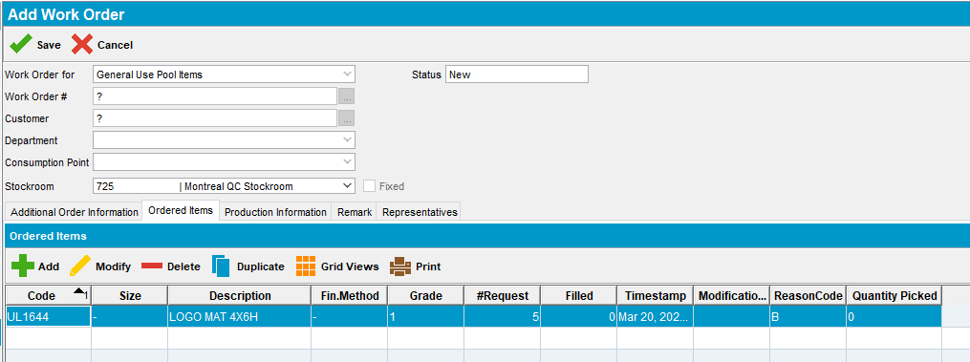
- Work Order Status Control: Issue the WO by scanning an ID code like “300ED89F335001501E9E13CB”

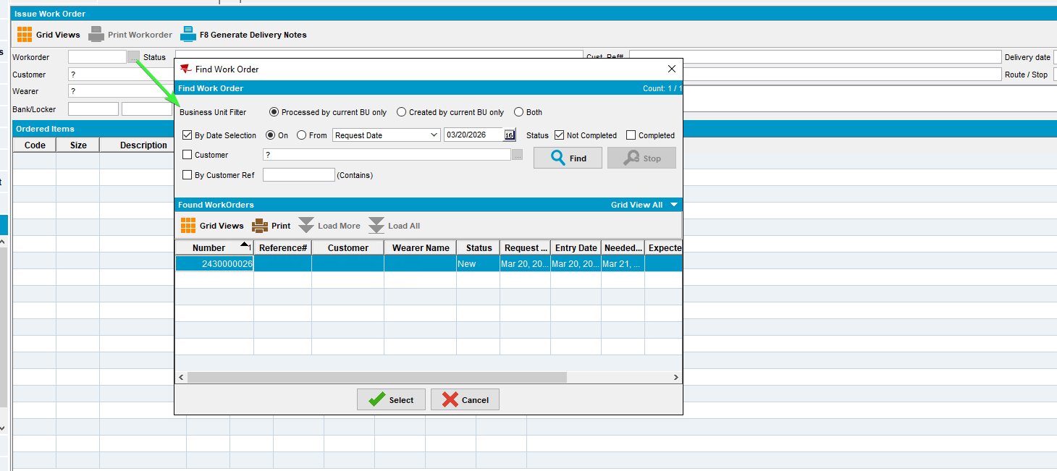
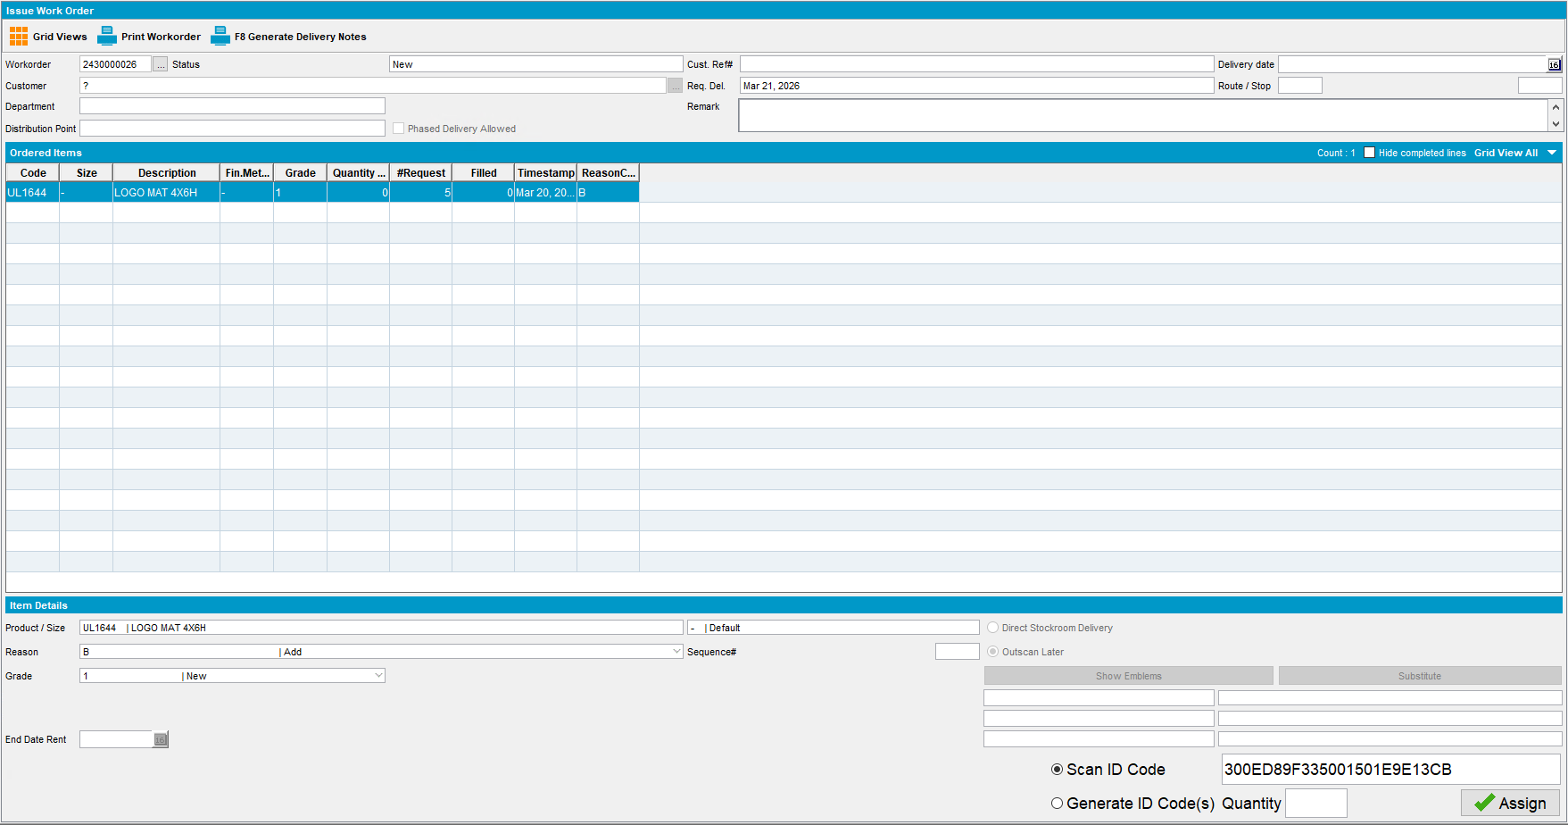

- Take Items Out of Circulation DLG: Scan the ID previously mentioned "300ED89F335001501E9E13CB"

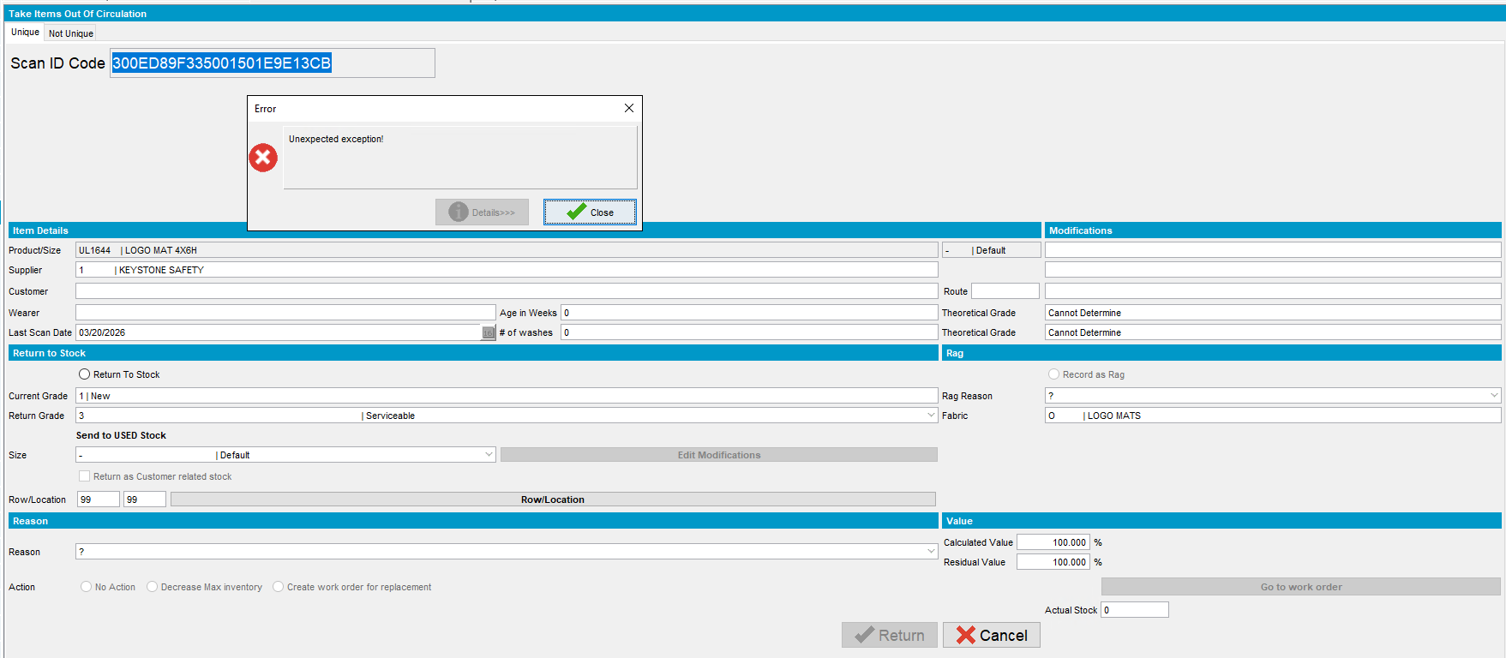
Error Stack trace:
2026-02-27 05:25:51.052 ---> ABSSolute exception occurred <---
When: Fri Feb 27 05:25:51 EST 2026
User: CRA
Error message: Unexpected exception!
Stack trace: java.lang.NullPointerException
at absgroup.forms.scan.JReturnToStock.isCustomerMBYO(JReturnToStock.java:1046)

Current behavior:
Error when scanning an ID in Take items out of circulation which was created as a pool item without a customer

Expected behavior:
The taking out of circulation should work.

Reproduced OK

Retest after fix
Bu: 725
9.07.00.UNF21 hash: a6ae3d73dbf6

Steps to reproduce:

- Work Order DLG: Create a new workorder for “General Use Pool Items.
- Don’t input any customer.
- Ordered items tab: add the following mat UL1644
- Work Order Status Control: Issue the WO by scanning an ID code like “300ED89F335001501E9E13CB”

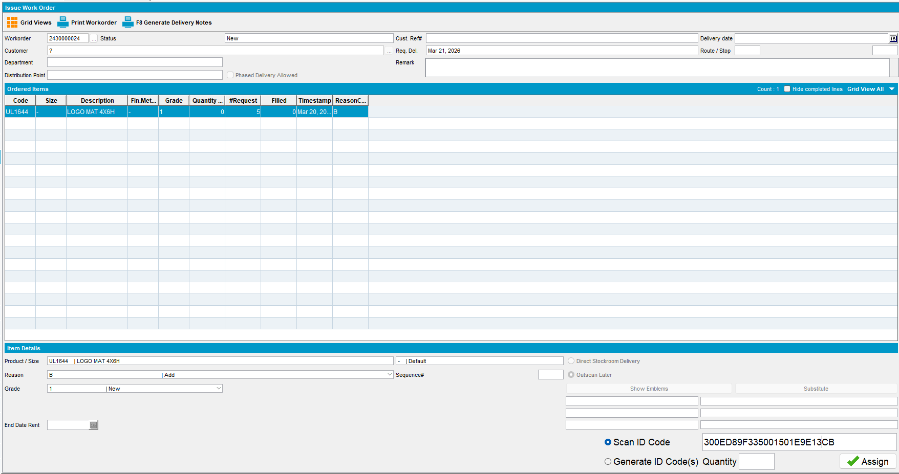

- Take Items Out of Circulation DLG: Scan the ID previously mentioned "300ED89F335001501E9E13CB"

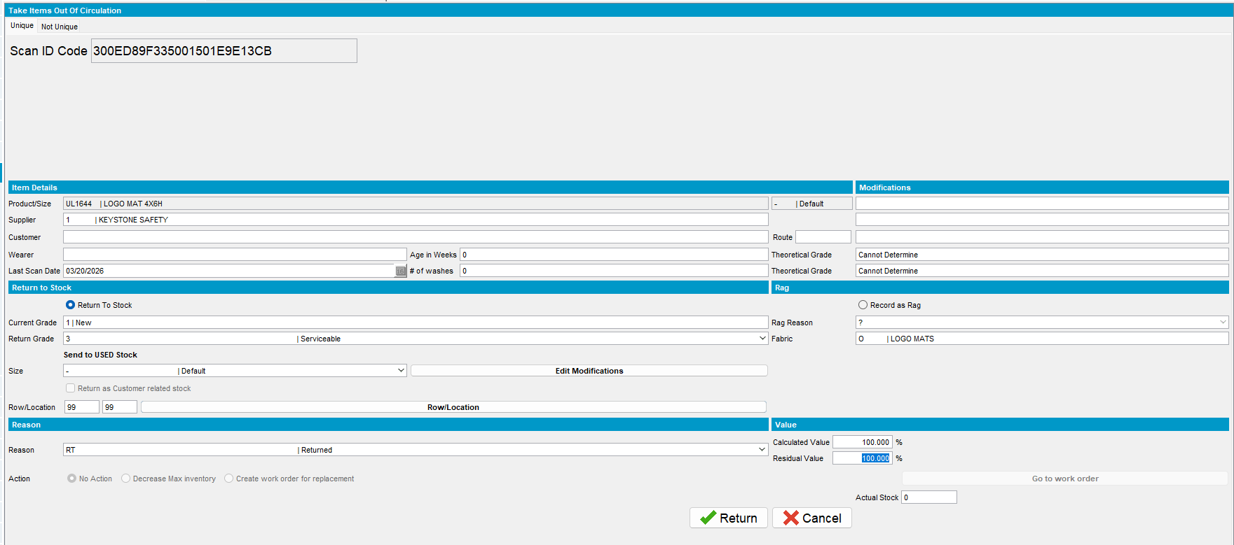
- Maintain Unique items:Check that the item was indeed returned to stock.
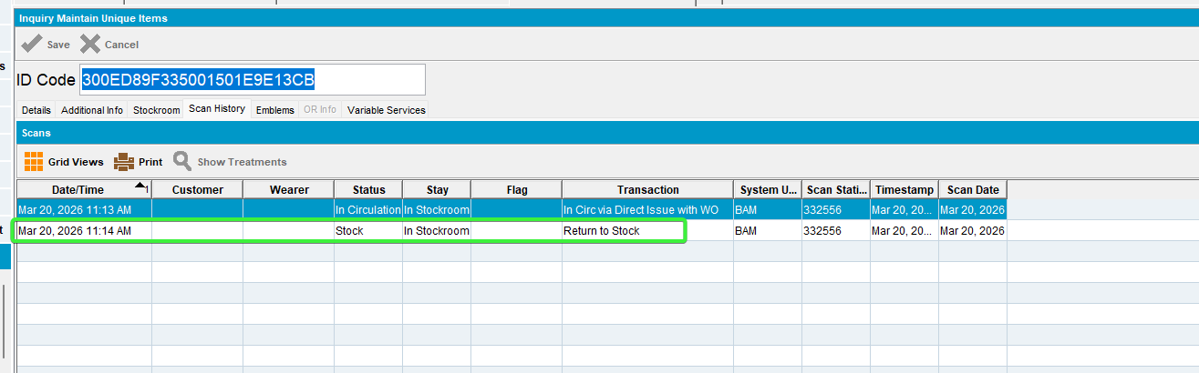
- Check serverErrolog.
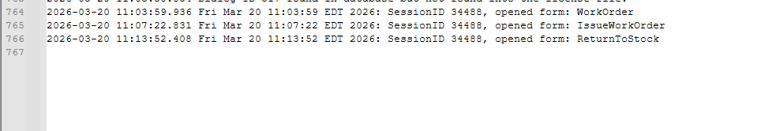
No errors

Tested OK

