ABSN-15890 If a route has a value, it can only be settled in WebX route check in
DataBase | Preconditions
Version:9.07.00.UNF21  DBServerName= abs-srv19.internal.abslbs.com  DBSID=CUST22  DBUser=UNFLIVE | - Module: SETTLEMENTONLYFROMWEBXRCI  - System setting: SETTLEMENTONLYFROMWEBXRCI
Contents
Without “SETTLEMENTONLYFROMWEBXRCI” module in license. 1
Test Case #1 - Settlement from “Route Status Control” dlg for invoice value <> 0 1
Test Case #2 - Settlement from “Route Check In” dlg for invoice value <> 0 3
Test Case #3 - Settlement from “Settlement” dlg for invoice value <> 0 5
Test Case #4 - Settlement from “Route Status Control” dlg for invoice value = 0 6
Test Case #5 - Settlement from “Route Check In” dlg for invoice value = 0 8
Test Case #6 - Settlement from “Settlement” dlg for invoice value = 0 10
“SETTLEMENTONLYFROMWEBXRCI” module in license. 12
Test Case #1 - Settlement from “Route Status Control” dlg for invoice value <> 0 13
Test Case #2 - Settlement from “Route Check In” dlg for invoice value <> 0 15
Test Case #3 - Settlement from “Settlement” dlg for invoice value <> 0 16
Test Case #4 - Settlement from “Route Status Control” dlg for invoice value = 0 18
Test Case #5 - Settlement from “Route Check In” dlg for invoice value = 0 20
Test Case #6 - Settlement from “Settlement” dlg for invoice value = 0 23

Without “SETTLEMENTONLYFROMWEBXRCI” module in license.

Test Case #1 - Settlement from “Route Status Control” dlg for invoice value <> 0
- Add a route, generate and do the taxes.

- Check the invoice has a value.
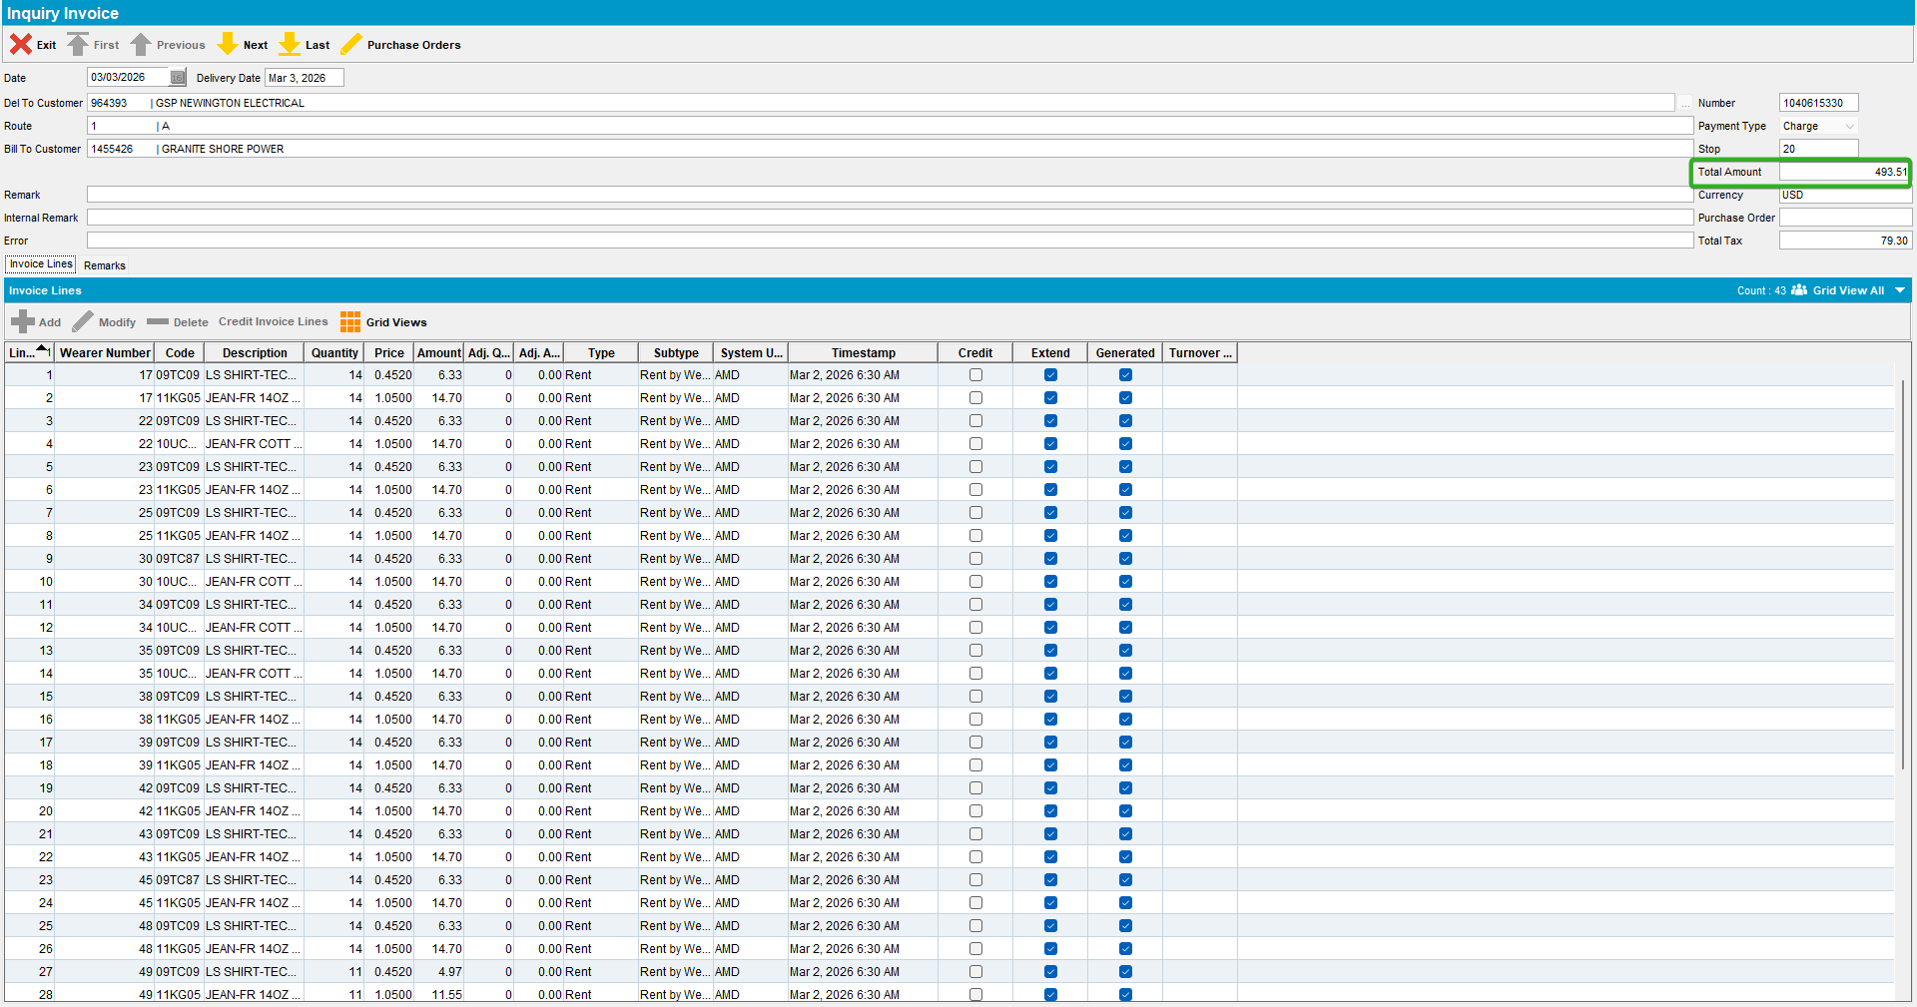

- Settle the route in Route Status Control.
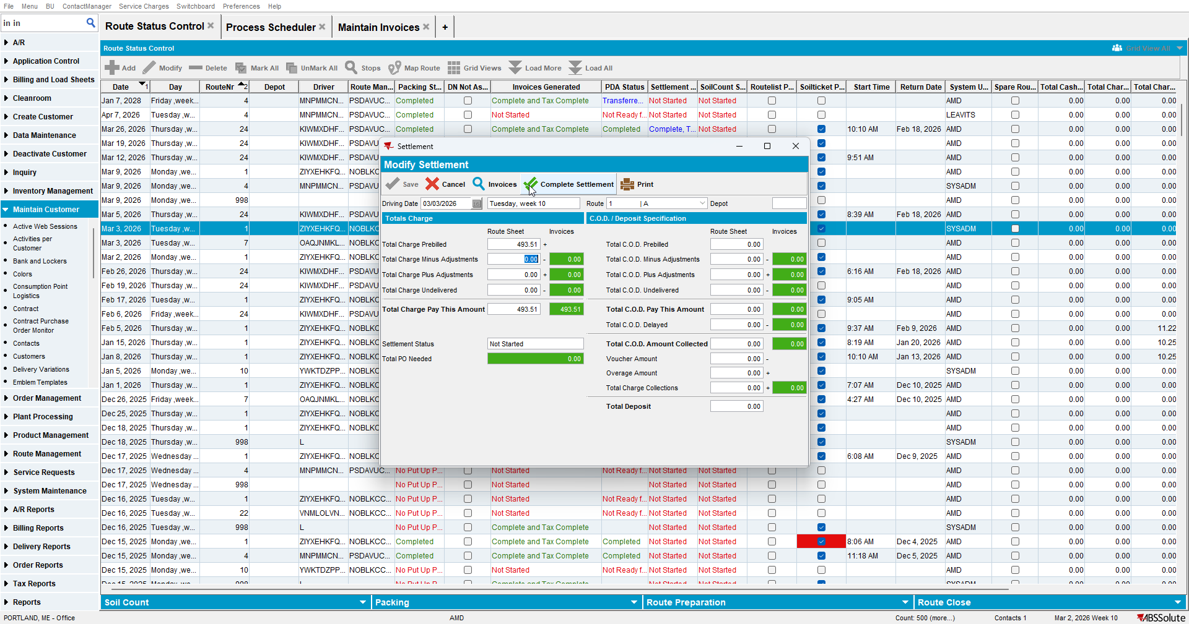
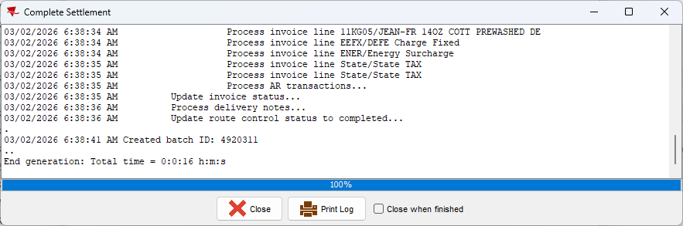

Test Case #2 - Settlement from “Route Check In” dlg for invoice value <> 0

- Add a route, generate and do the taxes.

- Check the invoice has a value.
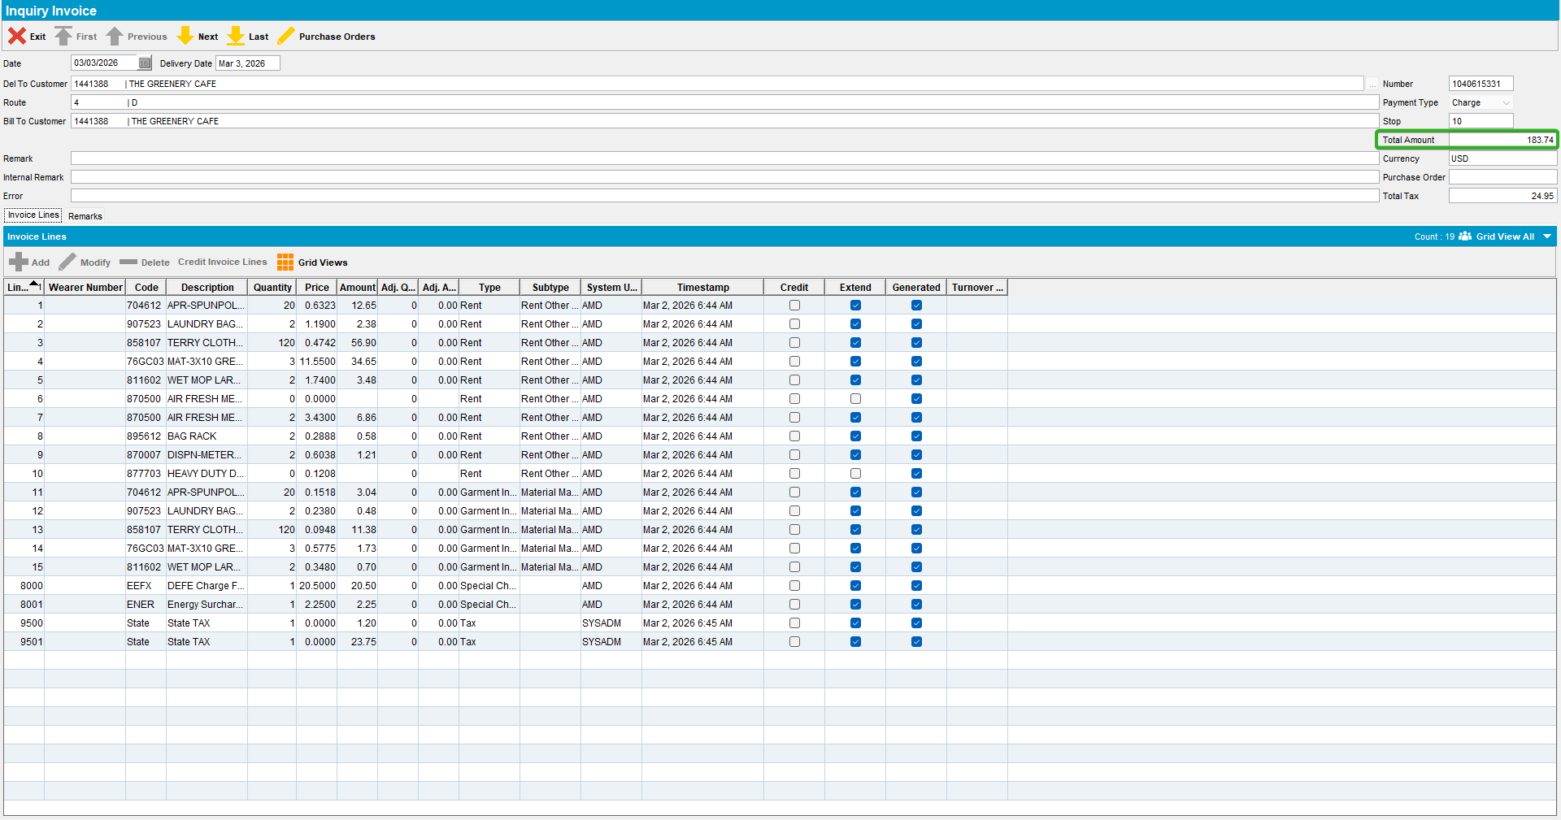

- Settle the route in Route Check in.
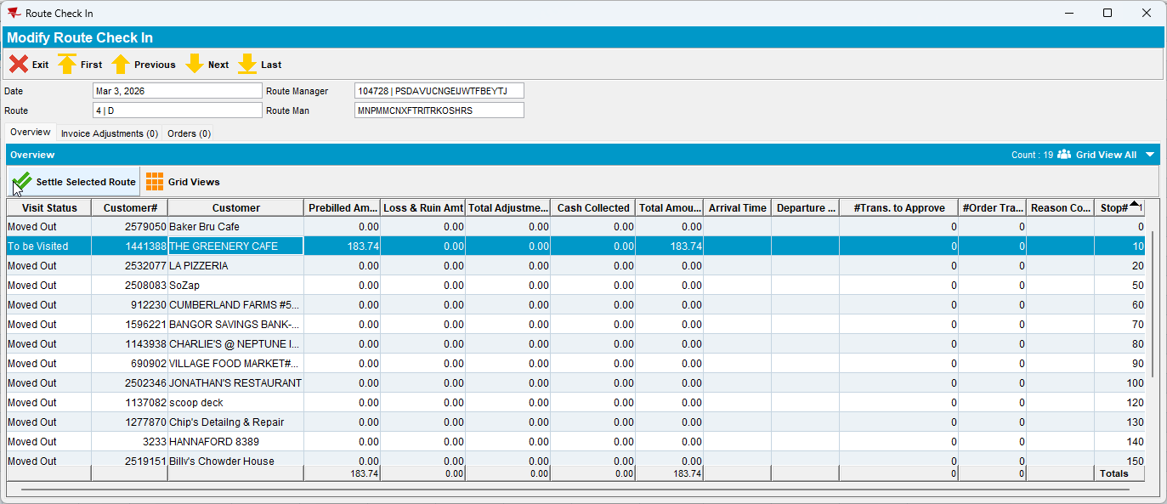
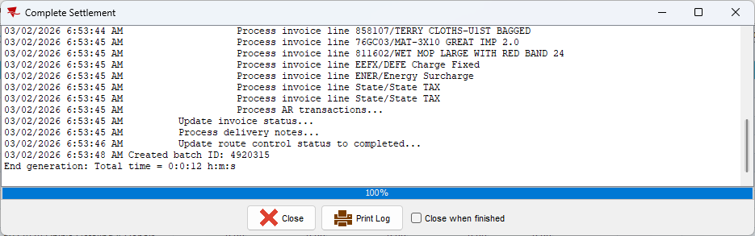

Test Case #3 - Settlement from “Settlement” dlg for invoice value <> 0

- Add a route, generate and do the taxes.

- Check the invoice has a value.
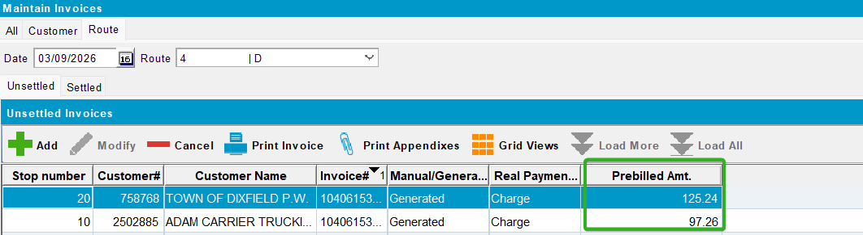

- Settle the route in Settlement.
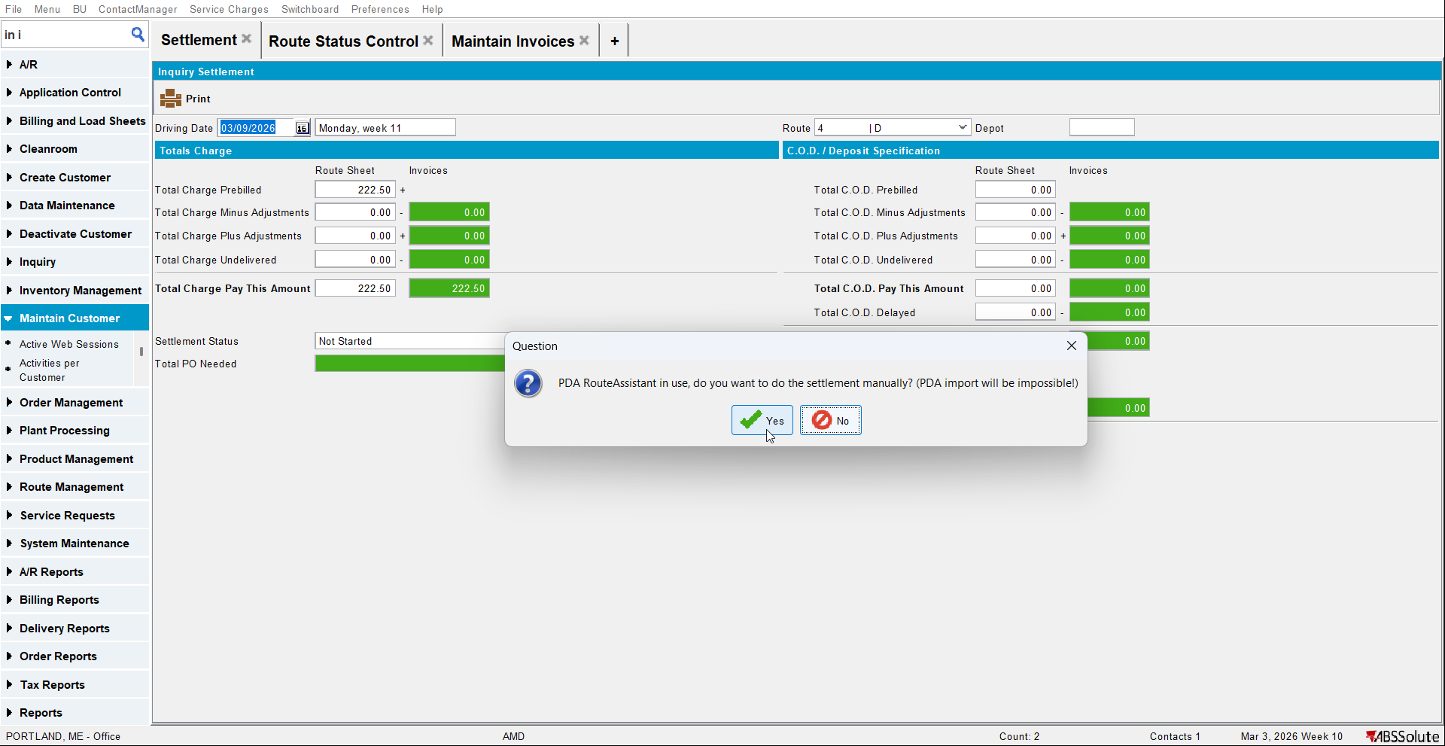
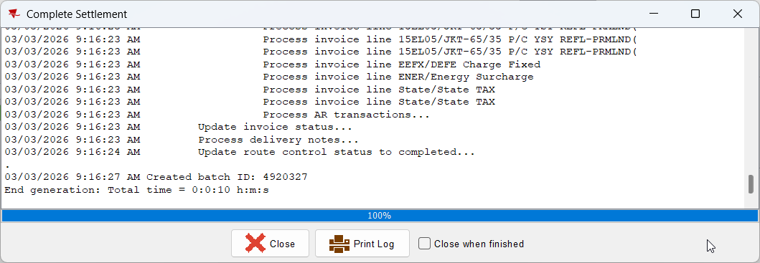

Test Case #4 - Settlement from “Route Status Control” dlg for invoice value = 0

- Add a manual invoice with value = 0 and assign it to a route.
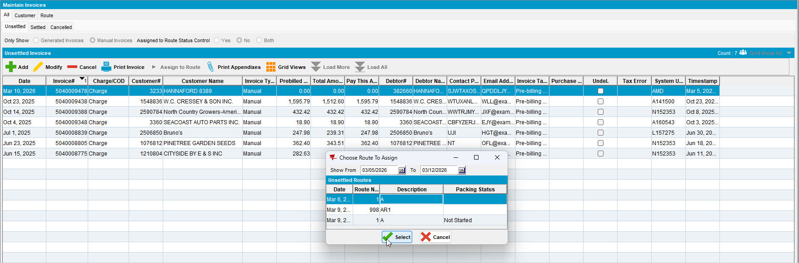

- Make sure there is no other stop To Be Visited on the route.
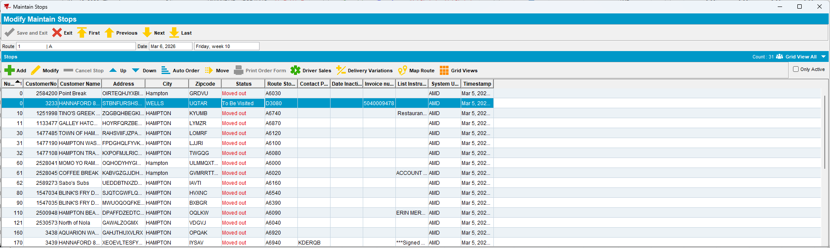

- Complete the route.

- Settle the route in Route Status Control.
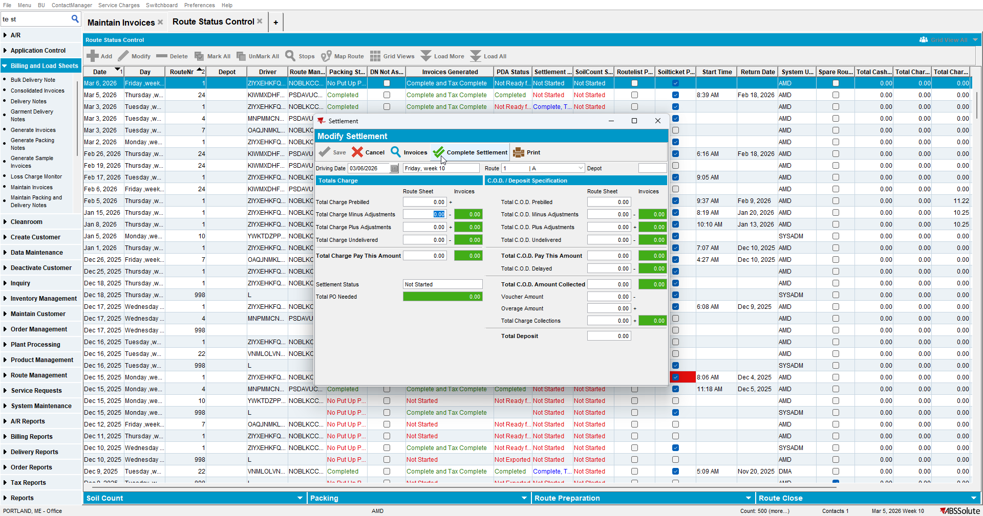
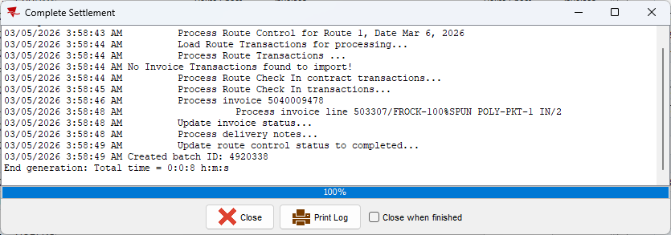

Test Case #5 - Settlement from “Route Check In” dlg for invoice value = 0

- Add a manual invoice with value = 0 and assign it to a route.
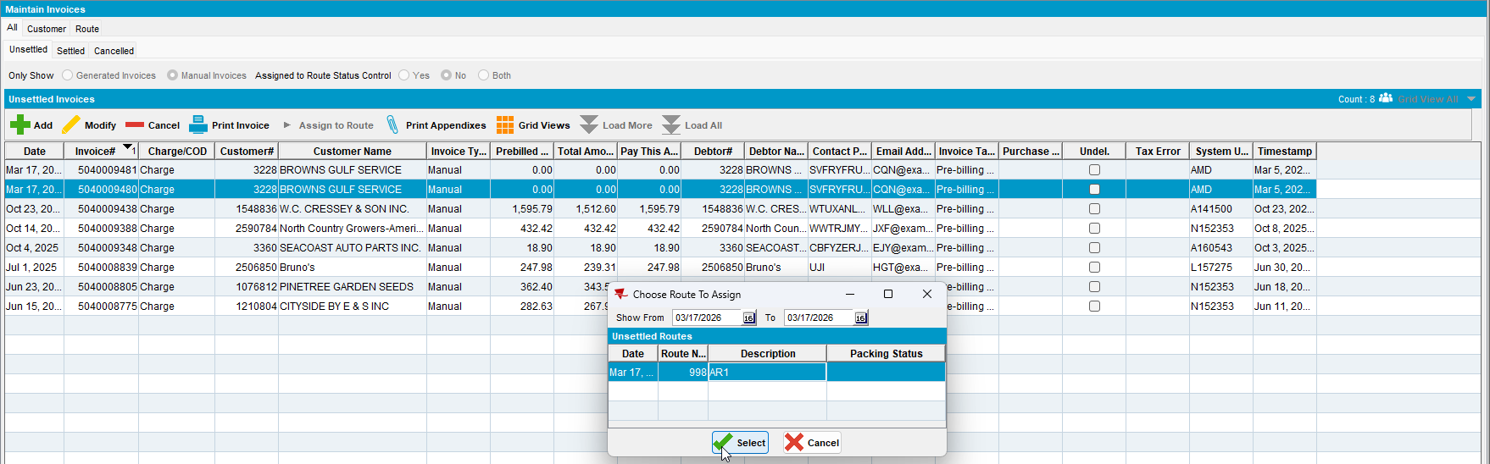

- Make sure there is no other stop To Be Visited on the route.
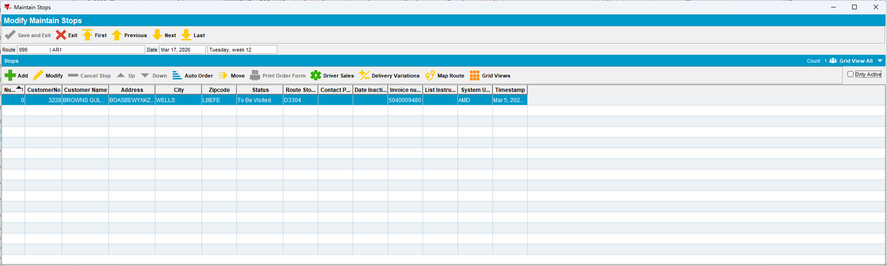

- Complete the route.

- Settle the route in Route Check In.
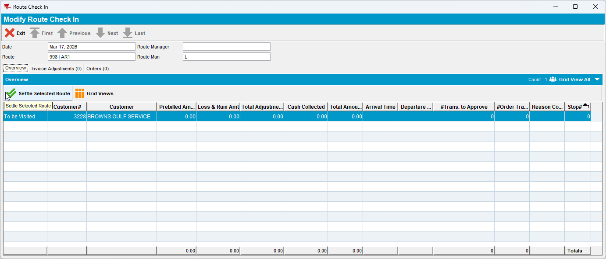
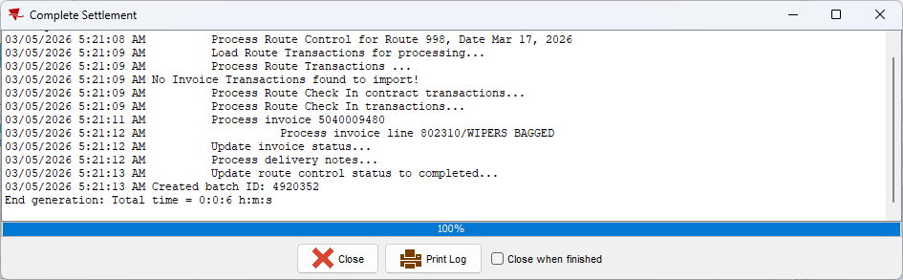

Test Case #6 - Settlement from “Settlement” dlg for invoice value = 0

- Add a manual invoice with value = 0 and assign it to a route.
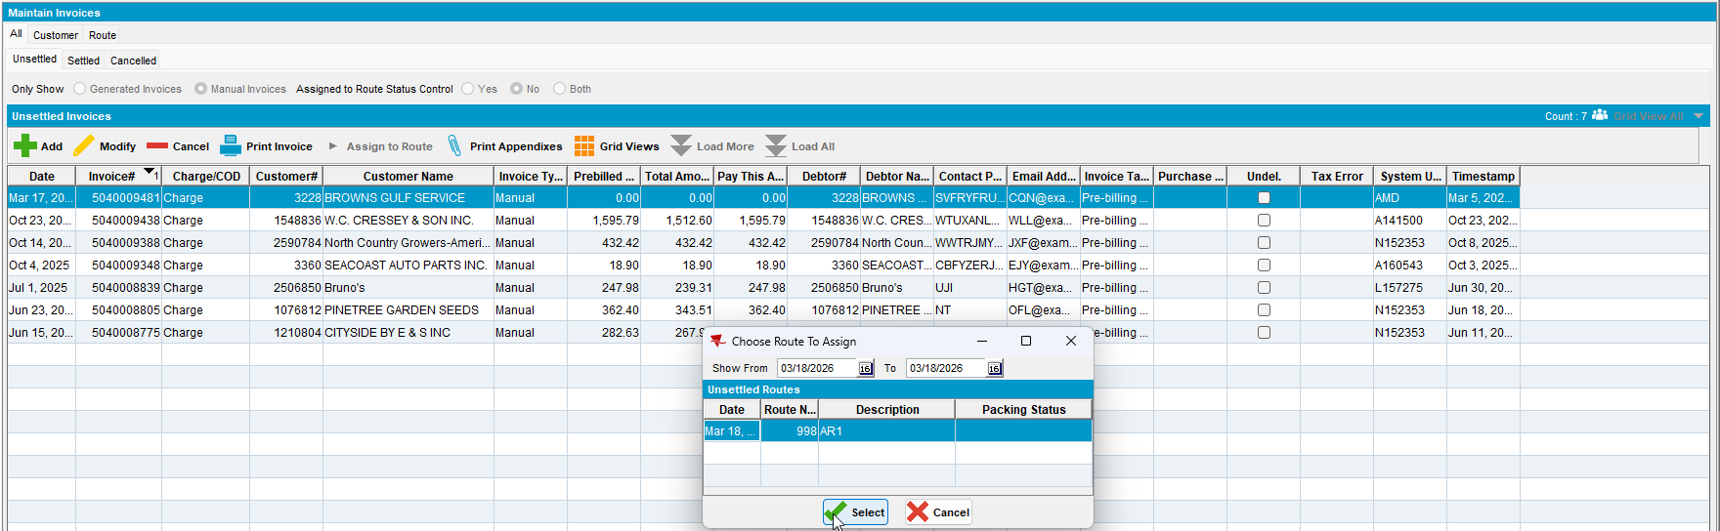

- Make sure there is no other stop To Be Visited on the route.
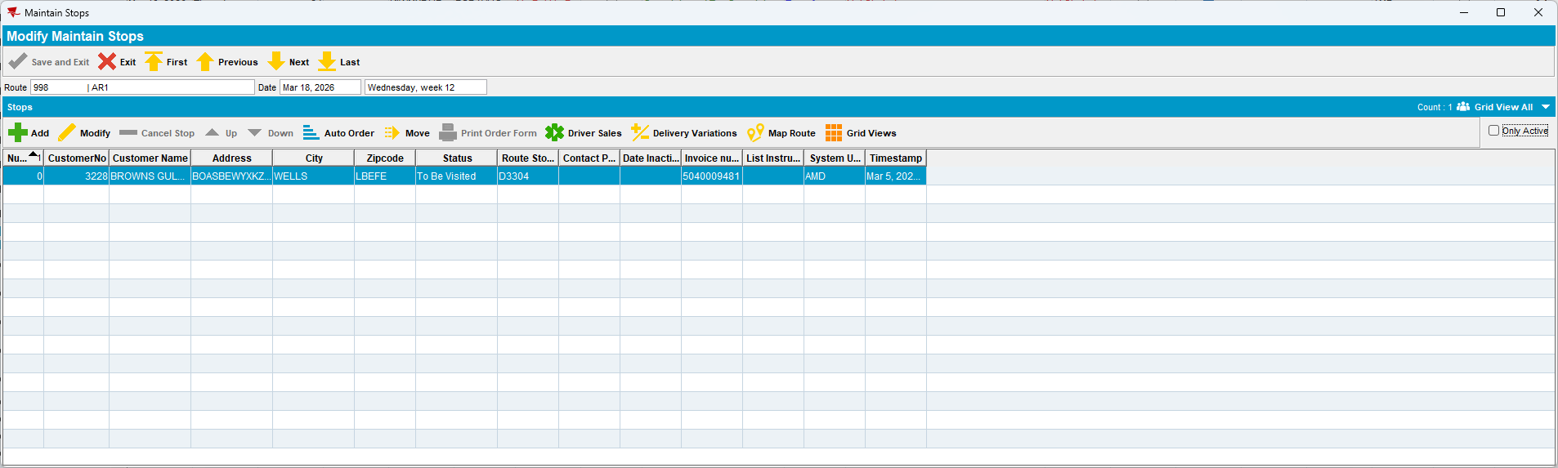

- Complete the route.

- Settle the route in Settlement.
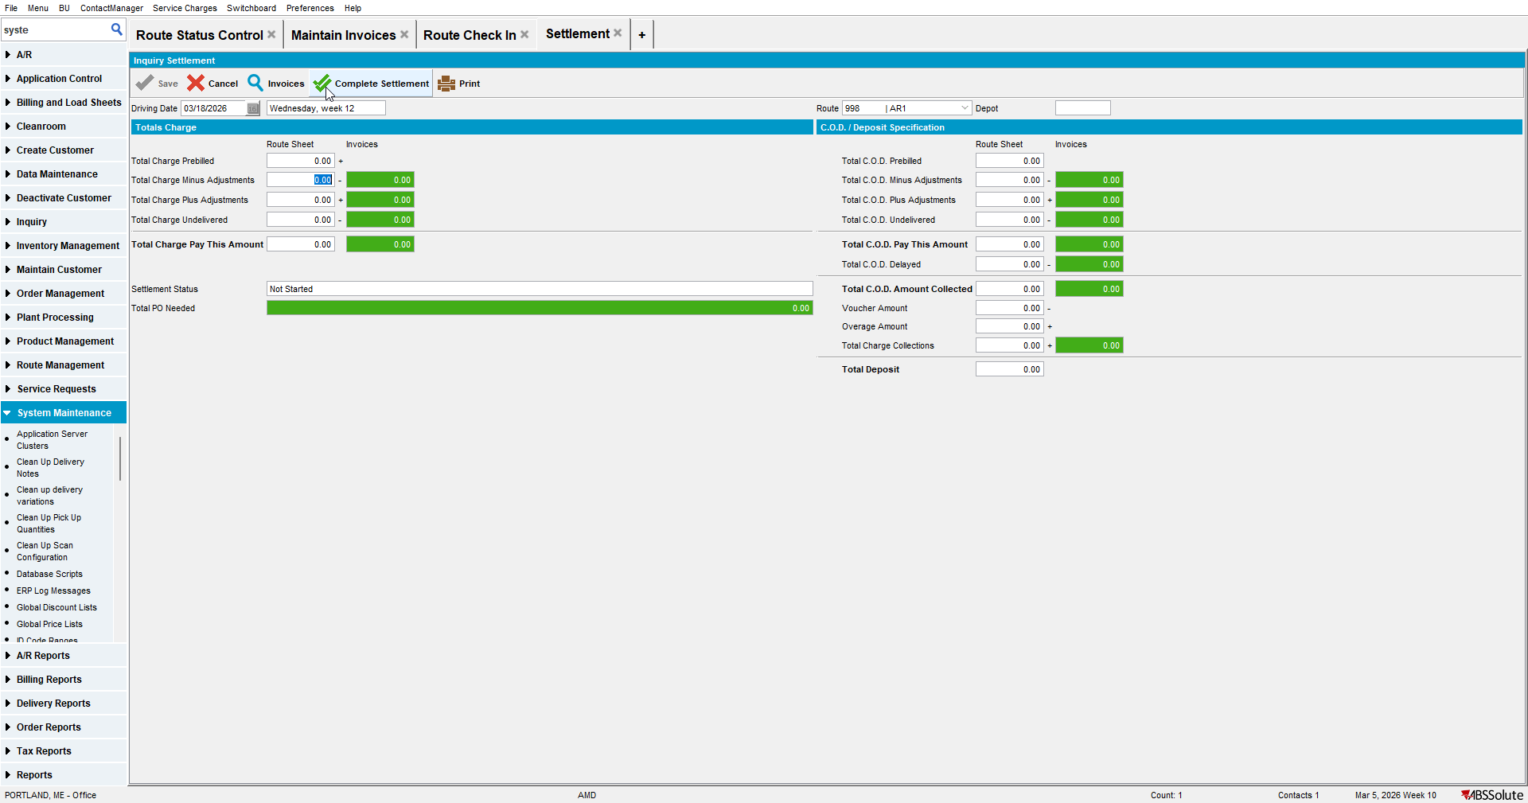
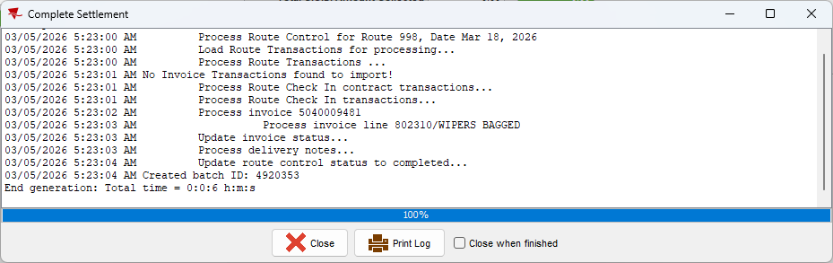

“SETTLEMENTONLYFROMWEBXRCI” module in license.
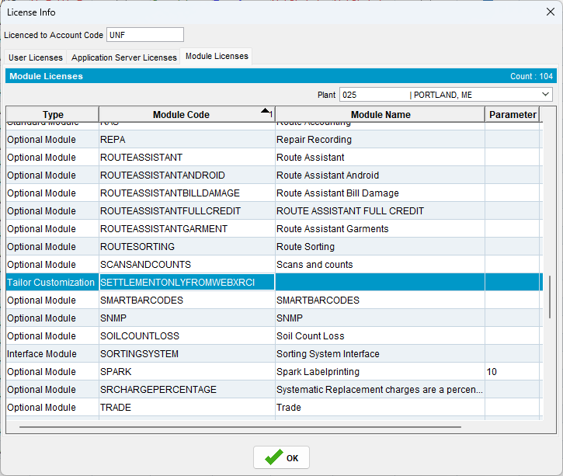
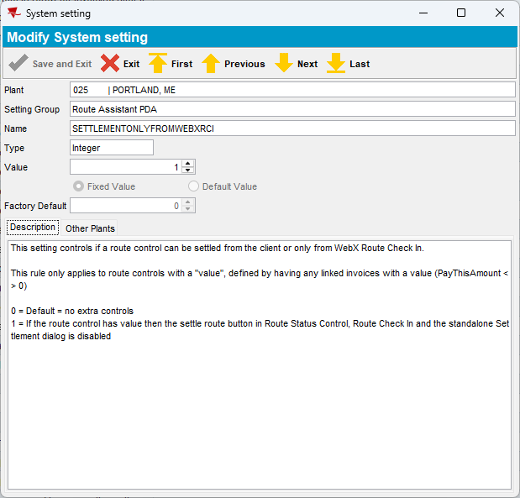

Test Case #1 - Settlement from “Route Status Control” dlg for invoice value <> 0

- Add a route, generate and do the taxes.

- Check the invoice has a value.
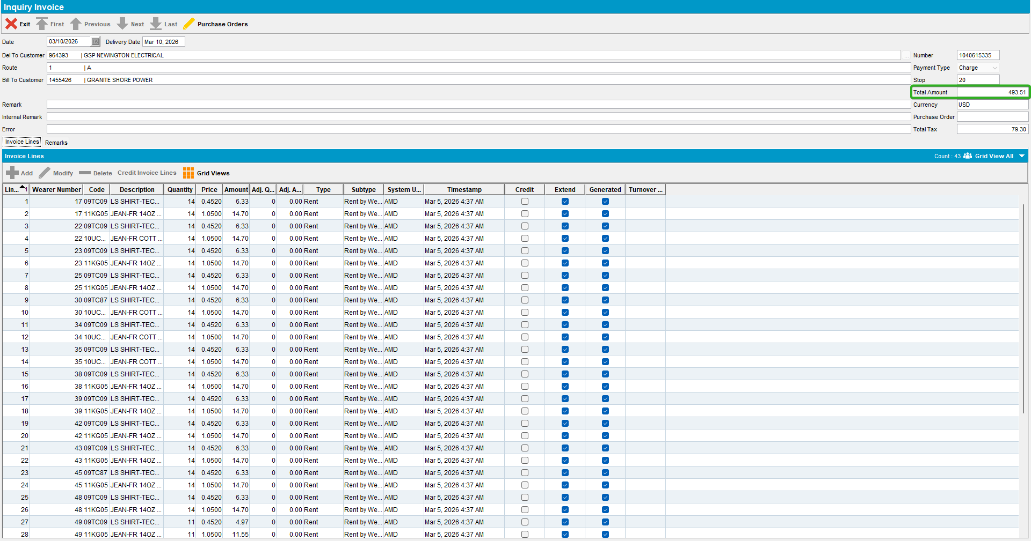

- Settle the route in Route Status Control.
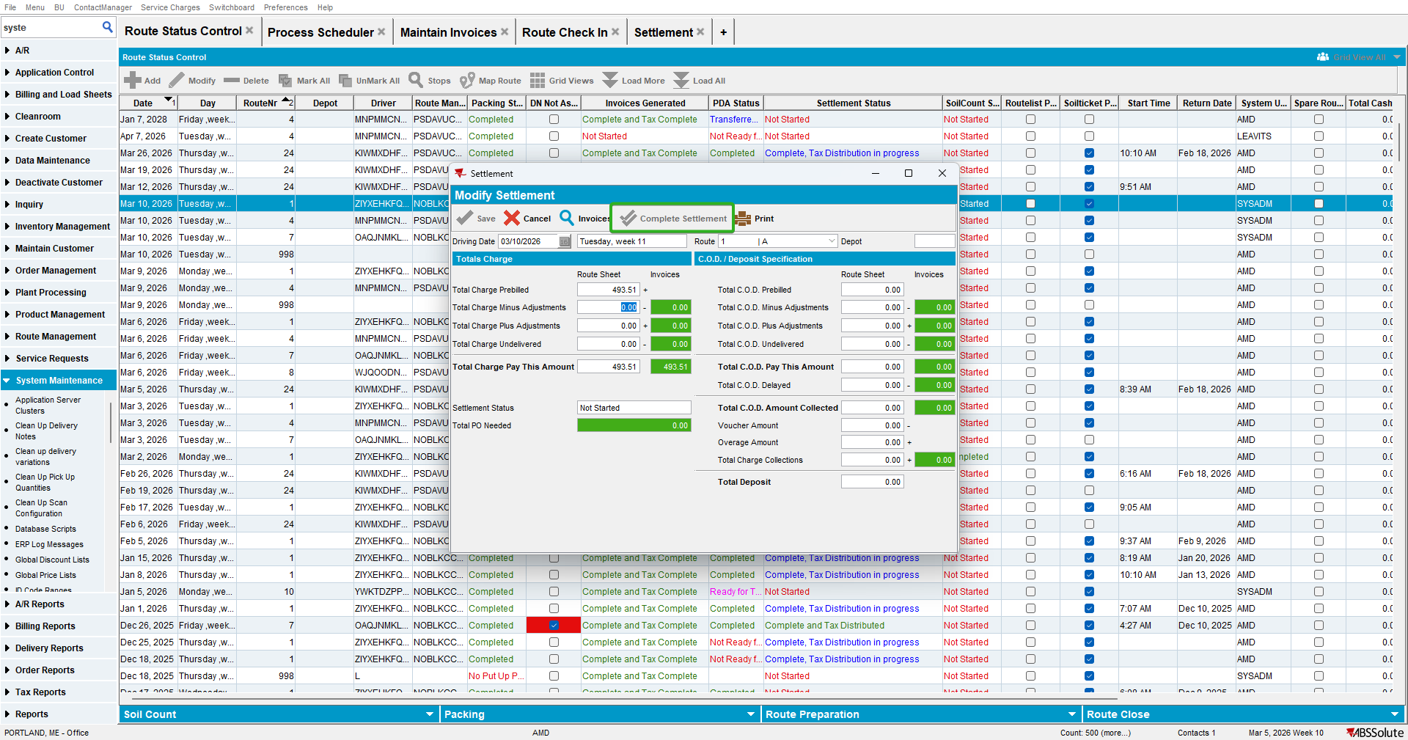
“Complete Settlement” button it’s disabled.

Test Case #2 - Settlement from “Route Check In” dlg for invoice value <> 0

- Add a route, generate and do the taxes.

- Check the invoice has a value.
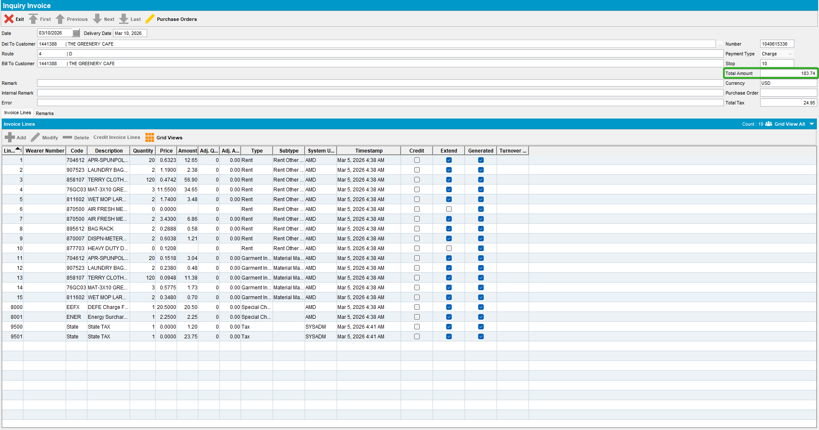

- Settle the route in Route Check in.
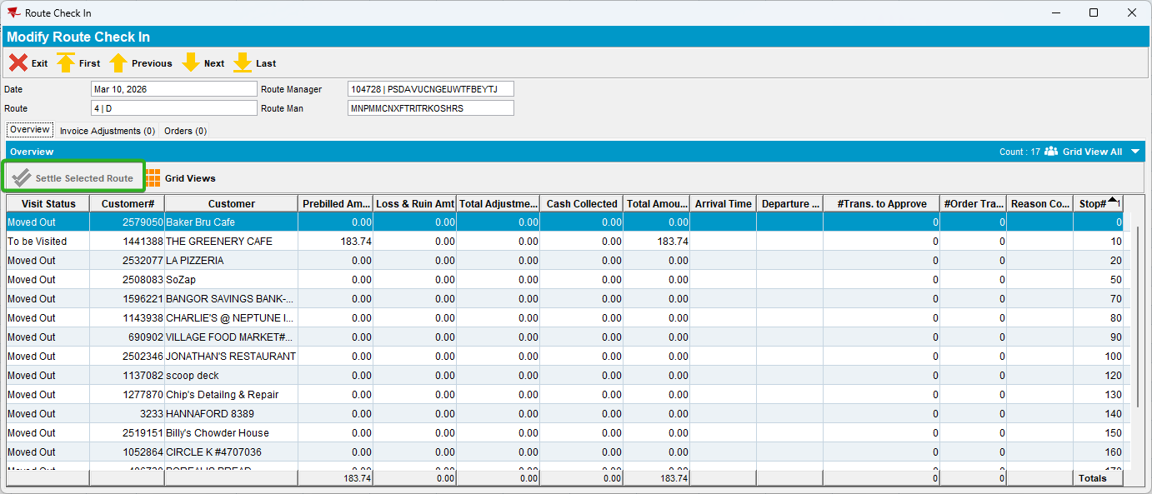
“Settle Selected Route” button is disabled.

Test Case #3 - Settlement from “Settlement” dlg for invoice value <> 0

- Add a route, generate and do the taxes.

- Check the invoice has a value.
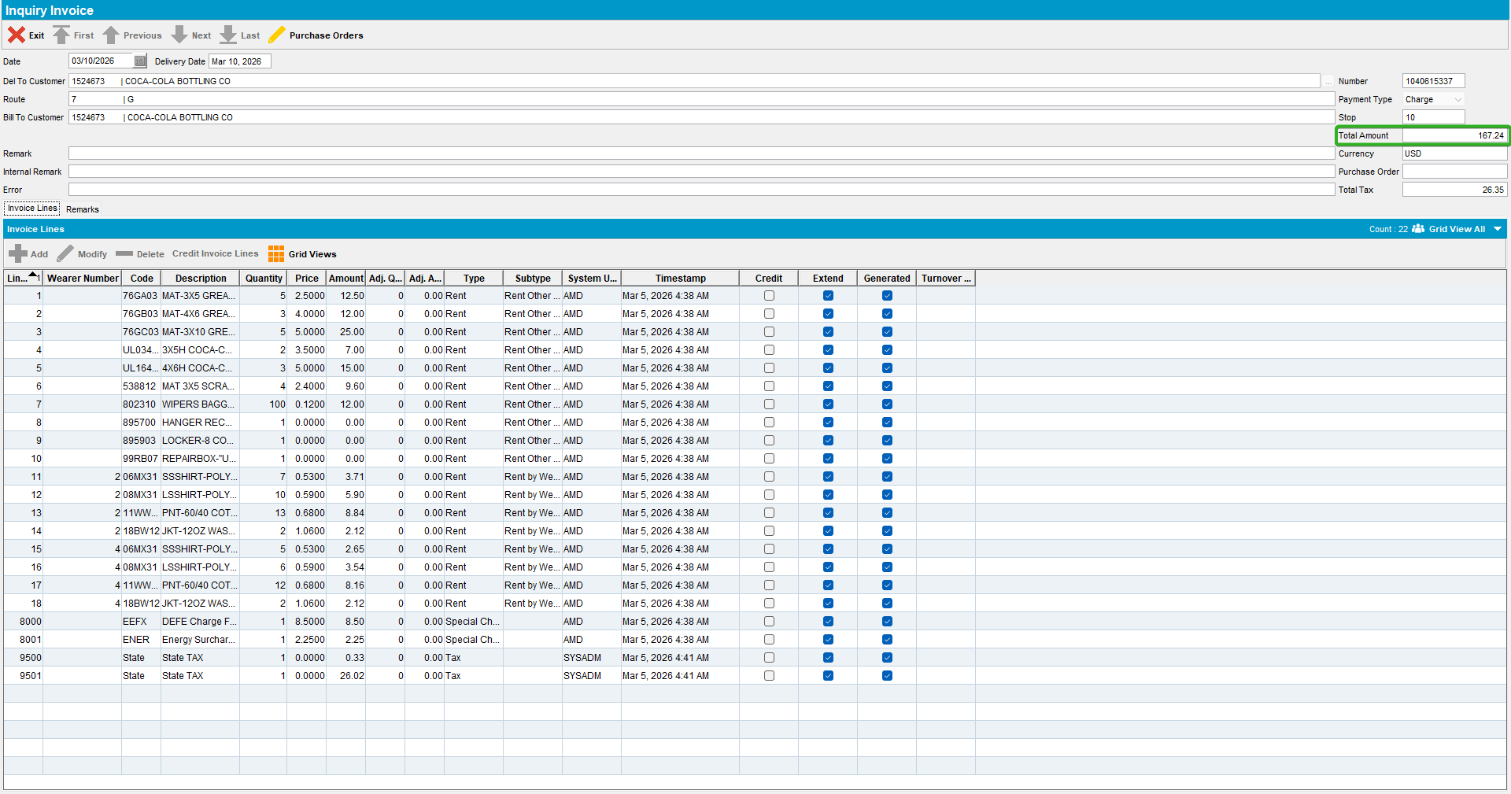

- Settle the route in Settlement.
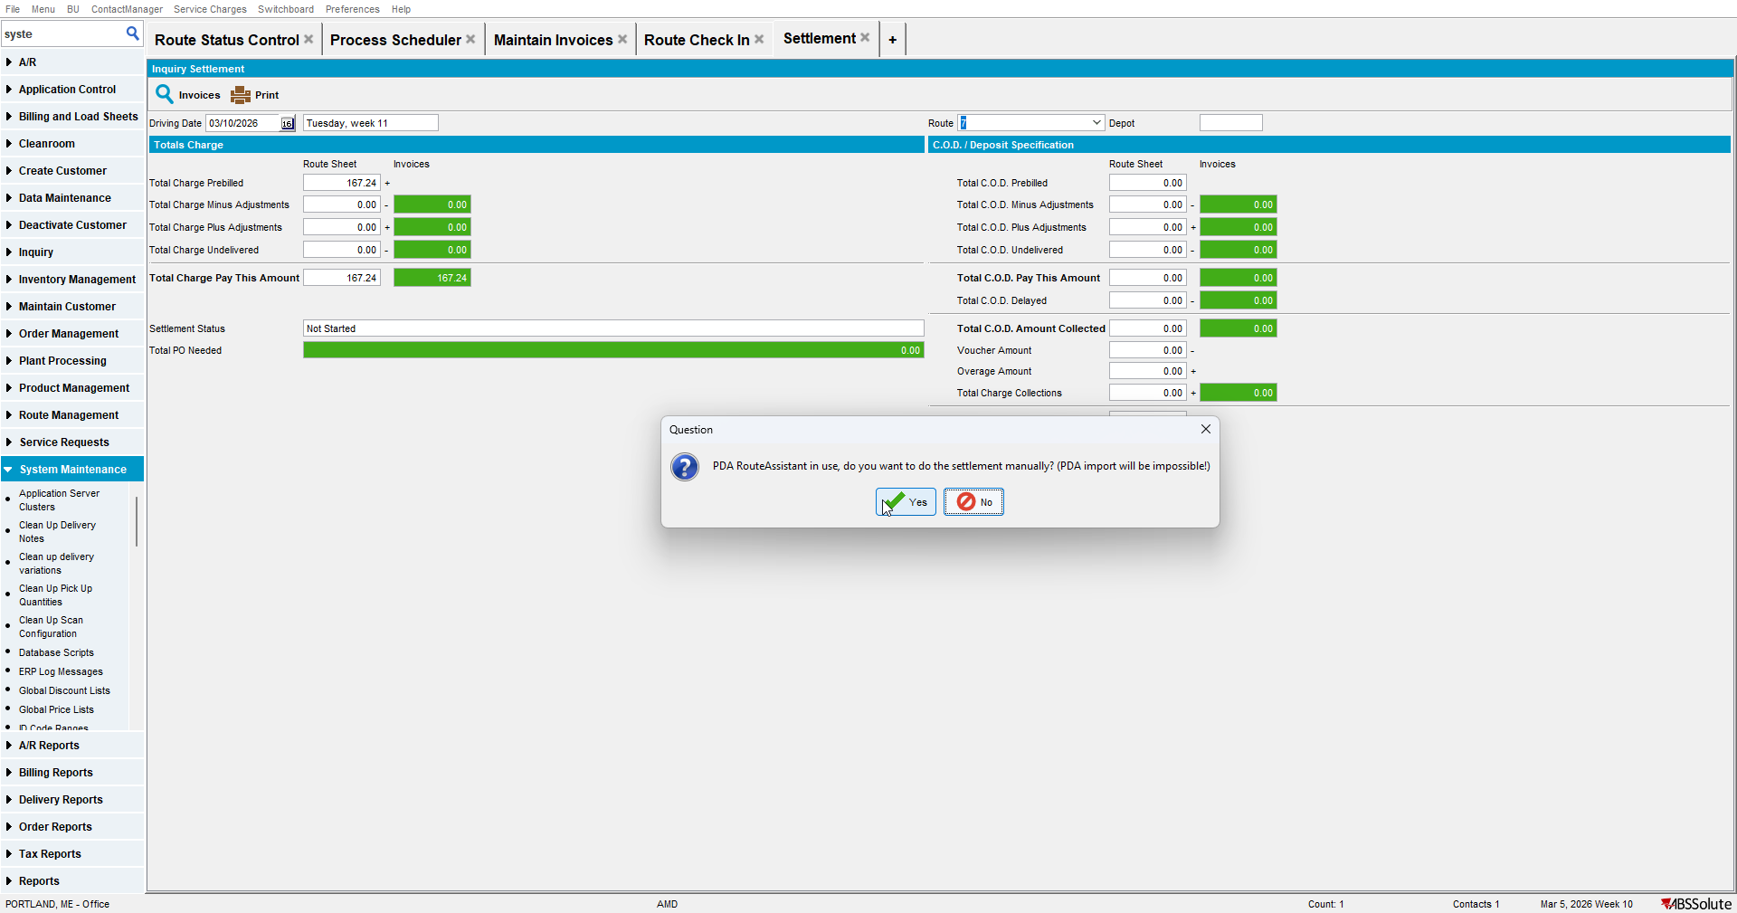
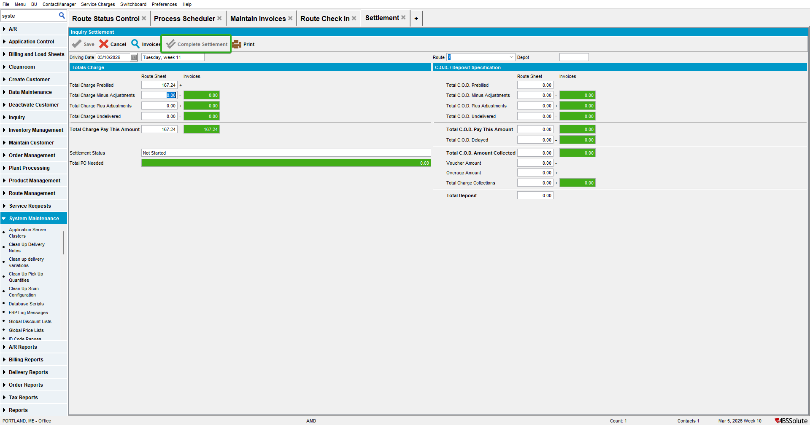
“Complete Settlement” button is disabled.

Test Case #4 - Settlement from “Route Status Control” dlg for invoice value = 0

- Add a manual invoice with value = 0 and assign it to a route.
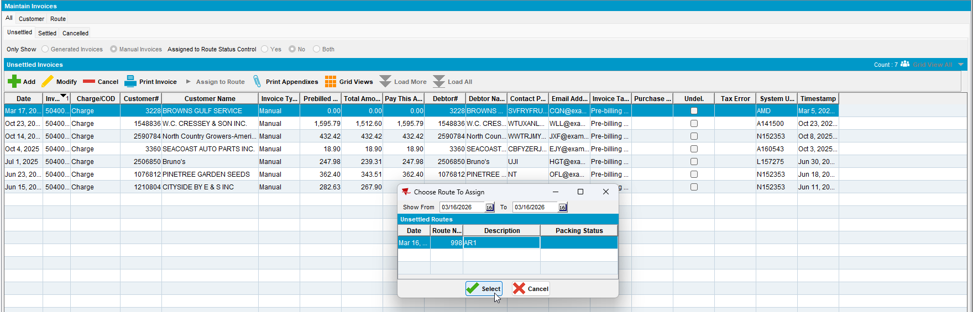

- Make sure there is no other stop To Be Visited on the route.
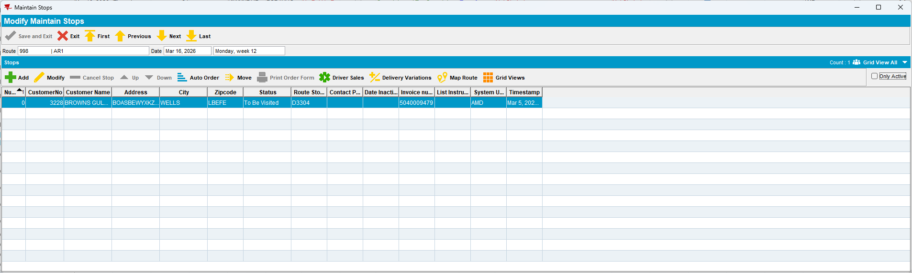

- Complete the route.

- Settle the route in Route Status Control.
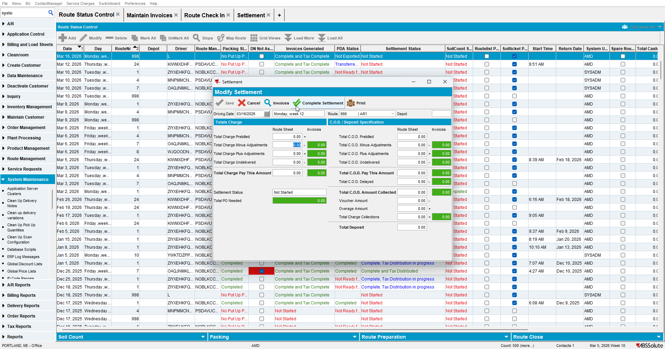
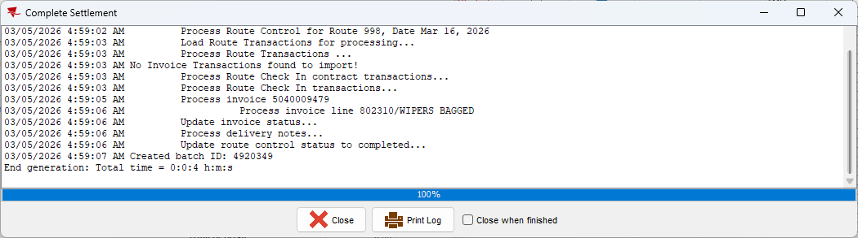
A route with a total invoice value of 0 can still be settled even when "SETTLEMENTONLYFROMWEBXRCI" is present in the license.

Test Case #5 - Settlement from “Route Check In” dlg for invoice value = 0

- Add a manual invoice with value = 0 and assign it to a route.

- Make sure there is no other stop To Be Visited on the route.

- Complete the route.

- Settle the route in Route Check In.
A route with a total invoice value of 0 can still be settled even when "SETTLEMENTONLYFROMWEBXRCI" is present in the license.

Test Case #6 - Settlement from “Settlement” dlg for invoice value = 0

- Add a manual invoice with value = 0 and assign it to a route.

- Make sure there is no other stop To Be Visited on the route.

- Complete the route.

- Settle the route in Settlement.
A route with a total invoice value of 0 can still be settled even when "SETTLEMENTONLYFROMWEBXRCI" is present in the license.

