ABSN-15622 D_UBS_2267 Multiple uploads are causing Expected Qtys in Route Returns to multiply
Environment | Prerequisites
DBServerName= abs-srv20.internal.abslbs.com  DBSID=CUST24  DBUser=UNFDEV  Environment=PRODUCTION | - Module:  - System setting

Contents
Reproduce before fix 1
Steps to reproduce: 1
Expected behavior: 11
Retest after fix 11
Steps to reproduce: 11
Expected behavior: 18

Reproduce before fix
Bu: 044 Nashua, NH
9.07.00.UNF17.p20 hash: 3930ae9c21a + 12.40 hash: f0b01c385

Steps to reproduce:

- Use SQL below to find data:
select p.code, rc.drivingdate, r.routenumber, rt.* from routetransaction rt
join routecontrol rc on rc.routecontrol_id = rt.routecontrol_id
join ROUTE R
on R.ROUTE_ID = RC.ROUTE_ID
join PLANT P
on P.PLANT_ID = R.PLANT_ID
where rt.processedstatus = 3 and rc.pocketpcstatus = 2
and rt.routetransactiontype_id = 804

OR make a duplicate upload

- Have a wearer with non unique items
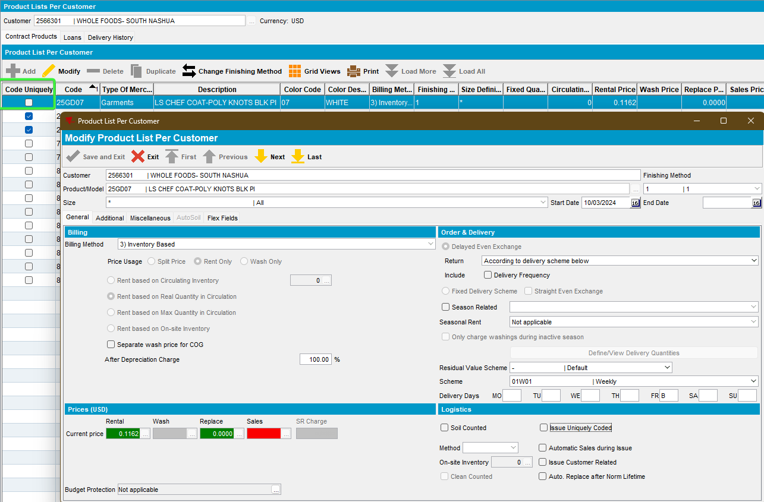
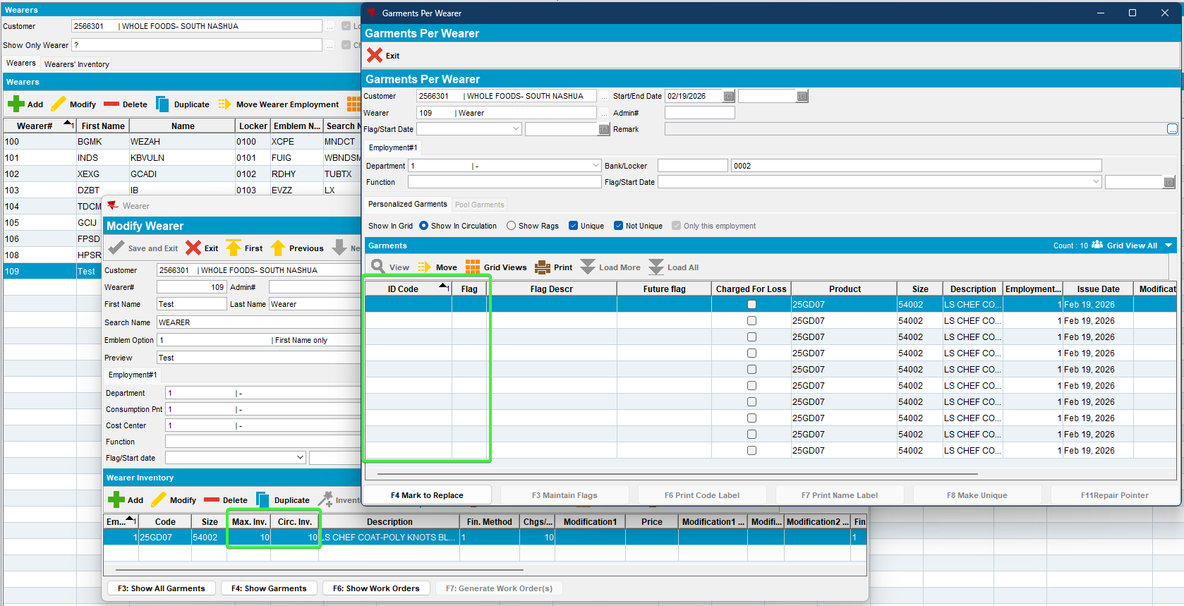
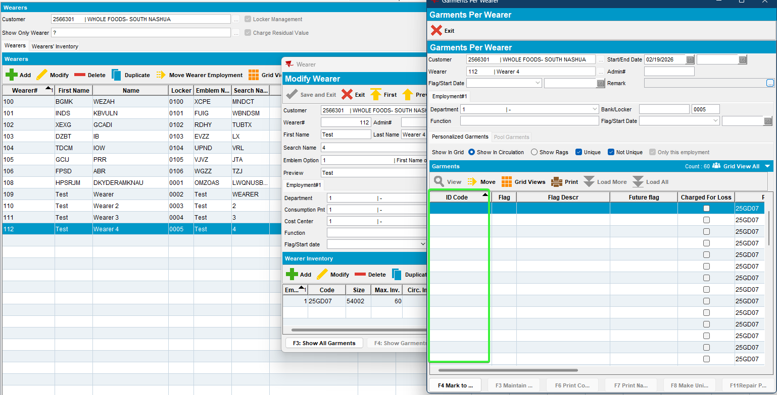
- RSC dlg: Generate packing notes and invoices, script the taxes. Send the route to PDA.
- On Route Assistant, do a multiple decrease of inventories of the wearers created above with the same product
First wearer, decrease by 3, scan return 2
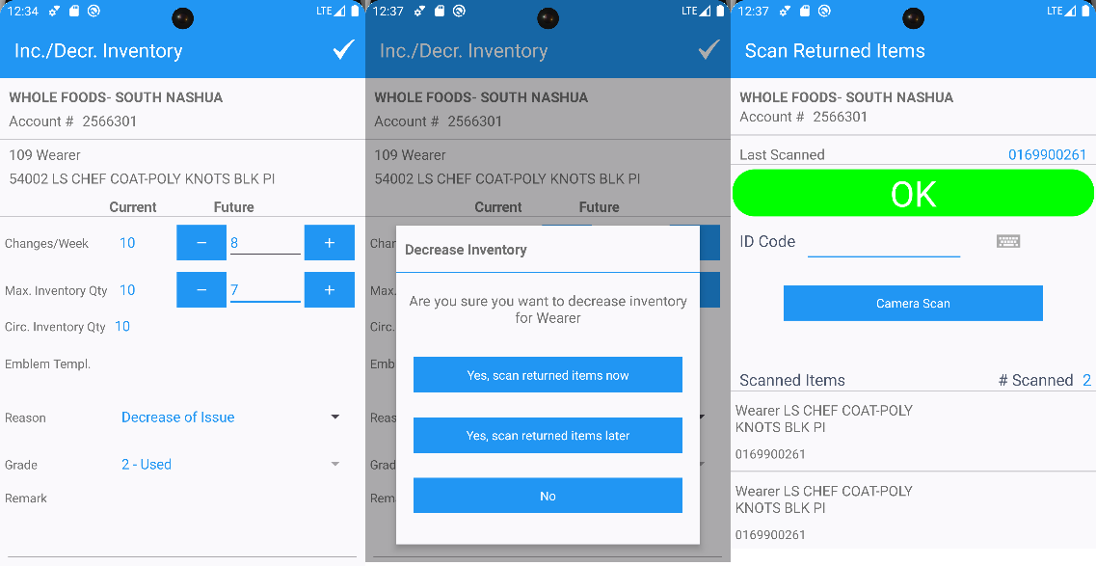
Second wearer, decrease 3 scan return 1
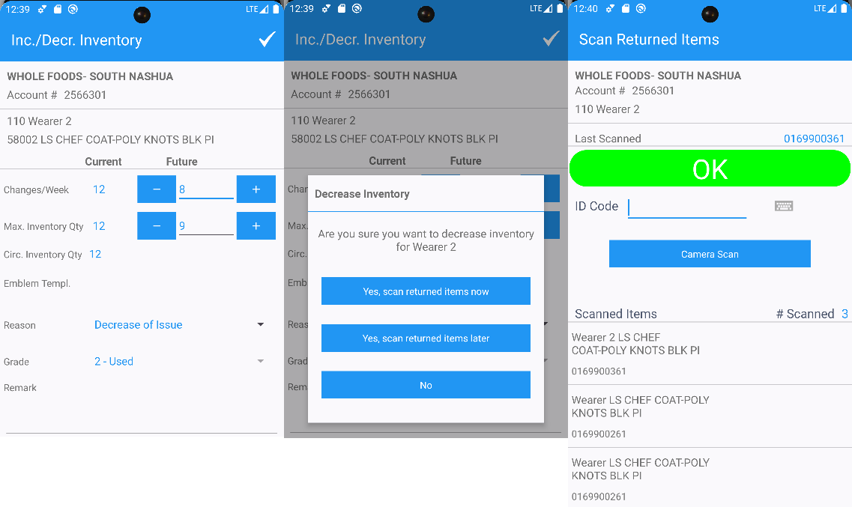
Third wearer, decrease 10 scan return 8
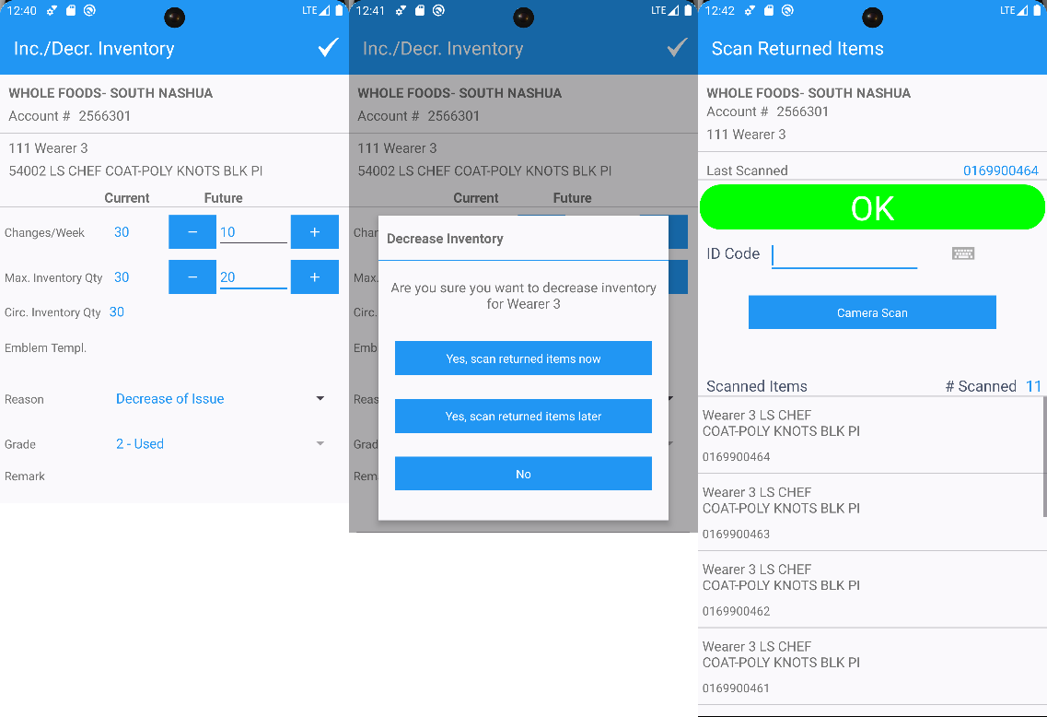
Fourth wearer, size exchange for same product, scan return 20
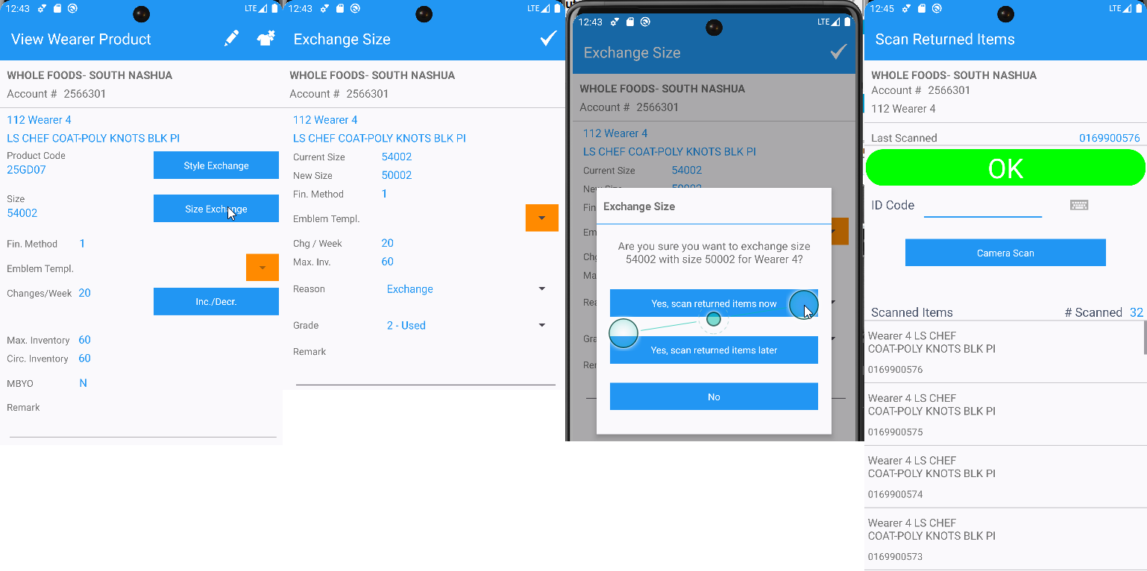
- RA: Settle and depart.
- RA: For the other customers make some transactions
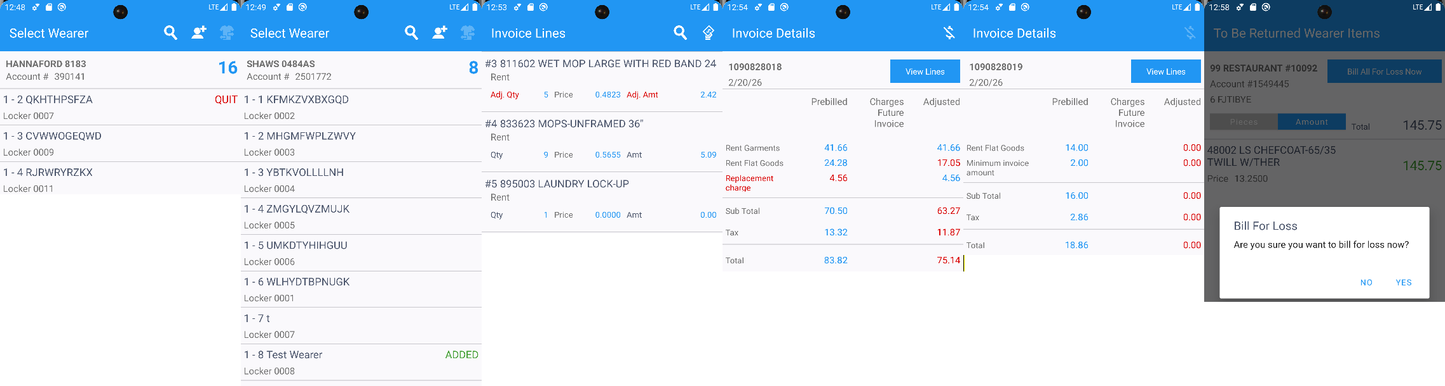
- RA: Finish the route.
- RA: Spam the download button (this also makes an upload first if the app sees there are transactions made on RA that needs to be uploaded)
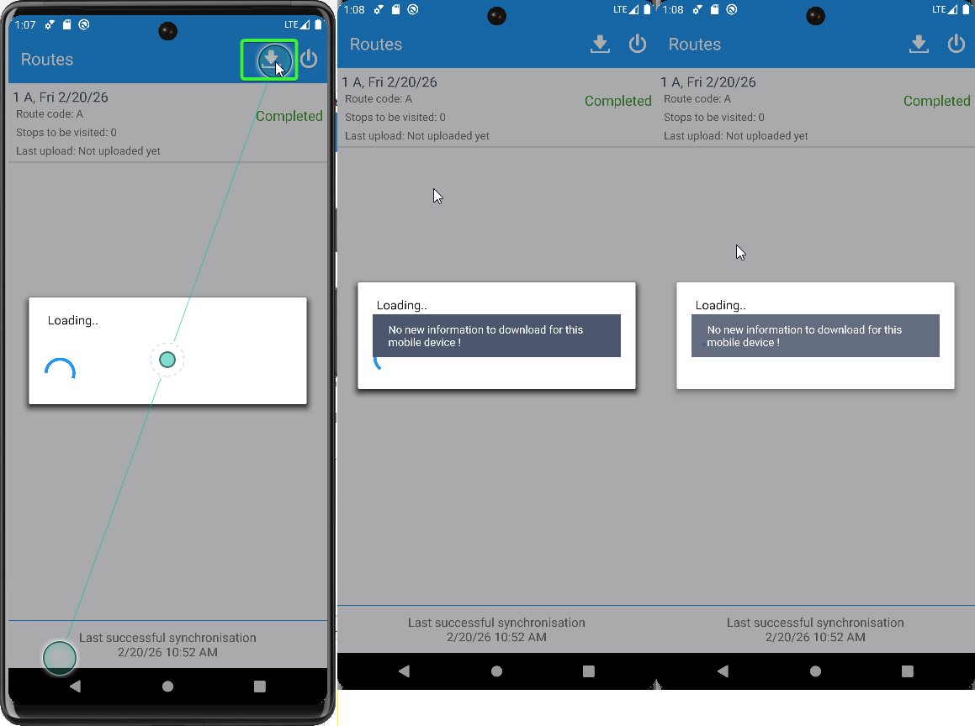
- Check in database if any multiple uploads were made.
-- How many duplicate uploads from RA
select PJ.MOBILEDEVICE_ID,
TO_CHAR(PJ.STARTTIMESTAMP, 'mm/dd/yyyy HH24:mi'),
count(1)
from abslogprocessjob PJ
JOIN ABSLOGPROCESSJOBPART PJP
ON PJP.ABSLOGPROCESSJOB_ID = PJ.ABSLOGPROCESSJOB_ID
join MOBILEDEVICE MD
on MD.MOBILEDEVICE_ID = PJ.MOBILEDEVICE_ID
WHERE PJP.PROCESSNAME = 'uploadRouteData'
AND PJ.STARTTIMESTAMP > TRUNC(sysdate - 2)
AND md.code = '444'
group by TO_CHAR(PJ.STARTTIMESTAMP, 'mm/dd/yyyy HH24:mi'),
PJ.MOBILEDEVICE_ID
HAVING COUNT(1) > 1;
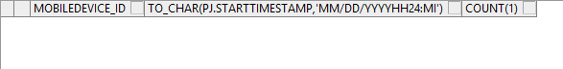

We couldn’t reproduce the multiple uploads on our side

- Simulate a multiple upload by tampering with the data.
select RT.ROUTETRANSACTION_ID, RT.ROUTETRANSACTIONTYPE_ID,RT.APPROVEDBYSYSTEMUSER_ID, RT.APPROVALTIMESTAMP, RT.PROCESSEDSTATUS, RT.APPROVALSTATUS, IL.DESCRIPTION, RT.WEARER_ID, RT.WEARERINVENTORY_ID, RT.STRINGVALUE1, RT.STRINGVALUE2, RT.STRINGVALUE3,
RT.DOUBLEVALUE1, RT.DOUBLEVALUE6, RT.DOUBLEVALUE9, RT.Stringvalue10,
RT.*
from ROUTETRANSACTION RT
left outer join INVOICELINE IL
on IL.INVOICELINE_ID = RT.INVOICELINE_ID
left join INVOICEHEADER IH
on IH.INVOICEHEADER_ID = RT.INVOICEHEADER_ID
join STOP S
on S.STOP_ID = RT.STOP_ID
where RT.ROUTECONTROL_ID =
(select RC.ROUTECONTROL_ID
from ROUTECONTROL RC
join ROUTE R
on R.ROUTE_ID = RC.ROUTE_ID
join PLANT P
on P.PLANT_ID = R.PLANT_ID
where P.CODE = '044'
and R.ROUTENUMBER = 1
and RC.ORIGINALDRIVINGDATE = TO_DATE('20260220', 'YYYYMMDD'))
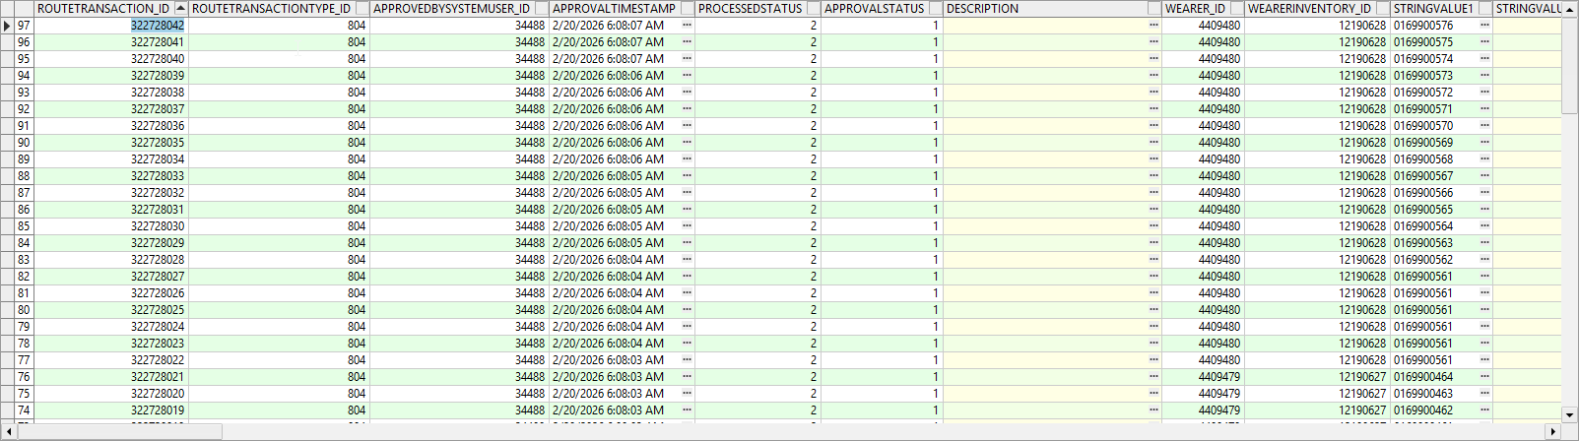
Sort descending the routetransaction_id to get the latest number

- Make a selection only for the latest transaction.
SELECT * FROM ROUTETRANSACTION RT
WHERE RT.ROUTETRANSACTION_ID = 322728042;
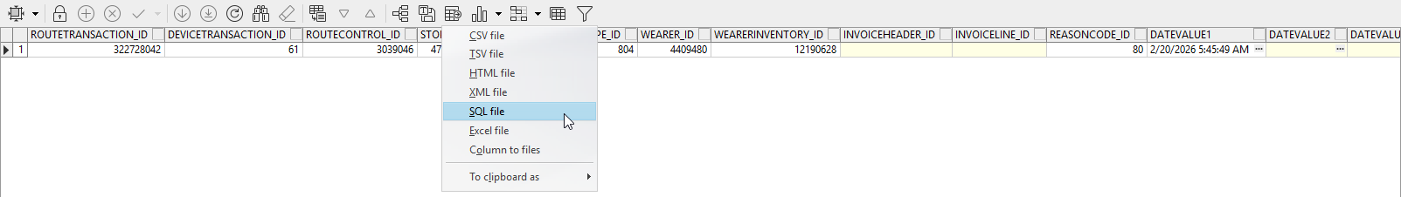
Export the query to a SQL file
- Open the file, copy the command to PLSQL
- Find the next value
SELECT SEQ_ROUTETRANSACTION.NEXTVAL FROM dual;
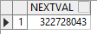

- Duplicate transaction by running the insert using the above next value for routetransaction. Run the insert 2 more times, each time with an increased +1 next value
- Update processedstatus of each of the inserted transactions to 3 (error).
SELECT RT.PROCESSEDSTATUS, RT.* FROM ROUTETRANSACTION RT
WHERE RT.ROUTETRANSACTION_ID = 322728043 for update;
Do the same for the other 2 inserts
- Check the transactions with errors.
--check the transactions with error that have decrease inventory 804
select p.code, rc.drivingdate, r.routenumber, rt.* from routetransaction rt
join routecontrol rc on rc.routecontrol_id = rt.routecontrol_id
join ROUTE R
on R.ROUTE_ID = RC.ROUTE_ID
join PLANT P
on P.PLANT_ID = R.PLANT_ID
where rt.processedstatus = 3 and rc.pocketpcstatus = 2
and rt.routetransactiontype_id = 804;
- Route Returns: Load the route an check the number of items remaining to scan
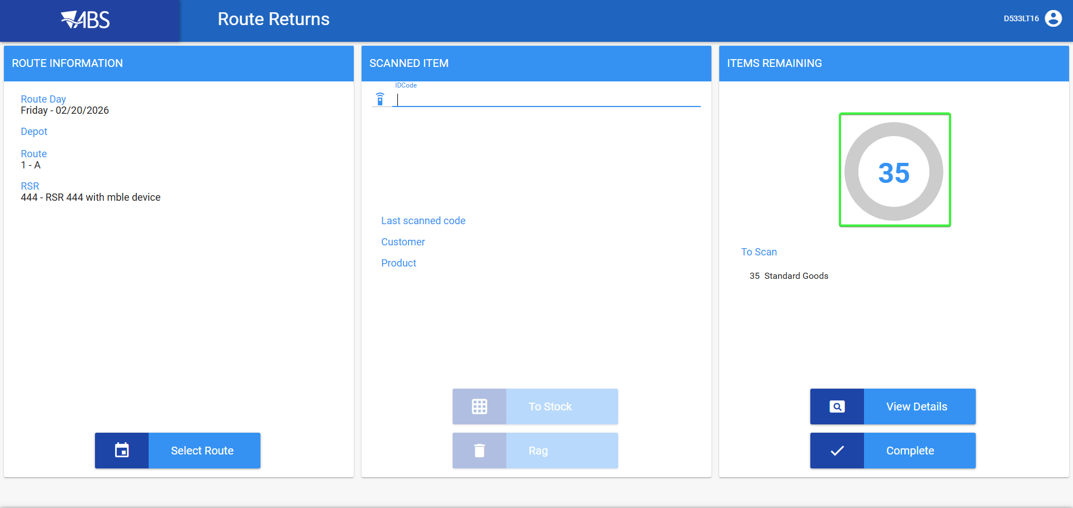
- Enter View details and check the expected quantity.
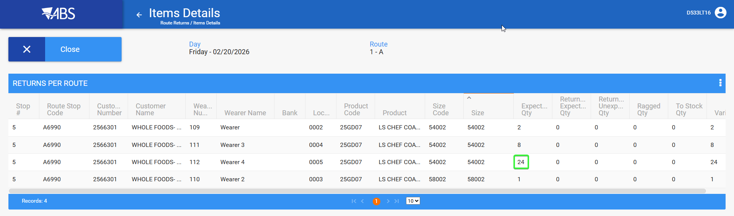

Current behavior:

In Route Returns web app, the quantity expected is increased in the donut chart and Details grid for expected qty because it counts also the error 3 processed status.

Expected behavior:
Numbers match the actual items scanned in RA and Route Transactions with ProcessStatus = 3 (Error) are excluded from the counts.

Reproduced OK

Retest after fix
Bu: 044 Nashua, NH
9.07.00.UNF21 hash: b1a75411ff8b + RouteAssistant_v12.40.INTERNAL_TEST_ONLY.f0b01c385

Steps to reproduce:

- Use SQL below to find data:
select p.code, rc.drivingdate, r.routenumber, rt.* from routetransaction rt
join routecontrol rc on rc.routecontrol_id = rt.routecontrol_id
join ROUTE R
on R.ROUTE_ID = RC.ROUTE_ID
join PLANT P
on P.PLANT_ID = R.PLANT_ID
where rt.processedstatus = 3 and rc.pocketpcstatus = 2
and rt.routetransactiontype_id = 804

OR make a duplicate upload

- Have a wearer with non unique items
- RSC dlg: Generate packing notes and invoices, script the taxes. Send the route to PDA.
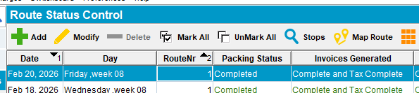
- On Route Assistant, do a multiple decrease of inventories of the wearers created above with the same product
First wearer, decrease by 3, scan return 2
Second wearer, decrease 3 scan return 1
Third wearer, decrease 10 scan return 8
Fourth wearer, size exchange for same product, scan return 20
- RA: Settle and depart.
- RA: For the other customers make some transactions
- RA: Finish the route.
- RA: Spam the download button (this also makes an upload first if the app sees there are transactions made on RA that needs to be uploaded)
- Check in database if any multiple uploads were made.
-- How many duplicate uploads from RA
select PJ.MOBILEDEVICE_ID,
TO_CHAR(PJ.STARTTIMESTAMP, 'mm/dd/yyyy HH24:mi'),
count(1)
from abslogprocessjob PJ
JOIN ABSLOGPROCESSJOBPART PJP
ON PJP.ABSLOGPROCESSJOB_ID = PJ.ABSLOGPROCESSJOB_ID
join MOBILEDEVICE MD
on MD.MOBILEDEVICE_ID = PJ.MOBILEDEVICE_ID
WHERE PJP.PROCESSNAME = 'uploadRouteData'
AND PJ.STARTTIMESTAMP > TRUNC(sysdate - 2)
AND md.code = '444'
group by TO_CHAR(PJ.STARTTIMESTAMP, 'mm/dd/yyyy HH24:mi'),
PJ.MOBILEDEVICE_ID
HAVING COUNT(1) > 1;

We couldn’t reproduce the multiple uploads on our side

- Simulate a multiple upload by tampering with the data.
select RT.ROUTETRANSACTION_ID, RT.ROUTETRANSACTIONTYPE_ID,RT.APPROVEDBYSYSTEMUSER_ID, RT.APPROVALTIMESTAMP, RT.PROCESSEDSTATUS, RT.APPROVALSTATUS, IL.DESCRIPTION, RT.WEARER_ID, RT.WEARERINVENTORY_ID, RT.STRINGVALUE1, RT.STRINGVALUE2, RT.STRINGVALUE3,
RT.DOUBLEVALUE1, RT.DOUBLEVALUE6, RT.DOUBLEVALUE9, RT.Stringvalue10,
RT.*
from ROUTETRANSACTION RT
left outer join INVOICELINE IL
on IL.INVOICELINE_ID = RT.INVOICELINE_ID
left join INVOICEHEADER IH
on IH.INVOICEHEADER_ID = RT.INVOICEHEADER_ID
join STOP S
on S.STOP_ID = RT.STOP_ID
where RT.ROUTECONTROL_ID =
(select RC.ROUTECONTROL_ID
from ROUTECONTROL RC
join ROUTE R
on R.ROUTE_ID = RC.ROUTE_ID
join PLANT P
on P.PLANT_ID = R.PLANT_ID
where P.CODE = '044'
and R.ROUTENUMBER = 1
and RC.ORIGINALDRIVINGDATE = TO_DATE('20260220', 'YYYYMMDD'))
Sort descending the routetransaction_id to get the latest number

- Make a selection only for the latest transaction.
SELECT * FROM ROUTETRANSACTION RT
WHERE RT.ROUTETRANSACTION_ID = 322728042;
Export the query to a SQL file
- Open the file, copy the command to PLSQL
- Find the next value
SELECT SEQ_ROUTETRANSACTION.NEXTVAL FROM dual;

- Duplicate transaction by running the insert using the above next value for routetransaction. Run the insert 2 more times, each time with an increased +1 next value
- Update processedstatus of each of the inserted transactions to 3 (error).
SELECT RT.PROCESSEDSTATUS, RT.* FROM ROUTETRANSACTION RT
WHERE RT.ROUTETRANSACTION_ID = 322728043 for update;
Do the same for the other 2 inserts
- Check the transactions with errors.
--check the transactions with error that have decrease inventory 804
select p.code, rc.drivingdate, r.routenumber, rt.* from routetransaction rt
join routecontrol rc on rc.routecontrol_id = rt.routecontrol_id
join ROUTE R
on R.ROUTE_ID = RC.ROUTE_ID
join PLANT P
on P.PLANT_ID = R.PLANT_ID
where rt.processedstatus = 3 and rc.pocketpcstatus = 2
and rt.routetransactiontype_id = 804;
- Route Returns: Load the route and check the number of items remaining to scan
Without fix
Enter View details and check the expected quantity.

With fix
- Load the same route created above and check the Route return, the quantity expected in the donut chart and Details grid.
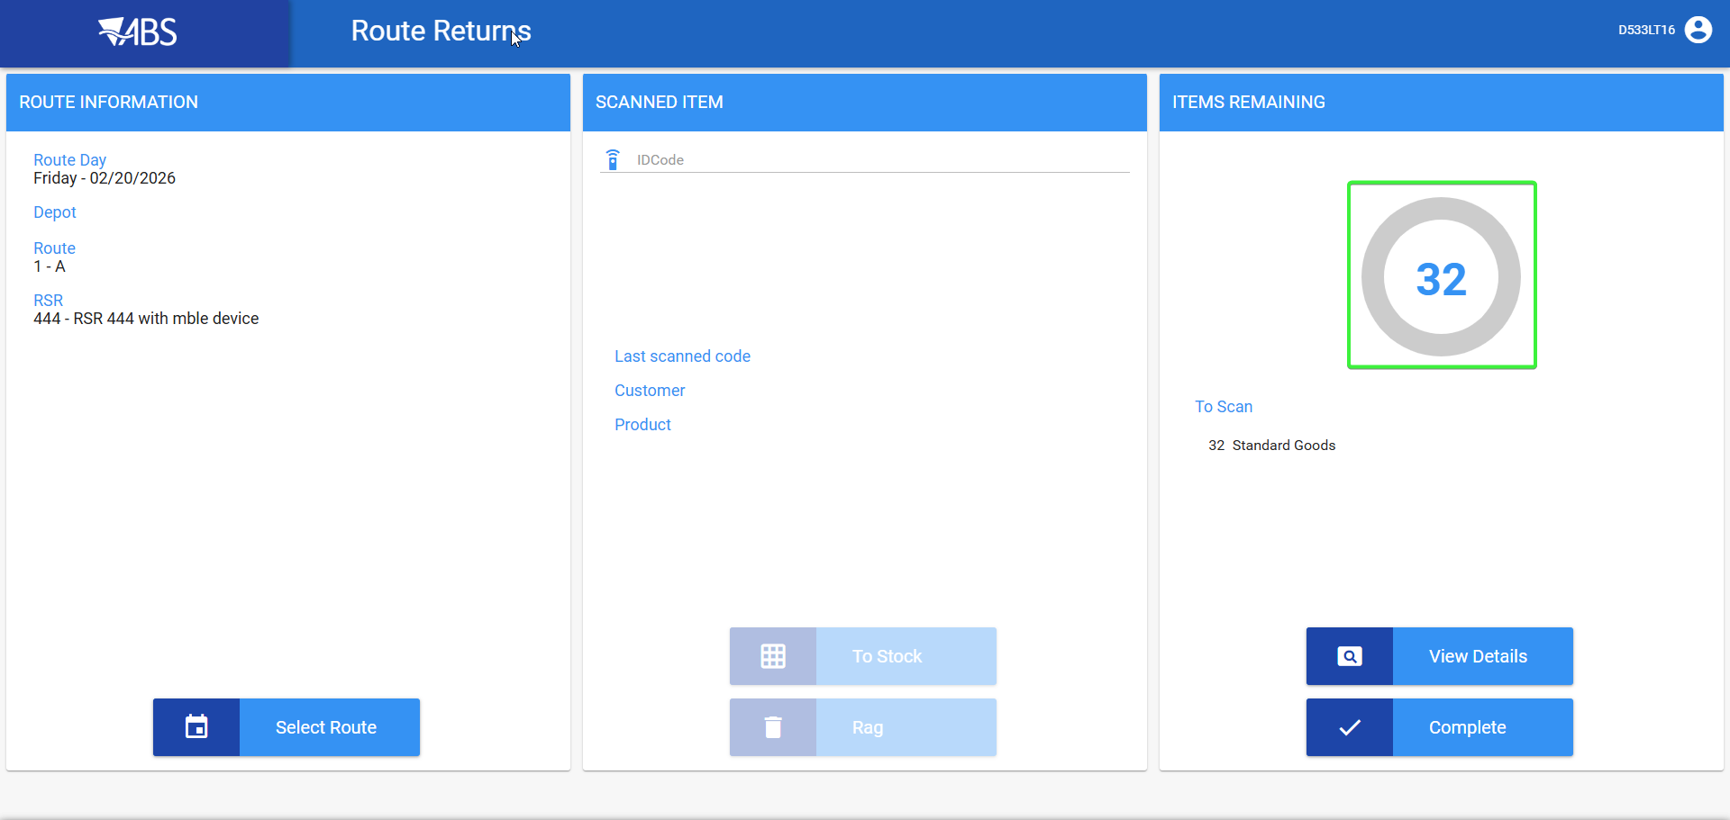
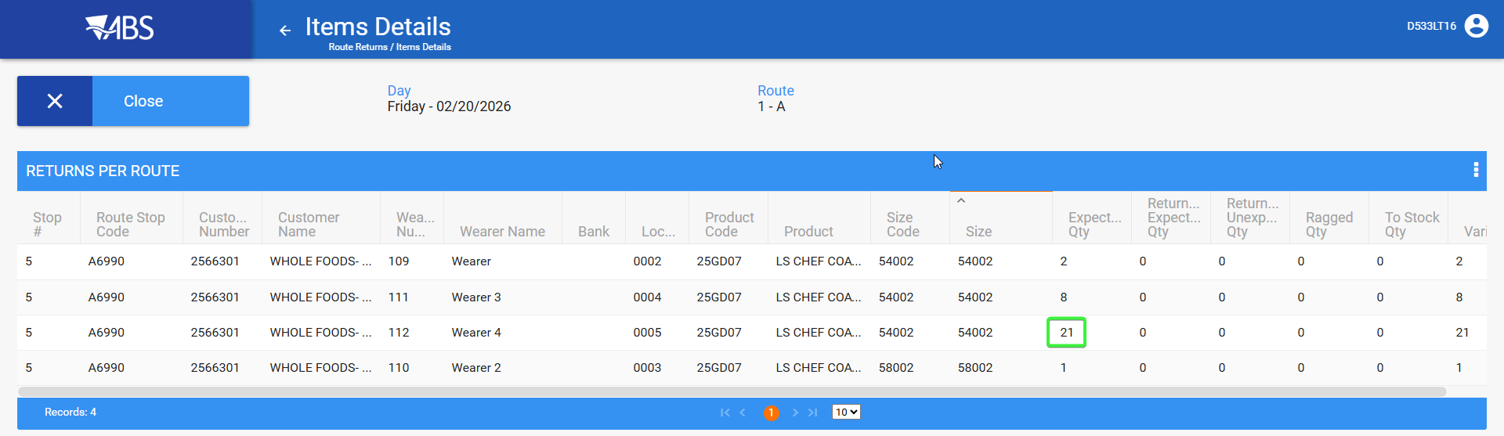

Current behavior:
Numbers match the actual items scanned in RA . Route Transactions with ProcessStatus = 3 (Error) are excluded from the counts.
Tested OK

