ABSN-15475 D_UBS_2266 Unable to update Prep charges on the contract
Environment | Prerequisites
Version:9.07.00.UNF21  DBServerName=abs-srv19.internal.abslbs.com  DBSID=CUST22  DBUser=UNFLIVE  Environment=Production | - Module:  - System setting

Contents
Reproducing before fix 1
Test after fix 4
Test Case 1 – Add prep charge = by pressing cancel and save when there are 2 prices with the same start date– Tested OK 4
Test Case 2 – Add prep charge = by pressing cancel and save when there are no prices with the same start date– Tested OK 8

Reproducing before fix

- Load a contract and go to products
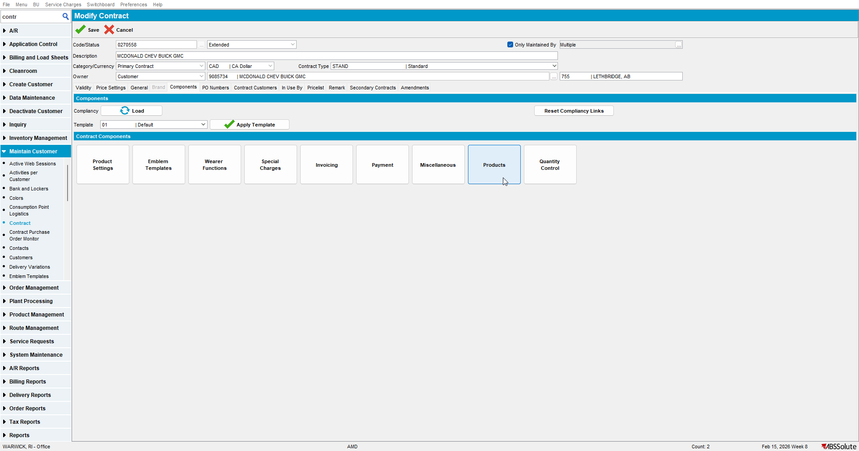

- Go to Charges and select General Prep Charge
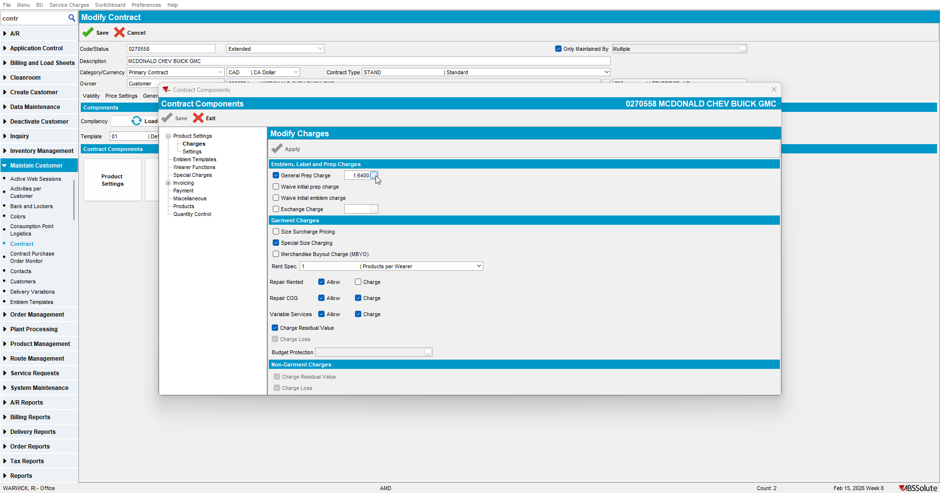

- Check that you have 2 prices with the same starting date
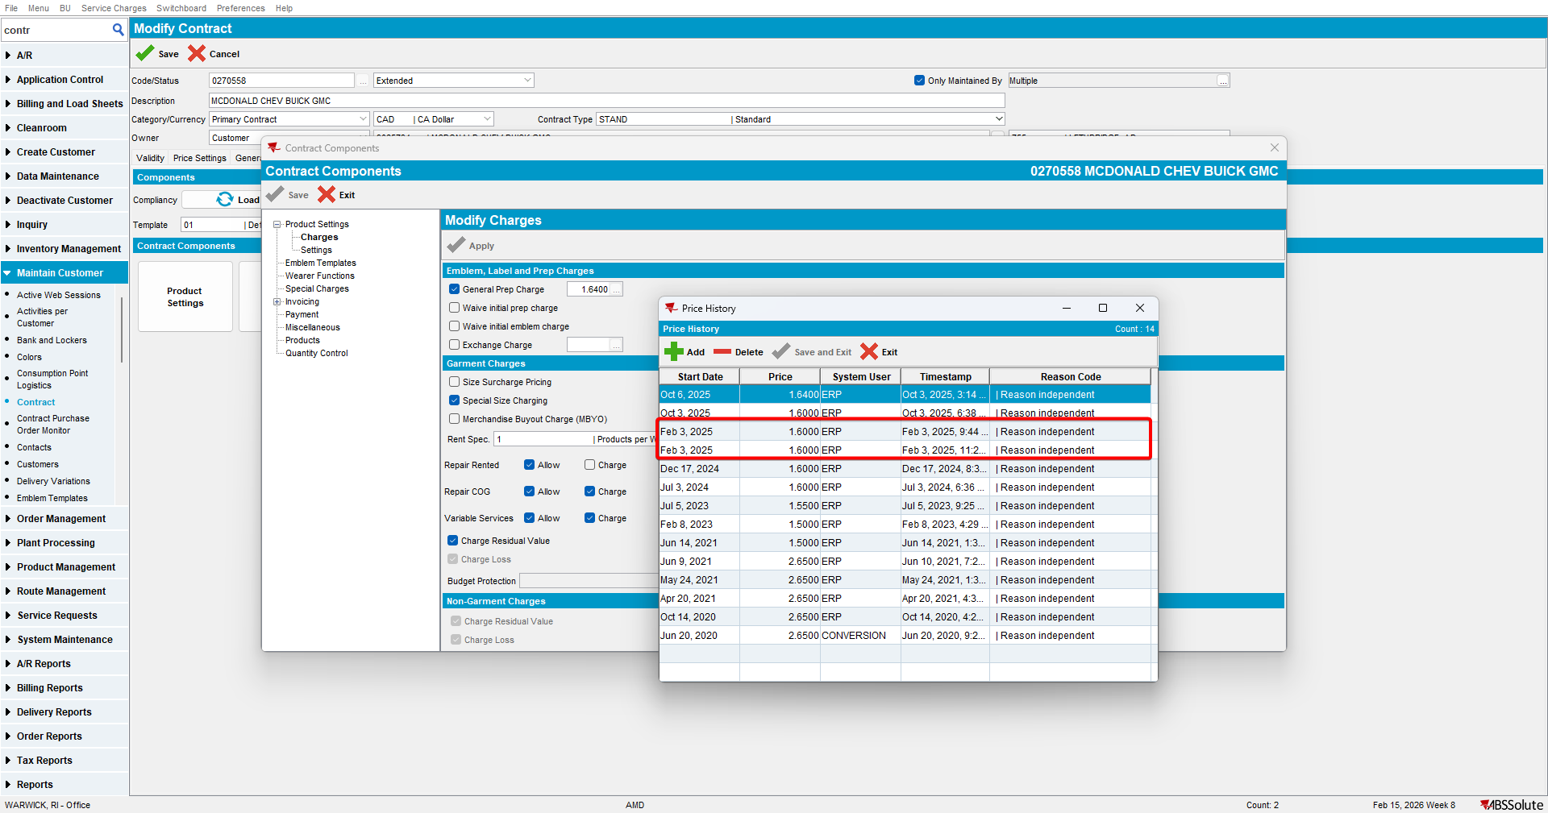

- Add a price and press save
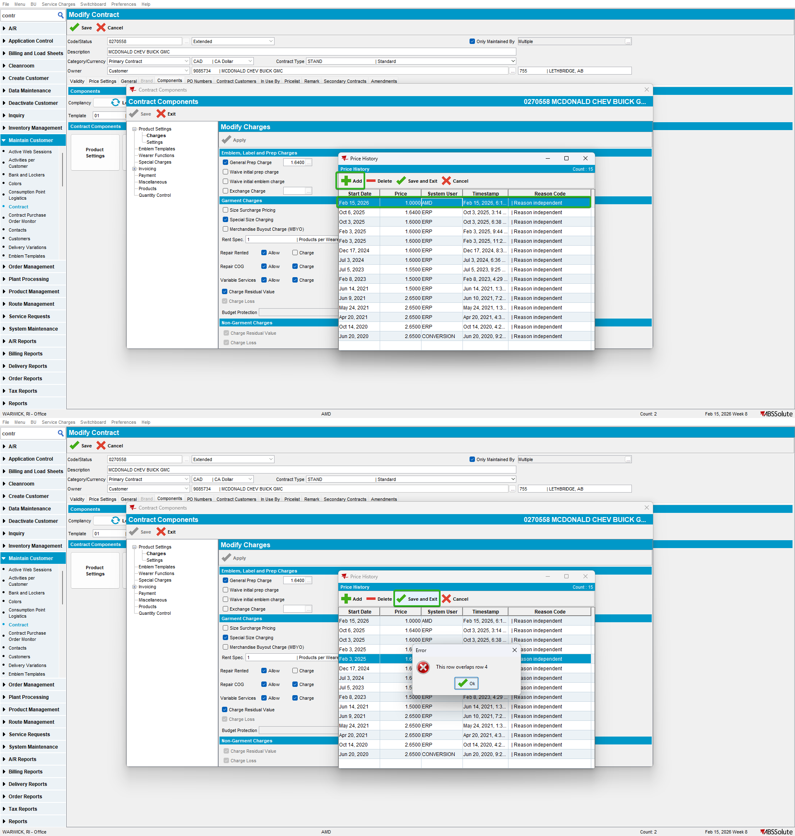

Test after fix

Test Case 1 – Add prep charge = by pressing cancel and save when there are 2 prices with the same start date– Tested OK
Expected behavior: The price will be added only when pressing cancel and save. If pressing Save & Exit an error will appear.
Hash: a3414f605cdc
- Load a contract and go to products

- Go to Charges and select General Prep Charge

- Check that you have 2 prices with the same starting date

- Add a price and press save

- Press Cancel and press Yes when asked if you want to save the changes
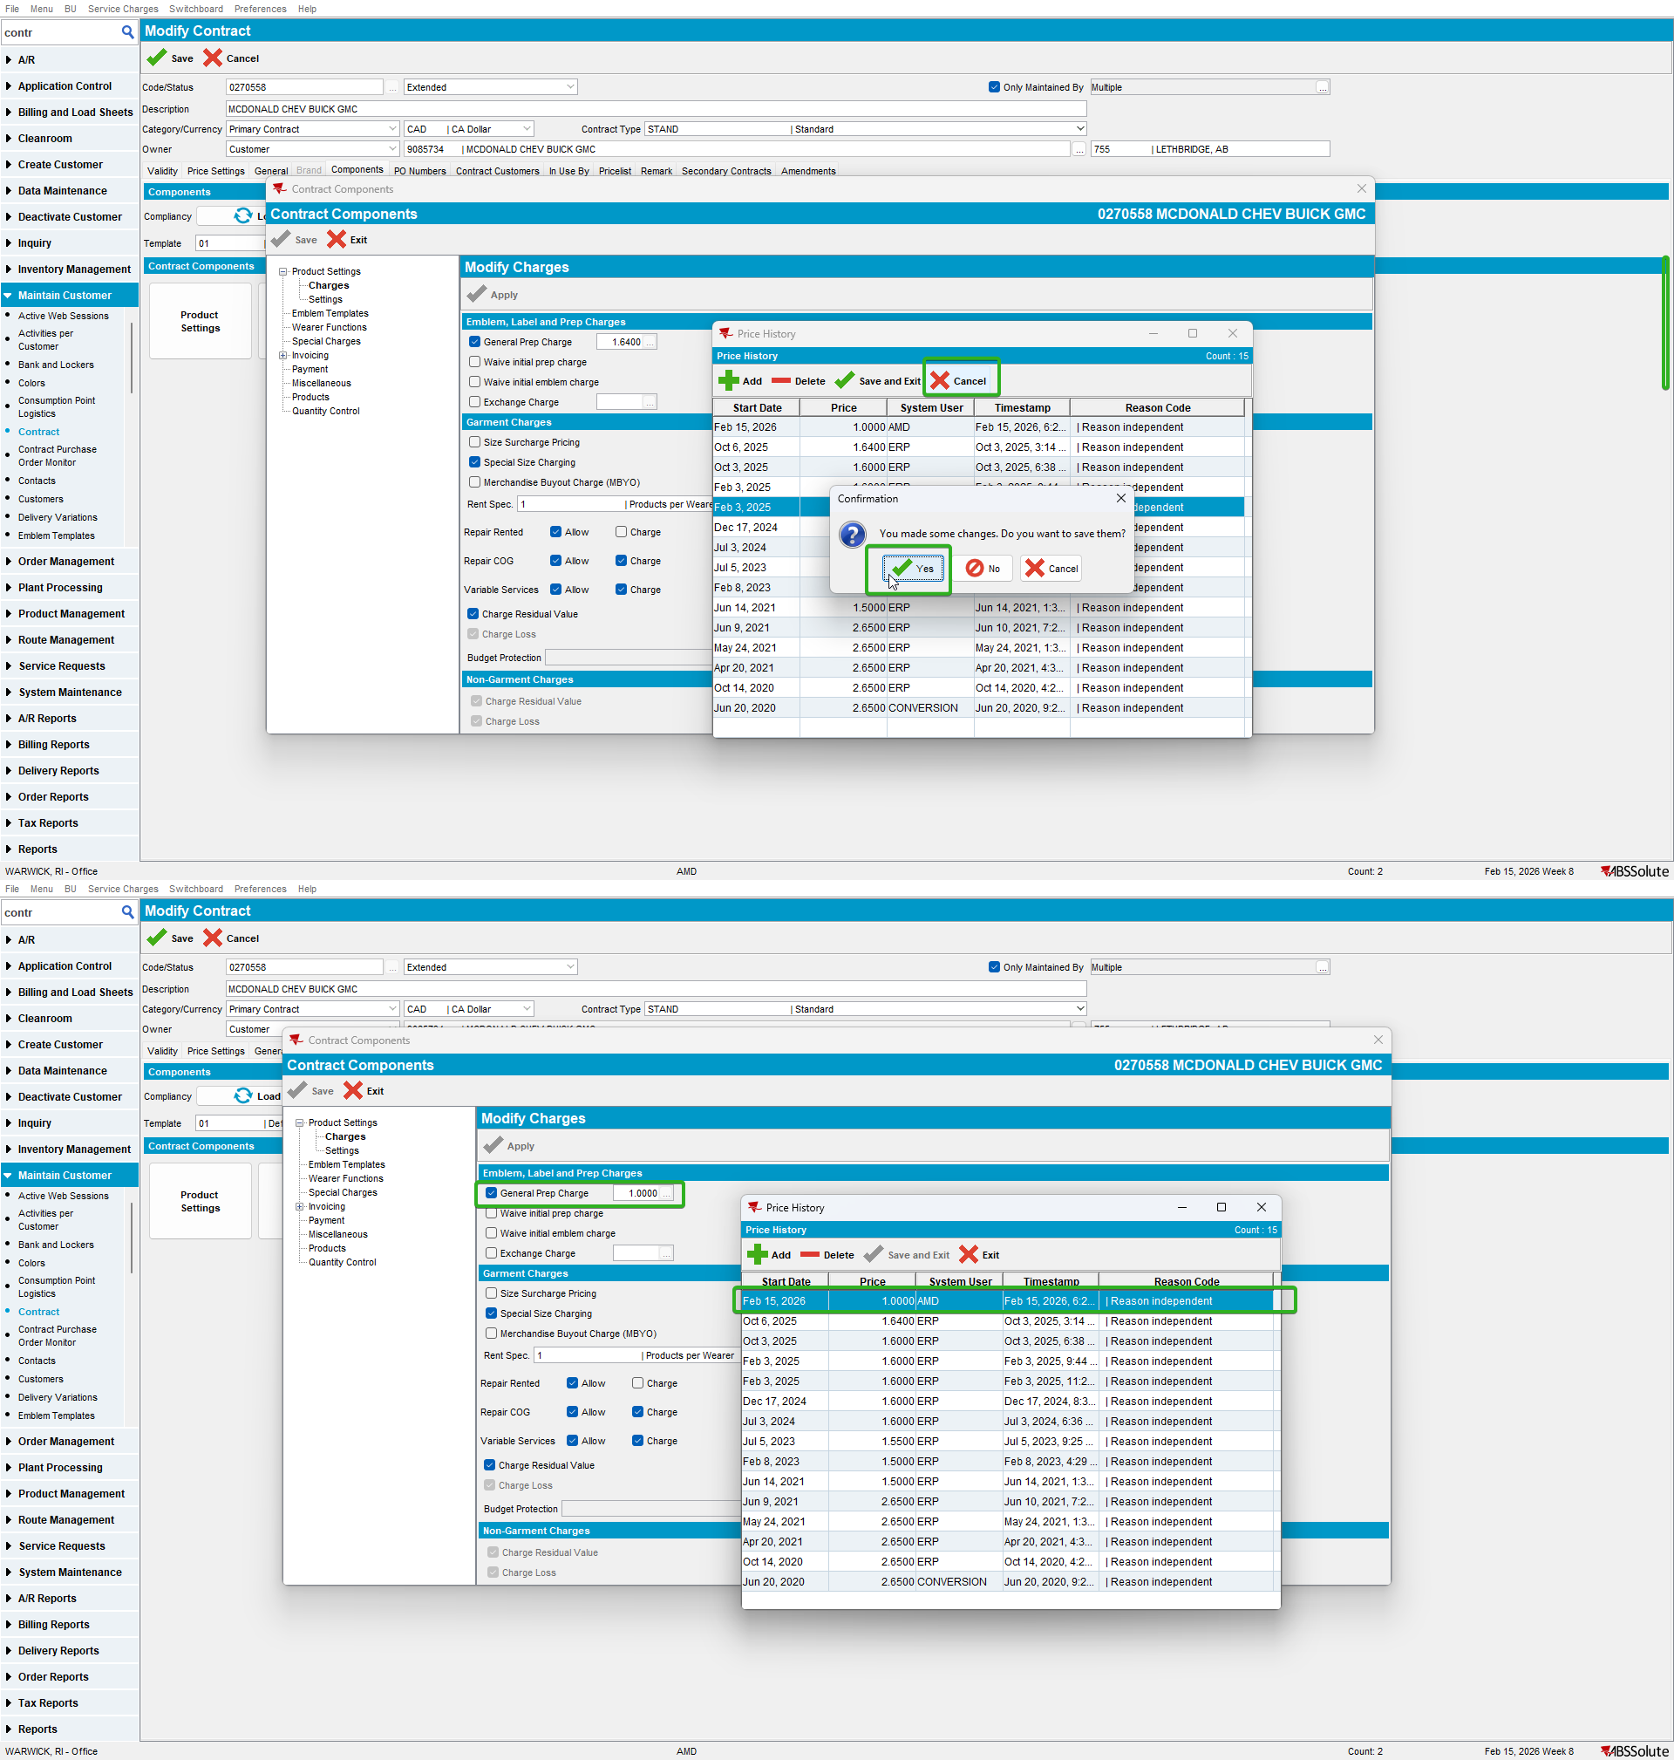

Test Case 2 – Add prep charge = by pressing cancel and save when there are no prices with the same start date– Tested OK
Expected behavior: The price is added and saved without errors.
Hash: a3414f605cdc
- Load a contract and go to products
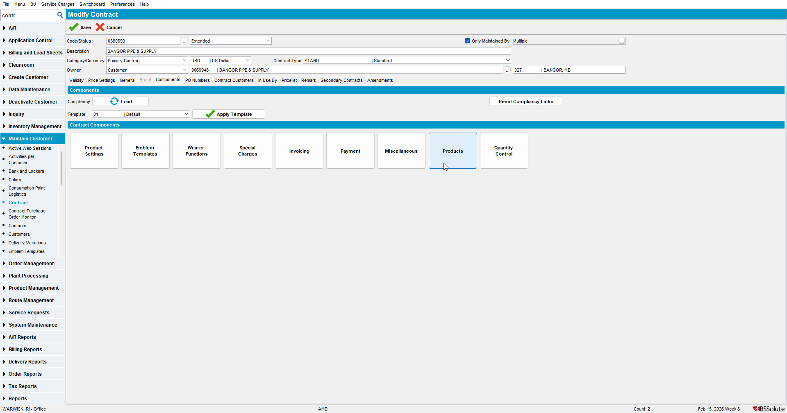

- Go to Charges and select General Prep Charge
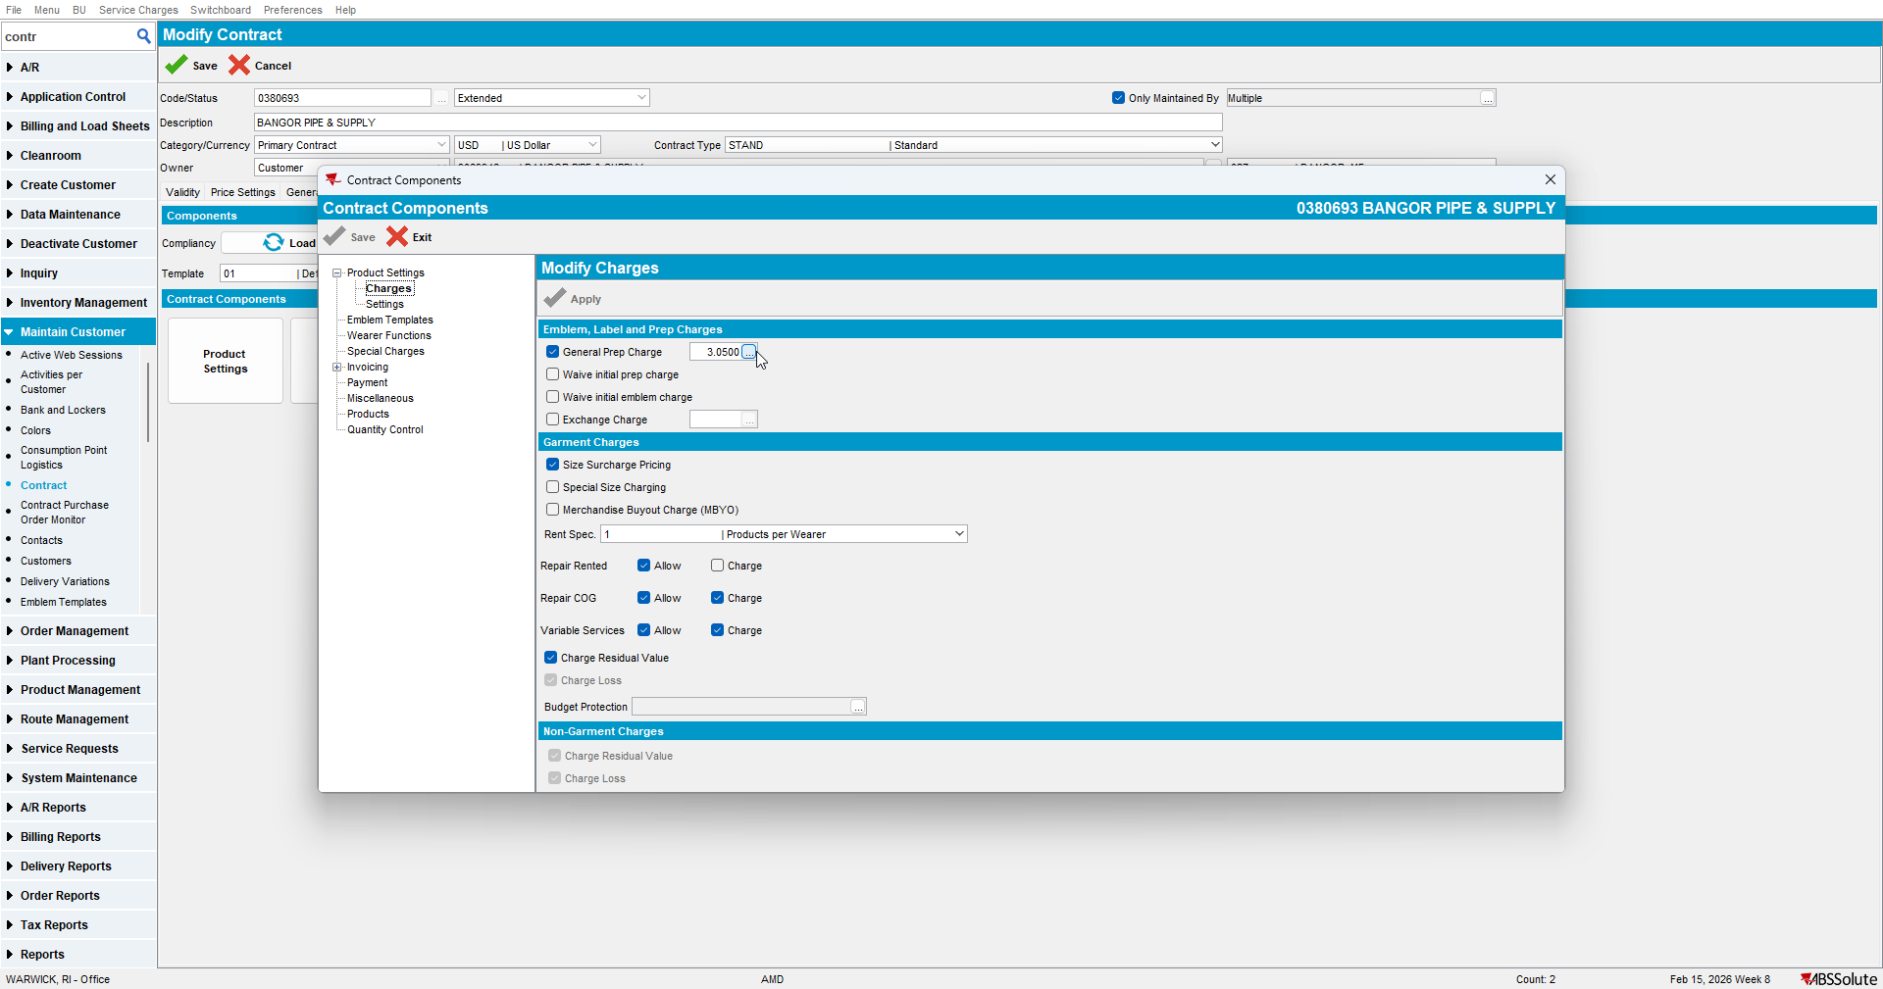

- Check that you don’t have 2 prices with the same starting date
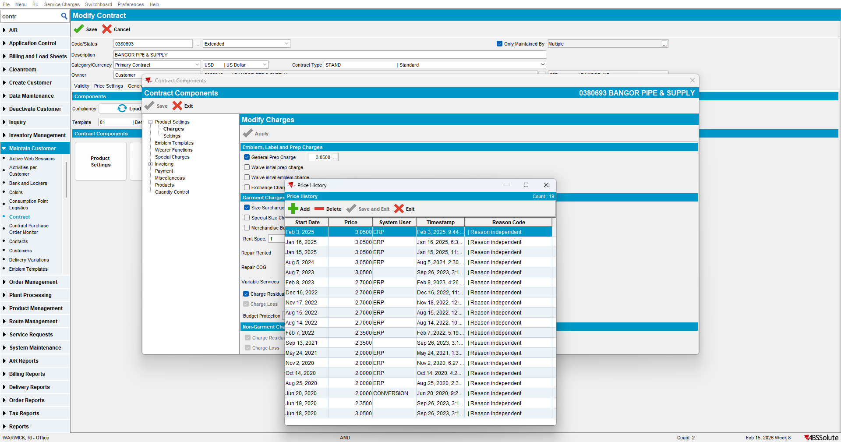

- Add a price and press save
