ABSN-14597 FreedomPay suppress 0 amount lines
DataBase | Preconditions
Version:9.07.00.UNF21  DBServerName= abs-srv19.internal.abslbs.com  DBSID=CUST22  DBUser=UNFLIVE | - Module:  - System setting:
Contents
Summary: Retest after fix 1
Test case #1 – Full negative amount adjustment 1
Test case #2 – Full negative quantity adjustment 3
Test case #3 – Partial negative amount adjustment 5
Test case #4 – Partial negative quantity adjustment 7
Test case #5 – Amount = 0 9

Summary: Retest after fix
Preconditions: Hash: 9.07.00.UNF21 hash: 7c4c8481d76c

Test case #1 – Full negative amount adjustment

- Have a settled invoice with a line having a full negative amount adjustment and another line with the same product.
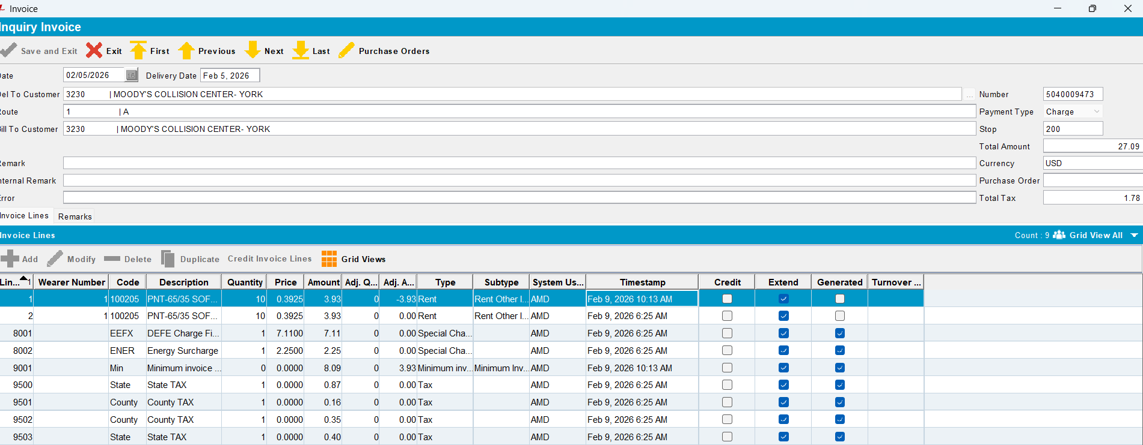

- Generate Credit Card Transactions.
- Process Credit Card Transaction.
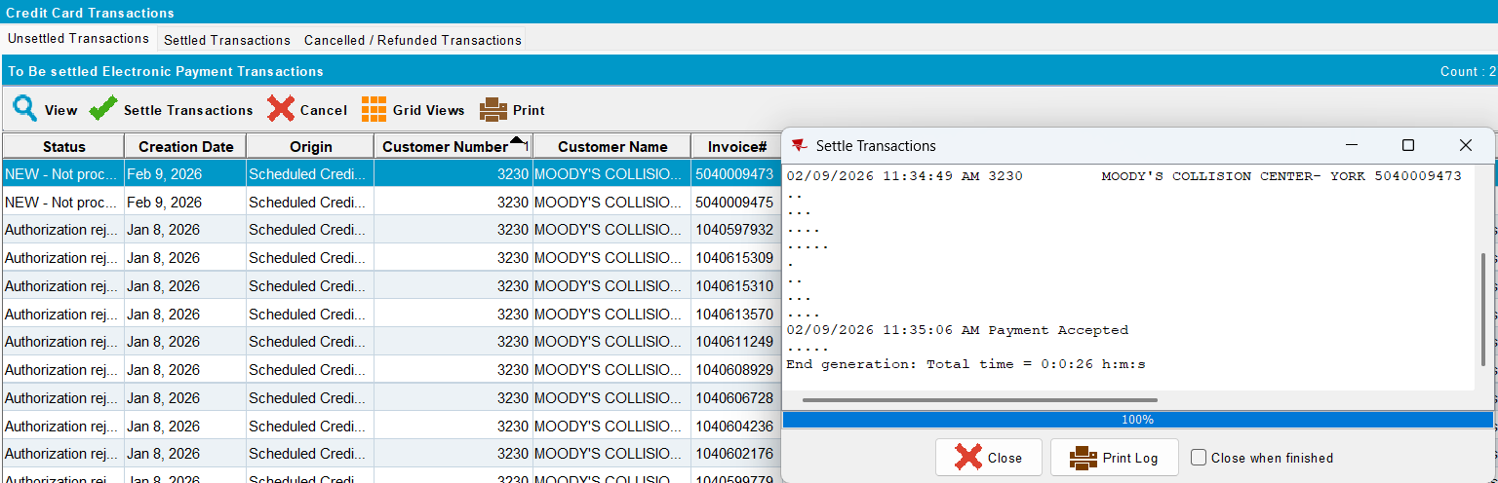
The transaction was processed successfully.

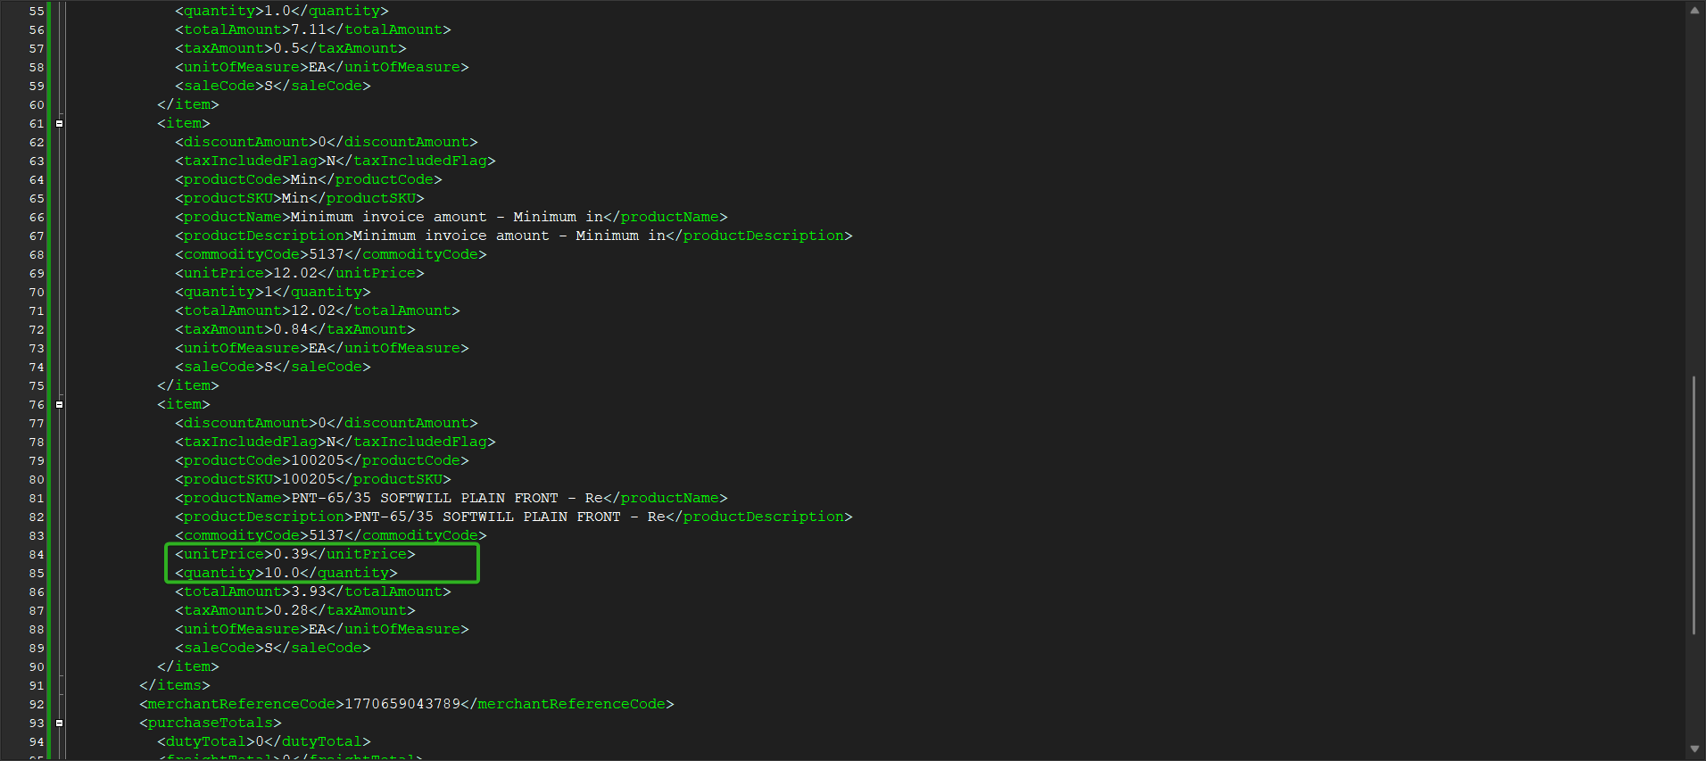
The quantity and price for the product are correct in the request.

Test case #2 – Full negative quantity adjustment

- Have a settled invoice with a line having a full negative quantity adjustment and another line with the same product.
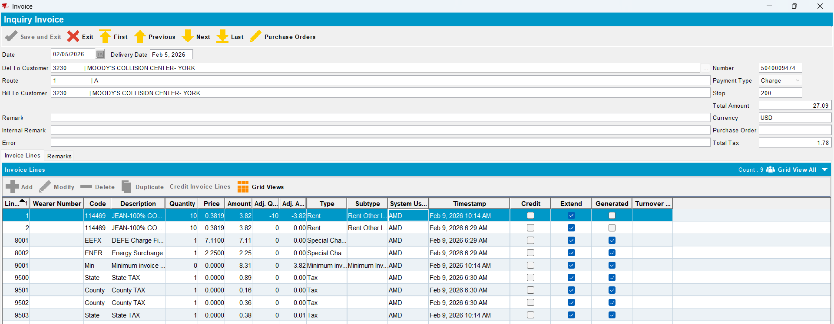

- Generate Credit Card Transactions.
- Process Credit Card Transaction.
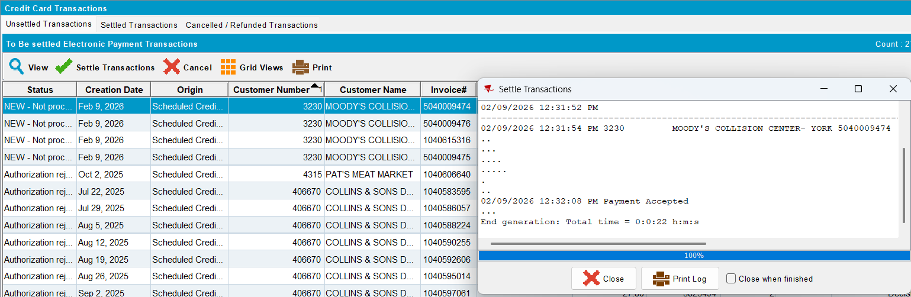
The transaction was processed successfully.

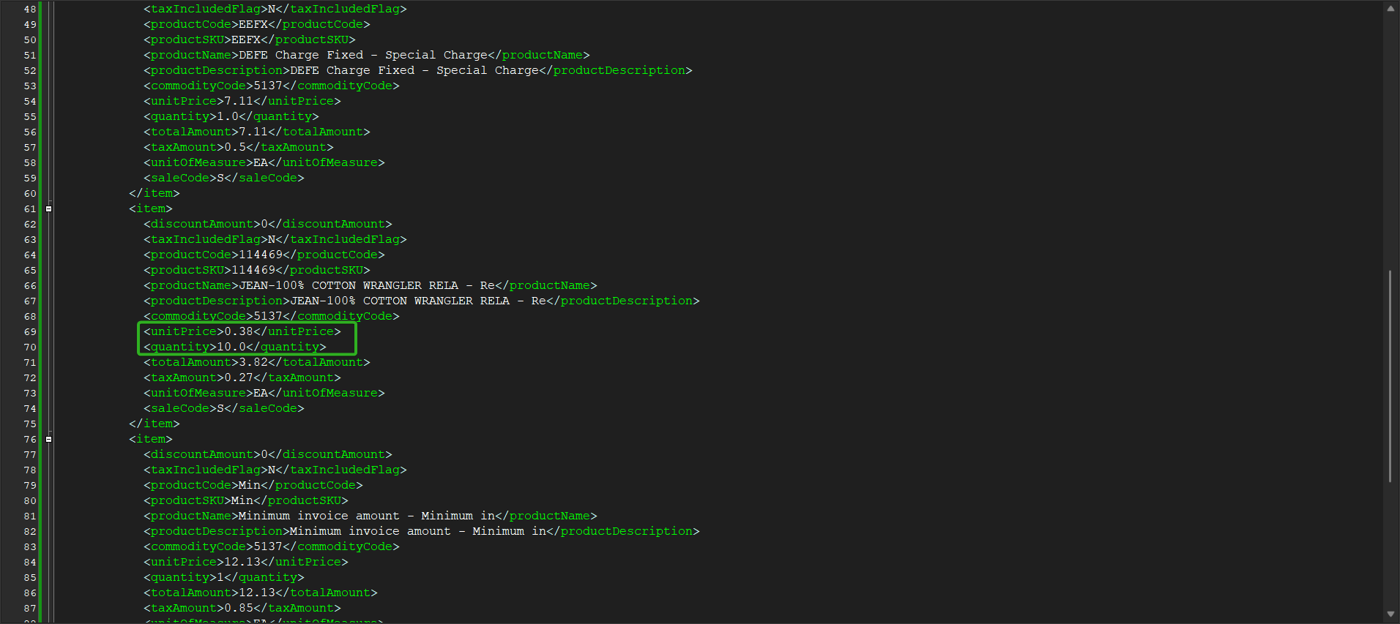
The quantity and price for the product are correct in the request.

Test case #3 – Partial negative amount adjustment

- Have a settled invoice with a line having a partial negative amount adjustment and another line with the same product.
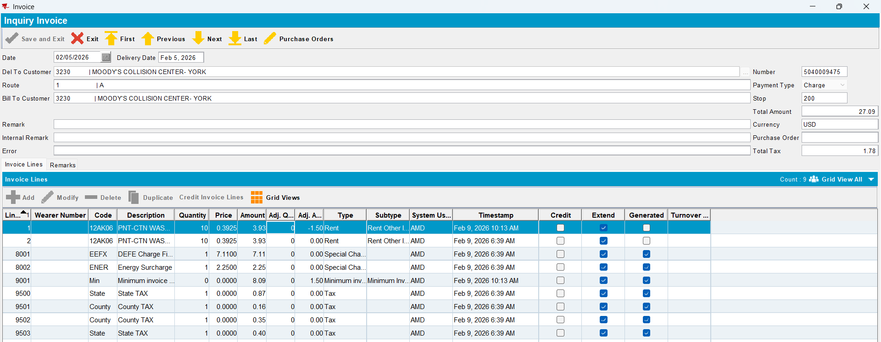

- Generate Credit Card Transactions.
- Process Credit Card Transaction.
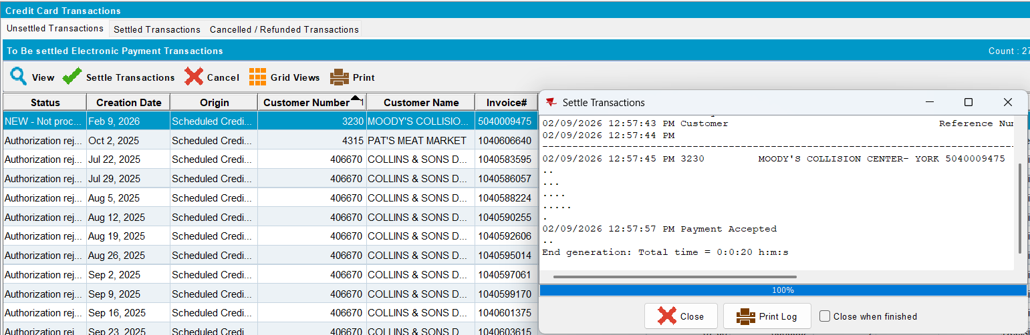
The transaction was processed successfully.

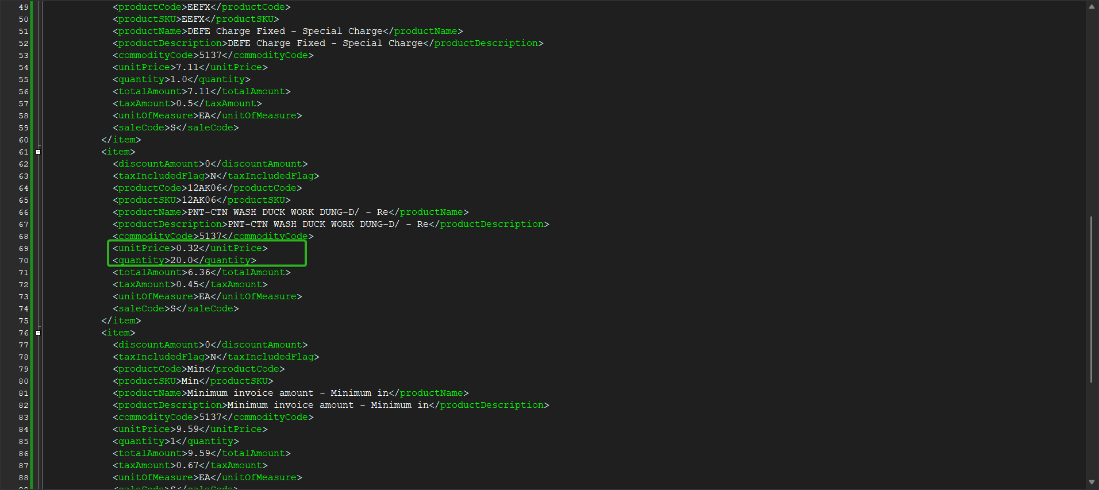
The quantity and the total amount for the product are correct in the request.

Test case #4 – Partial negative quantity adjustment

- Have a settled invoice with a line having a partial negative quantity adjustment and another line with the same product.
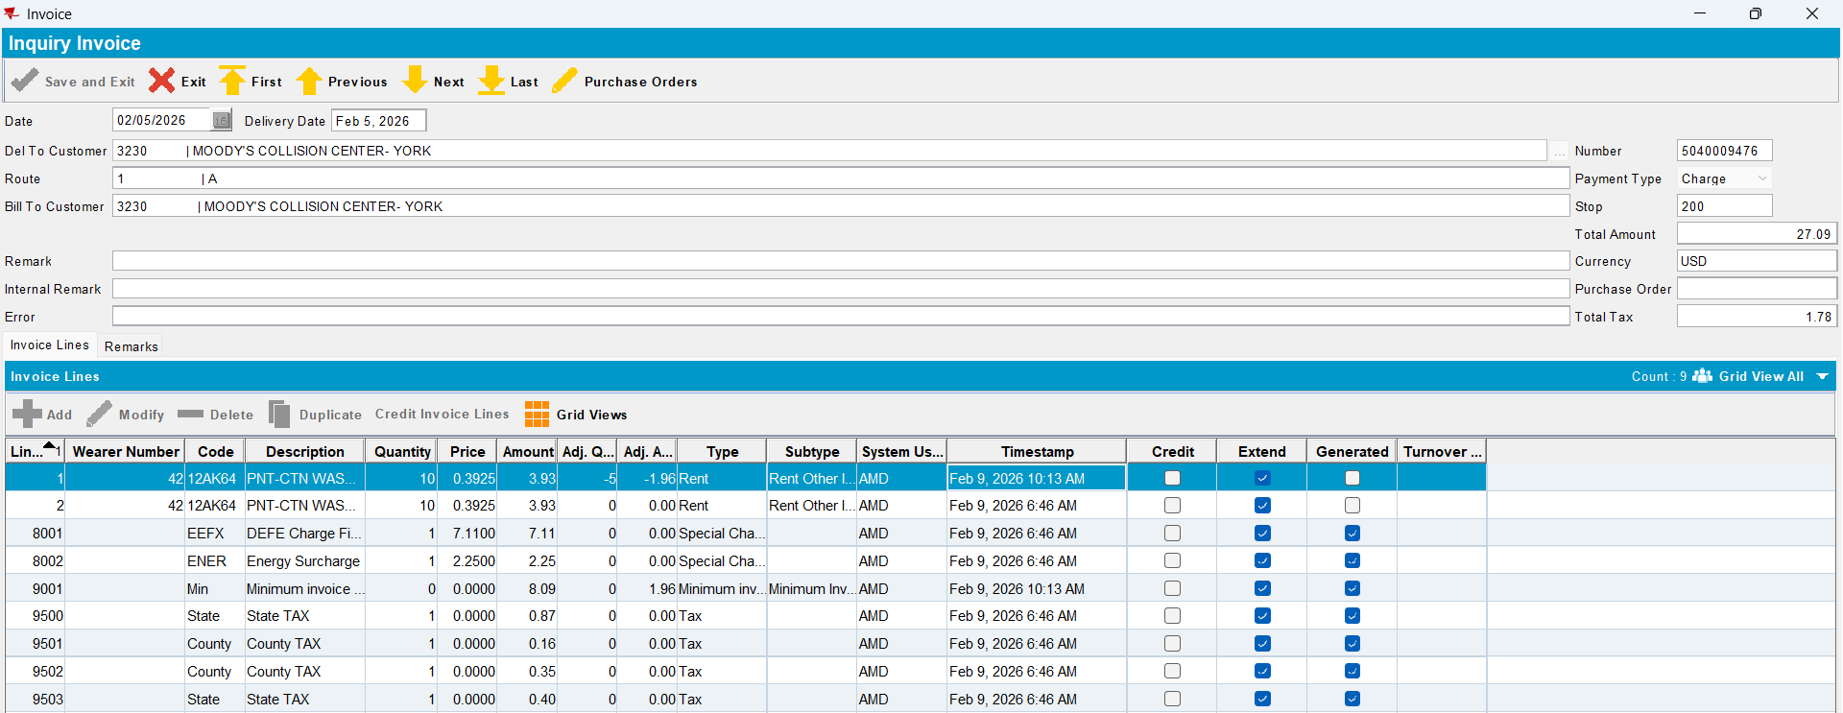

- Generate Credit Card Transactions.
- Process Credit Card Transaction.
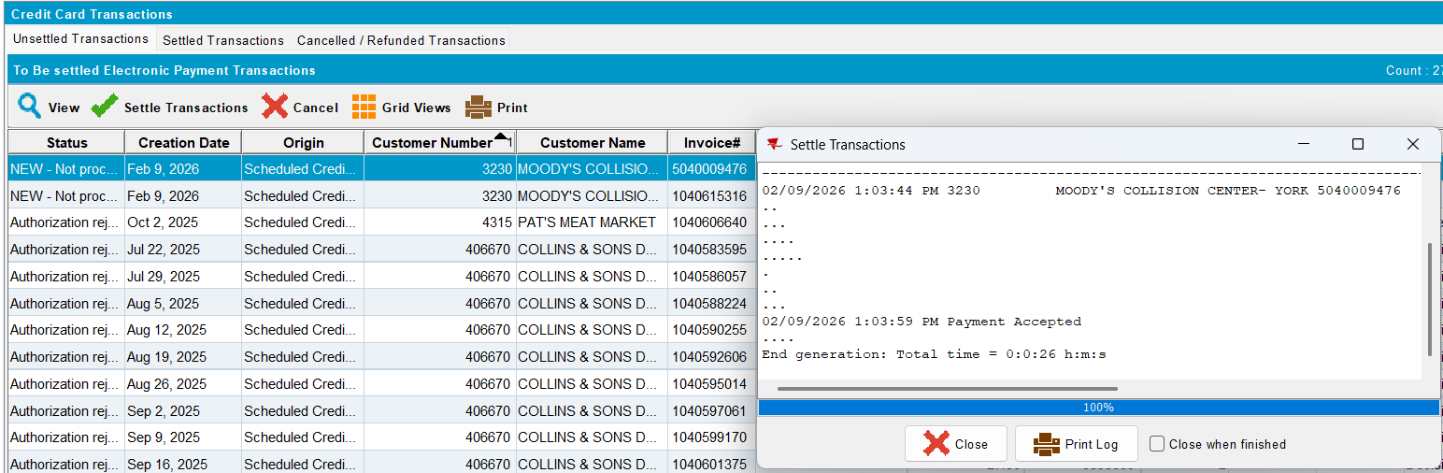
The transaction was processed successfully.

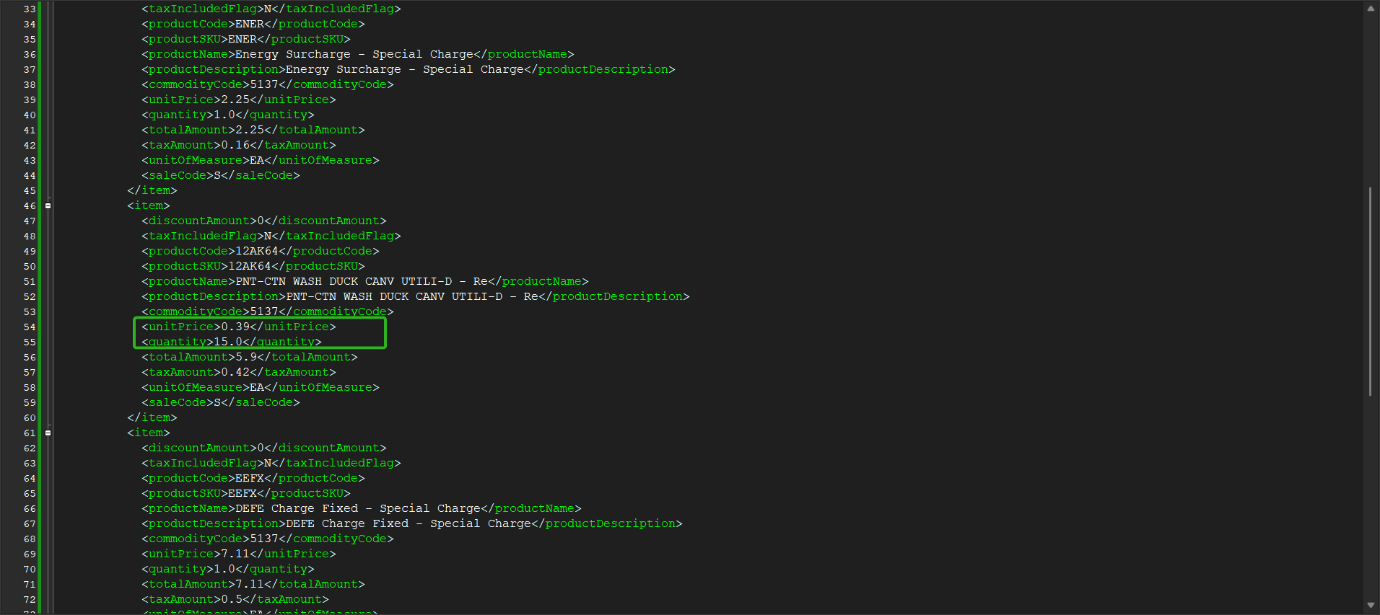
The quantity and the total amount for the product are correct in the request.

Test case #5 – Amount = 0

- Have a settled invoice with a line having amount = 0 and another line with the same product.
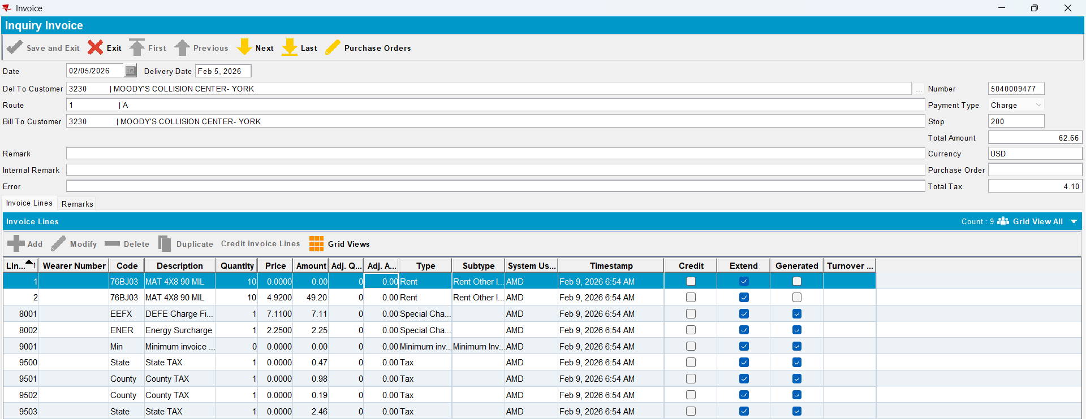

- Generate Credit Card Transactions.
- Process Credit Card Transaction.
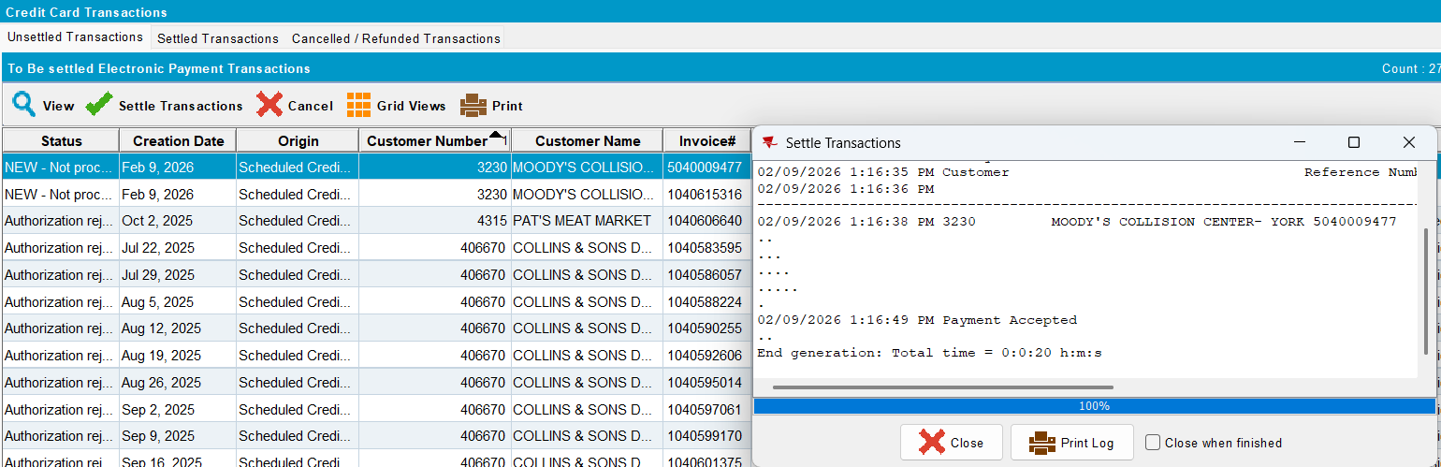
The transaction was processed successfully.

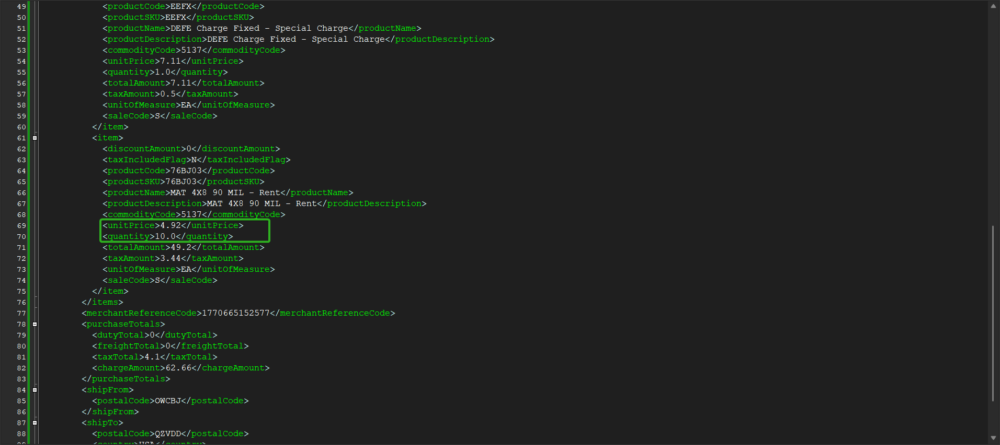
The quantity and price for the product are correct in the request.

