ABSN-14189 - Flag to recreate PDF when PO is changed
Environment | Prerequisites
Version: 9.07.00.UNF21  DBServerName= abs-srv20.internal.abslbs.com  DBSID=CUST24  DBUser=UNFDEV  Environment=Test | - Module:  - System setting

Contents
Data Preparation 1
Retest after fix 3
Test Case 1 –Contract DLG - Move a single invoice to a new PO 3
Test case 2 - Contract DLG - Move multiple invoices to a new PO 7
Test Case 3 - Maintain Invoices DLG > Customer>Settled - Select an invoice and move it to a different PO by clicking on Modify Purchase order button 9
Test Case 4 - WebX Route Check In > Select a route with settled invoices> overview tab > Select a customer with settled invoices move one of the invoices to a different PO by clicking on Modify Purchase order button 12
Test Case 5 –Contract DLG - Move a single invoice to a new PO and IHEI.PDFCreated=0 15

Data Preparation
- Contract Purchase Order Monitor: Find a contract with Purchase orders on your BU
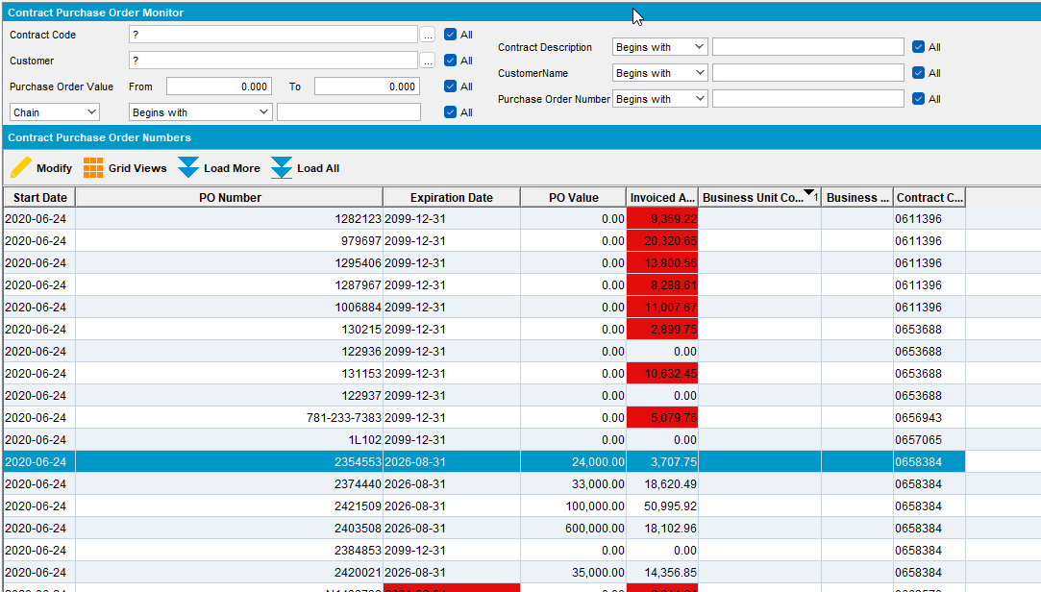
- Contract DLG: ADD a new Contract Purchase order with a start date set few years in the past and expiration date in the future
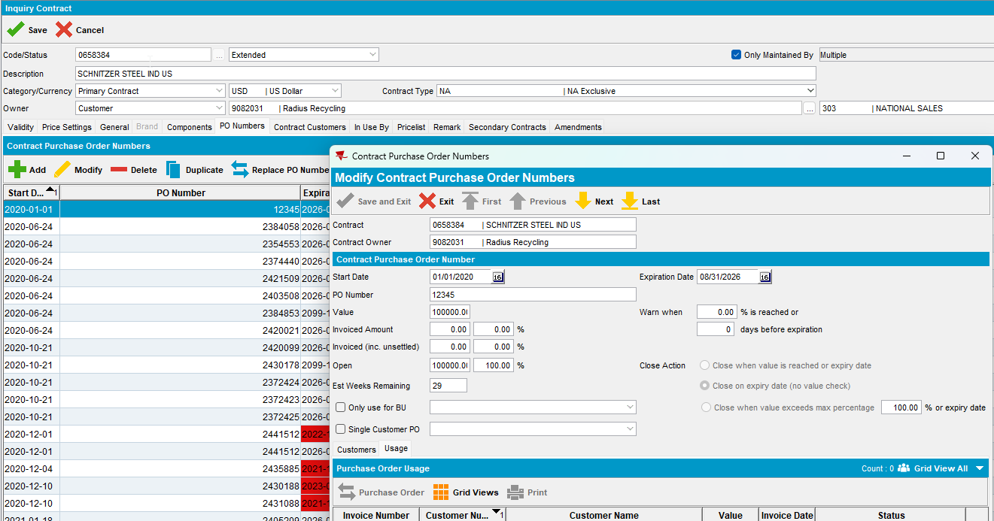
- Contract Customers Tab Press modify on the existing customers and add the new PO number
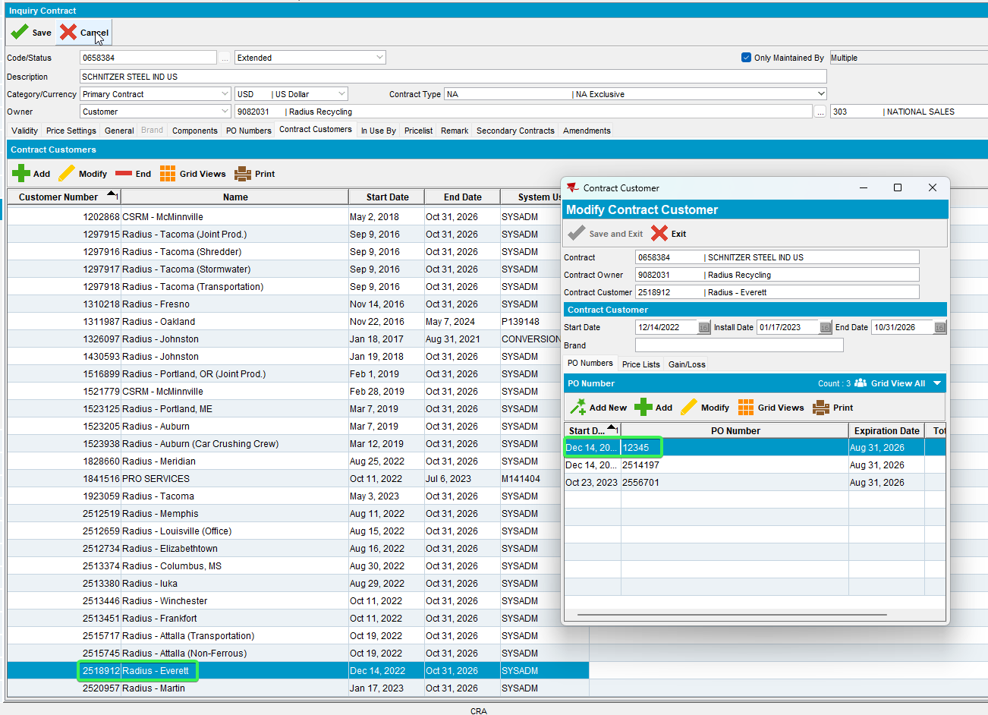

Retest after fix

Test Case 1 –Contract DLG - Move a single invoice to a new PO
Hash: 67f1ee4cbe92
Expected behavior:
When running the following select for the invoice that was moved we get IHEI.PDFCreated = 1
select ihei.pdfcreated, ih.* from invoiceheader ih
join invoiceheaderextrainfo ihei on ihei.invoiceheader_id = ih.invoiceheader_id
where ih.invoicenumber in (1000492475);

Steps:
- Contract DLG: Input a contract with Purchase Orders ex: 0658384
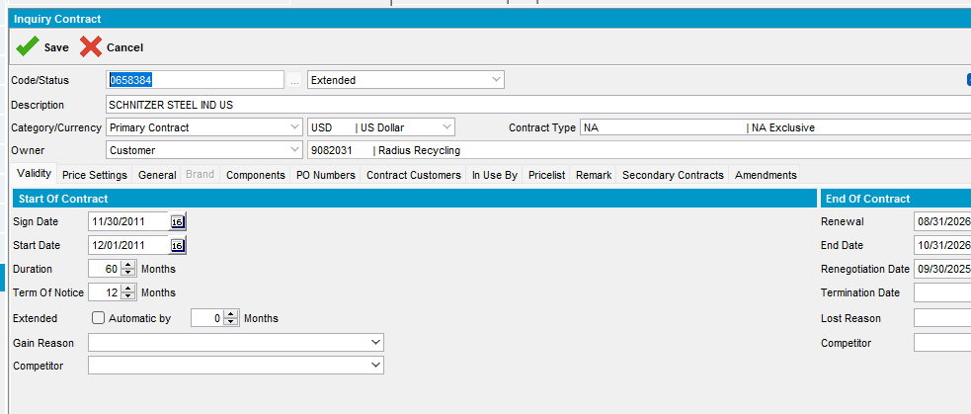
- Press Modify and go to PO Numbers Tab
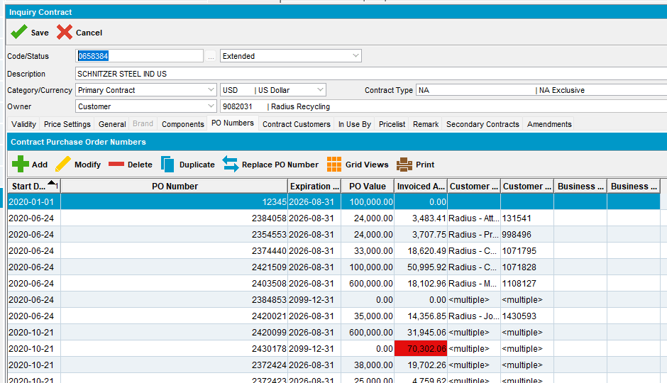
- Pick one of the PO and go to tab Usage
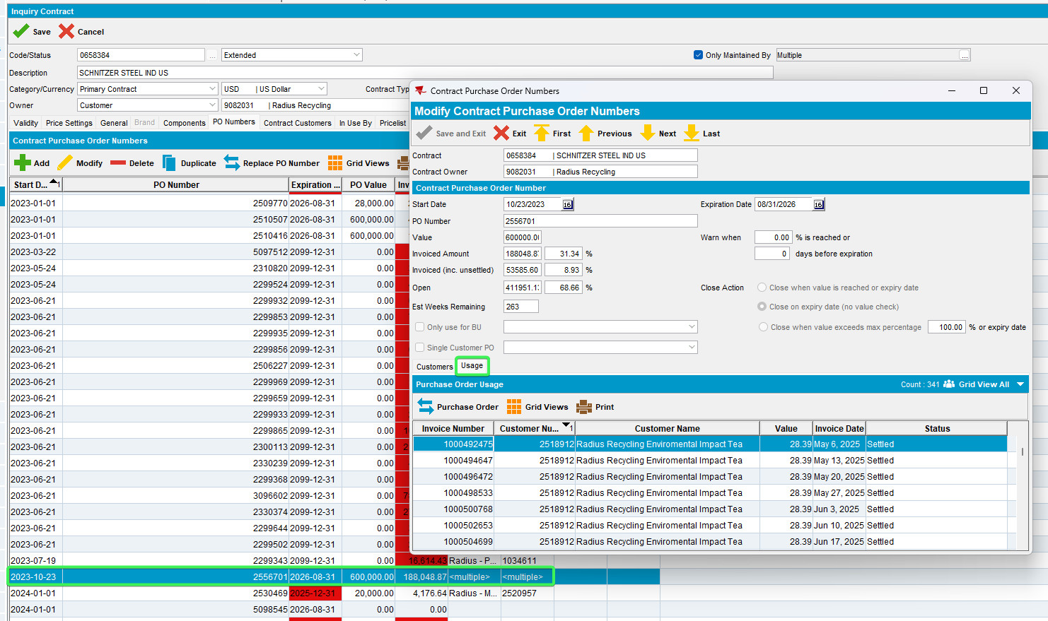
- Pick a settled invoice and change ihei.pdfcreated so that it is 2 with the following select:
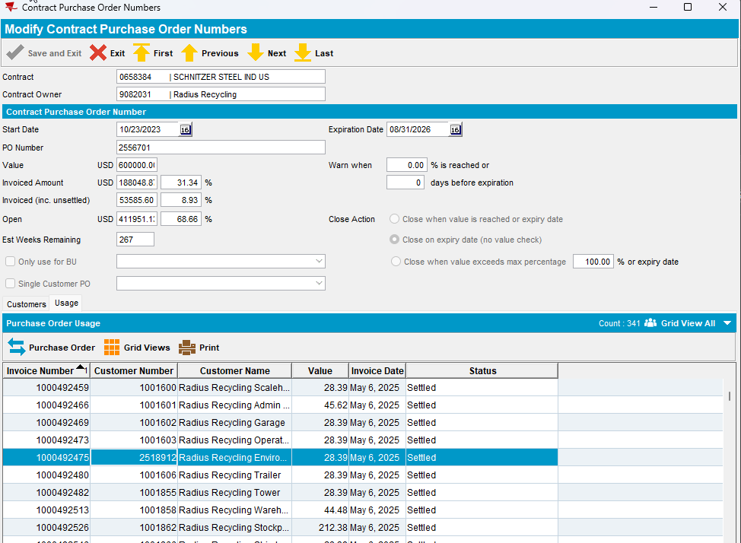
update invoiceheaderextrainfo ihei set
ihei.pdfcreated = 2
where ihei.invoiceheader_id in
(select ih.invoiceheader_id from invoiceheader ih
where ih.invoicenumber = 1000492475);
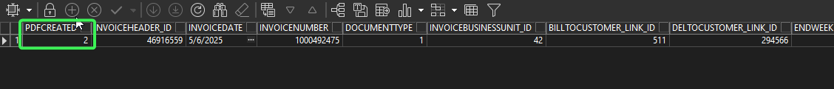
- Select the settled invoice and press Purchase Order button
- On the Change Purchase Order pop-up select the purchase order created in data preparation: 12345
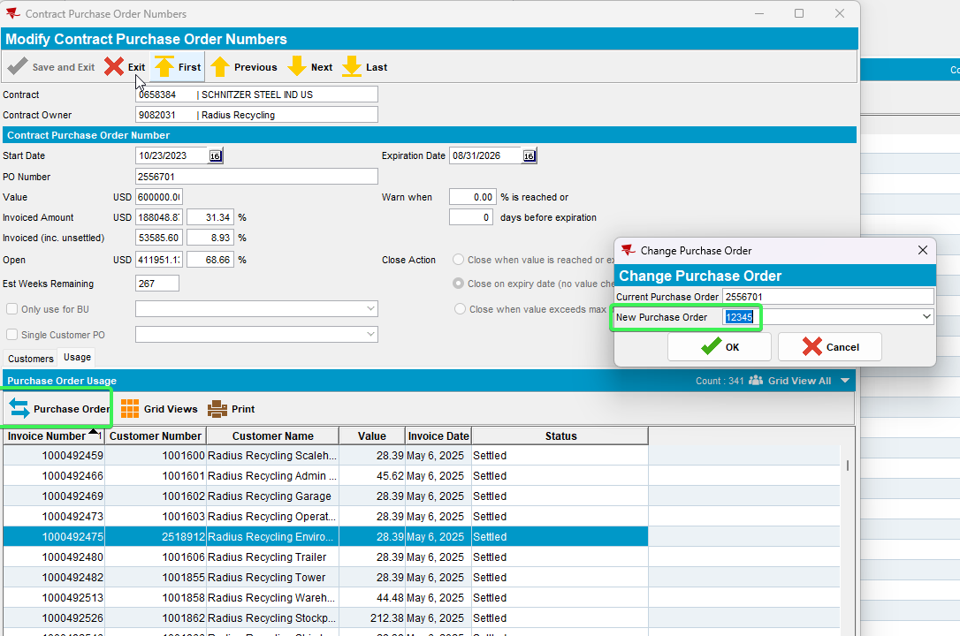
- PLSQL use the following select and see that ihei.pdfcreated has changed to 1
select ihei.pdfcreated, ih.* from invoiceheader ih
join invoiceheaderextrainfo ihei on ihei.invoiceheader_id = ih.invoiceheader_id
where ih.invoicenumber=1000492475;
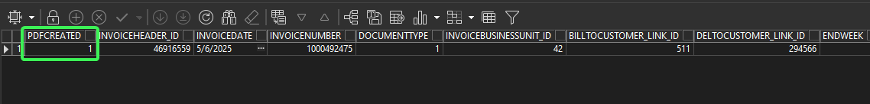
Tested OK

Test case 2 - Contract DLG - Move multiple invoices to a new PO
Hash: 67f1ee4cbe92
Expected behavior:
When running the following select for the invoices that were moved we get IHEI.PDFCreated = 1
select ihei.pdfcreated, ih.* from invoiceheader ih
join invoiceheaderextrainfo ihei on ihei.invoiceheader_id = ih.invoiceheader_id
where ih.invoicenumber in (1000492466, 1000492469);

Steps:
- Contract DLG: Input a contract with Purchase Orders ex: 0658384
- Press Modify and go to PO Numbers Tab
- Pick one of the PO and go to tab Usage
- Pick 2 settled invoices and change ihei.pdfcreated so that is 2 with the following select:
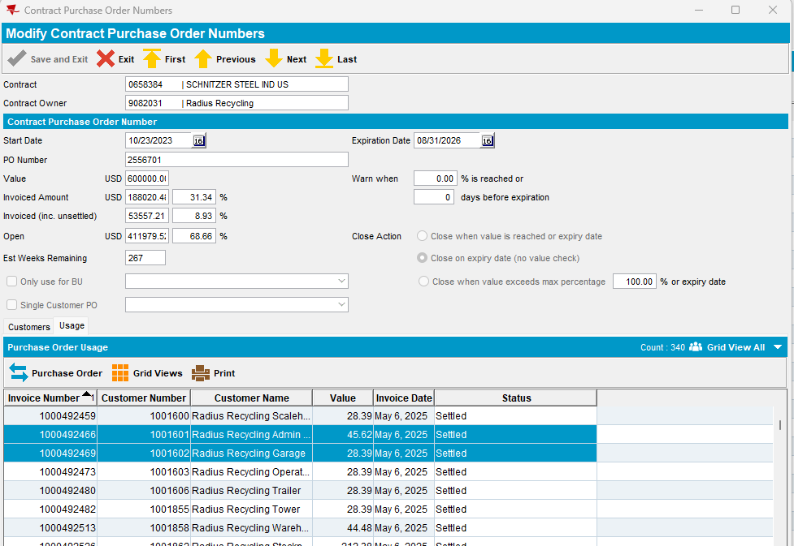
update invoiceheaderextrainfo ihei set
ihei.pdfcreated = 2
where ihei.invoiceheader_id in
(select ih.invoiceheader_id from invoiceheader ih
where ih.invoicenumber in (1000492466, 1000492469) ;
- Select the 2 settled invoices and press Purchase Order button
- On the Change Purchase Order pop-up select a different PO
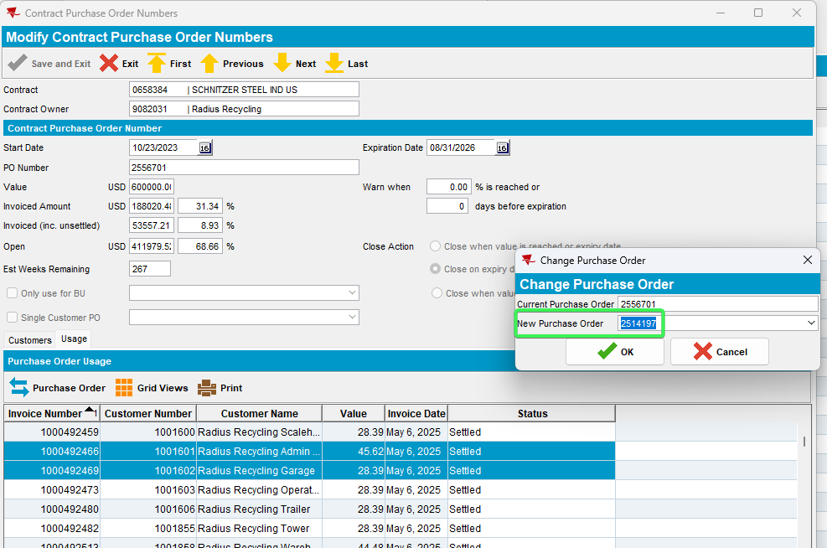
- PLSQL use the following select and see that ihei.pdfcreated has changed to 1
select ihei.pdfcreated, ih.* from invoiceheader ih
join invoiceheaderextrainfo ihei on ihei.invoiceheader_id = ih.invoiceheader_id
where ih.invoicenumber in (1000492466, 1000492469);

Test Case 3 - Maintain Invoices DLG > Customer>Settled - Select an invoice and move it to a different PO by clicking on Modify Purchase order button
Hash: 67f1ee4cbe92
Expected Behavior: After processing the move to the new PO the invoice gets IHEI.PDFCREATED = 1

Steps:
- Maintain Invoices DLG: Customers tab input a customer that belongs to contract 0658384 like: 1001603
- Settled tab select to show data from few years back
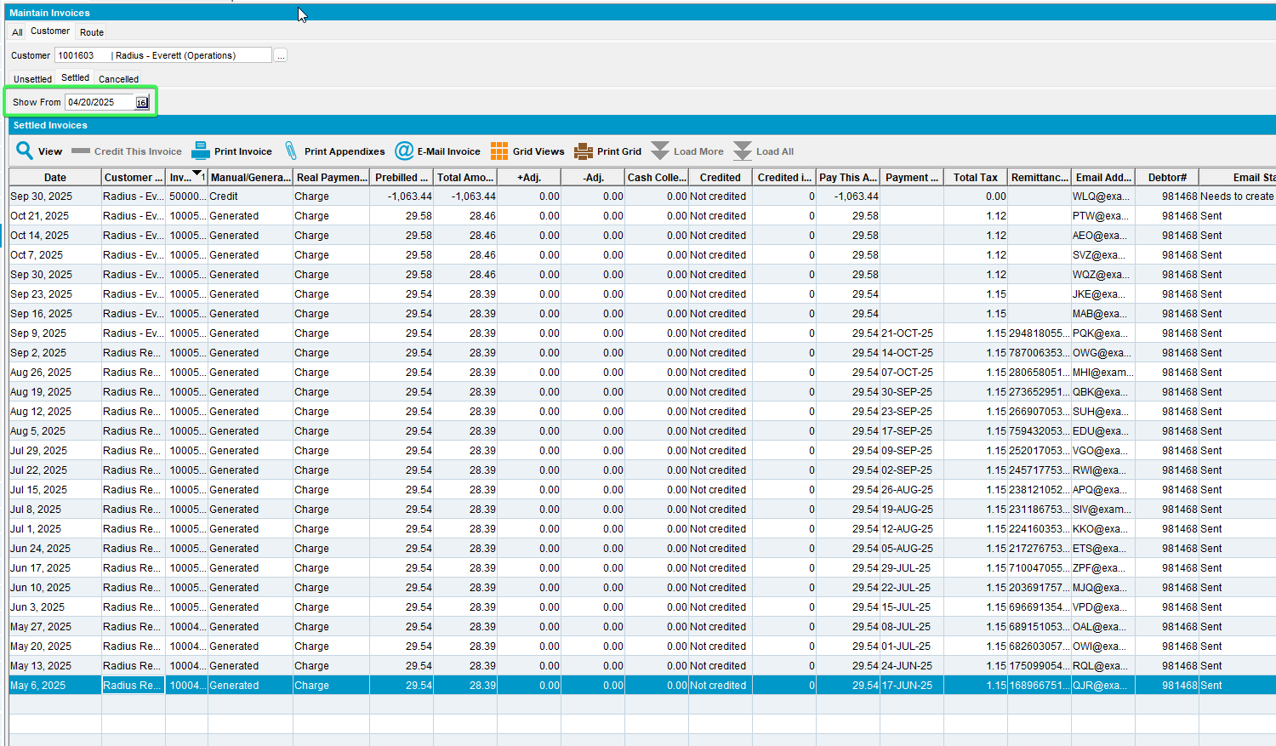
- Pick a settled invoice and change ihei.pdfcreated so that is 2 with the following select:
update invoiceheaderextrainfo ihei set
ihei.pdfcreated = 2
where ihei.invoiceheader_id in
(select ih.invoiceheader_id from invoiceheader ih
where ih.invoicenumber =1000492473);
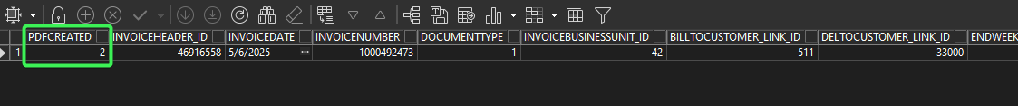
- Press view on the invoice and then press Purchase Orders
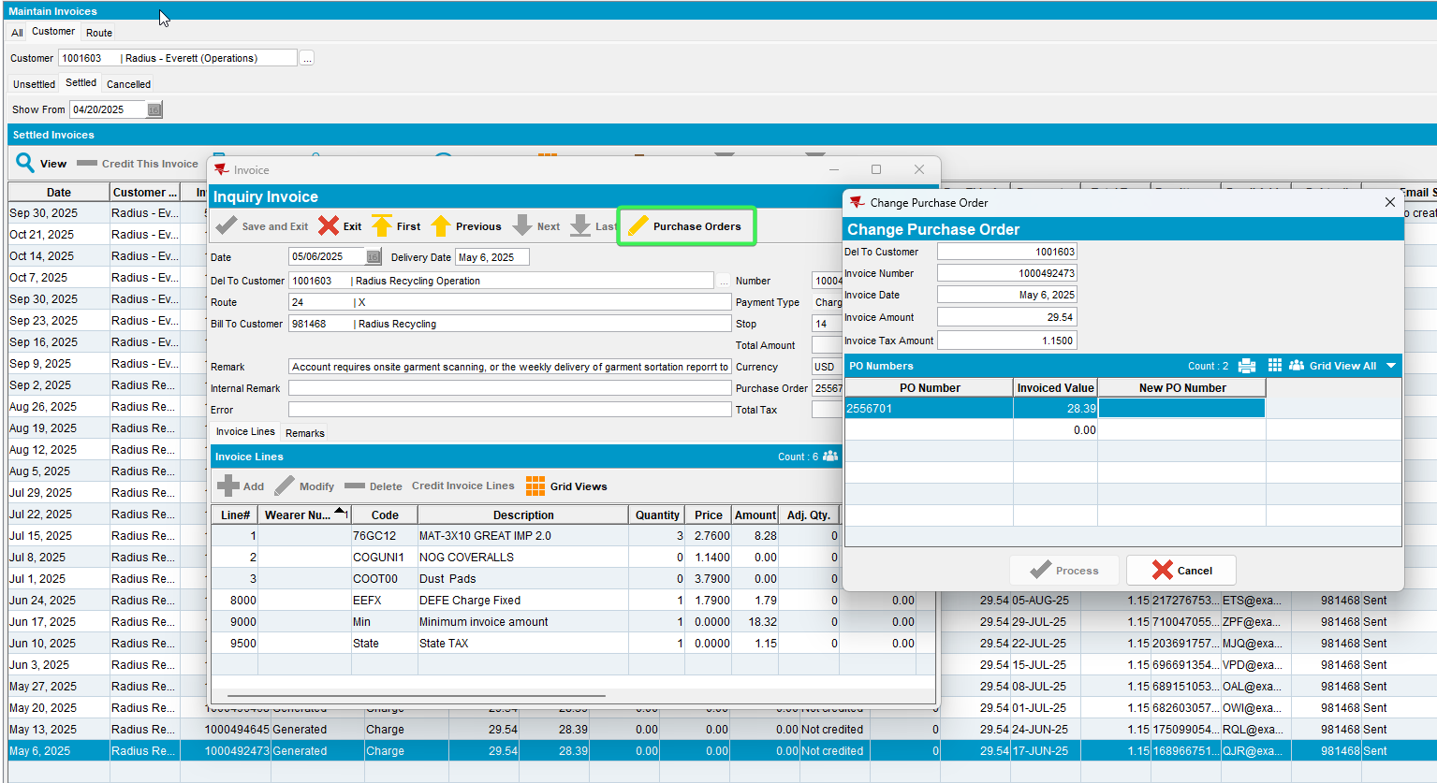
- Select the New PO number from the list and process
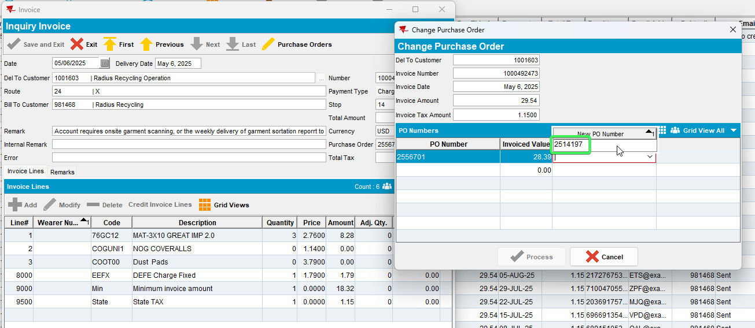
- PLSQL use the following select and see that ihei.pdfcreated has changed to 1
select ihei.pdfcreated, ih.* from invoiceheader ih
join invoiceheaderextrainfo ihei on ihei.invoiceheader_id = ih.invoiceheader_id
where ih.invoicenumber in (1000492473);
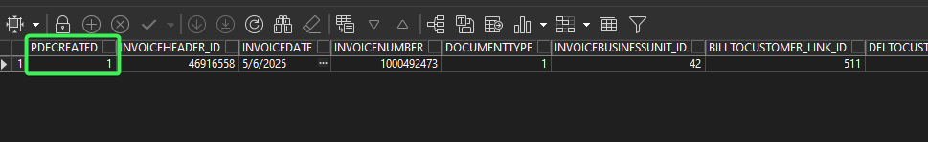
Tested OK

Test Case 4 - WebX Route Check In > Select a route with settled invoices> overview tab > Select a customer with settled invoices move one of the invoices to a different PO by clicking on Modify Purchase order button
Hash: 67f1ee4cbe92
Expected Behavior: After processing the move to the new PO the invoice gets IHEI.PDFCREATED = 1

Steps:
- Pick a customer which is linked to contract: 0658384
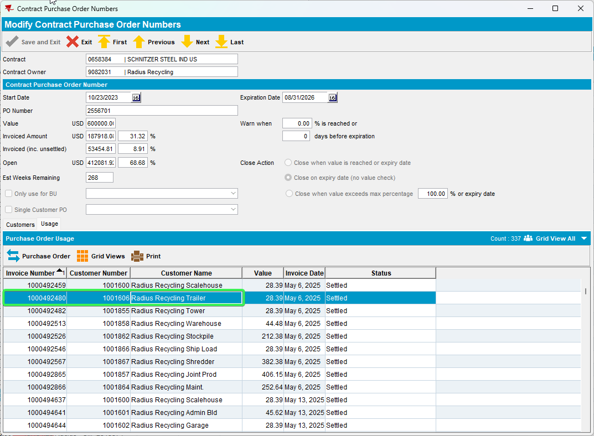
- Customers: Find the route on which your customer is invoiced
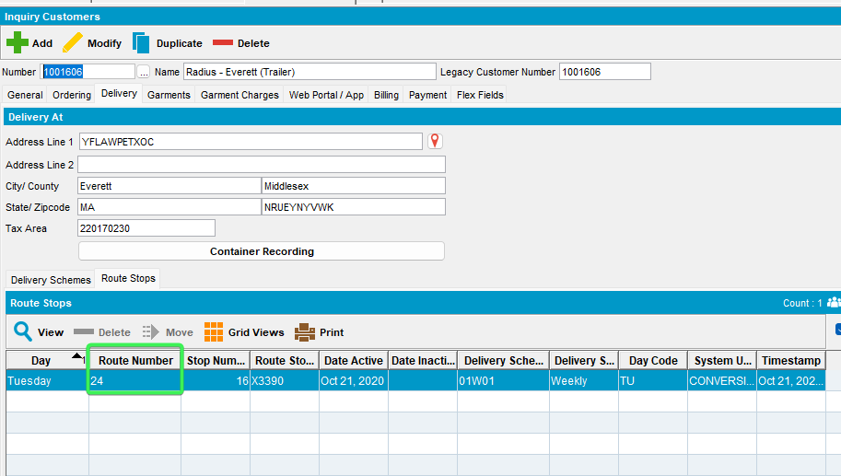
- PLSQL: change ihei.pdfcreated so that is 2 with the following select
update invoiceheaderextrainfo ihei set
ihei.pdfcreated = 2
where ihei.invoiceheader_id in
(select ih.invoiceheader_id from invoiceheader ih
where ih.invoicenumber =1000492480);
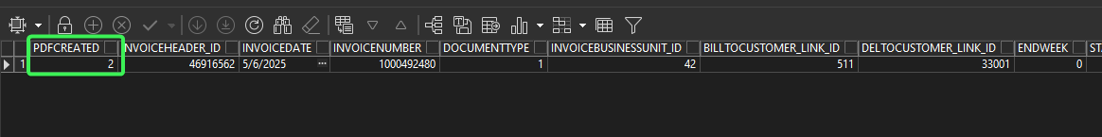
- WebX: Go to the date of that invoice also switch the Show Settled Routes ON
- Select your route (24) and go to Overview tab
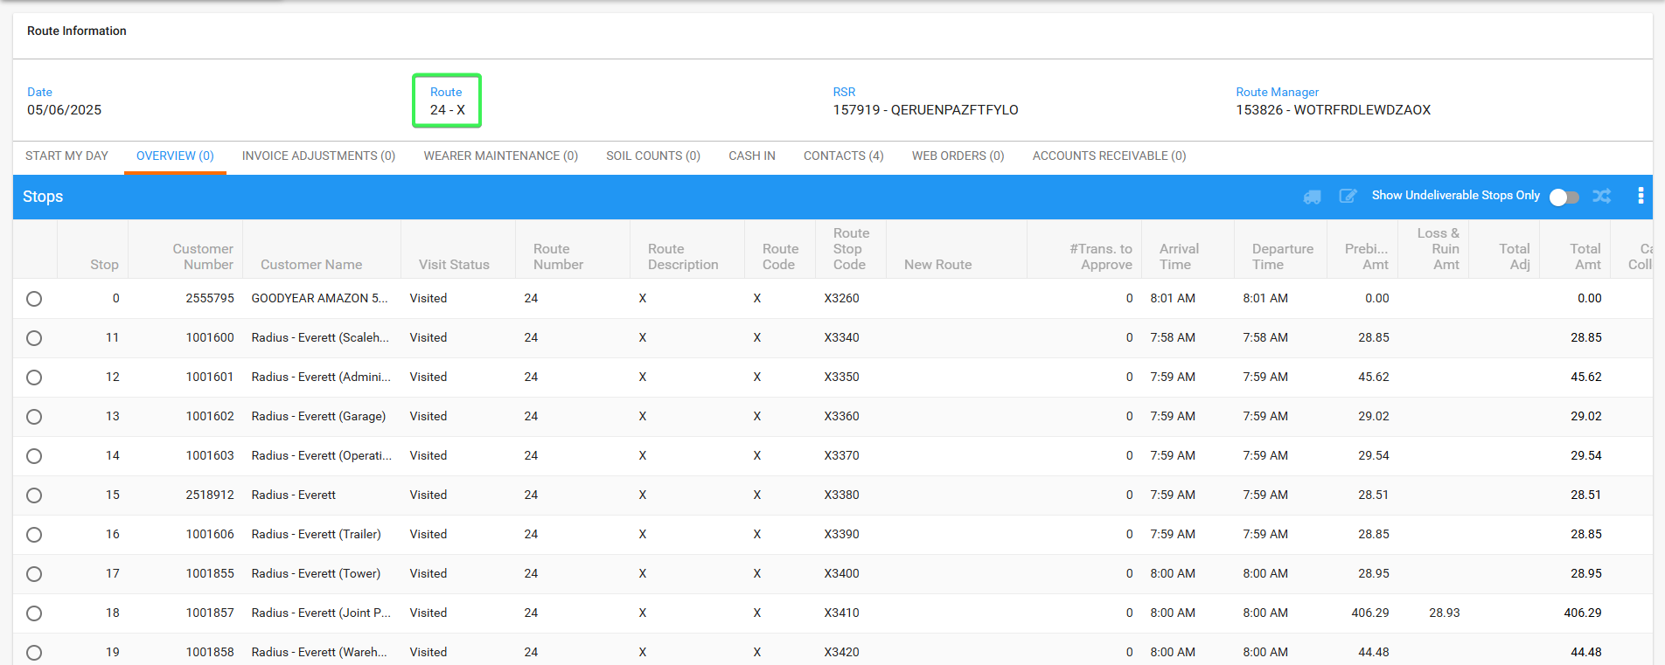
- Select your customer and press the Change Purchase Order button
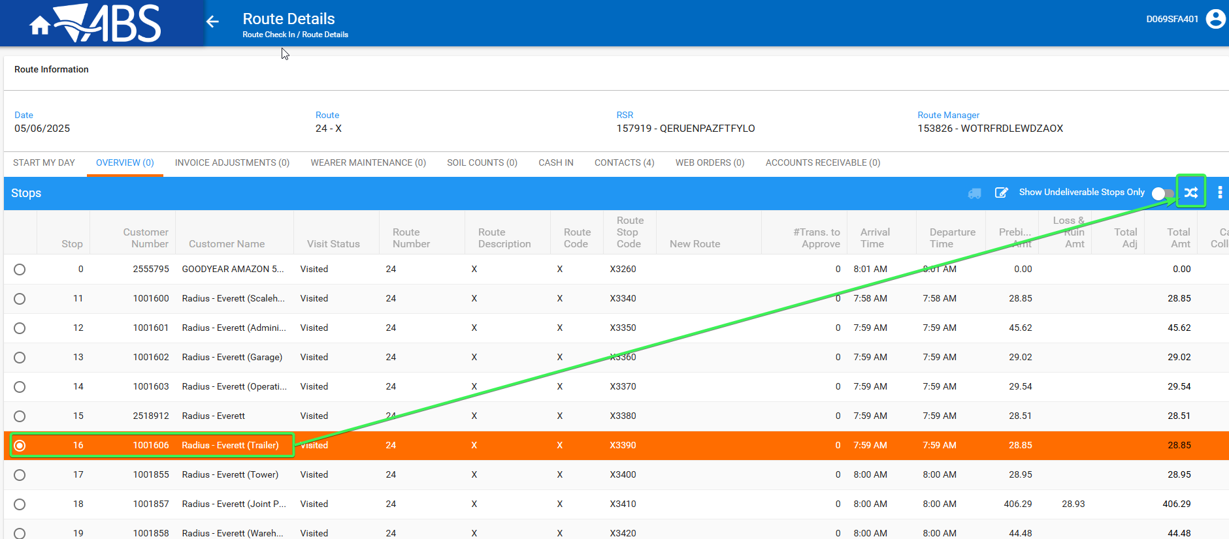
- Change the PO Number to a different one and Process the changes
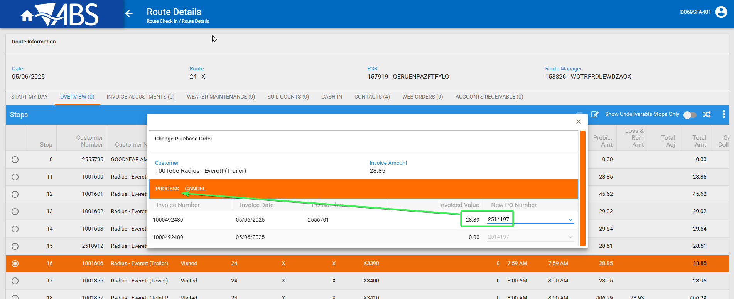
- PLSQL use the following select and see that ihei.pdfcreated has changed to 1
select ihei.pdfcreated, ih.* from invoiceheader ih
join invoiceheaderextrainfo ihei on ihei.invoiceheader_id = ih.invoiceheader_id
where ih.invoicenumber= 1000492480;
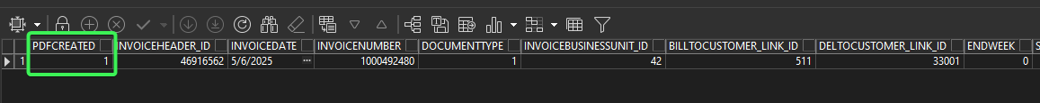
Tested OK

Test Case 5 –Contract DLG - Move a single invoice to a new PO and IHEI.PDFCreated=0
Hash: 67f1ee4cbe92
Expected Behavior: After processing the move to the new PO the invoice remains with IHEI.PDFCREATED = 0

Steps:
- Contract DLG: Input a contract with Purchase Orders ex: 0658384
- Press Modify and go to PO Numbers Tab
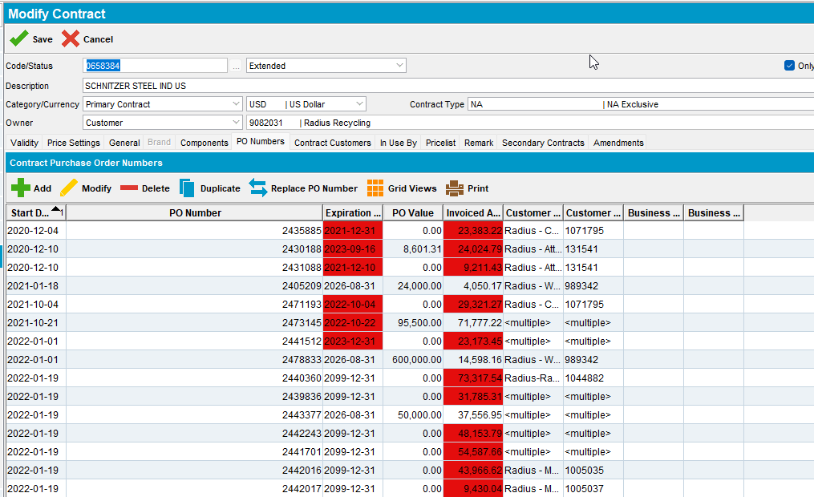
- Pick one of the PO and go to tab Usage
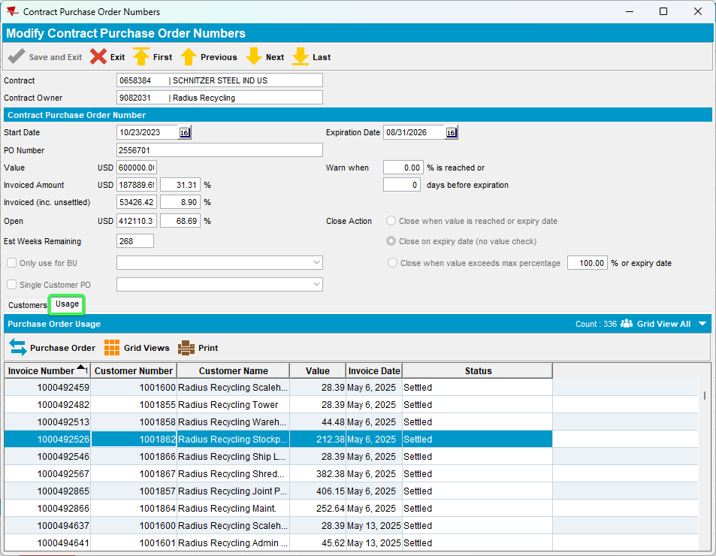
- Pick a settled invoice and check it’s IHEI.PDFCreated, and see that it is 0
select ihei.pdfcreated, ih.* from invoiceheader ih
join invoiceheaderextrainfo ihei on ihei.invoiceheader_id = ih.invoiceheader_id
where ih.invoicenumber= 1000492526;
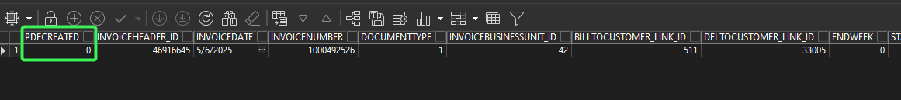
- Move this invoice to a new purchase order
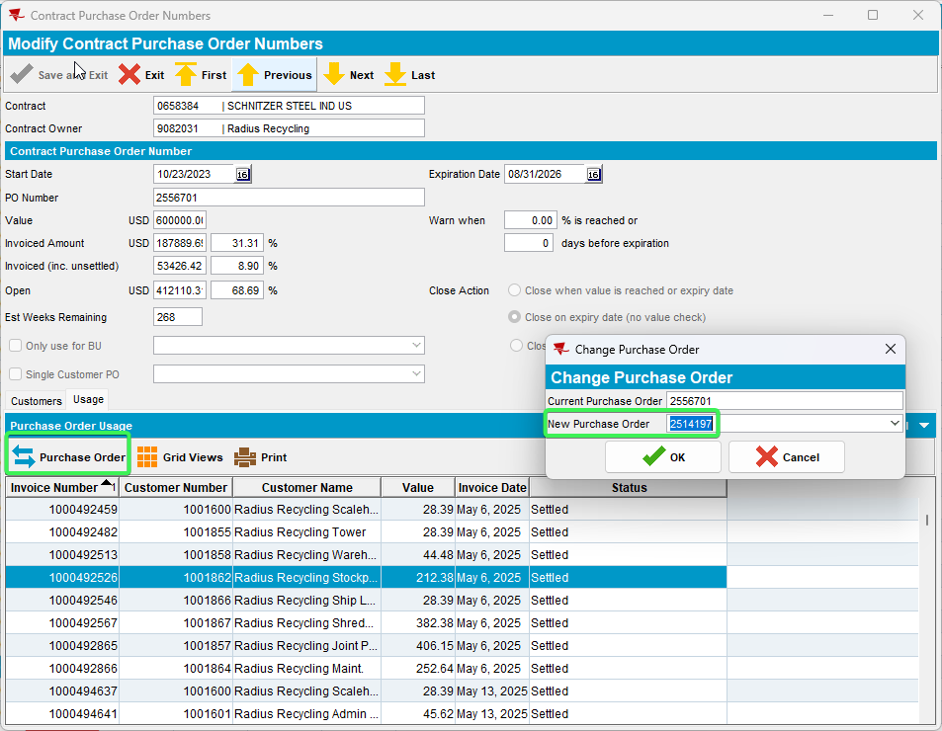
- Check that IHEI.PDFCreated is still 0
select ihei.pdfcreated, ih.* from invoiceheader ih
join invoiceheaderextrainfo ihei on ihei.invoiceheader_id = ih.invoiceheader_id
where ih.invoicenumber= 1000492526;
Tested OK

