ABSN-14087 D_UBS_2805 Manual invoice lines not included in AR Transaction Details for credit invoice
Environment | Prerequisites
Version:9.07.00.UNF21  DBServerName= abs-srv19.internal.abslbs.com  DBSID= CUST22  DBUser= UNFLIVE  Environment= Test | - Module: CREDITFLOW, VERTEXTAX  - System settings:  - Others:

Contents
Reproducing before fix 1
Data preparation 1
Steps to reproduce 1
Current Behavior 6
Expected behavior 6

Retest after fix

Data preparation
- BU 248 Omaha, NE
- Customer 2536781 Jiffy Lube 0029

Steps to reproduce
- Maintain Invoices – Customer – Settled: Choose an existing invoice and credit a few lines using Credit Flow. Assign to route but do not settle.
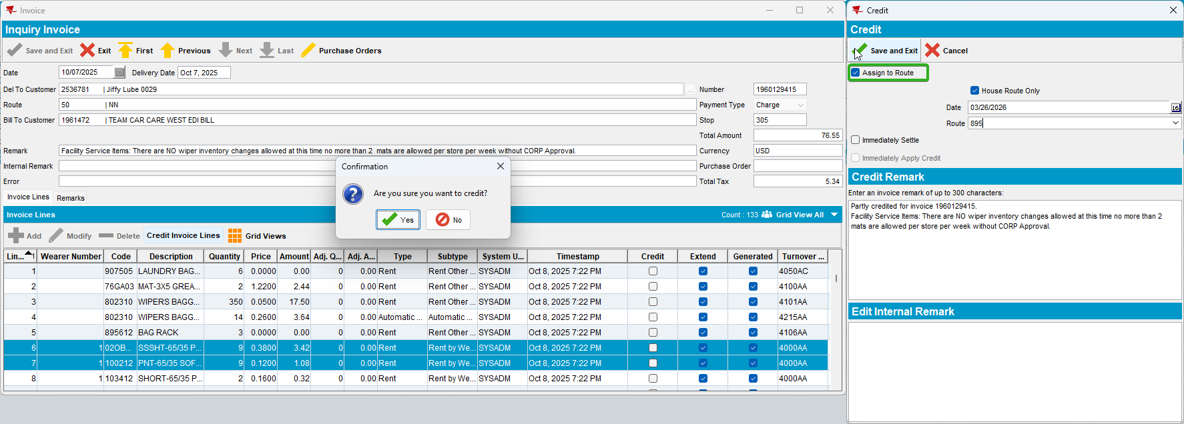
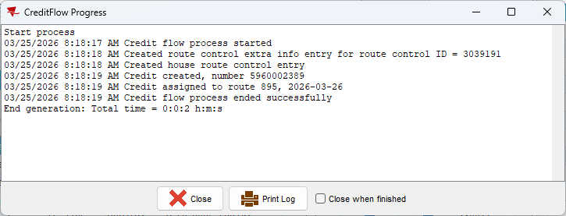

- Maintain Invoices – Customer – Unsettled: Find the credit invoice you just created and check turnover groups – only available on credited lines. Also note that tax lines are already created.
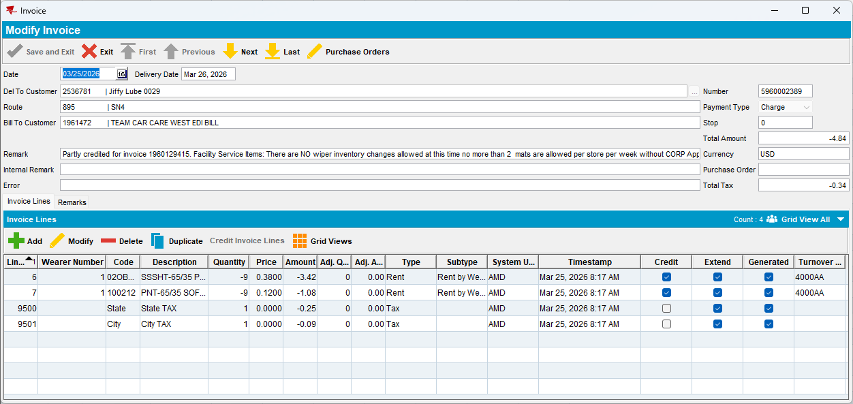

- Add a manual invoice line
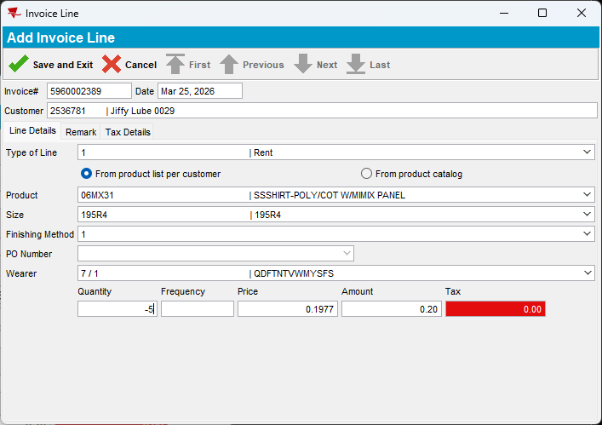

- Note that the new line (number 8) has no turnover group and also that tax lines are automatically deleted.
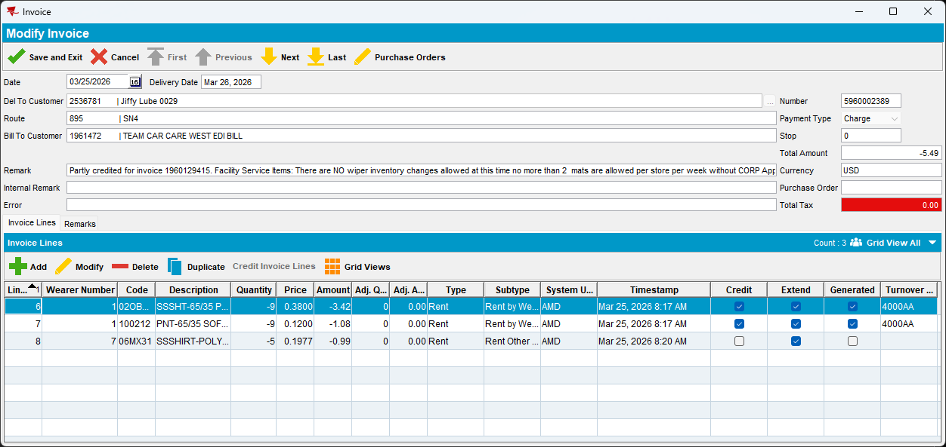
- Route Status Control – Find the route selected in Credit flow screen and generate invoices.
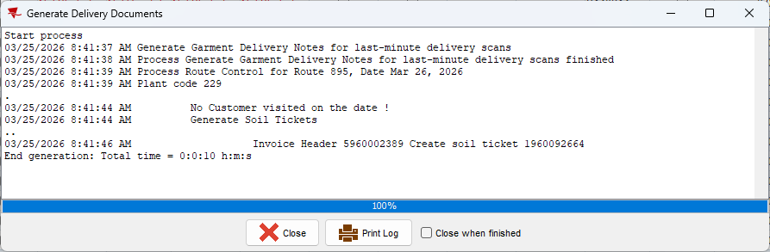

- Check the invoice – tax lines were added. Until this point, there are no AR Transactions or Details created.
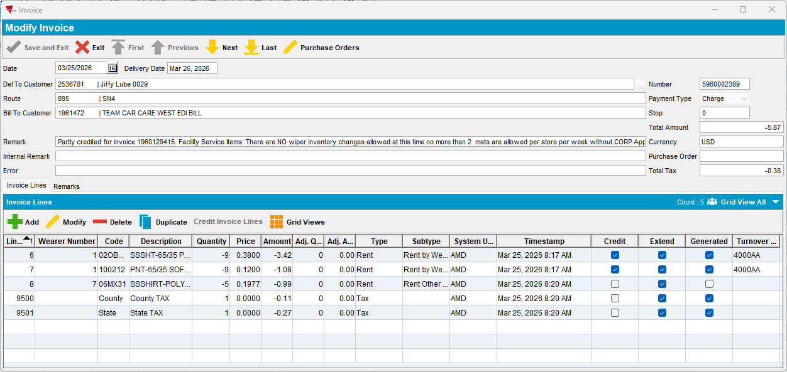

- Settle route
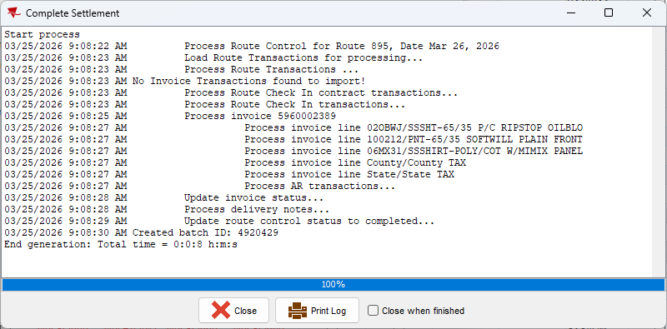

- Check invoice, AR Transaction, AR Transaction Details.
AR Transaction Details are created only for the lines having turnover groups.
AR Transaction is created correctly for the invoice, with AR amount = invoice total amount.
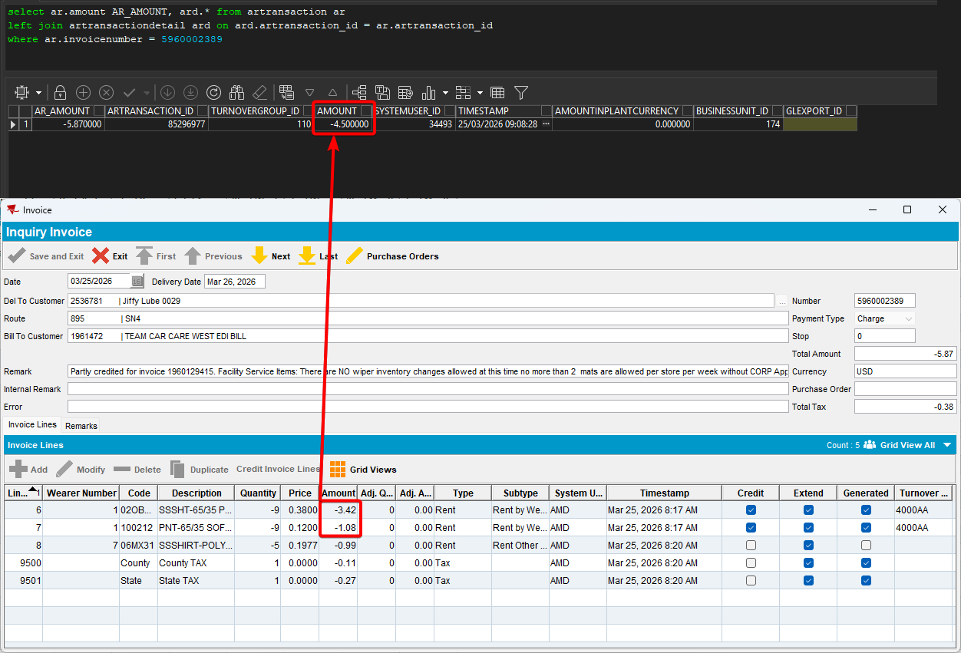
- Run BCI scripts for batch id mentioned in Settlement log and run scheduled process Import Vertex BCI Tax Response.
- Check invoice, AR Transaction, AR Transaction Details.
New AR Transaction Detail created for tax lines because they have a different turnover group than the one from existing detail.
Existing AR Transaction Detail not updated for the remaining amount from the manual invoice line, even if it now has a turnover group..
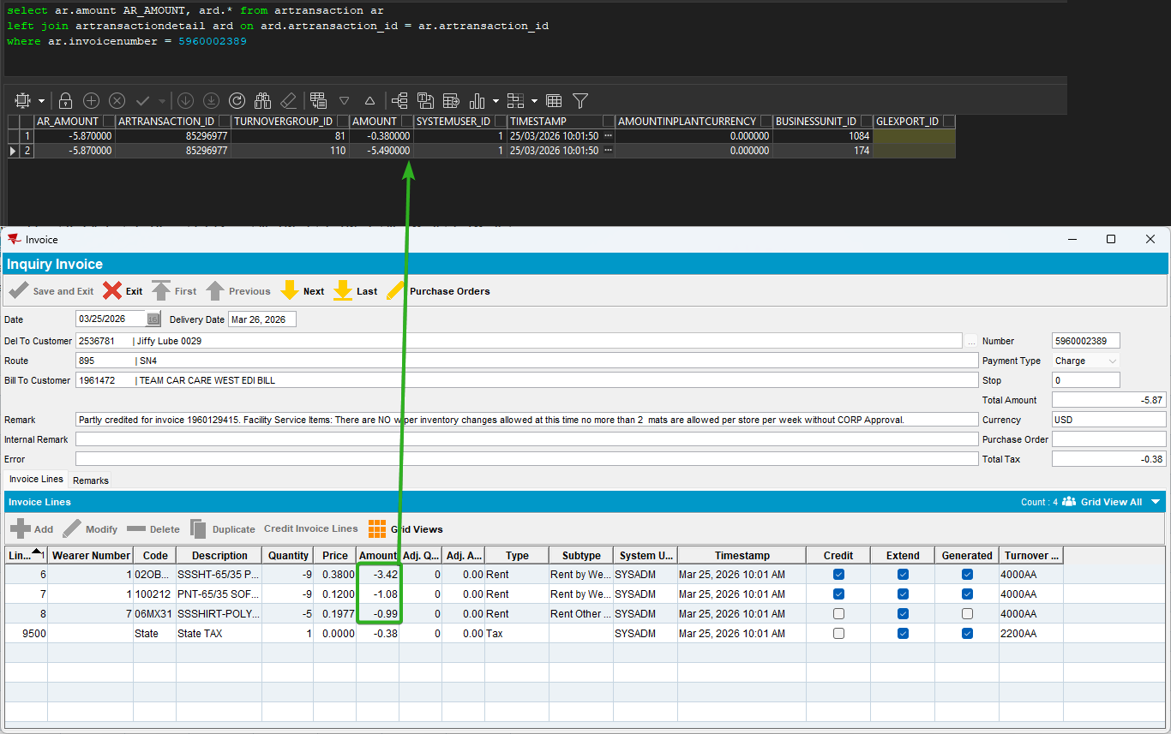
TESTED OK.

Current Behavior
AR Transaction Details are created correctly, including all eligible amounts (lines is extended and has a turnover group).

Expected behavior
AR Transaction Details are created correctly, including all eligible amounts (lines is extended and has a turnover group).

