ABSN-14059 - Address cleaning and Tax area ID using REST web service
Environment | Prerequisites
Version: 9.07.00.UNF21  DBServerName= abs-srv20.internal.abslbs.com  DBSID=CUST24  DBUser=UNFDEV  Environment=Test | - Module:  - System setting

Contents
Data Preparation 2
Customers DLG – Add Mode Test Cases 2
Test 1 – Add mode VERTEXUPDATEADDRESS = 0 all addresses the same confidence <100% 2
Test 2 – Add mode VERTEXUPDATEADDRESS = 0 all addresses the same confidence =100% 6
Test 3 – Add mode VERTEXUPDATEADDRESS = 1 all addresses the same confidence <100% 11
Test 4 – Add mode VERTEXUPDATEADDRESS = 1 all addresses the same confidence =100% 16
Test 5 – Add mode VERTEXUPDATEADDRESS = 2 all addresses the same confidence <100% 19
Test 6 – Add mode VERTEXUPDATEADDRESS = 2 all addresses the same confidence =100% 23
Test 7 - Add mode VERTEXUPDATEADDRESS = 2 and bill-to <> del-to, general tab and delivery tab addresses are the same with confidence <100% 27
Test 8 – Add mode VERTEXUPDATEADDRESS = 2 with VERTEXADDCLEANINGTOKENURL having an incorrect string 30
Test 9 – Add mode VERTEXUPDATEADDRESS = 2 with VERTEXADDCLEANINGTOKENURL having the default value “–“ 33
Test 10 – Add mode VERTEXUPDATEADDRESS = 2 with VERTEXADDCLEANINGCLIENTID having an incorrect string 36
Test 11 – Add mode VERTEXUPDATEADDRESS = 2 with VERTEXADDCLEANINGCLIENTID having the default value “-“ 38
Customers DLG – Modify Mode Test Cases 41
Test 1 – Modify mode VERTEXUPDATEADDRESS = 0 general tab address is changed confidence <100% 41
Test 2 – Modify mode VERTEXUPDATEADDRESS = 0 general tab address is changed confidence =100% 45
Test 3 – Modify mode VERTEXUPDATEADDRESS = 1 general tab address is changed confidence <100% 50
Test 4 – Modify mode VERTEXUPDATEADDRESS = 1 delivery tab address is changed confidence =100% 56
Test 5 – Modify mode VERTEXUPDATEADDRESS = 2 Billing tab address is changed confidence <100% 58
Test 6 – Modify mode VERTEXUPDATEADDRESS = 2 Billing tab address is changed confidence =100% 63
Test 7 – Modify mode VERTEXUPDATEADDRESS = 2 with VERTEXADDCLEANINGTOKENURL having an incorrect string – modify any address on an existing customer 67
Test 8 – Modify mode VERTEXUPDATEADDRESS = 2 with VERTEXADDCLEANINGTOKENURL having default string “-“ – modify any address on an existing customer 71
Test 9 – Modify mode VERTEXUPDATEADDRESS = 2 with VERTEXADDCLEANINGCLIENTID having an incorrect string – modify any address on an existing customer 74
Test 10 – Modify mode VERTEXUPDATEADDRESS = 2 with VERTEXADDCLEANINGCLIENTID having the default string “-“ – modify any address on an existing customer 77
Process Scheduler Test Cases 80
Test Case 1 – Active customer with 3 good addresses and bad taxareaids that are not manually set (script the change to TaxAreaID) 80
Test Case 2 – Unsuccessful response from Web Service by blocking traffic with the IP with clumsy 87
Test Case 3 – Garbage input for address and >100 confidence result 88

Data Preparation
The following System Settings must have the following values
VERTEXUPDATEADDRESS = 2
VERTEXADDCLEANINGTOKENURL = https://login.microsoftonline.com/7cf50681-c05a-4dff-9263-d297df8c8bd9/oauth2/v2.0/token
VERTEXADDCLEANINGCLIENTID = bb568220-c7a4-4ea9-87bb-a0918d7a15c5
VERTEXADDCLEANINGSECURITY = kVl8Q~Qt~Ze0DWXT3p0maDA.6OYCRPkZ_OgXIaQS
VERTEXADDCLEANINGURL = https://eifdev.unifirst.com/unf-address-validation-papi/api/address/validate-taxcode
VERTEXTAXAREACLEANINGURL = https://eifdev.unifirst.com/unf-address-validation-papi/api/vertex/taxArea

Customers DLG – Add Mode Test Cases

Test 1 – Add mode VERTEXUPDATEADDRESS = 0 all addresses the same confidence <100%
Hash: 9.07.00.UNF21 hash: 115015c453a4
Expected behavior:
Show screen with both buttons no matter confidence check that both buttons work as expected:
Update only taxareaid -> saves only the taxareaid
Update all -> updates address and taxareaid
Check WebServiceLog to see that the call was logged.

Steps:
- System settings: Have SS VERTEXUPDATEADDRESS = 0
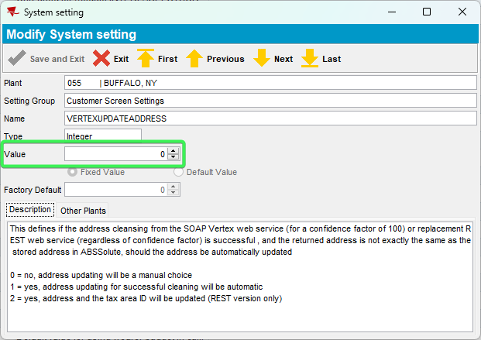

- Customers DLG: Press Add button > input a valid address
Address Used: 1 Seymour H Knox III Plaza, Buffalo, NY 14203, United States
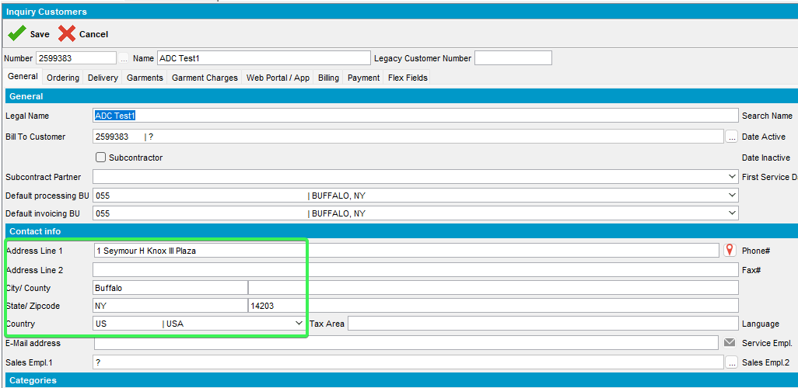
- See that the address has been saved in the Delivery and Billing tabs as well
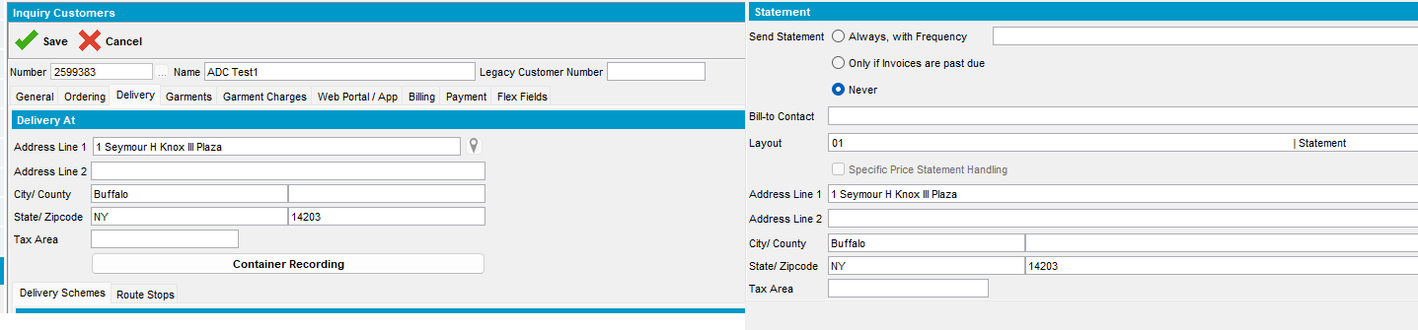

- Complete all the other mandatory fields and save the customer: 2599383
- On the Pop-Up message select Update Tax Area Only and Exit for all 3 tabs: Contact Address, Delivery Adress and Billing Address
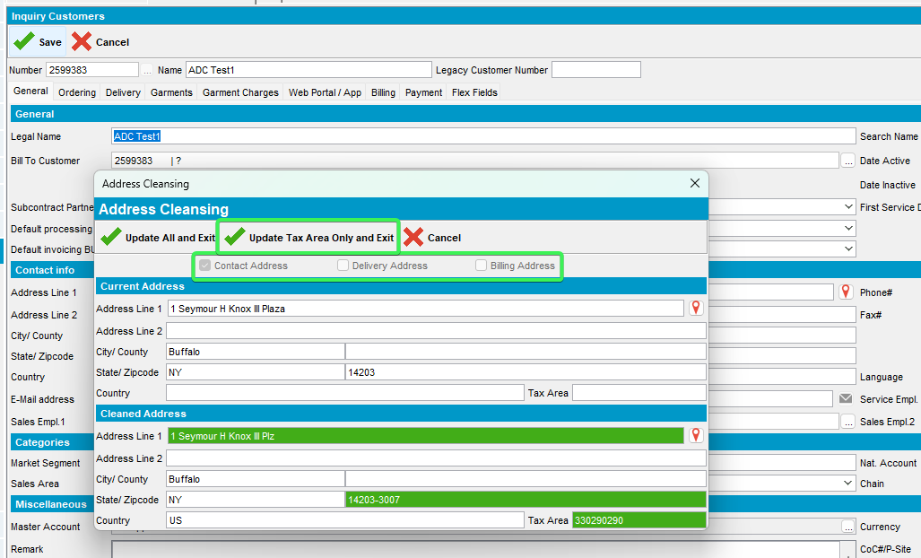
- Check the 3 tabs and see that only the Tax Area ID has been cleaned
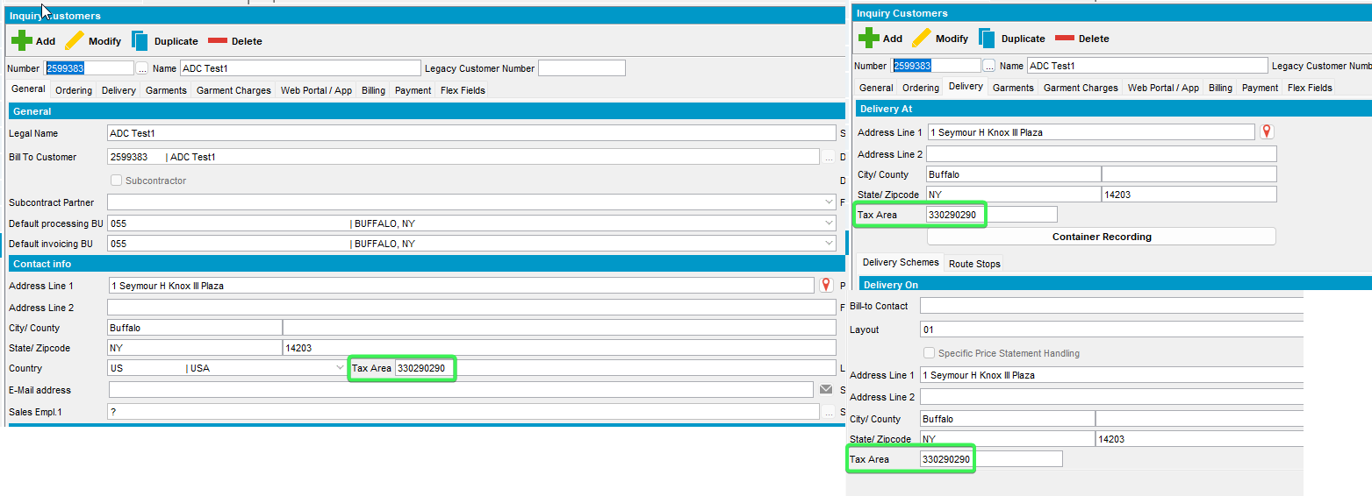
- Verify the confidence indicator that is <100%
select at.*, s.username from addresstaxareaid at
join systemuser s on s.systemuser_id = at.systemuser_id
join address a1 on a1.address_id = at.address_id
join customer c on c.mailaddress_id = a1.address_id
where c.customernumber =2599383
order by s.timestamp desc;
- Check WebServiceLog to see that the call was logged
Select * from Webservicelog WSL
where wsl.application='UNFAddressCleaning' and customer=’2599383’
order by wsl.requesttimestamp desc
- Add another customer with the same address and save it: 2599384
- On the Pop-up message press Update All and Exit for all 3 tabs:
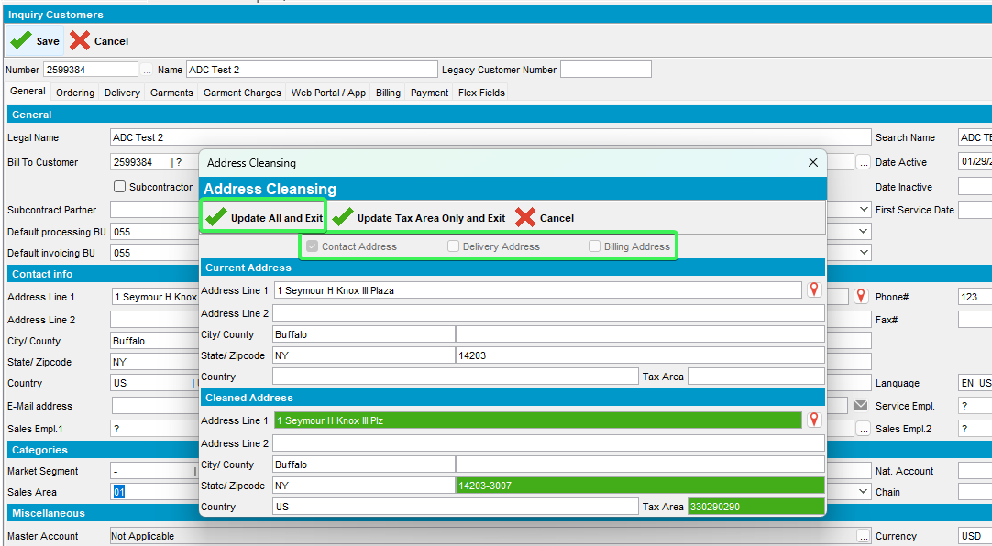
- Check that all 3 tabs have been updated with all the lines that were modified
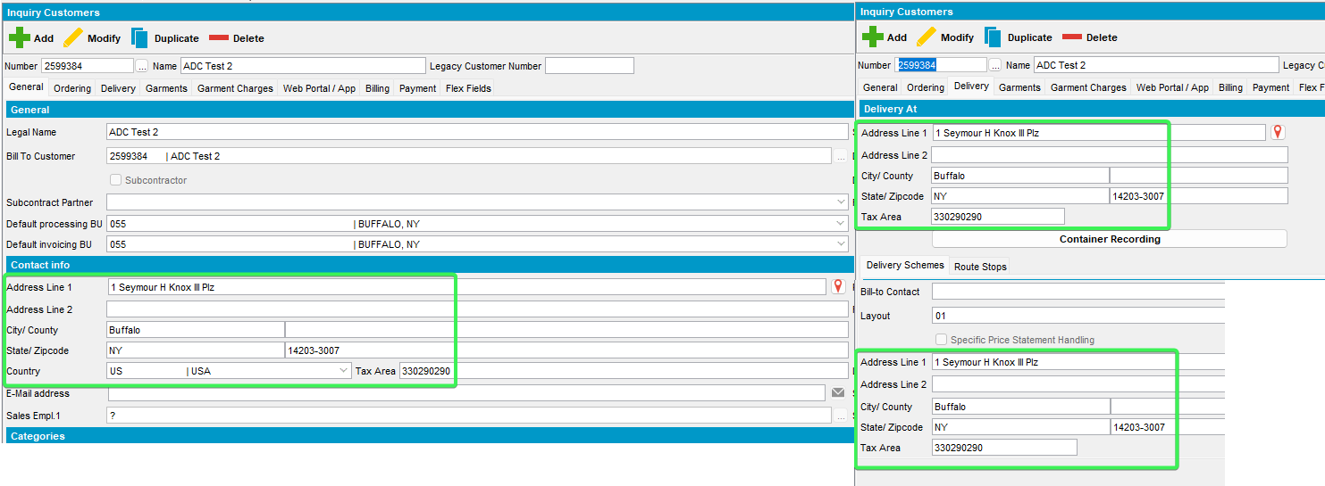
- Check WebServiceLog to see that the call was logged
Select * from Webservicelog WSL
where wsl.application='UNFAddressCleaning' and customer=2599384
order by wsl.requesttimestamp desc
Tested OK

Test 2 – Add mode VERTEXUPDATEADDRESS = 0 all addresses the same confidence =100%
Hash: 9.07.00.UNF21 hash: 115015c453a4
Expected behavior:
Show screen with both buttons no matter confidence check that both buttons work as expected:
Update only taxareaid -> saves only the taxareaid
Update all -> updates address and taxareaid
Check WebServiceLog to see that the call was logged.
Steps:
- System settings: Have SS VERTEXUPDATEADDRESS = 0
- Customers DLG: Press Add button > input a valid address
1 Seymour H Knox III Plz, Buffalo, NY 14203-3007, United States
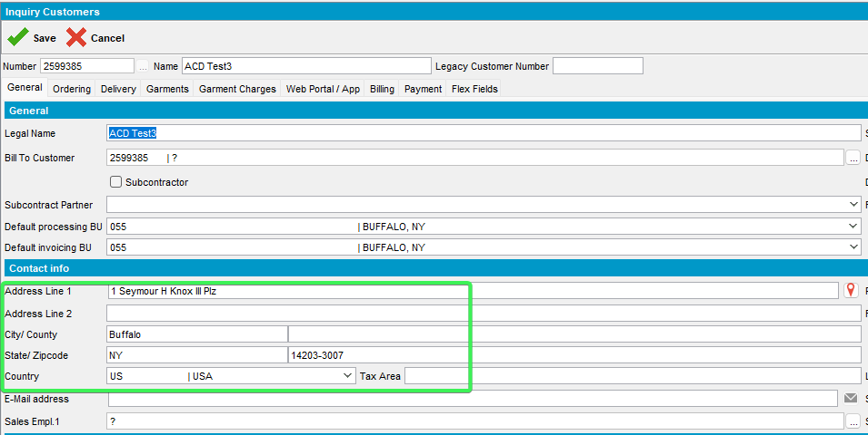
- See that the address has been saved in the Delivery and Billing tabs as well
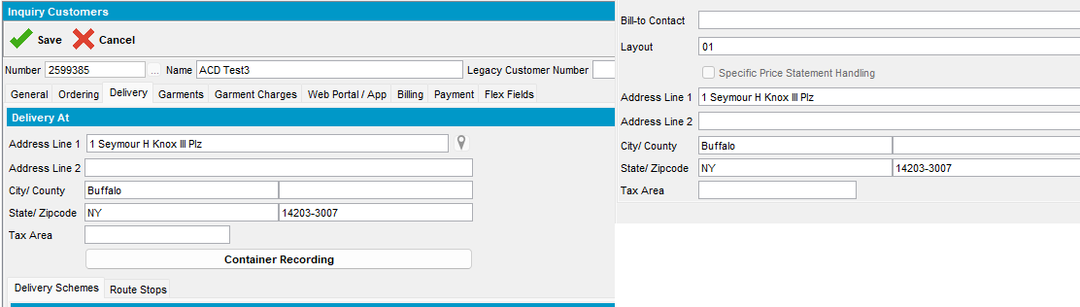
- Complete all the other mandatory fields and save the customer: 2599385
- On the Pop-Up message select Update Tax Area Only and Exit for all 3 tabs: Contact Address, Delivery Adress and Billing Address
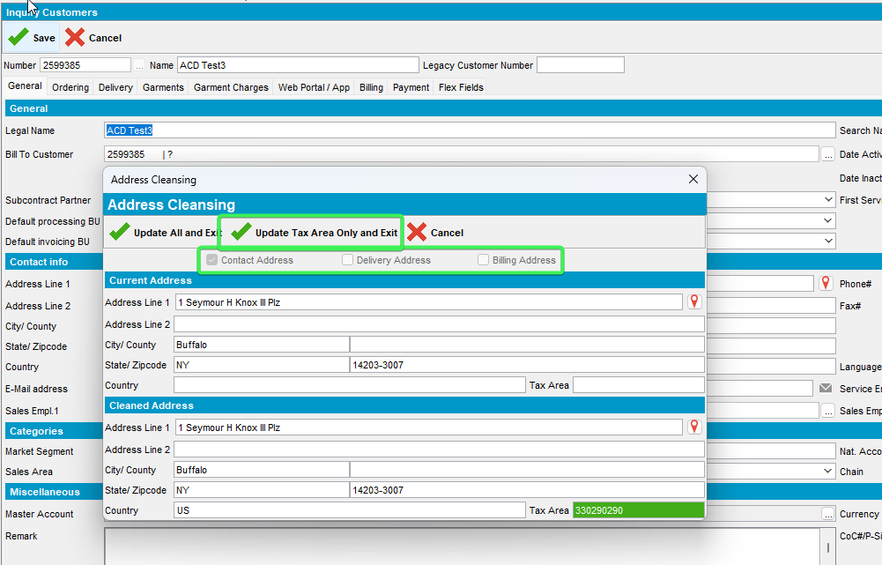
- Check the 3 tabs and see that only the Tax Area ID has been added
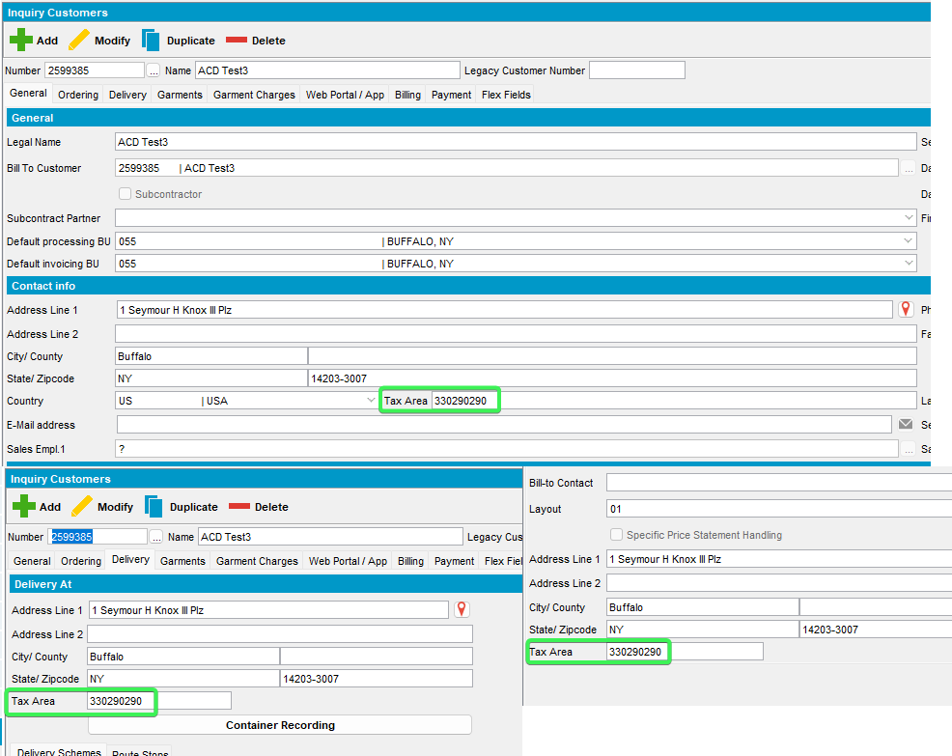
- Verify the confidence indicator that is =100%
select at.*, s.username from addresstaxareaid at
join systemuser s on s.systemuser_id = at.systemuser_id
join address a1 on a1.address_id = at.address_id
join customer c on c.mailaddress_id = a1.address_id
where c.customernumber =2599385
order by s.timestamp desc;
- Check WebServiceLog to see that the call was logged
Select * from Webservicelog WSL
where wsl.application='UNFAddressCleaning' and customer=2599385
order by wsl.requesttimestamp desc
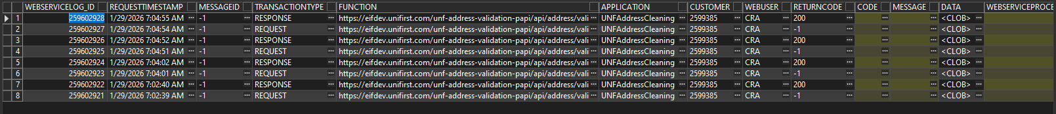
- Add another customer with the same address and save it: 2599386
- On the Pop-up message press Update All and Exit for all 3 tabs
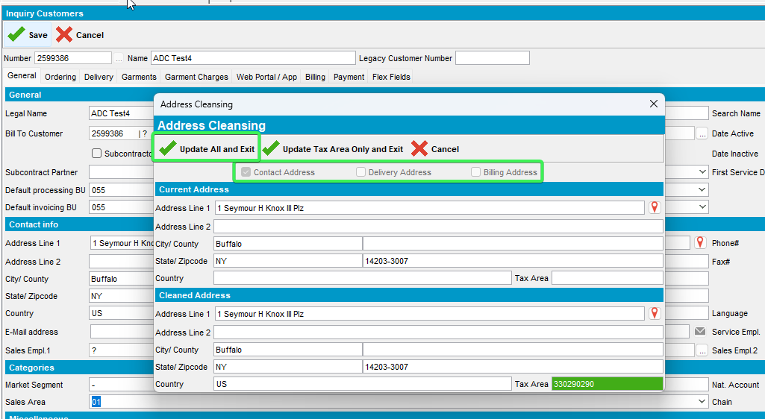
- Check that all 3 tabs have been saved with the lines that were displayed in the pop-up
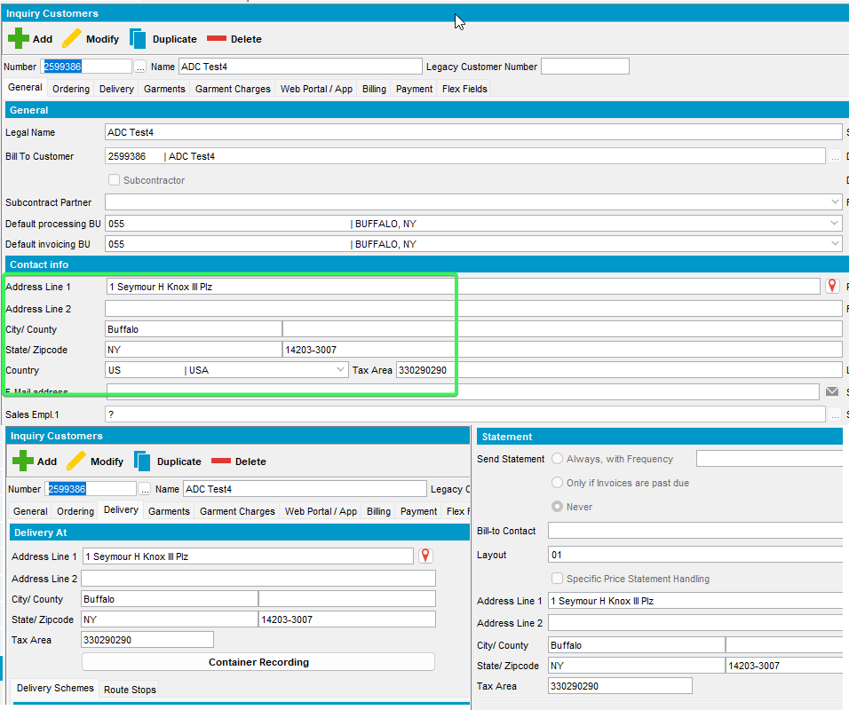
- Check WebServiceLog to see that the call was logged
Select * from Webservicelog WSL
where wsl.application='UNFAddressCleaning' and customer=2599386
order by wsl.requesttimestamp desc
Tested OK

Test 3 – Add mode VERTEXUPDATEADDRESS = 1 all addresses the same confidence <100%
Hash: 9.07.00.UNF21 hash: 115015c453a4
Expected behavior:
Show screen with both buttons no matter confidence check that both buttons work as expected:
Update only taxareaid -> saves only the taxareaid
Update all -> updates address and taxareaid
Check WebServiceLog to see that the call was logged.

Steps:
- System settings: Have SS VERTEXUPDATEADDRESS = 1
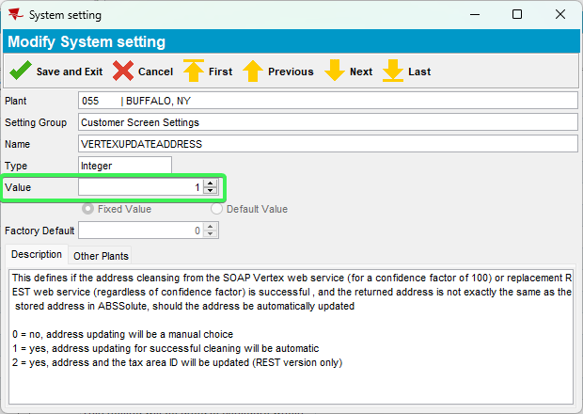
- Customers DLG: Press Add button > input a valid address
Address Used: 1 Seymour H Knox III Plaza, Buffalo, NY 14203, United States
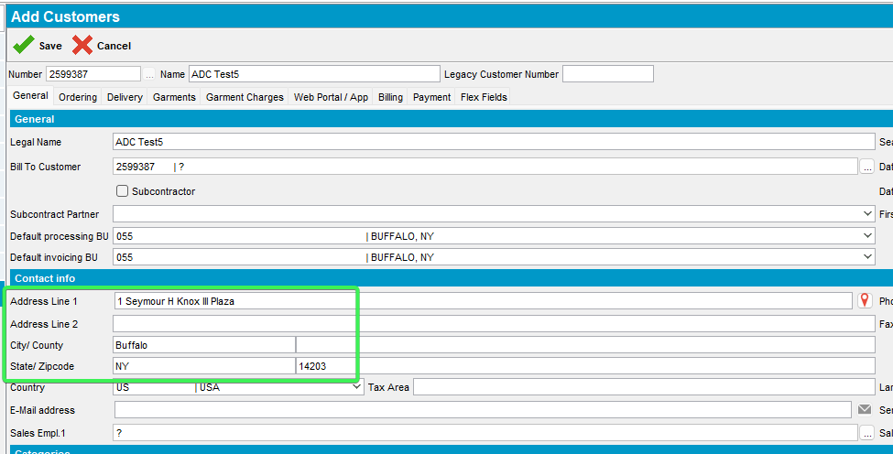
- See that the address has been saved in the Delivery and Billing tabs as well
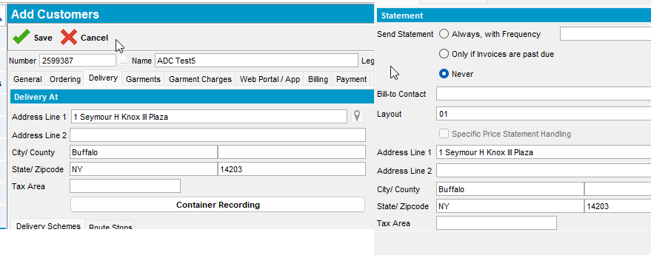
- Complete all the other mandatory fields and save the customer: 2599387
- On the Pop-Up message select Update Tax Area Only and Exit for all 3 tabs: Contact Address, Delivery Adress and Billing Address
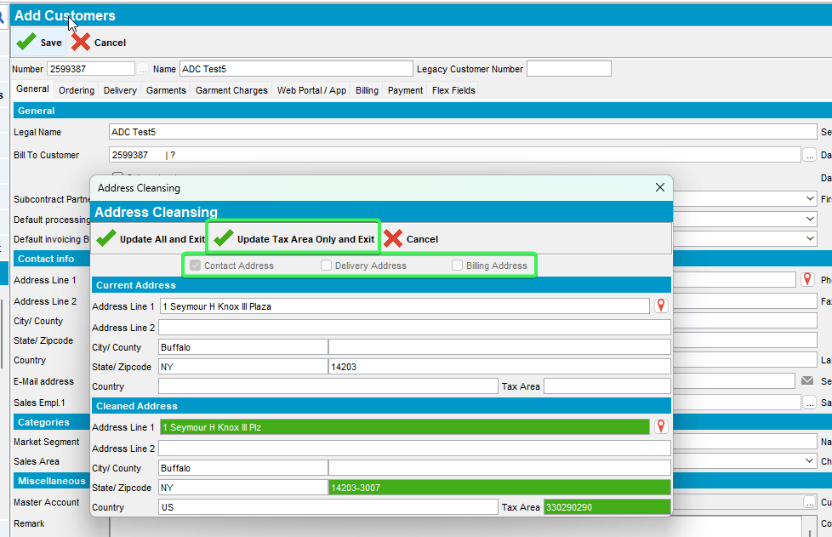
- Check the 3 tabs and see that only the Tax Area ID has been added
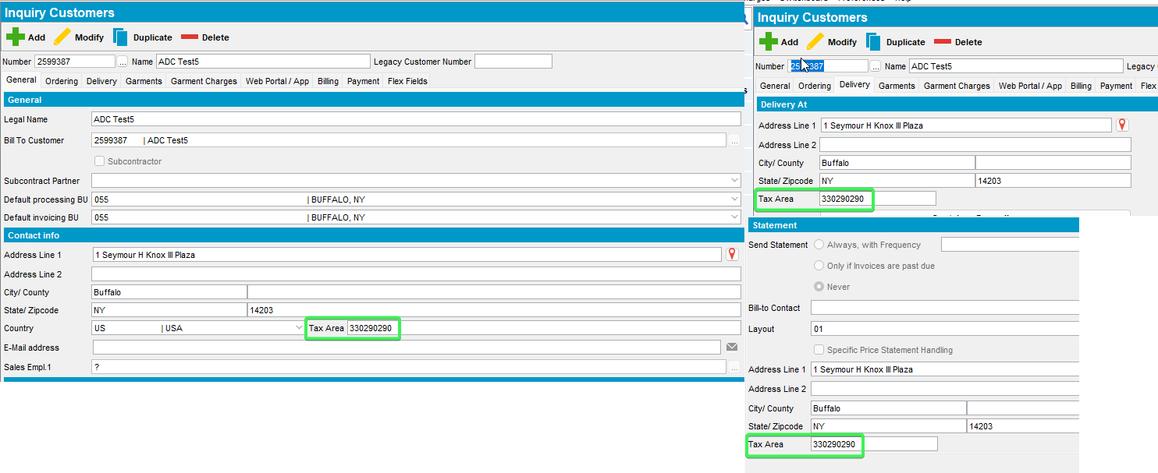
- Verify the confidence indicator that is <100%
select at.*, s.username from addresstaxareaid at
join systemuser s on s.systemuser_id = at.systemuser_id
join address a1 on a1.address_id = at.address_id
join customer c on c.mailaddress_id = a1.address_id
where c.customernumber =2599387
order by s.timestamp desc;
- Check WebServiceLog to see that the call was logged
Select * from Webservicelog WSL
where wsl.application='UNFAddressCleaning' and customer=2599387
order by wsl.requesttimestamp desc
- Add another customer with the same address and save it: 2599388
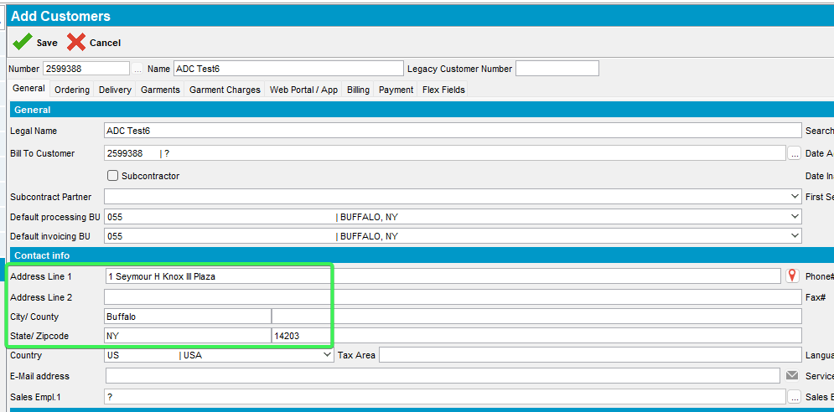
- On the Pop-up message press Update All and Exit for all 3 tabs:
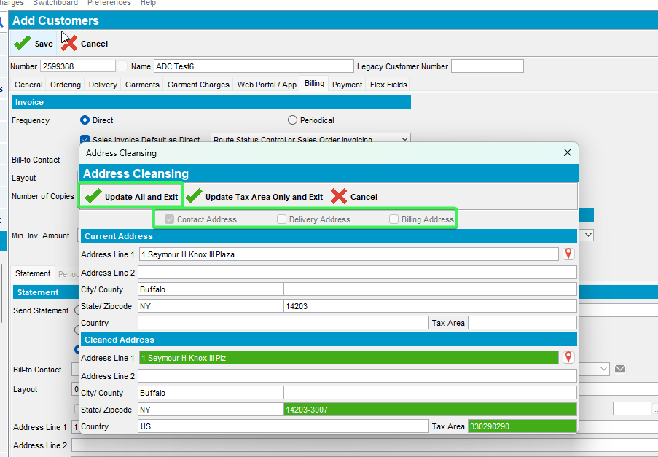
- Check that all 3 tabs have been updated with the lines that were modified
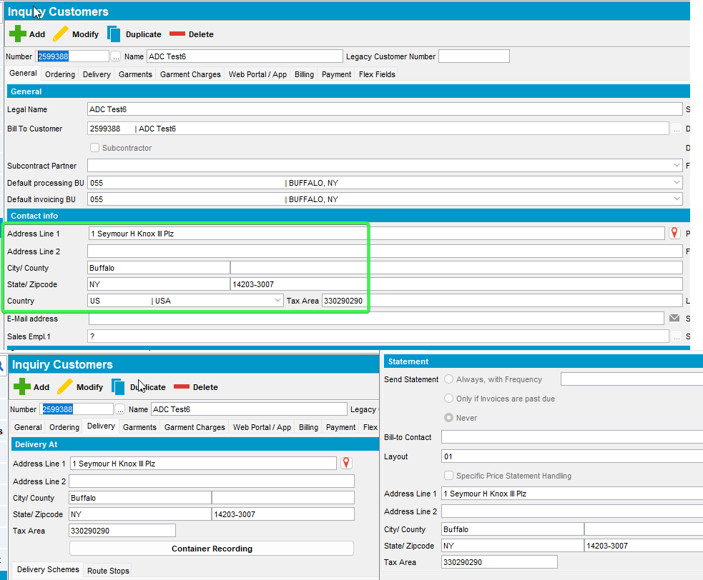
- Check WebServiceLog to see that the call was logged
Select * from Webservicelog WSL
where wsl.application='UNFAddressCleaning' and customer= 2599388
order by wsl.requesttimestamp desc
Tested OK

Test 4 – Add mode VERTEXUPDATEADDRESS = 1 all addresses the same confidence =100%
Hash: 9.07.00.UNF21 hash: 115015c453a4
Expected behavior:
No screen shown, both address and taxareaid are updated
Check WebServiceLog to see that the call was logged.
Steps:
- System settings: Have SS VERTEXUPDATEADDRESS = 1
- Customers DLG: Press Add button > input a valid address
Address Used: 1 Seymour H Knox III Plz, Buffalo, NY 14203-3007, United States
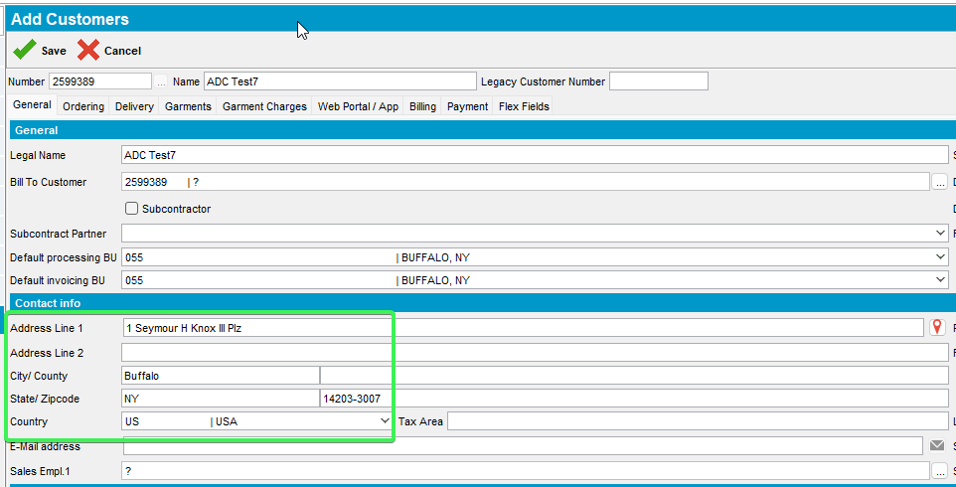
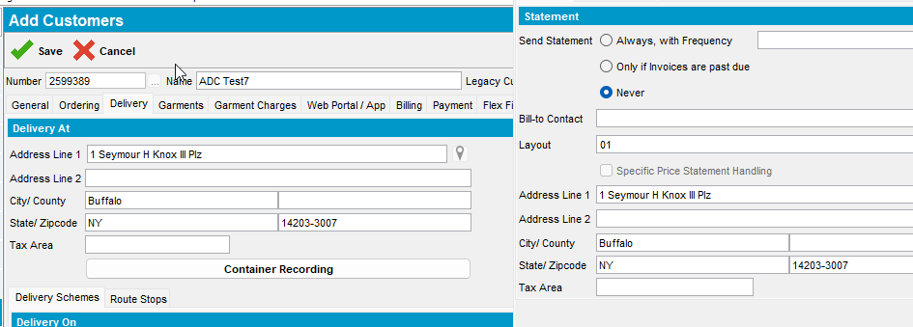
- Complete all the other mandatory fields and save the customer: 2599389
- Check the 3 tabs and see that the Tax Area ID has been added correctly
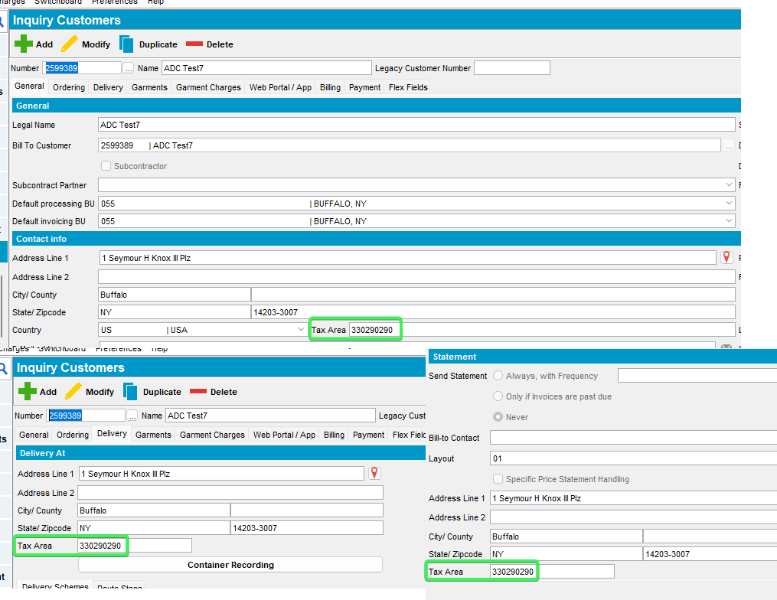
- Verify the confidence indicator that is =100%
select at.*, s.username from addresstaxareaid at
join systemuser s on s.systemuser_id = at.systemuser_id
join address a1 on a1.address_id = at.address_id
join customer c on c.mailaddress_id = a1.address_id
where c.customernumber =2599389
order by s.timestamp desc;
- Check WebServiceLog to see that the call was logged
Select * from Webservicelog WSL
where wsl.application='UNFAddressCleaning' and customer=2599389
order by wsl.requesttimestamp desc
Tested OK

Test 5 – Add mode VERTEXUPDATEADDRESS = 2 all addresses the same confidence <100%
Hash: 9.07.00.UNF21 hash: 115015c453a4
Expected behavior:
Show screen with only one button:
Update all -> updates address and taxareaid
Check WebServiceLog to see that the call was logged.

Steps:
- System settings: Have SS VERTEXUPDATEADDRESS = 2
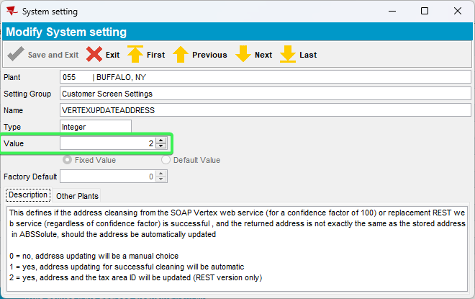
- Customers DLG: Press Add button > input a valid address
Address Used: 1 Seymour H Knox III Plaza, Buffalo, NY 14203, United States
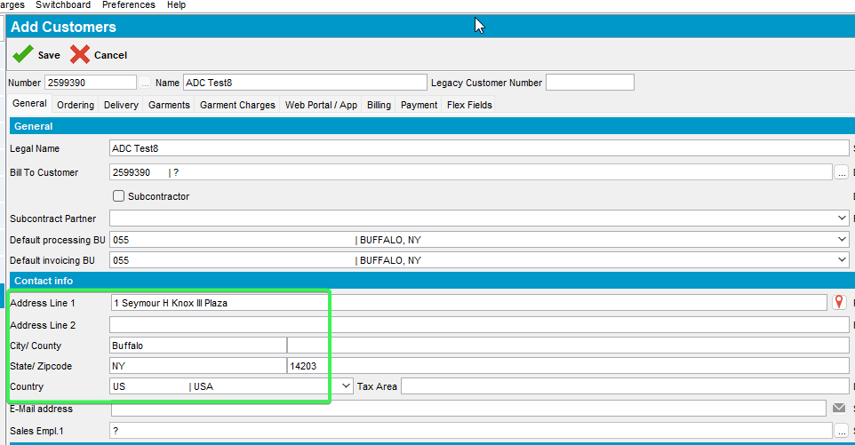
- See that the address has been saved in the Delivery and Billing tabs as well
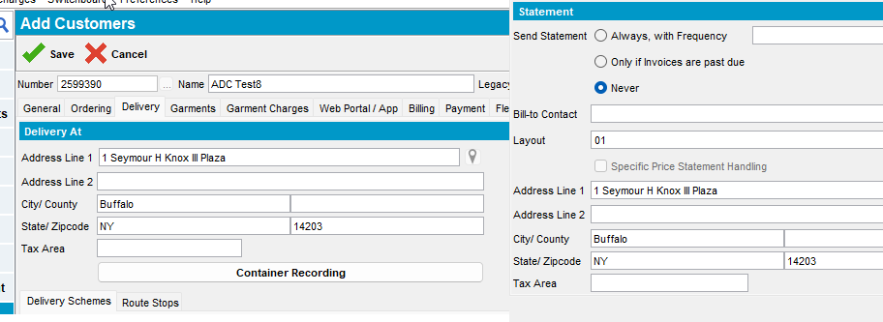
- Complete all the other mandatory fields and save the customer: 2599390
- On the Pop-Up message select Update All and Exit for all 3 tabs: Contact Address, Delivery Adress and Billing Address
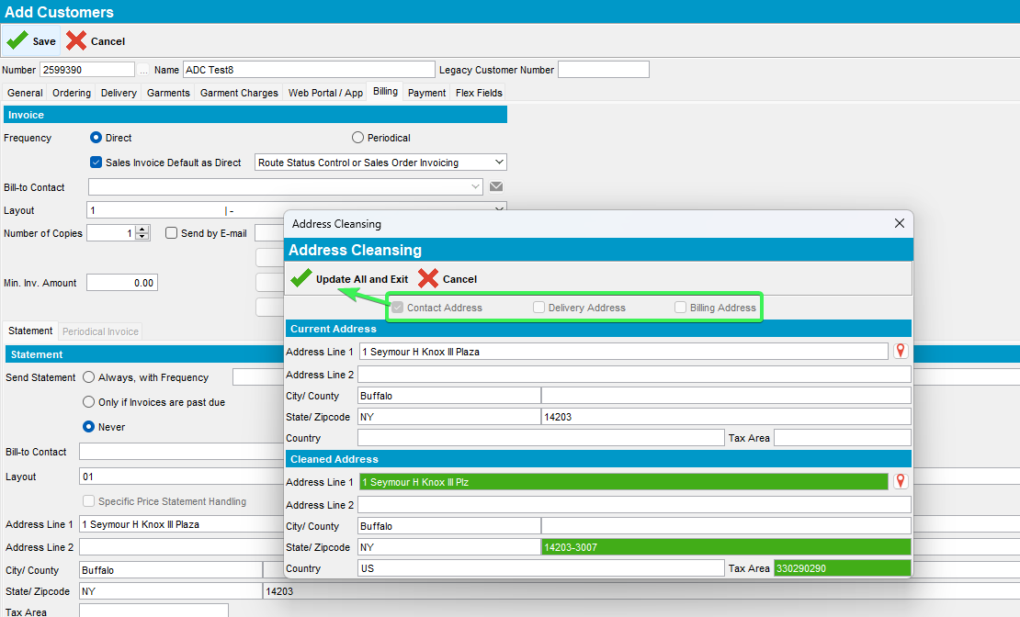
- Check the 3 tabs and see that the address has been cleaned
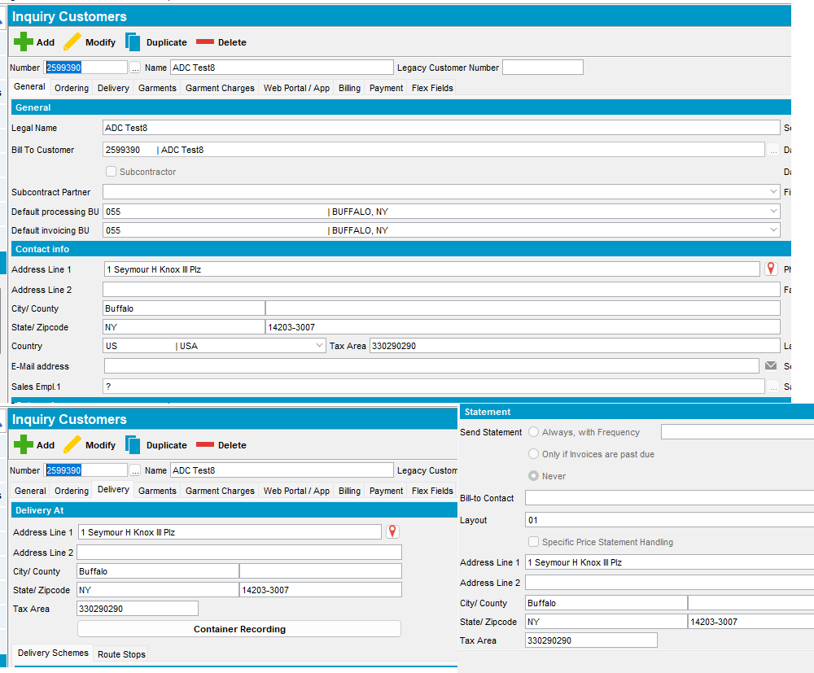
- Verify the confidence indicator that is <100%
select at.*, s.username from addresstaxareaid at
join systemuser s on s.systemuser_id = at.systemuser_id
join address a1 on a1.address_id = at.address_id
join customer c on c.mailaddress_id = a1.address_id
where c.customernumber =2599390
order by s.timestamp desc;
- Check WebServiceLog to see that the call was logged
Select * from Webservicelog WSL
where wsl.application='UNFAddressCleaning' and customer=2599390
order by wsl.requesttimestamp desc
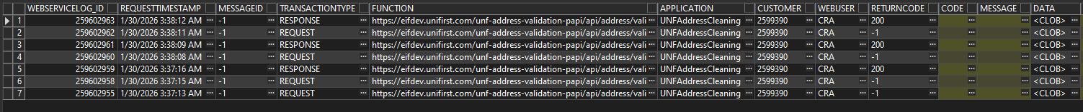
Tested OK

Test 6 – Add mode VERTEXUPDATEADDRESS = 2 all addresses the same confidence =100%
Hash: 9.07.00.UNF21 hash: 115015c453a4
Expected behavior:
Show screen with only one button:
Update all -> updates address and taxareaid
Check WebServiceLog to see that the call was logged.

- System settings: Have SS VERTEXUPDATEADDRESS = 2
- Customers DLG: Press Add button > input a valid address
Address Used: 1 Seymour H Knox III Plz, Buffalo, NY 14203-3007, United States
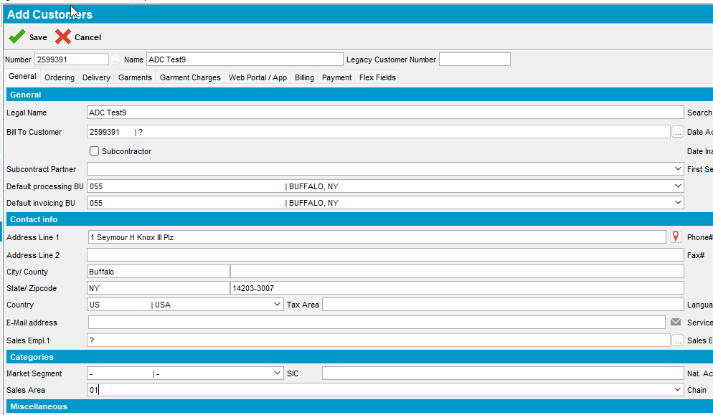
- See that the address has been saved in the Delivery and Billing tabs as well
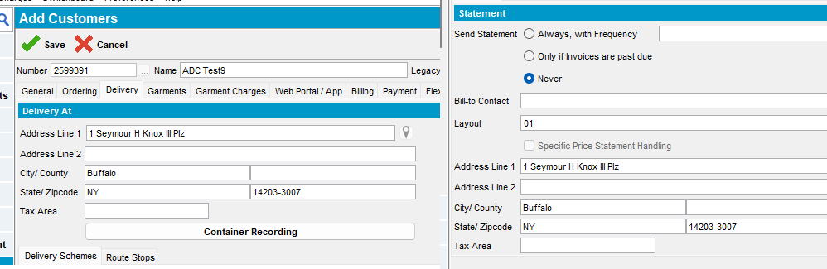
- Complete all the other mandatory fields and save the customer: 2599391
- On the Pop-Up message select Update All and Exit for all 3 tabs: Contact Address, Delivery Adress and Billing Address
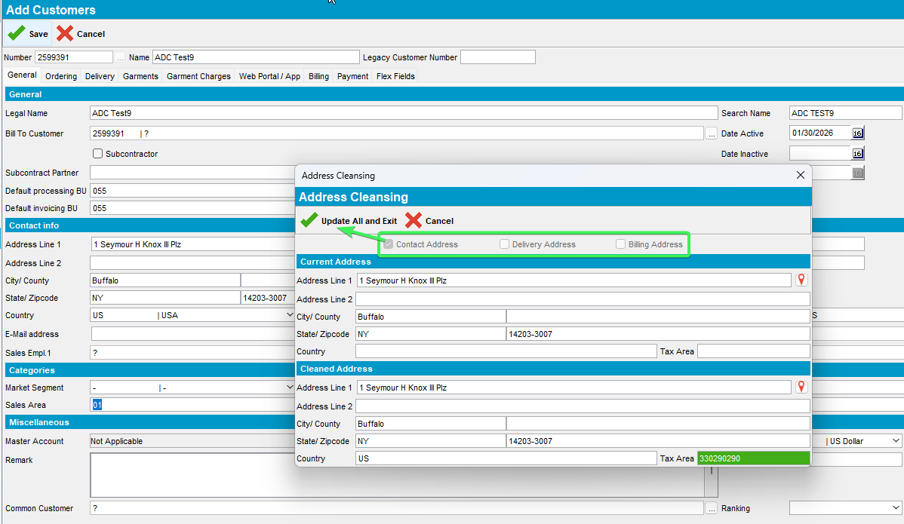
- Check the 3 tabs and see that the address has been cleaned
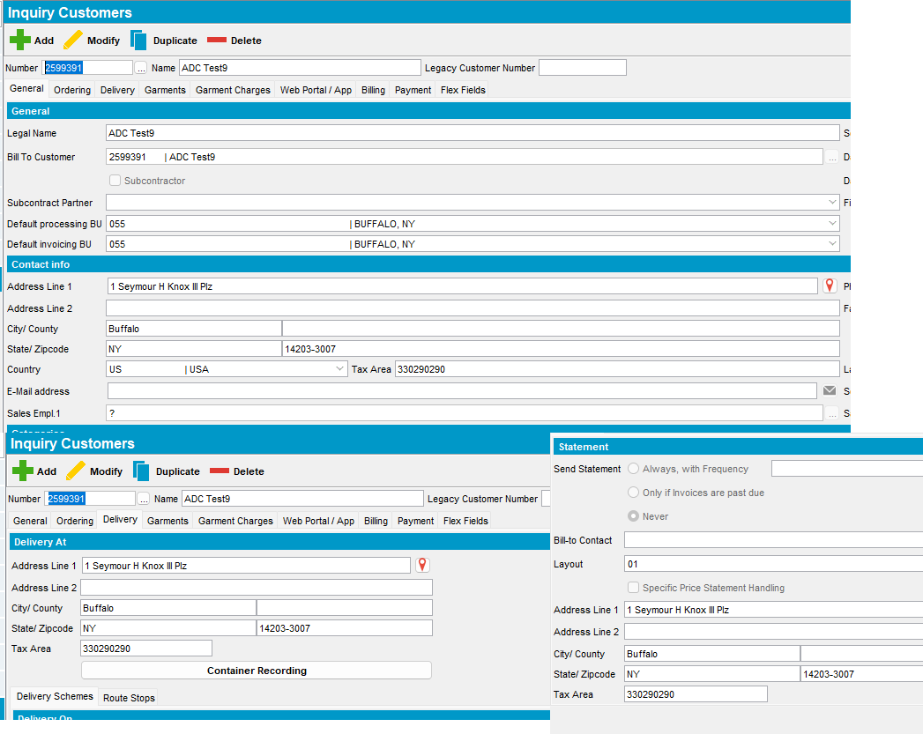
- Verify the confidence indicator that is =100%
select at.*, s.username from addresstaxareaid at
join systemuser s on s.systemuser_id = at.systemuser_id
join address a1 on a1.address_id = at.address_id
join customer c on c.mailaddress_id = a1.address_id
where c.customernumber =2599391
order by s.timestamp desc;
- Check WebServiceLog to see that the call was logged
Select * from Webservicelog WSL
where wsl.application='UNFAddressCleaning' and customer=2599391
order by wsl.requesttimestamp desc
Tested OK

Test 7 - Add mode VERTEXUPDATEADDRESS = 2 and bill-to <> del-to, general tab and delivery tab addresses are the same with confidence <100%
Hash: 9.07.00.UNF21 hash: 115015c453a4
Expected behavior:
Show screen with only one button:
Update all -> updates address and taxareaid
Check WebServiceLog to see that the call was logged.

Steps:
- System settings: Have SS VERTEXUPDATEADDRESS = 2
- Customers DLG: Press Add button > input a valid address
Address Used: 326 Amherst St, Buffalo, NY 14207, United States
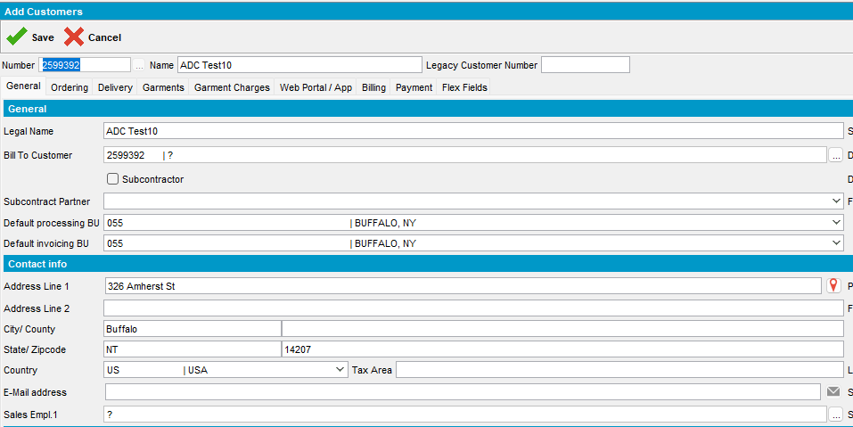
- Change the Bill To Customer to a different one
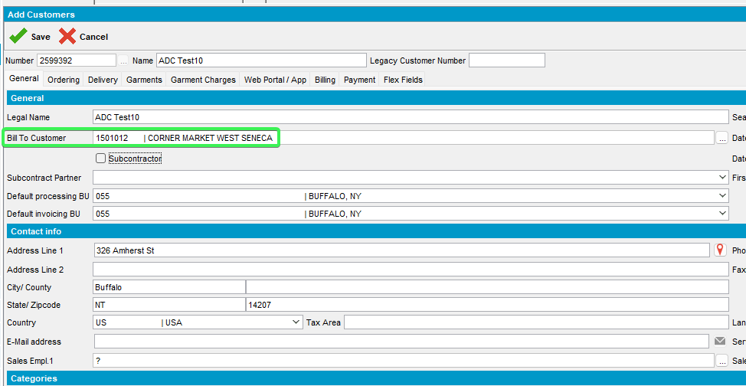
- Check that the Delivery Address Is different than the Billing address
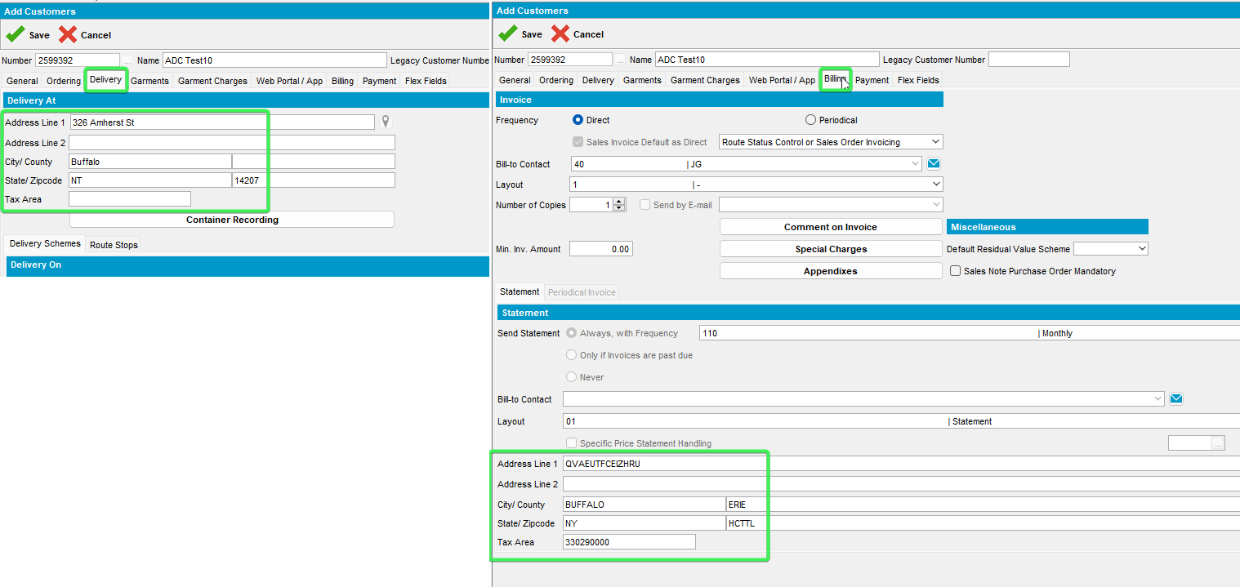

- Save the new customer: 2599392
- On the Pop-up message Press Update All and Exit for Contact Address and Delivery Address
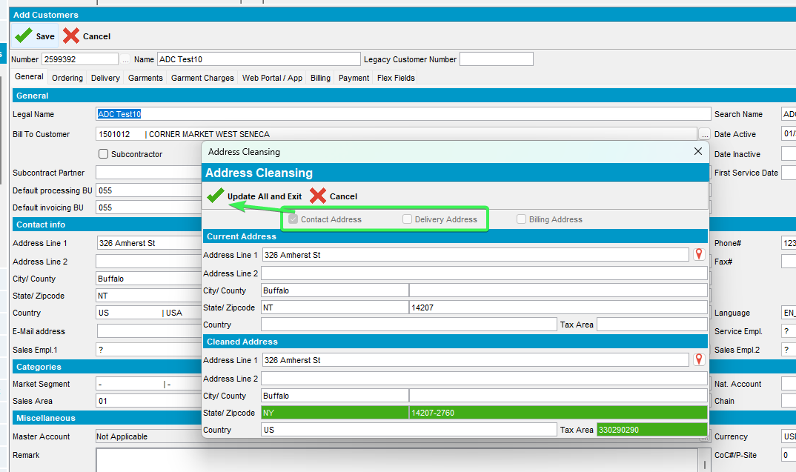
- Check that the address in General and Delivery tab has been cleaned, Tax Area ID has been added and zip code has been updated
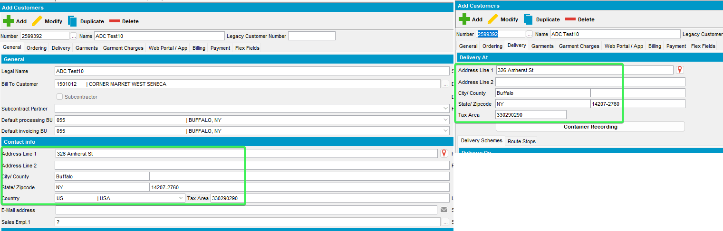
- Verify the confidence indicator that is <100%
select at.*, s.username from addresstaxareaid at
join systemuser s on s.systemuser_id = at.systemuser_id
join address a1 on a1.address_id = at.address_id
join customer c on c.mailaddress_id = a1.address_id
where c.customernumber =2599392
order by s.timestamp desc;
select at.*, s.username from addresstaxareaid at
join systemuser s on s.systemuser_id = at.systemuser_id
join address a1 on a1.address_id = at.address_id
join customer c on c.visitaddress_id = a1.address_id
where c.customernumber =2599392
order by s.timestamp desc;
- Check WebServiceLog to see that the call was logged
Select * from Webservicelog WSL
where wsl.application='UNFAddressCleaning' and customer=2599392
order by wsl.requesttimestamp desc
Tested OK

Test 8 – Add mode VERTEXUPDATEADDRESS = 2 with VERTEXADDCLEANINGTOKENURL having an incorrect string
Hash: 9.07.00.UNF21 hash: 115015c453a4
Expected behavior:
Show error on save, do not allow user to finish adding the customer.
Check ClientErrorLog

Steps:
- System settings: Have SS VERTEXUPDATEADDRESS = 2
- System settings: Have SS VERTEXADDCLEANINGTOKENURL = with wrong TOKEN
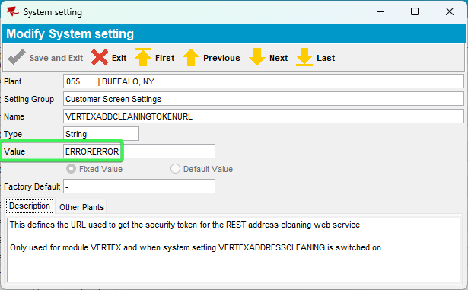
- Customers DLG: Press Add button > input a valid address
326 Amherst St, Buffalo, NY 14207, United States
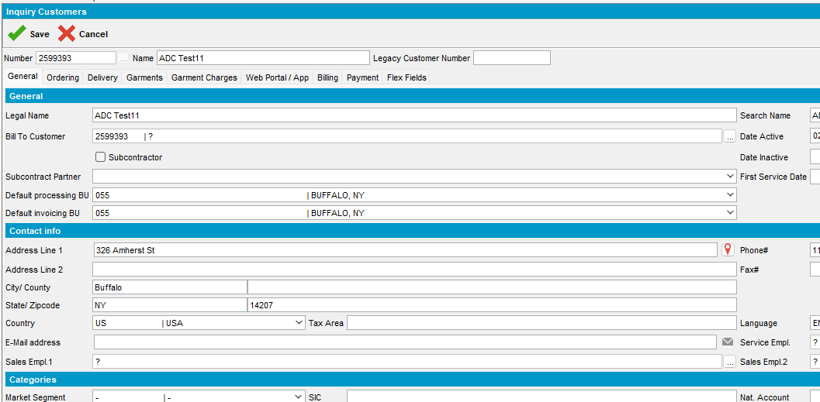
- Save your customer after completing all the required data
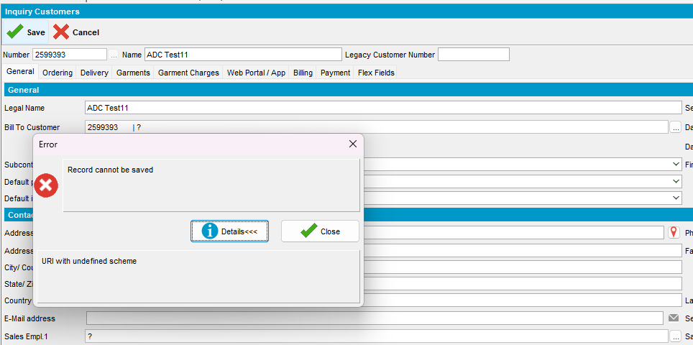
- Check ClientErrorLog to see that the call was logged
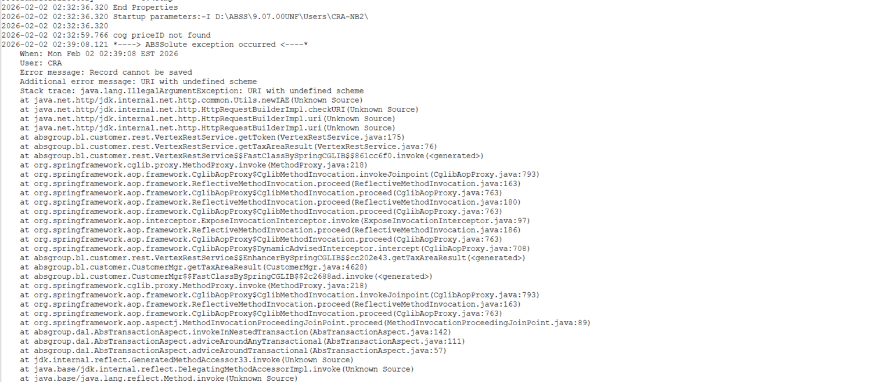
Tested OK

Test 9 – Add mode VERTEXUPDATEADDRESS = 2 with VERTEXADDCLEANINGTOKENURL having the default value “–“
Hash: 9.07.00.UNF21 hash: 115015c453a4
Expected behavior:
Show error on save, do not allow user to finish adding the customer.
Check ClientErrorLog for errors

Steps
- System settings: Have SS VERTEXUPDATEADDRESS = 2
- System settings: Have SS VERTEXADDCLEANINGTOKENURL = “-“
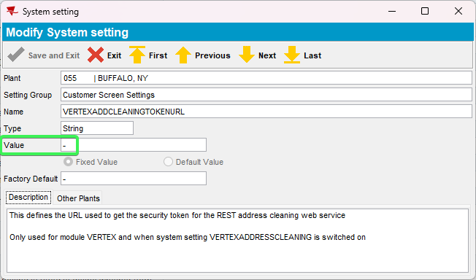
- Customers DLG: Press Add button > input a valid address
326 Amherst St, Buffalo, NY 14207, United States
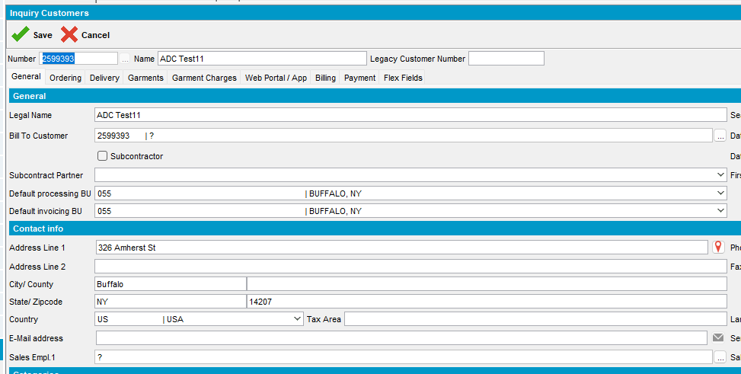
- Save your customer after completing all the required data
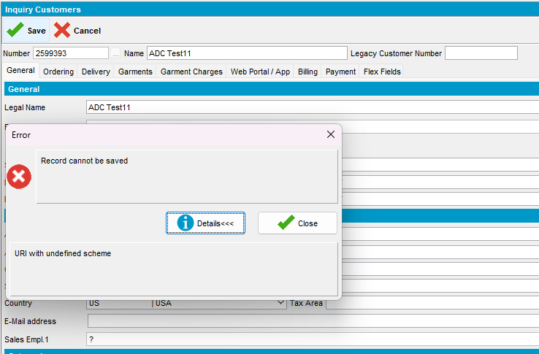
- Check ClientErrorLog to see that the call was logged
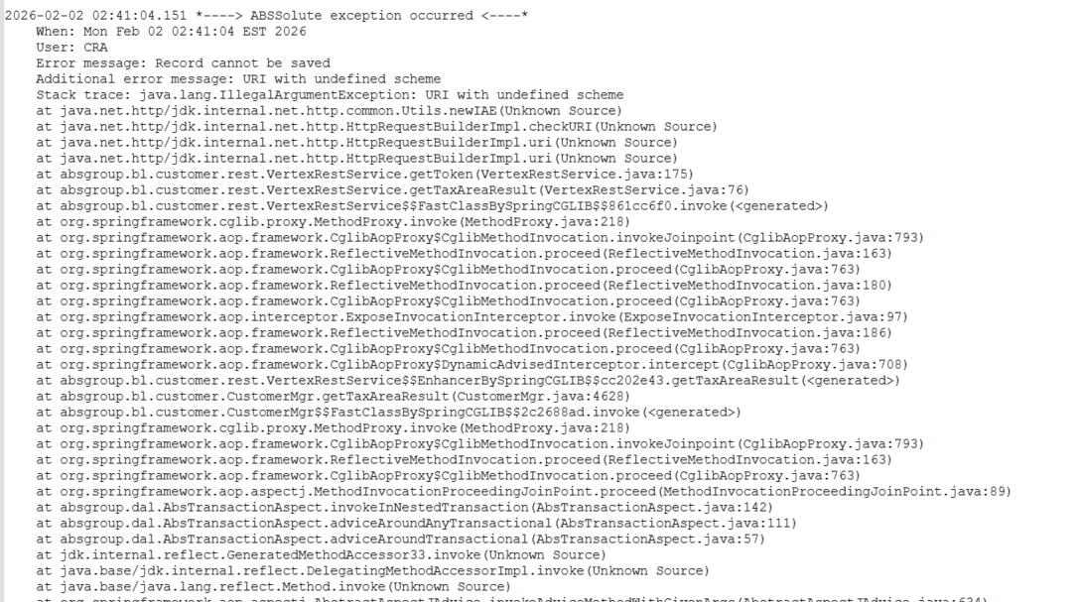
Tested OK

Test 10 – Add mode VERTEXUPDATEADDRESS = 2 with VERTEXADDCLEANINGCLIENTID having an incorrect string
Hash: 9.07.00.UNF21 hash: 115015c453a4
Expected behavior:
Show error on save, do not allow user to finish adding the customer.
Check ServerErrorLog, WebServiceLog for errors

Steps
- System settings: Have SS VERTEXUPDATEADDRESS = 2
- System settings: Have SS VERTEXADDCLEANINGCLIENTID = Wrong value
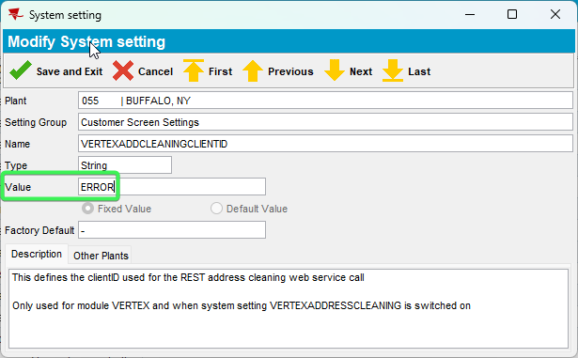
- Customers DLG: Press Add button > input a valid address
326 Amherst St, Buffalo, NY 14207, United States
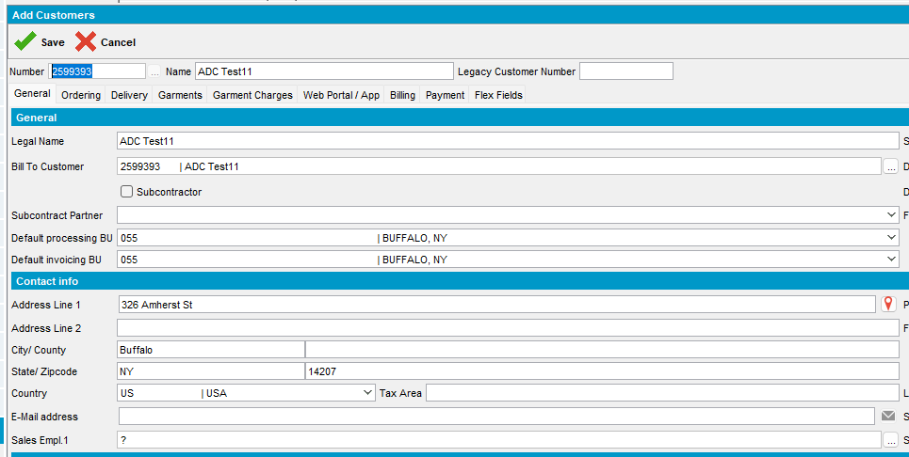
- Save your customer after completing all the required data
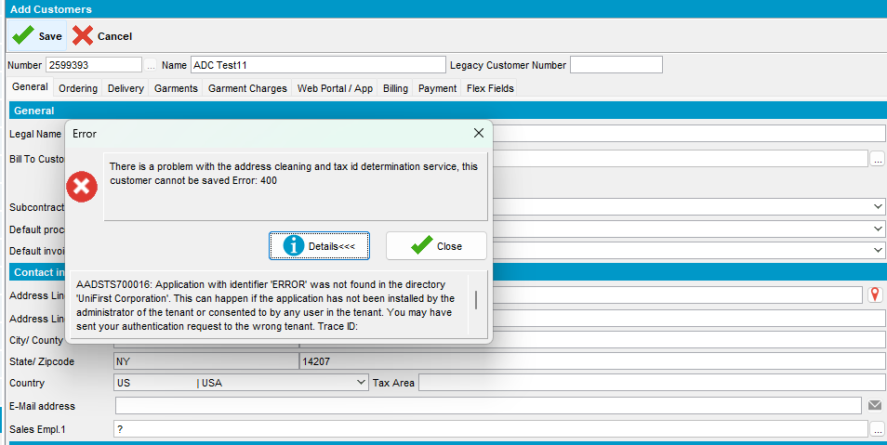
- Check ClientErrorLog to see that the call was logged
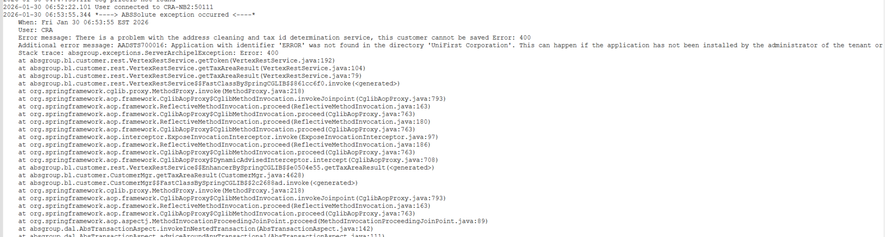
Tested OK

Test 11 – Add mode VERTEXUPDATEADDRESS = 2 with VERTEXADDCLEANINGCLIENTID having the default value “-“
Hash: 9.07.00.UNF21 hash: 115015c453a4
Expected behavior:
Show error on save, do not allow user to finish adding the customer.
Check ServerErrorLog, WebServiceLog for errors

Steps
- System settings: Have SS VERTEXUPDATEADDRESS = 2
- System settings: Have SS VERTEXADDCLEANINGCLIENTID = “-“
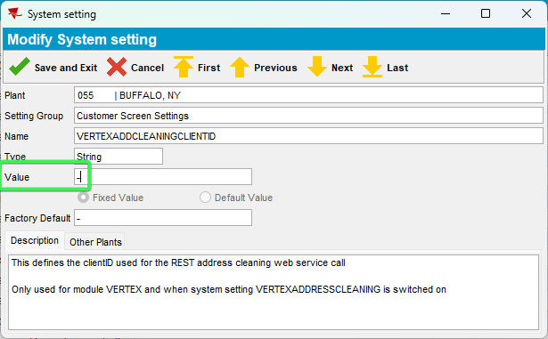
- Customers DLG: Press Add button > input a valid address
326 Amherst St, Buffalo, NY 14207, United States
- Save your customer after completing all the required data
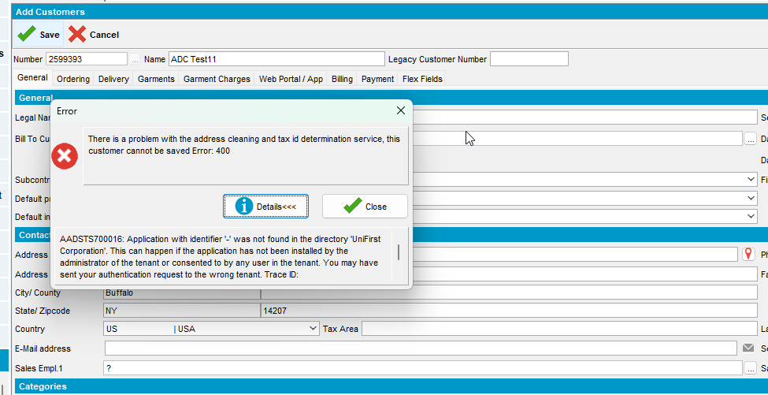
- Check ClientErrorLog to see that the call was logged
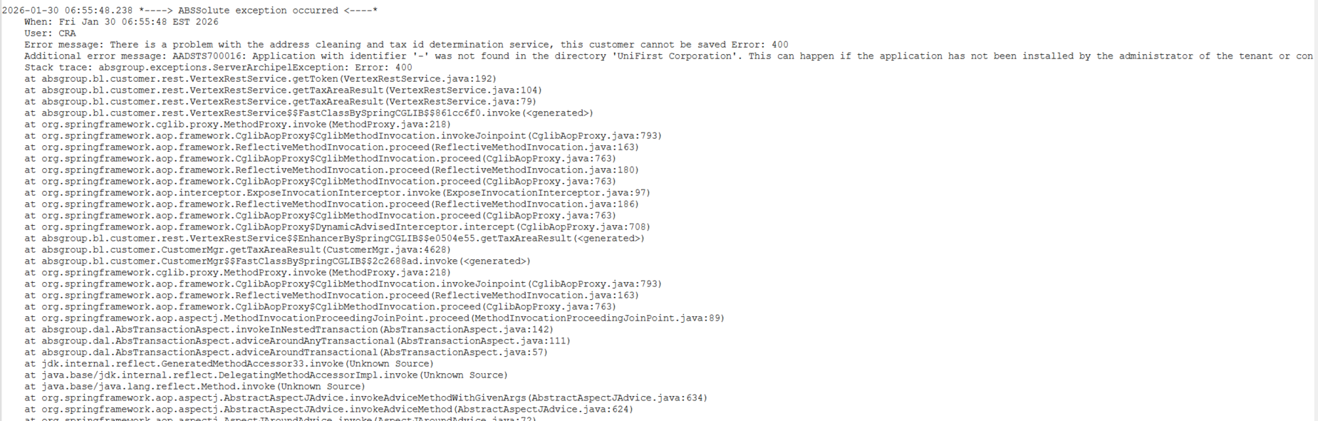
Tested OK

Customers DLG – Modify Mode Test Cases

Test 1 – Modify mode VERTEXUPDATEADDRESS = 0 general tab address is changed confidence <100%
Hash: 9.07.00.UNF21 hash: 115015c453a4
Expected behavior:
Show screen with both buttons no matter confidence check that both buttons work as expected:
Update only taxareaid -> saves only the taxareaid
Update all -> updates address and taxareaid
Check WebServiceLog to see that the call was logged.

Steps:
- System settings: Have SS VERTEXUPDATEADDRESS = 0
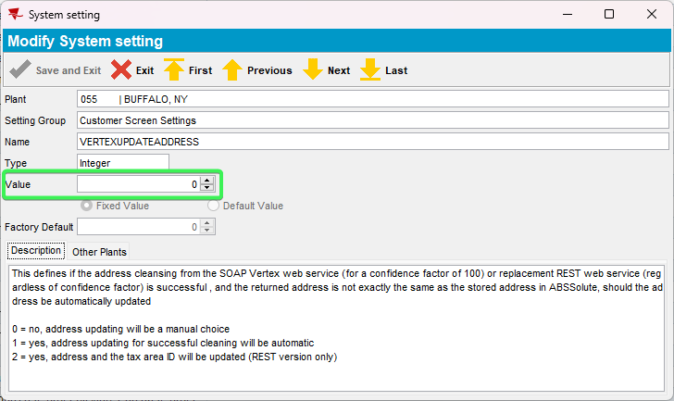

- Customers DLG: Input an existing customer: 2599383
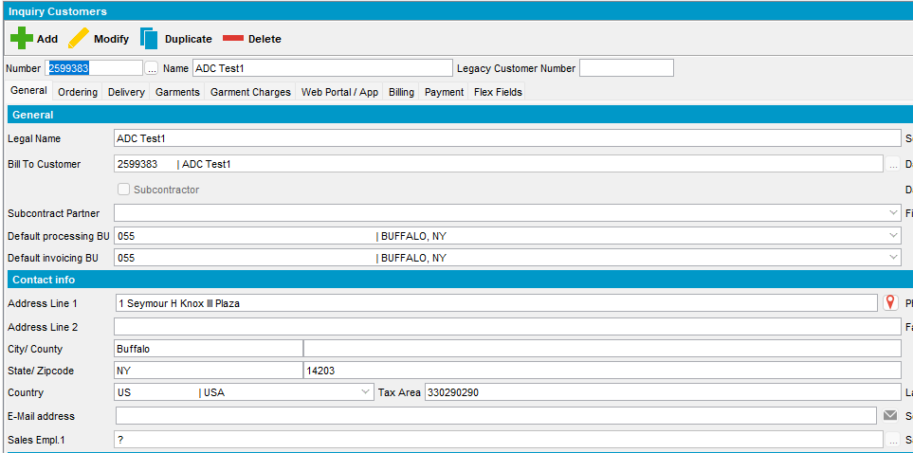
- Press Modify and input a different address General tab
Address: 4 Yawkey Way, Boston, MA 02215, United States
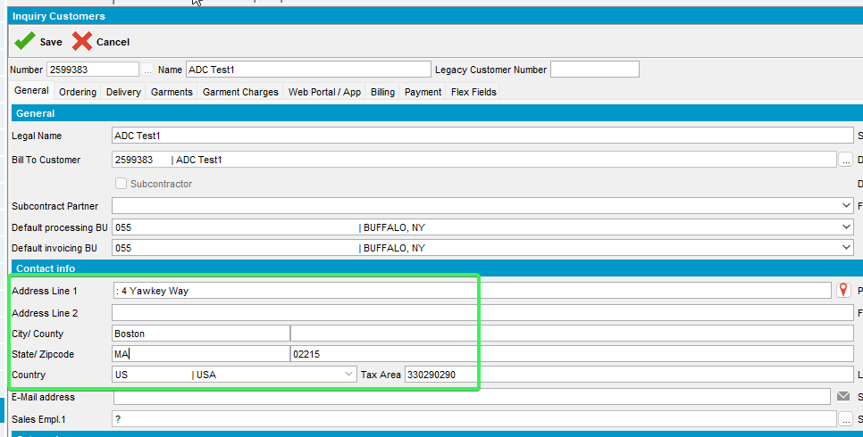

- Save the customer and On the Address Cleaning pop-up press “Update Tax Area Only and Exit” button for Contact Address
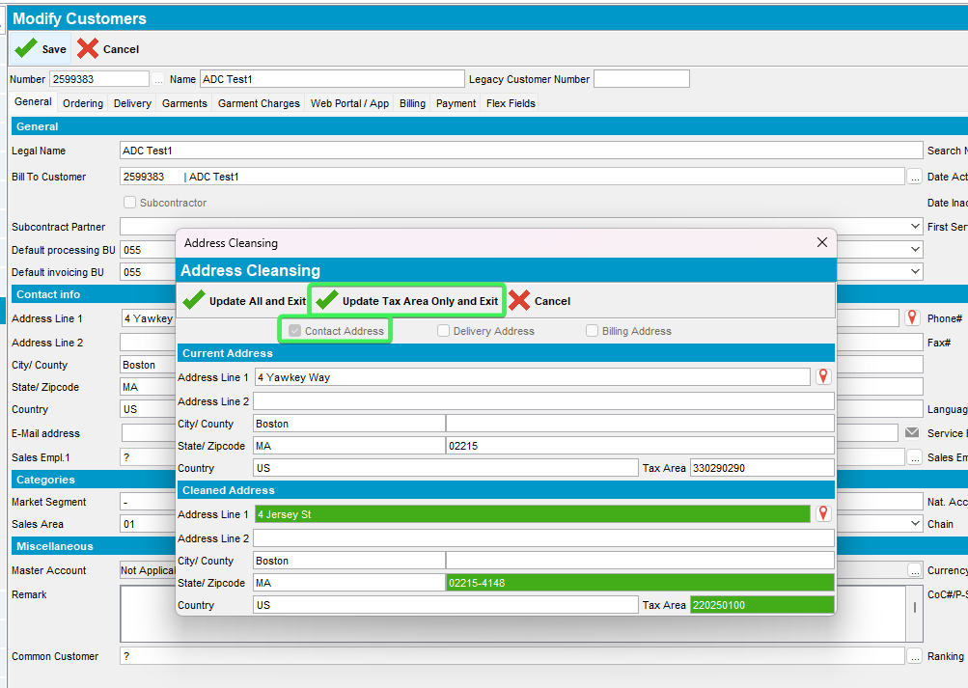
- Check that between the 2 displayed addresses only the Tax Area ID has changed
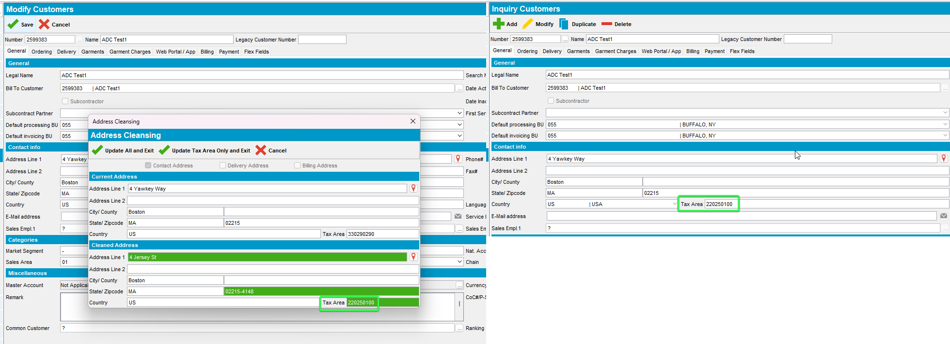
- Input another customer and press modify: 2599384
- Check that this customer has a <100 % Confidenceindicator
select at.*, s.username from addresstaxareaid at
join systemuser s on s.systemuser_id = at.systemuser_id
join address a1 on a1.address_id = at.address_id
join customer c on c.mailaddress_id = a1.address_id
where c.customernumber =2599384
order by s.timestamp desc;
- Change the address in General tab
Address: 4 Yawkey Way, Boston, MA 02215, United States
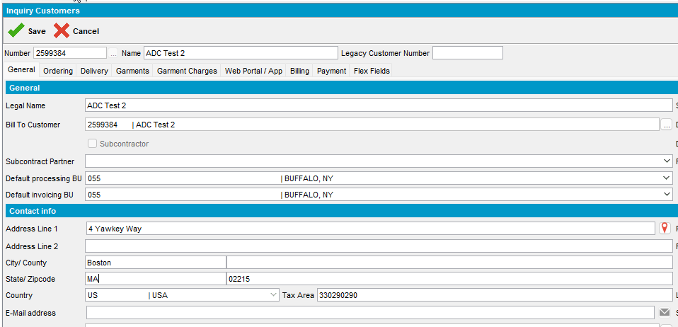
- Press save button and for Contract Address use the Update All and Exit button
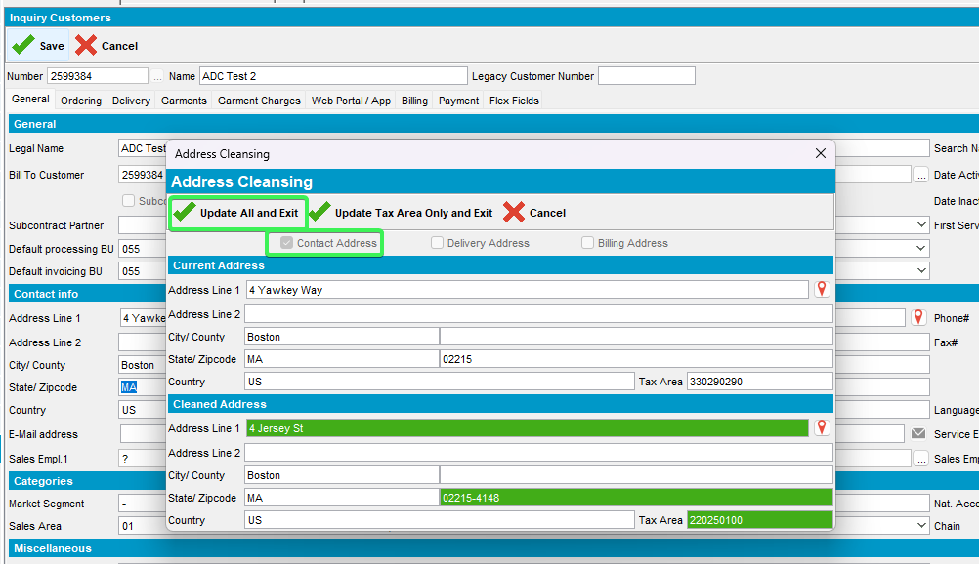
- Check that all the fields in address in General tab have been updated
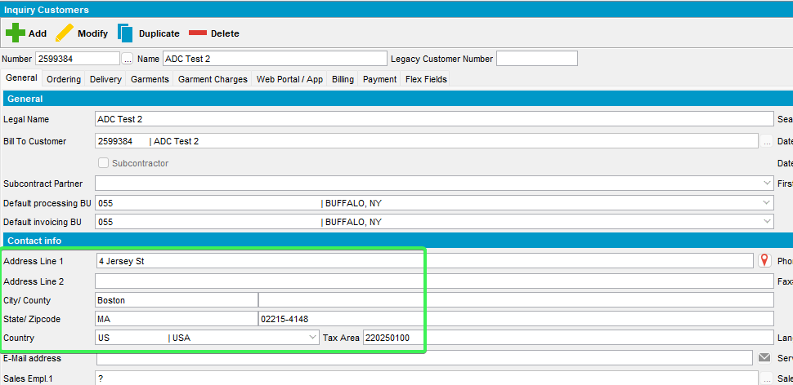
- Check that on delivery and Billing tabs the address has not changed
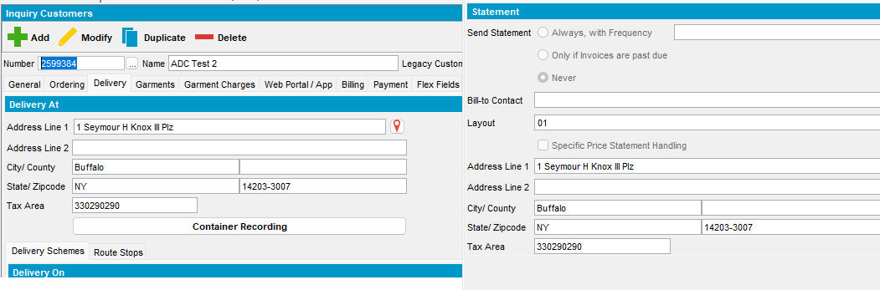
- Check WebServiceLog to see that the call was logged
Select * from Webservicelog WSL
where wsl.application='UNFAddressCleaning' and customer=2599384
order by wsl.requesttimestamp desc
Tested OK

Test 2 – Modify mode VERTEXUPDATEADDRESS = 0 general tab address is changed confidence =100%
Hash: 9.07.00.UNF21 hash: 115015c453a4
Expected behavior:
Show screen with both buttons no matter confidence check that both buttons work as expected:
Update only taxareaid -> saves only the taxareaid
Update all -> updates address and taxareaid
Check WebServiceLog to see that the call was logged.
Steps:

- System settings: Have SS VERTEXUPDATEADDRESS = 0

- Customers DLG: Input an existing customer: 2599385
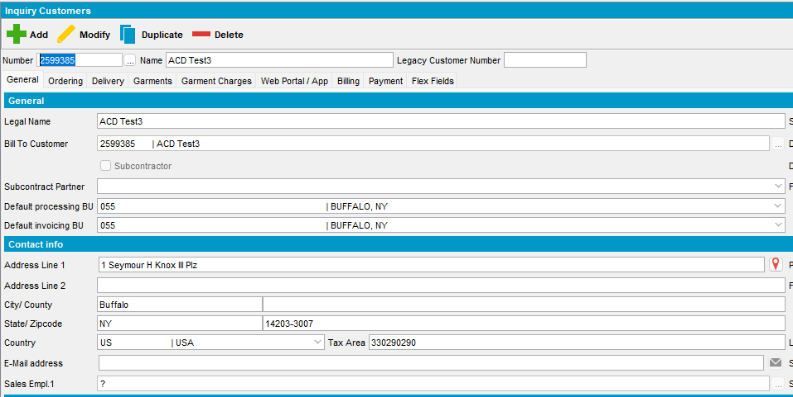
- Check the Confidence indicator, it must be 100
select at.*, s.username from addresstaxareaid at
join systemuser s on s.systemuser_id = at.systemuser_id
join address a1 on a1.address_id = at.address_id
join customer c on c.mailaddress_id = a1.address_id
where c.customernumber =2599385
order by s.timestamp desc;
- Press Modify and input a different address in the General, Delivery and Billing tabs
Address: 4 Yawkey Way, Boston, MA 02215, United States
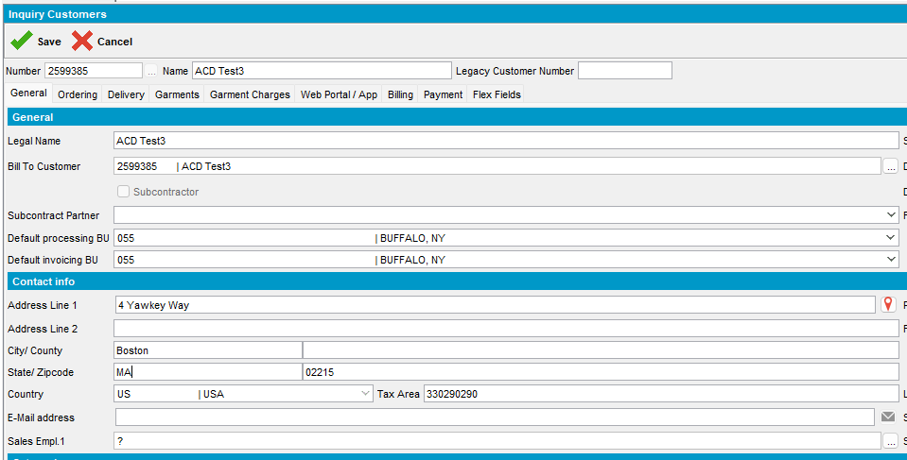
- Save the customer
- On the Address Cleaning pop-up for Contacts tab press “Update Tax Area Only and Exit” button
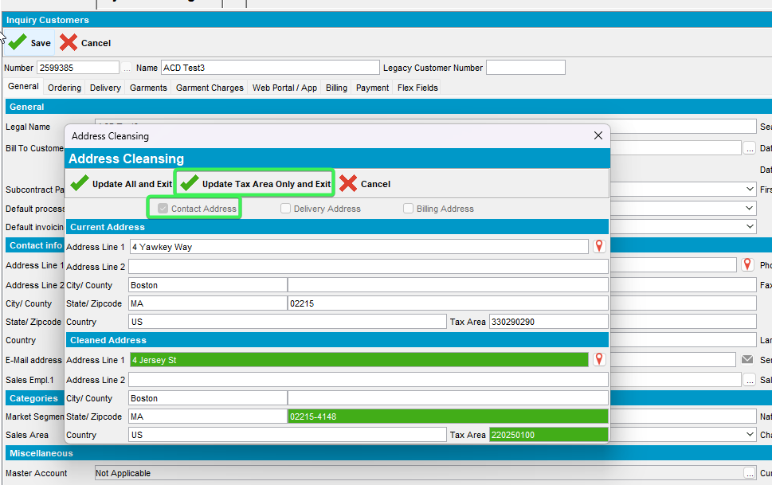
- Check that only the Tax Area ID has been updated
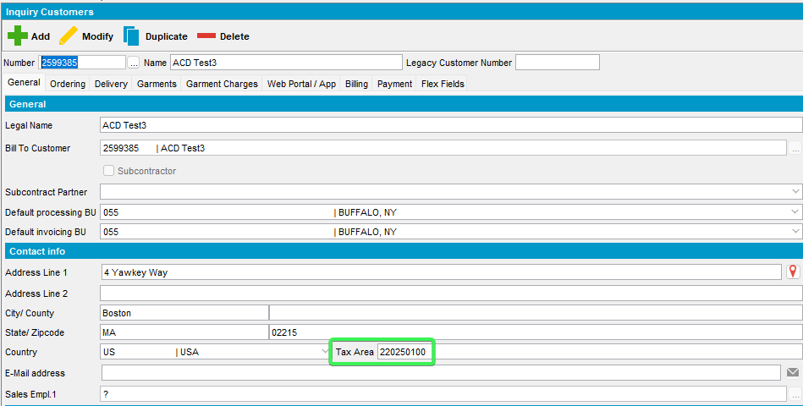
- Input another customer and press modify: 2599386
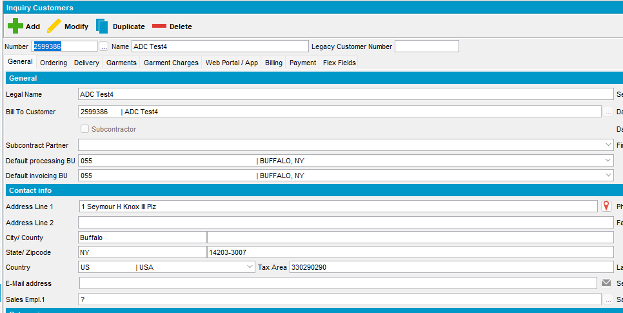
- Check the confidenceindicator
select at.*, s.username from addresstaxareaid at
join systemuser s on s.systemuser_id = at.systemuser_id
join address a1 on a1.address_id = at.address_id
join customer c on c.mailaddress_id = a1.address_id
where c.customernumber =2599386
order by s.timestamp desc;
- Change the address in General tab
Address: 4 Yawkey Way, Boston, MA 02215, United States
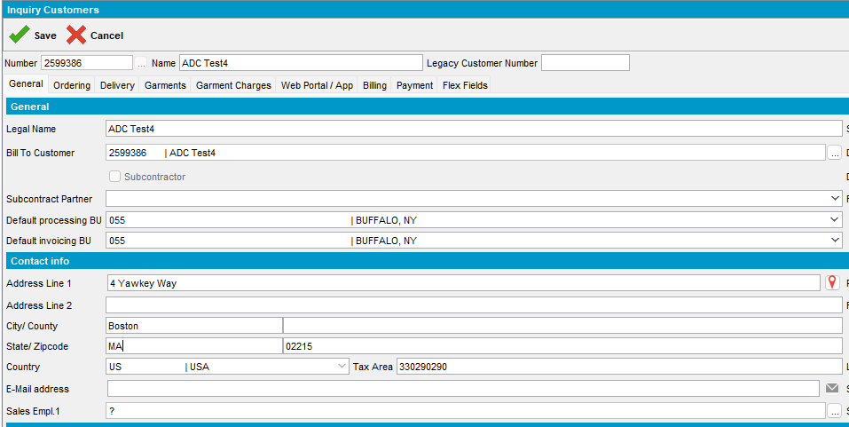
- Press save button and on the pop-up screen select “Update all and exit” for Contact Address
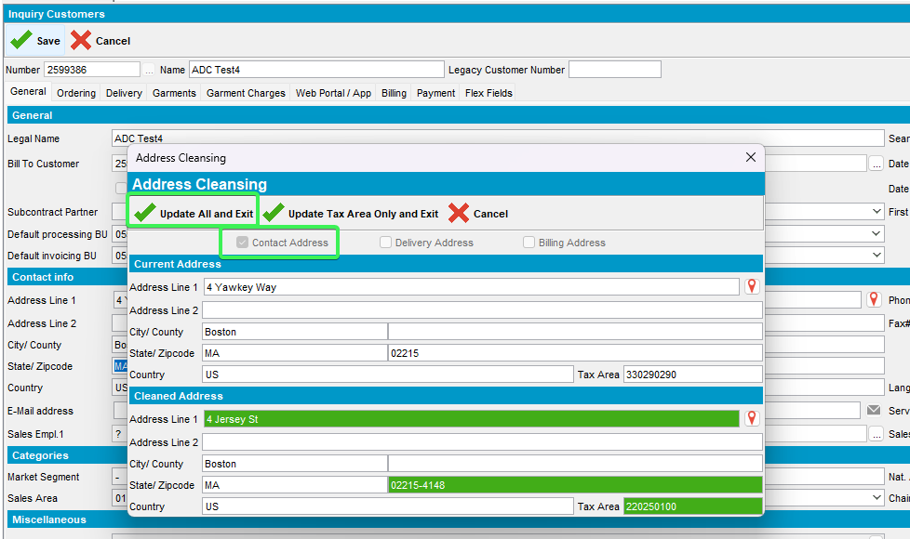
- Check that all the fields in address in General tab have been updated
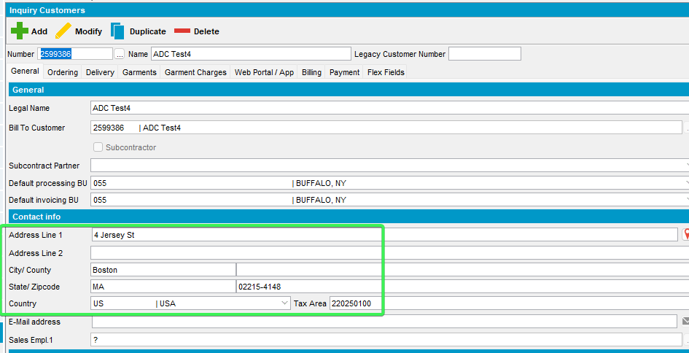
- Check that on delivery and Billing tabs the address has not changed
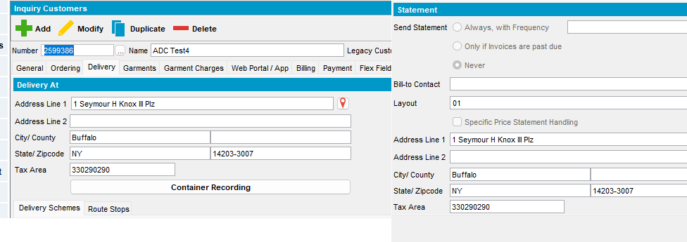
- Check WebServiceLog to see that the call was logged
Select * from Webservicelog WSL
where wsl.application='UNFAddressCleaning' and customer=2599386
order by wsl.requesttimestamp desc
Tested OK

Test 3 – Modify mode VERTEXUPDATEADDRESS = 1 general tab address is changed confidence <100%
Hash: 9.07.00.UNF21 hash: 115015c453a4
Expected behavior:
Show screen with both buttons no matter confidence check that both buttons work as expected:
Update only taxareaid -> saves only the taxareaid
Update all à updates address and taxareaid
Check WebServiceLog to see that the call was logged.

Steps
- System settings: Have SS VERTEXUPDATEADDRESS = 1
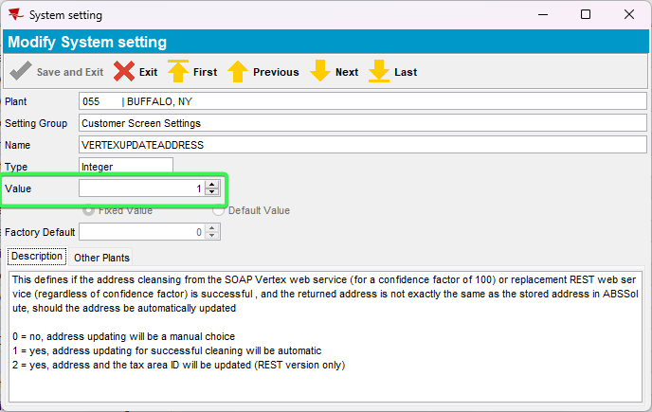

- Customers DLG: Input an existing customer: 2599387
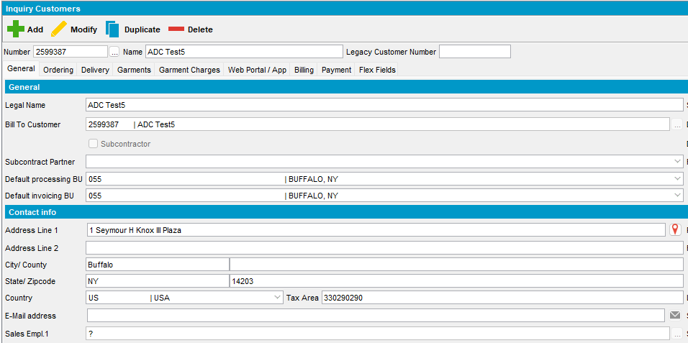
- Check the Confidence indicator, it must be <100
select at.*, s.username from addresstaxareaid at
join systemuser s on s.systemuser_id = at.systemuser_id
join address a1 on a1.address_id = at.address_id
join customer c on c.mailaddress_id = a1.address_id
where c.customernumber =2599387
order by s.timestamp desc;
- Press Modify and input a different address General tab
Address: 4 Yawkey Way, Boston, MA 02215, United States
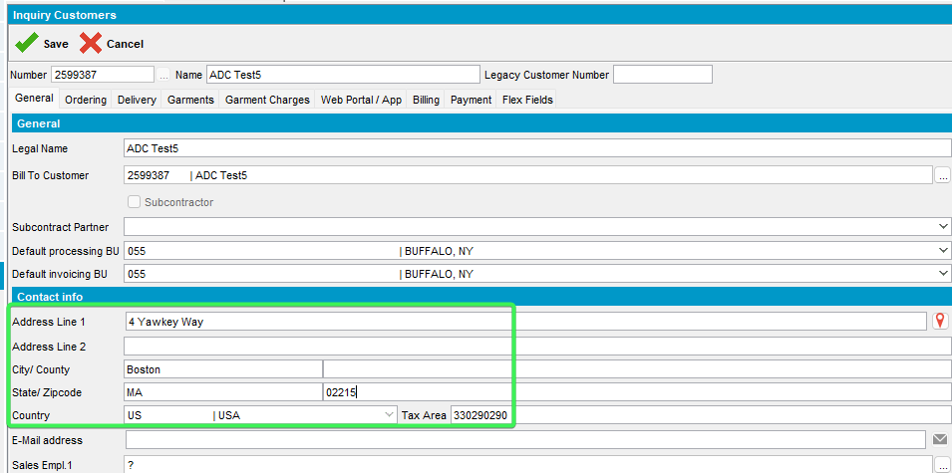
- Save the customer and on the Address Cleaning pop-up press “Update Tax Area Only and Exit” button for Contact Address
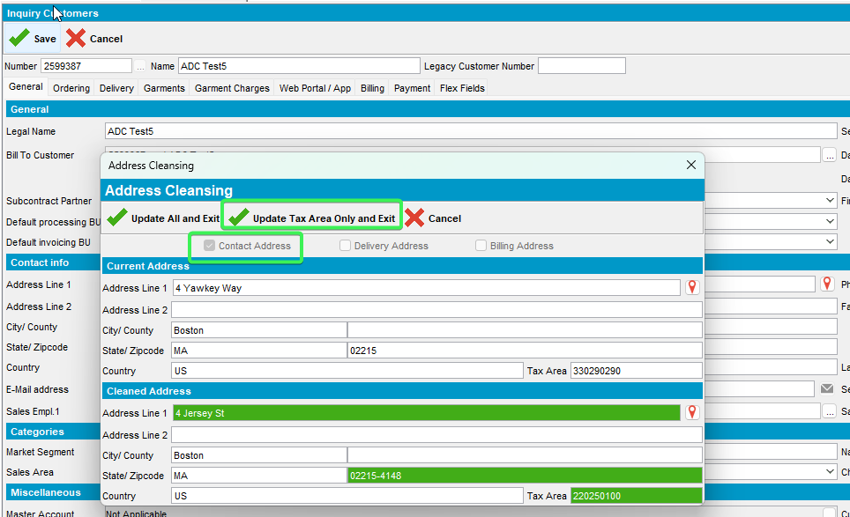
- Check that between the 2 displayed addresses only the Tax Area ID has changed
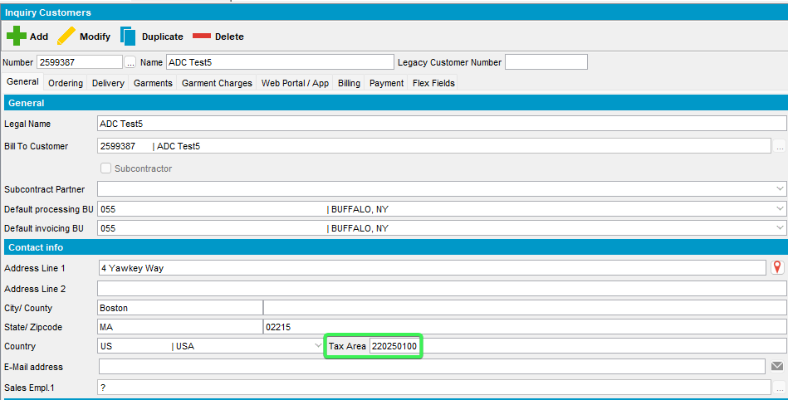
- Check that the address for Delivery and Billing tab has not changed
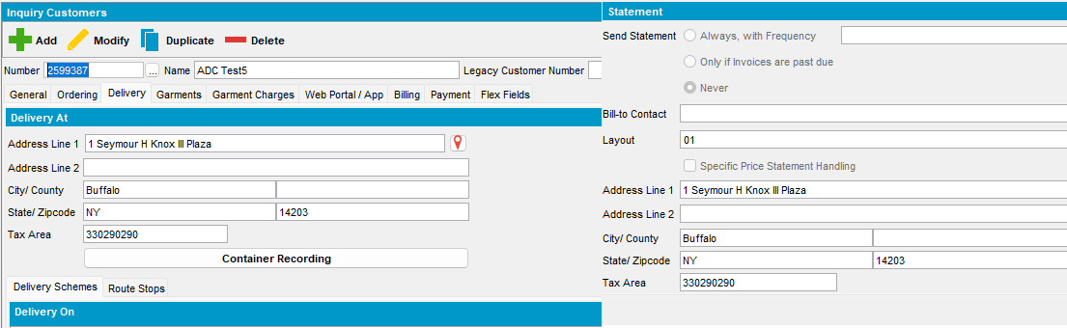
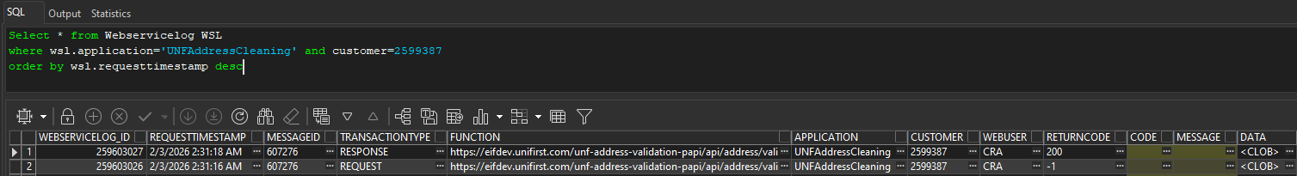
- Input another customer and press modify: 2599388
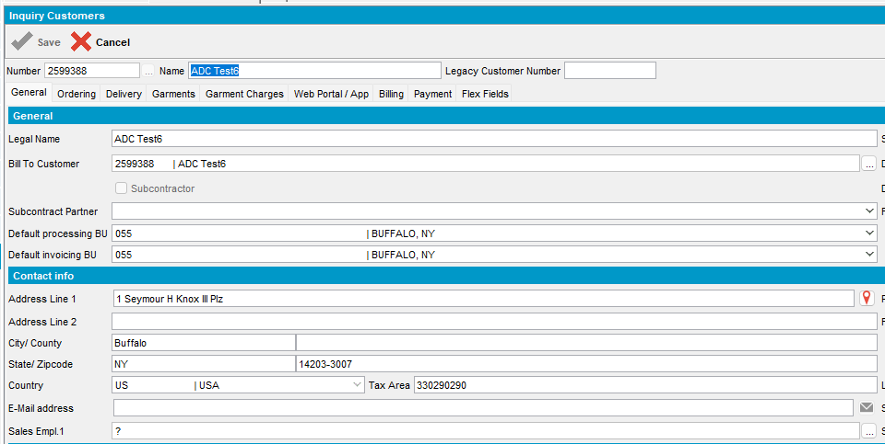
- Check that this customer has a <100 % Confidenceindicator
select at.*, s.username from addresstaxareaid at
join systemuser s on s.systemuser_id = at.systemuser_id
join address a1 on a1.address_id = at.address_id
join customer c on c.mailaddress_id = a1.address_id
where c.customernumber =2599388
order by s.timestamp desc;
- Change the address in General tab
Address: 4 Yawkey Way, Boston, MA 02215, United States
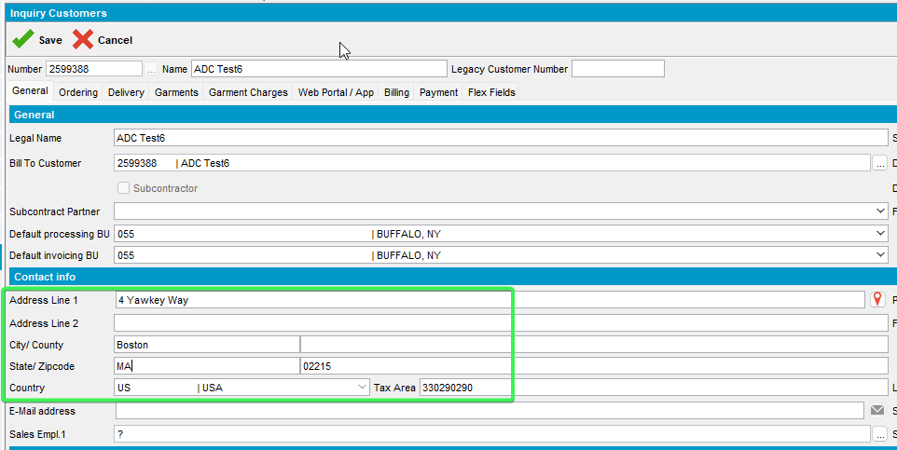
- Press save button and for Contract Address use the Update All and Exit button
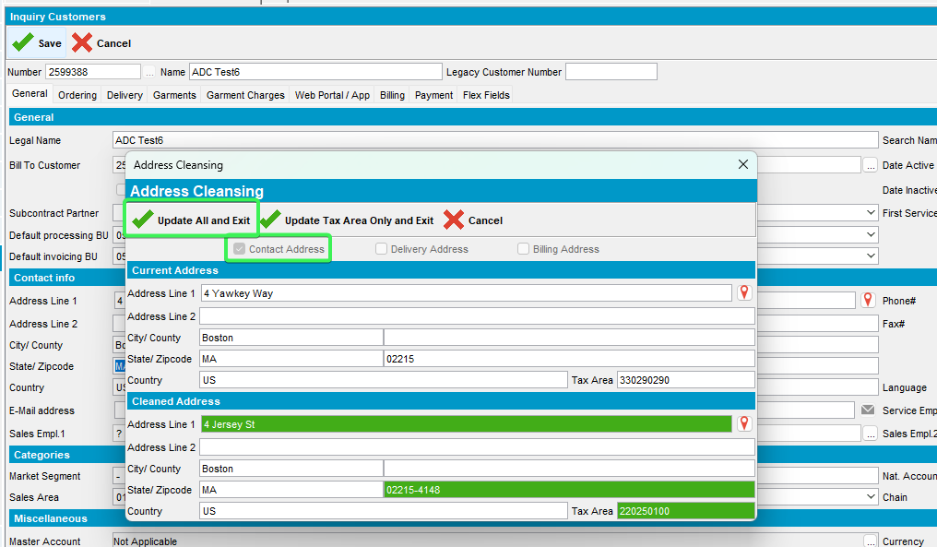
- Check that all the fields in address in General tab have been updated
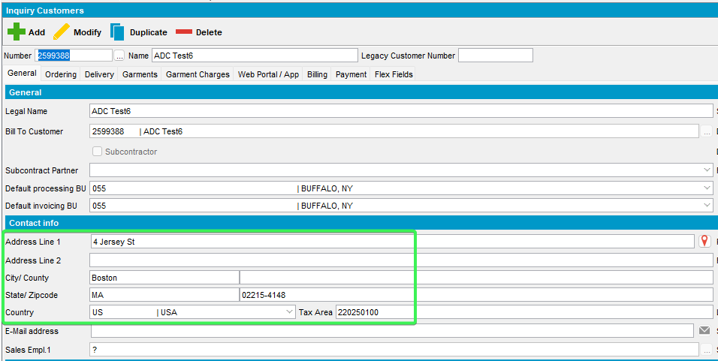
- Check that on delivery and Billing tabs the address has not changed
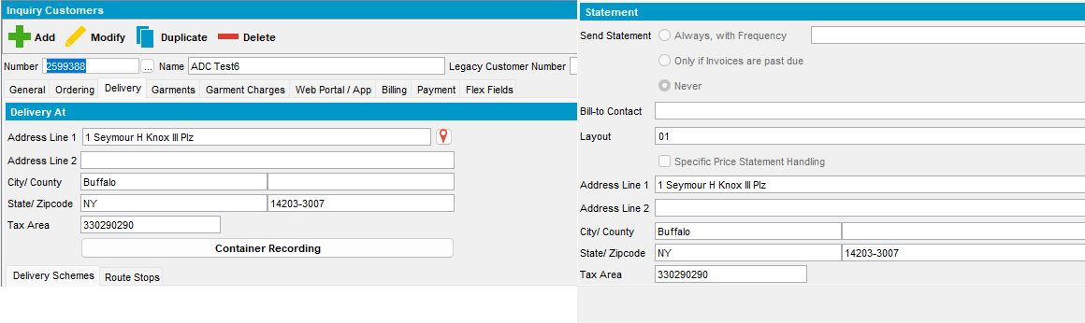
- Check WebServiceLog to see that the call was logged
Select * from Webservicelog WSL
where wsl.application='UNFAddressCleaning' and customer=2599388
order by wsl.requesttimestamp desc

Test 4 – Modify mode VERTEXUPDATEADDRESS = 1 delivery tab address is changed confidence =100%
Hash: 9.07.00.UNF21 hash: 115015c453a4
Expected behavior:
No screen shown, both address and taxareaid are updated
Check WebServiceLog to see that the call was logged.

Steps:
- System settings: Have SS VERTEXUPDATEADDRESS = 1

- Customers DLG: Input an existing customer: 2599389
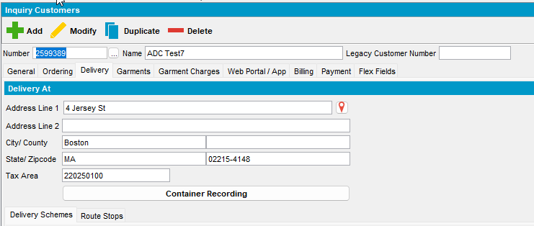
- Press Modify and input a different clean address Delivery tab
Address: 1 Seymour H Knox III Plz, Buffalo, NY 14203-3007, United States
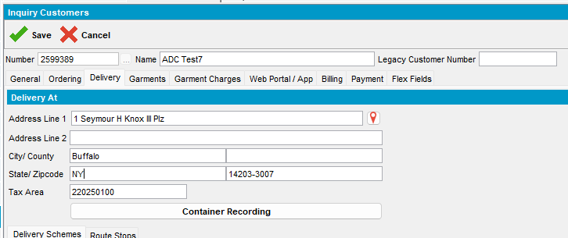
- Save the customer modification
- Check the confidence indicator for delivery tab
select at.*, s.username from addresstaxareaid at
join systemuser s on s.systemuser_id = at.systemuser_id
join address a1 on a1.address_id = at.address_id
join customer c on c.visitaddress_id = a1.address_id
where c.customernumber =2599389
order by s.timestamp desc;
- Check WebServiceLog to see that the call was logged
Select * from Webservicelog WSL
where wsl.application='UNFAddressCleaning' and customer=2599389
order by wsl.requesttimestamp desc
Tested OK

Test 5 – Modify mode VERTEXUPDATEADDRESS = 2 Billing tab address is changed confidence <100%
Hash: 9.07.00.UNF21 hash: 115015c453a4
Expected behavior:
Show screen with only one button:
Update all -> updates address and taxareaid
Check WebServiceLog to see that the call was logged.

Steps:
- System settings: Have SS VERTEXUPDATEADDRESS = 2
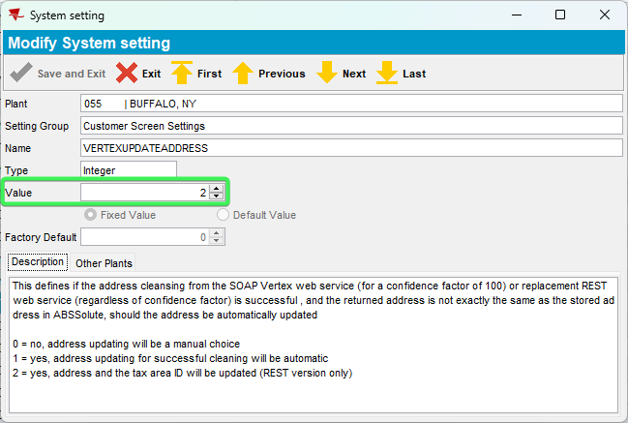
- Customers DLG: input an existing customer: 2599390 and see the Billing address
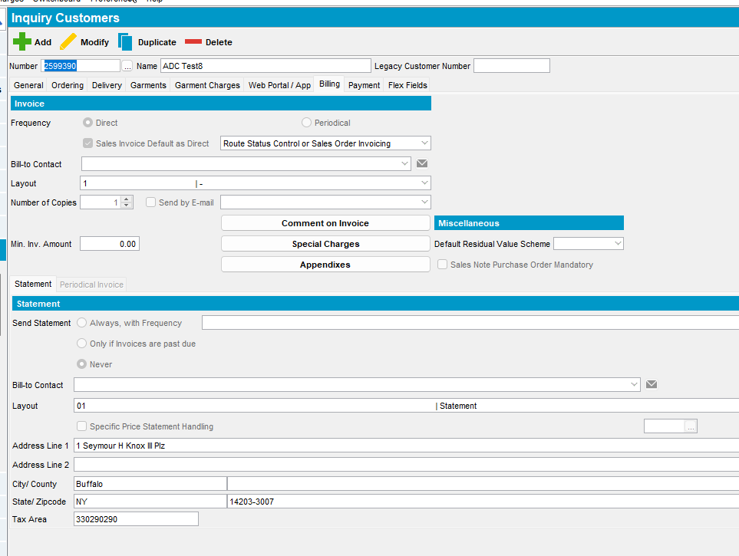
- Change the address with a low confidence address like: 4 Yawkey Way, Boston, MA 02215, United States
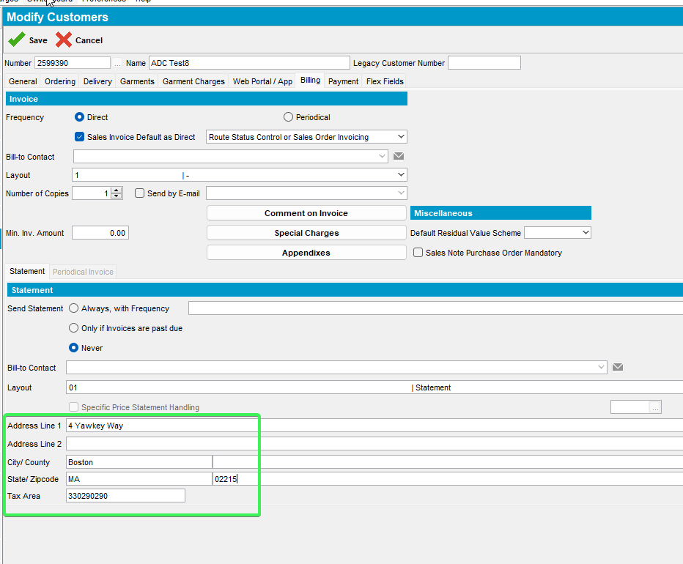
- Save the customer and on the pop-up message press Update All and Exit for Billing Address
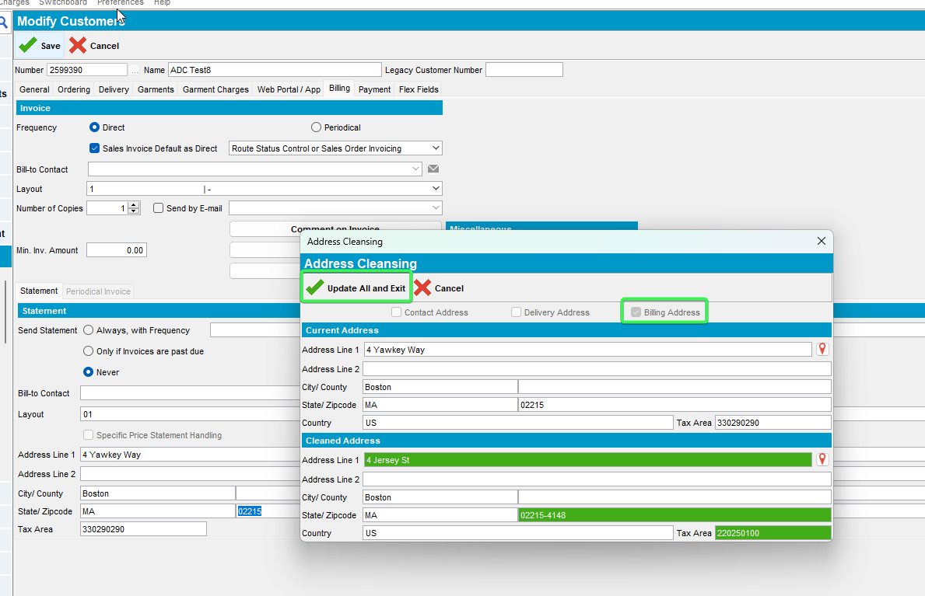
- Verify that the address has been updated for billing tab
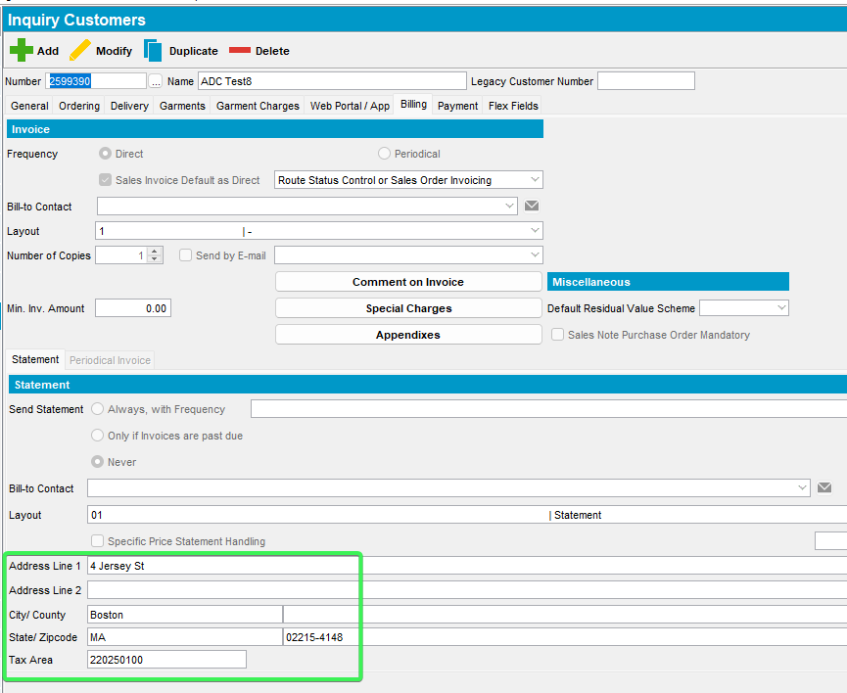
- Check that the address did not change for General or Delivery tab
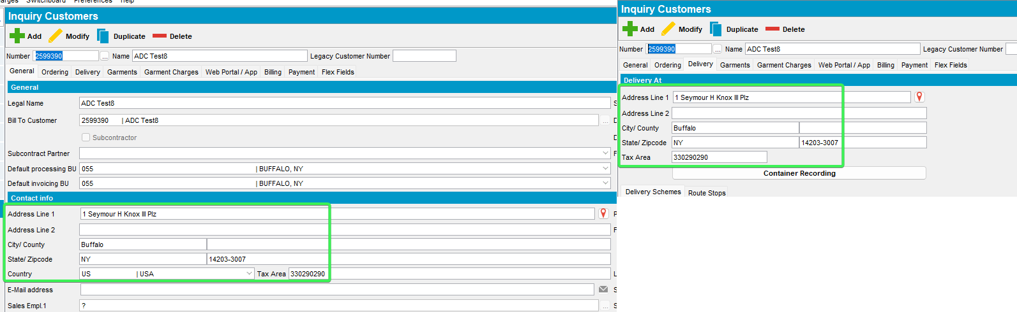
- Verify the confidence indicator that is <100%
select at.*, s.username from addresstaxareaid at
join systemuser s on s.systemuser_id = at.systemuser_id
join address a1 on a1.address_id = at.address_id
join customer c on c.invoiceaddress_id = a1.address_id
where c.customernumber =2599390
order by s.timestamp desc;
- Check WebServiceLog to see that the call was logged
Select * from Webservicelog WSL
where wsl.application='UNFAddressCleaning' and customer=2599390
order by wsl.requesttimestamp desc
Tested OK

Test 6 – Modify mode VERTEXUPDATEADDRESS = 2 Billing tab address is changed confidence =100%
Hash: 9.07.00.UNF21 hash: 115015c453a4
Expected behavior:
Show screen with only one button:
Update all -> updates address and taxareaid
Check WebServiceLog to see that the call was logged.

- System settings: Have SS VERTEXUPDATEADDRESS = 2
- Customers DLG: input an existing customer: 2599391 and see the Billing address
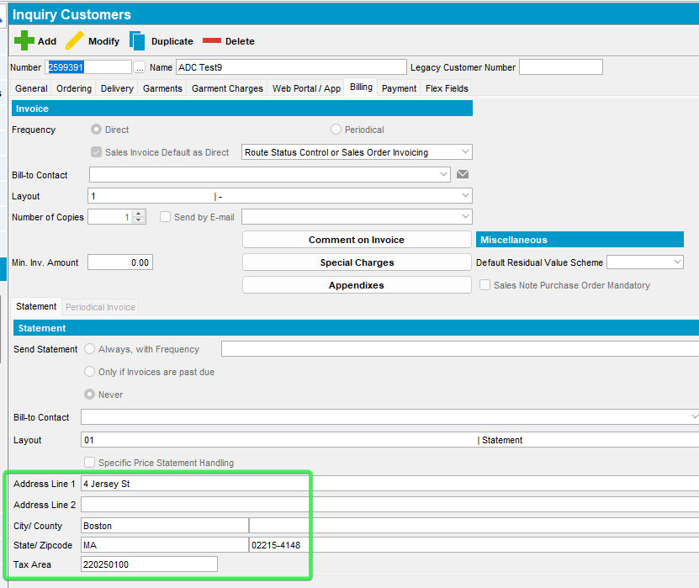
- Change the address with a 100% confidence address like: 1 Seymour H Knox III Plz, Buffalo, NY 14203-3007, United States
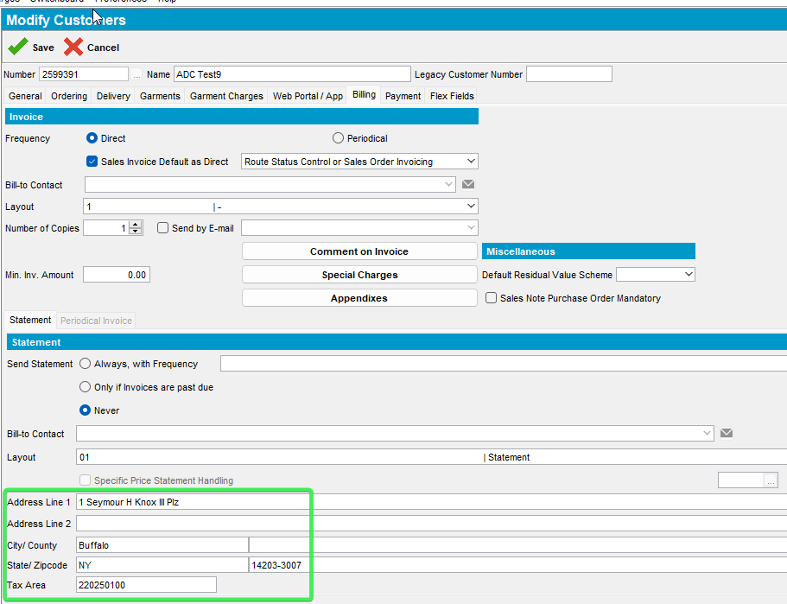
- Save the customer and on the pop-up message press Update All and Exit for Billing Address
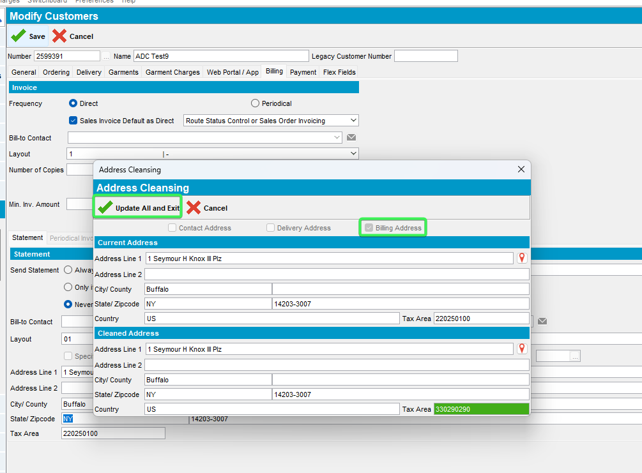
- Verify that the address has been updated for billing tab
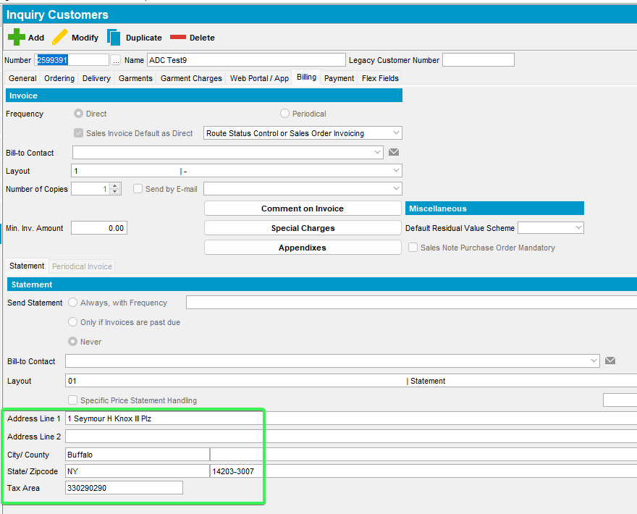
- Verify the confidence indicator that is =100%
select at.*, s.username from addresstaxareaid at
join systemuser s on s.systemuser_id = at.systemuser_id
join address a1 on a1.address_id = at.address_id
join customer c on c.invoiceaddress_id = a1.address_id
where c.customernumber =2599391
order by s.timestamp desc;
- Check WebServiceLog to see that the call was logged
Select * from Webservicelog WSL
where wsl.application='UNFAddressCleaning' and customer=2599391
order by wsl.requesttimestamp desc
Tested OK

Test 7 – Modify mode VERTEXUPDATEADDRESS = 2 with VERTEXADDCLEANINGTOKENURL having an incorrect string – modify any address on an existing customer
Hash: 9.07.00.UNF21 hash: 115015c453a4

Expected behavior:
Show error on save, do not allow user to finish adding the customer.
Check ServerErrorLog, WebServiceLog for errors
Check WebServiceLog to see that the call was logged.

Steps:
- System settings: Have SS VERTEXUPDATEADDRESS = 2
- System settings: Have SS VERTEXADDCLEANINGTOKENURL = with wrong TOKEN
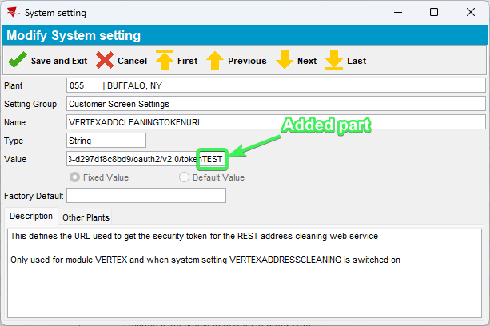
- Customers DLG: Input an existing customer 2599391 > change the address
326 Amherst St, Buffalo, NY 14207, United States
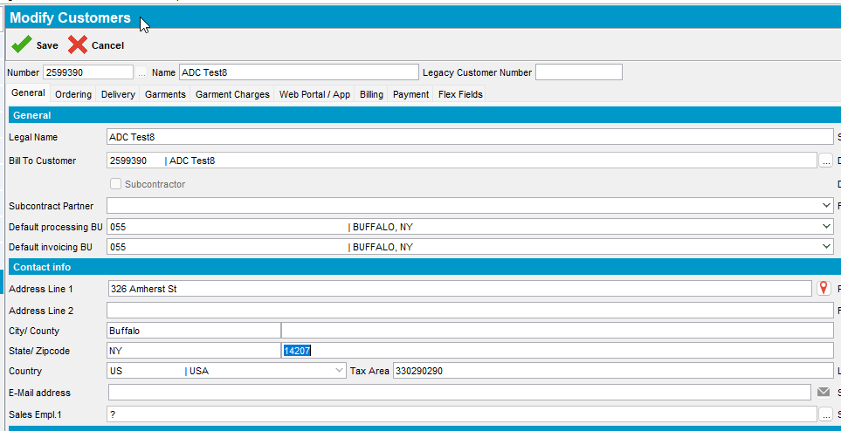
- Save your customer after completing all the required data
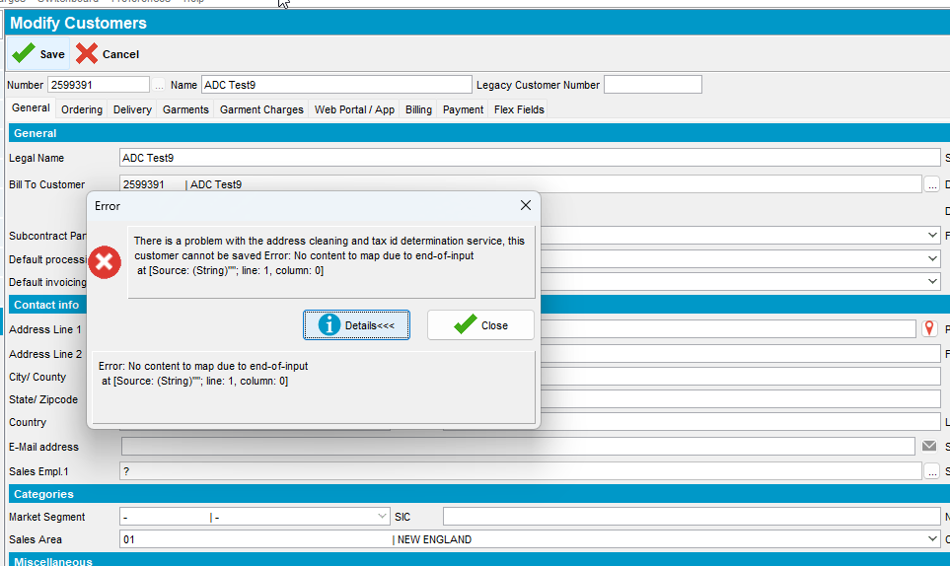
- Check ClientErrorLog to see that the call was logged
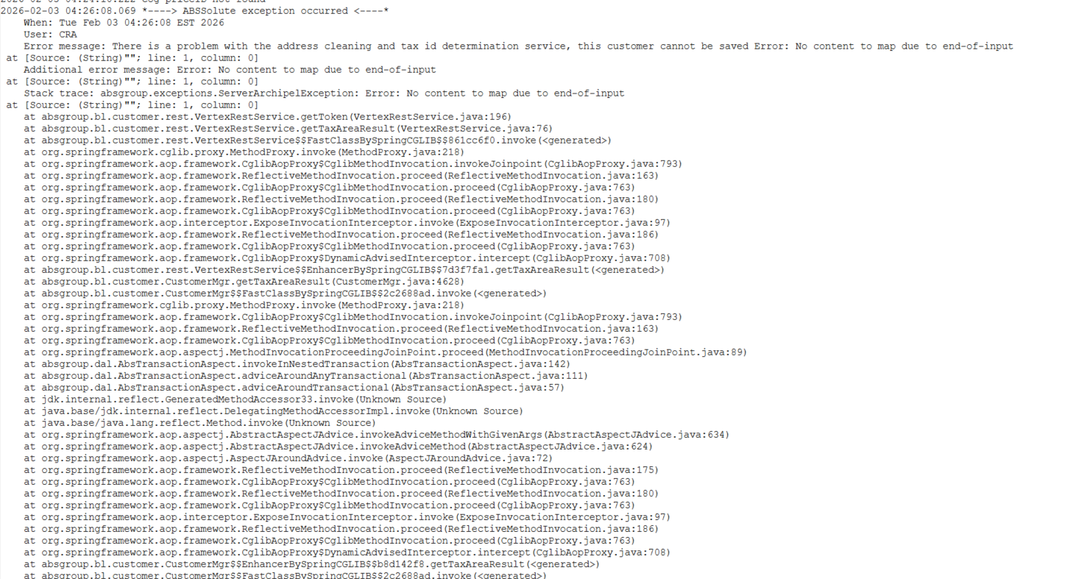
- Check the Webservicelog and see that a request was made and response was received
Select * from Webservicelog WSL
where wsl.application='UNFAddressCleaning' and wsl.requesttimestamp >sysdate -1
order by wsl.requesttimestamp desc
Tested OK

Test 8 – Modify mode VERTEXUPDATEADDRESS = 2 with VERTEXADDCLEANINGTOKENURL having default string “-“ – modify any address on an existing customer
Hash: 9.07.00.UNF21 hash: 115015c453a4
Expected behavior:
Show error on save, do not allow user to finish adding the customer.
Check ServerErrorLog, WebServiceLog for errors

- System settings: Have SS VERTEXUPDATEADDRESS = 2
- System settings: Have SS VERTEXADDCLEANINGTOKENURL = the default value “–“
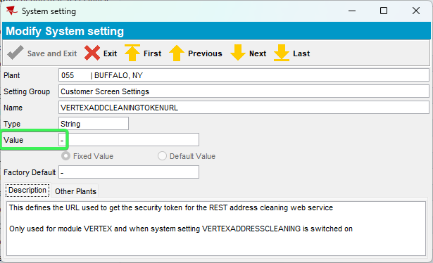
- Customers DLG: Input an existing customer 2599391 > change the address
326 Amherst St, Buffalo, NY 14207, United States
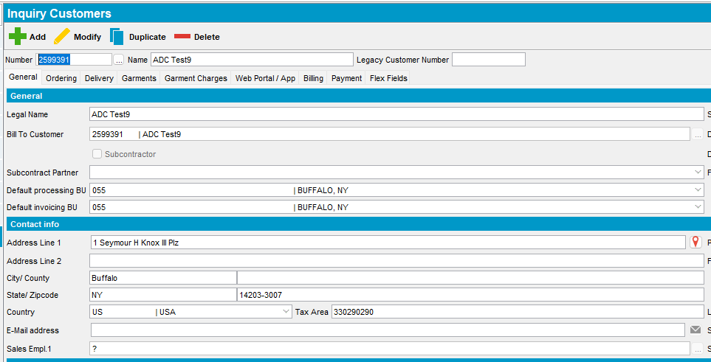
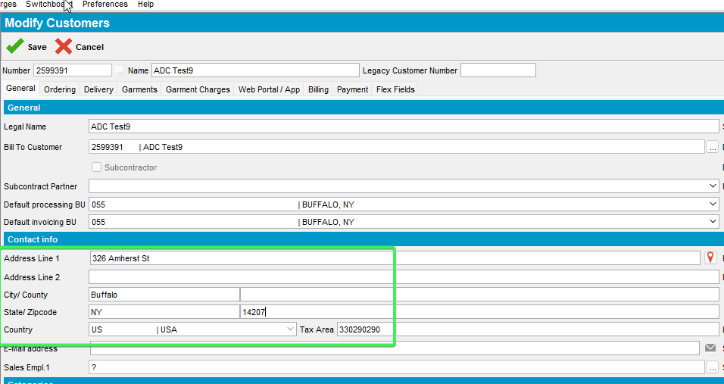
- Save your customer after completing all the required data
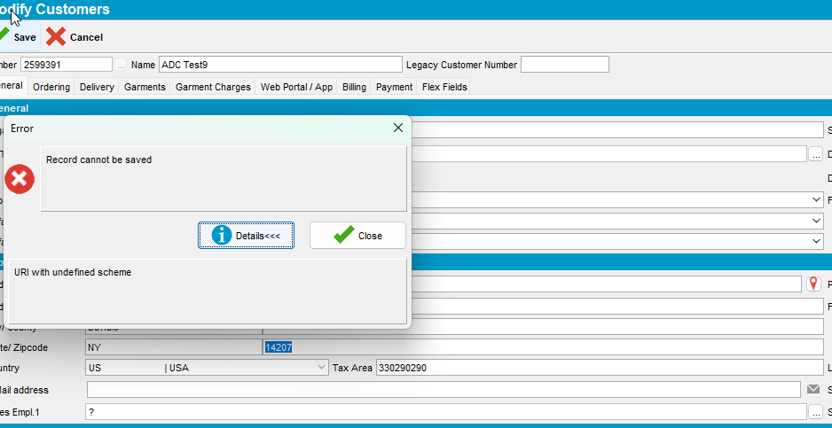
- Check ClientErrorLog to see that the call was logged
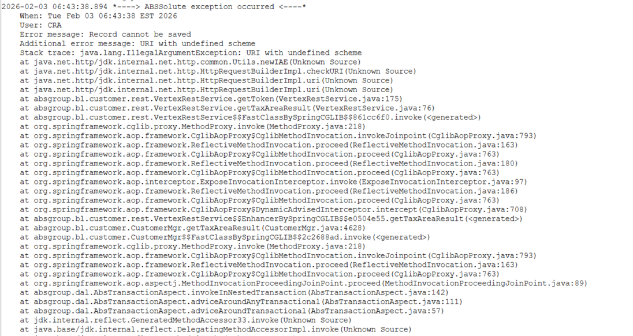
Tested OK

Test 9 – Modify mode VERTEXUPDATEADDRESS = 2 with VERTEXADDCLEANINGCLIENTID having an incorrect string – modify any address on an existing customer
Hash: 9.07.00.UNF21 hash: 115015c453a4
Expected behavior:
Show error on save, do not allow user to finish adding the customer.
Check ServerErrorLog, WebServiceLog for errors
- System settings: Have SS VERTEXUPDATEADDRESS = 2
- System settings: Have SS VERTEXADDCLEANINGCLIENTID = with wrong TOKEN
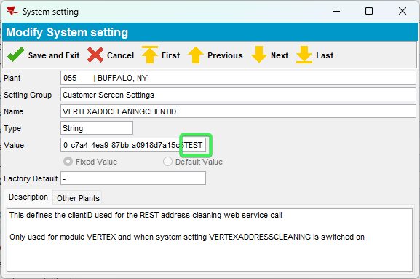
- Customers DLG: Input an existing customer 2599391 > change the address
326 Amherst St, Buffalo, NY 14207, United States
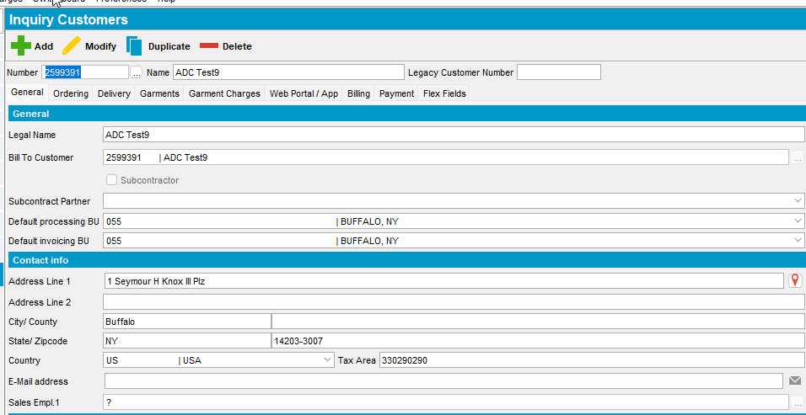
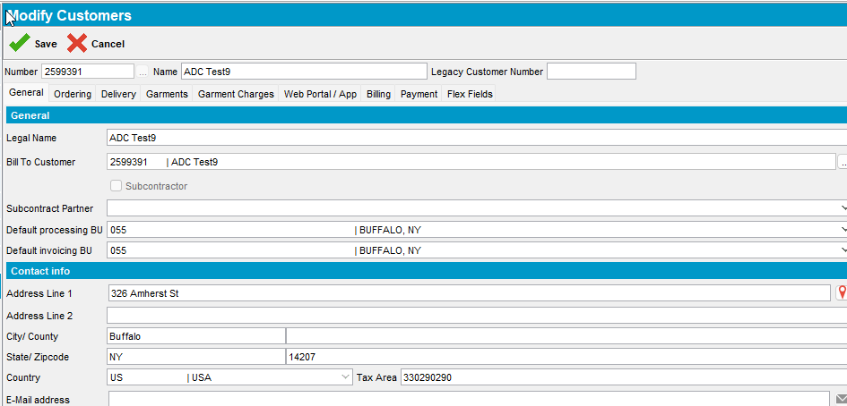
- Save your customer after completing all the required data
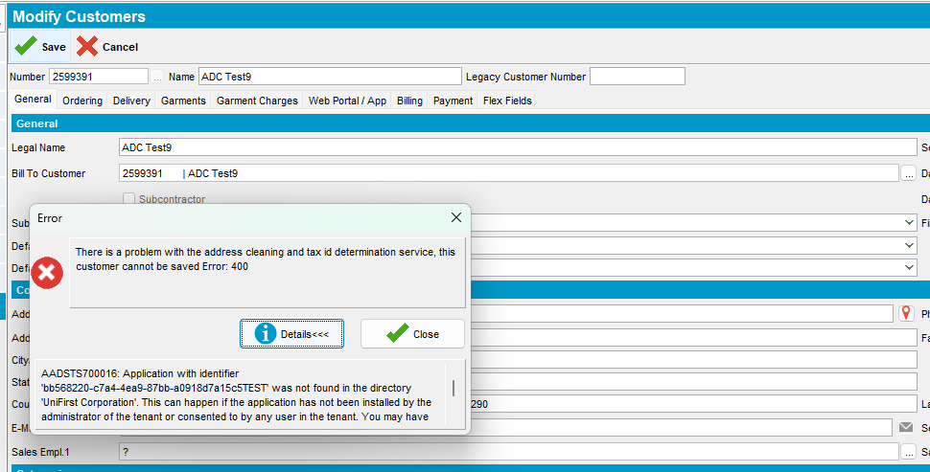
- Check ClientErrorLog to see that the call was logged
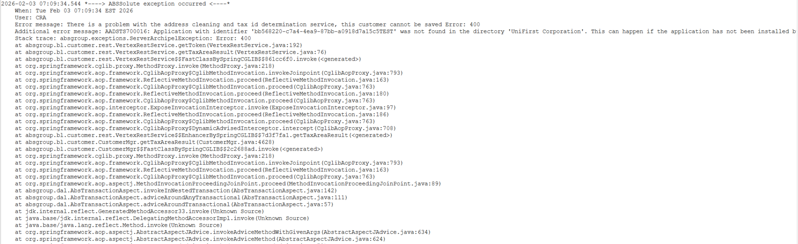
- Check the Webservicelog and see that a request was made and response was received
Select * from Webservicelog WSL
where wsl.application='UNFAddressCleaning' and wsl.requesttimestamp >sysdate -1
order by wsl.requesttimestamp desc
Tested OK

Test 10 – Modify mode VERTEXUPDATEADDRESS = 2 with VERTEXADDCLEANINGCLIENTID having the default string “-“ – modify any address on an existing customer
Hash: 9.07.00.UNF21 hash: 115015c453a4
Expected behavior:
Show error on save, do not allow user to finish adding the customer.
Check ServerErrorLog, WebServiceLog for errors
Steps:
- System settings: Have SS VERTEXUPDATEADDRESS = 2
- System settings: Have SS VERTEXADDCLEANINGCLIENTID = default “–“
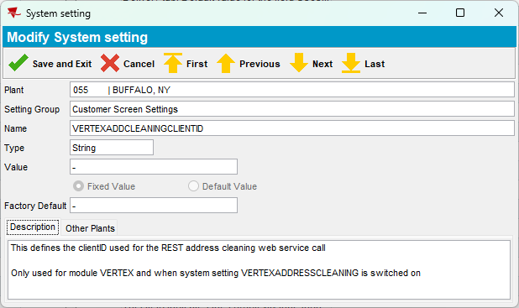
- Customers DLG: Input an existing customer 2599391 > change the address
326 Amherst St, Buffalo, NY 14207, United States
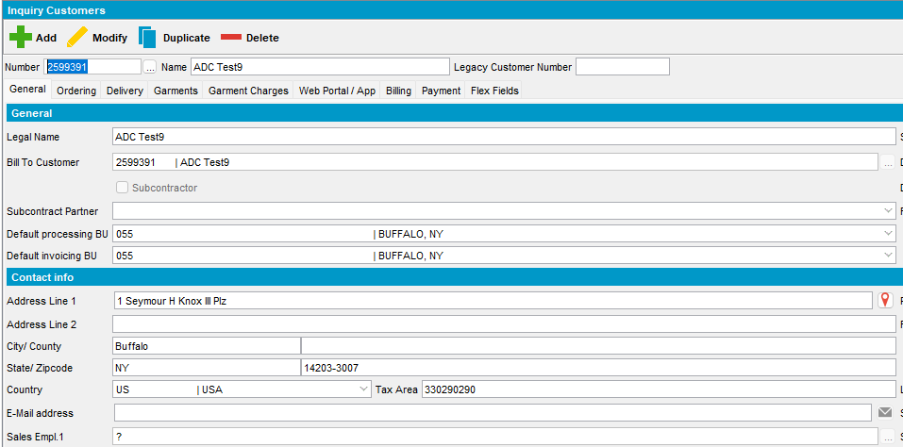
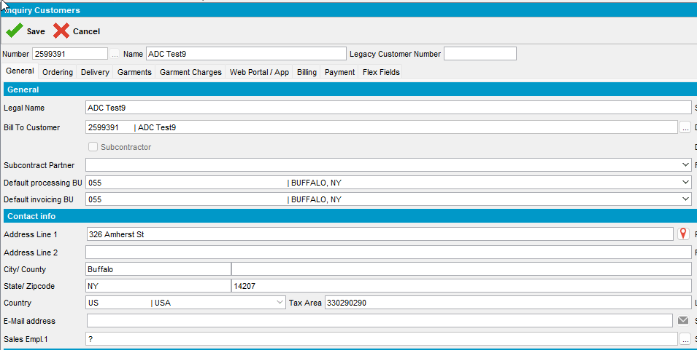
- Save your customer after completing all the required data
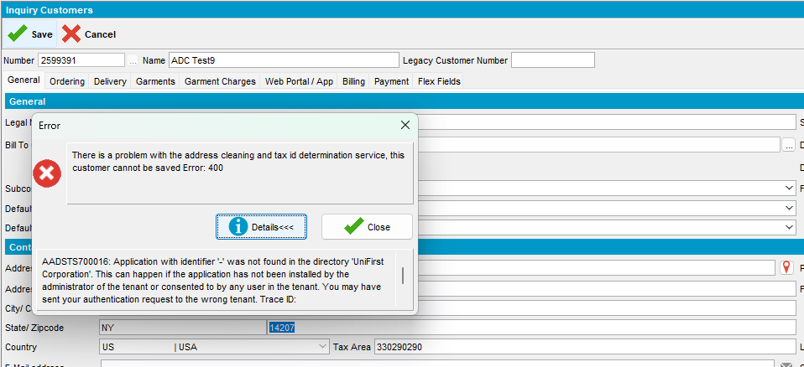
- Check ClientErrorLog to see that the call was logged
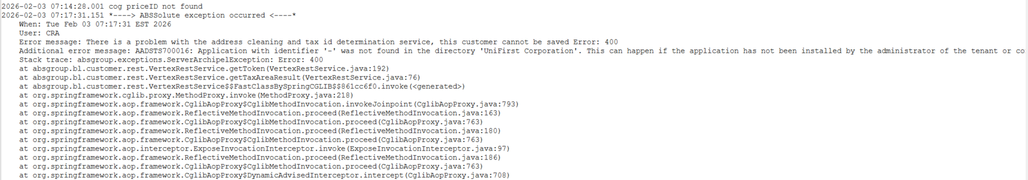
- Check the Webservicelog and see that a request was made and response was received
Tested OK

Process Scheduler Test Cases

Test Case 1 – Active customer with 3 good addresses and bad taxareaids that are not manually set (script the change to TaxAreaID)
Hash: 9.07.00.UNF21 hash: 368257e34c52
Expected behavior: Change TaxareaID and log the change
- System settings: Have SS VERTEXUPDATEADDRESS = 2
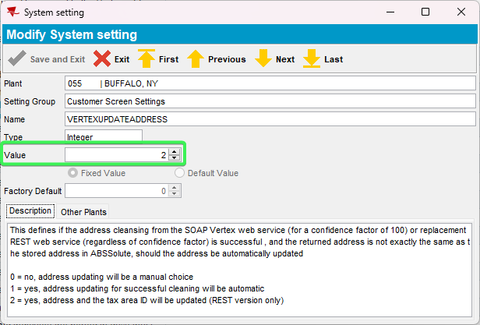
- Customers DLG: Press Add button > input a valid address:
Address Used: 1 Seymour H Knox III Plz, Buffalo, NY 14203-3007, United States
Customer #: 2599393
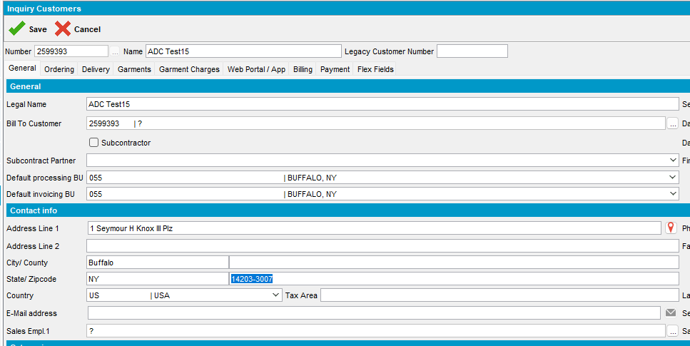
- On the Pop-up message Update all for all 3 tabs
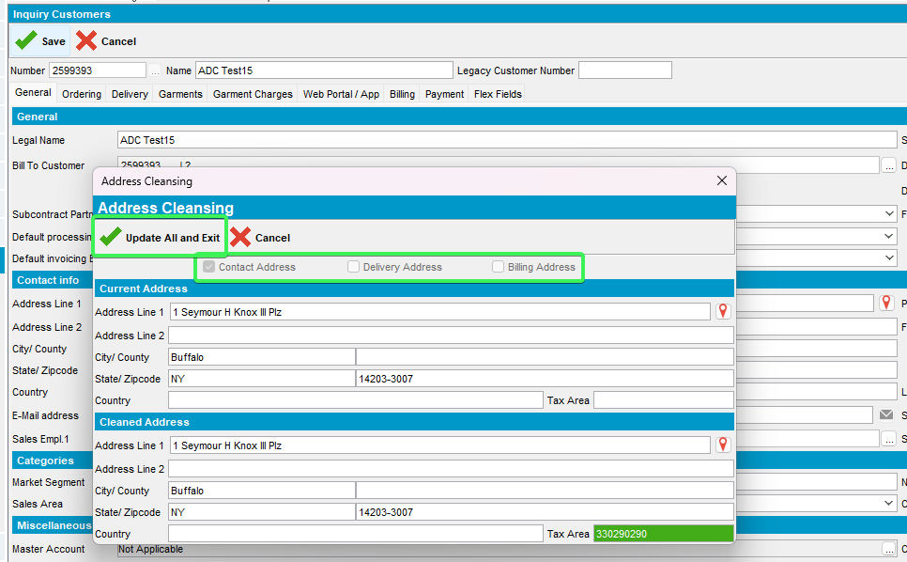
- Check that the address was added in all 3 tabs
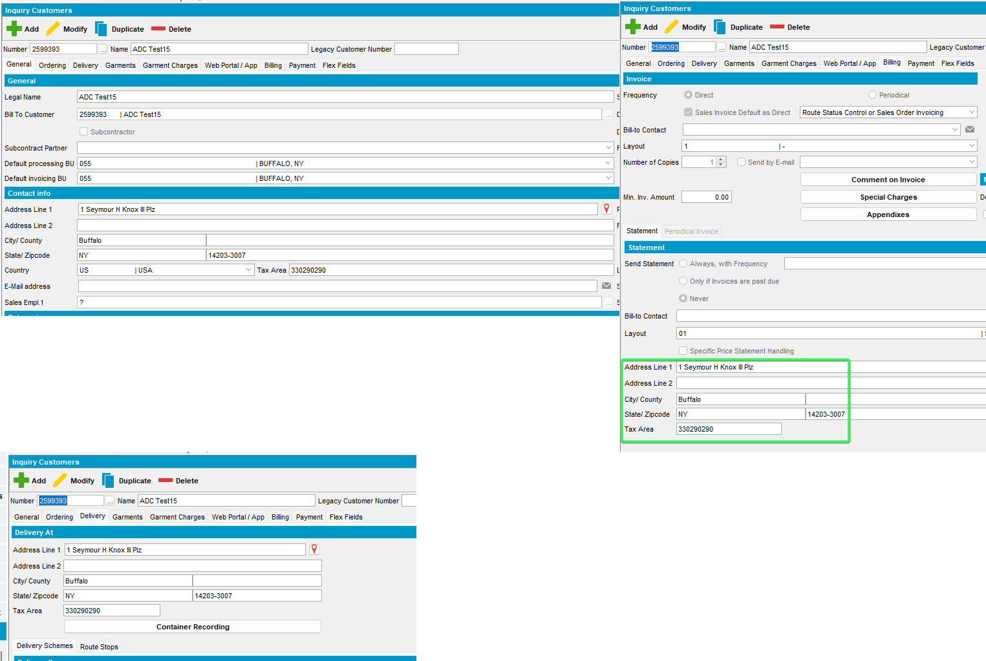
Check from PLSQL the taxareaid and that taxareaids are not manually set
select a.* from customer c, addresstaxareaid a
where c.visitaddress_id = a.address_id and c.customernumber=2599393
From PLSQL alter the tax area as it would’ve been added wrong from the system and not manually by user.

Update the General tab
select a.* from addresstaxareaid a
where a.address_id in (select c.visitaddress_id from customer c where c.customernumber=)
for update
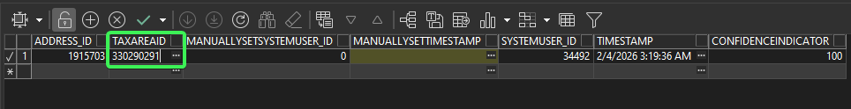
Update the Delivery tab
select a.* from addresstaxareaid a
where a.address_id in (select c.mailaddress_id from customer c where c.customernumber=)
for update
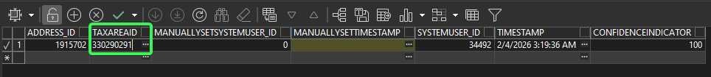
Update the Billing tab
select a.* from addresstaxareaid a
where a.address_id in (select c.invoiceaddress_id from customer c where c.customernumber=)
for update
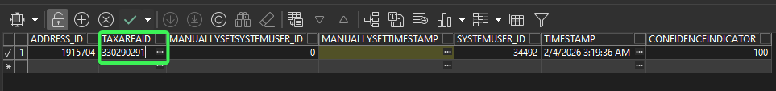
- Customers dlg: Load customer 2599393 to check the results
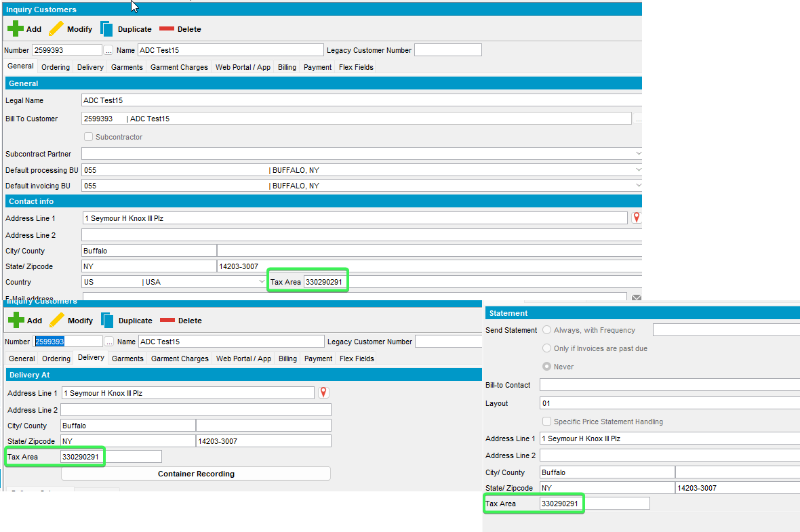
- Process Scheduler dlg: Run the process Vertex Address Cleaning from 055 Buffalo and check the logs.
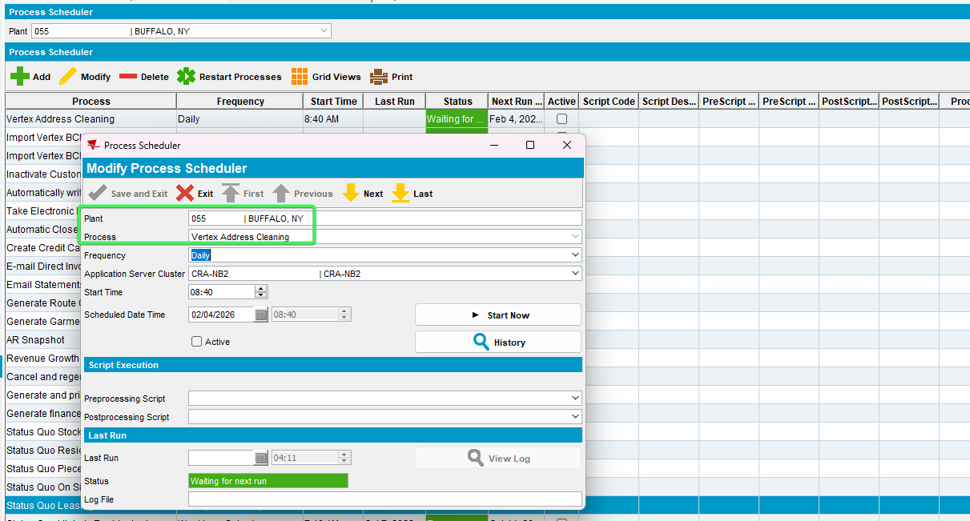
- Check that the tax area ID has been cleansed for all 3 tabs for the customer you changed it
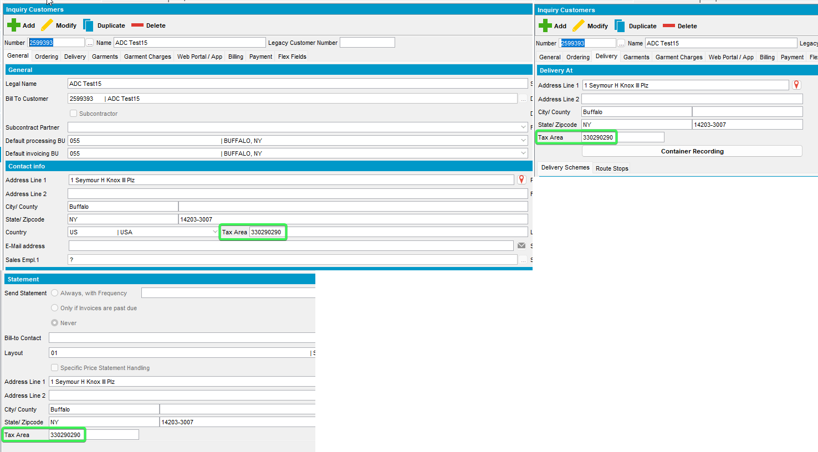
- Check the Process scheduler log and the server error log and see if any process stopping errors are present
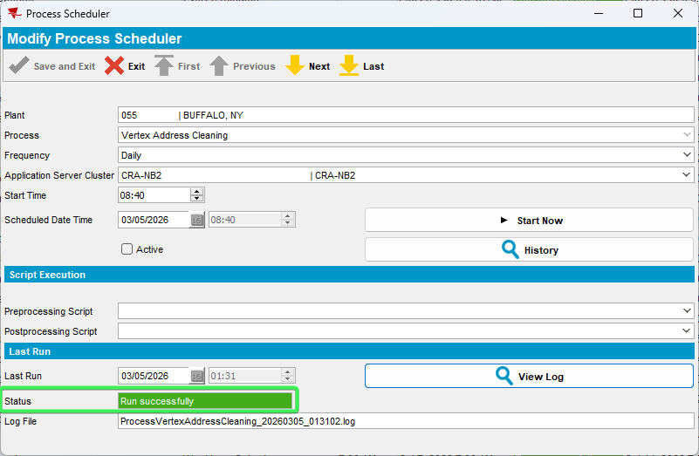
Process log
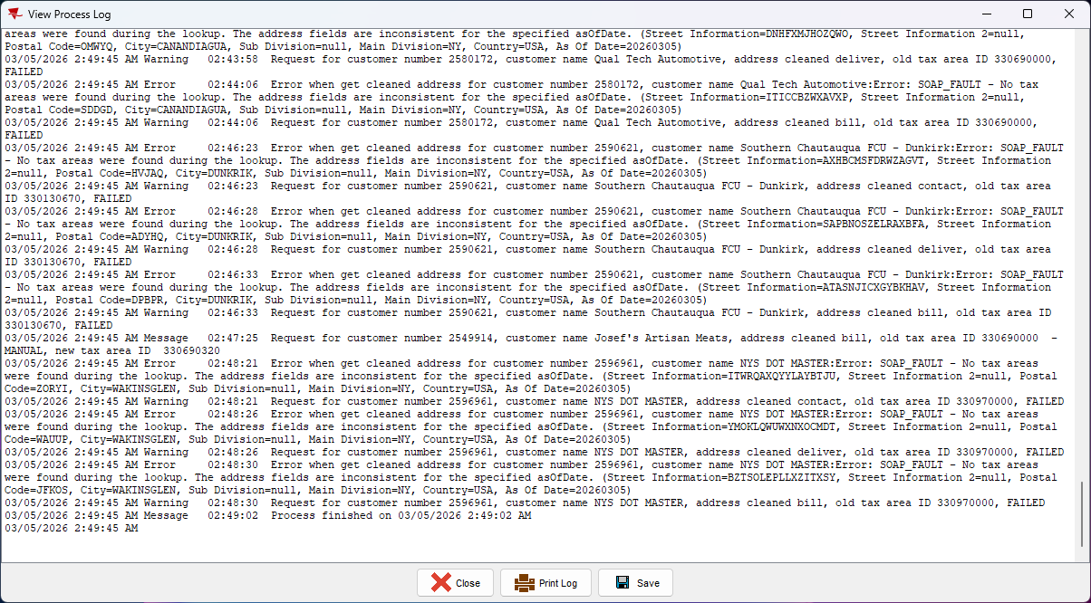
Server Error Log
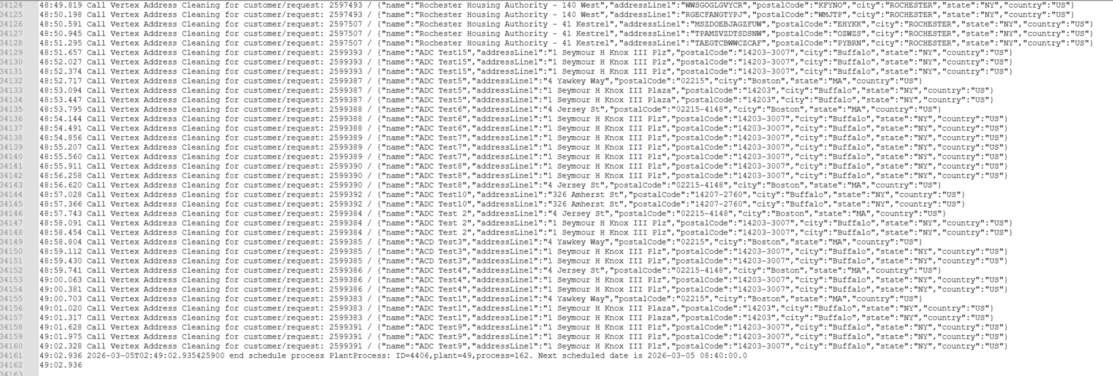

Test Case 2 – Unsuccessful response from Web Service by blocking traffic with the IP with clumsy
Hash: 9.07.00.UNF21 hash: 95e71d148f04
Expected behavior: Hard stop and log an error in WebServiceLog and Abslogprocessjobline
Steps:
- Convert the vertex address to an ip using site http://domaintoipconverter.com/index.php => 52.21.102.222
- Open the clumsy tool and block all traffic to that ip - outbound and ip.DstAddr >= 52.21.102.222 and ip.DstAddr <= 52.21.102.222
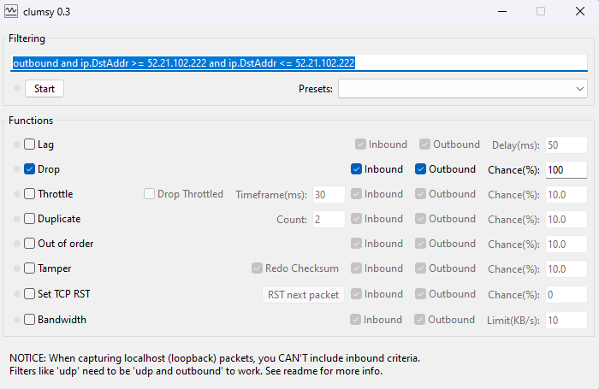
- Process Scheduler: Run process Vertex Address Cleaning, wait for it to stop and check the logs.
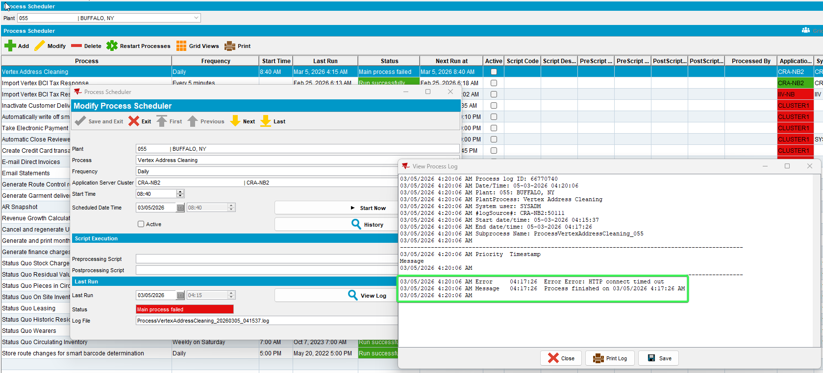
- Open the ServerErrorLog
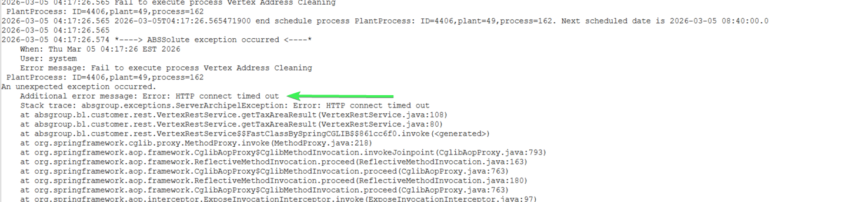

Test Case 3 – Garbage input for address and >100 confidence result
Hash: 9.07.00.UNF21 hash: 95e71d148f04
Expected behavior: do not change taxareaid and log in Abslogprocessjobline
Steps:
- Process Scheduler dlg: VERTEXADDRESSCLEANING is still to 0
- Customers dlg: Add a new customer 2599394 with Address Line 1 containing rubbish data.
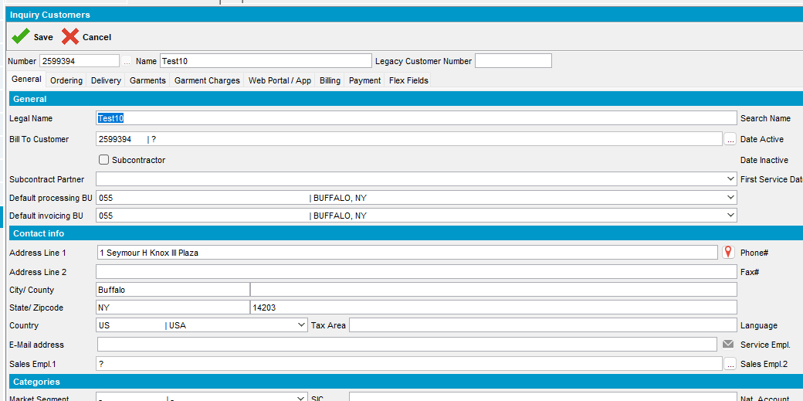
Save with update only for Tax Area Only.
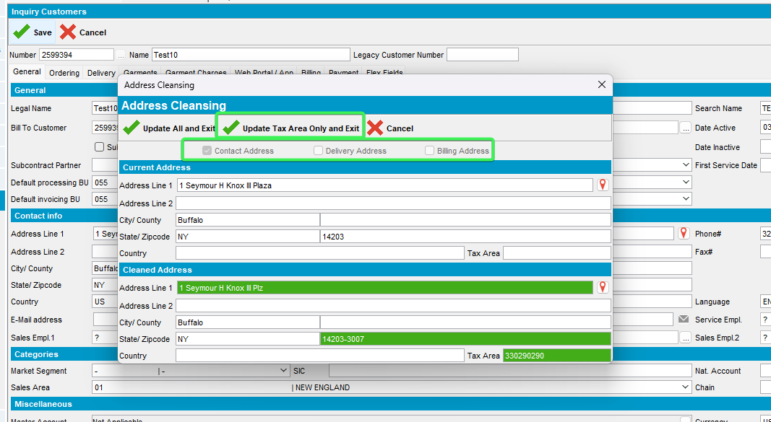
Go to PLSQL to tamper the tax area Id, change it from 330290290 to 330290291
-- General tab
select a.* from addresstaxareaid a
where a.address_id in (select c.mailaddress_id from customer c where c.customernumber=2599394)
for update
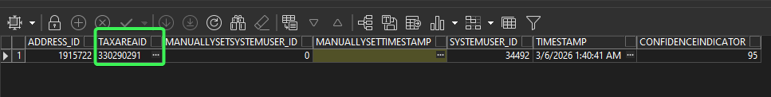
-- Delivery tab
select a.* from addresstaxareaid a
where a.address_id in (select c.visitaddress_id from customer c where c.customernumber=2599394)
for update
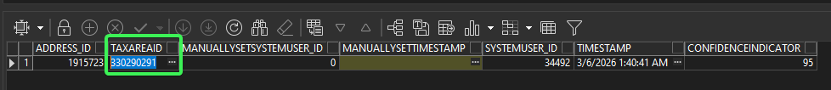
-- Billing tab
select a.* from addresstaxareaid a
where a.address_id in (select c.invoiceaddress_id from customer c where c.customernumber=2599394)
for update
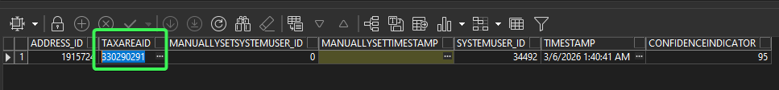
- Process Scheduler dlg: Run Vertex Address Cleaning. Check the process log
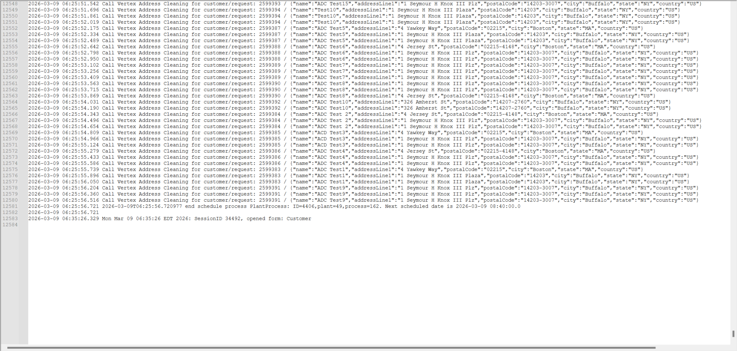
- Customers dlg: Check that the Tax Area was cleaned.
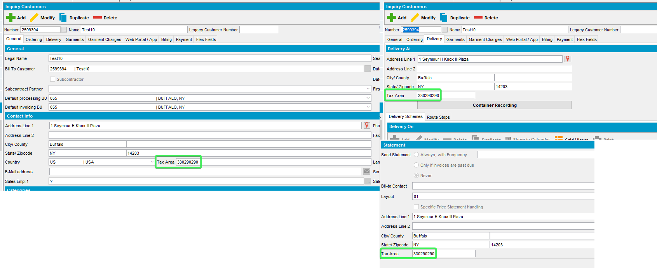
- Process Scheduler dlg: Change VERTEXADDRESSCLEANING on 0(zero) to be able to save with more rubbish data.
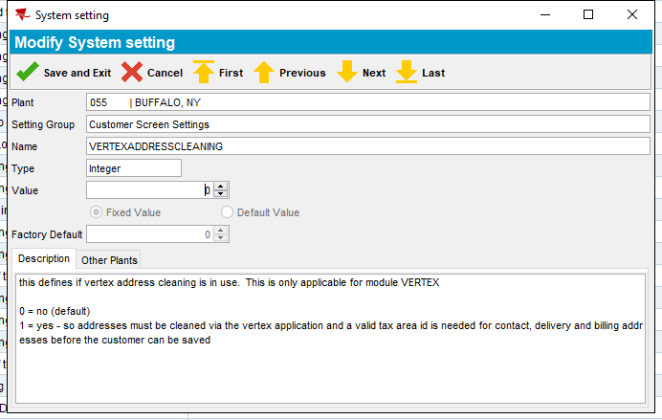
- Customers dlg: Add rubbish data for City, County, State, Zipcode as well for General, Delivery and billing tabs.
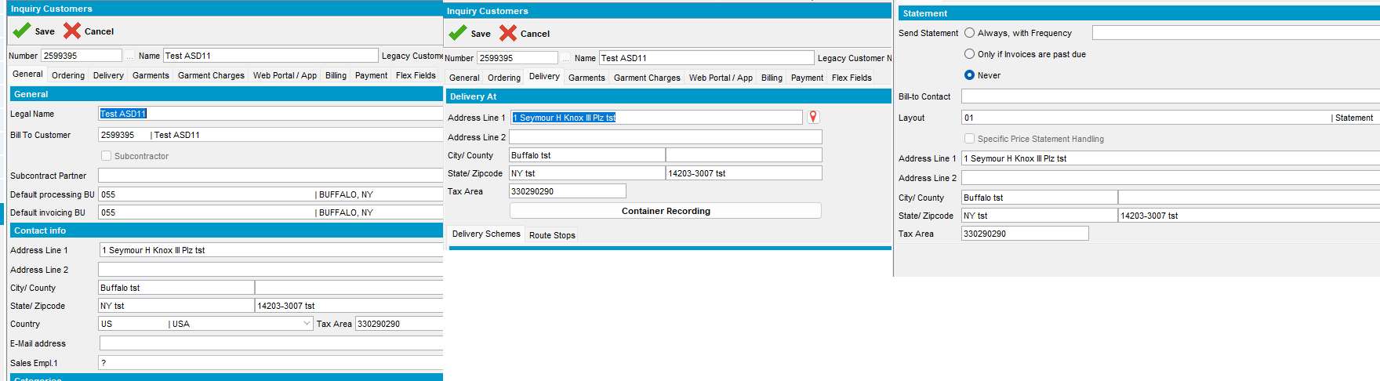
- From PLSQL change the tax area Id, change it from 330290290 to 330290291
General tab
Delivery tab
Billing tab
- Process Scheduler dlg: Run Vertex Address Cleaning. Check the process log
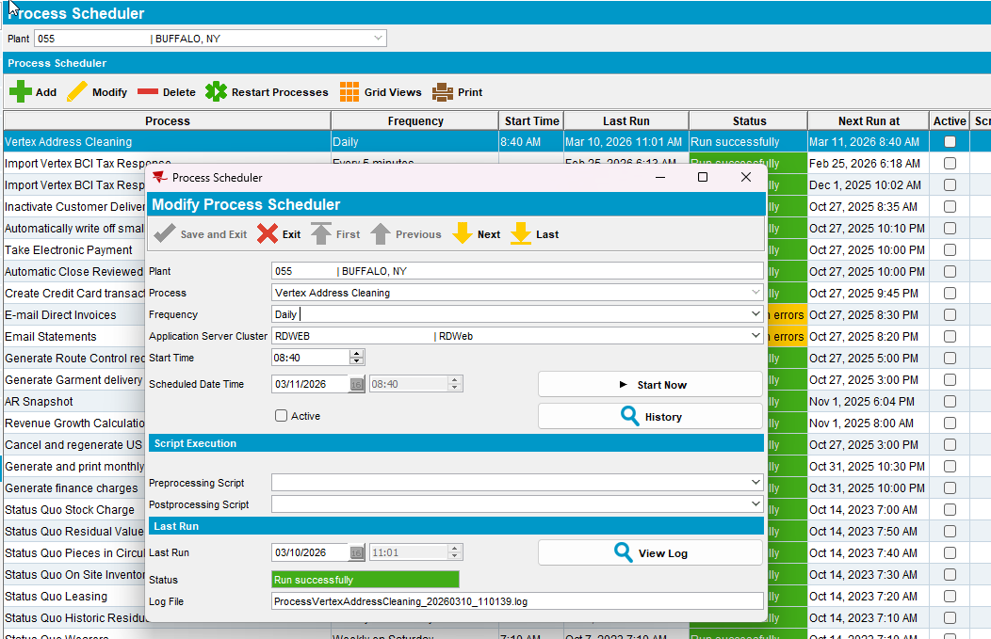
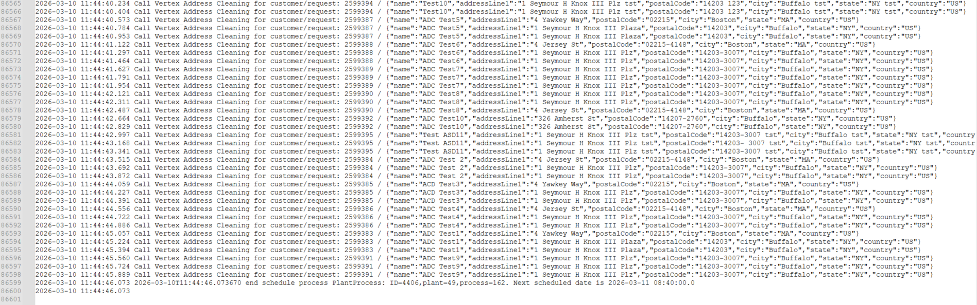
- Customers dlg: Check that the Tax Area was cleaned.
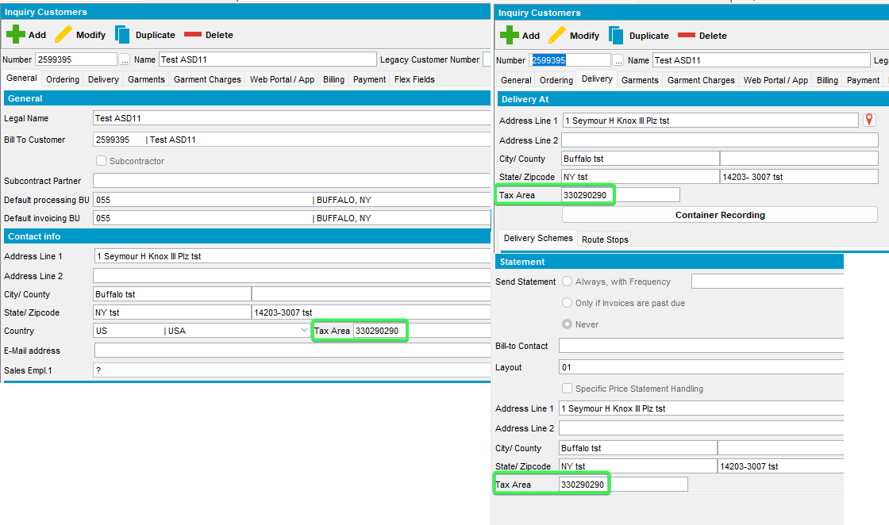
- System setting dlg: Go and change VERTEXADDRESSCLEANING
- Customers dlg: Create a new customer with address that is not 100%confident
Use the following address: 1 Seymour H Knox III Plz, Buffalo, NY 14203-3007, United States
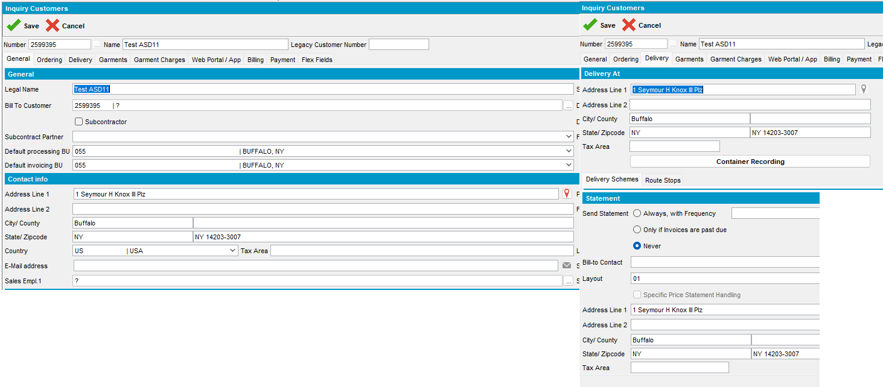
- Customers dlg: Create 2599395 with the address above and choose Update Tax area.
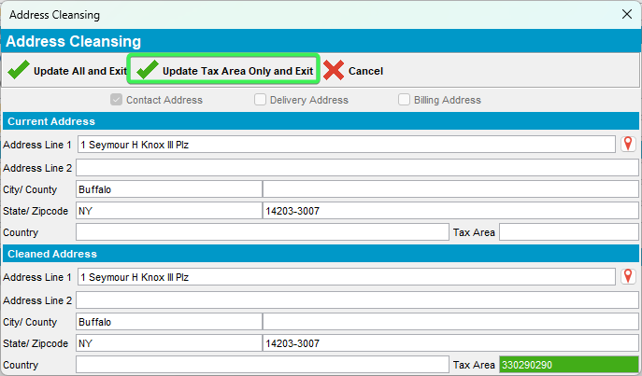
- From PLSQL change the tax area Id, change it from 330290290 to 330290291 for all fields
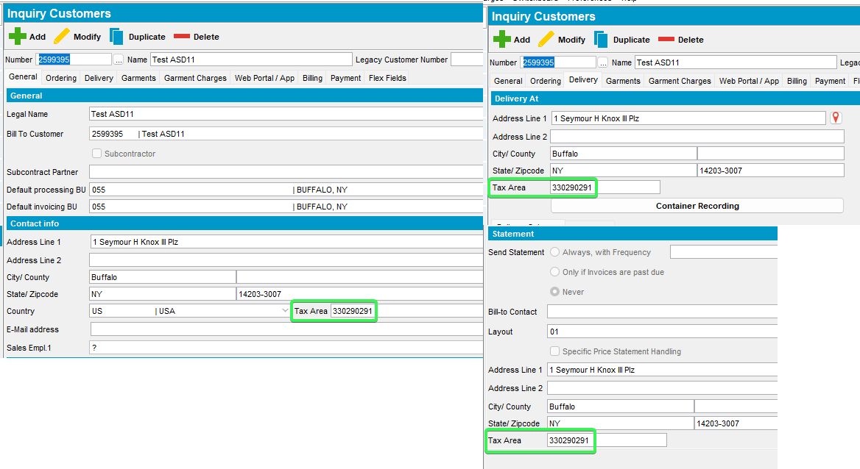
- Process Scheduler dlg: Run Vertex Address Cleaning. Check the process log.
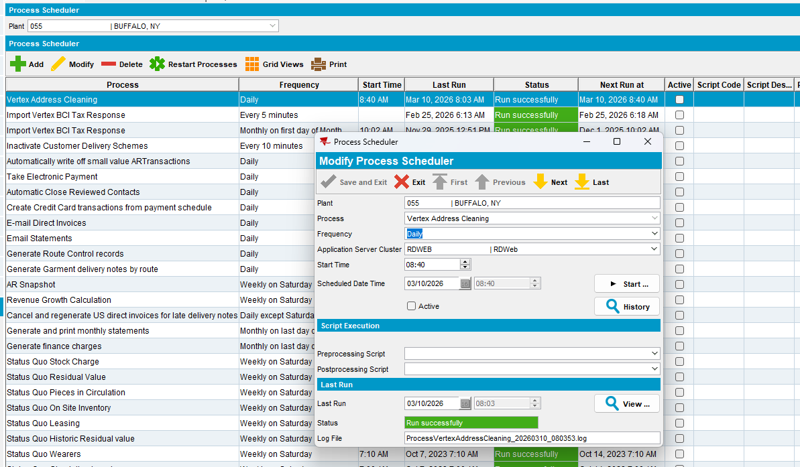
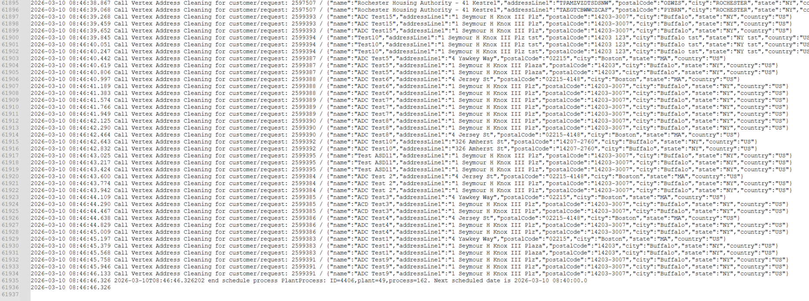
- Customers dlg: Check that the Tax Area was cleaned.
