ABSN-13894 D_UBS_2811 Tax line created on credit invoice for tax exempt customer
Environment | Prerequisites
Version: 9.07.00.UNF20
DBServerName= abs-srv19.internal.abslbs.com
DBSID= CUST22
DBUser= UNFLIVE
DBPassword= UNFLIVE
Environment=Production

Contents
Reproducing before fix 1
Retest after fix 3
Version: 9.07.00.UNF20 hash: 29b8af54c71 3
BU/Plant: 059 | NEWARK, NJ 3
Test Case #1 – Partial Credit for an Invoice with Total Tax = 0 3
Test Case #2 – Partial Credit for an Invoice with Total Tax <> 0 6

Reproducing before fix

- Find an invoice with Total Tax equal to 0 that includes a line of type Special Charge with code DISCP.
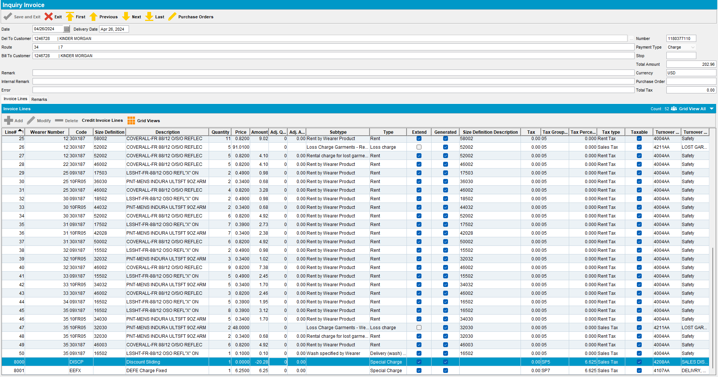

- Credit this line along with other lines.
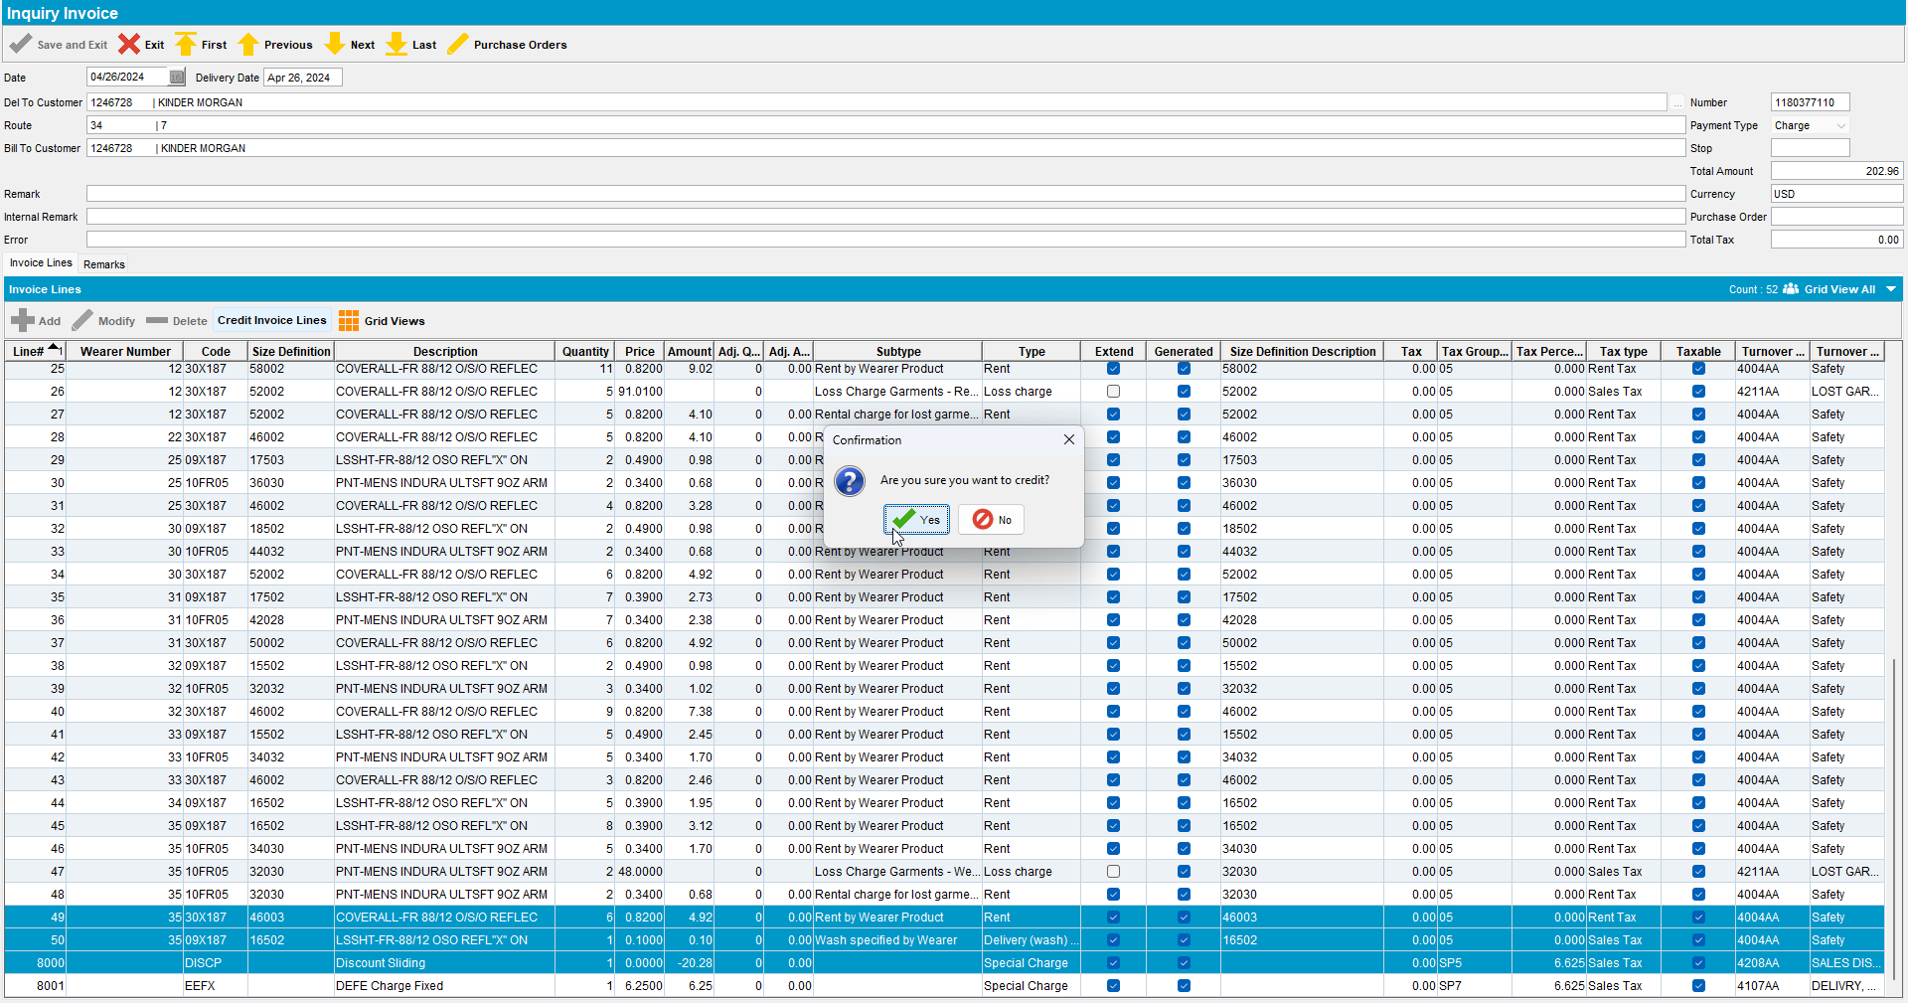
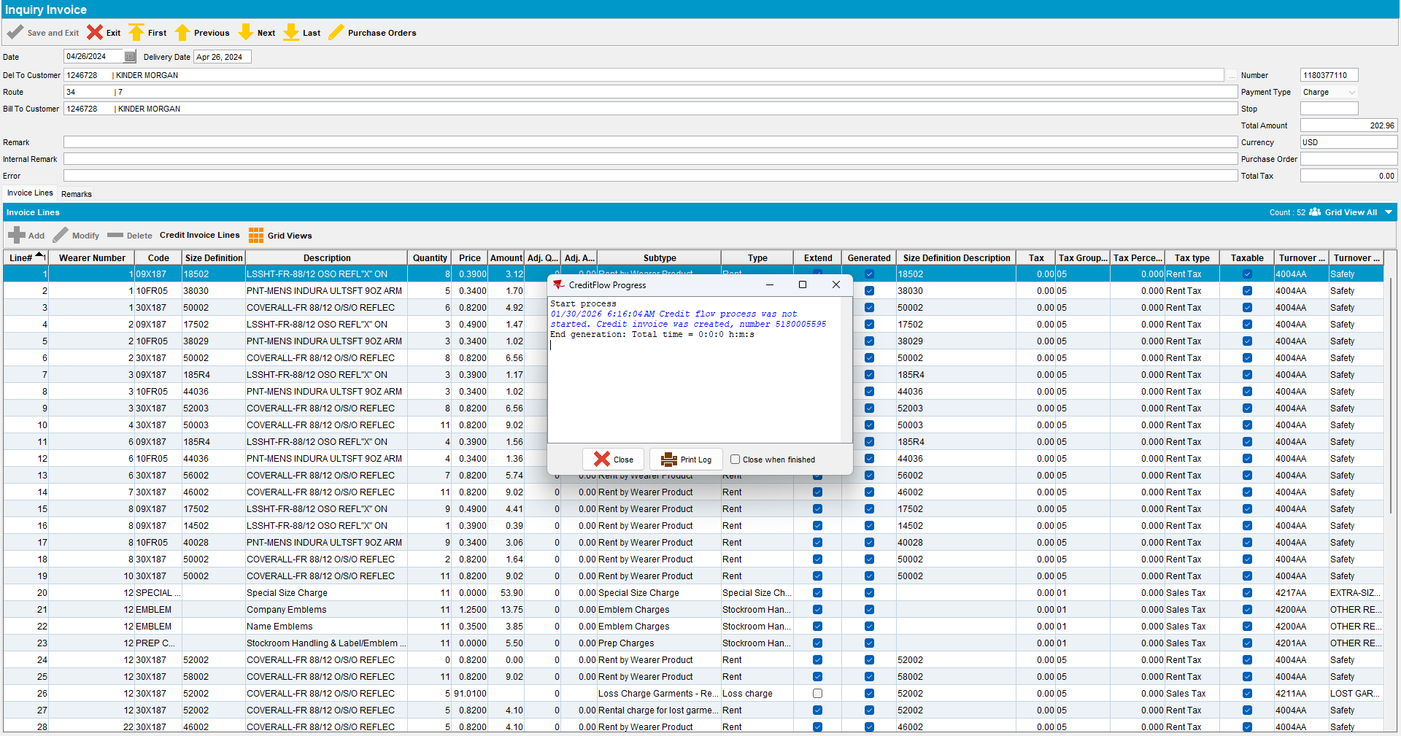

- Verify the newly generated credit invoice.
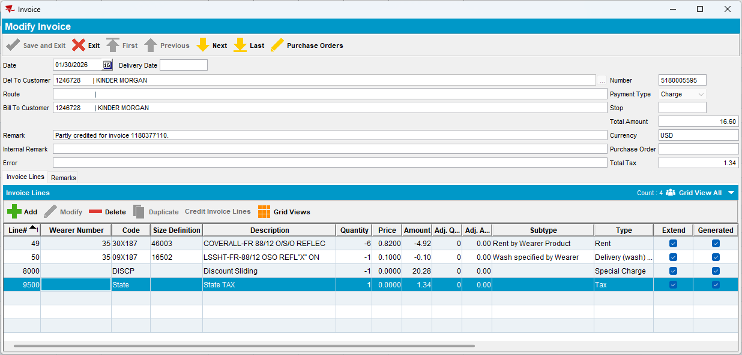
A tax line was created on the credit invoice for a tax-exempt customer.
REPRODUCED OK.

Retest after fix

Version: 9.07.00.UNF20 hash: 29b8af54c71

BU/Plant: 059 | NEWARK, NJ

Test Case #1 – Partial Credit for an Invoice with Total Tax = 0

- Find an invoice with Total Tax equal to 0 that includes a line of type Special Charge with code DISCP.
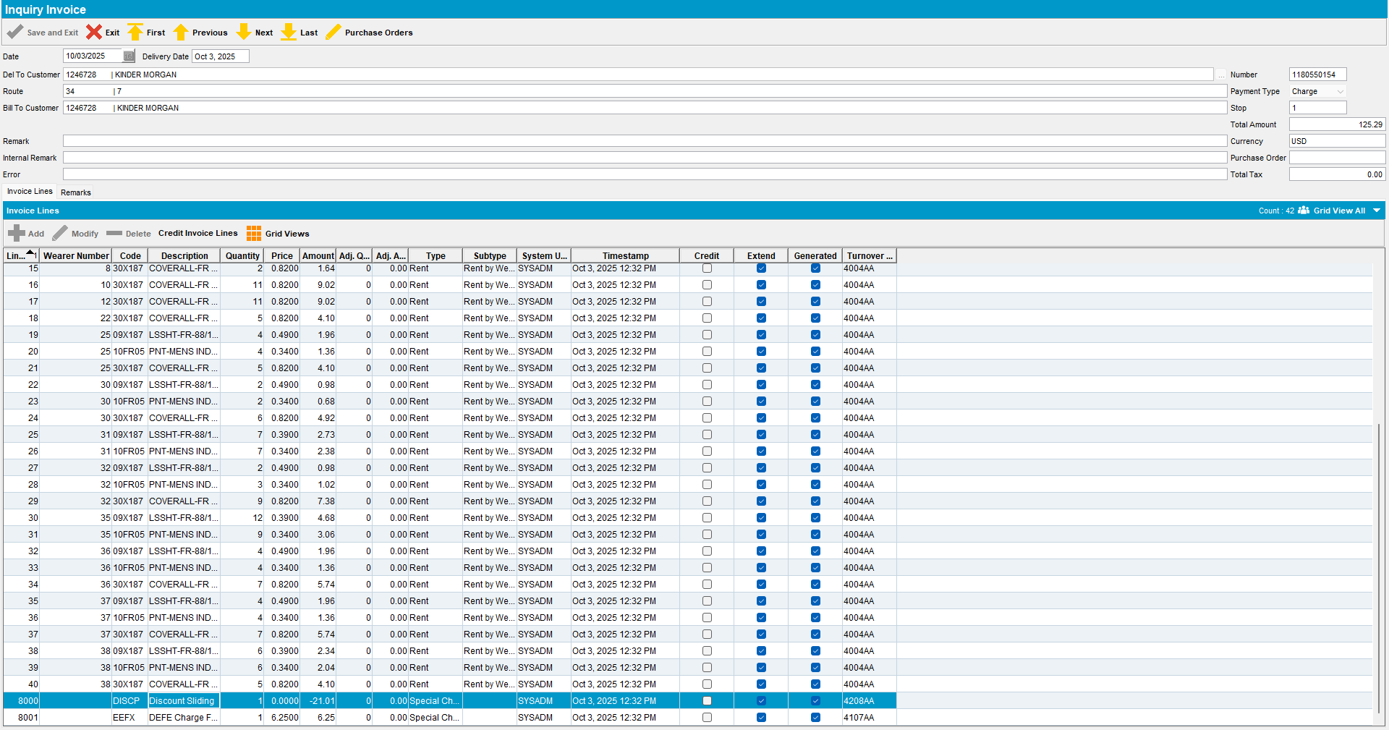

- Credit this line along with other lines.
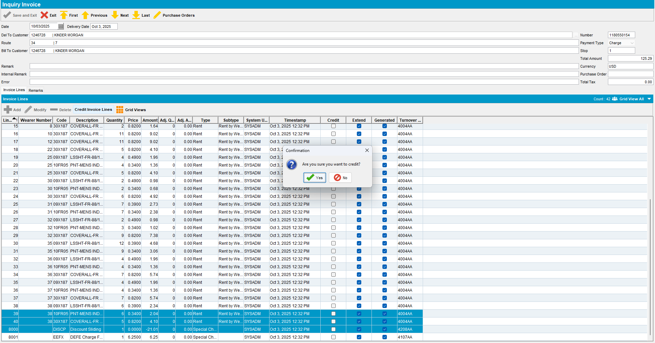
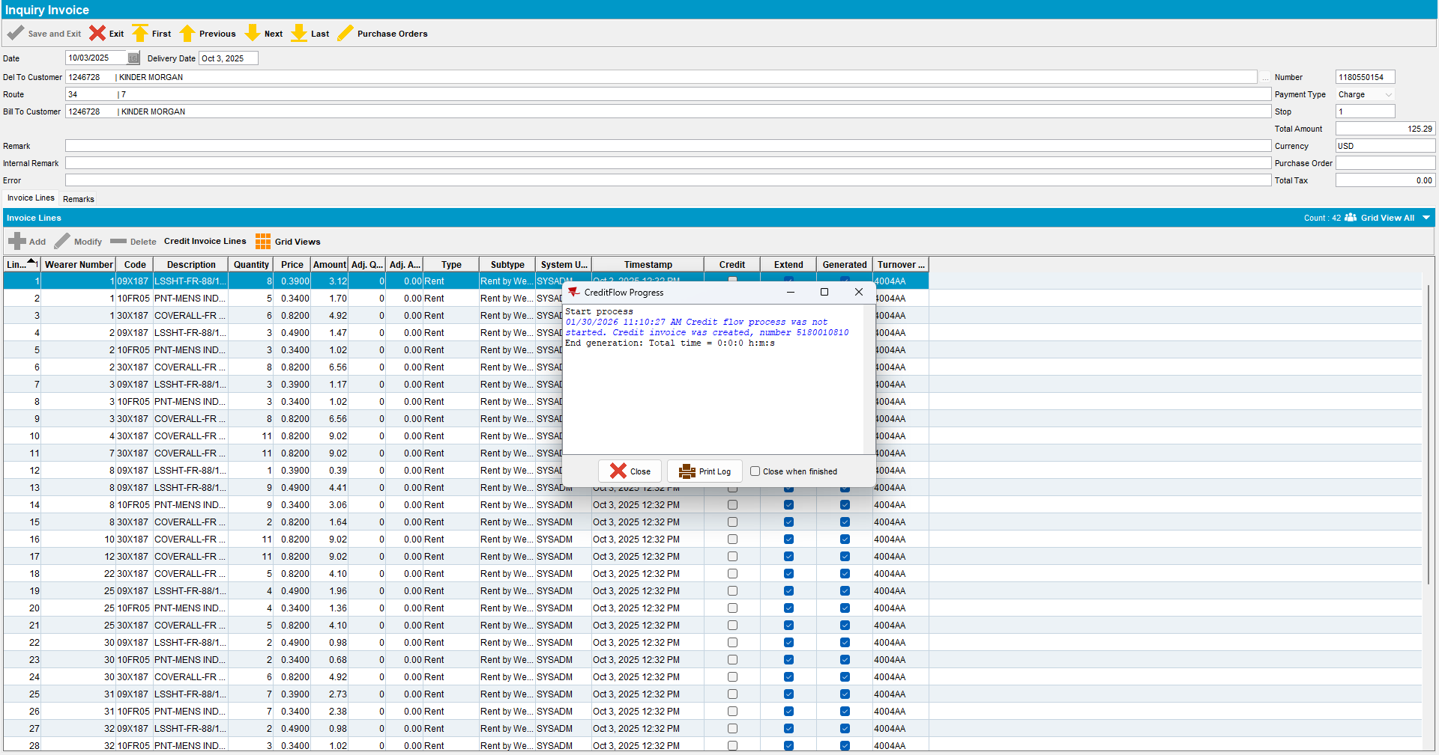

- Verify the newly generated credit invoice.
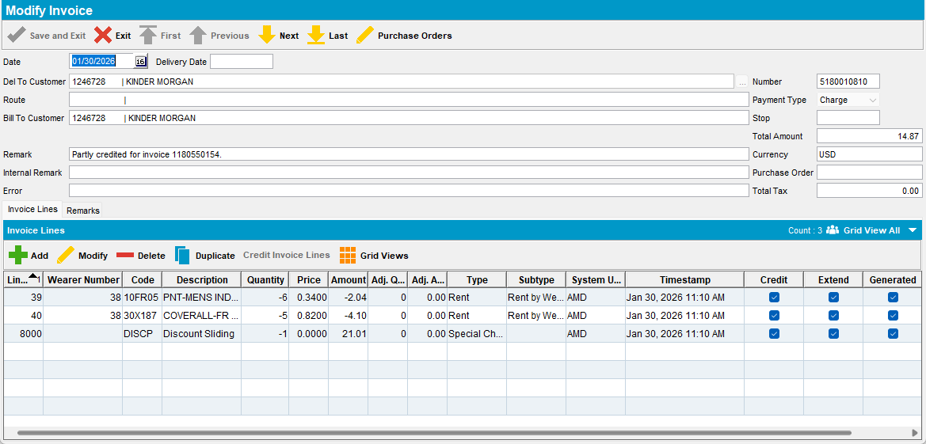
No tax line is created on the credit invoice for a tax-exempt customer.

Test Case #2 – Partial Credit for an Invoice with Total Tax <> 0

- Find an invoice with Total Tax is not 0.
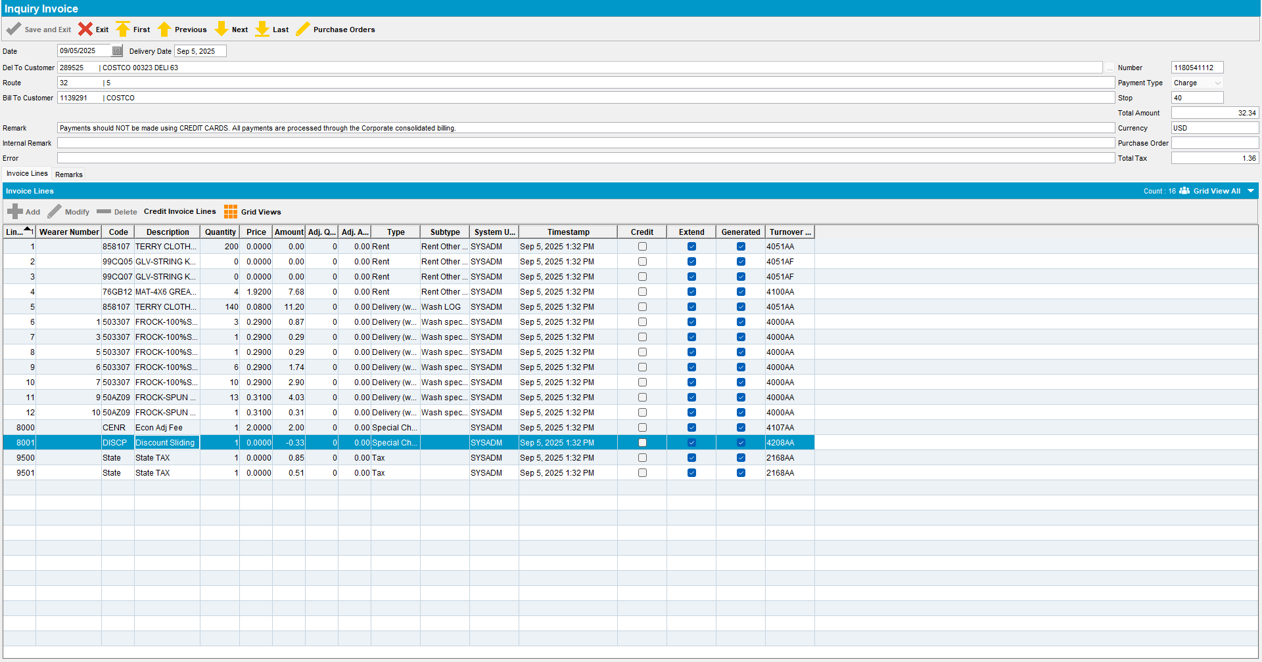

- Credit some lines.
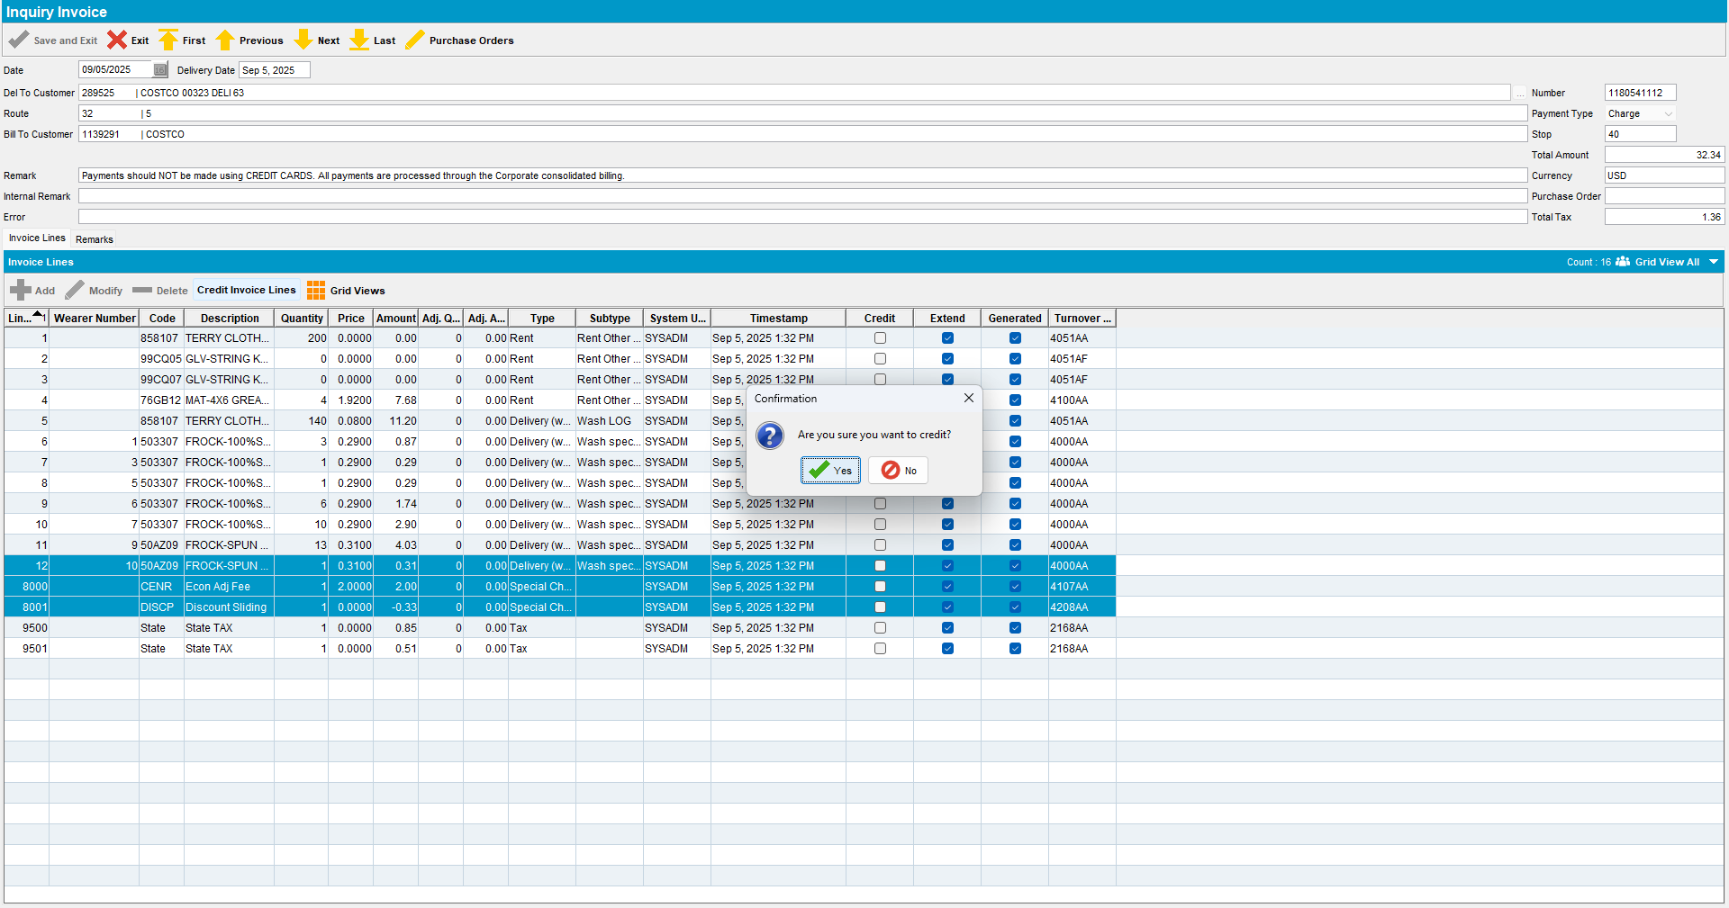
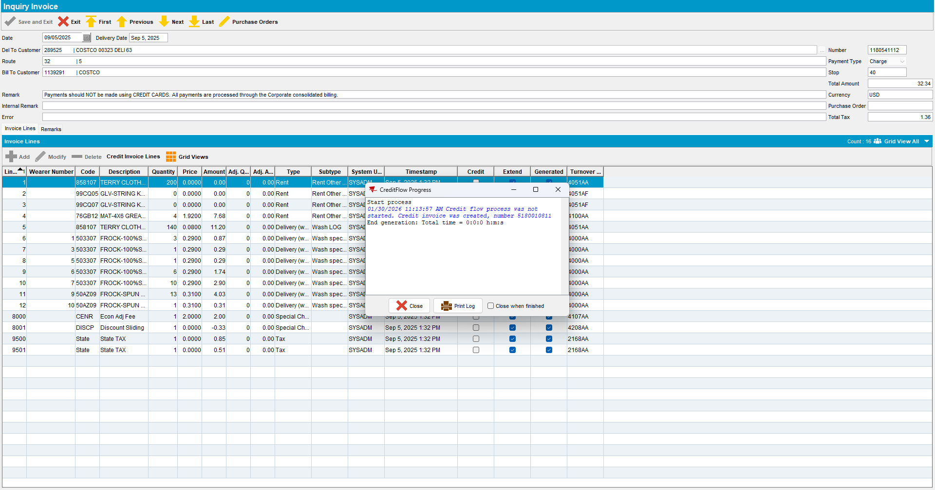

- Verify the newly generated credit invoice.
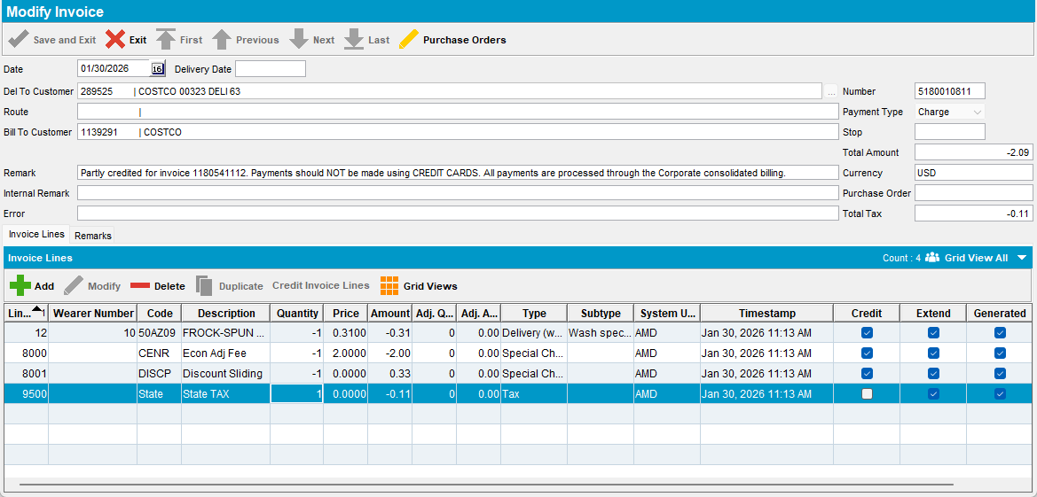
A tax line was created on the credit invoice.
TESTED OK.

