ABSN-13841 Contact Web service - Redundant check on Business Unit
Environment | Prerequisites
Version:9.07.00.UNF21  DBServerName=abs-srv19.internal.abslbs.com  DBSID=CUST22  DBUser=UNFLIVE | - Module:  - System setting

Contents
Reproducing before fix 1
Retest after fix 3

Reproducing before fix

- Create a contact from Contact Manager dialog or any other process, including web service or just pick an existing contact.
- Call web service to modify contact and provide a different BU.
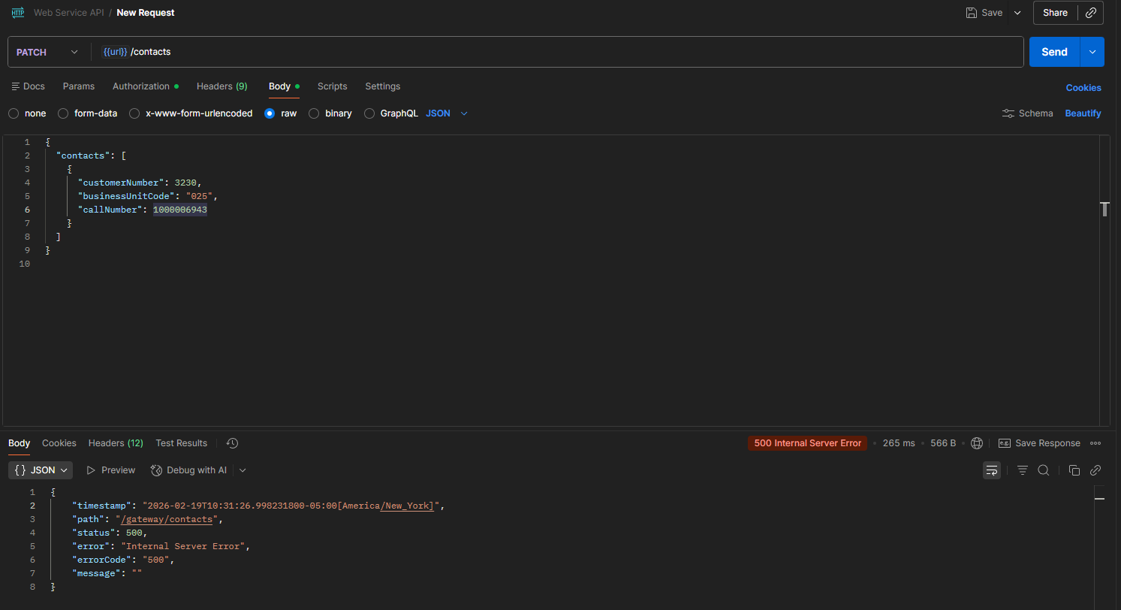
The CTC011 error scenario is not handled correctly, resulting in an internal server error instead of the expected CTC011 response.

- Try the request without providing a BU.
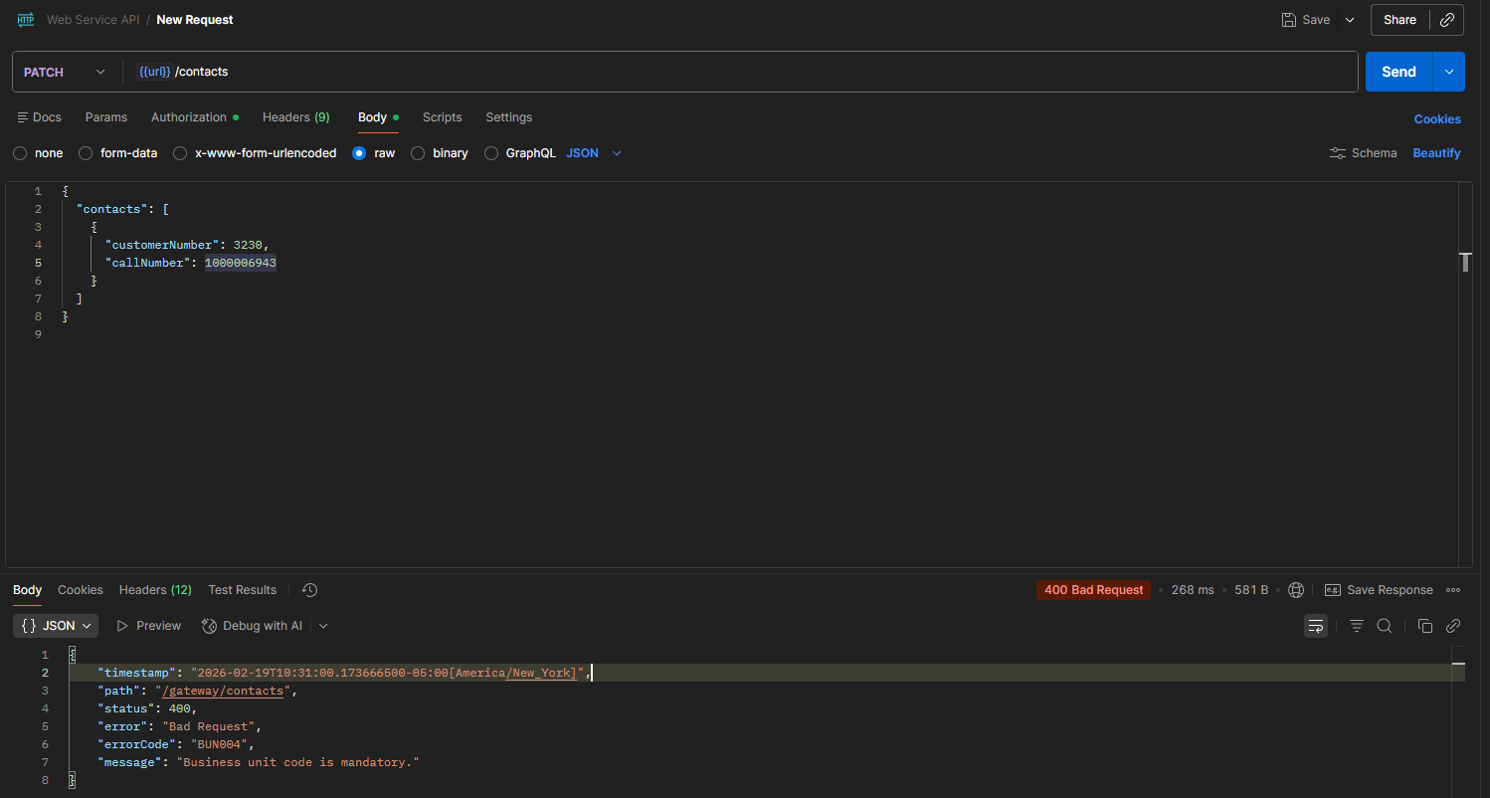
The Business Unit is mandatory. The request cannot be processed without specifying a BU.

REPRODUCED OK.

Retest after fix
Version: 9.07.00.UNF21 hash: 3b3b3b42df12
- Create a contact from Contact Manager dialog or any other process, including web service or just pick an existing contact.
select bu.code, c1.customernumber, c.* from contact c join customer c1 on c1.customer_id = c.customer_link_id join businessunit bu on bu.businessunit_id = c1.defaultbusinessunit_id
where c.businessunit_id <> c1.defaultbusinessunit_id

- Call web service to modify contact and provide a different BU.
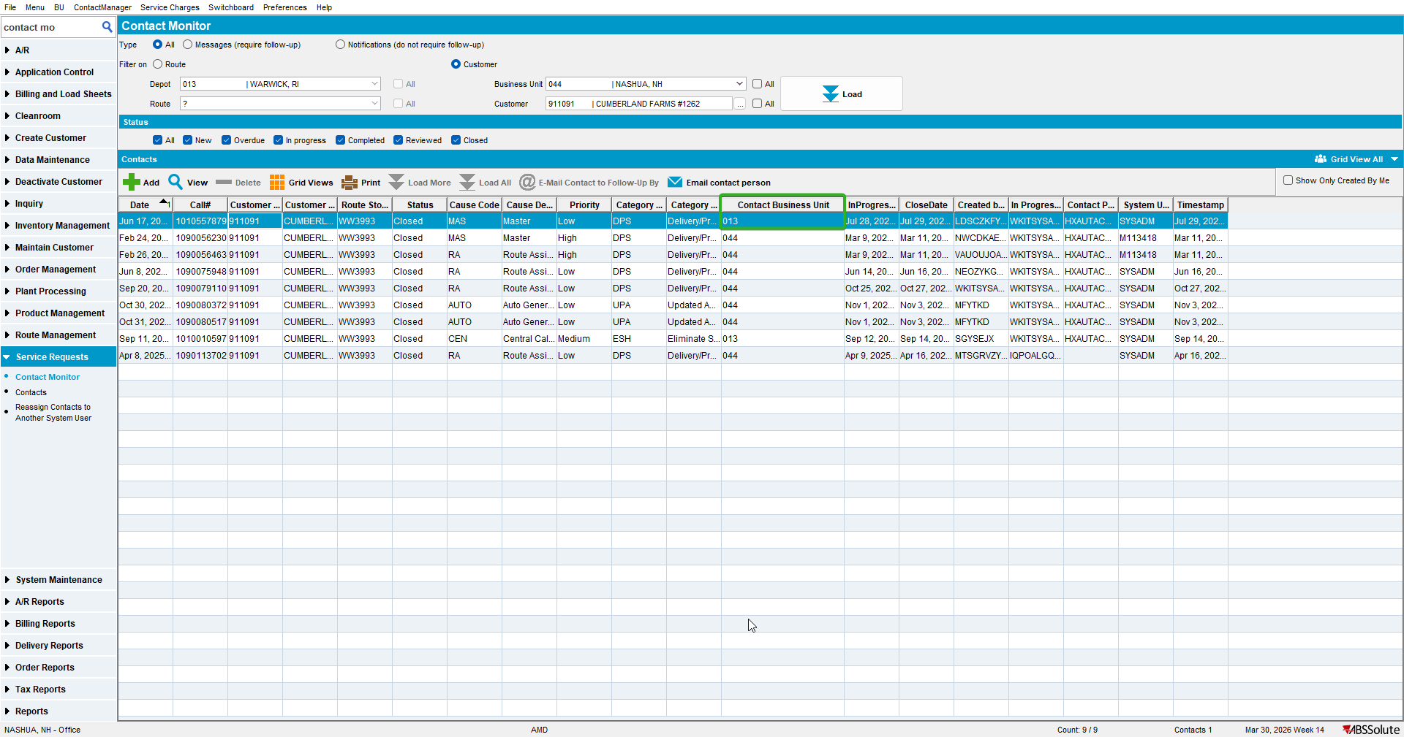
<soapenv:Envelope xmlns:soapenv="http://schemas.xmlsoap.org/soap/envelope/" xmlns:urn="urn:ABS">
<soapenv:Header/>
<soapenv:Body>
<urn:processRequest>
<String_1><![CDATA[

<ABSServiceHeader xmlns="http://absgroup/webservice/generated/xmlbindings/ABSServiceHeader">
<messageID xmlns="">4P2018101113020265416</messageID>
<transactionType xmlns="">Update</transactionType>
<function xmlns="">CONTACT</function>
<application xmlns="">JUnit Test</application>
<customer xmlns="">QuickFit</customer>
<webuser xmlns="">AMD</webuser>
</ABSServiceHeader>

]]></String_1>

<String_2><![CDATA[<ContactRequest xmlns="http://absgroup/webservice/generated/xmlbindings/ContactRequest">
<ModifyContact CustomerNumber="911091" DepartmentNumber="1" BusinessUnitCode="044" CallNumber="1010557879" Priority="Medium" UserName="AMD" ShowOnRouteList="false" ContactNotes="notes" Attachement="ABC" xmlns="">
<ContactFollowUp FollowUpUserName="AMD" FollowUpNotes="AKA's followup notes" FollowUpDate="2026-10-26T07:15:00-06:00"/>
<ContactInProgress InProgressUserName="AMD" InProgressDate="2026-06-30T00:00:00-06:00"/>
<ContactClosing ClosingUserName="AMD" ClosingDate="2027-07-05T00:00:00-06:00"/>
<ContactPerson>
<ContactPersonName>HXAUTACWRAARBPJN</ContactPersonName>
</ContactPerson>
</ModifyContact>
</ContactRequest>]]></String_2>
</urn:processRequest>
</soapenv:Body>
</soapenv:Envelope>
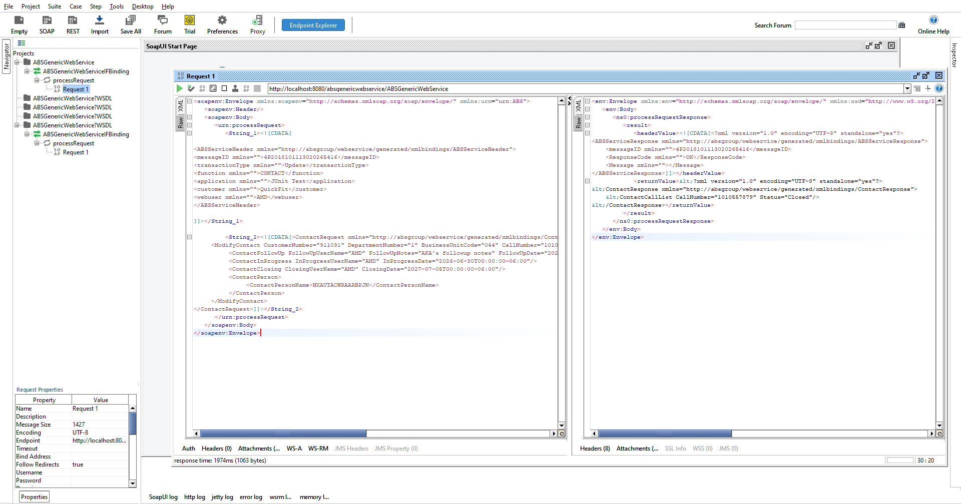

The call does not return an error when a different Business Unit is provided, which indicates that the Business Unit is no longer being validated.

TESTED OK.

