ABSN-13830 error in webservice found in the log files
Environment | Prerequisites
Version:9.07.00.UNF21  DBServerName=abs-srv19.internal.abslbs.com  DBSID=CUST22  DBUser=UNFLIVE  Environment=Production | - Module:  - System setting

Contents
Reproducing before fix 1
Test after fix 2

Reproducing before fix

- Send a request in SoapUI with a null message ID
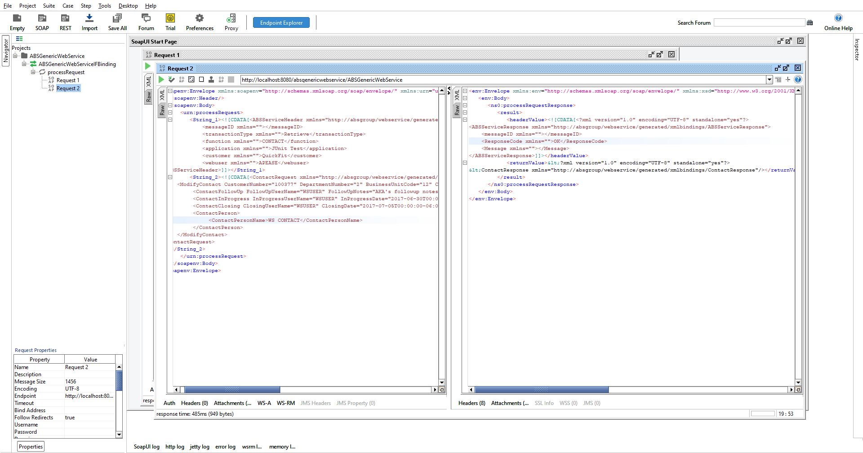

- The following error appears in the ServerErrorLog
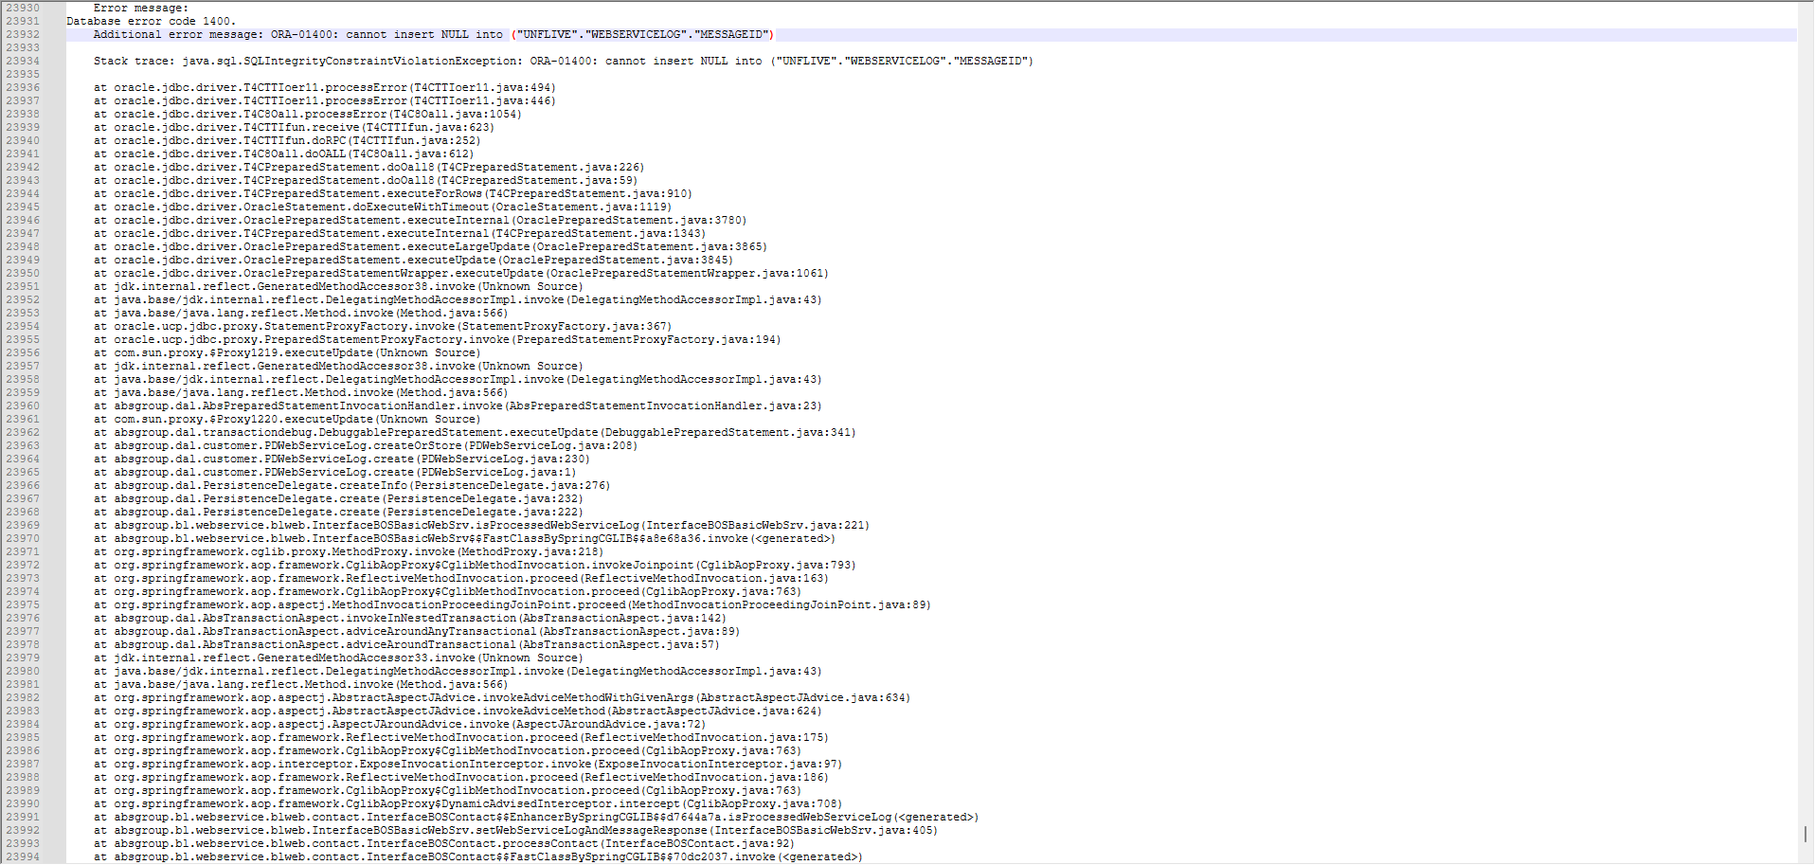

Test after fix
Hash: 67f1ee4cbe92

- Send a request in SoapUI with a null message ID
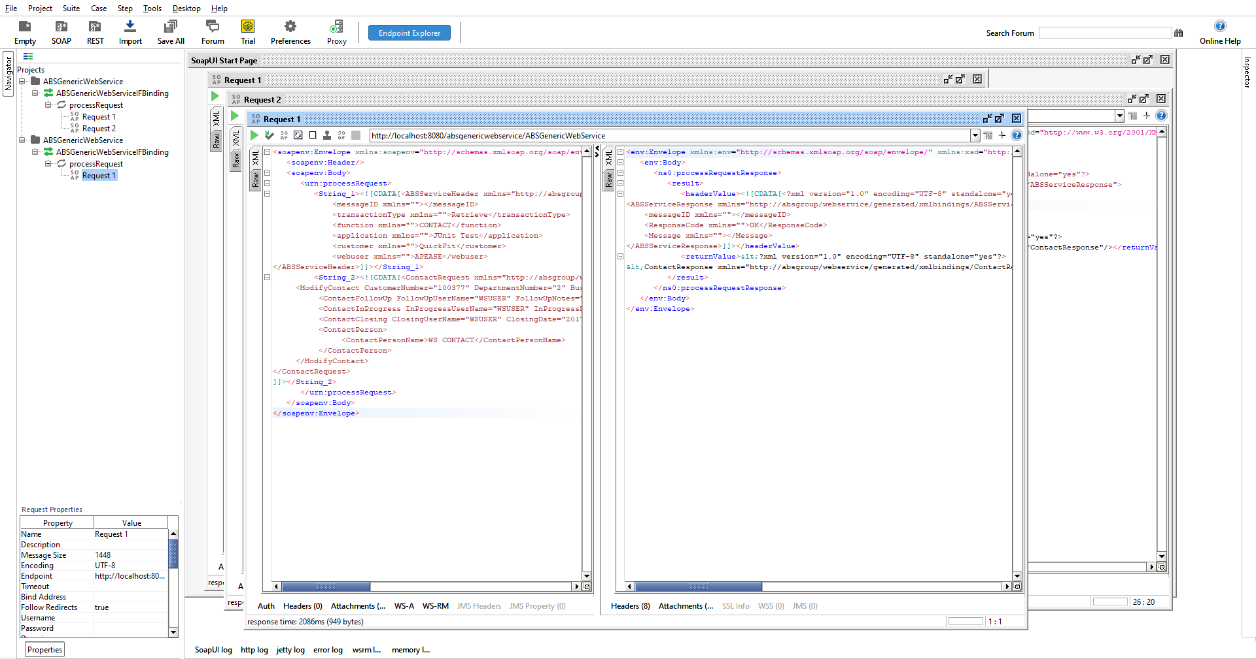

No error appears in the ServerErrorLog, and a record is created in the WebServiceLog table with MESSAGEID = -1.

